**Original Research Article**

**EVALUATION OF GRAFTED TOMATO FOR RESISTANCE TO *FUSARIUM* WILT UNDER TELANGANA CONDITIONS**

**ABSTRACT:**

**Aims:** Evaluation of grafted tomato for resistance to *Fusarium* wilt under Telangana conditions.

**Study Design:** The poly bag experiment was laid out in Randomized Block Design (RBD).

**Place and Duration of Study:** The current experiment was conducted at College of Horticulture, Rajendranagar during *Rabi*, 2022.

**Methodology:** To find out the sources of resistance in grafted tomato for *Fusarium* wilt, three graft combinations *i.e*.T1 – Arka Vikas on *Solanum torvum*, T2 – Arka Vikas on Surya and T3 – Arka Vikas on Arka Keshav along with T4- Arka Vikas (Susceptible un grafted check) were screened under artificial inoculation conditions in poly bags.

**Results:** Among the four treatments, *Fusarium* wilt incidence ranging from 0 to 1 among three graft combinations such as T1 – Arka Vikas on *Solanum torvum* (0.00), T2 – Arka Vikas on Surya (1.00) and T3 – Arka Vikas on Arka Keshav (0.67) and (4.00) in T4 – Arka Vikas (Susceptible un grafted check). Among these T1 – Arka Vikas on *Solanum torvum* was showed highly resistance to *Fusarium* wilt with “0” score and the remaining graft combinations T2 – Arka Vikas on Surya and T3 – Arka Vikas on Arka Keshav was showed the resistance with the score values 1.00 and 0.67 respectively. Per cent of incidence was varied from 0% to 100%. The lowest per cent of incidence was recorded with the graft combination of T1 – Arka Vikas on *Solanum torvum* (recorded zero per cent incidence) and the highest per cent incidence was recorded in T4 – Arka Vikas (100% of incidence) where as T2 – Arka Vikas on Surya (25 % of incidence) and T3 – Arka Vikas on Arka Keshav (16.66% of incidence) respectively.

**Conclusion:** T1 – Arka Vikas on *Solanum torvum* was highly resistant to *Fusarium oxysporum* *f*. sp. *lycopersici.*

**Keywords:** Tomato; Grafting; *Fusarium* wilt; Resistance; Per cent of incidence

**INTRODUCTION:**

Tomato (*Solanum lycopersicum* L.) is one of the most important vegetables grown globally. “The fruit improves the supply of vitamins and minerals in human nutrition” (Sabongari and Aliero, 2004). How ever, “it is infected by*Fusarium oxysporum f.* sp*. lycopersici*(Fol),causing a reduction in yields. Grafting has been utilized widely in tomato production to prevent losses caused by soil pathogens” (Saman *et al.,* 2023)*. “*Vascular wilt diseases, caused by bacteria, fungi, or oomycetes, impact a wide array of economically important crops globally” ([Oliver *et al*., 2009](https://www.frontiersin.org/journals/plant-science/articles/10.3389/fpls.2024.1384431/full#B39); [Planas-Marquès](https://www.frontiersin.org/journals/plant-science/articles/10.3389/fpls.2024.1384431/full" \l "B41) *[et al](https://www.frontiersin.org/journals/plant-science/articles/10.3389/fpls.2024.1384431/full" \l "B41)*[., 2020](https://www.frontiersin.org/journals/plant-science/articles/10.3389/fpls.2024.1384431/full" \l "B41); [Chitwood-Brown](https://www.frontiersin.org/journals/plant-science/articles/10.3389/fpls.2024.1384431/full" \l "B10) *[et al.,](https://www.frontiersin.org/journals/plant-science/articles/10.3389/fpls.2024.1384431/full" \l "B10)* [2021](https://www.frontiersin.org/journals/plant-science/articles/10.3389/fpls.2024.1384431/full" \l "B10)). “*Fusarium oxysporum* is major soil borne fungal pathogens of both greenhouse and field grown tomatoes in the warm vegetable growing areas of the world” (Rosewich *et al*., 1999). “*Fusarium oxysporum* penetrates the roots mainly through wounds and proceeds into and throughout the vascular system, leading to functional collapse, systemic wilting and often the death of the infected plant. *Fusarium oxysporum f*. sp. *lycopersici* (FOL) causes disease only in plants of the genus *Lycopersicon* (Rowe, 1980) and inhabits most tomato growing regions worldwide, causing tomato production yield losses” (Staniazsek *et al.,* 2007). “This fungus responsible for vascular wilt disease in tomato and infects the vascular system of roots, inhibiting water transport, which in turn results in rapid plant death” (Malhotra *et al.,* 1993; McGrath *et al*.,1987). “The first symptom of *Fusarium* wilt in gardens and fields is usually the golden yellowing of a single leaflet or shoot, or a slight wilting and drooping of the lower leaves on a single stem. Yellowed and wilted leaflets drop early. Affected plants turn to bright yellow, wilt, dry up and usually die before maturity. Three physiologic races of FOL, named 1, 2 and 3 in order of their discovery” (Booth 1971; Grattidge and Obrien,1982) are traditionally distinguished by each having a specific pathogenicity to tomato cultivars.

**MATERIAL AND METHODS:**

This experimental study was conducted at PG Students Research Block, College of Horticulture, Rajendranagar, Hyderabad during the year *Rabi,* 2022. The experiment was laid out in Randomized Block Design (RBD) with four treatments (Rootstocks - 3 and Scion -1)

in five replications. The general view of the experimental plot is presented in (Plate 1).

**Treatment details**

T1 – Arka Vikas on *Solanum torvum* + soil inoculated with *Fusarium oxysporum* *f*. sp. *lycopersici*

T2 – Arka Vikas on Surya + soil inoculated with *Fusarium oxysporum* *f.* sp. *lycopersici*

T3 – Arka Vikas on Arka Keshav + soil inoculated with *Fusarium oxysporum* *f*. sp. *lycopersici* T4 – Arka Vikas (Susceptible un grafted check) + soil inoculated with *Fusarium oxysporum* *f*. sp. *lycopersici*

**Isolation of culture**

*Fusarium oxysporum* *f*. sp. *lycopersici* pure culture was collected from ITCC, New Delhi. (Plate 2). Further sub cultured on PDA media and incubated on BOD incubator at 240C with 12h light and 12h dark.

**Procedure for Screening *Fusarium* wilt:**

* Two kgs of sorghum grains were soaked in water overnight in flasks.

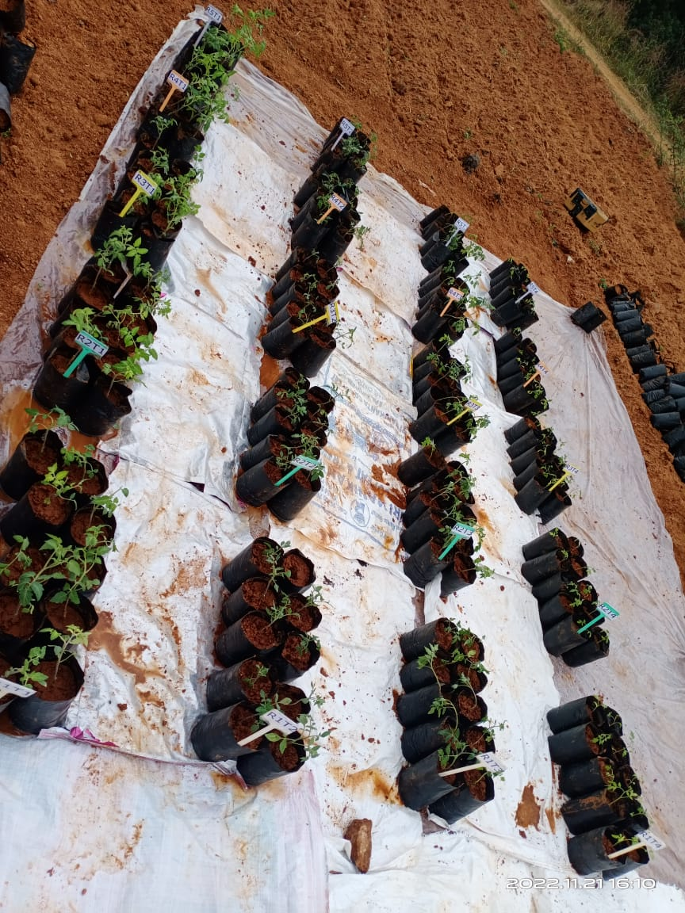

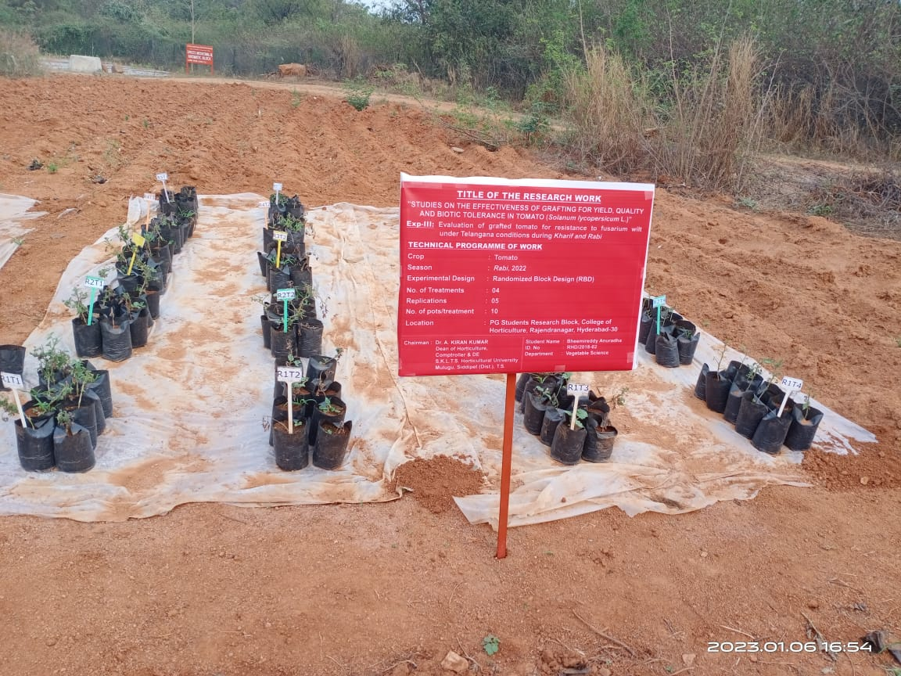

**Plate 1: Evaluation of grafted tomato for resistance to *Fusarium* wilt under Telangana conditions during *Rabi,* 2022**

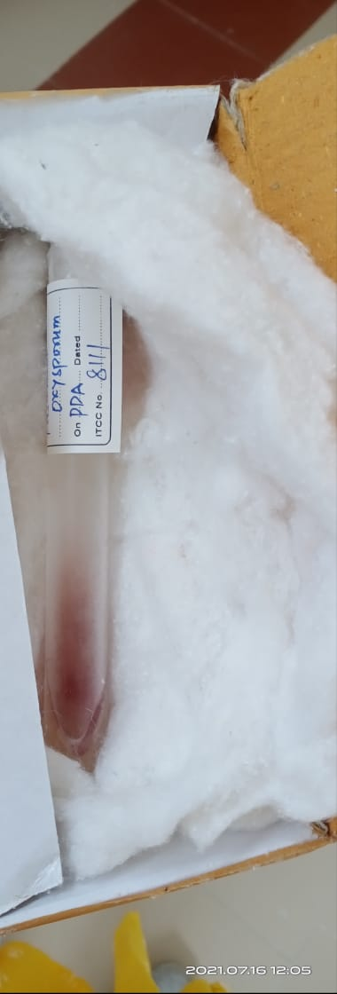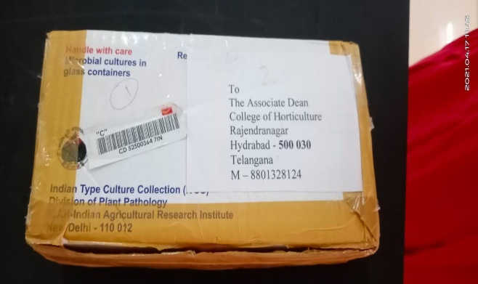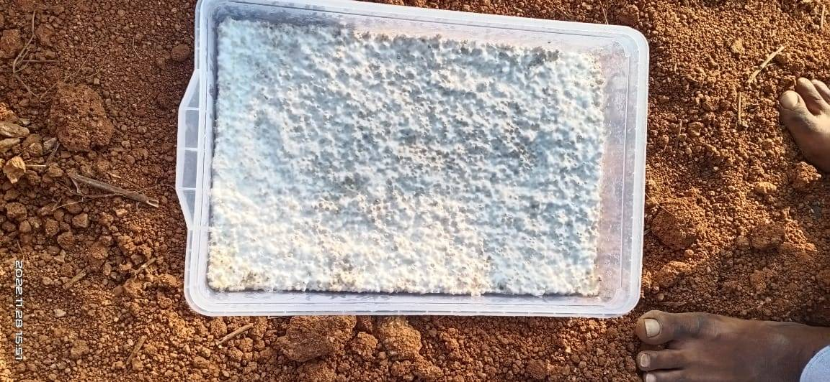

***Fusarium* culture mass multiplied on sorghum grains**

**Sub culture on PDA**

***Fusarium* pure culture (Source: ITCC, New Delhi)**

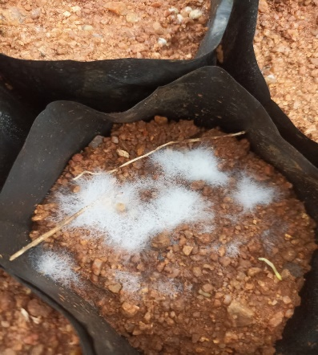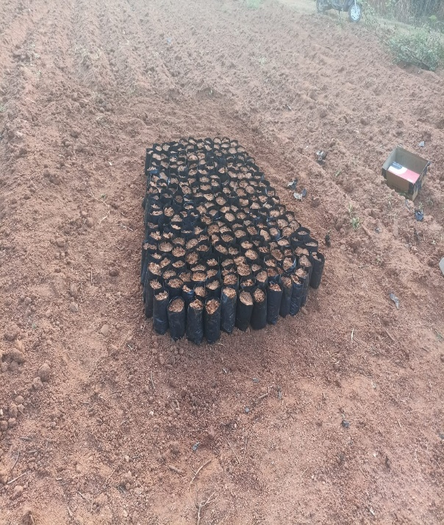

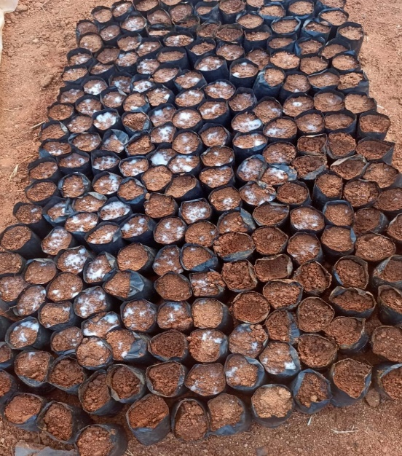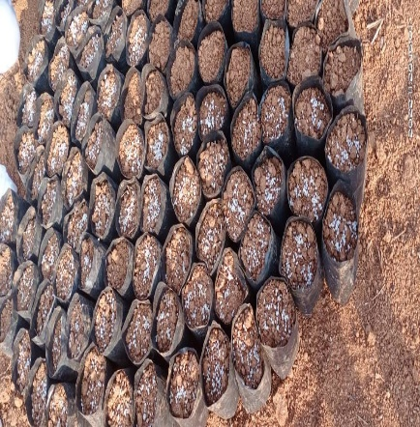

**Growth of mycelia appeared in polybags after seven days**

**Poly bags filled for**

**screening**

***Fusarium* culture application in polybags**

***Fusarium* culture application in polybags**

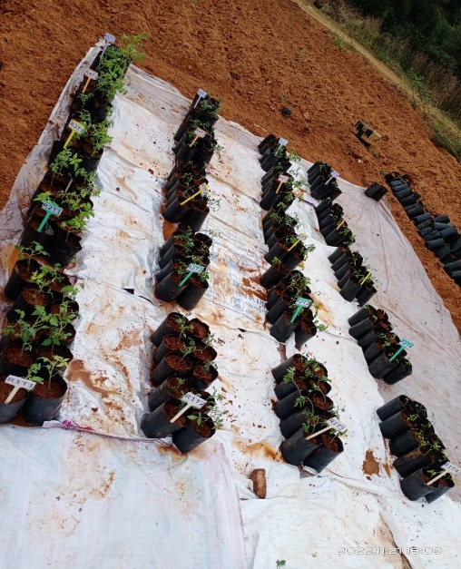

**Transplanting of seedlings in polybags**

**Plate 2: *Fusarium* wilt culture collection, sub culturing and multiplication**

* The excess water which is left after maximum absorption by different grain substrate was drained off and the flasks containing soaked grains were plugged and autoclaved at 15 psi pressure for 30 minutes.
* The substrate in flasks was inoculated with actively growing 5 mm mycelial disc of the pathogen under aseptic conditions and inoculated flasks were incubated at 25±10C in BOD incubator.
* *Fusarium oxysporum* *f*. sp. *lycopersici* mass multiplied on sterilize sorghum grains, were added to the pots/poly bags, each @ 5g/kg of soil.
* One plant per polybag was maintained.
* The data was recorded at 30 days after inoculation (DAI) and per cent disease incidence was calculated.
* The reaction of each genotype was categorized based on per cent disease incidence.
* The disease reaction was calculated as per the scale suggested by (Morid *et al*.2012).

**Observations recorded:**

Data on per centage of *Fusarium* wilt incidence for four treatments were recorded and presented as per the disease scale given by Morid *et al.* (2012).

1. No symptoms
2. Slight chlorosis, wilting or stunting of the plant.
3. Moderate chlorosis, wilting or stunting of the plant.
4. Severe chlorosis, wilting or stunting of the plant.

4- Death of the plant.

**Per cent disease incidence**

Per cent disease incidence was calculated by using following formula,

Per cent disease incidence = Number of plants infected x 100

Total number of plants planted

**RESULTS AND DISCUSSION**

The results of the experiment revealed that among the four treatments, *Fusarium* wilt incidence was reported ranging from 0 to 4 scores according to Morid *et. al* (2012). In the present study it was varied from 0 to 1 among three graft combinations such as T1 – Arka Vikas on *Solanum torvum* (0.00), T2 – Arka Vikas on Surya (1.00) and T3 – Arka Vikas on Arka Keshav (0.67) and (4.00) in T4 – Arka Vikas (Susceptible un grafted check) (Table 1). Among these T1 – Arka Vikas on *Solanum torvum* was showed highly resistance to *Fusarium* wilt with “0” score and the remaining graft combinations T2 – Arka Vikas on Surya and T3 – Arka Vikas on Arka Keshav were showed the resistance with the score values 1.00 and 0.67 respectively (Plate 3). Per cent of incidence was varied from 0% to 100%. The lowest per cent of incidence was recorded with the graft combination of T1 – Arka Vikas on *Solanum torvum* (recorded zero per cent incidence) and the highest per cent incidence was recorded in T4 – Arka Vikas (100% of incidence) where as T2 – Arka Vikas on Surya (25 % of incidence) and T3 – Arka Vikas on Arka Keshav (16.66% of incidence) respectively (Fig.1). If the plant showing healthier (than incidence ranged 0% incidence or 0 severity level) and the plants with the maximum disease severity level (than incidence ranged from 80%-100% incidence will be increased) was represented in the (Table 2).

**Table 1: Scores and per cent of incidence of *Fusarium* wilt in scion and rootstocks**

|  |  |  |
| --- | --- | --- |
| **Treatments** | **Score** | **Percent incidence** |
| T1 – Arka Vikas on *Solanum torvum* | 0.00 | 0.00 |
| T2 – Arka Vikas on Surya | 1.00 | 25 |
| T3 – Arka Vikas on Arka Keshav | 0.67 | 16.66 |
| T4- Arka Vikas  (Susceptible un grafted check) | 4.00 | 100 |

**Table 2: Grouping of graft combinations based on disease reaction to *Fusarium* wilt incidence**

|  |  |  |  |  |
| --- | --- | --- | --- | --- |
| **S.No** | **Disease reaction** | **Score** | **Total** | **Treatment** |
| 1. | Highly resistant  (HR) | 0 | 1 | T1- Arka Vikas on  *Solanum torvum* |
| 2. | Resistant  (R) | 1  (0-1) | 2 | T2- Arka Vikas on Surya  T3- Arka Vikas on Arka Keshav |
| 3. | Moderately resistant (MR) | 2  (1-2) | - | - |
| 4. | Moderately susceptible (MS) | 3  (2-3) | - | - |
| 5 | Susceptible (S) and Highly Susceptible (HS) | 4  (3-4) | 1 | T4- Arka Vikas  (Susceptible un grafted check) |

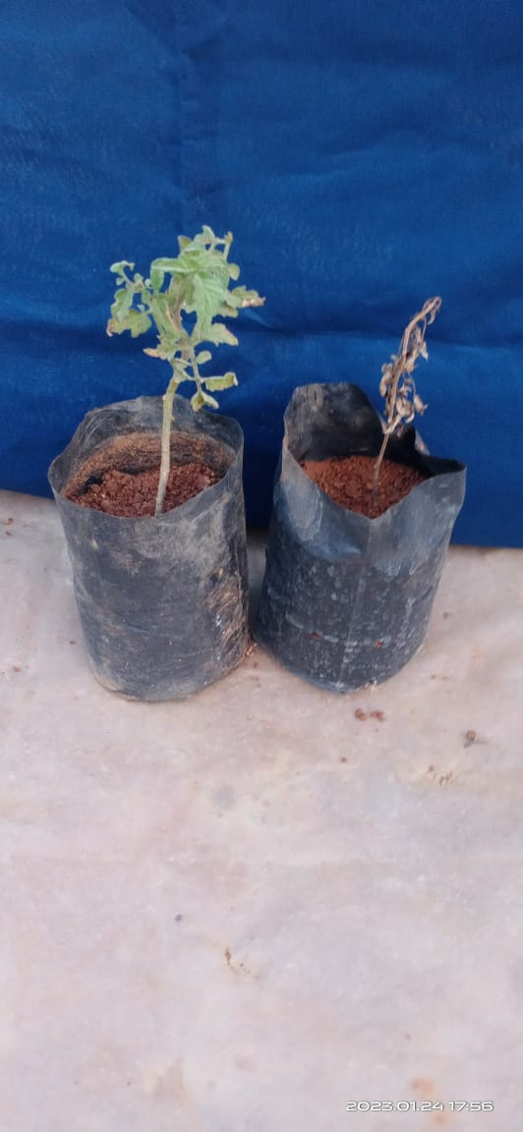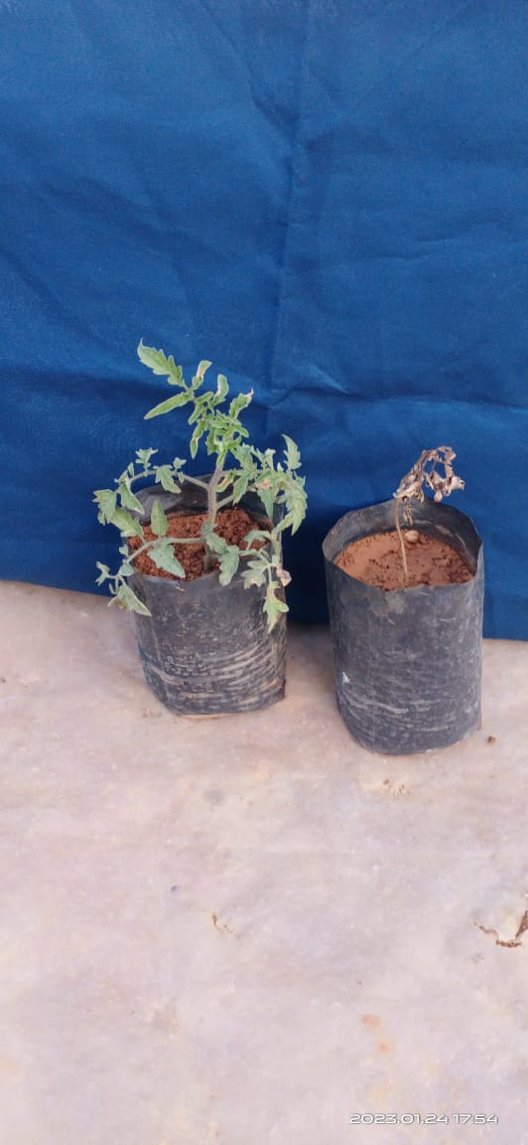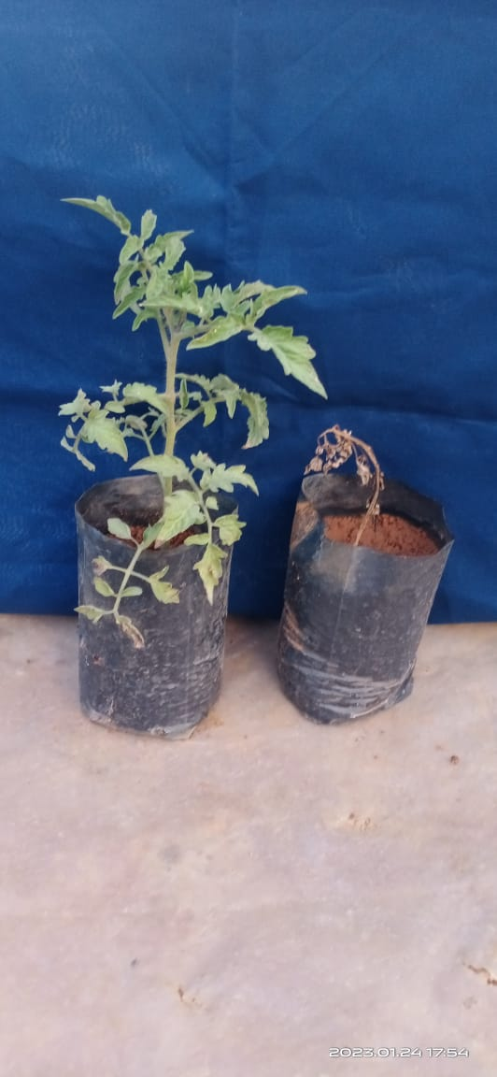

**Resistant (R)**

**Highly resistant (HR)**

**T2- Arka Vikas on Surya**

**T1- Arka Vikas on *Solanum torvum***

**T3- Arka Vikas on**

**Arka Keshav**

**Highly susceptible (HS)**

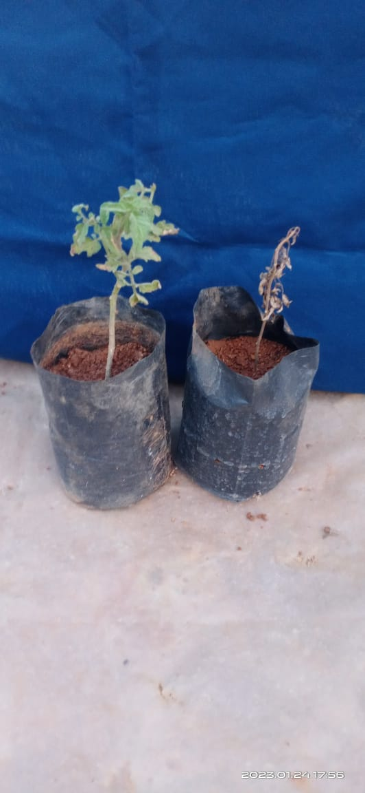

**T4- Arka Vikas**

**(Susceptible ungrafted check)**

**Plate 3: Disease reaction on *Fusarium* wilt screening**



**Fig. 1. Interaction of scion and rootstocks on *Fusarium* wilt disease**

These results were in uniformity with the findings of Huang *et al*. (1999), Chaudhary and Sharma (2000), Gousset *et al*. (2005), Rivard and Louws (2008), Akansha Pandey and Sanjeev Dubey (2017), Biswas and Ghosh (2018), Latifah *et al.* (2018) and Sushma *et al*. (2022).Jennifer *et al.* (2023) investigated “two [rootstocks](https://www.sciencedirect.com/topics/agricultural-and-biological-sciences/rootstock) (*[Solanum torvum](https://www.sciencedirect.com/topics/agricultural-and-biological-sciences/solanum-torvum" \o "Learn more about Solanum torvum from ScienceDirect's AI-generated Topic Pages)* and *Solanum macrocarpon*) were used in grafting experiments. Plant growth, yield, disease severity and incidence of both grafted plants, and non-grafted plants were evaluated in a pot experiment and also under a naturally infected open field condition at Berekum. *[Solanum lycopersicum](https://www.sciencedirect.com/topics/agricultural-and-biological-sciences/solanum-lycopersicum" \o "Learn more about Solanum lycopersicum from ScienceDirect's AI-generated Topic Pages)* grafted onto *S. macrocarpon* and *S. torvum* were moderately susceptible (20%–40%) to *[Fusarium oxysporum](https://www.sciencedirect.com/topics/agricultural-and-biological-sciences/fusarium-oxysporum" \o "Learn more about Fusarium oxysporum from ScienceDirect's AI-generated Topic Pages)*. However, the non-grafted plants were highly susceptible (50%–100%). *Solanum macrocarpon* and *S. torvum* as rootstocks offered resistance against *F. oxysporum* and showed significantly lower disease progression, than the non-grafted plants (P < 0.05). This study revealed that grafting is an effective tool for the management of *Fusarium* wilt disease and for tomato growth and yield improvement.”

Saman *et al*. (2023) reported that “a susceptible cultivar of tomato ‘Sidathip 3’ (STD3), was grafted onto four different Fol disease-resistant tomato accession rootstocks with grafting combinations, including self-graft (SDT3/SDT3) and intraspecific heterograft (SDT3/LE314, SDT3/LE472, SDT3/LE482, and SDT3/LE501). The survival rate of grafted plants was 100% at 20 days after grafting (DAG) compared to non-grafted tomatoes. All the intraspecific heterografted tomatoes had significantly reduced Fol disease symptoms at 60 days post-inoculation. The heterografted plants performed a disease severity score (DSS) of 1 and 0% of disease index (DI) compared to a self-grafted and non-grafted SDT3 with 5 DSS and 100% DI.

Variation in symptoms on aerial parts and within the stem tissues of tomato plants infected with *F. oxysporum f*. sp. *lycopersici* was observed. At early stage, symptoms appeared as yellowing of the lower leaves and in later stages, drooping of the leaves was observed. In severe infection, the pith of the stem was turned brown in colour. In severely infected plants lower leaves dried, ultimately the aerial parts of the tomato plant showed loss of turgidity and drooped down.”

**CONCLUSION**

Results from *Fusarium* wilt screening revealed that among three graft combinations T1- Arka Vikas on *Solanum torvum* was highly resistant (HR) whereas T2- Arka Vikas on Surya and T3- Arka Vikas on Arka Keshav were resistant (R) and T4- Arka Vikas was highly susceptible (HS) to *Fusarium oxysporum f*. sp. *lycopersici.*

**DISCLAIMER (ARTIFICIAL INTELLIGENCE)**

Author(s) hereby declares that NO generative AI technologies such as Large Language Models (ChatGPT, COPILOT, etc.) and text-to-image generators have been used during the writing or editing of this manuscript.

**REFERENCES**

Akansha Pandey and Sanjeev Dubey. 2017. Evaluations of brinjal germplasm for resistance to *Fusarium* wilt disease. *International Journal of Scientific and Research Publications*, 7(7).

Biswas, M.K and Ghosh, T. 2018. Screening of brinjal genotypes for their resistance against fungal and bacterial wilt and integrated management of the disease. *Plant Cell Biotechnology and Molecular Biology.* 19 (1&2): 61-71.

Booth, C. 1971. The genus *Fusarium*, Common wealth Mycological Institute, Kew, Surrey, England.

Chaudhary, D.R. and Sharma, S.D. 2000. Screening of some brinjal cultivars against *Fusarium* wilt and fruit borer. *Agricultural Science Digest*. 20:129-130.

Chitwood-Brown, J., Vallad, G. E., Lee, T. G., Hutton, S. F. 2021. Breeding for resistance to *Fusarium* wilt of tomato. *Genes.* 12: 1673.

Gousset, C., Collonnier, C., Mulya, K., Rotino, G. L., Besse, P., Servaes, A. and Sihachkar, D. 2005. *Solanum torvum*, as a useful source of resistance against bacterial and fungal diseases for improvement of eggplant (*S. melongena* L.). *Plant Science*. 168: 319-27.

Grattidge, R. and O’Brien, R.G. 1982. Occurrence of a third race of *Fusarium* wilt of tomato in Queensland. *Plant Diseases*. 66:165–166.

Huang, Y., Tang, R., Cao, Q. and Bie, Z. 1999. Improving the fruit yield and quality of cucumber by grafting onto the salt tolerant rootstock under NaCl stress. *Scientia Horticulturae*. 122(1): 26-31.

Jennifer E. Awu, Seloame T. Nyaku, Jacqueline N. Amissah, Benjamin A. Okorley, Prince J.A. Agyapong, Favour E. D. 2023. Grafting for sustainable management of *Fusarium* wilt disease in tomato production in Ghana. *Journal of Agriculture and Food Research.* 14:100710.

Latifah, E., Widaryanto, E., Maghfoer, M.D., Arifin. 2018. Economic analysis, growth and yield of grafting tomato varieties for *Solanum torvum* as a rootstock. *International Journal of Biological and Ecological Engineering*. 12(10).

Malhotra, S.K and Vashistha, R.N. 1993. *Indian Journal of Agricultural Science*. 63: 246-347.

McGrath, D.J., Gillespie, G. and Vawdrey, L. 1987. *Australian Journal of Agricultural Research.* 38: 729-733.

Morid, B., Hajmansoor, S and Kakvan, N. 2012. Screening of resistance genes to *Fusarium* root rot and *Fusarium* wilt diseases in tomato (*Lycopersicon esculentum*) cultivars using RAPD and CAPs markers. *European Journal of Experimental Biology*. 2 (4): 931-939.

Oliver, J. P., Castro, A., Gaggero, C., Cascón, T., Schmelz, E. A., Castresana, C. 2009. *Pythium* infection activates conserved plant defense responses in mosses. *Planta*. 230: 569–579.

Planas-Marquès, M., Kressin, J. P., Kashyap, A., Panthee, D. R., Louws, F. J., Coll, N. S. 2020. Four bottlenecks restrict colonization and invasion by the pathogen *Ralstonia solanacearum* in resistant tomato. *J. Exp. Bot.* 71:2157–2171.

Rivard, C. and Louws, F., 2008, Grafting to manage soil borne diseases in heirloom tomato production. *Horticultural Science*. 43: 2104-11.

Rosewich, U.L., Pettway, R.E., Katan, T. and Kistler, H.C. 1999*. Phyto pathology*. 89: 623-630.

Rowe, R.C. 1980. *Phytopathology*. 1980, 70, 1143-1148.

Sabongari S. and B.L. Aliero. 2004. Effects of soaking duration on germination and seedling growth of tomato (*Lycopersici esculentum* M.). *African J. Biotechnol*.3: 47-51.

Saman, P., Kawicha, P., Sangdee, A., Wongpakdee, S., Rattanapolsan, L. and Thanyasiriwat, T. 2023. Evaluation of intraspecific grafted tomato on *Fusarium* wilt disease protection, tomato scion growth, and grafting compatibility. *Acta Hortic*. 1384: 355-366.

Staniazsek M, Kozik EU, Marczewski W, Plant Breed., 2007, 126(3), 331-333.

Sushma, K., Saidaiah, P., Harikishan Sudini, Geetha, A and Ravinder Reddy. 2022. SSR marker based genetic diversity and *Fusarium* wilt resistance screening of tomato (*Solanum lycopersicum* L.) genotypes. *Indian Journal of Plant Genetic Resource*. 35(2): 257–263.