Review Article
Impact of Organic Mulching on Weed Suppression, Soil Moisture Conservation and Yield in Vegetable Crops: A Comprehensive Review

ABSTRACT
Mulching is a time-tested agro-technique that significantly enhances vegetable crop performance, especially under water-limited and organic production systems. Organic mulching, which involves the use of biodegradable materials such as straw, hay, leaves, compost, and plant residues, has gained renewed attention due to its multifaceted benefits. This review consolidates recent findings on the impact of organic mulching on weed suppression, soil moisture conservation, and crop yield enhancement in vegetable crops. Organic mulches effectively suppress weed emergence by creating a physical barrier and blocking light, which limits seed germination and seedling establishment. In particular, they are most effective against annual broadleaf weeds and small-seeded species, though less so against aggressive perennials. Mulching also enhances soil moisture retention by reducing evaporation, moderating soil temperatures, and improving water infiltration. These effects are particularly beneficial in arid and semi-arid climates, where water availability is a major constraint. Furthermore, the gradual decomposition of organic mulch improves soil structure, microbial activity, and fertility, thereby promoting healthier root systems and better plant growth. Studies in vegetables like tomato, chilli, okra, brinjal, and cucumber have shown significant increases in yield, biomass accumulation, and fruit quality under organic mulching. The practice also helps maintain soil health over the long term and reduces the need for frequent irrigation and chemical weed control. Integration of organic mulching with other agronomic practices can enhance its effectiveness and mitigate its limitations. However, challenges such as labour-intensive application, possible introduction of weed seeds, and the risk of nitrogen immobilization must be managed for optimal outcomes. Overall, organic mulching stands out as a sustainable and ecologically sound practice to enhance productivity and resource efficiency in vegetable cultivation systems.

Keywords: Organic mulch, weed suppression, soil moisture conservation, crop yield, sustainable agriculture

- INTRODUCTION
Vegetables hold immense significance in global agriculture due to their economic value, nutritional importance, and potential for employment generation. They contribute vital micronutrients, vitamins, antioxidants, and dietary fibre essential for human health, playing a protective role against chronic diseases such as diabetes, cardiovascular ailments, and certain cancers (Oyegoke et al., 2024). In addition to their rapid growth cycles and suitability for intercropping, vegetables provide multiple harvests per season, making them highly profitable compared to many staple crops. However, vegetable production is a resource-intensive enterprise, often demanding frequent irrigation, labour for weeding, and substantial inputs such as fertilizers and pesticides (Xiong et al., 2022). These requirements become especially challenging under rainfed or low-input conditions, common in arid and semi-arid regions. Among the critical constraints in vegetable cultivation, water scarcity, weed competition, and declining soil fertility pose significant threats to sustainable yield enhancement.
Mulching has emerged as an age-old yet increasingly relevant agro-technique that can mitigate several production challenges in vegetable crops. By definition, mulching involves the application of a protective layer of material over the soil surface to regulate temperature, retain moisture, suppress weed growth, and improve soil health. Organic mulches composed of biodegradable plant residues such as straw, hay, grass clippings, leaves, compost, and sawdust offer a low-cost, environmentally friendly option compared to synthetic counterparts (Ahmad et al., 2022). Unlike plastic mulches, which require mechanized removal and contribute to environmental pollution, organic mulches decompose over time and contribute to soil organic matter, improving overall fertility and structure (Rossi et al., 2024).
Weed management remains one of the most laborious and costly aspects of vegetable cultivation. Weeds not only compete with crops for nutrients, light, and water but also serve as hosts for pests and diseases. Traditional weed control practices such as manual weeding or herbicide application are either labour-intensive or ecologically unsustainable. Organic mulching, particularly with materials like straw or hay, can substantially reduce weed emergence by creating a physical barrier that limits light penetration and physically obstructs seedling growth (Prem et al., 2020). Mulch is particularly effective against annual broadleaf weeds and small-seeded species, although less effective on deeply rooted or perennial weeds. Moreover, organic mulching reduces the need for chemical herbicides, thus supporting integrated weed management in organic and conventional systems alike.
Another critical factor affecting vegetable yield and quality is water availability. Vegetables are shallow-rooted and highly sensitive to fluctuations in soil moisture. In water-limited environments, maintaining optimum moisture levels becomes essential to ensure seedling establishment, vegetative growth, and fruit development (Bhattacharya & Bhattacharya, 2021). Organic mulches reduce surface evaporation by insulating the soil, thus retaining moisture for longer periods. They also improve water infiltration and reduce runoff, especially in sloping fields or sandy soils. Several studies have demonstrated that mulched plots consistently exhibit higher soil moisture content and reduced irrigation frequency compared to unmulched controls. This is particularly beneficial in dryland or rainfed agriculture where irrigation infrastructure is lacking.
In addition to moisture conservation and weed suppression, organic mulching positively influences microclimatic conditions around the root zone. It moderates diurnal soil temperature fluctuations, providing thermal insulation during both hot and cold weather. This buffering effect can accelerate germination, root activity, and microbial processes, fostering improved nutrient cycling and root health. In hot climates, mulches keep soil cooler during the day and warmer at night, promoting plant resilience under thermal stress (El-Beltagi et al., 2022). In temperate zones, they offer protection against early frost or unseasonal cold snaps. Such environmental regulation contributes to more uniform crop development and improved quality traits, such as fruit size, weight, and shelf life.
From a yield perspective, numerous experiments in crops like tomato, brinjal, chilli, okra, and cucumber have shown substantial improvements in productivity under organic mulch. These improvements are attributed not only to moisture and weed management but also to enhanced soil health over the growing season. As mulch decomposes, it increases the organic carbon content, supports beneficial soil organisms like earthworms and mycorrhizae, and slowly releases nutrients that aid plant growth (Chaudhari et al., 2021). Furthermore, organic mulching reduces the incidence of fruit rot and blemishes by minimizing fruit-to-soil contact, especially in creeping or ground-touching vegetables like cucurbits. In this way, mulching contributes not only to higher yields but also to improved produce quality.
Despite its numerous benefits, organic mulching is not without challenges. Labour demands for mulch application and removal are higher than for synthetic materials. Additionally, mulches sourced from external fields may introduce weed seeds or pathogens. If applied too early or in thick layers, they may cool the soil excessively or hinder seedling emergence. High-carbon materials like sawdust can immobilize nitrogen and slow plant growth unless supplemented with additional fertilization (Reichel et al., 2018). Still, these limitations can be managed with informed application timing, proper selection of mulch type, and integration with other crop management strategies.
In light of the increasing need for climate-resilient and resource-efficient agricultural practices, organic mulching presents a promising tool for sustainable vegetable production. This review compiles and critically analyses available literature on the role of organic mulching in weed suppression, soil moisture conservation, and yield enhancement in vegetable crops. By synthesizing outcomes from field studies, experimental trials, and real-world practices, the review aims to provide insights for researchers, extension workers, and farmers seeking low-cost, eco-friendly solutions to improve vegetable productivity.

2. CONCEPT OF MULCHING
2.1. Definition and Historical Background
Mulching is an ancient agricultural practice involving the application of natural or synthetic materials over the soil surface to protect and enhance soil conditions. The term “mulch” originates from the German word molsch, meaning soft or beginning to decay, referring to materials that decompose over time and enrich the soil. Initially used in traditional farming systems to mimic natural processes such as leaf litter in forests mulching has evolved into a strategic tool for sustainable agriculture. Historically, farmers used straw, leaves, or animal manure to cover the soil, reducing erosion, conserving moisture, and enhancing crop performance.
In contemporary agriculture, mulching is widely applied in horticulture, particularly in vegetable production, to combat challenges like water scarcity, weed pressure, and soil degradation (Prem et al., 2020). It has gained renewed importance under organic and climate-resilient farming systems, where external inputs are limited, and ecological functions of soil amendments are emphasized.

2.2. Classification of Mulches
Mulches used in agriculture are broadly classified into two major categories: organic mulches and inorganic (synthetic) mulches, based on their origin, composition, and biodegradability. Organic mulches are derived from naturally occurring plant or animal residues and are biodegradable over time. These include a wide range of materials such as crop residues (e.g., wheat or paddy straw, maize stalks, groundnut shells), compost and farmyard manure, which are rich in nutrients, and plant biomass including leaves, hay, sawdust, grass clippings, banana leaves, and water hyacinth. Additionally, agro-industrial byproducts like sugarcane bagasse and coir pith are also used as mulching materials in various regions. Organic mulches offer a multitude of agronomic and ecological benefits. As they decompose, they improve soil structure, enrich the soil with organic carbon, enhance microbial activity, and contribute to long-term fertility. They act as effective physical barriers against weed emergence by blocking sunlight and suppressing seedling growth (Stigter et al., 2018). Furthermore, organic mulches buffer soil temperature fluctuations and retain soil moisture by reducing evaporation and improving water infiltration. These properties make them particularly effective in vegetable crops such as tomato, chilli, okra, cucumber, and brinjal, which are highly sensitive to moisture stress and weed competition. However, their effectiveness depends on factors like mulch thickness, stage of application, decomposition rate, and crop type.
Over-application or inappropriate timing may sometimes lead to nitrogen immobilization or increased pest activity. On the other hand, inorganic or synthetic mulches include non-biodegradable materials like plastic films (e.g., black polyethylene, silver/black, red/black films), landscape fabrics, gravel, and reflective sheets (Manzano et al., 2019). These materials are widely adopted in high-input or commercial vegetable production due to their efficiency in weed control, moisture conservation, and soil temperature modulation. For instance, black plastic film is highly effective in weed suppression and is commonly used in crops like tomato and watermelon. Reflective mulches such as silver or white films are also employed to deter insect pests and regulate soil temperature. However, synthetic mulches do not improve soil fertility and must be removed and disposed of after harvest, posing environmental challenges. A concise comparison of organic and inorganic mulches, along with common examples and their features, is presented in Table 1.

Table 1: Classification and Characteristics of Different Types of Mulches
Type | Mulch Material | Description & Features
ORGANIC MULCHES
Straw/Hay | Wheat straw, paddy straw, dry grass | Easily available; suppresses weeds, conserves moisture, and adds organic matter
Compost | Decomposed organic matter | Rich in nutrients; improves soil fertility and structure
Leaves | Tree leaves, banana leaves | Decomposes slowly; provides soil cover and organic input
Sawdust | Wood residues | Needs nitrogen supplement; slow decomposition
Water hyacinth | Aquatic weed biomass | Effective in weed suppression and moisture retention
Crop residues | Maize stalks, sugarcane trash | Utilizes farm waste; offers good weed control and soil cover
Manure mulch | Farmyard manure, green manure | Adds nutrients and microbial diversity; improves soil health
INORGANIC MULCHES
Plastic films | Black polyethylene, silver/black, red/black | Controls weeds, warms soil, conserves moisture; nonbiodegradable
Landscape fabric | Woven/nonwoven geotextiles | Durable, used in permanent beds or raised beds
Gravel/Stone | Crushed stones or pebbles | Used in landscaping or semi-permanent setups; limits evaporation
Reflective films | White, silver films | Useful for pest deterrence and temperature moderation

2.3. Comparison Between Organic and Synthetic Mulches
Organic and synthetic mulches serve the same fundamental purpose in agriculture—improving soil conditions, conserving moisture, and suppressing weeds—but differ significantly in terms of composition, function, environmental impact, and suitability across production systems.
Organic mulches, composed of biodegradable materials such as straw, compost, leaves, or crop residues, are inherently sustainable and integrate well with ecological farming practices. They decompose over time, thereby enhancing soil structure, increasing microbial activity, and contributing to nutrient cycling. In addition to suppressing weed emergence, they buffer soil temperature extremes and facilitate moisture retention by reducing evaporation and improving infiltration. These qualities make them ideal for organic vegetable production, particularly in rainfed or resource-limited systems.
In contrast, synthetic mulches—mainly petroleum-based plastic films like black polyethylene—are widely used in intensive commercial horticulture due to their high efficiency in weed control and soil moisture conservation. Plastic mulches form a near-impermeable barrier that blocks evaporation, retains warmth in the root zone, and promotes early crop growth, especially for thermophilic vegetables like tomato and brinjal. However, they do not decompose and therefore contribute to long-term waste accumulation if not properly managed. Moreover, their removal post-harvest is labour-intensive and costly. A comparative summary of the key attributes of organic and synthetic mulches is provided in Table 2.
Table 2. Comparison Between Organic and Synthetic Mulches
Parameter | Organic Mulches | Synthetic Mulches (Plastic)
Source | Natural, biodegradable | Petroleum-based, non-biodegradable
Weed Control | Effective against annual weeds, less effective on perennials | Highly effective if intact; less so if perforated or aged
Soil Moisture Conservation | High; slows evaporation, improves infiltration | Very high; blocks evaporation, minimizes runoff
Soil Temperature | Lowers temperature; buffers daily extremes | Raises soil temperature; accelerates early growth
Soil Fertility Contribution | Adds organic matter and nutrients over time | Does not contribute to fertility
Labour Requirement | High; manual or semi-mechanized application | Moderate; requires machinery like mulch layers
Environmental Impact | Eco-friendly; decomposes into humus | Waste disposal issues; contributes to plastic pollution
Cost | Low; often locally available | High initial and recurring costs for material and labour

In summary, organic mulches are well-suited for small-scale, sustainable, and organic farming systems where soil health is a priority. They offer ecological benefits but require more labour and management. Synthetic mulches, though highly effective and widely adopted in mechanized farming, pose environmental concerns and require careful disposal. The choice between the two depends on various factors such as crop type, production scale, climate, cost-effectiveness, and long-term sustainability goals. Integrating both types—such as using organic mulch in alleyways and plastic mulch in crop rows—is also a common practice in integrated systems.

3. ORGANIC MULCHING: MATERIALS AND METHODS OF APPLICATION
Organic mulching is an integral component of sustainable vegetable production (Fig. 1). By utilizing biodegradable materials from natural sources, organic mulching offers both immediate and long-term benefits, including weed suppression, soil moisture conservation, improved soil structure, and enhanced biological activity. The effectiveness of organic mulch depends not only on the type of material used but also on the method, timing, and extent of its application.
3.1. Common Organic Mulch Materials
Organic mulches are generally sourced from farm-based or locally available residues, making them cost-effective and environmentally sustainable. These materials decompose over time, releasing nutrients and improving soil fertility.
3.1.1. Straw, Hay, and Crop Residues
Straw and hay are among the most commonly used organic mulches in vegetable production. They are lightweight, easy to spread, and effective at suppressing weeds when applied in sufficient thickness. Paddy straw, wheat straw, and maize stalks act as physical barriers that reduce light penetration, thereby minimizing weed seed germination. Studies (e.g., Teame et al., 2017; Goswami and Saha, 2006) have shown that straw mulches enhance soil moisture retention and reduce soil temperature fluctuations, particularly during early crop stages. Crop residues like groundnut shells or sugarcane trash are also effective in suppressing weeds and maintaining favorable soil conditions.
3.1.2. Compost and Farmyard Manure
Composted plant material and well-rotted farmyard manure (FYM) are nutrient-rich mulches that not only provide weed control but also enrich the soil with organic matter and essential nutrients. When used as surface mulch, compost improves soil microbial activity and promotes better root health. FYM, in particular, enhances soil water-holding capacity and promotes biological diversity in the root zone.
3.1.3. Leaves, Sawdust, and Green Waste
Dry leaves collected from deciduous trees can serve as effective mulch when layered around vegetable crops. Banana leaves and water hyacinth have been successfully used in tropical regions for their moisture conservation properties (Goswami and Saha, 2006). Sawdust, though slower to decompose, provides durable cover but may require supplemental nitrogen due to its high carbon-to-nitrogen (C:N) ratio. Other green waste such as grass clippings or immature plant residues should be applied after slight wilting to avoid excessive heat generation or nitrogen tie-up.

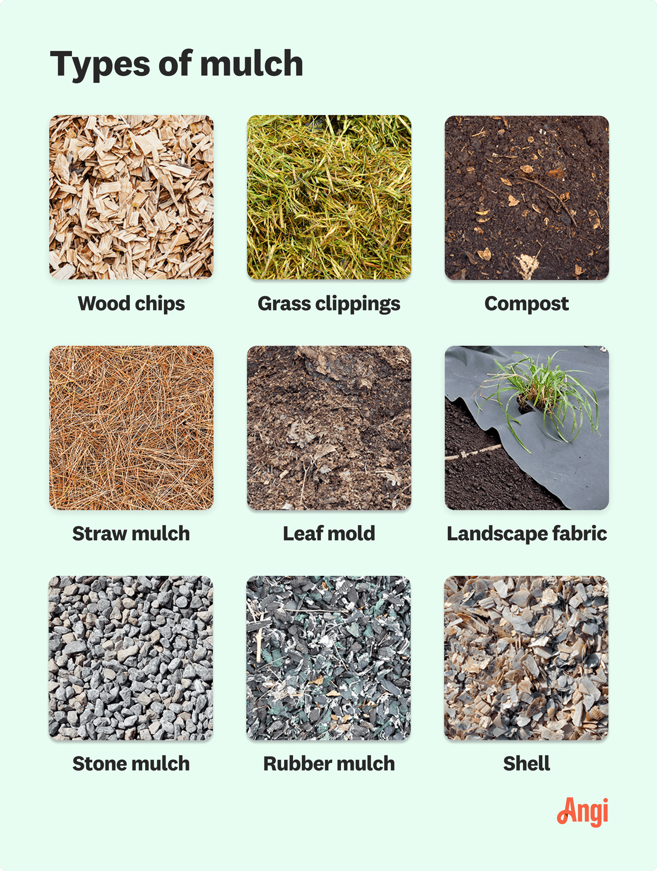
Fig. 1. Types of organic mulches

3.2. Application Techniques
Proper application techniques are crucial to maximize the effectiveness of organic mulches. Factors such as application method, timing, and the amount of material used can significantly influence the mulch’s performance.
3.2.1. Manual vs. Mechanized
In small-scale and organic vegetable farms, mulch is typically applied manually using simple tools. This method allows precision placement around plant bases and in narrow crop rows. However, manual application is labour-intensive and may not be feasible on a commercial scale. In larger operations, mulch application can be partially mechanized using bale choppers or mulch blowers, especially for materials like straw and hay. While mechanization reduces labour demands, it may require initial capital investment and skilled operation.
3.2.2. Timing of Mulch Application
The timing of mulch application is critical for ensuring both weed control and optimal crop growth. For maximum weed suppression, mulch is often applied immediately after the last cultivation or weeding operation—typically just after transplanting or crop establishment. Applying mulch too early, especially before soil warming in spring, may slow crop emergence or growth. In warm climates, organic mulch helps cool the soil during summer, while in temperate regions it helps insulate roots during early or late-season cultivation.
3.2.3. Mulch Thickness and Coverage Area
The depth of mulch application directly affects its efficacy in weed suppression and moisture conservation. A thickness of 5–7 cm (2–3 inches) is usually recommended for effective coverage. Lighter materials like straw may require thicker layers (up to 10 cm) to prevent weed penetration. For weed-prone areas or alleys between crop rows, mulch can be applied more generously. However, excessively thick mulch can inhibit gas exchange and lead to anaerobic conditions. Uniform coverage is essential to ensure consistent benefits across the field.

3.3. Duration and Decomposition Behaviour
The duration of mulch effectiveness depends on the material’s decomposition rate, environmental conditions, and microbial activity in the soil. Fast-decomposing materials such as green manure and grass clippings may need reapplication within a few weeks, while straw and dry leaves may last an entire growing season. Sawdust and coir pith decompose slowly and may persist for more than one season, providing extended soil coverage.
As organic mulches break down, they contribute to the soil organic carbon pool, improve porosity, and enhance nutrient cycling. Decomposition is generally faster in warm, moist conditions and in soils with active microbial populations. In arid regions, decomposition is slower, and mulch may remain intact for extended periods, continuing to suppress weeds and conserve moisture. However, periodic monitoring is necessary to determine whether reapplication is needed, especially in long-duration vegetable crops. Organic mulching involves a diverse range of materials and techniques tailored to the specific needs of the crop and agro-climatic conditions. Appropriate selection, timing, and application of mulch materials not only improve weed and water management but also enhance soil health and crop productivity in a sustainable manner.

4. IMPACT OF ORGANIC MULCHING ON WEED SUPPRESSION
Weeds are one of the most significant constraints in vegetable production systems, particularly under organic and low-input conditions where synthetic herbicides are discouraged or prohibited. They compete with crops for light, nutrients, and water, and also serve as alternate hosts for pests and diseases. Organic mulching offers a promising ecological approach for weed suppression through a variety of mechanisms. Its effectiveness depends on mulch type, application method, thickness, and the nature of the weed flora.

4.1. Mechanisms of Weed Control
Organic mulches suppress weeds through both physical and biochemical mechanisms. These include the exclusion of light, physical obstruction of weed emergence, and, in some cases, allelopathic effects that inhibit germination and seedling development.
4.1.1. Light Exclusion and Physical Barrier
One of the primary mechanisms by which organic mulches suppress weed growth is by blocking light from reaching the soil surface, which is essential for the germination of many weed seeds (Teame et al., 2017; Schonbeck & Evanylo, 1998). A dense layer of straw, dry leaves, or hay prevents the activation of light-sensitive seeds such as Chenopodium album (common lambsquarters) and Amaranthus spp. (pigweed). Additionally, the physical barrier created by a mulch layer impedes the emergence of germinated seedlings by restricting their access to light and air. This is particularly effective against small-seeded annual broadleaf weeds, which have weak shoots unable to penetrate the mulch cover.
4.1.2. Allelopathic Interactions
Certain organic mulch materials may also exert allelopathic effects, releasing natural chemical compounds that inhibit the germination or growth of nearby weeds. Mulches derived from immature grass clippings, legume residues, or fresh straw can sometimes leach inhibitory compounds into the soil. While these allelopathic effects are not universally present in all mulch materials, their occurrence can provide an added layer of weed control, particularly when combined with other physical suppression mechanisms.

4.2. Effectiveness on Different Weed Types (Annuals vs. Perennials)
The effectiveness of organic mulching varies considerably depending on the type of weed species present in the cropping system. Mulching is generally more effective against annual weeds that germinate from seed each season. These include species like Galinsoga spp., Stellaria media (chickweed), and Portulaca oleracea (purslane), which are highly sensitive to light deprivation and surface disturbance. In contrast, perennial weeds such as Cyperus rotundus (nutgrass) and Sorghum halepense (Johnson grass), which regenerate from underground rhizomes or tubers, often emerge through organic mulches due to their robust underground reserves and shoot systems. While mulching may slow their emergence, it typically does not eliminate them entirely. In such cases, mulching must be combined with other management strategies to achieve comprehensive control.

4.3. Comparative Studies and Field Evidence in Vegetable Crops
Numerous studies have documented the weed-suppressive effects of organic mulching in a wide range of vegetable crops: Teame et al. (2017) reported that straw mulch significantly reduced the emergence of broadleaf weeds in vegetable plots, enhancing overall crop vigour due to reduced weed-crop competition. Goswami and Saha (2006) found that mulches like paddy straw, banana leaves, and water hyacinth suppressed weed populations effectively while also conserving soil moisture in elephant foot yam—a tuberous vegetable sensitive to weed competition. Schonbeck (2017) observed that applying 5–7 cm thick layers of hay or straw after the final cultivation kept weed density below the economic threshold in tomatoes and peppers. In okra and chilli crops, Luqman et al. (2013) showed that organic mulches like Rumex crispus and sawdust were as effective as chemical herbicides in reducing weed biomass and diversity. These results confirm that organic mulching can be a powerful tool in integrated weed management for vegetables, especially when matched with the correct crop and environmental conditions.

4.4. Integration with Other Weed Control Practices
While organic mulching alone can provide substantial weed suppression, it is most effective when integrated with other cultural or mechanical weed management practices. For example: Pre-plant cultivation followed by immediate mulching can reduce the initial weed seed bank and prolong weed-free periods (Westbrook et al., 2022). Crop rotation and cover cropping can be used to minimize the build-up of perennial weeds before mulch application. In mechanized systems, high-residue cultivators can be used to manage weeds that escape mulch barriers without disturbing the mulch layer excessively. Mulching also complements biological control by creating habitats that support natural weed seed predators like ground beetles.
Furthermore, combining organic mulches in alleyways with plastic mulch in crop rows is a common practice in diversified systems. This approach optimizes weed control, conserves soil moisture, and reduces the labour required for mulching entire plots. In conclusion, organic mulching is an effective and eco-friendly method of weed suppression in vegetable crops. By acting through both physical and chemical mechanisms, it reduces the dependency on synthetic herbicides and labour-intensive weeding. Its integration with other cultural practices further enhances weed management efficiency and supports sustainable vegetable production.

5. IMPACT OF ORGANIC MULCHING ON SOIL MOISTURE CONSERVATION
Efficient water use is a critical component of sustainable vegetable production, especially under conditions of water scarcity, irregular rainfall, or limited irrigation infrastructure. Vegetables, being shallow-rooted and sensitive to moisture fluctuations, require consistent soil moisture throughout their growth stages. Organic mulching has been widely recognized as an effective method to conserve soil moisture through a combination of physical, chemical, and biological effects. This section discusses how organic mulch reduces water loss, enhances infiltration, moderates temperature, and supports crop performance, especially in arid and semi-arid conditions.

5.1. Reduction in Evaporation Losses
One of the primary mechanisms through which organic mulch conserves soil moisture is by reducing evaporation losses. A mulch layer acts as a barrier between the soil surface and the atmosphere, blocking direct solar radiation and reducing wind velocity at the soil surface—two key factors that drive water loss. By shielding the soil from the sun and slowing air movement, organic mulch helps maintain higher moisture levels in the root zone for longer periods. Studies by Teame et al. (2017) and Goswami and Saha (2006) reported significantly higher moisture content in mulched plots compared to bare soil treatments in vegetables and tuber crops. Organic mulches like straw and banana leaves reduced surface evaporation and extended the interval between irrigation events, contributing to water savings and increased irrigation efficiency.

5.2. Enhancement of Water Infiltration and Retention
In addition to minimizing evaporation, organic mulch enhances the infiltration of rainwater and irrigation water into the soil. The porous and fibrous nature of materials like straw, dry leaves, and compost reduces the impact of raindrops, preventing crust formation and promoting gentle water absorption into the soil profile. This improves the soil’s ability to retain moisture and reduces surface runoff, particularly on sloping or degraded lands. Over time, as mulch decomposes, it improves soil structure and porosity, further enhancing water-holding capacity. Organic matter from decomposed mulch also contributes to the formation of stable soil aggregates, which support better capillary movement of water within the root zone.

5.3. Soil Temperature Moderation
Soil temperature plays a key role in controlling water evaporation, root activity, and microbial processes in the soil. Organic mulch has an insulating effect that buffers temperature extremes, benefiting both moisture conservation and crop growth.
5.3.1. Summer Insulation and Winter Buffering
During hot summer months, organic mulches reduce soil temperature by intercepting solar radiation and minimizing heat conduction to the soil. This cooling effect reduces water loss and protects roots from heat stress. In contrast, during cooler seasons, mulch slows the loss of radiant heat from the soil, keeping the root zone warmer and improving early crop establishment. Zhang et al. (2009) and Musie et al. (2015) demonstrated that straw mulching can reduce daily temperature fluctuations and protect crops from thermal shock. In the winter season, wheat straw mulch has been shown to raise soil temperatures by 2–3°C, enhancing seedling vigor.
5.3.2. Effects on Microclimate and Root Zone Environment
Mulching creates a favourable microclimate in the root zone by maintaining moderate temperature and humidity levels. This promotes root growth, enhances nutrient uptake, and supports beneficial microbial activity. Maida and Kumar (2020) observed that mulched soils in vegetable fields maintained more stable conditions than non-mulched soils, improving overall plant performance. The moderated microclimate also supports consistent germination and reduces physiological stress in sensitive crops like tomato and chilli.

5.4. Case Studies in Arid and Semi-Arid Vegetable Production
The effectiveness of organic mulching in conserving soil moisture is particularly evident in arid and semi-arid regions, where rainfall is erratic and evaporation rates are high. Several field trials have highlighted the value of mulch in these conditions: Awasthi et al. (2006) reported that local grass mulches like Lasiurus sindicus and Leptadenia pyrotechnica improved soil moisture by 33–100% over unmulched plots in hot arid regions of India, especially in crops like brinjal. Agrawal et al. (2010) recorded higher water use efficiency (WUE) in tomato grown under red, black, and white plastic mulches, with red mulch improving WUE by 63% over the control. While this study used synthetic mulch, similar results have been noted with dense straw mulch under organic systems. Manyatsi and Simelane (2017) found that compost mulch recorded the highest average moisture retention (22.9%) in vegetable beds compared to no mulch (14.4%) and other materials. Ashrafuzzaman et al. (2011) showed that mulching significantly increased soil moisture content in chilli plots, with transparent and black plastic mulches retaining 21.1% and 20.4% moisture, respectively, compared to 14.6% in the control. Comparable moisture gains have been observed with organic alternatives like compost and hay mulch.
These findings collectively underscore that organic mulch is a vital practice in water-scarce vegetable farming, helping to bridge the gap between water availability and crop water needs. In conclusion, organic mulching plays a crucial role in soil moisture conservation by reducing evaporation, improving water infiltration and retention, and moderating temperature in the crop root zone. These benefits are particularly critical in rainfed and dryland agriculture where water availability is limited. When used correctly, organic mulch not only conserves water but also enhances the resilience and productivity of vegetable crops under challenging environmental conditions. Fig. 2: Comparative soil moisture retention (%) under different mulch types as reported by Manyatsi & Simelane (2017) and Ashrafuzzaman et al. (2011). Organic mulches such as compost and treated sewage significantly improved soil moisture compared to control and were comparable to synthetic mulches.

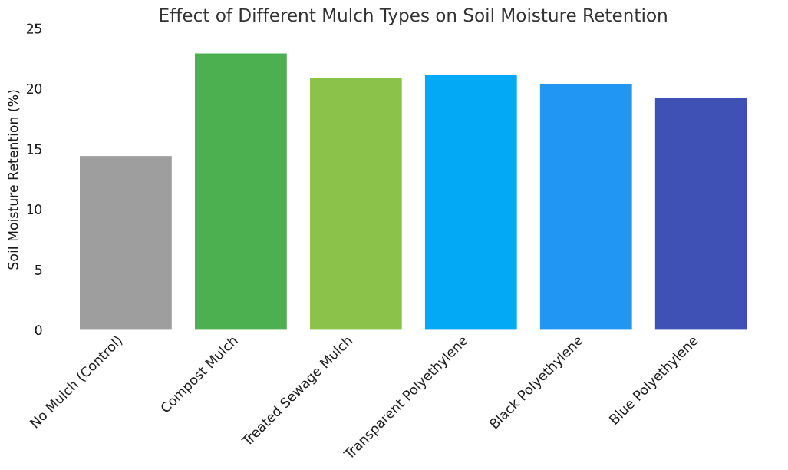
Fig. 2. Effect of Organic Mulching on Soil Moisture Retention

6. IMPACT OF ORGANIC MULCHING ON YIELD AND CROP PERFORMANCE
Organic mulching not only aids in weed suppression and soil moisture conservation but also plays a significant role in improving the overall growth, productivity, and quality of vegetable crops. By creating a favourable microclimate around the root zone and improving soil fertility over time, mulching supports the physiological and biochemical processes necessary for robust plant development and high yields (Kumari et al., 2023). This section discusses the influence of organic mulching on plant growth parameters, yield traits, quality attributes, and its crop-specific impacts in various vegetable crops.

6.1. Influence on Plant Growth Parameters
Organic mulching enhances vegetative growth by regulating soil temperature, improving moisture availability, and facilitating better nutrient uptake.
6.1.1. Plant Height, Branch Number, Leaf Area Index
Increased soil moisture and moderated soil temperature under mulch promote active root growth and nutrient absorption, resulting in taller plants, more branches, and higher leaf area index (LAI). For instance, Kumar et al. (2019) reported that black polyethylene mulch significantly increased plant height and the number of shoots per plant in brinjal. Similarly, Maida and Kumar (2020) found that chilli plants grown on silver/black mulch exhibited greater plant spread and vegetative vigor compared to control plots. Although synthetic mulch was used in these studies, comparable results have been recorded for organic mulches like straw and compost, which also improve soil aeration and biological activity, further supporting plant growth.

6.2. Influence on Yield Traits
Enhanced growth parameters under mulched conditions translate directly into improved yield components such as fruit size, weight, and overall marketable yield.
6.2.1. Fruit Size, Weight, Marketable Yield
Mulching helps maintain uniform soil moisture and temperature, which promotes continuous nutrient uptake during the reproductive stage. As a result, fruits tend to be larger, heavier, and more uniform, improving both market value and harvest efficiency. For example, Kayum et al. (2008) reported that straw mulch improved fruit length and weight in tomato. Similarly, Maida and Kumar (2020) observed that in chilli, mulch treatments resulted in greater fruit diameter, average fruit weight, and total fruit yield per plant and per plot.
6.2.2. Crop Maturity and Harvest Index
Mulching influences crop maturity by reducing physiological stress and facilitating timely flowering and fruit set. Crops grown under mulch often mature earlier and have a higher harvest index (i.e., the proportion of economic yield to total biomass). According to Agrawal et al. (2010), mulching with red plastic resulted in earlier flowering and improved harvest index in tomato, and similar trends have been observed in organic mulch treatments due to their ability to maintain favorable moisture and nutrient conditions.

6.3. Influence on Crop Quality
In addition to boosting yields, organic mulching also enhances the quality attributes of vegetables, making them more desirable for fresh markets and processing.
6.3.1. Nutrient Content, Taste, Shelf Life
Mulched crops often show improved nutrient profiles, better taste, and longer shelf life. The consistent availability of moisture and slow mineralization of organic matter support balanced nutrient uptake. Maida and Kumar (2020) noted that chilli fruits grown under mulch had significantly higher ascorbic acid content (269.07 mg/100 g), a key quality parameter in fresh produce. Moreover, organic mulching reduces the risk of soil-borne contamination, enhancing fruit cleanliness and reducing post-harvest losses. The physical barrier between the fruit and soil also minimizes blemishes, rot, and mechanical damage, particularly in ground-level fruits like cucumbers and gourds.

6.4. Yield Gains in Key Vegetable Crops
Numerous studies have documented substantial yield increases in major vegetable crops as a result of organic mulching practices tabulated in Table 3:
Tomato: Organic mulches like straw and compost improved plant height, fruit size, and total yield. Ajibola and Amujoyegbe (2019) reported that straw mulch enhanced early and total fruit yield compared to control. Brinjal (Eggplant): Kumar et al. (2019) found that black polythene mulch increased brinjal yield by 50.3% over control, with similar improvements observed under straw mulch in organic systems. Chilli: Studies by Tyagi and Kulmi (2019) and Ashrafuzzaman et al. (2011) demonstrated significant increases in fruit number per plant, average fruit weight, and dry chilli yield with mulch application. Organic alternatives like leaf mulch and compost showed comparable benefits in field trials. Okra: Vankar and Shinde (2007) found that okra grown under white polythene mulch produced higher yields and biomass than other treatments; straw mulch was also effective in promoting early emergence and improved pod quality. Cucumber: Organic mulches improved fruit diameter, reduced non-marketable yield, and improved moisture conditions during fruiting stages (Ajibola and Amujoyegbe, 2019). Organic mulching has a profound positive impact on both the quantitative and qualitative performance of vegetable crops. It fosters a more favorable soil-plant environment that supports vigorous growth, timely development, higher yields, and improved fruit quality. These benefits not only enhance productivity but also contribute to the economic sustainability and marketability of vegetable farming, particularly under organic and climate-smart agricultural systems.

Table 3. Yield Gains in Key Vegetable Crops Under Organic Mulching
Crop | Organic Mulch Used | Yield Improvement / Benefit | Reference
Tomato | Straw, compost | Increased fruit size, weight, and total yield | Kayum et al. (2008)
Brinjal | Straw, grass mulch | Up to 50% yield increase compared to control | Kumar et al. (2019)
Chilli | Compost, leaf mulch | Higher fruit count, fruit weight, and dry chilli yield | Tyagi & Kulmi (2019); Maida & Kumar (2020)
Okra | Paddy straw, wheat straw | Improved plant biomass, pod quality, and total yield | Vankar & Shinde (2007)
Cucumber | Leaf mulch, compost | Increased fruit diameter, marketable yield, and reduced rotting | Ajibola & Amujoyegbe (2019)

While the present review focuses on organic mulching, it is valuable to highlight that synthetic mulches, particularly black polyethylene, have also been widely adopted due to their significant yield-enhancing effects in commercial vegetable production. Table 4 and Fig. 3 presents comparative yield data across vegetables under plastic mulch from national-level trials.

Table 4. Yield Response of Vegetable Crops to Plastic Mulching
Crop | Yield with Mulch (t/ha) | Yield without Mulch (t/ha) | % Increase in Yield | Remarks
Brinjal | 47.06 | 36.73 | 28.12% | Enhanced fruit size, reduced weed interference
Broccoli | 25.14 | 15.64 | 60.74% | Early maturity and better head formation
Bitter Gourd | 25.63 | 20.12 | 27.39% | Improved vine growth and fruiting efficiency
Cabbage | 19.90 | 14.30 | 39.16% | Compact heads and uniform development
Cauliflower | 25.02 | 18.58 | 34.66% | Better curd formation under moderated temperature
Chilli | 19.71 | 16.79 | 17.39% | More fruit per plant and reduced soil splash
Okra | 8.56 | 6.91 | 23.88% | Faster pod development and better moisture use
Tomato | 94.85 | 69.10 | 37.26% | Early harvest, larger fruit  clusters
Source: NCPAH, New Delhi – National Committee on Plasticulture Applications in Horticulture

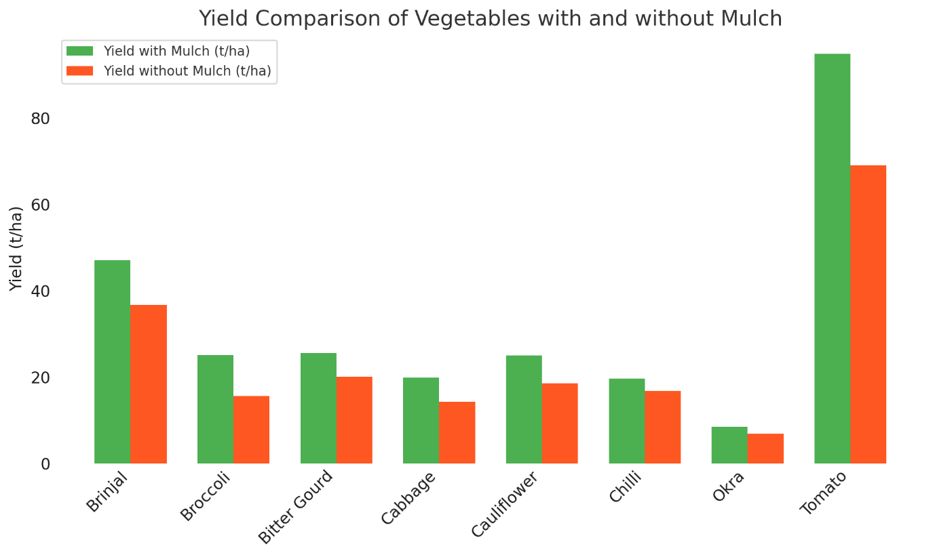
Fig. 3. Yield Response of Vegetable Crops to Plastic Mulching

7. SOIL HEALTH AND FERTILITY BENEFITS OF ORGANIC MULCHING
Beyond its direct impacts on weed suppression, moisture conservation, and yield improvement, organic mulching plays a pivotal role in enhancing soil health and fertility. Unlike synthetic mulches, organic materials actively contribute to the biological, physical, and chemical integrity of the soil through their decomposition and interaction with soil organisms. These benefits are cumulative and long-lasting, making organic mulching a sustainable soil management strategy, particularly important in vegetable cropping systems where soil fertility can rapidly decline due to high nutrient demands.

7.1. Organic Matter Enrichment and Soil Structure Improvement
As organic mulches decompose, they gradually increase the soil organic matter (SOM) content. This enrichment improves soil texture, porosity, water-holding capacity, and aggregate stability, which are vital for aeration and root development. Mulches such as straw, compost, and leaf litter release humic substances that bind soil particles into stable aggregates. This not only prevents soil erosion but also creates a favorable environment for root expansion and nutrient uptake. Studies such as those by Testani et al. (2019) confirm that continued use of organic mulch enhances the physical structure of soils, particularly in vegetable fields subjected to repeated tillage. Improved structure also enhances infiltration and reduces compaction critical for shallow-rooted vegetables like lettuce, radish, and cucumber.

7.2. Microbial Activity and Earthworm Population
Organic mulches stimulate a thriving soil microbial ecosystem, which is essential for nutrient mineralization and disease suppression. As mulch materials break down, they provide energy sources and substrates for bacteria, fungi, and actinomycetes, accelerating decomposition and nutrient turnover. This microbial activity leads to the formation of stable organic compounds and supports the development of beneficial microbial consortia around the root zone (rhizosphere). Moreover, the mulched environment offers optimal conditions of moisture and moderate temperature, which are ideal for earthworm colonization and reproduction. Earthworms are vital bioindicators of soil health—they improve aeration through burrowing, aid in mixing organic residues, and excrete nutrient-rich castings. According to Memon et al. (2017), mulched vegetable plots recorded significantly higher earthworm populations compared to bare or plastic-mulched plots.

7.3. Long-Term Effects on Soil Fertility and Nutrient Cycling
The nutrient release from decomposing organic mulch materials is often slow and synchronized with crop needs, reducing nutrient leaching and improving nutrient use efficiency (NUE). Unlike synthetic inputs, which provide immediate but short-lived fertility boosts, organic mulches contribute to a sustainable nutrient reservoir. For instance, compost and FYM mulches supply macro-nutrients like nitrogen (N), phosphorus (P), and potassium (K), as well as secondary nutrients and micronutrients essential for vegetable crop development. Their presence in the soil enhances cation exchange capacity (CEC) and buffering ability, thus maintaining a stable pH and reducing the risk of soil degradation. Long-term mulching has also been shown to reduce the dependency on chemical fertilizers, thereby lowering input costs and preventing nutrient imbalances.

7.4. Potential for Carbon Sequestration
In the context of climate-smart agriculture, organic mulching contributes significantly to carbon sequestration, helping mitigate greenhouse gas emissions. The addition of biomass in the form of mulches increases the soil organic carbon (SOC) pool, which is crucial for global carbon cycling and climate regulation. As organic residues break down, a portion of the carbon is stabilized in the soil as humus, improving long-term soil fertility and serving as a carbon sink. Lalljee, 2013 and Ngosong et al. (2019) have reported that soils managed with organic mulches not only show higher fertility but also exhibit increased carbon storage capacity compared to soils treated with inorganic mulches or conventional tillage. This makes organic mulching a dual-purpose strategy enhancing both soil productivity and environmental sustainability.
The soil health benefits of organic mulching extend well beyond the growing season. By improving soil structure, stimulating biological life, enhancing nutrient dynamics, and supporting carbon sequestration, organic mulching transforms the soil into a resilient and self-sustaining medium. These advantages underscore its importance in long-term vegetable production, particularly under organic and low-input systems aiming to preserve natural resources while ensuring profitable yields.

8. LIMITATIONS AND CHALLENGES IN ORGANIC MULCHING
While organic mulching offers a multitude of agronomic and ecological benefits, its widespread adoption is sometimes limited by practical challenges, crop-specific responses, and agronomic risks. These constraints need to be recognized and managed to ensure the successful integration of organic mulching into vegetable production systems. Understanding these limitations can help in the development of optimized mulching strategies tailored to specific environments and crops.

8.1. Labour and Logistical Constraints
One of the major limitations of organic mulching is the intensive labour requirement for collection, transportation, and application of mulch materials. Unlike synthetic mulches, which can be laid quickly using machines, organic materials like straw, compost, or dry leaves often need to be manually spread across the field, especially in smallholder systems. This process becomes even more laborious when mulch needs to be replenished mid-season due to decomposition or wind dispersal. The logistics of sourcing adequate volumes of mulch, especially for large-scale farms, can be challenging. Transporting bulky, low-density organic materials adds cost and time. In many cases, farmers rely on locally available materials, which may be insufficient in quality or quantity during peak demand periods, such as before transplanting.

8.2. Risk of Weed Seed Introduction via Mulch
Organic mulches like hay, straw, and leaf litter, when sourced from unmanaged or off-farm areas, may introduce viable weed seeds into vegetable fields. This creates a paradox where a tool designed to suppress weeds may inadvertently become a source of infestation. Schonbeck (2017) highlighted cases where wild buckwheat and other aggressive weeds were introduced through hay mulch in organic gardens. If improperly cured, some mulch materials may also carry pathogens or invasive plant fragments, posing further threats to the cropping system. To prevent this, mulch should be sourced from weed-free areas or processed (e.g., composted) before application.

8.3. Nitrogen Immobilization and Nutrient Imbalance
High-carbon mulches such as sawdust, straw, and dried grasses can lead to temporary nitrogen immobilization during their decomposition. Microorganisms that break down high C:N ratio materials consume soil nitrogen, making it temporarily unavailable to plants. This can result in stunted growth or chlorosis in young vegetable seedlings, especially in nutrient-demanding crops like tomato and chilli. To mitigate this, nitrogen supplementation (e.g., via organic fertilizers or compost) is often recommended when using carbon-rich mulches. Additionally, applying mulch after the initial crop establishment phase can help reduce the risk of early nutrient stress.

8.4. Pest and Disease Concerns
Organic mulches may alter the microhabitat of vegetable fields in ways that promote pest or pathogen proliferation. For example, slugs, cutworms, and certain soil-borne insects may find shelter under dense mulch layers, particularly in moist conditions. In crops like lettuce, brassicas, and cucurbits, slug damage has been reported when mulches were applied before or during early crop establishment. Moreover, mulches that retain excessive moisture may increase the risk of fungal diseases such as root rot or collar rot, especially in poorly drained soils. Although some pests may also attack weed seedlings under mulch, the net effect on pest pressure varies with location, crop, and mulch type.

9. CONCLUSION
Organic mulching emerges as a vital agroecological practice in vegetable production, offering significant benefits in terms of weed suppression, soil moisture conservation, enhanced crop yield, and improved soil health. Its ability to reduce evaporation, moderate soil temperature, and suppress light-dependent weed germination makes it particularly valuable in rainfed and arid vegetable farming systems. Moreover, organic mulches enhance microbial activity, contribute to soil organic matter, and promote long-term nutrient cycling and fertility restoration. However, despite these agronomic advantages, the widespread adoption of organic mulching remains limited due to several practical and ecological challenges. High labour requirements for application, inconsistent availability of suitable biomass, and logistical difficulties in large-scale implementation can hinder its use. Furthermore, the potential for introducing weed seeds or pathogens through untreated mulch materials, and issues like nitrogen immobilization or pest habitat creation, require careful management and planning. Not all vegetable crops respond equally to mulching, and its effects can vary based on crop type, climate, and soil conditions. Therefore, site-specific mulch selection, proper timing of application, and integration with other management practices, such as crop rotation and organic fertilization are critical to maximizing its benefits while minimizing risks. Organic mulching holds significant promise for sustainable vegetable production, especially in low-input and organic systems. Continued research, farmer education, and innovation in mulch handling techniques are essential to overcome current limitations and promote its wider adoption as a key component of climate-resilient and soil-friendly agriculture.

DISCLAIMER (ARTIFICIAL INTELLIGENCE)
Author(s) hereby declare that NO generative AI technologies such as Large Language Models (ChatGPT, COPILOT, etc) and text-to-image generators have been used during writing or editing of this manuscript.

COMPETING INTERESTS
Authors have declared that no competing interests exist.

REFERENCES
Agrawal, N., Kumar, S., & Namdeo, K. N. (2010). Effect of coloured plastic mulch on growth and yield of tomato and chilli. Indian Journal of Agricultural Sciences, 80(9), 790–793.
Ahmad, S., Tariq, H., Abbas, S., Arshad, M., Mumtaz, A., & Ahmed, I. (2022). Organic and synthetic mulching: Effects on soil-plant productivity and environment. In Mulching in agroecosystems: Plants, soil & environment (pp. 329-351). Singapore: Springer Nature Singapore.
Ajibola, A. T., & Amujoyegbe, B. J. (2019). Effect of mulching on performance of cucumber (Cucumis sativus L.) in a rainforest zone of Nigeria. African Journal of Agricultural Research, 14(17), 738–744.
Ashrafuzzaman, M., Halim, M. A., Ismail, M. R., Shahidullah, S. M., & Hossain, M. A. (2011). Effect of plastic mulch on growth and yield of chilli (Capsicum annuum L.). Brazilian Archives of Biology and Technology, 54(2), 321–330.
Awasthi, O. P., Singh, I. S., & Singh, R. S. (2006). Effect of grass mulches on growth and yield of brinjal under hot arid ecosystem. Indian Journal of Horticulture, 63(4), 454–457.
Bhattacharya, A., & Bhattacharya, A. (2021). Effect of soil water deficit on growth and development of plants: a review. Soil water deficit and physiological issues in plants, 393-488.
Chaudhari, S., Upadhyay, A., & Kulshreshtha, S. (2021). Influence of organic amendments on soil properties, microflora and plant growth. Sustainable Agriculture Reviews 52, 147-191.
El-Beltagi, H. S., Basit, A., Mohamed, H. I., Ali, I., Ullah, S., Kamel, E. A., ... & Ghazzawy, H. S. (2022). Mulching as a sustainable water and soil saving practice in agriculture: A review. Agronomy, 12(8), 1881.
Gordon, G. G., Foshee, W. G., Reed, S. T., Brown, J. E., & Vinson, E. L. (2010). The effects of colored plastic mulches and row covers on the growth and yield of okra. HortTechnology, 20(1), 224–233.
Goswami, S. B., & Saha, S. (2006). Effect of organic and inorganic mulches on soil-moisture conservation, weed suppression and yield of elephant-foot yam (Amorphophallus paeoniifolius). Indian Journal of Agronomy, 51(2), 154–156.
Kayum, M. A., Asaduzzaman, M., & Haque, M. M. (2008). Effect of indigenous mulches on growth and yield of tomato. Journal of Agriculture & Rural Development, 6(1-2), 1–6.
Kumar, H., Sharma, A. K., & Pandey, V. B. (2018). Response of brinjal to different mulching materials on growth and yield parameters. Journal of Pharmacognosy and Phytochemistry, 7(3), 1356–1360.
Kumari, S., Kumar, R., Chouhan, S., & Chaudhary, P. L. (2023). Influence of various organic amendments on growth and yield attributes of mung bean (Vigna radiata L.). International Journal of Plant & Soil Science, 35(12), 124-30.
Lalljee, B. (2013). Mulching as a mitigation agricultural technology against land degradation in the wake of climate change. International Soil and Water Conservation Research, 1(3), 68-74.
Lamont, W. J. (2005). Plastic mulches for the production of vegetable crops. HortTechnology, 15(3), 477–481.
Maida, P., & Kumar, S. (2020). Effect of mulch types on growth and yield of chilli under drip irrigation system. International Journal of Current Microbiology and Applied Sciences, 9(7), 2104–2112.
Manyatsi, A. M., & Simelane, S. B. (2017). Mulching effects on soil moisture retention under rainfed conditions. International Journal of Agriculture and Environmental Research, 3(4), 2969–2981.
Manzano, V., García, N. L., Ramírez, C. R., D’Accorso, N., & Goyanes, S. (2019). Mulch plastic systems: Recent advances and applications. Polymers for Agri-Food Applications, 265-290.
Memon, M. S., Zhou, J., Guo, J., Ullah, F., Hassan, M., Ara, S., & Ji, C. Y. (2017). Comprehensive review for the effects of ridge furrow plastic mulching on crop yield and water use efficiency under different crops. International Agricultural Engineering Journal, 26(2), 58-67.
Musie, S., Alemayehu, B., & Tadesse, T. (2015). Effects of mulch types on temperature and performance of crops. Ethiopian Journal of Agricultural Sciences, 25(2), 12–22.
NCPAH (National Committee on Plasticulture Applications in Horticulture). (n.d.). Response of plastic mulch on the yield of vegetables. Ministry of Agriculture and Farmers Welfare, New Delhi.
Ngosong, C., Okolle, J. N., & Tening, A. S. (2019). Mulching: A sustainable option to improve soil health. Soil fertility management for sustainable development, 231-249.
Oyegoke, R. A., Oladele, J. O., Oladele, O. T., & Oladiji, A. T. (2024). Role of Dietary Fibre and Phytonutrients in Human Health and Nutrition. In Nutrition and Diet in Health (pp. 121-147). CRC Press.
Prem, M., Ranjan, P., Seth, N., & Patle, G. T. (2020). Mulching techniques to conserve the soil water and advance the crop production—A Review. Curr. World Environ, 15, 10-30.
Rajablariani, H. R., Hassankhan, F., & Rafezi, R. (2012). Effect of colored plastic mulches on yield of tomato and weed biomass. International Journal of Environmental Science and Development, 3(6), 590–593.
Ranjan, P., Patle, G. T., Prem, M., & Solanke, K. R. (2017). Organic mulching—A water saving technique to increase the production of fruits and vegetables. Current Agriculture Research Journal, 5(3), 371–380.
Reichel, R., Wei, J., Islam, M. S., Schmid, C., Wissel, H., Schröder, P., ... & Brüggemann, N. (2018). Potential of wheat straw, spruce sawdust, and lignin as high organic carbon soil amendments to improve agricultural nitrogen retention capacity: an incubation study. Frontiers in Plant Science, 9, 900.
Rossi, G., Beni, C., & Neri, U. (2024). Organic Mulching: A Sustainable Technique to Improve Soil Quality. Sustainability, 16(23), 10261.
Schonbeck, M. (2017). Soil health and organic farming. Organic Farming Research Foundation: Santa Cruz, CA, USA.
Schonbeck, M. W., & Evanylo, G. K. (1998). Effects of mulches on soil properties and tomato growth and yield. Journal of Sustainable Agriculture, 13(1), 55–81.
Stigter, K., Ramesh, K., & Upadhyay, P. K. (2018). Mulching for microclimate modifications in farming-An overview. Indian Journal of Agronomy, 63(3), 255-263.
Teame, G., Tsegay, A., & Abrha, B. (2017). Effect of organic mulching on soil moisture, yield, and yield contributing components of sesame (Sesamum indicum L.). International Journal of Agronomy, 2017, Article ID 4767509.
Testani, E., Ciaccia, C., Campanelli, G., Leteo, F., Salvati, L., & Canali, S. (2019). Mulch-based no-tillage effects on weed community and management in an organic vegetable system. Agronomy, 9(10), 594.
Tyagi, R., & Kulmi, G. S. (2019). Impact of silver/black plastic mulch on growth and yield of chilli (Capsicum annuum L.). International Journal of Agriculture, Environment and Biotechnology, 12(2), 153–157.
Vankar, P. S., & Shinde, R. N. (2007). Effect of different mulching materials on growth and yield of okra. Annals of Plant Physiology, 21(2), 240–243.
Westbrook, A. S., Bhaskar, V., & DiTommaso, A. (2022). Weed control and community composition in living mulch systems. Weed Research, 62(1), 12-23.
Xiong, L., Shah, F., & Wu, W. (2022). Environmental and socio-economic performance of intensive farming systems with varying agricultural resource for maize production. Science of the Total Environment, 850, 158030.
Zhang, S., Lövdahl, L., Grip, H., Tong, Y., Yang, X., & Wang, Q. (2009). Effects of mulching on soil temperature, moisture, and biomass yield of millet in Northwest China. Soil and Tillage Research, 102(1), 45–51.

