**Effect of Starch Source on the Microstructure of Extruded Feed Pellets**

**ABSTRACT**

Scanning Electron Microscopy (SEM) is a powerful tool for analyzing the microstructure of extruded feed pellets. It offers high-resolution imaging to study surface topology, granule morphology, and textural changes, enabling a deeper understanding of how processing conditions affect feed quality. SEM has found extensive application in material sciences and biology, but its adaptation for food science, especially aquafeeds, has provided new insights into structural changes induced during extrusion. This study was conducted to evaluate the effect of different carbohydrate sources on the physical and microstructural characteristics of extruded diets formulated for tilapia. The main objectives were to (i) assess the influence of starch origin on pellet pore size and granule morphology, (ii) analyze the extent of starch gelatinization through extrusion processing, and (iii) examine the structural integrity of pellets using scanning electron microscopy (SEM). Seven experimental diets were prepared using corn flour, wheat flour, rice flour, and their combinations, maintaining uniform protein (25%) and lipid (4%) content across all treatments. The SEM analysis revealed significant differences (P<0.05) in both pore and granule sizes among the various starch-based diets. The highest average pore size (220.63±14.73 μm) was observed in the wheat and rice flour combination (WRF), whereas the smallest pore size (50.60±9.44 μm) was recorded in wheat flour (WF) alone. In terms of granule size, corn flour (CF) exhibited the largest starch granules (7.03±2.37 μm), while the corn and wheat flour combination (CWF) showed the smallest (2.22±0.43 μm). These differences were attributed to the varying botanical origins of starch and their distinct amylose-to-amylopectin ratios, which affect the degree of starch gelatinization and physical expansion during extrusion. The findings underscore the importance of starch selection in aquafeed formulation, as it significantly influences pellet texture, structural stability, water solubility, and digestibility—factors critical to feed efficiency and nutrient utilization in tilapia farming. This research is significant for advancing sustainable aquaculture practices by optimizing carbohydrate use in fish diets, reducing dependency on protein as a primary energy source, and enhancing the overall quality and performance of extruded aquafeeds.

KEY WORDS: amylopectin ratios, corn flour, Scanning Electron Microscopy (SEM), starch gelatinization, pellet texture

**INTRODUCTION**

Extruders act as high-temperature, short-duration bioreactors that transform raw components into modified intermediate or final products. These bioreactors facilitate several unit operations, including homogenization, cooking, kneading, shearing, molding, and texturing (Riaz, 2000; 2007).

Starch, a carbohydrate stored as a reserve in plants, is an essential component in food and feed production, with common sources including wheat, corn, potatoes, and rice (Kaushik *et al.,* 2022). In human diets, carbohydrates are a primary energy source, contributing significantly to daily energy intake. However, farmed fish exhibit limited capacity to utilize dietary carbohydrates as an energy source due to factors such as feeding habits, anatomical and physiological features, and farming environments (Kamalam *et al.,* 2017). Despite these limitations, optimizing starch utilization in aquafeeds is emphasized to reduce the reliance on proteins as an energy source.

The botanical origin of starch significantly influences its functionality during feed processing and its digestibility in fish. Key factors affecting starch functionality include the primary structure, granule morphology, size distribution, and the amylose-to-amylopectin ratio (Svihus *et al.,* 2005). Starch granules exhibit diverse shapes, such as spherical, lenticular, polyhedral, and irregular forms, with sizes ranging from 1 to 100 μm. For instance, wheat starch granules typically measure about 22 μm, maize starch granules about 35 μm, and potato starch granules between 40 and 100 μm. These variations directly affect the digestibility of starch in fish, impacting nutrient assimilation and energy availability (Bergot, 1993).

In aquafeed formulation, starch plays a pivotal role, not only as an energy source but also as a binding agent that affects the physical properties of feed pellets. Starch is critical for producing both floating and sinking pellets, with optimal inclusion levels ranging from 18–22% for floating pellets and 5–11% for sinking pellets (Riaz, 1997). During extrusion, the combination of high shear forces and elevated temperatures disrupts the starch granules, leading to gelatinization and partial or complete breakdown of amylose and amylopectin. This process enhances the water solubility of starch, reduces viscosity, and improves nutrient bioavailability (Svihus *et al.,* 2005).

Extrusion parameters, such as temperature, shear rate, and feed composition, directly impact the physicochemical properties of the final aquafeed product. Control of these parameters influences radial expansion, density, texture, pellet durability, sinkability, and water stability—factors critical for efficient nutrient utilization and minimizing feed wastage in aquaculture systems. Starch's hydrocolloid properties also improve pellet stability and nutrient retention, ensuring optimal feed performance for aquatic organisms (Rokey *et al.,* 2010).

Scanning electron microscopy (SEM) serves as a vital analytical tool for studying the microstructural properties of extruded feed pellets. SEM produces high-resolution, three-dimensional images, providing detailed insights into the topology, morphology, and compositional changes occurring during feed extrusion. These microscopic evaluations are essential for assessing feed quality, optimizing processing parameters, and understanding starch's role in structural modifications of aquafeed pellets (Sharma & Vasudha, 2019).

By integrating the unique properties of starch and advanced imaging techniques such as SEM, feed manufacturers can develop optimized aquafeed formulations that enhance feed performance, reduce waste, and improve sustainability in aquaculture practices. The primary purpose of feed production is to efficiently fulfill both qualitative and quantitative levels of essential dietary nutrients, nutritional digestion, absorption, & processing practises (D'Abramo,. 2021). Superior aquaculture production method depends on a successful feeding strategy and high quality feed components.

The main objectives were to (i) assess the influence of starch origin on pellet pore size and granule morphology, (ii) analyze the extent of starch gelatinization through extrusion processing, and (iii) examine the structural integrity of pellets using scanning electron microscopy (SEM)

**MATERALS AND METHODS**

Evaluation of Carbohydrate Sources on Extruded Tilapia Diets

**Experimental Setup**

The study was designed to assess the impact of different carbohydrate sources on the physical properties, engineering characteristics, starch gelatinization, and microstructure of extruded diets formulated for tilapia.

**Location**

Feed formulation, preparation, and analysis were conducted at the feed mill within the Department of Aquaculture, Kerala University of Fisheries and Ocean Studies (KUFOS), Panangad, Kochi. The biochemical analysis of the diets was carried out in the Nutrition and Feed Technology Laboratory, also within the Department of Aquaculture at KUFOS.

**Feed Formulation and Preparation**

Key ingredients included corn flour, rice flour, wheat flour, soybean meal, fishmeal, DDGS (Distillers Dried Grains with Solubles), groundnut oil cake (GNOC), a vitamin-mineral mix, and vegetable oil, all procured from local markets. Coarse materials were processed using a hammer mill, then sieved manually with a 250-micron mesh to achieve uniform particle size. Seven experimental diets were formulated, each with 25% crude protein and 4% crude lipid. The protein and lipid components (soybean meal, fish meal, DDGS, GNOC, vitamin-mineral mix, and vegetable oil) were constant across all diets, with the starch source being the variable factor.

The starch sources used were

1. Corn flour (CF)

2. Wheat flour (WF)

3. Rice flour (RF)

4. Corn and rice flour combination (CR)

5. Corn and wheat flour combination (CW)

6. Wheat and rice flour combination (WR)

7. Corn, wheat, and rice flour combination (CWR)

The diets were labelled CF, WF, RF, CRF, CWF, WRF, and CWRF, respectively.

**Feed Manufacturing Process**

The feed manufacturing process involved multiple stages:

1. Grinding: Raw materials were initially ground into coarse particles using a hammer mill with a 600 μm screen, followed by finer grinding with a 400 μm screen.

2. Mixing: Ingredients were weighed and mixed in a batch mixer, with hot water gradually added over a minute. The mixture was stirred for five minutes, with portions reintroduced into the mixer to ensure uniformity.

3. Pre-conditioning: Hot water (100°C) was added manually during ingredient homogenization, and moisture content was monitored using a moisture meter.

4. Extrusion: The twin-screw extruder (KK LIFESCIENCES Model DS 56-III) processed the feed at controlled temperatures (90°C and 120°C). Screw and feeder speeds were adjusted between 28–35Hz and 12–20Hz, respectively. The extruded material exited as noodles, which were cut into pellets using a cutter operating at 25Hz.

5. Drying: Pellets were dried using a hot-air drier at 60°C for 1–2 hours to lower moisture levels and prevent spoilage.

6. Coating**:** Pellets were coated with oil using a drum coater, ensuring uniform distribution through rotation facilitated by a central shaft and lever mechanism.

This systematic approach ensured the production of high-quality, consistent feed pellets optimized for tilapia aquaculture.

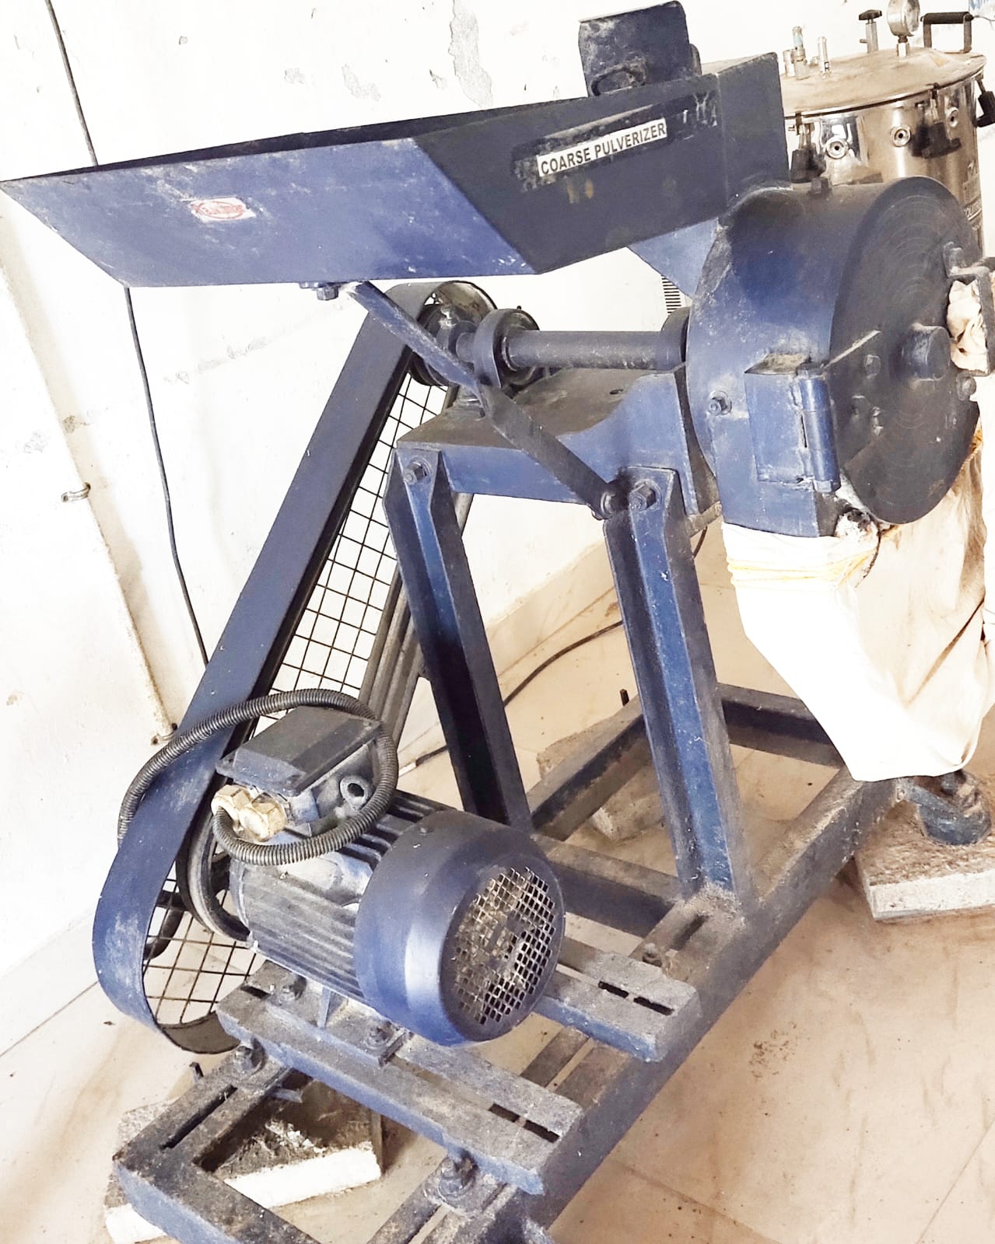 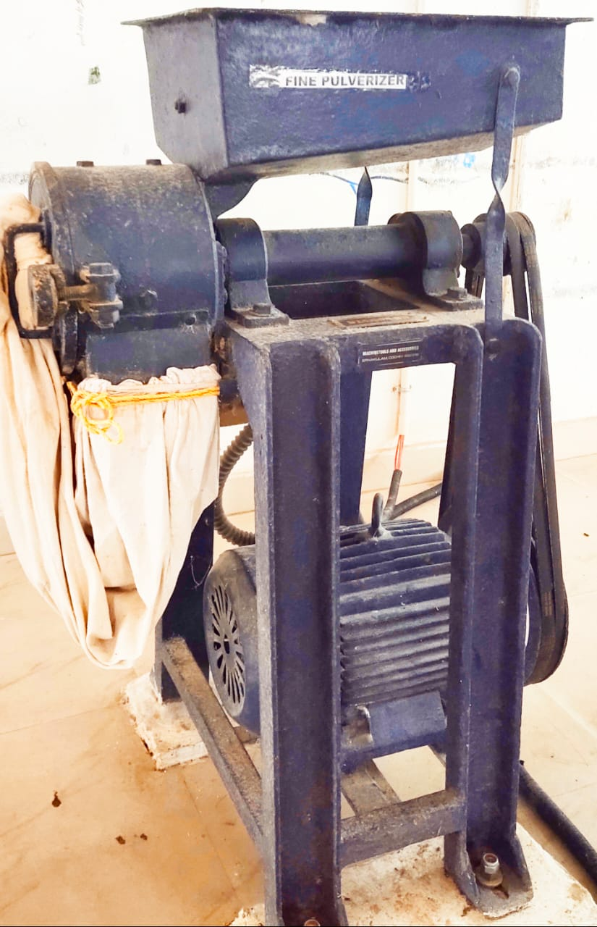

**Fig. 1 Hammer mill Fig. 2 pulverizer**

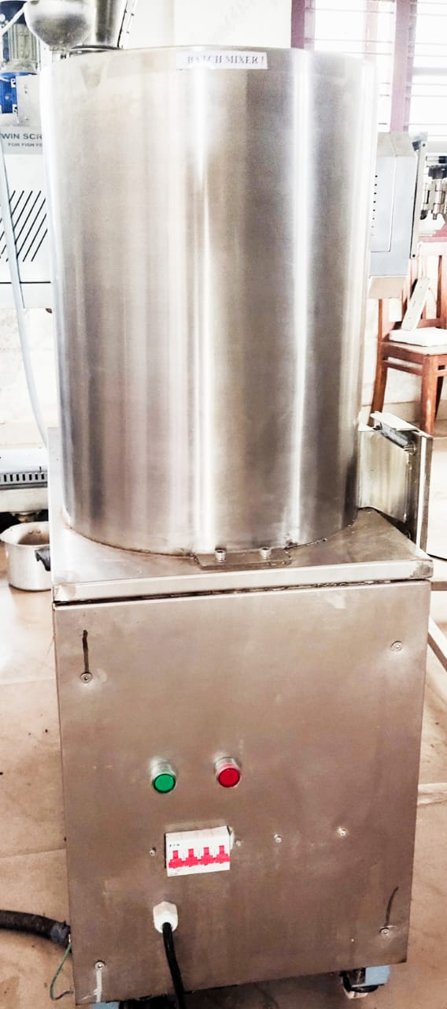

**Fig. 3 Batch mixer**

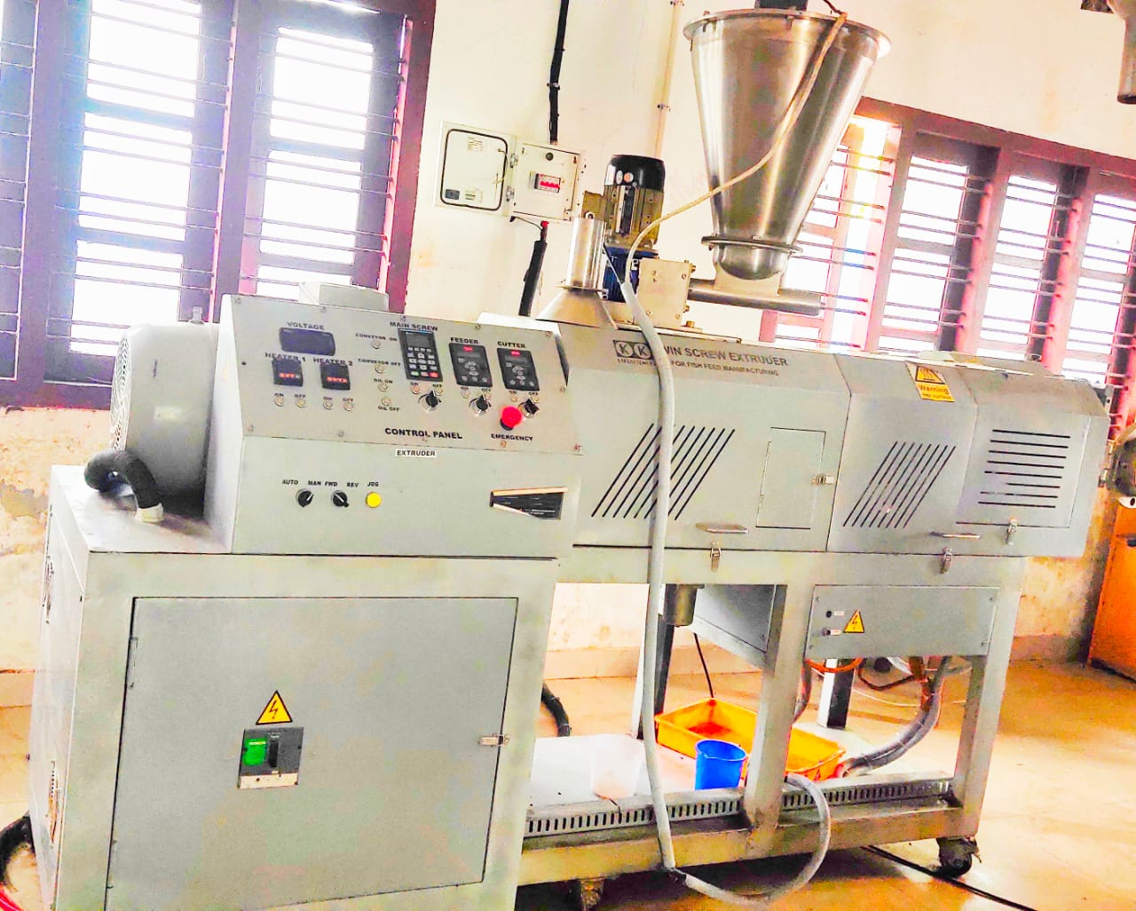

**Fig. 4 Twin screw extruder**

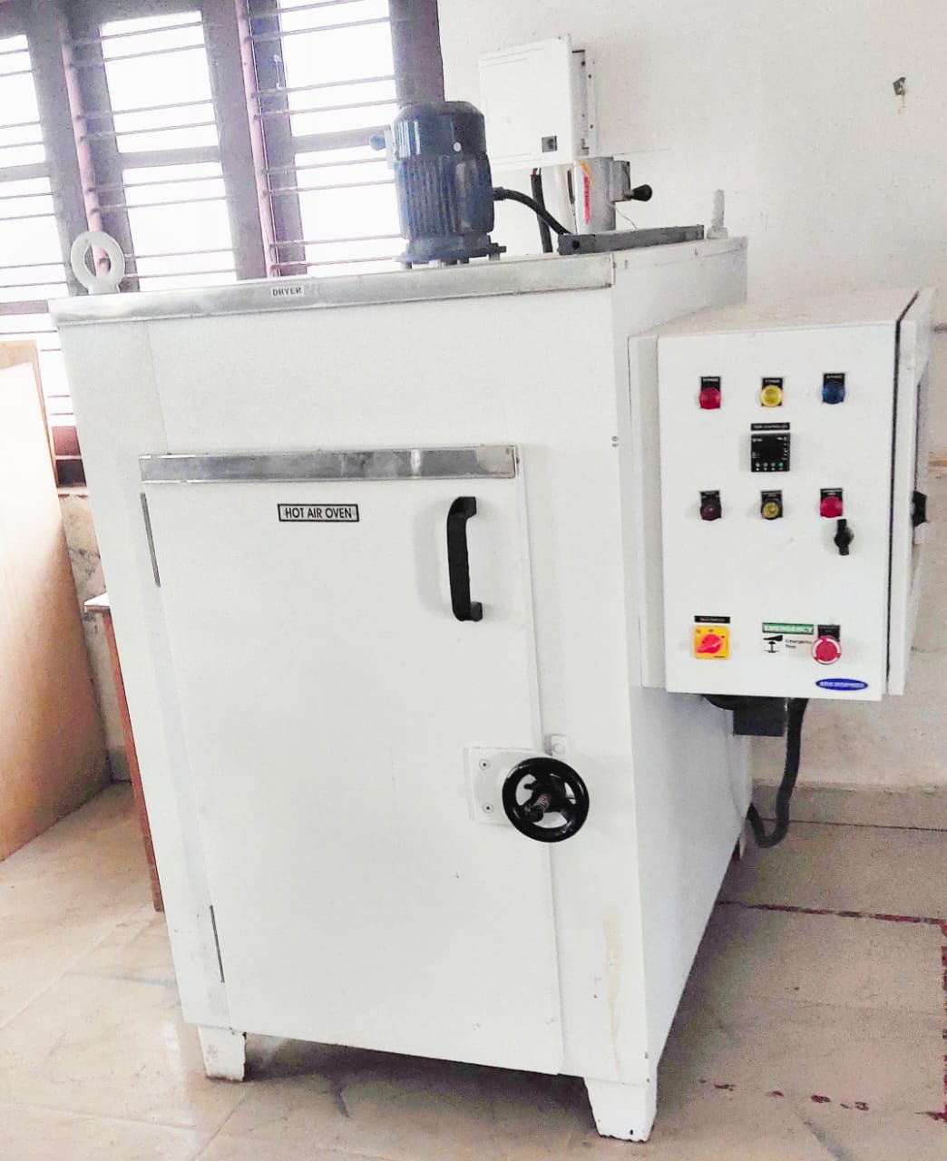

**Fig. 5 Hot- air oven**

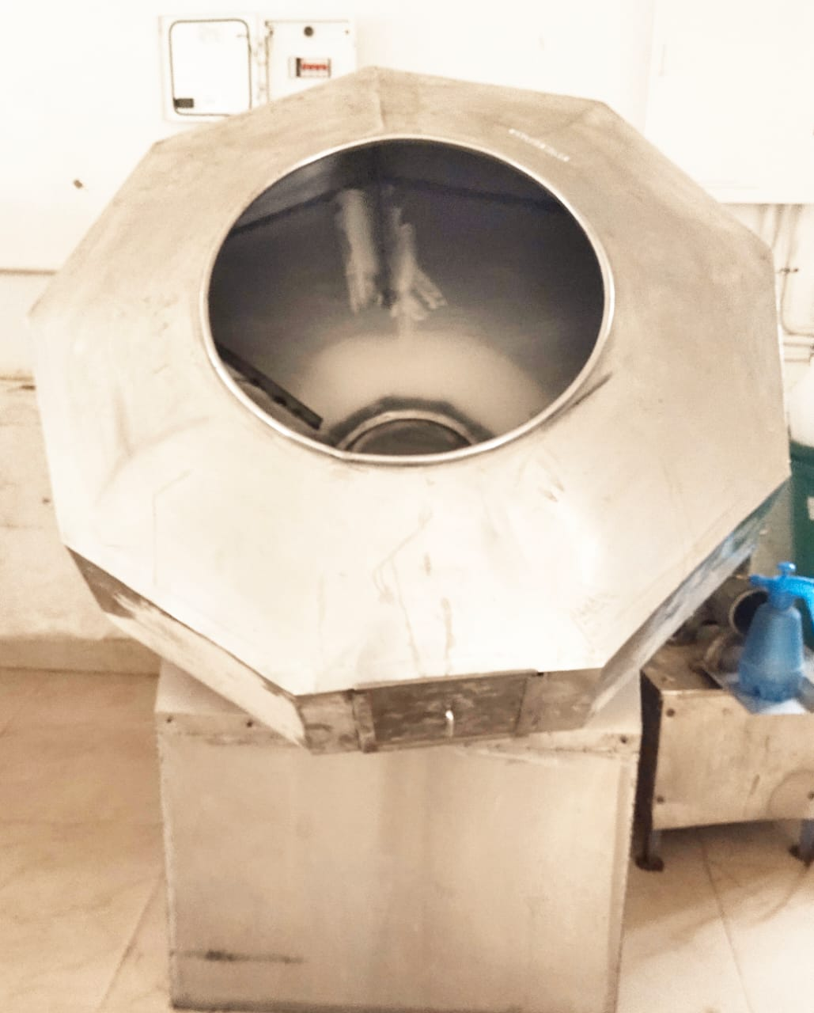

**Fig. 6 Drum coater**

**Scanning Electron Microscopy Evolution**

The provided samples were placed on the sample holder (adhesive carbon tape fixed over brass stub) and were over-coated with gold using a JFC 1600 auto fine coater machine. The SEM measurements were performed at 100-1000 kV accelerating voltage (check SEM Image for Voltage and magnification). Different magnifications were used as indicated on the images. (Make/Model: JEOL, JSM—6390LV, Tokyo, Japan).

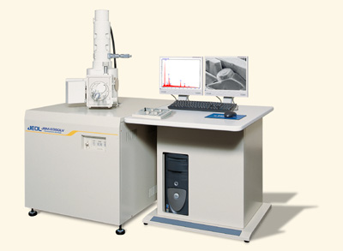

**Fig.7 Assembly of SEM (JEOL, JSM—6390LV)**

**Result**

In cross section SEM (Rice feed, Corn and Wheat feed & Wheat and Rice feed) grains clearly differ from the grains of aquafeeds and each feed surface starch granule has different size. The results related to pore and granule size are presented in are showing in table.

|  |  |  |
| --- | --- | --- |
| **Table 1 Result of scanning electron microscopy Feed** | **Pore size (μm)** | **Granule size (μm)** |
| CF | 174.77±15.34c | 7.03±2.37b |
| WF | 50.60±9.44a | 6.52±3.21b |
| RF | 123.56±18.54bc | 3.38±0.91a |
| CRF | 86.05±7.18a | 4.07±0.38a |
| CWF | 200.00±18.27d | 2.22±0.43a |
| WRF | 220.63±14.73d | 3.23±0.81a |
| CWRF | 130.12±10.89bc | 3.46±2.19a |

(In research results, letters (like a, b, c) following means indicate that those means are statistically significant and not the same as the means of other groups sharing the same letter.)

There was significant difference among the feeds (P<0.05) in terms of pore size. The highest average pore size were recorded in WRF. The lowest average pore size was recorded in WF. There was significant difference among the feeds (P<0.05) in terms of granule size. The highest average granule size were recorded in CF. The lowest average pore size was recorded in CWF.

**Fig 8. CROSS SECTION VIEW OF FEED THROUGH SEM**

|  |  |
| --- | --- |
| **Corn pore size** | **Corn granule size** |
| **Wheat feed pore size** | **Wheat granule size** |
| **Rice feed pore size** | **Rice granule size** |
| **Corn and Rice feed pore size** | **Corn and Rice granule size** |
| **Corn and wheat feed pore size** | **Corn and wheat granule size** |
| **Wheat and rice feed pore size** | **Wheat and rice granule size** |
| **Corn, Wheat and Rice feed pore size** | **Corn, Wheat and Rice granule size** |

**Discussion**

The results of this study demonstrate that the botanical origin of starch has a significant influence on the microstructure of extruded tilapia diets, particularly in terms of pore size and starch granule morphology. These structural differences, observed through scanning electron microscopy (SEM), directly correlate with the degree of starch gelatinization and expansion during the extrusion process, which are crucial parameters affecting feed quality and performance. Significant variation was observed in pore size across different feed formulations. The wheat and rice flour combination (WRF) exhibited the highest average pore size (220.63±14.73 μm), while wheat flour alone (WF) produced the lowest (50.60±9.44 μm). These results suggest that the combination of certain starches can enhance radial expansion and create more porous structures, which may benefit nutrient absorption and feed floatability. This is in agreement with the findings of Ishak et al. (2020), who reported that starches such as corn, cassava, and sago, when used individually, produced smaller pores and higher expansion ratios; however, combining starches led to larger pore sizes and lower expansion, a trend similarly observed in the present study. Additionally, granule size differences were statistically significant (P<0.05), with the largest granules found in corn flour (CF) and the smallest in the corn and wheat flour combination (CWF). These observations support the findings of Singh et al. (2003), who emphasized that starch granule size and shape vary widely with botanical origin, influencing gelatinization behavior and interaction with other feed components during processing. According to Singh et al., corn starch generally has larger and more uniform granules compared to wheat or rice, which aligns with the current data showing greater granule sizes in CF-based diets.

Furthermore, Tester et al. (2004) highlighted the importance of the amylose-to-amylopectin ratio in starch functionality, noting that starches with higher amylopectin content typically result in higher expansion and better digestibility due to easier gelatinization. This supports the performance of wheat and rice combinations, which may have a more balanced amylose/amylopectin profile conducive to expansion and microstructural porosity. Similarly, Zhou et al. (2010) found that rice starch, due to its smaller granule size and lower amylose content, tends to gelatinize more readily, improving feed texture and water stability—attributes beneficial in aquaculture systems. The differences observed in microstructure are not only attributed to starch source but also to extrusion parameters, including temperature, shear rate, and moisture content. The extrusion process facilitates gelatinization and expansion by disrupting the crystalline structure of starch granules. As suggested by Riaz (2000) and Rokey et al. (2010), the combination of high temperature and mechanical shear during extrusion causes starch to melt and re-aggregate, forming the porous structures visible in SEM images.

From a nutritional standpoint, the more porous structures in WRF and CWF feeds may enhance water absorption and enzyme accessibility, improving feed digestibility. Conversely, denser structures in WF-based feeds may slow nutrient release but improve water stability, which can be desirable depending on the feeding behavior of the cultured species. These insights are consistent with the studies of Kaushik et al. (2004) and Kamalam et al. (2017), who noted that while fish have limited carbohydrate digestibility, appropriate processing and starch source selection can significantly improve utilization efficiency.

In summary, the current findings emphasize that starch source selection critically affects the physical and functional characteristics of extruded aquafeeds. The observed variations in microstructure, including pore and granule sizes, are closely linked to botanical origin and compositional properties of starch. Aligning these properties with targeted extrusion conditions can optimize feed performance, nutrient availability, and overall sustainability in aquaculture practices.

**Conclusion**

The study highlights the significant role of Scanning Electron Microscopy (SEM) in analyzing the microstructural characteristics of extruded feed pellets, particularly in terms of pore size and granule morphology. It was found that different carbohydrate sources, such as corn, wheat, rice, and their combinations, significantly influence the internal structure of extruded pellets, affecting properties such as expansion, granule size, and pore structure. Specifically, wheat and rice-based feeds exhibited larger pore sizes, while corn and wheat-based feeds had smaller granule sizes. These variations are directly linked to the starch characteristics, including the amylose-to-amylopectin ratio, which influences the gelatinization process during extrusion. The findings underscore the importance of selecting appropriate starch sources to optimize pellet texture, expandability, and nutrient bioavailability in aquafeeds, contributing to improved feed efficiency and sustainability in aquaculture. Thus, SEM serves as an invaluable tool for evaluating and enhancing the quality and performance of aquafeeds through precise adjustments in feed formulation and extrusion parameters.

**Disclaimer (Artificial intelligence)**

**Option 1:**

**Author(s) hereby declare that NO generative AI technologies such as Large Language Models (ChatGPT, COPILOT, etc.) and text-to-image generators have been used during the writing or editing of this manuscript.**

**Option 2:**

**Author(s) hereby declare that generative AI technologies such as Large Language Models, etc. have been used during the writing or editing of manuscripts. This explanation will include the name, version, model, and source of the generative AI technology and as well as all input prompts provided to the generative AI technology**

**Details of the AI usage are given below:**

**1. no use of any kind of AI tool**

**2.**

**3.**

**Reference**

1. Bergot, F. (1993). Digestibility of starch by rainbow trout: Effects of the physical state of starch and of the intake level. *Aquaculture, 113*(1–2), 83–92. <https://doi.org/10.1016/0044-8486(93)90235-K>
2. D’Abramo, L. R. (2021). Nutritional requirements and feeding strategies in aquaculture. In C. C. Kohler & C. E. Lim (Eds.), Aquaculture: Farming aquatic animals and plants (3rd ed., pp. 442–459). Wiley-Blackwell.
3. Ishak, W. I. W., Mat Hashim, D., Rahman, M. R. A., & Sazili, A. Q. (2020). Physical characteristics of aquafeed pellets produced with different starch sources using single screw extrusion. *Journal of Applied Animal Research, 48*(1), 240–247. <https://doi.org/10.1080/09712119.2020.1775744>
4. Ishak, W. I. W., Zahari, M. W., & Abdullah, N. (2020). Effect of different starch sources and extrusion conditions on physical quality of aquafeeds. Journal of Applied Aquaculture, 32(1), 1–13. <https://doi.org/10.1080/10454438.2019.1646905>
5. Kamalam, B. S., Medale, F., & Panserat, S. (2017). Utilisation of dietary carbohydrates in farmed fishes: New insights on influencing factors, biological limitations and future strategies. Aquaculture, 467, 3–27. https://doi.org/10.1016/j.aquaculture.2016.02.007
6. Kamalam, B. S., Medale, F., & Panserat, S. (2017). Utilization of dietary carbohydrates in farmed fishes: New insights on influencing factors, biological limitations and future strategies. *Aquaculture, 467*, 3–27. <https://doi.org/10.1016/j.aquaculture.2016.02.007>
7. Kaushik, S. J., Cravedi, J. P., Lalles, J. P., Sumpter, J., Fauconneau, B., & Laroche, M. (2004). Partial or total replacement of fishmeal by soybean protein on growth, protein utilization, and body composition in rainbow trout. Aquaculture, 133(3-4), 257–274. https://doi.org/10.1016/0044-8486(94)90427-8
8. Kaushik, S. J., Seiliez, I., & Panserat, S. (2022). Carbohydrate utilization in fish: The key role of nutritional regulation. *Reviews in Aquaculture, 14*(1), 303–324. <https://doi.org/10.1111/raq.12614>
9. Riaz, M. N. (1997). Extruders and expanders in feed processing. Animal Feed Manufacturing Technology, 49, 225–236.
10. Riaz, M. N. (2000). *Extruders in food applications*. CRC Press.
11. Riaz, M. N. (2000). Extruders in food applications. Technomic Publishing Co., Inc.
12. Riaz, M. N. (2007). *Extrusion problems solved: Food, pet food and feed*. CRC Press.
13. Riaz, M. N. (2007). Textured soy protein as meat analogues. In M. N. Riaz (Ed.), Soy applications in food (pp. 77–100). CRC Press.
14. Rokey, G. J., Plattner, B., & Souza, E. (2010). Feed extrusion: Process description and product development. In Aquafeed Formulation (pp. 277–304). Academic Press. <https://doi.org/10.1016/B978-1-893997-73-5.50016-9>
15. Sharma, M., & Vasudha, S. (2019). Role of scanning electron microscopy (SEM) in food science research: A review. *International Journal of Current Microbiology and Applied Sciences, 8*(1), 1284–1294. <https://doi.org/10.20546/ijcmas.2019.801.137>
16. Sharma, M., & Vasudha, S. (2019). Role of scanning electron microscopy in food structure analysis and quality control: A review. International Journal of Food Properties, 22(1), 1032–1043. <https://doi.org/10.1080/10942912.2019.1636190>
17. Singh, N., Kaur, L., Sandhu, K. S., Kaur, J., & Nishinari, K. (2007). Relationships between physicochemical, morphological, thermal, rheological properties of rice starches. Food Hydrocolloids, 21(3), 402–416. <https://doi.org/10.1016/j.foodhyd.2006.03.005>
18. Singh, N., Singh, J., Kaur, L., Sodhi, N. S., & Gill, B. S. (2003). Morphological, thermal and rheological properties of starches from different botanical sources. Food Chemistry, 81(2), 219–231. <https://doi.org/10.1016/S0308-8146(02)00416-8>
19. Singh, N., Singh, J., Kaur, L., Sodhi, N. S., & Gill, B. S. (2007). Morphological, thermal and rheological properties of starches from different botanical sources. *Food Chemistry, 81*(2), 219–231. <https://doi.org/10.1016/S0308-8146(02)00416-8>
20. Svihus, B., Uhlen, A. K., & Harstad, O. M. (2005). Effect of starch granule structure, associated components and processing on nutritive value of cereal starch: A review. *Animal Feed Science and Technology, 122*(3–4), 303–320. https://doi.org/10.1016/j.anifeedsci.2005.02.025
21. Svihus, B., Uhlen, A. K., & Harstad, O. M. (2005). Effect of starch granule structure, associated components and processing on nutritive value of cereal starch: A review. Animal Feed Science and Technology, 122(3–4), 303–320. <https://doi.org/10.1016/j.anifeedsci.2005.02.025>
22. Tester, R. F., Karkalas, J., & Qi, X. (2004). Starch—composition, fine structure and architecture. Journal of Cereal Science, 39(2), 151–165. <https://doi.org/10.1016/j.jcs.2003.12.001>
23. Zhou, Z., Liu, Y., He, J., Shi, H., & Yao, B. (2010). Effects of different carbohydrate sources on growth performance, feed utilization and glucose metabolism in tilapia (Oreochromis niloticus). Aquaculture Nutrition, 16(2), 145–153. <https://doi.org/10.1111/j.1365-2095.2009.00642.x>