**Antimicrobial Properties of Plant-Derived Compounds against Multidrug-Resistant Bacteria**

**Abstract:**

The worldwide epidemic rise in antimicrobial resistance (AMR) is a result of the careless and excessive use of therapeutically useful antibiotics in the veterinary, medicinal, and agricultural sectors. Researchers and stakeholders are becoming increasingly concerned that the environment serves as a reservoir for antimicrobial resistance genes (AMR) and is crucial to the spread of these genes. The use of antimicrobial drugs in healthcare, agriculture, livestock, and the environment, as well as the release of remnants of antibiotics from various residential settings, are some of the causes that contribute to the development of bacteria resistant to antibiotics and associated antibiotic resistance genes (ARGs). These development of resistance mechanisms such efflux pumps, enzyme alterations, and target transformation is the primary cause of AMR, a serious worldwide health concern. Natural microbial interactions have shaped the ancient origins of resistance genes, which are a component of the resistance molecules. The importance of environmental reservoirs, such as soil and water, in the evolution and dissemination of resistance genes has been clarified by developments in genomic and metagenomic technologies. These phytochemicals work in concert with traditional antibiotics to focus on the walls of bacterial cells, biofilm development, and quorum sensing. The methods, benefits, and difficulties of based on plants antimicrobials in therapeutic settings are examined in trending research, along with their potential to combat multidrug-resistant bacteria and their contribution to the fight against antibiotic resistance worldwide. Many antimicrobial medications are used to prevent bacterial infections in the modern world. These medications are considered beneficial to society because of their immediate effectiveness, ease of use, lack of strict prevention and transportation prerequisites, and economic viability. However, when more bacteria developed mechanisms for resistance (drug inactivation, drug efflux, drug target change, and more) against antibiotics, their effectiveness rapidly decreased. The development of sensitive technologies opened the door to new discoveries, such as the way conjugative plasmids work alongside additional mobile genetic elements (MGEs) to increase the number of AMR genes.

***Keywords:*** Plant-derived antimicrobials, Multidrug-resistant bacteria, Phytochemicals Natural compounds, Antimicrobial resistance (AMR) Synergistic

Introduction

There are an estimated 500,000 plant species on Earth, both known and unidentified. Only 1-10% of them are consumed by mammals’ people (Borris 1996). Plants have been used for centuries as a source of pharmaceuticals and alternative medicine to combat disease. Neanderthals in pre-modern Iraq employed plants like hollyhock 60,000 years ago (Cowan 1999), which are still used in ethnomedicine today. Interestingly, over 50% of pharmaceutical products supplied in India are of plant origin.

Shortly after the first antibiotic was discovered, antibiotic resistance developed and has since continued to be a serious public health concern. It is still difficult to manage antibiotic resistance in clinical settings, especially in light of the emergence of superbugs—bacteria that are resistant to several antibiotics, also referred to as multidrug-resistant (MDR) bacteria.   
Forced scientists to keep looking for new antimicrobial medicines to stop resistance even while the supply of new medications is running low. Because of their potential qualities, the focus of antimicrobial research has recently switched to plants, fungus, lichens, endophytes, and diverse marine sources, including seaweeds, corals, and other microorganisms.

Few antimicrobials are commonly used due to their reliance on microbial sources (Cowan 1999). Since the introduction of antibiotics in the 1950s, plant derivatives have not been widely used as antimicrobials. Plant extracts are being studied as a viable alternative to prescribed antibiotics (Cowan 1999). The public is becoming more aware of the issue of antibiotic overuse and misuse. Furthermore, Cowan (1999) found that many individuals prefer greater control over their healthcare.

Self-medication using plant compounds is prevalent due to their availability. Plant-derived natural products are becoming increasingly popular in medical therapies due to their potential efficacy and lack of adverse effects (Cowan 1999). Plants have useful secondary metabolites, including quinones, tannins, terpenoids, alkaloids, and polyphenols, which serve as defence mechanisms against bacteria, insects, and herbivores. Plant smells are caused by terpenoids, while coloring is caused by quinones and tannins. Terpenoids, which contribute to plant flavour, may also have therapeutic properties in herbs and spices used in cooking (Kyaw *et al*. 2012).

An estimated 200,000 or more bioactive chemicals are derived from plants, yet this still only represents a small portion of the molecules made by the Earthly plant species (Efferth and Koch 2011). The rise in publications on plant-based pharmacological interactions and synergistic principles indicates that research interest in medicinal plants has increased recently (van Vuuren and Viljoen 2011). Because of this interest, academics and the pharmaceutical industry have discovered new or innovative biologically active chemicals, and the general people has begun using plant extracts for self-medication.

This Chapter attempts to provide an overview of plant antimicrobials, including crude and partially purified plant extracts, as well as purified plant-based bioactive compounds, against MDR human pathogens such as MRSA, MDR-M. tuberculosis, and malaria parasites Plasmodium spp. This is by no means a comprehensive search of all chemicals and plant extracts discovered over the previous ten years. However, the list presented in this review is excellent and shows how plant antimicrobials can combat multidrug-resistant human diseases.

**Bacterial treatment resistance: urgent need for novel antibiotics**

Worldwide, bacterial illnesses resistant to antibiotics are already common (Golkar *et al.* 2014). The World Health Organization (WHO) released its first-ever list of "priority pathogens" that are antibiotic-resistant and the biggest threats to human health. Carbapenem-resistant microorganisms are the first essential priority. Acinetobacter baumannii, Pseudomonas aeruginosa that is resistant to carbapenem, and Enterobacteriaceae that produce carbapenem and extended spectrum beta lactamase (ESBL).

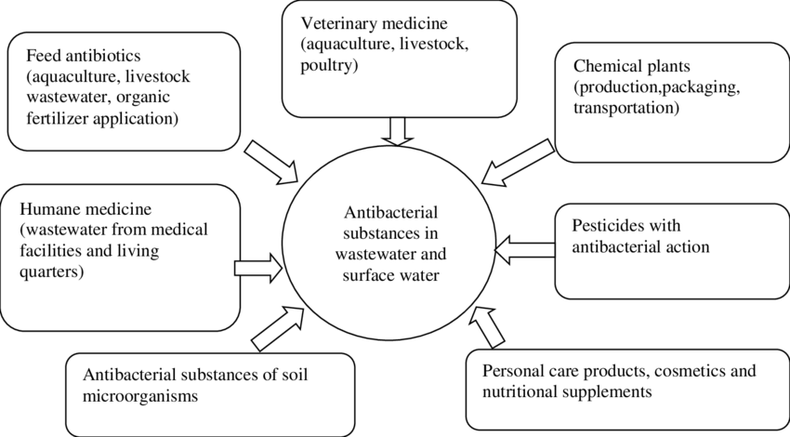

**Fig. 1. Resistance to treatment microorganism’s urgent requirement for revolutionary antibiotics.**

The methicillin-resistant and vancomycin-resistant *Enterococcus faecium* are the second level high priority pathogens. *Staphylococcus aureus*, resistant to clarithromycin *Helicobacter pylori,* resistant to fluoroquinolones *Campylobacter* species that are resistant to fluorquinolones *Salmonella* *spp.* that are resistant to cephalosporins and fluoroquinolones. These priority infections have built-in resistance to treatment, are resistant to several antibiotics, and can spread genetic material that makes other bacteria resistant to drugs. .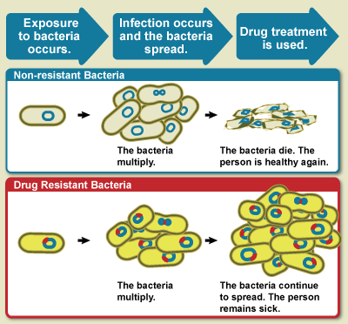

**Fig.2. Bacteria that are resistant to drugs and non-drugs.**

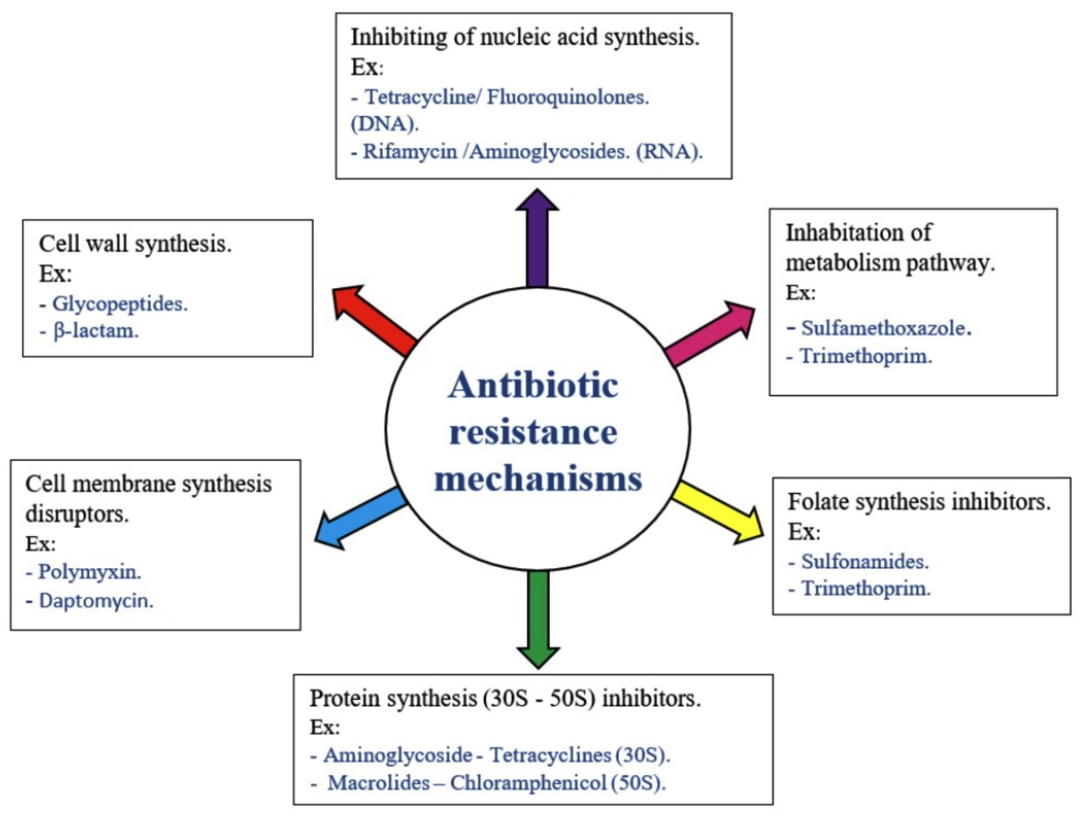

**Fig. 3. Mechanism of organisms resistant to antibiotics.**

Over the past 20 years, there have been fewer opportunities to treat these drug-resistant microorganisms due to a progressive decline in the manufacture of novel antibiotics (Ventola 2015). According to Kanj and Kanafani (2011), treating infections brought on by MDR pathogens is challenging and has limitations. To prevent and cure these super bugs, doctors continue to prescribe the current medications in the right dosages and combinations of different medications (Safavi *et al.* 2016).

**Bacteria**  
 High rates of antibiotic resistance and bacterial infections are prevalent issues that need to be addressed globally. Sources, modes of action, chemical structures, and their spectrum of activity (broad-spectrum and narrow-spectrum) are used to classify antibiotic resistance (Pancu *et al.,* 2021). Pathogens have developed new resistance mechanisms to the currently available antibiotics due to a number of circumstances, such as improper use and long-term overprescription of antibiotics. this approach consequently prolongs the disease time, raises treatment costs, and increases the chance of death by contributing to the insufficiency or failure of the usual treatments. Sexually transmitted infections, urinary tract infections, diarrhea, and sepsis are among the newly emerging infections that are commonly linked to this occurrence.

**Virus**

Since the 18th century, when the first tobacco mosaic virus was discovered, causing a 90% global mortality rate, a persistent recurrence of harmful viruses has had a significant impact on human health. Persistent drug exposure and viral replication have resulted in the emergence of various resistant strains and the persistence of infection despite treatment; additionally, viral mutations that occur frequently in the viral genome during the replication process have been the primary cause of the presentation of various variants among affected individuals (Zoulim, 2011). Antiviral resistance is also increasing the burden in the immunosuppressed patient group, as resistance has developed to most antivirals, including antiretroviral (ARV) medications. The rise of drug-resistant HIV puts the ARV medications, especially those from more recent classes, at risk of becoming partially or completely inactive. The best choice and management of antiretroviral therapy (ART) regimens would benefit from appropriate and frequent surveillance of the effectiveness of ART administered, as there is a chance that the population receiving ART will develop resistance to HIV drugs prescribed (World Health Organization, 2020).

**Fungi**

The development of medicines to treat bacterial infections coincided with the emergence and sharp increase of fungal infections. However, the primary cause of fungal infection's global impact is antifungal resistance. The most common and invasive pathogenic fungus that cause mortality globally are *Aspergillus, Candida, Pneumocystis,* and *Cryptococcus* species (Arastehfar *et al.,* 2020). The increase in underlying diseases including cancer, AIDS, diabetes mellitus, and cystic fibrosis is also linked to the growth in fungal infections. *Aspergillus fumigatus* and *Candida auris* are two dangerous fungus that are resistant to several antifungal medications. Prolonged hospital stays and treatment failures could result from this circumstance, which could force the use of costly therapeutic solutions.

**Parasites**   
Parasite infections and resistance are considered to be among the most serious and potentially fatal conditions, particularly in tropical nations. The primary causes of this are the parasites characteristics and the vaccines inefficiency. The development of parasitic resistance frequently compromises the effectiveness of chemotherapeutic medicines, which make up the majority of currently available treatments for parasitic diseases. In order to choose the best course of treatment for parasitic illnesses, especially in the cases of malaria, leishmaniasis, and toxoplasmosis, it is crucial to precisely define the processes underlying drug resistance (Ertabaklar *et al.,* 2020).

**Pathogens that are resistant to multiple drugs (MDR): A risk to public health**

Antibiotic resistance in bacteria is ultimately caused by the selective pressure caused by human overuse, underuse, and misuse of antibiotics (Davies and Davies 2010). These days, public health is seriously threatened by new MDR pathogens, commonly known as "ESKAPE" organisms, including *Enterococcus species*, S. aureus, Klebsiella species, *A. baumanii*, *P. aeruginosa*, and *Enterobacter* species (Boucher *et al.* 2009).Because MDR germs can withstand antimicrobial medication, traditional treatments are rendered ineffective, infections continue, and the danger of infection spreading to others increases. *Mycobacterium tuberculosis* strains are exceptionally drug resistant (XDR), meaning they are nearly resistant to every type of antibiotic (Gandhi *et al.* 2006). In general, MDR bacteria are resistant to three more drugs (Styers *et al*. 2006).

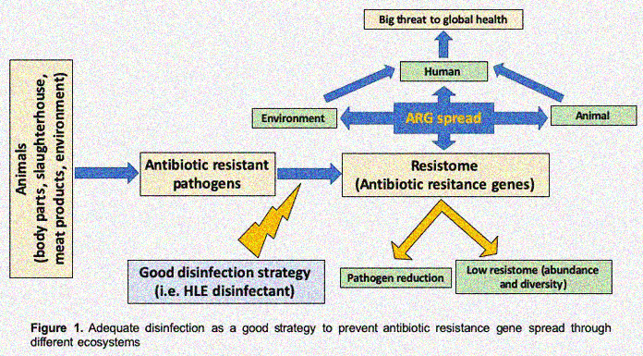

**Figure 4. Multiple resistant to drugs (MDR) pathogenic organisms: A worldwide health priority.**

**Effective sterilization is an excellent technique for preventing resistance to antibiotics genetic propagation among different habitats.**

Although it did not reach critical levels, WHO reported a slow rise in HIV medication resistance in 2012. Since then, reports of increased resistance to first-line therapy medications have surfaced, which may soon necessitate the use of more costly medications. According to the Centres for Disease Control (CDC), over 2 million Americans contract an infection while in hospitals each year, which leads to 90,000 fatalities. At least one of the typical antibiotics used to treat these illnesses is ineffective against more than 70% of the bacteria that cause them However, the worldwide rise in antibiotic resistance makes MDR bacteria extremely challenging. to kill or subdue them and to make them stronger. There is a definite need for greater research and new antimicrobial sources because the antibiotics that are now on the market are insufficient to control these superbugs.

**TB that is resistant to many drugs (MDR-TB)**

Tuberculosis (TB) is a highly contagious illness caused by *Mycobacterium spp*., namely *M. tuberculosis*. The World Health Organization reports that tuberculosis (TB) is the second leading cause of mortality worldwide, following HIV. In 2013, around 6.1 million TB cases were reported, with 5.7 million (93%) being new. In current, around 9.6 million people became ill from tuberculosis, with 1.5 million dying. TB is primarily prevalent in Asia and Africa, accounting for over 80% of all reported cases.

It appears that *M. tuberculosis* is becoming resistant to traditional medications, which is alarming the international health community. Treatment regimens for MDR-M. TB are significantly longer and less successful than those for non-resistant M. tuberculosis. There are 100 countries worldwide where extensively drug-resistant TB (XDR-TB), which is defined as MDR-TB plus resistance to any fluoroquinolone and any second-line injectable medicines, has been found. This chapter lists the chemicals and plant derivatives that have been shown to have strong anti-mycobacterial action against MDR-TB.

**Malaria that occurs: a contemporary healthcare issue**

Globally, malaria is a lethal blood disease that is complicated Malaria poses a threat to around half of the world's population, and the disease alone is responsible for 1-2 million deaths per year in 2006, there were about 245 million cases of malaria worldwide, and 3.3 billion individuals were at risk of contracting the illness of them, children under the age of five accounted for the majority of the approximately one million deaths. Forty-five of the 109 malarious nations and territories that exist today are in Africa (WHO 2008).

Among other medications, these include artemisinin, mefloquine, quinine, and chloroquine. Nevertheless, over time, the protozoans have become resistant in many nations due to the following significant factors: inadequate vector control programs, unsanitary circumstances, and the lack of currently licensed vaccinations (White 2004).   
The development of phytomedicines and natural origins are the primary areas of attention for researchers now working on novel antimalarial drugs.

**Plant-based drug discovery**

Although the idea of "the active principle" in medicine was initially documented in the fifteenth century, pure substances that were separated documented in the late eighteenth and early nineteenth centuries from the plant extracts.

It is significant to remember that pure chemicals obtained from plants have comparable effects to plant extracts and were thus quickly used as a key component in many medications. The first naturally occurring substances to be separated from Papaver somniferum were codeine and nicotine. Many of the chemicals that have since been identified from plants are still widely used as medications in medicine.

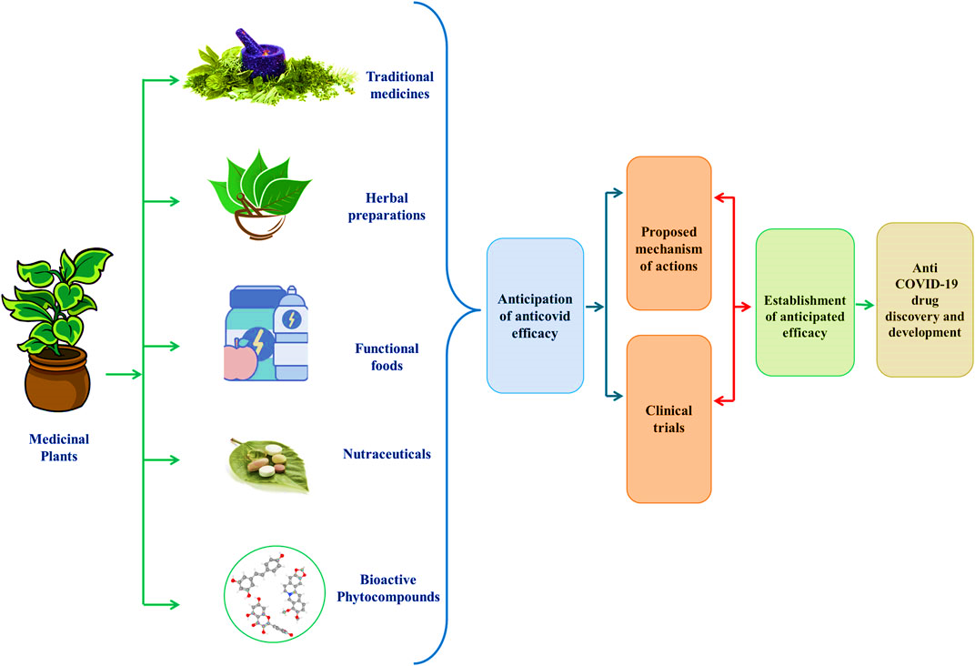

**Fig. 5. Pharmaceutical development using botanicals.**

Several well-known plant-derived medications, their sources, brand names, and therapeutic applications Secondary metabolites and other compounds generated from plants that exhibit therapeutic qualities may function through comparable or distinct mechanisms. Plant-derived quines (which bind to adhesions, inactivate enzymes, and complex with cell wall) and flavonoids (which bind to adhesions and complex with cell wall) have similar mechanisms of antibacterial action. However, there are differences in the ways that polyphenols and tannins (which block enzymes, deprive substrates, disturb membranes, and complex with metal ions), terpenoids and essential oils (which disrupt membranes), and alkaloids (which intercalate into cell walls) have antimicrobial effects.

**Prospects for the future**

The most well-known natural labs for creating structurally distinct, varied, and intricate natural products are plants. In addition to the plants, a lot of work is being conducted for pharmaceutically significant proteins on microbes and other creatures from another living environment, including the oceans. However, less than 10% of plants, especially angiosperms, have undergone screening for the discovery of natural products (Houghton 2001). As a result, there is a vast potential for more intriguing bioactive substances from blooming plants to produce brand-new medications.

To access this hidden treasure, more integrative approach with various natural product discovery tools will be the key for success in discovery of phytomedicines. The complex and rich chemical diversity in plants pave to the isolation of natural products which is tough and laborious. Therefore, the significant application of tools such as high performance liquid chromatography coupled to mass spectrometry (HPLC–MS), liquid chromatography–mass spectrometry (LC–MS), liquid chromatography–nuclear magnetic resonance–mass spectrometry (LC–NMR–MS), capillary NMR (cap-NMR) spectroscopy, LC–solid phase extraction (SPE)–NMR along with bioassay-guided frac tionation and high-throughput bioassays will accelerate the access of plant-derived natural products. However, the substantial use of medicinal plants for drug discovery programme endangers their existence, so farming of medicinal plants must be instigated for assuring the future accountability.

It's interesting to note that secondary metabolites derived from plants are of tremendous interest to researchers and doctors due to their antibacterial activity without causing antibiotic resistance. As a result, plant-based antimicrobials have been utilized extensively to treat and prevent infections that are resistant to several drugs. Emerging MDR and XDR pathogens on a global scale are a major worry. However, the majority of chemically synthesized antibiotics are quite costly and may have unfavourable side effects. Consequently, the utilization of alternative medicine sources, especially medicinal plants, is becoming more and more popular these days. Numerous plant species have already been extensively documented to exhibit possible therapeutic benefits. However, the fast evolution of pathogens and the emergence of new infections and disorders push scientists to look deeper into nature for new natural compounds.

**Conclusion**

An estimated 85% of people worldwide still receive their primary medical treatment from traditional medicines, despite the widespread acceptance of the use of herbs and herbal products in our contemporary lifestyle. The importance of natural goods obtained from plants and their extracts utilized by the general public has been acknowledged and recorded since. Due to the growing number of diseases brought on by bacteria, viruses, fungi, and parasites, antimicrobial resistance (AMR) needs to be given careful consideration. The majority of antimicrobials that are already on the market, such as antibiotics, antivirals, antifungals, and antiparasitics, were not able to successfully treat infections brought on by organisms that have AMR. Finding and looking for further possible remedies from plant secondary metabolites is so essential. In conclusion, we anticipate that a number of secondary metabolite combinations may be useful in the treatment of infections linked to AMR.

**Acknowledgement**

The Rajendra Singh (Rajju Bhaiya) University Prayagraj, UP, India and Sciences are gratefully acknowledged by the authors for providing all necessary facilities and resources.

**Conflicts of Interest Statement**

We have no conflicts of interest to disclose. Authors declare that they have no conflicts of interest. The research was fully done in independently not any financial support involved.

**Author contribution**

Contributed to the conception and design of the analysis paper Contributed to the data collection Data and analysis tools wrote the analyzed paper. Also evaluated the paper and then suggested to publish in this journal.

Disclaimer (Artificial intelligence)

Option 1:

Author(s) hereby declare that NO generative AI technologies such as Large Language Models (ChatGPT, COPILOT, etc.) and text-to-image generators have been used during the writing or editing of this manuscript.

Option 2:

Author(s) hereby declare that generative AI technologies such as Large Language Models, etc. have been used during the writing or editing of manuscripts. This explanation will include the name, version, model, and source of the generative AI technology and as well as all input prompts provided to the generative AI technology

Details of the AI usage are given below:

1.

2.

3.

**References**

* Arastehfar, A., Gabaldón, T., Garcia-Rubio, R., Jenks, J. D., Hoenigl, M., Salzer, H. J. F., et al. (2020). Drug-resistant fungi: An emerging challenge threatening our limited antifungal armamentarium. *Antibiotics* 9, 8777–E929.
* Borris RP (1996) Natural products research: perspectives from a major pharmaceutical company. J Ethnopharmacol 51:29–38
* Boucher HW, Talbot GH, Bradley JS, Edwards JE, Gilbert D, Rice LB, Scheld M, Spellberg B, Bartlett J (2009) Bad bugs, no drugs: no ESKAPE! an update from the infectious disease’s society of America. Clin Infect Dis 48:1–12
* Cowan MM (1999) Plant products as antimicrobial agents. Clin Microbiol Rev 12:564–582
* Davies J, Davies D (2010) Origins and evolution of antibiotic resistance. Microbiol Mol Biol Rev 74:417–433
* Efferth T, Koch E (2011) Complex interactions between phytochem icals. The multi-target therapeutic concept of phytotherapy. Curr Drug Targets 12:122–132
* Ertabaklar, H., Malatyali, E., and Ertug, S. (2020). Drug resistance in parasitic diseases. *Eur. J. Ther.* 26, 1–5.
* Gandhi NR, Moll A, Sturm AW, Pawinski R, Govender T, Lalloo U, Zeller K, Andrews J, Friedland G (2006) Extensively drug-resistant tuberculosis as a cause of death in patients co-infected with tuberculosis and HIV in a rural area of South Africa. Lancet Infect Dis 368:1575–1580
* Golkar Z, Bagazra O, Pace DG (2014) Bacteriophage therapy: a potential solution for the antibiotic resistance crisis. J Infect Dev Ctries 8:129–136
* Kanj SS, Kanafani ZA (2011) Current concepts in antimicrobial therapy against resistant Gram-negative organisms: extended spectrum b-lactamase-producing enterobacteriaceae, car bapenem-resistant enterobacteriaceae, and multidrug-resistant *Pseudomonas aeruginosa*. Mayo Clin Proc 86:250–259
* Kyaw BM, Arora S, Lim CS (2012) Bactericidal antibiotic-phyto chemical combinations against methicillin resistant Staphylo coccus aureus. Braz J Microbiol 43:938–945
* Pancu, D. F., Scurtu, A., Macasoi, I. G., Marti, D., Mioc, M., Soica, C. (2021). Antibiotics: Conventional therapy and natural compounds with antibacterial activity—a pharmaco-toxicological screening.
* Safavi M, Sabourian R, Foroumadi A (2016) Treatment of *Helicobacter pylori* infection: current and future insights. World J Clin Cases 4:5–19
* Van Vuuren S, Viljoen A (2011) Plant-based antimicrobial studies— methods and approaches to study the interaction between natural products. Planta Med 77:1168–1182.
* Ventola CL (2015) The antibiotic resistance crisis. Part 1: causes and threats. P T 40:277–283.
* World Health Organization, (2020). *Fact sheet: HIV drug resistance*. PubMed, WHO.
* Zoulim, F. (2011). Hepatitis B virus resistance to antiviral drugs: Where are we going? *Liver Int.* 31,