***Review Article***

**Harnessing Breeding and Genomic Advances for Nutritional and Climate-Resilient Minor Millets**

**ABSTRACT**

The looming challenge of feeding 9.8 billion people by 2050 requires a 60-70% increase in global food production. Additionally, about 2 billion people worldwide currently suffer from hidden hunger due to micronutrient deficiencies. Minor millets offer a promising solution to these challenges, combining exceptional nutritional value with remarkable climate resilience. These nutrient-rich crops demonstrate impressive adaptability to diverse ecological conditions and require minimal water resources. For instance, finger millet contains exceptionally high calcium levels exceeding 350 mg per 100g and significant iron content ranging from 9.3 to 18.6 mg per 100g. Importantly, the development of improved minor millet varieties through breeding and genomic approaches has become crucial for enhancing their productivity and nutritional quality. Recent advances in next-generation sequencing technologies have significantly reduced the time and cost of genomic studies, opening new possibilities for crop improvement. This article explores the evolution of minor millet breeding programs, from traditional methods to cutting-edge genomic technologies, highlighting the significant advances that are reshaping their improvement strategies.

***Keywords:*** nutritional value; climate resilience; adaptability; finger millet; genomic approaches; crop improvement

1. **INTRODUCTION**

Minor millets, including, among others, finger millet *(Eleusine coracana)*, foxtail millet *(Setaria italica)*, proso millet *(Panicum miliaceum)*, kodo millet *(Paspalum scrobiculatum)*, barnyard millet *(Echinochloa spp.)*, and little millet *(Panicum sumatrense)*, have formed an important part of traditional agriculture for centuries. Considered as the main domesticated cereal crop, millet is among the ancient staple human diets. It is assumed that millet was cultivated, and domesticated in the neolithic stage of Africa 7000 years back, and was later spread throughout the world as food for humans. As of 168709, accessions of millet varieties have been preserved in gene banks around the world. Minor millet breeding efforts trace their roots to the early 20th century, marking a significant period in agricultural development. These crops, initially cultivated in specific regions, underwent systematic improvement through various breeding approaches. Prior to organized breeding programs, farmers relied on mass selection from local landraces. These traditional methods focused on selecting plants with desirable traits such as drought tolerance and higher yields (Begna, 2021). This approach laid the foundation for more systematic breeding efforts in different regions of India.

The first structured breeding programs emerged in specific states during the 1920s. Tamil Nadu established the Millet Research Station at Coimbatore in 1923 under the Madras Presidency (Chowdappa et al., 2016). The program later expanded to Anakapalle in Andhra Pradesh and Hagari in Karnataka. Karnataka initiated finger millet research as early as 1900, while Uttar Pradesh began its programs at Kanpur and Gorakhpur in 1944. The launching of coordinated crop improvement programs during the late 1950s and 60s marked a turning point in minor millet breeding (Patil, 2017). Before these coordinated efforts, breeding activities were primarily confined to Tamil Nadu, Andhra Pradesh, Karnataka, and Uttar Pradesh.

The release of H 22 in Karnataka in 1918 marked a milestone as the first improved finger millet variety in India. Throughout the 1930s and 1940s, several notable varieties were developed, including Co 6 (1935), R 0870, ES13, K1, ES11 (1939), Hagari 1 (1941), Co1, Co2, Co3, Co4 (1942), and T36 B (1949). The establishment of the All India Coordinated Small Millets Improvement Project (AICSMIP) in 1986 represented a major advancement. Under this project, more than 15,000 accessions of various small millets were conserved with comprehensive data documentation. Consequently, the program facilitated the release of 151 varieties across different millet types, including 67 in finger millet, 20 each in foxtail and kodo millet, 14 in little millet, 16 in proso millet, and 17 in barnyard millet. The period between 1950-60 witnessed intensified interest in finger millet improvement, particularly in Karnataka, resulting in the development of varieties such as Aruna, Udaya, K1, Purna, ROH 2, and Cauvery (Seetharam, 2013). Moreover, the recognition of genetic resources' importance led to the first systematic germplasm collection effort in 1961 under the PL 480 project, accumulating nearly 3,000 genetic stocks of various small millets (Singh & Upadhyaya, 2015).Milestones in Minor Millet Breeding in India illustrated in Fig. 1.

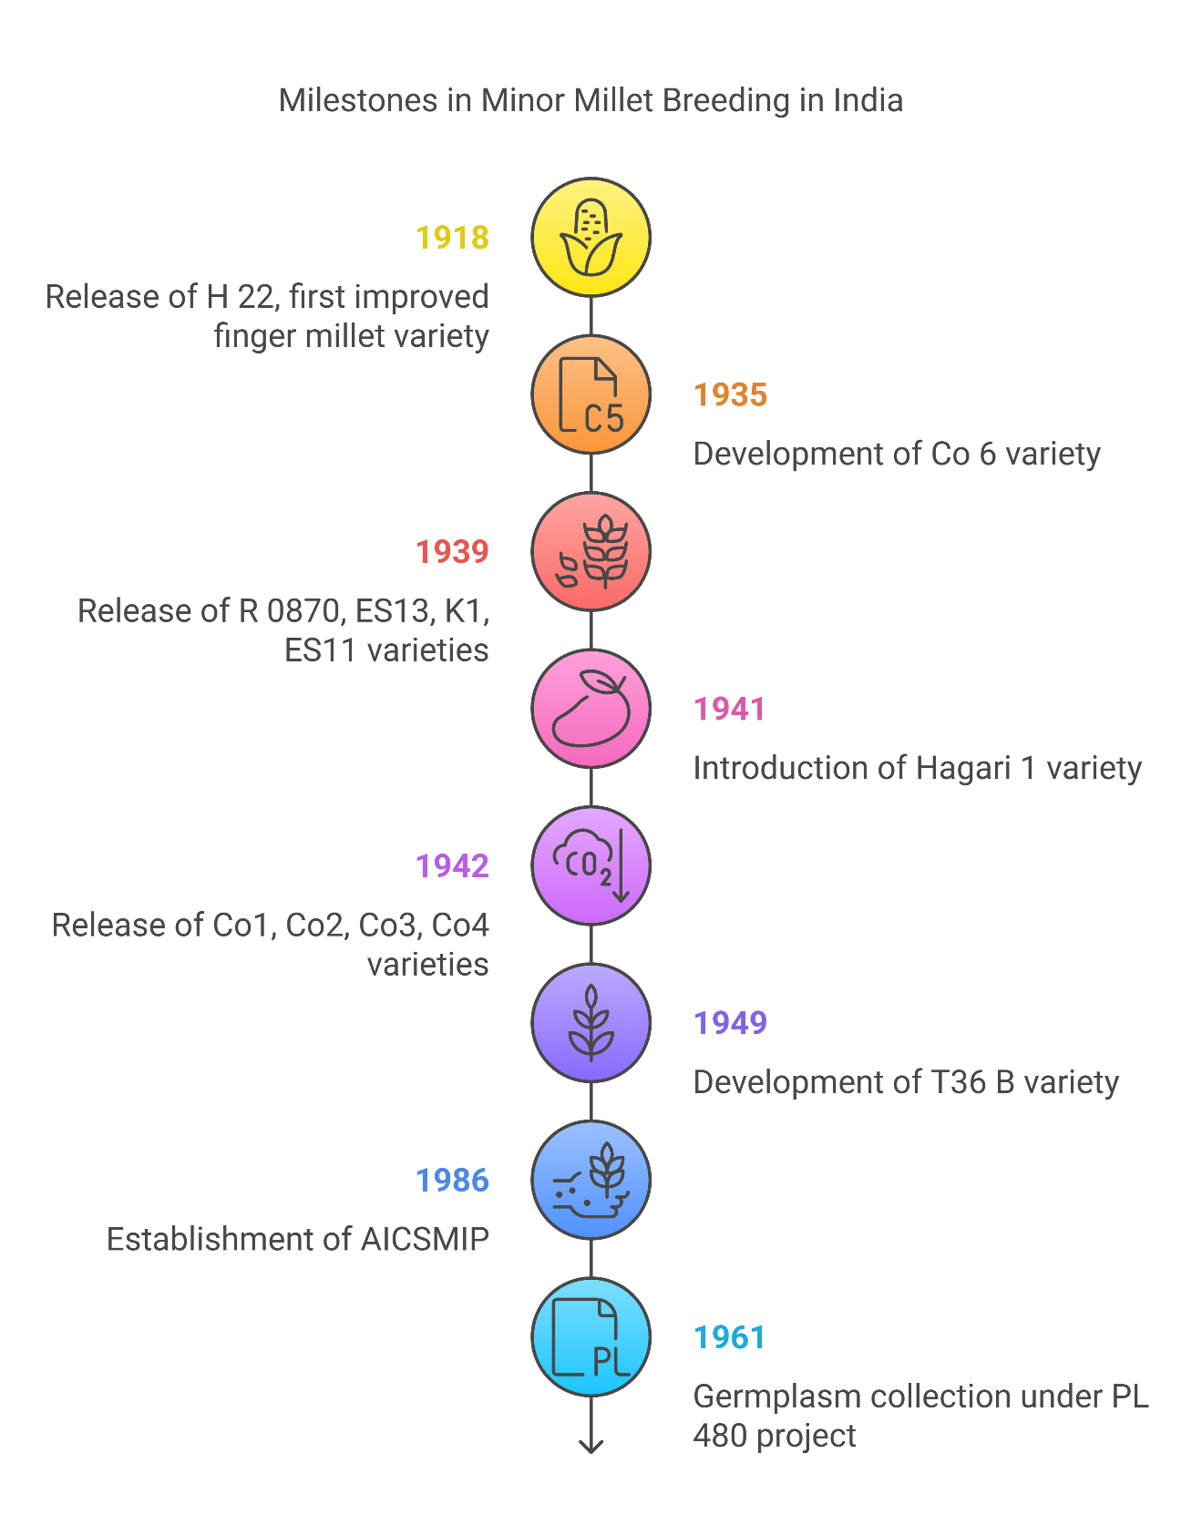

**Fig. 1. Milestones in Minor Millet Breeding in India**

1. **CONVENTIONAL BREEDING APPROACHES**

Conventional breeding approaches in minor millets have evolved through systematic selection and hybridization methods. These approaches remain fundamental to crop improvement programs, with about 65% of varieties released through selection from landraces and 30% through pedigree selection (Dwivedi et al., 2016). A range of breeding techniques, including pure line selection, pedigree selection, mass selection, and mutation breeding, suitable for self-pollinated crops, are also employed in the cultivation of small millets. Data pertaining to the small millet cultivars released over the years indicate that the majority of these cultivars were developed by selection from landraces or existing cultivars, followed by pedigree selection (with hybridization and selection) as the second most common method. For instance, in India, of 248 cultivars of six small millets, namely finger millet (121), foxtail millet (32), proso millet (24), kodo millet (33), barnyard millet (18), and little millet (20), around 65% were released on the basis of selection from landraces, around 30% through pedigree selection, and 5% through mutation breeding. In the United States, 11 proso millet cultivars were released through selection from landraces, while 8 were developed through pedigree selection.

Pure line selection has served as the primary breeding method in little and Kodo millet, although genetic gains have remained limited (Nagaraja et al., 2024). This method involves selecting individual plants from local landraces or germplasm accessions for subsequent generations (Pradhan et al., 2021). Nonetheless, pure line selection has contributed to developing varieties with specific adaptations to different ecological conditions. Mass selection stands as a widely practiced method wherein seeds from morphologically superior plants are collected and grown in subsequent seasons. This phenotypic selection technique specifically aims to purify cultivars and multiply varieties bred through other methods (Maid et al., 2019). Although mass selection has shown modest improvements, varieties like Gidda Ragi, Hullubele of Karnataka, and Saluchodi of Andhra Pradesh demonstrate its practical application. Hybridization techniques represents a sophisticated approach for generating variability in minor millets. The contact method, introduced in 1951, marked a significant advancement in crossing techniques (Vinod et al., 2022) in which to increase the chances of natural cross-pollination, the panicles of selected plants are carefully covered with parchment bags before they begin to flower. This technique helps ensure better pollen exchange while protecting the developing flowers. This method achieves success through several specialized approaches: Hot water treatment (48°C to 52°C for 5 minutes) for female panicles (3-4 days of emergence). In finger millet for creating male sterility at 52℃ for 5 min is effective, while in barnyard millet 48℃ for 4-5 min Modified crossing methods specific to proso and little millet (SMUASB method), Genetic male sterility systems for enhanced hybridization. The success rate of hybridization typically ranges between 2% to 3% using the contact method. Accordingly, breeders employ marker traits, specifically pigmentation on nodes in male parents, to identify true hybrid crosses. This approach has led to the development of notable varieties including Aruna, Poorna, Udaya, Annapurna, and Cauvery. The floral biology of minor millets presents unique challenges, specifically in emasculation and pollination processes (Dash et al., 2021). Hence, modified crossing methods have been developed for each minor millet crop, considering their distinct floral morphology. The hot water emasculation method offers a practical alternative, especially in finger millet breeding programs. Furthermore, the identification of genetic male sterility has opened new possibilities for hybrid development (Mirza & Marla, 2019).

1. **MUTATION BREEDING ADVANCES**

Mutation breeding represents a powerful approach for creating genetic variations in minor millets, particularly valuable for crops with limited natural variability. This breeding method has contributed to the development of approximately 5% of released varieties across six minor millet species (Raina et al., 2016). Through mutation breeding, a total of 13 improved small millet varieties have been developed and released in India, including 8 for finger millet, 3 for kodo millet, and 2 for little millet.  Radiation-based mutagenesis marked the beginning of mutation breeding in minor millets. X-ray irradiation led to the development of Hagari-1, the first commercialized mutant variety in finger millet (*Eleusine coracana*) in 1941 (Nagaraja et al., 2024). Gamma radiation has proven particularly effective, resulting in several notable varieties with improved traits. For instance, the blast-resistant mutant M21 emerged from gamma irradiation of cultivar HES 927 (Ramesh et al., 2024). Similarly, the early-maturing Hamsa variety, characterized by increased finger numbers, originated through gamma radiation treatments. Chemical mutagens have demonstrated remarkable effectiveness in generating valuable genetic variations. The most commonly employed chemical agents include Ethyl Methane Sulfonate (EMS), Sodium Azide (SA), and Nitroso Guanidine (NG).

EMS stands out as the most potent chemical mutagen, generating mutations with high frequency. Rather interestingly, studies indicate that Sodium Azide shows superior efficiency concerning lethality compared to EMS (Das et al., 2021). The effectiveness of these mutagens typically depends on dosage levels, with even low concentrations capable of producing significant results. In Mutation detection methods, Mutation detection primarily relies on phenotypic screening and chlorophyll mutant identification. The frequency of chlorophyll mutants serves as a crucial indicator of mutagenic effectiveness. Therefore, researchers often evaluate mutation success through careful observation of Chlorophyll deficiency types emerge from cytoplasmic gene modifications, though most prove detrimental to crop growth (Pogson et al., 2015). Undoubtedly, the identification process requires meticulous screening across generations. The M2 generation typically provides the most reliable data for assessing mutagenic effectiveness. Recent advances have yielded promising results in finger millet mutation breeding. For instance, the PS1 mutant, generated through EMS treatment, demonstrates approximately 10% seed setting under bagging conditions and up to 49% in controlled crossing (Nagaraja et al., 2023). Furthermore, twelve partial sterile lines and five virescence lines have been developed at AICRP, expanding the genetic diversity available for breeding programs.

1. **MOLECULAR MARKER DEVELOPMENT**

Molecular markers serve as powerful tools in minor millet breeding programs, offering precise genetic analysis capabilities (Padhiyar et al., 2024). Presently, these markers provide essential complements to conventional breeding methods in germplasm conservation and crop improvement.

* 1. **DNA Marker Types**

The evolution of marker technology in minor millets has witnessed significant progress. In effect, researchers have developed various marker types for genotyping applications (Table 1): Simple Sequence Repeats (SSRs) from BAC sequences, Single Nucleotide Polymorphisms (SNPs), EST-based microsatellite markers, DArT platforms. The first genetic map of finger millet emerged using 82 SSR markers. As well as this, genome-wide marker data sets for 190 accessions were generated with genotyping-by-sequencing (GBS), representing one of the first comprehensive genomic analyzes in little millet and kodo millet (Mundada et al., 2022).

**Table 1. Different Types of Markers for genotyping applications**

|  |  |  |  |
| --- | --- | --- | --- |
| **Crop** | **Marker Name & Type** | **Trait of Interest** | **Reference** |
| **Finger Millet** | SSR markers from BAC sequences | Genetic mapping | Padhiyar et al., 2024 |
| **Little Millet** | GBS-generated SNPs | Genomic analysis | Mundada et al., 2022 |
| **Kodo Millet** | GBS-generated SNPs | Genomic analysis | Mundada et al., 2022 |
| **Pearl Millet** | MAS using molecular markers | Hybrid development (HHB 67 Improved) | Sehgal, 2016 |
| **Pearl Millet** | MAS using molecular markers | Terminal drought tolerance | Tripathy et al., 2021 |
| **Foxtail Millet** | Genomic selection tools (e.g., next-generation sequencing) | Germplasm resource analysis | Upadhyaya et al., 2016 |
| **Foxtail Millet** | ISSR markers | Cultivar identification | Venkatesan et al., 2021 |
| **Foxtail Millet** | InDel markers (e.g., Ghd7InDel) | Heading date | Gao et al., 2025 |

* 1. **Marker Assisted Selection**

Marker-assisted selection (MAS) has proven highly effective in crop improvement programs. In fact, ICRISAT became the first institution to implement molecular MAS in pearl millet, culminating in the release of hybrid 'HHB 67 Improved' - the first non-genetically modified product of marker-assisted selection released in India (Sehgal, 2016). The application of MAS for terminal drought tolerance has demonstrated superior results compared to field selection when both systems utilized identical testcross hybrid field screening evaluations (Tripathy et al., 2021). Currently, marker-assisted breeding programs focus on downy mildew resistance and drought tolerance, with consistent grain and stover yield advantages observed in improved lines.

* 1. **Genomic Selection Tools**

Advanced genomic tools primarily facilitate various aspects of minor millet improvement. These tools enable analysis of germplasm resources, allele mining and QTL mapping, gene tagging and fine mapping, and genome-wide marker-trait association. The establishment of DArT platforms has essentially reduced the data point cost for molecular marker analysis (Alam et al., 2018). Furthermore, next-generation sequencing approaches have accelerated genomic selection for germplasm resource analysis and QTL mapping (Upadhyaya et al., 2016). The sequencing of whole genomes of sorghum and foxtail millet has expedited the genomic selection of better-performing millets through marker-assisted breeding.

1. **NEXT GENERATION SEQUENCING APPLICATIONS**

Recent advancements in next-generation sequencing technologies have opened unprecedented opportunities for minor millet improvement. These developments mark a significant shift in understanding genetic diversity and trait expression in these crops.

* 1. **Whole Genome Sequencing**

PacBio high-fidelity (HiFi) technology has dramatically reduced the cost of producing highly complete and contiguous de novo assemblies. The first pearl millet reference genome, published using Illumina HiSeq and bacterial artificial chromosome technology, revealed approximately 38,579 gene templates covering 90% of the genome (Naidu et al., 2023). Soon after, efforts focused on improving this initial version by enhancing alignments in centromeric regions and placing unknown scaffolds in chromosomes. The annotated genome sequences currently available for foxtail millet and finger millet serve as valuable resources (Sahoo et al., 2021). Generally, draft genome sequences exist for proso millet and barnyard millet, enabling SNP identification and next-generation sequencing-based allele discovery (Chaudhary et al., 2023). Whether examining whole or draft genomes, these resources primarily support marker-assisted breeding programs and trait identification.

* 1. **Transcriptome Analysis**

Transcriptomics has emerged as a powerful tool for examining gene expression patterns under various conditions. RNA sequencing technology enables precise gene expression quantification at the transcriptional level (Marioni et al., 2008). The analysis typically involves removal of low-quality reads and adapters, de novo transcriptome assembly using Trinity, evaluation of transcript expression levels, differential expression analysis. A notable achievement includes the identification of 5,039 differentially expressed genes under drought stress and 4,603 under heat stress has been reported in Pearl millet (*Pennisetum glaucum*). (Liu & Jiang, 2010). Furthermore, transcriptome sequencing of genotypes with varying iron content has revealed crucial insights into mineral accumulation pathways in Barnyard millet (*Echinochloa frumentacea*). A study compared two genotypes with notably different iron content, BAR-1433 and BAR-1423, to identify differentially expressed genes involved in iron accumulation.

* 1. **Comparative Genomics**

Pan-genome analysis represents a significant advancement in understanding species-wide genomic diversity (Fig. 2). The analysis identified 744,364 structural variants, namely inversions, copy number variations, and presence-absence variants (Kasule et al., 2024). Simultaneously, comparative analysis between protein sequences of different millet species has provided insights into evolutionary processes contributing to abiotic stress tolerance. The reduction in sequencing costs has substantially increased whole genome sequencing applications. These genomic resources support various research objectives, including, understanding species evolution on a genome-wide scale, identifying genomic regions governing adaptive traits, conducting genetic diversity analyses, performing association studies. Overall, comparative genetic maps constructed between pearl millet and foxtail millet genomes have successfully described homoeology between these species. The data generated through these analyzes continues to enhance breeding programs and variety development strategies.

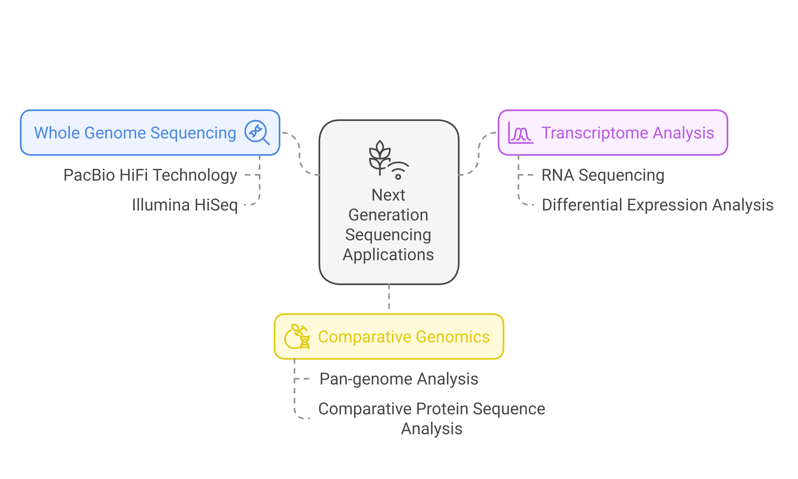

**Fig. 2. Next Generation Sequencing in Millet Improvement**

1. **MODERN BREEDING TECHNOLOGIES**

Technological breakthroughs have dramatically accelerated the pace of minor millet improvement programs. Advanced breeding methods now enable faster variety development while maintaining precision in trait selection.

* 1. **Speed Breeding**

Speed breeding has redefined the timeline of crop improvement, reducing variety development from traditional 9-17 years to just 5-9 years in controlled environments. Indeed, this acceleration tackles various breeding challenges, primarily male sterility, self-incompatibility, and seed shattering. The rapid single-seed descent method notably enables the creation of near-homozygous lines in 1-2 years, allowing finger millet to achieve up to five generations annually (Watson et al., 2018). Currently, indoor phenotyping platforms enhance speed breeding by providing detailed monitoring of plant traits. These systems measure crucial characteristics like leaf expansion, width, phyllochron, and stomatal conductance.

* 1. **Double Haploid Technology**

Double haploid (DH) technology markedly accelerates the development of homozygous lines through tissue culture or in vivo induction. This process typically requires only two to three generations, thereupon reducing the breeding cycle significantly. The technology begins with haploid plant production, followed by chromosome doubling to obtain inbred lines (Alahmad et al., 2018). Another culture serves as an essential technique for generating double haploid plants. These doubled haploids straightaway help produce homozygous lines, which accelerates breeding programs. Unlike conventional methods, DH technology facilitates: Studying mutagenesis and gene interactions, Analyzing dosage effects, developing reproducible DNA polymorphism, Enabling genetic transformation

* 1. **CRISPR Gene Editing**

CRISPR/Cas9 technology has emerged as the most effective gene editing system. The system consists of two main components: single guide RNA (sgRNA) and Cas9 endonuclease (Nowak et al., 2016). With sgRNA guidance, specific targets containing protospacer-adjacent motif (PAM) are identified and cut, resulting in double-strand breaks in the host genome.

Recent studies have demonstrated successful editing of five endogenous genes using CRISPR/Cas9 and two endogenous genes using cytosine or adenine base editors in two varieties. These mutations proved heritable and transmitted faithfully to the next generation. Base editing systems represent a new type of gene editing technology, enabling irreversible single-base replacement at specific gene sites to enhance crops. The integration of these modern breeding technologies with genomic selection has created unprecedented opportunities for minor millet improvement. Context-dependent selection enables plants to adapt better to target environments (Satapathy et al., 2021). Furthermore, phenotyping and selecting plants under speed breeding conditions in glasshouses has improved selection intensity and genetic gain rates.

1. **VARIETY DEVELOPMENT PIPELINE**

The systematic development of minor millet varieties follows a structured pipeline that combines traditional breeding methods with modern evaluation techniques. First of all, this process encompasses multiple stages, beginning with pre-breeding activities and culminating in multi-location testing.

* 1. **Pre-breeding Activities**

Basic and strategic research forms the foundation of pre-breeding activities, focusing on germplasm characterization and development of high-yielding varieties with disease and pest tolerance (Reddy, 2024). Currently, these activities emphasize the improvement of grain yield through the maximization of biomass and harvest index. The primary objectives include: Development of location-specific cultivars adapted to varying soil conditions, rainfall patterns, and cropping systems, Enhancement of nutrient-use efficiency, particularly for NPK utilization, Creation of drought-tolerant cultivars with high water-use efficiency. In addition, pre-breeding efforts target the development of non-shattering cultivars to prevent field losses. The process likewise considers post-harvest technology demands, focusing on traits that facilitate easy threshing and dehulling of grains.

* 1. **Advanced Breeding Lines**

The development of advanced breeding lines involves rigorous selection processes across multiple generations. Thus far, research centers have undertaken the production and supply of breeder seed based on indents from the Department of Agriculture and Co-operation (Prasad et al., 2017). The evaluation process examines several key parameters: Days to 50% flowering (ranging from 68 to 83 days), Maturity duration (105 to 120 days), Plant height variations (85cm to 101cm), Grain and fodder yield potential. The breeding lines undergo thorough assessment for both grain and fodder yields. For instance, in finger millet trials, entries like FMV1191 achieved yields of 3,388 kg/ha, surpassing standard checks.

**7.3 Multi-location Testing**

Multi-location testing represents a critical phase in variety development, conducted across diverse agro-ecological zones. The All India Coordinated Research Project on Small Millets (AICRP on SM) coordinates these trials nationwide. The testing network achieved an overall success rate of 87% across locations. The zonal concept divides testing into South zone (Zone-I) and North zone (Zone-II), ensuring appropriate variety evaluation for specific regions (Vinod et al., 2022). The evaluation process encompasses: Grain yield assessment, Fodder yield measurement, Agronomic trait analysis, Disease resistance screening

Multi-location trials have demonstrated remarkable success in identifying superior varieties. For example, in foxtail millet, entry FXV 628 ranked first and showed superiority over the check variety SiA 3156 in grain yield. Similarly, in kodo millet, entries KMV 559 and KMV 558 exhibited 10.71% and 10.45% higher grain yields compared to the best check, TNAU 86. The variety development pipeline maintains strict quality control through systematic evaluation at each stage. Performance data from these trials guide decisions regarding variety release and commercialization. For instance, little millet entries LMV556 and LMV558 demonstrated numerical superiority of 11.62% and 8.70% respectively for grain yield over the standard check DHLM 36-3.

1. **FUTURE PROSPECTS FOR BREEDING AND GENOMIC ADVANCES IN MINOR MILLETS**

The future of breeding and genomic advances in minor millets holds significant promise, driven by technological innovations and a growing recognition of the importance of these crops in addressing global food security and nutritional challenges. Advances in next-generation sequencing technologies and genomic tools are expected to continue transforming breeding programs, making them more efficient and precise.

**8.1 Nutritional Enhancement through Genomics**

Future breeding efforts will likely focus on further enhancing the nutritional profiles of minor millets. With the help of genomic tools, researchers can identify and target specific genes responsible for key nutrients such as calcium, iron, and antioxidants. Finger millet, already rich in calcium and iron, could be biofortified to even higher levels through targeted breeding and gene editing. This would make minor millets even more valuable in combating micronutrient deficiencies, particularly in regions where these crops are staple foods.

**8.2 Climate Resilience and Adaptation**

Climate change poses a significant threat to global agriculture, but minor millets, with their inherent resilience, are well-positioned to adapt. Genomic studies can help identify and incorporate genes that confer tolerance to drought, heat, and salinity, further enhancing the climate resilience of these crops. CRISPR/Cas9 and other gene-editing technologies, researchers can develop new varieties that thrive under changing environmental conditions, ensuring stable yields even in adverse climates.

**8.3 Accelerated Breeding through Genomic Selection**

Genomic selection tools will play a crucial role in accelerating the breeding process. Molecular markers to predict the performance of plants, breeders can select the best candidates more efficiently, reducing the time and resources needed to develop new varieties. This approach will enable the rapid improvement of traits such as yield, disease resistance, and nutritional quality, bringing superior varieties to market more quickly.

**8.4 Speed Breeding and Double Haploid Technology**

Speed breeding techniques, which allow for multiple generations per year, will continue to revolutionize minor millet breeding. Combined with double haploid technology, which accelerates the development of homozygous lines, these methods will significantly shorten breeding cycles. This will enable breeders to respond more quickly to emerging challenges and market demands, ensuring that new and improved varieties are available in a timely manner.

**8.5 Functional Genomics and Gene Editing**

Functional genomics, including transcriptome analysis and pan-genome studies, will provide deeper insights into the genetic basis of important traits in minor millets. This knowledge will be crucial for the development of new breeding strategies and the identification of novel genes for improvement. Gene editing technologies will allow for precise modifications to the genome, enabling the development of varieties with desired traits such as enhanced nutritional content, improved stress tolerance, and better agronomic performance.

**CONCLUSION**

Minor millets stand at the intersection of traditional agriculture and cutting-edge genomic technologies. These nutrient-rich crops have undergone remarkable transformation through scientific advances, progressing from simple mass selection methods to sophisticated CRISPR-based gene editing. Significant breakthroughs in molecular marker development, next-generation sequencing, and speed breeding techniques have accelerated variety improvement programs. These technological advances enable researchers to develop climate-resilient, high-yielding varieties while preserving essential nutritional qualities. The establishment of structured breeding pipelines, coupled with rigorous multi-location testing protocols, ensures the delivery of superior varieties to farmers. The commercialization landscape demonstrates promising growth, particularly through India's leadership in global production. Successful implementation of conservation-cum-commercialization programs, along with enhanced seed production systems, strengthens the market presence of minor millets. The recognition of these crops as 'Nutri-cereals' further validates their importance in addressing global food security challenges. Looking ahead, minor millets offer sustainable solutions for climate-smart agriculture while meeting growing nutritional demands. Their continued improvement through genomic technologies and modern breeding approaches positions them as vital contributors to future food systems. The integration of traditional knowledge with modern science creates robust pathways for developing resilient, nutritious, and commercially viable minor millet varieties.

**DISCLAIMER (ARTIFICIAL INTELLIGENCE)**

Author(s) hereby declare that NO generative AI technologies such as Large Language Models (ChatGPT, COPILOT, etc.) and text-to-image generators have been used during the writing or editing of this manuscript.

**REFERENCES**

Alahmad, S., Dinglasan, E., Leung, K. M., Riaz, A., Derbal, N., Voss-Fels, K. P., Able, J. A., Bassi, F. M., Christopher, J., & Hickey, L. T. (2018). Speed breeding for multiple quantitative traits in durum wheat. *Plant methods*, *14*, 1-15.

Alam, M., Neal, J., O’Connor, K., Kilian, A., & Topp, B. (2018). Ultra-high-throughput DArTseq-based silicoDArT and SNP markers for genomic studies in macadamia. *PloS one*, *13*(8), e0203465.

Begna, T. (2021). Conventional breeding methods widely used to improve self-pollinated crops. *International Journal of Research*, *7*(1), 1-16.

Chaudhary, N., Salgotra, R. K., & Chauhan, B. S. (2023). Genetic Enhancement of Cereals Using Genomic Resources for Nutritional Food Security. *Genes*, *14*(9), 1770.

Chowdappa, P., George, J., Muralikrishna, H., & Rajesh, M. (2016). CPCRI: 100 Years of Scientific Excellence. In.

Das, T. R., Baisakh, B., & Prusti, A. M. (2021). Studies on mutagenic effectiveness and efficiency of gamma rays, ethyl methane sulfonate, nitrosoguanidine, maleic hydrazide and their combination in greengram (Vigna radiate L. Wilczek). *International Journal of Current Microbiology and Applied Sciences*, *10*(01), 33543362.

Dash, L., Rout, S., Mishra, U., Sahoo, G., & Prusty, A. K. (2021). Insecticidal genes in pest management. *Annals of the Romanian Society for Cell Biology*, *25*(6), 5601-5608.

Dwivedi, S. L., Ceccarelli, S., Blair, M. W., Upadhyaya, H. D., Are, A. K., & Ortiz, R. (2016). Landrace germplasm for improving yield and abiotic stress adaptation. *Trends in plant science*, *21*(1), 31-42.

Gao, L., Zhu, Q., Li, H. *et al.* Construction of a genetic linkage map and QTL mapping of the agronomic traits in Foxtail millet (*Setaria italica*). *BMC Genomics,* *26,* 152 (2025).

Hariprasanna, K. (2019). Distinctness, Uniformity, and Stability (DUS) Testing in Sorghum. In *Breeding Sorghum for Diverse End Uses* (pp. 341-365). Elsevier.

Kasule, F., Diack, O., Mbaye, M., Kakeeto, R., & Econopouly, B. F. (2024). Genomic resources, opportunities, and prospects for accelerated improvement of millets. *Theoretical and Applied Genetics*, *137*(12), 1-32.

Kumari, A., Deb, A., Prusty, A. K., Suman, S., Rout, D. S., & Amar, A. K. (2024). Preservation of the indigenous medicinal knowledge network of the Bonda tribe. *Indian Journal of Extension Education*, *60*(4), 40-46.

Liu, S., & Jiang, Y. (2010). Identification of differentially expressed genes under drought stress in perennial ryegrass. *Physiologia Plantarum*, *139*(4), 375-387.

Maid, M., Kitingan, C., & Kodoh, J. (2019). Managing Planting Materials and Planting Stock Production of Tropical Tree Species. *Prospects and Utilization of Tropical Plantation Trees*, 29-73.

Marioni, J. C., Mason, C. E., Mane, S. M., Stephens, M., & Gilad, Y. (2008). RNA-seq: an assessment of technical reproducibility and comparison with gene expression arrays. *Genome research*, *18*(9), 1509-1517.

Mirza, N., & Marla, S. S. (2019). Finger millet (Eleusine coracana L. Gartn.) breeding. *Advances in Plant Breeding Strategies: Cereals: Volume 5*, 83-132.

Mundada, P. S., Kadam, S. B., Pable, A. A., & Barvkar, V. T. (2022). Recent Advances and Applicability of GBS, GWAS, and GS in Millet Crops. *Genotyping by Sequencing for Crop Improvement*, 270-294.

Nagaraja, T., Gazala Parveen, S., Meenakshi, J., Murtujasab, S., Chetana, Manjunatha, M., Bhat, S., & Nandini, C. (2024). Panorama of small millets breeding: A review. *Plant Breeding*, *143*(6), 810-827.

Nagaraja, T., Nandini, C., Bhat, S., & Parveen S, G. (2023). Artificial hybridization techniques in small millets—a review. *Frontiers in Plant Science*, *14*, 1112117.

Naidu, S., Suman, S., Roy, A., Chakraborty, A., Singh, I. K., & Singh, A. (2023). Impact of Genomics Tools and Techniques on Crop Improvement. In *Genomics of Plant–Pathogen Interaction and the Stress Response* (pp. 123-156). CRC Press.

Nowak, C. M., Lawson, S., Zerez, M., & Bleris, L. (2016). Guide RNA engineering for versatile Cas9 functionality. *Nucleic Acids Research*, *44*(20), 9555-9564.

Padhiyar, S. M., Kheni, J., Bhatt, S. B., & Tomar, R. S. (2024). Genetic Improvement of Barnyard Millet Through Advanced Biotechnological Methods. *Genetic improvement of Small Millets*, 529-553.

Patil, J. V. (2017). *Millets and Sorghum: biology and genetic improvement*. John Wiley & Sons.

Pogson, B. J., Ganguly, D., & Albrecht-Borth, V. (2015). Insights into chloroplast biogenesis and development. *Biochimica et Biophysica Acta (BBA)-Bioenergetics*, *1847*(9), 1017-1024.

Pradhan, K., Rout, S., Tripathy, B., Mishra, U. N., Sahoo, G., Prusty, A. K., & Dash, L. (2021). Role of Biotechnology in Vegetable Breeding. *Turkish Online Journal of Qualitative Inquiry*, *12*(3).

Prasad, S. R., Chauhan, J., & Sripathy, K. (2017). An overview of national and international seed quality assurance systems and strategies for energizing seed production chain of field crops in India. *The Indian Journal of Agricultural Sciences*, *87*(3), 287-300.

Prusty, A. K., Panigrahi, R. S., Padhy, C., & Rout, S. (2020). Knowledge level of farmers regarding system of rice intensification (SRI) method in Puri district of Odisha. *Indian Journal of Pure and Applied Biosciences*, *8*(3), 270-277.

Raina, A., Laskar, R. A., Khursheed, S., Amin, R., Tantray, Y. R., Parveen, K., & Khan, S. (2016). Role of mutation breeding in crop improvement-past, present and future. *Asian Research Journal of Agriculture*, *2*(2), 1-13.

Ramesh, G. V., Gudi, S., Singh, N., & Bhandhari, D. (2024). Breeding finger millet for biotic stress resistance. In *Genetic improvement of Small Millets* (pp. 279-295). Springer.

Reddy, P. S. (2024). Germplasm Utilization and Pre‐breeding in Pearl Millet. *Pearl Millet: A Resilient Cereal Crop for Food, Nutrition, and Climate Security*, 121-164.

Saha, P., Prusty, A. K., & Nanda, C. (2024). Extension strategies for bridging gender digital divide. *Journal of Applied Biology & Biotechnology Vol*, *12*(4), 76-80.

Sahoo, G., Wani, A., Rout, S., Sharma, A., & Prusty, A. (2021). Impact and contribution of forest in mitigating global climate change. *Des. Eng*, *4*, 667-682.

Satapathy, A., Satapathy, A., Rout, D. S., Prusty, A. K., & Rout, S. (2021). Prevalence of protein energy malnutrition among under-five children in Odisha: a review. *J Phytopharm*, *10*, 272-276.

Seetharam, A. (2013). Genetic improvement of small millets In India during Pre and Post Crop Coordinated Project era. *Indian Institute of Millets Research (IIMR)*.

Sehgal, D. (2016). Advances in Molecular Breeding of Pearl Millet. *Molecular Breeding for Sustainable Crop Improvement: Volume 2*, 397-419.

Singh, M., & Upadhyaya, H. D. (2015). *Genetic and genomic resources for grain cereals improvement*. Academic Press.

Sowjanya, B. L., Banerjee, P., Punnarao, P., & Anurag, S. (2018). Impact of Annapurna Krishi Prasara Seva (AKPS) agro advisory services in east coastal districts of Andhra Pradesh. *International Journal of Agricultural Science and Research*, *8*(4), 49-58.

Tripathy, B., Rout, S., Mishra, U. N., Sahoo, G., Pradhan, K., Prusty, A. K., & Dash, L. (2021). Vegetables: A Potential Source of Nutraceuticals. *Annals of the Romanian Society for Cell Biology*, 17921-17941.

Upadhyaya, H. D., Vetriventhan, M., & Deshpande, S. (2016). Sorghum germplasm resources characterization and trait mapping. *The Sorghum Genome*, 77-94.

Venkatesan, J., Ramu, V., Sethuraman, T. *et al.* Molecular marker for characterization of traditional and hybrid derivatives of *Eleusine coracana* (L.) using ISSR marker. *J Genet Eng Biotechnol*, *19,* 178 (2021).

Vinod, K., Gopala Krishnan, S., Senapati, M., & Singh, A. K. (2022). Breeding field crops: history, current status and introspections. In *Fundamentals of Field Crop Breeding* (pp. 1-38). Springer.

Watson, A., Ghosh, S., Williams, M. J., Cuddy, W. S., Simmonds, J., Rey, M.-D., Asyraf Md Hatta, M., Hinchliffe, A., Steed, A., & Reynolds, D. (2018). Speed breeding is a powerful tool to accelerate crop research and breeding. *Nature plants*, *4*(1), 23-29.