*Original Research Article*

Molecular Characterization of *HSP*60 gene in Poonchi chicken

ABSTRACT

|  |
| --- |
| **Background:** Heat shock proteins are widely present in lower as well as higher forms of life ranging from bacteria and yeast to humans. HSP60 stabilizes the inner and outer membrane of the mitochondria and thereby preventing the apoptosis of cells.  **Aims**: To amplify and sequence *HSP*60 gene in local Poonchi chicken and to study its genetic similarity and difference between different species of local chicken of Poonch.  **Place and duration of study**: Division of Animal Genetics and Breeding, Sher-e-Kashmir University of Agricultural Sciences and Technology, R. S. Pura, Jammu, between August 2019 and February 2022.  **Methodology:** 2 ml of blood was collected from wing vein of chicken. Total RNA was extracted from freshly collected chicken and cDNA was synthesized by reverse transcription from RNA. HSP60 gene was amplified from cDNA using specific primers designed by Primer 3 software. The amplified product was purified by GenElute Gel extraction kit and thereafter cloned and sequenced. A partial cDNA sequence of chicken HSP60 gene of 1002bp encoding 327 amino acids was obtained. The pairwise distance between sequences aligned with ClustalW method was estimated by MEGA X software.  **Results:** PCR amplification revealed 1002-bp PCR product of HSP60 gene. The obtained sequence was of HSP60 gene as confirmed by BLAST. The percentage identity of chicken HSP60 cDNA sequence with other species and the percentage identity of deduced amino acid sequence with that of other species was taken from BLAST. Deduced amino acid sequence of 327 residues of chicken *HSP*60 gene was 98.47%, 96.94%, 96.64%, 99.30%, 98.17%, 99.00%, 96.33%, 98.47% and 99.08% homology to pigeon, ostrich, rabbit, guinea fowl, turkey, quail, guinea pig, geese and duck, respectively. The phylogenetic tree drawn by MEGA X software at nucleotide level showed the conserved nature of HSP60 gene. Maximum divergence from chicken partial cDNA was observed with guinea pig CDS with the value of 0.20695875 and minimum divergence was observed with guinea fowl with value of 0.02806869. Z test was conducted in order to test whether positive selection is operating on a gene. It was found selection is of purifying type.  **Conclusion:** From the present study it can be concluded that chicken HSP60 is highly conserved among different species. The HSP60 gene might have evolved by purifying selection (dS > dN) and chicken CDS sequence is the closest to quail, ostrich, turkey, pigeon duck and the most divergent to guinea pig. |

*Keywords: [HSP60 gene, Molecular characterization, Sequencing, Homology, , Poonchi chicken.*

1. INTRODUCTION

“Increases in global temperature pose severe environmental challenges. Heat stress is one of the most challenging environmental stresses imposed by global warming and the rise in global temperature. Heat stress occurs in two ways: 1) acute heat stress, which is characterized by a brief period of intense environmental temperatures and 2) chronic heat stress, which is characterized by prolonged high temperatures. Heat stress affects domestic animal production, especially in commercial poultry, causing massive economic losses” (Bastaki et al., 2023; Truong et al., 2023). The Poonchi chicken population is distributed in Jammu province of UT of J&K. The chicken is highly adaptable to extreme cold climates (survive even on snow) and even survives at about 35°C. The chicken is reared under very low input. No vaccination and medications are generally practiced. Black and brown plumage colour is prominent. Single comb is mostly present but butter cup/rose comb are also seen. The comb is red in colour and is prominent in males, absent in females. Adult body weight in cock is 2-2.5kg and in hen is 1.6-1.8kg. Average egg weight is 50 gms and egg shell has a brown tinge. Bird starts laying eggs at 6 months of age and laying period is approximately 8 months. Total egg production is 70-120 eggs (Singh,2020).

“The heat shock proteins (HSPs) are ubiquitous and conserved protein families in both prokaryotic and eukaryotic organisms, and they maintain cellular proteostasis and protect cells from stresses” (Hu et al., 2022). Heat shock proteins are widely present in lower as well as higher forms of life ranging from bacteria and yeast to humans (Kregel, 2002). The main function of HSPs is to protect cells against the negative effects of stress (Timperio *et al.*, 2008; Kalmar and Greensmith, 2009). Various families of HSPs have been named and classified based on their approximate molecular weight i.e. 8, 28, 58, 72, 90 and 110 KDa, hence referred as HSP 8, HSP 28, HSP60, HSP70, HSP90 and HSP110. HSP60 is present in abundance in mitochondria and helps in transporting and refolding of proteins from the cytoplasm into the mitochondrial matrix and plays an important role in transmitting and replicating mitochondrial DNA. Although mitochondria is the main site of the presence of *HSP*60, they are also found in cytoplasm and there exists good amount of difference between HSP60 of mitochondria and cytoplasm (Itoh *et al.,* 2002). “In addition, HSP60 also performs some other important functions like regulation of intracellular protein aggregation, ATP production, and oxidative stress in diabetes-induced renal tubular dysfunction (Lebret *et al.,* 2003). HSP60 stabilizes the inner and outer membrane of the mitochondria and thereby preventing the apoptosis of cells” (Bruschi *et al.,* 1993; Reading *et al.,* 1989). *HSP*60 gene is located on chromosome no 7 and has an exon count of 12 (http://www.ncbi.nih.gov). HSPs are amongst the most evolutionary conserved proteins and *HSP60* exhibits functional and structural homology with prokaryotic homolog of phage growth E large (GroEL) in *E coli* (Xu *et al.*, 1997). *HSP*60 consists of monomers that are arranged into two heptameric rings stacked on one another to form a 60 kilodalton oligomer (Cheng *et al.*, 1990). *HSP60* has 327 amino acids (http://www.ncbi.nih.gov). “*HSF3* is the major HSP gene in poultry. The *HSP60* gene has an important role to play in protecting cellular homeostatic processes and preserving the structure of normal proteins and repairing damaged ones” (Tytell and Hooper, 2001). No information regarding the characterization of HSP60 gene in Poonchi chicken is available. Therefore, the present study was undertaken for molecular characterization of *HSP*60 gene in Poonchi chicken.

2. material and methods

**2.1 Blood collection and RNA isolation**

2 ml blood sample was aseptically taken from the wing vein of Poonchi Chicken in sterile K3 EDTA coated vacutainer (Vacutech, Labtech disposables, India). Total RNA was isolated from the venous blood samples using all Blood RNA Purification Kit (HiPurA). Isolated RNA was stored at -80°C. RNA quality was checked through 1% horizontal submarine agarose gel electrophoresis. Electrophoresis was carried out at 75 volts for 40 min and then gel was visualized under UV trans-illuminator. Three intact bands of 28s, 18s and 5s with smearing indicated good quality and intactness of RNA. These RNA samples were used for further analysis. The purity of genomic RNA stock samples was quantified by using a Nano-drop spectrophotometer (ND-1000) at 260 nm and 280 nm. The ultraviolet (UV) absorbance was checked at 260 nm and 280 nm for determination of RNA concentration and its purity. Samples having OD ratio (260/280 nm) of approximately 2 were used for cDNA synthesis.

Concentration of RNA was estimated using the following formula:

RNA concentration (µg/µl) = OD260 × Dilution factor × 40/1000.

**2.2 First strand cDNA synthesis**

Revert Aid first strand cDNA synthesis kit was used for synthesizing cDNA from RNA template. 20µl mixture was prepared by mixing 8 µl nuclease-free water, 3 µl template RNA, 1 µl random hexamer, 4 µl reaction buffer (5X), 1 µl RiboLock RNase inhibitor (20U/µl), 1µl RevertAid RT(200U/µl), 2 µl dNTP (10mM). The mixture was incubated in PCR machine first at 25°C for 5 minutes, followed by 42°C for 60 minutes. The reaction was terminated by heating at 70°C for 5 minutes. The cDNA was chilled on ice and stored at -20°C.

**2.3 Designing of primers and PCR Amplification**

Specific primers for Poonchi chicken HSP60 were designed based on an available sequence of chicken HSP60 gene (Accession number: NM 001012916.2) using Primer3 software available at NCBI. The amplicon size was of 1002 bp. The sequence of the primer pair used was HSP60 Forward:5'CTCCCGTAACCCCGCAGA3'andHSP60-Reverse:5'TCCTCTCCAAACACAGCAC 3'. 50µl reaction mixture was prepared. The standardized reaction mixture concentrations of the different components which gave optimum result for HSP60 gene consisted of 25µl PCR master mix, 4µl forward Primer, 4 µl reverse primer, 4µl template cDNA, 13µl distilled water. Cyclic conditions standardized for PCR amplification included one cycle of initial denaturation at 95°C for 3 min followed by 35 cycles each of denaturation (95°Cfor 0.30sec), Annealing (58°C for 0.30 sec) and Extension (72°C for 1 min 50 seconds) followed by final extension at 72°C for 5 min. The PCR product was analyzed by running on 2% agarose gel in 1X TAE buffer. Ethidium bromide was added in the agarose (1%solution@ 5μl/100ml).The run was performed at constant voltage at 75V for 45minutes. Along with the test samples Gene DireX Kplus DNA Ladder RTU (Ready-to-use) was also run in one lane. The amplified product was visualized as a single compact band under UV transilluminator.

**2.4 Gel purification, ligation, cloning and transformation of PCR product**

HSP60 gene-specific PCR was carried out in 50 µl reaction. 8 µl of PCR product was analyzed by 2% agarose gel electrophoresis. Rest of the product was purified using GenElute Gel extraction kit. The purified PCR product was ligated into pGEM-T Easy vector by preparing a ligation mixture consisting of 5µl 2X Rapid Ligation Buffer, 1 µl pGEM-T Easy vector, 3 µl PCR product, 1 µl T4 DNA. The components in the tube were mixed by pipetting and incubated overnight at 4°C. Ligated product was transformed and cloned using DH5α competent cells. Recombinant clones produced white colonies whereas non recombinant clones produced blue colonies. Randomly white colonies were picked and inoculated to 10ml LB broth containing ampicillin and incubated at 37°C overnight in a shaking incubator. The colony was used as template and remaining PCR reagents were added to tube to make up volume upto 25 µl. The colony PCR was carried out under same optimized condition as was used to amplify the HSP60 gene. The amplified PCR product from clones were run in 2% agarose gel with DNA marker and they showed clear band of 1002bp.

**2.5 Sequence analysis**

After the confirmation, the recombinant colony was selected and was sent for Sanger sequencing with “Primer Walking” at AgriGenome Labs Pvt. Ltd. Kochi, India. The obtained sequence of Poonchi chicken HSP60 was subjected to BLAST analysis in order to confirm whether the obtained sequence is of HSP60 or not. The obtained sequence of HSP60 gene of Poonchi chicken was analysed by MEGA X software and compared with other reported CDS (Coding sequences) of different poultry species obtained from the NCBI (National Center for Biotechnology Information). Multiple sequence alignment was done by ClustalW method using MEGA X software. The Phylogenetic tree was constructed using Neighbor-Joining method (Saitou and Nei, 1987), based on the aligned sequences. To assess the reliability of a phylogenetic tree, MEGA X provides the Bootstrap test with 1000 replicates. This test uses the bootstrap re-sampling strategy. The evolutionary distances between each pair of sequences were estimated by computing the proportion of nucleotide differences between the sequences. The evolutionary distances can also be calculated based on the proportion of amino acid differences. Analyses were conducted using the Maximum Composite Likelihood model (Tamura et al., 2004). The relative frequencies of the four nucleotides (nucleotide composition) and that of the twenty amino acid residues (amino acid composition) were computed for all the sequences used. Z test was conducted in order to test whether positive selection is operating on a gene or not. Analyses were conducted using the Nei-Gojobori method (Nei and Gojobori, 1986). It was done by comparing the relative abundance of synonymous (dS) and non-synonymous substitutions (dN) that have occurred in the gene sequences. Null hypothesis is that H0: dN = dS. Alternate hypothesis are HA: dN ≠ dS (test of neutrality, dN > dS (positive selection), dN < dS (purifying selection).

3. results and discussion

**3.1 Characterization of HSP60 gene and sequence analysis**

PCR amplificationrevealed 1002-bp PCR product of HSP60 gene .The obtained sequence was of HSP60 gene as confirmed by BLAST. Thepercentage identity of chicken HSP60 cDNA sequence with other species and thepercentage identity of deduced amino acid sequence with that of other species was taken from BLAST. The HSP60 sequences of other species were downloaded from NCBI (National Center for Biotechnology Information). The comparison of chicken HSP60 cDNA sequence demonstrated 95.83, 93.3, 91.3, 96.85, 97.46, 92.35 , 90.61, 83.63, 82.6 percent homology with quail, duck, pigeon, turkey, guinea fowl, geese, ostrich, rabbit and guinea pig respectively which indicates close evolutionary relationship and high sequence homology among the species. Deduced amino acid sequence of 327 residues of chicken HSP60 was 100, 99.39%, 99.08%, 99%, 98.47%, 98.47%, 98.17%, 96.94%, 96.64%, 96.33% percent similar to chicken, guinea fowl, duck, quail, pigeon, geese, turkey, ostrich, rabbit and guinea pig, respectively.

**3.2 Multiple Alignment of chicken HSP60 gene with coding sequence of different species by ClustalW method**

The obtained sequence of chicken HSP60 was analysed by MEGA X software and compared with other reported CDS (Coding sequences) of HSP60 in different species of poultry. All HSP60 cDNA sequences of different bird species viz. pigeon, quail, turkey, geese, ostrich, emu and guinea fowl were aligned (multiple sequence alignment) using ClustalW method which reveals the nucleotide substitutions. There are 47 changes in cDNA sequence of the chicken HSP 60 gene when compared with *Columba livia* (pigeon), *Struthio camelus* (ostrich)*, Meleagris gallopavo* (turkey)*, Coturnix japonica* (Japanese quail), 123 changes in the nucleotide sequence when compared with *Oryctolagus cuniculus* (Rabbit) and *Anser cygnoides* (Goose). 210 changes with *Cavia porcellus* and 47 with *Anas platyrhynchos*. The alignment report of inferred amino acid sequence of HSP60 gene in chicken, guinea fowl, duck, quail, pigeon, geese, turkey, ostrich, rabbit and guinea pig in Figure 1. Comparison of chicken HSP60 amino acid sequence with *Oryctolagus cuniculus* showed 13 changes in amino acid sequence and 12 changes when compared to *Cavia porcellus*, 13 changes when compared to *Anser cygniodes*, 2 changes when compared with *Coturnix japonica*. The maximum amino acid sequence changes is reported with *Oryctolagus cuniculus* and *Anser cygniodes* and minimum with *Coturnix japonica*. The nucleotide composition as calculated by MEGA X. GC content of the sequences was high at about 45.9% approximately. The translated protein of chicken HSP60 partial cDNA sequence ( 1002 bp) has molecular weight of 34983.57 Daltons with 327 amino acids out of which 39 are strongly acidic (-) amino acids (D,E), 46 strongly basic (+) amino acids (K,R), 131 hydrophobic amino acids (A,I,L,F,W,V) and 63 polar amino acids (N,C,Q,S,T,Y).

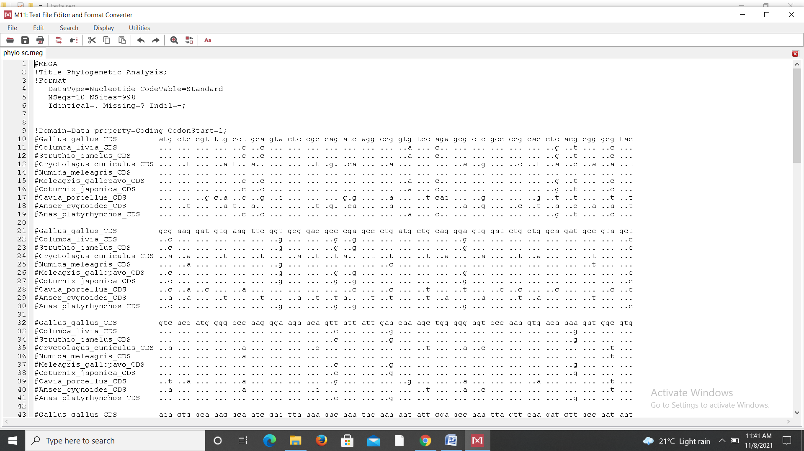

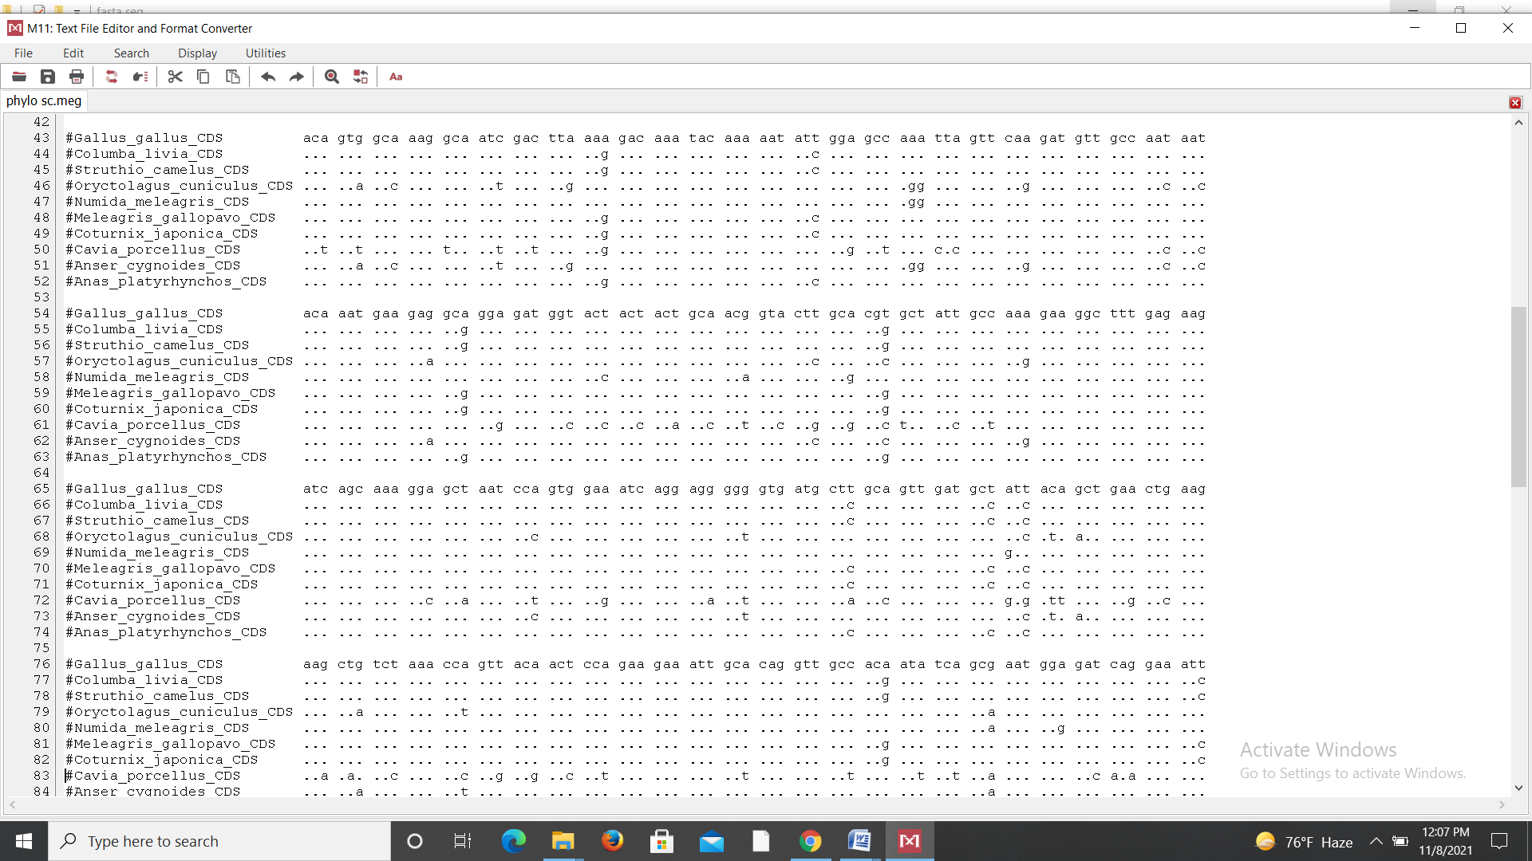

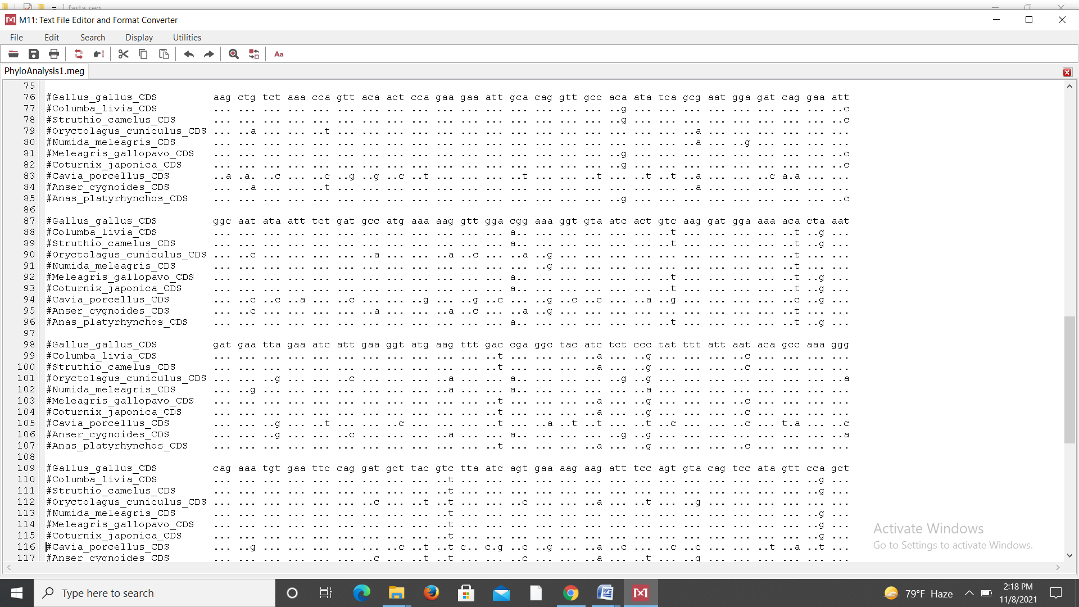

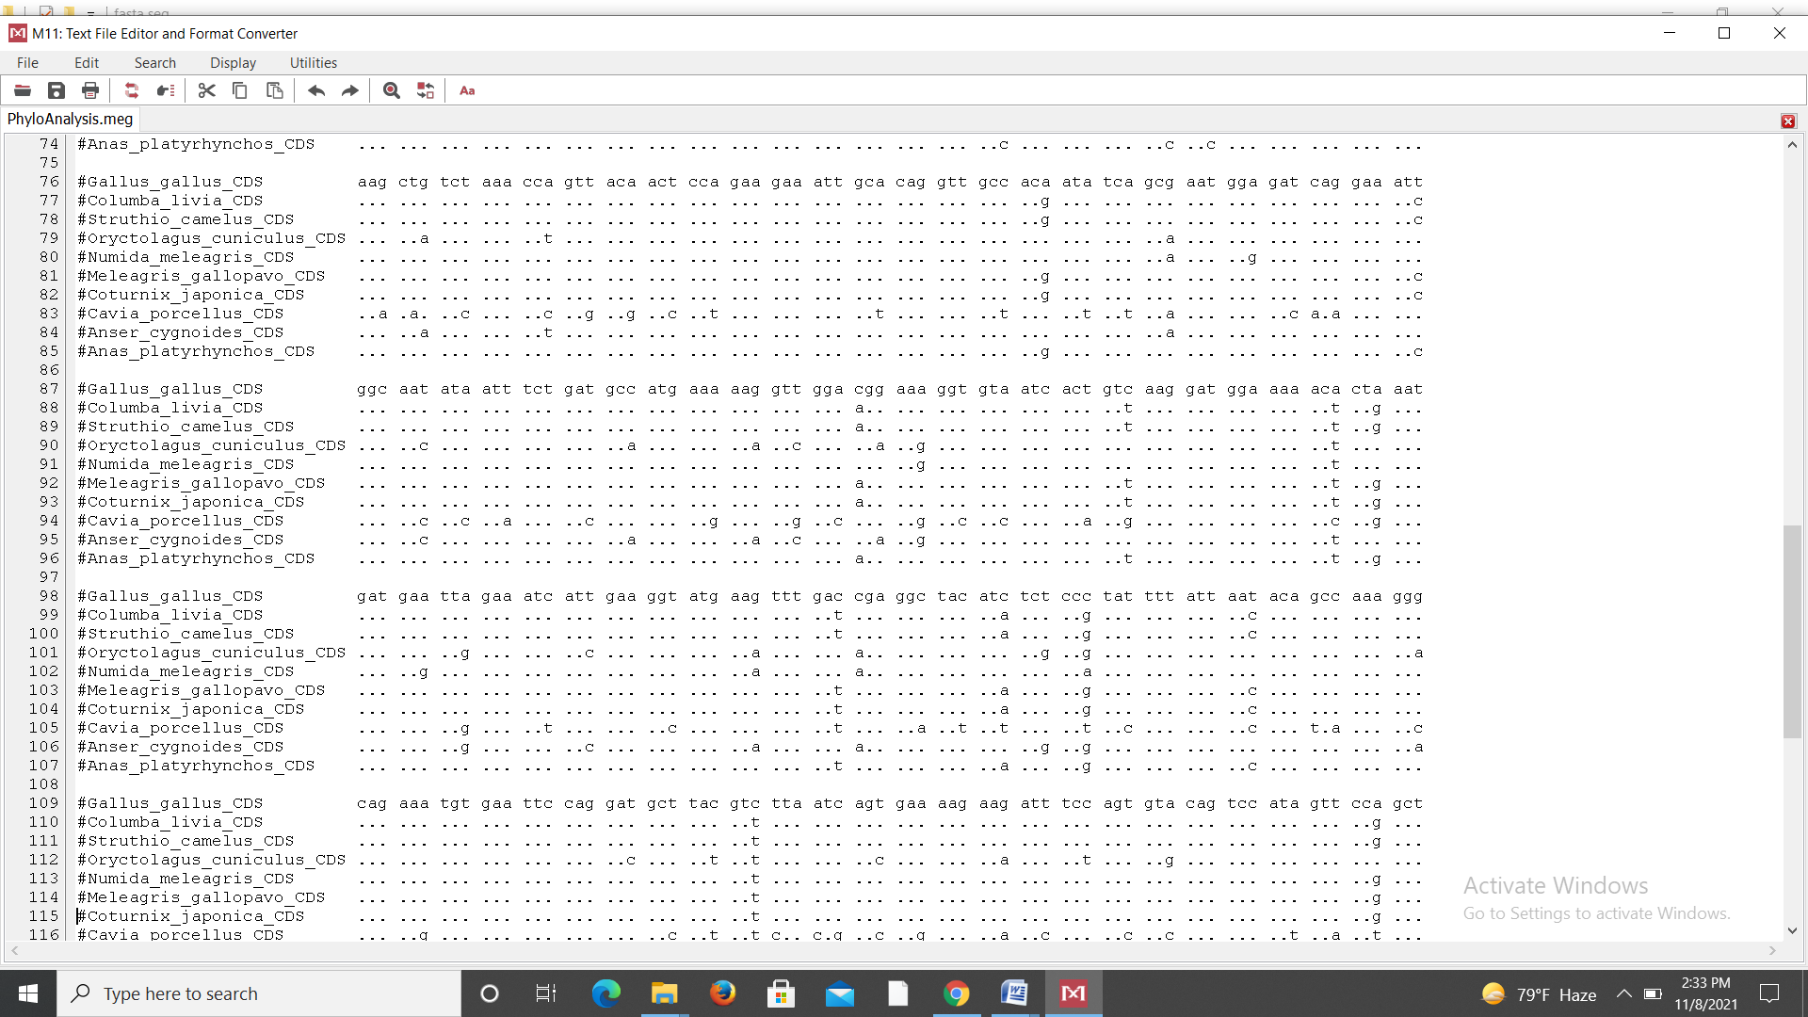

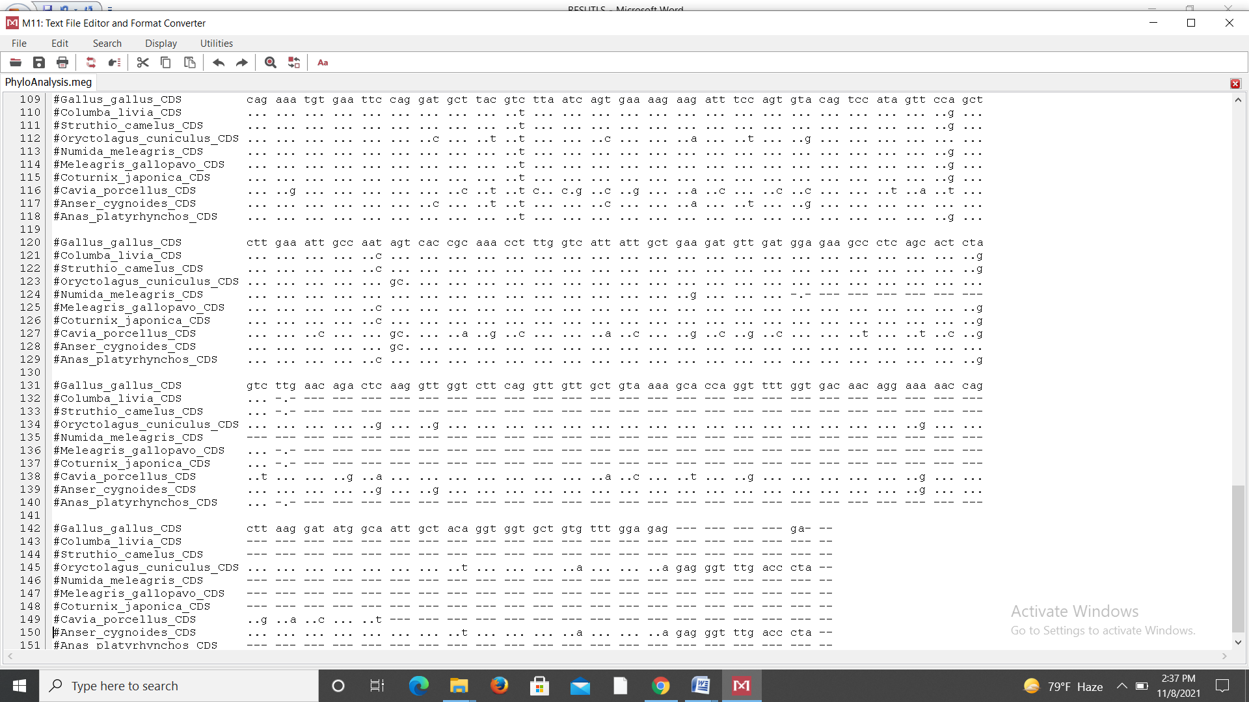

*Figure 1: Multiple alignment report of chicken HSP60 gene partial CDS with that of other species*

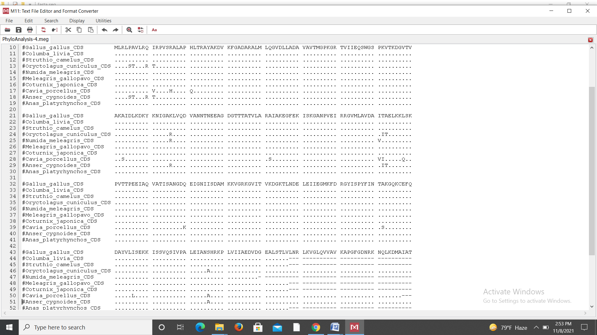

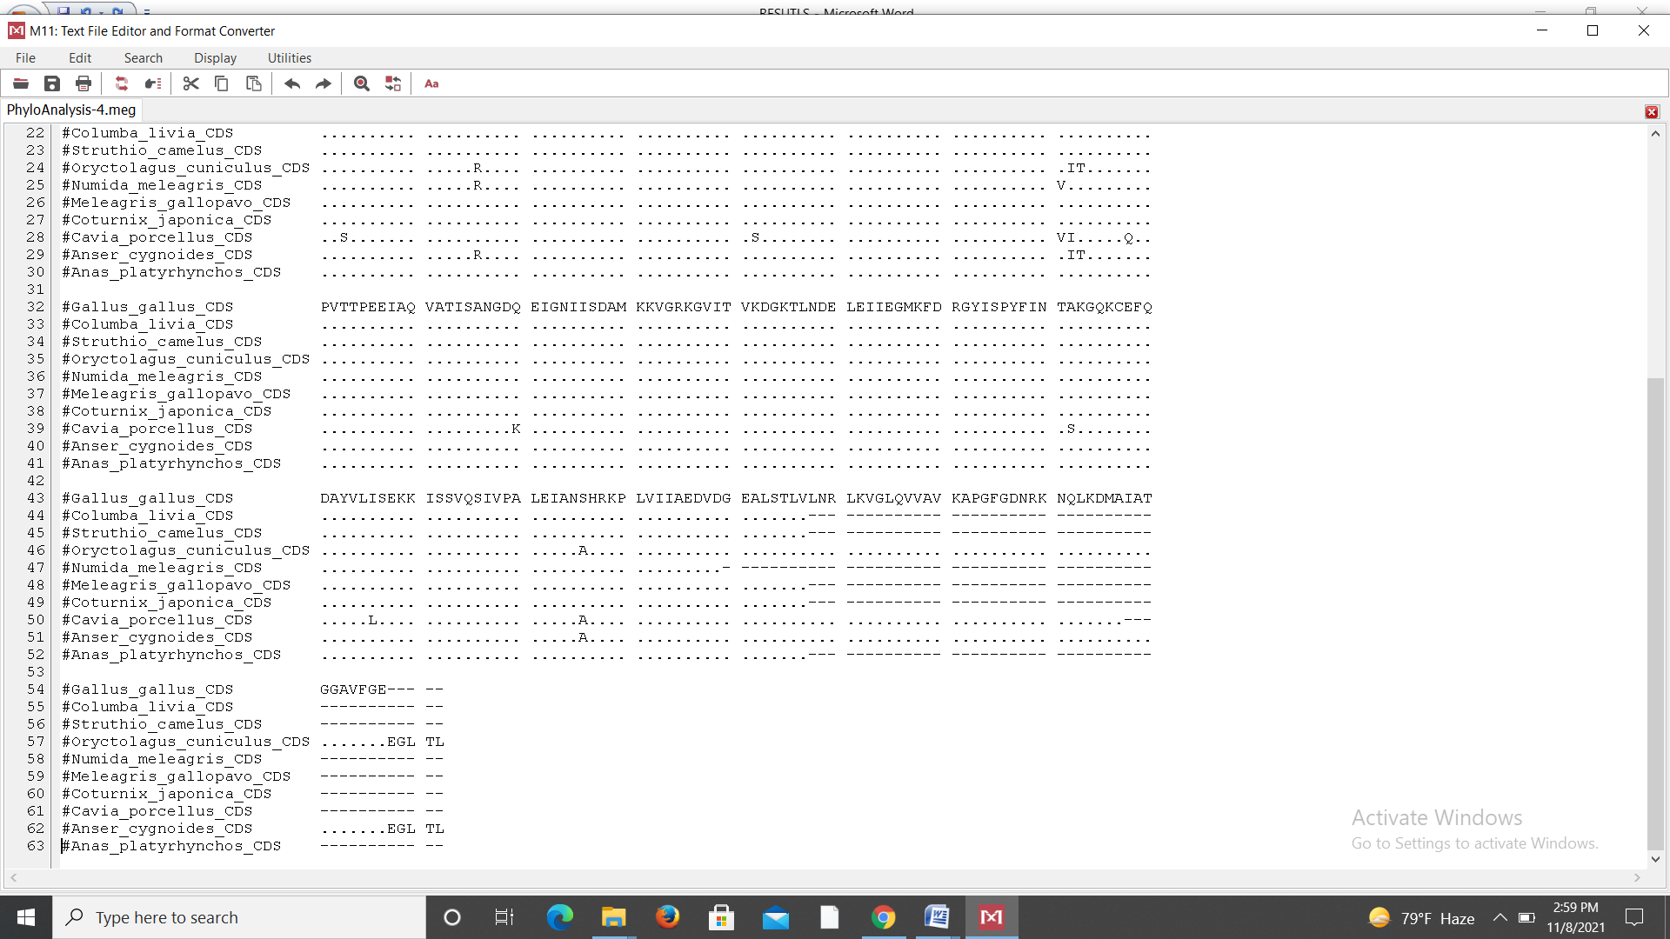

*Figure 2: Multiple alignment report of deduced amino acid sequence of chicken HSP60 gene with that of other species*

**3.3 Phylogenetic tree analysis**

MEGA X software was used to construct a phylogenetic tree at nucleotide level. Chicken and guinea fowl HSP60 gene form the same cluster and showed identical lineage. Quail, ostrich, pigeon and duck might have evolved from same common ancestor. Geese and rabbit form same cluster, with bootstrap value of 100%. Chicken, quail and guinea pig sequences showed dissimilarities suggesting different ancestry.

**3.4 Estimating Evolutionary Distances Using Pairwise Distance**

The pair wise distance between sequences aligned with ClustalW method was estimated by MEGA X software by computing the proportion of nucleotide differences between each pair of sequences. The pairwise distance estimates the evolutionary divergence between sequences. Analyses were conducted using the Maximum Composite Likelihood model (Tamura et al., 2004). Maximum divergence from chicken partial cDNA was observed with guinea pig CDS with value of 0.20695875 and minimum divergence was observed with guinea fowl with value of 0.02806869

**3.5 Z test for Test of Neutrality**

In order to check whether positive selection was operating on HSP60 gene or not Z test was conducted. P values of less than 0.05 are considered significant at the 5% level. With the above tests conducted on MEGA X software the alternate hypotheses dN ≠ dS (test of neutrality) and dN < dS (purifying selection) are accepted. It means that the number of non-synonymous nucleotide changes is low as compared to synonymous changes and hence the selection is of purifying type. There is no positive selection.

4. Conclusion

Based on genetic similarity of chicken *HSP*60, it was found to be highly conserved among different species. The *HSP*60 gene might have evolved by purifying selection (dS > dN). Based on phylogenetic analysis, chicken CDS sequence is the closest to quail, ostrich, turkey, pigeon, duck and the most divergent to guinea pig.

Ethical approval

“All authors hereby declare that "Principles of laboratory animal care" (NIH publication No. 85-23, revised 1985) were followed, as well as specific national laws where applicable. All experiments have been examined and approved by the appropriate ethics committee”

Disclaimer (Artificial intelligence)

Option 1:

Author(s) hereby declare that NO generative AI technologies such as Large Language Models (ChatGPT, COPILOT, etc.) and text-to-image generators have been used during the writing or editing of this manuscript.

References

Bruschi, S.A., West, K.A., Crabb, J.W., Gupta, R.S. and Stevens, J.L. (1993). Mitochondrial HSP60 (P1 protein) and a HSP70-like protein (mortalin) are major targets for modification during S-(1,1,2,2-tetrafluoroethyl)-L-cysteine-induced nephrotoxicity. J Biol Chem*.,*268, 23157–23161.

Cheng, M.Y., Hartl, F.U. and Horwich, A.L. (1990). The mitochondrial chaperonin HSP 60 is required for its own assembly. Nature, 348, 455–8.

Itoh, H., Komatsuda, A., Ohtani, H., Wakui, H., Imai, H., Sawada, K. I. and Hamada, F. (2002). Mammalian HSP60 is quickly sorted into the mitochondria under conditions of dehydration. European Journal of Biochemistry, 269(23), 5931-5938.

Kalmar, B. and Greensmith, L. (2009). Induction of heat shock proteins for protection against oxidative stress. Advanced Drug Delivery Review, 61, 310–318.

Kregel, K.C. (2002). Heat shock proteins: modifying factors in physiological stress responses and acquired thermotolerance*.*J Appl Physiol., 92,2177–2186. doi:10.1152.

Lebret, T., William, R. and Watson, G. (2003). Heat shock proteins HSP27, HSP60, HSP70, and HSP90: expression in bladder carcinoma. Biological Science, 9, 970-7.

Nei, M. and Gojobori, T. (1986). Simple methods for estimating the numbers of synonymous and nonsynonymous nucleotide substitutions. Molecular Biology and Evolution, 3, 418-426.

Saitou, N. and Nei, M. (1987). The neighbor-joining method: a new method for reconstructing phylogenetic trees*.* Molecular Biology and Evolution, 4, 406- 425.

Singh, S. (2020). Characterization of Indigenous Chicken of Poonch District of Jammu & Kashmir. P.h.D thesis submitted to Shere-e-Kashmir University of Agriculture Sciences and Technology of Jammu,Chatha.

Tamura, K., Nei, M. and Kumar, S. (2004). Prospects for inferring very large phylogenies by using the neighbor-joining method*.* Proceedings of the National Academy of Sciences (USA), 101(30), 11030-11035.

Timperio, A.M., Eqidi, M.G. and Zolla, L. (2008). Proteomics applied on plant abiotic stresses: Role of heat shock proteins (*HSP*). Journal of Proteomics*,*71, 391–411.

Tytell, M. and Hooper, P. L**.** (2001). Heat shock proteins: new keys to the development of cytoprotective therapies . Expert Opin. Ther. Targets*,* 5**,** 267-287.

Bastaki, N. K., Albarjas, T. A., Almoosa, F. A., & Al-Adsani, A. M. (2023). Chronic heat stress induces the expression of HSP genes in the retina of chickens (Gallus gallus). Frontiers in Genetics, 14, 1085590.

Truong, A. D., Tran, H. T. T., Chu, N. T., Nguyen, H. T., Phan, L., Phan, H. T., ... & Dang, H. V. (2023). Comprehensive genome‑wide analysis of the chicken heat shock protein family: identification, genomic organization, and expression profiles in indigenous chicken with highly pathogenic avian influenza infection. BMC genomics, 24(1), 793.

Hu, C., Yang, J., Qi, Z., Wu, H., Wang, B., Zou, F., ... & Liu, Q. (2022). Heat shock proteins: Biological functions, pathological roles, and therapeutic opportunities. MedComm, 3(3), e161.