**Original Research Article**

**Development of Early Maturing and High Yielder Finger Millet Cultivar (VL *Mandua* 400)**

**Abstract**

A new finger millet variety (VL *Mandua* 400) has been developed by ICAR-Vivekananda Parvatiya Krishi Anusandhan Sansthan, Almora. Newly bred cultivar was developed from the cross between VL-352 (early maturing finger millet cultivar) and GPU 48 (blast resistant finger millet variety) followed by pedigree method of selection in the segregating generations. It has consistently performed well in All India Coordinated Trials, showing adaptability across diverse agro-climatic conditions, with notable yield improvements in the seven states namely, Madhya Pradesh, Karnataka, Chhattisgarh, Bihar, Jharkhand, Gujarat, and Andhra Pradesh. VL *Mandua* 400, achieving an average grain yield of 3,476.76 kg/ha over 3 years (*kharif* 2019 to *kharif* 2021) compared to national check VL *Mandua* 376 (3,111.72 kg/ha) of testing under rainfed *kharif* ecology condition. Its performance in Coordinated trials showed grain yield advantages of 11.50% over the elite early national check variety VL *Mandua* 376, underscoring its adaptability to various agro-climatic conditions. VL *Mandua* 400 (8,480.39 kg/ha) also out-yielded the elite early check VL *Mandua* 376(7,190.06 kg/ha) in terms of fodder yield by an impressive margin of 17.95% in All India Coordinated trials conducted across the mentioned seven states. It matures in 101 to 103 days (early) and features an erect growth habit, non-pigmented node and semi-compact ear-heads with top incurved fingers, reaching heights of 88 to 95 cm, with medium, round-shaped grains of brown color.

VL *Mandua* 400 recorded low incidence to leaf blast (grade score 3.4), neck blast (13.48%) and finger blast (12.0%), banded leaf blight (29.5%) and foot rot (12.06%). It also possesses multi pest resistance and exhibited very low incidence of Myllocerus weevil (3.64%; stem borer (7.72%), shoot aphids (7.42%) and grasshopper (12.60%).

Nutritionally, VL *Mandua* 400 overtook national checks in calcium (399.5 mg/100g) with the superiority of 25.3%, compared to elite early check VL *Mandua* 376 (318.9 mg/100g). It also possesses high protein (8.5%) compared to VL *Mandua* 376 (7.7%).

VL *Mandua* 400 was identified in 2022 and subsequently released and notified in 2023 because to its exceptional performance in grain yield, grain quality and resistance towards major diseases and insect-pest as documented in All India Coordinated trials.

**Keywords**: VL *Mandua* 400, high yielder, early maturing, blast resistance, grain quality.

1. **INTRODUCTION**

Small millets include a group of small- seeded cereal crops of the grass family *Poaceae.* These are particularly suitable for rainfed cultivation as a result of their short growing season, ability to produce even in poor soil with low moisture content and an inadequate management practices, and C4 photosynthesis system (Himasree *et al.,* 2017; Vetriventhan *et al*., 2020). By virtue of above capabilities these crops are considered as resilient to climate. Among these, finger millet is the most important nutrient-dense staple grains, extensively grown by marginal farmers in dry lands of Asia and Africa (Bhinda *et al*., 2023). Millets are also nutritionally superior to rice and wheat since their grains contain high amounts of vitamins, iron, carbohydrate, calcium (Ca), potassium, zinc, phosphorus, magnesium, and essential amino acids (Saleh *et al*., 2013).

Finger millet known as nutri-cereal because of high concentration of fibre and calcium in its grains (Keerthana *et al*., 2019) and consumed in a variety of ways. The Ca content in finger millet (344 mg/100 g) is almost 10-fold higher than wheat (41 mg/100 g), maize (26 mg/100 g) and rice (33 mg/100 g) and three times higher than milk. So, finger millet is an example of Ca rich crop in developing countries of tropical and subtropical regions. Finger millet grains also contain higher content of minerals such as phosphorus, iron and manganese compared to other cereals (Kumar *et al*., 2016). More importantly, it is recommended for diabetic patients because of its low glycemic index (Sood *et al*., 2017).

The seeds can be stored for more than 5 years without insect damage that makes it a valuable crop for famine hit areas (Latha *et al*., 2005).

This crop has a broad range of seasonal adaptations ranging from sea level (in parts of Andhra Pradesh and Tamil Nadu) to around 2400 metres above mean sea level in the hills of Uttarakhand, India (Joshi *et al*., 2021).

Finger millet has huge significant prospective to function as a substitute grain for assuring food and nutritional security across most parts of the globe due to high concentration of micronutrients, dietary fibre, vitamins, and phytochemicals of numerous therapeutic benefits in its grains (Joshi *et al.,* 2021).

Finger millet grains are more nutrient-dense than rice, containing 8 times higher calcium, 4 times more minerals, and 2 times more phosphorus per unit grain consumed (Malathi *et al*., 2016). Therefore, the use of finger millet as a nutritional alternative in different food preparations has gained popularity over the last decade.

Despite the huge potential of finger millet, efforts for genetic improvement considerably lag those of major crops. Yield enhancement in finger millet can be realize through recuperating yield components like early flowering, synchronized maturity, ear length, number of fingers per ear, finger length and number of productive tillers per plant. Beside these vital traits, breeding for resistance to blast is one of the most important objectives of finger millet genetic improvement programme (Sood *et al*., 2023).

The finger millet crop is grow as traditional cultivar types by the majority of farmers, which have loose panicles, are low yielding, and are blast susceptible, which has resulted in low crop productivity levels in the area (Joshi *et al*., 2022)

Thus, keeping the above point in consideration the cultivar VL *Mandua* 400 was developed to add finger millet diversity in the adapted states, with the goal of developing a high yielding, blast resistant and nutritionally superior finger millet cultivar especially matched to rainfed agro-ecology of major finger millet growing areas of country.

1. **MATERIALS AND METHODS**

The finger millet genotype VL *Mandua* 400 developed at ICAR-Vivekananda Parvatiya Krishi Anusandhan Sansthan, Almora. This was developed from the cross between VL-352 (early maturing finger millet cultivar) and GPU 48 (blast resistant finger millet variety). This was followed by the selection process in the segregating generations using the pedigree method. The selections were made during the segregating generations of the progenies (F2 to F5) derived from the cross VL 352 x GPU 48 with a keen emphasis on high yield, maturity (100-105 days), and blast resistance. In 2016, during F6 generation the uniform progenies were harvested in bulked. A homozygous and homogeneous genotype VL 400 was tested in station trial during 2017 and 2018.

Subsequently, the culture was evaluated as code name **FMV-1162** at multi-locations under All India Coordinated Small Millets (Early and Medium Duration) (AICRP-SM) trials across India along with elite early national check VL *Mandua* 376 during the *Kharif* season of2019, 2020 and 2021. The testing was done in randomized block design with three replications in AICRP with plot size of 3.00 x 1.125 m2. The crop was grown with recommended dose of fertilizers under rainfed condition. Additionally, during the AICRP-SM trials, the genotype was tested for reaction to major diseases and insect pests under natural field conditions at the hot spot locations. Also, evaluated for adaptability to agronomic variables (using different doses of fertilizers) in advance varietal trial-II during *Kharif* 2021 to test the reaction of fertility level to grain and fodder yield.

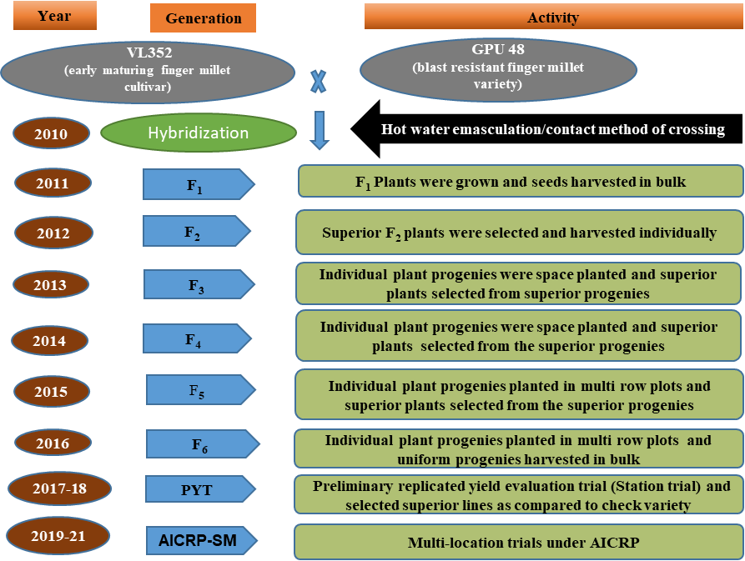

**Figure 1. Flow chart of development of high yielding, early maturing and blast resistant finger millet variety VL *Mandua* 400**

1. **RESULTS AND DISCUSSION**

**3.1 Yield Performance in evaluation trials**

VL 400 demonstrated a substantial improvement in grain and fodder yield over local and national benchmarks under preliminary yield evaluation done in Station trial during 2017 to 2018 at Hawalbagh farm, Almora. Further, VL 400 (FMV 1162) was evaluated under All India Coordinated Trials, where it participated in initial varietal trials during the 2018-19 season and advanced varietal trials in the subsequent 2019-20 and 2020-21 seasons under inorganic conditions.

The comparison was made with early elite national check (VL *Mandua* 376) and there was no qualifying entry other than the proposed variety (VL *Mandua* 400) in the early maturity group. The consistent yield advantage underscores the adaptability and resilience of the cultivar, making it a promising candidate for enhancing finger millet production under diverse agro-climatic.

Over three years and multi locational trials, the entry VL 400 (FMV 1162) consistently provided an average grain yield of 3,476.76 kg/ha and shown superiority of 11.50% over elite early duration national check VL *Mandua* 376 (3,111.72 kg/ha) in All India Coordinated trials conducted across the mentioned seven states (**Table 1**). This yield advantages underscoring VL *Mandua* 400’s enhanced productivity and suitability for broader cultivation. This sustained performance across diverse environments supports its potential as a reliable, high-yielding variety suitable for national adoption and highlights its contribution to improved grain production

Similarly, the proposed variety VL *Mandua* 400 (8,480.39 kg/ha) out-yielded the elite early check VL *Mandua* 376(7,190.06 kg/ha) in terms of fodder yield by an impressive margin of 17.95% in All India Coordinated trials conducted across the mentioned seven states **(Table 2).**

**Table 1. Summary of grain yield (kg/ha) of VL *Mandua* 400 in All India coordinated varietal trials**

|  |  |  |  |  |  |  |  |
| --- | --- | --- | --- | --- | --- | --- | --- |
| Item | Year of testing | No. of locations | **Proposed variety**  **(VL *Mandua* 400)** | **Days to maturity** | **Elite early Check (VL 376)** | **Days to maturity** | **Other Qualifying variety** |
| Mean yield (kg/ha) | 1st year  (2019-20) | 14 | 3316.65 | 101 | 2953.75 | 101 | NA* |
| 2nd year  (2020-21) | 14 | 3896.10 | 103 | 3394.99 | 100 |
| 3rd year  (2021-22) | 12 | 3174.32 | 101 | 2965.53 | 101 |
|  | **Weighted Mean** | **40** | **3476.76** | **102** | **3111.72** | **101** |
| Percentage increase over the elite early check | 1st year  (2019-20) |  |  |  | 12.29 |  |
| 2nd year  (2020-21) |  |  |  | 14.76 |  |
| 3rd year  (2021-22) |  |  |  | 7.04 |  |
|  | **Weighted mean** | **40** |  |  | **11.73** |  |

*NA: **There was no qualifying variety other than the proposed variety (VL*Mandua* 400) in the early maturity group**

**Table 2. Summary of fodder yield (q/ha) of VL *Mandua* 400 in All India coordinated varietal trials**

|  |  |  |  |  |
| --- | --- | --- | --- | --- |
| Item | Year of testing | No. of locations | **Proposed variety**  **(VL *Mandua* 400)** | **Elite early Check (VL 376)** |
|
|
| Mean fodder yield (kg/ha) | 1st year  (2019-20) | 13 | 8327.52 | 6893.38 |
| 2nd year  (2020-21) | 10 | 8757.41 | 7342.30 |
| 3rd year  (2021-22) | 12 | 8415.15 | 7384.61 |
|  | **Weighted Mean** | **35** | **8480.39** | **7190.06** |
| Percentage increase over the elite early check | 1st year  (2019-20) |  |  | 20.80 |
| 2nd year  (2020-21) |  |  | 19.27 |
| 3rd year  (2021-22) |  |  | 13.96 |
|  | **Weighted mean** | **35** |  | **17.95** |

State-wise and yearly yield data for VL *Mandua* 400, shown in **Table 3**, indicating its strong adaptability and yield performance in major finger millet-producing states: Madhya Pradesh, Karnataka, Bihar, Chhattisgarh, Jharkhand, Gujarat and Andhra Pradesh. To ensure its success in these regions, it is critical for the variety to be resilient to changing climate conditions. **VL *Mandua* 400** has recorded significant grain yield superiority over the elite early check VL *Mandua* 376in the states of Madhya Pradesh (19.65%), Karnataka (10.73%), Chhattisgarh (26.32%), Bihar (17.62%), Jharkhand (6.68%), Gujarat (5.01%) and Andhra Pradesh (5.02%). This substantial yield advantage highlights VL *Mandua* 400’s suitability and potential for widespread cultivation in varied agro-climatic conditions across states.

**Table 3. State wise and year wise grain yield data of the proposed variety VL *Mandua* 400 in All India coordinated varietal trials**

|  |  |  |  |  |
| --- | --- | --- | --- | --- |
| **States** | **Year of testing** | **No. of locations** | **Proposed variety (VL *Mandua*400)** | **Elite early Check (VL 376)** |
| Madhya Pradesh | 1st year (2019-20) | 2 | 2776.68 | 2494.49 |
| 2nd year (2020-21) | 2 | 3677.32 | 2797.33 |
| 3rd year (2021-22) | 2 | 3112.66 | 2703.71 |
| **Weighted Mean** | **6** | **3188.88** | **2665.17** |
| **% increase or decrease over early check** |  |  | **19.65** |
| Karnataka | 1st year (2019-20) | 4 | 3767.86 | 3633.30 |
| 2nd year (2020-21) | 4 | 4077.68 | 3344.18 |
| 3rd year (2021-22) | 3 | 3468.54 | 3276.28 |
| **Weighted Mean** | **11** | **3798.89** | **3430.80** |
| **% increase or decrease over the early check** |  |  | **10.73** |
| Chhattisgarh | 1st year (2019-20) | 1 | 2907.94 | 2351.85 |
| 2nd year (2020-21) | 1 | 1898.15 | 1782.41 |
| 3rd year (2021-22) | 1 | 3180.25 | 2188.27 |
| Weighted Mean | **3** | **2662.11** | **2107.51** |
| **% increase or decrease over the early check** |  |  | **26.32** |
| Bihar | 1st year (2019-20) | 1 | 4012.35 | 3395.06 |
| 2nd year (2020-21) | 1 | 4845.68 | 4135.80 |
| 3rd year (2021-22)* | - | 1420 | 1790 |
| **Weighted Mean** | **2** | **4429.02** | **3765.43** |
| **% increase or decrease over the early check** |  |  | **17.62** |
| Jharkhand | 1st year (2019-20) | 1 | 3635.80 | 3061.73 |
| 2nd year (2020-21) | 1 | 5730.37 | 4876.54 |
| 3rd year (2021-22) | 1 | 2697.53 | 3370.37 |
| **Weighted Mean** | **3** | **4021.23** | **3769.55** |
| **% increase or decrease over the early check** |  |  | **6.68** |
| Gujarat | 1st year (2019-20) | 2 | 3386.97 | 3021.46 |
| 2nd year (2020-21) | 2 | 3794.73 | 3777.31 |
| 3rd year (2021-22) | 2 | 2853.09 | 2765.43 |
| **Weighted Mean** | **6** | **3344.93** | **3188.07** |
| **% increase or decrease over the early check** |  |  | **5.01** |
| Andhra Pradesh | 1st year (2019-20) | 3 | 2728.97 | 2718.34 |
| 2nd year (2020-21) | 3 | 3248.76 | 3051.39 |
| 3rd year (2021-22) | 3 | 3733.86 | 3489.15 |
| Weighted Mean | **9** | **3237.20** | **3086.29** |
| **% increase or decrease over the early check** |  |  | **5.02** |

**Table 4. Summary of grain yield data under adaptability to Agronomic Variable Trials**

|  |  |  |  |  |  |
| --- | --- | --- | --- | --- | --- |
| **Name of experiment** | **Item** | **VL *Mandua* 400 (Proposed variety)** | **VL 376**  **(elite early check)** | **GPU 67**  **(National check)** | **PR 202**  **(National check)** |
| **Fertilizer experiment** | **Grain yield (kg/ha) under F1 (50%** **recommended dose of fertilizer)** | 2157 | 1321 | 2245 | 1905 |
| **Grain yield (kg/ha) under F2 (100% recommended dose of fertilizer)** | 2594 | 1983.34 | 2680.45 | 2257.34 |
| **Grain yield (kg/ha) under F3 (125% of recommended dose of fertilizer)** | **2838** | **2330** | **2930** | **2373** |

The fertilizer response experiment conducted across six locations during advanced varietal trial - II in the 2020-21 season. Under this experiment the recommended dose of fertilizers (RDF) was taken as N:P2O5:K2O @ 50:40:25 kg/ha on the finger millet proposed variety VL *Mandua* 400 and national checks (VL *Mandua* 376, GPU-67 and PR-202). The proposed variety VL *Mandua* 400 has shown positive response in terms of grain and fodder yield to higher fertilizer dose. This revealed that VL *Mandua* 400 demonstrated competitive yield performance under different fertilizer regimes (**Table 4**).

When subjected to a 50% recommended dose of fertilizer (RDF), VL *Mandua* 400 produced a grain yield of 2157 kg/ha, compared to 1321 kg/ha for VL-376, 2245 kg/ha for GPU-67 and 1905 kg/ha for PR 202. At the 100% RDF, VL *Mandua* 400 achieved a yield of 2594 kg/ha, while VL-376, GPU-67 and PR 202 yielded 1983 kg/ha, 2680 kg/ha and 2257 kg/ha, respectively. With the higher fertilizer level (125% RDF) than the RDF used, VL *Mandua* 400 produced 2838 kg/ha, while VL-376, GPU-67 and PR-202 yielding 2330 kg/ha, 2930 and 2373 kg/ha, respectively. These results suggest that although VL *Mandua* 400 may benefit from higher fertilizer applications, its performance under varying fertilizer levels makes it a valuable genotype for regions with less intensive fertilizer use.

**3.2 Reaction to major diseases and insect pests**

The proposed variety VL *Mandua* 400 has shown resistance against major diseases affecting finger millet, making it well-suited for all India *Kharif* and rainfed production (**Table 5**). Blast is one of the major disease that has a highly negative impact on the production and yield level of finger millet in the hills as well plains (Sood et al., 2019).

VL *Mandua* 400 exhibited fewer incidences to leaf (grade score 3.4), neck (13.48%) and finger blast (12.0%), banded leaf blight (29.5%) and foot rot (12.06%) and fell in the same disease scale category of moderately resistant with early duration national check variety (VL *Mandua 376*) in all India coordinated trials (mean of 7-9 locations). These consistent disease resistance levels position for VL *Mandua* 400 as a resilient option for cultivation, offering enhanced stability and productivity in varied environments.

**Table 5. Reaction to major diseases**

|  |  |  |  |  |  |  |
| --- | --- | --- | --- | --- | --- | --- |
| Disease name | Year | Number of locations | VL 400  (Proposed variety ) | VL 376  Elite early check | GE 4999  (Resistant check) | *Uduru Malige*  (Susceptible check) |
| **Leaf blast (grade)** | 2019 | 9 | 4 | 3.2 | 2.7 | 6.7 |
| 2020 | 7 | 2.7 | 3.4 | 4.3 | 7.4 |
| 2021 | 9 | 3.6 | 3.9 | 2.8 | 6.7 |
| **Mean** | **-** | **3.4** | **3.5** | **3.3** | **6.9** |
| **Neck blast disease (%)** | 2019 | 8 | 14.83 | 14.77 | 8.36 | 37.46 |
| 2020 | 7 | 12.73 | 17.52 | 12.61 | 36.63 |
| 2021 | 9 | 12.90 | 17.94 | 6.69 | 29.4 |
| **Mean** | **-** | **13.48** | **16.74** | **9.22** | **34.5** |
| **Finger blast (%)** | 2019 | 9 | 11.2 | 10.5 | 6.7 | 29.10 |
| 2020 | 7 | 8.34 | 13.90 | 9.27 | 32.90 |
| 2021 | 9 | 16.48 | 20.05 | 9.17 | 29.73 |
| **Mean** | **-** | **12.00** | **14.82** | **8.38** | **30.58** |
| **Banded leaf blight (%)** | 2019 | 2 | 18.10 | 15.70 | 5.20 | 49.90 |
| 2020 | 2 | 24.64 | 16.51 | 11.67 | 49.17 |
| 2021 | 3 | 40.42 | 37.62 | 18.34 | 52.40 |
| **Mean** | **-** | **29.50** | **25.40** | **11.74** | **50.49** |
| **Foot rot**  **(%)** | 2019 | 1 | 18.13 | 18.71 | 3.51 | 16.96 |
| 2020 | 2 | 14.97 | 14.90 | 10.82 | 21.02 |
| 2021 | 1 | 3.09 | 16.51 | 3.32 | 24.64 |
| **Mean** | **-** | **12.06** | **16.70** | **5.89** | **20.88** |

The Proposed variety, VL *Mandua* 400, exhibited a multi pest resistance and recorded very low incidence of *Myllocerus* weevil (3.64%), stem borer (7.72%), shoot aphids (7.42%) and grasshopper (12.60%) over the three years of natural infestation, demonstrating its suitability for *Kharif* and rainfed production across India (**Table 6**).

**Table 6. Reaction to major insect pest**

|  |  |  |  |  |
| --- | --- | --- | --- | --- |
| **Insect** | **Year** | **VL 400**  **(Proposed variety )** | **VL 376**  **Elite early check** | **GPU 66**  **(Resistant check)** |
| **Grasshopper (% plant affected )** | 2019 | 14.6 | 11.07 | 7.49 |
| 2020 | 7.98 | 7.92 | 6.53 |
| 2021 | 15.23 | 9.65 | 12.25 |
| Mean | 12.60 | 9.54 | 8.75 |
| **Stem borer (% plants affected)** | 2019 | 9.67 | 10.0 | 0.0 |
| 2020 | 4.92 | 6.92 | 10 |
| 2021 | 8.54 | 5.11 | 3.83 |
| **Mean** | 7.72 | 7.34 | 4.61 |
| **Myllocerus weevil/plant** | 2019 | 4.70 | 2.73 | 1.48 |
| 2020 | 2.20 | 3.71 | 2.45 |
| 2021 | 4.00 | 1.67 | 1.00 |
| **Mean** | 3.64 | 2.70 | 1.65 |
| **Shoot aphid (% Plants affected)** | 2019 | 7.41 | 9.40 | 11.92 |
| 2020 | 6.48 | 6.82 | 6.35 |
| 2021 | 8.35 | 5.19 | 7.34 |
| **Mean** | 7.42 | 7.14 | 8.54 |

**3.3 Quality parameters**

The newly tested variety VL *Mandua* 400 exhibited superior nutritional quality compared to checks. The grains of proposed variety, VL *Mandua* 400 (399.5 mg/100g) own 25.3%, 15.8% and 11.8% higher calcium than elite early check VL *Mandua* 376 (318.9 mg/100g), medium duration check GPU 45 (344.8mg/100g) and popular local early duration variety VL *Mandua* 352 (357.5 mg/100g) respectively. It also possessed high protein (8.5%), calcium (399.5 mg/100g), zinc (34.5 mg/kg), iron (48.3 mg/kg), total polyphenols (0.52 mg GAE/g) and high antioxidant activity (10.93 mM trolox equivalent/g dw) compared to check varieties (**Table 7**).

**Table 7. Data on Quality Characteristics**

|  |  |  |  |  |  |
| --- | --- | --- | --- | --- | --- |
| **Quality**  **Characteristics** | **Nutrient** | Proposed variety  **(VL *Mandua* 400)** | Elite Early National Check  **(VL 376)** | National Check **(GPU 45)** | Popular local Check **(VL 352)** |
| Parameter -1 | Calcium (Ca) (mg/100g) | 399.5 | 318.9 | 344.8 | 357.5 |
| Parameter -2 | Iron (Fe) (mg/kg) | 48.3 | 34.6 | 40.4 | 41.2 |
| Parameter -3 | Zinc (Zn) (mg/kg) | 34.5 | 23.7 | 30.9 | 29.8 |
| Parameter -4 | Protein (%) | 8.5 | 7.7 | - | 8.2 |
| Parameter-5 | Total polyphenols (mg GAE/g) | 0.52 | 0.33 | - | 0.46 |
| Parameter- 6 | Total antioxidants  (mM trolox equivalent /g dw) | 10.93 | 8.71 | - | 9.87 |

Overall, the impressive nutritional profile of VL *Mandua* 400 positions it as an excellent option for enhancing dietary health, making it a strong candidate for broader cultivation and inclusion in nutrition-focused food initiatives.

* 1. **Distinguishing characteristics**

The proposed variety VL *Mandua* 400 reveal its potential for successful cultivation due to its morphological and agronomic characteristics. VL *Mandua* 400 having non-pigmented node and compact ear-heads with top incurved fingers. Plant height 88-95 cm. VL *Mandua* 400 is an early duration variety which takes 101-103 days (mean 102 days), which is at par with early duration national check VL *Mandua* 376 (101 days), allowing for timely harvesting and potentially facilitating double cropping in suitable regions. The plant has an erect growth habit with green appearance. The leaves exhibit blade pubescence. The ear heads are compact with high grain density and long fingers (8.06 cm). The seed size is bold, with a test weight (1000-seed weight) of 3.20 g, indicating a robust seed that may perform well in terms of germination and yield potential. The brown seed coloured **(Figure 2)** and round shape are desirable traits that align with consumer preferences and market standards. The variety's comprehensive descriptors are shown in **Table 8**.

**Table 8. Descriptors of the VL *Mandua* 400**

|  |  |  |
| --- | --- | --- |
| **Sl. No.** | **Characters** | **Description** |
| 1 | Plant growth habit | Erect |
| 2 | Plant: Pigmentation at leaf juncture | Absent |
| 3 | Days to 50 % flowering (days) | 66-68 days |
| 4 | Plant height (cm) | 88-95 cm (Medium) |
| 5 | Days to maturity (days) | 101-103 (Early) |
| 6 | No. of Productive tillers | 2.42-2.65 (Medium) |
| 7 | Main ear length | 7.55-8.64 (Long) |
| 8 | Fingers/Ears | 7.38-7.45 (Medium) |
| 9 | Glumes colour | Green |
| 10 | Ear : Shape | Compact (fingers incurved) |
| 11 | Finger: Branching | Absent |
| 12 | Seed: Shattering | Absent |
| 13 | Seed: Covering by glumes | Intermediate |
| 14 | Seed: Colour | Brown |
| 15 | Seed: Shape | Round |
| 16 | Seed: Surface | Smooth |
| 17 | 1000 grain weight (g) | 3.20 (Bold) |
| 18 | Biotic stress | Medium resistance |

Importantly, VL *Mandua* 400 is noted for its medium resistance for major diseases and insect pests, making it a suitable option for cultivation in all the regions. Overall, the combination of these morphological traits and biotic stress tolerance positions VL *Mandua* 400 as a promising variety for farmers, offering not only the potential for higher yields but also enhanced resilience against biotic threats, ultimately contributing to food security and sustainable agricultural practices.

**3.5 Release and Notification**

Based on its superior performance for grain yield and grain quality recorded in All India Coordinated varietal trials, VL *Mandua* 400 was recommended by Varietal Identification Committee for Sorghum and Small Millets on 29th April 2022. Subsequently, it was released and notified by the Central Sub-Committee on Crop Standards, Notification and Release of Varieties of Agricultural Crops vide notification number S.O.1056 (E); dated 06th March, 2023 with name **VL *Mandua*** (**CFMV 5**). The specific area of adaptation of this variety is the rainfed kharif ecology condition of Madhya Pradesh, Karnataka, Chhattisgarh, Bihar, Jharkhand, Gujarat and Andhra Pradesh.

**3.6 Economical Importance**

VL *Mandua* 400 combines high yield potential, disease resistance, nutritional superiority, and favorable agronomic traits, making it a promising option for sustainable finger millet cultivation across India. Due to Nutritional superiority over the traditional cultivars, it will be helpful to fight against malnutrition and strengthen the nutritional security in the country. will help save money by lowering the need for chemicals.

Apart from high yield and nutritional superiority, resistance against major diseases and insect pest will help to save money by lowering the need for chemicals. Being an early maturing variety (102 days), this variety will also suit to those areas, where monsoon gets delayed or drought is a common phenomenon, higher hills or areas where crop growth period is limited.

1. **Conclusion**

At the national level, the newly developed finger millet variety VL *Mandua* 400 consistently outperformed elite early national check variety VL *Mandua* 376 in both grain and fodder yields across various locations in seven states. In view of the high yield potential, early maturity, blast resistance and superior grain quality (high calcium and protein) with check, VL *Mandua* 400 was released and notified in 2023 as finger millet cultivar well suited for rainfed inorganic agro-ecology. This would meet the enduring needs of the finger millet grower farmers, because it is primarily cultivated in rainfed condition. This variety also revealed resistance to major diseases and pest, including blast, banded leaf blight, foot rot, Myllocerus weevil, stem borer, and grasshopper, making it an attractive option for farmers seeking to enhance their income while minimizing the environmental impact.

Overall, the findings suggest that VL *Mandua* 400 has great potential to promote sustainable agricultural practices, bolster nutritional security, and increase farmers' incomes in finger millet cultivation throughout India. Because of its virtue by high yield potential and early maturity farmers will adopt the variety more readily, and consumers will find it more appealing with diversified value-added products due its nutritional attributes.

**Acknowledgement**

The authors are grateful and duly recognize the Project Coordinator and all the PIs of All India Coordinated Research Project (AICRP) on Small Millets.

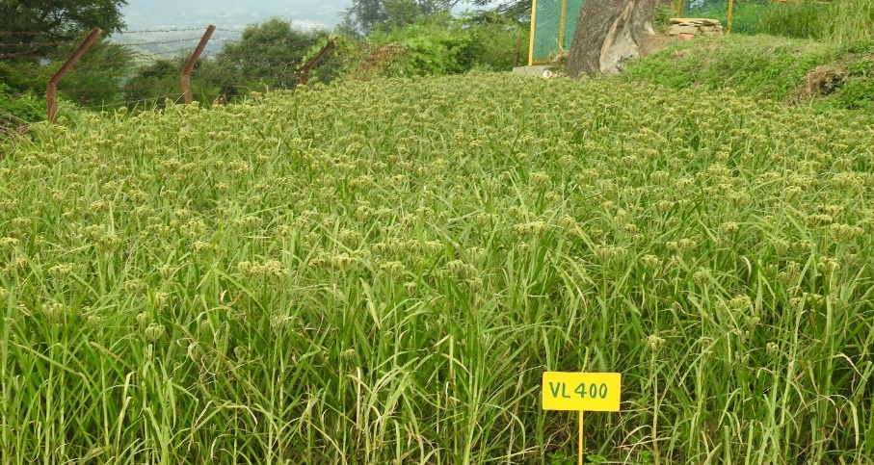

**Figure 2**. **Photographs** **of** **field view of VL *Mandua* 400**

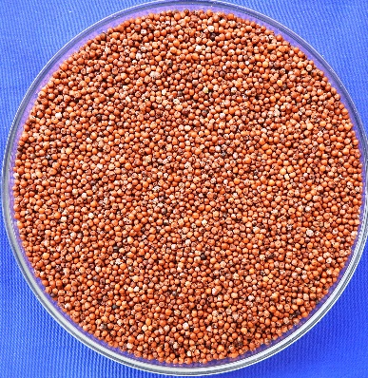

**Figure 3**. **Photographs** **of Seeds of VL *Mandua* 400**

**Disclaimer (Artificial intelligence)**

**Option 1:**

**Author(s) hereby declare that NO generative AI technologies such as Large Language Models (ChatGPT, COPILOT, etc.) and text-to-image generators have been used during the writing or editing of this manuscript.**

**References:**

Bhinda, M.S., Joshi, D.C., Sood, S., Gupta, A., Khulbe, R.K., Pandey, B.M., Rajashekara. H. and Kant, L. (2023). VL *Mandua* 378: A high yielding, medium maturing, blast resistant finger millet cultivar suitable for rainfed organic agro-ecology of Himalayan region. *Pharma Innovation*, 12(12):1100-1104.

Himasree, B., Chandrika, V., Sarala, N.V. and Prasanthi, A. (2017). Evaluation of remunerative foxtail millet (*Setaria italica* L.) based intercropping systems under late sown conditions. Bulletin of Environment, Pharmacology and Life Sciences, 6th Special issue; (3): 306-308.

Joshi, D.C., Sood, S., Gupta, A., Khulbe, R.K., Pandey, B.M., Pal, R., Bhinda, M.S. and Kant, L. (2021). VL *Mandua* 382: The first early maturing, white seeded finger millet cultivar suitable for rainfed organic agro-ecology of the Himalayan region. *Electronic Journal of Plant Breeding*, 12(4): 1308-1313.

Joshi, D.C., Sood, S., Gupta, A., Khulbe, R.K., Bhinda, M.S., Pandey, B.M., Meena, R. and Kant, L. (2022). VL *Mandua* 380: A medium maturing, high yielding and blast tolerant finger millet cultivar for rainfed organic agro-ecology of hills. *Electronic Journal of Plant Breeding*, 13 (3): 1150-1155.

Keerthana, K., Chitra, S., Subramanian, A., Nithila, S. and Elangovan, M. (2019). Studies on genetic variability in finger millet (*Eleusine coracana* (L.) Gaertn) genotypes under sodic conditions. *Electronic Journal of Plant Breeding*, **10**: 566-569.

Kumar, A., Metwal, M., Kaur, S., Gupta, A. K., Puranik, S., Singh, S., et al. (2016). Nutraceutical value of finger millet [*Eleusine coracana* (L.) Gaertn.], and their improvement using omics approaches. *Front. Plant Sci.*, 7:934. doi: 10.3389/fpls.2016.00934

Latha, A. M., Rao, K. V., and Reddy, V. D. (2005). Production of transgenic plants resistant to leaf blast disease in finger millet (*Eleusine coracana* (L.) Gaertn.). *Plant Sci.,* 169, 657–667. doi: 10.1016/j.plantsci.2005.05.009

Malathi, B., Appaji, C., Reddy, G.R., Dattatri, K. and Sudhakar, N. (2016). Growth pattern of millets in India. *Indian Journal of Agricultural Research*, 50(4): 382-386.

Saleh, A.S., Zhang, Q., Chen, J., and Shen, Q. (2013). Millet grains: nutritional quality, processing, and potential health benefits. Compr. *Rev. Food Sci. Food Saf.,* 12: 281–295. doi: 10.1111/1541-4337.12012

Sharma, N., Bandyopadhyay, B.B., Chand, S., Pandey, P. K., Baskheti, D.C., Malik, A. and Chaudhary, R. (2022). Determining selection criteria in finger millet (*Eleusine coracana*) genotypes using multivariate analysis. *The Indian Journal of Agricultural Sciences*, 92(6): 763–768.

Sood, S., Joshi, D.C., Chandra, A.K. and Kumar, A. (2019). Phenomics and genomics of finger millet: current status and future prospects. *Planta*,250: 731-751.

Sood, S., Gupta, A.K., Kant, L. and Pattanayak, A. (2017). Finger millet (*Eleusine coracana* (L.) Gaertn.) varietal adaptability in North-Western Himalayan region of India using AMMI and GGE biplot techniques. *Electron J Plant Breed.*, **8**: 816-824.

Sood, S., Joshi, D.C., Rajashekara, H., Tiwari, A., Bhinda, M.S., Kumar, A., Kant, L. and Pattanayak, A. (2023). Deciphering the genomic regions governing major agronomic traits and blast resistance using genome wide association mapping in finger millet. *Gene*, 854: 147115.

Vetriventhan, M., Azevedo, V.C.R., Upadhyaya, H.D. et al. (2020). Genetic and genomic resources, and breeding for accelerating improvement of small millets: current status and future interventions. *Nucleus*, 63: 217–239. https://doi.org/10.1007/s13237-020-00322-3