**Assessment of diversity and genetic parameters for yield and quality traits in tomato (*Solanum lycopersicum* L.)**

**Abstract**

Germplasm evalution of 15 genotypes of tomato (*Solanum lycopersicum* L.) was carried out during Rabi 2020-21. The experiment laid in Randomized Block Design with three replications examined genetic variability, heritability and genetic advances. Phenotypic variance was greater than genotypic variation for all characteristics. The studied traits showed a wide range of variance, which is quite intriguing to tomato breeders. The high magnitude of PCV and moderate GCV were found for total soluble solids (TSS) (21.62 and 19.71) and High heritability coupled with high genetic advance was observed for lycopene content (98.67%), titrable acidity (97.23%) and dry fruit weight (91.67%). The Mahalanobis D² statistics revealed significant genetic diversity among accessions, dividing the studied genotypes into five clusters using Tocher's method based on D² values. Cluster II emerged as the largest group, comprising 6 genotypes whereas highest magnitude of intra-cluster distance was observed in cluster III (247.56). The investigation of genetic variability and divergences in the available genotypes would serve as preliminary information in devising further breeding programmes for effective selection of superior genotypes of tomato.

**Keywords:** Tomato, PCV, GCV, heritability, genetic advance, genetic diversity, yield

**Introduction**

Domesticated tomato (*Solanum lycopersicum* L.), which is grown in a range of climatic conditions worldwide, holds the top spot among other vegetables. It is a self-pollinated (Depra *et al*.,2014, Campos *et al.,*2021, Rasheed, *et al.,* 2023), annual crop that is a member of the Solanaceae family with somatic chromosome number 2n = 24 (Jenkins, 1948). Tomatoes are enriched in phytonutrients such as vitamin A, C (ascorbic acid), glutathione (GSH), carotenoids and polyphenols, as well as mineral nutrients such as Ca, P and Fe (Saleem *et al*., 2013, Kumar, *et al*., 2020, Rusu *et al.,* 2023) and are consumed fresh as well as in various cooked and processed items (Mazurenko, *et al.,* 2023 Rasheed, *et al.,* 2023, Wu and Nelson, 2023). Tomatoes and their derivatives are the primary source of lycopene and other antioxidants in the human diet (Fraser *et al.,* 2002) and Lycopene levels in tomato fruit rise 500 times during ripening (Bai and Lindhout, 2007). High antioxidant capacity in both fresh and processed tomatoes is linked to a greater ability to remove reactive oxygen species (ROS) and aids in the prevention of certain types of human cancer (Capanoglu *et al*., 2010). Several epidemiological studies have revealed that its ingestion aids in the prevention of cardiovascular disease (Arab and Steck, 2000) as well as various malignancies, such as prostate cancer (Barber and Barber, 2002). Due to the fruit's excellent nutritional value, tomatoes are known as "Poor man's orange" (Singh *et al*., 2004 and Kumar, *et al*., 2022).

Genetic variability components, such as heritability (h2) and genetic advance (GA), are crucial biometric tools for assessing the potential of the population to result into efficient selection outcome (Akhter *et al.,* 2021) and for enhancing tomato germplasm via breeding methodologies (Eppakayala *et al.,* 2021). Higher magnitude of genotypic coefficient of variation (GCV) and genetic advance as a percentage of the mean were observed for the studied traits. These findings indicate a predominance of additive genetic variances. Consequently, phenotypic selection for the enhancement of these traits can be effectively accomplished through straightforward selection methods. Comprehending whether tomato traits are inherited phenotypically or genotypically is critical (Anuradha *et al.,* 2020).

To examine variability, scientists often use two metrics: the genotypic coefficient of variability (GCV) and the phenotypic coefficient of variability (PCV). Selection parameters are depended on GCV, PCV, heritability and genetic advance. However, high heritability does not indicate that the character has potential to respond positively under the selection (Johnson *et al.,* 1955). A high heritability and a high degree of genetic advances suggest that a trait may be able to be improved by phenotypic selection. For the purpose of choosing appropriate parents for hybridization, it is crucial to understand the kind and extent of genetic divergence present in a species. (Mahebub *et al*., 2021). Evaluation of tomato variability is a crucial prerequisite for designing a successful selection programme to find genotypes with dual functions.

Mahalanobis D² analysis serves as a powerful method for estimating the degree of divergence at the genotypic level among genotypes and evaluating the relative contribution of various components traits to the overall divergence at both inter- and intra-cluster levels. Progenies resulting from the hybridization of genetically diverse parents are likely to exhibit a wide range of genetic variability, thereby enhancing the potential to isolate superior recombinants. Consequently, incorporating genetically distinct genotypes into a hybridization program is crucial for obtaining desirable recombinants as well as the heterotic combinations. The study emphasises on yield and yield-related characteristics, assessing selection effectiveness through genetic components such as genetic variability, heritability and genetic advances.

**Material and methods**

The field experiment was conducted at the Vegetable Research Farm, Department of Horticulture, Institute of Agricultural Sciences, Banaras Hindu University, Varanasi, Uttar Pradesh during rabi season 2020-21, to evaluate fifteen genotypes of tomato with three replications in RBD. Row to row and plant to plant spacing were kept to the prescribed spacing of 60 x 60 cm. Standard cultural practices were used to assure a healthy crop in the experimental field. The experimental material comprised of tomato 15 genotypes and released varieties (VRT-13, VRT-16, VRT-19, VRT-30, VRT-34, ToLCV-16, ToLCV-28, Kashi Amrit, BT-12, Azad T-5, Pant T-3, Arya, Navodaya, Arka Rakshak and Himsona) which were obtained from public sector institutions like IIVR (Varanasi), GBPUAT (Pantnagar) and private sector agencies like Syngenta, Ashok Seeds Farm which were evaluated systematically during the research period.

Data were collected for all characteristics by observing 5 randomly selected plants within each replication The plant height (cm) was measured after harvesting from five randomly selected plants using a meter scale, recording the height from ground level to the plant's tip. The number of primary branches per plant was counted from the same plants at the final harvest and the average value was calculated. Days to 50% flowering were recorded by measuring the time from transplanting to 50% flowering in tagged plants.

Fruit length and diameter were measured from five randomly selected fruits using vernier calipers (RS PRO 150mm Digital Caliper, India). Locules per fruit were counted by cutting the fruit and averaging the values, while pericarp thickness was measured from selected fruits using vernier calipers (RS PRO 150mm Digital Caliper, India) in millimeters.

The number of fruits per plant was recorded from total number of harvests and was used for statistical analysis. Average fruit weight was measured using an electronic balance on fully matured fruit, while fruit yield per plant was determined by weighing harvested fruit and expressing it in kg per plant. Seed test weight was obtained by weighing 1000 seeds from different replications using an electronic balance.

Biochemical assays included the estimation of total soluble solids (TSS) using a digital refractometer (Hanna Instruments HI 96801), which operates within a range of 0–85 °Brix, on juice extracted from five randomly selected fruits (Niec-Lesniak *et al.*, 2024). Fruit firmness was measured with a penetrometer (NEWTRY test stand with a hard fruit firmness sclerometer) (Thuy *et al*., 2020). pH was determined using a Siemens pH meter (Huang *et al.*, 2018). Dry fruit weight was measured by drying samples in a hot air oven and weighing them with an electronic balance. Titrable acidity (%) was estimated according to Ranganna (1986), ascorbic acid content (mg/100g) was measured following Jones and Hughes (1983) and lycopene content (mg/100g) was determined based on the method of Lee (2001).

**Statistical Analysis**

The statistical analysis of variance (ANOVA) was done following Fisher and Yates, (1963) method. The genotypic (GCV) and phenotypic (PCV) coefficients of variation were determined by the formula suggested by Burton and Devanes (1953). Heritability and genetics advance were calculated by the method proposed by Johnson *et al*. (1955). The mean data were used to estimate genetic components of variance and divergence using the Mahalanobis D2 statistics, as proposed by Mahalanobis (1936). This analysis was conducted using statistical software WINDOSTAT 9.1, developed by INDOSAT Services Ltd., Hyderabad, India. The accessions were grouped into different clusters according to the Tocher’s method, as recommended by Rao (1952).

* **Phenotypic coefficient of variation (PCV)**

PCV (%) = $\frac{\sqrt{Phenotypic variance (Vp)}}{The general mean of population}$ x100

* **Genotypic coefficient of variation (GCV)**

GCV (%) = $\frac{\sqrt{Genotypic variance (Vg)}}{The general mean of population (GM)}$ x100

* **Heritability** (h2 %) = x 100
* **Genetic advance (GA)** = K×h2×σp

Whereas

K= Selection differential which is equal to 2.06 at 5 per cent selection intensity

h2= Heritability in broad sense

σp = Phenotypic standard deviation

* **Genetic advance as a % mean** = $\frac{Genetic advance}{Total mean}$ x 100

**Result and Discussion**

Table 1 presents the findings of the analysis of variance for various quantitative and qualitative traits of 15 tomato genotypes. The analysis of variance demonstrated highly significant differences across all the studied traits among the genotypes, underscoring the presence of substantial genetic variance. Estimates of genetic parameters, including the mean, range, genotypic coefficient of variation (GCV), phenotypic coefficient of variation (PCV), heritability and genetic advance as a percentage of the mean, are presented in Table 2. Although the PCV values were consistently higher than the GCV values for all the traits studied, the narrow difference between them suggests that environmental factors had minimal influence on the expression of most of the traits.

**Mean performance**

Analysis of variance showed significant differences among the genotypes for all the characteristics (Table 2). These differences proved the existence of genetic diversity and offered strategic foundation for improving tomato yield and quality via selective breeding. Genotype VRT-30 was shown to have superior early blooming (53.60 days). The average performance values indicated that Himsona (113.79) was most suited for growing taller plants. Superiority in main branch count per plant was seen in the Pant T-3 (8.27) genotype. It was observed that Arka Rakshak (40.27) produced more fruit per plant than any other variety included in the study. Kashi Amrit outperformed in terms of fruit length and fruit diameter (6.02 cm, 5.65 cm) among the studied genotypes. When comparing pericarp thickness, Arka Rakshak genotype (7.06 mm) stands as the ideal option suggesting its potential for safe storage and trasportaion for marketing. Triveni *et al*. (2017), Sushma *et al*. (2021) and Eppakayala *et al*. (2021) have all reported similar findings in their respective studies.

**Coefficient of variance**

Table 02 and Figure 1 illustrated that high magnitude of PCV and moderate GCV were found for total soluble solids (TSS) (21.62 and 19.71) and ascorbic acid, while high PCV and low GCV were seen for titrable acidity (49.27 and 48.58), dry fruit weight (32.94 and 31.54), locules per fruit (29.92 and 27.41), firmness (28.91 and 25.94), fruit yield per plant (26.29 and 24.78) and lycopene (21.33 and 19.96). Comparatively, lower magnitude of PCV and GCV values were recorded for plant height (9.67 and 8.17) and pH of fruit, while moderate values were recorded for pericarp thickness (18.91 and 17.78), primary branches per plant (18.35 and 16.98), fruit length (16.92 and 14.11), seed test weight (16.71 and 11.13), fruit weight (14.84 and 12.64), fruit diameter (14.42 and 11.74), fruits per plant (13.14 and 11.80) and days to 50% flowering (11.19 and (5.78 and 5.29). Findings strengthened the existence of genetic variability for both quality and yield traits. The abundance of genetic variation found in the genus Solanum, which may be used in applied breeding programs, is reflected in its adaptability to meet a wide range of purposes and habitats.

These findings are consistent with prior study by Meitei *et al*. (2014), who also discovered significant GCV and PCV for fruit yield per plant, number of main branches and fruit diameter. Similar findings were reported by Khapte and Jansirani (2014), who found a high GCV and PCV for fruit yield per plant and a moderate PCV and GCV for the number of main branches per plant, fruit per plant, pericarp thickness and average fruit weight. Shankar *et al*. (2013) discovered a high GCV and PCV for titrable acidity and lycopene concentration. Mohanthy (2003), Singh and Cheema (2005), Kumar *et al*. (2013), Saleem *et al*. (2013) and Bamaniya *et al*. (2020) Meena and Kumar (2023) all found very similar outcomes in several tomato genotypes. Other studies, such as those by Waiba *et al.* (2021), reported moderate GCV and PCV with high heritability and low genetic advance for number of fruits per plant and yield per plant (kg). Additionally, Mahurtale *et al.* (2023) found traits such as 'fruit yield per plant,' 'average fruit weight,' 'number of fruits per plant,' and 'plant height' exhibited high heritability and considerable genetic advance, except for 'days to 50 percent flowering.' These findings highlight substantial potential for targeted selection strategies.

### Heritability (h2) and Genetic advances as a (%) mean

Among the genotypes the heritability estimates for the studied traits varied from 44.32 to 98.67%. High heritability was reported for lycopene content (98.67%), titrable acidity (97.23%), dry fruit weight (91.67%), days to 50% flowering (91.49%) and fruit yield per plant (88.82%). The medium range of heritability was observed for test weight (44.32%). Similarly, high genetic advance as present of mean observed for titrable acidity (98.68%), dry fruit weight (62.20%), locules per plant (51.70%), fruit yield per plant (48.11%) and firmness (47.92%) while moderate value was observed for fruit diameter (19.73), seed test weight (15.26%) and plant height (14.21%). (Table 02 and Figure 1). High heritability coupled with high genetic advance as percent of mean was observed for the characters like titrable acidity, dry fruit weight and fruit yield per plant.

These findings are consistent with those of Somraj *et al*. (2017) and Shankar *et al*. (2013), who in their respective studies reported that lycopene, titrable acidity, days to 50% blooming, yield per plant, main branches per plant, locules, total soluble solids and fruit weight were all highly heritable. For comparable parameters of several tomato genotypes, similar findings have been published by Vyas *et* al. (2013), Prajapati *et al*. (2015) Singh *et al*. (2015), Meena *et al*. (2018), Rawat *et al*. (2020), Anuradha *et al*. (2020), results for lycopene agreed with the findings of Pooja *et al.,* (2022) and Meena and Kumar (2023) and previous investigations conducted by Khapte and Jansirani (2014), Ullah *et al*. (2015) and Rawat *et al* (2020). Anuradha *et al*. (2020) and Prajapati *et al*. (2015) both indicated that there was a high genetic progress in terms of the percent mean for fruit yield per plant, lycopene and ascorbic acid. Singh (2009) and Ara (2009) also observed high heritability with genetic advance as a percentage of the mean (GAM) for traits such as number of fruits per plant and fruit yield per plant. This suggests that additive gene action plays a significant role in in the inheritance of these characteristics. In other words, these traits are predominantly governed by additive gene effects, thus, are ideal traits for direct selection schemes.

**Genetic divergences**

The sum of the squared variances between the mean values of eighteen yield-related traits were calculated to categorize the diversity among the genotypes. Based on D² statistics, 15 genotypes were categorized into five distinct clusters. Cluster II, the largest, comprised of six genotypes followed by Cluster I which included four genotypes and Cluster III contained three genotypes. Clusters IV and V were represented by a single genotype each (Table 03 and figure 02). These results are consistent with the findings of Sharma, *et al.*, (2006), Narolia and Ready (2012), Khapte and Jansirani, (2014), Meena and Bahadur,(2015) and Debnath, *et al*., (2020).

The D² statistic was utilized to estimate the divergence at both inter and intra-cluster levels, as depicted in Table 04 and Figure 03. The D² values within clusters ranged from 0.00 in Clusters 4 and 5 to 247.56 in Cluster 3, indicating that Cluster 3 exhibits the highest intra-cluster distance, followed by Clusters 2 and cluster 1. The significant intra-cluster distance in Cluster 3 highlighted the outstanding genetic divergence among the genotypes Arka Rakshak, Himsona and VRT-16. Regarding intercluster distances, the highest value was observed between Clusters 3 and 4 (1561.48), followed by between Clusters 2 and 3 (1122.00), Clusters 1 and 3 (803.55), Clusters 4 and 5 (544.82) and between Clusters 3 and 5 (503.91). The smallest intercluster distance was between Clusters 1 and 2 (332.76), followed closely by Clusters 2 and 4 (358.52). Genetic diversity across the population correlated with the distance between clusters, where greater divergence suggests a more likely suitability recombination breeding programs as well as hybrid breeding aimed at achieving desirable magnitude of heterosis. Similar results were observed by Reddy, *et al.,* (2013), Naveen, *et al*., (2018)

Table 05 and Figure 04 provide breakdown of the contribution of 18 characters to genetic divergence. The highest contribution to the total divergence was estimated from fruit yield per plant (15.95%), followed by lycopene content (9.54%), seed test weight (8.99%), ascorbic acid (8.54%), fruit weight (6.23%) and both fruit length and firmness at 6.00%. Other significant contributors included titratable acidity (5.64%), plant height (5%), dry fruit weight (4.76%) and fruits per plant (4.59). These results are consistent with the findings of Narolia and Ready (2012) and Ullah *et al*., (2015) in tomato.

Table 06 presents the mean values of 18 yield and quality-related parameters across five clusters. For days to 50% flowering, Cluster 1 recorded the highest mean (68.25 days), while Cluster 5 has the lowest (55.73 days). Regarding plant height, Cluster 4 showed the highest mean (107.83 cm) and Cluster 5 the lowest. Cluster 1 lead in primary branches (7.10), while Cluster 5 lags behind (4.67). Fruit length was shortest in Cluster 4 (3.36 cm) and longest in Cluster 2 (4.61 cm). Similarly, fruit diameter was greatest in Cluster 2 (4.75 cm) and smallest in Cluster 4 (3.38 cm). For Number of locules per fruit, Cluster 4 showed the highest mean (5.60), while Cluster 3 had the lowest (2.98). Pericarp thickness was highest in Cluster 3 (5.82) and lowest in Cluster 5 (4.01). The number of fruits per plant was greatest in Cluster 3 (35.60) and smallest in Cluster 2 (30.18). Cluster 3 also had the highest fruit yield per plant (2.94 kg), whereas Cluster 2 had the lowest (1.77 kg). Total soluble solids (TSS) was highest in Cluster 2 (6.03) and lowest in Cluster 1 (4.34). Lycopene content peaked in Cluster 4 (5.17) and was lowest in Cluster 3 (3.21). For titratable acidity, the highest value was in Cluster 1 (0.55), while Clusters 2 and 5 showed the lowest (0.21). The highest dry fruit weight is recorded in Cluster 5 (7.49) and the lowest in Cluster 3 (4.03). In terms of pH, Cluster 1 (4.49) had the highest value, while Cluster 5 (3.87) had the lowest. Firmness was greatest in Cluster 1 (1.77) and lowest in Cluster 2 (1.19). Cluster 1 also lead in seed test weight (3.21), whereas Cluster 5 had the smallest value (2.70). Fruit weight was highest in Cluster 2 (74.72 g) and lowest in Cluster 4 (53.91 g). Ascorbic acid content was greatest in Cluster 1 (19.70 mg), while Cluster 5 had the lowest concentration (13.14 mg). These clusters with superior means for specific traits provide valuable targets for improving particular genetic characteristics in future breeding programs. These results align with the findings of Reddy, *et al.,* (2013) and Naveena, *et al*., (2018) in tomato.

**Conclusion**

The results of the study of 15 tomato genotypes showed that there was a wide range of variation in yield and quality. Based on the research conducted, the most crucial factors for which direct selection may provide a favourable enhancement in selecting superior tomato genotype are the yield related traits like fruit per plant, fruit weight and quality traits like lycopene content, titrable acidity, ascorbic acid and firmness. Arka Rakshak, Himsona and VRT-16 were the highest-yielding and best in quality traits as lycopene content and ascorbic acid. The information from this study can be used to devise future tomato breeding programs. And, titrable acidity, dry fruit weight and fruit yield per plant showed high heritability and significant genetic advance as % of mean. The 15 genotypes were grouped into five clusters based on D² values. Cluster 2 was the largest, with six genotypes. Cluster 3 showed the highest inter- and intra-cluster distances. Cluster 1 excelled in days to 50% flowering, primary branches, fruit firmness and ascorbic acid. Cluster 2 had the longest fruit and highest fruit diameter. Fruit yield per plant, lycopene content and firmness contributed most to genetic diversity. These genotypes could help in producing high-yielding and qualitative tomato varieties. Also, the superior combinations of genotypes from diverse clusters may be utilised in heterotic breeding programmes. We highly recommend doing more studies on these genotypes to confirm the results and keep working on developing new tomato varieties.

**Table 01: Analysis of variance for yield and quality traits**

|  |  |  |  |  |  |
| --- | --- | --- | --- | --- | --- |
| **Source of variances** | **Replication** | **Treatment** | **Error** | **CV** | **LSD at 5%** |
| **d.f.** | **2** | **14** | **28** |  |  |
| Days to 50% flowering | 1.6830 | 133.63** | 4.021 | 3.26 | 3.35 |
| Plant height (cm) | 19.8520 | 227.625** | 26.859 | 5.17 | 8.67 |
| Number of primary branches | 0.0110 | 3.273** | 0.174 | 6.98 | 0.70 |
| Fruit length (cm) | 0.0340 | 1.292** | 0.165 | 9.34 | 0.68 |
| Fruit diameter (cm) | 0.3160 | 1.005** | 0.145 | 8.32 | 0.64 |
| Number of locules per fruit | 0.2990 | 3.413** | 0.205 | 12.01 | 0.76 |
| Pericarp thickness (mm) | 0.0720 | 2.399** | 0.101 | 6.45 | 0.53 |
| Number of fruits per plant | 3.2030 | 46.798** | 3.477 | 5.79 | 3.12 |
| Fruit weight (g) | 94.2390 | 263.312** | 29.516 | 7.78 | 9.09 |
| Seed test weight (g) | 0.1280 | 0.485** | 0.143 | 12.46 | 0.63 |
| Fruit yield per plant (Kg) | 0.010 | 0.848** | 0.034 | 8.79 | 0.31 |
| TSS (oBrix) | 0.6860 | 3.578** | 0.227 | 8.89 | 0.80 |
| Lycopene content (mg/100 g) | 0.0080 | 1.962** | 0.009 | 2.36 | 0.16 |
| Titrable acidity (%) | 0.0010 | 0.085** | 0.001 | 8.20 | 0.05 |
| Dry fruit weight(g) | 0.0330 | 6.874** | 0.202 | 9.51 | 0.75 |
| PH | 0.0030 | 0.167** | 0.01 | 2.33 | 0.17 |
| Firmness (kg/cm2) | 0.010 | 0.429** | 0.032 | 12.78 | 0.30 |
| Ascorbic acid (mg/100g) | 1.2570 | 35.189** | 1.595 | 7.53 | 2.11 |

**Table 02: Estimates of range, mean, variability, heritability and genetic advance for 18 parameters of 15 genotypes**

|  |  |  |  |  |  |  |  |  |  |  |  |
| --- | --- | --- | --- | --- | --- | --- | --- | --- | --- | --- | --- |
| **Sl.No.** | **Parameters** | **Range** | | **Mean** | **variance** | | **PCV** | **GCV** | **h2 (Broad Sense)** | **GA** | GAM |
| **Min.** | **Max.** | **PV** | **GV** |
| **1** | **Days to 50% flowering** | 53.6 | 72.67 | 61.44 | 47.23 | 43.20 | 11.19 | 10.71 | 91.49 | 12.94 | 21.08 |
| **2** | **Plant height (cm)** | 84.4 | 113.79 | 100.19 | 93.78 | 66.92 | 9.67 | 8.17 | 71.36 | 14.24 | 14.21 |
| **3** | **Primary branches** | 4.67 | 8.27 | 5.99 | 1.21 | 1.03 | 18.36 | 16.98 | 85.55 | 1.94 | 32.35 |
| **4** | **Fruit length (cm)** | 3.36 | 6.02 | 4.34 | 0.55 | 0.38 | 16.93 | 14.11 | 69.52 | 1.05 | 24.24 |
| **5** | **Fruit diameter (mm)** | 3.38 | 5.65 | 4.57 | 0.44 | 0.29 | 14.42 | 11.75 | 66.46 | 0.91 | 19.73 |
| **6** | **locules per fruit** | 2.13 | 5.60 | 3.77 | 1.28 | 1.07 | 29.92 | 27.41 | 83.89 | 1.95 | 51.71 |
| **7** | **Pericarp thickness (mm)** | 3.96 | 7.06 | 4.92 | 0.87 | 0.77 | 18.92 | 17.78 | 88.36 | 1.69 | 34.43 |
| **8** | **Fruits per plant** | 27.60 | 40.27 | 32.22 | 17.92 | 14.44 | 13.14 | 11.80 | 80.59 | 7.03 | 21.81 |
| **9** | **Yield per plant (Kg)** | 1.39 | 3.14 | 2.10 | 0.31 | 0.27 | 26.29 | 24.78 | 88.81 | 1.02 | 48.11 |
| **10** | **TSS** | 4.02 | 7.37 | 5.36 | 1.35 | 1.12 | 21.62 | 19.71 | 83.09 | 1.98 | 37.01 |
| **11** | **Lycopene content (mg/100)** | 3.07 | 5.71 | 3.97 | 0.66 | 0.65 | 20.45 | 20.31 | 98.67 | 1.65 | 41.55 |
| **12** | **Titrable acidity (%)** | 0.15 | 0.59 | 0.35 | 0.03 | 0.03 | 49.27 | 48.58 | 97.23 | 0.34 | 98.68 |
| **13** | **Dry fruit weight(g)** | 2.70 | 7.49 | 4.73 | 2.43 | 2.22 | 32.94 | 31.54 | 91.67 | 2.94 | 62.20 |
| **14** | **PH** | 3.87 | 4.61 | 4.58 | 0.07 | 0.05 | 5.78 | 5.29 | 83.81 | 0.44 | 9.98 |
| **15** | **Firmness (kg/cm2**) | 0.95 | 2.51 | 1.40 | 0.16 | 0.13 | 28.91 | 25.94 | 80.47 | 0.68 | 47.92 |
| **16** | **Test weight (g)** | 2.28 | 3.78 | 3.03 | 0.26 | 0.11 | 16.71 | 11.13 | 44.32 | 0.47 | 15.26 |
| **17** | **Fruit weight (g)** | 53.91 | 96.03 | 69.85 | 107.45 | 77.93 | 14.84 | 12.64 | 72.53 | 15.49 | 22.18 |
| **18** | **Ascorbic acid (mg/100g)** | 9.77 | 21.33 | 16.77 | 12.80 | 11.19 | 21.33 | 19.96 | 87.53 | 6.45 | 38.46 |

PV – Phenotypic variation GV: Genotypic Variation

PCV- Phenotypic coefficient of variation GCV- Genotypic coefficient of variation

h 2 - broad sense heritability GM- Genetic advance

GAM- Genetic advance as per cent over mean

**Table 03:- The grouping of 15 tomato genotypes based on D2 analysis.**

|  |  |  |
| --- | --- | --- |
| **Cluster Group** | **No. of Genotype** | **List of Genotypes** |
| **1 Cluster** | 4 | BT-12, Azad T 5, PantT 3 and Arya |
| **2 Cluster** | 6 | VRT34, TOLCV16, Kashi Amrit, VRT30, TOLCV28 and Navodya |
| **3 Cluster** | 3 | Arka Rakshak, Himsona and VRT16 |
| **4 Cluster** | 1 | VRT19 |
| **5 Cluster** | 1 | VRT13 |

**Table 04 The intra-cluster and inter-cluster Distance values for various clusters**

|  |  |  |  |  |  |
| --- | --- | --- | --- | --- | --- |
| **Cluster Distances** | | | | | |
|  | **Cluster 1** | **Cluster 2** | **Cluster 3** | **Cluster 4** | **Cluster 5** |
| **Cluster 1** | 163.16 | 332.76 | 803.55 | 453.33 | 488.22 |
| **Cluster 2** |  | 201.51 | 1122.00 | 358.52 | 497.50 |
| **Cluster 3** |  |  | 247.56 | 1561.48 | 503.91 |
| **Cluster 4** |  |  |  | 0.00 | 544.82 |
| **Cluster 5** |  |  |  |  | 0.00 |
|  |  |  |  |  |  |

**Table 05: - The percentage contribution of various traits to the overall genetic diversity**

|  |  |  |
| --- | --- | --- |
| **Source** | **Contribution %** | **Times ranked 1st** |
| Days to 50 % flowering | 2 | 2 |
| Plant height (cm) | 5 | 5 |
| Number of primary branches | 3 | 3 |
| Fruit length (cm) | 6 | 6 |
| Fruit width (cm) | 4 | 4 |
| Number of locules per fruit | 3.2 | 3 |
| Pericarp thickness (mm) | 0.75 | 1 |
| Number of fruits per plant | 4.59 | 5 |
| Yield per plant (Kg) | 15.95 | 17 |
| TSS | 2 | 2 |
| Lycopene (mg/100) | 9.54 | 10 |
| Titrable acidity (%) | 5.64 | 6 |
| Dry matter content (g) | 4.76 | 5 |
| PH | 3.81 | 4 |
| Firmness | 6 | 6 |
| Test weight (g) | 8.99 | 9 |
| Fruit weight (g) | 6.23 | 7 |
| Ascorbic acid (mg/100g) | 8.54 | 9 |
|  |  |  |

### Table 06: cluster mean of 18 parameters to genetic diversity

|  |  |  |  |  |  |
| --- | --- | --- | --- | --- | --- |
| **Cluster Means: Tocher Method** | | | | | |
|  | **Cluster 1** | **Cluster 2** | **Cluster 3** | **Cluster 4** | **Cluster 5** |
| Days to 50% flowering | 68.25 | 57.57 | 63.47 | 57.07 | 55.73 |
| Plant height (cm) | 99.38 | 102.93 | 98.50 | 107.83 | 84.40 |
| Number of primary branches | 7.10 | 5.61 | 5.78 | 5.73 | 4.67 |
| Fruit length (cm) | 4.41 | 4.61 | 4.29 | 3.36 | 3.64 |
| Fruit diameter (cm) | 4.74 | 4.75 | 4.62 | 3.38 | 4.05 |
| Number of locules per fruit | 3.57 | 3.80 | 2.98 | 5.60 | 5.00 |
| Pericarp thickness (mm) | 4.42 | 5.00 | 5.82 | 4.70 | 4.01 |
| Number of fruits per plant | 32.13 | 30.18 | 35.60 | 31.67 | 35.33 |
| Yield per plant (Kg) | 2.08 | 1.77 | 2.94 | 1.95 | 1.83 |
| Total soluble salts (TSS) | 4.34 | 6.03 | 5.75 | 5.07 | 4.63 |
| Lycopene content (mg/100) | 4.15 | 3.34 | 5.17 | 3.21 | 4.25 |
| Titrable acidity (%) | 0.55 | 0.21 | 0.44 | 0.25 | 0.21 |
| Dry fruit weight(g) | 4.81 | 4.19 | 4.03 | 7.00 | 7.49 |
| PH | 4.49 | 4.28 | 4.47 | 4.02 | 3.87 |
| Firmness (kg/cm2) | 1.77 | 1.29 | 1.19 | 1.24 | 1.40 |
| Seed test weight (g) | 3.21 | 3.04 | 2.94 | 2.95 | 2.70 |
| Fruit weight (g) | 69.53 | 74.72 | 70.50 | 53.91 | 55.89 |
| Ascorbic acid (mg/100g) | 19.70 | 14.44 | 18.64 | 16.98 | 13.14 |

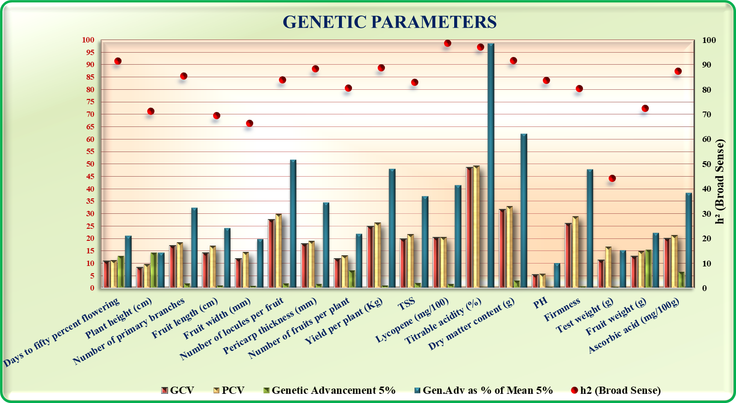

**Figure 01: Graphical representation of genetic variability, heritability and genetic advance of characters under study.**

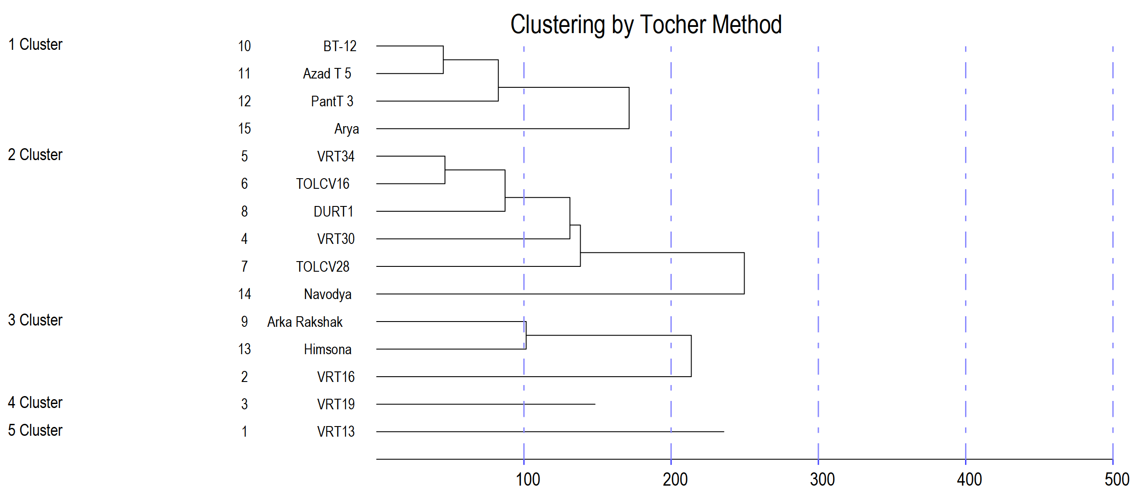

### Figure 02: Cluster composition of 15 genotype (Tocher’s method)

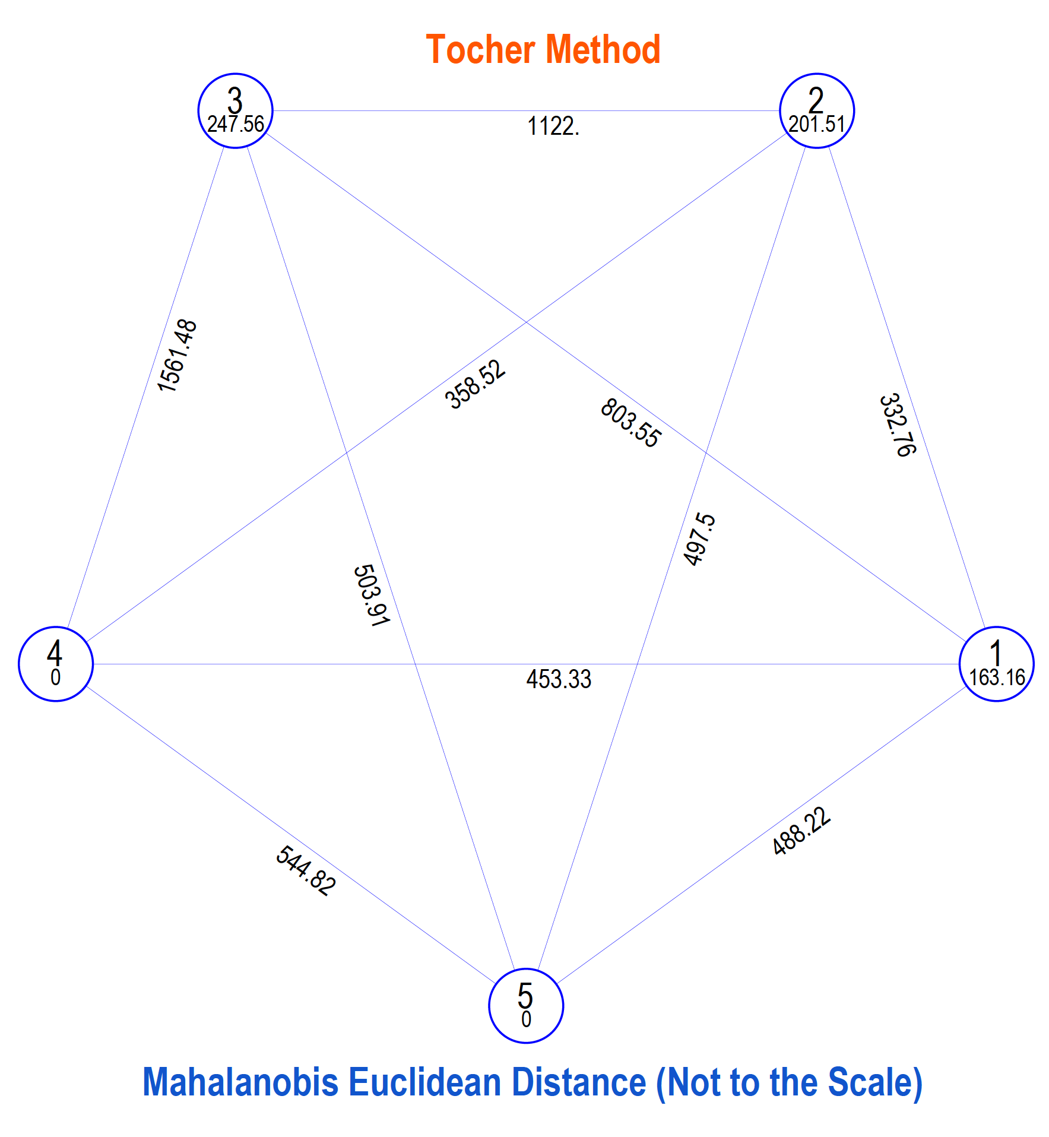

### Figure 03: Cluster distance diagram

**Figure 04: Pie chart depicting contribution %age of different characters towards genetic divergence**

Disclaimer (Artificial intelligence)

Option 1:

Author(s) hereby declare that NO generative AI technologies such as Large Language Models (ChatGPT, COPILOT, etc.) and text-to-image generators have been used during the writing or editing of this manuscript.

Option 2:

Author(s) hereby declare that generative AI technologies such as Large Language Models, etc. have been used during the writing or editing of manuscripts. This explanation will include the name, version, model, and source of the generative AI technology and as well as all input prompts provided to the generative AI technology

Details of the AI usage are given below:

1.

2.

3.

**References**

Akhter, M., Apon, F. N., Bhuiyan, M. M. R., Siddique, A. B., Husna, A. and Zeba, N. (2021). Genetic variability, correlation coefficient, path coefficient and principal *component analysis in tomato (Solanum lycopersicum L.) genotypes. Plant Cell Biotech.* Mol. Biol. 22, 46–59.

Anuradha, B., Saidaiah, P., Ravinder Reddy, K., Harikishan, S. and Geetha, A. (2020). Genetic Variability, heritability and genetic advance for yield and yield attributes in tomato (*Solanum lycopersicum* L.). *International Journal of Current Microbiology and Applied Sciences*, *9*(11), 2385-2391.

Arab, L. and Steck, S. (2000). Lycopene and cardiovascular disease. *The American Journal of Clinical Nutrition*, **71**(6), 1691S-1695S.

Bai, Y. and Lindhout, P. (2007). Domestication and breeding of tomatoes: what have we gained and what can we gain in the future? *Annals of botany*, **100**(5), 1085-1094.

Bamaniya, B., Ali, S. A., Shrivastava, A. and Bain, R. P. (2020). Genetic variability and trait relationship for yield and its attributes tomato hybrids under the western track of Vindhyan plateau of Madhya Pradesh, India. *Plant Archives*, **20**(2): 8189-8194.

Barber, N. J. and Barber, J. (2002). Lycopene and prostate cancer. *Prostate Cancer and Prostatic Diseases*, *5*(1), 6-12.

Burton, G. W. and Devane, D. E. (1953). Estimating heritability in tall fescue (*Festuca arundinacea*) from replicated clonal material 1. *Agronomy Journal*, **45**(10): 478-481.

Campos, M. D., Félix, M. D. R., Patanita, M., Materatski, P., & Varanda, C. (2021). High throughput sequencing unravels tomato-pathogen interactions towards a sustainable plant breeding. Horticulture research, 8.

Capanoglu, E., Beekwilder, J., Boyacioglu, D., De Vos, R. C. and Hall, R. D. (2010). The effect of industrial food processing on potentially health-beneficial tomato antioxidants. *Critical Reviews in Food Science and Nutrition*, **50**(10), 919-930.

Debnath, A., Kumar, R., Prasad, S. K., Sharma, N. and Kushwah, J. K. (2020). Multivariate analysis for genetic diversity estimation among tomato (*Solanum lycopersicum* L.) genotypes. *Ecology, Environment and Conservation*, **26**: 1208-1211.

Depra, M. S., Delaqua, G. C., Freitas, L. and Cristina, M. (2014). Pollination deficit in open-field tomato crops (*Solanum lycopersicum* L.) in Rio de Janeiro State, Southeast Brazil. *Journal of Pollination Ecology*, **12**(1): 1-8.

Eppakayala, K., Pidigam, S., Natarajan, S., Amarapalli, G. and Komatireddy, R. R. (2021). Study of genetic variability, heritability and genetic advance for yield and yield parameters in tomato (*Solanum lycopersicum* L.) germplasm. *Journal of Pharmacognosy and Phytochemistry*, **10**(1): 768-771.

Fraser, P. D., Romer, S., Shipton, C. A., Mills, P. B., Kiano, J. W., Misawa, N., Drake, R. G., Schuch, W. and Bramley, P.M., (2002). Evaluation of transgenic tomato plants expressing an additional phytoene synthase in a fruit-specific manner. *Proceedings of the National Academy of Sciences*, *99*(2), 1092-1097.

Gomez, K. A. and Gomez, A. A. (1983). Statistical procedures for agricultural research. John Wiley & Sons, New York.

Huang, Y., Lu, R., Hu, D. and Chen, K. (2018). Quality assessment of tomato fruit by optical absorption and scattering properties. *Postharvest Biology and Technology*, **143**: 78-85.

Hussain, K., Lone, S., Malik, A., Masoodi, K.Z., Dar, Z.A., Nazir, N., Ali, G. and Farwah, S. (2021). Genetic variability studies in cherry tomato for growth, yield and quality traits in open field conditions. *International Journal of Agricultural and Applied Sciences*, *2*(2), 60-64.

Jenkins, J. A. (1948). The origin of the cultivated tomato. *Economic Botany*, **2**(4), 379-392.

Johnson, H. W., Robinson, H. F. and Comstock, R. E. (1955). Estimates of genetic and environmental variability in soybeans 1. *Agronomy Journal*, **47**(7), 314-318.

Jones, E. and Hughes, R. E. (1983). Foliar ascorbic acid in some angiosperms. *Phytochemistry* **22**(11): 2493-2495.

Khapte, P. S. and Jansirani, P. (2014). Genetic diversity studies in tomato (*Solanum lycopersicum* L.) genotypes. *Trends Biochemestry Science* **71**(5): 1958-1961.

Khapte, P. S. and Jansirani, P. (2014). Genetic variability and performance studies of tomato (*Solanum lycopersicum* L.) genotypes for fruit quality and yield. *Trends in Bioscience*, **7** (12): 1246-1248.

Kumar M, Chandran D, Tomar M, Bhuyan DJ, Grasso S, Sá AG, Carciofi BA, Radha, Dhumal S, Singh S, Senapathy M. (2022). Valorization potential of tomato (Solanum lycopersicum L.) seed: nutraceutical quality, food properties, safety aspects and application as a health-promoting ingredient in foods. *Horticulturae*, *8*(3), 265.

Kumar, A., Kumar, V., Gull, A., & Nayik, G. A. (2020). Tomato (Solanum Lycopersicon). *Antioxidants in vegetables and nuts-Properties and health benefits*, 191-207.

Kumar, D., Kumar, R., Kumar, S., Bhardwaj, M. L., Thakur, M. C., Kumar, R., Thakur, K. S., Dogra, B. S., Vikram, A., Thakur, A. and Kumar, P. (2013). Genetic variability, correlation and path coefficient analysis in tomato. *International Journal of Vegetable Science*, **19**: 313-323.

Kumar, Manoj, Deepak Chandran, Maharishi Tomar, Deep Jyoti Bhuyan, Simona Grasso, Amanda Gomes Almeida Sá, Bruno Augusto Mattar Carciofi et al. "Valorization potential of tomato (Solanum lycopersicum L.) seed: nutraceutical quality, food properties, safety aspects and application as a health-promoting ingredient in foods." *Horticulturae* 8, no. 3 (2022): 265.

Lee, H. S. (2001). Characterization of carotenoids in the juice of red navel orange (Cara Cara). *Journal of Agriculture and Food Chemistry*, **49**: 2563-2568.

Mahebub, P. A., Babu, M. R. and Sasikala, K. (2021). Studies on genetic variability in tomato (*Solanum lycopersicum* L.) for growth, yield and quality traits. *The Pharma Innovation Journal*, **10**(10): 1741-1743.

Mahurtale, R., Gawali, K., Nagmote, A., Bondre, C., & Sarda, A. (2023). Genetic variability, heritability and genetics advance in tomato. *International Journal of Statistics and Applied Mathematics*, *8*(5), 468-471.

Mazurenko, I., Shao, Z., Li, Y., & Muhammad Noaman, Z. (2023). Food technologies, concentrated tomato products.

Meena, O. P. and Bahadur, V. (2015). Breeding potential of indeterminate tomato (*Solanum lycopersicum* L.) accessions using D2 analysis. *SABRAO Journal of Breeding and Genetics*, **47**(1): 49-59.

Meena, R. K. and Kumar, S. (2023). Variability, Heritability and Genetic Advance in Tomato (Solanum lycopersicum L.) Genotypes. *International Journal of Plant & Soil Science*, *35*(4), 138-144.

Meena, R. K., Kumar, S., Meena, M. L. and Verma, K. (2018). Genetic variability, heritability and genetic advance for yield attributes in tomato (*Solanum lycopersicum* L.). *Journal of Pharmacognosy and Phytochemistry*, **7**: 1937-1939.

Meitei, K. M., Bora, G. C., Singh, S. J. and Sinha, A. K. (2014). Morphology based genetic variability analysis and identification of important characters for tomato (*Solanum lycopersicum* L.) crop improvement. *Journal of Agriculture and Environmental Science*, **14**(10): 1105-1111.

Mohanty, B. K. (2003). Genetic variability, correlation and path coefficient studies in tomato. *Indian Journal Agricultural Research*, **37**(1): 68-71.

Narolia, R. K. and Reddy, R. V. S. K. (2012). Genetic divergence studies in tomato (*Lycopersicon esculentum* Mill.). *Crop Research*, **44**(1and2): 125-128.

Naveen, B. L., Reddy, K. R. and Saidaiah, P. (2018). Genetic divergence for yield and yield attributes in tomato (*Solanum lycopersicum*). *Indian J. Agric. Sci*, *88*(7), 1018-1023.

Fisher, R. A. and Yates, F. (1963). Statistical Tables for Biological, Agricultural and  
Medical Research. 6th Ed. *Oliver and Boyd Ltd, London*, pp: 146.

Pooja, H. M., Gasti, V. D., Bhavidoddi, A., Yashvant Kumar, H. K., Prashantha, A. and Srikantaprasad, D. (2022). Genetic variability, heritability and genetic advance in determinate types of tomato (*Solanum lycopersicum* L.). *The Pharma Innovation*, *11*(4), 222-225.

Prajapati, S., Tiwari, A., Kadwey, S. and Jamkar, T. (2015). Genetic variability, heritability and genetic advance in tomato (*Solanum lycopersicon* Mill.). *International Journal of Agriculture, Environment and Biotechnology,* **8**(2): 245-251.

Ranganna, S. (1986). *Handbook of Analysis and Quality Control for Fruit and Vegetable Products*. Tata McGraw-Hill Education; pp. 88-91.

Rao, C. R. (1952). *Advanced statistical methods in biometrical research*. John Wiley and Sons.

Rasheed, A., Ilyas, M., Khan, T.N., Mahmood, A., Riaz, U., Chattha, M.B., Al Kashgry, N.A.T., Binothman, N., Hassan, M.U., Wu, Z. and Qari, S.H. (2023). Study of genetic variability, heritability and genetic advance for yield-related traits in tomato (Solanum lycopersicon MILL.). *Frontiers in Genetics*, *13*, 1030309.

Rawat, M., Singh, D. and Kathayat, K. (2020). Studies on genetic parameters for yield and yield attributing traits in tomato (*Solanum lycopersicum* L.). *Journal of Pharmacognosy and Phytochemistry,* **9**(3): 1439–1442.

Reddy, B. R., Begum, H., Sunil, N. and Reddy, T. M. (2013). Genetic divergence studies in exotic collections of tomato (*Solanum lycopersicum* L.). *International Journal of Agricultural Sciences*, *9*(2), 588-592.

Reddy, B. R., Reddy, M. P., Begum, H. and Sunil, N. (2013). Genetic diversity studies in tomato (*Solanum lycopersicum* L.). *IOSR Journal of Agriculture and Veterinary Science (IOSR-JAVS)*, 4(4), 53-55.

Rusu, O. R., Mangalagiu, I., Amăriucăi-Mantu, D., Teliban, G. C., Cojocaru, A., Burducea, M., ... & Stoleru, V. (2023). Interaction effects of cultivars and nutrition on quality and yield of tomato. *Horticulturae*, *9*(5), 541.

Saleem M. Y., Iqbal Q. and Asghar M. (2013). Genetic variability, heritability, character association and path analysis in F1 hybrids of tomato, *Pakistan Journal of Agricultural Science*, **50**(4): 649-653.

Shankar, A., Reddy, R. V. S. K., Sujatha, M. and Pratap, M. (2013). Genetic variability studies in F1 generation of tomato (*Solanum lycopersicum* L.). *IOSR Journal of Agriculture and Veterinary Science*, **4**(5): 31-34.

Sharma, H. R., Sharma, D. and Thakur, A. K. (2006). Analysis of genetic divergence in tomato (Lycopersicon esculentum Mill.). *Journal of Horticultural Sciences*, *1*(1), 52-54.

Singh, H. and Cheema, D. S. (2005). Studies on genetic variability and heritability for quality traits of tomato (*Lycopersicon esculentum* Mill) under heat stress conditions. *Journal of Applied Horticulture*, **7**(1): 55-57.

Singh, N. P., Bharadwaj, A. K., Kumar, A. and Singh, K. M. (2004). Modern technology on vegetable Production. International Book Distribution Corporation, Lucknow. pp: 84-98.

Singh, N., Ram, C. N., Chandra, D., Yadav, G. C. and Singh, D. P. (2015). Genetic variability, heritability and genetic advance in tomato (*Solanum lycopersicum* L.). *Plant Archives*, **15**: 705-709.

Somraj, B., Reddy, R. V. D. K., Reddy, K. R., Saidaiah, P. and Reddy, M. T. (2017). Genetic variability, heritability and genetic advance for yield and quality attributes in heat tolerant exotic lines of tomato (*Solanum lycopersicum* L.). *Journal of Pharmacognosy and Phytochemistry*, **6**(4): 1956-1960.

Sushma, K., Saidaiah, P., Sudini, H., Geetha, A. and Ravinder, K. (2021). Per SE performance of tomato (Solanum lycopersicum L.) germplasm for yield and yield attributes. *The Pharma Innovation Journal* 10(5): 854-858.

Triveni, D., Saidaiah, P., Ravinder Reddy, K. and Pandravada, S. R. (2017). Mean performance of the parents and hybrids for yield and yield contributing traits in tomato. *International Journal of Current Microbiology and Applied Sciences*, **6**(11): 613-619.

Ullah, M. H., Hassan, L., Shahid, S. B. and Patwari, A. K. (2015). Variability and interrelationship studies in tomato. *Journal of Bangladesh Agricultural University*, **13**(1): 65-69.

Ullah, M. Z. (2015). Genetic divergence in tomato lines (*Solanum lycopersicum* L.). *Journal of the Bangladesh Agricultural University*, *13*(1), 61-64.

Venkadeswaran, E., Vethamoni, P. I., Arumugam, T., Manivannan, N., Harish, S., Sujatha, R., & Rani, E. A. (2020). Genetic variability studies in cherry tomato [*Solanum lycopersicum* (L.) var. *cerasiforme* Mill.] for growth, yield and quality. *Electronic Journal of Plant Breeding*, *11*(04), 1222-1226.

Vyas, M., Singh, A. K., Rai, V. K. and Ramanand, M. (2013). Genetic variability, correlation and path coefficient analysis of tomato (Lycopersicon esculentum Mill.). *Environment and Ecology*, **29**(3): 1076-1081.

Waiba, K. M., Sharma, P., Kumar, K. I., & Chauhan, S. (2021). Studies of genetic variability of tomato (*Solanum lycopersicum* L.) hybrids under protected environment. *International Journal of Bio-resource and Stress Management*, *12*(4), 264-270.

Niec-Lesniak, J., Szczepanska, E., Bialek-Dratwa, A., Kiciak, A. and Niewiadomska, E. (2024). Evaluation of phenolic content in selected red fruit juices. *Roczniki Państwowego Zakładu Higieny*, *75*(2).

Thuy, N. M., Phuong, N. P., Suong, C. T. D. and Tai, N. V. (2020). Physical and chemical characteristics of goldenberry (*Physalis peruviana*) grown in Lam Dong province, Vietnam. *Food Res*, *4*, 1217.

Wu, J. S. B. and Nelson, P. E. (2023). Tomato products. In *Processing Vegetables* (pp. 389-415). Routledge.

Ara, A., Raj, N., Nazzer, A. and Khan, S.H. (2009). Genetic variability and selection parameters for yield and quality attributes in tomato. *Indian Journal of Horticulture*,66(1): 73-78.

Singh, A. K. (2009). Genetic variability, heritability and genetic advance studies in tomato under cold arid region of Ladakh. *Indian Journal of Horticulture*, *66*(3), 400-403.