***Minireview Article***

**A Review on Paddy Straw Mushroom Farming: Cultivation, Opportunities and Challenges in Odisha, India**

.

ABSTRACT

|  |
| --- |
| This review examined the potential of mushroom farming, particularly paddy straw mushroom cultivation, as a sustainable and empowering agricultural practice for farmers and farm women in Odisha, India. Nationally, the total contribution of Odisha to mushroom production is 11 percent (%). Out of which, 67 % of paddy straw mushrooms, 32% of oyster mushrooms, and 1% of button mushrooms were cultivated in the state, enhancing the socio-economic benefits of this accessible farming method. The review can benefit both researchers and consumers of mushrooms, enhancing our understanding of the nutritional benefits, emphasizing the production of paddy straw mushrooms, highlighting its minimal land and capital requirements, short crop cycle, and adaptability to homestead environments. The review further explored the nutritional and economic significance of mushroom cultivation, emphasizing the growth trajectory of this sector in Odisha. Examination of the role of government policies, training programs, and market demand in fostering the participation of women in mushroom farming. The analysis underscores the transformative challenges and potential of this sustainable agricultural practice for enhancing nutrition, empowering women, enhancing livelihoods, and promoting environmentally sound food production systems in the state. This review aims to promote the cultivation of Paddy Straw Mushrooms across Odisha by understanding the nutritional benefits, opportunities, and challenges for boosting social, economic, and nutritional prospects in the state. |

*Keywords:* Cultivation, Nutrients, Odisha, Paddy straw Mushroom, Women empowerment

1. INTRODUCTION

Mushrooms are enlarged, complex fleshy fruiting bodies from the kingdom of Fungi (Virágh et al., 2022) rich in nutrients, bioactive compounds, vitamins, and crucial minerals (Madhumita et al., 2021). It is also known as the white vegetable meat (Das et al., 2021). It is recognized as an immunity booster and superfood for children, pregnant women, and old people (Katoch et al., 2023). There is a diverse range of species that supplement human food. Out of all the species, only 4–5 are used in industries at the global level (Kaliyaperumal et al., 2018). In India, only 3 species are used for commercial cultivation, i.e., *Agaricus bisporus* (Button Mushroom), *Pleurotus florida* (Oyster Mushroom) and *Volveriella volvacea* (Paddy Straw Mushroom or Straw Mushroom) (Rath and Sarangi, 2021). Button mushroom takes the first space with a major (70%) share, followed by oyster mushroom (17%), paddy straw mushroom (9%), milky mushroom (3%) and others (Bijla and Sharma, 2023; Thakur, 2020; Singh et al., 2020; Gogoi et al., 2019).

The paddy straw mushroom (*Volvariella volvacea*), commonly referred to as the Chinese mushroom or the Straw mushroom, belongs to the Pluteaceae family of the Basidiomycetes (Wasule et al., 2023). It is a tropical and subtropical edible mushroom that was cultivated in China in 1822 (Sahoo and Meshram, 2022; Sarkar and Archana, 2022). Initially, this mushroom was known as “Nanhua mushroom” after the Nanhua Temple in China’s Northern Guangdong Province. It was grown by Buddhist monks for their meals but was provided as a tribute to the elite family by 1875. It is presumed that these mushrooms were first cultivated approximately 300 years ago, before the 18th century (Ahlawat and Arora, 2016). Between 1932 and 1935, the Chinese introduced this mushroom to Malaysia, the Philippines and other South Asian countries (Wasule et al., 2023; Ahlawat and Arora, 2016; Reddy, 2015). Paddy straw mushroom is regarded as a “warm mushroom” (Wasule et al., 2023; Pattanayak and Das, 2022; Reddy et al., 2022) growing at relatively high temperatures. It is a quick-growing mushroom with a total crop cycle of 4–5 weeks under favourable growing conditions. Compared to other farmed mushrooms, the paddy straw mushroom requires a relatively high C:N ratio of 40 to 60 and may be grown on diversified cellulosic materials (Ahlawat and Arora, 2016; Biswas, 2014).

It grows easily and quickly on uncomposted substrates like cotton waste, paddy straw, or other cellulosic organic waste materials (Thakur, 2024). In 1940, the paddy straw mushroom was first cultivated in India. It was, however, not until 1943 that a systematic cultivation attempt was made (Ahlawat and Arora, 2016). Although it can be grown in most states where the agroclimatic conditions are suitable and there is an abundance of agro-waste, this mushroom is currently more admired in coastal states like Andhra Pradesh, Kerala, Odisha, Tamil Nadu and West Bengal (Patra, 2016).

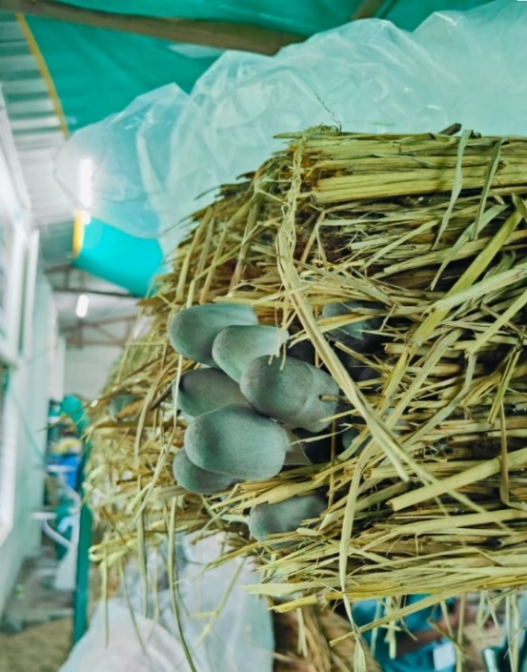

**Fig. 1. Paddy Straw Mushroom**

Nationally, the total contribution of Odisha to mushroom production is 11%. Of which 67% of paddy straw mushrooms, 32% of oyster mushrooms and 1% of button mushrooms are cultivated in the state. In Odisha, the straw mushroom is generally cultivated for 8–9 months (March to November) due to the favourable hot and humid coastal climate. Puri ranks first with 20% of the total mushrooms produced in Odisha, followed by Khurda and Ganjam (15%), Dhenkanal (10%) and others (Rath and Mishra, 2023). There has been a rise in the yield of paddy straw mushrooms from 5000 tonnes per annum (t a-1) in 2010–11 to 21500 t a-1 in 2021–22, accounting for 67% of the total mushroom production of the State (Mohapatra, 2023). It is fast-growing and has excellent taste and unique flavour, which distinguishes this mushroom from other edible mushrooms, including substantial amounts of crude fibres (1.87 g), acids like ascorbic acid (18 mg) and minerals like potassium (0.32 g), iron (1.70 mg), copper and magnesium (minimal amount) (Rath and Sarangi, 2021; Ahlawat and Arora, 2016). A brief on the nutritional composition of Fresh Paddy Straw mushrooms is highlighted in table 1. It can be easily cultivated indoors or outdoors, under the shade of trees as an intercrop and under the open sky in the backyard.

**Table 1. Nutritional Composition of Fresh Paddy Straw Mushroom (100 g-1) (Ahlawat and Arora, 2016)**

|  |  |
| --- | --- |
| Nutrient Composition | Concentration of Nutrients |
| Moisture | 90.4% |
| Protein | 3.90 grams (g) |
| Fats | 0.25 g |
| Crude Fibre | 1.87 g |
| Phosphorus | 0.10 g |
| Potassium | 0.32 g |
| Iron | 1.70 milligrams (mg) |
| Calcium | 5.60 mg |
| Thiamine | 0.14 mg |
| Riboflavin | 0.61 mg |
| Niacin | 2.40 mg |
| Ascorbic Acid | 18 mg |

**2. Paddy Straw Mushroom: A Superfood for Mankind (Ali et al., 2024; Raut and Adhikari, 2021)**

* Contains high-quality proteins and 10–50% dietary fibres in the dried matter.
* Good source of Vitamins B, C, D and K, minerals and essential amino acids.
* Contains some important carbohydrates like arabinose, fructose, fucose, glucose, mannitol, mannose, melezitose, rhamnose, sucrose, trehalose and xylose.
* Good for the heart and has low levels of fats, calories and sodium due to low cholesterol.
* High content of Selenium: Excellent antioxidant.
* Contain a variety of such bioagents like atherosclerosis have promising effects on several cardiovascular risk biomarkers like coronary heart disease and stroke.
* Regulates the digestive system and strengthens immunity.
* Potential activity against prominent viruses such as hepatitis B and C viruses, herpes simplex virus (HSV), human immunodeficiency virus (HIV), influenza (Chun et al., 2021), etc.
* Anti-aging and weight-reducing properties.
* Beneficial for diabetics due to low glucose content.

**3. Biological Characteristics of Paddy Straw Mushroom**

The paddy straw mushroom’s fruiting body is classified into six developmental stages, viz., pinhead, tiny button, button, egg, elongation, and mature stage, which has its morphology and anatomy (Manoharachary, 2022; Ahlawat and Arora, 2016).

**3.1 Pinhead stage**

The veil is perfectly white at the pinhead stage, where it resembles a pinhead. The stipe and pileus are hidden in the vertical portion. The entire structure is made up of hyphal cell knots.

**3.2 Tiny button**

The interwoven hyphae produce the tiny button and pinhead stages. Just the top of the veil is brown and the rest is white with a young tiny button. It is spherical and the lamellae are seen as a narrow band on the lower surface of the pileus when a vertical cut is made through the button.

**3.3 Button stage**

At this stage, the paddy straw mushrooms are sold at a premium price in the market. The coat, which is known as the universal veil, wraps the whole structure. The existing pileus is closed inside the veil. As such, the stipe is not visible, however, it is visible in the longitudinal section of the mushroom.

**3.4 Egg stage**

The veil pushes out the pileus and the veil remain as a volva. This stage also fetches an exorbitant price in the market. Once again, at this stage, the stipe is not visible. The basidiospores are absent in the lamellae of this stage. The size of the pileus remains very small up to this stage.

**3.5 Elongation stage**

The pileus stays close and is smaller than in the mature stage. The stipe reaches its maximum length and is marked with waterproof drawing ink.

**3.6 Mature stage**

At the mature stage, the structure is fractioned into three regions:

* the cap or pileus
* the stalk or stipe
* the cup or volva

The pileus is usually 6–12 centimeters (cm) in diameter and is connected in the center with a stipe. When the pileus is fully grown, it has a smooth, round shape with a dark gray center and a lighter grey border. Around 280–380 lamellae are present on the lower surface of the pileus, varying from one-quarter size to full size of the pileus. Under a microscope, each lamella is visible to be made up of three layers of interwoven hyphae. It creates the club-shaped basidia and the cystidia and the outermost layer is called the hymenium. The basidia carry basidiospores. Four basidiospores, which can be ellipsoidal, spherical, or egg-shaped, are typically held by a single basidium. The basidiospores vary between light yellow, pink, or dark brown. The stipe connecting the pileus and the volva is the mature fruiting body. The pileus size decides the length of the stipe, which is usually about 3–8 cm long and 0.5–1.5 cm in diameter. It lacks any annulus and is fleshy and whitish. At the base of the stipe remains the volva, a thin layer of interwoven hyphae surrounding the stipe's bulbous base. The volva is a cup-shaped fleshy with uneven edges. Rhizomorphs bearing nutrients from the substrate are found at the base of the volva.

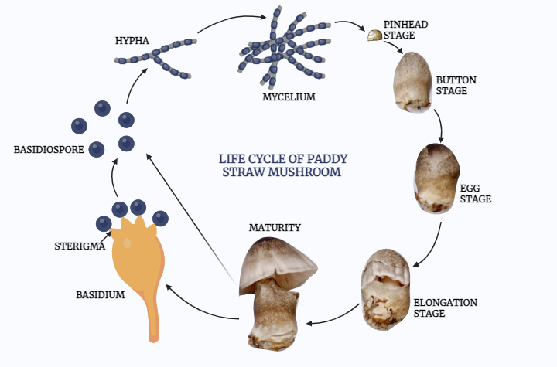

**Fig. 2. Life cycle of Paddy Straw Mushroom**

**4. Basic Requirements for Growing Fresh Straw Mushrooms (Thakur, 2024; Thuc et al., 2020)**

**4.1 Climatic requirements**

* Temperature: 30–38ºC
* Relative Humidity: 85–90%
* Light intensity: 1000 luminous intensity (lux)
* Substrate pH: 6.5–7.0
* Substrate moisture: 65%
* Oxygen requirement: More concentration during the fruiting stage

**4.2 Input requirements**

* Standard Bed Size: 1.5 feet (ft) × 1.5ft × 1.5ft
* Paddy straw: 14 bundles
* Spawn: 200 g (1 bottle)
* Additives (Pulse powder): 150–200 g
* Polythene sheet: 6 ft × 6 ft
* Sprayer: 2 Litres (L)

**5. Procedure for Paddy Straw Mushroom Production in Odisha**

* The paddy straw bundles are cut into 1.5 ft lengths and soaked in water for 12–18 hours.
* Excess water is removed by keeping the wet bundles in the standing position under the shed. The water should not drip from the bed during bed preparation but should be moistened enough.
* Prepare a raised platform with bamboo and support by arranging bricks on all four corners to avoid any contact with the ground.
* The bed is prepared by placing four bundles side by side. The spawn is taken out of the bottle and divided into four equal parts.
* Spawning of the beds at a spacing of 10–15 cm all along the margin is done, leaving 10–15cm from the edge of the straw.
* One part of spawn and one part of pulse powder or besan is used for each layer.
* The second layer is prepared with another four bundles as above but is arranged in opposite directions to the first layer (criss-cross manner). In the third layer, the remaining two parts of the spawn and pulse powder or besan are spread all over the straw.
* On the top layer, two bundles of paddy straw are scattered, and thus the mushroom bed is ready.
* Press the bed to make it as compact as possible and cover it with a transparent polythene sheet to check the growth of the fungus. Keep the beds undisturbed for seven days.
* Remove the polythene sheet after 7 days and spray water 2–3 times every day from the 8th day onward.

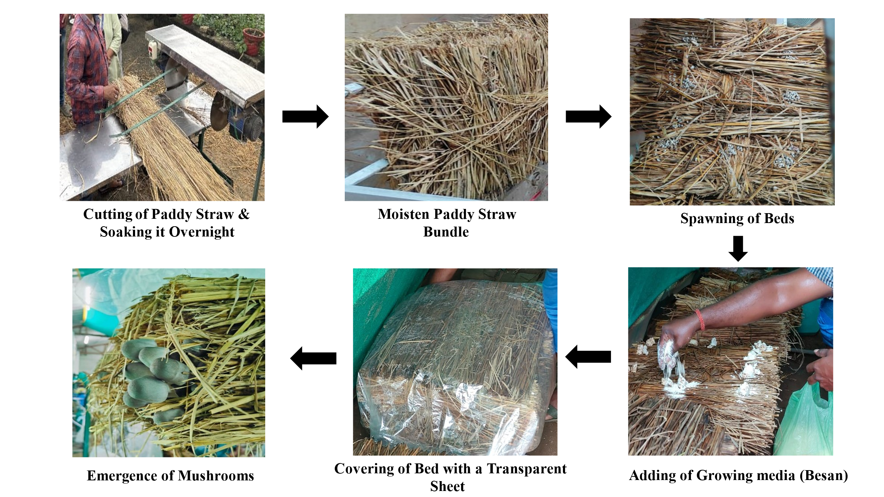

**Fig. 3. Procedure of Paddy Straw Mushroom Production**

**6. Harvesting**

The appropriate stages of mushroom harvesting are the egg and elongation stages; cap-opening affects marketability. In Odisha, mature mushrooms are handpicked by twirling them from the base. When harvesting at the base of the stalk, knives or scissors should not be used because the stalk remains behind on the bed/substrate and will rot, be attacked by pests and be contaminated by moulds, which destroy the mushroom bed (Ahlawat and Arora, 2016). The first harvest is obtained after 12–14 days of bed preparation and yields around 70–90% of the total yield. So, to harvest straw mushrooms in good condition, they must be harvested two to three times a day (morning, noon and afternoon) (Sahoo and Meshram, 2022). After first harvesting, water is sprinkled over the bed and covered again with a plastic sheet to provide the desired temperature. The second harvest shall appear in 7–8 days. The second and third phases of harvest are taken after seven days each. On average, 1 kilogram (kg) of mushrooms is harvested per bed (Thuc et al., 2020; Gogoi et al., 2019; Ahlawat and Arora, 2016; Reddy, 2015).

**7. Opportunities in Paddy Straw Mushroom Production**

**7.1 Management of Agricultural Wastes**

The waste produced from 9.62 million metric tonnes of rice (Anonymous, 2023) cultivated in Odisha, i.e., Paddy straw, can be effectively utilized as a substrate to cultivate mushrooms, promoting sustainable agricultural practices. The rice bran is also utilized as the growth promoter for the fungus. It reduces environmental pollution by avoiding the burning of straws and offers additional secondary income sources for farmers by turning wastes into vulnerable agricultural raw materials (Padhiary et al., 2024; Singh and Patel, 2022). By leveraging agricultural wastes in this manner, paddy straw mushroom cultivation creates a circular economy in the agricultural system, reduces waste production, promotes sustainability, and provides a profitable venture to farmers.

**7.2 High Market Demand**

Mushroom is known as vegetarian meat due to its diverse nutritive value and has a higher demand for health benefits and culinary versatility in Odisha. These mushrooms are rich in nutrients, including proteins, vitamins, and minerals, making them popular in both vegetarian and non-vegetarian diets (Pandey et al., 2022). Additionally, the rising trend toward plant-based diets and sustainable food sources has led to increased consumption of mushrooms as a meat alternative. Opportunities exist for exporting paddy straw mushrooms to international markets, especially in regions with a high demand for exotic mushrooms (Sangeeta et al., 2024). This can boost the scalability of mushroom farming providing an opportunity for small-scale and large-scale producers to enter the market.

**7.3 Low Investment**

Compared to other agricultural and allied ventures, the production process requires relatively low capital investment in infrastructure and resources, making it accessible to small and marginal farmers in Odisha. Basic structures like low-cost sheds or bamboo frames can be used for growing mushrooms, and the inputs primarily include paddy straw, spawn, water, and a controlled environment. Also, using locally available materials reduces transportation costs and boosts local economies (Rath, 2023; Pandey and Kumaran, 2021). The low operational costs, combined with the high market demand and profitability of paddy straw mushrooms, make this an attractive and low-risk opportunity for individuals (Sadiq et al., 2024) looking to diversify their agricultural activities.

**7.4 Diverse Utilization**

Mushrooms are used as delicacies in Odisha cuisine, increasing their marketability. High nutritional value, including proteins, vitamins, and minerals, attracts health-conscious consumers. Research on the health benefits of mushrooms opens avenues in functional foods and nutraceuticals (Sangeeta et al., 2024; Madhumita et al., 2021).This waste-to-resource model helps farmers diversify their income streams, as they can sell compost or use it to improve soil fertility on their farms, reducing the need for external fertilizers.

**7.5 Scope for Value Addition**

Developing value-added products like dried mushrooms, mushroom powders, pickles, sauces, or ready-to-cook meals can increase profitability. Farms can offer tours or workshops on mushroom cultivation, attracting visitors and generating additional income (Martín et al., 2023).

**7.6 Climate Resilience**

The traditional crops become increasingly vulnerable to unpredictable weather patterns, droughts, and floods, mushroom cultivation, particularly paddy straw mushrooms, offers a more resilient agricultural practice as it can thrive in various climatic conditions, providing opportunities for Odisha farmers in different regions to successfully cultivate for around 7–8 months, increasing an additional or main source of income for farmers (Rath and Sarangi, 2021). Paddy straw mushrooms are not heavily dependent on specific seasonal conditions, thus offering farmers consistent yields and a stable income year-round.

**7.7 Policy Support**

Various government initiatives may offer subsidies, grants, or training programs to encourage mushroom cultivation, particularly using agricultural waste. By capitalizing on these opportunities, farmers and entrepreneurs can develop sustainable and profitable paddy straw mushroom production systems (Shirur et al., 2022).

**8. Challenges in Paddy Straw Mushroom Production**

**8.1 Contamination**

High susceptibility to bacterial contaminants and pests can reduce the yield and quality of paddy straw mushrooms. Mites, Phorids, etc., can directly destroy the whole bed by affecting the growth of the fungus. Diseases like bacterial button rot caused by *Pseudomonas spp.,* growth inhibition caused by *Staphylococcus saprophyticus, Bacillus pumilis,* etc., can reduce the vigour of the mushroom production (Sattar et al., 2021).

**8.2 Post-Harvest Losses**

Matured paddy straw mushrooms' shelf life is 24–48 hours. This reduces marketability due to inadequate storage techniques and facilities. This marketing cycle is also disturbed due to the limited adaptability of mushroom cultivation as a main source of income (Dhar, 2017).

**8.3 Substrate Quality**

The availability of quality paddy straw for bed preparation can vary over a span of time. The residual effect of high dosages of fungicides, pesticides, or herbicides can affect the growth, development and life cycle of *Volvariella volvacea*, thus decreasing the yield of the mushrooms (Singh and Patel, 2022).

**8.4 Lack of Skills and Knowledge**

Limited technical knowledge and training among farmers can hinder the effective production practices of the paddy straw mushroom. This affects the adaptation, cultivation and management of the produce (Rath and Sarangi, 2021).

**9. Why Paddy Straw Mushroom Farming is Women-Friendly in Odisha?**

* Adequate utilization of leisure time for productive pursuits.
* Helps women supplement their household food and nutrition.
* Easy access to raw materials (straw, pulse powder, polythene, spawn).
* Quick returns with less investment.
* Young and educated girls and women can go for Agri-Start-Up through mushroom cultivation.
* No mobility issue for women as it is possible at homestead land, veranda, unused house premises, etc.
* No land is required and it is suitable for landless women also.
* Mushroom has a ready market in restaurants and hotels too.
* It can also generate additional avenues for employment and income through value-added products like powder, pickles, soup, dried mushrooms, etc.

**10. Conclusion**

Paddy Straw Mushroom farming in Odisha offers a unique blend of opportunities and challenges, particularly for those seeking sustainable livelihood options utilizing paddy straw and enhancing resource efficiency by reducing waste. With low initial investment and simple cultivation techniques, providing a steady income source for farmers and farm women. However, challenges like limited access to markets, inadequate knowledge about disease management, cultural norms hindering women's participation and lack of financial support for scaling operations remain. Collaborative efforts from government agencies, NGOs, and local communities are essential to address the barrier by promoting awareness and providing training and resources, stakeholders can create an ecosystem that improves the socio-economic conditions of Odisha's farming communities.

**Acknowledgments:** The authors express their sincere gratitude towards the University Institute of Agricultural Sciences and University Institute of Biosciences and Biotechnology, Chandigarh University, Gharuan, Mohali, Punjab, India, the Institute of Agricultural Sciences, Siksha ‘O’ Anusandhan (Deemed to be University), Bharatpur, Bhubaneswar, Odisha, India and the MS Swaminathan School of Agriculture, Centurion University of Technology and Management, Bhubaneswar, Odisha, India for providing the review facilities and guidance during the entire work.

**Competing Interests:** Authors have declared that no competing interests exist.

**Author’s Contributions:** Subhrajit Ojha designed the study for review. Subhrajit Ojha, Suryakant Pradhan, Asit Kumar Samal and Madhusmita Pani managed the literature searches and wrote the first draft. Lopamudra Nayak and Preeti Parihar designed the illustrations, reviewed and edited the manuscript. All the authors read and approved the final manuscript.

**Disclaimer (Artificial intelligence):** Authors hereby declare that generative AI technologies such as Large Language Models, etc. have been used during the writing or editing of manuscripts. This explanation will include the name, version, model, and source of the generative AI technology and as well as all input prompts provided to the generative AI technology.

Details of the AI usage are given below:

1. Grammarly for grammatical errors

2. Biorender for image illustrations (fig. 2)

References

1. Ahlawat, O. P., & Arora, B. (2016). Paddy straw mushroom (*Volvariella volvacea*) Cultivation. In S. Sharma, M. Singh, S. Prasad & H. Rathore (Eds.), Mushrooms in India Diversity, Improvement, Cultivation, Medicinal Uses and Value Addition for Rural Development (pp. 165–182). CRDT, IIT New Delhi.
2. Ali, S., Yousaf, N., Usman, M., Javed, M. A., Nawaz, M., Ali, B., Azam, M., Ercisli, S., Tirasci, S., & Ahmed, A. E. (2024). *Volvariella volvacea* (paddy straw mushroom): A mushroom with exceptional medicinal and nutritional properties. *Heliyon*, 10(21), e39747. <https://doi.org/10.1016/j.heliyon.2024.e39747>
3. Anonymous. (2023). India: Rice production volume in Odisha 2023. Statistica. <https://www.statista.com/statistics/1019581/india-rice-production-volume-in-odisha/>
4. Bijla, S., & Sharma, V. P. (2023). Status of Mushroom Production: Global and National Scenario. *Mushroom Research*,32(2), 91–98. <https://doi.org/10.36036/MR.32.2.2023.146647>
5. Biswas, M. K. (2014). Cultivation of Paddy straw Mushrooms (*Volvariella volvacea*) in the Lateritic Zone of West Bengal-A Healthy food for Rural People. *International Journal of Economic Plants*, 1(1), 23–27.
6. Chun, S., Gopal, J., & Muthu, M. (2021). Antioxidant Activity of Mushroom Extracts/Polysaccharides—Their Antiviral Properties and Plausible AntiCOVID-19 Properties. *Antioxidants*, 10(12), 1899. <https://doi.org/10.3390/antiox10121899>
7. Das, A. K., Nanda, P. K., Dandapat, P., Bandyopadhyay, S., Gullón, P., Sivaraman, G. K., McClements, D. J., Gullón, B., & Lorenzo, J. M. (2021). Edible Mushrooms as Functional Ingredients for Development of Healthier and More Sustainable Muscle Foods: A Flexitarian Approach. *Molecules*, 26(9), 2463. <https://doi.org/10.3390/molecules26092463>
8. Dhar, B. L. (2017). Mushroom farm design and technology of cultivation. In C. Z. Diego & A. [Pardo-Giménez](https://onlinelibrary.wiley.com/authored-by/Pardo%E2%80%90Gim%C3%A9nez/Arturo) (Eds.), Edible and Medicinal Mushrooms: Technology and Applications (pp. 271–308). Wiley Publications. <https://doi.org/10.1002/9781119149446.ch14>
9. Gogoi, R., Rathaiah, Y., & Borah, T. R. (2019). Mushroom Cultivation Technology. Scientific Publishers, Jodhpur, India.
10. Kaliyaperumal, M., Kezo, K., & Gunaseelan, S. (2018). A Global Overview of Edible Mushrooms. In B. Singh, Lallawmsanga & A. K. Passari (Eds.), Biology of Macrofungi (pp. 15–56). Springer, Cham. <https://doi.org/10.1007/978-3-030-02622-6_2>
11. Katoch, A., Paudel, M., & Katoch, P. (2023). An Overview on Mushrooms. In A. Sharma, G. Bhardwaj & G. A. Nayik (Eds.), Phytochemistry and Nutritional Composition of Significant Wild Medicinal and Edible Mushrooms: Traditional Uses and Pharmacology (pp. 1–30). Royal Society of Chemistry.<https://doi.org/10.1039/BK9781837672097-00001>
12. Madhumita, M., Behera, G., Nanda, A., Das, P. K., Pradhan, S., & Sarkar, A. (2021). Effect of Hot Air, Microwave and Freeze Drying on Drying Characteristics of Button Mushroom Slices (*Agaricus bisporus*). *Journal of Scientific Research and Reports*, 27(7), 53–61. <https://doi.org/10.9734/jsrr/2021/v27i730411>
13. Manoharachary, C. (2022). Edible and Medicinal Mushrooms: Some Aspects and Prospects. In A. Arya & K. Rusevska (Eds.), Biology, Cultivation and Applications of Mushrooms (pp. 259–284). Springer, Singapore. <https://doi.org/10.1007/978-981-16-6257-7_9>
14. Martín, C., Zervakis, G. I., Xiong, S., Koutrotsios, G., & Strætkvern, K. O. (2023). Spent substrate from mushroom cultivation: exploitation potential toward various applications and value-added products. *Bioengineered*, 14(1), 2252138. <https://doi.org/10.1080/21655979.2023.2252138>
15. Mohapatra, K. B. (2023). Women Empowerment through Mushroom Cultivation. In: National Seminar on Improvement of Tribal Through Sustainable Agriculture (LITTSA-2023) (pp. 30–35). School of Agriculture, GIET University, Gunupur, Odisha, India.
16. Padhiary, M., Roy, P., & Dey, P. (2024). Synergistic Substrate Formulation for Enhanced Oyster Mushroom Production Using *Tectona grandis* Leaves, Waste Paper, and Straw. *Environment and Ecology*, 42(4B), 1876–1881. <https://doi.org/10.60151/envec/IAMX1320>
17. Pandey, M., & Kumaran, G. S. (2021). Potential of mushroom technology as a social enterprise-The way forward. *Mushroom Research*, 30(1), 1–10. <https://doi.org/10.36036/MR.30.1.2021.116216M>
18. Pandey, M., Satisha, G. C., Azeez, S., & Kumaran, G. S. (2022). Mushrooms for integrated and diversified nutrition. *Journal of Horticultural Sciences*, 17(1), 6–18. <https://doi.org/10.24154/jhs.v17i1.1193>
19. Patra, S. (2016). Standardization of growing techniques of summer paddy straw mushroom, *Volvariella volvacea* in East and South-Eastern coastal plain of Odisha. Doctoral dissertation, Orissa University of Agriculture and Technology, Bhubaneswar, India.
20. Pattanayak, S., & Das, S. (2022). Optimization of Biological efficiency and comparative analysis of nutraceutical properties in paddy straw and oyster mushrooms cultivation: A Review. *Journal of Mycopathological Research*, 60(1), 13–21.
21. Rath, S., & Sarangi, K. K. (2021). Economic feasibility of straw mushroom production in Odisha: A case study. *Journal of Agricultural Development and Policy*, 31(2), 140–146.
22. Rath, S. S. (2023). Strengthening economic and nutrition security through mushroom value chain management model in Odisha. Doctoral Dissertation, Odisha University of Agriculture and Technology, Bhubaneswar, Odisha, India.
23. Rath, S. S., & Mishra, S. N. (2023). A Study on Mushroom Production in India and Odisha Vis a Vis Global Level. *International Journal of Environment and Climate Change*, 13(1), 205–213. <https://doi.org/10.9734/IJECC/2023/v13i11791>
24. Raut, J. K., & Adhikari, M. K. (2021). Mushroom: a true super food. In S. L. Shyaula, G. B. Bajracharya, K. C. Gopal, S. M. Shakya & D. Subba (Eds.), Comprehensive Insights in Vegetables of Nepal (3323rd ed., pp. 201–234). Nepal Academy of Science and Technology (NAST), GPO box.
25. Reddy, D. V. S. C., Dheebakaran, G. A., Thiribhuvanamala, G., Kokilavani, S., & Sathyamoorthy, N. K. (2022). Seasonal variation of paddy straw mushroom performance under different microclimate environments. *Journal of Agrometeorology*, 24(4), 367–372. <https://doi.org/10.54386/jam.v24i4.1806>
26. Reddy, S. M. (2015). Diversity and Applications of Mushrooms. In: B. Bahadur, M. V. Rajam, L. Sahijram & K. Krishnamurthy (Eds.), Plant Biology and Biotechnology Volume I: Plant Diversity, Organization, Function and Improvement (pp. 231–261). Springer, New Delhi. <https://doi.org/10.1007/978-81-322-2286-6_9>
27. Sadiq, M. S., Singh, I. P., Ahmad, M. M., & Sani, B. S. (2024). Mushroom Farming for Youth Empowerment: A High-Value Crop with Minimal Land Requirements. *ShodhPrabandhan: Journal of Management Studies*, 1(1), 65–75. <https://doi.org/10.29121/ShodhPrabandhan.v1.i1.2024.13>
28. Sahoo, A. K., & Meshram, S. (2022). An Overview and study on Paddy Straw Mushroom and its Market from Anandapur District Odisha. *Environment and Ecology*, 40(1), 174–186.
29. Sangeeta, Sharma, D., Ramniwas, S., Mugabi, R., Uddin, J., & Nayik, G. A. (2024). Revolutionizing Mushroom processing: Innovative techniques and technologies. *Food Chemistry: X*, 23, 101774. <https://doi.org/10.1016/j.fochx.2024.101774>
30. Sarkar, B., & Archana, T. S. (2022). A Review on Cultivation Technology of Paddy Straw Mushroom (*Volvariella volvacea*). In S. Kulshreshtha, Ukaogo, P. Onyedinma & Siddhant (Eds.), Recent Advances in Mushroom Cultivation Technology and Its Application (pp. 169–186). Bright Sky Publications, New Delhi. <https://doi.org/10.22271/bs.book.48>
31. Sattar, M. N., Iftikhar, S., Saeed, F., Shaalan, R., Hourani, W., Bejjani, R., el Sebaaly, Z., Afzaal, Y., & Sassine, Y. N. (2021). Mushroom Farm Design, Management of Pests, and Control of Diseases. In Y. N. Sassine (Eds.), Mushrooms: *Agaricus bisporus* (37th ed., pp. 297–356). CAB International.
32. Shirur, M., Gummagolmath, K. C., & Singh, M. (2022). Leveraging government policies and schemes for promoting mushroom entrepreneurship in India. *Mushroom Research*, 30(2), 213–221. <https://doi.org/10.36036/MR.30.2.2021.95991>
33. Singh, M., Kamal, S., & Sharma, V. P. (2020). Status and trends in world mushroom production-III-World Production of different mushroom species in 21st century. *Mushroom Research*, 29(2), 75–111. <https://doi.org/10.36036/MR.29.2.2020.113703>
34. Singh, R., & Patel, M. (2022). Effective utilization of rice straw in value-added by-products: A systematic review of state of art and future perspectives. *Biomass and Bioenergy*, 159, 106411. <https://doi.org/10.1016/j.biombioe.2022.106411>
35. Thakur, M. P. (2020). Advances in mushroom production: Key to food, nutritional and employment security: A review. *Indian Phytopathology*, 73, 377–395. <https://doi.org/10.1007/s42360-020-00244-9>
36. Thakur, R. (2024). Studies on utilization of paddy straw for compost preparation of button mushroom (*Agaricus bisporus*). Doctoral Dissertation, Dr. Yashwant Singh Parmar University of Horticulture and Forestry, Nauni- Solan, Himachal Pradesh, India.
37. Thuc, L. V., Corales, R. G., Sajor, J. T., Truc, N. T. T., Hien, P. H., Ramos, R. E., Bautista, E., Tado, C. J. M., Ompad, V., Son, D. T., & Van Hung, N. (2020). Rice-Straw Mushroom Production In M. Gummert, N. Hung, P. Chivenge & B. Douthwaite (Eds.), Sustainable Rice Straw Management (pp. 93–109). Springer, Cham. <https://doi.org/10.1007/978-3-030-32373-8_6>
38. Virágh, M., Merényi, Z., Csernetics, Á., Földi, C., Sahu, N., Liu, X. B., Hibbett, D. S., & Nagy, L. G. (2022). Evolutionary Morphogenesis of Sexual Fruiting Bodies in Basidiomycota: Toward a New Evo-Devo Synthesis. *Microbiology and Molecular Biology Reviews*, 86(1), e00019–21. <https://doi.org/10.1128/MMBR.00019-21>
39. Wasule, D. L., Gaharwar, A. M., Shingote, P. R., & Rathod, D. R. (2023). Paddy Straw Mushroom (*Volvariella volvacea*). In D. Pandita & A. Pandita (Eds.), Mushrooms: Nutraceuticals and Functional Foods (pp. 349–365). CRC Press.