*Original Research Article*

Evaluation of Correlation and Path analyses on yield and yield contributing characters in 30 Indigenous genotypes and 3 varieties of Cowpea [*Vigna unguiculata* (L.) Walp]

.

ABSTRACT

|  |
| --- |
| The current study was conducted during 2019-2020 at the Post Graduate Research Farm, RCSM, College of Agriculture, Kolhapur. Correlation and path coefficient analyses among eleven morphological traits were studied in 30 genotypes and 3 released cowpea varieties. According to the correlation data, the number of pods per plant, number of main branches, number of seeds per pod, leaf width, and pod length all exhibited a highly significant positive link with seed yield per plant. This showed a highly significant positive association of seed yield per plant with number of pods per plant (0.740), followed by number of main branches (0.638), number of seeds per pod (0.376), leaf width (0.363) and pod length (0.281). The characters such as leaf length (0.216), number of days to maturity (0.195) and test weight (0.171) were positively associated but non-significant at the genotypic level. The path analysis revealed that at the genotypic level, the nodes on the main stem (-0.209) and the number of days to 50% blooming (-0.026) were non-significant and negatively correlated. The number of pods per plant, the number of seeds per pod, leaf width, and test weight all showed a significant positive direct effect on seed yield. Genotypes such as PMCP-1021, CP-20, CP-25, CP-26, CP-7, CP-2-1, CP-15, CP-9-1, CP-17, CP-2-1, PCP-1809, PCP-1124, PCP-1123, Phule Rukmini and Phule Pandhari were found to be superior for seed yield per plant. This study reveals the contribution of various traits to yield and assists breeders in enhancing yield by improving key traits directly or indirectly. |

*Keywords: Cowpea, Correlation, Path analysis, Yield characters*

1. INTRODUCTION

*Vigna unguiculata* L., widely recognized as cowpea, crowder pea, southern pea, black-eyed pea, or lobia, is often known as "vegetarian meat" (Ghodake et al., 2023). It is a major leguminous crop grown around the world for its nutritious seeds and fodder. It is resilient to a wide range of environmental circumstances and farmed in a variety of agro-climatic areas. Its protein-rich seeds are not only a staple food source in many countries but also contribute to soil fertility through nitrogen fixation. Maximizing cowpea yield is essential to meet the increasing demand for nutritious food and enhance rural livelihoods. Cowpea yield and yield-contributing features are critical in determining overall productivity and economic relevance. This study aimed to determine the genotypic correlations and analyze the direct and indirect effects of yield components on grain yield among 11 quantitative traits in 30 Indigenous genotypes and three released varieties of cowpea. The goal was to identify the most important traits for selection in future breeding programs.

2. material and methods

The experimental material consisted of 30 indigenous genotypes and 3 released varieties of cowpea from Pulses and Oilseed Crops Research and Training Centre, Pandharpur (Dist. Solapur, Maharashtra). The list of genotypes and varieties are listed in Table 1. The present study was carried out during 2019-2020 at Post Graduate Research Farm, RCSM, College of Agriculture, Kolhapur, following a Randomized Block Design with three replications. Each genotype was sown in four rows of 5-meter length with spacing of 45 cm between the rows and 10 cm between plants. The 11 morphological traits namely*,* days to 50 percent flowering, days to maturity, leaf length, leaf width, number (no.) of nodes on the main stem, number of main branches, number of pods per plant, pod length, number of seeds per pod, 100 seed weight and seed yield per plant were studied in the present study. The statistical analysis was performed following Panse and Sukhatme (1985). The genotypic covariances were estimated according to Singh and Chaudhari (1977). The genotypic correlation coefficient was calculated using the method developed by Johnson et al. (1955). The Genotypic correlation coefficient was calculated using the following formula,

$$r_{g}1.2=\frac{{COV}_{g}1.2}{\sqrt{\left(\sqrt{σ^{2}g_{1}+σ^{2}g_{2}}\right)}} x 100$$

Where, $r_{g}1.2$ = Genotypic correlation between characters 1 and 2, (COVg1.2) =Genotypic covariance between characters 1 and 2, σ2g1 and σ2g2 = Genotypic variance of character 1 and 2, respectively. The significance of genotypic correlation coefficients was tested by ‘t’ value (Panse and Sukhatme, 1985).

$t=r\sqrt{\left(n-2\right)\left(1-r^{2}\right)}$

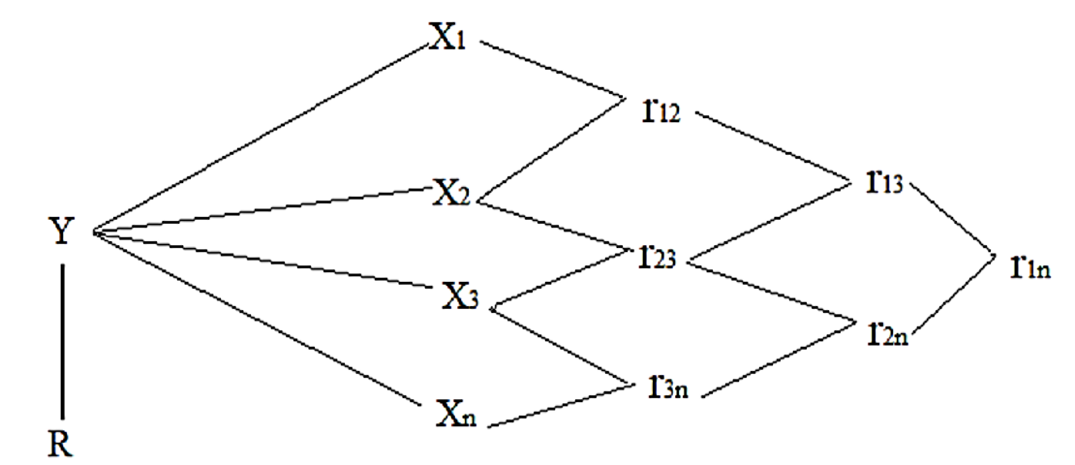Where, r = Correlation coefficients, n = Total number of observations. The calculated ‘t’ value was tested with the ‘t’ value for respective (n-2) degrees of freedom for significance. To establish a cause-and-effect link, the first stage was to partition the genotypic correlation coefficient into direct and indirect effects using path analysis, as proposed by Dewey and Lu (1959) and developed by Wright (1921), and the second step was path diagram construction.

**Fig.1 Association of various components (X1, X2, and X3) on yield. (Y: Yield, R: Residual effect)**

Path coefficients were derived by solving a set of simultaneous equations of the kind proposed by Dewey and Lu (1959).

rny = Pny + rn2 P2y + rn3P3y + …………….

Where,

rny = represents the correlation between one component and yield

Pny = represents the path coefficient between that character and the yield

rn2= represents the correlation between that character and each of the

other components in turn.

Matrix A Matrix B Matrix C

$\left[\begin{aligned}r1y \\ r2y \\ rny\end{aligned}\right]$ = $\left[\begin{aligned}r11 r12 r13……r1n \\ r21 r22 r23……r2n \\ rn1 rn2 rn3……1 \end{aligned}\right]\left[\begin{aligned}P1y \\ P2y \\ Pny\end{aligned}\right]$

Where,

R12 = r21 and so on

R1y = Correlation between one component character and seed yield

The ‘B’ matrix was inverted [B]-1 and path coefficients (Pij) were obtained as,

i.e. Pij = (B)-1. A

The indirect effects of a particular character through other characters were obtained by multiplication of direct paths and particular correlation between these characters separately.

Indirect effects= rij × piy

Where,

i = 1 to 9

j = 1 to 9

Piy = P1y, P2y, ……………………, Pny

Path coefficient (Pij), correlation coefficient (rij), and residual factors (R) were diagrammatically presented. The residual factor i.e. variation in yield unaccounted for by these associations was calculated with the following formula:

Residual factor (R) = (1 – R2)

Where,

R2 = P1y r1y + P2y r2y + ……………... + Pnyrny

P1y, P2y, ……………, Pny = Direct path values

R1y, r2y, rny = Correlation coefficient

**Table 1. List of Genotypes and Varieties of Cowpea used in the present study**

|  |  |  |  |
| --- | --- | --- | --- |
| **Sr.**  **No.** | **Genotypes/Varieties** | **Pedigree** | **Source(s)** |
| 1 | CP-5 | RC-101 × Ajmer selection | RARI, Durgapura |
| 2 | CP-6 | RC-101 × RC-19 |
| 3 | CP-7 | C 152 × V 16 | UAS, Bangalore |
| 4 | CP-8 | C 152 × V 57817 |
| 5 | CP-13 | Vamban 1 × COCP-7 | PRC, Vamban |
| 6 | CP-15 | COCP-7×Vamban 1 |
| 7 | CP-16 | Selection from bidoli local | SKRU, Bikaner |
| 8 | CP-17 | Answara × Bhagyalaxmi | RARS, Pattambi |
| 9 | CP-18 | Selection from GC-13 | SDAU, Srinagar |
| 10 | CP-19 | TPTC-29 | ARS, Tirupati |
| 11 | CP-20 | DC-15 | UAS, Dharwad |
| 12 | CP-25 | PGCP-1 × PGCP-12 | GBPAU & T, Pantnagar |
| 13 | CP-26 | PL-3 × PL-1 |
| 14 | CP-2-1 | Local Selection | RARI, Durgapura |
| 15 | CP-9-1 | Local Selection |
| 16 | CP-17-1 | Local Selection |
| 17 | PCP-1110 | RC-101 × Phule Vithai-2-3-1 | ARS, Pandharpur |
| 18 | PCP-1115 | RC-101 × Phule Vithai -4-3-3 |
| 19 | PCP-1116 | RC-101 × Phule Vithai -4-5-3 |
| 20 | PCP-1123 | RC-101 × Phule Vithai -7-1-1 |
| 21 | PCP-1124 | RC-101 × Phule Vithai -7-1-5 |
| 22 | PCP-1126 | RC-101 × Phule Vithai -7-7-1 |
| 23 | PCP-1805 | PCP-1123 × SHRCP-01 |
| 24 | PCP-1809 | PCP-1124 × SHRCP-01 |
| 25 | PCP-1810 | PCP-1124 × SHRCP-02 |
| 26 | PCP-1814 | PCP-1124 × SHRCP-03 |
| 27 | PMCP-1002 | Mutant Phule Pandhari |
| 28 | PMCP-1005 | Mutant Phule Pandhari |
| 29 | PMCP-1008 | Mutant Phule Pandhari |
| 30 | PMCP-1021 | Mutant Phule Pandhari |
| 31 | Phule Pandhari | VC8 × V575 |
| 32 | Phule Rukmini | Pusadofasali x VCM 8 |
| 33 | Phule Vithai | VCM 8 x Konkan safed |

3. results and discussion

The correlation and path analysis for grain yield per plant and its contributing characters in cowpea genotypes, such as the number of pods per plant, pod length (cm), number of seeds per pod, test weight (gm), and seed yield per plant (gm) are presented in Table 3 and 4. The characters such as the number of pods per plant (0.740), number of main branches (0.638), number of seeds per pod (0.376), leaf width (0.363), and pod length (0.281) are positively correlated with the number of seeds per plant. whereas, leaf length (0.216), days to maturity (0.195), and test weight (0.171) were positively correlated but not statistically significant. The number of nodes on the main stem (-0.209) and days to 50% blooming (-0.026) showed a non-statistically significant negative correlation. Previous research found comparable results for the number of pods per plant and the number of main branches per plant (Sharma et al., 2016), the number of seeds per pod (Nigude et al., 2004), leaf width (Bhardwaj et al., 2014), 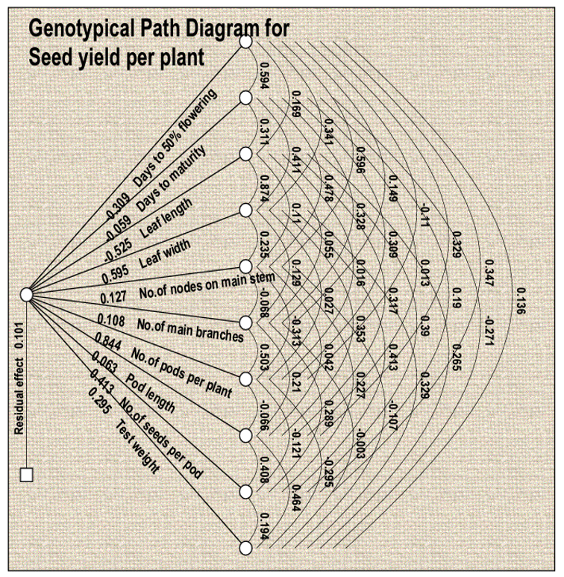and pod length (Tyagi et al., 2000).

**Fig. 2. Genotypical path diagram for seed yield per plant in Cowpea**

The genotypic correlation between days to maturity and seed yield per plant (0.195) and leaf length and seed yield per plant (0.216) was non-significant positive. Leaf width and seed yield per plant were positive and highly significant (0.363) and number of main branches and seed yield per plant was positive and highly significant (0.638), whereas the correlation between number of nodes on the main stem and seed yield per plant was negative and non-significant (-0.209).

The characters like days to 50% flowering, days to maturity, leaf length, leaf width, number of nodes on the main stem, pod length, number of seeds per pod, and test weight were highly significant and positively correlated with each other. In agreement with the earlier studies by Thorat and Gadewar (2013) for days to 50% flowering and days to maturity, number of seeds per pod and pod length (Paghadar et al. 2019), and for days to 50% flowering, days to maturity, pod length, number of seeds per pod and test weight (Kalambe et al. 2019).

The direct and indirect effect of yield and yield contributing characters at genotypic levels were as indicated in Fig. 1. The genotypic correlation between the days to 50% flowering and seed yield per plant was negative and non-significant (-0.026). Its direct effect on seed yield per plant was negative and high (-0.308). The negative correlation suggests that delayed flowering tends to reduce seed yield, though not significantly. The strong negative direct effect (-0.308) implies that early flowering genotypes may be preferable for higher yield in breeding programs.

The genotypic correlation between the number of pods per plant and seed yield per plant, pod length and seed yield per plant, number of seeds per pod, and seed yield per plant was positive and highly significant. Its direct effect on seed yield per plant was positive and high, whereas the correlation between test weight and seed yield per plant was positive and non-significant (0.171) while its direct effect on seed yield per plant was positive and high (0.294). Previous studies have also found similar results for different characters such as, for the number of pods per plant, seeds per pod, and 100 seed weight (Vineeta et al. (2003) and number of main branches (Sharma et al. 2016), pod length (Venkatesan et al. 2003), number of pods per plant and pod length (Lal et al.2007), number of pods per plant and days to 50% flowering (Patil et al. 2021), number of branches per plant (Phogat et al. 2017), number of pods per plant (Das et al. 2020), number of pods per plant, number of seeds per pod, number of branches and pod length (Chaudhary et al. 2020), number of branches, pod length and pods per plant (Gupta et al. 2019), number of seeds and number of pods per plant in correlation and path analyses (Tirkey et al. 2022), number of pods per plant (Aliyu et al. 2022), number of pods per plant, pod length and number of seeds per pod (Sogalad et al. 2022), number of seeds per pod (Panchta et al. 2020), 100 seed weight, number of pods, pod length and number of branches (Singh et al. 2020). Looking into the future, these analyses hold great promise. Advancements in genomics enable a deeper understanding of the genetic basis of these characters, facilitating targeted breeding for improved yield. Incorporating omics data, and precision agriculture technologies can provide comprehensive insights into complex interactions and optimize yield. Addressing climate resilience, integrating multi-trait selection, and considering nutritional quality in analyses contribute to sustainable agriculture and food security.

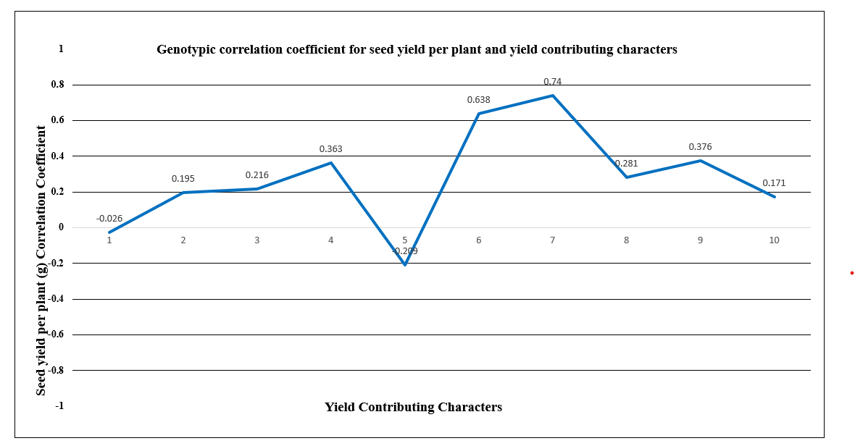

**Fig. 3. Genotypic Correlation Coefficient of Cowpea**

[1: Days to 50% flowering, 2: Days to maturity, 3: Leaf length (cm), 4: Leaf width (cm), 5: Number of nodes on the main stem, 6: Number of main branches, 7: Number of pods per plant, 8: Pod length (cm), 9: Number of seeds per pod, 10: Test weight (100 seed weight) (g)]

The analysis of variance (Table 2) revealed that the mean sum of squares due to genotypes for all the characters studied was highly significant, which indicated the presence of an appreciable amount of variability among the genotypes.

4. Conclusion

The characters like the number of pods per plant, followed by the number of main branches per plant, number of seeds per pod, leaf width, and pod length showed a positive and highly significant correlation with seed yield per plant. The characters such as number of pods per plant, number of seeds per pod, leaf width, and test weight had high positive direct effect on seed yield per plant. Thus, direct selection for these traits will be beneficial in the yield improvement program.

Based on the present study the genotypes *viz.,* PMCP-1021, CP-20, CP-25, CP-26, CP-7, CP-2-1, CP-15, CP-9-1, CP-17, CP-2-1, PCP-1809, PCP-1124, PCP-1123, Phule Rukmini and Phule Pandhari can be used for the further breeding program.

Ethical approval

This article does not contain any studies with human participants or animals performed by any of the authors.

**DISCLAIMER (ARTIFICIAL INTELLIGENCE)**

Author(s) hereby declare that NO generative AI technologies such as Large Language Models (ChatGPT, COPILOT, etc.) and text-to-image generators have been used during the writing or editing of this manuscript.

REFERENCES

Abha, Ruchika, and M. L. Meena. 2024. Correlation and Path Analysis in Cowpea (Vigna Unguiculata (L.) Walp.). Journal of Experimental Agriculture International 46 (7):1071-85. <https://doi.org/10.9734/jeai/2024/v46i72660>.

Afutu E. 2017. Resistance of cowpea to scab disease and diversity of *Sphaceloma* sp. occurring in Uganda. Doctoral Dissertation, Makerere University. Kampala, Uganda.

Agahi K, Fotokian M H and Farshadfar E. 2007. Correlation and path coefficient analysis for some yield-related traits in rice genotypes (Oryza sativa L.). Asian Journal of Plant Sciences.

Agza B, Kasa B, Zewdu S, Aklilu E and Alemu F. 2012. Animal feed potential and adaptability of some cowpea (*Vigna unguiculata*) varieties in North West lowlands of Ethiopia. Journal of Agricultural Research **11**: 478-483.

Aliyu O M, Tiamiyu A O, Usman M and Abdulkareem Y F. 2022. Variance components, correlation and path analyses in cowpea [Vigna unguiculata (L.) Walp]. Journal of Crop Science and Biotechnology 25:173–182. <https://doi.org/10.1007/s12892-021-00121-5>

Asiwe J A N. 2009. Needs assessment of cowpea production practices, constraints and utilization in South Africa. African Journal of Biotechnology **8**(20).

Avinashe H A, Shukla R S and Jaiwar N D S. 2015. Correlation and path analysis for yield and yield contributing characters in bread wheat (Triticum aestivum L.). Electronic Journal of Plant Breeding **6**(2):555-559.

Belay N. 2018. Genetic variability, heritability, correlation and path coefficient analysis for grain yield and yield component in maize (Zea mays L.) hybrids.  Advances in Crop Science and Technology **6**(5):399.

Bhardwaj R, Singh D P, Upasana R, Tiwana U.S and Bajaj R K. 2014. Association studies in cowpea (Vigna unguiculata L.). Journal of food legumes 27(1): 74-76.

Chaudhary A R, Solanki S D, Rahevar P M and Patel D A. 2020. Genetic Variability, Correlation and Path Coefficient Analysis for Yield and Its Attributing Traits in Cowpea [Vigna unguiculata (L.) Walp] Accessions. International Journal of Current Microbiology and Applied Sciences 9(2):1281-1293. doi: https://doi.org/10.20546/ijcmas.2020.902.151

Das S, Karak C and Roy S. 2020. Genetic variability, correlation and path analysis studies in cowpea [Vigna unguiculata (L.) Walp.]. International Journal of Economic Plants 7(3):123-128.

Dewey D R and Lu K. 1959. A correlation and path‐coefficient analysis of components of crested wheatgrass seed production 1. Agronomy journal 51(9):515-518.https://doi.org/10.2134/agronj1959.00021962005100090002x

Fonseca S and Patterson F L. 1968. Yield Component Heritabilities and Interrelationships in Winter Wheat (Triticum aestivum L.). Crop Science **8**(5):614-617. https://doi.org/10.2135/cropsci1968.0011183X000800050032x

Francis N, Packiaraj D, Geethanjali S and Hemaprabha K. 2018. Correlation and path coefficient analysis for yield contributing characters in rice (Oryza sativa L.) cultivars. Journal of Current Microbiology and Applied Science **7**(6):2292-2296.

Ghodake B D., More K., & Gund S. 2023. Assessment of genetic diversity in cowpea (Vigna unguiculata L.) genotypes by using RAPD markers. Pharma Innovation, 12(2):605-608. DOI: https://doi.org/10.22271/tpi.2023.v12.i2h.18484

Güler M, Adak M S and Ulukan H. 2001. Determining relationships among yield and some yield components using path coefficient analysis in chickpea (Cicer arietinum L.). European journal of agronomy. ;14(2):161-166. DOI:[10.1016/S1161-0301(00)00086-1](http://dx.doi.org/10.1016/S1161-0301(00)00086-1)

Gupta R K, Pramila, Banshidhar and Kumar U. 2019. Study on correlation and path analysis in cowpea [Vigna unguiculata (L.) Walp]. International Journal of Chemical Studies 7(6):1264-1268.

Iqbal M, Chang M A, Iqbal M Z and Nasir A. 2003. Correlation and path coefficient analysis of earliness and agronomic characters of upland cotton in Multan. Journal of Agronomy.

Johnson H W, Robinson H F and Comstock R E. 1955. Genotypic and phenotypic correlations in soybean and their implications in selection. Agronomy Journal 47(10): 477 – 483.http://dx.doi.org/10.2134/agronj1955.00021962004700100008x

Kalambe A S, Wankhade M P, Deshmukh J D, Chavan B R and Shinde A V. 2019. Correlation studies in cowpea (Vigna unguiculata L.). Journal of Pharmacognosy and Phytochemistry 8(3):321-323.

Kumari A and Vishwakarma S R. 2022. Evaluation of correlation and path analysis for yield contributing traits in Barley (Hordeum vulgare L.). Journal of Agricultural Research Advances **4**(1): 8-11.

Lonardi S, Muñoz‐Amatriaín M, Liang Q, Shu S, Wanamaker S I, Lo S and Close T J. 2019. The genome of cowpea (Vigna unguiculata L. Walp.). The Plant Journal **98**(5): 767-782.doi: 10.1111/tpj.14349, PMID:

Martins L M V, Xavier G R, Rangel F W, Ribeiro J R A, Neves M C P, Morgado L B and Rumjanek N G. 2003. Contribution of biological nitrogen fixation to cowpea: a strategy for improving grain yield in the semi-arid region of Brazil. Biology and fertility of soils **38**(6):333-339. doi: 10.1007/s00374-003-0668-4

Mohammadi S A, Prasanna B M and Singh N N. 2003. Sequential path model for determining interrelationships among grain yield and related characters in maize. Crop Science **43**(5):1690–1697.<https://doi.org/10.2135/cropsci2003.1690>

Munawar M, Shahbaz M, Hammad G and Yasir M. 2013. Correlation and path analysis of grain yield components in exotic maize (Zea mays L.) hybrids. International Journal of Sciences: Basic and Applied Research **12**(1): 22-27.

Nigude A D, Dumbre A D, Lad D B and Bangar N D. 2004. Genetic variability and correlation studies in cowpea [Vigna unguiculata (L.) Walp]. Journal of Maharashtra Agricultural University 29(1):30-34.

Paghadar P J, Vachhani J H, Gajera K P and Chovatiya S J. 2019. Evaluation of correlation and path analysis in vegetable cowpea [Vigna unguiculata (L.) Walp.]. International Journal of Chemical Studies 7(4): 628-630.

Pal S, Dubey N, Avinashe H, Khan S and Reddy J P. 2019. Estimation of genetic variability, correlation and path analysis for yield and yield contributing characters in Indian mustard (Brassica juncea L.). Journal of Pharmacognosy and Phytochemistry **8**(1S): 102-105.

Panchta R, Arya S, Singh D P, Satpal, Preeti and Kumar R. 2020. Genetic Variability and Association Studies in Cowpea [Vigna unguiculata (L.) Walp] For Seed Yield and Related Traits. Forage Research 46(3):232-235.

Panse V G and Sukhatme P V. 1985. Statistical method for Agricultural worker. ICAR, New Delhi 4: 145-150.

Patil S, Pethe U B, Mahadik S G, Dalvi V V and Joshi M M. 2021. Correlation and path analysis study in F3 generation of cowpea [Vigna unguiculata (L.) Walp] genotypes. Journal of Pharmacognosy and Phytochemistry 10(1):203-207.

Phogat D S, Panchita R, Kumari P, Niwas R and Arya S. 2017. Variability, Correlation and Path Analysis Studies in Fodder Cowpea [Vigna unguiculata (L.) Walp]. Trends in Biosciences 10(3):1130-1132.

Sharma P, Sharma M and Vyas M. 2016. Correlation coefficient and path analysis between seed yield and its components traits in cowpea [Vigna unguiculata (L.) Walp.]. International Journal of Current Research 8(8): 35783-35786.

Shengu M K. 2017. Path coefficient analysis of early maturing maize (Zea mays) inbred lines in central rift valley of Ethiopia. Plant **5**(3): 47–50.doi: 10.11648/j.plant.20170503.11

Singh O V, Shekhawat N, Singh K and Gowthami R. 2020. Assessment of genetic variability and inter-character association in the germplasm of cowpea [Vigna unguiculata (L.) Walp] in hot arid climate. Legume Research-An International Journal 43(3):332-336.

Singh R K and Choudhary B D. 1977. Biometrical Methods in Quantitative Genetic Analysis. Kalyani Publishers New Delhi39-68.

Sogalad M S, Deshpande S K and Kavyashree N M. 2022. Genetic variability, correlation and path analysis studies in grain cowpea [Vigna unguiculata (L.) Walp sub sp. unguiculata]. The Pharma Innovation Journal 11(12):3749-3754.

Tadesse J and Leta T. 2019. Association and path coefficient analysis among grain yield and related traits in Ethiopian maize (Zea mays L.) inbred lines. African Journal of Plant Science **13**(9):264–272. https://doi.org/10.5897/AJPS2019.1784

Thorat A and Gadewar R D. 2013. Variability and Correlation studies in cowpea (Vigna unguiculata). International Journal for Environmental Rehabilation and Conservation 4(1): 44-49.

## Tirkey, Milka, Lal G M and Anand S P. 2022. Estimation of Correlation and Path Analysis for Quantitative Traits in Cowpea (Vigna unguiculata (L.) Walp). International Journal of Plant & Soil Science 34 (22):1194-1200. https://doi.org/10.9734/ijpss/2022/v34i2231486.

Tyagi P C, Kumar N and Agarwal M C. 2000. Genetic variability and association of component characters for seed yield in cowpea. Legume Research 23(2):92-96.

Uddin M J, Abdullah M R and Wazuddin M. 2007. Correlation and path analysis of yield and yield contributing characters of hybrid rice. Journal of the Bangladesh Society for Agricultural Science and Technology **4**(4&3):149-154.

Venkatesan M, Prakash M and Ganesan J. 2003. Correlation and path analysis in cowpea [Vigna unguiculata (L.) Walp.]. Legume Research 26(2): 105-108.

Vineeta K, Arora R N and Singh J V. 2003. Variability and path analysis in grain cowpea. Advances in arid legumes research 59-62.

Wright S J. 1921. Correlation and causation. Journal of Agricultural Research. 20: 557-585.

**Table 2. Analysis of variance for 11 characters in cowpea**

|  |  |  |  |  |
| --- | --- | --- | --- | --- |
| **Sr. No.** | **Characters** | **Mean sum of squares (MSS)** | | |
| **Replications (2)** | **Treatments (32)** | **Error (64)** |
| 1 | Days to 50% flowering | 0.01 | 180.39** | 12.89 |
| 2 | Days to maturity | 6.90 | 152.59** | 8.03 |
| 3 | Leaf length (cm) | 0.47 | 3.96** | 0.73 |
| 4 | Leaf width (cm) | 1.06 | 2.74** | 0.34 |
| 5 | No. of nodes on main stem | 0.05 | 37.09** | 1.61 |
| 6 | No. of main branches | 0.82 | 7.63** | 1.02 |
| 7 | No. of pods per plant | 2.12 | 88.89** | 1.66 |
| 8 | Pod length (cm) | 3.36 | 15.19** | 1.09 |
| 9 | No. of seeds per pod | 0.88 | 7.66** | 0.75 |
| 10 | Test weight (gm) | 0.07 | 17.52** | 0.14 |
| 11 | Seed yield per plant (g) | 2.53 | 77.78** | 2.03 |

*, ** significant at 5 and 1 per cent, respectively.

**Table 3. Genotypic correlation of 11 characters in 30 Genotypes and 3 Varieties of Cowpea**

|  |  |  |  |  |  |  |  |  |  |  |  |
| --- | --- | --- | --- | --- | --- | --- | --- | --- | --- | --- | --- |
| **Observations** | **Days to 50% flowering** | **Days to maturity** | **Leaf length (cm)** | **Leaf width (cm)** | **No. of nodes on main stem** | **No. of main branches** | **No. of pods per plant** | **Pod length (cm)** | **No. of seeds per pod** | **Test weight (gm)** | **Seed yield per plant (gm)** |
| **Days to 50% flowering** | **1.000** | 0.594** | 0.169 | 0.340** | 0.595** | 0.149 | -0.109 | 0.328** | 0.347** | 0.136 | -0.026 |
| **Days to maturity** | 0.594** | **1.000** | 0.311** | 0.411** | 0.477** | 0.328** | 0.308** | 0.012 | 0.19 | -0.271** | 0.195 |
| **Leaf length (cm)** | 0.169 | 0.311** | **1.000** | 0.873** | 0.109 | 0.055 | 0.016 | 0.317** | 0.389** | 0.265* | 0.216 |
| **Leaf width (cm)** | 0.340** | 0.411** | 0.873** | **1.000** | 0.234* | 0.129 | 0.027 | 0.352** | 0.413** | 0.328** | 0.363** |
| **No. of nodes on main stem** | 0.595** | 0.477** | 0.109 | 0.234* | **1.000** | -0.067 | -0.313** | 0.042 | 0.227* | -0.107 | -0.209 |
| **No. of main branches** | 0.149 | 0.328** | 0.055 | 0.129 | -0.067 | **1.000** | 0.502** | 0.21 | 0.288** | -0.003 | 0.638** |
| **No. of pods per plant** | -0.109 | 0.308** | 0.016 | 0.027 | -0.313** | 0.502** | **1.000** | -0.066 | -0.121 | -0.294** | 0.740** |
| **Pod length (cm)** | 0.328** | 0.012 | 0.317** | 0.352** | 0.042 | 0.21 | -0.066 | **1.000** | 0.408** | 0.463** | 0.281** |
| **No. of seeds per pod** | 0.347** | 0.19 | 0.389** | 0.413** | 0.227* | 0.288** | -0.121 | 0.408** | **1.000** | 0.194 | 0.376** |
| **Test weight (gm)** | 0.136 | -0.271** | 0.265* | 0.328** | -0.107 | -0.003 | -0.294** | 0.463** | 0.194 | **1.000** | 0.171 |
| **Seed yield per plant (gm)** | -0.026 | 0.195 | 0.216 | 0.363** | -0.209 | 0.638** | 0.740** | 0.281** | 0.376** | 0.171 | **1.000** |

**\* and ** significant at 5% and 1%, respectively**

**Table 4. Direct (diagonal) and Indirect (above and below diagonal) path effects of different characters towards seed yield at genotypic level in Cowpea**

|  |  |  |  |  |  |  |  |  |  |  |  |
| --- | --- | --- | --- | --- | --- | --- | --- | --- | --- | --- | --- |
| **Observations** | **Days to 50% flowering** | **Days to maturity** | **Leaf length (cm)** | **Leaf width (cm)** | **No. of nodes on main stem** | **No. of main branches** | **No. of pods per plant** | **Pod length (cm)** | **No. of seeds per pod** | **Test weight (gm)** | **Seed yield per plant (gm)** |
| **Days to 50% flowering** | **-0.308** | -0.034 | -0.088 | 0.202 | 0.075 | 0.016 | -0.092 | 0.020 | 0.143 | 0.040 | -0.026 |
| **Days to maturity** | -0.183 | **-0.058** | -0.163 | 0.244 | 0.060 | 0.035 | 0.260 | 0.001 | 0.078 | -0.079 | 0.195 |
| **Leaf length (cm)** | -0.052 | -0.018 | **-0.525** | 0.520 | 0.014 | 0.006 | 0.013 | 0.019 | 0.160 | 0.078 | 0.216 |
| **Leaf width (cm)** | -0.105 | -0.024 | -0.458 | **0.595** | 0.029 | 0.014 | 0.022 | 0.022 | 0.170 | 0.096 | 0.363** |
| **No. of nodes on main stem** | -0.183 | -0.028 | -0.057 | 0.139 | **0.127** | -0.007 | -0.264 | 0.002 | 0.093 | -0.031 | -0.209 |
| **No. of main branches** | -0.046 | -0.019 | -0.029 | 0.077 | -0.008 | **0.108** | 0.424 | 0.013 | 0.119 | -0.001 | 0.638** |
| **No. of pods per plant** | 0.033 | -0.018 | -0.008 | 0.016 | -0.039 | 0.054 | **0.843** | -0.004 | -0.050 | -0.086 | 0.740** |
| **Pod length (cm)** | -0.101 | -0.001 | -0.166 | 0.209 | 0.005 | 0.022 | -0.055 | **0.062** | 0.168 | 0.136 | 0.281** |
| **No. of seeds per pod** | -0.107 | -0.011 | -0.204 | 0.246 | 0.029 | 0.031 | -0.102 | 0.025 | **0.412** | 0.057 | 0.376** |
| **Test weight (gm)** | -0.042 | 0.015 | -0.139 | 0.195 | -0.013 | -0.001 | -0.248 | 0.029 | 0.080 | **0.294** | 0.171 |

**(R=0.1009). *, ** significant at 5% and 1%, respectively**