**Biometrics and biology of citrus psylla, *Diaphorina citri* Kuwayama on Kinnow**

**Abstract**

Citrus (Sapindales: Rutaceae) is the largest cultivated group of fruits in the world, which includes Kinnow, sweet orange, limes, lemons, mandarins, tangerines and grapefruit. Asian citrus psyllid (ACP), *Diaphorina citri* Kuwayama is one of the most important and serious pest of citrus. Both nymphs and adults of psylla suck the cell sap from flower buds, leaves, young shoots which results in leaf distortion, curling and complete defoliation or shedding. It is important to understand pest biology and ecology before initiating control measures. Therefore, the experiment was conducted to study the biometrics and biology of citrus psylla under laboratory conditions on Kinnow. Different life stages, duration along with their morphological parameters were recorded to differentiate between different instars. Eggs were laid in clusters on the half opened tender leaves and tender twigs. There are five nymphal stages with their body length varying from 0.36 to 1.66 mm. The incubation, nymphal and adult longevity were 4.5±0.53, 14.9±0.99 and 26.4±3.03 days, respectively. Pre-ovipositional, Ovipositional and Post-ovipositional period were found to be 3.28±0.46, 19.5±1.60 and 3.13±0.64 days, respectively. Thus, the life span of ACP ranged between 37 to 48 days, with an average of 41.2±3.26 days. The preponderance of female was noticed with female:male ratio of 1.08:1. This study provides the fundamental knowledge about the biology of citrus psylla infecting Kinnow, which will be helpful in identifying the weak links in its life cycle for formulating different IPM strategies.

**Keywords:** Kinnow, *Diaphorina citri*, citrus, biology, sex ratio, biometrics, adult longevity, nymphs

**Introduction**

In many tropical and subtropical regions of the world, including Brazil, China, the United States, India, Pakistan, Italy, Spain, Australia, and Argentina, citrus is one of the most widely cultivated fruit crop. Within the Rutaceae family, the genus *Citrus* contains a variety of species including oranges, mandarins, grapefruits, limes, and lemons (Langgut, 2017; Noorizadeh *et al*., 2022). Citrus production is restricted by biotic (pathogens and insect pests) and abiotic (temperature, humidity, soil conditions, and water availability) variables. Insects are a significant biotic factor limiting citrus production to a greater extent (Pathak and Rizvi, 2003; Chen et al., 2022). There are about 250 pest species known to harm citrus trees, but only a small number of pests become a persistent issue that have the potential to do significant harm.

Asian citrus psylla (ACP) is a phloem-feeding hemipteran insect exclusively associated with Rutaceae. It has been described breeding upon almost 100 species and hybrids of this family. Both nymphs and adults suck the sap and affect the plants in direct as well as indirect way. High densities of nymphs feeding on budbreak flushes can affect their growth resulting in the development of stunted and distorted shoots (Aubert, 1987). Lateral leaf notching is also associated with feeding on tender leaves (Nage et al., 2023; Khan et al., 2015). However, at low insect densities, the described symptomatology usually goes unnoticed. Both *D. citri* adults and nymphs secrete a semi-solid honeydew under high infestation levels and humid environmental conditions serves as a substrate for sooty mould growth. The additional damage is due to its role in spreading Citrus greening disease (Da Graça et al., 2004; Halbert and Manjunath, 2004) which is one of the most devastating diseases of Citrus globally. This insect is known to be the most efficient vector of phloem-inhabiting bacterium *Candidatus Liberobacter* *asiaticus* that causes Citrus greening disease and is also known as ‘Huanglongbing disease’ throughout Asia and Far East (Pande, 1971). Citrus greening is characterized by yellow shoots and blotchy mottle eventually results in defoliation and dieback sets in the plants (Ghosh et al., 2018). Stunted with little foliage, infected trees may bloom during off-seasons. Furthermore, there is formation of small, asymmetrical hard fruit with little, black, and abortive seeds, as well as twig dieback, leaf, and fruit drop (Bouvert et al., 2019; Tipu et al., 2021).

*Diaphorina citri* exhibits high fecundity and a short life cycle, allowing for rapid population growth. Gravid females display bright orange abdomen indicating reproductive maturity prefers to oviposits exclusively on developing tender tissue and young flushes. A single female can deposit up to 800 eggs in her lifetime (Mead, 1977). The eggs are almond-shaped and initially pale, but as they develop, they progressively turn yellow or orange. The nymphs have a yellow body, red eyes, and, in later instars, wings that are visible when they hatch. Adult citrus psyllas have speckled wings that are held "roof-like" over the body and range in length from 3 to 4 mm. Adults and nymphs are obligate phloem feeders, meaning they can only eat the delicate tissues of fresh shoots. The most serious harm is caused by disease transmission through nymphs and adults (Yang et al., 2006).

At the optimal temperature of 20-25°C, the complete life cycle takes around 14-50 days depending upon different environmental conditions which translates into a potential of 9-14 overlapping generations per year (Liu and Tsai, 2000). The number of generations under field conditions is nevertheless conditioned by its host phenology (Corallo et al., 2021). Commercial citrus trees have a limited number of major flushing periods in which ACP can develop (Udell et al., 2017).

The percentage of losses caused by psylla infestation varied from 83 to 95 per cent (Randhava, 1974). The production of citrus fruit crops has gone down in the recent past years due to several factors and citrus greening disease is recognized as one of the major predisposing factors for such decline in citrus production. Throughout the year, the psyllid *D. citri* is present, but its population peaks in the spring and summer when citrus trees undergo their largest vegetative flushes. Although *D. citri* is more active in the spring and following monsoon flushes, their population growth is negatively impacted by the cold winter and summer months (when temperatures approach 40°C). The two main elements that affect psyllid development and reproduction are temperature and the presence of fresh flush. For psyllid females to lay eggs and eventually develop into psyllid nymphs, they require a new flush. Temperature and the quantity of psyllids in the field are strongly correlated (Rogers and Stansly, 2012).

With reference to manage this pest in integrated manner, determining number of instars, durations and morphometric characters in insect systematics is very critical (Daly, 1985). A thorough understanding of the pest’s biology via biometrics (life measurements) (Croxton and Stansly, 2014; Afzal et al., 2023) is must for understanding the weak links in their life cycle which ultimately leads to their effective management. Morphometric techniques are particularly amazing scientific approaches when used for detailed biological knowledge to develop a finer understanding of how insects grow and develop and contribute to their management, since the size and dimensions of an insect's exoskeleton also mirrors its mode of life. While *Diaphorina citri* has been the subject of numerous studies conducted worldwide, there is a dearth of comprehensive research on their biometrics in addition to their biological studies. Therefore, the biology and morphometric analysis of *Diaphorina citri* on Kinnow are the main subjects of this study.

**Materials and methods:**

**a) Site selection and experiment design:** The biology of *D. citri* on Kinnow plants was studied during August-September, 2022 in the screen house, Department of Entomology, on one year old Kinnow plants in screen house. The recommended package of practices of CCS HAU, Hisar was followed to raise the Kinnow seedlings. For the fulfilment of this objective, no insecticidal treatment was applied to the plants at any growth stage. The citrus psylla culture was maintained individually in 10 jars in laboratory for analysing different biological parameters.

**b) Raising culture for biological studies:** To raise the culture of the *D. citri*, 4th or 5th instar nymphs of citrus psylla were collected from the field and raised in a screen house conditions on one year old Kinnow. The adults so emerged were then aspirated into cylindrical cages and released for eight hours with a set of five plants, each pair consisting of 2 males and 2 females by following the methodology given by Singh et al. (2018).

After oviposition, the adults were removed to count the number of eggs laid with the help of a magnifying lens. Serial transfer of the Kinnow plants was made till the female ceased to lay eggs. Twenty 1st instar nymphs collected within 8 hours of egg hatching were transferred individually to a seedling of Kinnow using a camel hair brush in a glass jar covered with muslin cloth. Individual insects were checked for moulting and the exuviae were used to determine moulting. To record the adult longevity, 20 freshly emerged adults (10 males and 10 females) were released in caged plants and observations were recorded daily up to the death of test insect. The culture maintained was used for further biological studies *viz*., incubation period, nymphal instars, pre-oviposition period, oviposition period, post-oviposition period, sex-ratio, adult longevity and fecundity/female (Roma et al., 2019).

**c) Statistcal analysis:** The biology of citrus psylla on Kinnow was analysed with analysis of variance complete randomized design (CRD) using standard deviation (SD). The biometrics of different instars of *D. citri* were compared using analysis of variance (ANOVA) in SPSS (Version 26) software . The model's explanatory variables/factors were various biological characteristics associated with various life phases. Male and female pairwise comparisons were carried out, along with analyses of the biology (egg incubation period, length of various nymphal instars, adult longevity, total life period, sex ratio), morphometrics (length and width of larval instars), and morphometry of the insect.

**Results and Discussion**

**Life cycle**

Detailed observations of duration of distinct life stages and diverse biological parameters are presented in Table 1.

**Incubation period**

Study on biology of *D. citri* demonstrated that female oviposited singly or in clusters in the folds of half–opened leaves, axils of tender leaves and between the axillary buds. Eggs were small, elongated, oval shaped and bright yellow in colour initially, later turning into bright orange colour with two distinct eye spots when ready to emerge. The eggs were anchored by means of a short stalk which was inserted into the plant’s tissue and new unfold flushes . The incubation time took an average of 4.5±0.53 days, but it varied from 4-5 days.

The present observations align with the conclusions made by Nehru et al. (2006), Rogers and Stansly (2012) and Devi and Sharma (2013), who recorded the incubation period of 3.01 to 8.49 days during August-September on Kinnow. The present findings are also in line with Roma et al. (2019) and Singh et al. (2018) who observed the average incubation period of 3.64±0.70 and 3.5±0.24 days, respectively on sweet orange.

**Nymphal instars**

Nymphs of *D. citri* mainly suck the sap from tender shoots and new flush and also secretes waxy secretion which ultimately affect photosynthesis. Therefore, controlling this pest requires an awareness of their growth and development throughout this phase. In this study, *D. citri* had five nymphal instars with total duration of 14.9±0.99 days. The observation aligns with earliest discoveries (Chhetry et al., 2012; Cifuentes-Arenas et al., 2018; Singh et al., 2018).

**First Nymphalinstar:** As soon as the first instar nymphs emerged from the egg, they began feeding at the location of their emergence in fresh flushes and unopened leaves. Due to their minute, delicate, sessile, and immobile nature, they were invisible to the unaided eye. They seemed flattened, oval in shape with rounded ends, orange in colour, with two segmented antennae, and without wing pads when examined under a microscope. The duration of the first instar nymph lasted with a mean duration of 2.3±0.48 days (Table 1) are in conformity with the findings of Roma et al. (2019) however Singh et al. (2018) found a comparatively longer (2.6±0.25 days) duration of first nymphal instar. The first instars moult faster than second instars compared to other life stages (Chhetry et al., 2012). The initial nymphal instar was 0.36 mm in length and 0.16 mm in width, as documented by Nehru et al (2006). In contrast, the second nymphal instar measured 0.42 mm by 0.25 mm, nearly resembling Devi and Sharma. (2013) (Fig. 2).

**Second nymphal instar:** Second instars resembled their previous stage in appearance and was confirmed by observing their exuviae. This conclusion was supported by the findings of Singh et al. (2018), which also noted that the first nymphal instar shared a similar morphological appearance. The second nymphal instar which was resulted from the moulting of first nymphal instar was flat and rounded and they were slightly deep orange in colour and red eyed. The wing pads were like small triangular processes projecting from the body. The average duration of second instar nymph was 2.3±0.48 days. The findings align with the findings of Singh et al (2018) who stated that the second nymph instar lasted 3.0±0.18 days. Roma et al. (2019), Singh et al. (2018), and Chhetry et al. (2012) previously observed that 1.76, 3.0, and 2.70 days were required for the development of second instar to third instar nymphs for the same stage of this pest under identical conditions.

**Third nymphal instar:** It is simple to determine when the nymphs enter their third instar by looking at their exuviae and size. The freshly moulted third instar nymphs were just like the previous instars. The wing pads were rudimentary, the anterior end of the mesothorax with pads were just reaching the eyes. From the third instar forward, the antennal tip turned black and the eyes turned a deep red. The third instar nymphal duration ranged from 2-3 days, with an average of 2.8±0.42 days. Roma et al. (2019) and Nehru et al. (2006) specified the same morphological features and completely justified the findings of the present study. Previously, Singh et al. (2018) and Chhetry et al. (2012) noticed somewhat longer (4.5±0.21 days) and shorter (2.5±0.18 days) duration, respectively. This variation is due to different weather conditions, host plant and seasons when the studies were carried out. According to Nehru et al. (2006), the average size of a third-instar nymph was determined to be 0.86 mm × 0.47 mm. (Fig. 2).

**Fourth nymphal instar:** The freshly moulted fourth instar did not undergo any change from previous instar except in size and antennae segment and moult was observed by their exuviae. The fourth nymphal instars were light orange with well-developed red eyed than previous instars. Antennae were very clear, well-marked and five segmented. The duration of fourth instar ranged from 3-4 days (3.7±0.48 days). The observations and characteristics were in line with the findings of Nehru et al. (2006) and Singh et al. (2018). However, Roma et al. (2019) recorded the shorter duration of 2.52±0.51 days at laboratory condition during 2017-18.

**Fifth nymphal instar:** Once the nymphs entered into their fifth instars, they were easily identified based on their characteristic appearance.They were light yellow in colour with an orange-tinge in the abdominal area. The colour of the eyes, the antennal tip and rostrum darkened as the nymph grew. The wing pads were further developed and produced cephalad at the humeral angle. The mean duration of fifth instar nymph was 3.8±0.42 days and ranged from 3-4 days. The duration of fifth instar nymphs in present study matches with findings of Singh et al. (2018) and Devi and Sharma (2013) with nymphal duration of 4.8±0.92 days in Ludhiana. The fifth instar was more susceptible to insecticide applications because it took them longer to moult into adults than it did for the other life stages (Grafton-Cardwell et al., 2013). Devi and Sharma (2013) also stated that the average size of the fourth instar nymph was 1.12 mm × 0.68 mm, while the fifth instar measured about 1.66 mm × 0.93 mm.

**Adults:** After emergence, the adults displayed a sluggish appearance, with colors ranging from dirty white to mottled brown. They also had translucent wings, dark eyes, and seven segmented antennae with black tips. Later, the colour of the adult changed to brown. The adults fed on both sides of the leaves but prefer to feed on lower surface of leaves with their heads touching the leaf and abdomen raised up at 30° angle with closed wings. The male and female can easily be distinguished by the presence of typical/pointed abdomen in females as compared with blunt abdomen in males (Fig. 1).

The female adults lived longer than the males. The average lifespan of males and females was 21.6±3.63 days and 22–32 days, respectively, with ranges of 18–28 days and 26.4±3.03 days. The preponderance of female has been observed with sex ratio of 1.08:1. The total development period was recorded as 41.2±3.26 days in females and 36.4±3.9 days for males (Table 1). The studies conducted by Nehru et al. (2006) completely justifies the findings of the present study. However, Roma et al. (2019) reported longevity of male and female was 22.27±2.19 and 28.13±2.77 days, respectively. According to Patel (2002), the average lifespan of males and females on kagzi lime was 17.00 days in the monsoon and 36.55 days in the winter. The measurements of the male and female, respectively, were 2.94 mm × 0.52 mm and 2.03 mm × 0.52 mm and 3.19 mm × 0.77 mm and 2.43 mm × 0.77 mm (Fig. 2). The adult's size varied from that of Mathur (1975), but it was consistent with the 2-3 mm body length that Fernández and Miranda (2005) recorded.

**Ovipositional periods and fecundity:** The pre-ovipositional, ovipositional and post-ovipositional period of *D. citri* ranged from 3-4 days (3.28±0.46), 17-22 days (19.5±1.60) and 2-4 days (3.13±0.64), respectively. The orange abdomens of the gravid females indicate that the eggs are ready to be laid. The eggs laid/female was 440- 527 eggs with an average of 488.37±26.72 eggs. The average fecundity was 488.37±26.72 eggs per female. The results are in agreement with the findings of Singh et al. (2018) who reported 505.2±26.08 eggs/female on sweet orange. The results are also in conformity with Roma et al. (2019), who observed the fecundity of 561.44±34.91 eggs/female. More or less similar results were recorded by Liu and Tsai (2000) on different host plants viz., on lemon (572 eggs), sweet orange (612 eggs) and orange jasmine (626 eggs).

The results of the previous studies indicated that the fecundity and other biological parameters duration and numbers may vary and depends on period of study, host plant and weather conditions. Studies conducted by Nehru et al. (2006) justifies the findings of the present study who reported the pre-oviposition and oviposition period of 1.38 to 3.90 and 10.00 to 38.38 days, respectively. The present results are in conformity with Singh et al. (2018) who observed mean pre-oviposition and oviposition period of 1.8±0.26 days and 22.1±0.75 days, respectively. The present results are also in agreement with Nehru et al. (2006). The adult citrus psylla showed the post-oviposition period with mean duration of 3.13±0.64 days. The sex ratio was 1.08 female per male. Similarly, the post oviposition period of 3.89 days was reported by Nehru et al. (2006).

A thorough understanding of the life stages of the target pest species is necessary for the development of successful population control methods. Our knowledge of the biology and morphometric variability linked to the many stages of *Diaphorina citri* is improved by this work.

**Conclusion**

Development of effective strategies for controlling pest populations requires a detailed knowledge of life stages of target pest species. This study enhances our understanding of biology and morphometric variability associated with different stages of *Diaphorina citri*. Fecundity, survival rate, and sex ratio are factors that influence a species' rate of population expansion, based on earlier research. However, in this study citrus psylla was found to have five nymphal instars and dry weather conditions directly favoured its multiplication which is further related with duration of feeding on target plants, resulting in damaging the plants. These recorded biological parameters contribute directly to effectively managing the ACP by analysing its weak point. Our study was limited to a screen house and controlled laboratory settings, so further fieldwork is needed to see whether these effects hold true in more natural settings.

**Disclaimer (Artificial intelligence)**

**Option 1:**

**Author(s) hereby declare that NO generative AI technologies such as Large Language Models (ChatGPT, COPILOT, etc.) and text-to-image generators have been used during the writing or editing of this manuscript.**

**Option 2:**

**Author(s) hereby declare that generative AI technologies such as Large Language Models, etc. have been used during the writing or editing of manuscripts. This explanation will include the name, version, model, and source of the generative AI technology and as well as all input prompts provided to the generative AI technology**

**Details of the AI usage are given below:**

**1.**

**2.**

**3.**

**References:**

Afzal M B S, Banazeer A, Serrao J E, Rizwan M, Naeem A. 2023. Ecology, biology, damage, and management of sucking and chewing insect pests of citrus. In Citrus Research-Horticultural and Human Health Aspects. Intech Open 4 (1): 25-32.

Aubert B. 1987. *Trioza erytreae* Del Guercio and *Diaphorina citri* Kuwayama (Homoptera: Psylloidea), the two vectors of citrus greening disease: biological aspects and possible control strategies. Fruits 42(3): 149-162.

Bouvet J P R, Urbaneja A, Monzó C. 2019. Effects of citrus overwintering predators, host plant phenology and environmental variables on aphid infestation dynamics in clementine citrus. Journal of Economic Entomology 112(4): 1587-1597. doi:10.1093/jee/ toz101

Chen X D, Stockton D, Gossett H, Qureshi J A, Ibanez F, Pelz-Stelinski K S, Stelinski L L. 2022. Comparisons of economic thresholds for Asian citrus psyllid management suggest a revised approach to reduce management costs and improve yield. Frontiers in Sustainable Food Systems 6: 948278.

Chhetry M, Gupta R, Tara J S. 2012. Bionomics of *Diaphorina citri* Kuwayama, on Citrus sinensis in Jammu Region of J&K State. Munis Entomology and Zoology 7: 304-308.

Cifuentes-Arenas J C, Goes A de, Miranda M P de, Beattie G A C, Lopes S A. 2018. Citrus flush shoot ontogeny modulates biotic potential of *Diaphorina citri.* PLoS ONE 13(1): e0190563. doi:10.1371/journal.pone.0190563

Corallo A B, Evelin-Pechi E, Bettucci L, Tiscornia S. 2021. Biological control of the Asian citrus psyllid, *Diaphorina citri* Kuwayama (Hemiptera: Liviidae) by entomopathogenic fungi and their side effects on natural enemies. Egyptian Journal of Biological Pest Control 31(15): 1-9.

Croxton S D, Stansly P A. 2014. Metalized polyethylene mulch to repel Asian citrus psyllid, slow spread of huanglongbing and improve growth of new citrus plantings. Pest Management Science 70(2): 318-323. doi: 10.1002/ps.3566

Da Graça, J. V., & Korsten, L. (2004). Citrus huanglongbing: Review, present status and future strategies. *Diseases of Fruits and Vegetables Volume I: Diagnosis and Management*, 229-245.

Daly H V. 1985. Insect Morphometrics. Annual Review of Entomology 30: 415–438.

Devi H S, Sharma D R. 2013. Comparative biology of citrus psylla, *Diaphorina citri* Kuwayama on three host plants during spring season. Journal of Insect Science 26(1): 121-125.

Fernández M, Miranda I. (2005). Comportamiento de *Diaphorina citri* Kuwayama (Hemiptera: Psyllidae). Part I: Caracteristicas morfologicas, incidencia y enemigos naturales asociados. Rev. Pro. Veg. 20: 27-31.

Ghosh, D. K., Motghare, M., & Gowda, S. (2018). Citrus greening: overview of the most severe disease of citrus. *Adv Agric Res Technol J*, *2*(1), 83-100.

Grafton-Cardwell E E, Stelinski L L, Stansly P A. 2013. Biology and management of Asian citrus psyllid, vector of the huanglongbing pathogens. Annual Review of Entomology 58: 413– 432.

Gupta S. 2020. https://legaldesire.com/biometric-analysis/

Halbert S E, Manjunath K L. 2004. Asian citrus psyllids (Sternorrhyncha: Psyllidae) and greening disease of citrus. Florida Entomologist 87(3): 330-353.

Khan, A. A., Afzal, M., Ullah, M. I., Khan, A. M., & Saeed, S. (2015). Asian citrus psyllids (Hemiptera: Psyllidae), its vectored disease ‘‘Huanglongbing’’and its eco-friendly management. Applied Sciences In Business Economy 2(1): 12.

Langgut D. 2017. The citrus route revealed: From Southeast Asia into the Mediterranean. Horticulture Science 52(6): 814-822.

Liu Y H, Tsai J H. 2000. Effects of temperature and life table parameters of the Asian citrus psyllid, *Diaphorina citri* Kuwayama (Homoptera: Psyllidae). Annals of Applied Biology 137: 201–206.

Mathur R N (1975). Psyllidae of the Indian Subcontinent (pp. 20). Indian Council of Agricultural Research, New Delhi.

Mead, F. W. (1977). The Asiatic citrus psyllid, *Diaphorina citri* Kuwayama (Homoptera: Psyllidae). Florida Department of Agriculture and Consumer Services, Division of Plant Industry Entomology.(http://www.doacs.state.fl.us/pi/enpp/ento/entcirc/ Entcirc180.pdf)

Monzo C, Qureshi J A, Stansly P A. 2014. Insecticide sprays, natural enemy assemblages and predation on Asian citrus psyllid, *Diaphorina citri* (Hemiptera: Psyllidae). Bulletin of Entomological Research 104(5): 576-585. doi:10.1017/S0007485314000315

Nage SM, Kulkarni US, Undirwade DB, Sant SS. 2023. Relative Toxicity of Different Insecticides to Asian Citrus Psylla (Diaphorina citri Kuwayama). International Journal of Environmental and Climate Change13(11): 3635-41

Nehru R K, Bhagat K C, Koul V K. 2006. Biology of Diaphorina citri Kuwayama on Citrus sinensis Osbeck. Environment and Ecology 24: 443-448.

Noorizadeh S, Golmohammadi M, Bagheri A, Bertaccini A. 2022. Citrus industry: Phytoplasma-associated diseases and related challenges for Asia, America and Africa. Crop protection 151: 105822.

Pande Y D, 1971. Biology of citrus psylla, *Diaphorina citri* (Hemiptera: Psyllidae). Israel Journal of Entomology 6(2): 307-311.

Patel B J, 2002. Bio-Ecology and control of psylla, *Diaphorina citri* Kuwayama infesting Kagzi lime. M.Sc. (Agri.) thesis, G. A. U., Sardar Krushinagar.

Pathak M, Rizvi Q. 2003. Effect of different temperatures and host plants on the developmental behavior of lemon butterfly, *Papilio demoleus*. Indian Journal of Entomology 65(4): 496-499.

Randhava G S. 1974. Horticulture - Importance of pest control. Pesticides Annual 8: 85-87.

Rogers M E, Stansly P A. 2012. Biology and Management of the Asian citrus psyllid, *Diaphorina citri* Kuwayama, in Florida Citrus.

Roma T, Snehal P, Surela V A, Saxena S P, Pandya H V. 2019. Biology of citrus psyllid, *Diaphorina citri* Kuwayama (Homoptera: Psyllidae). Journal of Entomology and Zoology Studies 7(5): 1101-1106.

Singh N V, Yadav, G S, & Meenakshi, D. (2018). Biology of citrus psylla, *Diaphorina citri* Kuwayama on sweet orange. Journal of Experimental Zoology 21(2): 705-708

Tipu M M H, Masud M M, Jahan R, Baroi A, Hoque A K M A. (2021). Identification of citrus greening based on visual symptoms: A grower's diagnostic toolkit. Heliyon 7(11).

Udell B J, Monzo C, Paris, T M, Allan S A, Stansly P A. 2017. Influence of limiting and regulating factors on populations of Asian citrus psyllid and the risk of insect and disease outbreaks. Annals of Applied Biology 171(1): 70-88. doi:10.1111/aab.12349

Yang Y, Huang M, Beattie GAC, Xia Y, Ouyang G, Xiong J. 2006. Distribution, biology, ecology and control of the psyllid *Diaphorina citri* Kuwayama, a major pest of citrus: a status report for China. International Journal of Pest Management 52: 343–352.

**Table 1: Duration of different stages of *D. citri***

|  |  |  |  |  |  |  |  |  |  |
| --- | --- | --- | --- | --- | --- | --- | --- | --- | --- |
| **S. No.** | **Insect stage/Duration** | | | | **Number observed** | | | **Mean duration(days)** | **Range** |
| **Mean±SD** |
| 1. | **Incubation Period** | | | | 20 | | | 4.5±0.53 | 4-5 |
| **Nymphal instars** | | | | | | | | | |
| 2. | 1st instar | | | | 20 | | | 2.3±0.48 | 2-3 |
| 3. | 2nd instar | | | | 20 | | | 2.3±0.48 | 2-3 |
| 4. | 3rd instar | | | | 20 | | | 2.8±0.42 | 2-3 |
| 5. | 4th instar | | | | 20 | | | 3.7±0.48 | 3-4 |
| 6. | 5th instar | | | | 20 | | | 3.8±0.42 | 3-4 |
| **Total Nymphal Period** | | | | | | | | 14.9±0.99 | 13-16 |
| **Adults** | | | | | | | | | |
| 7. | | Pre-ovipositional period | | | | 10 | | 3.28±0.46 | 3-4 |
| 8. | | Ovipositional period | | | | 10 | | 19.5±1.60 | 17-22 |
| 9. | | Post-ovipositional period | | | | 10 | | 3.13±0.64 | 2-4 |
| **Adults Longevity** | | | | | | | | | |
| 10. | | | Female | | 10 | | | 26.4±3.03 | 18-28 |
| 11. | | | Male | | 10 | | | 21.6±3.63 | 22-32 |
| **Total life cycle** | | | | | | | | | |
| 12. | | | | Female | | | 10 | 41.2±3.26 | 37-48 |
| 13. | | | | Male | | | 10 | 36.4±3.90 | 32-43 |
| 14. | | | | Pre-mating | | | 10 | 5.20±0.61 | 4-7 |
| 15. | | | | Fecundity/female | | | 10 | 488.37±26.72 | 440-527 |



Fig. 1. Life cycle of *Diaphorina citri*



Fig. 2. Life stages and micrometry of life stages of *D. citri*

**Supplementary photos:**

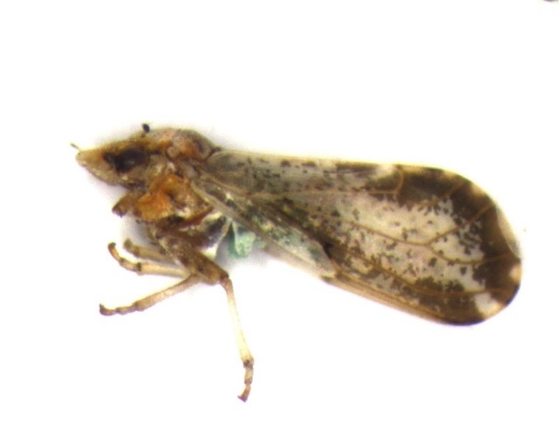 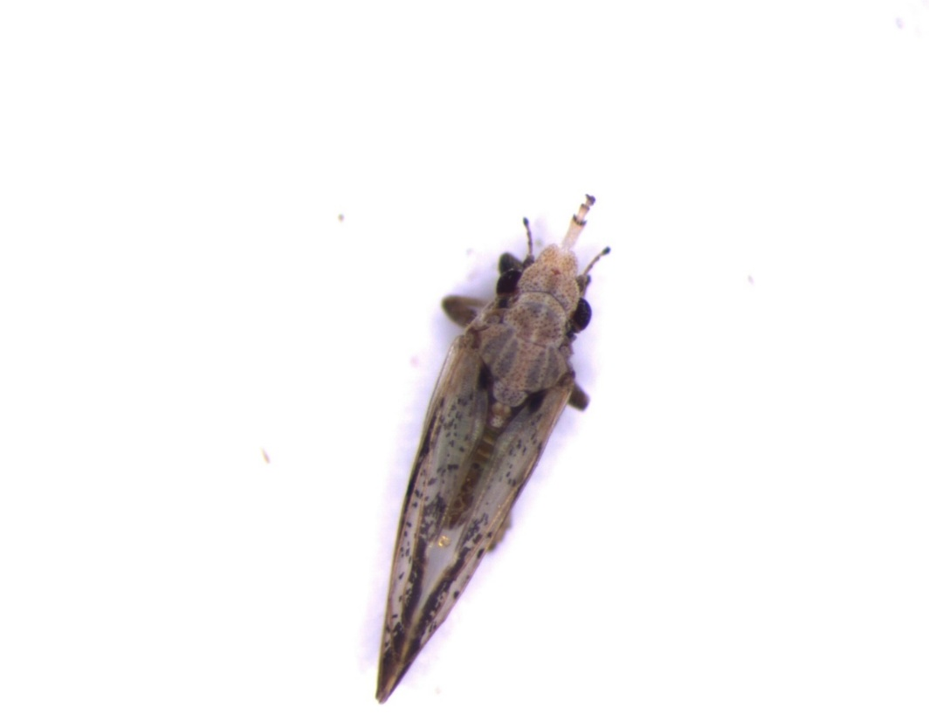

**(A)** Lateral view of *D. citri* adult **(B)** Dorsal View of *D. citri* adult

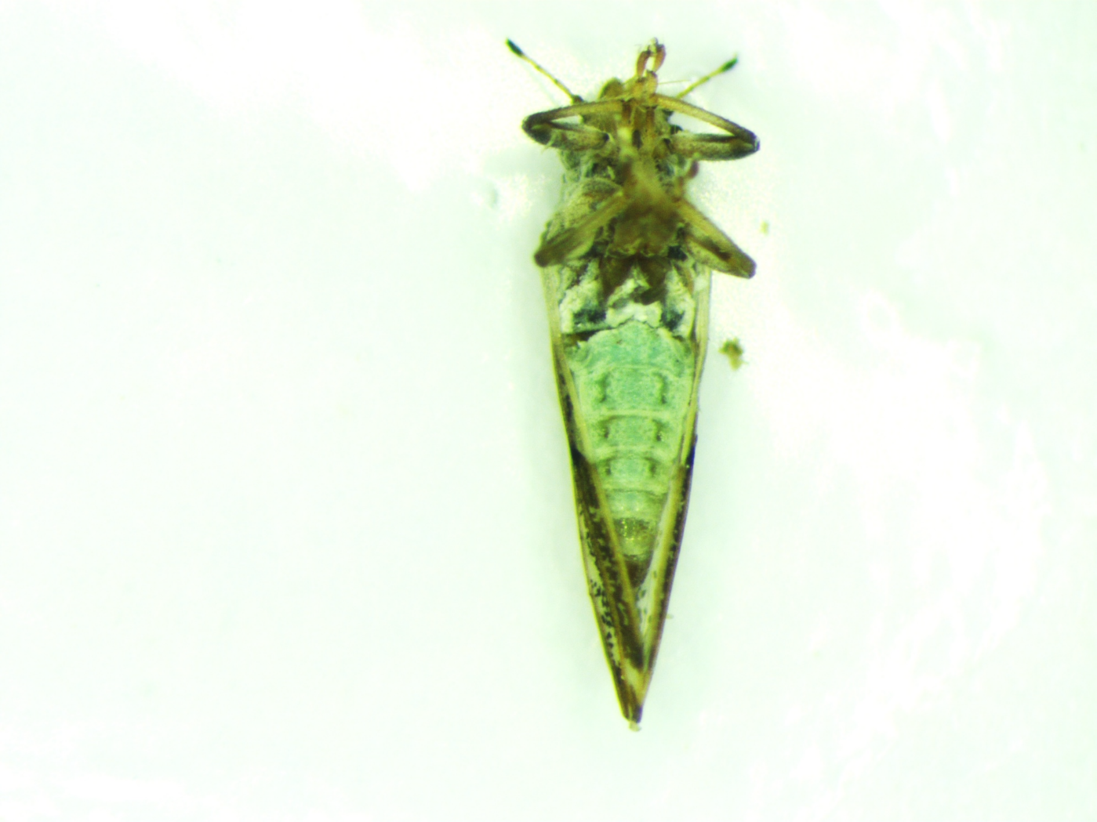

**(C)** Male of *D. citri* with blunt abdomen

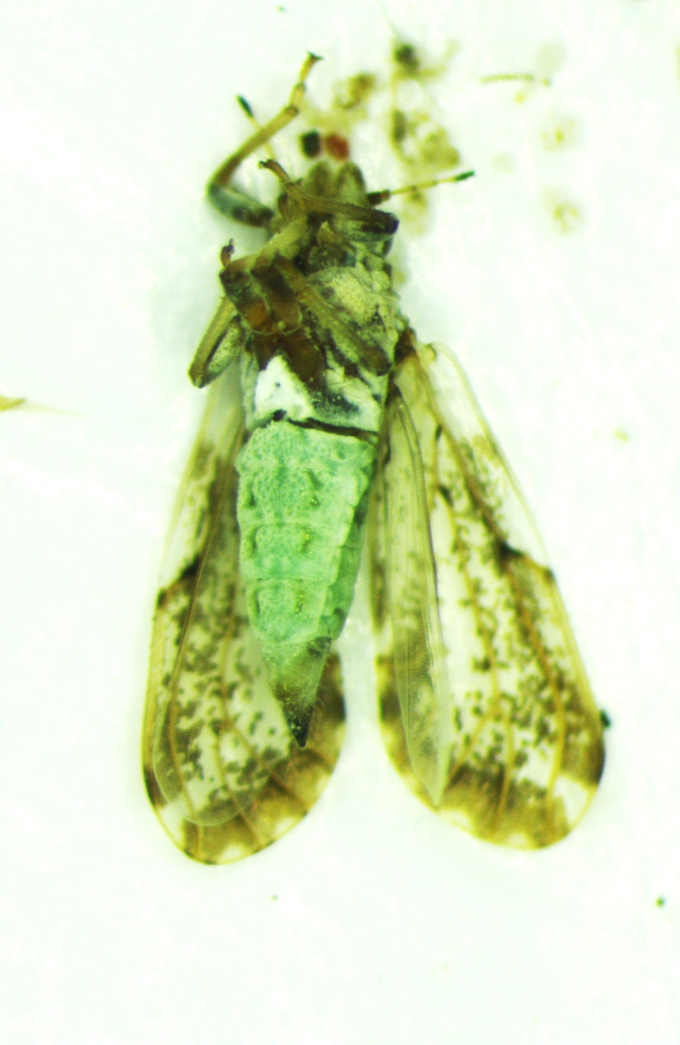

**(D)** Female of *D. citri* with pointed abdomen