***Review Article***

**DELINEATION IN *MELIA* SPECIES: A REVIEW**

**ABSTRACT**

The *Melia* genus comprises several species, including *Melia azedarach, Melia dubia, Melia volkensii* which are widely distributed across different geographical regions and exhibit considerable morphological similarities. Despite their economic, ecological, and medicinal significance, the taxonomic status and species boundaries within the *Melia* genus have been a matter of contention. Various factors, such as hybridization, geographical variation, and phenotypic plasticity, contribute to the complexity of species identification in this genus. Accurate delineation of *Melia s*pecies is vital for several reasons as it enables us to understand the evolutionary relationships and genetic diversity within the genus, providing insights into its evolutionary history and potential future adaptation. The taxonomic status of *Melia* is uncertain because of its variable anatomical and morphological features. So, integrative approach using traditional taxonomic methods with molecular techniques is mandatory to address the challenges associated with *Melia* species delineation. The presence of cultivated varieties and morphotypes has added to ongoing species complexity between *Melia dubia* and *Melia azedarach*. The objective of this review is to overview useful approaches that may successfully discriminate between *Melia dubia* and *Melia azedarach* and provide a significant comprehension for conservation endeavours in *Melia* genus. The review also incorporates preliminary research findings from the author’s ongoing investigation into this subject.

**Keywords:** Geographical variation, *Melia dubia*, *Melia azedarach*, molecular techniques, phenotypic plasticity, taxonomic status

**INTRODUCTION**

In India, annual timber wood production is about 70.9 million m3, while the wood consumption stands at 68.9 million m3 per year. The increasing demand of wood has led to the shortage of wood in pulp and paper industry (Chauhan et al*.,* 2018). Agarwal and Saxena (2017) reported that forests contribute just 6.4 % of the total domestic requirement. Therefore, due to inadequate availability of raw material, wood-based industry looks towards agroforestry farms for sustenance. Hence, to address the industrial wood demand, it is important to consider fastest growing tree species (Chauhan et al*.,* 2018). The family *Melia*ceae belongs to order Sapindales having 58 genera encompassing about 740 species (MuellnerRiehl and RojasAndres, 2021). It is widely distributed in tropical and subtropical regions of India (Fig. 1). In India, the family limits to 19 genera and 70 species (Jain and Bennet, 1997). *Melia*ceae contains many commercially important tree species of high valued timber and medicinal properties such as *Melia dubia*, *Melia azedarach*, *Swietenia macrophylla*, *Toona ciliata*, *Azadirachta indica* and *Cedrela odorata*. *Melia* is a small genus containing 2 - 3 species only. The divergence of *Melia* occurred in Eocene or early oligocene as revealed by studies based on molecular clock approaches (Muellner et al*.,* 2008, 2006). The genus *Melia* further carved its own space and established itself as a suitable alternate indigenous source of pulp, plywood, pole, and matchstick in India (Chavan et al*.,* 2021). Genus *Melia* is a group of flowering plants belonging to family *Melia*ceae. The two most well-known species in this genus are *Melia azedarach*, commonly known as the chinaberry or Persian lilac and *Melia dubia*. *Melia dubia* is a fast-growing tree species widely distributed in tropical and subtropical regions around the world mainly including, India, Australia, Sri lanka, Malaysia and China (Geetha et al*.,* 2018). The species has an umbrella-shaped crown with a dense foliage cover, reaching heights ranging from 15 to 30 meters (Fig. 2), depending on the environmental conditions. It has emerged as a significant alternative species for agroforestry schemes, with its adaptability to diverse climates and geographical conditions. The plantation of *Melia dubia* has potential of ameliorating soil pH on degraded lands, shifting it from alkaline to neutral in adverse climatic conditions (Singh et al*.,* 2018). This tree requires relatively low water input and can thrive in various soil types.

Traditionally, *Melia*ceae was divided into two subfamilies (Melioideae and Swietenioideae) and two monotypic genera (Capuronianthus J.F. Leroy and Quivisianthe Baill.) as described by Pennington and Styles (1975). However, Quivisianthe is placed in Melioideae and Capuronianthus in Swietenoideae based on phylogenetic analysis on nuclear and plastid DNA sequences (Muellner et al*.,* 2003). Sweitenoideae is now renamed as Cedreloideae as reported by Mabberley (2011). Therefore, *Melia*ceae is divided into two subfamilies, Melioideae and Cedreloideae. Melioideae subfamily has fleshy fruits (drupes), wingless seeds whereas the Cedreloideae subfamily has winged seeds and they produce capsules. 36 genera and 8 tribes are recognised for the subfamily Melioideae including the tribe Melieae. Melieae contains only two genera that is *Melia* L. and *Azadirachta* A. Jussieu (Muellner et al*.,* 2006; Mabberley, 2011). According to Hajra et al. (1997) *Melia azedarach* and *Melia dubia* are two distinct species with *Melia azedarach* having honey-scented flowers and *Melia dubia* having white inodorous flowers. The fruits are globose-ellipsoid in *Melia azedarach* and in *Melia dubia* they are ovoid-ellipsoid. Many studies have considered *Melia azedarach* as an accepted species (Dassanayake, 1995; Ahmed et al., 2012; Dharmalingam et al., 2014; Lake, 2015). There are four varieties of *Melia* reported by Liao et al*.* (2022) i.e., *Melia azedarach, Melia toosendan, Melia dubia* and *Melia volkensii*, differing in various leaflets and fruit characteristics as reported in studies by Chen (1997), Peng and David (2008), Hanaoka et al. (2012), Liao et al. (2016), and Sivaraj et al. (2018). Parthiban et al*.* (2019) reported three species of *Melia* existing in India i.e., *Melia azedarach, Melia composita* and *Melia dubia.* While Plants of the World Online distinguish them as distinct species, the Plantlist (http://www.theplantlist.org/) reports *Melia dubia* as a synonym for *Melia azedarach*. The presence of cultivated varieties and morphotypes has led to ongoing species complexity within *Melia*, making it challenging to definitively determine the number of species.

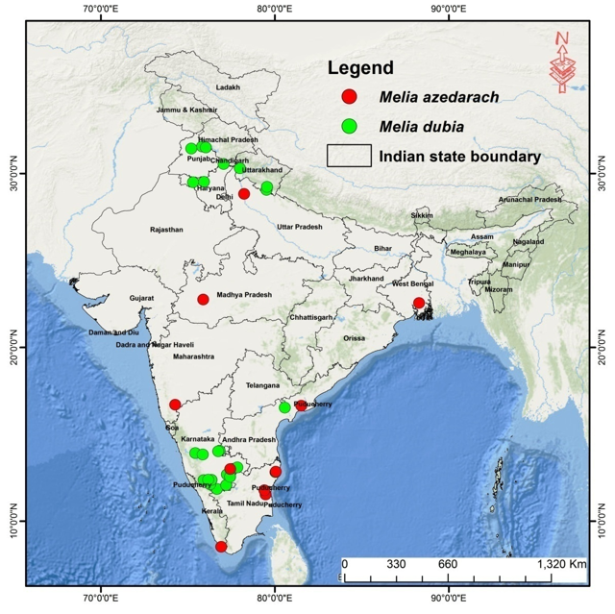

**Fig. 1**. **Distribution Map of *Melia dubia* and *Melia azedarach* in India (Kumar et al., 2021; Sivaraj et al*.,* 2018)**

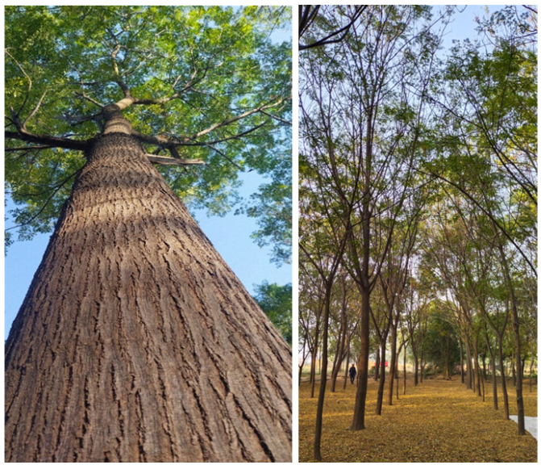

**Fig. 2. Morphological features and botanical illustration of *Melia dubia***

A recent case reported by Rajiv et al. (2020) involved the tragic death of a 25-year-old woman who consumed *Melia dubia* leaves. However, phytochemical analysis and forensic toxicology revealed the presence of *Melia azedarach* compounds, shifting the case from *Melia dubia* poisoning to fatal *Melia azedarach* poisoning. This highlights the need for clear morphological distinctions and molecular tools to untangle the complexities in identifying these closely related *Melia* species within the *Melia*ceae family. Although *Melia azedarach* have many medicinal values it can become toxic if consumed in excess amount. The features such as underlying genes, differences in phytochemicals (Table 1) and phylogenetic relationships among species, have not been completely explored, thereby, delimiting genetic breeding programs, as well as the ability of *Melia* to be used as medicinal species (Liao et al*.,* 2022). The details of preliminary phytochemical analysis of *Melia dubia* and *Melia azedarach* are given in Table 1. Although there are some noteworthy variances in the amount of these compounds, the type of phytochemicals contained in both species are mostly comparable. *Melia dubia* produces flowers with no discernible aroma, whereas *Melia azedarach* is known for its fragrant, honey-scented blossoms.They both produce bi-tri pinnate leaves (Fig. 3). Moreover, *Melia azedarach* and *Melia dubia* yield different fruit forms: globular to ellipsoid for *Melia azedarach* and ovoid to ellipsoid for *Melia dubia*. Table 2 provides an extensive analysis of these differences. Regardless of this, there is a clear need for exact differentiation in the *Melia* species owing to the similarities in their physical characteristics.

**Table 1.** **Preliminary Phytochemicals analysis from leaves of *Melia dubia* and *Melia azedarach* (Valentina et al*.,* 2013; Ahmed et al*.,* 2012; Farook et al*.,* 2019).**

|  |  |  |  |  |  |  |  |  |  |  |
| --- | --- | --- | --- | --- | --- | --- | --- | --- | --- | --- |
| **Phytochemical**  **constituents** | **n-Hexane**  **extract** | | **Petroleum ether extract** | | **Acetone extract** | | **Ethanol extract** | | **Water extract** | |
|  | *Melia dubia* | *Melia azedarach* | *Melia dubia* | *Melia azedarach* | *Melia dubia* | *Melia azedarach* | *Melia dubia* | *Melia azedarach* | *Melia dubia* | *Melia azedarach* |
| Saponins | - |  | - | + | - | + | - | + | + | + |
| Phytosterols | + |  | + |  | - |  | - |  | - |  |
| Triterpenoids | - |  | - | + | - | + | - | + | - | + |
| Steroids | + |  | + | + | - |  | - | + | - | + |
| Fat and Fixed Oil | + |  | + |  | - |  | - |  | - |  |
| Tannins | - |  | - | + | - | + | + | + | - | - |
| Protein and amino acids | - |  | - |  | - |  | - |  | + | + |
| Carbohydrates | - |  | - |  | + | + | + |  | + | - |
| Alkaloids | - |  | - | + | - | + | + | + | + | + |
| Glycosides | - |  | - | + | + | + | + | + | + | - |
| Essential Oil | - |  | + |  | - |  | - |  | - |  |
| Flavonoids | - |  | - | + | + | - | + | + | + | + |
| Anthraquinone |  |  |  | - |  | - |  | + |  | + |
| Reducing Sugar |  |  |  | - |  |  |  | - |  | + |
| Phenols |  |  |  | + |  | - |  | + |  | + |

***\*****Presence of phytochemical (+), absence of phytochemical (-) and blank space represents unavailable information or missing data*

**Table 2. Comparative differences between *Melia dubia* and *Melia azedarach* based on distinct morphological features observed and analysed by the authors in field.**

|  |  |  |
| --- | --- | --- |
|  | ***Melia dubia*** | ***Melia azedarach*** |
|  | The deciduous *Melia dubia* tree is valued for its economic value. It has a narrow crown that can grow as high as 25 metres or more. This species is highly valued as a source of priceless timber as well as a great raw material for making veneer and plywood surfaces of superior quality.  M dubia 2.jpg | M aza 1.jpg*Melia azedarach* is a deciduous shade tree characterized by its rounded crown, typically cultivated in parks and open areas to provide shade. It is a relatively smaller tree, often growing up to 11 meters in height. The wood of this tree is primarily utilized as firewood, producing a bitter-smelling smoke, and occasionally finds application in pulp production. |
|  | Bark is found to be dark brown, smooth, exfoliating in thin and narrow strips | Dark brown thick and deeply exfoliated |
|  | Bole is found to be very less fluted | The bole is fluted below when old |
|  | Leaves are bigger in two to three pinnate less than 1 m long. The leaflet shape and size are reported to be 5 to 13 on each pinna ovate to lanceolate oblique at base, serrulate or entire at margins, acuminate at apex, 3-12 x 1.5-4 cm | Leave morphology is comparatively smaller but with two to three pinnate of about 30 cm long. The leaflet shape and size are reported to be little smaller of 5 to 9 on each pinna ovate - lanceolate or elliptic – lanceolate oblique at base or toothed or lobed at margins, acuminate at apex, 2-5-5.0 x 1 – 2.50 cm |
|  | The secondary nerves are found to be 6 to 16 pairs with petioles 0.5 mm long and longer in terminal leaflets | The secondary nerves are found to be 8 to 15 pairs with petioles 0.5 mm long and longer in terminal leaflets |
|  | Style is found to be cylindrical, clavate at apex, longer than staminal tube with stigma having 3 to 5 fids, truncate | Style is found to be cylindrical, clavate at apex, longer than staminal tube, apiculate with stigma having 3 to 5 fids, truncate |
|  | The drupes are found to be ovoid-ellipsoid, 2.5 – 4 x 2 – 2.5 cm, yellowish when riped, pendulous with 1 to 4 or more seeds | The drupes are found to be globose-ellipsoid, 1 – 1.5 x 0.8 – 1 cm, bright yellow when riped with 1 seed |

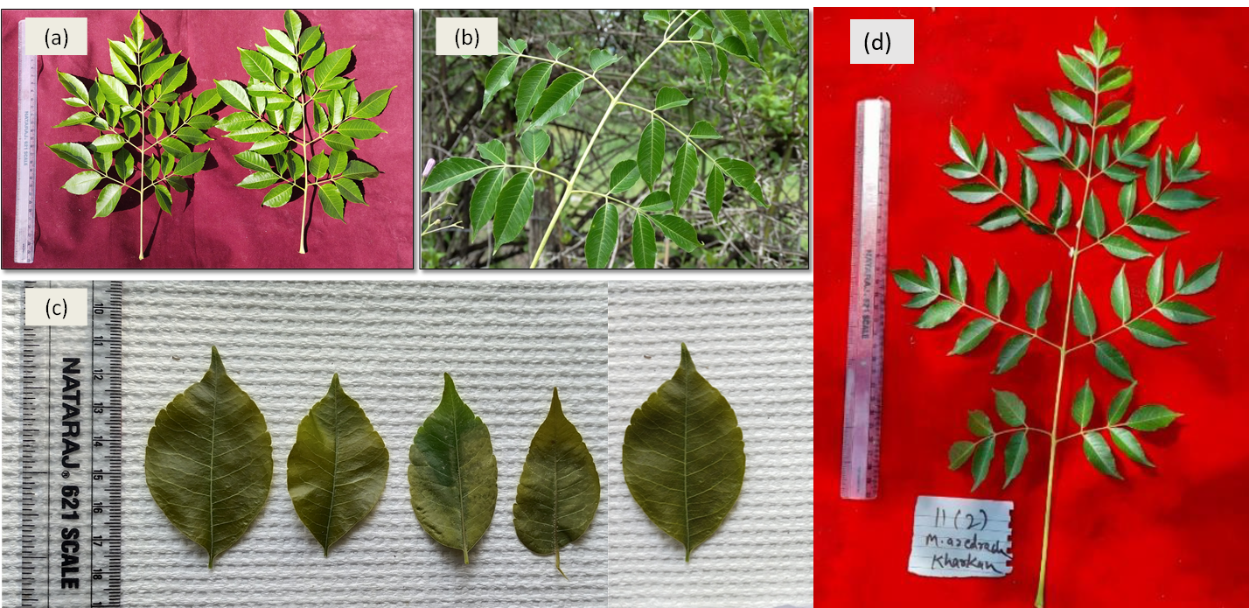

**Fig.3. Picture depicting (a) leaves of Melia dubia (b) leaves of Melia azedarach (c) Variation in leaves of Melia dubia (d) Variation in leaves of Melia azedarach**

**ROLE OF GEOGRAPHICAL AND MORPHOLOGICAL VARIATION IN ESTABLISHING DIFFERENT SPECIES**

Geographical variation plays vital role in shaping phenotypic traits. Different climatic conditions, habitat suitability, resource availability and biotic interactions drive divergence among populations of same species (Losos, 2011). Madigan et al. (2015) reported that according to Bergmann’s and Allen’s rule, larger body size tends to conserve heat in colder climates whereas smaller body sizes facilitate heat in warmer climates. Furthermore, local adaptations to specific environmental stresses such as altitude, salinity, predation can lead to morphological and physiological variation (Andersson, 1994). Genetic variation within a species enables it to evolve, adapt and respond to environmental stress which not only influences the evolutionary potential of a species but its survivability (Thakur et al., 2016). However, in addition to genetic factors, phenotypic plasticity also contributes to geographical variations in response to different environmental conditions. Restricted gene flow resulted from formation of geographical barriers and agroclimatic zones makes a population prone to random genetic drift (Fischer et al. 2000). However, genetic variation plays a vital role in species survivability and adaptability in changing environment. Additionally, rate of seed and pollen dispersal, inbreeding, and limited gene flow due to geographical barriers are results in such genetic changes which over time exhibit speciation (Hamrick et al., 1992). In a study done by Thakur et al. (2016), Melia azedarach samples were collected from a total of 33 geographically isolated wild populations from arid and semi-arid zones representing the plains of North-Western India. The hierarchical Analysis of Molecular Variance (AMOVA) based on 43 microsatellite markers revealed a large proportion of variation (73%) within the population.

Thakur et al. (2016), observed a significant ‘isolation by distance’ (Rxy = 0.365, P = 0.010; r2 = 0.133) which also explains genetic differentiation in the population of M. azedarach. Both the distance matrices showed congruence i.e. genetic distance between populations pairs, that increased with geographic distance (JNU-PTL; 402 km, 0.404; PTL-SMN, 54 km, 0.023) and are in accordance with ‘isolation by distance’ model. Such correlation indicates gene flow between the M. azedarach populations of North-Western plains of India to be dependent on geographic distance. The study revealed presence of two types of original genetic stock in Melia azedarach populations of North-Western plains of India. The authors suggested hindrance in Gene flow between arid and semi-arid region possibly was due to seed dispersal mechanism and climatic factors. Consequently, genetic differentiation among regions was established. produced in the present study have provided insight Therefore, understanding geographical variation role in shaping phenotypes is essential in species identification, conservation biology and predicting species response to climate change. However, morphological features rely on distinct physical traits such as body structure, coloration, size, rate of seed dispersal, reproductive organs, and developmental patterns, to distinguish congruent species to determine their evolutionary relationships (Andersson, 1994; Losos, 2011).

**SPECIES DELINEATION: CHALLENGES AND TASKS**

The identification and naming of a species are a prerequisite for any biological investigation. Although the boundaries of existence of species are quite intuitive, the delineation of species is a difficult task even for specialists. Systematics involves defining species and studying relationships between living entities. It is necessary to determine which variables (arbitrary /constrained) should be considered for measuring things. For instance, morphology is not equally powerful in all taxa. The risk of coalesce sibling species is probably higher in small, morphologically simplified organisms, whereas there is a higher risk of over splitting large complex organisms into different taxonomic entities. Genetic data can resolve this issue by providing ubiquitous, objective markers in any taxon of interest (Galtier, 2019).

Obstacle in species delineation is that individuals do not always cluster in well-defined entities and intermediate individuals are frequently observed (Fig. 4). Another problem is that significant differences in allelic frequencies are also observed between entities as distinct populations of a single species (Mallet, 2007). The nature of species and its existence is independent of amount of data available to scientists however, genetic clusters are still of interest irrespective of limitation of species. They can be informative on gene flow reduction events or on strength of genetic drift sometimes associated with local adaptation. Therefore, many geneticists are content with identifying and analysing genetic clusters whereas whether they are subspecies, species or population which are still considered as uninteresting secondary issue (Galtier, 2019).

The urgent need for accurate and effective tracking techniques is most apparent in forest tree species, particularly considering illicit logging operations. Threats to tropical forests are great because they support many endangered species and are disappearing worldwide. To mitigate this problem, logs that come from the critically endangered tropical tree genus Intsia (Merbau) are identified using DNA markers. According to Wong et al. (2009), these hypervariable microsatellite markers are utilised to genetically profile harvested tree rootstocks and determine if the harvested logs and the rootstocks are genetically compatible. The capability to identify species is critical, particularly in the context of controlling the trade in protected plants and their by-products and locating the source of endemic species' wood. According to Chase and Fay's (2009), plant barcoding advancements will greatly enhance the use of DNA variation for species identification and therefore, significant work is needed to assemble data sources with appropriate phylogeographic information, allowing the differentiation of various locations of origin for trees, particularly for the most important species.

High-throughput sequencing methods that are both affordable and time-efficient will make the construction of these databases more efficient (Binladen et al*.,* 2007). But it is necessary to recognise that there are limitations unique to some species.

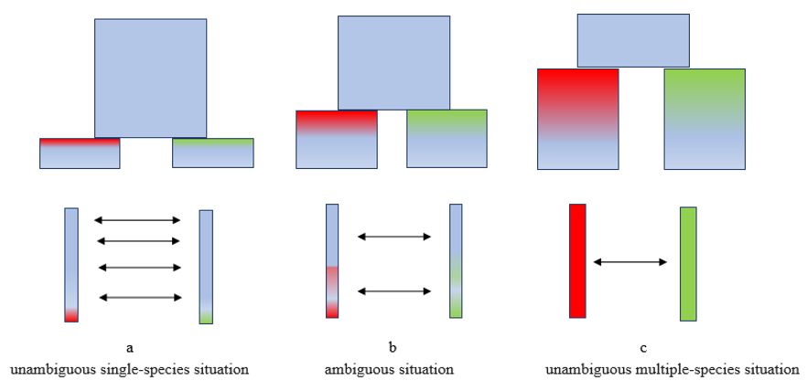

**Fig. 4**. **Species are defined as entities sufficiently diverged where gene flow (arrows) is very rare or inexistent. (A) unambiguous single-species situation (B) ambiguous situation (C) unambiguous multiple-species situation. Ambiguous situations appear when intermediate individuals are common and gene flow exists but limited to a certain fraction of the genome.**

**POPULATION GENETICS AND DNA BARCODING**

Sequence-based analysis has supplemented traditional analytical tools, with careful consideration given to selecting appropriate marker systems, such as those easily amplified via PCR. SatheeshKumar and Jagadeesan (2010) explored genetic diversity and conducted phylogenetic analysis of two marine polychaete species based on 16S rRNA sequences. Large-scale analysis of sequence-based markers is aimed at studying genetic variations associated with human diseases (Janzen, 2004). In case of forestry species, it is both feasible and crucial to extract DNA from processed wood samples to identify and stop the illegal trade in endangered timber species (Asif et al*.,* 2005). Despite, the difficulties caused by the deterioration of genetic material during processing, DNA can be extracted from treated wood samples hence, it is noteworthy because it creates new opportunities for the identification of timber species in wood products used in commerce. To precisely identify the wood species, the scientists probably used cutting-edge molecular biology methods like DNA barcoding and sequencing. These techniques support the creation of thorough genetic databases for wood species, which may be utilised for further studies and law enforcement initiatives as well as help in species identification (Asif et al*.,* 2005).

**PRELIMINARY INVESTIGATIONS REVEALING THE MORPHOLOGICAL COMPLEXITIES WITHIN MELIA DUBIA AND MELIA AZEDARACH**

A total of 180 samples of *Melia dubia* and *Melia Azedarach* were selected for morphological studies from different regions of Northern India i.e. Punjab, Haryana and Uttarakhand. The bark color was documented by RHS color chart and it varies from dark greyish brown to light olive grey in both the species whereas bark texture was found to be smooth in *Melia dubia* and rough in *Melia azedarach* respectively. The flower color was also documented using RHS color chart and it varies from pale lilac to white in both the species. The leaf shape also varies from lanceolate to elliptic in both the species. There are significant variations observed within *Melia dubia* and *Melia azedarach* both in different climatic zones of India. This may be due to cultivar driven speciation, when introduced to new geographical regions over the period of time, resulting in reproductive isolation leading to complexity within the species.

Another study on half sib families of *Melia dubia* on growth performance and variability demonstrated significant genetic diversity among progenies, with seedling height being the most contributing factor to genetic diversity (Yadav et al., 2019). Study on DUS descriptors of *Melia dubia* done by Warrier (2021) highlighted the significant variations in leaves, stones and fruits of *Melia dubia*. Similar research studies related to phenological and morphological characteristics of *Melia azedarach* are also documented by Cavusoglu and Sulusoglu (2015). Therefore, species identification with integrated molecular approach are mandatory to provide better insights in conservation practices and successful cultivation of the *Melia* species.

DNA barcoding research in *Melia* species has been relatively limited, not as extensive, or well-documented as in some other plant groups may be due to recent emergence of DNA barcoding as a tool in taxonomy and species identification (Fig. 5). Sivaraj et al. (2018) used DNA barcoding method for delineation of *Melia dubia* Cav. from *Melia azedarach* L and the most promising DNA barcode for species distinction was discovered to be *ITS2*. *ITS2* has also been identified as the top candidate for species identification with substantial genetic divergence in previous investigations on the taxonomic categorization of different congeneric taxa (Sivaraj et al*.,* 2018). The parsimony analysis of DNA barcoding data revealed that *Melia azedarach* and *Melia dubia* were clearly separated as separate monophyletic clades in *rbcL, matK, trnH-psbA* and *ITS2*. Mulanda et al. (2016) used DNA barcoding to study phylogenetic relationship between *Melia volkensii* and other important members of the family. Certain taxa were resolved down to the species level by the plant barcoding genes matK and rbcL (Mulanda et al*.,* 2016). The Meliaceae and closely related families have a partial molecular phylogeny. The primary impediment was the absence of comprehensive information on *matK* and *rbcL* sequences in the DNA repositories for these families' members. Limited availability of comprehensive DNA barcode reference databases specific to the *Melia* genus is one of the challenges in DNA barcoding research. Developing such databases is essential for accurate species identification.

**DNA PANEL: EVOLVED TECHNIQUE FOR PRECISE IDENTIFICATION OF SPECIES**

DNA panel is a molecular technique that utilizes combination of different genetic markers by analysing multiple genetic loci thereby improving accuracy in identification of species and providing comprehensive genetic fingerprint of an organism (Andersson, 1994). Unlike traditional single-gene method which relies on sequencing single genetic marker i.e. COI (cytochrome c oxidase I) or ITS (internal transcribed spacer), these multi-locus approach helps in reducing errors caused by genetic variation within a species thereby increasing resolution in delineating closely related or cryptic species. Therefore, DNA panels can include chloroplast, nuclear, and mitochondrial gene which not only improvesphylogenetic resolution, but also allows detection of hybridization events**,** which ultimately helps in refining species boundaries (Madigan et al., 2015). Furthermore, advancements in bioinformatics tool and high-throughput sequencing (HTS) havesignificantly improved the efficiency of DNA panel analyses, thereby helps in assessment of large-scale biodiversity and evolutionary processes with greater accuracy and reproducibility. Ahmad et al. (2019) in his study used multi-locus approach to identify ten Palm species using DNA fingerprinting method.

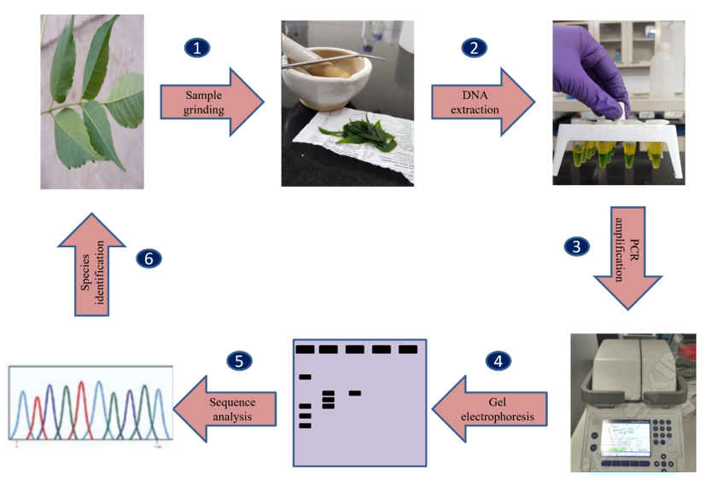

**Fig. 5. Schematic diagram representing steps involved in plant DNA barcoding**

**CONCLUSION**

Many species of ecological, commercial, and medical importance are found in the genus *Melia*. But the absence of significant differences between these species can cause misunderstandings and incorrect categorization, which can have serious ramifications for resource management and scientific study. To precisely comprehend the distribution, variety, and ecological roles of *Melia* species, morphological characterisation, DNA analysis, and thorough taxonomic investigations are necessary for species delineation. By resolving taxonomic uncertainties and providing a clear understanding of species boundaries, delineation efforts contribute to the broader scientific knowledge, conservation efforts, and sustainable utilization of *Melia* species. Moreover, accurate species identification is essential for the sustainable use of resources in landscaping, medicinal extraction, and timber production. Misidentification has the potential to destroy natural ecosystems and deplete precious resources.

**DISCLAIMER (ARTIFICIAL INTELLIGENCE)**

Author(s) hereby declare that NO generative AI technologies such as Large Language Models (ChatGPT, COPILOT, etc.) and text-to-image generators have been used during the writing or editing of this manuscript.

**REFERENCES**

Agarwal, S., Saxena, A.K. (2017). The puzzle of forest productivity: Are forest development corporations solving it right? (Ed. A. Shankar). *Centre for Science and Environment*, *New* *Delhi*, *India*. P48.

Ahmad, I., Khan, S., Naeem, M., Hayat, M., Ahmed, S., Murtaza, G. and Irfan, M. (2019). Molecular Identification of Ten Palm Species using DNA Fingerprinting. *International Journal of Pure and Applied Bioscience,* 7(1): 46-51.

Ahmad, M.F., Rao, A.S., Ahemad, S.R. and Ibrahim, M. (2012). Phytochemical studies and antioxidant activity of *Melia* azedarach Linn leaves by DPPH scavenging assay. *International Journal of Pharmaceutical Applications* 3: 271-276.

Andersson, L. (1994). Identification of species: Principles and problems. *Systematic Biology****,*** 43(3), 421–432.

Asif, J. and Cannon, C. (2005). DNA extraction from processed wood: A case study for the identification of an endangered timber species (Gonystylus bancanus). *Plant Molecular Biology Reporter,* 23: 185-192.

Binladen, J., Gilbert, M.T., Bollback, J.P., Panitz, F., Bendixen, C., Nielsen, R. and Willerslev, E. (2007). The use of coded PCR primers enables high throughput sequencing of multiple homolog amplification products by 454 parallel sequencing. *PLOS ONE,* 2: e197.

Cavusoglu, A. and Sulusoglu, M. (2015). Phenological and Morphological Characteristics of Melia azedarach L. in Kocaeli city in Turkey. *Scientific Papers. Series B, Horticulture*, Print ISSN 2285-5653.

Chase, M.W. and Fay, M.F. (2009). Barcoding of Plants and Fungi. *Science* 325: 682 - 683.  
<https://doi.org/10.1126/science.1176906>.

Chauhan, R.S., Jadeja, D.B., Thakur, N.S., Jha, S.K. and Sankanur, M.S. (2018). Selection of Candidate Plus Trees (CPTs) of Malabar Neem (*Melia dubia* Cav.) for Enhancement of Farm Productivity in South Gujrat. *International Journal of Current Microbiology and Applied Science,* 7(5): 3582 - 3592.

Chavan, S., Vishnu, R., Kumar, N., Kumar, D., Sirohi, C. and Handa, A.K. (2021). *Melia dubia: An indigenous tree species for industrial agroforestry in India,* 71(6): 7–11.

Chen, S.K. (1997). *Melia*ceae. In: Chen C, Chang H, Miau R, Hsu T, editors. *Flora Reipublicae Popularis Sinicae*. *Science Press:* Beijing, China, pp 99 - 103.

Dassanayake, M.D. (1995). Flora of Ceylon. *Oxford and IBH publisher Co. New Delhi, India*. Vol. 9: 276-278.

Dharmalingam, S.R., Madhappan, R., Chidambaram, K., Ramamurthy, S., Gopal, K., Swetha, P. and Kumar, K.L.S. (2014). Anti-urolithiatic activity of *Melia azedarach* Linn leaf extract in ethylene glycol-induced urolithiasis in male albino rats. *Tropical Journal of Pharmaceutical Research,* 13: 391–397.

Farook, M. A., Mohamed, H., Tariq, N., Paranjothi, M., Kumar, G., Subash, S., Ahmed, V., Kumar, M., Madhan, R., Naveez, V. and Mohammed. (2019). Phytochemical screening, Antibacterial and Antioxidant activity of *Melia azedarach*. *International Journal of Research and Analytical Reviews,* PRINT ISSN 2349-5138.

Fischer, M., Husi, R., Prati, D., Peintinger, M., Van Kleunen, M., Schmid, B. (2000). RAPD variation among and within small and large populations of the rare clonal plant Ranunculus reptans (Ranunculaceae). *American Journal of Botany*, 87:1128–1137

Galtier, N. (2019). Delineating species in the speciation continuum: A proposal. *Evolutionary Applications,* 12: 657 - 663.

Geetha, S., Venkatramanan, K.S., Warrier, K.C.S. and Warrier, R. (2018). Propagation protocols for enhancing conservation and utilization of *Melia dubia* Cav. *Journal of Tree Sciences,* 37(2): 22 - 35.

Hajra, P.K., Nair, V.J. and Daniel, P. (1997). Flora of India (Malpighiaceae- Dichapetalaceae). *Botanical Survey of India publisher, Calcutta, India.*

Hamrick, J.L., Godt, M.J.W., Sherman-Broyles, S.L. (1992). Factors influencing levels of genetic diversity in woody plant species Population genetics of forest trees. *Springer,* 42:95–124

Hanaoka, S., Muturi, G.M. and Watanabe, A. (2012). Isolation and characterization of microsatellite markers in *Melia* volkensii Gurkee. *Conservation Genetics Resources,* 4(2): 395 - 398.

Jain, S.S. and Bennet, S.S.R. (1997). *Melia*ceae in Flora of India (Eds. Hajra et al.) *Botanical Survey of India* 4: 453-526.

Janzen, D.H. (2004). Now is the time. Philosophical Transactions of the Royal Society of London. Series B, Biological Sciences, 359 (1444):731-2.

Kumar, A., Rana, A., Kumari, P., Kumar, R. and Rawat, U. (2021). Release of varieties in *Melia dubia. Recent advances in Melia dubia Cav.* Ashok kumar and Geeta joshi (Ed).141-151.

Lake, M. (2015). Australian Rainforest Woods: Characteristics, Uses and Identification. *CSIRO Publishing, Australia.*

Liao, B., Que, Q., Xu, X., Zhou, W., Ouyang, K., Li, P., Li, H., Lai, C. and Chen, X. (2022). Climate-Driven Adaptive Differentiation in *Melia* azedarach: Evidence from a Common Garden Experiment. *Genes (Basel),*13(11):1924. doi: 10.3390/genes13111924.

Liao, B., Wang, F., Chen, L., Li, P., Ouyang, K., Pian, R., Liu, M., Que, Q., Zhou, X., Xi, W. and Chen, X. (2016). Population structure and genetic relationships of *Melia* taxa in China assayed with sequence-related amplified polymorphism (SRAP) markers. *Forests,* 7(12):81.

Losos, J. B. (2011*). Principles of Vertebrate Biolog*y*.* Pearson*.*

Mabberley, D.J. (2011). *Melia*ceae. Flowering Plants Eudicots. Sapindales, Curcurbitales, Myrataceae. In Kubitzki, K.(ed). *The Families and Genera of Vascular Plants,* 10:185-211.

Madigan, M. T., Bender, K. S., Buckley, D. H., Sattley, W. M. and Stahl, D. A. (2015). *Brock Biology of Microorganisms* (15th ed.). Pearson.

Mallet, J. (2007). Species, concepts of. In S. Levin (Ed.), *Encyclopedia of biodiversity, San Diego*, *CA:* *Academic Press* 5: 427–440.

Muellner, A.N., Pannell, C.M., Coleman, A. and Chase, M.W. (2008). The origin and evolution of Indomalesian, Australasian and Pacific island biotas: Insights from Aglaieae (*Melia*ceae, Sapindales). *Journal of Biogeography*, 35 (10): 1769–1789.

Muellner, A.N., Samuel, R., Johnson, S.A., Cheek, M., Pennington, T.D. and Chase, M.W. (2003). Molecular phylogenetics of *Melia*ceae (Sapindales) based on nuclear and plastid DNA sequences. *American Journal of Botany*, 90(3): 471–480. doi:10.3732/ajb.90.3.471.

Muellner, A.N., Savolainen, V., Samuel, R. and Chase, M.W. (2006). The mahogany family “out of Africa”: Divergence time estimation, global biogeographic patterns inferred from plastid rbcL DNA sequences, extant, and fossil distribution of diversity. *Molecular Phylogenetics and Evolution,* 40 (1): 236–250.

Muellner-Riehl, A.N. and Rojas-Andrés, B.M. (2021). Biogeography of Neotropical *Melia*ceae: geological connections, fossil and molecular evidence revisited. *Brazilian Journal of Botany,* 45: 527–543. https://doi.org/10.1007/s40415-021-00770-4

Mulanda, E. S., Awori, R. M., Chuhila, Y., Adero, M. O., Amugune, N. O., Akunda, E. and Kinyamario, J. I. (2016). A DNA-barcode for *Melia* volkensii GÃ¼rke (*Melia*ceae) and its phylogenetic relationship with some economically important relatives. *African Journal of Plant Science,* 10(3): 58-67.

Parthiban, K.T., Chauhan, S.K. and Sudhagar, R.J. (2019). Malabar Neem: *Melia dubia.* Agrobios India, Rajasthan, India.

Peng, H., David, J.M. (2008). Flora of China. In: Wu Z, Peter HR, editors, *Missouri Botanical Garden Press: St. Louis MO*, Vol 11:130-131.

Pennington, T.D. and Styles, B. T. (1975). A Generic Monograph of the *Melia*ceae. *Blumea,* 22: 419–540.

Rajiv, R., Thirunavukkarasu, G. and Shanmugam, D. (2020). Accidental Acute Fatal Poisoning with *Melia azedarach*: A Rare Case Report. Journal of Forensic Sciences & Criminal Investigation, 14(2): JFSCI.MS.ID.555884.

Satheeshkumar, P. and Jagadeesan, L. (2010). Phylogenetic position and genetic diversity of Neridae - Polychaeta based on molecular data from 16S rRNA sequences. *Middle-East Journal of Scientific Research,* 6: 550-555.

Singh, R., Singh, C. and Gulati, A. (2018). Growth and yield attributes of *Melia composite* and *Emblica officinalis* based agri silvimedicinal agroforestry in degraded lands. *The India Forester*, 144 (1):78-83.

Sivaraj, I., Nithaniyal, S., Bhooma, V., Senthilkumar, U. and Parani, M. (2018). Species delimitation of *Melia dubia* Cav. from *Melia azedarach* L. complex based on DNA barcording. *Botany,* 96(5):329–336.

Thakur, S., Choudhary, S., Singh, A., Ahmad, K., Sharma, G., Majeed, A., & Bhardwaj, P. (2016). Genetic diversity and population structure of *Melia azedarach* in North-Western Plains of India. *Trees*, 30(5), 1483–1494.

Valentina, P., Ilango, K., Kiruthiga, B. and Parimala, M.J. (2013). Preliminary phytochemical analysis and biological screening of extracts of leaves of *Melia dubia* Cav. *International Journal of Research in Ayurveda and Pharmacy*, 4(3):417.

Warrier, R. (2021). Dus Descriptors for *Melia dubia.* In book: *Recent Advances in Melia dubia Cav.* Publisher: Indian Council of Forestry Research and Education & M/s Bishen Singh Mahendra Pal Singh.

Wong, K.N., Tan, W.L. and Chew, F. T. (2009). Identification and Characterization of microsatellite loci in *Intsia palembanica* (Leguminosae), a valuable trophical timber species. Molecular Ecology Resources, 9: 360-364.

Yadav, D., Sahoo, G., and Wani. A. M. (2019). Growth performance and variability studies in different half sib families of *Melia dubia* under greenhouse condition. *Journal of Pharmacognosy and Phytochemistry*, 8(2):1008-1011.