*Original Research Article*

Minimally Invasive and Conventional Surgical Approaches for Canine Urolithiasis: A Comparative Study

.

ABSTRACT

|  |
| --- |
| Urolithiasis, the formation of urinary calculi, is a common urinary tract disorder in canines, with an increasing incidence attributed to dietary and environmental factors. This study aimed to assess the occurrence and surgical management of urolithiasis in dogs, evaluating three different treatment modalities: conventional cystotomy, laparoscopic-assisted cystotomy (LAC), and extracorporeal shock wave lithotripsy (ESWL).  A total of 100 dogs with symptoms of haematuria, dysuria, and urinary obstruction were screened, out of which 16 were diagnosed with urolithiasis. The prevalence was higher in male dogs (81.25%), particularly in Spitz breeds (31.25%) and those above eight years of age (50%). Based on stone location and size, cases were divided into three groups: Group I (cystoliths >2 cm) underwent conventional cystotomy, Group II (cystoliths 6 mm–2 cm) underwent LAC, and Group III (nephroliths >3 mm) were treated with ESWL.  The study revealed that conventional cystotomy was effective but had a higher incidence of postoperative complications, including wound dehiscence and peritonitis. LAC provided a minimally invasive alternative with reduced postoperative complications and faster recovery. ESWL successfully fragmented nephroliths with no major complications, offering a non-invasive approach for kidney stones. Haemato-biochemical parameters, including blood urea nitrogen and creatinine, showed significant improvement postoperatively across all groups.  Laparoscopic-assisted cystotomy emerged as a superior technique for moderate-sized cystoliths due to its minimal invasiveness and lesser complications. ESWL proved to be an effective, non-surgical alternative for nephrolith management. This study underscores the importance of advanced surgical techniques in canine urolithiasis treatment and suggests further exploration of ESWL for ureteroliths in both canines and felines. |

*Keywords: Canine Urolithiasis, Cystotomy, Laparoscopic-assisted Cystotomy, Extracorporeal Shock Wave Lithotripsy, Urinary Calculi*

1. INTRODUCTION

Urolithiasis is frequently observed in dogs suffering from lower urinary tract diseases. Urolithiasis is a common and recurring condition in dogs that requires timely and accurate diagnosis due to the risks associated with urolith formation. It is defined as the accumulation of sediment containing one or more poorly soluble urinary crystals. Uroliths can develop in any part of the urinary tract, including the kidneys, ureters, urinary bladder, and urethra (Mulyani et al., 2024). They form when the urine becomes overly saturated with substances that promote crystal formation (Vukomanović et al., 2025). Various minerals found in urinary calculi include struvite, calcium oxalate, silicate, urate and cystine etc. (Da Silva et al., 2025).

The risk factors for urolithiasis in dogs are breed, age, sex, neuter status, and, in some cases, the presence of a urinary tract infection (UTI), particularly with struvite uroliths associated with urease-producing bacteria (Okafor et al., 2014 and Kopecny et al., 2021). Calcium oxalate, urate, and cystine uroliths are more frequently observed in male dogs (Burggraaf et al., 2021), whereas female dogs are more prone to struvite uroliths due to their higher susceptibility to UTIs (Koehler et al., 2009). Miniature dog such as Pomeranians, Shih Tzu, Pug, Beagle, Lhasa Apso and poodle etc. are the most commonly affected breeds.

Dogs fed with high protein diet or high purine content are more likely to have uroliths. Dogs of middle- or high-class family totally dependent on commercial diet which increases the risk of urolithiasis in canines. The most common factor responsible for urolithiasis is urinary pH. When diet offered to dogs alter the urinary pH it decreases the solubility of different elements and enhances the nidus formation (Syme, 2012).

For many years the urinary calculi have been looked on as a surgical problem. Many of these diseases were only treatable with invasive surgeries or may not have had a treatment option. In recent years, advancements in equipment and techniques have allowed the development of minimally invasive urology procedures, alone or combined with surgery, to treat many conditions of the urinary tract. These techniques rely on imaging including fluoroscopy, ultrasound and endoscopy, often in combination (Andrews et al, 2024). Cystotomy is the surgical procedure of giving incision on the wall of urinary bladder and it is most often performed to remove calculi from urinary bladder (Salve et al., 2021).

Conventional surgical cystotomy increases the likelihood of requiring multiple procedures, which can result in suture-induced stone formation, strictures, adhesions, bleeding, uro-abdomen, pain, and other life-threatening complications. In contrast, less invasive techniques carry a comparatively lower risk (Defarges et al., 2013).

Newer minimally invasive cystotomy procedures, such as percutaneous cystolithotomy and laparoscopic-assisted cystotomy (LAC), have emerged as promising options, particularly for patients with a high stone burden and stones that cannot be dissolved medically (Buote et al., 2022). Laparoscopic-assisted cystotomy is a novel technique for removing small bladder stones, offering the advantage of minimizing environmental contamination to abdominal organs. Additionally, repeated nephrotomies for recurrent nephrolithiasis have been associated with reduced renal function and, in some cases, renal failure. As a result, Extracorporeal Shock Wave Lithotripsy (ESWL) is considered a preferable alternative to nephrotomy for managing nephroliths in dogs.

Extracorporeal shock wave lithotripsy (ESWL) is an emerging technique in veterinary filed that utilizes high-energy shock waves generated outside the body to fragment uroliths (Milišić et al., 2021). This method is particularly suitable for treating nephroliths in dogs. ESWL delivers external shockwaves through a water medium directed under fluoroscopic guidance in two planes (Berent, 2011). The shock waves effectively break down the stone, making it a non-invasive procedure. However, it requires more time compared to invasive techniques. Depending on the chemical composition of the calculi, approximately 900 to 2,500 shock waves are needed for stone fragmentation.

Shock wave lithotripsy has revolutionized the management of uroliths in canines and felines. With a 100% success rate in treating urolithiasis in dogs, these techniques eliminate the need for urethrotomy and urethrostomy surgeries to relieve urethral obstruction. Lithotripsy enables the application of the "golden rule" in urolith management, as emphasized by Lulich and Osborne (2009). Considering the advantages of various cystotomy techniques, the present study aims to evaluate the effectiveness of minimally invasive surgical protocols for urolithiasis in dogs, including extracorporeal shock wave lithotripsy (ESWL).

2. material and methods

The present work was conducted in the Department of Veterinary Surgery and Radiology, Veterinary Clinical Complex (VCC), College of Veterinary Science and Animal Husbandry, Nanaji Deshmukh Veterinary Science University, Jabalpur (M.P.) in collaboration with Golchha Hospital and Urology Research Center, Jabalpur (M.P.). The study was conducted for period of six months viz. from June to November, 2022.

Dogs irrespective of age, sex, breed and body weight registered at VCC showing the symptoms of haematuria, dysuria, dribbling of urine, anuria etc. were screened to obtain the occurrence of uroliths. The detailed anamnesis of each case was recorded including sex, age, breed, frequency of urination, posture during urination, frequency of water intake, history of feeding commercial foods, urinary incontinence, haematuria and changes in physical properties of urine.

Total three abdominal radiographs were taken for diagnosis of urolith. For cystoliths, animal was hold in lateral recumbency to take lateral view of bladder and urethra. For nephroliths, animal was first hold in dorsal recumbency for ventro-dorsal view and then lateral recumbency to take lateral view of both kidneys.

Around 3 ml of blood was aseptically collected from the cephalic or saphenous vein using a vacutainer, both with and without an anticoagulant for haemato-biochemical analyses. Samples were taken before surgery and on the 7th postoperative day and analysed using an automatic blood analyser and a biochemical analyser respectively, employing commercially available standard kits from Coral Clinical Systems, Tulip Diagnostic (India) Pvt. Ltd.

Microscopic and macroscopic examination of urine was done prior to surgery and on day 7 postoperatively to analyse the urine components like colour, opacity, pH, specific gravity, organized and unorganized cast.

On the basis of final diagnosis, location and size of urinary calculi all the dogs were further divided in three different groups according to the location and size of uroliths present in patients the for suitable surgical procedure as outlined in Table 1.

**Table 1: Grouping of animals on the basis of size of location and size of urinary calculi**

|  |  |  |
| --- | --- | --- |
| **Group** | **Location and size** | **Suitable surgical procedure** |
| I | Cystolith of > 2cm | Conventional cystotomy |
| II | Cystolith of 6mm-2cm | Laparoscopic assisted cystotomy |
| III | Nephrolith of >3mm | Extra corporeal shock wave lithotripsy |

All the animals were weighed and kept off feed for twelve hours and off water for six hours prior to surgery. Animal was premedicated to ensure relaxation and pain management. General anaesthesia was induced by Injection Propofol (Troikaa Pharmaceuticals Ltd., Uttarakhand, India) at the dose rate of 4.0 mg/kg body weight intravenously. Maintenance of anaesthesia was done by using Injection Propofol intravenously or by isoflurane (Troikaa Pharmaceuticals Ltd., Uttarakhand, India) at the dose rate of 2-3% minimum alveolar concentration as per the requirement. Immediately after induction of anaesthesia, endotracheal intubation was performed to secure the airway and facilitate controlled ventilation. The surgical site was shaved widely as required to maintain asepsis.

**2.1 Surgical procedure**

In patients with urethral calculi, retro-hydropropulsion was performed preoperatively after induction of general anaesthesia to flush all calculi into the urinary bladder. A urethral catheter was placed, and retro- hydropropulsion of urethral calculi was done with lukewarm sterile saline (0.9% NaCl) solution during which the catheter was advanced in a retrograde manner (Singh et al., 2016). Different surgical procedures are as follows:

**2.1.1 Conventional Cystotomy (CC)**

The animals having cystoliths of more than 2 cm were subjected for this procedure. Caudal paramedian laparotomy incision for male and caudal mid line laparotomy incision for females was performed to exteriorize the bladder followed by longitudinal incision on dorsal surface of bladder between the major blood vessels. Calculi were removed with the help of grasping forceps/artery forceps. After removal of calculi the urethra was flushed with 0.9% NaCl to ensure patency. Bladder incision was closed with two rows of continuous inverting suture lines using polyglactin 910 no. 0 (Lotus Surgicals Pvt. Ltd., Uttarakhand, India). Finally, the laparotomy incision was closed in standard manner (Fossum, 2012).

**2.1.2 Laparoscopic Assisted Cystotomy (LAC)**

Animals having cystoliths of 6 mm to 2 cm were subjected for this surgical procedure. Standard laparoscopic instruments (KARL STORZ & Co. KG, Tuttlingen, Germany) were used for the study. The study was carried out at the Laparoscopy unit, Department of Veterinary Surgery and Radiology, NDVSU, Jabalpur (M.P.).

Abdominal insufflation was performed using CO2 maintaining an intra-abdominal pressure of 10-12 mmHg. A 6 mm smooth, non-threaded trocar (camera port) cannula was inserted at the sub-umbilical location on ventral midline (Figure 1). Another trocar of same dimension (instrument port) was inserted just cranial to the prepuce in male and half way between the pubis and camera port in female dog. A Laparoscopic Babcock forceps was introduced through the instrument port to grasp the bladder apex. Insufflation was then halted, the laparoscope was removed, and the instrument port was expanded to create a 2-3 cm mini-laparotomy incision, allowing for the exteriorization of urinary bladder. After ensuring proper orientation, a temporary cystopexy was performed using 3-0 monofilament suture material. A mm diameter smooth cannula was inserted into the bladder to remove calculi using a suction system (Singh et al., 2016).

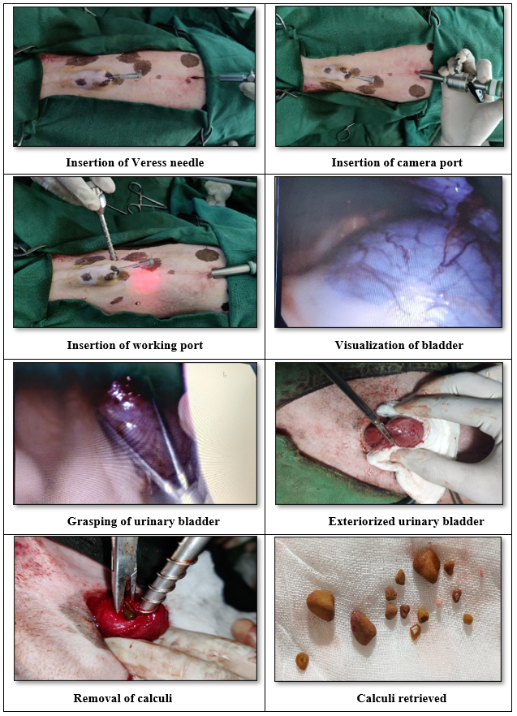

**Figure 1: Laparoscopic Assisted cystotomy**

**2.1.3 Extra-corporeal Shock Wave Lithotripsy (ESWL)**

Animals having nephroliths were subjected for this surgical procedure. Extra corporeal shock wave lithotripter (Digiscope RX2 plus) unit along with U-arm fluoroscopy unit was used. U-arm fluoroscopy was used to position the patient so that the uroliths could be located within the treatment focal spot (Figure 2). Using lithotripter 750-1200 shock waves (generated at 13.5-15 kV) adequate fragmentation of most nephroliths was done (Adams and Senior, 1999). In one minute maximum 90 shocks were given and this makes it time consuming. After shock wave treatment, animal was subjected for voiding uro-hydropropulsion (VUH) as follows:

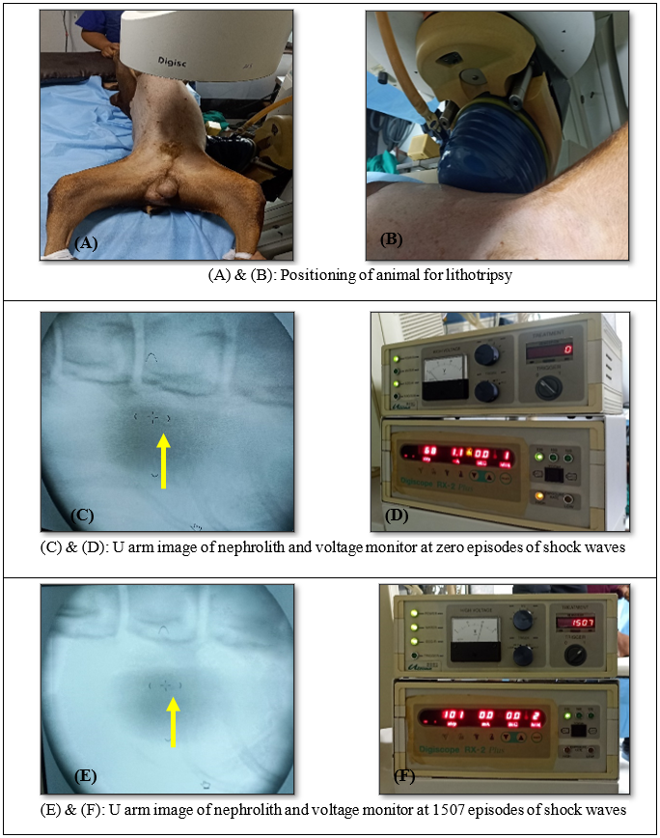

**Figure 2: Electrocarporeal schockwave lithotripsy**

**Voiding Uro-Hydropropulsion (VUH)**

Animals were prepared for aseptic urinary catheterization with 5 to 10 FG baby feeding tube as per the size of urethra to fill the urinary bladder. A sterile isotonic crystalloid solution of 0.9% NaCl was used to fill the bladder (capacity of 10-20 ml/kg and a pressure of 80 cm H2O) until it became moderately turgid. The bladder was then gently agitated from side to side, allowing the urocystoliths to settle in the trigone area.

To facilitate voiding, intra-vesicular pressure was gradually increased through manual compression of the bladder, ensuring a strong urine flow to dilate the urethra and flush out the urocystoliths. The bladder was subsequently refilled with sterile saline via the urinary catheter, and the procedure was repeated until no more urocystoliths were expelled with the voided fluid (Defarges et al., 2013).

**2.2 Post-operative management**

The incision site was dressed with a 5% povidone-iodine antiseptic on alternate days. Ceftriaxone sodium (Albert David Limited, Kolkata, West Bengal, India) was administered intramuscularly at a dose of 20.0 mg/kg body weight twice daily for five days. Additionally, Meloxicam (Intas Pharmaceuticals Ltd., Ahmedabad, India) was given intramuscularly at a dose of 0.3 mg/kg for three days. The owner was advised to administer a urinary alkalizer or acidifier (depending on the nature of urolith) to prevent recurrence. A urinary catheter was kept in place for five days to ensure proper bladder flushing and maintain urethral patency. Skin sutures were removed at 10th-12th postoperative days.

**2.3 Statistical analysis**

Statistical analysis of data was carried out to determine the mean ± SE. One way analysis of variance (ANOVA) technique (by using SPSS software package) (Snedecor and Cochran, 1994) was taken to interpret the effect of treatment on various parameters. The effects of treatments were estimated by using General Linear Model's procedures of statistical software SPSS 17.0 (SPSS, Chicago, IL, USA). Duncan’s test was applied to differentiate treatment means, and differences were considered statistically significant at P<0.05.

3. results and discussion

**3.1 Occurrence of urolithiasis in dogs**

Total cases registered at VCC during the study period for various diseases were 2423, out of these 115 cases (4.74%) were diagnosed with different urinary affections. Among these 115, only 100 cases were randomly selected for study. These cases were showing the sign of haematuria, dysuria, dribbling of urine, anuria etc. and they were screened for presence of uroliths and subjected for radiography. Among these cases, ten cases had cystoliths larger than 2 cm (Figure 3) and were classified as group I. Three animals had cystoliths ranging from 6 mm to 2 cm (Figure 3) and were categorized as group II, while another three animals had nephroliths exceeding 3 mm and were placed in group III.

Out of 100 cases, maximum cases were of chronic renal failure (47%), followed by acute renal failure (21%), urinary calculi (16%), cystitis (12%) and transitional cell carcinoma (4%) (Table 2). The incidence of urolithiasis in canines is attributed to factors such as inadequate water intake, high protein consumption, and frequent feeding of commercial diets. In Jabalpur, the total hardness of water and calcium ion concentration ranged from 320 to 670 mg/L and 138 to 233 mg/dL, respectively, as reported by Saxena et al. (2016), exceeding the permissible limits set by the World Health Organisation. These factors further contribute to the increased risk of urolith formation in dogs.

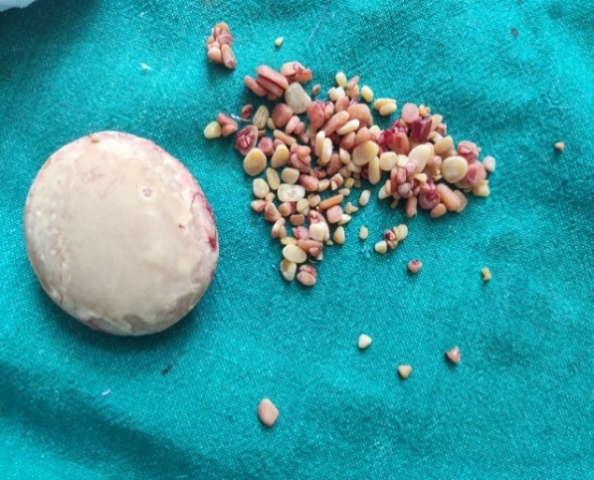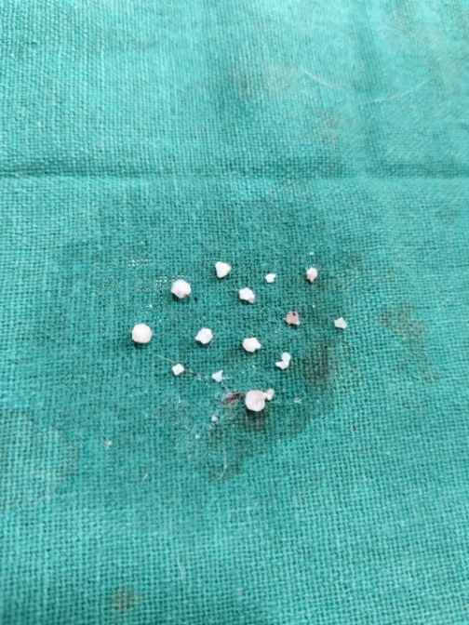

**A.**

**B.**

**Table 2: Occurrence of urinary affection in canines during six months**

|  |  |  |
| --- | --- | --- |
| **Urinary affection** | **No. of cases** | **Percentage (%)** |
| Acute renal failure | 21 | 21 |
| Chronic renal failure | 47 | 47 |
| Cystitis | 12 | 12 |
| Urinary calculi | 16 | 16 |
| Transitional cell carcinoma | 4 | 4 |



**A.**

**B.**

**Figure 3: Urolith (A) Size more than 2 cm, (B) Size 6mm to 2 cm.**

Urolithiasis was more prevalent in male dogs (n=13, 81.25%) than in female dogs (n=3, 18.75%) out of a total of 16 cases. This higher incidence in males is attributed to the anatomical structure of the male urinary system. The curved urethral passage promotes the deposition of urinary elements, while the presence of the os penis restricts urethral expansion, making males more susceptible to urolithiasis. These findings align with Sosnar et al. (2005), who reported a higher occurrence in males (61.4%) compared to females (38.6%). Similarly, Nadkarni (2014) observed a greater prevalence in males (83%) than females. Hunprasitet al. (2017) further supported this trend, stating that males excrete higher levels of calcium, oxalate, and uric acid, making them more prone to urolithiasis.

In the present study, urolithiasis was found to be more common in older dogs. Among the 16 cases, 8 dogs (50%) were over 8 years old, 5 dogs (31.25%) were between 5 and 8 years old, and 3 dogs (18.75%) were between 0 and 4 years old. The higher prevalence of urolithiasis in older dogs may be attributed to the cumulative effects of long-term feeding of commercial or high-protein diets and elevated androgen levels in males. These findings align with those of Gisselman et al. (2009), who reported that the average age of dogs at risk for uroliths is between 7 and 8.4 years. Similarly, Wisener et al*.* (2010) stated that the likelihood of urolith formation increases with age, peaking between 9 and 10 years.

Among the total cases of urolithiasis presented at the VCC, Spitz accounted for the highest proportion, with 5 cases (31.25%), followed by non-descript dogs with 4 cases (25%). Doberman and Labrador breeds each had 2 cases (12.25%), while German Shepherd, Pomeranian, and Great Dane had 1 case (6.25%) each (Table 3). Similar findings were reported by Pal (2015) who observed a higher incidence of urolithiasis in Spitz/Samoyed (39%), followed by non-descript dogs (19%), Lhasa Apso (7%), Pomeranian (14%), Doberman (8%), German Shepherd (5%), Cocker Spaniel (3%), Boxer (3%), and Great Dane (2%). Similarly, Hunprasitet al. (2017) highlighted that small breed dogs are hypercalciuric, leading to increased urinary calcium oxalate saturation, making them more susceptible to urolithiasis.

**Table 3: Breed wise occurrence of urolithiasis in canines**

|  |  |  |
| --- | --- | --- |
| **Breed** | **No. of cases** | **Percentage (%)** |
| Spitz | 05 | 31.25 |
| Non-descript | 04 | 25.00 |
| Labrador | 02 | 12.25 |
| Doberman | 02 | 12.25 |
| Great Dane | 01 | 06.25 |
| Pomeranian | 01 | 06.25 |
| German shepherd | 01 | 06.25 |

The urethra along with bladder were identified as the most common sites for urolith formation. In the present study, 62.50% of cases involved simultaneous urethrolith and cystolith occurrence in males, while 18.75% of cases exhibited both cystoliths and nephroliths (Table 4).

**Table 4: Occurrence of urolithiasis in canines according to location of calculi in urinary system**

|  |  |  |
| --- | --- | --- |
| **Location** | **No. of animal** | **Percentage (%)** |
| Urethra and bladder | 10 | 62.50 |
| Bladder | 03 | 18.75 |
| kidney | 03 | 18.75 |

**3.2 Clinical examination**

Non-significant decrease was observed in heart rate and respiration rate while rectal temperature showed significant (P<0.05) decrease between the animals of group I and II on day 7 post operatively (Table 5). This might be due to subside of infection after a course of antibiotics and analgesics. The findings of present study were similar to the findings of Snyder et al.(2005), worked on diagnosis and surgical management of ureteral calculi in dogs. Lethargy, vomition and anorexia were most common sign noticed during study period.

**Table 5: Mean ± S.E. value of clinical parameters of group I & II**

|  |  |  |  |  |
| --- | --- | --- | --- | --- |
| **Clinical**  **parameters** | **Group I** | | **Group II** | |
| 0 day | 7th day | 0 day | 7th day |
| Temperature (0F) | 101.54ab±0.20 | 100.3b± 0.95 | 103.57a±2.24 | 102.07ab±0.53 |
| Heart rate (beats per minute) | 114.29± 12.46 | 112.71±11.23 | 133.67±21.40 | 128.00 ± 8.33 |
| Respiration rate (breaths per minute) | 29.14 ± 10.38 | 21.85 ± 3.20 | 22.33 ± 10.83 | 21.33 ± 5.33 |

*Values with different superscript within day between group differ significantly (P<0.05)*

**3.3 Findings of haematological and biochemical examination**

Non-significant variations were observed in haemoglobin, packed cell volume and total leucocyte count between the day prior to surgery and 7th day postoperatively as shown in Table 6. The numerical data indicated slight decrease in haemoglobin and packed cell volume, likely be due to blood loss during surgery or continuous fluid infusion. The decrease in total leucocyte count might be due to long course of antibiotics which subside the infection.

Nadkarni (2014) compared conventional cystotomy with laparoscopic-assisted cystotomy and reported significant differences in haematological parameters between the two procedures, with values returning to baseline within 48 hours post-surgery.

Total protein, alanine transferase, and serum creatinine showed no significant changes at different time intervals in animals from Groups I and II. However, blood urea nitrogen (BUN) exhibited a highly significant decrease (p<0.01) between the preoperative day and the seventh postoperative day. The mean values declined from 48.06 ± 7.61 to 33.71 ± 7.62 in Group I and from 14.68 ± 1.77 to 12.87 ± 2.33 in Group II (Table 6).

Obstruction of urethra due to lodging of stone hampered removal of waste from body through urine leading to elevated serum BUN and creatinine levels. Post-surgical restoration of normal urine flow helped bring these values back within the physiological range.

The present study aligns with the findings of Snyder et al. (2005), who investigated the diagnosis and surgical management of ureteral calculi in 16 canine cases. They observed elevation in blood urea nitrogen, creatinine, total calcium-phosphorus and decrease in albumin.

**Table 6: Mean ± S.E. value of haematological parameters of group I & II**

|  |  |  |  |  |
| --- | --- | --- | --- | --- |
| **Parameters** | **Group I** | | **Group II** | |
| **0 day** | **7th day** | **0 day** | **7th day** |
| Haemoglobin (mg/dL) | 12.31 ± 1.83 | 11.69 ± 1.16 | 13.57 ± 0.54 | 12.43 ± 0.23 |
| Packed cell value (%) | 36.64 ± 5.85 | 33.36 ± 2.67 | 36.23 ± 5.58 | 35.00 ± 1.73 |
| Total leucocyte count (103/µL) | 48.97 ± 30.42 | 31.39 ± 18.56 | 17.83 ± 4.19 | 13.27 ± 2.45 |
| Total protein (g/dL) | 05.67 ± 00.38 | 05.59 ± 00.30 | 06.72 ± 00.71 | 06.13 ± 00.82 |
| Alanine transferase (IU/L) | 86.52 ± 11.46 | 74.14 ± 04.22 | 94.44 ± 12.78 | 86.67 ± 05.78 |
| Creatinine (mg/dL) | 03.61 ± 01.02 | 02.20 ± 00.65 | 01.25 ± 00.15 | 00.90 ± 00.06 |
| Blood urea nitrogen (mg/dL) | 48.06a ± 07.61 | 33.71ab ± 07.62 | 14.68ab ± 01.77 | 12.87b ± 02.33 |

*Values with different superscript within day between group differ significantly (P<0.05)*

**3.4 Findings of urine analysis**

Comparison between Group I and Group II revealed no significant differences in urinary pH or specific gravity within or between the groups at different time intervals (Table 7). However, numerical data indicated a decrease in specific gravity, likely due to removal of stone, healing of the damaged bladder wall, and regular flushing of the urinary bladder.

Microscopic examination of urine samples showed the presence of erythrocytes (50/ high power field) in all cases included in the study. Additionally, some samples contained squamous cell epithelium, transitional cell epithelium, neutrophils, and pus cells. In most cases, organized casts (crystals) of calcium oxalate and struvite crystals were observed.

These findings align with those of Snyder et al*.* (2005), who analysed urine samples from 16 urolithiasis cases and reported haematuria (>0–2 red blood cells per high power field [hpf]; n=12), pyuria (>0–2 WBC/hpf; n=9), bacteriuria (n=4), struvite crystalluria (n=2), and miscellaneous crystalluria (n=1). Additionally, Mao et al*.* (2021) concluded that urinary specific gravity is significantly correlated with kidney stone formation, with individuals exhibiting higher specific gravity being more prone to renal stones.

**Table 7: Mean ± S.E. value of parameters of urine analysis of group I & II**

|  |  |  |  |  |
| --- | --- | --- | --- | --- |
| **Parameters** | **Group I** | | **Group II** | |
| **0 day** | **7th day** | **0 day** | **7th day** |
| pH | 07.61 ± 0.29 | 06.80 ± 0.31 | 07.00 ± 0.58 | 06.93 ± 0.37 |
| Specific Gravity | 1.028 ± 0.004 | 1.026 ± 0.003 | 1.027 ± 0.009 | 1.021 ± 0.008 |

**3.5 Intra operative or post operative complication**

Postoperative complications such as suture dehiscence, discharge, and peritonitis were observed in Group I animals that underwent conventional cystotomy. Wound dehiscence occurred in one case on the third postoperative day, likely due to the animal being overweight and highly active. This case was re-sutured and fully recovered by the 12th postoperative day. Peritonitis was noted in another animal on the fourth day, possibly due to a breach in aseptic protocol during conventional cystotomy. This animal received intensive care, including intravenous antibiotics and fluid therapy, and recovered within 14 days.

In contrast, no complications were recorded in laparoscopic-assisted cystotomy, likely due to the smaller incision size, minimal exposure of abdominal organs to the environment, and strict adherence to aseptic techniques during surgery.

**3.6 Extra corporeal shock wave lithotripsy (ESWL)**

In the present study, nephrolithiasis was diagnosed in three dogs. One owner declined treatment, and the associated dog collapsed after two months. The remaining two dogs underwent extracorporeal shock wave lithotripsy (ESWL) under general anaesthesia at Golchha Hospital and Urology Research Center, Jabalpur.

Radiographic examination in lateral and ventro-dorsal views revealed radio-opaque nephroliths in all three cases. Among them, one dog exhibited renal mineralization along with cystoliths and hydronephrosis. Post-lithotripsy radiographs showed a significant reduction in stone size, with the initial average stone size of 8.2 mm decreasing to 3 mm by the 7th postoperative day.

Bevan et al. (2009) compared laser lithotripsy with cystotomy for managing urolithiasis in dogs and found that fragments exceeding 3 mm in diameter were not clinically significant. Treatment was considered successful when residual fragments measured less than 3 to 4 mm. On average, laser lithotripsy took 23 minutes longer than cystotomy. However, dogs in the lithotripsy group were often discharged on the same day as the procedure.

One of the key advantages of ESWL is its minimally invasive nature, eliminating the need for surgical intervention and significantly reducing the risk of postoperative infections and complications. The procedure allows for a quicker recovery period, with dogs returning to normal activities in a short time. Additionally, ESWL preserves renal function by avoiding direct trauma to kidney tissue, making it a preferred option in select cases of nephrolithiasis. The ability to target and fragment stones without major incisions enhances patient safety and comfort.

No significant difference was noticed in the value of clinical, haemato-biochemical, and urinary parameters in a 7-day interval (Table 8) in group III in the present study. The slight decrease in urinary specific gravity was noticed on day 7 postoperatively. Microscopic examination of urine samples from dogs with nephroliths revealed the presence of renal epithelial or tubular cells along with urinary casts. No significant intraoperative or postoperative complications were observed during or after ESWL. However, in one case, mild rashes appeared on the lumbar region, which had been in contact with the water cushion during treatment. These rashes disappeared within 48 hours of lithotripsy.

Despite its advantages, ESWL has certain limitations. The procedure may require multiple sessions to achieve complete stone fragmentation, particularly for larger or harder calculi. Additionally, there is a potential risk of ureteral obstruction due to fragmented stone debris (Cléroux, 2018), which can lead to transient discomfort or complications. Similarly, Adams and Senior (1999) reported no complications in their study, although three dogs developed transient ureteroliths that partially obstructed the ureter following ESWL treatment.

In some cases, renal injury due to shock waves has been documented, though it is generally mild and self-limiting. Other possible disadvantages include the need for general anesthesia, as patient movement must be minimized for precise targeting of stones, and the possibility of stone recurrence, necessitating long-term management and preventive strategies.

**Table 8: Mean ± S.E. value of clinical, haemato-biochemical and urinary parameters of group III**

|  |  |  |
| --- | --- | --- |
| **Parameters** | **Group III** | |
| **0 Day** | **7th Day** |
| Temperature (0F) | 101.80 ± 00.30 | 101.45 ± 00.35 |
| Heart rate (beats per minute) | 146.00 ± 36.00 | 122.50 ± 20.50 |
| Respiration (breaths per minute) | 39.00 ± 04.00 | 32.50 ± 00.50 |
| Haemoglobin (mg/dL) | 12.25 ± 01.75 | 11.18 ± 01.08 |
| Packed cell value (%) | 42.50 ± 03.50 | 36.25 ± 01.25 |
| Total leucocyte count (103/µL) | 11.40 ± 01.20 | 09.30 ± 01.20 |
| Blood urea nitrogen (mg/dL) | 20.00 ± 07.32 | 16.77 ± 05.54 |
| Creatinine (mg/dL) | 01.34 ± 00.06 | 01.07 ± 00.17 |
| SGPT (IU/L) | 105.10 ± 15.10 | 98.00 ± 17.00 |
| Total protein (g/dL) | 08.57 ± 00.53 | 07.01 ± 40.49 |
| pH | 07.05 ± 01.05 | 07.30 ± 00.10 |
| Specific gravity | 01.04 ± 00.03 | 01.01 ± 00.01 |

4. Conclusion

The study highlights the occurrence, classification, and management of urinary calculi in dogs, emphasizing the role of the penile urethra and os penis in urolith obstruction. Microscopic examination of urine samples revealed renal epithelial and tubular cells along with urinary casts, aiding in the diagnosis. Conventional cystotomy is effective for removing cystoliths larger than 2 cm, whereas laparoscopic-assisted cystotomy is a preferable alternative for cystoliths ranging from 6 mm to 2 cm. This is because it allows for complete visualization of the bladder while minimizing environmental contamination of the abdominal organs. ESWL proved to be an effective and minimally invasive treatment, with no major intraoperative or postoperative complications, except for transient rashes in one case that resolved within 48 hours. The findings are consistent with previous studies, reaffirming that nephroliths and ureteroliths account for a small percentage of total urolith submissions, with calcium oxalate being the most commonly detected crystal. Comparative studies in cats further support these observations, demonstrating similar trends in crystal composition.

Overall, this study contributes valuable insights into the clinical presentation, diagnosis, and management of urinary calculi in small animals. Further research with larger sample sizes and long-term follow-ups on treatment efficacy is recommended to enhance clinical decision-making for optimal management strategies.

5. Competing interests

Authors have declared that no competing interests exist

6. DISCLAIMER (ARTIFICIAL INTELLIGENCE)

Authors hereby declare that no generative AI technologies such as Large Language Models (ChatGPT, COPILOT, etc) and text-to-image generators have been used during writing or editing of manuscripts.

7. Consent

All authors declare that written informed consent was obtained from the pet’s owner for publication of the research.

8. Ethical approval

The research described in the study was conducted in compliance with the ethical standards and guidelines of the Institutional Animal Ethics Committee (IAEC) and due permission was received from the ethical committee of the University.

9. References

Adams, L. G. and Senior, D. F. (1999). Electrohydraulic and extracorporeal shock-wave lithotripsy. *Veterinary Clinics: Small Animal Practice*, 29(1): 293-302. <https://doi.org/10.1016/S0195-5616(99)50017-X>

Andrews, C., Williams, R., Arjoonsingh, A. and Grosso, F. R. V. (2024). Cystine and urate cystoliths in dogs are frequently visible on radiographs prior to surgical or nonsurgical removal. *Journal of the American Veterinary Medical Association*, 262(10): 1-5.

Berent, A. C. (2011). Ureteral obstructions in dogs and cats: a review of traditional and new interventional diagnostic and therapeutic options. *Journal of Veterinary Emergency and Critical Care*, 21(2): 86-103. <https://doi.org/10.1111/j.1476-4431.2011.00628.x>

Bevan, J. M., Lulich, J. P., Albasan, H. and Osborne, C. A. (2009). Comparison of laser lithotripsy and cystotomy for the management of dogs with urolithiasis. *Journal of the American Veterinary Medical Association*, 234(10): 1286-1294. <https://doi.org/10.2460/javma.234.10.1286>

Buote, N. J., Hayes, G., Bisignano, J. and Rosselli, D. (2022). Retrospective comparison of open vs minimally invasive cystotomy in 28 cats using a composite outcome score. *Journal of Feline Medicine and Surgery*, 24(10): 1032-1038.

Burggraaf, N. D., Westgeest, D. B. and Corbee, R. J. (2021). Analysis of 7866 feline and canine uroliths submitted between 2014 and 2020 in the Netherlands. *Research in veterinary science*, 137, 86-93. <https://doi.org/10.1016/j.rvsc.2021.04.026>

Cléroux, A. (2018). Minimally invasive management of uroliths in cats and dogs. *Veterinary Clinics: Small Animal Practice*, 48(5): 875-889. <https://doi.org/10.1016/j.cvsm.2018.05.008>

Da Silva, W. C., Rocha, B. C. A., Castro, S. V., Belo, T. S., Sousa, C. E. L., Serruya, F. J. D., and Camargo-Júnior, R. N. C. (2025). Retrospective study of 353 confirmed cases of urolithiasis in dogs and cats treated at veterinary clinics in the northern region of Pará, Brazil. *Brazilian Journal of Veterinary Medicine*, 47: e005624. <https://doi.org/10.29374/2527-2179.bjvm005624>

Defarges, A., Dunn, M. and Berent, A. (2013). New alternatives for minimally invasive management of uroliths: lower urinary tract uroliths. *Compendium*, 35(1): 6-10.

Fossum, T. W. (2012). *Small Animal Surgery,* 4th Edn., Elsevier Health Sciences.

Gisselman, K., Langston, C., Palma, D. and McCue, J. (2009). Calcium oxalate urolithiasis. *Compendium Continuing Education for Veterinarians*, 31(11): 1-8.

Hunprasit, V., Osborne, C. A., Schreiner, P. J., Bender, J. B. and Lulich, J. P. (2017). Epidemiologic evaluation of canine urolithiasis in Thailand from 2009 to 2015. *Research in Veterinary Science*, 115: 366-370.

Koehler, L. A., Osborne, C. A., Buettner, M. T., Lulich, J. P. and Behnke, R. (2009). Canine uroliths: frequently asked questions and their answers. *Veterinary Clinics of North America: Small Animal Practice*, 39(1): 161-181. <https://doi.org/10.1016/j.cvsm.2008.09.007>

Kopecny, L., Palm, C. A., Segev, G. and Westropp, J. L. (2021). Urolithiasis in dogs: Evaluation of trends in urolith composition and risk factors (2006‐2018). *Journal of Veterinary Internal Medicine*, 35(3): 1406-1415. <https://doi.org/10.1111/jvim.16114>

Lulich, J. P. and Osborne, C. A. (2009). Changing paradigms in the diagnosis of urolithiasis. *Veterinary Clinics of North America: Small Animal Practice*, 39(1): 79-91. <https://doi.org/10.1016/j.cvsm.2008.10.005>

Mao, W., Zhang, H., Xu, Z., Geng, J., Zhang, Z., Wu, J., Xu, B. and Chen, M. (2021). Relationship between urine specific gravity and the prevalence rate of kidney stone. *Translational Andrology and Urology*, 10(1): 184-194. <https://doi.org/10.21037/tau-20-929>

Milišić, E., Alić, J., Zvizdić, Z., Lepara, O., Jonuzi, A., Milišić, L. and Fajkić, A. (2021). Urinary neutrophil gelatinase-associated lipocalin level as a biomarker of acute kidney injury following extracorporeal shock wave lithotripsy. *Central European Journal of Urology*, 74(4): 579-587. <https://doi.org/10.5173/ceju.2021.0174>

Mulyani, G. T., Pramono, A. B. and Pangestiningsih, T. W. (2024). Diagnosis and treatment of urolithiasis in a Toy Poodle dog. *Open Veterinary Journal*, 14(3): 937-940. <https://doi.org/10.5455/OVJ.2024.v14.i3.23>

Nadkarini, N. N. (2014). Comparative conventional cystotomy and laparoscopic assisted cystotomy. M.V.Sc. thesis (Surgery and Radiology), Maharashtra Animal and Fishery Sciences University, Nagpur.

Okafor, C. C., Lefebvre, S. L., Pearl, D. L., Yang, M., Wang, M., Blois, S. L., Lund, E. M., and Dewey, C. E. (2014). Risk factors associated with calcium oxalate urolithiasis in dogs evaluated at general care veterinary hospitals in the United States. *Preventive veterinary medicine*, 115(3-4): 217-228. <https://doi.org/10.1016/j.prevetmed.2014.04.006>

Pal, A. J. (2015). Clinical study on surgical management of canine urolithiasis. M.V.Sc. thesis (Surgery and Radiology), Anand Agriculture University, Anand.

Salve, P., Hatzade, R., Thorat, M., and Raulkar, R. (2021). Surgical management of urolithiasis in a male dog. *Journal of Entomology and Zoology Studies*, 9(1): 1687-1690.

Saxena, S., Singh, N. and Bajpai, A. (2016). Physico-chemical assessment of water quality in and around jabalpur city of Madhya Pradesh (India). *International Journal of Current Science Research,* 6(3): 1-20.

Singh, A., Hoddinott, K., Morrison, S., Oblak, M. L., Brisson, B. A., Ogilvie, A. T., Monteith, G. and Denstedt, J. D. (2016). Perioperative characteristics of dogs undergoing open versus laparoscopic-assisted cystotomy for treatment of cystic calculi: 89 cases (2011–2015). *Journal of the American Veterinary Medical Association*, 249(12): 1401-1407. <https://doi.org/10.2460/javma.249.12.1401>

Snedecor, G. W. and Cochran, W. G. (1994). *Statistical Methods*, 8th Edn. Oxford and IBH Publishing Co., Bombay, 593p.

Snyder, D. M., Steffey, M. A., Mehler, S. J., Drobatz, K. J. and Aronson, L. R. (2005). Diagnosis and surgical management of ureteral calculi in dogs: 16 cases (1990–2003). *New Zealand Veterinary Journal*, 53(1): 19-25. <https://doi.org/10.1080/00480169.2005.36464>

Sosnar, M., Bulkova, T. and Ruzicka, M. (2005). Epidemiology of canine urolithiasis in the Czech Republic from 1997 to 2002. *Journal of Small Animal Practice*, 46(4): 177-184. <https://doi.org/10.1111/j.1748-5827.2005.tb00308.x>

Syme, H. M. (2012). Stones in cats and dogs: What can be learnt from them? *Arab journal of Urology*, 10(3): 230-239. <https://doi.org/10.1016/j.aju.2012.06.006>

Vukomanović, A. G., Davidov, I., Blagojević, B., Gazibara, D. and Erdeljan, M. (2025). Sensitivity and specificity of radiographic and ultrasonographic imaging in the detection of canine urinary bladder urolithiasis. *Contemporary Agriculture*. <https://doi.org/10.2478/contagri-2025-0004>

Wisener, L. V., Pearl, D. L., Houston, D. M., Reid-Smith, R. J. and Moore, A. E. (2010). Risk factors for the incidence of calcium oxalate uroliths or magnesium ammonium phosphate uroliths for dogs in Ontario, Canada, from 1998 to 2006. *American Journal of Veterinary Research*, 71(9): 1045-1054. <https://doi.org/10.2460/ajvr.71.9.F1045>