Original Research Article
Incidence and severity of Taro Leaf Blight (Phytophthora colocasiae Raciborski) in the Sudanian climatic zone of Burkina Faso

Abstract
Taro leaf blight is considered the most destructive disease affecting taro worldwide. In the Sudanian climatic zone of Burkina Faso, the disease has led to a consistent decline in taro production over recent years.
Aims: The current research study was aimed to determine the incidence and the severity of taro leaf blight in various taro fields in three provinces of the sudanian climate zone.
Methodology: Plant growing conditions were assessed in 27 fields. Data on healthy and diseased plants, and leaves per plant, were collected within 64 m² quadrats. Disease incidence was the percentage of infected plants per field. Severity was rated on a 12-point scale (0–11) and converted to percentage of affected leaf area, averaged over 10 plants per field. Infestation intensity was calculated as the ratio of infected to total leaves per plant
Place and Duration of Study: Surveys were conducted in fields across the provinces of Houet, Kénédougou, and Comoé between June and July 2021.
Results: Phytophthora colocasiae was morphologically identified from diseased taro samples based on the shape of sporangia, mycelial structure, colony characteristics, and the presence of chlamydospores, revealing morphological variability. The results showed that the disease was widespread across all three surveyed provinces, with notable differences in severity. The local variety Tabouchi, which is highly susceptible to leaf blight, was found in 88.88% of the surveyed fields. In contrast, the exotic variety BL/SM/120, known for its higher tolerance to the disease, was grown by only a minority of farmers. Disease incidence and intensity exceeded 50% in all provinces, with Kénédougou recording the highest severity (31.85%), followed by Houet (20.21%), and Comoé with the lowest (13.80%).
Conclusion: These results indicate that leaf blight constrains taro cultivation in these provinces. They also lay the groundwork for developing effective control strategies to safeguard taro production in the Sudanian climate zone of Burkina Faso.
Key words: Food security, taro leaf blight, incidence, severity, mycelial structure
Introduction
Taro (Colocasia esculenta (L.) Schott) is a major staple food in many parts of the world. It is one of the few plants where all parts are consumed (Matthews, 2010). Taro corms are essential food in the African diet, consumed in a variety of ways and used as food additives (Ubalua et al., 2016). The leaves are used as vegetables and are a good source of vitamins. They contain 23% protein by dry weight and are a rich source of calcium, phosphorus, iron, vitamin C, thiamine, riboflavin and niacin (Rashmi et al., 2018). In some Asian and Pacific food cultures, the flowers are also eaten. The corms and leaves are also used for medicinal purposes. They are used to treat high blood pressure, liver infections, rheumatism and snake bites (Safo-Kantanka, 2021). In addition, taro is a good source of calcium for children who cannot take milk due to lactose intolerance (Kreike et al., 2004) and is gluten-free, making it suitable for people with gluten intolerance. In Burkina Faso, taro contributes to food security and provides income to rural people (Traoré, 2014). It is produced in two climatic zones, the Sudanian and the Sudano-Sahelian. Four local varieties are cultivated (Cécé, 2019).
However, taro production is increasingly confronted with numerous biotic constraints including fungal diseases as Taro Leaf Blight (TLB) caused by the oomycete fungus Phytophthora colocasiae Raciborski. This pathogen is the major constraint to taro production worldwide and is the main cause of severe yield losses ranging up to 100% of corms and leaves (Hong et al., 2021). The first symptoms are small brown spots on the leaf lamina that enlarge to dark brown lesions, often with a yellow margin (Manju et al., 2017). Petioles infection is infrequent, but occurs in susceptible varieties. Taro corms quality is affected by the disease. Rapidly development of rots is observed after harvest (Hong et al., 2021). TLB epidemics have potential to reduce food availability, indeed a serious threat to rural residents and regional food security.
Since 2009 in West Africa, TLB epidemics has been the main constraints to taro production (Onyeka, 2021). In Burkina Faso, the disease is a major constraint to the production of taro in the Sudanian climatic zone area with consequences on the plant and farmer’s livelihoods (Cécé et al., 2024). The incidence and severity of disease studies are of fundamental importance to any effective disease management process. These studies have already been conducted on several crops such as yam (Ntawuruhunga et al., 2007), potato (Naher et al., 2013) and cassava (Kabemba et al., 2017) and taro (Lum et Takor, 2021). However, these data are still insufficient in Burkina Faso. This study aimed to describe the symptoms of the disease and to estimate its incidence and severity in farmers' fields in the sudanian area of Burkina Faso.
I. Method
I.1 Study area
The study was carried out in July 2021 during the rainy season across the three taro-producing provinces located in the Sudanian climatic zone of Burkina Faso: Houet, Comoé, and Kénédougou. This region is the most humid in the south, with average annual rainfall ranging from 900 to 1200 mm, distributed over a six-month period (World Bank, 2021). Additionally, it is characterized by minimal temperature fluctuations. These climatic conditions promote the growth of Phytophthora colocasiae, the pathogen that causes TLB (Benzohra et al., 2018).
I.2. Sample collection and isolation of pathogen
During the survey, some samples of infected leaves showing notable symptoms such as brown spots with yellow margins, water-soaked necrotic areas that coalesced into large lesions, blighted leaf blades were collected randomly, placed in collection bags and sent to the Phytopathology Laboratory at Joseph KI-ZERBO University for isolation and purification of the pathogen according to the fungus isolation protocols of Abdulai et al., (2020). The isolation was carried out under a laminar flow hood. Portions of taro leaves, including both symptomatic and healthy parts, were cut. They were surface-sterilized in 70% ethanol for 1 minute, then carefully washed in three exchanges of distilled water and dried on filter paper for 2 minutes, after which they were placed on potato dextrose agar at 28 °C for three days and examined daily for mycelial growth development. The isolation was replicated three times. The identification involved first examining the necrotic parts of each sample under a magnifying glass. Then, these necrotic parts were scraped using a metal loop, and the obtained residues were mounted between a slide and cover slip, followed by observation under a microscope (magnifications of 10x10 and 40x10). The images of the sporangia obtained were compared to the description provided by Barry (1989) for microscopic identification of the pathogen.
I.2. Disease incidence determination
The study involved sampling for disease incidence in 10 randomly selected taro fields, each aged 6 to 7 months, across the provinces of Kénédougou and Comoé. In contrast, only 7 fields were chosen in the province of Houet due to the gradual decline of taro cultivation in that area. Initially, the study documented field characteristics, including the varieties cultivated and the type of fertilizers used. Subsequently, quadrats measuring 64 m² were established within each field. The density of plants was determined by dividing the total number of plants by the area of the quadrat. Disease incidence was then calculated using the formula provided by Chaube and Pundhir (2005):
Incidence (%) = $\frac{Number of diseased plants}{Total number of plants in the quadrat} x 100$
I.3. Disease severity determination
Ten plants were then randomly selected and observed individually to describe the disease symptoms. Disease severity was assessed by observation using a scale (figure 1) on the 10 plants. New partially rolled leaves and old leaves touching the ground were not assessed. Leaves showing symptoms of TLB were scored on a 12-point scale ranging from 0 to 11 per plant (Miyasaka et al., 2012). Scores for each leaf blade were converted to the average percentage of leaf blade area affected by disease (0%, 0.5%, 3%, 7%, 13.5%, 28%, 50%, 72%, 86.5%, 94%, 97.5% and 100%) according to the scale and averaged over 10 plants.
I.4. Determination of disease intensity
Ten diseased taro plants were randomly selected from each quadrat. For each plant, the number of diseased and healthy leaves was counted. Infestation intensity was calculated according the formula of Brunner et al. (2017):
Infestation intensity (%) = $\frac{Number of infected leaves}{Total number of leaves per plant } x 100$
I.5. Data analysis
The calculation of frequencies, incidence, mean infestation intensity and the construction of diagrams were performed using Excel version 2016. The test of Pearson's correlation was carried out with the data on density, incidence, severity and average intensity of infestation to highlight the relationships between these different parameters using XLstat (2016).
II. Results
II.1. Symptoms description of the disease
Of the 27 fields surveyed in the three provinces, 22 showed similar symptoms, in particular more or less large, zoned necrotic spots that coalesce to destroy the leaf blade (figure 1a). The margin of the lesion is marked by a white powdery band of sporangia and numerous droplets of orange exudate (figure 1b). Lesions may become dry during the day, disintegrating and giving the appearance of holes in the leaf blade (figure 1c, e). Rotting petioles (figure 2a, b, c), sheaths (figure 3a) and flowers (figure 3b) have also been observed. However, in the province of Houet, fields in the locality of “Karangasso-Sambla” showed different symptoms compared with fields elsewhere. In this locality, yellowing and non-zonal necrosis of the leaf blades were observed (figure 4).
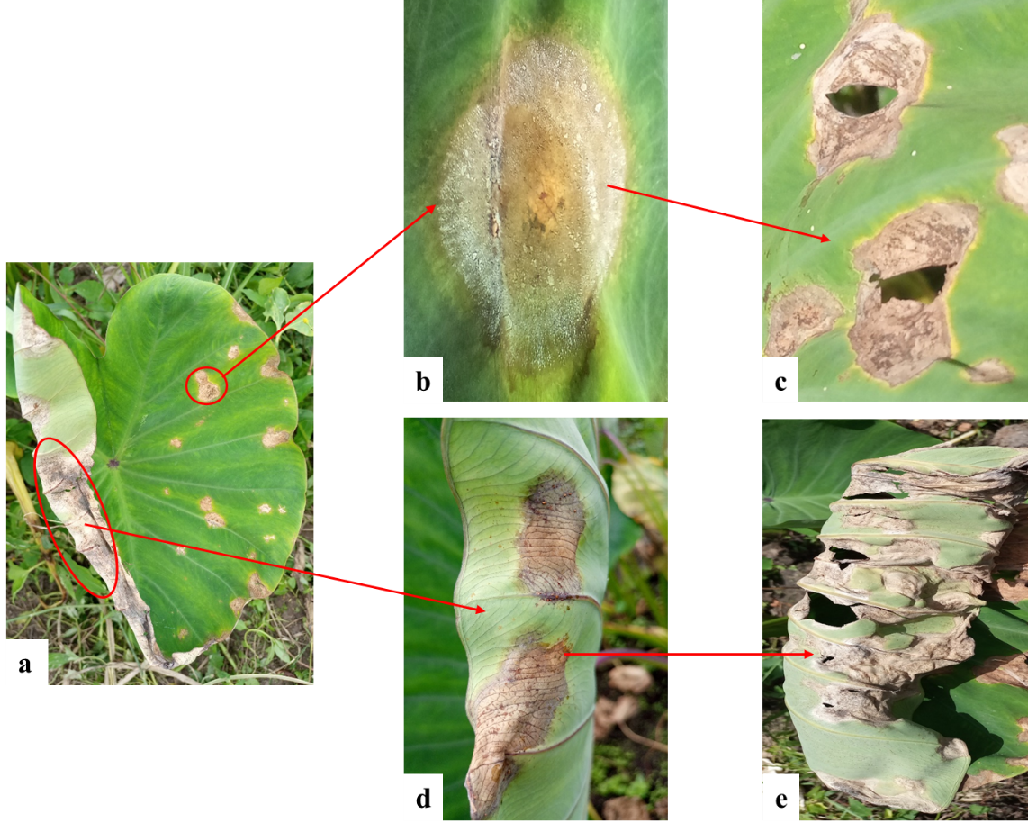
Figure 1: TLB symptoms in the field
Legend: a: symptomatic leaf; b: zoom of the symptom on the upper side of the leaf blade; c: evolution of the symptom forming holes; d, e: view of the symptom on the lower side of the leaf blade.
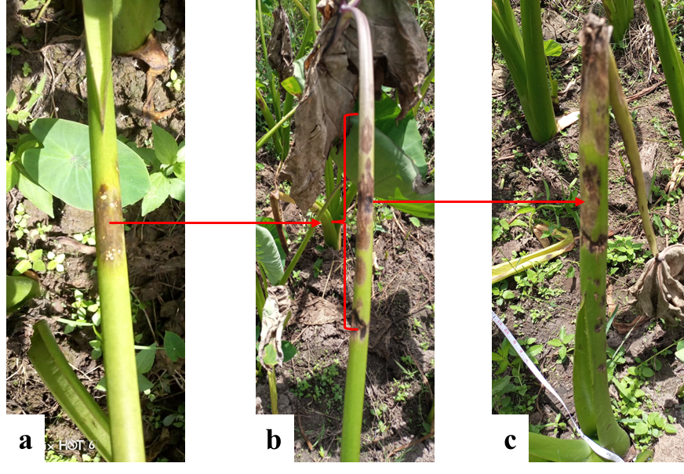
Figure 2: petiole rot
Legend: a: initial necrotic spot; b: development of necrotic spots; c: destruction of the petiole.
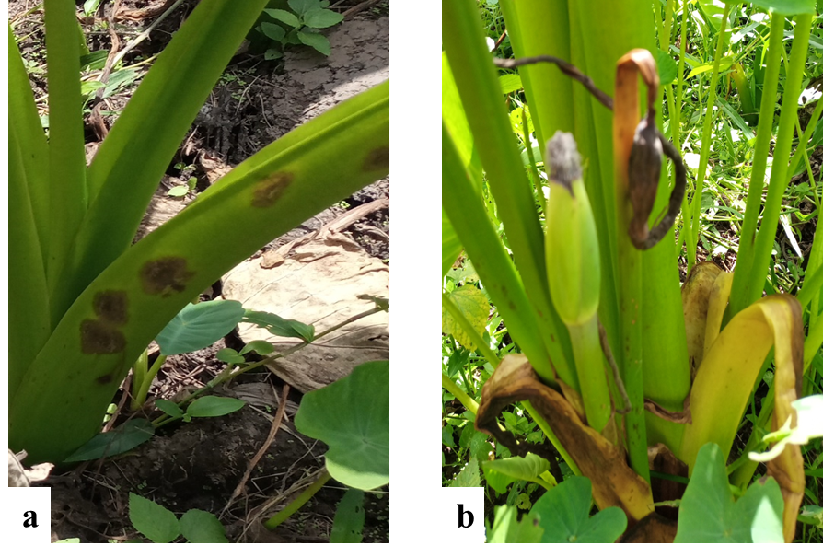
Figure 3: sheath (a) and flower (b)
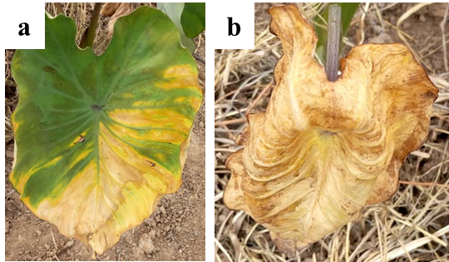
Figure 4: symptoms observed at Karangasso-Sambla (Houet)
Legend: a: beginning of yellowing of the leaf blade; b: complete necrosis of the leaf blade.
II.2. Morphological identification of the pathogen
Pathogens isolated from diseased taro samples in localities in the Houet, Kénédougou and Comoé provinces were morphologically identified as Phytophthora colocasiae on the basis of sporangia shape, mycelium, colony color and shape, and observation of chlamydospores. The results showed three types of sporangia. Sporangium A has a cylindrical shape containing spores in aggregate and forming a nucleus. Its membrane is less visible, with a transparent outgrowth. It ends with a less distinct mycelial branching (figure 5_A). Sporangium B has a slightly elongated ovoid shape, lacking mycelial branching and formed of two well-visible membranes with a less developed outgrowth. The spores are formed in aggregates (figure 5_B). As for sporangium C, it is elongated and rounded with a thick membrane containing spores grouped in aggregates and/or free in the cytoplasm of the sporangium. These elements are visible under an optical microscope, particularly at a magnification of 40x10 (figure 5_C). The colors of the colonies varied from white to light pink, with textures ranging from cottony (figure 6_A) to star-shaped (figure 6_B). The chlamydospores are cylindrical in shape, with a thick membrane and visible contents under an optical microscope, particularly at a magnification of 40x10 (figures 7).
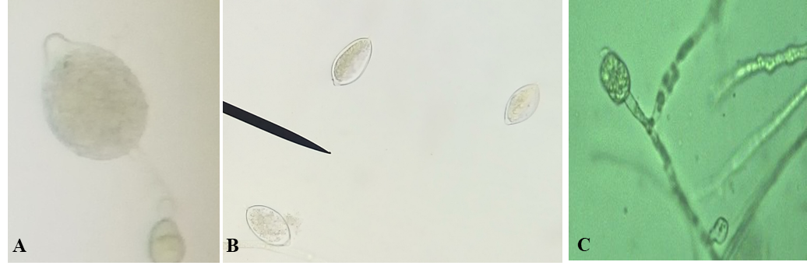
Figure 5: different types of sporangia of Phytophthora colocasiae
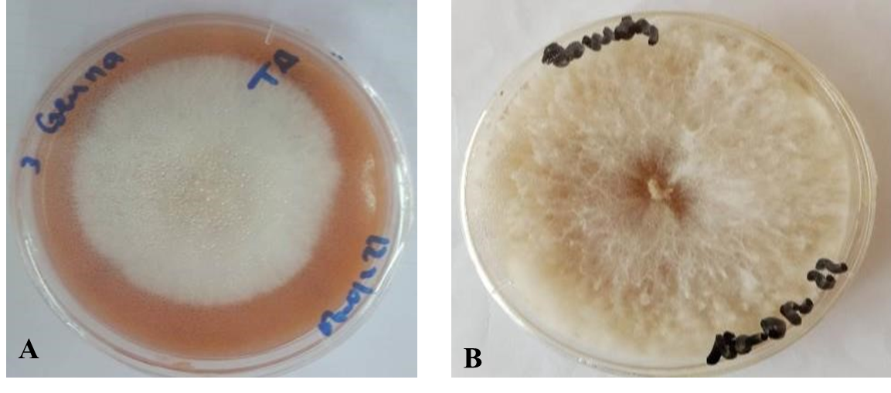
Figure 6: mycelial colonies of Phytophthora colocasiae
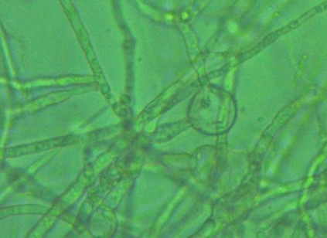
Figure 7: microscopic view of a chlamydospore of Phytophthora colocasiae
II.3. Profile description of field
The studied fields showed various characteristics. In terms of topography, 55.56% of fields were located on plains, while 44.44% were in lowlands, mainly in the province of Kénédougou. In the provinces of Houet and Comoé, all fields were surrounded by mango, banana and avocado plantations. The cropping system predominantly involved monoculture, with two varieties being grown either alone or together. The local variety Tabouchi was the most widely grown in the provinces of Houet and Kénédougou, while the exotic variety BL/SM/120 was more common in the province of Comoé. All producers utilized organic manure and mineral fertilizer.
II.4. Effect of the disease on varieties produced in the Sudanian climatic zone
Both varieties Tabouchi and BL/SM/120 produced in the area are affected by TLB. However, they differ in their expression of disease symptoms. In the fields where the exotic variety BL/SM/120 was grown, the minimum incidence was 26% and the maximum 42%. Disease severity was also low in these fields (minimum: 3%; maximum: 7%). In addition, the spots were only visible on the leaf blade, without completely destroying the entire blade (figure 8). The petioles of this variety are not attacked by the disease. This variety seems to be tolerant to leaf blight. Most of the fields surveyed were planted with the local Tabouchi variety (88.88%). Growers produce it despite its high susceptibility to the disease. The disease affects all parts of the plant (leaf blade, petiole, corm) (figure 9). The minimum incidence was 34.54% and the maximum 100%. The estimated severity had a minimum value of 3% and a maximum of 97.5%.
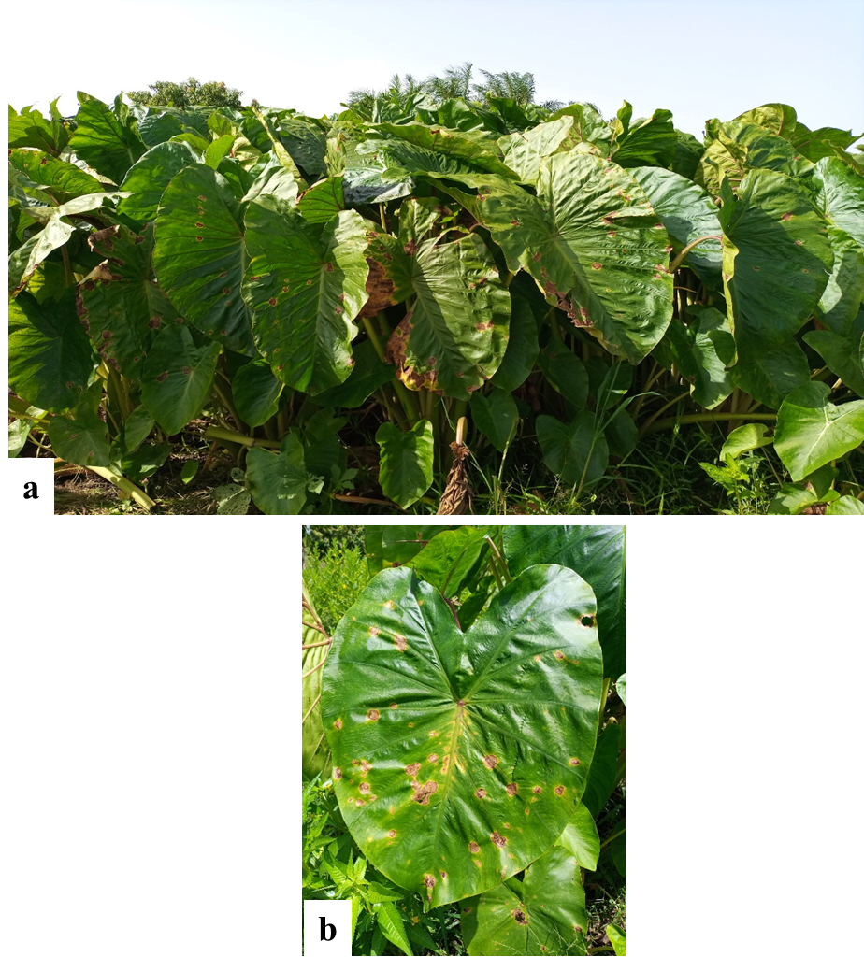
Figure 8: symptoms of TLB on the exotic variety BL/SM/120.
Legend: a: infested fields of the exotic taro variety BL/SM/120; b: necrotic spots on the leaf blade.
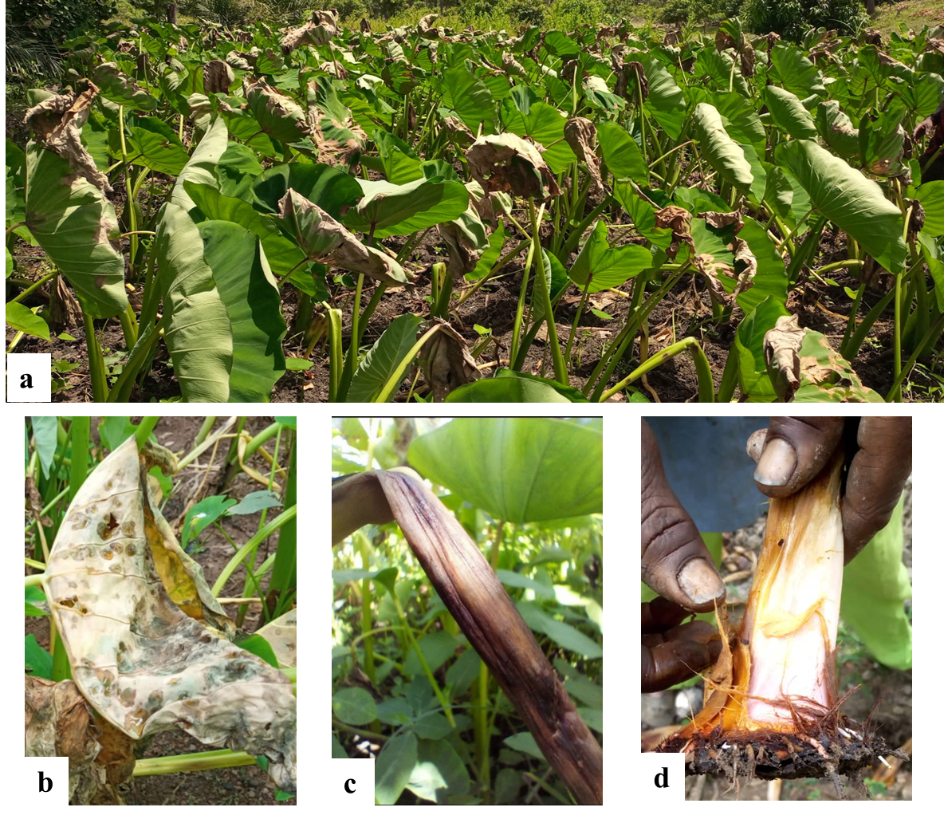
Figure 9: symptoms of TLB on the local variety Tabouchi
Legend: a: field of the local variety Tabouchi infested by leaf blight; b: leaf blade destroyed by the disease; c: petiole rot; d: collet and root rot.
II.4. Incidence, severity and intensity of TLB in the three provinces
The incidence of TLB is very high in the Sudanian climatic zone of Burkina Faso. The province of Kénédougou recorded the highest average incidence (96%), followed by the province of Comoé (80.4%) and the province of Houet (73.90%) (figure 10). As for the severity of the disease, the mean values were 31.85%, 31.88% and 13.80% respectively for Kénédougou, Houet and Comoé provinces (figure 10). The province of Kénédougou recorded the higher mean intensity of disease infestation (76.63%) (figure 11).
The Pearson correlation test (table 1) shows non-significant correlations between taro planting density and the incidence, severity and average intensity of disease infestation. A strong positive correlation (0.748) was observed between incidence and infestation intensity of TLB.

Figure 10: average incidence and severity of TLB in the three provinces

Figure 11: average infestation intensity
Table 1: Pearson correlation test
Variables | Density | Incidence | Severity
Incidence | -0,018
Severity | 0,024 | 0,371
Intensity | -0,067 | 0,748 | 0,322

Discussion
Taro is affected by at least ten major pests and diseases worldwide (Kohler et al., 1997), among which Phytophthora colocasiae, the causal agent of taro leaf blight (TLB), is considered the most destructive. This pathogen has been reported to cause up to 95% reduction in leaf yield, post-harvest rot affecting up to 50% of the yield, and deterioration of corm quality (Jackson, 1999; Singh et al., 2006; Nelson et al., 2011).
In the Sudanian climatic zone of Burkina Faso, field observations revealed that TLB has spread throughout most taro-growing areas, with the notable exception of Karangasso Sambla (Houet province). In all other surveyed fields, symptoms typical of TLB were observed, consistent with those reported in Samoa (Hunter et al., 1998), Nigeria (Bandyopadhyay and Sharma, 2011), and Cameroon (Manju et al., 2017). The spread of the disease in this region may be associated with informal seed exchange practices, as reported in Ghana (Abdulai et al., 2020). According to Traoré (2014), farmers often obtain planting materials either from local markets or from other farmers within or near their communities. Previous studies have shown that once the disease is introduced into a country, it can quickly spread across production zones (Bandyopadhyay and Sharma, 2011; Fontem and Mbong, 2011; Omane et al., 2012). The apparent absence of the disease in Karangasso Sambla may be attributed to the farmers’ reliance on self-saved planting material, which may have contributed to delaying the introduction of the pathogen in that locality.
Monoculture is the dominant cropping system (95%) in the study area. A small fraction of fields (0.07%) uses a mixed cropping system involving the exotic variety BL/SM/120, known by farmers for its tolerance to TLB, cultivated alongside the local variety Tabouchi. This strategy, observed in Comoé province, serves as a cultural control method to reduce disease damage to the local cultivar. As reported by Akanda and Mundt (1996), disease spreads more slowly in mixed cropping systems, likely due to the presence of non-host plants or resistant varieties that interrupt the transmission cycle. In this case, the inclusion of a less susceptible variety helps lower disease severity in the field.
TBL disease incidence is high across the three provinces surveyed. However, disease severity is relatively lower in Comoé province, likely due to the cultural control measures adopted by farmers. The high incidence and severity observed in the region can be attributed to two main factors: the favorable climatic conditions for the pathogen’s development and the high susceptibility of the widely cultivated local variety. Similar results were also reported for bacterial leaf blight caused by Xanthomonas oryzae pv. oryzae, with an incidence rate of 72.34% recorded (Yagnasree et al., 2024). In Kenya, Otieno et al. (2018) highlighted the role of environmental factors in the occurrence of TLB, with an average incidence of 27.9%, which is lower than the rates observed in Burkina Faso likely due to varietal differences. Likewise, field surveys in Ghana reported high disease incidence (30% to 92.5%) and severity (6.5% to 86.5%) (Adomako et al., 2016).
Since severity is measured as the percentage of the leaf area affected by blight, high severity levels can be used as an indirect indicator of potential yield loss. Leaf characteristics such as blade length and width, plant height, and the number of leaves per plant are positively correlated with yield-related traits such as corm weight and diameter (Traoré, 2014; Cécé, 2019; Boampong et al., 2018). Thus, severe leaf damage is likely to negatively impact taro productivity. According to farmers, TLB has caused a noticeable decline in taro production in the Sudanian zone of Burkina Faso (Cécé et al., 2024).
These findings confirm that TLB is the main constraint to taro cultivation in the region. The results presented here provide a scientific basis for the development of effective and locally adapted strategies to manage the disease in the Sudanian climatic zone of Burkina Faso.
Conclusion
Characterization of farmers' taro fields in the three provinces of the Sudanian climate zone shows that the plant is produced on a varied topographical type. Taro production in the area is limited by the high incidence and severity of the disease. Despite its susceptibility to the disease, the local variety Tabouchi is predominant in the area, demonstrating the attachment of producers to this variety.

Data Availability
Data presented in this study will be available on a fair request to the corresponding author

Disclaimer (Artificial intelligence)

Author(s) hereby declares that NO generative AI technologies such as Large Language Models (ChatGPT, COPILOT, etc.) and text-to-image generators have been used during the writing or editing of this manuscript.

References
- Abdulai, M., Norshie, P. M., & Santo, K. G. (2020). Incidence and severity of taro (Colocasia esculenta L.) blight disease caused by Phytophthora colocasiae in the Bono Region of Ghana. SSRG International Journal of Agriculture and Environmental Science, 7(2), 52-63.
- Adomako J, Kwoseh CK, Moses E, Larbi-Koranteng S (2016). Prevalence of Phytophthora Leaf Blight of taro (Colocasiae esculenta (L.) Schott) in the semi deciduous forest zone of Ghana. The African Journal of Educational Assessors 11(4):1-7.
- Akanda, S. I., & Mundt, C. C. (1996). Path coefficient analysis of the effects of stripe rust and cultivar mixtures on yield and yield components of winter wheat. Theoretical and Applied genetics, 92, 666-672.
- Bandyopadhyay R, Sharma K, Onyeka TJ, Aregbesola A, Lava Kumar P (2011). First report of taro (Colocasia esculenta) leaf blight caused by Phytophthora colocasiae in Nigeria. Plant Disease 95:618
- Bary, A. (1989). A compendium all\jd classification of the species of the genus Phytophthora de bary by the canons of the traditional taxonomy blight of taro (Colocasia esculenta (L.) Schott) in the Semi deciduous Forest Zone of Ghana. American Journal of Experimental Agriculture, 11(4): 1-7pp.
- Boampong, R., Aboagye, L. M., Nyadanu, D., & Esilfie, M. (2018). Agro-morphological characterization of some taro (Colocasia esculenta (L.) Schott.) germplasms in Ghana. Journal of Plant Breeding and Crop Science, 10(8), 191-202.
- Brooks, F.E. (2005). Taro leaf blight. The plant health instructor. American Phyto pathological society.DOI:10.1094/PH1-1-2005-0531-
- Brunner, S., Vetterli, C., Krebs, H., Hebeisen, T., Romeis, J., & Winzeler, M. (2017). Genetically modified potato plants are resistant to late blight. Swiss Agricultural Research, 208.
- Cabi (2016). Phytophthora colocasiae (taro leaf blight) accessed at http://www.cabi.org/isc/datasheet/40955 on 13/11/2017
- CECE M. C., 2019. Genetic characterization of local varieties of taro (Colocasia esculenta (L.) Schott) in Burkina Faso. Maste, Univ Joseph KI-ZERBO, Burkina Faso, 61p.
- Cécé, M. C., Traoré, R. E., Ouédraogo, N., & Korbéogo, G. (2024). Ethnobotanical survey to evaluate the endogenous knowledge and consequences of Taro Leaf Blight (TLB) in Sudanian climatic zone of Burkina Faso.
- Chaube, H. S., & Pundhir, V. S. (2005). Crop diseases and their management. PHI Learning Pvt. Ltd.
- Fontem DA, Mbong GA (2011). A novel epidemic of taro (Colocasia esculenta) blight by Phytophthora colocasiae hits Cameroon (Abstact). In. In Life Science and animal production. Third life Science Conference. CAFOBIOS, University of Dschang, Cameroun.
- Hong, Z., Talib, K. M., Mujtaba, K. G., Dabin, H., Yahya, F., Congying, Z., & Fukai, W. (2021). Antifungal potential of cinnamon essential oils against Phytophthora colocasiae causing taro leaf blight. Chemical and Biological Technologies in Agriculture, 8, 1-9.
- Hunter, D., Pouono, K., & Semisi, S. (1998). The impact of taro leaf blight in the Pacific Islands with special reference to Samoa. Journal of South Pacific Agriculture, 5(2), 44-56.
- Jackson, G. V. H. (1999). “Taro leaf blight” in Pest Advisory Leaflet; the Plant Protection Service of the Secretariat of the Pacific Community: Noumea, New Caledonia, No. 3, pp. 2.
- Jackson, G. V. H., & Gollifer, D. E. (1975). Disease and pest problems of taro (Colocasia esculenta L. Schott) in the British Solomon Islands. PANS Pest Articles & News Summaries, 21(1), 45-53.
- Kabemba, N. K., Gikug, J. M., Otono, F. B., & Hity, S. N. D. (2017). Incidence and severity of African cassava mosaic disease in fields and home gardens in Kinshasa (Democratic Republic of Congo). Tropicultura, 35(4).
- Kohler, F., Pellegrin, F., Jackson, G.V. H. and MacKenzie, E. (1997). “Taro” in Diseases of Cultivated Crops in Pacific Island Countries; Secretariat of the Pacific Community: Noumea, New Caledonia.
- Kreike, C. M., Van Eck, H. J., & Lebot, V. (2004). Genetic diversity of taro, Colocasia esculenta (L.) Schott, in Southeast Asia and the Pacific. Theoretical and Applied Genetics, 109, 761-768.
- Lum, A. F., & Takor, M. C. (2021). Journal of Agriculture and Crops.
- Manju, B. E., Mbong, A. G., Fokunang, C. N., Tembe-Fokunang, E. A., & Hanna, R. (2017). Application of in-vitro micropropagation technique for sustainable production of four local taro cultivars [Colocasia esculenta (L.) Schott] in Cameroon.
- Matthews, P. J. (2010). An introduction to the history of taro as a food. The Global Diversity of Taro, 6.
- Mbong, G. A., Fokunang, C. N., Fontem, L. A., Bambot, M. B., & Tembe, E. A. (2013). An overview of Phytophthora colocasiae of cocoyams: a potential economic disease of food security in Cameroon.
- Miyasaka, S. C., McCulloch, C. E., & Nelson, S. C. (2012). Taro germplasm evaluated for resistance to taro leaf blight. HortTechnology, 22(6), 838-849.
- Naher, N., Hossain, M., & Bashar, M. A. (2013). Survey on the incidence and severity of common scab of potato in Bangladesh. Journal of the Asiatic Society of Bangladesh, Science, 39(1), 35-41.
- Nelson S., Brooks F. and Teves, G. (2011). “Taro Leaf Blight in Hawaii”, Plant Disease Bulletin No. PD-71; University of Hawaii: Manoa, HI, USA.
- Ntawuruhunga, P., Legg, J. P., Okidi, J., Okao‐Okuja, G., Tadu, G., & Remington, T. (2007). Southern Sudan, Equatoria region, cassava baseline survey technical report.
- Oduro, E., Donkor, E. F., Ackah, E., & Santo, K. G. (2023). Adaptability and yield performance of taro (Colocasia esculenta (L.) Schott) cultivars in three agro-ecological zones in Ghana. Ecological Genetics and Genomics, 28, 100191.
- Omane E, Oduro KA, Cornelius EW, Opoku IY, Akrofi AY, Sharma K, Kumar PL, Bandyopadhyay R (2012). First report of leaf blight of taro (Colocasia esculenta) caused by Phytophthora colocasiae in Ghana. Association for Psychological Science 96:(2) :292.
- Onyeka J. (2021). Status of Cocoyam (Colocasia esculenta and Xanthosoma spp) in West and Central Africa: Production, Household Importance and the Threat from Leaf Blight; CGIAR Research Program on Roots, Tubers and Bananas (RTB): Lima, Peru. 2014. Available online: www.rtb.cgiar.org.
- Otieno, C. A., OPANDE, G., & Palapala, V. A. (2018). Evaluation of taro leaf blight disease (Phytophthora colocasiae) incidence on Kenyan and Pacific Island taro (Colocasiae esculenta) accessions in Kakamega (Western Kenya).
- Rashmi, D. R., Anitha, B., Anjum, S. R., Raghu, N., Gopenath, T. S., Chandrashekrappa, G. K., & Basalingappa, K. M. (2018). An overview of taro (Colocasia esculenta): a review.
- Singh, D., Guaf, J., Okpul, T., Wiles, G. and Hunter, D. (2006). “Taro (Colocasia esculenta) variety release recommendations for Papua New Guinea based on multi‐location trials”, New Zealand journal of crop and horticultural science, 34, 163-171.
- Thiombiano A, Kampmann D (2010). Atlas of biodiversity in West Africa, Volume II: Burkina Faso, Ouagadougou and Frankfurt/Main
- TRAORE E. R., 2014. Study of the diversity of Taro (Colocasia esculenta (L.) Schott): case of a collection from Burkina Faso and an international collection. Thesis, Univ. Ouagadougou, Burkina Faso, 161p.
- Ubalua, A. O., Ewa, F., & Okeagu, O. D. (2016). Potentials and challenges of sustainable taro (Colocasia esculenta) production in Nigeria. J Appl Biol Biotechnol, 4(1), 53-59.
- Yagnasree, S., Jyosthna M. K., Arunasri P., and Lavanya Kumari P. (2024). “Scenario of Bacterial Leaf Blight of Rice Caused by Xanthomonas Oryzae Pv. Oryzae in Major Rice Growing Areas of Andhra Pradesh, India”. Journal of Experimental Agriculture International 46 (8):891-99. https://doi.org/10.9734/jeai/2024/v46i82775.

