**Horner Syndrome : Gateway to Neuro-Behçet Syndrome**

**Abstract**

**Background :** Horner syndrome (HS), a rare neurological condition caused by disruption of the oculosympathetic pathway, can occasionally serve as an early indicator of systemic diseases such as Behçet syndrome (BS). Neuro-Behçet syndrome (NBS) represents a severe manifestation of BS affecting the central nervous system (CNS). It is associated with significant morbidity.

**Case description :** This report describes an unusual case of NBS revealed by HS in 43-year-old male who initially presented with progressive-onset left ptosis. The symptomatology was enriched by left-sided hemicranial headaches and homolateral carotidynia. NBS diagnosis was established after ruling out other potential differential diagnosis. The association of corticosteroids (CSs) and other immunosuppressants (ISs) led to a significant improvement.

**Conclusion :** Considering atypical revelation’s mode of NBS remains a noteworthy occurrence for clinicians. Prompt diagnosis and intervention are crucial to prevent further neurological deterioration.

**Keywords :** Behçet syndrome, Neuro-Behçet syndrome, Horner syndrome, Central nervous system, Corticosteroids, Immunosuppressants, Case report.

**Introduction**

Behçet syndrome (BS) is a chronic inflammatory disorder characterized by mucocutaneous lesions, ocular inflammation and systemic vasculitis. While it commonly presents with oral aphthous ulcers and uveitis, its involvement in the central nervous system (CNS) can lead to diverse symptoms. Neuro-Behçet syndrome (NBS) refers to neurological involvement occuring in approximately 5% to 59% of patients with BS [1]. These manifestations are divided into two main forms that are parenchymal lesions as meningoencephalitis and non-parenchymal lesions as cerebral venous thrombosis [2]. In rare instances, NBS might reveal itself through symptoms akin to Horner syndrome (HS). In NBS, brainstem or diencephalic lesions often resulting from inflammatory vasculitis, may impair sympathetic fibers and lead to HS. Such rare mode of revelation is diagnostic and prognostic marker necessitating early intervention and prompt immunosuppressive therapy [3]. This can prevent irreversible neurological damage and severe complications, emphasizing the importance of vigilance in interpreting isolated neurological symptoms.

We present the case of 43-year-old male who presented with HS, ultimately leading to a diagnosis of BS. Treatment combining corticosteroids (CSs) and immunosuppressants (ISs) led to notable improvement.

**Case Description**

**1. Patient Presentation and Initial Symptoms**

The 43-year-old male agricultural worker from El Jadida first presented with progressive onset of left ptosis. Few days later, clinical presentation was supplemented by hemicranial headaches, left hemifacial pain and homolateral carotidynia. The symptoms occurred in the absence of fever but were associated with noticeable decline in his overall health status. Upon clinical examination, the patient exhibited signs of severe cerebral vascular involvement, including reactive myosis, left ptosis and pseudo-enophthalmos (Fig.1). Additionally, his lower limbs were large, symmetrical, warm, red and painful, though they did not exhibit pitting edema.

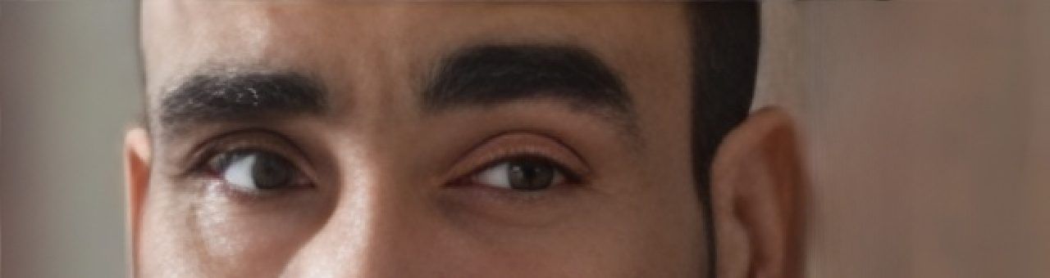

**Fig.1 :** The left HS.

**2. Diagnostic Confirmation and Imaging Findings**

The diagnosis of BS was confirmed with a score of 6 points according to the ***International Diagnostic Criteria for Behçet Syndrome* (ICBS)**:

| **Symptom** | **Points** |
| --- | --- |
| Oral Aphthosis | 2 points |
| Genital Aphthosis | 2 points |
| Pseudofolliculitis | 1 point |
| Vascular Lesions | 1 point |

**Table 1 :** The criteria used to retain BS in the patient according to *ICBS*.

Imaging studies were performed to further evaluate the extent of vascular involvement. A cervicoencephalic magnetic resonance angiography (MRA) revealed a sacciform aneurysm of the left internal carotid artery (Fig.2 and 3), with extensive thrombotic material extending from the carotid bulb to the cervical portion. Calcification of the intracavernous segment was also noted. Additionally, MRA showed extensive cerebral thrombophlebitis affecting the superior longitudinal sinus and lateral sinuses. Doppler ultrasound venous of the lower limbs detected deep vein thrombophlebitis in the iliofemoropopliteal region. Transthoracic echocardiography ruled out intracardiac thrombus, and thoracic angiography excluded pulmonary embolism.

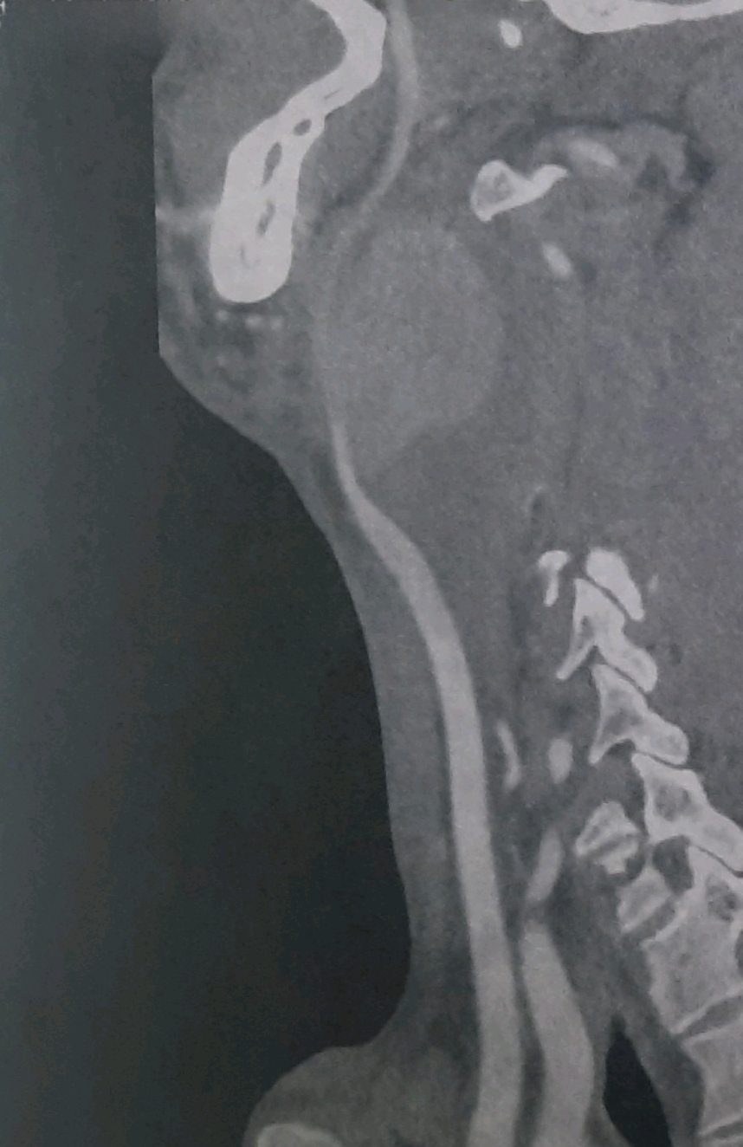

**Fig.2 :** Cervical MRI (sagittal view) with the red arrows showing left internal carotid aneurysm.



**Fig.3 :** MRA 3D of the Willis’s circle revealing the sacciform aneurysm of the left internal carotid artery.

**3. Histopathology and Laboratory Findings**

A biopsy of the left aortic aneurysm was performed, which revealed fibrosis of the media and chronic inflammation with acute fibrinous exacerbation in the vascular wall. These findings were consistent with vasculitis and supported the diagnosis of BS. Laboratory tests confirmed a severe inflammatory syndrome, with C-reactive protein (CRP) level of 260 mg/L, hyperthrombocytosis (491,000/mm³), and hyperfibrinogenemia (6.3 g/L). Infectious workup, including retroviral serologies, tests for syphilis, hepatitis B and C returned negative.

**4. Treatment and Management**

The patient underwent surgical repair of the left carotid aneurysm using an inverted saphenous graft between the common carotid artery and external carotid artery. Postoperatively, he was started on venous compression therapy combined with anticoagulation using acenocoumarol (4 mg/day). Immunosuppressive therapy was initiated to manage the underlying vasculitis. This included intraveinous (IV) methylprednisolone pulses (1g/day for 3 days), followed by a tapering course of oral CSs. The patient also received six cyclophosphamide IV boluses (1g every 3 weeks), transitioning to azathioprine maintenance therapy (150 mg/day).

**5. Outcome and Follow-Up**

The patient’s clinical and biological evolution improved significantly under the treatment regimen. Notably, the left HS disappeared (Fig.4). The combination of surgical intervention, anticoagulation and ISs effectively addressed the severe presentation.

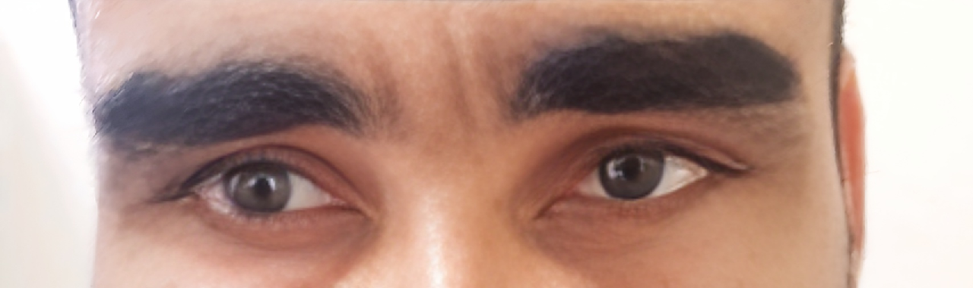

**Fig.4 :** Regression of the left HS in the patient after treatment.

**Discussion**

*Johann* *Friedrich* *Horner*, a Swiss ophthalmologist, is widely recognized for providing the first comprehensive description of HS in 1869 and accurately attributing it to oculosympathetic paresis [4]. This syndrome is resulting from disruption in the sympathetic pathways connecting the brain to the eye. The classic triad of symptoms includes ptosis, miosis, and pseudo-enophthalmos. Anhidrosis on the affected side may also occur but is not universally present [5]. The sympathetic pathway responsible for maintaining normal ocular function involves complex neural circuits originating from hypothalamic centers that descend through cervical spinal cord segments before synapsing in superior cervical ganglia. From there, postganglionic fibers travel along blood vessels to reach their target organs in the head. Disruption at any point along this pathway can lead to HS [6]. Causes are diverse and include central lesions affecting brainstem or spinal cord areas involved in sympathetic transmission, peripheral causes such as carotid artery dissection or tumors compressing nerves near superior cervical ganglia, and even iatrogenic causes like surgical damage during neck procedures [7,8]. BS, characterized by recurrent oral aphthous ulcers, genital ulcers, and uveitis, was first comprehensively described by Turkish dermatologist *Hulusi**Behçet* in 1937. This landmark description marked the recognition of these symptoms as a distinct medical condition [9]. BS is known for its inflammatory-driven damage to blood vessels throughout the body. Neurological involvement can manifest either parenchymally with meningoencephalitis or non-parenchymally through cerebral venous thrombosis or arterial complications like aneurysms. In BS, inflammation primarily targets medium-sized arteries but can affect any size vessel leading to both arterial and venous complications. Neurological manifestations arise when these inflammatory processes disrupt normal vascular function within critical regions such as those supplying sympathetic nerves responsible for ocular control.

While direct evidence linking HS specifically as a revelation for BS might be limited compared to more common manifestations like oral ulcers or uveitis, understanding these complex interactions can enhance diagnostic acumen. The vasculitic nature of BS could theoretically disrupt sympathetic pathways leading to HS.

Few case reports highlight the occurrence of HS in patients with BS, often associated with CNS involvement such as medullary ischemia, acute NBS’s attacks or bulbar lesions [3,10,11].

Treatment typically involves CSs as a first-line approach. High-dose CSs such as methylprednisolone pulses are commonly used to reduce inflammation quickly [11]. Following initial pulse therapy, maintenance treatment often includes oral CSs like prednisone at doses adjusted based on clinical response. In cases where CS therapy alone is insufficient or for long-term management, ISs such as azathioprine or methotrexate may be added [12]. These drugs help control chronic inflammation and prevent further neurological damage. For high-risk patients or those with severe manifestations, IV cyclophosphamide may be considered alongside CSs. If these regimens fail to achieve desired outcomes, tumor necrosis factor-α (TNF-α) inhibitors like infliximab can be introduced as an additional therapeutic option [3,12,13].

**Conclusion**

Early recognition and treatment of NBS can significantly improve patient outcomes by reducing neurological complications and improving life’s quality. Therefore, clinicians should remain vigilant for signs like HS that may signal more severe systemic involvement in patients with suspected or confirmed BS. Future efforts should focus on early diagnosis using advanced tools and multidisciplinary teams for comprehensive care. Personalized treatment strategies as biological therapies are crucial and combination therapy trials should be explored. Further research is needed to better understand the mechanisms linking HS to NBS and to refine therapeutic approaches for affected patients.

**Disclaimer (Artificial intelligence)**

Authors hereby declare that **NO** generative AI technologies such as Large Language Models (ChatGPT, COPILOT, etc.) and text-to-image generators have been used during the writing or editing of this manuscript.

**Ethical approval :**

All procedures performed in this study are in accordance with the ethical standards of the institutional and/or national research comittee.

**Consent :**

Written informed consent was obtained from the patient for publication of this case report.

**References**

[1] Kidd DP. Neurological involvement by Behçet's syndrome: clinical features, diagnosis, treatment and outcome. Pract Neurol. 2023;23(5):386-400.

[2] Al-Araji A, Kidd DP. Neuro-Behçet's disease: epidemiology, clinical characteristics, and management. Lancet Neurol. 2009 Feb;8(2):192-204.

[3] Matsui T, Ishida T, Tono T, Yoshida T, Sato S, Hirohata S. An attack of acute neuro-Behçet's disease during the course of chronic progressive neuro-Behçet's disease: report of two cases. Mod Rheumatol. 2010;20(6):621-6.

[4] Kanagalingam S, Miller NR. Horner syndrome: clinical perspectives. Eye Brain. 2015;7:35-46.

[5] Khan Z, Bollu PC. Horner Syndrome. 2023 Apr 10. In: StatPearls [Internet]. Treasure Island (FL): StatPearls Publishing; 2025 Jan–. PMID: 29763176.

[6] Lykstad J, Reddy V, Hanna A. Neuroanatomy, Pupillary Dilation Pathway. 2023 Aug 8. In: StatPearls [Internet]. Treasure Island (FL): StatPearls Publishing; 2025 Jan–. PMID: 30571042.

[7] Sabbagh MA, De Lott LB, Trobe JD. Causes of Horner Syndrome: A Study of 318 Patients. J Neuroophthalmol. 2020;40(3):362-369.

[8] Martin TJ. Horner Syndrome: A Clinical Review. ACS Chem Neurosci. 2018;9(2):177-186.

[9] Kocak Nuhoglu GE, Nuhoglu C, Osoydan M, Arslan B. Dr. Hulusi Behçet: A Pioneer in Dermatology and the Legacy of Behçet's Disease. Cureus. 2024;16(9):e69600.

[10] Kaido T, Otsuki T, Ogawa M, Takahashi A et al. Medullary ischemia due to vertebral arteritis associated with Behçet syndrome: a case report. Asian Pac J Allergy Immunol 2012;30:239-42.

[11] Certal M, Alves A, Santos MB et al. Neuro-Behçet Disease Presenting as a Bulbar Lesion: A Case Report. Cureus. 2014;16(8): e68236.

[12] Borhani Haghighi A. Treatment of neuro-Behçet's disease: an update. Expert Rev Neurother. 2009;9(4):565-74.

[13] Hirohata S, Kikuchi H, Sawada T, Okada M et al. Recommendations for the Management of Neuro-Behçet's Disease by the Japanese National Research Committee for Behçet's Disease. Intern Med. 2020;59(19):2359-67.