**Ocular Tuberculosis with Sea Fan Neovascularization: A Case Report and Literature Review**

**Abstract**

Eye diseases may lead to visual impairment which is one of the public's most feared disabilities. Tuberculosis is a systemic infectious disease caused by Mycobacterium tuberculosis. Ocular tuberculosis is a rare manifestation of this condition. We report the case of a 36-year-old patient who was referred to the ophthalmology department due to acute vision loss in both eyes. An ophthalmological examination revealed retinal vasculitis in both eyes, complicated by pre-retinal neovascularization. Blood tests were positive for QuantiFERON-TB Gold, and the Mantoux test was also positive. Antitubercular treatment was initiated, along with corticosteroids, leading to a positive evolution within two months. Recovery under antitubercular treatment is observed in 95% of cases of presumed ocular tuberculosis; however, there is currently no consensus on the optimal duration of treatment. Diagnosing ocular tuberculosis remains challenging. Although retinal vasculitis is rare in ocular tuberculosis, it is associated with a poor prognosis, and the visual outcome heavily depends on the timely initiation of appropriate treatment, which can stabilize or improve vision.

**Keywords:** uveitis, ocular tuberculosis, vasculitis, neovascularization.

**Introduction**

“ Eye diseases may lead to visual impairment which is one of the public's most feared disabilities. Visual impairment is often linked to falls, injury, hip fractures, depression, loss of independence, inability to self-care, fear of blindness, the early need of nursing home placement and overall a significant decline in quality of life (QoL) ” [11-14].

“ Tuberculosis is a serious systemic infectious disease caused by Mycobacterium tuberculosis (MTB). Tuberculosis infection can spread hematogenously in body and the manifestations in ocular tuberculosis could be the result of direct infection or indirect immune-mediated hypersensitivity ” [15].

“ Ocular tuberculosis is defined as an infection by MTB in the eye, around the eye, or on its surface ” [1]. It is a rare, extrapulmonary manifestation of systemic tuberculosis.

The diagnosis of ocular tuberculosis remains problematic due to the large spectrum of clinical manifestations, and the absence of early and appropriate treatment may lead to severe visual loss [2].

“ Tubercular retinal vasculitis is a common presentation of Ocular tuberculosis but is variably defined in the literature in terms of clinical profile and the investigations essential for diagnosis and treatment ”. [3]

**Case Presentation**

We report the case of a 36 years old patient, who was referred to the ophthalmology department for an acute visual loss in both eyes. There was no history of ocular pain or photopsia, and the patient did not report any systemic complaints. On examination, the visual acuity was: 6/10 (Snellen Chart) in the right eye and 10/10 (Snellen chart) in the left eye.

Examination of the left eye was characterized by the presence of signs of non-gulomatous anterior uveitis.

The examination of the ocular adnexa and the anterior chamber of the right eye revealed no abnormalities, and the intra-ocular pressure was normal in both eyes.

The funduscopic examination of both eyes revealed vitreous haze, an exudative, hemorrhagic, posterior retinal vasculitis with predominantly venous involvement. There was also pre-retinal hemorrhage in the inferior and nasal quadrants of the right eye. There were no papilloedema or choroidal lesions. The macula was normal in both eyes. Fluorescein angiography revealed active vasculitis and peri phlebitis with leakage from the vessel wall in both eyes associated with peripheral sea-fan neovascularization corresponding to the neovascular tuft surrounded by areas of capillary non-perfusion in both eyes (Figures 1 and 2).

The OCT scan showed a normal macular thickness in both eyes.

Blood tests were positive for QuantiFERON-TB Gold. The Mantoux test has been realized and was positive. All the other ecologies are normal (inflammatory, infectious, and auto-immune). Chest X-ray was normal too.

The patient was treated with systemic antituberculosis therapy: Rifampicin (R), Ethambutol (E), and Isoniazid (H) Pyrazinamide.

(Z) for two months, then Rifampicin and Isoniazid for four months, with a total of six months of treatment and an argon laser photocoagulation in the ischemic areas. Systemic corticosteroids were initiated one month after the start of anti-tuberculosis treatment (ATT).

The evolution was favourable within two months, with a complete disparition of the vitreous haze, regression of retinal va, and sculpture-retinal retinal neovascularization (Figure 3,4).

**Discussion**

The ophthalmological manifestations of tuberculosis remain rare (1 to 2% of the cases) [4].

Ocular tuberculosis may be explained by two mechanisms: Hematological, inducing a direct mycobacterial infection, or immunological, hypersensitivity response to mycobacterium [5]. “ Posterior uveitis is the most common presentation of intraocular tuberculosis, with lesions predominantly present in the choroid as focal, multifocal or serpiginous choroiditis, solitary or multiple choroidal nodules (tubercles), choroidal granuloma (tuberculoma), neuroretinitis, and retinal vasculitis, which is frequently ischemic and may lead to proliferative vascular retinopathy with recurrent vitreous haemorrhage ” [6].

“ The Diagnosis of tuberculosis uveitis is usually presumptive and based on a set of arguments: local epidemiology, and the results of the immunological tests: Tuberculin skin test (TST) and/or interferon-gamma release assays (IGRAs) [7-9]. Several studies attempt to present a set of diagnostic criteria for tuberculosis uveitis, because of the lack of comprehensive evidence for diagnostic approaches for tuberculosis uveitis. The Collaborative Ocular Tuberculosis Study (COTS-1) suggested agreed-on guidelines for the diagnosis of TB uveitis and analyzed the role of ATT in the management of patients with tuberculosis uveitis ” [8].

For our patient, we concluded to presumed ocular tuberculosis based on the presence of clinical signs suggestive of ocular tuberculosis (retinal vasculitis), the exclusion of other uveitic entities, a positive Mantoux test, and QuantiFERON-TB –Gold, and the local epidemiology ( endemic region of tuberculosis).

Management of ocular tuberculosis aims to reduce inflammation and recurrence and to improve visual acuity [9-10]. However, Anti-tubercular treatment, although necessary for the treatment of tuberculosis, has been described to cause a worsening of the disease, and it was explained by authors as Jarisch-Herxheimer reactions, which can be managed by corticosteroids [2-4].

Luckily, the treatment was well tolerated in our patient.

Recovery under ATT is observed in 95% of cases of presumed ocular tuberculousis [5,6]. In a retrospective Indian study of 360 suspected tuberculosis uveitis, the 216 patients receiving ATT had a relapse rate of 16%, significantly lower than the 46% of 144 patients treated with corticosteroid therapy alone [6]. A recent meta-analysis shows a success rate of 84% in patients treated with ATT, with no significant difference between patients treated with ATT alone or combined with corticosteroid therapy [5].

The rate of ATT failure is estimated at 13% in a multicenter series of 801 tuberculous uveitis, and the vitreous or choroidal involvement seems to be a predictive factor of treatment failure [8].

“ ATT typically consists of an initial quadritherapy during 2 to 4 months, including isoniazid (5 mg/kg/d), rifampicin (10 mg/kg/day), ethambutol (15 mg/kg/day) and pyrazinamide (25–30 mg/kg/day), then triple therapy instead of conventional dual therapy with isoniazid/rifampicin/pyrazinamide ”[7-9].

Despite the potential toxicity of ethambutol (optic neuropathy), its use in initial treatment is still recommended due to the growing prevalence of multi-resistant tuberculosis.

There is currently no consensus on the duration of the ATT [9]. Most studies prescribed ATT for at least 6 months, with a maximum between 12-19 months [5]. There does not seem to be any correlation between the duration of therapy and the clinical features, and no randomized study has been performed to confirm the benefit in terms of reducing ocular inflammation or recurrences if the treatment is maintained beyond 6 months [5,8,10].

Therapeutic response to the ocular inflammation is expected within 4 to 6 weeks. Corticosteroids are often used along with ATT to treat intraocular tuberculosis. The addition of steroids may help suppress inflammation caused by infection. Oral corticosteroids are often adopted for patients with posterior segment inflammation, whereas topical steroids are used for those with anterior segment inflammation.

In the case of retinal vasculitis, laser photocoagulation of the ischemic areas must be performed in addition to corticosteroid therapy.

**Conclusion**

The diagnosis of ocular tuberculosis remains difficult. However, retinal vasculitis in patients with latent tuberculosis in tuberculosis-endemic areas is suggestive of a tubercular cause of uveitis and merits specific treatment. The visual prognosis depends on the initiation of appropriate treatment allowing visual stabilization or improvement.

**Disclaimer (Artificial intelligence)**

Option 1:

Author(s) hereby declare that NO generative AI technologies such as Large Language Models (ChatGPT, COPILOT, etc.) and text-to-image generators have been used during the writing or editing of this manuscript.

Option 2:

Author(s) hereby declare that generative AI technologies such as Large Language Models, etc. have been used during the writing or editing of manuscripts. This explanation will include the name, version, model, and source of the generative AI technology and as well as all input prompts provided to the generative AI technology

Details of the AI usage are given below:

1.

2.

3.

**References :**

[1] Shakarchi F. Ocular tuberculosis: current perspectives. Clin Ophthalmol 2015 ;9 : 2223-2227.

[2]Agrawal R, Gupta B, Gonzalez-Lopez JJ, et al. The role of anti-tubercular therapy in patients with presumed ocular tuberculosis. Ocul Immunol Inflamm. 2015;23(1):40-46.

[3]Shukla D, Kalliath J, Dhawan A. Tubercular Retinal Vasculitis: Diagnostic Dilemma and Management Strategies. Clin Ophthalmol 2021 ;15 : 4681-4688.

[4] Albert DM, Raven ML. Ocular Tuberculosis. Microbiol Spectr 2016 ;4 : 1128.

[5] Kee AR, Gonzalez-Lopez JJ, Al-Hity A, Gupta B, Lee C S, Gunasekeran D , et al. Anti- tubercular therapy for intraocular tuberculosis: A systematic review and meta-analysis. Survey of ophthalmology.2016 ; 61 : 628-653.

[6] Sheu SJ, Shyu JS, Chen LM, Chen YY, Chirn SC, Chirn JS. Ocular manifestations of tuberculosis. Ophthalmology.2001 ;108 : 1580-1585.

[7] Gineys R, Bodaghi B, Carcelain G, Cassoux N, Boutin LTH, Amoura Z, et al. QuantiFERON- TB gold cut-off value: implications for the management of tuberculosis-related ocular inflammation. Am J Ophthalmol 2011;152: 433–40.

[8] Agrawal R, Gunasekeran D, Grant R, Agarwal A, Kon OM , NguyenQ, et al. Clinical Features and Outcomes of Patients With Tubercular Uveitis Treated With Antitubercular Therapy in the Collaborative Ocular Tuberculosis Study (COTS)–1. JAMA Ophthalmology 2017 ; 135 : 1318-1327.

[9] Lou SM, Larkin KL, Winthrop K, Rosenbaum S, Uveitis Specialists Study Group. Lack of consensus in the diagnosis and treatment for ocular tuberculosis among uveitis specialists. Ocul Immunol Inflamm.2015 ;23 : 25-31.

[10] La Distia Nora R, van Velthoven ME, Ten Dam-van Loon NH, Misotten T, Bakker M, van Hagen MP, et al. Clinical manifestations of patients with intraocular inflammation and positive QuantiFERON-TB gold in-tube test in a country nonendemic for tuberculosis. Am J Ophthalmol 2014;157:754–61

[11]Kandel, H., Nguyen, V., Piermarocchi, S., Ceklic, L., Teo, K., Arnalich‐Montiel, F., ... & Watson, S. L. (2022). Quality of life impact of eye diseases: a Save Sight Registries study. Clinical & experimental ophthalmology, 50(4), 386-397.

[12].Scott, A. W., Bressler, N. M., Ffolkes, S., Wittenborn, J. S., & Jorkasky, J. (2016). Public attitudes about eye and vision health. JAMA ophthalmology, 134(10), 1111-1118.

[13]Finger, R. P., Fenwick, E., Marella, M., Dirani, M., Holz, F. G., Chiang, P. P. C., & Lamoureux, E. L. (2011). The impact of vision impairment on vision-specific quality of life in Germany. Investigative ophthalmology & visual science, 52(6), 3613-3619.

[14] Singh, R. K., Bewtra, C., & Kher, P. (2021). A review on Ocular Tuberculosis: Epidemiology, Clinical Features and Treatment. Journal of Pharmaceutical Research International, 33(60B), 471–477. <https://doi.org/10.9734/jpri/2021/v33i60B34642>

[15] Raina, R., & Chhabra, N. (2021). Choroidal Tubercles, an Ocular Presentation in Tuberculosis- a Retrospective Observational Hospital-based Study. Ophthalmology Research: An International Journal, 15(2), 1–6. https://doi.org/10.9734/or/2021/v15i230207

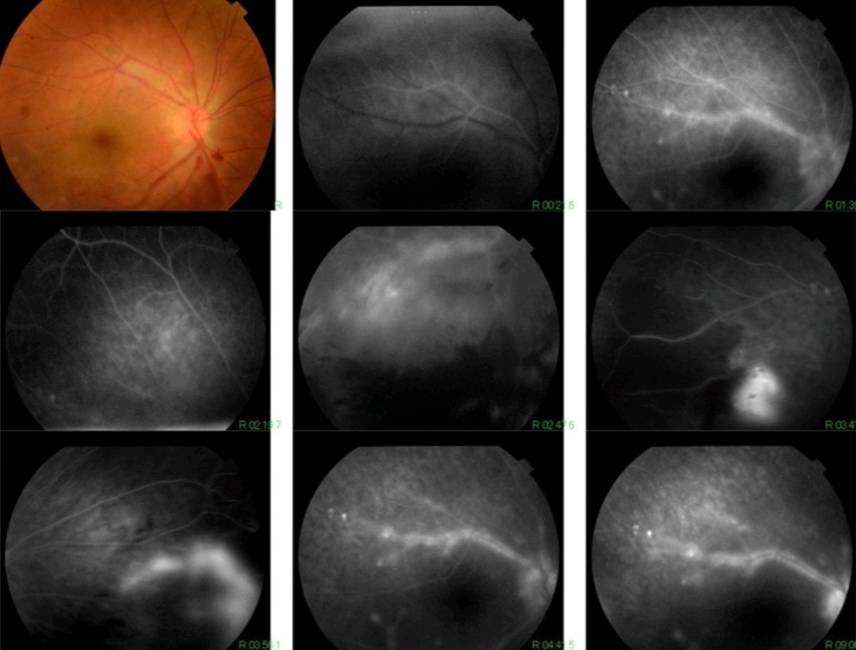

Figure 1 : Fluorescein angiography of the right eyes showing active vasculitis complicated by peripheral ischemia and Sea Fan neovascularization and intravitreal hemorrhage.

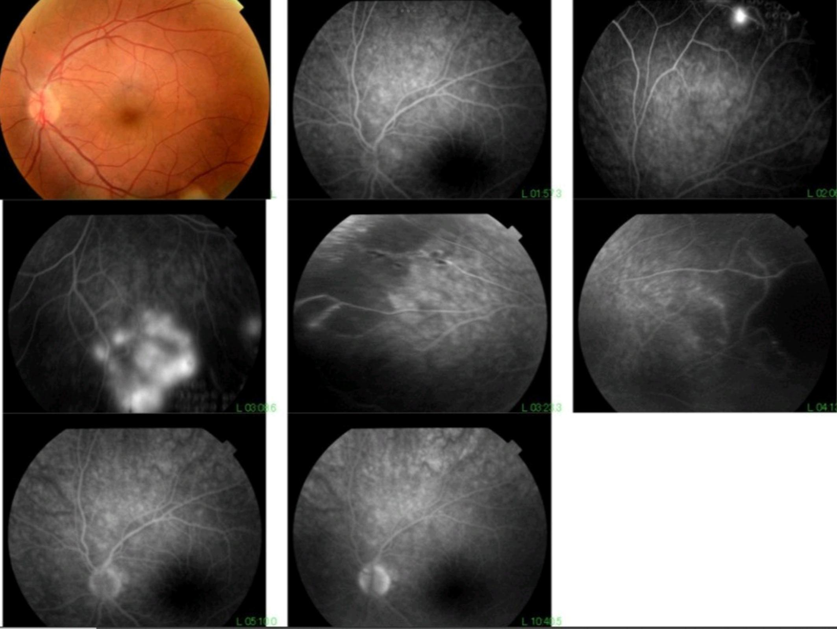

Figure 2 : Fluorescein angiography of the left eyes showing peripheral retinal hypoperfusionwith focal area of fluorescein leakage corresponding to Sea Fan neovascularization.

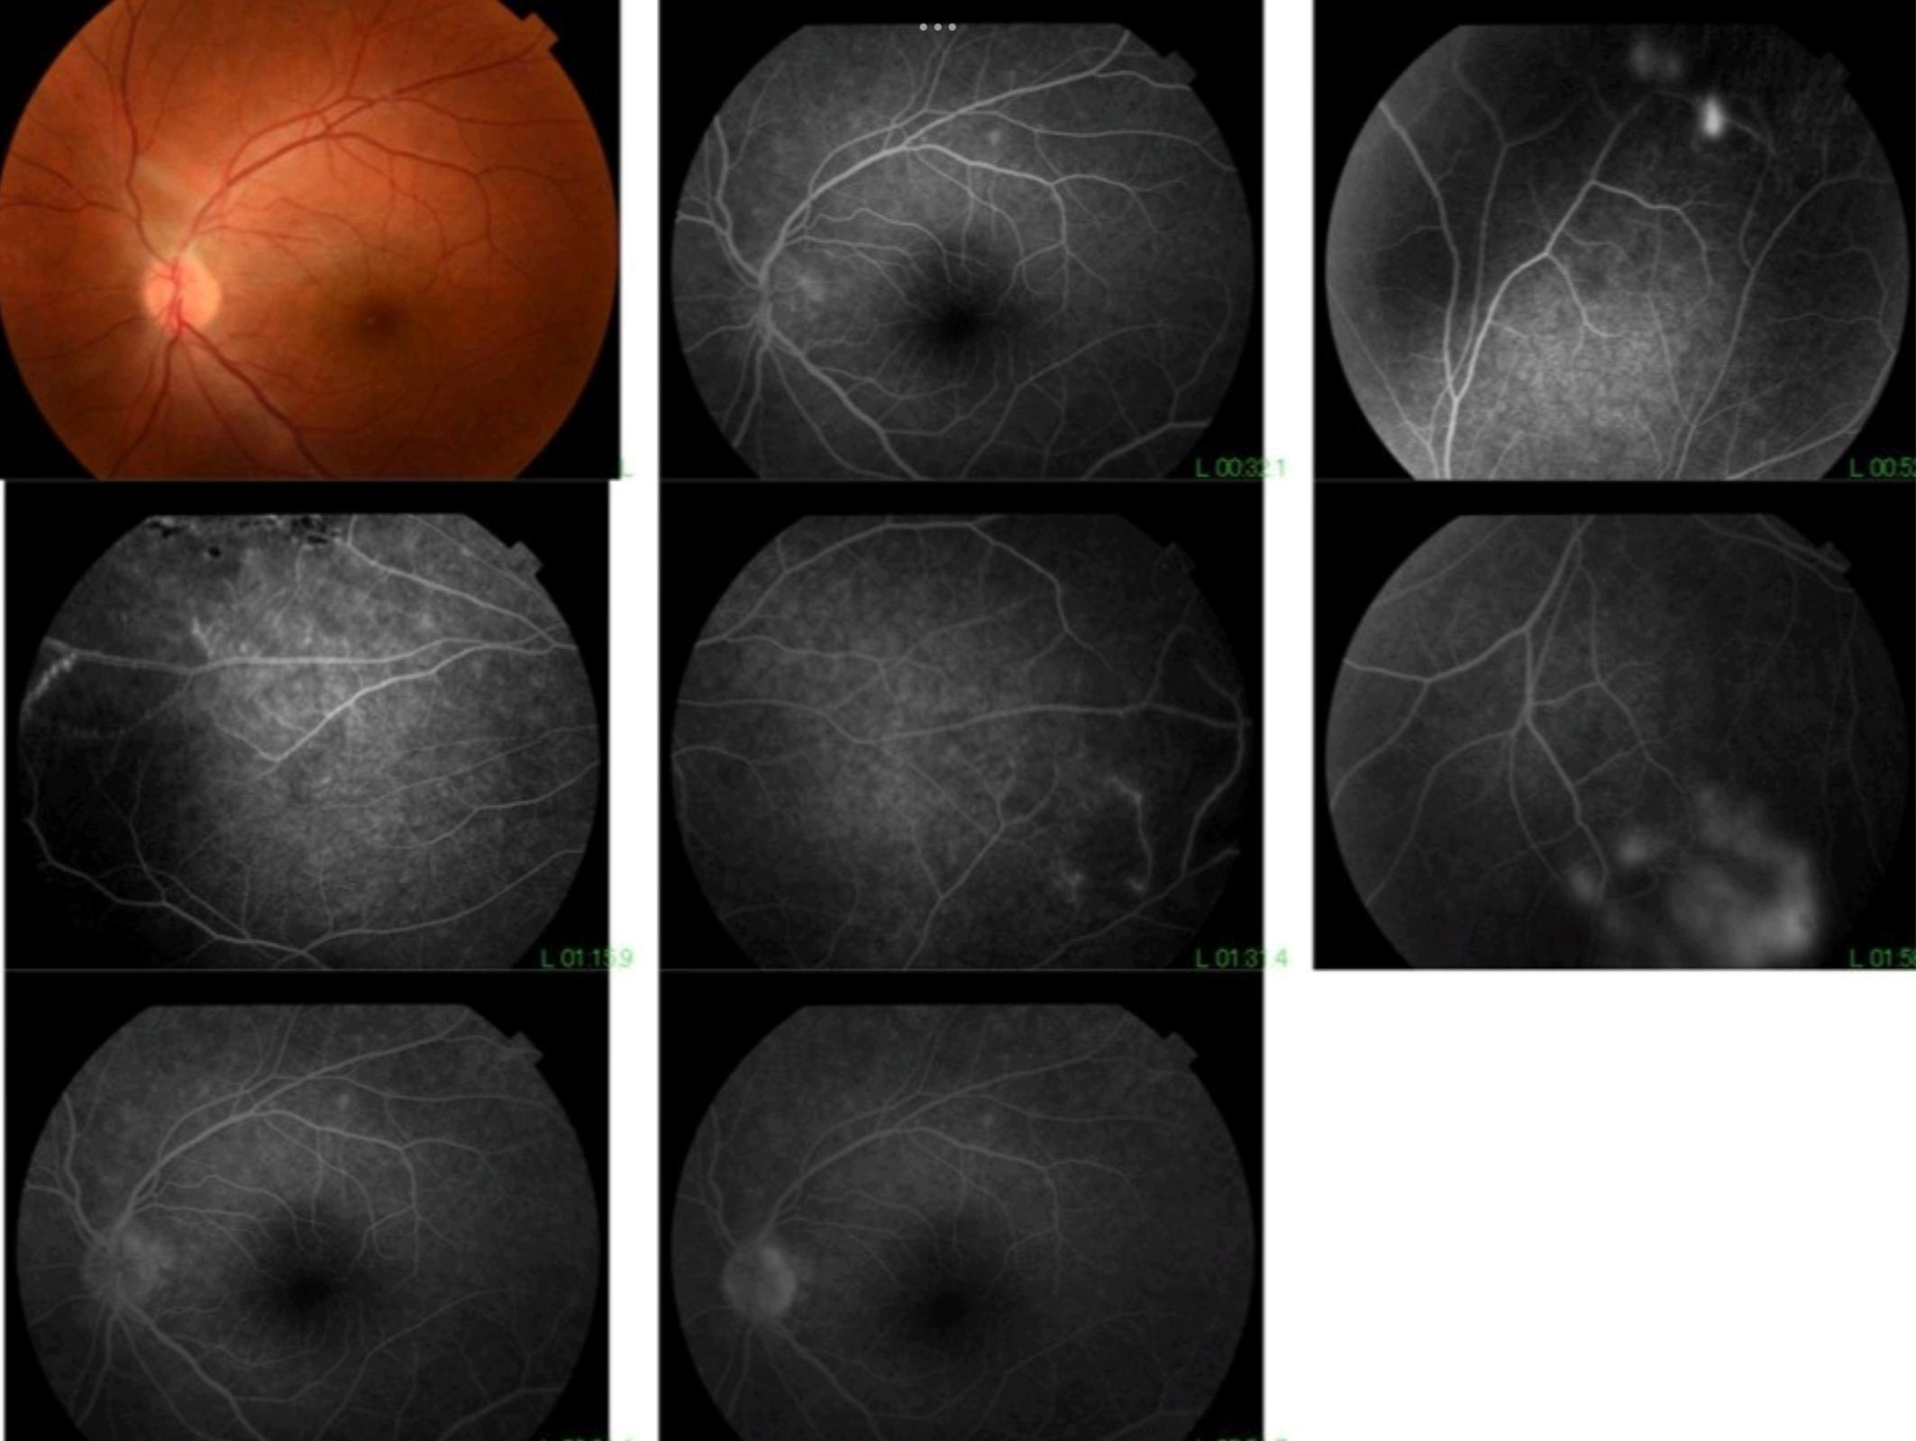

Figure 3 : Fluorescein angiography of the left eye after treatment , with the regression of the neovascularization.

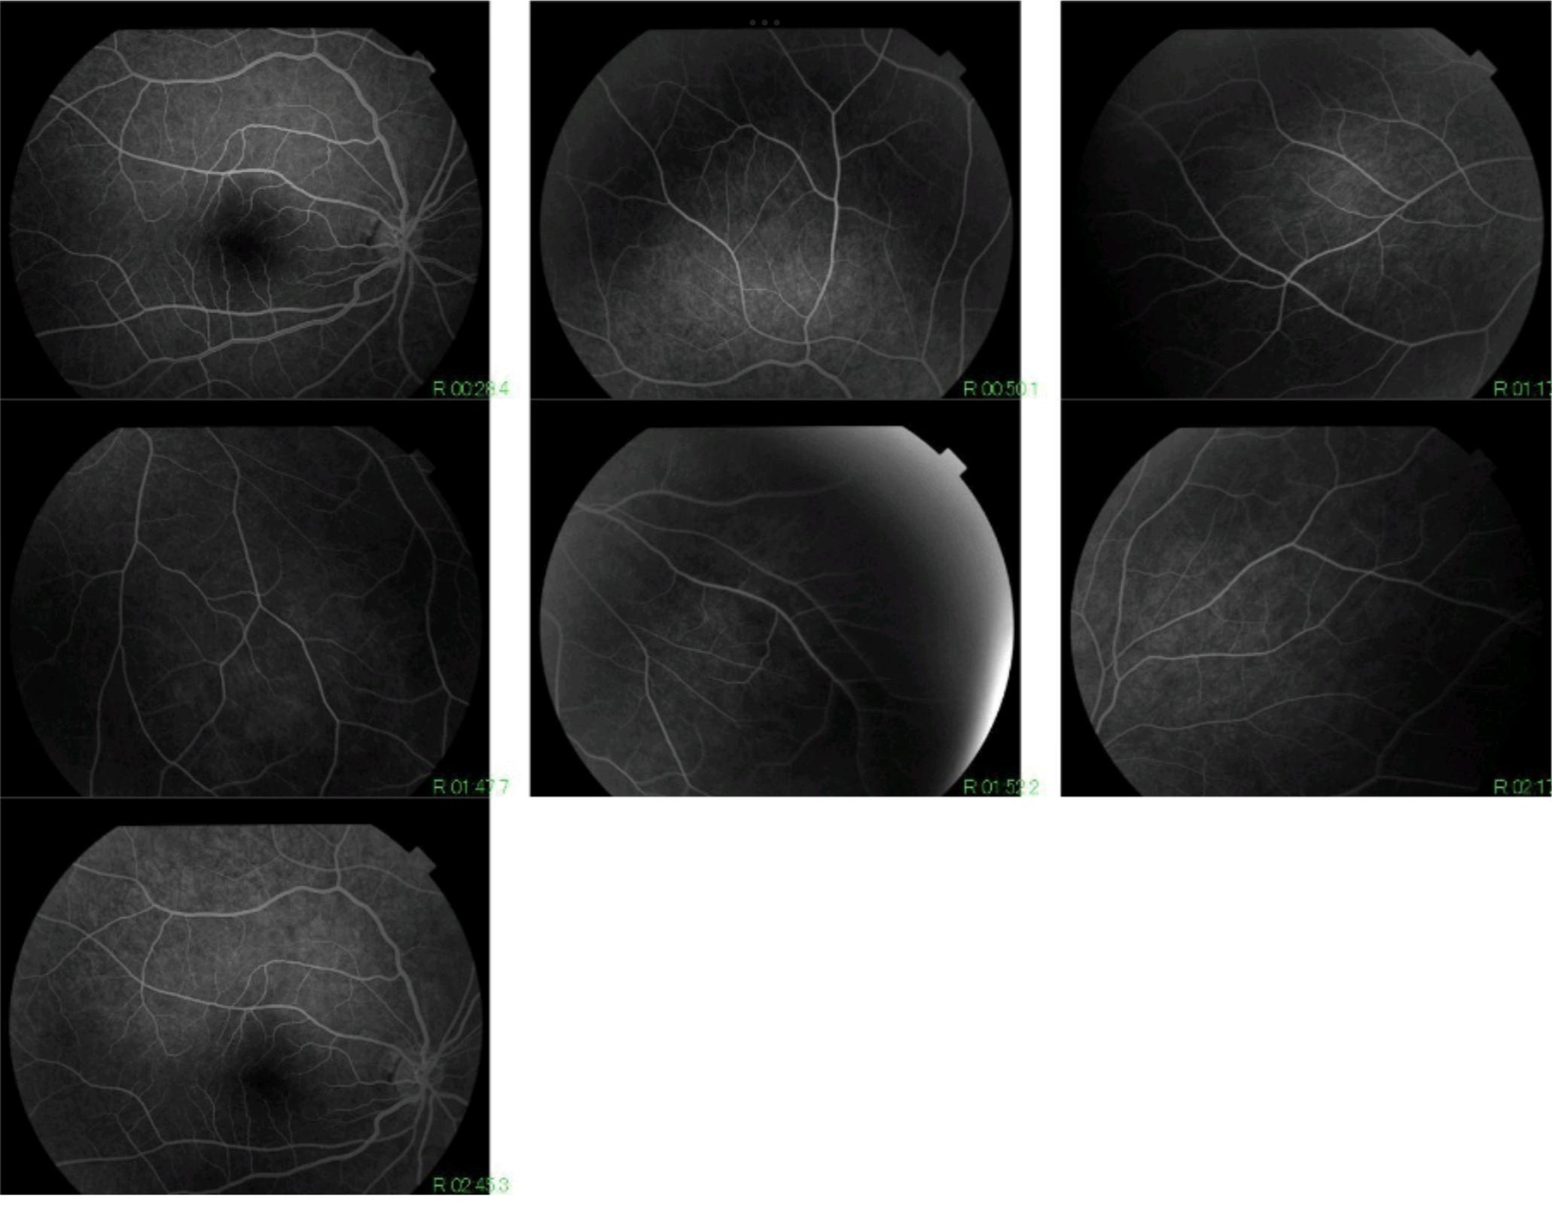

Figure 4 : Fluorescein angiography of the right eye after treatment, with complet regression of the retinal vasculitis.