Groundwater Quality Assessment for Drinking and Agricultural Use in Motipur Block, Muzaffarpur District, Bihar, India

Abstract:
Groundwater is a critical resource for drinking and irrigation, yet its quality in rural areas such as Motipur block, Muzaffarpur (Bihar), remains poorly characterized. This study evaluated groundwater suitability by analyzing 40 samples from hand pumps and tube wells for key parameters, including pH, electrical conductivity (EC), bicarbonate (HCO₃⁻), chloride (Cl⁻), and total dissolved solids (TDS). Results revealed slightly alkaline conditions (pH 7.50–8.34, avg. 7.95), within WHO/BIS permissible limits. However, EC exceeded the BIS threshold (500 µS/cm), and 23 samples surpassed WHO bicarbonate standards (350 mg/L). Although most TDS values (300–1150 mg/L) complied with BIS limits (500 mg/L), chloride concentrations (355–1136 mg/L) consistently exceeded safe thresholds (250 mg/L). These findings underscore localized contamination risks, emphasizing the need for targeted interventions to ensure sustainable groundwater management in the region.
Key words: Groundwater quality, Drinking water, Irrigation suitability, Electrical Conductivity, Chloride, Bicarbonate, Spatial mapping, Muzaffarpur

Introduction
Groundwater serves as a vital natural resource, sustaining life, agriculture, and industrial development globally (Mariappan et al., 2005; Kumar et al., 2024). As the primary source of drinking water for both rural and urban populations, its quality critically influences public health and ecosystem integrity (Kumar et al., 2024a). However, growing contamination from anthropogenic activities and poor water management practices has intensified concerns over groundwater safety and sustainability (Kumar & Jha, 2021; Ajeet et al., 2021; Chattopadhyay et al., 2021). For example, the U.S. Environmental Protection Agency (EPA) warns against consuming water with total dissolved solids (TDS) exceeding 500 mg/L, emphasizing the necessity of systematic quality monitoring (Kumar et al., 2025). The chemical composition of groundwater is governed by soluble ions—including calcium (Ca²⁺), magnesium (Mg²⁺), sodium (Na⁺), potassium (K⁺), chloride (Cl⁻), sulfate (SO₄²⁻), carbonate (CO₃²⁻), and bicarbonate (HCO₃⁻)—as well as trace elements such as arsenic (As) and fluoride (F⁻) (Bangar et al., 2022). Elevated levels of electrical conductivity (EC), TDS, total hardness (TH), and fluoride can compromise water potability, underscoring the need for routine assessments (World Health Organization [WHO], 2011).
Groundwater Challenges in Bihar, India
In Bihar, India, salinization affects approximately 3.2 lakh hectares of land, with districts like Muzaffarpur experiencing significant threats to soil health and crop productivity due to poor-quality irrigation water (Seleiman et al., 2022; Singh et al., 2025; Kumar et al., 2025). Inadequate drainage systems further exacerbate soil salinization and alkalization, degrading soil structure and diminishing agricultural yields (Kamra, 2021; Zade et al., 2021). Compounding these issues, the indiscriminate extraction of groundwater contaminated by chemical pollutants (Rekha et al., 2025) and sewage infiltration poses severe risks to human health and compromises water suitability for domestic, industrial, and agricultural use (Jha et al., 2000; Kumar, 2016). To mitigate these challenges, comprehensive datasets and standardized parameters—aligned with guidelines from the World Health Organization (WHO), Bureau of Indian Standards (BIS), and Food and Agriculture Organization (FAO)—are essential for robust water quality evaluation (Ashfaq & Ahmad, 2014; Deshmukh & Urkude, 2014). In Muzaffarpur’s Motipur block, where communities depend predominantly on hand pumps and tube wells, awareness of water quality issues remains alarmingly low.
Study Objectives
This study assesses the suitability of groundwater for drinking and irrigation by analyzing key physicochemical parameters, spatial variability, and compliance with international and national standards. By leveraging GPS and GIS technologies, we provide a systematic evaluation to guide sustainable water management strategies in the region.
Materials and Methods:
Study Area: Motipur Block, Muzaffarpur District, Bihar
This study was carried out in the Motipur Block, located in the Muzaffarpur District of Bihar, a state in eastern India. Bihar covers an area of 94,163 square kilometers and is geographically situated between West Bengal to the east and Uttar Pradesh to the west. It shares an international border with Nepal to the north and is bounded by Jharkhand to the south. The state lies between latitudes 24°20'10"N and 27°31'15"N, and from longitude 83°19'50"E, with an average elevation of 52.73 meters above mean sea level (Bihar at a Glance, Directorate of Economics and Statistics, Patna, 2016). The Motipur Block spans an area of 3,122.56 square kilometers and is geographically positioned between latitudes 25°54'N and 26°23'N, and longitudes 84°53'E and 85°45'E.
Meteorological Data
Meteorological data, specifically rainfall records for the year 2023–24, were collected from established weather stations located in the Motipur Block. The monthly rainfall varied between 0 mm and 454.2 mm. The distribution pattern of this rainfall is illustrated in Figure 1.
Water Sampling and Analysis
Water sampling was carried out in 2023, with samples randomly collected throughout the study area. Precise geo-coordinates for each sampling site were recorded using a GPS device. The study area and sampling locations are presented in Figures 1 and 2. To assess water quality, 30 groundwater samples were collected from tube wells located across the Motipur and Kanti blocks at predetermined, GPS-marked points to evaluate spatial variability. Each sample comprised 1 liter of water, stored in two high-density plastic bottles, and transported to the laboratory for analysis. Water quality parameters were analyzed in the Soil Science Department laboratory at TCA, Dholi, using standard procedures as outlined in the accompanying table.

water quality attributes
The assessment of water quality attributes was carried out using standard analytical methods and instruments, as detailed below. The pH of the water samples was measured using a pH meter, following the procedure outlined by Richards (1954). Electrical conductivity (EC), expressed in µS/cm, was determined using a conductivity meter, also based on the method described by Richards (1954). Total dissolved solids (TDS), measured in mg/L, were assessed using a conductivity meter, following the guidelines provided by Saxena (1994) and the American Public Health Association (APHA, 1994). Chloride content (mg/L) was estimated using Mohr’s titration method, as described by Jackson (1973). Carbonate and bicarbonate concentrations (mg/L) were determined through acidimetric titration, in accordance with the methods outlined by Richards (1954).

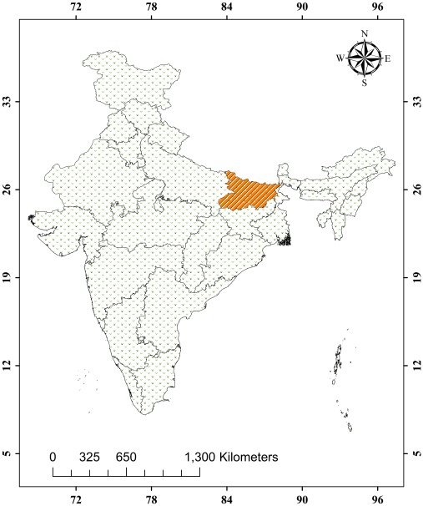
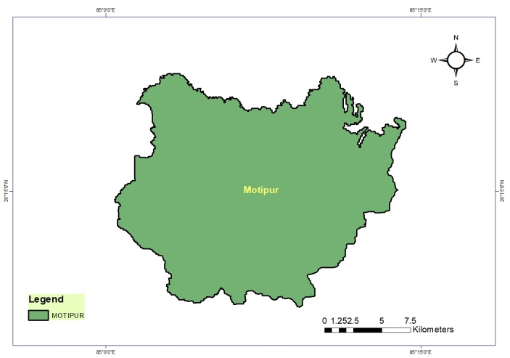
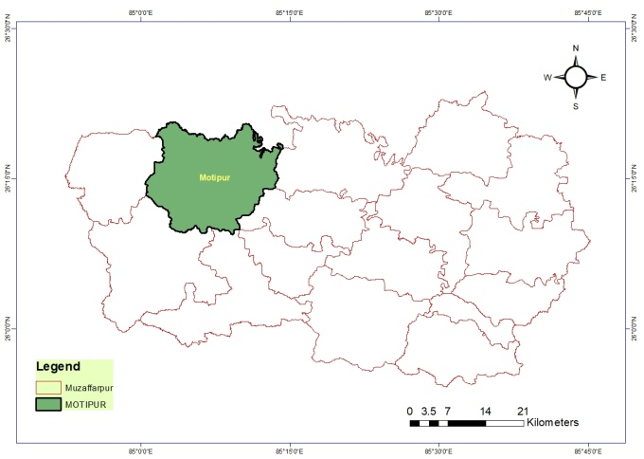

Map. 1 Map of the study area

Results and Discussion:
The groundwater samples used for the analysis of various parameters related to drinking and irrigation purposes were collected from different depths of hand pumps and tube wells across thirty locations within the Motipur Block of Muzaffarpur District, Bihar. The determined data of pH of the groundwater samples of the investigated sites is depicted in Table 1. The pH levels of groundwater in the Motipur Block were found to be slightly alkaline, ranging from 7.50 to 8.34, with an average value of 7.95. The highest pH value (8.34) was recorded in a sample from Baruraj village (26.26125221°N, 85.13605556°E), while the lowest pH value (7.50) was observed in Jathwalia village (26.22488889°N, 85.03641667°E), both located within the Motipur Block. According to the standards set by the World Health Organization (WHO) and the Bureau of Indian Standards (BIS, 2011), the permissible pH range for drinking water is between 6.5 and 8.5. Based on these guidelines, all the groundwater samples analyzed in this study were found to be within the acceptable range and are considered safe for both drinking and irrigation purposes, as per WHO and FAO norms. The spatial variability in pH levels across the study area is illustrated using GPS and GIS-based maps, represented with distinct color notations, as shown in Map 1.

Figure 1. pH Values in Groundwater Samples from Different Villages in Motipur Block

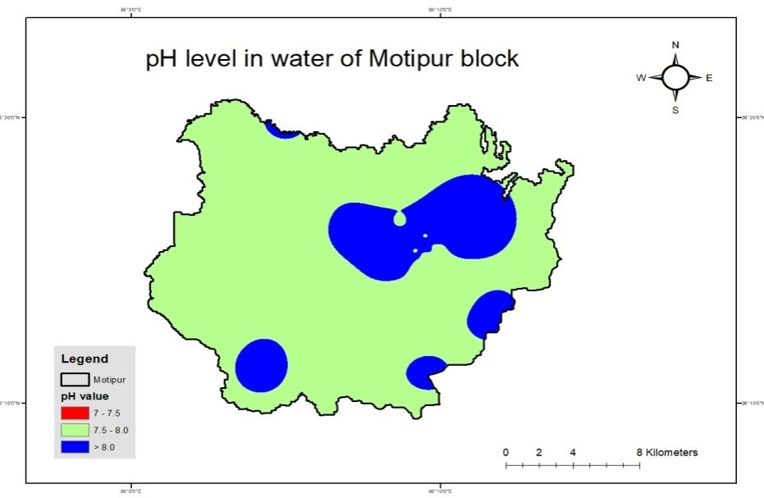
The elevated pH values observed in the groundwater samples can be attributed to the presence of bicarbonates (HCO₃⁻), which contribute to the alkaline nature of the water (Adams et al., 2001). The findings of the present study are consistent with those reported by Ranjan et al. (2023) and Zafar and Kumari (2024).
Table 1. The electrical conductivity (EC) of groundwater samples in Motipur Block varied from 547 to 1788 µS/cm, with an average value of 750.4 µS/cm
Map 2. Spatial Distribution of pH in Groundwater in the Study Area (Motipur Block)

The lowest EC (547 µS/cm) was recorded at Bariyarpur South village (26.2727222°N, 85.14463889°E), while the highest EC (1788 µS/cm) was observed at Bansghat village (26.36288889°N)

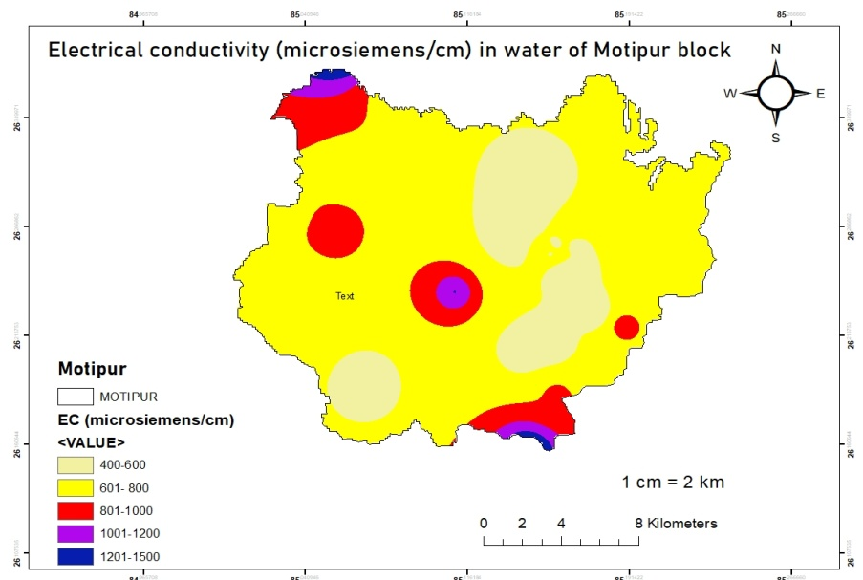
Fig. 2 Electrical conductivity (EC) in groundwater samples of different villages at Motipur block
and 85.0605833 E longitude of Motipur block. The analysis indicates that the majority of the water samples in the study area exhibited an electrical conductivity (EC) value greater than 500 µS/cm, as per the Bureau of Indian Standards (BIS). According to BIS guidelines for drinking water, the standard EC limit is set at 750 µS/cm, although this can be extended up to 3000 µS/cm in areas where no alternative water source is available. All groundwater samples from Motipur and Kanti blocks were found to be within the permissible limits set by both BIS and WHO. However, according to FAO standards for irrigation water, an EC value below 700 µS/cm is considered within the safe zone
Map 3. Spatial distribution of EC in groundwater in the
study area (Motipur block

The study found that only 50% of the water samples from Motipur Block fell within this limit. A spatial distribution map of EC was created using GPS and GIS techniques, displaying the variations in EC levels through different color gradations, as shown in Map 3. Electrical conductivity (EC) is a crucial water quality parameter, as it measures the water's ability to conduct electricity, which is directly related to the concentration of ions present in the water. Higher ion concentrations in the water result in higher EC values (John & Das, 2020). Ranjan et al. (2013), Varol and Davraz (2015), and Pal et al. (2023) also reported similar trends in their studies. The total dissolved solids (TDS) content in groundwater samples used for drinking and irrigation in the Motipur Block, as presented in Table 1, ranged from 300 to 1150 mg/L, with an average value of 513 mg/L.
Figure 3. Total Dissolved Solids (TDS) in Groundwater Samples from Different Villages in Motipur Block

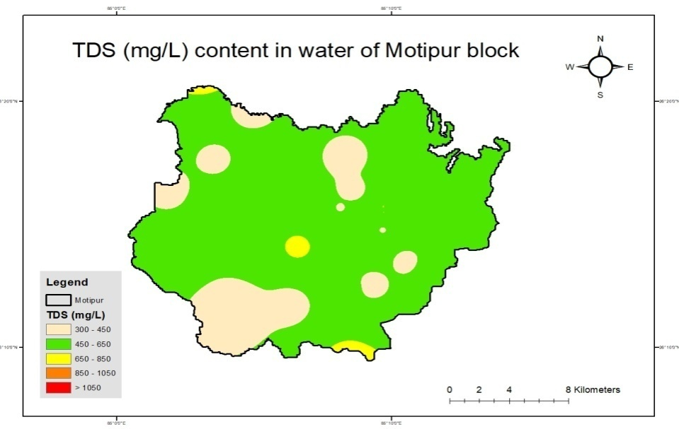
The lowest TDS value observed was 300 mg/L at Ranpur Beriyahi village, located at 26.19055556°N latitude and 85.07113889°E longitude. In contrast, the highest TDS value of 1150 mg/L was recorded at Bansghat village, located at 26.36288889°N latitude and 85.06058333°E longitude, within Motipur Block, Muzaffarpur District. The Bureau of Indian Standards (BIS) sets the permissible limit for TDS at 500 mg/L. Out of the 30 water samples collected from Motipur Block, 19 samples (63.33%) were found to have TDS levels below the BIS standard of 500 mg/L, while the remaining 11 samples (36.33%) exceeded this limit. According to the World Health Organization (WHO), the desirable limit for TDS is 1000 mg/L. In this study, 29 water samples from Motipur Block fell within the WHO standard limit, with only one sample exceeding this threshold. The variable distribution of

Map 4. Spatial Distribution of TDS in Groundwater in the Study Area (Motipur Block)

The TDS values, shown on the map generated through GPS and GIS techniques, depict the distribution of dissolved organic and inorganic elements across different locations in the study area, as illustrated in Map 4. TDS values represent the concentration of dissolved solids in a given volume of water. High TDS concentrations in groundwater may result from anthropogenic activities such as industrial discharge, the application of chemical fertilizers, agricultural runoff, or natural processes contributed by various minerals (Boyd, 2000). A similar pattern in groundwater TDS values has been reported by Varol and Davraz (2015), Krishan et al. (2018), Kumar et al. (2022), and Pal et al. (2023).
The chloride content in the collected groundwater samples is presented in Table 2. The results from the study area of Motipur Block show that chloride concentrations range from 355 to 1136 mg/L, with an average value of 657.93 mg/L.

Figure 4. Chloride Content in Groundwater Samples from Different Villages in Motipur Block

The results of the investigation revealed that the lowest chloride content in Motipur Block was recorded at Mahmada village (355 mg/L), located at 26.33302778°N latitude and 85.08191667°E longitude. The highest chloride concentration of 1136 mg/L was observed at Barhmpur village, situated at 26.21827778°N latitude and 85.18897222°E longitude. In this study, all 30 water samples from Motipur Block were found to exceed the WHO and BIS desirable limit for chloride content, which is set at 250 mg/L. The variability in chloride concentration across the study area is depicted in a GPS and GIS-based map, with different color gradations, as shown in Map 5.
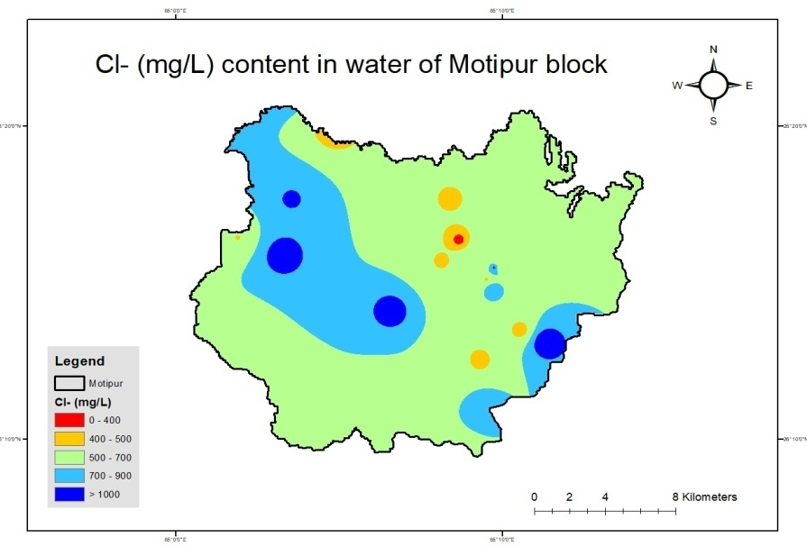
The origin of chloride in groundwater can be attributed to both natural and anthropogenic sources. Naturally, chloride may originate from minerals, while anthropogenic sources include the use of inorganic fertilizers, landfill leachates, septic tank effluents, animal feeds, industrial effluents, and irrigation drainage (Kelly et al., 2012). Similar findings regarding chloride contamination in groundwater have been reported by Rawat and Singh (2018) and Batarseh et al. (2021). The analysed samples showed results, there was no
.
Map 5. Spatial distribution of Chlorine in groundwater in the
study area (Motipur block)

carbonate content obtained in the study area. The results regarding bicarbonate content in the groundwater used for drinking and irrigation purposes, collected from various locations, are presented in Table 2. The bicarbonate concentrations in Motipur Block ranged from 305.1 to 549.18 mg/L, with an average value of 399.5 mg/L. The lowest bicarbonate concentration (305.1 mg/L) was recorded in Saraiya village, located at 26.2554477°N latitude and 85.1535207°E longitude. In contrast, the highest bicarbonate concentration (549.18 mg/L) was observed in Mahmada village.
Figure 5. Bicarbonate Content in Groundwater Samples from Different Villages in Motipur Block
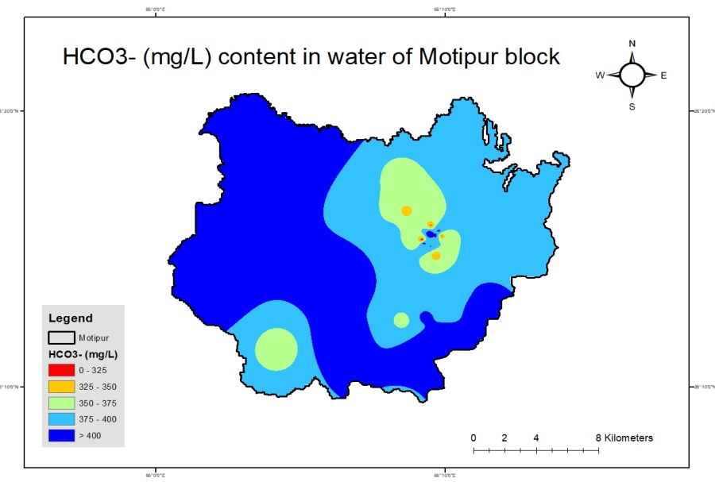
Seven of the samples were found to have bicarbonate concentrations below the WHO limit of 350 mg/L, while the remaining 23 samples exceeded the WHO threshold. The elevated bicarbonate concentrations in groundwater may be attributed to the presence of carbonaceous minerals in the soil. Additionally, the origin of bicarbonate could be linked to the decomposition of organic pollutants, which produces carbon dioxide (CO₂) that reacts with soil, thereby releasing bicarbonate into groundwater (Kumar & Singh, 2015). GPS and GIS-based maps were generated to show the distribution of bicarbonate concentrations across the study area, represented by various color gradations. These maps are presented in Map 5 and Map 6.
Map 6. Spatial Distribution of Bicarbonate in Groundwater in the Study Area (Motipur Block)

Similar findings have also been reported by Varol and Davraz (2015), Rawat and Singh (2018), and Mohammed et al. (2023).

Conclusions:

The assessment of groundwater quality in Motipur Block, Muzaffarpur District, Bihar, revealed that while pH levels were within safe limits (7.50–8.34), other critical parameters raised concerns. Electrical conductivity (EC) exceeded the BIS threshold (500 µS/cm) in all samples, and chloride concentrations (355–1136 mg/L) universally surpassed the WHO/BIS safe limit (250 mg/L). Additionally, 23 out of 30 samples showed bicarbonate levels above WHO standards (350 mg/L), and 36.33% of samples exceeded the BIS TDS limit (500 mg/L). These findings underscore significant localized contamination risks, likely stemming from anthropogenic activities and natural mineral dissolution. The study highlights the urgent need for targeted interventions, such as improved water treatment, sustainable agricultural practices, and enhanced monitoring, to ensure safe drinking and irrigation water, thereby safeguarding public health and soil productivity in the region.

Recommendations:
To address the concerning groundwater quality issues in Motipur Block, immediate implementation of water treatment measures such as community-based reverse osmosis (RO) or activated carbon filtration systems is crucial, particularly in villages with elevated chloride, TDS, and bicarbonate levels, while household-level purification methods like boiling or ceramic filters should be promoted where centralized solutions are impractical. Sustainable agricultural practices must be prioritized, including the adoption of drip irrigation, precision farming, and reduced chemical fertilizer use to minimize groundwater overexploitation and contamination from agricultural runoff. Strengthening monitoring and regulation through a decentralized groundwater quality testing network and stricter enforcement of industrial discharge policies will help track and mitigate pollution trends, complemented by public awareness campaigns to educate communities on contamination risks and water conservation techniques. Policy interventions should integrate groundwater quality data into regional water management plans, incentivize alternative water sources like rainwater harvesting, and support research into cost-effective remediation technologies such as desalination or bioremediation, fostering collaboration between government agencies, researchers, and local stakeholders to ensure long-term water security and sustainable development in the region.

Future scope of study:
To build on this research, future studies could expand the geographical coverage to include adjacent blocks in Muzaffarpur and other districts of Bihar to assess regional groundwater contamination trends. Incorporating additional parameters such as nitrate, fluoride, arsenic, and heavy metals would provide a more comprehensive risk assessment. Advanced techniques like isotopic tracing and machine learning-based predictive modeling could help identify contamination sources and forecast water quality degradation. Long-term monitoring programs should be established to track temporal changes, while socio-economic studies could evaluate community awareness and adoption of mitigation measures. Furthermore, pilot projects on cost-effective remediation technologies, such as biochar filtration or decentralized treatment systems, could be explored to improve groundwater sustainability in rural areas. Integrating these findings with policy frameworks will ensure actionable solutions for water resource management in Bihar.
Acknowledgement
The authors express their gratitude to the technical staff of the college, whose invaluable assistance greatly contributed to the success of this study. Their unwavering support and commitment were integral to the completion of this research.

Table 2. Data of ground water quality attributes (mg/L) in the study area (Motipur block)
SN.  No. | Locations | Geo-coordinates |  | pH | EC  (µS/cm) | TDS  (mg/L) | Cl⁻  (mg/L) | CO₃⁻²  (mg/L) | HCO₃⁻(mg/L)
SN.  No. | Locations | Latitude N | Longitude E
1. | Baruraj | 26.26125221 | 85.13605556 | 8.34 | 556 | 440 | 461.5 | 0 | 378.32
2. | Ratampura | 26.26122222 | 85.16294444 | 8.2 | 669 | 440 | 426 | 0 | 414.94
3. | Patti aswari | 26.18469444 | 85.15766667 | 8.1 | 828 | 490 | 816.5 | 0 | 463.75
4. | Brahmpur | 26.21827778 | 85.18897222 | 8.06 | 860 | 540 | 1136 | 0 | 427.14
5. | Bariyarpur | 26.29427778 | 85.14025331 | 7.85 | 598 | 360 | 461.5 | 0 | 366.12
6. | Bariyarpur North | 26.22486111 | 85.17597222 | 7.93 | 602 | 380 | 426 | 0 | 390.53
7. | Bariyarpur South | 26.27272222 | 85.14463889 | 7.98 | 547 | 310 | 355 | 0 | 341.71
8. | Jahangirpur | 26.20886111 | 85.15494444 | 7.97 | 604 | 380 | 426 | 0 | 402.73
9. | Mahmada | 26.33302778 | 85.08191667 | 8.04 | 714 | 340 | 355 | 0 | 549.18
10. | Ebrahimpur | 26.26455556 | 85.05466667 | 7.99 | 852 | 460 | 1029.5 | 0 | 414.94
11. | Mahmadpur Mahmada | 26.31533333 | 85.74630556 | 7.90 | 563 | 360 | 390.5 | 0 | 341.71
12. | Bansghat | 26.36288889 | 85.06058333 | 7.70 | 1788 | 1150 | 1065 | 0 | 512.57
13. | Parsouninth | 26.29438889 | 85.05927778 | 7.93 | 769 | 430 | 923 | 0 | 414.94
14. | Harnahi | 26.19522222 | 85.10561111 | 7.88 | 742 | 380 | 639 | 0 | 427.14
15. | Magurahan Tajpur | 26.27383333 | 85.03180556 | 7.86 | 782 | 420 | 497 | 0 | 451.55
16. | Jathwalia | 26.22488889 | 85.03641667 | 7.50 | 701 | 490 | 603.5 | 0 | 414.94
17. | Ranpur Beriyahi | 26.19055556 | 85.07113889 | 8.10 | 575 | 300 | 674.5 | 0 | 353.92
18. | Pagahia | 26.15641667 | 85.14386111 | 7.66 | 1293 | 920 | 639 | 0 | 390.53
19. | Thikaha | 26.20683333 | 85.14227778 | 7.68 | 566 | 490 | 603.5 | 0 | 366.12
20. | Jasauli | 26.23486111 | 85.11030556 | 7.90 | 1060 | 730 | 1065 | 0 | 463.75
21. | Singaila | 26.2516933 | 85.1586133 | 7.87 | 739 | 550 | 461.5 | 0 | 402.73
22. | Singaila Shankar Tola | 26.24645916 | 85.1613403 | 7.93 | 568 | 420 | 852 | 0 | 329.51
23. | Singaila | 26.2536931 | 85.1545163 | 8.05 | 653 | 525 | 639 | 0 | 414.94
24. | Saraiya | 26.2554477 | 85.1535207 | 7.98 | 784 | 568 | 532.5 | 0 | 305.10
25. | Baruraj Rd | 26.25904604 | 85.1579922 | 8.21 | 589 | 488 | 497 | 0 | 439.34
26. | Mahamadpur Balmi | 26.2642096 | 85.1586945 | 7.98 | 687 | 612 | 603.5 | 0 | 317.30
27. | Unnamad Rd | 26.261868 | 85.1619976 | 8.05 | 798 | 698 | 710 | 0 | 378.32
28. | Mahaveer Asthan | 26.2580892 | 85.16221453 | 8.12 | 784 | 684 | 852 | 0 | 451.55
29. | Ratanpura | 26.2580731 | 85.16271643 | 7.84 | 678 | 586 | 1065 | 0 | 341.71
30. | Niranjan Rd | 26.2578274 | 85.16469053 | 7.92 | 562 | 458 | 532.5 | 0 | 317.30
Mean value |  |  |  | 7.95 | 750.37 | 513.30 | 657.93 | 0 | 399.48

Disclaimer (Artificial intelligence)
Author(s) hereby declare that NO generative AI technologies such as Large Language Models (ChatGPT, COPILOT, etc.) and text-to-image generators have been used during the writing or editing of this manuscript.
References:
Adams, S., Titus, R., Pietersen, K., Tredoux, G. and Harris, C. (2001). Hydrochemical characteristics of aquifers near Sutherland in the Western Karoo, South Africa. Journal of Hydrology, 241: 91–103
Ajeet Kumar, C.K. Jha, and K. Sunita (2021) बिहार की मक्का आधारित फसल प्रणाली में नाइट्रेट लीचिंग और भूजल संदूषण का खतरा (Nitrate leaching and ground water contamination in maize based cropping system of Bihar), “Krishisewa Magazine” 01 October 2021. Pg. 1-6. The url of the article is https://www.krishisewa.com/miscellaneous/1362-nitrate-leaching-and-ground-water-contamination-in-maize-based-cropping-system-of-bihar.html.
Ashfaq, A. and Ahmad, F. (2014). Quality of assessment ground water at Agra district, India. International journal of Current Research & Academic Review, 2(8): 304-308
Bangar, K. S., Narendra Kumawat, Tiwari, S. C., Kaledhonkar, M. J., Parmar, B. B. and Tagore, G. S. (2022). Groundwater Quality Assessment, Characterization and Mapping for Madhya Pradesh, India for Irrigation Purpose. Journal of Soil Salinity and Water Quality, 14(1): 33-52.
Batarseh, M., Imreizeeq, E., Tilev, S., Al Alaween, M., Suleiman, W., Al Remeithi, A.M., Al Tamimi, M.K. and Al Alawneh, M. (2021). Assessment of groundwater quality for irrigation in the arid regions using irrigation water quality index (IWQI) and GIS-Zoning maps: Case study from Abu Dhabi Emirate, UAE. Groundwater for Sustainable Development, 14: 100611.
Bureau of Indian Standard (BIS, 2012). Specification for drinking water IS 1000: New Delhi, India.
Chattopadhyay, S., Kumar, Ajeet., Singh, S. K. (2021) Nitrate Leaching and threat of Ground Water Contamination in Sugarcane Based Cropping System of Bihar. Agriculture & Food: E-Newsletter; 3 (11): 369-372. https://agrifoodmagazine.co.in/2021/volume-3-issue-11-november-2021/ ; ⟨hal-04935232⟩.
Deshmukh, C. K. and Urkude, R. N. (2014). Physico-chemical and microbial status of malkhed lake at chandur railway, district: Amravati. The Bioscan. 2: 677-682.
FAO-UN (1985). Water quality index for agriculture, Food and Agriculture Organization of the United Nation. Rome, Italy, 29.
Jha A. N and Verma, P. K. (2000). Physico–chemical property of drinking water in town area of Godda district under Santal Pargana, Bihar. Pollution Research. 19(2): 245–247.
Kamra, S. K. (2021). Subsurface drainage for saline and waterlogged alluvial soils. Managing salt affected soils for sustainable agricultue, 346-366.
Krishan, A., Mishra, R. K. and Mohan, D. (2018). Groundwater quality assessment: A case study of Manpur, India. Journal of Environmental Nanotechnology, 7(4): 25-33.
Kumar Ajeet and Jha C. K. (2021) Nitrate leaching and threat of ground water contamination in maize based cropping system of Bihar, Agriculture & Food: E-Newsletter. 3 (5): 144-147. ⟨hal-04936434⟩.
Kumar Ajeet, Bairwa Mohit, Meena Sunita Kumari, Singh Sanjay Kumar, Sinha S.K., Rana Lalita, Singh Yad Vir, Kumar Amrendra, Singh Harendra and Paswan Sudhir (2025) Nutrient Index Value as a Tool for Evaluating Soil Fertility in Diverse Agroecosystems of Indo-Gangetic plains of India. AATCC Review (Agriculture Association of Textile Chemical and Critical Reviews). Manuscript Number: AATCC_Review-YR-1581. (In Press).
Kumar Yadav, S., Kafle, K., Poudel, A., Gelal, R. and Adhikari, B. (2022). Use of Gis for Spatial Mapping of Soil Fertility in Dhanusha, Nepal. International Journal of Applied Biology, 6 (2): 1-13.
Kumar, A., Singh, S.K., Meena, S.K., Sinha, S.K., Rana, L., Singh, A.K., Kumar, A., Singh, H., & Paswan, S. (2025). A Comprehensive Review on Impact of Intensive Use of Nitrogenous Fertilizer on Nitrate Contamination in Groundwater under Sugarcane Based Cropping System in Indo-Gangetic Plains of India. International Journal of Environment and Climate Change, 15(2), 286–300. DOI: https://doi.org/10.9734/ijecc/2025/v15i24727.
Kumar, Ajeet (2016) Soil Health and Soil Quality: - The Fundamental Keys to a Sustainable and Productive Agriculture; Pg. 48-54; Souvenir of International Symposium on Management of Rice based agricultural system under stress prone environment; organized by Rajendra Agricultural University, Pusa, Samastipur, Bihar during 17-19 March, 2016. https://hal.science/hal-04972899.
Kumar, Ajeet. ., Singh, S. K. ., Meena, S. K. ., Sinha, S. ., Rana, L. ., Kumari, A. ., Singh, A.K ., & Kumar, A. . (2024). Human Health Risk Assessment of Nitrate-Contaminated Groundwater in North East Alluvial Plains of India. In Book: Geography, Earth Science and Environment: Print ISBN: 978-93-48388-08-7, Geography, Earth Science and Environment: Research Highlights Vol. 2, 1–26. https://doi.org/10.9734/bpi/geserh/v2/1424.
Kumar, Ajeet., Singh, S.K., Meena, S.K., Sinha, S.K. and Rana L (2024a) Groundwater contamination with nitrate and human health risk assessment of North East alluvial plains of Bihar. International Journal of Environment and Climate Change, 14(3), 17–31. https://doi.org/10.9734/ijecc/2024/v14i34016; https://hal.science/hal-04484961.
Mariappan, V., Prabakaran, P., Rajan, M. R. and Ravichandran, A. D. (2005). Systematic study of water quality index among the physico-chemical characterstics of groundwater in and around Thanjavur Town. Indian Journal of Environmental Protection, 25 (6): 551-555.
Mohammed, M. A., Kaya, F., Mohamed, A., Alarifi, S. S., Abdelrady, A., Keshavarzi, A., Szabó, N. P. and Szűcs, P. (2023). Application of GIS-based machine learning algorithms for prediction of irrigational groundwater quality indices. Frontiers in Earth science, 11: 1274142.
Pal, S., Singh, S. K., Singh, P., Pal, S. and Kashiwar, S. R. (2023). Spatial pattern of groundwater arsenic contamination in Patna, Saran, and Vaishali districts of Gangetic plains of Bihar, India. Environmental Science and Pollution Research, 1-15.
Ranjan, R. K., Ramanathan, A. L., Parthasarathy, P. and Kumar, A. (2013). Hydrochemical characteristics of groundwater in the plains of Phalgu River in Gaya, Bihar, India. Arabian Journal of Geosciences, 6: 3257-3267
Rawat, K. S. and Singh, S. K. (2018). Water Quality Indices and GIS-based evaluation of a decadal groundwater quality. Geology, Ecology, and Landscapes, 2(4): 240-255.
Rekha, R., Kumar, A., & Kumar, A. (2025). Integrated Assessment of Pesticide Efficacy Against Aceria litchii (Keifer) in Litchi Orchards of Bihar, India. Journal of Advances in Biology & Biotechnology, 28(4), 388–398. 10.9734/jabb/2025/v28i42200
Seleiman, M. F., Aslam, M. T., Alhammad B. A., Assan, M. U., Maqbool, A. and Chattha, M. U. (2022). Salinity stress in wheat: effects, machanisms and management strategies. Phyton-International Journal of Experimental Botany, 91(4): 0031-945.
Singh, Y.V., Goswami, S., Singh, S.K., Kumar, A., Bhartiya, P.K. and Singh. K. (2025). Impact of Nutrient Management Technologies on Soil Physico-Chemical Properties, Yield and Economics of Mustard under Irrigated Condition of Chandauli District, Uttar Pradesh, India. International Journal of Plant & Soil Science 37 (2):78-83. https://doi.org/10.9734/ijpss/2025/v37i25306.
Varol, S. and Davraz, A. (2015). Evaluation of the groundwater quality with WQI (Water Quality Index) and multivariate analysis: a case study of the Tefenni plain (Burdur/Turkey). Environmental earth sciences, 73: 1725-1744.
World Health Organization (2011). Guidelines for drinking-water quality. World health organization, 216: 303-304.
World Health Organization (2012). Rapid assessment of drinking-water quality: a handbook for implementation. World Health Organization.
Zade,S P., Gourkhede, P H., Vaidya, P.H., Singh, R. S.,.Sinha, S. K., Kumar, Ajeet., Kumar, Vipin., Brajendra (2021) PROBLEM SOILS AND THEIR MANAGEMENT PRACTICES. Pg 1-147. ISBN:978-81-925878-3-5, Edition-First –January 2021, Revised Second Edition-December,2021; Published by: Mr.Gajendra Parmar, Proprietor, Parmar Publication 854, KG Ashram, Bhuinphod, Govindpur Road, Dhanbad-828109, Jharkhand.
Zafar, M. M., Sulaiman, M. A., Prabhakar, R. and Kumari, A. (2024). Evaluation of the suitability of groundwater for irrigational purposes using irrigation water quality indices and geographical information systems (GIS) at Patna (Bihar), India. International Journal of Energy and Water Resources, 8(2): 241-254.

