**Review Article**

**“Ecosystem Valuation and Carbon Metrics: Strategic Tools for Climate Action and Policy Making.”**

**Abstract:**

This review paper critically evaluates the role of ecosystem valuation and carbon metrics as tools for driving ecological sustainability in economic and policy decision-making. Based on a state-of-the-art synthesis of peer-reviewed articles, policy documents, and valuation databases like the Ecosystem Services Valuation Database (ESVD), the paper reviews economic quantification of ecosystem services in terms of provisioning, cultural, regulatory, and supporting values. It draws on such seminal publications as Robert Costanza’s 1997 global valuation of ecosystem services, reviewing methodological advances and findings for specific biomes, and identifies coral reefs and mangroves as among the most valued. It reviews economic frameworks like direct and indirect values, and Payment for Ecosystem Services (PES) schemes as drivers for promoting conservation. Case studies of India, such as the Ashtamudi Wetland and the Dal Lake, illustrate localized applications of these methods of valuation. The review also assesses carbon metrics, with attention paid to the carbon budget framework that computes allowable emissions necessary to limit global warming to 1.5°C or 2°C. According to the Global Carbon Project 2023, the remaining carbon budget to limit warming to 1.5°C with the 50% probability will be exhausted in approximately six years if current emission rates persist, the study considers the role of carbon credits—classified into avoided, decreased, and eliminated emissions—within compliance and voluntary markets. Through the combination of ecological and climate valuation tools, the review contributes to the debate by explaining their symbiotic potential for aiding biodiversity conservation, climate resiliency, and sustainable development. It provides policymakers, economists, and conservation practitioners with practical suggestions for equitable alignment of environmental integrity with socio-economic goals.

Keywords: **Ecosystem Valuation, Carbon Budget, Carbon Credits, Payment for Ecosystem Services (PES), Climate Mitigation, Natural Capital**

Introduction:

Ecosystem Valuation is the economic process of giving an ecosystem and/or its ecosystem services a value, whether monetary, biophysical, or otherwise, is known as ecosystem valuation. Such monetization, for instance, would ideally give policymakers and conservationists a tool to assess management impacts and compare a cost-benefit analysis of potential policies by quantifying the human welfare benefits of a forest to reduce flooding and erosion while sequestering carbon, providing habitat for endangered species, and absorbing harmful chemicals. These valuations are estimates, though, and come with the philosophical debate and inherent quantitative uncertainty of weighing a variety of non-market costs and benefits.

The field of ecosystem valuation gained new attention in 1997 when Robert Costanza, Distinguished University Professor of Sustainability at Portland State University in Oregon, became the first to estimate the global value of ecosystem services. He and his associates estimated that the value of these services was $33 trillion a year, or $44 trillion in current currency (Costanza, 1997).

**Economic Models: Values, Costs, and Value Methodology**:

Using a variety of economic techniques, ecosystem valuation aims to capture the range of costs and benefits found in a complex natural web. Four broad categories of services are offered by ecological systems: provisioning (such as fish for consumption or timber for sale), regulatory, supporting, and cultural (such as ecosystems that support traditional clothing or indigenous gathering methods) (Holzman, 2012). For a mangrove-specific illustration of this intricate topic, see figure 1.

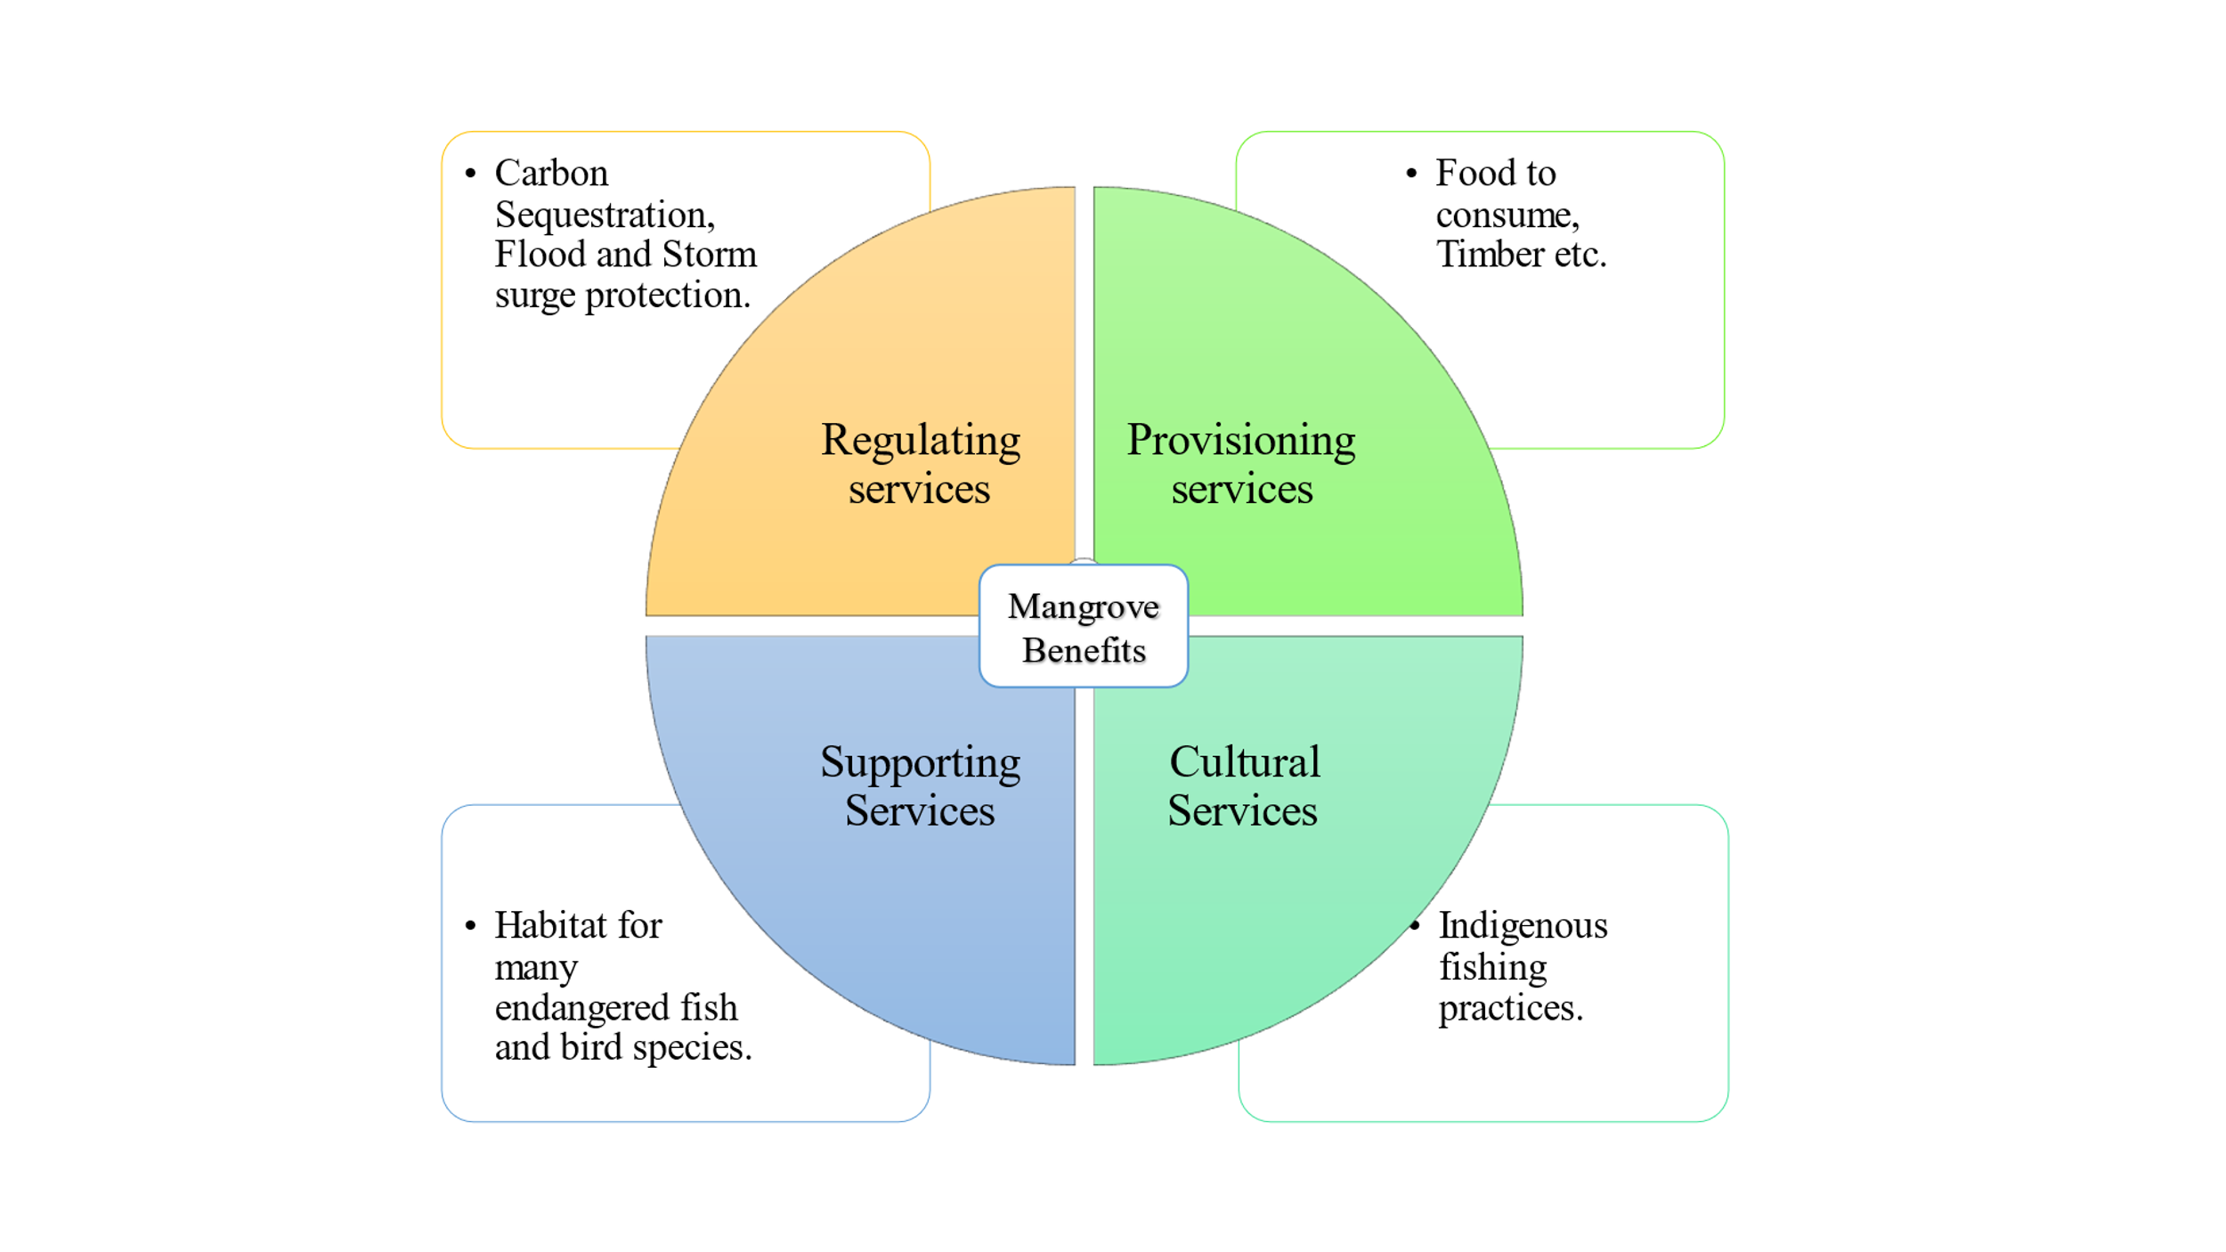

Figure 1. For a mangrove-specific example of this complex subject

The categories that people are willing to pay for have been further divided by environmental economists:   
1. Direct-use value: According to traditional environmental economists, this is the most basic method of valuing ecosystems. It represents the direct ecological yield as it would appear on commodity markets, such as the value of fish, timber, water, or other commodities if they were developed right away and sold at market value. As a result, an exchange value, or "price," is linked to the valuable items that are considered natural capital and are connected to ecosystems. This can be based on a system's capacity to generate yields annually that are exchangeable in active markets with established exchange rates.

2. Indirect use value that is ascribed to using ecosystem services indirectly by means of the beneficial externalities that ecosystems offer. These values are "derived from ecosystem services that provide benefits outside the ecosystem itself," according to the World Bank. Examples include carbon sequestration, which benefits the entire world by slowing down climate change, the storm protection role of mangrove forests, which benefits coastal properties and infrastructure, and natural water filtration, which frequently benefits people far downstream.

**Results of the valuation:**

• Groot *et al*. (2012), after jointly assessing the ecosystems, "shows that the total value of ecosystem services is considerable and ranges between 490 int$/year for the total bundle of ecosystem services that can potentially be provided by a ‘average’ hectare of open oceans to almost 350,000 int$/year for the potential services of a ‘average’ hectare of coral reefs." Depending on the extent of exploitation and how sustainable it is, this potential benefit could take many different forms. For instance, it could lead to significant ecotourism profits for nearby communities, protection from storm damage, or financial gain for a global lumber company.

• In one of its first comprehensive reports, The Economics of Ecosystems and Biodiversity (TEEB) also discovered that ecosystem services range from about $100/hectare/year for the open ocean to over $1,000,000/hectare/year for the most profitable coral reefs (TEEB, 2013).

The Integrated Valuation Environmental Services and Tradeoffs (InVEST) Natural Capital Project is administered by the National Oceanic and Atmospheric Administration (NOAA). This open-source tool lets anyone interact with a map that quantifies "trade-offs between alternative management choices" and identifies "areas where investment in natural capital can enhance human development and conservation," despite being targeted at scientists, advocates, and policymakers (InVEST, 2018).

• For instance, the Artificial Intelligence for Environment & Sustainability (ARIES) Project is housed at the Basque Centre for Climate Change (BC3). With an initial emphasis on ecosystem services, this open-source software was created to incorporate scientific models for evaluating environmental sustainability and formulating policy.

**Payment for Environmental Services (PES)**:

Some programs have tried to internalize those values by offering payments for environmental services after (and occasionally before) assessing the costs and benefits of ecosystems. In 2010, Norway started paying Indonesia a total of $1 billion to mitigate deforestation; China responded to the 1998 floods with payments aimed at soil erosion and deforestation; Costa Rica paid landowners approximately $42/hectare to preserve forests; and numerous other initiatives, both big and small (Arturo, 2007). Alternatively referred to as payments for environmental services (or benefits), payments for ecosystem services (PES) are incentives given to landowners or farmers in return for managing their property to produce an ecological service figure, 2. They have been described as "a transparent system for the additional provision of environmental services through conditional payments to voluntary providers" Tacconi, (2012)*.* These initiatives encourage the market to conserve natural resources.

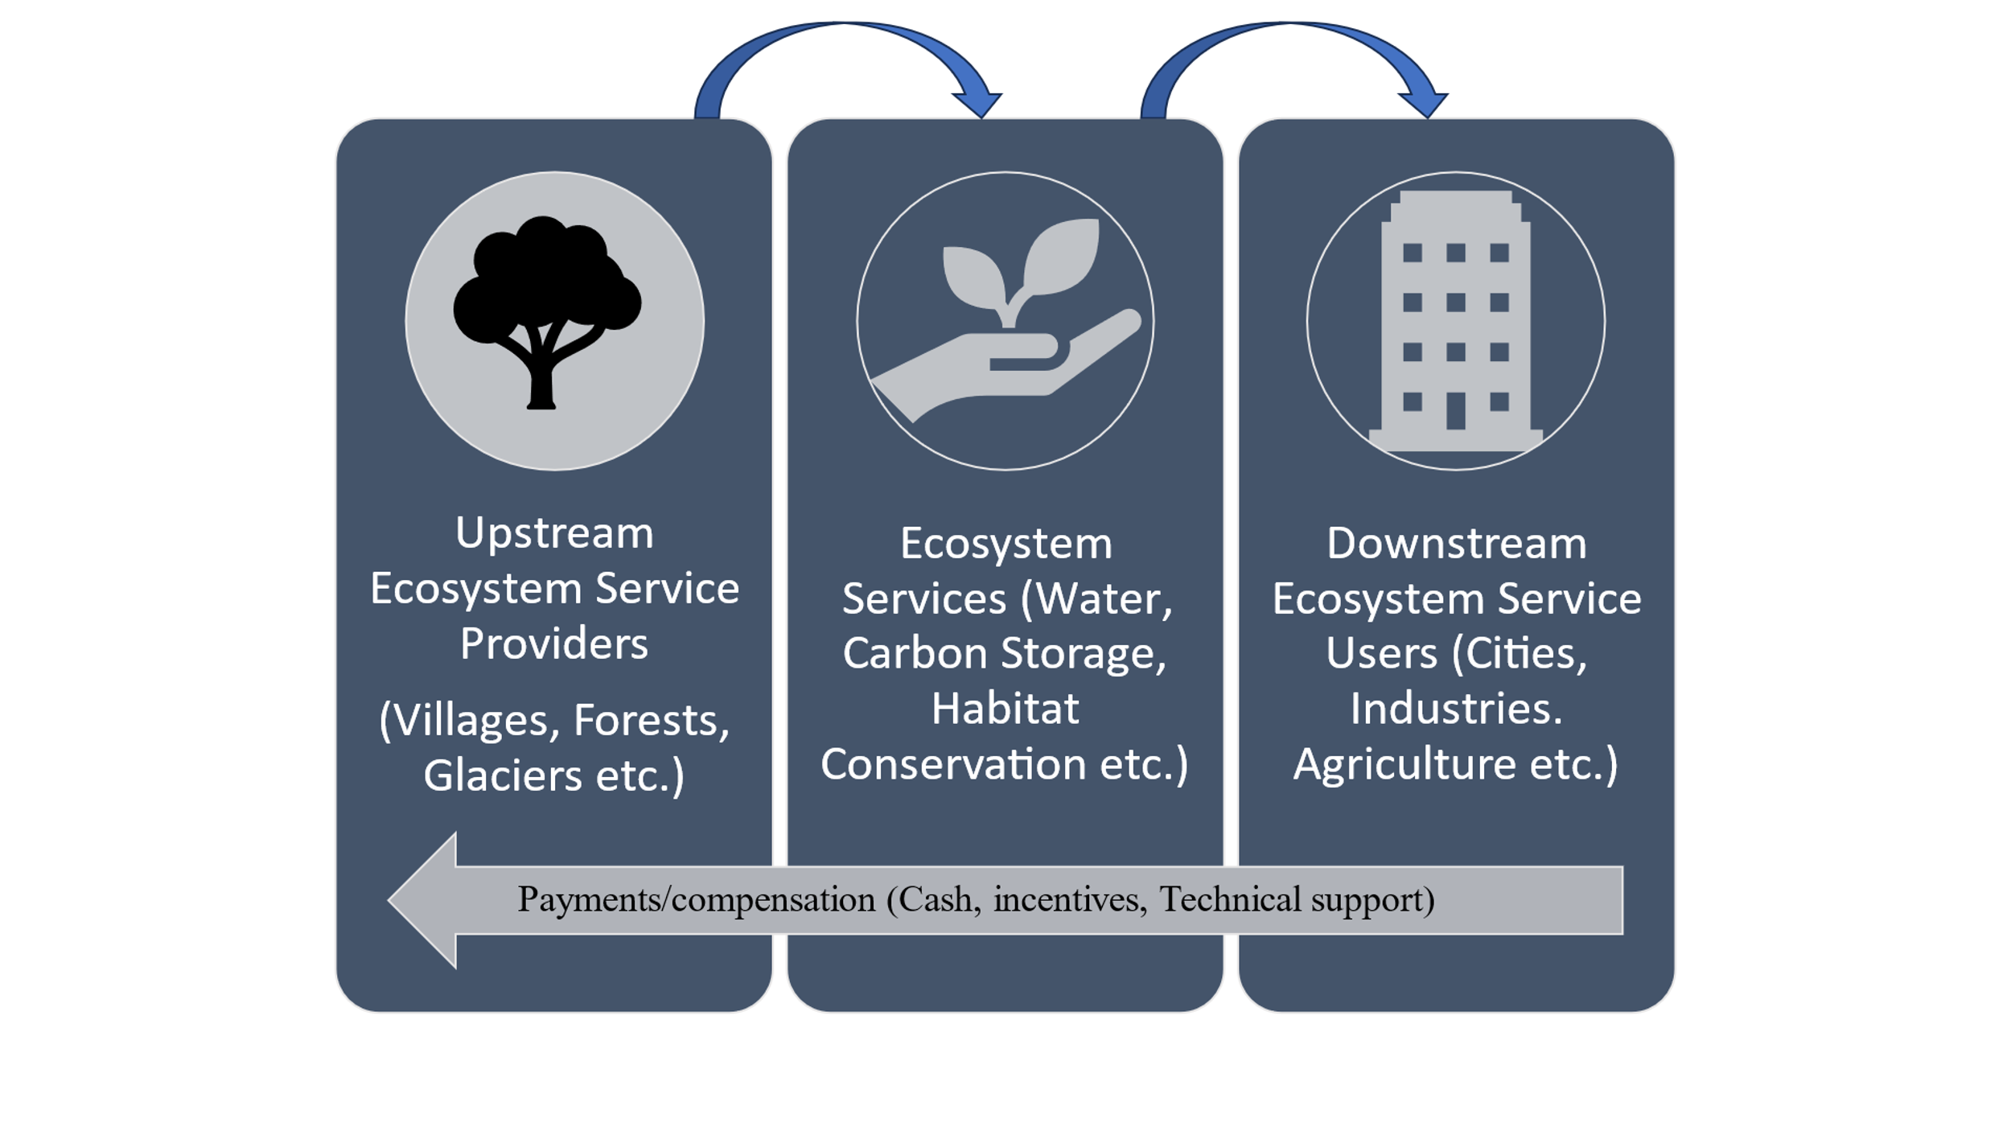

Figure 2: Payment system in ecosystem valuation.

**Ecosystem Services Valuation Database (ESVD), Global synthesis:**

In order to measure the contribution of natural capital to human well-being and to guide decisions regarding its management and conservation, the economic value of ecosystem services has grown significantly over the last ten years. This evolution is reflected in the ESVD, which now has over 9,400 value estimates from over 1,300 studies, with roughly ten times as many standardized ES values as in 2012. These data are drawn from more than 2,000 study sites across more than 140 countries, providing global coverage. The largest publicly available database of ecosystem service values is currently the ESVD. The highest total values for the various biomes come from urban and industrial areas (64,167 Int$/ha/year), mangroves (77,928 Int$/ha/year), and coral reefs (87,211 Int$/ha/year). The distribution of value estimates by continent shows that **Europe** accounts for the largest proportion of value estimates (32 %), followed by Asia (24 %) Africa (16 %), North America (15 %), South America (8 %) and [Oceania](https://www.sciencedirect.com/topics/earth-and-planetary-sciences/oceania) (5 %), figure 3, (Brander *et al*., 2024).. The marine biome, which includes coral reefs, has the most value estimates (21%), followed by the intensive land use biome (16%) and the coastal systems biome, which includes mangroves (15%), according to the distribution of value estimates across biomes, figure, 4, (Brander *et al*., 2024).

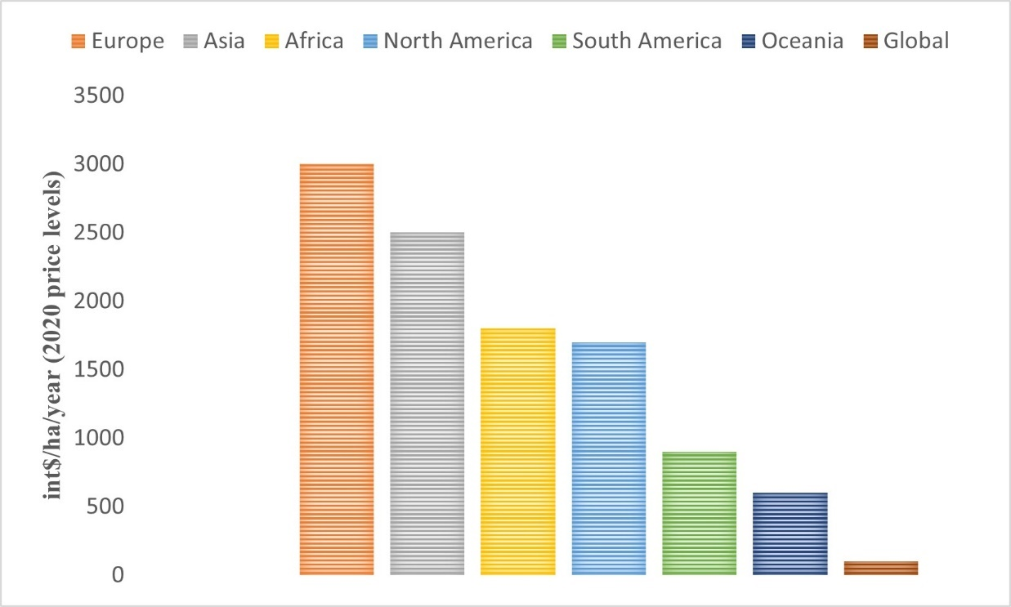

Figure 3: Number of value estimates in the ESVD by continent.

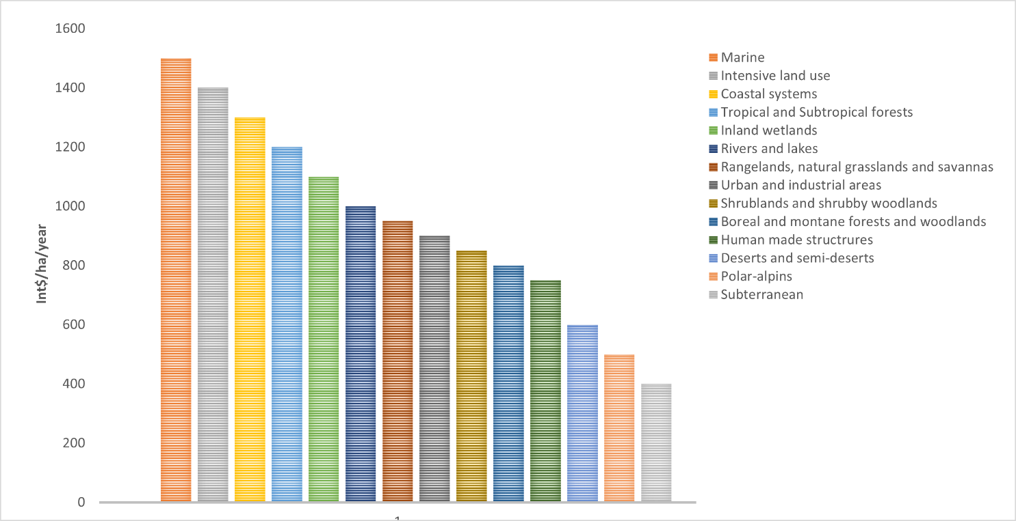

Figure 4: Number of value estimates in the ESVD by biome.

**Case studies-India:**

**1. Ecosystem Services Provided by the Ashtamudi Wetland Region:**

Wetlands offer vital services like food production, habitat provision, water quality maintenance, and protection from flooding and wave action. Kerala state's second-largest wetland ecosystem, Ashtamudi, offers a wide range of ecosystem services (ES). The economic worth and present condition of 11 significant ES that this wetland provides have been examined in this study. The production of fish, clams, shrimp and prawn larvae, inland navigation, coir, carbon sequestration and erosion prevention by mangroves, flood protection, cooling effect, tourism, and future use-value are among the services taken into consideration. Taking into account the aforementioned services, the wetland's total economic value is 424 million US dollars (in terms of the 2017 International $ value), and each 100 square meters of the wetland generates about 820 US dollars in economic output annually (Joy and Pual, 2021).

**Economic valuation of Dal Lake Srinagar, Kashmir, India:**

In the center of Srinagar city, Dal Lake continues to be a popular tourist destination. Dal Lake was therefore selected for the study due to its scenic beauty as well as the various ecological and economic services it provides, serving as a source of income (livelihood) for the communities. According to TCM and CVM calculations, the floating gardens of Dal Lake are generating an enormous sum of money (Rs 16,18,66,000). According to the survey, 68% of respondents were willing to pay (WTP) for better services and Dal Lake restoration (mean value: Rs 62,852.20). In order to find a long-term solution for the sustainable conservation of Dal Lake, monitoring and assessment were conducted to determine how the lake contributes to the state economy through its various services and the main tourist attraction in addition to the potential causes of the decline in water quality (Parry *et al*., 2024).

**Carbon metrics:**

**1. Carbon budget**

The term "carbon budget" refers to a concept used in climate policy to help set emissions reduction targets in a fair and effective way. It looks at the "maximum amount of cumulative net global anthropogenic carbon dioxide (CO2) emissions that would result in limiting global warming to a given level." It can be expressed relative to the pre-industrial period (the year 1750). In this case, it is the total carbon budget. Or it can be expressed from a recent specified date onwards. In that case it is the remaining carbon budget (IPCC, 2021).

An emissions budget, quota, or allowable emissions is another name for a carbon budget that will prevent global warming from rising above a predetermined temperature threshold (Meinshausen *et al*., 2009; Mathews *et al.,* 2018; Raupach *et al*., 2014). Limiting sea level rise is another goal of such an emissions budget, in addition to limiting the increase in global temperatures. National emissions budgets are a further subset of global carbon budgets. This can assist nations in establishing their own emission targets. A finite amount of carbon dioxide can be released over time before causing dangerously high levels of global warming, according to emissions budgets. The source of these emissions and, to a large extent, the timing of these emissions have no bearing on the change in global temperature (Zickfeld *et al.*, 2012). Publication of a yearly carbon budget fulfills two main roles. Firstly, it satisfies the demand for up-to-date knowledge of the anthropogenic disturbances of the climate system and their drivers. Many groups of users of the related datasets, such as researchers, policy makers, industry leaders, journalists, and non-governmental organizations, rely on them for guiding their work in climate change mitigation and adaptation. Secondly, over the past few decades, there have been tremendous changes in human activities and the functioning of the natural world, such as the unpredictability of the fossil fuel emissions, the influence of the COVID-19 pandemic, global temperature rise, and carbon sink variations. All these require periodic assessments of the global carbon cycle, improved attribution of its drivers, and predictive skill in its future development. Bringing science up-to-date with the urgent needs of climate mitigation calls for datasets and associated methodologies that are generated regularly and are characterized by robustness, transparency, traceability, and reproducibility (Friedlingstein *et al*., 2024)

**Recent and currently remaining carbon budget**

The Global Carbon Project, the Mercator Research Institute on Global Commons and Climate Change (MCC), and the CONSTRAIN project are among the organizations that offer yearly updates on the remaining carbon budget. Before the "Global Carbon Budget 2021" preprint was formally published in March 2022, scientists reported using data from Carbon Monitor (CM) that global CO2 emissions had sharply rebounded by 4.8% in 2021 following record-level declines in 2020 due to the COVID-19 pandemic. This suggests that, if current trends continue, the carbon budget for a ⅔ likelihood of keeping warming to 1.5 °C would be depleted in 9.5 years (Liu *et al*., 2022).

A team of scientists revised the carbon budget in October 2023, taking into account the CO2 emissions from 2020–2022, as well as new research on the impact of fewer polluting particles in the atmosphere (Lam Boll *et al*., 2023). They discovered that, starting in January 2023, we can emit 250 Gt CO2, or six years of emissions at current levels, to have a 50% chance of staying below 1.5 degrees; to achieve this goal, humanity will need to have zero CO2 emissions by 2034; to have a 50% chance of staying below 2 degrees, we can emit 1220 GtCO2, or 30 years of emissions at current levels (McGrath, 2023; Borenstein, 2023). The Global Carbon Project, 2024 suggests that the Global CO2 emission rates must decline after 2024 to limit the global temperature increase to 1.5, 1.7, or 2.0 degrees Celsius without relying on net-negative emissions, Figure 5.

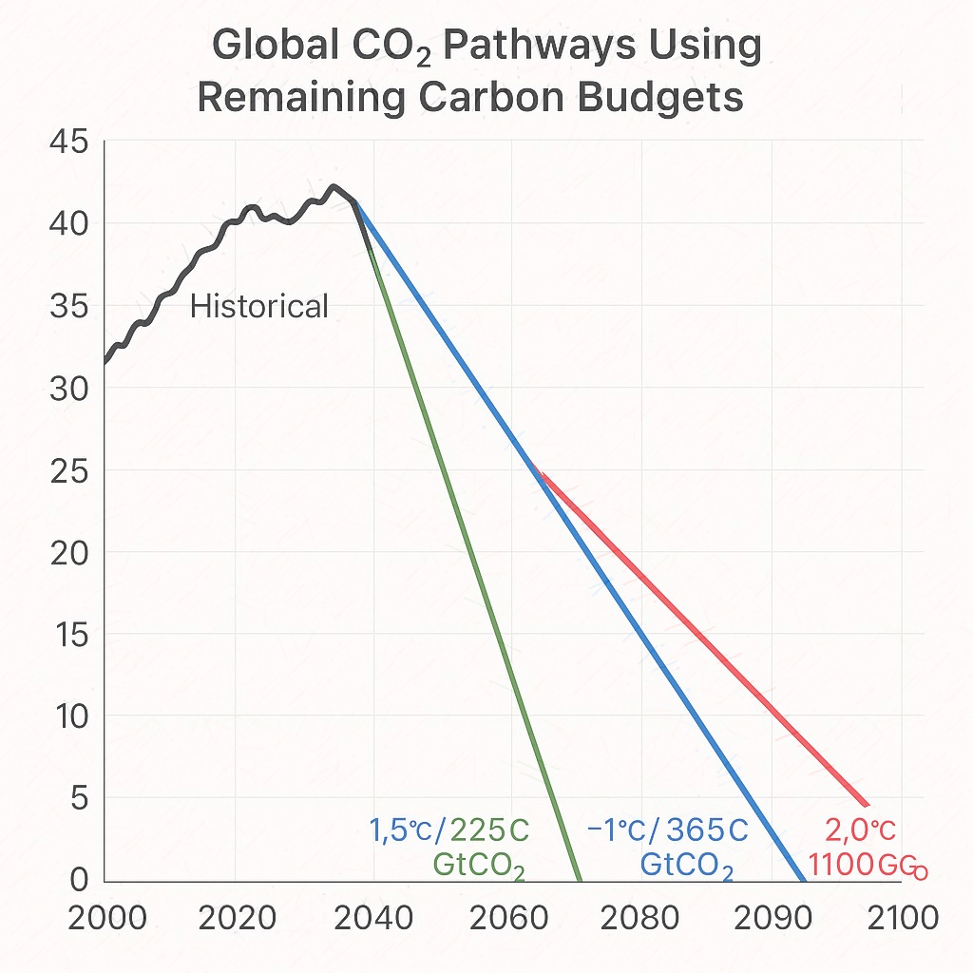

Figure 5: Global Carbon Project, 2024.

Researchers use estimates of the following to determine the size of remaining carbon budgets:

* The amount of warming that has already occurred as a result of human activity;
* The amount of warming per cumulative unit of CO2 emissions (also referred to as the transient climate response to cumulative emissions of carbon dioxide, or TCRE);
* The amount of warming that may still occur after all CO2 emissions are stopped (also known as the zero emissions commitment);
* And the impact of Earth system feedbacks that would not otherwise be considered.

Estimation of the remaining carbon budget at the global level depends on climate science and value judgments or choices, while translating global carbon budgets to the national level requires further value judgments and choices, Figure 6 (Alex *et al*., 2019).

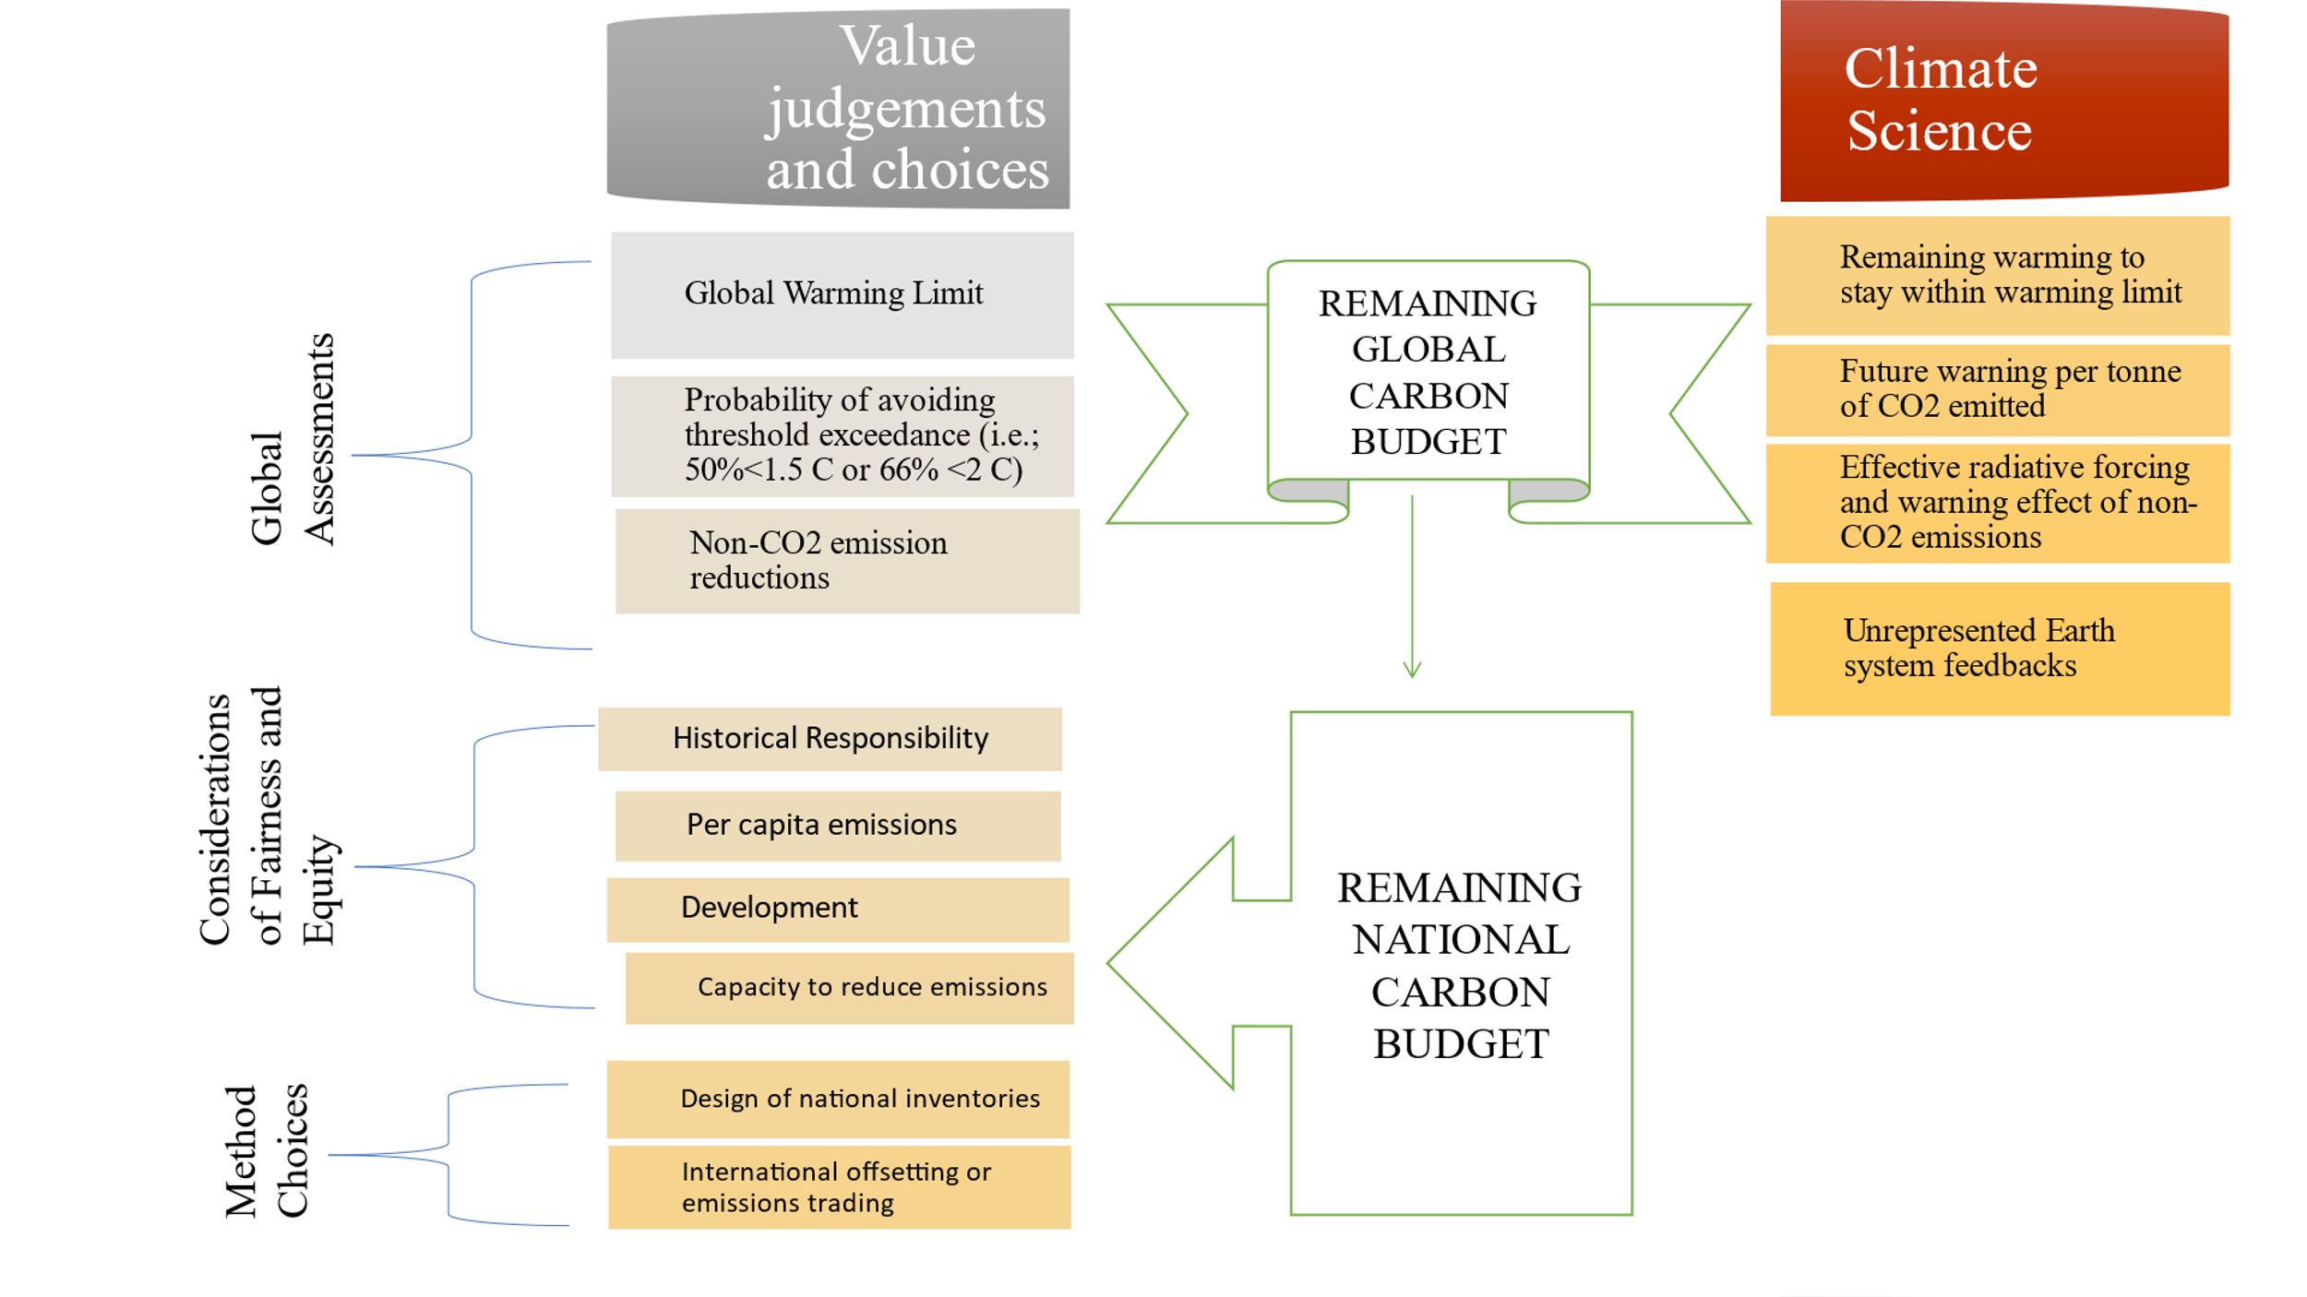

Figure 6:This diagram illustrates how estimating the carbon budget at the global level depends on climate science and value judgments, whereas translating global carbon budgets to the national level involves further value judgments.

**Ways to stay within one's carbon budget:**

The idea of mitigating climate change explains the actions that can be taken to stay within one's carbon budget.

* Reducing the amount of greenhouse gases in the atmosphere that contribute to climate change is known as climate change mitigation, or decarbonization. Energy conservation and switching to clean energy sources from fossil fuels are two ways to mitigate climate change. Removing carbon dioxide (CO2) from the atmosphere and altering land use are examples of secondary mitigation techniques. According to Ritchie *et al*. (2020), current climate change mitigation measures are insufficient because they would still cause global warming of roughly 2.7 °C by 2100, which is much higher than the 2015 Paris Agreement's target of keeping global warming to less than 2 °C (Fiona, 2019; UN Report, 2019).
* Some processes, like air travel and cement production, are more challenging to decarbonize; solar and wind energy can replace fossil fuels at the lowest cost when compared to other renewable energy options. In these situations, carbon capture and storage (CCS) may be able to lower net emissions; however, using CCS technology in fossil fuel power plants is currently an expensive method of mitigating climate change.
* Approximately one-fourth of climate change is caused by changes in human land use, such as deforestation and agriculture. Reducing food waste, adopting a more plant-based diet (also known as a low-carbon diet), and enhancing farming practices can all help reduce emissions from agriculture.
* Climate change mitigation can be promoted by a number of policies. Either a carbon price system that taxes CO2 emissions or a system that caps total emissions and trades emission credits has been established. Clean energy subsidies and incentives for installing energy-saving devices or moving to electric power sources could replace fossil fuel subsidies. Overcoming environmental concerns when building new clean energy sources and altering the grid is another problem.

**2. Carbon credits:**

When an organization takes part in a carbon offsetting scheme, it receives carbon credits, also termed as offset credits, that symbolize quantified net climate gains realized by one party on account of, and for the benefit of, some other party. The credits, once endorsed by a government agency or an accredited third-party organization, are tradable on regulated and voluntary carbon markets. Carbon credits, also called carbon offsets, are a market-based instrument for reducing greenhouse gas (GHG) emissions. They allow persons to offset their own emissions by financing measures that measurably reduce, avoid, or remove emissions somewhere else. One carbon credit equals one certified reduction, avoidance, or removal of one metric tonne of carbon dioxide or an equivalent in other greenhouse gases (CO₂e).

In accordance with the Paris Agreement, we must cut current greenhouse gas emissions in half by 2030 and reach "net zero" by 2050 in order to keep global warming to 1.5°C. However, there are certain activities that cannot be carbon-free. They therefore choose carbon credit schemes. Companies can make up for their environmental impact and, in the most ambitious cases, use carbon credits to achieve carbon-neutral status by paying someone else to either reduce their emissions or capture their carbon. The fundamental idea is straightforward. If one party is unable to stop emitting CO2, it can request that another reduce their emissions so that the overall amount of carbon in the atmosphere is decreased even as the first party continues to produce CO2.

**Carbon credits are categorized into three core categories based on their underlying mechanisms:**

* **Avoided emissions**, meaning credits that are created through the prevention of the emission of greenhouse gases that would have otherwise taken place—such as when carbon-dense ecosystems like rainforests are conserved;
* **Lowered emissions**, usually resulting from the application of energy-saving measures or production optimizations that reduce the total emission of greenhouse gases;
* **Removed emissions**, which include the active removal of carbon dioxide from the atmosphere through technology like carbon capture and storage (CCS) or through nature-based solutions such as afforestation and reforestation.

Carbon credit mechanisms offer a platform whereby carbon credits are earned by project developers through voluntary emission reduction activities such as the conservation of forests and the implementation of renewable energy technology. The mechanisms are established and operated by a range of institutions, such as international institutions like the Clean Development Mechanism (CDM) and Joint Implementation (JI) of the Kyoto Protocol, state and sub-state governmental programs like California’s Compliance Offset Program, and independent nongovernmental institutions like Verra and the Gold Standard Foundation (Probst *et al*., 2024)

**Markets in carbon credit-system:**

**Compliance Market**: Government policy has a significant influence on compliance carbon credit prices. The maximum emission limits, also referred to as allowances or credits, will be determined by government strategy. Government rules are implemented in this regard to encourage businesses to lower their emissions. California and Europe have some of the most active compliance markets.

**Voluntary Markets**: Generally unregulated, voluntary carbon markets (VCM) are where businesses, people, and organizations—who are not legally required to reduce emissions—trade carbon offsets. Carbon offsets are used by businesses and individuals in voluntary carbon markets to reach their own emission reduction targets. Credits are issued under independent crediting standards (Axel *et al*., 2019).

**Schemes and regulations:**

68 carbon pricing programs were either planned or already in existence worldwide as of 2022 (World Bank, 2022). CORSIA, Article 6 of the Paris Agreement, and the Clean Development Mechanism are examples of international initiatives. ETS systems like the California Cap and Trade Program and the European Union Emissions Trading System (EU-ETS) are examples of national programs. Credits issued by independent or international crediting systems may be eligible for credit under these programs. Additionally, independent, non-governmental organizations like Verra and Gold Standard oversee standards and crediting systems.

**Conclusion:**Together, carbon budgeting, carbon crediting, and ecosystem valuation highlight how important natural systems are to reducing climate change and promoting sustainable development. We can measure and control carbon stocks and flows, guaranteeing their sustainable use, by giving ecosystem services an economic value and implementing carbon budgeting frameworks. The carbon crediting mechanism aligns economic interests with environmental stewardship by providing additional incentives for conservation and restoration efforts. These resources highlight the connection between biodiversity conservation and climate resilience by offering a road map for incorporating ecological sustainability into economics, policy, and international climate action.

**Disclaimer (Artificial intelligence)**

Option 1:

Author(s) hereby declare that NO generative AI technologies such as Large Language Models (ChatGPT, COPILOT, etc) and text-to-image generators have been used during writing or editing of manuscripts.

Option 2:

Author(s) hereby declare that generative AI technologies such as Large Language Models, etc have been used during writing or editing of manuscripts. This explanation will include the name, version, model, and source of the generative AI technology and as well as all input prompts provided to the generative AI technology

Details of the AI usage are given below:

1.

2.

3.

**COMPETING INTERESTS DISCLAIMER:**

Authors have declared that they have no known competing financial interests OR non-financial interests OR personal relationships that could have appeared to influence the work reported in this paper.

**ETHICAL ISSUES**: Not Applicable

**References:**

"Integrated Valuation of Environmental Services and Tradeoffs (InVEST)". coast.noaa.gov. Retrieved 2018.

"The Economics of Ecosystems and Biodiversity (TEEB) For Water and Wetlands". February 2013.

Borenstein, S. (2023, October 30). Earth will lock in 1.5°C of warming by 2029 at current rate of burning fossil fuels. *Times*. Retrieved November 1, 2023.

Constanza, R. (1997, May 15). The value of the world's ecosystem services and natural capital. *Nature*, 387(6630), 253–260. https://doi.org/10.1038/387253a0

Cut Global Emissions by 7.6 Percent Every Year for Next Decade to Meet 1.5°C Paris Target – UN Report". United Nations Framework Convention on Climate Change. United Nations. Retrieved 27 November 2019.

De Groot, R., Brander, L., Van Der Ploeg, S., Costanza, R., Bernard, F., Braat, L., ... & Van Beukering, P. (2012). Global estimates of the value of ecosystems and their services in monetary units. *Ecosystem Services*, 1(1), 50–61.

Friedlingstein, P. *et al.* Global carbon budget 2024.  *Earth Syst. Sci*. *Data* <https://doi.org/10.5194/essd-2024-519> (2024).

Global Carbon Project (2024-11-03). ["Global CO2 pathways using Remaining Carbon Budgets"](https://robbieandrew.github.io/GCB2024/). *Figures from the Global Carbon Budget 2024*. Exeter, UK: University of Exeter. Retrieved 2025-04-03.

Harvey, Fiona (26 November 2019). "UN calls for push to cut greenhouse gas levels to avoid climate chaos". The Guardian. Retrieved 27 November 2019.

Holzman, D. C. (2012). Accounting for nature's benefits: The dollar value of ecosystem services. *Environmental Health Perspectives*, 120(4), A157.

IPCC. (2021). Annex VII: Glossary. In J. B. R. Matthews, V. Möller, R. van Diemen, J. S. Fuglestvedt, V. Masson-Delmotte, C. Méndez, ... & B. Zhou (Eds.), Climate Change 2021: The Physical Science Basis. Contribution of Working Group I to the Sixth Assessment Report of the Intergovernmental Panel on Climate Change. Cambridge University Press, pp. 2215–2256.

Joy, N. M., & Paul, S. K. (2021). Analysis of the economic value and status of the ecosystem services provided by the Ashtamudi wetland region, a Ramsar site in Kerala. *Journal of the Indian Society of Remote Sensing*, 49, 897–912.

L.M. Brander, R. de Groot, J.P. Schägner, V. Guisado-Goñi, V. van 't Hoff, S. Solomonides, A. McVittie, F. Eppink, M. Sposato, L. Do, A. Ghermandi, M. Sinclair, R. Thomas, Economic values for ecosystem services: A global synthesis and way forward, Ecosystem Services, Volume 66,2024, 101606,

Lamboll, R. D., Nicholls, Z. R. J., Smith, C. J., Kikstra, J. S., Byers, E., & Rogelj, J. (2023, December). Assessing the size and uncertainty of remaining carbon budgets. Nature Climate Change, 13(12), 1360–1367. https://doi.org/10.1038/s

Liu, Z., Deng, Z., Davis, S. J., Giron, C., & Ciais, P. (2022). Monitoring global carbon emissions in 2021. Nature Reviews Earth & Environment, 3(4), 217–219.

Matthews, H. D., Zickfeld, K., Knutti, R., & Allen, M. R. (2018, January 1). Focus on cumulative emissions, global carbon budgets and the implications for climate mitigation targets. *Environmental Research Letters*, 13(1), article 010201.

McGrath, M. (2023, October 31). Carbon emissions threaten 1.5°C climate threshold sooner than thought - report. Nature Climate Change, BBC. Retrieved November 1, 2023.

Meinshausen, M., Meinshausen, N., Hare, W., Raper, S. C. B., Frieler, K., Knutti, R., ... & Allen, M. R. (2009). Greenhouse-gas emission targets for limiting global warming to 2 °C. *Nature*, 458(7242), 1158–1162. https://doi.org/10.1038/nature

Michaelowa, A., Shishlov, I., Hoch, S., & Bofill, P. (2019). Overview and comparison of existing carbon crediting schemes (PDF). Nordic Initiative for Cooperative Approaches (NICA) and Perspectives Climate Group GmbH. Retrieved December 20, 2022.

Nauels, Alex; Rosen, Debbie; Mauritsen, Thorsten; Maycock, Amanda; McKenna, Christine; Roegli, Joeri; Schleussner, Carl-Friedrich; Smith, Ela; Smith, Chris; Forster, Piers (2019). ["ZERO IN ON the remaining carbon budget and decadal warming rates. The CONSTRAIN Project Annual Report 2019"](http://eprints.whiterose.ac.uk/154082/). University of Leeds. [doi](https://en.wikipedia.org/wiki/Doi_(identifier)):[10.5518/100/20](https://doi.org/10.5518%2F100%2F20)..

Probst, B.S., Toetzke, M., Kontoleon, A. *et al.* (2024). Systematic assessment of the achieved emission reductions of carbon crediting projects. *Nat Commun* **15**, 9562.

Raupach, Michael R.; Davis, Steven J.; Peters, Glen P.; Andrew, Robbie M.; Canadell, Josep G.; Ciais, Philippe; Friedlingstein, Pierre; Jotzo, Frank; van Vuuren, Detlef P.; Le Quéré, Corinne (21 September 2014). "Sharing a quota on cumulative carbon emissions". Nature Climate Change. 4 (10): 873–879. Bibcode:2014NatCC...4..873R. doi:10.1038/nclimate2384. hdl:11250/2484054.

[Ritchie, Hannah](https://en.wikipedia.org/wiki/Hannah_Ritchie); [Roser, Max](https://en.wikipedia.org/wiki/Max_Roser); Rosado, Pablo (11 May 2020). ["CO2 and Greenhouse Gas Emissions"](https://ourworldindata.org/co2-and-other-greenhouse-gas-emissions#future-emissions). Our World in Data. Retrieved 27 August 202

Sánchez-Azofeifa, G. Arturo; Pfaff, Alexander; Robalino, Juan Andres; Boomhower, Judson P. (October 2007). "Costa Rica's payment for environmental services program: intention, implementation, and impact" (PDF). Conservation Biology. 21 (5): 1165–1173. doi:10.1111/j.1523-1739.2007.00751.x. hdl:10161/6955. ISSN 1523-1739. PMID 17883482. S2CID 17567114.

Siraj Yousuf Parray, Simranjeet Singh, Bhupendra Koul, Nadeem A. Khan, Praveen C. Ramamurthy, Joginder Singh, Economic valuation and characterization of heavy metal contamination in Dal Lake Srinagar, Kashmir, India, Heliyon,Volume 10, Issue 14, 2024.

[State and Trends of Carbon Pricing 2022](https://openknowledge.worldbank.org/entities/publication/a1abead2-de91-5992-bb7a-73d8aaaf767f). World Bank. 2022. [doi](https://en.wikipedia.org/wiki/Doi_(identifier)):[10.1596/978-1-4648-1895-0](https://doi.org/10.1596%2F978-1-4648-1895-0) (inactive 1 November 2024). [hdl](https://en.wikipedia.org/wiki/Hdl_(identifier)):[10986/37455](https://hdl.handle.net/10986%2F37455). [ISBN](https://en.wikipedia.org/wiki/ISBN_(identifier)) [9781464818950](https://en.wikipedia.org/wiki/Special:BookSources/9781464818950). Retrieved 24 March 2023.

 Tacconi, L (2012). "Redefining payments for environmental services". Ecological Economics. **73** (1): 29–36

Zickfeld, K.; Arora, V. K.; Gillett, N. P. (March 2012). "Is the climate response to CO emissions path dependent?". Geophysical Research Letters. 39 (5): n/a. Bibcode:2012GeoRL..39.5703Z. doi:10.1029/2011gl050205.