**Resilience, Mitigation and Adaptation Strategies to Combat Climate Change for a Sustainable Future**

**Abstract**

*This review delves into climate change resilience and brings forth climate change mitigation strategies and adaptation mechanisms for a sustainable future. Climate change is an unprecedented major global threat. It is an unavoidable phenomenon attributed largely to increased atmospheric carbon dioxide (CO2) produced by burning fossil fuels. When atmospheric CO2 and other greenhouse gases (**GHGs)levels are higher than the permissible level, it causes the Greenhouse effect and, consequently, rising temperatures, the world experiences heat waves.* *Cutting GHG emissions can slow the pace of global warming - this is known as mitigation. Climate change mitigation and adaptation strategies can impact genotoxicity by reducing exposure to genotoxic agents like air pollutants and UV radiation. Wildfires occur uncontrollably, generating particulate matter (PMs) that easily penetrate deep inside the lungs. Burning fossil fuels can pile up PMs, and smoke causes serious air pollution that harms human health and threatens organisms. Escalate vector-borne diseases since warmer climate favours insects’ arthropods (mosquitoes, mites, ticks) reproducing profusely. The reported spread of waterborne illnesses (dermatitis, conjunctivitis, ENT) infections. Extreme climatic conditions include floods due to melting glaciers, low-lying coastal areas/islands submerged under the sea, draughts, and hurricanes. Habitat destruction of vulnerable ecosystems can cause biodiversity loss, species extinction, and the destruction of agricultural crops (food insecurity). Earth can become a hostile place to live. Mitigation can be achieved by reducing emissions, stabilizing the levels of heat-trapping GHGs in the atmosphere, and adapting to climate change. The goal of mitigation is to avoid significant human interference with Earth's climate, “stabilize greenhouse gas levels in a timeframe sufficient to allow ecosystems to adapt naturally to climate change, ensure that food production is not threatened, and to enable economic development to proceed sustainably”.*

**Keywords**: Climate change, Greenhouse gases, Particulate matter, Resilience, Mitigation, Adaptation, Sustainable Future

1. **Introduction:**

“Climate change is the long-term global changes in the Earth’s average temperatures and shifts in climate patterns mainly caused by greenhouse gas emissions from natural systems and human activities” (**United Nations; Samer Fawzy et al. 2020**). “Greenhouse gases include water vapor, CO2, methane, nitrous oxide (N2O) and other gases. Carbon dioxide (CO2) and other greenhouse gases turn like a blanket, gripping Infrared radiation and preventing it from escaping into outer space. The clear effect of greenhouse gases is the stable heating of the Earth's atmosphere and surface, thus causing global warming” (Kweku et al. 2018; Hasan et al. 2024). “A consumption-based carbon emissions study based on the C40 Cities’ product life-cycle calculations found that 79 cities had consumption-based carbon emissions of 3.5 billion tons, while the production-based carbon emissions were only 2.2 billion tons” (C40 Cities Climate Leadership Group). “Natural systems include changes in sun activity, wild forest fires, earthquakes, oceans, permafrost, wetlands, mud volcanoes, and large volcanic eruptions” (**Yue and Gao 2018**). “Human activities are primarily due to burning fossil fuels like coal, oil, and gas, related to energy production, industrial activities, forestry, land use, and land-use change” (**UN; Edenhofer et al. 2014**). “Greenhouse gas emissions by the earth’s natural system are self-balancing. However, man-made or anthropogenic activities add extra pressure to the earth's system and have been the major driver for climate change since the 1800s” (**UN; Yue and Gao 2018**). “Population explosion causes deforestation and urbanization, an increased number of industrial establishments, buildings, and more vehicles, emitting tonnes of GHGs such as water vapour (H2O), carbon dioxide (CO2), methane (CH4), nitrous oxide (N2O), and ozone (O3), Chlorofluorocarbons (CFCs), Hydrofluorocarbons (HFCs). Moreover, air pollution and wildfires cause the release of suspended particulate matter, which can be inhaled and accumulate deep inside the human lungs, causing respiratory problems and diseases like chronic respiratory allergies such as asthma, sensitization to aero and food allergens and the development of eczema and hay fever, allergic rhinoconjunctivitis and sinusitis characterized by repeated sneezing and autoimmune” (**Devi, SH 2025**). The way waste is disposed of often adds to these harmful emissions. Even food waste creates another greenhouse gas called methane when it rots.

“Climate change is now a major global crisis and a threat that the world faces today that needs to be dealt with immediately. Climate scientists have measured the Earth’s climate directly for over 100 years by monitoring temperature and rainfall. They also use evidence in the Earth’s rock layers, fossil record, and ice cores to study its climate back into geological history, 100,000s years ago” (**WWF**). “Climate change (sometimes called global warming) is heating our planet up. Earth’s temperature has already warmed by an average of 1°C in the last 100 years and GHG emission continues, it could increase by a lot more. Global warming causes harmful impacts such as the melting of Arctic Sea ice, more severe weather events like heatwaves, floods, and hurricanes, rising sea levels, the spread of disease, and the acidification of the ocean and lake (affecting fish sustainable production), flash floods, droughts, food and water insecurity” (**Devi, SH 2025**; **WWF**). “At an alarming rate, climate change is melting polar and sea ice caps. If this trend continues, it’s predicted that in 2040, there could be ice-free summers in the North and South Poles Arctic regions” (**WWF**). A new study has warned that climate change could drive ocean waves to reach monstrous heights, growing by 5-8 per cent by 2100. This could lead to widespread coastal (New York) flooding and island erosion (**Down To Earth**). “Scientists project that hurricane-associated storm intensity and rainfall rates will increase as the climate continues to warm. Moreover, as the sea level continues to rise, the severity of storm surges will escalate, exacerbating flooding caused by heavy rainfall and leading to heightened damage” (**NASA**). “The current global pandemic and war in Europe have been held responsible for the energy, inflation, and food crises. These greenhouse gases absorb heat from the sun and radiate it back to Earth. The higher concentrations of greenhouse gases piled up in the earth’s atmosphere, the warmer our planet gets, changing the Earth’s climate and affecting every part of the globe. Global temperatures will likely surge to record levels in the next five years, fuelled by heat-trapping greenhouse gases and a naturally occurring El Niño weather pattern” (**UN News**). “NASA scientists have observed Earth’s surface is warming, and many of the warmest years on record have happened in the past 20 years. 16 of the 17 warmest years on record have occurred since 2001. Extreme and unpredictable weather is becoming more common, and our sea ice is decreasing at a rate of 13% per decade 5” (**World Bank Blogs**). This change impacts the planet Earth's environment surrounding our rivers, lakes, oceans, trees, plants, and animals vulnerable to ecosystems due to habitat destruction and biodiversity loss, low species diversity, and many species on the verge of extinction.

In Manipur, North-East India, excessive forest area destruction, deforestation and firing, and mass poppy plantation cause the impact of climate change, causing changes in annual precipitation patterns, water insecurity and even unusual drying rivers, heat waves, and reduced winter season. “Increased frequencies of mutations and related genetic alterations in the gene pools of individual species or populations in ecosystems have to be judged against the background of spontaneous mutations that have enabled species to survive and adapt to changing environments since the beginning of life on our planet” (**Wurgler FE, et al., 1992**). “The potential for developing synergy between climate change mitigation and adaptation has become a recent focus of climate research and policy. There are also increasing calls for research to define the optimal mix of mitigation and adaptation” (VijayaVenkataRaman et al. 2012; Wang et al. 2023). Climate change mitigation and adaptation strategies can also impact genotoxicity by reducing exposure to genotoxic agents like air pollutants and UV radiation. Additionally, genotoxicology studies are essential for assessing the potential risks associated with various climate-related adaptations and interventions. A comprehensive approach to addressing climate change and genotoxicity is crucial for protecting human and environmental health in a changing world (**Anas Ghawanmeh**). “Scientists estimate that 1 in 6 species are now at risk of extinction due to climate change, and it’s thought that extreme weather and rising sea levels will displace millions of people worldwide” (**Carbon Brief**). “Climate change is a powerful determinant of present and future health for all human populations and other living organisms” (**Costello, A. et al., 2009; Smith, K.R. et al., 2014**). However, “climate change is irreversible over the next hundreds to thousands of years according to the Intergovernmental Panel on Climate Change (IPCC) — the United Nations body established to assess the science related to climate change, inequitable and, without substantial corrective action, will exacerbate existing health inequities between and within countries” (**Friel, S. et al., 2008; World Health Organization, Geneva 2014**). “Over two million deaths, displaced, and $4.3 trillion in economic losses are the impact of a half-century of extreme weather events turbo-charged by man-made global warming” (**WMO**). According to the Global Risks Report 2023 released by the World Economic Forum (WEF) on January 12, 2023, ‘Natural disasters and extreme weather events’ are the second-most severe risk, generating heavy metals, its exposure can adversely affect neurological impairments, and both cognitive difficulties and executive dysfunction as well as behavioural disorders (**Ankita Bhushan et.al 2025**). “Over the next 10 years or by 2033, the interconnections between biodiversity loss, pollution, natural resource consumption, climate change, and socioeconomic drivers will make for a dangerous mix, alerted WEF in its flagship annual report. Failure to mitigate climate change as well as ‘failure of climate change adaptation’ are the two most severe risks facing the world in the next decade, followed by ‘natural disasters and extreme weather events’ and ‘Biodiversity loss and ecosystem collapse’ severe drought and associated food insecurity, flooding, rains, and disease outbreaks, malnutrition, heat stress, and respiratory diseases” (**NRDC**).

“Growing evidence confirms that current mitigation efforts and future emissions commitments are not sufficient to achieve the temperature goals set by the Paris Agreement” (**Nieto et al., 2018; Lawrence et al., 2018**). “Climate resilience in the context of agriculture can be defined as the capacity for agricultural systems to absorb, adapt, and recover from climate-related shocks and stresses in a way that ensures food security and supports livelihoods while maintaining ecosystem services” (C M, R. et al. 2024; Gitz & Meybeck, 2012). “This concept extends beyond the mere survival of such impacts; it involves making informed decisions that enable agricultural communities to anticipate, prepare for, respond to, and recover from detrimental climate events” (Wilson, 2012). To achieve climate goals for sustainable development to combat climate change challenges (3C), further measures and new abatement routes must be explored, and resilience, implementation of new mitigation policies, and adaptation measures should be adopted worldwide at once.

1. **Climate change resilience steps that need to be built:**

Climate change resilience can be built by engaging three agencies: government, communities, and businesses, combining disaster risk reduction and management, including emergency preparedness. UN Climate Action has proposed six important steps that different sectors need to take in developing climate resilience:

1. **Awareness-raising and advocacy** – Be clear that the future will not resemble the past; base this on science and examine different scenarios (e.g., 1.5 degrees and higher) and their impacts.

2. **Conduct climate risk assessments** at national, local (city/region), sectoral, or organizational levels and use a systems approach.

3. **Develop and implement appropriate actions** and interventions.

4. **Mobilize resources** – Build capacity and scale up actions.

5. **Monitor and track progress**.

6. **Share knowledge**, experiences, and solutions (**UN climate change**).

1. **Climate change mitigation strategies:**

“Cutting GHG emissions can slow the pace of global warming - this is known as mitigation. The daily level of CO2 in the atmosphere in 2013 [surpassed 400 parts per million for the first time in human history](http://climate.nasa.gov/climate_resource_center/7). The last time levels were that high was about three to five million years ago, during the Pliocene Epoch. Accelerating the individuals’ lifestyle transformation is an attractive option to mitigate climate change. Most countries now realize the potential of demand-side mitigation, which requires support from the supply side (embedded in institutional actions) and supply networks with related constraints. AI-based behavior learning may generate unique, personalized, and better mitigation strategies tailored to individuals to contribute to overall mitigation” (**Nature Climate Change** 2024). “In the Working Group III Report of the IPCC Sixth Assessment Report, demand-side mitigation is included with a focus on equity” (Creutzig, F. et al. in Climate Change 2022).

According to Global Climate Change by NASA, to some extent, humans are already committed to some level of climate change; responding to climate change involves a two-pronged approach:

1. Reducing emissions of and stabilizing the levels of heat-trapping greenhouse gases in the atmosphere **(“mitigation”)**;
2. Adapting to climate change is already in the pipeline **(“adaptation”)**.

The IPCC says greenhouse gas emissions must peak by 2025 and then rapidly decline if further warming is to be limited. Mitigation – reducing climate change – involves reducing the flow of heat-trapping greenhouse gases into the atmosphere, either by reducing sources of these gases (for example, the burning of fossil fuels for electricity, heat, or transport) or enhancing the “sinks” that accumulate and store these gases (such as the oceans, forests, and soil). The goal of mitigation is to avoid significant human interference with Earth's climate, “stabilize greenhouse gas levels in a timeframe sufficient to allow ecosystems to adapt naturally to climate change, ensure that food production is not threatened, and to enable economic development to proceed sustainably” (from the 2014 report on Mitigation of Climate Change from the United Nations Intergovernmental Panel on Climate Change, page 4).

“The following strategies can achieve mitigation” by reducing the amount of carbon pollution:

1. Greenhouse gas emissions and concentrations (stock of GHG emissions in the atmosphere ‘ppm’)
2. Greenhouse gas reductions:

-Intensity and absolute targets

3. Carbon capture and storage

4. Carbon sequestration and

5. Geo-engineering

Earth systems and human systems are very closely interwoven, any change that happens in the Earth’s systems may directly or indirectly affect the human system as explained by the below picture.

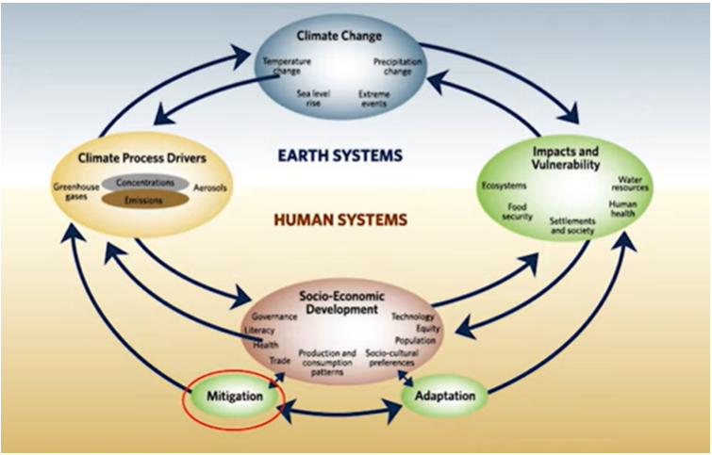

**FIG 1.** Correlation between Earth System and Human System

1. **Greenhouse gas emissions and concentrations (stock of GHG emissions in the atmosphere ‘ppm’)**

As per the IPCC Fifth Assessment Report, the change in GHG concentrations between 1750 and 2011 is

CO2 278 ppm 390.5 ppm (+40%)

CH4 722 ppb 1803 ppb (+150%)

N2O 271 ppb 324.2 ppb (+20%).

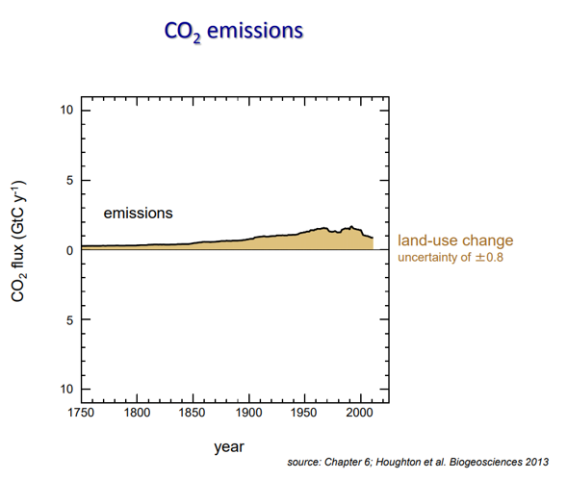

FIG 2. **The change in** CO2 **emissions between 1750 and 2011**

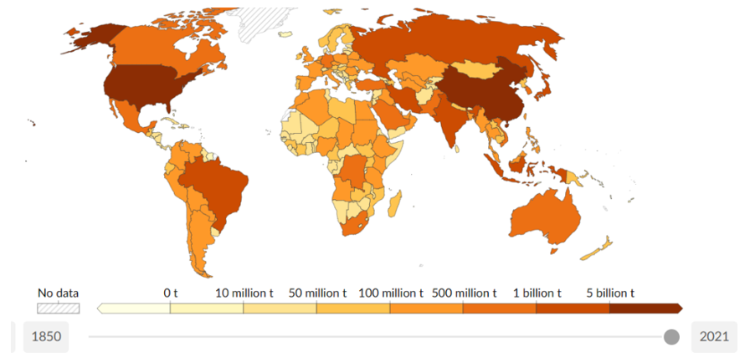

*source:* ***Our World in Data***

**FIG 3. Greenhouse gas emissions across the globe**

1. **Greenhouse gas reductions:**

**-Intensity and absolute targets**

Intensity-based greenhouse gas reduction targets= a goal to reduce the total amount of GHGs produced per unit, i.e., gross domestic product.

Absolute greenhouse gas reduction targets = a goal to reduce the total amount of emissions produced regardless of any other factor, such as a growing population or a growing economy.

1. **Carbon capture and storage:**

The approach to mitigate climate change that involves:

- Capturing GHG emissions at large point sources (i.e., fossil fuel-based power plants)

- Injecting those emissions back into empty geological formations

- Usually refers to non-biological storage of carbon approach.

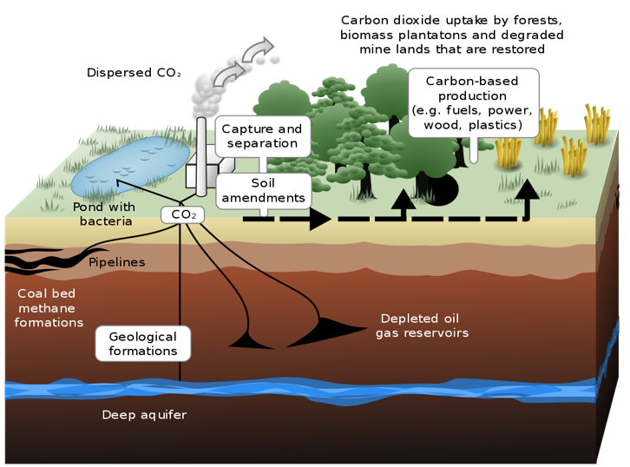

*sourse: Wikipedia*

***FIG 4.* Carbon capture and storage**

1. **Carbon sequestration**

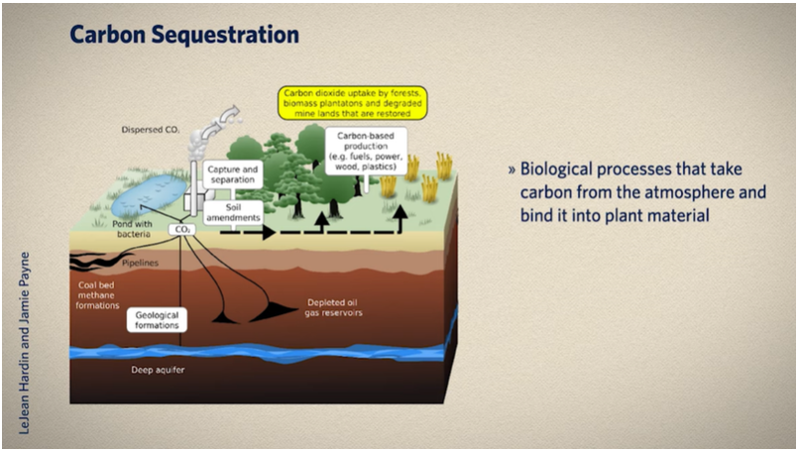

**FIG 5. Carbon sequestration**

“Biomass-forest age connections estimate carbon sequestration potential in larger-scale study areas, such as national and provincial scales, and incorporate stand age in the present stand growth model framework to reduce estimation bias” (**Zhang C. et al., 2018**). “The biomass-forest age relationship has become a frequently utilized method for predicting future forest carbon pools and estimating forest biomass carbon stocks.The carbon sequestration potential of natural forests is significantly higher than planted forests. The carbon stock of natural forests is about 2.31 times higher than that of planted forests in 2019, increasing to 3.15 by 2070. The annual carbon sinks in planted forests will peak between 2025 and 2026, while that of natural forests will peak between 2031 and 2032. The growth rate of carbon density in natural forests is also consistently higher than that in planted forests, reaching the same level between 2035 and 2036. By 2070, the carbon density of natural forests will reach 80.03 t/ha, higher than planted forests at 69.99 t/ha, indicating that natural forests can provide a more effective carbon sequestration function” (**He G et al., 2022**).

1. **Geo-engineering**

Geoengineering, often known as climate engineering, includes techniques like managing solar radiation and fertilizing oceanic iron.

Proposals deliberately manipulate the Earth’s climate to counteract or halt the effects of climate change intentionally, e.g., adding fertilizer to the ocean increases the growth of Algae, which in turn uptake more carbon from the atmosphere and act as carbon sinks.

**Some of the climate change mitigation policies include:**

i). Carbon Tax/ Carbon Pricing

-A tax is placed on each unit of greenhouse gases emitted

-Can target individuals, companies, communities

ii). Global and multilateral mitigation policy

-The Kyoto Protocol was adopted in 1997 (United Nations Framework Convention on Climate Change)

-Entered into force in 2005

-The average GHG reduction was 5% below 1990 levels.

**CARBON FOOTPRINT CALCULATOR:**

Our carbon footprint measures the total amount of greenhouse gases released into the atmosphere due to our daily actions. It’s measured in the tonnes of carbon we produce each year. Each person’s carbon footprint depends on their actions that impact the planet. It includes the amount of electricity they use and where this comes from, how much they travel, what they eat, where they go on holiday, how much stuff they buy, and how much they throw away. This activity uses the WWF carbon footprint calculator (https://footprint.wwf.org.uk) to determine how different lifestyles can impact the planet.



FIG 6. Carbon footprint measurement

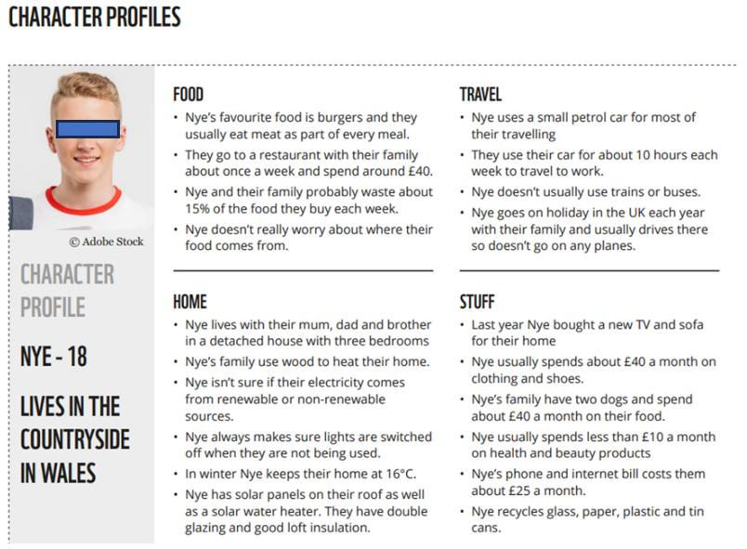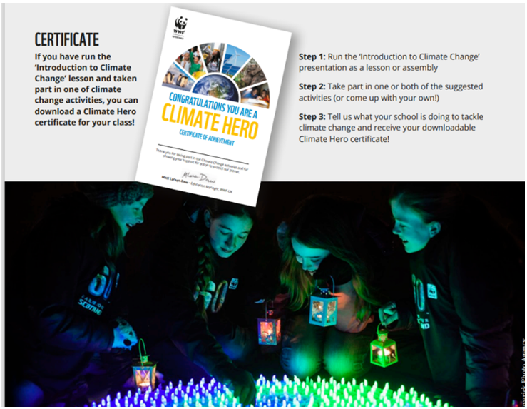

FIG 7. Encouraging people by providing certificates based on Carbon footprint profile

We can encourage school and college students, and young minds youths to contribute towards achieving climate goals as Climate Heros.

**The topic of climate change should be included in the curriculum, such as**

**•** Biodiversity, habitats, hot and cold climates, animal adaptations, rainforests, polar regions, oceans, nature and habitats

• Renewable and non-renewable energy, natural resources

• Recycling and waste, reducing water use, reducing energy use, carbon footprints, plastic pollution

• Weather and climate, water cycle, coastal erosion, natural hazards (flooding, extreme weather, forest fires)

• Sustainable development goals, food, and farming, urbanization, transport, and population.

"The magnitude and rate of climate change and associated risks depend strongly on near-term mitigation and adaptation actions, and projected adverse impacts and related losses and damages escalate with every increment of global warming."- Intergovernmental Panel on Climate Change. ‘Biodiversity loss and ecosystem collapse’ has not been perceived to be of concern over the short term. It has been ranked as the fourth most severe risk in the long term or over the next ten years (by 2033). The Kunming-Montreal Global Biodiversity Framework (GBF) adopted at the 15th Conference of Parties (COP15) to the UN Convention on Biological Diversity (CBD) is thus a significant breakthrough as far as global action on biodiversity is concerned. Public- and private-sector resources will likely reduce the speed and scale of climate change mitigation short-term efforts over the next two years. The European Union spent at least 50 billion euros on new and expanded fossil-fuel infrastructure and supplies. Some countries including Austria, Italy, the Netherlands, and France restarted coal power stations. Climate change affects all individuals, but it will hit the poorest people and the least developed countries on our planet the worst. This means that those who did the least to cause climate change are the ones who will suffer most from its effects here comes the importance of Climate justice.

The 2018 climate change report had many recommendations for governments around the world:

-Stop burning fossil fuels by the middle of this century.

-Plant more trees.

-Protect forests.

-Work out how to block the Sun's rays.

-Develop machines to suck carbon out of the air.

These could help limit the most serious effects of climate change and stop global temperatures from rising above 1.5 degrees.

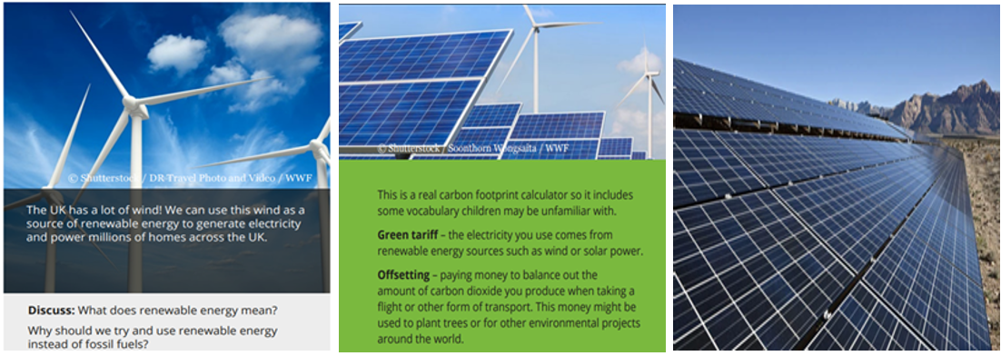

FIG 8. Use of solar energy to manage carbon footprint

**Indian Context of Mitigation:**

Prime Minister Narendra Modi announced the establishment of a National Hydrogen Mission. India has co-founded the International Solar Alliance (ISA) with France and, in doing so, is leading the global movement towards solar power, with a focus on promoting energy access and transition. India’s pledge to reach net-zero emissions by 2070 was one of the most important announcements at COP26. The federal government recently approved India’s Updated Nationally Determined Contribution (NDC), which aligns with the prime minister's statement. A 6% carbon capture and reuse decarbonization could reduce 126 million tons of CO2, equal to 17GW of coal-fired capacity decarbonization in India by 2030.

* Transfer Pricing and International Economics Consulting Expert with over nine years of experience in international economic policies can significantly contribute to combating climate change and aiding countries in achieving their climate-related aspirations.
* Green bonds are a powerful tool for financing projects promoting environmental sustainability, including renewable energy infrastructure and energy-efficient buildings. Attracting investments for vital climate change mitigation projects.
* Carbon pricing is instrumental in internalizing the cost of carbon emissions. It can be achieved through carbon taxes or cap-and-trade systems.
* Carbon footprint reduction and investment in cleaner technologies, thereby advancing climate change mitigation efforts and aligning with countries' climate goals.

Technological advancements are pivotal for climate change mitigation, but disparities in access to sustainable technologies persist, which can be overcome by capacity-building programs, research collaborations, and adopting climate-friendly solutions. Sustainable trade policies are key to reducing carbon emissions associated with international trade. International economic cooperation can provide crucial financial support through mechanisms like the Green Climate Fund and offer grants and concessional loans. Collaboration on research and development initiatives accelerates innovation in critical areas such as renewable energy and climate adaptation strategies.

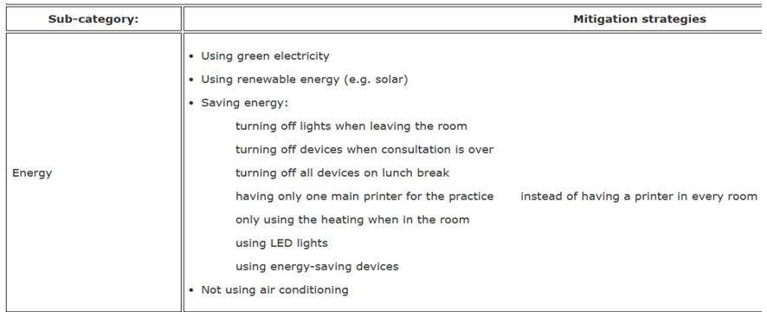

FIG 9. **Energy management**

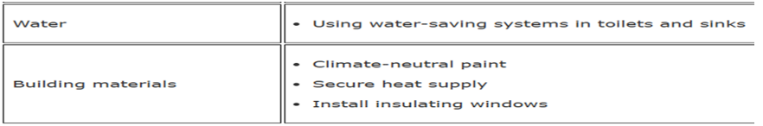

FIG 10. **Water and building materials management**

1. **Need for adaptation:**

Because of the pollution that has already been released into the atmosphere over many years, reducing emissions is “no longer enough” to stave off the effects of climate change. As a result, many communities are working to adapt to the expected consequences of rising temperatures. For the first time, the 2015 Paris Climate Agreement included a global adaptation goal, and now, many countries, states, and cities are developing climate adaptation plans.

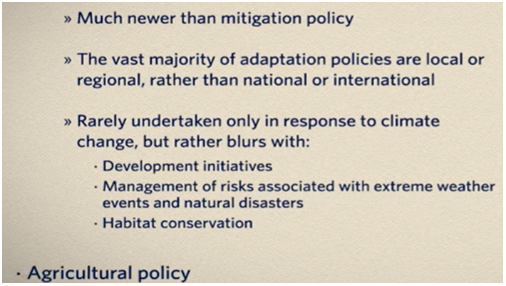

**FIG 11. Agricultural policy**

The IPCC says adaptation to climate change means “adjusting our behaviour (e.g., where we choose to live; the way we plan our cities and settlements) and adapting our infrastructure (e.g., the greening of urban areas for water storage)”. “Adaptation could include building roads and bridges that can withstand higher temperatures and more powerful storms, reinforcing coastal defence systems, switching to drought-resistant crops, and regenerative agriculture” (**Bera R et al., 2025**).

**1. Prepare for longer, more intense fire seasons**

Drier, warmer conditions spell more wildfire for the West. Communities adapt to this reality in several ways, such as California's town putting goats to work to clear brush. The Mendocino County Youth Project is helping kids adapt to the aftermath of fires, offering a small support group for young wildfire survivors to help them heal.

**2. Rise to the challenge of sea-level rise**

Scientists expect the global sea level will rise between eight inches and 6.6 feet by 2100, threatening low-lying coastal areas. So, Miami Beach is “Rising Above” the challenge, putting millions of dollars into installing massive drain pipes and pumps, raising roads, and strengthening sea walls. Meanwhile, in Georgia, volunteers are helping keep the Tybee Island 4H center above water by creating a “living shoreline” made of oyster shells to provide a buffer against storm surges and erosion.

**3. Ensure disaster and public health plans account for more severe weather**

Intense storms and extreme heat can have dire impacts on public health. So many communities are working to update infrastructure, real estate, and community planning strategies. The Red Cross, for example, is using climate science to prepare for disasters and to better supply vulnerable communities with food, water, and medical supplies. Cedar Rapids, Iowa, is building a levee and flood wall system and elevating bridges to defend against future flooding. Meanwhile, because temperature extremes can lead to various health problems, cities like Emeryville, California, coordinate cooling centers and work with unions to protect manual labourers during extreme weather.

**4. Protect farms and the food supply from climate impacts**

Temperature swings, prolonged drought, extreme storms, and other climate impacts threaten long-standing farming practices. So, farmers and agricultural experts are digging up other approaches, from investing in irrigation systems that help address drought to developing new crop varieties that may be better adapted to changing conditions. For example, at Dickinson College Farm in Pennsylvania, farmers are growing native trees in cattle pastures, a practice called silvopasture. As the climate warms, the shade of trees can help protect the animals from heat.

**5. Protect air quality**

Climate change can lead to more tiny particles and allergens in the air, harming the respiratory and cardiovascular systems. So many communities are working to clean up the air. For example, Phoenix High School students have convinced their school board to purchase its first electric bus. The bus emits zero tailpipe emissions, a small but important step toward cleaning up air pollution.

**6. Prioritize climate justice**

Climate impacts often exacerbate existing inequities because lower-income and other marginalized people are often disproportionately affected by extreme weather, worsened air pollution, and other climate impacts. Indigenous communities and others who live close to the land are also among the hardest hit by climate change. Prioritizing adaptation efforts that explicitly help vulnerable populations will contribute to a more equitable future, according to the Fourth National Climate Assessment. For example, in Harlem, one nonprofit advocates affordable in-home air conditioning for low-income seniors who cannot get to a cooling center during a heat wave.

**7. Prepare for managed retreat**

Sometimes, people can’t go home again, whether to a neighbourhood lost in a fire or threatened by rising sea levels. The result is the new notion of “managed retreat” – giving up on adapting to climate impacts in some places. Some have already made this choice, like the Biloxi-Chitimacha-Choctaw tribe, whose low-lying island home has lost 98% of its land. Tribal leaders are leading a relocation to a larger settlement on higher ground.

**United Nations Climate Change Conference COP27**

Climate change adaptation involves adjusting our behaviour, and building improved infrastructure to better cope with changing weather patterns. Raising more finance to help developing countries cope with climate impacts, such as more frequent extreme weather events, will be one of the main goals of the upcoming COP27 summit in Egypt.

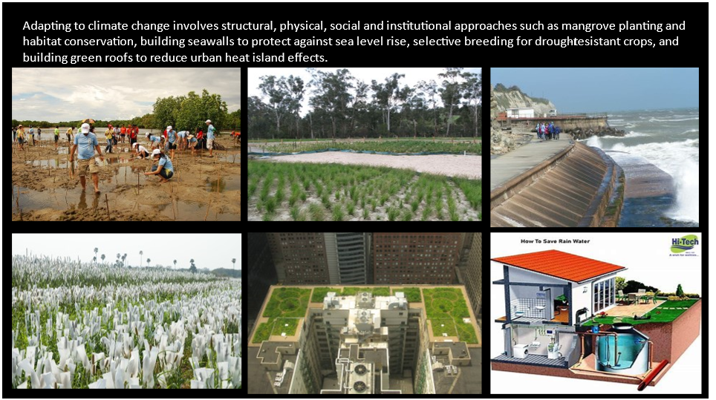

*FIG 12. Rainwater harvesting*

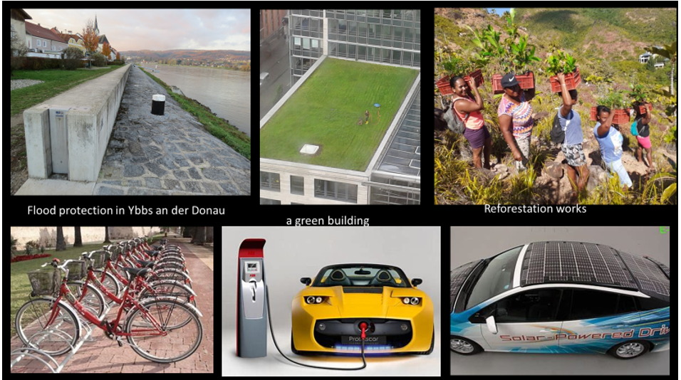

FIG 13. Climate change adaptation

Flood protection by constructing walls, green buildings for absorbing heat waves, afforestation and reforestation of bare lands by planting bamboo, grassland ecosystems converting jhum cultivation area to forest, using bicycles, smart cities using renewable sources of energy solar-powered electric vehicles, solar-driven cars, etc.

*Climate change adaptation could look like this. Image: IPCC*

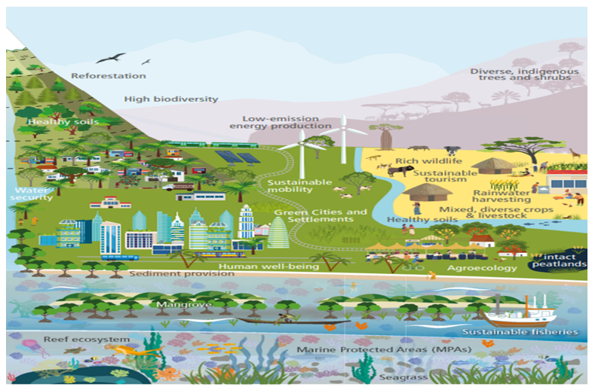

FIG 14. Ways of *Climate Change Adaptation*

**Conclusion**

Climate experts agree that although it’s too late to avoid some negative consequences of a warming climate, it’s not too late to avoid the most severe impacts. Reducing the severity of climate warming will make it easier for communities to adapt, so adaptation and mitigation must go hand in hand to become resilient. CoP28 was held in UAE at Dubai Expo City from November 30 to December 12, 2023, with the main goal of increasing ambition, implementing existing goals, and strengthening commitments to tackle the climate crisis. Immediate action by establishing important mitigating and adaptation strategies to climate change. We can only achieve a sustainable development future and maintain a stable climate of clean Mother Earth through a holistic approach with adaptive infrastructure development and adequate action plans from individuals, NGOs, academia, and policymakers.

**DISCLAIMER (ARTIFICIAL INTELLIGENCE)**

Author(s) hereby declare that NO generative AI technologies such as Large Language Models (ChatGPT, COPILOT, etc.) and text-to-image generators have been used during the writing or editing of this manuscript.

**References:**

1. Fawzy, S., Osman, A.I., Doran, J. et al. Strategies for mitigation of climate change: a review. Environ Chem Lett 18, 2069–2094 (2020). <https://doi.org/10.1007/s10311-020-01059-w>
2. Yue X-L, Gao Q-X (2018) Contributions of natural systems and human activity to greenhouse gas emissions. Adv Clim Change Res 9:243–252. <https://doi.org/10.1016/j.accre.2018.12.003>
3. Edenhofer ORP-M, Sokona Y, Kadner S, Minx JC, Brunner S, Agrawala S, Baiocchi G, Bashmakov IA, Blanco G, Broome J, Bruckner T, Bustamante M, Clarke L, Conte Grand M, Creutzig F, Cruz-Núñez X, Dhakal S, Dubash NK, Eickemeier P, Farahani E, Fischedick M, Fleurbaey M, Gerlagh R, GómezEcheverri L, Gupta S, Harnisch J, Jiang K, Jotzo F, Kartha S, Klasen S, Kolstad C, Krey V, Kunreuther H, Lucon O, Masera O, Mulugetta Y, Norgaard RB, Patt A, Ravindranath NH, Riahi K, Roy J, Sagar A, Schaefer R, Schlömer S, Seto KC, Seyboth K, Sims R, Smith P, Somanathan E, Stavins R, von Stechow C, Sterner T, Sugiyama T, Suh S, Ürge-Vorsatz D, Urama K, Venables A, Victor DG, Weber E, Zhou D, Zou J, Zwickel T (2014) Technical summary. In: Edenhofer O, Pichs-Madruga R, Sokona Y, Farahani E, Kadner S, Seyboth K, Adler A, Baum I, Brunner S, Eickemeier P, Kriemann B, Savolainen J, Schlömer S, von Stechow C, Zwickel T, Minx JC (eds) Climate change 2014: mitigation of climate change. Contribution of working group III to the ffth assessment report of the Intergovernmental Panel on Climate Change. Cambridge University Press, Cambridge, United Kingdom and New York, NY, USA. https:// www.ipcc.ch/site/assets/uploads/2018/02/ipcc_wg3_ar5_techn ical-summary.pdf. Accessed 17 Dec 2019
4. Devi SH. Human Immune Response and Tolerance Compensating for the Adverse Impacts of Climate Change on Human Respiratory Health and Autoimmunity. J Clin Immunol Microbiol. 2025; 6(1):1-2. <http://dx.doi.org/10.46889/JCIM.2025>
5. Devi SH. Potential Eco-Genotoxicological Effects of Nitrate Contamination from Chemical Fertilizers on the Aquatic Biota of Loktak Lake of Manipur and Human Health. Conservation of Biodiversity and Environmental Monitoring. Biotech Book, 2025, ISBN 978-81-7622-598-4. https://www.researchgate.net/publication/387980369
6. WWF (<https://www.wwf.org.uk/sites/default/files/2021-11/WWF_Clima>)
7. Down To Earth (<https://www.downtoearth.org.in/news/climate-change/threat-by-monster>)
8. NASA (<https://sealevel.nasa.gov/faq/17>)
9. UN News (<https://news.un.org/en/story/2023/05/1136732>)
10. Lei Zhu & Pengfei Liu. How demand-side mitigation can help shape effective climate policies. Nature Climate Change, 2024 Volume 14 | November 2024 | 1117–1118 | 1117. <https://doi.org/10.1038/s41558-024-02148-2>
11. Creutzig, F. et al. in Climate Change 2022: Mitigation of Climate Change (eds Shukla, P. R. et al.) Ch. 5 (Cambridge Univ. Press, 2022).
12. World Bank Blogs (<https://blogs.worldbank.org/opendata/chart->)
13. Wurgler FE, Kramers PG. Environmental effects of genotoxins (eco-genotoxicology). Mutagenesis. 1992 Sep; 7(5): 321-7. Doi: 10.1093/mutage/7.5.321. PMID: 1470026.
14. Carbon Brief (<https://www.carbonbrief.org/climate-change-threatens-one-in-six-species-with-extinction-study-finds/>)
15. Costello, A.; Abbas, M.; Allen, A.; Ball, S.; Bell, S.; Bellamy, R.; Friel, S.; Groce, N.; Johnson, A.; Kett, M.; et al. Managing the health effects of climate change: Lancet and University College London Institute for Global Health Commission. Lancet 2009, 373, 1693–1733. [CrossRef]
16. Smith, K.R.; Woodward, A.; Campbell-Lendrum, D.; Chadee, D.; Honda, Y.; Liu, Q.; Olwoch, J.M.; Revich, B.; Sauerborn, R. Human Health: Impacts, Adaptation, and Co-benefits. In Climate Change 2014: Impacts, Adaptation and Vulnerability. Contribution of Working Group II to the Fifth Assessment Report of the Intergovernmental Panel on Climate Change; Field, C.B., Barros, V.R., Dokken, D.J., Mach, K.J., Mastrandrea, M.D., Bilir, T.E., Chatterjee, M., Ebi, K.L., Estrada, Y.O., Genova, R.C., et al., Eds.; Cambridge University Press: Cambridge, UK; New York, NY, USA, 2014; pp. 709–754.
17. Friel, S.; Marmot, M.; McMichael, A.J.; Kjellstrom, T.; Vagero, D. Global health equity and climate stabilisation: A common agenda. Lancet 2008, 372, 1677–1683. [CrossRef]
18. World Health Organization. Quantitative Risk Assessment of the Effects of Climate Change on Selected Causes of Death, 2030s and 2050s; World Health Organization: Geneva, Switzerland, 2014.
19. WMO (World Meteorological Organization) said on Monday 22 May 2023.
20. Ankita Bhushan, Sanket Patel, Apurva Patel, Jyoti Judah, Rajesh K M, Salam Himika Devi. Exploring the Association Between Heavy Metal Exposure and Neurodevelopmental Disorders in Children. Afr. J. Biomed. Res. Vol. 28(2s) (February 2025); 1009-1016. DOI:https://doi.org/10.53555/AJBR.v28i2S.6994
21. NRDC (<https://www.nrdc.org/bio/joel-scata/failure-m>)
22. Nieto J et al (2018) Less than 2 °C? An economic-environmental evaluation of the Paris Agreement. Ecol Econ 146:69–84. https ://doi.org/10.1016/j.ecolecon.2017.10.007
23. Global climate change by NASA (https://climate.nasa.gov/solutions/adaptation-mitigation)
24. Lawrence MG et al (2018) Evaluating climate geoengineering proposals in the context of the Paris Agreement temperature goals. Nat Commun 9:3734. <https://doi.org/10.1038/s41467-018-05938-3>
25. United Nations Climate Change. CLIMATE ACTION PATHWAY Climate Resilience Executive Summary. Global climate action. [ExecSumm_Resilience.pdf](https://unfccc.int/sites/default/files/resource/ExecSumm_Resilience.pdf)
26. *Our World in Data* (<https://ourworldindata.org/greenhouse-gas-emissions>)
27. He G, Zhang Z, Zhu Q, Wang W, Peng W, Cai Y. Estimating Carbon Sequestration Potential of Forest and Its Influencing Factors at Fine Spatial-Scales: A Case Study of Lushan City in Southern China. Int J Environ Res Public Health. 2022 Jul 27;19(15):9184. doi: 10.3390/ijerph19159184. PMID: 35954542; PMCID: PMC9368071.
28. Zhang C., Ju W., Chen J., Fang M., Wu M., Chang X., Wang T., Wang X. Sustained Biomass Carbon Sequestration by China’s Forests from 2010 to 2050. Forests. 2018; 9:689. doi: 10.3390/f9110689. [CrossRef] [Google Scholar]
29. Bera R., Dey P., Bhattacharya P., Barik A.K., Narasimhan V.L. and Quah E. Climate Change, Regenerative Agriculture and Carbon Neutrality in the Context of Tea Cultivation. International Journal of Environment and Climate Change. Volume 15, Issue 4, Page 49-70, 2025; Article no. IJECC.133394ISSN:2581-8627. DOI: 10.9734/ijecc/2025/v15i44793
30. C M, R., Jadhav, A., K N, M., Bhat, P. P., R, R. P., K, A., & V, P. (2024). A Review on Adaptive Strategies for Climate Resilience in Agricultural Extension Services in India. Archives of Current Research International, 24(6), 140–150. <https://doi.org/10.9734/acri/2024/v24i6772>
31. Gitz, V., & Meybeck, A. (2012). Risks, vulnerabilities and resilience in a context of climate change. Building Resilience for Adaptation to Climate Change in the Agriculture Sector, 23, 19.
32. Wilson, G. A. (2012). Community resilience, globalization, and transitional pathways of decision-making. Geoforum, 43(6), 1218-1231.
33. Kweku, D. W., Bismark, O., Maxwell, A., Desmond, K. A., Danso, K. B., Oti-Mensah, E. A., Quachie, A. T., & Adormaa, B. B. (2018). Greenhouse Effect: Greenhouse Gases and Their Impact on Global Warming. Journal of Scientific Research and Reports, 17(6), 1–9
34. Hasan, M. M., Nobi, F. B., Khan, N. A., Toma, N. I., Islam, M. W., Ali, M. A., & Akram, S. (2024). Greenhouse Gas Emissions and Energy Consumption in the Garments, Textile, and Dyeing Sectors in Savar, Dhaka (2019-2021). Asian Journal of Environment & Ecology, 23(10), 88–95.
35. The Future of Urban Consumption in a 1.5 °C World (C40 Cities Climate Leadership Group, Arup & University of Leeds, 2019)
36. VijayaVenkataRaman, S., Iniyan, S., & Goic, R. (2012). A review of climate change, mitigation and adaptation. Renewable and Sustainable Energy Reviews, 16(1), 878-897.
37. Wang, F., Harindintwali, J. D., Wei, K., Shan, Y., Mi, Z., Costello, M. J., ... & Tiedje, J. M. (2023). Climate change: Strategies for mitigation and adaptation. The Innovation Geoscience, 1(1), 100015-1.