Seasonal distribution, bioavailability and ecological risk assessment of heavy metals in sediments from gold mining in the northern part of Côte d’Ivoire, West Africa

**Abstract**

This study aimed to evaluate the spatial and seasonal distribution, bioavailability and potential risk of metal in surface sediment from Korhogo and Tengrela gold mines in the Savanah District, one of the main mining areas of Côte d’Ivoire. Lead (Pb), cadmium (Cd), and mercury (Hg) concentrations in surface sediments collected were evaluated using inductive coupled plasma-optical emission spectrometer (ICP-OES). Bioavailability was evaluated according to the Community Bureau Reference (BCR) sequential extraction protocol and Risk assessment Code (RAC) was calculated to appreciate the potential risks. The results revealed that sediments from Korhogo and Tengrela were contaminated with Pb, Cd, and Hg. Except for Cd, seasonal variation indicated that metal concentrations decreased from dry season to rainy season. The extractable fractions showed that the largest metals were bound to the crystalline structure of the sediments with a quantitative percentage ranging from 56.1 to 85.9 %, indicating their low mobility. Regarding the potential mobility and availability of lead, cadmium, and mercury in sediments , the mean concentrations of the sum of the non-residual fractions varied from 1.087 to 20.917 µg.g-1, from 0.082 to 0.238 µg.g-1, and from 0.011 to 0.267 µg.g-1 for Pb, Cd and Hg, respectively Overall, the surface sediments are at a low to medium toxicity-risk level with RAC values lower than or equal to 15%, indicating that metals could not cause a threat to organisms in the sediments and to humans via consumption to crops irrigated with water around the Korhogo and Tengrela gold mine sites.

***Keywords:*** *Heavy metal, BCR-sequential extraction, Potential ecological risk, Mobility, Distribution, Gold mining*

1. INTRODUCTION

Over the past few decades, long-term impact of trace metals in the environment has been increasing owing to the growing mining activities in developing countries (Anyanwu et al. 2018, Kothapalli et al. 2021). Once metals are in the environment, they can become incorporated into the river ecosystem, particularly in sediments (Córdoba-Tovar et al. 2023, Proshad et al. 2022). Various studies have shown that trace metal concentrations in sediments can be sensitive indicators of the overall contamination of aquatic systems (Kubra et al. 2022).

Additionally, trace metals in aquatic sediments can either be retained or released back into the water column through various remobilization processes (Cheng et al. 2022, Li et al. 2019). However, they pose a serious threat to human health and living organisms, because of their toxicity, persistence, and bioaccumulation (Ali et al. 2019, Calabró et al. 2022). Mining is essential in many developing countries such as Côte d'Ivoire (Kouamé et al. 2019, N’Goran et al. 2022). It provides jobs for indigenous populations, particularly in rural communities where economic activities are extremely limited (Worlanyo et al. 2021). Both artisanal and industrial gold mining are growing in scale and importance in our country (Kinimo et al. 2018; Ahoussi et al. 2020; N’Goran et al. 2022). However, these mining activities have a negative impact on the environment, and the severity of this impact depends on the methods and technical skills of the miners (Agboola et al. 2020). Due to their accumulation and persistence in the environment, trace metals such as Pb, Cd, and Hg are highly toxic to human health (Bharti et al. 2022, Mishra et al., 2019). Thus, long-term exposure to these trace metals can lead to cancer and other illnesses (Kan et al 2021), mercury toxicity is the cause of Minamata disease, while cadmium poisoning is the cause of itai-itai disease (Mitra et al 2022). Moreover, (Hg, Cd, and Pb) can also cause toxicity in certain organs of the human body, such as lung and kidney damage, neurological disorders, infectious diseases, DNA damage, infertility lung cancer, kidney dysfunction, osteoporosis and heart failure (Alengebawy et al. 2021; Oyugi et al 2021; Basu et al 2023). It is assumed that the total concentration of metals in sediments does not always represent their capacity for mobilization and bioavailability, or their potential toxicity to living organisms and the environment (Zheng et al., 2020). Many populations around the world, including Côte d'Ivoire are exposed to transient of trace metals from gold mining activities (Sako et al., 2020). Consequently, evaluating the mobility of trace metals would allow us to estimate the risk to the surrounding population. Nonetheless, few studies have focused on aquatic sediments in the savannah region of northern Côte d'Ivoire (N'goran et al., 2022).

The savannah District is located in the northern part of the Côte d’Ivoire (West Africa). The district covers an area of 40,323 km2 with a population estimate to 2,159,434 inhabitants (RGPH, 2021). This region hosted some of the country’s major industrial gold mines such as Tongon and Sissingué sites, as well as several artisanal gold mining sites (N’Goran et al., 2022). From a geological point of view, the district is characterized by an Archean formation which is undergone under catazonal type of metamorphism. They consist of grey banded gneisses of tonalitic composition with intercalations of pinkish orthopyroxene granulites and charnockites (Kouamelan et al., 1997).

The objective of this study was to investigate the impact of gold mining activities on the distribution, mobility, and potential toxicity of Cd, Pb, and Hg in the surface sediments of the Bagoue River (Tengrela) and Bandama River (Korhogo), (Cd, Pb, and Hg) were assessed using the Risk Assessment Code (RAC).

2. material and methods

**2.1. Study Area**

The study area covered the Bandama and Bagoué rivers in the Savannah District of northern Côte d'Ivoire (Figure 1). The Bandama River is in the Korhogo region, while the Bagoué River is in the Tengrela part. The Bandama River is the largest river in Côte d'Ivoire, with its source in northern Côte d'Ivoire, between Korhogo and Boundiali (Sako et al., 2018; Traore et al., 2017; Girard et al., 1971). The Bagoué River is a small stream in northern Côte d'Ivoire. It rises in the Kokoum region, near the border between Côte d'Ivoire and Mali, passing through Tengrela (Côte d'Ivoire). In this study, two towns were selected in the Savannah District (Korhogo and Tengrela) to get an idea of the state of cadmium, mercury, and lead contamination in their environments. In northern Côte d’Ivoire, the geology is predominately made up of feral soils. These soils are derived from felsic or intermediate parent rocks (granite, gneiss, phyllite, and schist) of the underlying Precambrian rocks. The rocks are mainly composed of green schist of low metamorphic grade, bounded on either side by tectonized granitoid gneiss Terrans. The dominant lithological unit in the area consists of mafic rocks and dislocated clastic sediments, intercalated with volcano-sedimentary formations and intruded by a large body of granodiorite (Sako et al 2018, N’Goran et al 2022). The Savannah District is well known through activities such as livestock, cotton, cashew, and food activities, in addition to several industrial (Ran Gold (Korhogo) and Perseus Mining (Tengrela)), and artisanal and small-scale gold mining extractions (N’Goran et al., 2022). Various sampling stations were chosen based on site accessibility and their potential to reveal possible metal pollution in the environment. General sampling conditions (upstream, central, and downstream) were monitored to ensure representative site sampling. A total of 30 sampling stations were selected, including 20 for the M'bengue mining sites and 10 for the Tengrela mining sites, as shown in Figure 1. At Korhogo mining sites such as Badenou (R1 to R5), Tongon (M1 to M5), Taoura (K1 to K5), Bevogo (K6 to K10), five (05) sampling stations were selected, considering the mining activities (industrial or artisanal) carried out there. At Tengrela, during the period of our sample collection, industrial mining activities had not yet started. Consequently, all stations (T1 to T5) (Sissingue) and (T6 to T10) (Kanakono) are considered artisanal.

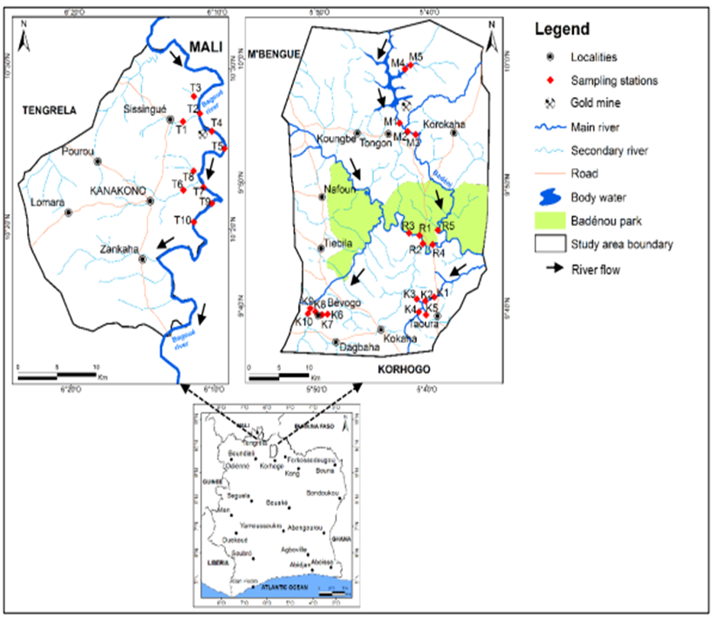

**Figure 1:** Location of the savanna district and sediments sampling sites. *Sissingue (T1, T2, T3, T4, T5); Kanakono (T6, T7, T8, T9, T10); Tongon (M1, M2, M3, M4, M5); Badenou (R1, R2, R3, R4, R5); Taoura (K1, K2, K3, K4, K5); Bevogo (K6, K7, K8, K9, K10)*

**2.2. Sediments characterization and heavy metal analysis**

The sampling campaigns took place in 2016 during the dry and rainy seasons. The collection of the sediment samples, digestion, and total metal concentration measurements have been described by N’Goran et al. (2022). A total of 5 samples surfaces of sediment (0-5 cm) were collected from each site (Figure 1). To take the local variability into account, each sample (300 g) was made of five subsamples collected using a Van Veen stainless steel grab (with an area of 0.02 m2) (N’goran et al., 2022, Saleem et al. 2015). Without emptying the grab, a sample was taken from the centre with a polyethylene spoon (acid washed) to avoid contamination by the metallic parts of the dredge. Samples were then put into ice bags and transported to the laboratory, stored in a deep-freeze unit before the drying procedure. Sediment samples were air-dried at room temperature, ground with an agate mortar to pass through a 63 µm sieve. And then, they were stored in polyethylene zip-type bags and shipped to Laboratoire de Chimie Organique Bioorganique Réactivité et Analyse (COBRA), Université de Rouen (France) for further analysis. All sampling devices were cleaned by rinsing with pure water and kept in 0.1 M HNO3 (68%, Fischer Scientific) for several days before sampling. Sediment samples were digested using a microwave-assisted digestion system (Milestone Ethos 1 microwave, Shelton, US), following Method 3051 A (N’goran et al., 2022). About 0.5 g of homogenized sediments was first left to react with a mixture of 3 mL 68% HNO3 and 9 mL 37% HCl (trace metal grade, Fisher Scientific) in loosely capped Teflon reactors for 30 min at room temperature, in a fume hood, to avoid an overpressure during the heating step (N’Goran et al 2022). Then, the digestion was performed under high power at programmed temperatures and time intervals: 0 to 10 min, 25 to 150°C; 10 to 15 min, 150°C; 15 to 20 min, 150 to 165 °C; 20 to 25 min, 165°C; 25 to 30 min, 180°C. After cooling, the solutions were diluted to 50 mL with ultrapure 2% HNO3 in Teflon tubes and centrifuged at 4000 rpm for 5 min prior to analysis of the supernatant. Duplicate blanks were prepared and analysed with each batch of digested samples. Trace metals (Fe, Hg, Cd, and Pb) were measured using an inductively coupled plasma-optical emission spectrometer (ICP OES Icap 6200, Thermo Fisher, Cambridge, UK). Three replicates of each analysed sample presented an error that was within 6%. Accuracy of the analytical procedures were evaluated through the analysis of the certified reference material CRM CNS 301-04-050 (Sigma-Aldrich; Missouri, U.S.A) for freshwater sediment. The measured concentrations fell within the range of certified values.

**2.3. Sequential extraction of heavy metals**

A modifying BCR sequential extraction procedure (Rodgers et al., 2015) was performed on 1g of dried samples. Acid-soluble fraction (F1) was extracted by 40 mL of 0.11 M acetic acid at room temperature for 16h (step 1). The residue from step 1 was leached with 40 mL of 0.5 M hydroxylamine hydrochloride, pH = 1.5 at room temperature for 16h (step 2) to receive reducible fraction (F2). The residue from the second extraction step was treated twice with 5 mL of 8.8 M hydrogen peroxide, pH = 2 at room temperature for 1h and then 80°C for1h. After cooling down, 20 mL of 1.0 M ammonium acetate (pH = 2) was added at room temperature for 16h to extract oxidizable fraction (F3) (step 3). The residue from step 3 was digested using a mixture of HNO3-HCl (1:3) at 180°C for 2h 30 min (residual fraction) (Baran et al. 2019, Saleem et al. 2017). Previous study upon river sediment showed recoveries (Recovery =(F1+F2+F3+F4)/(Pseudo-total) ×100) of this method in the range of 95–107% for Cd, Hg, and Pb.

**2.4.7. Risk assessment code (RAC)**

The Risk Assessment Code (RAC) considers the ability of metals to be released and subsequently enter into the food chain and is based on the strength of the bond between metals and other components in sediments. Therefore, the RAC assesses the availability of metals by applying a scale to the percentage of metal in the carbonate and exchangeable fractions (F1). When the percentage F1 is less than 1% there is no risk (NR). For a range of 1–10%, there is low risk (LR), medium risk (MR) for a range of 11–30%, high risk (HR) for 31–50%, and very high risk (VHR) for 51–100% (Sundaray et al., 2011, Marrugo-Negrete et al., 2017).

2.4.8. Statistical analysis (missing)

The One-Way Analysis of variance (ANOVA) was employed to examine differences among heavy metal concentrations and the activity types. The pairwise multiple comparison procedures were performed using the Tukey Test when the tests of normality and equal variance were positive. The Kruskal-Wallis One Way Analysis of Variance on Ranks was used when the equal variance test failed. The difference was considered statistically significant at p < 0.05. Statistical analysis was carried out with SigmaPlot 12.5, except. Spatial analysis was performed by the geostatistical analyst tool in ArcGIS V (10.2).

3. results and discussion

**3.1. Distribution of Pb, Cd and Hg concentrations in surface sediments**

The total concentrations of lead, cadmium and mercury in surface sediment from Korhogo and Tengrela were depicted in Figure 2a, 2b, and 2c, respectively. Total concentration of lead. Lead concentrations ranged from 0.97 to 200 µg.g-1, with an average of 23.7±51.2 µg.g-1 in Korhogo, and from 2.07 to 25.2 µg.g-1, with an average of 10.21±5.53 µg.g-1 in Tengrela. The Bevogo station recorded the highest mean value (73.86 ± 84.24 µg.g-1). Tongon sediments were the least contaminated with lead (4.02 ± 2.87 µg.g-1). Cadmium concentrations at the Korhogo sites ranged from 0.1 to 2.03 µg.g-1, with an average of 0.61 ± 0.4 µg.g-1. At Tengrela stations, values ranged from 0.09 to 0.60 µg.g-1, with an average of 0.32 ± 0.17 µg.g-1. Mercury concentrations at the Korhogo sites ranged from 0.011 to 14.4 µg.g-1, with an average of 0.59 ± 2.28 µg.g-1. At Tengrela ones, mercury concentrations ranged from 0.02 to 0.68 µg.g-1, with an average of 0.16 ± 0.16 µg.g-1. The total concentrations in surface sediment of the three studied elements were higher at Korhogo than those recorded at Tengrela. This trend can be attributed to the age of the Korhogo gold mine as opposed to the Tengrela gold mine which is much more recent. Overall, concentrations of lead, cadmium and mercury obtained in surface sediment from both sites were far higher than the reported metal concentration in shales (Wedepohl, 1995) as reference background level. The results can be attributed to the rock material of each area, the mineral recovery processes, and the waste management (Jimérez-Oyola, 2021). In addition, agricultural practices and excessive uses of fertilizers and pesticides increase the availability of naturally occurring lead, cadmium and mercury (Khatan et al. 2022; N'Guessan et al., 2009). The variance analysis showed that there is no significant difference

**3.2 Lead, Cadmium, and mercury level assessment**

The data from the present study were compared with some results from the literature (Table 1). Lead concentrations obtained in Korhogo sediments are comparable to those obtained by Sims et al., (2010) and by Niane et al., (2014) in Nevada (USA), and Senegal, respectively. Whereas the values obtained by Ruelas-inzunza et al., (2011), Kagambega et al., (2023), Agyarko et al., (2014), and Chernova et al., (2015) in surface sediments impacted by mining activities in Mexico, Burkina Faso, Ghana, and Japan, respectively, were lower than those in the current work. Thus, anthropogenic activities in the Korhogo area contribute to severe sediment contamination. However, lead concentrations obtained in sediments around mining areas in China (Tao et al., 2014), and Serbia (Filimon et al., 2016) are higher than those in Korhogo and Tengrela. Furthermore, the level of contamination in Tengrela sediments is relatively comparable to those obtained by Ruelas-inzunza et al., (2011), and Agyarko et al., (2014) in Mexico and Ghana, respectively.

Comparison of our data with the literature showed that sediments from Korhogo and Tengrela were less contaminated with mercury than sediments near mining areas in Colombia (Olivero-Verbal et al., 2014), Senegal (Niane et al., 2014), and Ghana (Agyarko et al., 2014). In fact, these authors obtained higher mercury concentrations than our data. In contrast, the mercury concentrations obtained by Hoyarh et al. (2016) and Lim et al. (2008) in Ghana and South Korea, respectively, were lower than our results. The data in Table 1 also indicated that the values obtained in Korhogo were comparable to those obtained by Affum et al., (2016), Marrugo-negrete et al., (2015), Gray et al., (2015), and Atibu et al., (2016) in Ghana, Colombia, Texas, and the Democratic Republic of Congo, respectively. While those from Tengrela were comparable to those obtained from South Africa (Lusino-makiese et al., 2016), Côte d’Ivoire (N’Guessan et al., 2021), Burkina Faso (Kagambega et al., 2023), and Venezuela (Santos-froncés et al., 2011). This comparison showed that the watercourses around the mining areas in Korhogo and Tengrela were among the most mercury-contaminated aquatic environments.

**3.3 Seasonal concentration of Pb, Cd, and Hg variation in sediment**

The seasonal distribution of Cd, Pb, and Hg concentrations in the sediment is shown in Fig. 2. In dry season, the mean concentrations were 27.01±58.87 µg.g-1 and 11.8±6.57 for Pb, 0.61±0.40 µg.g-1 and 0.29±0.14 µg.g-1 for Cd, and 0.96±3.18 µg.g-1 and 0.19±0.21 µg.g-1 for Hg in Korhogo and Tengrela, respectively. During the rainy season, the trace metal concentrations were 20.40±45.10 µg.g-1 and 8.75±4.31 µg.g-1 for Pb, 0.62±0.63 µg g-1 and 0.35±0.20 µg g-1 for Cd, and 0.21±0.21 µg g-1 and 0.13±0.10 µg g-1 for Hg in Korhogo and Tengrela, respectively. The average seasonal metal concentrations recorded in Korhogo were higher than those obtained in Tengrela, in both seasons. The seasonal variation pattern showed a decrease in the concentration of the studied metal from the dry season to the rainy season in all sediments, except for Cd. However, no significant difference (ANOVA, p < 0.05) was observed between metal concentration in the rainy and dry seasons in sediment from Korhogo and Tengrela. The highest concentrations recorded in the dry season can be explained by high solar radiation due to the extreme temperatures in this part of the country, which can reach 36°C in the dry season, causing water evaporation and increasing the concentration of trace metals in sediments (Bercerra-Lirra et al., 2024). The reverse trend observed for cadmium could be due to soil and tailings erosion and leaching. In fact, during the rainy season, soil erosion and tailings leaching result in large amounts of suspended solids due to the transport of organic and mineral particles. These suspended particles are also loaded with trace metals (Muhammad et al., 2014).

As a result, the average of the total concentrations of each metal will be used in the remainder of the work. However, for a better understanding of the seasonal distribution of lead, cadmium and mercury, a study over a very long period is needed. The total concentration measured did not provide any information on the degree of contamination or on the quality of the sediments studied. A more detailed study is therefore required, including the calculation of metal indices and the comparison of concentrations with sediment quality standards.

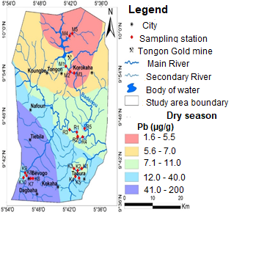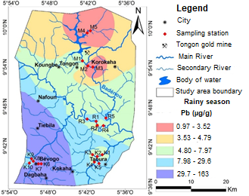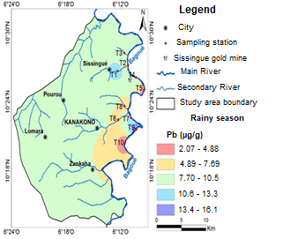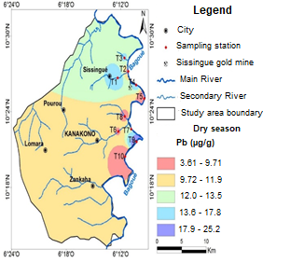

(a)

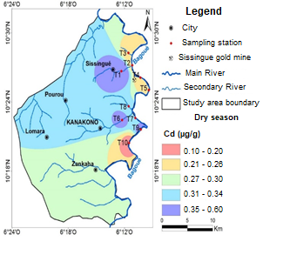

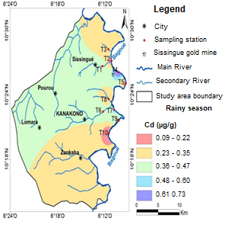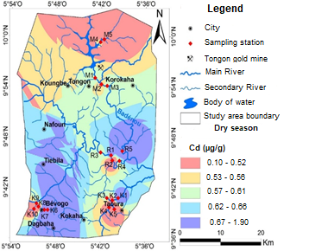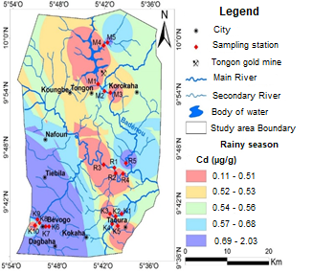

(b)

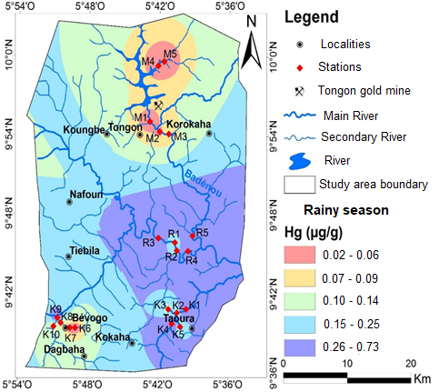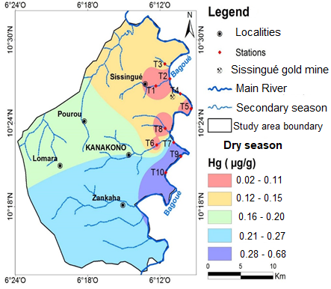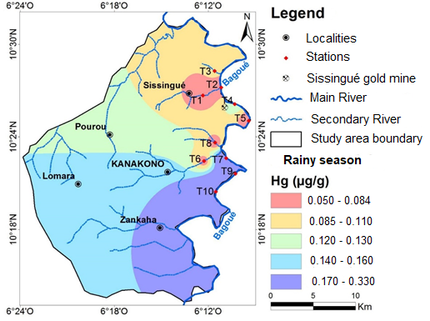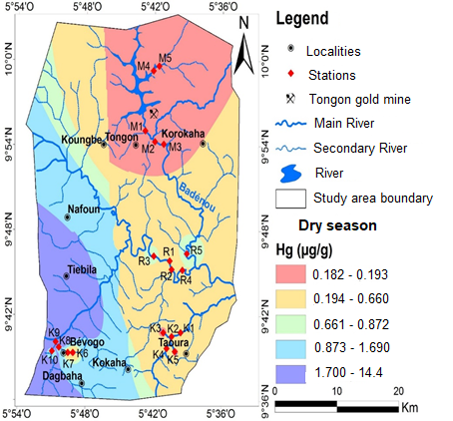

(c)

**Fig. 2**: Distribution patterns of Pb, Cd and Hg concentrations in sediment from gold mining areas

**Table 1:** Comparison of total metal concentrations in sediment from this study

|  |  |  |  |  |
| --- | --- | --- | --- | --- |
| **Country** | **Trace metals (µg.g-1)** | | | **Reference** |
| **Pb (a)** | **Cd (b)** | **Hg (c)** |
| Côte d’Ivoire (Korhogo) | 0.97-200 | 0.10-2.03 | 0.018-14.4 | Present study |
| Côte d’Ivoire (Tengrela) | 2.07-25.2 | 0.09-0.73 | 0.02-0.33 | Present study |
| **Africa** |  |  |  |  |
| Burkina Faso | 3.8-30.2 | **-** | 0.01-1.18 | Kagambega et al. 2023 |
| Ghana | 1.13-10.6 | 0.17-0.63 | 1.60-46.60 | Agyarko et al., 2014 |
| Senegal | 4-103 | **-** | 0.01-9.93 | Niane et *al.,* 2014 |
| Republic Democratic of Congo | **-** | **-** | 0.2-1.1 | Atibu et *al.,* 2016 |
| **America** |  |  |  |  |
| Mexico | 16.14-38.46 | 0.08-0.48 | 0.17-1.09 | Ruelas-inzunza et *al* .,2011 |
| Serbia | 43.12-480.1 | **-** | **-** | Filimon et *al.,* 2016 |
| Nevada, USA | 8.27-133.2 | 0.01-0.474 |  | Sims et *al.,* 2011 |
| Texas, USA | - | **-** | 0.1962-1.1876 | Gray et *al.,* 2015 |
| Colombia | - | **-** | 0.145-1.021 | Marrugo-negrete et *al.,* 2015 |
| Colombia | - | **-** | 0.1-232.81 | Olivier-verbal et *al.,* 2014 |
| Venezuela | - | **-** | 0.019 – 0.265 | Santos-francés et *al.,* 2011 |
| **Asia** |  |  |  |  |
| China | 31.6-545.2 | **-** | **-** | Tao et *al.,* 2014 |
| Japan | 13.2-81.8 | 0.6-2.29 | **-** | Chernova et *al.,* 2015 |
| Thailand | - | 0.11-2.38 | **-** | Maftei et *al.,* 2014 |
| China |  | 0.57-5.25 |  | Nabuntou et *al.,* 2010 |
| China | - | - | 0.023-0.168 | Chen et *al.,* 2013 |
| South Korea |  | 0.3-0.5 | 0.02-0.26 | Lim et *al.,* 2008 |
| Upper Continental Crust values (UCC) | 17 | 0.1 | 0.06 | Wedepohl, 1995 |

**3.4. Speciation and distribution of heavy metals in sediments**

The distribution of cadmium in the different sediment fractions is shown in Figure 3. Cadmium is predominantly bound to the residual faction (R), with percentages ranging from 56.11±7.43% (Tongon) to 78.25±8.63% (Taoura). Its concentrations ranged from 0.29 ± 0.05 µg.g-1 to 0.41 ± 0.17 µg.g-1. These results suggested that a significant proportion of cadmium was linked to the crystalline structure of the sediment. ANOVA analysis showed that there was a significant difference at p < 0.05 at Korhogo between the Tongon, Taoura, and Bevogo stations. The highest proportions were obtained in Taoura and Bevogo. Conversely, no significant difference (ANOVA, p<0.05) was observed between the Tengrela stations. Our results agreed with those of Sebei et al. (2017), who showed that cadmium is predominantly bound to the residual fraction (60%) in Tessa River sediments in the vicinity of a mine in Tunisia. Similarly, Olujimi et al., (2015) showed that the residual fraction controlled the distribution of cadmium in sediment fractions collected in the vicinity of the Igun mine in Nigeria. In contrast, Makinde et al. (2016) showed that cadmium was not primarily bound to the residual fraction in stream sediments in the vicinity of a gold mine at Osun State in southwestern Nigeria. Their conclusion was contrary to our results.

The proportions of cadmium bounded to organic matter and sulfides (F3) ranged from 8.38±5.44% (Bevogo) to 17.11±9.85% (Tongon). These percentages corresponded to concentrations ranging from 0.06±0.04 µg.g-1 to 0.09±0.02 µg.g-1. These low proportions of the F3 fraction indicated that a small amount of cadmium bounded to organic matter and was available under oxidizing conditions.

The fraction (F2) of cadmium bounded to iron and manganese oxides ranged from 5.44±2.97% (Kanakono) to 13.48±10.51% (Sissingue). This observation equated to a total concentration ranged of 0.02±0.01 µg.g-1 to 0.04±0.03 µg.g-1. The oxide-bound fraction represented the largest reactive fraction in sediments from Badenou, Taoura, Bevogo, and Sissingue. Thus, a significant proportion of the cadmium in the sediments of those areas can be bounded by iron and manganese oxides. Consequently, a change in redox conditions would lead to the solubilization of cadmium by dissolution of these oxides. Cadmium percentages related to the acid-soluble fraction (F1) ranged from 5.24±1.58% (Taoura) to 15.61±4.54% (Tongon), corresponding to a concentration of 0.02±0.01 µg.g-1 to 0.08±0.03 µg.g-1. The Tongon industrial extraction zone recorded the highest percentage, with a significant difference (p<0.05) compared to the other sites. This equates to an available concentration of 0.08±0.03 µg.g-1. The distribution of cadmium in the various sedimentary phases et M’bengue and Tengrela is as follows: the residual fraction (R) is greater than the fraction bound to oxides (F2), which is in turn greater than the fraction bound to organic matter and sulfides (F3). The exchangeable and bound to carbonate (F1) is the smaller of these fractions for the Badenou, Taoura, Bevogo, and Sissingué stations. In contract, at Tongon and Kanakono, the fractionation follows a different trend, with the residual fraction (R) being the largest, followed by organic matter and sulfide-bound fraction (F3), then the carbonate-bound exchangeable fraction (F1), and finally the oxide-bound fraction (F2). This difference can be explained by the different types of mining activity in these areas. The activities in Tongon were industrial, while those in Bevogo, Taoura, and Badenou were artisanal.

The percentages of lead in several sediment fractions are shown in Figure 3. The residual fraction (R) controlled the distribution of lead in the various sediment fractions, with percentages ranging from 62.57±6.25% (Taoura) to 72.38±8.01% (Badenou). This result corresponded to a concentration varying from 5.45±2.32 µg.g-1 to 6.23±2.32 µg.g-1. Statistical analysis (ANOVA, p<0.05) showed no significant difference between stations. All proportions of residual fractions recorded were above 62%, indicating that lead was less available in these study areas. Results from the distribution of lead in the sediments from Tessa River in the vicinity of a mine in northeast Tunisia have shown that lead was predominantly bounded to the residual fraction (Sebei et al., 2017). These studies corroborate our data. On the other hand, the work conducted by Liu et al. (2013) on agricultural soils in the vicinity of a mine in Jiangxi province (China) disagreed with those of the present study. Indeed, the authors observed that lead was weakly associated with the residual fraction.

Fraction (F3), corresponding to the lead fraction bounded to organic matter and sulfides, ranged from 10.77±6.69% (Badenou) to 23.94±5.22% (Sissingue). This observation presented a concentration ranging from 0.83±0.57 µg.g-1 to 2.42±0.98 µg.g-1. No significant differences (p<0.05) were observed between stations. This fraction represented the largest reactive fraction at the Tongon, Taoura, Sissingue, and Kanakono stations, suggesting that a concentration range between 0.73±0.57 µg.g-1 and 2.42±0.94 µg.g-1 was likely released into the water column under oxidizing conditions.

The F2 fraction of lead bounded to iron and manganese oxides ranged from 9.62±3.99% (Kanakono) to 14.15±4.28% (Bevogo), equivalent to a total concentration varying from 0.95±0.80 µg.g-1 to 8.08±9.28 µg.g-1. No significant differences (ANOVA, p<0.05) were observed between stations.

Lead percentages related to exchangeable fraction and carbonates (F1) ranged from 2.03±1.15% (Bevogo) to 4.71±2.62% (Badenou). There was no significant difference between stations at p<0.05. The important average proportion was obtained in the Badenou sediments. That value was equivalent to a concentration of 0.43±0.32 µg.g-1 out of a total concentration of 9.13±3.40 µg.g-1 available in the water column.

The residual and exchangeable and carbonate-bound fractions were, respectively, the largest and the smallest fraction at all stations. In the sediments of Tongon, Taoura, Sissingué, and Kanakono stations, the organic matter and sulphide-bound fraction constituted the second most important phase, while the oxide-bound fraction was the second most important phase at the Bevogo and Badenou stations.

Figure 3 shows the distribution of mercury in the various sediment fractions in Korhogo and Tengrela. It clearly showed that mercury was mainly bounded to the residual fraction (R), with an average proportion varying between 77.03±13.42% (Badenou) and 85.93±4.09% (Sissingue). This proportion corresponded to a concentration ranging from 0.073±0.03 µg.g-1 to 0.382±0.22 µg.g-1. These results denoted that a significant proportion of mercury was strongly linked to the crystalline structure of the sediment. ANOVA (p<0.05) showed that no significant differences were observed between stations. Our results were like those obtained by Lusilao-Makiese et al, (2016) and Santos-francés et al. (2011) in sediments around a mine in South Africa and Venezuela, respectively, where a large proportion (between 87 and 94%) was obtained in the residual fraction. The F3 fraction of mercury corresponded to the fraction bounded to organic matter and sulfides, with a proportion varying between 3.65±1.79% (Sissingue) and 9.21±4.63% (Badenou), equivalent to a total concentration ranging from 0.004±0.003 µg.g-1 to 0.053±0.03 µg.g-1. No significant differences (ANOVA, p<0.05) were observed between stations. The percentages of the reducible fraction (F2) of mercury ranged from 4.72±2.26% (Kanakono) to 7.85±4.49% (Tongon). This fraction represented the largest reactive fraction in the Tongon and Bevogo sediments. This would be due to the low dissolution of iron and manganese oxides in the sediments in these areas. The average concentration of mercury in the F2 fraction in Bevogo sediments (0.136±0.04 µg.g-1) was well above the UCC value (0.06 µg.g-1) for mercury. This value suggests that mercury may pose a threat to organisms. Statistical analysis (ANOVA, p<0.05) indicated that there was no significant difference between stations.

The exchangeable and carbonate-bound fraction (F1) of mercury was low at all stations. The proportions ranged from 4.75±1.79% (Kanakono) to 8.36±4.16% (Badenou), corresponding to a concentration varying from 0.015±0.018 µg.g-1 to 0.03±0.028 µg.g-1. Statistical analysis (ANOVA, p<0.05) depicted no significant difference between stations. The retention of mercury by the various sediment phases enabled two types of classification to be made. The first order concerned the Badenou, Touara, Sissingue, and Kanakono stations.

Two principal trends emerge from an examination of mercury fractionation. The residual fraction was the most significant mercury fraction at all stations. The fraction of mercury bound to organic matter and sulfides was the second most important fraction, followed by the exchangeable and carbonate bound fraction at the Badenou, Tongon, and Kanakono stations. Conversely, at the Taoura, Bevogo, and Sissingué stations, the exchangeable and carbonate and oxide-bound fractions were the second and third highest fractions, respectively.



**Figure 3**: Mean percentages of Cd, Pb, and Hg distributed in the acid soluble, reducible, oxidizable, and residual fractions in sediment from the study area

**3.5. Risk Assessment of environmental pollution**

**3.5.1. Risk assessment code (RAC)**

Table 2 gives the toxicity risk values for cadmium, mercury, and lead in sediments from various stations. Results for heavy metals (mercury and lead) caused a low risk at all the stations studied (2.03 ≤ RAC (%) ≤ 8.36). The results displayed that the sediments from Badenou, Taoura, Bevogo, and Kanakono presented a low risk of toxicity by cadmium toxicity, with percentages ranging from 5.24 to 9.60%. On contrary, sediments from Tongon and Sissingue presented a medium risk of cadmium toxicity (12.28 ≤ RAC (%) ≤ 15.61).

**Table 2**: Toxicity risk values for cadmium, mercury, and lead

|  |  |  |  |  |
| --- | --- | --- | --- | --- |
| Stations |  | cadmium | Lead | mercury |
| Badenou | RAC(%) | 9.60 | 4.71 | 8.36 |
| Tongon | RAC(%) | 15.61 | 2.32 | 7.13 |
| Taoura | RAC(%) | 5.24 | 2.67 | 6.43 |
| Bevogo | RAC(%) | 6.11 | 2.03 | 5.93 |
| Sissingue | RAC(%) | 12.28 | 2.06 | 5.04 |
| Kanakono | RAC(%) | 7.08 | 3.80 | 4.75 |

**3.5.2. Potential mobility and availability of lead, cadmium, and mercury in sediments**

The potential mobility of a heavy metal is related to its proportion in the non-residual fraction (%F1+%F2+%F3). The higher the proportion of heavy metals in the non-residual fraction, the greater its capacity for mobility and availability to the environment and living organisms, and vice versa if the residual fraction is dominant. The average sediment pH followed the order Bevogo (7.63 ± 0.95) > Tongon (6.85±0.92) > Taoura (6.76±0.55) > Badenou (6.59±0.47) at Korhogo (6.98 ± 0.80) and the order Kanakono (7.37±0.83) > Sissingue (7.49±0.49). The average pH values at Korhogo were slightly lower than those at Tengrela. No significant statistical difference was found among the sites (N’Goran et al 2021). Figure 4 shows the proportions of non-residual fractions in sediments from the different study areas. The proportions of non-residual fractions of trace metals in sediments from Korhogo ranged from 21.75 to 43.89%, from 16.24 to 22.97%, and from 27.62 to 37.43% for cadmium, mercury and lead, respectively, while those from Tengrela ranged from 23.98 to 34.77, from 14.07 to 17.78, and from 30.38 to 36.29% for cadmium, mercury, and lead, respectively. These metals had a low mobility potential. The decreasing order of metal mobility is: Badenou and Tongon: Cd > Pb > Hg; Taoura, Bevogo, Sissingue, and Kanakono: lead > cadmium. The decreasing order of metal mobility is: Badénou and Tongon: Cd> Pb> Hg; Taoura, Bevogo, Sissingue, and Kanakono: Pb > Cd > Hg. Thus, Hg seemed to be less mobile than lead and cadmium in the sediments of Korhogo and Tengrela. The mean concentrations of the sum of the non-residual fractions varied from 1.087 to 20.917 µg.g-1, from 0.082 to 0.238 µg.g-1, and from 0.011 to 0.267 µg.g-1 for Pb, Cd and Hg, respectively (Figure 4). A comparison of these concentrations with the UCC values (Wedepoh, 1995) showed that they were higher, especially at all stations (except Kanakono) for cadmium (UCC value: 0.1 µg.g-1), at the Bevogo station for lead (UCC value: 17 µg.g-1) and at the Badenou and Bevogo stations for mercury (UCC value: 0.06 µg.g-1). The values obtained showed that these trace metals represent a real threat to organisms. Mercury thus seemed to be less mobile than lead and cadmium in the sediments of Korhogo and Tengrela.



**Figure 4:** Non-residual concentration (µg g-1) of lead, cadmium, and mercury

**4. Conclusion**

In summary, the level of metal contamination of sediments in the Korhogo and Tengrela gold zones was investigated. The results showed that the average total concentrations of cadmium (between 0.32 µg.g-1 and 0.61 µg.g-1) and mercury (between 0.16 µg.g-1 and 0.59 µg.g-1) in the sediments of the different zones were higher than those of the earth's crust (0.01 µg.g-1 for cadmium and 0.056 µg.g-1 for mercury), indicating contamination of anthropogenic origin in these sediments. On the other hand, average lead concentrations were generally lower than in the Earth's crust (17 µg.g-1), with the exception of sediments from Bevogo (73.86 µg.g-1). Sediments from Korhogo were more contaminated with lead, cadmium, and mercury than those from Tengrela. In both sites, higher metal concentrations were recorded in rainy season than dry season. The mobility of metals (lead, cadmium, and mercury) in the sediments was assessed using the sequential extraction method. In terms of mobility, lead, cadmium, and mercury were mainly associated with the residual phase of the sediments, with percentages ranging from 62.57% to 72.38% for lead, 56.11% to 78.25% for cadmium and 77.03% to 85.93% for mercury. These results suggested that a significant proportion of these metals were linked to the crystalline structure of the sediments. Nevertheless, significant proportions of the non-residual fractions of lead (between 1.087 and 20.917 µg.g-1), cadmium (between 0.082 and 0.238 µg.g-1), and mercury (between 0.011 and 0.267 µg.g-1) were obtained in the various sediments. These concentrations were higher than those of the Earth's crust (17 µg. g-1 for lead, 0.1 µg.g-1 for cadmium, and 0.056 µg.g-1 for mercury), the elements lead, cadmium, and mercury could pose a true threat to organisms. The assessment of potential toxicity showed that the as-studied metals present a low risk of toxicity that could rarely cause adverse effects on aquatic life.

**Disclaimer (Artificial intelligence)**

Authors hereby declare that NO generative AI technologies such as Large Language Models (ChatGPT, COPILOT, etc.) and text-to-image generators have been used during the writing or editing of this manuscript.

References

Affum, A. O., Dede, S. O., Nyarko, B. J. B., Acquaah, S. O., Kwaansa-Ansah, E. E., Darko, G., Fianko, J. R. (2016). Influence of small-scale gold mining and toxic element concentrations in Bonsa River, Ghana: a potential risk to water quality and public health. Environmental Earth Sciences, 75(2), 178-184.

Agboola, O., Babatunde, D. E., Fayomi, O. S. I., Sadiku, E. R., Popoola, P., Moropeng, L., Mamudu, O. A. (2020). A review on the impact of mining operation: Monitoring, assessment and management. Results in Engineering, 8, 100181-100203.

Agyarko, K., Dartey, E., Kuffour, A.R., Sarkodie, A.P (2014). Assessment of Trace Elements Levels in Sedimentand Water in Some Artisanal and Small-Scale Mining (ASM) Localities in Ghana. Current World Environment, 9 (1), 07-16.

Ahoussi, K.E., Yapo, A.P., Kouassi, A.M, Koffi, Y.B. (2020). Surface Water Sediments Characterization Using Metallic Trace Elements (MTEs): Case of the Artisanal Gold Mining Sites of Kokumbo (Côte d’Ivoire). Journal of Environmental Protection, 11(09), 649-663.

Alengebawy, A., Abdelkhalek, S. T., Qureshi, S. R., Wang, M. Q. (2021). Heavy metals and pesticides toxicity in agricultural soil and plants: Ecological risks and human health implications. Toxics, 9(3), 42-74.

Ali, H., Khan, E., Ilahi, I. (2019). Environmental chemistry and ecotoxicology of hazardous heavy metals: environmental persistence, toxicity, and bioaccumulation. Journal of chemistry,2019, 1-14.

Anyanwu, B. O., Ezejiofor, A. N., Igweze, Z. N., Orisakwe, O. E. (2018). Heavy metal mixture exposure and effects in developing nations: an update. Toxics, 6(4), 65-96.

Atibu, E. K., Devarajan, N., Laffite, A., Giuliani, G., Salumu, J. A., Muteb, R. C., Poté, J. (2016). Assessment of trace metal and rare earth elements contamination in rivers around abandoned and active mine areas. The case of Lubumbashi River and Tshamilemba Canal, Katanga, Democratic Republic of the Congo. Chemie der Erde-Geochemistry, 76(3), 353-362.

Baran A, Mierzwa-Hersztek M, Gondek K, Tarnawski M, Szara M, Gorczyca O, Koniarz T (2019) The influence of the quantity and quality of sediment organic matter on the potential mobility and toxicity of trace elements in bottom sediment.Environ Geochem Health, 41(6), 2893-2910.

Basu, N., Bastiansz, A., Dórea, J. G., Fujimura, M., Horvat, M., Shroff, E., Zastenskaya, I. (2023). Our evolved understanding of the human health risks of mercury. Ambio, *52*(5), 877-896.

Bharti, R., Sharma, R. (2022). Effect of heavy metals: An overview. Materials Today: Proceedings, 51, 880-885.

Calabró, M. R., Roqueiro, G., Tapia, R., Crespo, D. C., Bargiela, M. F., Young, B. J. (2022). Chronic toxicity, bioavailability and bioaccumulation of Zn, Cu and Pb in Lactuca sativa exposed to waste from an abandoned gold mine. Chemosphere, 307, 135855-135869.

Cheng, Y., Zhao, F., Wu, J., Gao, P., Wang, Y., Wang, J. (2022). Migration characteristics of arsenic in sediments under the influence of cascade reservoirs in Lancang River basin. Journal of Hydrology, 606, 127424-127439.

Chernova, E.N., Potikha, E.V. Nesterenko, O. E., (2015). The Content of Heavy Metals in Bottom Sediments of the Streams of the Sikhote-Alin Biosphere Reserve and the Streams Draining Mines of the Transit Zone of the Reserve. Achievements in the Life Sciences, 9, 9-14.

Chibunda, R. T., Pereka, A. E., Tungaraza, C. (2008). Effects of sediment contamination by artisanal gold mining on Chironomus riparius in Mabubi River, Tanzania. Physics and Chemistry of the Earth, Parts A/B/C, 33(8-13), 738-743.

Córdoba-Tovar, L., Marrugo-Negrete, J., Barón, P. A. R., Díez, S. (2023). Ecological and human health risk from exposure to contaminated sediments in a tropical river impacted by gold mining in Colombia. Environmental research, 236, 116759-116774.

Filimon, M.N., Popescu, R., Horhat F.G., Voia, O.S. (2016). Environmental impact of mining activity in Bor area as indicated by the distribution of heavy metals and bacterial population dynamics in sediment. Knowledge and Management of Aquatic Ecosystems, 417, 30-.39.

Girard, G., Sircoulon, J., Touchebeuf, P. (1971). Aperçu sur les régimes hydrologiques de Côte d’Ivoire. ORSTOM Editions, Côte d’Ivoire, 50,109-155.

Gray, J. E. Theodorakos, P. M. Fey, D. L. Krabbenhoft, D. P. (2015). Mercury concentrations and distribution in soil, water, mine waste leachates, and air in and around mercury mines in the Big Bend region, Texas, USA. Environ Geochem Health, 37, 35–48.

Guedron, S., Grangeon, S., Lanson, B., Grimaldi, M. (2009). Mercury speciation in a tropical soil association; Consequence of gold mining on Hg distribution in French Guiana. Geoderma, 153(3-4), 331-346.

Hogarh, N.J., Adu Gyamfi, E., Nukpezah, D., Akoto,O., Adu Kumi, S. (2016).Contamination from mercury and other heavy metals in a mining district in Ghana: discerning recent trends from sediment core analysis. Environmental systems research, 5, 15-29.

Huang, S. (2014). Fractional distribution and risk assessment of heavy metal contaminated soil in vicinity of a lead/zinc mine. Trans. Nonferrous Met. Soc. China, 24, 3324−3331.

Kagambega, N., Ouedraogo, M., Sam, U. (2023). Assessment of Water and Stream Sediment Pollution Related to Artisanal Mining in Alga, Burkina Faso, West Africa. International Journal of Environment and Climate Change, 13 (11), 461-473.

Kagambega, N., Ouedraogo, M., Sam, U. (2023). Assessment of Water and Stream Sediment Pollution Related to Artisanal Mining in Alga, Burkina Faso, West Africa. International Journal of Environment and Climate Change, 13 (11), 461-473.

Kan, X., Dong, Y., Feng, L., Zhou, M., Hou, H. (2021). Contamination and health risk assessment of heavy metals in China’s lead–zinc mine tailings: A meta–analysis. Chemosphere, 267, 128909-128918.

Khatun, J., Intekhab, A, Dhak, D., 2022. Effect of uncontrolled fertilization and heavy metal toxicity associated with arsenic (As), lead(Pb) and cadmium (Cd), and possible remediation. Toxicology.

Kinimo, K. C., Yao, K. M., Marcotte, S., Kouassi, N. L. B., Trokourey; A., (2018). Distribution trends and ecological risks of arsenic and trace metals in wetland sediments around gold mining activities in central southern and south eastern Côte d'Ivoire. Journal of Geochemical Exploration, 190, 265-280.

Kothapalli, C. R. (2021). Differential impact of heavy metals on neurotoxicity during development and in aging central nervous system. Current Opinion in Toxicology, *26*, 33-38.

Kouame, K. J. A., Jiang, F. X., Feng, Y., & Zhu, S. T. (2017, February). A Study on Ivory Coast with the Impacts of Artisanal Gold Mining on Local Livelihoods and the Mining Industry. In Advanced Engineering Forum. Trans Tech Publications Ltd, 20, 68-77.

Kouamelan, A.N., Peucat, J.J., Delor, C., 1997b. Reliques arch_eennes (3.15 ga) au sein du magmatisme Birimien (2.1 Ga) de Côte d'Ivoire, Craton Ouest-Africain. C.R. Acad. Sci. 324, 719e727.

Kubra, K., Mondol, A. H., Ali, M. M., Palash, M. A. U., Islam, M. S., Ahmed, A. S., Rahman, M. M. (2022). Pollution level of trace metals (As, Pb, Cr and Cd) in the sediment of Rupsha River, Bangladesh: assessment of ecological and human health risks. Frontiers in Environmental Science, 10, 778544-778561.

Lane, E. A., Canty, M. J., More, S. J., (2015). Cadmium exposure and consequence for the health and productivity of farmed ruminants. Research in veterinary Science, 101, 132-139.

Li, L., Jiang, M., Liu, Y., Shen, X. (2019). Heavy metals inter-annual variability and distribution in the Yangtze River estuary sediment, China. Marine pollution bulletin, 141, 514-520.

Lim, H., Lee, J., Chon, H., Sager, M. (2008). Heavy metal contamination and health risk assessment in the vicinity of the abandoned Songcheon Au–Ag mine in Korea. Journal of Geochemical Exploration, 96, 223–230.

Liu, G., Tao, L., Liu, X., Hou, J., Wang, A., Li, R. (2013). Heavy metal speciation and pollution of agricultural soils along Jishui River in non-ferrous metal mine area in Jiangxi Province, China. Journal of Geochemical Exploration, 132, 156-163.

Lusilao-Makiese, J. G., Tessier, E., Amouroux, D., Tutu, H., Chimuka, L., Weiersbye, I., Cukrowska, E. M. (2016). Mercury speciation and dispersion from an active gold mine at the West Wits area, South Africa. Environmental monitoring and assessment, 188(1), 47-57.

Maftei, A.E., Iancu, O.G, Buzgar, N. (2014). Assessment of minor elements contamination in Bistriţa River sediments (upstream of Izvorul Muntelui Lake, Romania) with the implication of mining activity, J. Geochem. Explor. 145, 25-34.

Makinde, O. W., Adesiyan, T. A., OGUNDELE, K., ADELOWOTAN, O., OLUYEMİ, E. (2016). Assessment of heavy metals bioavailability in stream sediments around a gold mining environment in south-western Nigeria. Journal of International Environmental Application and Science, 11(2), 139-147.

Marrugo-Negrete, J., Pinedo-Hernández, J., Díez, S. (2017). Assessment of heavy metal pollution, spatial distribution and origin in agricultural soils along the Sinú River Basin, Colombia. Environmental research, 154, 380-388.

Mishra, S., Bharagava, R. N., More, N., Yadav, A., Zainith, S., Mani, S., Chowdhary, P. (2019). Heavy metal contamination: an alarming threat to environment and human health. *Environmental biotechnology:* For sustainable future, 103-125.

Mitra, S., Chakraborty, A. J., Tareq, A. M., Emran, T. B., Nainu, F., Khusro, A., Simal-Gandara, J. (2022). Impact of heavy metals on the environment and human health: Novel therapeutic insights to counter the toxicity. *Journal of King Saud University-Science*,*34*(3), 101865.

Muhammad, I., Ashiru, S., Ibrahim, I; D., Salawu, K., Muhammad, D.T., Muhammad, N.A. (2014). Determination of Some Heavy Metals in Wastewater and Sediment of Artisanal Gold Local Mining Site of Abare Area in Nigeria. Journal of Environmental Treatment Techniques, 1(3), 174-182.

N’goran, K. P. D. A., Diabate, D., Kouassi, N. G. L. B., Yao, K. M., Kinimo, K. C., Ouattara, A. A., Trokourey, A. (2022). Geochemical speciation and distribution of trace metals in sediments around industrial and artisanal gold mining areas in northern Côte d'Ivoire. Environmental Earth Sciences, 81(12), 333-350.

N’Guessan, A. K., Kamelan, M. T., Zeré, G. (2021). Clandestine gold mining and pollution risks of sediments from Bagoue river (Niger watershed. Cote d’Ivoire). International Journal of Fisheries and Aquatic Studies, 9(4) ,149-158.

N'guessan, Y. M., Probst, J. L., Bur, T., Probst, A. (2009). Trace elements in stream bed sediments from agricultural catchments (Gascogne region, SW France): where do they come from? Science of the total environment, 407(8), 2939-2952.

Niane, B., Moritz, R., Guédron, S., Ngom, P. M., Pfeifer, H. R., Mall, I., Poté, J. (2014). Effect of recent artisanal small-scale gold mining on the contamination of surface river sediment: Case of Gambia River, Kedougou region, southeastern Senegal.Journal of Geochemical Exploration, 144, 517-527.

Nobuntou, W., Parkpian, P., Oanh, N. T. K., Noomhorm, A., Delaune, R. D., Jugsujinda, A. (2010). Lead distribution and its potential risk to the environment: Lesson learned from environmental monitoring of abandon mine, Journal of Environmental Science and Health, Part A: Toxic/Hazardous Substances and Environmental Engineering, 45(13), 1702-1714.

Olivero-Verbel, J., Caballero-Gallardo, K., Turizo-Tapia, A. (2014). Mercury in the gold mining district of San Martin de Loba, South of Bolivar (Colombia). Environ Sci Pollut Res, 22(8), 5895–5907.

Olujimi, O. O., Oputu, O., Fatoki, O., Opatoyinbo, O. E., Aroyewun, O. A., & Baruani, J. (2015). Heavy metals speciation and human health risk assessment at an illegal gold mining site in Igun, Osun State, Nigeria. Journal of Health Pollution, 5(8), 19-32.

Oyugi, A. M., Kibet, J. K., Adongo, J. O. (2021). A review of the health implications of heavy metals and pesticide residues on khat users. Bulletin of the National Research Centre, 45, 1-22.

Paez-Osuna F., Bojorquez-Leyva H. M., Berges-Tiznado, O. A. Rubio-Hernandez,J. F. Fierro-Sanudo, J. Ramırez-Rochın ,J. A., Leon-Canedo, (2015). Heavy Metals in Waters and Suspended Sediments Affected by a Mine Tailing Spill in the Upper San Lorenzo River,Northwestern Mexico. Bull Environ Contam Toxicol, 94(5), 583–588.

Proshad, R., Kormoker, T., Al, M. A., Islam, M. S., Khadka, S., Idris, A. M. (2022). Receptor model-based source apportionment and ecological risk of metals in sediments of an urban river in Bangladesh. Journal ofhazardous materials, 423, 127030-127044.

Rodgers, K.J., Hursthouse A., Cuthbert, S. (2015). The potential of sequential extraction in the characterisation and management of wastes from steel processing: a prospective review. Int J Environ Res Public Health, 12(9), 11724-11755.

Ruelas-Inzunza, C. Green-Ruiz, M. Zavala-Nevárez, M. Soto-Jiménez, (2011). Biomonitoring of Cd, Cr, Hg and Pb in the Baluarte River basin associated to a mining area (NW Mexico). Science of the Total Environment, 409, 3527–3536.

Sako, A., Semdé, S., Wenmenga, U. (2018). Geochemical evaluation of soil, surface water and groundwater around the Tongon gold mining area, northern Côte d’Ivoire, West Africa. J Afr Earth Sci, 145, 297-316 https://plan.gouv.ci/assets/fichier/RGPH2021-RESULTATS-GLOBAUX-VF.pdf

Saleem, M., Iqbal, J., Shah, M.H. (2015). Geochemical speciation, anthropogenic contamination, risk assessment and source identification of selected metals in freshwater sediments—a case study from Mangla Lake, Pakistan. Environmental Nanotechnology, Monitoring & Management, 4, 27-36.

Santos-francés, F., García-Sánchez, A., Alonso-Rojo, P., Contreras, F. Adams, M. (2011). Distribution and mobility of mercury in soils of a gold mining region, Cuyuni river basin, Venezuela. Journal of Environmental Management, 92, 1268-1276.

Sebei, A., Helali, M.A., Oueslati, W., Abdelmalek, C., Chaabani, F. (2017). Bioavailability of Pb, Zn, Cu, Cd, Ni and Cr in the sediments of the Tessa River: a mining area in the North-West Tunisia. J Afr Earth Sci 137:1–8.

Sims, D. B., and Francis, A. (2011). Anthropogenic influences on geogenic trace elements and contamination in wash sediments from historical mining activities in the Carnation wash system, Nelson, Nevada (USA). International Journal of Soil, Sediment and Water, 3(1), 1-20.

Sundaray, S.K., Nayak, B.B., Lin, S., Bhatta, D. (2011). Geochemical speciation and risk assessment of heavy metals in the river estuarine sediments–A case study: Mahanadi basin, India. J. Hazard. Mater, 186, 1837–1846.

Tao, L., Liu, G., Liu, X., Zhang, C., Cheng, D., Wang, A., Li, R. (2014). Trace metal pollution in a Le'an River tributary affected by non-ferrous metal mining activities in Jiangxi Province, China, Chemistry and Ecology, 30, 3, 233-244.

Traore, I.W., Houhamdi, M. (2017). Bioassessment of Artisanal Mining’s Impact on Bagoé River Water Quality in Sikasso Region. World J Environ Biosci, 6(4), 7-14.

Wedepohl K. H. (1995). The composition of the continental crust. Geochimica et cosmochimica Acta, 59, 1217-1232.

Worlanyo, A. S., Jiangfeng, L. (2021). Evaluating the environmental and economic impact of mining for post-mined land restoration and land-use: A review. Journal of Environmental Management, 279, 111623-111634.

Zhang, X., Li, B., Schillereff, D. N., Chiverrell, R. C., Tefsen, B.,Wells, M. (2022). Whole-cell biosensors for determination of bioavailable pollutants in soils and sediments: Theory and practice. Science of the Total Environment, 811, 152178.

Zhuang, P., Lu, H., Li, Z., Zou, B., McBride, M.B. (2014). Multiple Exposure and Effects Assessment of Heavy Metals in the Population near Mining Area in South China. PLoS ONE 9(4): e94484.