**Statistical Analysis of Climate Variability and its Impact on Tank Irrigation: A Case Study of the Agaramar Sub-Basin, India**

**ABSTRACT**

Analyzing climatic behaviour at the relevant time scales is crucial in countries that rely on rain-fed agriculture. The study was carried out in the Thippasamudram tank of the Agaramar sub-basin. Data about rainfall and rainy days were obtained from the IMD data portal, Pune. This study used statistical analysis to detect trends in the temperature, rainfall, and rainy days at monthly, seasonal, and annual timescales from 1981 to 2020 at Thippasamudram village. The results revealed that the minimum temperature significantly increased during the SW and the NE monsoon seasons, summer, and yearly timescales at rates of 0.017 $℃$, 0.037 $℃$, 0.024 $℃$, and 0.018 $℃$ respectively. The Mann Whitney Pettitt test revealed that 2001 was the change point on the annual scale. The highest positive temperature anomaly was recorded in the year 2012, at a rate of 0.86 $℃$. From the Precipitation Concentration Index and Rainfall Anomaly Index results, the year 2012 was characterized as very dry and had an irregular distribution of rainfall, and the tank filling levels were triangulated with the actual data and found below 50%. According to the Coefficient of variation (CV) statistics, rainfall was found to be highly variable both monthly and seasonally. While the number of rainy days was significantly varied during the season-wise rainfall in the study area, the number of yearly rainy days exhibited less variation. There was no significant change in the annual precipitation trend. These findings aligned with the tank fillings data. Hence, the Thippasamudram tank, which is rainfed, has erratic rainfall, rendering the tank filling inconsistent.

**Keywords**: Climate variability, Precipitation Concentration Index, Rainfall Anomaly Index, Statistical analysis, Trend analysis, Temperature anomaly

**1. INTRODUCTION**

Global warming is the phenomenon of the heating up of the earth's system witnessed from the pre-industrial era. This is due to the excess release of heat-trapping gases such as water vapor, Carbon dioxide, Methane and Nitrous oxide into the earth’s atmosphere, which is mainly liberated from the energy sector, transportation sector, construction and mining industries and agriculture sector. Climate is a multi-fractal process of high fractal dimensions, and hydrological extremes are more than climate-driven phenomena; their patterns are difficult to pin down (Gan et al., 2016). IPCC Fourth Assessment Report (AR4) (IPCC, 2007) states that the rapid increase in Greenhouse Gas (GHG) emission is greatly due to the enhanced greenhouse gas effect. GHG gases capture solar radiation without reflecting and make changes in the global climate system, causing climate change. Increasing surface air temperature causes an uneven rate of evaporation from waterbodies such as lakes, tanks, etc., which leads to unpredicted high-intensity rainfall with poor rainfall distribution during non-monsoon seasons and monsoon shifts. This affects the soil moisture availability, nutrient balance and creates favorable conditions for pest and disease proliferation. A warming trend has been observed over South [Asia](https://www.sciencedirect.com/topics/earth-and-planetary-sciences/asia) in the last few decades, particularly in India, consistent with the global warming signal expected from human-induced climate change (Yaduvanshi et al., 2021). India ranks seventh in the global climate risk index (Eckstein et al., 2021) and Tamil Nadu is placed in twelfth position in the overall vulnerability index (Mohanty & Wadhawan, 2021). India is a developing and resource-poor country in terms of affordability of resilience to climate change. In India, 86 % of farmers are classified as marginal and small farmers, as per the agriculture census report 2015-2016. 18% of the GHG emissions in India come from the agricultural sector (Pathak, 2015). India occupies the first place in rain-fed farming (Sathyan et al., 2018), with 55% of net sown area cultivated by rain-fed irrigation, whereas tanks act as mini reservoirs. Rainfed areas, which make up over 60% of the total agricultural land in India, contribute about 60% of the country’s agricultural GDP in spite of facing constraints of poor soil health, high soil erosion, low moisture content and less productivity (Matham et al., 2024).

A tank is an irrigation structure used as a mini reservoir to capture the excess runoff during monsoon seasons, which is utilized during subsequent dry seasons. It is the traditional method of irrigation. The Tamil Nadu state is proud of holding 39,000 tanks, and more than one-third of the area is irrigated by tanks. Tanks are used for drinking, irrigation, livestock farming, fish culture, ground water recharge and flood management. Dependability on these structures is deteriorating because of the hydrologic uncertainty faced under the climate variability. Research works reveal that the tank irrigated area has declined from 0.9 to 0.5 million ha. during the past forty years (Palanisami & Nanthakumaran, 2009). This is mainly due to the unpredicted rainfall happening due to climate change and irregular periodic maintenance of tank components, encroachment in the catchment area, supply channels and conflicts between local bodies and stakeholders.

Climate change-related projections (2010-2039) predicted that agriculture is the most vulnerable sector with respect to the climate variability, which impacts the reduction of crop yields by about 4.5 to 9% (Guiteras, 2009). Precipitation and temperature are two of the most crucial variables in climate science and hydrology, serving as key indicators of climate change and variability (Farah et al., 2024). Climate change impacts the crop yield both directly and indirectly. The direct effects are heat stress, shortening of the growing period and biotic and abiotic stresses. The indirect effects are water shortage at the critical stages of crop growth, pests and disease proliferation and weed dynamics. The objective of the study is to assess the climate variability on a local scale and its impact on tank filling.

**2.** **MATERIALS AND METHODS**

**2.1 Study Area**

The study was carried out in the Thippasamudram tank of the Agaramar sub-basin, which is located within the administrative boundaries of the Vellore district. This tank was rehabilitated and modernized as part of the TNIAM Project Phase-2 (2017-2021). The Agaramar sub-basin lies between the geographic coordinates of latitude 12º 34’ 00” to 12º 47’ 20” N and longitude 78º 48’ 00” to 78º 57’10” E. It comes under the North Eastern agro-climatic zone. The Agaramar sub-basin is one of the nine sub-basins of the river Palar. The total sub-basin area is 575 sq.km. The approximate population is about two lakhs. The available groundwater potential is 35.32 MCM, and the surface water potential is 47.37 MCM. The Thippasamudram tank is located in the Anicut Block of the Vellore district. It is a non-system tank,which gets its supply only from the rainfall. Total ayacut area is 115.74 ha. The sub-tropical climate prevails in this region. The water spread area map of the Thippasamudram tank is shown in Figure 1. The water spread area of the tank is 0.70 sq. km, and its capacity is 46.96 Mcft. Clayey soil, black cotton soil and red soil are mostly found across the basin.

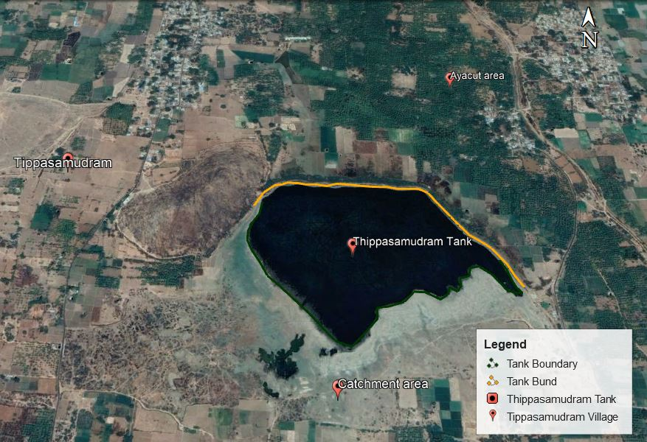

**Figure 1 Water-Spread Area Map of the Thippasamudram Tank**

*(Source: Google Earth, 21 November 2022)*

**2.2 Study Protocol:**

Examining climatic-behavior in the context of climate variability is essential to determine the climate-induced changes. Hence, trend analysis was performed to detect the changes in temperature, rainfall, and the number of rainy days in the Thippasamudram village during the period 1981-2020. Data analysis was done using XLSTAT software. Temperature anomaly and coefficient of variation were used to investigate temperature variation. The time series’ most likely breaking point was determined using the Mann Whitney Pettitt homogeneity test. Using the co-efficient of variation (CV), Rainfall Anomaly Index (RAI), and Precipitation Concentration Index (PCI), the variation in rainfall was determined. The study of the climate data was compared with the actual tank fillings data in order to correlate the outcomes at field level.

**2.3 Input Data**

Data about rainfall and rainy days for the years 1980-2020 were obtained from the IMD data portal, Pune. Over the years 1981-2020, data on the maximum (Tmax) and minimum temperatures (Tmin) were acquired from the Power Access NASA portal. Details regarding tank filling percentages from 2010 to 2020 was furnished by the Water Resources Department in the Agaramar subbasin of the Vellore district.

**2.4 Statistical Analysis**

* Mann Kendal Trend Analysis
* Mann Whitney Pettitt Test
* Co-efficient of Variation
* Temperature Anomaly
* Rainfall Anomaly Index
* Precipitation Concentration Index

**2.4.1 Mann Kendal Trend Analysis**

It is a non-parametric statistical trend analysis used to assess whether the time series has a continuous increasing or decreasing trend over the period of time at the 5% significance level. Time series data could be continuous rainfall, Tmax, Tmin data and number of rainy days.

Working theory relies on two assumptions: Ho: There is no trend in the time series. Ha: There is a trend in the time series. Ho denotes the null hypothesis, while Ha denotes the alternative hypothesis.

If the p value is less than 0.05, accept alternate hypothesis, Ha. Otherwise reject Ha and accept null hypothesis, Ho. Classification of the trend is done based on the Z- statistics (ZMK), as shown in Table 1.

In the present study, trend analysis was done for the variables of maximum temperature (Tmax), minimum temperature (Tmin), rainfall and the total number of rainy days on monthly, seasonal and yearly time scales for the period 1981-2020.

The formula for calculating ZMK is given below:

ZMK ----------------- Eqn.1 **Table 1. Classification of Trend**

|  |  |  |
| --- | --- | --- |
| **Sl. No.** | **Categories** | **Scales** |
| 1 | Significant trend of variable increase | ZMK > 1.96 |
| 2 | Non-significant trend of variable increase | 0 < ZMK > 1.96 |
| 3 | No trend | ZMK = 0 |
| 4 | Non-significant trend of variable reduction | -1.96 < ZMK < 0 |
| 5 | Significant trend of variable reduction | ZMK < -1.96 |

*Source: Hirsch et al., 1993)*

In order to analyze the seasonal temperature trends, the monthly data were categorized into four seasons: Winter (January-February), Summer (March-May), the SW monsoon (June-September), and the NE monsoon (October-December). For the investigation of the seasonal rainfall trend, the months were divided into four groups: Winter (January-February), Pre-monsoon (March-May), SW monsoon (June-September), and NE monsoon (October-December).

**2.4.2 Mann Whitney Pettitt Homogeneity Test**

Mann Whitney Pettitt is a non-parametric method applied to detect the change point of increasing or decreasing variable over the time series. Working theory relies on two assumptions: Ho: Data are homogeneous; Ha: There is a date at which there is change in the data.

A significant change point in the time series was assessed using the probability t statistics p(t). The following formula is used to calculate p(t).

$p(t) = 1- exp [\frac{-6 k_{T}^{2}}{T^{3}+T^{2}}$] ----------------- Eqn.2

Where, T is the length of time series. Accept Ha, if the estimated p(t) is below the level of significance, α = 0.05. If not, disregard Ha and accept Ho.

**2.4.3 Coefficient of Variation (CV)**

The coefficient of variation (CV) of the variable, a measure of climate risk, which shows the deviation from the mean values of the variable. A higher CV value indicates greater variability, and vice versa. The CV is calculated as follows:

$Coefficient of variation (CV) = \frac{Standard deviation}{Mean precipitation} ×100$-------- Eqn.3

(Hare, 2003) claims that, CV is used to categorize the amount of climatic variable fluctuation as less (CV < 20), moderate (20 < CV < 30), and more (CV > 30).

**2.4.4 Temperature Anomaly**

Temperature anomaly explains the deviation of temperature from the average temperature calculated from the long-term data set. A positive anomaly denotes the observed temperature is warmer than normal temperature and negative anomaly denotes the observed temperature is cooler than normal.

**2.4.5 Rainfall Anomaly Index (RAI)**

Rainfall Anomaly Index is used to analyze the intensity and frequency of dry and rainy years from the rainfall data. The formula for calculating RAI is given below:

$RAI=\left\{\begin{aligned}3×\left(\frac{N-N_{m}}{M_{m}-N_{m}}\right) for positive anamolies \\ -3 × \left(\frac{N-N_{m}}{X_{m}-N_{m}}\right) for negative anamolies\end{aligned}\right.$------- Eqn. 4

Where,

N = current monthly / seasonal / yearly precipitation in mm

Nm = mean annual precipitation of the time series in mm

Mm = mean of the ten highest monthly / seasonal / annual precipitation events of the time series in mm

Xm = mean of the ten lowest annual precipitation events of the time series in mm.

Positive anomalies have values that are higher than average rainfall, whereas negative anomalies have lower values. Table 2 lists the RAI intensity classes.

**2.4.6 Precipitation Concentration Index (PCI)**

The Precipitation Concentration Index is a potent method for assessing the temporal distribution of rainfall patterns. It is calculated as follows:

**Table 2 Rainfall Anomaly Index Intensity Classes**

|  |  |
| --- | --- |
| **RAI- Range** | **Intensity Class** |
| Above 4 | Extremely rainy |
| 2 to 4 | Very Rainy |
| 0 to 2 | Rainy |
| 0 | Normal |
| -2 to 0 | Dry |
| -2 to -4 | Very dry |
| Below -4 | Extremely dry |

*(Source: Van Rooy, 1965)*

$PCI = \frac{\sum_{i=1}^{12}{P_{i}^{2}}}{{\left(\sum_{i=1}^{12}{P_{i}}\right)}^{2}}× 100$------------ Eqn.5

Pi denotes the ith month of the year over the course of the observation period. As indicated in Table 3, the distribution of precipitation is categorized depending on the PCI value.

**3. RESULTS AND DISCUSSION**

**3.1 Trend Analysis Results:**

ZMK and p statistics were calculated for the whole set of Tmax, Tmin, and rainfall data using Equation 1 and classified according to Table 1. Table 4 illustrates the test results of the ZMK statistics, the Sen slope estimator, and the p value of Tmax, Tmin and rainfall.

**Table 3. Classification Based on PCI Range**

|  |  |  |
| --- | --- | --- |
| **Sl.No.** | **PCI-Range** | **Classification** |
| 1. | <10 | Uniform distribution |
| 2. | 11- 15 | Moderate distribution |
| 3. | 16 – 20 | Irregular distribution |
| 4. | >20 | Strong irregularity |

*Source****:*** *(Oliver, 1980)*

**Table 4. Results of ZMK, Sen Slope and p value**

| **Time scale** | **Tmax** | | | **Tmin** | | | **Rainfall** | | |
| --- | --- | --- | --- | --- | --- | --- | --- | --- | --- |
| **P**  **Value** | **Sen slope**  **($℃)$** | **ZMK** | **p**  **value** | **Sen slope**  **($℃)$** | **ZMK** | **P**  **value** | **Sen slope**  **($℃)$** | **ZMK** |
| January | 0.85 | -0.004 | -0.18 | 0.981 | -0.001 | -0.02 | 0.279 | 0 | 1.08 |
| February | 0.84 | -0.003 | -0.19 | 0.762 | -0.004 | -0.30 | 0.504 | 0 | -0.67 |
| March | 0.27 | -0.019 | -1.09 | **0.034** | 0.04 | 2.12 | 0.11 | 0 | -1.60 |
| April | **0.038** | -0.033 | **-2.07** | 0.616 | 0.004 | 0.50 | 0.901 | 0 | 0.12 |
| May | 0.188 | -0.026 | -1.31 | 0.064 | 0.018 | 1.85 | 0.857 | 0.091 | 0.18 |
| June | 0.576 | -0.013 | -0.55 | **0.018** | 0.021 | 2.36 | 0.425 | 0.569 | 0.80 |
| July | 0.825 | 0.005 | 0.22 | **0.004** | 0.022 | 2.87 | 0.964 | -0.022 | -0.04 |
| August | 0.87 | 0.002 | 0.16 | **0** | 0.018 | 3.49 | 0.387 | -1.046 | -0.86 |
| September | 0.692 | -0.008 | -0.39 | 0.477 | 0.006 | 0.71 | 0.135 | -1.508 | -1.49 |
| October | 0.328 | 0.015 | 0.97 | 0.059 | 0.037 | 1.88 | 0.629 | 0.527 | 0.48 |
| November | 0.333 | 0.015 | 0.96 | **0.008** | 0.062 | 2.65 | 0.661 | -0.542 | -0.44 |
| December | 0.753 | 0.009 | 0.31 | 0.268 | 0.015 | 1.10 | 0.362 | 0.436 | 0.91 |
| Winter | 0.954 | -0.001 | -0.05 | 0.807 | 0.003 | 0.24 | 0.439 | 0 | 0.77 |
| Summer | 0.059 | -0.025 | -1.88 | **0.015** | 0.024 | 2.43 | 0.796 | -0.223 | -0.26 |
| SW Monsoon | 0.718 | -0.006 | -0.36 | **0.003** | 0.017 | 3.00 | 0.412 | -1.878 | -0.82 |
| NE Monsoon | 0.753 | 0.009 | 0.31 | **0.009** | 0.037 | 2.62 | 0.902 | 0.39 | 0.12 |
| Annual | 0.239 | -0.014 | -1.17 | **0** | 0.018 | 3.49 | 0.661 | -1.785 | -0.44 |

**3.1.1 Maximum Temperature (Tmax)**

As noted in Table 4, the results of the MK test for Tmax for the month of April showed a statistically significant decreasing trend because the computed ZMK is less than -1.96. The Sen slope value of -0.033 ˚C/year indicates the magnitude of the declining trend. The trend of Tmax for the month of April from 1981-2020 is depicted in Figure 2. The months of January to June and September showed an insignificant decreasing trend (-1.96 < ZMK < 0), whereas the remaining months exhibited a statistically insignificant increasing trend of Tmax (0 < ZMK > 1.96) at the 5% level of significance.

The NE monsoon season exhibited a statistically insignificant trend of increase. The winter, summer and SW monsoon all revealed a statistically insignificant declining trend.

As illustrated in Figure 3, the annual analysis revealed an insignificant declining trend with a rate of 0.014 ˚C/year.

**3.1.2 Minimum Temperature (Tmin)**

In terms of the monthly analysis of Tmin, the months of March, June, July, August, and November exhibited a significant increasing trend (ZMK > 1.96) whereas, the months of January and February showed an insignificant decreasing trend. The remaining months showed an insignificant increasing trend.

On the basis of a season-wise examination, the summer, SW, and NE monsoon seasons showed a statistically significant increasing trend with the magnitude of 0.024˚C, 0.017˚C and 0.037˚C per year, respectively. While the insignificant increasing trend was observed during the winter season with a magnitude of 0.003 ˚C. According to the annual analysis, the ZMK value obtained is 3.49, which denotes a significant increasing trend, as seen in Figure 4.

**3.1.3 Rainfall**

As shown in Table 4, the months of January, April, May, June, October, and December exhibited an increasing trend that was statistically insignificant (0 < ZMK > 1.96). The remaining months showed a relatively insignificant decreasing trend (-1.96 < ZMK < 0).

In the season-wise analysis, the NE and winter seasons revealed an insignificant rising trend. The pre-monsoon and SW monsoon both exhibited a statistically insignificant declining trend. As shown in Figure 5, the annual analysis revealed an insignificant declining trend since the computed ZMK value is -0.44 with a rate of 1.785 mm/year.

**3.1.4 Rainy Days**

The MK test results and coefficient of variation outcomes are shown in Table 5.

**Table 5. MK Test CV results**

|  |  |  |  |  |  |  |
| --- | --- | --- | --- | --- | --- | --- |
| **Number of Rainy Days** | **Trend Analysis Results** | | | **CV Results** | | |
| **p Value** | **Sen Slope** | **ZMK** | **Mean**  **(days)** | **SD**  **(days)** | **CV**  **(%)** |
| Winter | 0.68 | 0 | 0.40 | 4.5 | 1.73 | 38.46 |
| Pre-monsoon | 0.64 | 0 | 0.46 | 7.24 | 3.40 | 46.92 |
| SW Monsoon | 0.94 | 0 | -0.07 | 25.27 | 6.42 | 25.40 |
| NE Monsoon | 0.92 | 0 | -0.10 | 17.12 | 6.11 | 35.67 |
| Annual | 0.55 | 0.09 | -0.58 | 50.26 | 9.98 | 19.98 |

On seasonal analysis, the number of rainy days for the NE (ZMK = -0.1) and SW (ZMK = -0.07) monsoons both indicated an insignificant declining trend. Winter (ZMK = 0.4) and pre-monsoon (ZMK = 0.46), conversely, showed an insignificant increasing trend.

On yearly analysis, an insignificant decreasing trend (ZMK= -0.58) was found at the 5% level of significance. Figures 6 and 7 show the trend in the number of rainy days on an annual and seasonal scale.

**Figure 2 Trend Analysis of April Tmax**

**Figure 4 Trend Analysis of Annual Tmin**

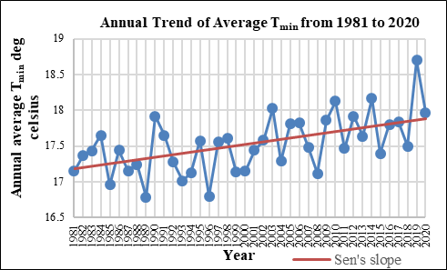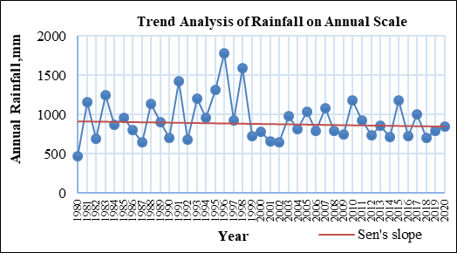

**Figure 5 Trend Analysis of Annual Rainfall**

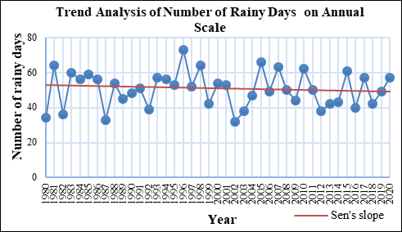

**Figure 6 Trend of Annual Number of Rainy Days**

**Figure 7 Trend of Number of Rainy Days during Pre-Monsoon**

**Figure 3 Trend Analysis of Annual Tmax**



**3.2 Mann Whitney Pettitt Homogeneity Test**

The Mann-Kendal statistical trend analysis identified a significant increasing trend in minimum temperature during the study period (1981-2020) on annual and seasonal time scales. The change point in the time period was assessed in accordance with Equation 2 using the Mann Whitney Pettitt homogeneity test. For the Thippasamudram region, the year 2001 was identified as the most probable change point of rising minimum temperature within the time period. According to statistics, it was found that the annual scale of climate variability has existed since 2001. The most likely change points in the year, according to the NE and SW seasonal scale, were 2008 and 1994, respectively. Figure 8 shows the homogeneity analysis of annual minimum temperature. The homogeneity analysis of minimum temperature on NE and SW seasonal scales was shown in Figures 9 and 10. As seen in Figure 11, there is no breakpoint detected for the summer.

**Figure 8 Homogeneity Analysis of Temperature on Annual Scale**

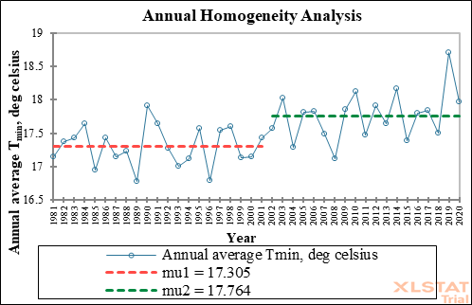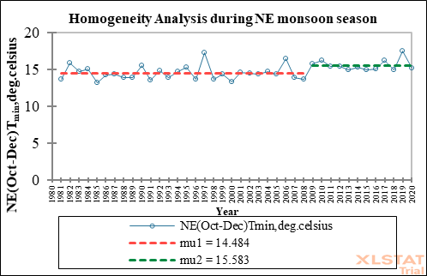

**Figure 9 Homogeneity Analysis of Temperature during during NE Monsoon Season**

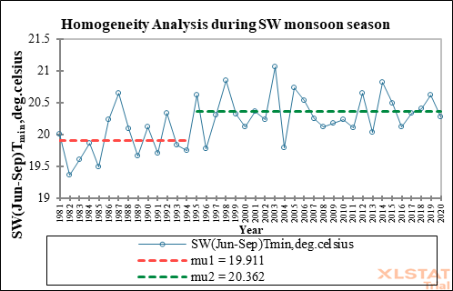

**Figure 10 Homogeneity Analysis of Temperature during SW Monsoon Season**

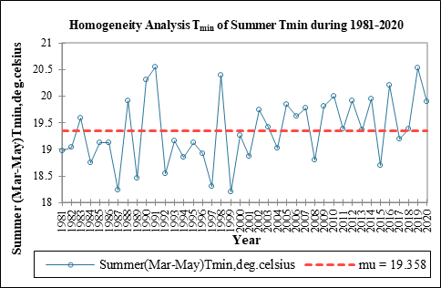

**Figure 11 Homogeneity Analysis of Temperature during Summer Season**

**3.3 Co-efficient of Variation**

The CV was calculated using Equation 3. The results are tabulated in Table 6.

**Table 6 CV Results of Tmax, Tmin and Rainfall**

| **Timescale** | **Tmax** | | | **Tmin** | | | **Rainfall** | | |
| --- | --- | --- | --- | --- | --- | --- | --- | --- | --- |
| **Mean**  **($℃)$** | **SD**  **($℃)$** | **CV**  **(%)** | **Mean**  **($℃)$** | **SD**  **($℃)$** | **CV**  **(%)** | **Mean**  **(mm)** | **SD**  **(mm)** | **CV**  **(%)** |
| January | 32.03 | 1.482 | 21.61 | 12.878 | 1.107 | 11.63 | 23.8 | 9.29 | 39.03 |
| February | 36.08 | 1.593 | 22.64 | 14.136 | 1.122 | 12.59 | 46.25 | 19.93 | 43.09 |
| March | 39.385 | 1.309 | 30.08 | 16.635 | 1.173 | 14.18 | 46.65 | 20.58 | 44.12 |
| April | 40.874 | 1.114 | 36.69 | 19.581 | 0.96 | 20.39 | 39 | 24.21 | 62.07 |
| May | 40.409 | 1.416 | 28.53 | 21.859 | 0.673 | 32.47 | 225.25 | 81.35 | 36.11 |
| June | 36.534 | 1.727 | 21.15 | 20.818 | 0.62 | 33.57 | 130.7 | 60.24 | 46.09 |
| July | 34.935 | 1.188 | 29.40 | 20.306 | 0.567 | 35.81 | 192 | 92.06 | 47.95 |
| August | 34.358 | 1.367 | 25.13 | 20.201 | 0.407 | 49.63 | 182.6 | 100.06 | 54.80 |
| September | 33.348 | 2.005 | 16.63 | 19.492 | 0.716 | 27.22 | 240.75 | 83.83 | 34.82 |
| October | 31.356 | 1.876 | 16.71 | 17.594 | 1.4 | 12.56 | 207.1 | 85.26 | 41.17 |
| November | 29.616 | 1.52 | 19.48 | 14.155 | 1.802 | 7.85 | 230.05 | 91.62 | 39.82 |
| December | 29.323 | 1.637 | 17.91 | 12.692 | 1.245 | 10.19 | 167.25 | 69.45 | 41.52 |
| Winter | 34.058 | 1.304 | 26.11 | 13.507 | 0.897 | 15.05 | 46.25 | 21.34 | 46.15 |
| Summer | 40.22 | 0.79 | 50.91 | 19.358 | 0.635 | 30.48 | 118.28 | 85.00 | 71.86 |
| SW Monsoon | 20.205 | 0.389 | 51.94 | 20.205 | 0.389 | 51.94 | 489.88 | 186.77 | 38.12 |
| NE Monsoon | 30.098 | 1.452 | 20.72 | 14.814 | 1.01 | 14.66 | 319.82 | 145.88 | 45.61 |
| Annual | 35.025 | 0.743 | 47.13 | 17.523 | 0.401 | 43.69 | 932.80 | 273.40 | 29.30 |

**3.3.1 Maximum Temperature**

The long term mean annual Tmax over the period of 40 years (1981-2020) in the study area was found to be 35˚C with a standard deviation (SD) of 0.743˚C and CV of 47.13%. The CV value indicates the higher annual variability.

According to the season-wise analysis, the highest mean Tmax recorded in the summer season was 40.22˚C with an SD of 0.79˚C and CV of 50.91%, indicating a higher degree of variability. The highest CV of 51.94 percent, was observed during the SW monsoon season, with an average Tmax of 20.20˚C and an SD of 0.38˚C. From this, it was evident that there exists an inter-annual fluctuation. Other seasons showed moderate fluctuation (20 < CV < 30).

On a monthly basis, December was the coldest month of the year (29.3˚C), and April was the warmest (40.8˚C), followed by May (40.4˚C). Less fluctuation was found from September to December (CV < 20). While March and April showed the greatest variability (CV > 30). The remaining months exhibited moderate fluctuation.

**3.3.2 Minimum Temperature**

The long term mean annual Tmin during the period of 40 years (1981-2020) in the study area was 17.5˚C with SD of 0.4 ˚C and CV of 43.69 percent, as shown in Table 6. The CV value implies a higher annual variability.

On season wise analysis, the highest mean Tmin was recorded during the SW monsoon season, at 20.2 °C with an SD of 0.38 °C and CV of 51.94 %, followed by the summer season, which had a CV of 30.48 %, showing a higher level of variability. The low fluctuation was also evident during the NE and winter seasons.

The coldest month of the year was December (12.6˚C), and the warmest was May (21.8˚C). The months January to March and October to December exhibited less variability. While September and April revealed a moderate degree of variability, greater variation was prevalent in the remaining months.

**3.3.3 Rainfall**

The highest mean monthly rainfall (240.75 mm) was recorded in September, with a SD of 83.83 mm and a CV of 34.82 percent, showing a high degree of variability that contributed around 25.8 percent to the yearly rainfall. The increased variability in rainfall was evident across all the months (CV > 30).

The season-wise analysis revealed that the SW monsoon season had the highest mean rainfall of 489.88 mm with an SD of 186.77 mm and CV of 38.12 percent, indicating a higher level of variability. The larger fluctuation was also observed in other seasons (CV > 30). The SW and NE monsoons accounted for approximately 52.5% and 34.2% of total rainfall, respectively. In terms of the percentage contribution to the mean annual rainfall, the pre-monsoon season (12.6%) made a greater contribution than the winter season (1.1%).

The long-term mean annual rainfall over the period of 41 years (1981-2020) in the study area was 932.8 mm, with a standard deviation (SD) of 273.40 mm and a CV of 29.30%. The CV value indicates moderate annual rainfall variability (20 < CV < 30).

**3.3.4 Rainy days**

As noted in Table 5, the observed mean number of rainy days during the SW monsoon was 25, with an SD of 6 days and moderately high variability (CV= 25.40%). The average number of rainy days throughout the NE and winter seasons were 17 and 4, respectively, with fluctuation (CV= 35.67 percent) and (CV= 38.46 percent). Pre-monsoon was the season with the highest variability (CV = 46.92%).

In the annual analysis, it was observed that there were 50 rainy days on an average, and that there was less variation (CV= 19.98%) with an SD of 10 days.

**3.4 Temperature Anomaly**

The temperature anomaly analysis was performed to determine the magnitude of the temperature increase over the study period while accounting for the duration from 1981 to 2020. Temperature anomalies in the Thippasamudram region are depicted in Figure 12. According to this study, the year 2012 had the highest positive anomaly, indicating that it was the warmest year during the study period, with an increase in surface air temperature of 0.86˚C, followed by 0.82˚C in 2019. The lowest negative anomaly on record occurred in 2008, with a rate of -0.85˚C, followed by 1981 with a rate of -0.67 ˚C. Figure 13 depicts a trend of insignificant increasing temperature anomaly.

**Figure 12 Anomalies of Air Temperature experienced in Thippasamudram Area**

**Figure 13 Trend Analysis of Temperature Anomaly**

**3.5 Rainfall Anomaly Index (RAI)**

For this study, RAI was calculated on seasonal and annual basis for the period 1980-2020, using the Equation 4. Figures 14, 15, and 16 illustrate the graphs that represent the positive and negative rainfall anomalies on an annual, SW and NE monsoon seasonal scales. Positive RAI values represent rainy years, whereas negative RAI values indicate dry years.

**Figure 14 Rainfall Anomaly Index on Annual Scale**

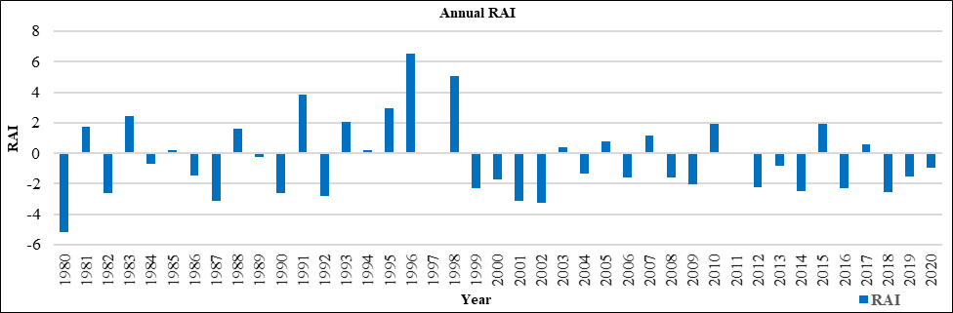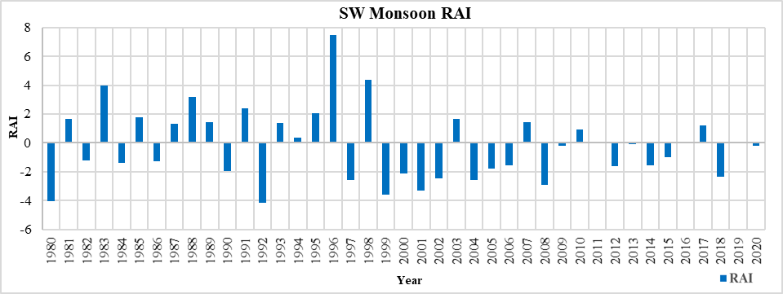

**Figure 15 Rainfall Anomaly Index during SW Monsoon Season**

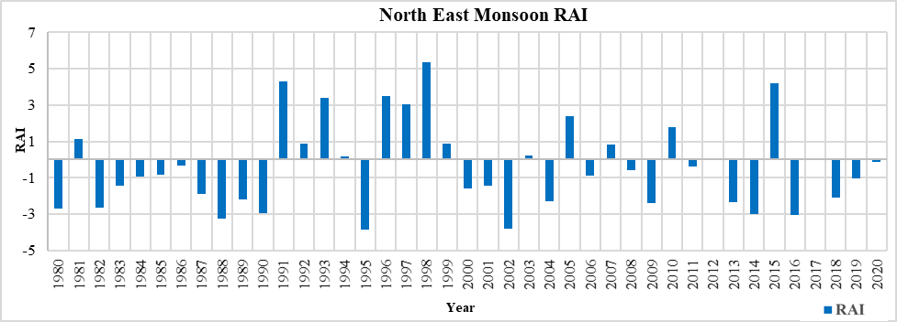

**Figure 16 Rainfall Anomaly Index during NE Monsoon Season**

According to the above graphs, the Thippasamudram region experienced 26 years of dry to extremely dry period, and 15 years of rainy to very rainy period on yearly basis.

24/41 years during the SW monsoon season ranged from dry to extremely dry, and 17/41 of the years during the same period were from rainy to very rainy. 25/41 of the years during the NE monsoon season ranged from dry to very dry, and 16/41 of the years ranged from rainy to very rainy.

The year 1996 showed the highest positive value, with a RAI of 6.503 described as extremely rainy, followed by the year 1998 with a RAI of 5.036. The year 1980 showed lower negative value, with a RAI of -5.168 regarded as an extremely dry year.

Rainfall intensity classes for precipitation events during the study period (1980-2020) were categorized according to Table 2 and are shown in Table 7.

**Table 7 Results of Year-wise categorization of RAI**

|  |  |  |  |  |  |  |  |
| --- | --- | --- | --- | --- | --- | --- | --- |
| **Years** | | | | | | | |
| **Rainy** | **Very Rainy** | **Extremely Rainy** | | **Dry** | **Very Dry** | | **Extremely Dry** |
| **Annual Scale** | | | | | | | |
| 1981, 1988,  1994, 2003,  2005, 2007,  2010, 2015,  2017 | 1983, 1991  1993, 1995 | 1996, 1998 | 1982, 1984, 1985, 1986, 1989, 1997, 2000, 2004, 2006, 2008, 2011, 2013, 2019, 2020 | | 1987, 1990, 1992, 1999,  2001, 2002,  2009, 2012,  2014, 2016,  2018 | | 1980 |
| **SW Monsoon Scale** | | | | | | | |
| 1981, 1985,  1987, 1989,  1993, 1994, 2003, 2007,  2010, 2017,  2019 | 1983, 1988,  1991, 1995 | 1996, 1998 | 1982, 1984, 1986, 1990, 2005, 2006, 2009, 2011, 2012, 2013, 2014, 2015,  2016, 2020 | | | 1997,1999,  2000,2001,  2002, 2004  2008, 2018 | 1980, 1982 |
| **NE Monsoon Scale** | | | | | | | |
| 1981, 1992,  1994, 1999,  2003, 2007, 2010, 2012,  2017 | 1993, 1996,  1997, 2005 | 1991, 1998,  2015 | 1983, 1984, 1985, 1986, 1987, 2000, 2001, 2006, 2008, 2011, 2019, 2020 | | | 1980, 1982, 1988, 1989,  1990, 1995,  2002, 2004,  2009, 2013,  2014, 2016,  2018 | - |

Table 7 highlights that, in terms of frequency of occurrence, dry years are more frequent than rainy years.

**3.6 Precipitation Concentration Index (PCI)**

Using Equation 5, the PCI was determined for the precipitation data for the years 1980 to 2020, and it was then classified in accordance with Table 3. According to Figure 17, the linear trend of the PCI value during the years 1980-2020 revealed an insignificant declining trend at a significance level of 0.05.

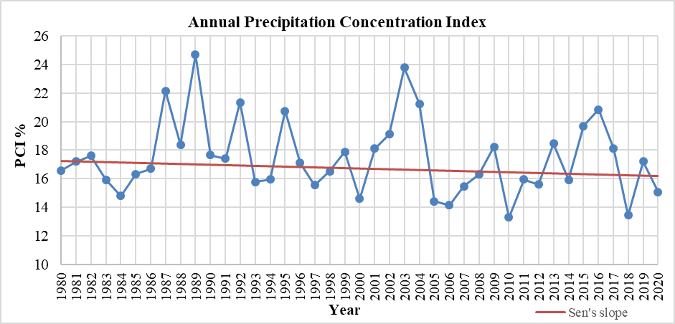

**Figure 17 Annual Precipitation Concentration Index of Thippasamudram Region**

The annual PCI value varied from the lowest of 13.29 in 2010 (moderate distribution of precipitation) to the highest of 24.68 in 1989 (strong irregular distribution). The precipitation events showed a strong irregularity in seven of the 41 years.

The outcomes of the trend analysis revealed that there was no statistically significant trend for rainfall and the number of rainy days. But it implies that the rainfall was distributed poorly. Hence Thippasamudram experienced significant inter-annual variation in rainfall during the period of study.

**3.7 COMPARISON WITH THE FIELD LEVEL DATA**

The RAI and PCI results were compared with the Thippasamudram tank fillings in order to correlate the climate data at field level. The year-by-year comparison of tank filling data with RAI and PCI results is shown in Table 8. The tank filling data was found to be consistent with the RAI and PCI results. Full tank filling was attained approximately once in four years. Tank filling data was obtained through a questionnaire survey and got triangulated with the WRD officials or records. It was revealed that the climate fluctuation impacts the tank fillings.

**Table 8 Comparison of Tank Filling Data with the Results of RAI and PCI**

|  |  |  |  |  |  |
| --- | --- | --- | --- | --- | --- |
| **Year** | **Annual**  **Rainfall**  **(mm)** | **Standard Deviation**  **(mm)** | **Classification based on RAI** | **Rainfall Distribution Based on PCI** | **Percentage of tank Filling (%)** |
| 2010 | 1181.6 | 79.36 | Rainy year | Moderate distribution | 100 |
| 2011 | 926.4 | 77.1 | Dry | Irregular distribution | <50 |
| **2012** | **732.4** | **59.52** | **Very dry** | **Irregular distribution** | **<50** |
| 2013 | 857.2 | 82.27 | Very dry | Irregular distribution | <50 |
| 2014 | 713.8 | 59.27 | Very dry | Irregular distribution | <50 |
| **2015** | **1182.7** | **120.23** | **Rainy year** | **Irregular distribution** | **100** |
| 2016 | 730.9 | 77.98 | Very dry | Strong irregularity | <50 |
| 2017 | 1009.2 | 95.14 | Rainy year | Irregular distribution | 75 |
| **2018** | **707.4** | **48.16** | **Rainy year** | **Moderate distribution** | **100** |
| 2019 | 798.8 | 71.71 | Dry | Irregular distribution | 50 |
| 2020 | 846.7 | 66.26 | Dry | Moderate distribution | 75 |

The tank filling percentage for 2015 was reported as 100%, and it was classified as a rainy year by RAI. The PCI value was calculated as 19.70 (irregular distribution) and the SD from the mean rainfall was 120.23 mm. The NE monsoon was accounted for 52% of the annual rainfall, particularly rain in November contributing for 71% of the total. It describes the temporal variation of rainfall throughout time.

In 2012, the SD was 59.52 mm, and the estimated PCI value was 15.6 (irregular distribution). Only around 4% of the annual total rainfall falls during the non-monsoon season, which results in uneven rainfall distribution and tank fill rates below 50%.

The average annual rainfall in the Thippasamudram region was 941.7 mm; in 2018, 707.4 mm of rainfall was reported, with a SD of 48.16 mm. The moderate distribution and full-tank fills have this as its justification.

**4. CONCLUSION**

The objectives of this study were to assess the temperature and rainfall variations and to observe the trends between 1981 to 2020. This study examined the statistical relationships of the data. The temperature and rainfall trend, temperature anomaly, homogeneity analysis, RAI, and PCI were carried out. The maximum temperature during the NE monsoon season showed an insignificant increasing trend of 0.009˚C, while the SW, winter, and summer revealed an insignificant declining trend of 0.006˚C, 0.001˚C, and 0.025˚C, respectively, during the study period. The SW, NE monsoon, summer, and annual Tmin exhibited an increasing trend at the rate of 0.017˚C, 0.037 ͦ˚C, 0.024 ˚C, and 0.018˚C each year, respectively. Mann Whitney Pettitt statistics indicate that there has been a yearly minimum temperature variation found since 2001. The NE seasonal scale indicated that 2008 was the year in which a shift occurred. On the SW monsoon scale, 1994 was the year in which such a shift was noticed.

According to the Coefficient of variation (CV) statistics, rainfall was found to be highly variable both monthly and seasonally. While the number of rainy days was significantly varied during the season-wise rainfall in the study area, the number of yearly rainy days exhibited less variation. There was no significant change in the annual precipitation trend. Poor distribution of rainfall was examined by calculating the Precipitation Concentration Index. As classified by the Rainfall Anomaly Index (RAI), the frequency of dry years was more than rainy years during the study period.

The conclusion drawn was that there has been a significant rise in the minimum temperature and that inter annual variations in the amount of rainfall have been examined in the study area. These findings got aligned with the tank fillings data. Hence the Thippasamudram tank which is rainfed, has the erratic rainfall rendered the tank filling inconsistent.

**Study Highlights:**

● This study assessed the climatic variability and trends at the local scale.

● The tank-filling data were triangulated with the results of climate variability.

**Disclaimer (Artificial intelligence)**

Option 1:

Author(s) hereby declare that NO generative AI technologies such as Large Language Models (ChatGPT, COPILOT, etc.) and text-to-image generators have been used during the writing or editing of this manuscript.

Option 2:

Author(s) hereby declare that generative AI technologies such as Large Language Models, etc. have been used during the writing or editing of manuscripts. This explanation will include the name, version, model, and source of the generative AI technology and as well as all input prompts provided to the generative AI technology

Details of the AI usage are given below:

1.

2.

3.

**REFERENCES**

1. Guiteras, R. (2009). *The Impact of Climate Change on Indian Agriculture* (pp. 1–54) [Manuscript]. Department of Economics, University of Maryland, College Park. http://econdse.org/wp-content/uploads/2014/04/guiteras_climate_change_indian_agriculture_sep_2009.pdf
2. Hare, W. (2003). *Assessment of Knowledge on Impacts of Climate Change Contribution to the Specification of Article 2 of the UNFCCC: Impacts on Ecosystems, Food Production, Water and Socio -economic Systems*. WBGU. http://www.wbgu.de/wbgu_sn2003_ex01.pdf
3. IPCC. (2007). *Climate change 2007: The physical science basis: contribution of Working Group I to the Fourth Assessment Report of the Intergovernmental Panel on Climate Change* (S. Solomon & Intergovernmental Panel on Climate Change, Eds.). Cambridge University Press.
4. Mohanty, A., & Wadhawan, S. (2021). *Mapping India’s Climate Vulnerability*. Council on Energy, Environment and Water. https://www.ceew.in/sites/default/files/ceew-study-on-climate-change-vulnerability-index-and-district-level-risk-assessment.pdf
5. Oliver, J. E. (1980). MONTHLY PRECIPITATION DISTRIBUTION: A COMPARATIVE INDEX. *The Professional Geographer*, *32*(3), 300–309. https://doi.org/10.1111/j.0033-0124.1980.00300.x
6. Palanisami, K., & Nanthakumaran, A. (2009). Water Resources Management with Special Reference to Tank Irrigation with Groundwater Use. *Second National Workshop on Strategic Issues in Indian Irrigation*, 305–333. https://publications.iwmi.org/pdf/H042698.pdf
7. Pathak, H. (2015). Greenhouse Gas Emission fromIndian Agriculture: Trends, Drivers and Mitigation Strategies. *Proceedings of the Indian National Science Academy*, *81*(5). https://doi.org/10.16943/ptinsa/2015/v81i5/48333
8. Sathyan, A. R., Funk, C., Aenis, T., & Breuer, L. (2018). Climate Vulnerability in Rainfed Farming: Analysis from Indian Watersheds. *Sustainability*, *10*(9), 3357. https://doi.org/10.3390/su10093357
9. Eckstein, D., Künzel, V., and Schafer, L. (2021). *GLOBAL CLIMATE RISK INDEX 2021 Who Suffers Most from Extreme Weather Events?* Westher-Related Loss Events in 2019 and 2000–2019, Germanwatch e.V., <https://www.germanwatch.org/en/cri>
10. Hirsch, R.M., Helsel, D.R., Cohn, T.A. & Gilroy, E. J. (1993) Statistical treatment of hydrologic data. In: *Handbook of Hydrology*. (ed. D. R. Maidment), McGraw-Hill, New York, pp. 17.1-17.52.
11. Van Rooy, M.P. (1965). A rainfall anomaly index independent of time and space. Notos 14: 43-48.
12. Agriculture Census Report (2015-2016). Downloaded from: https://agcensus.nic.in/document/agcen1516/T1_ac_2015_16.pdf. (Accessed date :25 February 2025).
13. Daily Rainfall Data (1980-2020). Downloaded from: https://dsp.imdpune.gov.in/ (Accessed date: 2 May 2022).
14. Daily Temperature Data (1981-2020). Downloaded from: https://power.larc.nasa.gov/data-access-viewer/ (Accessed date: 25 April 2022).
15. Google Earth Pro (2020). Available at: https://earth.google.com/web/ (Accessed date: 21 November 2020)
16. Gan, T. Y., Ito, M., Hülsmann, S., Qin, X., Lu, X. X., Liong, S. Y., ... & Koivusalo, H. (2016). Possible climate change/variability and human impacts, vulnerability of drought-prone regions, water resources and capacity building for Africa. *Hydrological Sciences Journal*, *61*(7), 1209-1226.
17. Yaduvanshi, A., Nkemelang, T., Bendapudi, R., & New, M. (2021). Temperature and rainfall extremes change under current and future global warming levels across Indian climate zones. *Weather and Climate Extremes*, *31*, 100291.
18. Matham, P. K., Pattanayak, S., Kolagani, N., & Shankari, U. (2024). Rainfed Agriculture and Use of Groundwater: Winners and Losers-A Review of Literature of Experiences in India. *Current Agriculture Research Journal*, *12*(2).
19. Farah, K. H., & Muhumed, U. M. (2024). Evaluation of the Effects of Climate Variability on Water Resources and Agriculture: Insights from Regional Climate Models. *Journal of Engineering Research and Reports*, *26*(9), 66–77.