Growth performance of paddy (*Oryza sativa* L.) under influence of foliar application of nano silica in calcareous soil condition

.

ABSTRACT

|  |
| --- |
| The pot experiment was conducted to study the “Growth performance of paddy (*Oryza sativa* L.) under influence of foliar application of nano silica in calcareous soil condition” during *rabi* season 2024 - 2025 at North farm, shade net, Karunya Institute of Technology and Sciences, Coimbatore. The soil used for this study was silt clay loam in texture and calcareous in nature. The experiment was laid out in complete randomized design replicated thrice with eight treatments. The variety CO 51 with short duration of 105 – 110 days was used as a test variety in this study. The treatments were foliar application of nano silica @ 0.1% (T1), foliar application of nano silica @ 0.25% (T2), foliar application of nano silica @ 0.5% (T3), foliar application of nano silica @ 0.75% (T4), foliar application of nano silica @1% (T5), foliar application of potassium silicate @ 1% (T6), foliar application of potassium silicate @ 2% (T7) and control (T8).The findings suggested that paddy growth was significantly affected by the application of nano silica @ 0.5% (T3) in calcareous soil, outperforming potassium silicate, a conventional type of silica fertilizer and recorded the highest plant height (98.90 cm), number of tillers hill-1 (25) and dry matter production (34.33 g plant⁻¹). Although higher concentrations of nano silica 0.75% and 1.0% increased plant growth, the optimum 0.5% treatment performed better than both the higher concentrations, indicating the superiority effect of nano silica even under less concentration. Overall, under calcareous soil conditions, nano silica can be considered as a better paddy growth promoter than potassium silicate. |

***Keywords:*** *Silica; Nano silica; Paddy (Oryza sativa* L*.*)*; foliar application; cereal crop,*

1. INTRODUCTION

Paddy (Oryza sativa L.), the most crucial food crop sustains over 60% of the global population and is a significant contributor to worldwide food security. Paddy has significant effects on agricultural and economic systems and is strongly associated with dietary and traditional systems of Tamil Nadu. But Tamil Nadu has 34% of its land covered by calcareous soil (Selvakumar *et al.,* 2019) and possess large amounts of calcium carbonate, high alkaline pH and poor availability of nutrients which, are not suitable for agricultural production (Bolan *et al.,* 2023). In addition to this issue, environmental factors like climate change and abiotic stresses worsen the scenario by drought, salinity, and nutrient deficiencies, collectively contributing to annual yield losses of 51–82% in vulnerable agroecosystems, threatening food security and environmental stability (Oshunsanya *et al*., 2019). Additionally, with the global population projected to reach 10 billion by 2050 (Montoya-Martínez *et al.,* 2022), the demand to adopt climate-resilient agriculture practices, improve crop resilience and, productivity through environmental sustainable agricultural developments has become greater. To overcome these obstructions, silicon (Si), a beneficial and the second most widely distributed element in the Earth's crust, has emerged as a critical component in plant physiology (Singh *et al*., 2021). Though not considered essential, Si is increasingly recognized for its role in reducing abiotic stress and boosting nutrient absorption efficiency. In paddy, silicon accumulated in shoots at levels are comparable to macronutrients, reinforces cell walls, increases mechanical stability, and improves stress tolerance (Berahim *et al.,* 2021; Garg *et al*., 2020).However, naturally present silica in the soil are mostly in the unattainable form for the plants and has poor bioavailability in soils (Thakral *et al*., 2024).Especially in such demanding environments, there is a great need for formulated silicon with an optimized delivery platform.

Nanomaterials are reported to be a potential solution to these challenges, particularly nano silica because of its distinctive physicochemical properties of huge surface area, adjustable porosity, and enhanced reactivity (Goswami *et al.,* 2022). These characteristics allow for better nutrient uptake, transport, and use efficiency than bulk or conventional type of Si fertilizers. Recent research has revealed that nano silica can help crops withstand abiotic stress by improving root architecture, photosynthetic efficiency, and biomass accumulation in crops exposed to salt, drought, and heavy metal stress (Siddiqui *et al*., 2020; Zargar *et al*. 2019). This present study addresses the gap by determining the role of nano silica in improving paddy growth characteristics in calcareous soils and hopes to provide the groundwork for optimizing nano silica treatments to improve crop resilience and productivity in stress prone agroecosystems and to provide environmentally sustainable crop production.

2. material and methods

A pot experiment was conducted in shade net located in North Farm, Karunya Institute of technology and sciences (100 94ʹ N latitude, 760 74ʹ E longitude and at an altitude of 448.6 m) Coimbatore, Tamil Nadu under controlled conditions during Samba season 2024-2025 to examine the effect of nano silica application on paddy to examine the growth attributes under calcareous soil condition. This site falls under the western agroclimatic zone of Tamil Nadu (Fig.1). During the cropping period, the maximum temperature ranged from 27.9 ℃ to 32.7 ℃ and minimum temperature ranged from 18.7 ℃ and 21.5 ℃. The mean rainfall received during the cropping period in 2024 - 2025 was 6.42 mm. The mean relative humidity recorded during the cropping period was 73.53 %. The soil in the experimental field was silt clay loam. and had NPK levels of 265.60, 30.35, 301.44kg ha-1 respectively.

Poly bags of 37 cm diameter and 21 cm length were used for this research and they are thoroughly cleaned, ensured with good proper drainage facility. The pots are filled with 20 kg of calcareous soil and carefully labelled and arranged in a organized manner under controlled environment to monitor various parameters accurately. The Paddy variety CO 51 is sown in twenty four pots. Each pot was sown with 4 to 5 seeds, evenly spaced at five points to ensure uniform distribution, and placed at an optimum depth before being gently covered with topsoil. The pots are then irrigated just enough to moisten the soil and placed in an area where there is sufficient sunlight to germinate and they are monitored regularly.

The experiment was laid out in complete randomized design replicated thrice with 8 treatments. Foliar application of nano silica @ 0.1% (T1), foliar application of nano silica @ 0.25% (T2), foliar application of nano silica @ 0.5% (T3), foliar application of nano silica @ 0.75% (T4), foliar application of nano silica @ 1% (T5), foliar application of Potassium silicate @ 1% (T6), Foliar application of Potassium silicate @ 2% (T7), Control (T8). separate row was kept and used for biometric observations on growth attributes to evaluate the impact of the treatments. Statistical analysis was performed to compare treatment means at a 5% significance level suggested by Gomez and Gomez (1984).

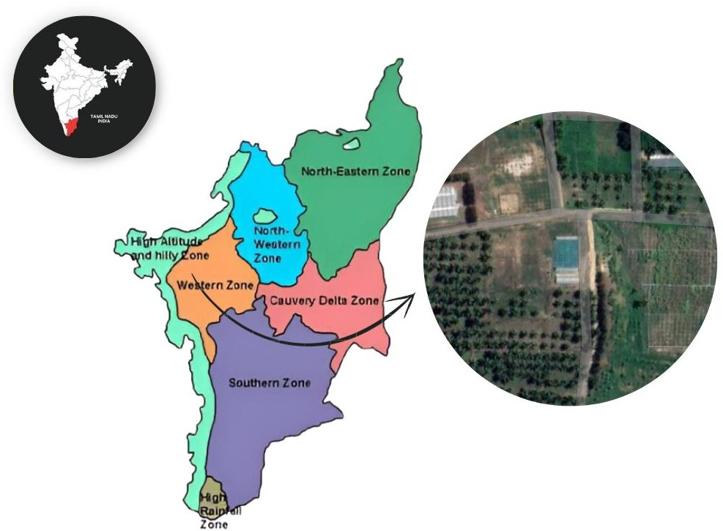

Fig. 1. Location of the experimental site during rabi season of 2024-2025

3. RESULTS

3.1 Plant height (cm)

Plant height is the visible indicator of crop growth. Significant effects of nano silica on plant height in Paddy CO 51 was observed throughout the different growth stages of crop *viz.,* 35 DAS, 65 DAS, 95 DAS and at harvest are given in Table 1 and Fig. 2

The effect of nano silica on plant height were significant on all stages. Among the treatments, foliar application of nano silica @ 0.5% (T3) recorded higher plant height at 35 DAS, 65 DAS, 95 DAS and at harvest (43.60, 84.86, 94.20 and 98.90 cm, respectively) and which was on par with foliar application of nano silica @ 0.75 % (T4) (41.86, 82.76, 93.16 and 96.96 cm, respectively) and foliar application of nano silica @ 1% (T5) with the plant height of 40.30, 87.53, 93.73 and 97.83 cm, respectively. It was followed by foliar application of potassium silicate @ 1 % (T6) and foliar application of potassium silicate @ 2% (T7), Control (only RDF) (31.46, 61.56, 71.26 and 75.56 cm, respectively).

3.2 Number of tillers hill-1

Foliar application of different concentrations of nano silica had significant influence on tiller production at all the stages of observation and is presented in Table 1 and Fig. 3.

Among the treatments, the foliar application of nano silica at 0.5% (T₃) recorded the higher number of tillers, (14.00, 24.66, 25.00, and 25.00 tillers hill-1 at 35, 65, 95 DAS, and at harvest, respectively). This was statistically on par with nano silica at 0.75% (T₄) and 1% (T₅), which recorded 11.33, 23.33, 24.00, and 24.33 tillers hill-1 (T₄) and 10.00, 21.00, 22.00, and 22.66 tillers hill-1 (T₅) at the respective stages.

The foliar application of potassium silicate at 1% (T₆) and 2% (T₇) resulted in moderate tiller production when compared to the best treatment, with values ranging between 6.33 to 15.33 tillers hill-1 at different growth stages and they were statistically on par with each other but foliar application of potassium silicate at 1% (T₆) (8.33, 15.33, 16.00, 16.33 tillers hill-1) was better when compared to foliar application of potassium silicate @ 2% (T7). In contrast, the control (T₈) recorded the lower number of tillers at all growth stages, with values of 4.33, 5.66, 6.00, and 6.33 tillers hill-1 at 35, 65, 95 DAS, and at harvest, respectively.

**3.3 Dry matter Production (g plant-1)**

Foliar application of different concentrations of nano silica had a significant influence on dry matter production at all the stages of observation, as presented in Table 1 and Fig.4. Among the treatments, the foliar application of nano silica at 0.5% (T₃) recorded the higher dry matter production, (11.33, 21.00, 29.00, and 34.33 g plant⁻¹ at 35, 65, 95 DAS, and at harvest, respectively). This was statistically on par with foliar application of nano silica at 0.75% (T₄) and 1% (T₅), which recorded 10.66, 20.66, 28.66, and 33.66 g plant⁻¹ (T₄) and 10.33, 20.00, 27.33, and 31.33 g plant⁻¹ (T₅) at the respective stages. The foliar application of potassium silicate at 1% (T₆) and 2% (T₇) exhibited a moderate increase in dry matter production compared to the nano silica application at 0.5, 0.75 and 1%, with values ranging between 7.00 g to 23.00 g plant⁻¹ across different growth stages. Among them, the foliar application of potassium silicate at 1% (T₆) (7.66 g, 14.00 g, 20.33 g, and 23.00 g plant⁻¹) showed relatively higher dry matter production compared to foliar application of potassium silicate at 2% (T₇) (7.00, 12.66, 15.66, 17.33 g plant-1).Conversely, the control (T₈) consistently exhibited the lower dry matter production throughout all growth stages, recording values of 4.00, 7.33, 9.33, and 11.66 g plant⁻¹ at 35, 65, 95 DAS, and at harvest, respectively. Among the various treatments, the foliar application of nano silica at 0.5% (T₃), 0.75% (T₄), and 1% (T₅) prove to significantly boost the dry matter production, emphasizing the beneficial impact of nano silica in promoting higher biomass accumulation in paddy.

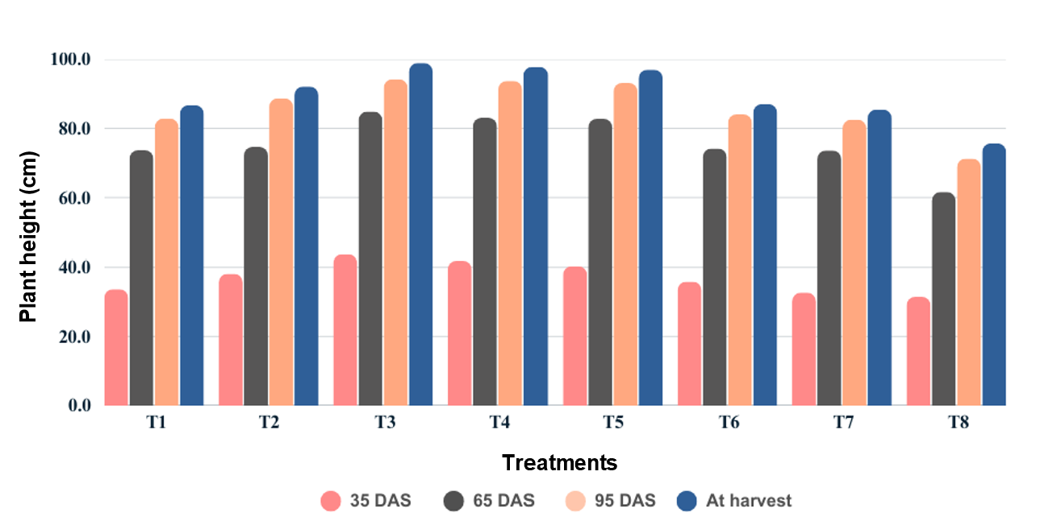

**Fig. 2. Influence of foliar application of nano silica on plant height of paddy**

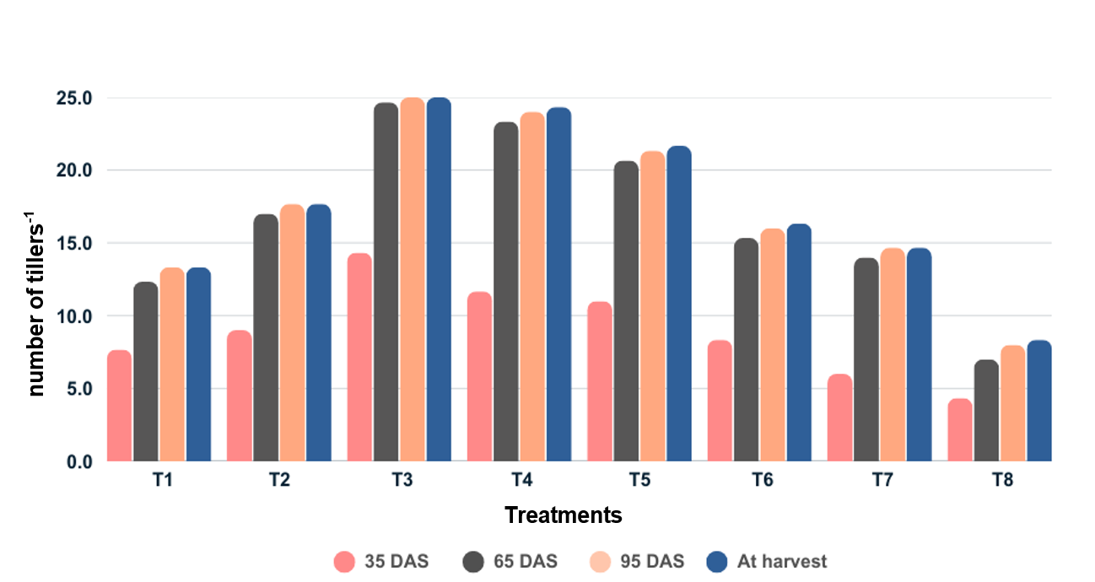

**Fig. 3. Influence of foliar application of nano silica on number of tillers-1 of paddy**

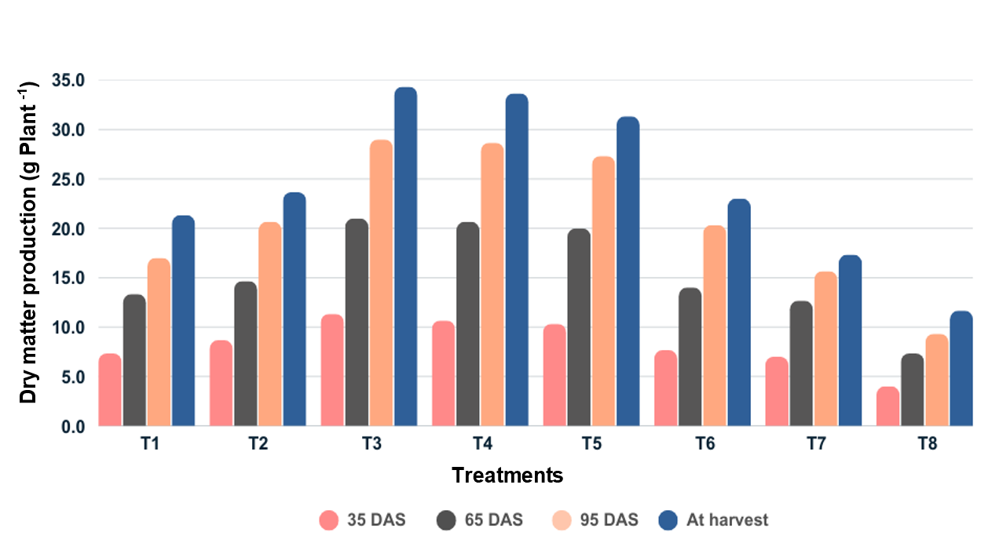Fig. 4. Influence of foliar application of nano silica on dry matter production (g plant-1) of paddy

Table 1. Influence of foliar application of nano silica on growth attributes of paddy

|  |  |  |  |  |  |  |  |  |  |  |  |  |
| --- | --- | --- | --- | --- | --- | --- | --- | --- | --- | --- | --- | --- |
| **Treatments** | **Plant height (cm)** | | | | **Number of tillers hill-1** | | | | **Dry matter Production**  **(g plant-1)** | | | |
|  | **35 DAS** | **65 DAS** | **95 DAS** | **At**  **harvest** | **35 DAS** | **65 DAS** | **95 DAS** | **At**  **harvest** | **35**  **DAS** | **65 DAS** | **95 DAS** | **At**  **harvest** |
| **T1** | 33.70 | 73.66 | 82.83 | 86.71 | 7.66 | 12.33 | 13.33 | 13.33 | 7.33 | 13.33 | 17.00 | 21.33 |
| **T2** | 38.16 | 74.66 | 88.71 | 92.11 | 9.00 | 17.00 | 17.66 | 17.66 | 8.66 | 14.66 | 20.66 | 23.66 |
| **T3** | 43.60 | 84.86 | 94.20 | 98.90 | 14.33 | 24.66 | 25.00 | 25.00 | 11.33 | 21.00 | 29.00 | 34.33 |
| **T4** | 41.86 | 83.10 | 93.73 | 97.83 | 11.66 | 23.33 | 24.00 | 24.33 | 10.66 | 20.66 | 28.66 | 33.66 |
| **T5** | 40.30 | 82.76 | 93.16 | 96.96 | 11.00 | 20.66 | 21.33 | 21.66 | 10.33 | 20.00 | 27.33 | 31.33 |
| **T6** | 35.86 | 74.20 | 84.06 | 87.03 | 8.33 | 15.33 | 16.00 | 16.33 | 7.66 | 14.00 | 20.33 | 23.00 |
| **T7** | 32.66 | 73.60 | 82.50 | 85.43 | 6.00 | 14.00 | 14.66 | 14.66 | 7.00 | 12.66 | 15.66 | 17.33 |
| **T8** | 31.46 | 61.56 | 71.26 | 75.66 | 4.33 | 7.00 | 8.00 | 8.33 | 4.00 | 7.33 | 9.33 | 11.66 |
| **Mean** | 37.20 | 76.05 | 86.31 | 90.08 | 9.04 | 16.79 | 17.5 | 17.66 | 8.37 | 15.45 | 21.00 | 24.54 |
| **SE(d)** | 3.92 | 4.49 | 4.70 | 2.77 | 1.14 | 1.84 | 1.76 | 1.16 | 1.22 | 2.28 | 2.76 | 2..52 |
| **CD**  **(p= 0.05)** | 8.31 | 9.53 | 9.97 | 5.87 | 2.42 | 3.90 | 3.73 | 3.53 | 2.59 | 4.84 | 5.86 | 5.34 |

*\*Foliar application of nano silica @ 0.1 % (T1), foliar application of nano silica @ 0.25 % (T2), foliar application of nano silica @ 0.5% (T3), foliar application of nano silica @ 0.75 % (T4), foliar application of nano silica @ 1% (T5), foliar application of Potassium silicate @ 1% (T6), Foliar application of Potassium silicate @ 2% (T7), Control (T8).*

4. discussion

4.1 Plant height (cm)

Plant height is a crucial growth factor that either directly or indirectly affects the total paddy productivity.

The results in Table 1 shows that foliar application of nano silica resulted in a considerable increase in plant height, notably at the 0.5% concentration (T3), which produced a maximum plant height of 98.90 cm at harvest. This was followed by 0.75% (T4) and 1% (T5) concentrations, with 97.83 and 96.86, respectively, which both resulted in higher plant heights when compared to the other two concentrations, 0.1% and 0.25%. From 35 DAS to harvest, the average plant height increased gradually across treatments, with the greatest increase observed at 95 DAS to harvest. This increase could be related to nano silica's role in boosting cell elongation, turgor pressure, and nutrient absorption, all of which lead to a greater plant height. Additionally, potassium silicate treatments (T6 and T7) also improved plant height when compared to the control, but their effects were much less significant than those of nano silica treatments, indicating the superiority of nano silica over traditional silicon sources.

The current results are consistent with a study by El-Kallawy *et al.* (2023) that found that nano silica improves metabolic processes like cell division and stem elongation, which directly contribute to increased plant height, and increases the bioavailability of essential nutrients, making it easier for them to be absorbed through foliar application. Additionally, the improvement in plant height can also be attributed to the stress mitigation effect of nano silica. This aligns with the findings of Mathur and Roy (2020), who reported that nano silica reduces oxidative damage by regulating reactive oxygen species (ROS), thereby preventing growth retardation and improving water-use efficiency. Furthermore, Bekkam and Thiyagarajan (2024) study confirms that foliar application of nano silica, especially at optimal concentrations, helps to increase plant height in cereal crops compared to higher concentration of nano silica.

In this study, root growth, which also contributes to plant height, was not measured, limiting the understanding of the complete effect of nano silica on plant development. Since root growth plays a vital role in nutrient uptake and overall plant vigor, future research should incorporate parameters such as root growth, stem thickness, and lodging resistance to provide a more comprehensive assessment of nano silica’s influence on plant architecture and exploring the nano silica interaction with other micronutrients or bio stimulants to enhance plant height further

4.2 Number of Tillers hill-1

Grain yield is directly impacted by the number of tillers, which is a critical yield attributing characteristic in rice.

The results (Table 1) show that using foliar application of nano silica considerably enhanced the number of tillers per hill at all growth stages. Among the treatments, foliar application of nano silica at 0.5% (T3) produced the most tillers per hill (25.00) at harvest, which was statistically comparable to T4 (24.33) and T5 (21.66). The increased number of tillers has been due to the favorable effects of foliar application of nano silica. It was also observed that treatments with potassium silicate (T6 and T7) produced less tillers per hill than nano silica treatments, emphasizing the superior efficacy of nano silica. The control treatment (T8) recorded the lower number of tillers, confirming the role of foliar application of nano silica in enhancing tiller production.

The study by Yue *et al*. (2023) supports that nano silica has the ability in increasing the number of tillers by improving silica bioavailability to the paddy. nano silica performed superior over conventional type of silica fertilizer (sodium silicate (Na₂SiO₃)), resulting in a more number of tiller compared to the control and sodium silicate (Na₂SiO₃), whereas sodium silicate showed minimal effects. These findings highlight the potential of nano silica as a more efficient alternative to traditional silica fertilizers.

Similar results were observed by Kheyri (2022), who reported that nano silica application significantly improved the productivity of paddy, increased the number of fertile tillers by 8.2% and increased grain yield by 9.5% compared to the control. These findings support that foliar nano silica application is a more effective means of increasing the number of fertile tillers and yield than control. However, as this study is mainly focused on foliar application, there is the absence of comparison between foliar and soil applied nano silica in a controlled experimental setup. Future research should explore this aspect to determine the best effective method for improving the productivity of crops.

4.3 Dry matter production (g plant-1)

Dry matter production is an important parameter that directly correlates with biomass and overall plant productivity. The role of nano silica in boosting dry matter production through enhanced nutrient absorption, photosynthetic rate and stress reduction is a key aspect for this improvement in dry matter production.

The results ( Table 1) clearly indicate a substantial increase in dry matter production when foliar applied with nano silica. The treatment T3 (foliar application of nano silica @ 0.5 %) recorded the higher dry matter production (34.33 g plant-1) at harvest, closely followed by T4 and T5. This significant increase in biomass may be attributed to enhanced nutrient absorption, improved photosynthetic efficiency, and reduced oxidative stress due to nano silica application These findings are in accordance with Larkunthod *et al.* (2022)

Additionally, it was noted that potassium silicate treatments (T6 and T7) resulted in lower dry matter production than nano silica treatments, implying the superior bioavailability and efficiency of foliar application of nano silica. The control treatment (T8) produced the least dry matter which confirms that foliar application of silicon has the ability to improve the dry matter production and overall biomass of the crop. These findings are in accordance with the study conducted by Elshayb *et al*. (2021). Similarly, Jin *et al*. (2024) emphasized the role of nano silica in improving plant growth and dry mass, which increased by 18–22% under salt stress condition.

Overall, under growth parameter the better growth results were consistently obtained with foliar application of nano silica @ 0.5%. Although higher concentrations (0.75% and 1%) also enhanced growth, their performance was slightly below that of the 0.5% treatment, demonstrating that nano silica is effective even at lower concentration. Additionally, when compared to conventional type of silica fertilizers, nano silica at 0.25% performed comparably to potassium silicate at 1%, indicating its efficiency at lower concentrations.

5. Conclusion

It is concluded that treatment with foliar application of nano silica @ 0.5% (T3) consistently demonstrated superior performance in promoting the growth attributes of paddy, reproductive growth, enhanced plant height, number of tillers hill-1 and dry matter production, which highlights the holistic improvement in growth attributes with this treatment. additionally, nano silica performed better than conventional type of silica fertilizer, as this is evident in many studies

**ACKNOWLEDGEMENT**

The authors are thankful to the division of Agronomy, karunya institute of technology and sciences, (Coimbatore) India for providing the necessary facilities to undertake the research

**Disclaimer (Artificial intelligence)**

Option 1:

Author(s) hereby declare that NO generative AI technologies such as Large Language Models (ChatGPT, COPILOT, etc.) and text-to-image generators have been used during the writing or editing of this manuscript.

Option 2:

Author(s) hereby declare that generative AI technologies such as Large Language Models, etc. have been used during the writing or editing of manuscripts. This explanation will include the name, version, model, and source of the generative AI technology and as well as all input prompts provided to the generative AI technology

Details of the AI usage are given below:

1.

2.

3.

References

Bekkam, R., & Thiyagarajan, C. (2024). Evaluating the effects of rice husk derived nanosilica on growth, photosynthesis, and antioxidant activity in hybrid maize. *Environmental Technology & Innovation*, 36, 103866.

Berahim, Z., Omar, M. H., Zakaria, N. I., Ismail, M. R., Rosle, R., Roslin, N. A., & Che’Ya, N. N. (2021). Silicon improves yield performance by enhancement in physiological responses, crop imagery, and leaf and culm sheath morphology in new rice line, PadiU Putra. *BioMed research international*, 2021(1), 6679787.

Bolan, N., Srivastava, P., Rao, C. S., Satyanaraya, P. V., Anderson, G. C., Bolan, S., Nortjé, G. P., Kronenberg, R., Bardhan, S., Abbott, L. K., Zhao, H., Mehra, P., Satyanarayana, S. V., Khan, N., Wang, H., Rinklebe, J., Siddique, K. H. M., & Kirkham, M. B. (2023). Distribution, characteristics and management of calcareous soils. In D. L. Sparks (Ed.), *Advances in agronomy*, 182, 81–130.

El-Kallawy, W. H., El-Salam, A., Rabeh, H. A., & Badawy, S. H. (2023). Impact of foliar application of nano-silicon and potassium humate on productivity and quality of Giza 178 rice cultivar under north delta conditions. *Menoufia Journal of Plant Production*, 8(5), 85-104.

Elshayb, O. M., Nada, A. M., Ibrahim, H. M., Amin, H. E., & Atta, A. M. (2021). Application of silica nanoparticles for improving growth, yield, and enzymatic antioxidant for the hybrid rice ehr1 growing under water regime conditions. *Materials*, 14(5), 1150.

Garg, K., Dhar, S., & Jinger, D. (2020). Silicon nutrition in rice (*Oryza sativa* L.)–A review. *Ann Agric Res*, 41, 221-229.

Gomez, K. A., & Gomez, A. A. (1984). *Statistical procedures for agricultural research*. John wiley & sons.

Goswami, P., Mathur, J., & Srivastava, N. (2022). Silica nanoparticles as novel sustainable approach for plant growth and crop protection. *Heliyon*, *8*(7).

Jin, W., Li, L., He, W., & Wei, Z. (2024). Application of silica nanoparticles improved the growth, yield, and grain quality of two salt-tolerant rice varieties under saline irrigation. *Plants*, 13(17), 2452.

Kheyri, N. (2022). Effect of silicon and nanosilicon application on rice yield and quality. *In Silicon and Nano-silicon in Environmental Stress Management and Crop Quality Improvement* (pp. 297-307). Academic Press.

Larkunthod, P., Boonlakhorn, J., Pansarakham, P., Pongdontri, P., Thongbai, P., & Theerakulpisut, P. (2022). Synthesis and characterization of silica nanoparticles from rice husk and their effects on physiology of rice under salt stress. *Chilean journal of agricultural research*, 82(3), 412-425.

Mathur, P., & Roy, S. (2020). Nanosilica facilitates silica uptake, growth and stress tolerance in plants. *Plant Physiology and Biochemistry*, 157, 114-127.

Montoya-Martínez, A. C., Parra-Cota, F. I., & de Los Santos-Villalobos, S. (2022). Beneficial microorganisms in sustainable agriculture: harnessing microbes’ potential to help feed the world. *Plants*, *11*(3), 372.

Oshunsanya, S. O., Nwosu, N. J., & Li, Y. (2019). Abiotic stress in agricultural crops under climatic conditions. *Sustainable agriculture, forest and environmental management*, 71-100.

Selvakumar, P. (2019). Spatial distribution of soil types in Yercaud Taluk using geo-spatial technology. *Journal of Emerging Technologies and Innovative Research (JETIR), 6*(3), 393-396

Siddiqui, H., Ahmed, K. B. M., Sami, F., & Hayat, S. (2020). Silicon nanoparticles and plants: current knowledge and future perspectives. *Sustainable Agriculture Reviews 41: Nanotechnology for Plant Growth and Development*, 129-142.

Singh, T., Singh, P., & Singh, A. (2021). Silicon significance in crop production: Special consideration to rice: An overview. *Pharma innov*, 10, 223-229.

Thakral, V., Raturi, G., Sudhakaran, S., Mandlik, R., Sharma, Y., Shivaraj, S., Tripathi, D. K., Sonah, H., & Deshmukh, R. (2024). Silicon, a quasi-essential element: Availability in soil, fertilizer regime, optimum dosage, and uptake in plants. *Plant Physiology and Biochemistry*, *208*, 108459.

Yue, L., Wang, J., Cao, X., Wang, C., Ma, C., Chen, F., ... & Xing, B. (2023). Silica nanomaterials promote rice tillering and yield by regulating rhizosphere processes, nitrogen uptake, and hormone pathways. *ACS Sustainable Chemistry & Engineering*, 11(46), 16650-16660.

Zargar, S. M., Mahajan, R., Bhat, J. A., Nazir, M., & Deshmukh, R. (2019). Role of silicon in plant stress tolerance: opportunities to achieve a sustainable cropping system. *3 Biotech*, 9(3), 73.