Climate Change, Regenerative Agriculture and Carbon Neutrality in the context of Tea Cultivation

Abstract
Climate change presents a significant challenge to global agriculture, impacting food security, crop productivity, and natural resources. While agriculture contributes to greenhouse gas (GHG) emissions, it also holds the potential to act as a carbon sink through regenerative practices. Regenerative agriculture, characterized by sustainable soil management, biodiversity enhancement, and ecosystem restoration, has emerged as a viable solution to mitigate climate impacts. In the context of tea cultivation, which is particularly susceptible to climate variability due to its C3 photosynthetic pathway, achieving carbon neutrality through regenerative agriculture is paramount.
However, while soil health management is central, it alone is not sufficient to build climate resilience within a time-bound framework. Plant health management is equally crucial, as it optimizes photosynthate utilization, minimizes pest and disease risks, and ensures better crop performance, a need recognized by the United Nations. Regenerative agriculture should extends beyond soil health management by incorporating plant health principles rooted in both ancient Indian philosophy and modern scientific theories. The Element Energy Activation (EEA) principle behind IRF Technology and the Trophobiosis Theory of Francis Chaboussou are conceptually interrelated. EEA emphasizes the role of plant energy dynamics in maintaining natural resilience, while Trophobiosis Theory highlights how healthy plants, with balanced biochemical processes, exhibit greater resistance to pests and diseases. By integrating these insights, IRF Technology offers a WHOLISTIC approach to plant health management, reducing chemical dependency, enhancing crop productivity, and improving ecosystem resilience. This has been demonstrated in initiatives like the one at Lakhipara Tea Estate, Dooars, where the adoption of Inhana Rational Farming (IRF) Technology resulted in increased productivity, reduced pesticide use, and a significant reduction in carbon footprint.
In this context, the Agriculture Carbon Footprint Assessor (ACFA) Version 2.0, developed collaboratively by Inhana Organic Research Foundation (IORF) and ICAR-ATARI Kolkata, serves as a groundbreaking tool for accurately assessing carbon footprints in agriculture. This innovative platform enables corporate net-zero compliance, supports ESG objectives, and advances sustainability initiatives by providing precise carbon emissions data and promoting regenerative practices.
In the tea sector, the Trustea Emission Calculator (TEC), developed using ACFA 2.0 framework, serves as a pioneering carbon computing tool. TEC offers estate-specific insights by considering agro-ecological variability and management diversity, enabling tea growers to quantify and reduce their carbon footprint effectively. This ensures transparency and accountability in sustainability efforts, supporting carbon-neutral farming and enhancing the resilience of the tea sector.
Policy frameworks must integrate regenerative agriculture principles with measurable impact assessments, incentivizing carbon-neutral practices and ensuring their alignment with food security and sustainability goals. By incorporating comprehensive soil and plant health management within a regenerative framework and leveraging tools like ACFA 2.0 and TEC, agriculture can transition from being a contributor to climate change to a key solution, ensuring food security, ecological balance, and long-term sustainability.

Key words: Soil health management, Plant health management, trophobiosis, carbon footprint, sustainable development goals (SDGs)

Introduction
Climate change is the greatest health threat facing humanity, jeopardizing global development, public health, and livelihood sustenance. Since 1850, the combined temperature of land and ocean has been rising at an average rate of 0.06°C per decade. Alarmingly, this warming rate has more than tripled since 1982, reaching approximately 0.20°C per decade (NOAA, 2023). These temperature shifts have profound consequences, disrupting ecosystems, intensifying extreme weather events, and exacerbating socioeconomic disparities worldwide.

Agriculture, as the backbone of human survival and development, is highly vulnerable to climate change. At the same time, it is also a significant contributor to global warming. Rising temperatures, erratic precipitation, and increased frequency of droughts and floods are leading to declining crop yields, soil degradation, biodiversity loss, and the spread of pests and diseases (Sikha et al., 2020; Annie et al., 2023; Wu et al., 2023). Additionally, these environmental changes are accelerating land degradation, reducing arable land availability, and threatening the long-term viability of agricultural production (Eekhout et al., 2022). Small and marginal farmers, who already struggle with limited access to land, finance, and technical training, are disproportionately affected, further exacerbating poverty and social inequality.

Addressing these challenges requires a comprehensive and forward-thinking approach that combines scientific innovation, policy support, and strong international collaboration (Yuan et al., 2024). Regenerative agriculture emerges as a viable solution, integrating sustainable practices that restore soil health, enhance biodiversity, and sequester atmospheric carbon. However, to ensure long-term sustainability, carbon neutrality in agriculture must be the ultimate goal. Achieving carbon neutrality would not only mitigate agriculture’s role in climate change but also create a resilient farming system capable of withstanding future environmental uncertainties.

Tea cultivation, being a C3 crop with vegetative propagation and continuous harvest cycles, is particularly susceptible to climate change-induced stresses. Therefore, regenerative agriculture principles must be adopted in tea plantations to restore soil vitality, improve plant resilience, and reduce pest and disease outbreaks through ecological balance. Given the sector’s vulnerability, achieving carbon neutrality in tea cultivation should be a top priority.

A crucial aspect of sustainability assessment in agriculture is carbon footprint analysis, which provides a scientific and quantifiable metric to evaluate the environmental impact of farming practices. By systematically measuring the carbon footprint of agricultural interventions, stakeholders can make informed decisions to enhance sustainability. In this context, carbon neutrality should be the primary objective of any sustainability initiative rooted in regenerative agriculture. Establishing policy frameworks that incentivize carbon-neutral farming practices will be essential for scaling up these efforts globally.

Hence, combating climate change’s impact on agriculture requires a paradigm shift towards regenerative farming, with a clear focus on carbon neutrality. Integrating soil and plant health management within a regenerative framework will enable agriculture to transition from being a major contributor to climate change to a key part of the solution. By adopting this approach, we can ensure food security, promote ecological balance, and pave the way for a truly sustainable agricultural future.

Climate Change Impact on Agriculture
Agriculture is very sensitive to weather and climate (Walsh et al, 2020) It also relies heavily on land, water, and other natural resources that climate affects. While climate changes (such as in temperature, precipitation, and frost timing) could lengthen the growing season or allow different crops to be grown in some regions (Walsh et al, 2020), it will also make agricultural practices more difficult in others. According to a scientific estimate using an ensemble of 21 climate model simulations suggest that the climate change could reduce global crop yields by 3–12% by midcentury and 11–25% by century’s end, under a vigorous warming scenario (Wing et al, 2021).
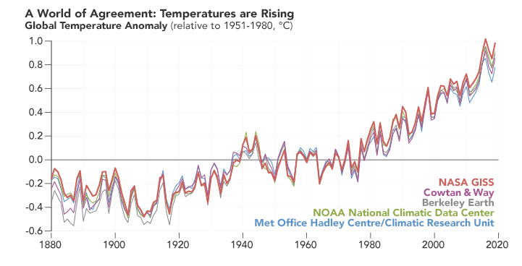
Fig 1: Yearly temperature anomalies from 1880 to 2020 as recorded by NASA, NOAA, the Berkeley Earth research group, the Met Office Hadley Centre (United Kingdom), and the Cowtan & Way analysis. (Surce : https://earthobservatory.nasa.gov/world-of-change/global-temperatures)

The climate change impact assessment was carried out using the crop simulation models by incorporating the projected climates of 2050 & 2080 in India’s context which showed climate change reduces crop yields and lower nutrition quality of produce and increases intensity of extreme events like droughts, flood, cyclones which affect the food and nutrient consumption, and impact on farmers livelihood. In absence of adoption of adaptation measures, rainfed rice yields in India are projected to reduce by 20% in 2050 and 47% in 2080 scenarios while irrigated rice yields are projected to reduce by 3.5% in 2050 and 5% in 2080 scenarios. Climate change is projected to reduce wheat yield by 19.3% in 2050 and 40% in 2080 scenarios towards the end of the century with significant spatial and temporal variations. Climate change is projected to reduce the kharif maize yields by 18 and 23% in 2050 and 2080 scenarios, respectively.. Extreme events like droughts affect the food and nutrient consumption, and its impact on farmers (PIB, 2023).

Climate Change Mitigation and Relevance of Regenerative Agriculture
In one side agriculture is one of the biggest source of GHG mitigation, it has the potential to be the biggest carbon sink to address climate change mitigation and restrict the global temperature rise. Since the beginning of agriculture, approximately 133 gigatonnes of carbon have been lost from soils globally, the equivalent of 480 GtCO2 emissions (Sanderman, 2017). Much of this loss has occurred since the 19th century due to deforestation, overgrazing, plow-out of prairies, and drainage of wetlands in order to grow crops, as well as degradative practices such as intensive soil tillage, monoculture cropping, bare fallowing, and heavy reliance on the use of chemical fertilizers and biocides (Teal and Burkart, 2024).

Climate-smart and regenerative agriculture measures designed to put farmers at the center can improve crop yields and turn farmland and pastures into carbon sinks, reverse forest loss, optimize the use of nitrogen-based fertilizers and rethink global and local supply chains to be more sustainable, reduce waste (Strauss, 2023). At both the regional and global levels, a growing body of scientific literature is identifying the potential of regenerative agricultural practices in sequestering carbon, helping to mitigate climate change while making croplands more productive and resilient as the planet warms (Teal and Burkart, 2024). Core principles of the regenerative agriculture are designed to closely mimic a comparable native ecosystem. According to a scientific estimation regenerative agriculture, as a diverse portfolio of practices that can be adapted to specific regions and crop types, can and should play a major role in tackling climate change, with the potential to remove 100-200 GtCO₂ by the end of the century (Teal and Burkart, 2024).

Thus Regenerative farming emerges as a potent force in the restoration of agricultural land, offering a promising solution to mitigate the environmental impact of industrial agriculture. By focusing on the regeneration of ecosystems that have suffered from the detrimental effects of industrial practices, regenerative farming becomes a key player in reversing the degradation caused over time. This approach not only aims to restore soil health, biodiversity, and water quality but also plays a crucial role in reducing the industry's overall environmental footprint, notably in lowering greenhouse gas emissions. Through a commitment to sustainable practices and a dedication to healing what has been degenerated, regenerative farming pioneers a transformative path towards a more resilient and harmonious coexistence between agriculture and the environment.

Regenerative Agriculture and Sustainable Farming
‘Sustainable’ agriculture and ‘Regenerative’ agriculture are terms that are often used interchangeably. Although these practices share some of the same methods and philosophies, they are not quite the same. While sustainable agriculture focuses on preserving the agro-ecosystem for the future, regenerative agriculture aims to rebuild and restore the biological and chemical processes that have diminished over time (Suterra, 2024).Sustainable farming addresses a holistic range of issues, such as water management, crop management, soil fertility, energy management, waste management and disease/pest management—all with the goal of making the farm more future-fit and resilient (Platt, 2022). The regenerative agriculture applies a comprehensive management framework to restore the environment. Regenerative agriculture aims to enhance soil carbon sequestration and capture carbon through aboveground biomass, reversing current global trends of atmospheric accumulation. It’s not just a way to continue to live with our environment, but aims to restore lands to their former productivity. The key difference between regenerative and sustainable agriculture is that regenerative agriculture intends to regenerate, or renew, the productivity and growth potential. By definition, sustainable practices seek to maintain systems without degrading them, whereas regenerative practices apply management techniques to restore the system to improved productivity. Looking at the practical scenario of agricultural land specially in India’s context where more than 40 % of agricultural land has already been degraded, taking policy for sustenance is not good enough, we have to reclaim, restore, and rejuvenate our agricultural land to meet our future food and nutritional security.

However, regenerative and sustainable agriculture are not distinctly different – in fact, regenerative agriculture can be practiced as part of an overall sustainability plan. Although regenerative and sustainable agriculture can use essentially the same practices, the difference comes in the application and the management of these methods (Platt, 2022).

Regenerative Agriculture: What are to be regenerated?
In the pursuit of the desired objectives of Regenerative Agriculture, it is essential to not only focus on restoring soil health, biodiversity, and water quality but also prioritize the reactivation of plant health. Long-term chemical interventions in agriculture have, in many cases, deactivated the natural vitality and resilience of plants. Regenerative Agriculture recognizes the need to revive and rejuvenate the overall health of plant ecosystems, acknowledging that the well-being of crops is integral to achieving the comprehensive goals of sustainable and regenerative practices. By prioritizing the reactivation of plant health, this approach strives for a harmonious balance that goes beyond mere productivity, fostering a resilient and thriving agricultural landscape.

Regenerative Agriculture: Transformative Tool and Vision for Sustainable Farming
Regenerative Agriculture encompasses a broad spectrum of practices, processes, and management approaches aimed at amplifying the efficiency and vitality of the systems it depends on. This holistic approach goes beyond merely sustaining and conserving; instead, it actively enhances core ecosystem cycles, including energy, water, and mineral cycles, by fostering robust biological functions. Notably, it extends its benefits to economic and social systems, making it a comprehensive strategy for overall sustainability. The distinguishing feature lies in its outcomes – any practice that consistently contributes to the health of the land, community, and economic bottom-line qualifies as regenerative. This outcome-focused perspective sets it apart from sustainable and conservation agriculture efforts.

While the term "Regenerative Agriculture" has gained significant traction in recent times, the concept itself has roots reaching back millennia. It represents a profound paradigm shift, moving beyond a singular focus on production to a more holistic approach that acknowledges and addresses multiple priorities within agriculture. This shift involves integrating a wealth of knowledge, including indigenous practices, modern research findings, adaptive learning, and a profound respect for the wisdom held by farmers. In essence, regenerative agriculture is a timeless and evolving philosophy that harmonizes ancient traditions with contemporary insights, emphasizing the enduring interplay between sustainable farming and the diverse needs of both the land and its stewards.

Sustainable practices, by definition, seek to maintain the same, whereas regenerative practices recognize that natural systems are currently impacted and it applies management techniques to restore the system to improved productivity. Regenerative and sustainable actions can use essentially the same practices; the difference is the application and the management of those tools.

Concept of Soil Health Management under Regenerative Agriculture
Soil is considered a living and complex ecosystem, harbouring a wide array of both micro- and microbiota that regulate its properties. The intensification of agriculture with modern technology has deteriorated the capacity of soil to maintain its functions, affecting long-term productivity and causing a loss of ecosystem services (Tilman et al, 2001; Bender et al, 2016; Wagg et al, 2014). The fundamental principles of regenerative agriculture are to keep the soil covered, minimize soil disturbance, preserve living roots in the soil year round, increase species diversity, integrate livestock, and limit or eliminate the use of synthetic compounds like chemical herbicides and fertilizers (Khangura et al, 2023). Principles related to soil health rejuvenation under Regenerative agriculture are as follows: (1) minimize soil disturbance, (2) keep the soil covered year-round, (3) keep live plants and roots in the soil for as long as possible and (4) incorporate biodiversity towards prevention of soil erosion and depletion, actively build soil, provide appropriate crop nutrients with minimum external inputs, produce healthy, high-yielding crops with few weeds and pests and limit greenhouse gas emissions (Fig 2).
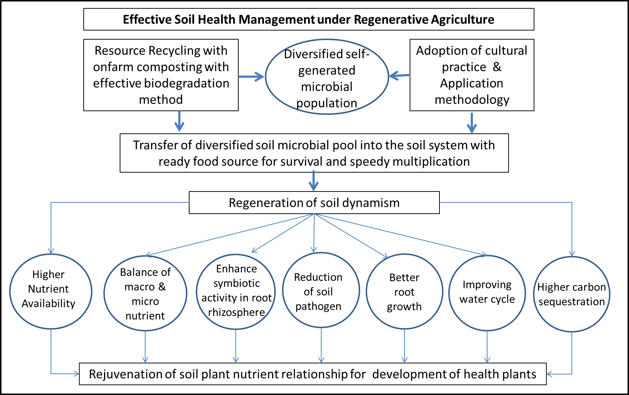
Fig 2 : Criteria for Soil Health Management under Regenerative Agriculture

Why Soil Health Rejuvenation is not enough to attain the objectives of Regenerative Agriculture
While soil health rejuvenation is a key component of regenerative agriculture, it alone is not enough to achieve its full objectives because regenerative agriculture aims to go beyond simply improving soil health by also addressing broader ecological concerns like biodiversity, water conservation, carbon sequestration, and overall ecosystem balance, which require a comprehensive approach that includes practices like diverse crop rotations, responsible livestock integration, minimizing chemical inputs across the entire farming system and most importantly a scientific approach towards plant health management for energization of plant system to tap the opportunity of rejuvenated soil system and uptake and utilized balance nutrient from soil nutrient pool specially micronutrient which requires more energy to uptake

We often forget the fact that plant nutrient uptake is an active physiological process that requires energy. This energy is provided in the form of photo assimilates (carbohydrates) produced by the leaves during photosynthesis, and, as such, roots have to compete for them with the rest of the plant (Cabrera, 2003). At the same time, as plants are non-motile and often face nutrient shortages in their environment, they utilize a plethora of sophisticated mechanisms in an attempt to acquire sufficient amounts of the macro- and micronutrients required for proper growth, development, and reproduction. These mechanisms include changes in the developmental program and root structure to better "mine" the soil for limiting nutrients, induction of high-affinity transport systems, and the establishment of symbioses and associations that facilitate nutrient uptake. Together, these mechanisms allow plants to maximize their nutrient acquisition abilities while protecting against the accumulation of excess nutrients, which can be toxic to the plant (Morgan and Connolly, 2013). Thus it is clear that energizing plant systems is the key to utilizing such mechanisms exerting significant influence over crop yields as well as plant community structure, soil ecology, ecosystem health, and biodiversity.

Regenerative Agriculture and the concept of Plant health
Today, though scientists recognized the importance of plant health management towards bringing sustainability in the food production system, but the concept of plant health management in organic/sustainable/regenerative farming system is limited to alternate pest management systems to reduce the irreversible damage to the ecosystem done by the conventional farming system. Present approaches of plant health management mostly aim, in principle, towards to be as little as possible forced to use reactive crop protection measures through supporting, and optimal exploitation of natural regulation of pests, weeds and diseases, embedded in good agronomy (Ruissen, 2005). Sometimes incorporation of bio-fertilizers, bio-stimulants, etc is considered as a prime strategy for plant health management. However the concept of plant health management is much bigger than that input-based concept (Fig 3).

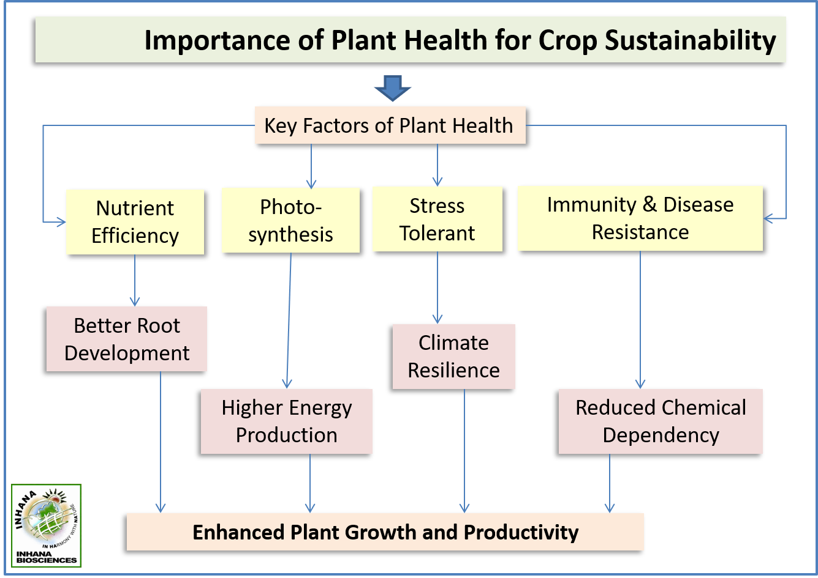
Fig 3 : Importance of Plant health for crop sustainability : IRF Technology focuses on energizing the plant system towards optimizing the nutrient uptake, and enhancing the natural defense mechanism, ensuring sustainable crop productivity

Plant health management is the science and practice of understanding and overcoming the succession of biotic and abiotic factors that limit plants from achieving their full genetic potential as crops, ornamentals, timber trees, or other uses (Cook, 2000). According to the trophobiosis theory, it is nutrient deficiencies and imbalances that lead to pest and disease outbreaks, and that synthetic pesticides and fertilizers can cause such deficiencies and imbalances. growth on free amino acids, and reducing sugars in solution in the plant's cell sap. Thus adoption of plant health management practices means re-activation of bio-chemical functions can directly compliment plant health while indirectly ensuring lesser pest interference; as pest starve on healthy plants (Paull, 2007). According to the trophobiosis theory of F. Chaboussou (Chaboussou, 2004), pests and disease set in with an increase in free amino acids and reducing sugar pools in plant cell sap. The phenomenon usually occurring whenever plant metabolism becomes impaired due to biotic and abiotic factors, excess fertilization specially with nitrogenous fertilizers, and application of systemic fungicides/pesticides etc. (Dias, 2012). Hence, better plant health vis-a-vis lesser pest incidence along with supportive soil functions can ensure the crop objective and economic balance in agriculture.
Identifying Key Stages of Plant Resilience
The degree of plant health and immunity is based on a plant’s ability to form structurally complete compounds such as carbohydrates and proteins. Complete carbohydrates, proteins, and lipids are formed by healthy plants with a fully functional enzyme system, which is dependent on trace mineral enzyme cofactors (Kempf, 2013). In simple understanding, as long as plants are photosynthesizing properly and producing pectins and other complex carbohydrates, these plants do not seem to be susceptible to abiotic and biotic stress and yielding as per their genetic potential. As photosynthetic energy increases, plants begin to transfer greater quantities of sugars to the root system and the microbial community in the rhizosphere. This increase in energy and a food source for the soil microbes will stimulate them to mineralize and release minerals and trace minerals from the soil matrix, and provide them in a plant available form. Plants then utilize these essential minerals as enzyme cofactors which are needed to form complete carbohydrates and especially proteins. Soluble sugars, monosaccharides, when partnered with nitrogen, are the base materials used to form amino acids. Through the action of enzyme catalysts, these amino acids are bonded together to form peptides from which complete proteins are formed. Later, the plant begins to store this surplus energy in the form of lipids and as energy and lipid levels increase, this cell membrane becomes much stronger and more resilient enabling it to better resist fungal pathogens (Kempf, 2013). At the same time, once plants achieve higher lipid levels and stronger cell membranes, they become more resistant to pathogens and resist pest attacks to a great extent.

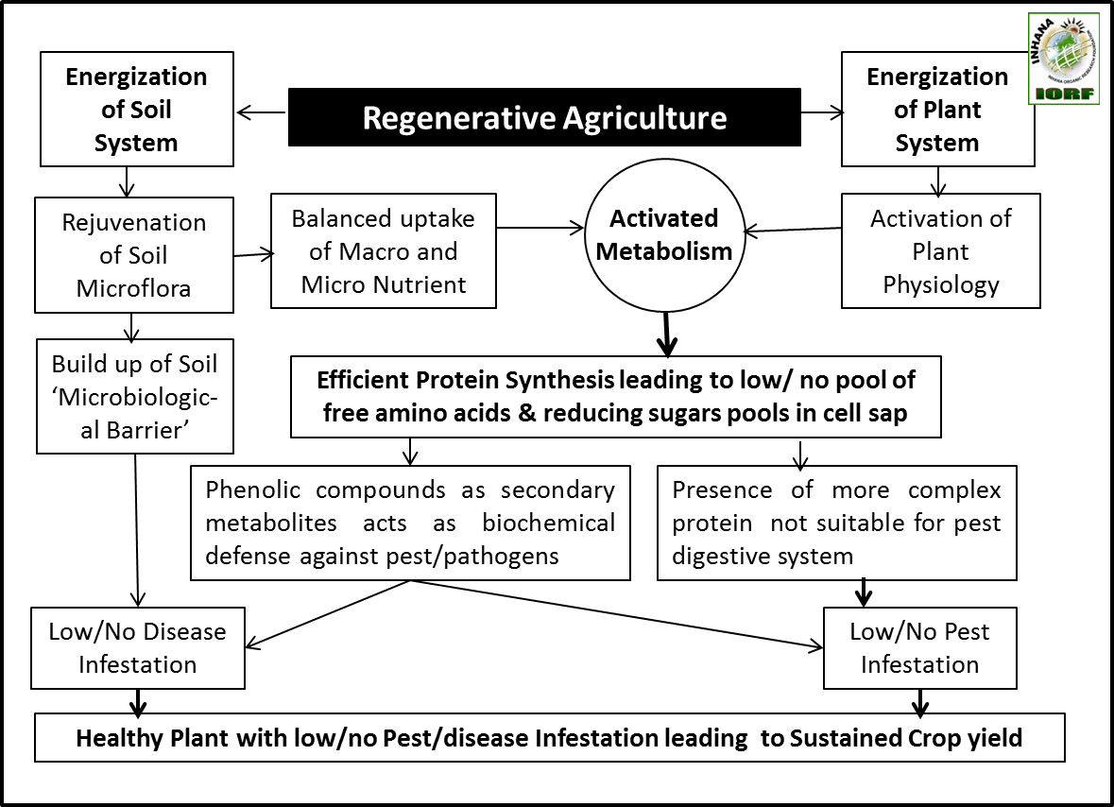
Fig 4 : Flow diagram towards increasing climate resilience of crop production system through adoption of Regenerative Farming

Now the management policy should aim at the energization of the plant system towards activation of plant physiological functioning viz higher photosynthesis efficiency and faster metabolic activity to utilize the glucose to complex protein and energy to attain its inherent nature gifted quality of self-nourishment and self-protection. Thus the approach needs practices that make the growing environment more conducive for crop growth by eliminating negative forces in terms of reducing biotic and abiotic stress, but importantly requires a technological intervention for plant physiological functioning (Fig 4).

Pest management through plant health management – A unique concept under Regenerative Agriculture
Pest management through plant health management is an innovative but most scientific and comprehensive approach residing the holistic approaches generally associated with any sustainable/ regenerative agriculture. The concept was first originated by a French agronomist Francis Chaboussou, who develop his ‘Trophobiosis theory’ through his life-long research on pest-plant relationship and conclude that ‘Pest starves on Health Plants’ (Paull, 2008)(Fig 5). According to the theory of Trophobiosis theory, it is nutritional imbalances within the plant that leads to disease rather than the simple presence of a disease-causing organism. Nutritionally imbalanced plants produce an abundance of amino acids and reducing sugars, whereas healthy plants form complete proteins and complex carbohydrates. The less biochemically complex molecules from imbalanced plants offer an alluring milieu for pests and diseases (Kakava, 2023).

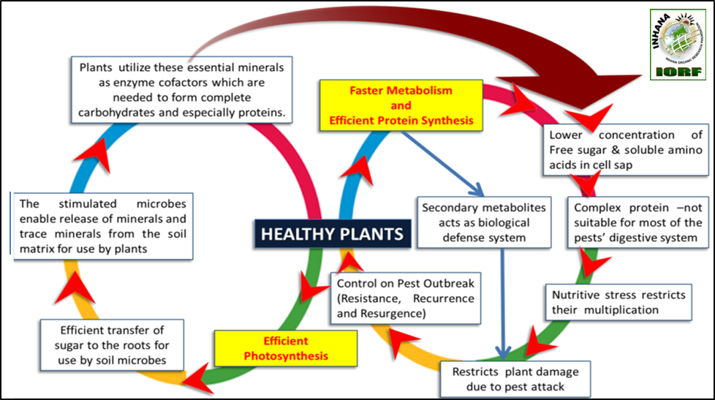
Fig 5 : The concept of ‘Pest Management through Plant Health Management : The essence of “Trophobiosis theory” behind Integrated Pest Management under Regenerative Agriculture

Chaboussou’s study indicated that protein metabolism is amongst the most sensitive of all plant processes and it can be compromised with repeated use of fungicides and pesticides. Compromised protein metabolism causes the consequent buildup of amino acids and reducing sugars in the plant cell sap. And the insects and fungi prefer to feed on plants that are over supplied with short chain amino acids and simple sugars. This is because amino acids are the protein building blocks and the reducing sugars offer the energy source for this protein synthesis (Beraet al, 2024a). Chaboussou also stated that nitrogen mismanagement is also a major player in creating conditions to foster pest and disease pressure. Heavy applications of soluble nitrogen fertilizers increase the cellular concentration of nitrate, ammonia and amino acids faster than can be used for the synthesis of protein which increase the risk of pest pressure after application of nitrogen (Seal et al, 2017).

Concept of plant health and defence against pest/disease from Indian mythology in relation to modern science
More than 2500 years before French scientist Francis Chaboussou came forward with his Trophobiosis Theory’ and established the need of healthy plants to manage pest and diseases purely as physicists basis, Indian philosophers revealed both the physiology and philosophy of plant system and conceptualized the underlined relationship behind plant health and its relevance and role in developing defence mechanism of the plant system. While Chaboussou advocated that healthy plants do not provide food to pest for which they invades, Indian philosophers interpreted how healthy plant functions and how these are operational from its birth till death. As they reached to the root of creation, they interpreted the life of a plant as a reflection of cosmic principles, emphasizing the interdependence of nourishment (Poshana) and protection (Rakshana). From its birth as a seed to its final decay, a plant embodies the cycle of creation, sustenance, and dissolution—mirroring the larger order of existence.

Through this perspective, they recognized that nourishment is essential for growth, while protection ensures survival. These two forces work in harmony, much like the dual responsibilities of nature and human life. Just as a plant draws sustenance from the soil, water, air, and sunlight, it also relies on mechanisms of defense against external threats. This understanding extended beyond botany into broader philosophical and spiritual domains, influencing Ayurvedic medicine, environmental ethics, and even social structures.

As the ancient Indian philosophers recognized the two inherent quality of plant system that they can both nourish and protect themselves; deep connection between plant health and pest/disease management also got revealed. While modern science often traces its roots to more recent developments like Chaboussou's Trophobiosis Theory, it's clear that traditional knowledge, embedded in ancient agricultural practices, had a more deeper understanding of plant ecosystems. While these understanding and wisdom were include in the various ancient scriptures, these have not been decoded in the modern scientific language, therefore the deep embedded science will philosophy gradually become oblivion. In our modern agriculture based on chemical fertilizers and pesticides is not even century old which first got inhibited with a concept of feeding the plants which soon included protecting the plants, could not --- that plants are efficient of both these functions.

In many traditional Indian agricultural practices, there’s a recognition of the interdependence between plants, soil, and the broader environment, often manifesting in practices like crop rotation, intercropping, and the use of natural pesticides. These practices are aligned with the broader idea that plant health is linked to the overall ecosystem, not just isolated treatments for pests or diseases. The concept that plants have inherent mechanisms for self-nourishment and self-protection is deeply embedded in many traditional Indian philosophies and agricultural practices. Ancient Indian thinkers, especially those who studied nature and Ayurveda, recognized that plants had their own natural defences and the ability to sustain themselves if their environment and needs were balanced correctly. This wisdom is reflected in how they approached agriculture, health, and sustainability. In Indian philosophy, plants are often seen as being intrinsically linked to the balance of the environment, and their health is seen as a reflection of the broader balance between the five elements—earth, water, fire, air, and ether. When these elements are in harmony, plants thrive and can naturally ward off pests and diseases. This idea mirrors Chaboussou’s Trophobiosis theory, which emphasizes plant health as a preventative measure against pest problems, rather than relying on external chemical solutions.

Phalguni Das Biswas, pioneer in sustainable organic tea cultivation under Inhana Rational Farming Technology in India interpreted this ancient Indian wisdom in his Element-Energy Activation (EEA) principle. According to that principle, all living bodies are like machines and the vital driving force or energy behind them is “Chaitanya Shakti” or Basic Life Force. Solar energy is the manifestation of “Chaitanya Shakti”. Energy specific plants which store the radiant solar energy or the basic life force in differential forms can serve as a potential medium of energy components, which when released at the right time and in the right proportion can make the matter (hereby the plant physiology) functional at the desired level and to restore/ revive equilibrium. Except at birth and at death, two major processes (i) Self-Nourishment &Self protection) are going on in every living body from birth till death or till the time they become deactivated due to human intervention.

(i) Self-Nourishment : According to EEA Principle, five Basic Elements (Panchamahabhutas) Soil, Air, Water, Fire and Space take care of nourishment till the time we Humans do not interfere with these qualities, it performs without any problem. The individual elements are responsible or role of Panchamahabhutas for specific mechanism of nourishment is as follows (Fig 6 and 7) .

- Earth : Nutrition and growth structure formation.
- Water: Transportation of nutrients and transpiration.
- Fire : Metabolism and Photosynthesis
- Air : Both Dark and Photo Respiration
- Space: Making space available for all bio-chemical reactions .

From the birth (Seed) till death (harvest) this quality remain in active form and ensures ideal nutrient dynamics

(ii) The Self-Protection : The self-protection mechanism is said to be controlled by five different Life Forces or Prana-Shaktis. These are originated from the basic life-force ie, Solar energy. The life forces or Prana-Shaktisor energies are actually vehicles of these Basic Elements or Phanchamahabhutas and all plant physiological functions are impossible without them. They are responsible for specific plant physiological functions by enabling the five Basic Elements. EEA Principles suggest when all the plant functions are at their optimum, then there is no food for any pest and diseases. Their role in the plant system are as follow.

- Apana Prana : Controls the function of roots extraction of nutrients.
- Samana Prana : Controls transpiration.
- Udana Prana : Controls Photosynthesis and secretion of enzymes, hormones.
- PranaPrana : Controls respiration and eases movement of respiratory products.
- Vyana Prana : Makes space available for all functions.

All these processes, functions and sub-functions are interdependent and operate in an orchestral manner, in nature. Any imbalance that effects the self-nourishment quality leads to the disease or pest manifestation or lack of nourishment. According to the concept, to overcome the disease or pest infestation, life forces are to be stimulated instead of encountering from outside leading to unfavourable repercussions (Chatterjee et al, 2014; Bera et al, 2024b).

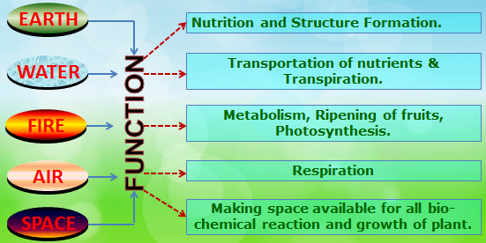 | 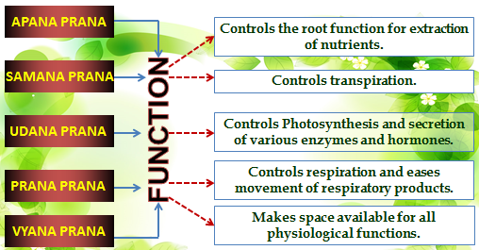
Fig 6 : The Mechanism of Self- Nourishment in the Plant System under EEA Principle | Fig 7 : The Mechanism of Self- Protection in Plant System under EEA Principle

If there is any imbalance in the sub-functions of a plant, such as Structure, Formation, Circulation, and Metabolism, it can affect the plant's nourishment and compromise its immunity. Ideally, when such an imbalance occurs, the entire plant system attempts to protect itself. In natural ecosystems, like forests, plants thrive without the need for feeding or protection, as propagation occurs naturally. However, in agriculture, where there is a target output within a specific time frame, it becomes necessary to provide nourishment. In this case, farmers need to supply only one-third of the total nutrient requirement, while the remaining two-thirds can be sourced from a healthy soil system. This healthy soil allows plants to uptake, assimilate, and utilize nutrients effectively. A healthy plant system ensures optimal and complete processes, leaving no excess or premature substances that could negatively impact nutrition and protection. This principle is illustrated in Chaboussou’s Trophobiosis Theory, which states that plants which are unhealthy can provide food sources for pests because their nutrients (such as free amino acids and reduced sugars) are not fully converted into their ultimate forms of proteins and carbohydrates.

The concept of plant health and its role in the defence mechanism against pests/disease from Ancient Indian Philosophy in relation to the modern science: Element Energy Activation (EEA) principle behind IRF Technology and Trophobiosis Theory of Francis Chaboussou are conceptually interrelated.
 | 
Francis Chaboussou-Noted French Scientist, the proponent of “Trophobiosis Theory” that emphasises Healthy Plants - parasite relationship & author of ‘Healthy Crops’- A forgotten classic of agroecological science | Phalguni Das Biswas – Developer of IRF Technology that ensures the development of Healthy Plants towards economically sustainable crop production & pioneer of sustainable organic tea production in India

The uniqueness of the IRF Technology operates under the EEA (Element Energy Activation) principle, which emphasizes the need for a deeper understanding of the relationship between plant conditions and the proliferation of parasites. The EEA principle outlines the process to maintain plant health and re-activate plants from a deactivated state. Inhana Rational Farming (IRF) Technology discusses the philosophy and importance of plant systems as the most important factor to sustainable, self-reliant, and resilient agriculture, merging ancient wisdom with modern scientific knowledge. Additionally, when the Trophobiosis theory represents a breakthrough in plant pathology, highlighting the physiological and biochemical states of plants as factors influencing their susceptibility to pests and diseases, the Indian wisdom on the other hand, illustrates how a healthy plant system operates through matter-energy conjugation, enabling it to maintain an activated defense mechanism. The success of IRF Technology is henceforth attributed to the facilitation of these environmental factors. This innovation advocates for further research into the pathways that underscore the relevance of plant health in promoting regenerative agriculture. The findings reveal that plants possess a sophisticated, self-reliant, and self-sufficient system, which is intrinsically linked to the earth and atmosphere.

Limitation of Input based Package of Practice and need of Comprehensive Technology to attain objectivities of Regenerative Agriculture.

Regenerative farming demands a comprehensive approach for management and only the practice which can best utilize the potential of nature can succeed the objectivity. As we understand scientifically the potentials of various individual inputs (as revealed from the soil input experiments), do not necessarily provide additive effects when they are combined together, therefore their effectivity need to be judged on the basis of their performance under a package of practice (Bera et al, 2011). That is the reason why conventional organic farming developed on the same approach of chemical farming fails to achieve the desired objectivity. Hence, for the development of a comprehensive management system individual input evaluation has to be transformed to the evaluation of ‘Package of Practices’, which may be composed of various individual inputs, but they must operate in an integrated manner, in order to be effectively functional. At the same time adaptation of any nature-friendly comprehensive agricultural package of practice/technology based on a defined principle to foster soil and plant health management can attain the principles of regenerative agriculture more precisely in a time bound manner.

IRF Technology as a Complete Plant Health Solution :
Unlike conventional farming, which focuses primarily on external inputs (fertilizers, pesticides), IRF strengthens the plant from within. By addressing nutrient uptake efficiency, natural immunity, stress resilience, and photosynthetic performance, IRF ensures that plants optimally utilize the rejuvenated soil, leading to higher yields, better quality, and sustainable crop production. By integrating soil rejuvenation, plant energization, and optimized physiological processes, IRF ensures that plants are self-sufficient, resilient, and productive. This approach naturally minimizes chemical dependency, enhances ecosystem health, and provides long-term agricultural sustainability (Fig 8 & 9).

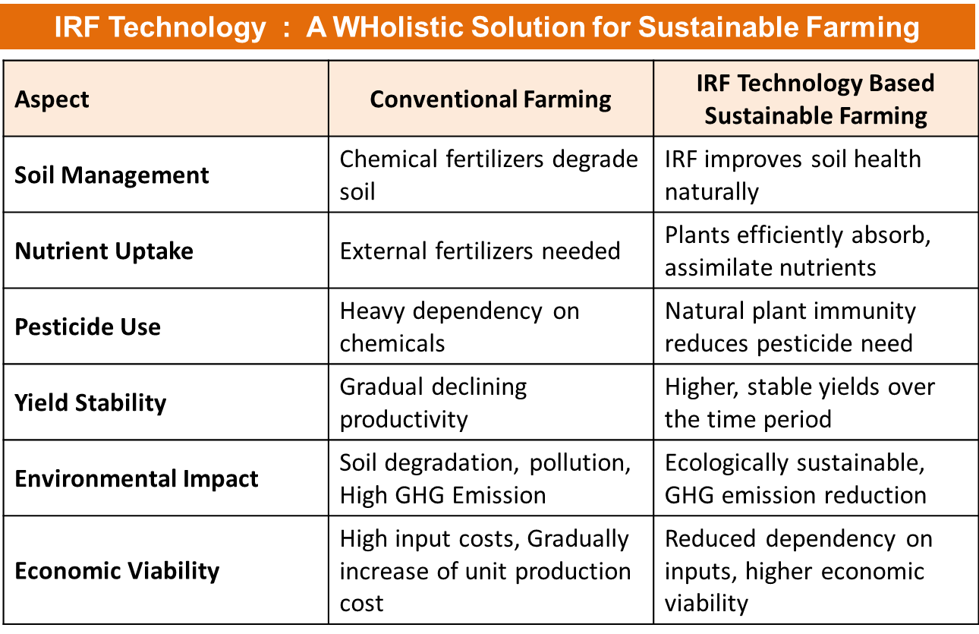
Fig 8 : A comparative view of Conventional Farming and IRF Technology based Sustainable Agriculture

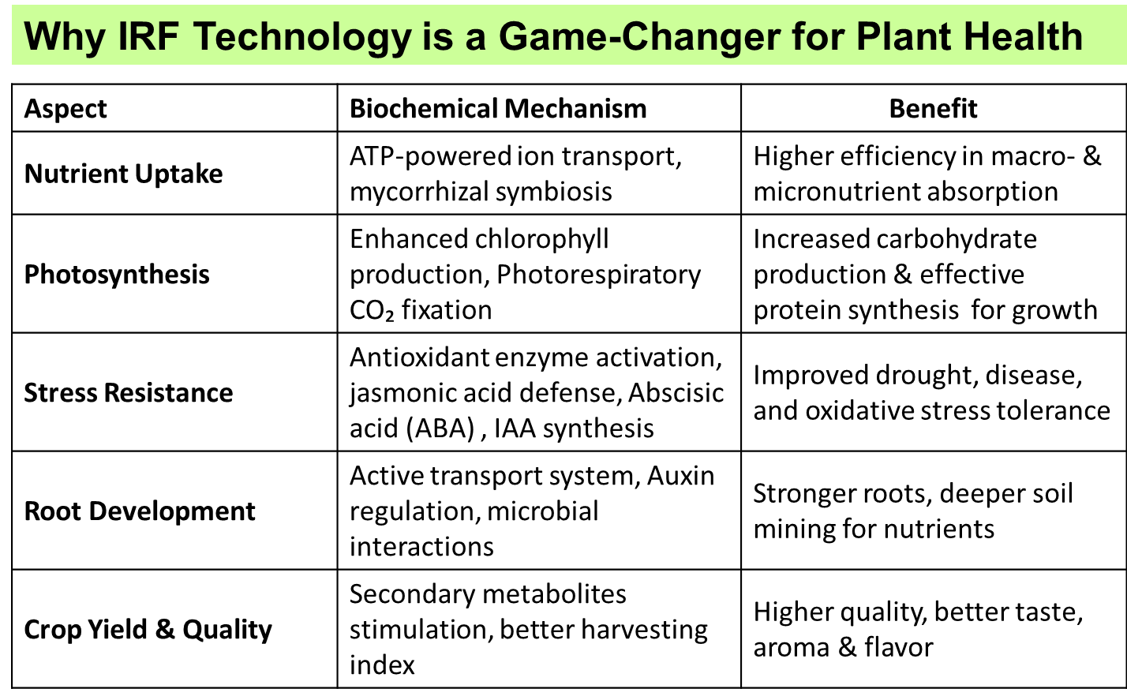
Fig 9: Energization of Plant system through IRF Plant health management aims towards efficient bio-chemical functions in the plant system.
Regenerative Agriculture and Sustainable Development Goals
The sustainable development goals (SDGs) provide a comprehensive framework for addressing global challenges, including land degradation, poverty, climate change, and environmental degradation. Regenerative agriculture intersects with all the SDGs viz no poverty (SDG 1), zero hunger (SDG 2), good health and well-being (SDG 3), quality education (SDG 4), achieve gender equality and empowering women (SDG 5), clean water and sanitations (SDG 6), affordable and clean Energy (SDG 7), decent work and economic growth (SDG 8), Sustainable Cities and Communities (SDG 11), responsible consumption and production (SDG 12), climate action (SDG 13), life below water (SDG 14), life on land (SDG 15), and partnerships for the goal (SDG 17).

Regenerative Agriculture prioritizes soil health, biodiversity, and ecosystem resilience, which in turn, helps mitigate climate impacts and improve food availability. Thus embracing regenerative agricultural practices enhances soil fertility, water retention, and biodiversity, leading to more robust and reliable crop yields (Joshi et al, et al, 2024). Thus it helps not only to address hunger but also promotes food security and nutrition. Thus adopting regenerative farming can help achieve the United Nations' (UN) Sustainable Development Goal (SDG) 2. 2nd most important SDG which regenerative agriculture attained is SDG 13 as the practice promotes agroforestry and cover cropping, crop rotation, reduced tillage and improve soil health by those practices which intern help towards higher soil carbon sequestration, contributing to climate change mitigation. Regenerative agriculture also contributes significantly to poverty reduction by creating resilient and diversified livelihoods. Small-scale farmers, when empowered with sustainable practices under regenerative agriculture, experience increased yields and improved incomes, breaking the cycle of poverty and thus attained the objectives of SDG 1. At the same time, it minimizes the use of harmful chemicals, reducing health risks for farmers and consumers alike and facilitates access to nutritious and uncontaminated food which supports overall well-being and public health; thereby attained the objectives of SDG 3 (SAN, 2022). Regenerative agriculture practices also prioritize efficient water use, reducing the overall demand on water resources and supporting the health of aquatic ecosystems along with preventing agricultural runoff and preserving water quality and thereby attained the objectivities of SDG 14. The practice also has a contribution towards gender equality as regenerative agriculture helps to empower women who play a crucial role in agriculture; by providing equal access to resources and opportunities. This, in turn, contributes to breaking down gender disparities in rural communities; an important objectives of SDG 5. Successful lab to land transfer of regenerative agriculture requires innovation in farming techniques and infrastructure which can lead to the development of more resilient and efficient agricultural systems. Thus promoting regenerative agriculture can bring better coherence in-between Agro-industry, innovation and Agro-infrastructure and thereby attained the objectives of SDG 9.

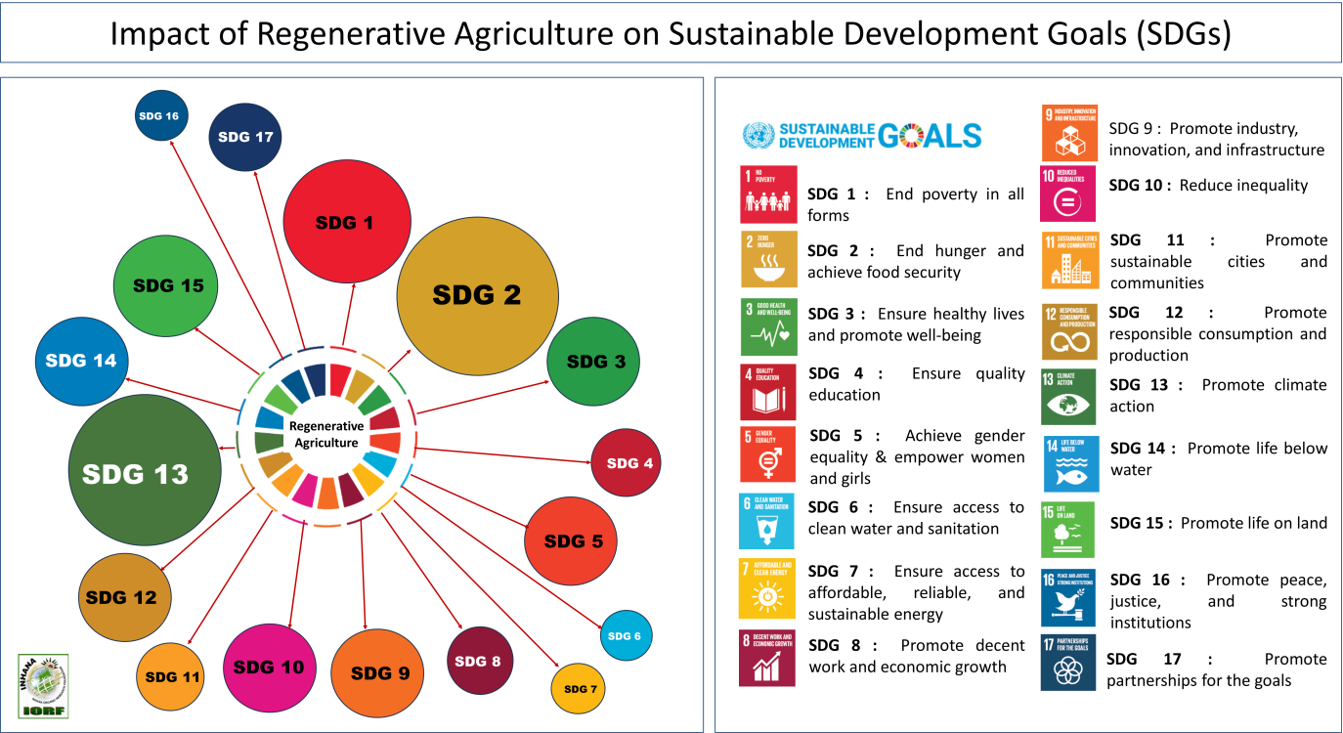
Fig 10 : Impact analysis of Regenerative agriculture on different Sustainable Development Goals (SDGs)

Regenerative agriculture techniques like cover cropping and minimal tillage prevent soil erosion and degradation, maintaining the integrity of terrestrial ecosystems, increase biodiversity through inclusion of agro-forestry in the farming system, thereby contributing to achieving SDG 15.At the same time, regenerative agriculture aligns with SDG 8, and 17 by addressing contemporary health challenges, fostering economic growth, and promoting global partnerships for sustainable development (Joshi et al, 2024). Regenerative agriculture also promotes responsible water use, minimizing pollution from agrochemicals and thus ensures the availability of clean water for both agricultural and domestic purposes- a key objectives of SDG 6. Regenerative agriculture often involves fair trade practices, promoting social justice and contributing to the development of strong and transparent agricultural institutions, attend a key objectives under SDG 16. At the same time, regenerative agriculture encourages crop rotation and diversification, reducing the need for chemical inputs and enhancing soil health and promoting healthier and more sustainable food production and thereby meet the objectives of SDG 15. Similarly by promoting healthier and more sustainable food production through systemic elimination / minimization of toxic synthetic pesticides and fertilizers, regenerative agriculture also meets the objectives of SDG 12. Farmers practicing regenerative agriculture around the world are using renewable energy in innovative ways to cut costs and reduce the carbon footprint like introduction of solar-powered irrigation systems, attending the objectives of SDG 7 (Fig 10).

Carbon Footprint : Indicator of successful induction of Regenerative Agriculture
The food and agriculture sector is responsible for approximately a third of global greenhouse gas emissions. Among key emissions reduction strategies for the sector, regenerative agriculture has gained increasing interest among agri-food industry leaders, civil society organizations, farming communities and research organizations (NCI, 2024). Now from current approaches to monitoring of agricultural sustainability in general, there are multitude of frameworks and tools that use indicators (Coteur et al., 2019; de Groot et al., 2010; FAO, 2014; O'Donoghue et al., 2022), but carbon footprint accounting prove to be most comprehensive Outcome-based indicator. Measuring greenhouse gas (GHG) emissions from farms, such as those from animals, fertilizers, manure, and diesel consumption, can help determine how successful regenerative agriculture is in reducing climate change. Specially when regenerative agriculture plays an increasingly large role in agriculture sustainability strategies, but the extent to which regenerative agriculture can systematically lead to fewer emissions is still in the process of being researched; especially which practices are effective in increasing permanent carbon sequestration in agricultural soils remains a subject of debate (NCI, 2024).

Higher the carbon footprint- higher the crop productivity : The paradox in conventional chemical farming
Input-based conventional agricultural system along with fertilizer sensitive plant materials follows high returns with high input application programs and thus comparative measurements of carbon footprint of two conventional food production system often showed a positive relationship between crop productivity with carbon footprint. The phenomenon might be used as an excuse to defend conventional farming but the biggest mistake was to not considering the system's stability. Higher productivity in the expense of soil quality depletion, environmental degradation, and loss of ecosystem services make the food production system vulnerable to long-term sustainability and the irreversible loss due to high input agriculture creates newer sources for GHG emission which was not accounted for in the carbon accounting.

The observed positive correlation between crop productivity and carbon footprint in conventional chemical farming is a manifestation of a short-term optimization strategy that neglects the long-term sustainability of the system. While high-input approaches can produce impressive yields, they do so at the cost of soil quality, ecosystem services, and ultimately, the resilience of the agricultural system. For a truly sustainable food production model, it is essential to balance productivity with practices that preserve and enhance the natural capital of the soil and surrounding environment.

Relevance of Regenerative Agriculture in tea
The sensitivity of tea plants to the environment in which they grow is part of tea’s appeal. However, this also makes crops susceptible to the properties of climate change (Bera et al, 2024b). The rise in temperature, shifting of seasons and increase in the ambient temperature have wedged tea yields across the board because, due to the C3 carbonic pathway, tea plants are already 1/3rd less efficient in photosynthesis than C4 plants, and photosynthesis in tea occurs only in the incidence of moderate temperature, moderate humidity and moderate sunshine (Costa et al, 2007; Srinivas et al, 2024; Kathpalia et al, 2023; Shang et al, 2024). The overall productivity of tea in India has gradually decreased over the years, dropping from 2,165 kg/ha in 2016-17 to 2,016 kg/ha in 2020-21 (Bera et al, 2024b). Like other crop cultivation, regenerative agriculture is equally important if not more in case of tea cultivation specially in the context of Indian Tea cultivation. Though by practice tea cultivation follows some major principles of regenerative agriculture like no /minimum tillage, perennial plantations with shade trees, and vegetative cover in soil. However due to random application of chemical fertilizers and toxic chemical formulations in the name of pest and weed management actually depressed the soil ecosystem and broke the soil-plant-ecosystem equilibrium resulting in outbreaks of pests and diseases which were further aggravated due to climate change impacts like prolonged drought, more frequency of raise in day temperature above 350C and shifting of rainfall pattern. This resulted in poor crop performance, depletion of inherent tea quality, and risk of pesticide residue above MRL resulting in lower economic return. Adopting principles of Regenerative agriculture in the management policy of tea cultivation is the only adoptable solution to attain both ecological and economical sustainability. As tea plantations are meant for at least 50 years in the field, rejuvenation of bush health is the only option to enhance the lost productivity potential especially when large scale soil rejuvenation program is not practically feasible due to raw material scarcity and economically viable.

Carbon Neutrality in Field Management : Primary Goal of Regenerative Agriculture in Tea
Carbon neutrality refers to agricultural practices that balance the amount of carbon dioxide (CO₂) emitted with an equivalent amount of CO₂ sequestered or offset. This approach aims to reduce the net carbon footprint of farming operations to zero. Carbon-neutral farming is all about practicing a scientifically proven methodology that arrests carbon emissions without affecting agricultural output (Arise, 2022). Proper farm management techniques can result in healthy crop yields, without endangering the planet. Regenerative Agriculture practices can help achieve carbon neutrality by reducing the carbon footprint of farming operations and increasing the amount of carbon absorbed from the atmosphere. Thus impact of regenerative agriculture management techniques as well as the intensity of management taken in field level can be measured through carbon footprint accounting. On the other hand, carbon neutrality and sustenance in food production are the two sides of the same coin, but the terminology is only valid when practices that have direct role in target crop management are only considered for carbon footprint calculation. In the case of tea, as the total management is distinctly divided into two parts, ie field management and factory operation; primary goal of any Regenerative Agriculture undertaken in tea estate should focus towards 100 % offsetting of field GHG emissions which arise due to field level management like application of fertilizer, pesticides, irrigation and fuel used for machinery and field level transport.

Development of TEC- carbon computing tool for tea- A major leap forward towards carbon footprint assessment in Indian Tea

Trustea Emission Calculator “TEC” has been jointly developed by Trustea Sustainable Tea Foundation (TSTF) and Inhana Organic Research Foundation (IORF) based on the Agriculture Carbon Footprint Assessor (ACFA) Version 2.0 expounded by Inhana Organic Research Foundation (IORF) and ICAR-ATARI, Kolkata (Zone-V) in association with i-NoCarbon Limited (i-NC), UK (based on relevant IPCC Guidelines and empirical scientific research works). At the same time, TEC is probably the 1st ever Carbon Computing Tool for carbon assessment in tea sector considering the agro-ecological variability of Indian tea agro-ecosystem as well as diversities in the management and alternate input usage. This tool kit is a hybrid module which need both audit and analysis-based datasets for final carbon calculation (Inhana, 2024). Thus TEC Tool completed the gap in impact assessment of Regenerative Agriculture in Tea.

 | TEC toolkit certified by i-NoCarbon Limited (i-NC), UK complies the major standards viz GHG Protocol, ISO-14044:2006, ISO-14064 and PAS 2060; This tool kit is a hybrid module which need both audit and analysis based dataset for final carbon calculation. Advanced version of TEC Tool highlights the relationship between carbon and sustainability indices and helpful for Sustainability SWOT study of any tea estate or small tea grower’s farm. At the same time, the analytical output from the ‘TEC Toolkit’ will help to develop Regenerative farming models along with management policies towards reduction of carbon footprint of the tea while infusing sustainability components.  Download Link :https://play.google.com/store/apps/details?id=com.trustea.tec&hl=en_IN

Practice flow diagram to achieve carbon neutrality in tea
To achieve carbon neutrality in tea, a comprehensive science based management system has to be adopted as age old bushes, continuous stress on plants due to multiple vegetative propagation, limited scope for soil rejuvenation, soil acidity and the related improper nutrient dynamics along with the unresolved pest and disease infestation; lead to complex problems – which are much different and difficult to address as compared to other crops. ‘Sustainability’ can be enabled when the potential and problems of a plantation is studied, resources are mapped and a customized Package of Practice (POP) is developed on the basis of the study. The POP should focus on re-activation of plant physiology vis-à-vis soil rejuvenation so that both these components can work in tandem thereby enabling harmonious ecological interactions.

Effective resource management is the first step towards any regenerative agriculture initiative and SWOT (Strength, Weakness, Opportunity & Threat) study is its foundation. Simultaneously ‘Soil Audit’ i.e., assessment of Soil Quality will help to formulate the regenerative soil management policy for a tea estate (Fig 11). As soil chemical fertilization, application of pesticides, irrigation and garden transport are the four major source of GHG, emission; mitigation from point of emission primarily depend on regenerative soil management policy taken by the garden like application of on-farm compost, cover cropping, recycling of pruning litter, maintaining a healthy vegetative cover on soil along with gradual reduction of chemical fertilizer and other chemical. And most importantly it will only happen when plant system will be responsive to this management change and thus plant health management will be the most important criteria towards sustenance of crop yield and building internal immunity against biotic and abiotic stress. The most critical phase is that management transformative stage, when intensive management support and higher investment in sustainability account pays off in long terms basis. However it is curtain that how much this transformation phase will be smooth, it depends upon the choice of plant health management practice and intensity of its time-bound application.

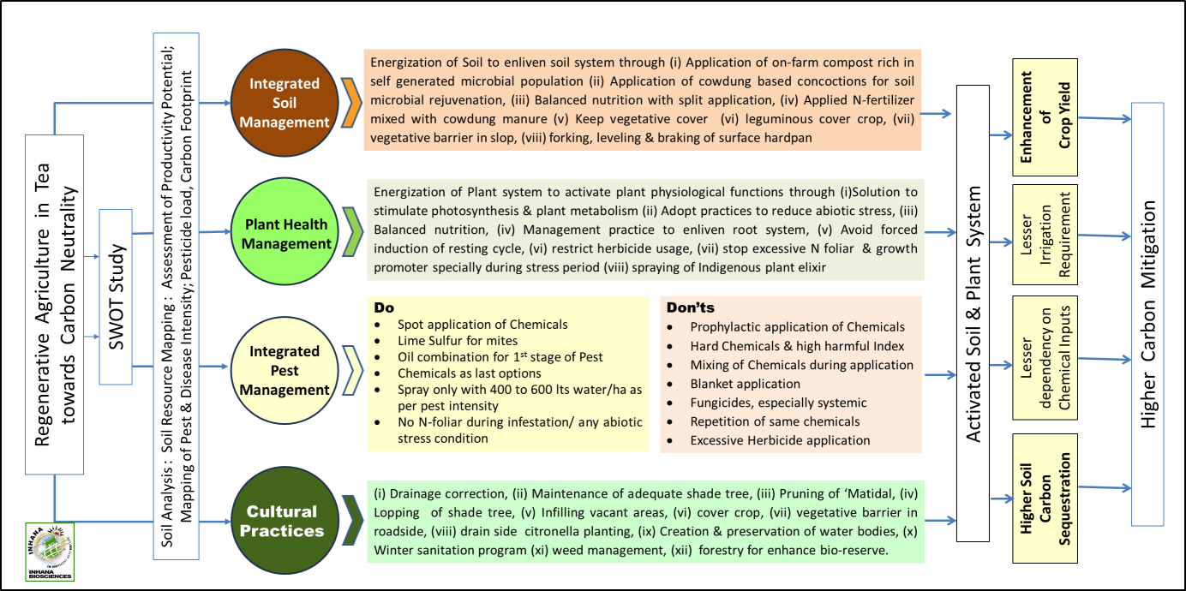
Fig 11: Regenerative Agricultural Practice to achieve carbon neutrality in tea

Regenerative Agriculture Initiative in Tea – Case studies from Indian Tea
India, as the second-largest tea producer globally, faces multiple environmental, economic, and social challenges in tea cultivation. Regenerative tea initiatives are crucial to restore soil health, improve sustainability, and enhance farmers’ livelihoods while ensuring long-term tea production. Several notable case studies exemplify this transformative approach:

Lakhipara Tea Estate, West Bengal : In 2014, the Goodricke Group Limited initiated a sustainable tea program at Lakhipara, aiming to reduce pesticide usage, enhance soil quality, and produce high-quality teas while maintaining crop yields and lowering the carbon footprint. This initiative adopted the Inhana Rational Farming (IRF) Technology, focusing on comprehensive soil and plant health management. This initiative aimed to reduce pesticide use, enhance soil quality, and mitigate climate change impacts. The project reported an increase in crop productivity by 78 kg/ha in the project area, contrasting with a loss of 118 kg/ha in non-project areas during the same period. Additionally, there was up to a 77% reduction in pesticide usage, leading to a 62% lower Crop Pesticide Pollution Index compared to the regional average. Soil assessments revealed an 8% increase in Soil Fertility Index and a fourfold boost in microbial activity potential, indicating improved soil health. Furthermore, the project area achieved a 65-70% reduction in carbon footprint, primarily due to decreased use of chemical fertilizers and pesticides (Bera et al, 2024a).

Barak Valley, Assam : In the Barak Valley of Assam, a decade-long study focused on adopting Inhana Rational Farming (IRF) technology to address sustainability issues in tea production. The IRF approach emphasizes regenerative farming practices that enhance soil fertility and reduce chemical inputs. Over ten years, tea estates observed improved soil health, increased yields, and a notable reduction in environmental footprint, demonstrating the long-term benefits of regenerative agriculture (Bera et al, 2024b).

Conclusion
Regenerative agriculture plays a crucial role in addressing the challenges of climate change and advancing carbon neutrality. However, it cannot be limited to soil rejuvenation alone. While healthy soils form the foundation of a sustainable system, the efficiency of plants in extracting, transporting, and utilizing nutrients is equally critical. Regenerative agriculture policies must go beyond soil restoration to integrate plant health management, ensuring a synergistic approach that enhances productivity, biodiversity, and climate resilience. By focusing on both soil and plant systems, farmers can fully harness the potential of rejuvenated soils, leading to higher yields, improved ecosystem resilience, and a more adaptive agricultural landscape in the face of climate uncertainties.

To make regenerative agriculture effective, productive, and adaptive, two key elements must be prioritized to ensure both short- and long-term sustainability. First, plant health management is essential—without it, all other components will remain suboptimal. A complementary, supplementary, and synergistic approach between soil and plant health is critical for sustained success. Second, a robust policy framework should mandate clear diagnostic protocols for both soil and plant health, enabling precise interventions that maximize the benefits of regenerative farming. These measures will strengthen scientific decision-making and ensure regenerative agriculture remains scalable, impactful, and aligned with global sustainability goals.
Thus, the future of regenerative agriculture must integrate soil health, plant physiology, and ecological balance into a single, cohesive strategy. Only through this holistic approach can we fully realize the promise of truly sustainable and regenerative farming.

Disclaimer (Artificial intelligence)

Author(s) hereby declare that NO generative AI technologies such as Large Language Models (ChatGPT, COPILOT, etc.) and text-to-image generators have been used during the writing or editing of this manuscript.

Reference
- Annie, M.; Pal, R.K.; Gawai, A.S.; Sharma, A. (2023) Assessing the Impact of Climate Change on Agricultural Production Using Crop Simulation Model. Int. J. Environ. Clim. Change 2023, 13, 538–550.
- Arise (2022). Carbon Neutral Farming in 2022, Available at https://www.ariseiip.com/blog-carbon-neutral-farming-in-2022/
- Bender, S.F., Wagg, C. and van der Heijden, M.G. (2016). An underground revolution: Biodiversity and soil ecological engineering for agricultural sustainability. Trends Ecol. Evol. 2016, 31, 440–452.
- Bera R. , Datta A, Bose S. , Barik A.K. , Asthana A. and Seal A. (2024a). Development of Regenerative Tea Cultivation Models through Dual Approach of Soil and Plant Health Management towards Crop Sustainability, Soil Quality Development, Pesticide Reduction and Climate Change Mitigation: A Case Study from Lakhipara Tea Estate, Dooars, West Bengal, India (PART-I). Int. J. Environ. Clim. Change, vol. 14, no. 2, pp. 494-512, 2024.
- Bera R., Datta A, Bose S., Barik A.K., Asthana A., and Seal A. (2024b). “Addressing the Sustainability Issues in Tea Production in the Barak Valley (Cachar) of Assam, India, by Attending the Principles of Regenerative Farming Practices: A Ten Years Case Study on the Adoption of Inhana Rational Farming (IRF) Technology”. Asian Journal of Environment & Ecology 23 (10):130-53. https://doi.org/10.9734/ajee/2024/v23i10616.
- Bera R., Datta A., Saha S., Dolui A.K., Chatterjee A.K., Sarkar R.K., De G.C., Barik A.K., Mazumdar D., Sahu S.S., Bhattacharyya P. and Seal A. (2011). Relevance of Comprehensiveness over Compartmental Approach towards Sustainable Organic Tea Production – A Case Study under CFC–TBI Project at Maud Tea Estate, Assam, India (2011). Tea-Organic-Low Carbon International Symposium‟, China (2011). Held on June 6-9, 428 – 443.
- Cabrera R.I., (2003). Production and Marketing | Mineral Nutrition, Editor(s): Andrew V. Roberts, Encyclopedia of Rose Science, Elsevier, 2003, Pages 573-580,
- Chaboussou F (2004) Healthy crops: A new agricultural revolution. Jon Carpenter Publishing, Oxford, England, pp: 244.
- Chatterjee A.K., Barik A.K., De G.C., Dolui A.K., Mazumdar D., Datta A., Saha S., Bera R., and Seal A.(2014). Adoption of Inhana Rational Farming (IRF) Technology as an Organic Package of Practice towards Improvement of Nutrient Use Efficiency of Camellia Sinensis through Energization of Plant Physiological Functioning. The International Journal of Science and Technoledge vol. 2, no. 6, pp. 181-195.
- Cook, R. (2000). Advances in Plant Health Management in the Twentieth Century. Annual review of phytopathology. 38. 95-116. 10.1146/annurev.phyto.38.1.95.
- Costa WAJMD, Mohotti AJ and Wijeratne MA (2007). Ecophysiology of tea. Braz. J. Plant Physiol. 2007;19(4):299-332.
- Coteur, I., Marchand, F., Debruyne, L., Lauwers, L., (2019). Structuring the myriad of sustainability assessments in agri-food systems: a case in Flanders. J. Clean. Prod. 209, 472–480. https://doi.org/10.1016/j.jclepro.2018.10.066.
- de Groot, R.S., Fisher, B., Christie, M., Aronson, J., Braat, L., Haines-Young, R., Gowdy, J., Maltby, E., Neuville, A., Polasky, S., Portela, R. and Ring, I., (2010). Integrating the ecological and economic dimensions in biodiversity and ecosystem service valuation. In: Kumar, P. (Ed.), The Economics of Ecosystems and Biodiversity (TEEB): Ecological and Economic Foundations. Environmental Systems AnalysisWIMEK, London, pp. 9–40
- Dias, M.C. (2012). Phytotoxicity: An Overview of the Physiological Responses of Plants Exposed to Fungicides. Journal of Botany, 2012 : 1-4.
- Eekhout, J.P.C.;and J.De Vente (2022). Global Impact of Climate Change on Soil Erosion and Potential for Adaptation through Soil Conservation. Earth-Sci. Rev. 2022, 226, 103921.
- FAO, (2014). Sustainability Assessment of Food and Agriculture Systems (SAFA): Guidelines, Version 3.0. Food and Agricultural Organization of the United Nations, Rome.
- Joshi, H, Sharma, T., Kaur, T., Singh, A., Mohapatra, A. and Saikia, N. (2024). Regenerative Agriculture and Sustainable Development Goals. In: Kumar, S., Meena, R.S., Sheoran, P., Jhariya, M.K. (eds) Regenerative Agriculture for Sustainable Food Systems. Springer, Singapore. https://doi.org/10.1007/978-981-97-6691-8_5
- Inhana (2025). Carbon Computing Standard, Available at https://inhana.in/anz/carbon-computing-standard/
- Kakava B.K. (2023). The Theory of Trophobiosis A Game Changer in Plant Disease and Pest Management, Available at https://www.linkedin.com/pulse/theory-trophobiosis-game-changer-plant-disease-pest-manage-kakava
- Kathpalia J, Chander S, Tyagi R, Kumari V and Naresh E. (2023). Adoption of agricultural technology and socio economic impact of super straw management system in Haryana, India. AJAEES.2023; 41(9):24-30. Available: https://journalajaees.com/index.php /AJAEES/article/view/2010Accessed On: 2024 May 22
- Kempf J. (2013). Crop Health Transitions, Available at https://bionutrient.net/ site/audio/2013_soil_nutrition_conference/2-Crop-HEALTH-Transitions-John-Kempf.pdf
- Khangura, R., Ferris, D., Wagg, C. and Bowyer, J. (2023). Regenerative Agriculture—A Literature Review on the Practices and Mechanisms Used to Improve Soil Health. Sustainability 2023, 15, 2338. https://doi.org/10.3390/su15032338
- Monteleone, B., Borzì, I., Bonaccorso, B. and Martina, M. (2022).Quantifying Crop Vulnerability to Weather-Related Extreme Events and Climate Change through Vulnerability Curves. Nat. Hazards 2022, 116, 2761–2796.
- Morgan, J. B. and Connolly, E. L. (2013) Plant-Soil Interactions: Nutrient Uptake. Nature Education Knowledge 4(8):2
- New Climate Institute (2024). Navigating regenerative agriculture in corporate climate strategies. Cologne, Germany. Available at: https://newclimate.org/resources/publications/ navigating-regenerativeagriculture-in-corporateclimate-strategies
- NOAA (2023). National Centers for Environmental Information. Monthly Global Climate Report for Annual 2023. Available online: https://www.ncei.noaa. gov/access /monitoring/ monthly-report/global/202313 (accessed on 20 December 2024).
- O’Donoghue, T., Minasny, B., and McBratney, A. (2022). Regenerative agriculture and its potential to improve farmscape function. Sustainability 14, 5815. https://doi.org/ 10.3390/su14105815.
- Paul J. (2007). Trophobiosis Theory: A pest starves on a healthy plant. Elementals- Journal of Bio- dynamics Tasmania 88: 20- 24
- Paull, J. (2008). Trophobiosis theory: A pest starves on a healthy plant, J.Biodynamic Agric. Austral., 76, 51–54 (2008).
- PIB (2023). Impact of Climate Change on Agriculture, Ministry of Agriculture & Farmers Welfare, Available at https://pib.gov.in/PressReleaseIframePage.aspx?PRID=1909206
- Platt, A (2022).Regenerative vs Sustainable Agriculture: What’s the difference, Available at https://regenz.co.za/blog/regenerative-vs-sustainable-agriculture
- Ruissen, Theo. (2005). Plant health management in organic farming; an organic or an organismic challenge?.Conference: Proceedings NJF Seminar 369: Organic Farming for a New Millennium, Alnarp Sweden ,June 15-17, 2005: p 201-202
- SAN (2022). Cultivating Sustainability: The Role of Sustainable and Regenerative Agriculture in Achieving the SDGs - Part 1, Sustainable Agriculture Network, Available at https://www.sustainableagriculture.eco/post/cultivating-sustainability-the-role-of-sustainable-and-regenerative-agriculture-in-achieving-the-sd
- Sanderman, J. (2017). Soil carbon debt of 12,000 years of human land use. Proceedings of the National Academy of Sciences, 114(36), 9575 LP – 9580.
- Seal A, Bera R, Roy Chowdhury R, Mukhopadhyay K, Mukherjee S, Dolui AK. (2017). Evaluation of an organic package of practice towards green gram cultivation and assessment of its effectiveness in terms of crop sustainability and soil quality development. Turkish Journal of Agriculture - Food Science and Technology. 2017;5(5):536-545
- Shang L, Heckelei T, Gerullis MK, Börner J, and Rasch S. (2021). Adoption and diffusion of digital farming technologies-integrating farm-level evidence and system interaction. Agricultural Systems. 2021;190:103074
- Sikha Karki, P.B. and Mackey, B. (2020) The Experiences and Perceptions of Farmers about the Impacts of Climate Change and Variability on Crop Production: A Review. Clim. Dev. 2020, 12, 80–95.
- Srinivas A, Sukanya T, Rao B. Farmers’ adoption of finger millet production technologies and the impact on finger millet yields (2024). J. Exp. Agric. Int. 2024;46(5):518-25.
- Strauss, T (2023). What is regenerative agriculture and how can it help us get to net zero food systems? 3 industry leaders explain, Available at https://climatechampions.unfccc.int/what-is-regenerative-agriculture-and-how-can-it-help-us-get-to-net-zero-food-systems-3-industry-leaders-explain
- Suterra (2024). Sustainable, Regenerative, and Biodynamic Agriculture: A Guide to Pest Management and Long-term Success, Available at https://www.suterra.com/blog/regenerative-vs.-sustainable-agriculture
- Teal N and Burkart K. (2024). Regenerative Agriculture can play a key role in combating climate change, Available at https://www.oneearth.org/regenerative-agriculture-can-play-a-key-role-in-combating-climate-change/
- Tilman, D., Fargione, J., Wolff, B., D′Antonio, C ., Dobson, A., Howarth, R., Schindler, D., Schlesinger, W.H., Simberloff, D. and Swackhamer, D. (2001). Forecasting Agriculturally Driven Global Environmental Change. Science 2001, 292, 281–284.
- https://doi.org/10.1126/science.1057544.
- Wagg, C., Bender, S.F., Widmer, F. and van der Heijden, M.G.A. (2024). Soil biodiversity and soil community composition determine ecosystem multifunctionality. Proc. Natl. Acad. Sci. USA 2014, 111, 5266–5270. https://doi.org/10.1073/pnas.1320054111.
- Walsh, M. K., P. Backlund, L. Buja, A. DeGaetano, R. Melnick, L. Prokopy, E. Takle, D. Todey and L. Ziska. (2020). Climate Indicators for Agriculture. USDA Technical Bulletin 1953. Washington, DC. 70 pages. DOI https://doi.org/10.25675/10217/210930.
- Wing, I.S., Cian E.D. and Mistry M.N. (2021). Global vulnerability of crop yields to climate change, Journal of Environmental Economics and Management, Volume 109, 2021, 102462, ISSN 0095-0696,
- Wu, Y., Meng, S., Liu, C., Gao, W., Liang, X.Z. (2023). A Bibliometric Analysis of Research for Climate Impact on Agriculture. Front. Sustain. Food Syst. 2023, 7, 1191305.
- Yang, Q. L., Du, T., Li, N., Liang, J., Javed, T., Wang, H., Guo, J., Liu, Y. Bibliometric (2023). Analysis on the Impact of Climate Change on Crop Pest and Disease. Agronomy 2023, 13, 920.
- Yuan, X., Li, S., Chen, J., Yu, H., Yang, T., Wang, C., Huang, S., Chen, H., and Ao, X. (2024). Impacts of Global Climate Change on Agricultural Production: A Comprehensive Review. Agronomy, 14(7), 1360. https://doi.org/10.3390/agronomy14071360.

