The Wisdom of the Mountains:
Traditional Knowledge for Resilience and Disaster Risk Reduction

Abstract
Mountain communities worldwide have developed unique and effective strategies for managing resources and mitigating risks associated with their challenging environments. This paper explores these traditional practices, focusing on the Uttarakhand Himalaya while drawing parallels with other mountainous regions globally. Based on long interaction with the masses and understanding of their traditions, this paper examines the manner in which communities have ensured water security, mitigated landslides, built earthquake-resistant structures, and maintained food security through innovative practices. These time-tested strategies, deeply intertwined with local ecosystems and cultural traditions, remain highly relevant even today. However, globalization and modernization are leading to their gradual erosion. This paper argues for the critical need to integrate this invaluable traditional knowledge with modern scientific approaches to develop holistic, cost-effective, and socially acceptable solutions for resource management and disaster risk reduction in mountain environments. This integrated approach, recognizing the wisdom embedded in the "little traditions" of mountain cultures, promises to enhance the resilience and well-being of these communities in a changing world.

Keywords: Traditional Knowledge, Indigenous Practice, Resource Management, Disaster Risk Reduction, Mountain Communities, Sustainable Development, Resilience, Uttarakhand Himalaya

1. INTRODUCTION
Mountainous regions across the globe are dynamic and often challenging environments, shaped by powerful geological forces and prone to a range of natural hazards. The evolution of these landscapes, characterized by steep slopes, complex geology, and extreme weather variations, often results in a heightened susceptibility to mass wasting, seismic activity, hydrological extremes, and other hazards that significantly impact human populations. Understanding how communities in these regions have adapted to and mitigated these hazards is crucial for promoting sustainable development and ensuring the long-term well-being of mountain societies.

A prime example of this dynamic geological context is the Himalayan mountain belt, formed by the ongoing collision of the Indian and Eurasian tectonic plates. This process, marked by uplift, metamorphism, folding, and shearing, has rendered the region highly vulnerable to earthquakes (Bilham et al., 2001; Feldl & Bilham, 2006). The Himalayas have experienced numerous devastating earthquakes, including the 1897 Shillong, 1905 Kangra, 1934 Bihar-Nepal, and 1950 Assam earthquakes (Magnitude > 8), as well as the 1720 Kumaun, 1803 Garhwal, and 2015 Gorkha earthquakes (Rajendran et al., 2015; Thakur, 2006). Seismic gaps, areas between the rupture zones of past earthquakes, represent regions where significant strain has accumulated, and these pose a threat of future large earthquakes (Bilham et al., 2001). This vulnerability is shared by other Himalayan regions, such as Nepal and Bhutan which also fall within the seismic gap and the 2015 Gorkha earthquake in Nepal caused widespread devastation, demonstrating the ongoing seismic risk throughout the region (Rajendran et al., 2015).

Similar seismic vulnerability is observed in other tectonically active mountain ranges. The Andes, formed by the subduction of the Nazca Plate beneath the South American Plate, are prone to large earthquakes, as evidenced by the 1960 Valdivia earthquake in Chile, the largest earthquake ever recorded (USGS, 2019). The Alpine region of Europe, resulting from the collision of the African and Eurasian plates, also experiences significant seismic activity, though generally of lower magnitude (Schenker et al., 2020).

In addition to seismic hazards, mountainous regions are often susceptible to hydrological extremes. The establishment of the southwest monsoon system in the Himalayas (Kale et al., 2004) brings intense rainfall, particularly during the monsoon season, leading to frequent flash floods and debris flows. Localized heavy rainfall events, known as cloudbursts, are particularly common and destructive in the Himalayas, with notable events in Uttarakhand in 1970, 2010, 2012, 2013, and 2021 (Rautela, 2018, 2021). Similar patterns of intense rainfall and associated hazards are observed in other mountainous regions. In the European Alps, heavy rainfall events combined with snowmelt has the potential of triggering devastating floods and landslides (Auer et al., 2007). The Rocky Mountains of North America also experience flash floods and debris flows, particularly in areas affected by wildfires, which reduce vegetation cover and increase runoff (Cannon et al., 2010).

Excess water during the monsoon season frequently triggers landslides in mountainous terrain. In Uttarakhand, major landslides in the Madhyamaheshwar and Kali valleys in 1998 resulted in over 350 fatalities (Rautela & Paul, 2001). Landslides are a common hazard in other mountainous regions as well. In the Andes, heavy rainfall and seismic activity contribute to frequent landslides, often impacting infrastructure and communities (Crosta & Clague, 2009).

The predominantly rainfed nature of agriculture in many mountainous regions makes these vulnerable to drought conditions, impacting crop yields and food security. This is exemplified by recent droughts in Uttarakhand in 2006, 2008, and 2009, linked to fluctuations in the southwest monsoon and winter rains. Drought is also a recurring challenge in other mountainous areas. The mountains of Central Asia, for instance, are experiencing increasing drought frequency and severity due to climate change, affecting water availability for agriculture and livelihoods (Lioubimtseva & Henebry, 2009). Furthermore, western disturbances can induce squalls and hailstorms, causing significant damage to horticultural crops, a challenge faced not only in the Himalayas but also in other mountain regions with similar climatic patterns.

Avalanches pose another significant threat in snow-covered mountain regions. The 2021 avalanche-triggered flash flood in the Dhauliganga valley, Uttarakhand, resulted in 204 fatalities (Rautela et al., 2021), while the 2022 avalanche near Draupadi ka Danda claimed the lives of 29 trainee mountaineers. The European Alps are also highly susceptible to avalanches, with significant impacts on human settlements, infrastructure, and winter tourism (Teich & Bebi, 2009). Similarly, the mountainous regions of western North America, including the Cascades and Sierra Nevada, experience frequent avalanches, necessitating extensive avalanche forecasting and control programs (Birkeland et al., 2003).

Forest fires are another common occurrence in mountainous regions, contributing to environmental degradation and exacerbating other erosional processes. While often a natural part of forest ecosystems, human activities and changing climate conditions can increase fire frequency and intensity. This phenomenon is observed not only in the Himalayas but also in the Mediterranean mountains (Pausas & Fernández-Muñoz, 2012) and the western United States, where large wildfires have become increasingly common and severe (Westerling et al., 2006).

Despite these formidable challenges, mountain communities have demonstrated remarkable resilience and adaptability throughout history. The present being the key to the past, it can be inferred that communities residing in these regions have long experienced the wrath of these hazards. With safety and survival being paramount, it is evident that indigenous populations have developed intricate systems of resource management and hazard mitigation, ensuring the continuity of human presence in these challenging landscapes. These traditional practices were likely developed through a process of keen observation of natural phenomena, experimentation with potential mitigating factors, and intergenerational transmission of knowledge.

This study explores the traditional resource management practices developed by mountain communities, drawing primarily on a case study from the Uttarakhand Himalaya, but also incorporating examples from other mountainous regions around the world. By examining these practices, this paper aims to highlight the ingenuity and effectiveness of indigenous knowledge in mitigating the impacts of natural hazards and ensuring sustainable resource use. It is important to note that while oral tradition has played a crucial role in transmitting this knowledge, especially concerning hazards with long recurrence intervals like earthquakes, formal documentation of these practices often remains limited. Further research is needed to address this gap and fully understand the depth and sophistication of traditional disaster management strategies in mountain communities globally.

2. WATER MANAGEMENT
Water is a precious and often scarce resource in mountainous environments globally. The steep topography, complex geological structures, and absence of a continuous water table characteristic of the plain regions pose significant challenges to water availability. Moreover, many mountain communities rely on glacier-fed rivers, whose water can be unsuitable for direct human consumption during summer months due to high silt loads from glacial melt. These factors necessitate innovative water management strategies, particularly for communities residing at higher elevations, away from major rivers. This section explores the traditional water management practices developed by mountain communities, with a particular focus on groundwater utilization and recharge zone management, demonstrating how these practices reflect a deep understanding of the hydrological cycle and a commitment to sustainable resource use. While the indigenous practices of communities in the Uttarakhand Himalaya serve as a primary case study, parallels are drawn with similar approaches employed in other mountainous regions around the world, highlighting the ingenuity and adaptability of mountain societies in securing water resources.

2.1 Groundwater Utilization
In many mountainous regions, the fractured and jointed nature of the bedrock allows for rapid infiltration of precipitation, making groundwater a vital resource. Major aquifers in the mountainous regions are however formed in the landslide debris. The absence of a continuous water table and the presence of localized perched aquifers however requires specialized knowledge and techniques for successful groundwater exploitation. Mountain communities have developed various methods for accessing and utilizing groundwater, reflecting a sophisticated understanding of subsurface hydrology.

2.1.1 Streams and Seepages: In the initial stages of settlement, many mountain communities, including those in the Uttarakhand Himalaya, relied on the water of local streams and springs fed by groundwater discharge. These natural seepages provided a readily available source of water, often located near settlements. However, as populations grew and settlements expanded, communities developed more advanced techniques for tapping the groundwater resources. Similar reliance on springs and seepages is documented in the Andean region, where communities traditionally utilized "pukios," natural springs that provided water for domestic use and irrigation (Earls, 2006).

2.1.2 Dhara: In the Uttarakhand Himalaya, naturally occurring seepages were often developed into dharas. These involved constructing a stone-lined chamber to collect the seeping water and a stone with a through-hole for regulated discharge. The outer edge of this stone was often sculpted in the shape of an animal head, directing the water flow in an aesthetically pleasing manner. Stone slabs were strategically placed on the ground to prevent erosion and maintain cleanliness. This practice of enhancing natural springs for water collection has parallels in other mountainous areas. In the European Alps, for example, springs have been traditionally managed and incorporated into water supply systems for villages and farms, often with stone structures built around them to protect the water source (Messerli et al., 2004).

2.1.3 Naula: A significant advancement in groundwater utilization in the Uttarakhand Himalaya was the development of naulas, shallow dug wells designed to collect groundwater seepage. These square or rectangular, stone-lined, stair-cased structures, typically 5-6 feet deep, allowed water to accumulate from all sides (Fig. 1). A stone-lined roof protected the water from contamination, and a small niche inside housed a sacred lamp and figurines of local deities (Fig. 2). A platform outside facilitated various activities while preventing wastewater from re-entering the naula. The stones used in construction were often ornately sculpted, reflecting the cultural significance of these water sources. The careful siting of naulas, likely based on indicators like moisture, seepage patterns, and vegetation, demonstrates a nuanced understanding of local hydrogeology.

2.1.4 Utilization of Deeper Aquifers: The presence of deep, baked brick-lined wells on ridges in locations like Almora and Nagthat in Uttarakhand indicates that communities were also able to access deeper aquifers (Fig. 3). Constructing such wells would have required a high degree of accuracy in assessing the water-yielding potential of these aquifers, suggesting the development of sophisticated groundwater prospecting techniques. While the exact methods used remain unknown, it is plausible that traditional knowledge systems incorporated techniques analogous to dowsing or other methods for detecting subsurface water. The ability to access deeper aquifers provided a more reliable water source, especially during dry periods. This is similar to the "qanat" system, an ancient method of groundwater extraction developed in arid and semi-arid regions of Persia and widely adopted in other parts of the world, including the mountainous regions of North Africa. Qanats are gently sloping tunnels that tap into underground aquifers and transport water to the surface, often over long distances, demonstrating a sophisticated understanding of hydrogeology (Lightfoot, 2000).

2.1.5 Groundwater Utilization and Expansion of Settlements: The ability to access and utilize groundwater, particularly through naulas and deep wells, was a crucial factor in the expansion of settlements in the Uttarakhand Himalaya. It freed communities from the constraint of settling exclusively near streams and seepages, enabling the establishment of towns and villages at higher elevations, such as Almora, Pithoragarh, Gopeshwar, Joshimath, and Pauri. This pattern of settlement expansion facilitated by groundwater access is observed in other mountainous regions as well. In the Atlas Mountains of Morocco, the development of sophisticated irrigation systems, including the use of khettaras (similar to qanats), allowed for the expansion of agriculture and settlements into areas with limited surface water (Bouchaou et al., 2009).

2.1.6 Decay of the Tradition: With the increasing availability of piped water and the weakening of traditional social structures, naulas and dharas are facing neglect and decline in many parts of Uttarakhand. Many have fallen into disrepair or disappeared altogether. This highlights the urgent need for conservation efforts to preserve these valuable structures and the associated traditional knowledge of their construction and maintenance.

2.2 Religio-Social Relevance of Water Sources
In many mountain cultures, water sources hold significant cultural and religious value, extending beyond their purely utilitarian function. In Uttarakhand, women traditionally collected water from dharas and naulas in rounded bronze vessels with a small opening called faulas, designed to minimize spillage on uneven terrain. The communal nature of water collection fostered social interaction, information exchange, and cooperation among women. Water sources also served as gathering places and played a role in recreational activities. Separate timings were often designated for men's visits, further structuring social interactions.

The presence of moisture around water sources often supported lush vegetation, and the peepal tree (Ficus religiosa), which held significant religious and cultural importance was particularly nurtured. Stone figurines of deities were often placed at the base of this tree, along with sacred lamps.

Strict rules governed the cleanliness and upkeep of water sources, with practices like defecation on the uphill side being prohibited. These rules were interwoven with local beliefs, rituals, and the broader Hindu way of life, imbuing water sources with sacred status and ensuring community compliance with conservation practices. Similar reverence for water sources is found in other mountain cultures. In the Andes, springs and other water sources are often considered sacred, associated with deities and spirits, and play a central role in rituals and ceremonies (Gelles, 2000).

2.3 Recharge Zone Management
Mountain communities have long recognized the importance of managing recharge zones to ensure the sustainability of water sources. In Uttarakhand, despite receiving substantial monsoon rainfall, the region often experiences prolonged dry spells when the discharge of springs and streams diminishes, and some even dry up. This likely led communities to develop strategies for augmenting the discharge of water source and preventing their desiccation.

2.3.1 Sacred Groves: The observation that springs near oak forests had higher water yields likely led to an understanding of the role of vegetation in groundwater recharge. Oak forests, with their dense canopy, thick undergrowth, and abundant leaf litter, promote infiltration and reduce runoff.

Recognizing this connection, communities in Uttarakhand often designated forests in the upper reaches of watersheds as sacred groves, dedicated to local deities. Resource extraction from these groves was either completely restricted or carefully regulated through a set of customary rules. These rules include periodic harvesting, restrictions on the types of tools used, or the requirement of rituals and offerings before resource utilization. These practices ensured the long-term health of the forest and its ability to recharge groundwater.

The practice of establishing and maintaining sacred groves is also found in other parts of the Himalayas, such as in Nepal and Bhutan, where they play a significant role in biodiversity conservation and watershed management (Raynor et al., 2007).

The relationship between lopping practices and forest health is critical in these contexts. It is understood that heavy and frequent lopping hinders flowering and seed production, leading to early senescence and reduced coppicing ability (Singh & Singh, 1992). Trees lopped annually or biennially generally do not produce seeds, unlike those lopped at longer intervals (Shrestha & Paudel, 1996). Traditional regulations on lopping in sacred groves thus implicitly incorporated this ecological understanding.

2.3.2 Recharge Pits: To further enhance groundwater recharge, communities in Uttarakhand constructed chals or khals, artificial recharge pits located on gentle slopes where rainwater naturally collected (Fig. 4). These pits, often lined with clay to improve water retention, not only augmented groundwater recharge but also provided water for livestock.

Similar practices of constructing artificial recharge structures are found in other arid and semi-arid mountainous regions. In the southwestern United States, for example, indigenous communities built check dams and terraces to slow down runoff and promote infiltration (Nabhan, 2013).

2.3.3 Social Sanctions: Recognizing that the long-term viability of water sources depended on regular maintenance, communities in Uttarakhand instituted social sanctions and religio-magical rites related to both water bodies and their recharge zones. These practices were integrated into the socio-cultural fabric of society, ensuring community participation in the upkeep of water resources. Similar social mechanisms for managing common pool resources, including water, are found in many traditional societies around the world (Ostrom, 1990).

3. LANDSLIDE MITIGATION STRATEGIES
Landslides, characterized by the downslope movement of soil, rock, and debris under the influence of gravity, are a pervasive threat in mountainous regions globally. The steep slopes, geological complexity, and often intense rainfall or seismic activity characteristic of these environments create conditions conducive to slope instability. Recognizing the risks posed by landslides, mountain communities have developed a range of strategies to minimize their impacts, often based on a sophisticated understanding of local geomorphology, hydrology, and the factors that trigger slope failures. These strategies encompass a variety of approaches, including water management on slopes, slope modification through terracing, strategic land use practices, and even seasonal migration to safer areas. This section explores these traditional landslide mitigation strategies, drawing on examples from the Uttarakhand Himalaya and other mountainous regions to highlight the common principles and adaptive capacity demonstrated by mountain societies worldwide.

3.1 Slope Drainage Management
A key factor contributing to landslides is the build-up of pore water pressure within hillslopes, particularly during periods of intense or prolonged rainfall. Increased pore water pressure reduces the shear strength of slope materials, making these more susceptible to failure. Mountain communities have long recognized this connection and developed techniques for managing water on slopes to minimize the risk of landslides.

3.1.1 Jungle Gools: In the Uttarakhand Himalaya, communities developed intricate systems of stone-lined canals known as jungle gools to intercept and divert surface runoff, particularly in areas identified as vulnerable to landslides. These channels, constructed in the upper reaches of slopes, helped to quickly drain rainwater into nearby streams and rivers, preventing excessive water accumulation and reducing pore water pressure within the slope. Remnants of jungle gools can still be observed in areas like the Madhyamaheshwar and Kali Ganga valleys of Uttarakhand.

The construction, maintenance, and efficient functioning of these systems were traditionally a community responsibility, with particular attention given to their upkeep before the monsoon season. Similar systems of slope drainage are found in other mountainous regions. In the Japanese Alps, for instance, elaborate networks of stone-lined channels, known as "dosan", were constructed to control surface runoff and prevent landslides, particularly on slopes used for agriculture and forestry (Chiba, 2009).

3.2 Slope Modification: Terracing
Terracing, while primarily practiced to expand cultivable land in mountainous terrain, also plays a significant role in slope stabilization. By creating a series of flat or gently sloping steps, terracing reduces the overall slope angle, increases infiltration, and reduces surface runoff, thereby decreasing the risk of landslides.

3.2.1 Agricultural Terraces and Slope Stability: The construction of agricultural terraces has been a widespread practice in mountainous regions for millennia. In the Uttarakhand Himalaya, as in many other parts of the world, terracing not only provided a means of growing crops on steep slopes but also contributed to slope stability.

The widespread use of terracing for stabilizing slopes in modern engineering practices may well be inspired by these traditional techniques. The effectiveness of terracing in reducing landslide risk is well-documented in the Andes, where extensive pre-Columbian terrace systems, known as "andenes", transformed vast areas of steep slopes into productive agricultural land while also mitigating erosion and landslides (Denevan, 2001).

3.2.2 Agricultural Terrace Induced landslides (ATIL): In recent times, out-migration from many mountainous regions, including Uttarakhand, has led to the abandonment of agricultural terraces. The lack of maintenance results in the deterioration of terrace walls and drainage systems, leading to increased erosion and, paradoxically, an increased risk of landslides.

During intense rainfall, these neglected terraces can become sources of mudflows, which can trigger larger landslides downslope; Agricultural Terrace Induced Landslides (ATIL). This highlights the importance of maintaining traditional land management practices, even in the face of socio-economic changes.

3.3 Strategic Land Use Practices
Mountain communities have also developed sophisticated land use practices that reflect a deep understanding of slope stability and the factors that contribute to landslides. These practices often involve making careful choices about the location of settlements, the types of crops cultivated, and the management of vegetation on slopes.

3.3.1 Unbunded Fields in Vulnerable Areas: In the Uttarakhand as also other Himalayan regions, farmers traditionally avoided constructing bunds (earthen embankments) along the outer edges of agricultural terraces in far-flung or difficult-to-manage fields (Ives & Messerli, 1989). While bunds were commonly used to retain soil and water in more accessible fields, their absence in vulnerable areas suggests a conscious decision to avoid water stagnation during periods of heavy rainfall.

This practice likely reflects an understanding that prolonged water accumulation in terraced fields could increase pore water pressure and trigger slope instability. This nuanced approach to water management demonstrates the sophisticated understanding of local conditions embedded in traditional farming practices. A similar awareness of the risks of water accumulation can be inferred from traditional farming practices in the Ifugao rice terraces of the Philippines, a UNESCO World Heritage site. These terraces, while meticulously maintained with bunds in most areas, may have strategically placed gaps or drainage channels in areas prone to excessive water build-up during typhoons (Conklin, 1980).

3.3.2 Settlement Location and Hazard Avoidance: Despite the availability of water sources and fertile land in middle and lower slopes of the valley, communities in the Uttarakhand Himalaya often chose to establish settlements on higher, more stable ground, away from rivers and streams. This preference for higher ground reflects a prioritization of safety over convenience, as it required daily travel to access water and agricultural fields. This decision was likely influenced by the risks of both landslides and flash floods, which are more prevalent in valley bottoms.

The people at the same time chose firm rocky place at a higher location for habitation. This, besides providing strategic advantage by way of ability to keep a watch over a large geographical area, safeguarded people from recurring seismic tremors as refraction of earthquake waves in soft ground amplifies the losses.

The ability to exploit groundwater resources, as discussed earlier, played a crucial role in enabling settlements to be located in these safer, higher-elevation locations. Similar patterns of settlement location are observed in other mountainous regions. In the Swiss Alps, for example, historical settlements were often located on elevated terraces or spurs, above the reach of floods and debris flows, with agricultural fields located on lower slopes (Price et al., 2011).

3.4 Seasonal Migration
In some parts of the Uttarakhand Himalaya, communities practiced seasonal migration, moving to higher elevations with their livestock during the monsoon season. This practice, known as transhumance, not only provided access to fresh pastures but also served as a strategy for avoiding the increased risks of landslides and flash floods during the rainy season. By temporarily relocating to higher, more stable ground, communities minimized their exposure to these hazards. Transhumance is a common practice in many mountainous regions around the world, including the European Alps, the Pyrenees, and the Caucasus, where it plays a vital role in both pastoral livelihoods and hazard mitigation (Fernández-Giménez & Fillat, 2005).

4. EARTHQUAKE RESISTANT BUILDING PRACTICES
Mountainous regions, often situated along tectonically active plate boundaries, are particularly vulnerable to earthquakes. The ongoing collision of tectonic plates, as seen in the Himalayas, generates significant seismic activity, posing a constant threat to human settlements. Despite this inherent risk, communities in these regions have not only survived but thrived, constructing multi-storied houses that have withstood the test of time and numerous seismic events.

This resilience is a testament to the ingenuity of these communities in developing and implementing earthquake-resistant building practices. These practices, honed over generations through observation, experimentation, and adaptation, reflect a deep understanding of seismic forces and their impact on structures. This section explores the traditional earthquake-resistant building techniques developed by mountain communities, focusing on a detailed case study from the Uttarakhand Himalaya while also drawing parallels with similar practices found in other seismically active mountainous regions around the world.

4.1 Traditional Multi-storied Construction in Seismic Zones
The prevalence of multi-storied houses in earthquake-prone regions like the Uttarakhand Himalaya is a striking feature that challenges conventional notions of seismic safety. While modern engineering often associates height with increased vulnerability to earthquakes, traditional communities in Uttarakhand, and other mountainous areas, successfully constructed multi-storied dwellings that have endured for centuries.

In Uttarakhand, even today, it is rare to find single-storied traditional houses, apart from animal sheds (chani). The local dialects, Kumaoni and Garhwali, have distinct words for each floor level in a four-storied house – ghot, chak, pan, and chaj in Kumaoni, and koti, manjua, baund, and baurar in Garhwali (Rautela, 2015). This linguistic richness underscores the historical prevalence of multi-storied construction. In the Yamuna and Bhagirathi valleys, four to five-storied traditional structures (chaukhat or panchapura) can still be observed, demonstrating the effectiveness of the indigenous earthquake-resistant techniques (Fig. 5).

4.2 Principles of Earthquake-Resistant Construction in Uttarakhand
The longevity of these traditional multi-storied houses, particularly their survival through the devastating 1803 Garhwal earthquake, which caused damage as far away as Delhi, Agra, Aligarh, and Lucknow (Rajendran & Rajendran, 2005; Rajendran et al., 2015), provides compelling evidence for the effectiveness of the earthquake-resistant construction techniques developed by the people of Uttarakhand. These techniques, based on accumulated experience, experimentation, and innovation, can be distilled into five fundamental principles.

4.2.1 Site Selection: Choosing Stable Ground: The first principle emphasizes the critical importance of site selection in ensuring structural stability during an earthquake. Just as modern geotechnical investigations assess the bearing capacity of a site for construction, traditional communities in Uttarakhand relied on the expertise of individuals who had mastered the art of evaluating site suitability.

These experts likely employed an objective algorithm, possibly based on soil texture, composition, colour, smell, moisture content, and the presence of humus, to assess the stability and suitability of a proposed construction site. This traditional practice, still observed in remote areas, highlights the importance of understanding local geological conditions in mitigating seismic risk. While modern development pressures often prioritize convenience and economic factors over safety in site selection, the traditional approach offers valuable lessons for developing cost-effective and sustainable site selection methods, particularly for smaller structures.

4.2.2 Foundation Design: Ensuring Stability: The second principle focuses on the foundation, recognizing its crucial role in transferring the structural load to the ground and maintaining stability during seismic events. In taller structures, the center of gravity and center of mass tend to be located higher, increasing the risk of overturning during earthquakes. Traditional builders in Uttarakhand addressed this challenge by constructing massive, solid platforms as the base for their multi-storied houses. These platforms, often built with dry stone masonry and rising 6 to 12 feet above ground level (Fig. 5), effectively lowered the center of gravity and center of mass, enhancing stability and minimizing the overturning effect during earthquakes. Where bedrock was exposed, the structure was constructed directly on it, further enhancing stability.

The practice of leaving foundation trenches exposed for several rainy seasons to allow for natural ground settlement was also observed, preventing settlement cracks that are common in modern constructions.

4.2.3 Structural Simplicity and Limited Openings: The third principle emphasizes the importance of structural simplicity and minimal openings in enhancing earthquake resistance. Traditional houses in Uttarakhand were typically built on a simple rectangular plan, with the length and width varying between 4 and 8 meters and a ratio between the sides ranging from 1.1 to 1.4. The height of the building above the platform was also generally limited to twice the length of the shorter side. These proportions align with modern building codes that advocate for simple, symmetrical designs to minimize torsion and stress concentration during earthquakes.

Openings, such as doors and windows, weaken the structural integrity of walls. Traditional houses in the region had a single, small entry and relatively few, small openings, further enhancing their seismic resistance. Strong wooden frames were incorporated around openings to compensate for the loss of strength. These small openings also contributed to energy efficiency by minimizing heat loss, reflecting a holistic approach to building design that considered both safety and sustainability.

Similar principles of structural simplicity and limited openings are observed in traditional Japanese architecture, where timber-framed structures with a regular grid pattern and minimal ornamentation have proven to be remarkably resilient to earthquakes (Yasui, 2004).

4.2.4 Joint Design: Ensuring Integrity: The fourth principle highlights the importance of strong and effective joints in connecting structural elements. In Uttarakhand, builders used both nailed and housed joints to connect wooden components (Fig 6). The integrity of the walls was ensured by using specially carved through and corner stones, allowing the entire wall to behave as a single unit during seismic shaking. All windows, doorways, ventilators, and floor joists were connected to the wooden logs incorporated into the walls, further enhancing the structural integrity.

This emphasis on strong joints is a common feature in earthquake-resistant construction traditions worldwide. In the traditional architecture of the Aegean region, for example, interlocking stone blocks and timber lacing were used to create flexible and resilient structures that could withstand seismic forces (Sinha & Goyal, 2005).

4.2.5 Load Transfer and Material Use: The fifth principle focuses on the meticulous use of locally available materials, particularly wood and stone, to create a structural system that effectively transfers and dissipates seismic forces. In the construction of multi-storied houses, builders alternated layers of double wooden logs and dressed flat stones to create a composite wall structure (Fig. 5). This system, reinforced with wooden beams running across the structure, effectively divided the building into four sections and provided support for the floorboards. This approach bears a resemblance to modern framed structures, with the wooden frame being completed before the infill of stone.

In particularly high buildings, wooden beams were often inserted from outside, acting as seismic shear keys that further enhanced the earthquake resistance of the structure. This judicious use of wood, a lightweight yet strong material, minimized the inertial forces generated during earthquakes, while the flexibility of the wood-frame system allowed for energy absorption and dissipation.

Similar use of timber framing in combination with masonry infill is observed in the "hımış" construction technique found in Turkey, where timber frames provide flexibility and ductility to structures during earthquakes (Langenbach, 2009).

4.3 Effectiveness and Longevity of Traditional Techniques
The effectiveness of these traditional earthquake-resistant building techniques is evident in the survival of multi-storied houses in Uttarakhand through numerous earthquakes, including the major 1803 event. Radiocarbon dating of wood samples from two prototype multi-storied houses in the Yamuna valley yielded ages of 880+90 and 728+60 years before present, indicating that these structures were built between 668 and 970 years ago (Rautela and Joshi, 2008). This longevity, coupled with the historical record of earthquakes in the region, provides strong evidence for the success of these indigenous construction methods.

4.4 Challenges of Knowledge Transmission and the Need for Documentation
The long recurrence intervals of major earthquakes pose a significant challenge to the study and refinement of earthquake-resistant building practices, particularly in traditional societies. The long periods of quiescence between seismic events make it difficult to assess the effectiveness of design modifications and to transmit knowledge across generations solely through oral tradition. This highlights the critical need for detailed documentation of both the structural design of buildings and their performance during earthquakes. However, the lack of written records related to earthquake-induced damage and the specific design features of traditional buildings in Uttarakhand makes it difficult to fully understand the methodology used by these communities to develop their earthquake-resistant construction techniques.

It is likely that some form of documentation existed, and further research is needed to uncover and analyze these records to gain a more complete understanding of this valuable traditional knowledge. This is similar to the preservation and study of traditional earthquake-resistant construction in other regions like Japan, where detailed records of building practices and their performance during earthquakes have contributed significantly to modern seismic design (Ohno, 2001).

5. TRADITIONAL FOOD SECURITY STRATEGIES IN MOUNTAIN ENVIRONMENTS
Food security, defined as the consistent access to sufficient, safe, and nutritious food to meet dietary needs and preferences for an active and healthy life, is a critical concern in mountainous regions worldwide. The steep terrain, limited arable land, unpredictable weather patterns, short growing seasons, and challenges related to irrigation and soil fertility pose significant obstacles to agricultural production.

Despite these constraints, mountain communities have developed a remarkable array of strategies to ensure food security, demonstrating a profound understanding of local ecosystems, resource management, and the importance of biodiversity. These strategies encompass a variety of approaches, including careful land management, the cultivation of diverse and resilient crop varieties, mixed cropping systems, crop rotation, organic practices, and ingenious methods of food storage and preservation.

This section explores these traditional food security strategies, drawing primarily on examples from the Uttarakhand Himalaya while also highlighting similar practices in other mountainous regions across the globe, demonstrating the adaptive capacity and ingenuity of mountain societies in securing their food supply.

5.1 Land and Water Management for Food Security
The careful management of land and water resources is fundamental to ensuring food security in mountainous environments. Limited arable land and the challenges of irrigation necessitate innovative approaches to maximize productivity and conserve resources.

5.1.1 Traditional Landholding Patterns: In the Uttarakhand Himalaya, traditional landholding patterns were characterized by the dispersal of land among households. Each family typically owned a mix of irrigated and rainfed fields, scattered across different locations. This fragmentation of landholdings, while seemingly inefficient, served as a risk-diversification strategy. If crops in one area failed due to localized adverse incidence like landslide, ground subsidence or flood, pest infestations, or other factors, the family could still rely on harvests from their other fields.

Similar patterns of dispersed landholdings have been observed in other mountainous regions, such as the Andes, where communities often hold land at different altitudes to access a wider range of microclimates and reduce the risk of total crop failure (Brush, 1977).

5.1.2 Traditional Irrigation Systems: Recognizing the limitations of rainfed agriculture, communities in Uttarakhand developed intricate irrigation systems to supplement water availability. Networks of unlined channels, locally known as gools, were constructed to divert water from streams at higher elevations to agricultural fields. These systems, often managed collectively by the community, demonstrate a sophisticated understanding of hydrology and water management. The use of unlined channels, while seemingly less efficient than modern lined canals, likely contributed to groundwater recharge, benefiting both agriculture and the overall water balance of the area.

Similar traditional irrigation systems are found throughout the world's mountainous regions. In the arid mountains of Oman, the aflaj system, a network of underground channels and surface canals, has been used for centuries to distribute water for irrigation and domestic use, showcasing a remarkable adaptation to water scarcity (Wilkinson, 1977).

5.2 Agricultural Practices for Enhanced Productivity and Resilience
Mountain communities have developed a suite of agricultural practices designed to maximize productivity, conserve resources, and enhance resilience to environmental variability. These practices reflect a deep understanding of local ecosystems, soil health, and the importance of biodiversity.

5.2.1 Terrace Farming and Erosion Control: Terrace farming, a defining feature of many mountainous landscapes, plays a crucial role in both food production and environmental management. In the Himalayas, as in the Andes and other mountain regions, terraces were often constructed on old, stabilized landslide debris, which provided relatively fertile soil. Terraces not only expanded the area available for cultivation but also helped to conserve rainwater, reduce soil erosion, and improve slope stability. The construction of contour-aligned dry stone walls further minimized soil loss and prevented livestock from entering fields. Contour bunds, planted with soil-binding grasses, were commonly used to retain moisture and prevent erosion. However, as noted earlier, bunds were avoided in far-flung or difficult-to-manage fields to prevent waterlogging and potential slope instability during periods of intense rainfall.

The Inca civilization in the Andes was renowned for its extensive and sophisticated terracing systems, which not only enabled agricultural production on steep slopes but also played a vital role in water management and soil conservation (Denevan, 2001).

5.2.2 Resilient Local Crop Varieties: The selection and cultivation of crop varieties adapted to the harsh mountain environment have been central to food security in Uttarakhand and other mountainous regions. Over generations, farmers in Uttarakhand developed a wide range of local crop varieties, including millets (finger millet, barnyard millet), pulses, oilseeds, and traditional varieties of wheat and barley. These varieties were often characterized by their drought resistance, ability to thrive in marginal rainfall conditions, tolerance to frost and snow, and resistance to pests and diseases. For instance, traditional wheat varieties like misri, chayoni, and bhami were reportedly resistant to frost and snow, while barley varieties like jhedu, kalaayun, jadkya, lathmar, khimanand ki ghodi, and kanguri were known for their drought tolerance and, in some cases, resistance to hailstorms. The thorny nature of jhedu barley also provided protection from crop-raiding animals. This focus on locally adapted varieties reflects a deep understanding of the specific challenges posed by the mountain environment.

Similarly, in the Andes, farmers have cultivated a remarkable diversity of potato and maize varieties, each adapted to specific altitudes, microclimates, and soil conditions (Zimmerer, 1996). However, the increasing availability of high-yielding but less resilient crop varieties has led to a decline in the cultivation of many traditional varieties, posing a threat to agrobiodiversity and long-term food security. The preservation of these traditional varieties in gene banks is therefore of paramount importance.

5.2.3 Mixed Cropping: The Barahanaja System: The Barahanaja system, a traditional mixed cropping practice in Uttarakhand, involved the intercropping of twelve or more different crop species, including cereals, millets, pulses, oilseeds, vegetables, spices, and fibers, in the same field. This diversity-based approach offered numerous benefits. Different crops provided mutual support, enhancing overall productivity. The varied heights of the crops allowed for efficient utilization of vertical space and sunlight. The system also provided protection against total crop failure, as different crops had varying levels of resistance to pests, diseases, and adverse weather conditions. Barahanaja played a vital role in maintaining soil fertility, suppressing weeds, providing a diverse diet, and supplying fodder for livestock.

Similar mixed cropping systems are found in other mountainous regions. In the highlands of Ethiopia, for example, farmers traditionally intercropped a variety of cereals, pulses, and oilseeds, creating a complex and resilient agricultural system (Teshome et al., 1997).

5.2.4 Crop Rotation: The Sari System: Crop rotation was another key element of traditional agriculture in Uttarakhand. The sari system involved dividing the village's arable land into two portions and rotating crops between them. For example, paddy or barnyard millet were grown in one portion, followed by wheat and oilseeds, while the other portion was planted with finger millet, amaranth, and pulses.

This rotation ensured that each crop was grown in the same field only after one and a half years, allowing the land to remain fallow during the winter. This fallow period provided grazing for livestock, which in turn manured the fields, enhancing soil fertility.

The sari system also helped to maintain biodiversity and reduce the build-up of pests and diseases associated with continuous monoculture. Crop rotation is a widely practiced technique for maintaining soil health and productivity in various agricultural systems around the world, including in mountainous regions.

5.2.5 Weed Management: Weed management in Uttarakhand traditionally relied on manual weeding using locally made tools, as well as on intercropping and crop rotation practices. The diversity of crops and agricultural practices disrupted the growth cycles of weeds, preventing the dominance of any particular weed species.

5.2.6 Organic Manure: The use of organic manure was central to maintaining soil fertility in the traditional agriculture of Uttarakhand. Farmers collected green leaves, leaf litter, crop residues, and animal bedding materials, which were then composted with animal dung and urine to create nutrient-rich manure. This practice not only enhanced soil fertility but also improved soil structure and water-holding capacity. The use of organic manure is a cornerstone of sustainable agriculture and is practiced by traditional farmers worldwide.

5.2.7 Mulching: Mulching, the practice of covering the soil with organic materials like leaves, crop residues, and weeds, was another important technique employed by farmers in Uttarakhand for moisture conservation and weed control. Mulch also provided nutrients to the soil as it decomposed, further enhancing soil fertility.

5.2.8 Animal Sacrifice and Nutrition: The practice of animal sacrifice, while controversial from an animal welfare perspective, played a key role in the traditional food system of Uttarakhand. Animals were pledged to deities and sacrificed upon the fulfilment of wishes. The meat was then distributed throughout the community, providing a source of protein and other essential nutrients. This practice, while subject to ethical debate, highlights the complex interplay between religious beliefs, social customs, and food security in traditional societies.

This is similar to other cultures where animal sacrifice formed part of the religious and social fabric, such as in certain traditional communities in the Andes where llama sacrifices were performed as part of agricultural rituals (Bastien, 1978).

5.3 Food Storage and Preservation Techniques
Given the seasonality of agricultural production and the risk of crop failure, mountain communities developed ingenious methods for storing and preserving food to ensure year-round availability.

5.3.1 Grain and Seed Storage: In Uttarakhand, grains were traditionally stored in specially designed containers called bhagar or kothar, made from materials like deodar, kataunj, bamboo, ringal, cheura, and tooni. These containers were often placed in dry locations within the house. Smaller bamboo or ringal containers, known as topare or doke, were plastered with a mixture of cow urine, cow dung, mud, mustard cake, and carbon, which acted as an insect and pest repellent. Seeds were often mixed with ash or treated with mustard oil to enhance their shelf life.

Similar traditional methods of grain storage, often using locally available materials and natural pest repellents, are found in many parts of the world. In parts of Africa, for example, grains are traditionally stored in clay pots or underground pits, sometimes treated with ash or herbs to deter pests (Stathers et al., 2008).

5.3.2 Vegetable Preservation: Root crops like potatoes, ginger, turmeric, and colocasia, along with lemons, were traditionally stored in underground pits covered with thatch and soil, providing a cool and stable environment for preservation. Seasonal vegetables and fruits were often sun-dried, either directly or after being pre-boiled. Mushrooms were dried by hanging them on strings. These dried products were then stored in containers for use during the lean season.

5.3.3 Other Preserved Foods: The people of Uttarakhand also preserved other food items, such as Hippophae (sea buckthorn), kachnar flowers, and rhododendron flowers, through sun-drying or pickling. Concentrates of citrus fruits, known as chukh, were prepared by boiling the extracted juice. Herbs and honey were also preserved using traditional methods. Sattu, a flour made from roasted wheat and barley, had a long shelf life and served as a convenient and nutritious food, particularly during long journeys.

5.3.4 Meat Preservation: Meat was traditionally preserved by drying strips of meat coated with turmeric, salt, and mustard oil. These strips were hung in the kitchen, where the smoke from the hearth further enhanced their shelf life and imparted a distinctive flavour. Animal fat (chhirbi) was also dried and used as cooking oil or butter.

6. ROAD SAFETY IN MOUNTAINOUS ENVIRONMENTS : TRADITIONAL ADAPTATIONS TO EMERGING CHALLENGES
Roads, while providing essential connectivity and facilitating economic development in mountainous regions, often introduce new safety challenges. The steep terrain, winding routes, unpredictable weather conditions, and the influx of visitors unfamiliar with mountain driving conditions contribute to a heightened risk of road accidents. Historically, the relative isolation of mountain communities meant that travel was primarily on foot or using animal transport along established trails. However, the arrival of motor vehicles and the expansion of road networks have brought about significant changes, requiring communities to adapt and develop new strategies for ensuring road safety. This section explores traditional adaptations for road safety in mountainous environments, focusing on how communities have used cultural practices and beliefs to mitigate the risks associated with vehicular travel.

6.1 The Emerging Challenge of Road Safety in Mountainous Regions
While modern roads have brought undeniable benefits, they have also introduced a relatively new set of hazards to mountain communities. Factors contributing to road accidents in these regions include:

- Steep Gradients and Sharp Curves: Navigating steep inclines and declines, often with sharp, blind curves, requires a high level of skill and concentration, particularly in larger or less manoeuvrable vehicles.
- Unpredictable Weather: Mountainous areas are prone to sudden changes in weather, including fog, rain, snow, and ice, which can significantly reduce visibility and make road surfaces treacherous.
- Landslides and Rockfalls: The same geological forces that create mountains also make them susceptible to landslides and rockfalls, which can damage roads and pose a direct threat to vehicles.
- Driver Fatigue: Long, winding journeys through mountainous terrain can lead to driver fatigue, increasing the risk of errors in judgment. This is especially true for those unfamiliar with the demanding nature of mountain driving.
- Increased Traffic and Tourism: The growth of tourism and increased traffic flow in many mountainous regions has placed additional strain on road infrastructure and amplified the risk of accidents, especially when drivers are unfamiliar with local conditions.

6.2 Traditional Adaptations for Road Safety
In response to the emerging challenges of road safety, mountain communities have drawn upon their cultural traditions and beliefs to develop unique strategies for mitigating risks. These strategies often involve incorporating spiritual or symbolic elements into the landscape to influence driver behaviour and promote safer travel.

6.2.1 Roadside Shrines and Markers: In many mountain cultures, communities erect roadside shrines, markers, or memorials at locations where accidents have occurred or on stretches of road perceived as particularly dangerous. These serve multiple purposes:

- Memorial and Remembrance: These act as memorials for those who have lost their lives in accidents, acknowledging the dangers of the road and honouring the deceased.
- Behavioural Influence: These encourage drivers to slow down, exercise caution, and be more mindful of the potential hazards. The presence of a shrine or marker often prompts a conscious or subconscious reduction in speed and increased alertness.
- Spiritual Protection: These often invoke spiritual or religious protection for travellers. The act of offering a prayer, making a symbolic gesture, or adding a stone to a cairn is believed to ensure safe passage.

In the Himalayan region roadside temples dedicated to local deities are a common sight. In Uttarakhand, for instance, temples are often constructed at accident-prone sites. Drivers frequently stop to offer prayers, or at the very least, slow down and bow their heads as a sign of respect (Rautela & Pant, 2007). This practice, while rooted in religious beliefs, has a tangible impact on road safety by encouraging drivers to reduce their speed at critical points.

In parts of the Andes, apachetas (stone cairns) are built along roads and trails, often at high passes or dangerous curves. These are not necessarily related to accidents, but to the difficulty of the path. Travelers add stones to the apachetas as offerings for safe passage, acknowledging the challenges of the journey and seeking protection (Bastien, 1978).

Roadside crosses and small chapels are common in the European Alps, serving as reminders of the dangers of mountain travel. These markers often commemorate those who have died in the mountains and provide places for travellers to pause, reflect, and offer prayers for safety.

6.2.2 Oral Traditions and Storytelling: Many mountain communities have rich oral traditions that include stories and legends about specific locations along roads and trails. These stories often highlight the dangers of certain areas, reinforcing the need for caution and respect for the environment. Passing down these stories through generations serves as a form of traditional education, instilling an awareness of road safety among community members.

6.2.3 Pilgrimage and Rituals: In some cultures, certain routes or locations are incorporated into local pilgrimages or rituals. These journeys, often undertaken on foot, reinforce a sense of connection to the landscape and promote a mindful approach to travel that carries over into driving behaviour.

6.3 The Enduring Relevance of Traditional Practices
While modern engineering and technology play a crucial role in improving road safety, the traditional practices highlight the enduring value of cultural adaptations in addressing local challenges. By incorporating spiritual and symbolic elements into the landscape, mountain communities have found effective ways to influence driver behaviour and promote safer travel in the absence of, or in addition to, modern infrastructure. These practices, often deeply rooted in local beliefs and customs, can be more readily accepted and adhered to than externally imposed regulations. These serve as a reminder of the interconnectedness between humans and their environment, and the importance of respecting the power and potential dangers of the natural world.

7. CONCLUSION:

INTEGRATING TRADITIONAL WISDOM WITH MODERN APPROACHES FOR SUSTAINABLLE DISASTER RISK REDUCTION IN MOUNTAIN ENVIRONMENTS
Mountainous regions across the globe, while possessing unique cultural and ecological characteristics, share a common thread: their inhabitants have, over generations, developed intricate and effective strategies for managing resources and mitigating risks associated with their challenging environments.

These traditional practices, honed through experience, experimentation, and a deep understanding of local ecosystems, have ensured the continuity of human presence in these often resource-scarce and hazard-prone landscapes. This study, focusing on the Uttarakhand Himalaya while drawing parallels with other mountainous regions worldwide, has highlighted the ingenuity and resilience of mountain communities in managing water resources, mitigating landslides, developing earthquake-resistant building practices, ensuring food security, and even addressing emerging challenges like road safety.

A recurring theme throughout this exploration is the interconnectedness of these practices. The careful selection of settlement locations, often situated away from valley bottoms and on stable slopes, was not an isolated decision but was linked to the development of sophisticated groundwater utilization techniques. Similarly, terracing served multiple purposes – expanding cultivable land, stabilizing slopes, managing water, and contributing to food security. The Barahanaja mixed cropping system exemplifies this interconnectedness, simultaneously enhancing food security, maintaining soil fertility, suppressing weeds, and providing diverse nutritional options.

However, the continuity of these time-tested traditional practices is increasingly threatened in many mountainous regions. Factors such as globalization, out-migration, the introduction of modern infrastructure, changing economic opportunities, and the erosion of traditional social structures are contributing to the decline of these practices and the knowledge systems that underpin them. In Uttarakhand, for instance, the disruption of traditional water harvesting practices, the abandonment of terraced fields, the decline in the cultivation of resilient local crop varieties, and the shift away from traditional earthquake-resistant building techniques are all contributing to increased vulnerability to natural hazards.

The recent increase in disaster-induced losses in the region, particularly from floods and landslides, can be partly attributed to these changes. The lure of economic opportunities associated with roads and tourism has led to settlements encroaching upon floodplains and unstable slopes, directly contradicting traditional wisdom that prioritized safety over convenience.

This pattern of change is not unique to the Uttarakhand Himalaya. Similar trends are observed in other mountainous regions globally. In the Andes, for example, the introduction of new crop varieties and the decline of traditional land management practices have, in some cases, led to increased soil erosion and reduced resilience to climate variability (Zimmerer, 1996). In the European Alps, changes in land use, driven by factors like tourism and the decline of traditional agriculture, are altering the landscape's vulnerability to natural hazards (Price et al., 2011). The increasing reliance on modern infrastructure and technology, while offering undeniable benefits, can inadvertently lead to a decline in traditional coping mechanisms and an underestimation of the risks associated with natural hazards if not carefully managed.

Despite these challenges, the traditional knowledge and practices of mountain communities remain a vital resource for building resilience to disasters. These practices offer several key advantages:

- Sustainability: These are often based on a deep understanding of local ecosystems and are designed to work in harmony with natural processes.
- Cost-effectiveness: These often rely on locally available materials and resources, making them more affordable and accessible than imported technologies.
- Social Acceptability: Being embedded in local culture and traditions, these are more likely to be accepted and adopted by communities.
- Adaptability: These have evolved over generations and are often adaptable to changing conditions.

Therefore, the path toward sustainable disaster risk reduction in mountainous regions lies in integrating these valuable traditional practices with modern scientific knowledge and technological advancements. This involves:

- Documentation and Research: Thorough documentation and scientific investigation of traditional practices are essential to understand their underlying principles, effectiveness, and adaptability. This includes studying traditional water management systems, landslide mitigation techniques, earthquake-resistant building practices, and food security strategies.
- Validation and Innovation: Traditional practices should be scientifically validated and, where necessary, refined or adapted using modern technologies and engineering principles. For example, traditional building techniques can be improved by incorporating modern materials and engineering knowledge to enhance their seismic resistance while retaining their cultural and aesthetic values.
- Capacity Building: Local communities, particularly younger generations, need to be educated and trained in both traditional and modern techniques. This will empower them to make informed decisions about resource management and disaster risk reduction. This could involve incorporating traditional knowledge into school curricula, developing training programs for local artisans and builders, and establishing community-based resource centers.
- Policy Integration: Disaster risk reduction policies and development plans should explicitly recognize and incorporate traditional knowledge and practices. This could involve creating incentives for maintaining traditional agricultural practices, providing support for the conservation of traditional buildings, and promoting the use of local materials and building techniques in new construction.
- Community Participation: A participatory approach, involving local communities in all stages of planning, implementation, and monitoring, is crucial to ensure that interventions are culturally appropriate, locally relevant, and sustainable.

By embracing a holistic approach that values and integrates the wisdom of the past with the innovations of the present, we can build more resilient and sustainable mountain communities that are better prepared to face the challenges of a changing environment. This approach not only safeguards lives and livelihoods but also preserves the rich cultural heritage and ecological integrity of these unique and valuable landscapes. The little traditions of the masses, when appropriately acknowledged and incorporated, can serve as powerful tools for fostering voluntary compliance and making disaster risk reduction more effective, affordable, and universally acceptable.

DISCLAIMER (ARTIFICIAL INTELLIGENCE)
The authors hereby declares that NO generative AI technologies, such as Large Language Models (ChatGPT, Copilot, etc.), or text-to-image generators have been used during the writing or editing of this manuscript.

ACKNOWLEDGEMENT
This work stands as a testament to the profound generosity of the people of Uttarakhand. Their willingness to share their rich traditions and invaluable insights formed the very foundation of this paper. Without their open hearts and patient engagement, this research would have remained an unrealized aspiration. I (Piyoosh Rautela) am deeply indebted to them. My sincere gratitude extends to all co-authors for their meticulous review and thoughtful contributions, which significantly enhanced the manuscript. Finally, I wish to express my heartfelt appreciation to my former colleagues at DMMC and USDMA particularly Shri Rajkumar Negi, ACEO USDMA, and my current colleagues at DMICS, particularly Dr. Ananda Babu and Maj. Rahul Jugran (Retd.) for their unwavering encouragement, steadfast and unwavering support, and insightful guidance. Two anonymous reviewers are thanked for their contribution in improving the original manuscript.

AUTHORS’ CONTRIBUTIONS
Piyoosh Rautela designed the article based on his consultations with community eledrs across the state and the same was finalised in consultation with all other authors. Meenakshi Bist, Deepshikha Rawat Bhatt and Kumar Raushan managed the literature searches and finalised the draft. All authors read and approved the final manuscript.

REFERENCES
- Auer, I., Böhm, R., Jurkovic, A., Lipa, W., Orlik, A., Potzmann, R., Schöner, W., Ungersböck, M., Matulla, C., Briffa, K., Jones, P., Efthymiadis, D., Brunetti, M., Nanni, T., Maugeri, M., Mercalli, L., Mestre, O., Moisselin, J.M., Begert, M., Gerhard, M. W., ... & Nieplova, E. (2007). HISTALP—historical instrumental climatological surface time series of the Greater Alpine Region. International Journal of Climatology: A Journal of the Royal Meteorological Society, 27(1), 17-46.
- Bastien, J. W. (1978). Mountain of the Condor: Metaphor and ritual in an Andean Ayllu. Waveland Press.
- Bilham, R., Gaur, V. K., & Molnar, P. (2001). Himalayan seismic hazard. Science, 293(5534), 1442-1444.
- Birkeland, K. W., Johnson, R. F., & Schmidt, D. S. (2003). Near-surface faceted crystals formed by diurnal recrystallization: A case study of weak layer formation in the mountain snowpack and its contribution to snow avalanche activity. Arctic, Antarctic, and Alpine Research, 35(2), 200-204.
- Bouchaou, L., Michelot, J. L., Qurtobi, M., Zine, N., Gaye, C. B., Vengosh, A., & Martinez, J. (2009). Origin and residence time of groundwater in the Chtouka-Massa aquifer (Morocco) using multiple isotopic and geochemical tools. Applied Geochemistry, 24(6), 998-1013.
- Brush, S. B. (1977). Mountain, field, and family: The economy and human ecology of an Andean valley. University of Pennsylvania Press.
- Cannon, S. H., Gartner, J. E., Wilson, R. C., Bowers, J. C., & Laber, J. L. (2010). Storm rainfall conditions for floods and debris flows from recently burned areas in southwestern Colorado and south-eastern Utah. Geomorphology, 116(3-4), 250-269.
- Chiba, T. (2009). Traditional forest management and disaster prevention in the Japanese Alps. In Sustainable Use of Forest Resources (pp. 195-204). Springer.
- Conklin, H. C. (1980). Ethnographic atlas of Ifugao: A study of environment, culture, and society in Northern Luzon. Yale University Press.
- Crosta, G. B., & Clague, J. J. (2009). Landslides and climate change in mountain areas. In Developments in Earth Surface Processes (Vol. 13, pp. 55-96). Elsevier.
- Denevan, W. M. (2001). Cultivated landscapes of native Amazonia and the Andes. Oxford University Press.
- Earls, J. (2006). The evolution of the Andean irrigation system. Pontificia Universidad Católica del Perú, Fondo Editorial.
- Feldl, N., & Bilham, R. (2006). Great Himalayan earthquakes and the Tibetan plateau. Nature, 444(7116), 165-170.
- Fernández-Giménez, M. E., & Fillat, F. (2005). Transhumance: The backbone of Mediterranean range management. Nomadic Peoples, 9(1-2), 43-63.
- Gelles, P. H. (2000). Water and power in highland Peru: The cultural politics of irrigation and development. Rutgers University Press.
- Ives, J. D., & Messerli, B. (1989). The Himalayan dilemma: Reconciling development and conservation. Routledge.
- Kale, V. S., Thakkar, M. G., & Kumar, R. (2004). Paleohydrology and geomorphology of the late Quaternary alluvial river systems in the Western Upland, Maharashtra. Journal of the Geological Society of India, 64(4), 435-446.
- Langenbach, R. (2009). Don't tear it down! Preserving the earthquake resistant vernacular architecture of Kashmir. UNESCO.
- Lightfoot, D. R. (2000). The origins and diffusion of qanats in Arabia: New evidence from the northern and southern peninsula. Geographical Journal, 166(3), 215-226.
- Lioubimtseva, E., & Henebry, G. M. (2009). Climate and environmental change in arid Central Asia: Impacts, vulnerability, and adaptations. Journal of Arid Environments, 73(11), 963-977.
- Messerli, B., Viviroli, D., & Weingartner, R. (2004). Mountains of the world: vulnerable water towers for the 21st century. Ambio, Special Report 13, 29-34.
- Nabhan, G. P. (2013). Growing food in a hotter, drier land: Lessons from desert farmers on adapting to climate uncertainty. Chelsea Green Publishing.
- Ohno, R. (2001). Development of structural systems for traditional timber buildings in Japan. Bulletin of the New Zealand Society for Earthquake Engineering, 34(3), 177-193.
- Ostrom, E. (1990). Governing the commons: The evolution of institutions for collective action. Cambridge university press.
- Pausas, J. G., & Fernández-Muñoz, S. (2012). Fire regime changes in the Western Mediterranean Basin: from fuel-limited to drought-driven fire regime. Climatic Change, 110(1-2), 215-226.
- Price, M. F., Borowski, D., & Rickenmann, D. (2011). Land-use change in the European Alps and its consequences for natural hazards. In Mountain Ecosystems: Dynamics, Management and Conservation (pp. 335-358). Nova Science Publishers.
- Rajendran, C. P., & Rajendran, K. (2005). The status of central Himalayan earthquakes of 1803 and 1905. Current Science, 89(3), 479-482.
- Rajendran, C. P., Rajendran, K., Duarah, B. P., Baruah, S., Earnest, A., & Thongbam, P. D. (2015). The great 1897 Shillong earthquake in the light of the 2015 Gorkha earthquake: Implications for seismic hazard in the Himalayan arc. Journal of Asian Earth Sciences, 113, 993-1000.
- Rautela, P., & Paul, S. K. (2001). August 1998 tragedies of Central Himalayas (India) : Learning from experience. International Journal of Environmental Studies, 58(3), 343-355.
- Rautela, P., & Pant, S.S. (2007). Delineating road accident risk along mountain roads. Disaster Prevention and Management An International Journal, 16(3), 334-343.
- Rautela, P. and Joshi, G.C. (2008). Earthquake-safe Koti Banal architecture of Uttarakhand, India. Current Science, 95(4), 475-81.
- Rautela, P. (2015). Traditional Practices of the people of Uttarakhand Himalaya in India and relevance of these in disaster risk reduction in present times. International Journal of Disaster Risk Reduction, 13(17-18), 281-90.
- Rautela, P. (2018). Lessons learned from 16/17 June 2013 disaster of Uttarakhand. In: Disaster Risk Governance in India and Cross Cutting Issues, Pal I. and Shaw R. (Editors), Springer, 165-92.
- Rautela, P., Khanduri S., Kundalia, S., and Joshi, G.C. (2021). Sequential damming induced winter season flash flood in Uttarakhand. International Journal of Earth Sciences Knowledge and Applications, 3(2). DOI:10.30564/jees.v3i2.3069
- Khanduri S. and Rautela, P. (2021). Key landslide triggers: A case study of Upper Alaknanda valley, Uttarakhand Himalaya, India. Journal of the Geological Society of India, 3(3), 321-327.
- Raynor, B., Raj, R., Dhakal, M., & Shrestha, B. B. (2007). Biodiversity conservation and livelihood security in Nepal's sacred natural sites: a review. Banko Janakari, 17(1), 3-13.
- Schenker, F. L., Strasser, M., Wirth, S. B., & Anselmetti, F. S. (2020). Earthquakes in the Alps: Combining limnogeological evidence with the historical record. Sedimentology, 67(6), 2863-2895.
- Shrestha, S. K., & Paudel, S. K. (1996). Effect of lopping on seed production of some fodder trees in the western hills of Nepal. In Fodder trees and their management in Nepal (pp. 91-96). Forest Research and Survey Centre.
- Singh, J. S., & Singh, S. P. (1992). Forests of Himalaya: structure, functioning, and impact of man. Gyanodaya Prakashan.
- Sinha, R., & Goyal, B. K. (2005). Traditional earthquake resistant construction in Uttaranchal, India. In Proceedings of International Conference on Seismic Retrofitting (pp. 1-8).
- Stathers, T., Golob, P., Mvumi, B. M., Kamanula, J., Nyakunga, Y. B., Mwalilino, J. K., ... & Kabi, F. (2008). Postharvest practices and losses in traditional grain storage systems in Tanzania: A review. International Journal of Postharvest Technology and Innovation, 1(3), 227-248.
- Teich, M., & Bebi, P. (2009). Evaluating the benefit of avalanche protection forests in the European Alps by risk analysis. Natural Hazards and Earth System Sciences, 9(4), 1181-1189.
- Teshome, A., Baum, M., Fahrig, L., Torrance, J. K., Arnason, T. J., & Lambert, J. D. (1997). Traditional farmers' knowledge of sorghum (Sorghum bicolor (L.) Moench) landrace storability in Ethiopia. Agriculture, Ecosystems and Environment, 62(2-3), 177-186.
- Thakur, V. C. (2006). Active tectonics of the Himalaya. Current Science, 90(10), 1349-1354.
- USGS. (2019, June 26). 20 largest earthquakes in world since 1900. Retrieved from https://www.usgs.gov/programs/earthquake-hazards/science/20-largest-earthquakes-world-1900#overview Accessed February 4, 2025
- Westerling, A. L., Hidalgo, H. G., Cayan, D. R., & Swetnam, T. W. (2006). Warming and earlier spring increase western US forest wildfire activity. Science, 313(5789), 940-943. ¹
- Wilkinson, J. C. (1977). Water and tribal settlement in South-East Arabia: A study of the Aflaj of Oman. Clarendon Press.
- Yasui, Y. (2004). Traditional wooden structures in Japan and their seismic capacity. In Proceedings of the 13th World Conference on Earthquake Engineering (Paper No. 1803). Vancouver, Canada.
- Zimmerer, K. S. (1996). Changing fortunes: Biodiversity and peasant livelihood in the Peruvian Andes. Univ of California Press.

Fig. 1. View of stone lined stepped architecture of shallow dug wells.
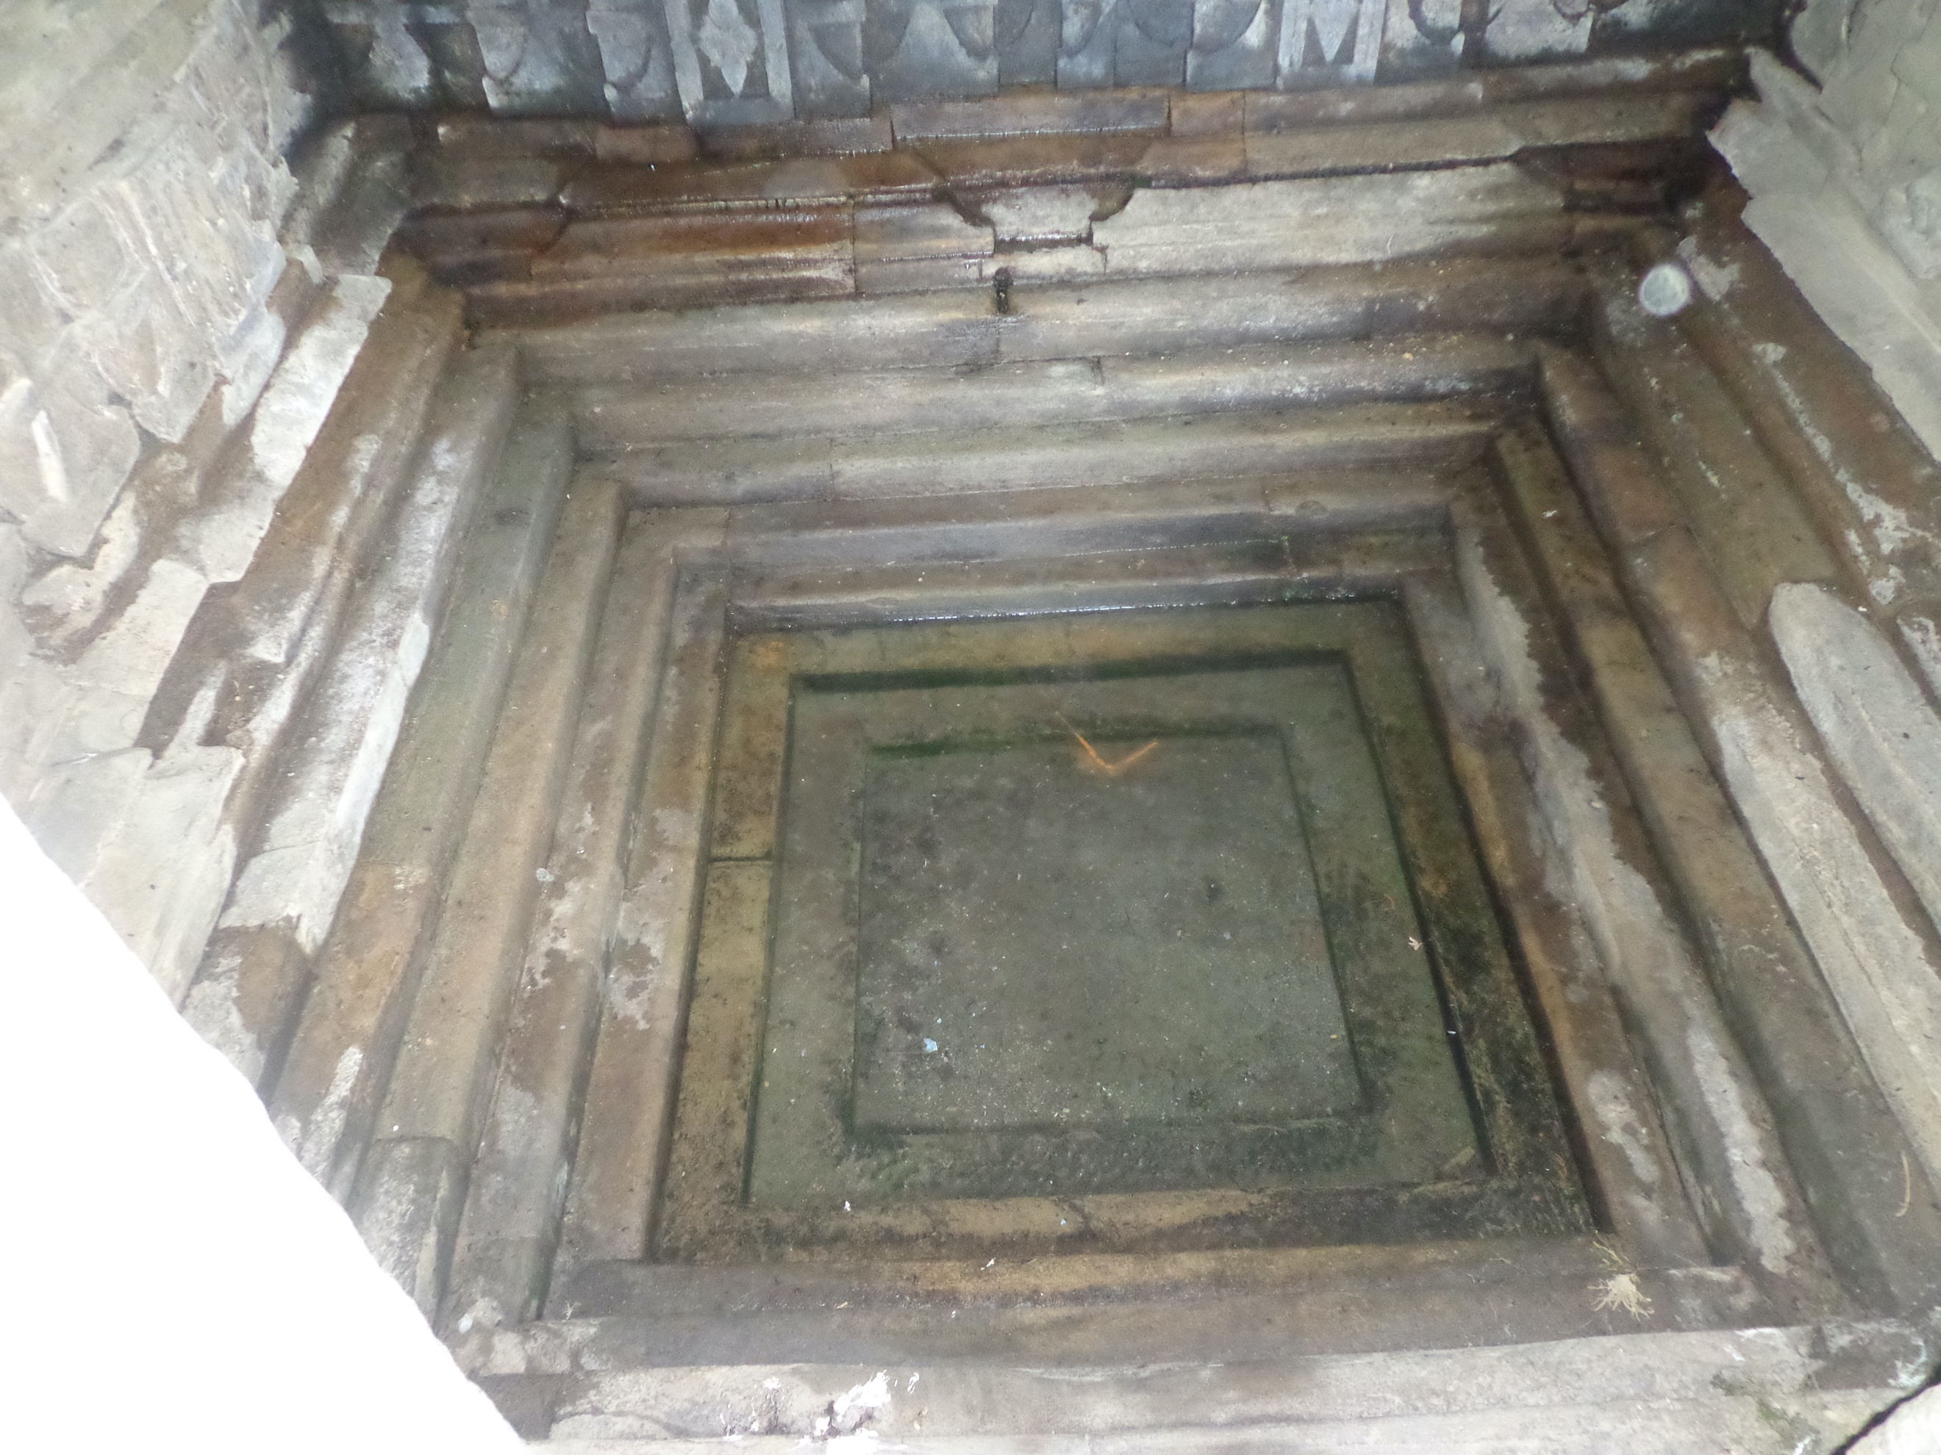

Fig. 2. View of traditional shallow dug well, Naula.
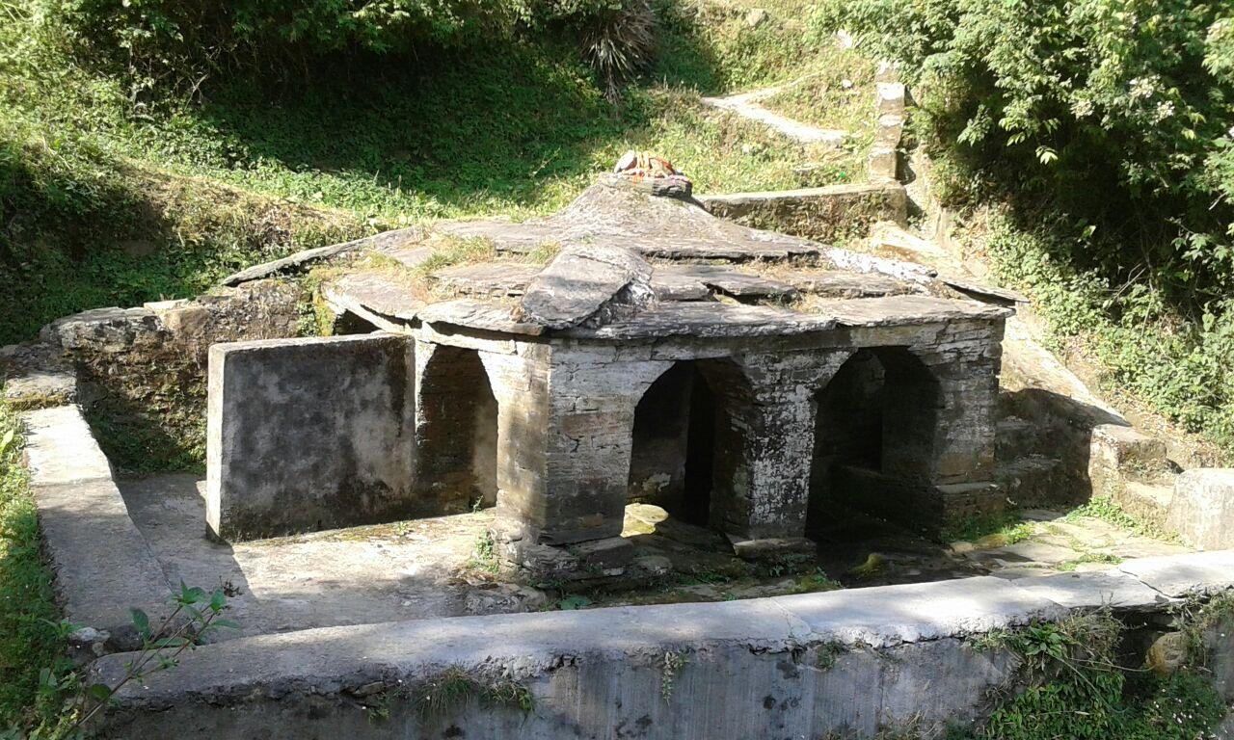

Fig. 3. View of brick lined deep dugwell at Almora.
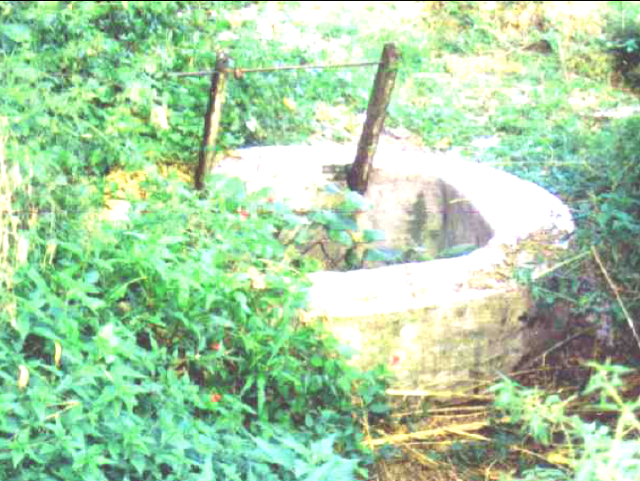

Fig. 4. View of traditional recharge pits, chal or khal.
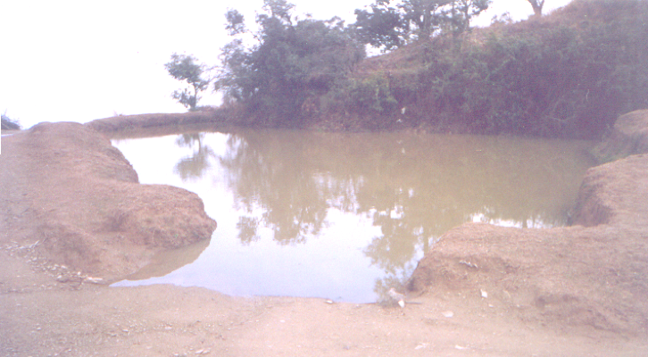

Fig. 5. View of traditional multistoreyed houses from Yamuna valley in Uttarkashi district.
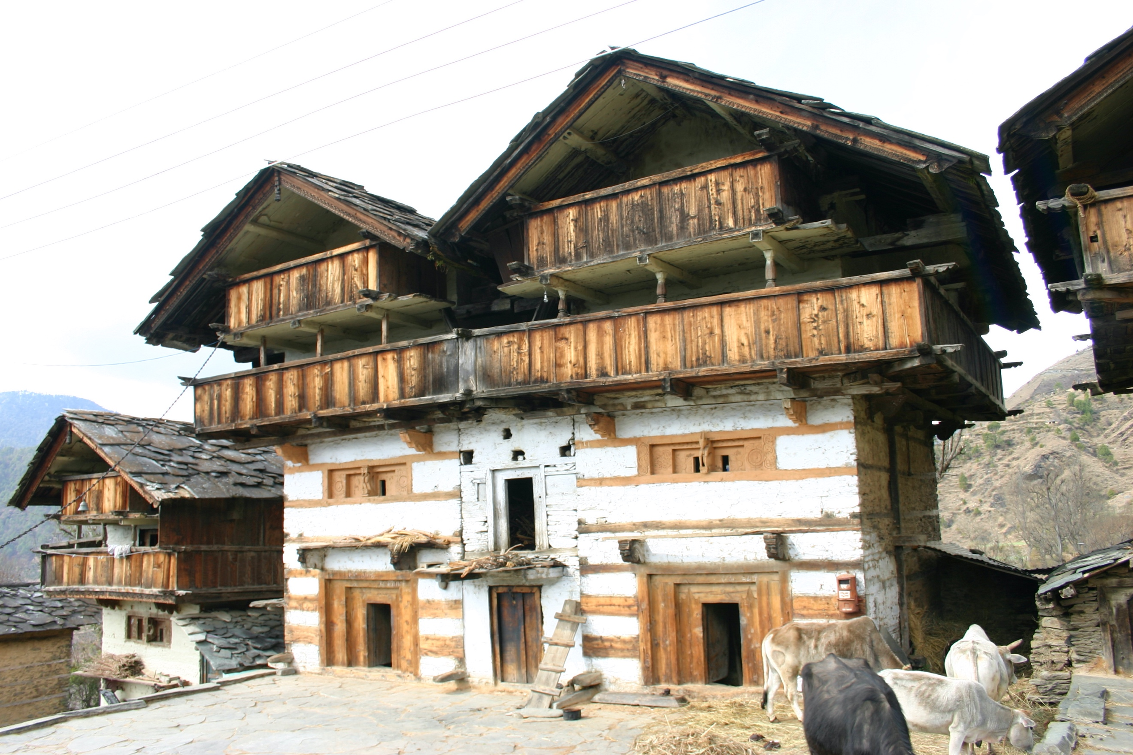 | 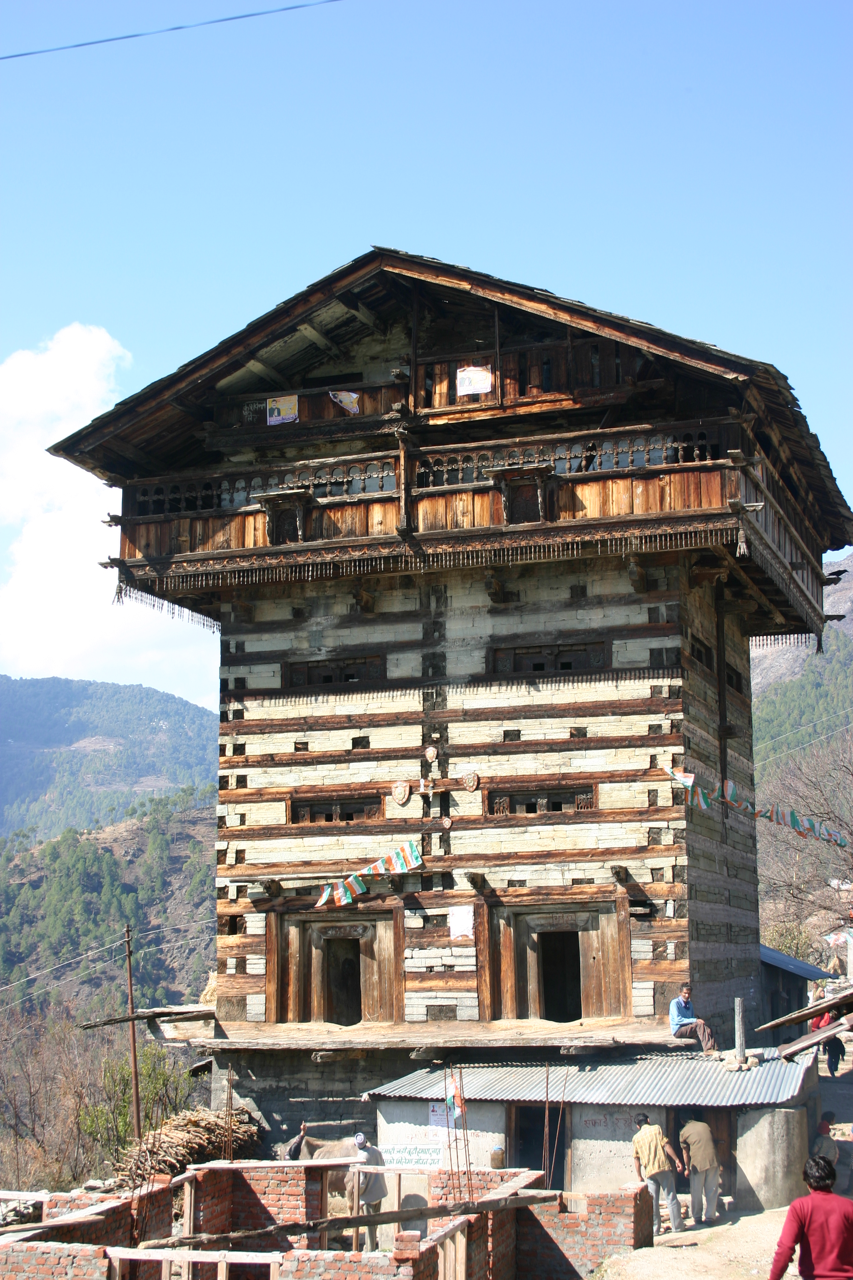

Fig. 6. Photograph showing housed and nailed joints used for fixing the wooden components of traditional houses.
