*Original Research Article*

**Assessing the adequacy of existing risk management programs for the safety of old dams: The case of Mindu dam in Morogoro Municipality.**

.

ABSTRACT

|  |
| --- |
| While structural evaluations of medium-to-large government-managed dams are common, small public-owned dams like Mindu remain critically understudied despite their vulnerability to failures. This study evaluates the adequacy of existing risk management programs for aging dams in developing countries, with a focus on the Mindu Dam in Morogoro Municipality, Tanzania. The study's three main goals are to: (1) determine whether Mindu Dam's safety practices comply with international standards, and (2) suggest context-sensitive policy improvements for aging dams in resource-constrained settings and(3) to identify The Variables Influencing Mindu Dam Safety Issues  A prime example of neglected ageing infrastructure is Mindu Dam, a small, publicly owned project built in 1978 for irrigation and municipal water supply. Due to its deteriorating state, antiquated design guidelines, and close proximity to heavily populated areas, it has been designated as a "high-risk" dam. The study's methodology combines both quantitative and qualitative techniques: criteria for "minimum" to "best" standards are informed by a global policy evaluation of dam safety frameworks, such as World Bank guidelines. Field surveys, soil erosion evaluations, vegetation observation, through field inspections which were carried out for Mindu in 2023. Technical data was augmented by structured interviews with 45 stakeholders, including local residents and dam operators.  The findings indicate systemic deficiencies, 80% of respondents identify that a reservoir perimeter experiences erosion from encroaching agricultural, 40% report that spillway capacity is below current flood projections, and 100% state that dam outlets show advanced corrosion. Because they lack regular monitoring and emergency response plans, risk management procedures fall short of even "minimum" criteria. The report incorporates World Bank recommendations into a tiered policy framework, giving institutional changes like required inspections for private dams and urgent repairs like outlet replacement priority.  For ageing dams, this study emphasizes the need to switch from informal management to systematic risk-based methods. It offers policymakers in developing nations a repeatable model for addressing governance inadequacies in infrastructure by striking a balance between socioeconomic viability and technical rigor. |

**Keywords:** *Policy Benchmarks, Dam Safety, Mindu-Morogoro, RUWA*

1. INTRODUCTION

Dam safety is a critical global concern as the world continues to rely on dams for various purposes such as water storage, irrigation, hydropower generation, and flood control (Materu *et al*., 2018; Pisaniello, 2011). Ensuring the integrity and safety of dams is paramount to prevent catastrophic failures that can lead to loss of lives, property damage, and environmental degradation. Dams play a crucial role in meeting the water and energy needs of many countries worldwide. According to the World Bank, there are over 57,000 large dams (height greater than 15 meters) across the globe, and countless smaller dams, serving a myriad of purposes(Adamo et al., 2020).

A significant challenge in dam safety is the aging infrastructure. Many dams were constructed decades ago, and their structural integrity may be compromised over time (Thi *et al*., 2012; Tingey-Holyoak *et al*., 2011). The International Commission on Large Dams (ICOLD) estimates that over 60% of the world's large dams are more than 50 years old. Climate change and extreme weather events contribute to the increasing risk factors for dam safety, the frequency and intensity of storms, floods, and other natural disasters pose threats to the stability of dams, making it essential to reassess and reinforce existing safety measures. Dam failures and incidents have occurred globally, underscoring the urgency of prioritizing dam safety (Pisaniello, 2010). Historical events, such as that reported by Xu et al., 2008 have resulted in significant loss of life and highlighted the potential consequences of inadequate safety measures. Various countries and international organisations have established regulatory frameworks and safety standards for dams. However, the level of adherence and enforcement varies globally. The World Bank indicates that strengthening regulatory capacities is crucial for enhancing dam safety on a global scale (Brewer *et al*., 2005; Pisaniello *et al*., 2011).

In Africa, dam safety is a critical concern, given the continent's increasing reliance on dams for various purposes. However, the region faces several challenges related to dam safety, ranging from inadequate infrastructure and maintenance practices to the impact of climate change. A significant number of dams in Africa are aging and may not meet modern safety standards. The lack of proper maintenance and surveillance can lead to potential risks, threatening both human lives and the environment (Perera et al., 2021). According to the World Bank, a substantial percentage of dams in Africa are classified as having high or significant hazard potential, signifying the potential for severe consequences in case of failure. Climate change exacerbates these concerns, as extreme weather events, such as heavy rainfall and floods, become more frequent, inadequate funding and limited technical expertise contribute to the challenges in ensuring dam safety across the continent. Efforts are being made to address these issues, including capacity-building initiatives, collaboration with international organizations, and the development of regional guidelines for dam safety. However, the statistics underscore the urgent need for comprehensive strategies and investments to enhance dam safety in Africa and mitigate potential risks associated with aging infrastructure and the changing climate (Arslan et al, 2016).

Tanzania has experienced a growing demand for water resources and energy, leading to an increased number of dams and reservoirs. However, the aging infrastructure and inadequate maintenance have raised concerns about the overall safety of these structures. To address these challenges, Tanzania has been working on improving its dam safety policies and practices. The government has implemented regulations and guidelines to ensure that dams adhere to international safety standards (Isomaki et al., 2012). Collaborative efforts with stakeholders, including local communities, engineers, and environmentalists, play a crucial role in monitoring and managing dam safety (Pisaniello, 2010). However, there are limited evidence to whether the current risk management programs are adequate to make Dams in Tanzania risk free.

This research aimed to evaluate the effectiveness and sufficiency of the current risk management programs, which are carried out in the old Mindu dam located in Morogoro municipality, Tanzania. The assessment covered a comprehensive examination of the existing strategies, policies, and practices in place to identify, mitigate, and manage various risks within the region's standards. Specifically, the study aimed to establish a dam safety policy benchmark for Tanzania, assess the rules and policies in place that control Tanzania's dam safety management and examine the variables that influence Mindu Dam Safety Issues.

2. material and methods

**2.1. Description of the study area**

This study was conducted at the Mindu dam, located in the Morogoro region's, Morogoro Municipality. Situated in the Ngerengere River Valley, the Mindu dam is roughly 3.8 kilometers southwest of Morogoro town (Kimambo et al., 2019). It is located at latitude 6.82°S and longitude 37.66°E (Figure 1). The area has a bimodal rainfall regime with short rains occurring between October and December (OND) and long rains from March to May (MAM) (Gobry *et al*., 2023). With an annual rainfall of between 800 and 1500 mm, the Uluguru Mountains receive the most precipitation in the basin. The dam primarily supplies Morogoro town with water (Kimambo *et al*., 2019). Its construction started in 1983 and was finished in 1985 with a dam design storage capacity of 20 Million m3(Stott, 1999).

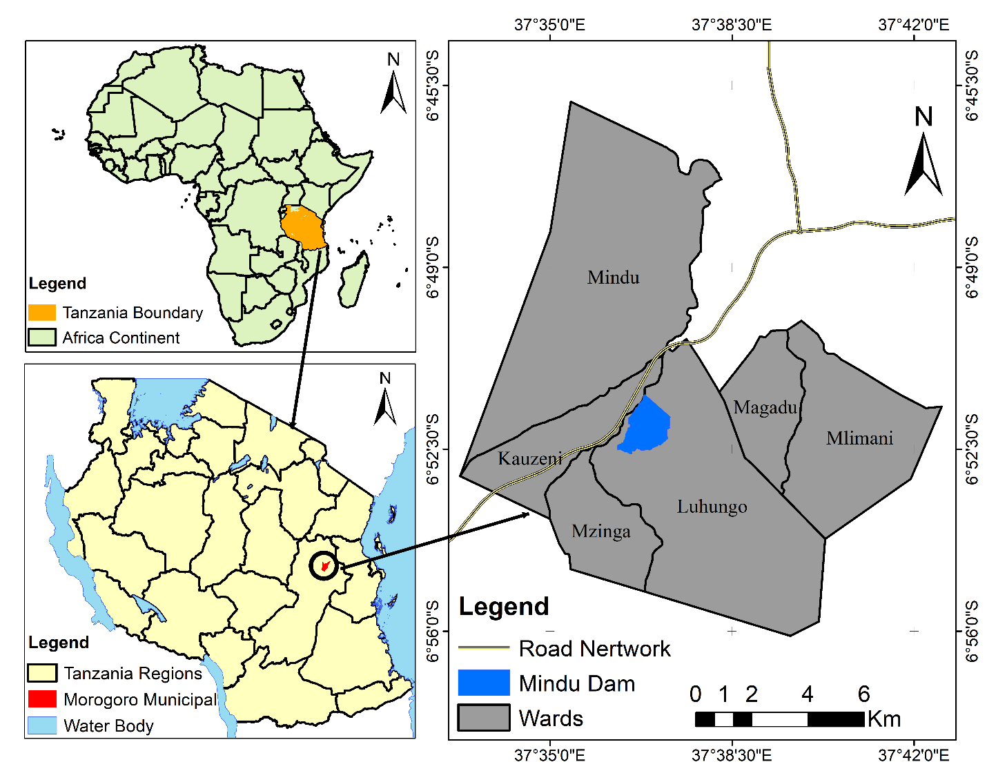

Figure 1. Study area showing the location of Mindu Dam

**Sample Size Selection**

To make sure that important socioeconomic and demographic groups were represented, a stratified purposive sampling technique was used. Although the appropriate sample size for the vulnerable population (n=88) was determined using the Cochran Formula, the actual sample size was only 45 due to practical limitations. To give high-risk groups priority, 30 of these were purposefully selected from the vulnerable category, while 15 of these were drawn from the non-vulnerable population.

$n=\frac{Z^{2}.p.q}{e^{2}}$……. equation 1

Where by

n = required sample size, Z= Z-score (critical value for the desired confidence level, e.g., 1.96 for 95% confidence), p = Estimated proportion of the population with a specific characteristic (use p=0.5*p*=0.5 for maximum variability if unknown), q=1−p, e = Margin of error (decimal form, e.g., 0.05 for 5%).

* 1. **Research Design**

The study adopted the cross-sectional research design whereby data were collected once from the six wards surrounding Mindu dam, namely Kauzeni, Mindu, Magadu, Mlimani, Luhungo, and Mzinga. The design allowed the collection of both quantitative and qualitative data within a short period by visiting the experts for more information based on the study subject. In addition, the design allows for cost, human and time effectiveness when it comes to data collection (Munshi & Ansari, 2021). Furthermore, the collected information is used in a variety of ways including to determine the association between variables as well as to approve and disapprove assumptions/hypotheses (Munshi & Ansari, 2021; Madhi *et al*., 2021).

* 1. **Data Collection**

This study was conducted in various phases as described below:

**Phase One:** To establish relevant benchmarks for comparing the sampled dams, a literature review was undertaken to explore global practices in benchmarking for dam safety.

**Phase Two:** Conducting ten on-site surveys as part of an embedded case study focusing on deliberately selected Mindu dam in Morogoro Municipality, Morogoro Region, Tanzania (Pisaniello *et a*l., 2013). Mindu dam was selected because it fulfilled the following two criteria: (1) being classified as "Significant" or "High" hazard based on an initial assessment of factors such as dam size, human habitation, and economic development in the downstream inundation area (Pisaniello & McKay, 2003; Tietenberg, 1998); and (2) qualifying as small dams(Salgado & Silva Carvalho, 2023). The on-site dam examination involved utilizing a dam inspection checklist sourced from the following periodicals: (1) "Your dam your responsibility: a guide to managing the safety of farm dams" released by the Department of Sustainability and Environment (DSE, 2007) in Victoria, (2) "Dam safety guidelines: inspection and maintenance of dams" published by the Water Management Branch of the Ministry of Environment, Lands and Parks, British Columbia (Cocklin *et al*., 2007; Donnelly *et al*., 2009) and (3) The global recommendations for the evaluation and examination of small earthen dams as outlined in the publications by Pisaniello, 2010a, b; Pisaniello and McCay, 2006.

**Phase Three:** The qualitative semi-structured interviews were conducted with representatives from thirty significant stakeholders. The in-person interviews took place between April 10 and October 11, 2023, to capture enough information on both rainy and dry season conditions of the dam.

The study employed the mixed methods approach in data collection whereby quantitative and qualitative data were collected concurrently to get more information to help answer the research questions. Primary data were collected using a structured questionnaire; key informant interviews (KIIs) and focus group discussions (FGDs). The KIIs and the FGDs were guided by a checklist and an FGD guide respectively. A total of 10 key informants occupying different positions including engineers and policymakers were interviewed. Moreover, ten FGDs, each involving 30 participants, were conducted.

**2.4. Data analysis**

Data collected from literature review, observations (on site surveys), semi-structured interviews regarding different applied coping strategies in farmers’ fields and observable risk of mindu dam in Morogoro, plus information collected from the household survey were analysed using descriptive statistics. R and Excel were used to generate frequency tables, percentages, charts and graphs to summarize, present and interpret survey results.

3. results and discussion

**3.1. Establishment of a global dam safety policy benchmark**

The assessment of adequate policy required a benchmark, which would be used for comparison purposes for the Tanzania reservoir in Morogoro. This global analysis demonstrates how different countries have different management plans for managing dam safety. Nonetheless, it is possible to identify essential elements of some techniques. Common law, command and control procedures, management, reservoir registration and categorization, monitoring, bookkeeping, and reporting, rules and/or standards of behaviour, readiness and education for residents, punitive enforcement, and owner instruction and direction are some of these. According to an analysis of the aforementioned international evaluation criteria, there are three primary independent ways to give the public more comfort about dam safety:

**Approach 1:** Owner instruction, support, and direction. Supplying dam owners with informational documents and guidelines in the hopes that they will behave responsibly and according to common law requirements (Gunningham and Sinclair, 1999, 2002; Zivie-Cohce, 1997).

**Approach 2:** Using emergency action plans (EAPs) to organize the community. Making EAPs a requirement for all dam owners may be necessary under legislation (Pisaniello and McKay, 2007). To mandate the creation and upkeep of increasingly sophisticated plans for increasing hazard potential and to monitor the overall state of reservoir safety management, it is also necessary for the government to establish and maintain a reservoir registration (Pisaniello and McKay, 2007). Because downstream populations are informed of the dangers and hazards they face and are given the option to evacuate in the event of a dam failure, this law respects the principle of the "Community Right to Know" (Gunningham and Grabosky, 1998).

**Approach 3:** Command and Control - stringent oversight and regulation through the application of dam safety laws. Gunningham and Grabosky (1998) and Eisner (2004) discussed the establishment of legal requirements for reservoir owners to adhere to specific rules, de facto standards, codes, and regulations on dam safety management, as well as the provision of supervision to guarantee compliance and provide a degree of regulatory certainty. All of these studies (Bradlow *et al*., 2002; Tigey-Holyoak *et al*., 2011; Pisaniello *et al*., 2011; Pisaniello, 2010; Pisaniello and Burritt, 2010; Pisaniello and McKay, 2003) have a primary focus on ensuring newly built dams are appropriately conceived and constructed, while also promoting proper maintenance and collecting information on risk assessment of existing dams. These studies have led to the establishment of international dam safety benchmarks. It is advised to use three general models of dam safety management policy, which range from "minimum practice" to "best practice," to give the public greater confidence regarding dam safety (Pisaniello, 2010). These models are known as the global models.

The models consist of the following:

Minimum practice = approach 1 + approach 2 (i.e., the minimum level benchmark).

Average practice = approach 1 + approach 2 + some element(s) of 3.

Best practice = approach 1+ approach 2 + approach 3 (i.e., the best practice benchmark).

Table 1.International policy levels of practices

|  |  |
| --- | --- |
| **Model category** | **Crucial element** |
| ‘Best Practices’ | The objectives of legal regulations  Implementation through administrative measures  Categorization and documentation of dams  Surveillance, scrutiny, and assessment of safety  Preparedness and education within the community  Responsibility of dam managers to furnish information  Guidance and oversight for dam managers  Application of sanctions for enforcement  Inclusion of the federal or central government |
| ‘Average practice’ | The objectives of legal provisions  Categorization and documentation of dams  Preparedness and educational initiatives within communities  Guidance and oversight for those responsible for managing dams |
| ‘Minimum practice’ | Enrolment and categorization of dams  Community awareness and readiness  Training and direction for those overseeing dams |

Source: (J. D. Pisaniello et al., 2011; Thi et al., 2012)

Together with the three global models, Bradlow *et al*. (2002) developed by the "World Bank frameworks," which are guidelines for dam safety regulations sponsored by the World Bank and also referred to as regulatory standards. As proposed by Gunningham and Grabosky (1998), a suitable regulatory mix that incorporates multiple mechanisms is meant to create a global standard or benchmark. This benchmark is essential for evaluating the effectiveness of on-farm water storage safety management in various legal contexts (Wagner & Schaltegger, 2003). In the event of a crisis, the public would be most assured and best practices would be established by a dam safety assurance policy that incorporates all three models. That being said, Gunningham and Sinclai (1999) suggest that it could theoretically be feasible to start and continue operations only using model 1's lowest benchmark. According to Pisaniello *et al*. (2011) and Pisaniello and McKay (2007), benchmark models are complementary to one another and can be used in concert to create thorough guidelines and crucial elements for establishing successful dam safety management policies in any jurisdiction. Table 1 integrates insights from the three international models and the World Bank frameworks to present key elements derived from international benchmarks. The international benchmarks mentioned earlier serve as the foundational standards for this paper's objective assessment of the suitability of the dam safety policy in Tanzania. The evaluation covers both central and local elements, including the overall policy enacted through laws and regulations, as well as practices and policy application on-site.

**3.2. An assessment of the rules and policies in place that control Tanzania's dam safety management**

In this section, we seek to lay the foundation for a comparative analysis of current laws and regulations against globally accepted standards. The National Water Policy of 1991 was thoroughly revised after a protracted consultation process resulting in the new National Water Policy (NAWAPO), which was approved by the Cabinet in July 2002, marking the end of this process. It is thought that the NAWAPO addressed and fixed the flaws in the prior policy. In addition, it instituted the decentralization of water supply management, by Agenda 21 from the 1992 United Nations Environment Meeting in Rio de Janeiro. The "subsidiarity principle," which promotes managing water supplies at the most suitable local level, was highlighted in this agenda (Lein & Tagseth, 2009; Materu *et al*., 2018).

The current initiatives of the Ministry of Water and Irrigation as well as the projects of its sub-sector have not followed the traditional rational order of policy, strategy, and planning. These include the development of the National Strategy for Improvement of Urban Water Supply and Sewerage, the National Rural Water Supply and Sanitation Programme, and the evaluation of laws about water resources, urban water supply, rural water supply, and sewerage. Due to this deviation from the typical order, possible problems like duplications or omissions may arise. Addressing the requirements of small towns, defining "sanitation," explaining the differing roles of the Ministry of Water and Irrigation and the Ministry of Health, and establishing institutional and legal frameworks are a few particular challenges(Phiri et al., 2007; Thi et al., 2012).

The Morogoro Water Supply and Sanitation Authority (MORUWASA) and other organizations have passed laws that form the basis for the country's dam safety management systems. Circulars, Instructions, Directives, and Decisions from pertinent Ministries or Provincial People's Committees are examples of by-law documents that are also available. In particular, (1) the Law on Water Resources Management (also known as the LWRM, Water Utilization (Control and Regulation) Act No. 42 of 1974, as amended by Acts No. 10 of 1981 and No.17 of 1989, Water Laws (Miscellaneous Amendments) Act No.8 of 1997, and Water Laws (Miscellaneous Amendments) Act of 1999), (2) Water Supply Aspects are governed by Urban Water Act No. 7 of 1981, Water Laws (Miscellaneous Amendments) Act No. 8 of 1997 and Water Laws (Miscellaneous Amendments) Act of 1999 (Mwaka, 1999; Ramachandra & Kumar, 2004).

Table 2.Inter-Institutional Cooperation in Dam Risk Management a case of Mindu dam, Tanzania

|  |  |  |  |
| --- | --- | --- | --- |
| **Institution** | **Role in Dam Risk Management** | **Example of Cooperation** | **Outcome** |
| Morogoro Municipal Council | Local enforcement of buffer zone policies, community engagement, and land-use planning. | Collaborated with MORUWASA to relocate residents in risk zones and enforce restrictions on human activities in buffer areas. | Reduced encroachment, minimized immediate risks to dam integrity, and protected local ecology. |
| MORUWASA | Technical oversight of dam safety, water resource management, and infrastructure maintenance. | Provided expertise on risk zones, supported relocation efforts, and implemented buffer zone demarcation with the Council. | Enhanced dam safety protocols and aligned local actions with national water resource goals. |
| National Environment Management Council (NEMC) | Regulatory oversight of environmental compliance (e.g., buffer zones, riverine ecosystems). | Reviewed environmental impact assessments, guided restoration of Mount Uluguru riverine areas, and monitored compliance. | Strengthened legal adherence, preserved biodiversity, and mitigated sedimentation risks. |
| Ministry of Water and Irrigation | National policy formulation, funding allocation, and coordination of inter-agency initiatives. | Issued guidelines for buffer zone enforcement, funded MORUWASA’s technical interventions, and facilitated multi-stakeholder dialogues. | Streamlined national-local alignment, ensured resource availability, and institutionalized best practices. |

**3.2.1 Registration and classification of dams**

For dam registration it’s a Mandates of the local government such as municipal council or Responsible authority do the following:(i) keep a record of major dams (i.e., Tanzania's "prescribed" classification system) inside their jurisdictions; and (ii) assign subjective hazard ratings based on the state's three-tiered hazard rating system. For the government to monitor the density of potentially dangerous dams and, consequently, the severity of the dam safety issue

The Second Schedule of the International Commission on Large Dams (ICOLD) guideline specifies the criteria that must be followed when categorizing dams and tailings dams. The following levels of external risks are to be used for categorization: (a) very high-risk (b) high risk (c) low risk and (d) very low risk.

Table 3.Criteria for classifying dam

|  |  |  |  |
| --- | --- | --- | --- |
| Rating Category4 | Loss of life | Economic and social loss | Environmental and cultural loss |
| Very high  “A “ | There is a big chance that residents and the working, travelling, and/or recreational public will die in multiple ways.  Development often included towns, sizable business and industrial zones, major thoroughfares, railroads, and areas with high concentrations of recreational activity within inundation areas (the region that could be submerged in the event of a dam failure).  Over a hundred deaths are estimated. | Significant financial loss affecting public, commercial, and infrastructure assets both inside and outside the flooded area. | Significant loss or degradation of habitat for wildlife, rare and/or endangered species, distinctive landscapes, or sites with cultural significance. |
| High “B” | There is a chance that residents who work, travel, or engage in public recreation might forfeit several lives. Development in areas prone to flooding usually consists of roads and railroads, business and industrial zones, | Severe financial losses impact public, private, and infrastructure properties both inside and outside the flooded area.  . | Habitat loss or significant degradation for rare and/or endangered species, wildlife, unique landscapes, culturally significant locations, and important national or provincial fisheries (including water quality). |
| Low “C” | Reduced possibility of multiple fatalities; inundation area is usually undeveloped, aside from small roads, briefly inhabited areas, non-residential farms, and rural activities. If a larger development is present, there needs to be a trustworthy component of natural warning. | Minimal financial losses as a result of fewer public, private, and commercial activities. The estimates expenses whether direct or indirect are minimal under this category | The disappearance or serious degradation of habitats supporting rare and/or endangered species, distinctive landscapes, places of cultural significance, wildlife habitat, and regionally significant fisheries. |
| Very low  “D” | Very little chance of a catastrophe. An area that is flooded is usually underdeveloped. | Little financial losses that are normally contained on the property of the owners | There is not a noticeable decline in the number of fisheries inhabitants, wildlife habitat, or uncommon or endangered species, |

4 The classification of the rating category is established based on external risks that could occur downstream in the event of dam failure.

Field data and institutional standards were used to determine Mindu Dam's "high hazard" categorization. Records from the Morogoro Municipal Council (2023) were used to determine the downstream population exposure (more than 1,000 inhabitants), which was then confirmed by home surveys. Using a checklist interview, the MORUWASA engineer found structural weaknesses, such as spillway capacity shortages. Interviews with representatives of the Morogoro Urban Water and Sanitation Authority (MURUWASA) confirmed the dam's vital role in the city's water supply. Globally, the categorization is consistent with the World Bank's (2010) definition of high-hazard dams, which are those that provide a "significant risk to essential infrastructure or human life.

Table 4.Mindu Dam risk Classification Status

|  |  |  |  |
| --- | --- | --- | --- |
| **Hazard Criterion** | **Threshold for "High Hazard"** | **Data Source** | **Mindu Dam Status** |
| Downstream population | 50 to 200meters buffer zone (Tanzania NEMC, **2004**) | Morogoro Municipal Council (2023) | 1,000 residents within flood zone |
| Critical infrastructure | Impacts water supply, roads, hospitals | MORUWASA records (2023) | Primary water source for Morogoro city |
| Structural condition | Severe deficiencies (ICOLD, 2005) | Field inspections (2023); | Outlet corrosion (100%); spillway deficit |
| Environmental sensitivity | Threat to protected ecosystems | Tanzania NEMC (2015) | Adjacent to Uluguru Mountains biodiversity hotspot |

**3.3. The Variables Influencing Mindu Dam Safety Issues**

Given the Natural factors i.e. flooding, erosion, structural deterioration i.e. Spillway capacity and other human factors such as vandalism associated with dam safety this study explores the factors contributing to the identification of safety issues with dams in Morogoro. According to feedback from and household interviews of various stakeholders, a significant number of dam failures occur during extreme weather events, notably floods and heavy rainfall, often coinciding with each other refer to Table 4. The majority of respondents expressed the belief that floods and heavy rains were prominent contributors to dam failures. Additionally, landslides were identified as another factor leading to dam failures, particularly in areas with mountainous terrain, such as the Uluguru Mountains. The age of dams was highlighted as a crucial determinant of their stability, with dams constructed over 40 years ago being more susceptible to failures. These insights were gleaned from both the questionnaires and interviews conducted as part of the study. The compromised safety resulted from inadequate design and construction, posing a threat to the inherent safety of these dams.

Stakeholders have conveyed the viewpoint that the main reason behind the present inadequate level of dam safety and instances of dam failures predominantly stems from subjective (human) factors. These key stakeholders emphasize that human factors are deemed as equally, if not more, significant than natural disasters and the age of dams in the context of ensuring dam safety (refer to Table 5).

The frequently cited factor contributing to dam safety issues is the lack of a risk-based assessment for dam safety.

Table 5 Common problems facing the Mindu dam in Morogoro.

|  |  |  |  |
| --- | --- | --- | --- |
| **Frequency(Key Participants)** | **Percentile (%)** | **Principal issues relating to dam safety** | **Source/Standard** |
| 25 | 83.3 | Significant erosion is evident on both the upstream and downstream faces. | Field survey and Local interviews, (2023); |
| 26 | 86.7 | The top has been affected by traffic, resulting in an uneven summit with depressions. | ICOLD (2005); Field inspection (2023) |
| 30 | 100 | The outlet is aged, damaged, and cracked. | inspection (2023) |
| 18 | 60 | Landslide occurrences in downstream | World Bank (2010) |
| 30 | 100 | Vegetation on both the upstream and downstream sides of the dam. | Tanzania NEMC (2015); Field survey (2023) |
| 30 | 100 | The spillway is obstructed and insufficiently sized. | FEMA (2013); World Bank (2010) |

**N.B:** Due to the proximity of numerous residences downstream and adjacent to the dam, the dam carries a significant risk rating.

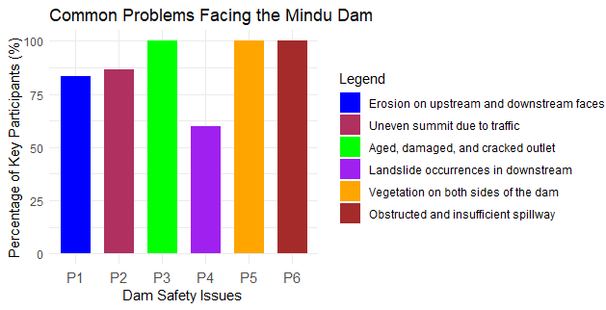

Figure 2.Common problem facing Mindu dam.

Several common problems facing the Mindu dam were identified from a field survey conducted through this study using 30 respondents from the field. 100% of all households interviewed agreed that the aging of the outlet of the dam, dense vegetation cover upstream and downstream of the dam and insufficient capacity and damage to the spillway are the leading problems facing the dam. Another leading problem facing Mindu dam is that it was observed with 86.7% agreement from household interviews that the dam top has been affected by human activities such as settlement which is attracted by the passage of trunk road it was also observed that the surrounding area of the dam has a lot of pit holes and depression caused by human activities encroachment. Not only that but also erosion was observed upstream and downstream of the dam and 83.3% percentage of the respondents agreed that this is the problem facing the dam and 60% of the respondents identified that the landside occurrences downstream are another problem facing the dam.

Table 3. Expertise Opinions on the Dam Conditions.

|  |  |  |  |
| --- | --- | --- | --- |
| **Sn** | **Issue** | **No of Expert** | **Percentile (%)** |
| 1 | Visible Holes/Cracks | 8 | 80 |
| 2 | Sign for erosion occurrences | 10 | 100 |
| 3 | water seepage | 7 | 70 |
| 4 | outlet pipe damage | 8 | 80 |
| 5 | vegetation blockage | 10 | 100 |
| 6 | animal damage | 8 | 80 |
| 7 | Flood occurrence | 10 | 100 |
| 8 | Compliance with the dam safety procedures | 5 | 50 |
|  |  |  |  |

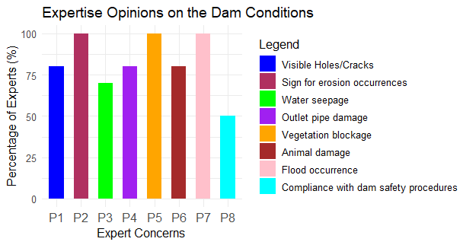

Figure 3.Expertise opinions on the Mindu dam condition

A comprehensive assessment of key issues affecting dam safety, through expertise from the responsible authority in managing the Mindu dam (MORUWASA) was conducted to highlight several critical factors affecting the safety of the dam like erosion, vegetation blockage, and flood occurrence. From the findings, it was observed that erosion, vegetation blockage and flood occurrence are the key factors affecting the dam.

Table 7.Physical elements that are thought to be causing the present dam safety issues

|  |  |  |
| --- | --- | --- |
| Element | No.of key participants(n=30) | Percentile (%) |
| Flooding occurrences | 26 | 86.7 |
| Intense rainfall | 28 | 93.3 |
| Dam impairment | 30 | 100.0 |
| Landslide incidents | 20 | 66.7 |

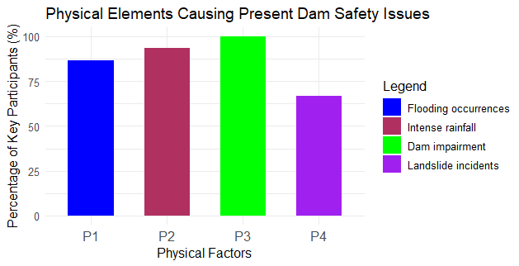

Figure 4.Physical element causing current dam safety issues.

Physical element causing current dam safety issues From the field interview of the experience of the respondents, it was observed that dam impairment downstream 100% agreed is the major causing present dam issues today due to poor maintenance and repairing of the downstream infrastructure, while 93.3% of dam safety issues are caused by high rainfall occurrence due to climate change, 86.7% of the damage were noticed to be caused by flooding caused by the occurrences of high rainfall in upstream along the mount Uluguru. Soil and landslide occurrence along the upstream was agreed by 66.7% of the respondents to another cause of dam damage.

|  |  |  |
| --- | --- | --- |
| Element | No.of key participants(n=30) | Percentile (%) |
| Insufficient risk-based assessment of dam safety | 25 | 83.3 |
| Local management of dam safety is deficient | 30 | 100.0 |
| Absence of centrally located dam governance | 20 | 66.7 |
| Lack of accountability | 24 | 80.0 |
| The value of life is deemed low | 18 | 18.0 |

Table 8.Examined human elements contributing to the current challenges in dam safety

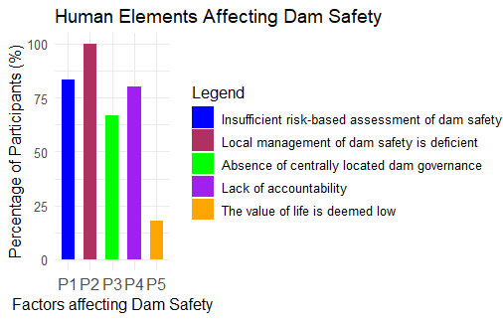

Figure 5.Factor contributing the current challenges the dam safety

All 30 participants unanimously agreed that the local management of dam safety is deficient. This represents 100% agreement among participants, showing a unanimous concern about the competence and effectiveness of local management in ensuring dam safety by the concerned authority. 83.3% of the participants believe that the current methods used to evaluate the safety risks of dams are inadequate. While 66.7% of the participants see the lack of a central authority as a significant issue in managing dam safety effectively. In addition, 18% agreement among participants, suggests that a minority perceives a disregard for human life in dam safety considerations.

Table 9.Key stakeholders’ shared concerns about the Mindu dam

|  |  |  |
| --- | --- | --- |
| Problems associated with the dam | No.of key participants (n=30) | **Percentile (%)** |
| Water seepage | 15 | 50.0 |
| Soil Erosion | 28 | 93.3 |
| Breaking | 20 | 66.7 |
| Incapacity due to sedimentation and/or losses | 30 | 100.0 |
| blocked exit | 15 | 50.0 |
| An improperly constructed spillway | 20 | 66.7 |
| Unlawful activity (sabotage or vandalism) | 19 | 63.3 |
| Excessing growing of vegetation/ trees | 29 | 96.7 |
| A sinkhole | 20 | 66.7 |
| Land/Soil slides | 30 | 100.0 |

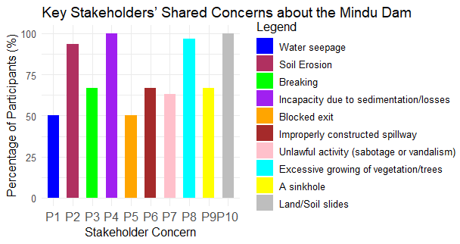

Figure 6. Stakeholders concerning on problem affecting the Mindu dam.

100% of all stakeholders agree that sedimentation and material losses reduce the dam's capacity to hold water, affecting its efficiency and longevity. (93.3%) of the household are worried about soil erosion around the dam area. 93.3% of the respondents agreed that Erosion can undermine the dam’s foundation, leading to structural instability.50% of the households interviewed are concerned about water seeping through the dam, which can weaken the structure and lead to potential failures.66.7% of the participants are concerned about the dam breaking. This reflects fears of catastrophic failure resulting in flooding and extensive damage downstream.

Table 10.Most Vulnerable Social Groups Affected by Dam Risks

|  |  |  |  |  |
| --- | --- | --- | --- | --- |
| **Vulnerable Social Group** | **Vulnerability** | **Group community** | **Protection Strategies** | **Protection Strategies (General)** |
| **1. Low-Income Households** | Reside in high-risk zones due to limited and unequal land access. | Informal settlers near Mindu Dam face displacement. | - Social Safety Nets: Cash transfers, subsidized relocation.  - Legal Safeguards: Enforce land tenure rights. | **Participatory Risk Assessments**  - Involve vulnerable groups in mapping risks and solutions**.** |
| **2. Subsistence Farmers and Fisher folk** | Depend on ecosystems disrupted by dam operations (e.g., altered water flow, reduced fish stocks). | Farmers along Uluguru Mountains facing crop failure. | - Livelihood Diversification: Climate-resilient farming. - Ecosystem Restoration: Rehabilitate riparian zones. | **Legal/Policy Frameworks**  **-** Enforce buffer zones and equitable compensation laws. |
| **3. Indigenous Communities** | Displacement erodes cultural heritage and traditional knowledge. | Communities near Rufiji River lost sacred sites due to a hydropower project. | - FPIC: Mandate community consent. - Cultural Impact Assessments: Include traditional knowledge. | **Social Safety Nets**  -Provide financial aid and livelihood support post-disaster. |
| **4. Women and Children** | Females face caregiving burdens post-disaster, and teen-agers involvement higher mortality and interrupted education. | Post-flooding in Morogoro, women struggled to access clean water. | - Gender-Sensitive DRR: Include women in planning. - Child-Centered Evacuation: Safe shelters, school continuity. | **Ecosystem-Based Adaptation**  **-**Restore ecosystems (wetlands/forests) to buffer flood impacts. |
| **5. Elderly and Persons with Disabilities** | Mobility constraints hinder evacuation and aid access. | - | - Inclusive Early Warning Systems: Tailored alerts. - Community-Based Support Networks: Train locals to assist. | **Gender-Responsive Planning**  -Prioritize women’s leadership in disaster planning  **Policy Recommendations for Morogoro**  - Strengthen Buffer Zone Governance - Community-Led Early Warning Systems - |

4. Conclusion

"The Mindu Dam’s classification as a ‘high-hazard’ structure (Table 3) is validated by severe structural deficiencies (100% outlet corrosion, 40% spillway deficit) and environmental risks (93.3% erosion, Table 7). These findings reflect Tanzania’s broader failure to adopt even minimum global standards (Approach 1 + 2), particularly in emergency preparedness (0% EAP compliance) and governance (66.7% lack of central oversight, Table 6). Immediate upgrades to spillways and outlets, paired with mandatory EAPs under the Tanzanian Water Act (2009), are critical to mitigating flood risks for 1,000 downstream residents. Long-term solutions require institutional reforms, including a national dam safety authority and IoT-based monitoring systems to address sedimentation (100% capacity loss, Table 7) and climate-driven flooding (86.7% linkage, Table 5). This case study underscores the urgency of adapting global frameworks to local contexts, offering a model for aging dam management in developing regions.

To strengthen the study’s applicability, we propose a follow-up phase involving collaboration with Tanzanian dam operators, policymakers, and communities to co-develop a draft National Dam Safety Policy. This would incorporate findings from this study while addressing contextual distinctions

AcknowledgEments

I sincerely thank the **East Africa Community Scholarship Programme**, sponsored by **KFW Germany Bank** and administered by the **Inter-University Council for East Africa,** for funding this research. Special thanks to **Adroit Consult International** for its support. I am also grateful to my **classmates** for their collaboration and encouragement. Heartfelt appreciation goes to my **family** for their unwavering love and support.

**Disclaimer (Artificial intelligence)**

Author(s) hereby declare that NO generative AI technologies such as Large Language Models (ChatGPT, COPILOT, etc.) and text-to-image generators have been used during the writing or editing of this manuscript.

6. References

Adamo, N., Al-Ansari, N., Sissakian, V., Laue, J., & Knutsson, S. (2020). Dam Safety : General Considerations. *Journal of Earth Sciences and Geotechnical Engineering*, *10*(6), 1–21.

Arslan et al. (2016). This document is discoverable and free to researchers across the globe due to the work of AgEcon Search . Help ensure our sustainability .

Brewer, C. K., Winne, J. C., Redmond, R. L., Opitz, D. W., & Mangrich, M. V. (2005). 04-001.Qxd. *Photogrammetric Engineering and Remote Sensing*, *71*(11), 1311–1320.

Cocklin, C., Mautner, N., & Dibden, J. (2007). Public policy, private landholders: Perspectives on policy mechanisms for sustainable land management. *Journal of Environmental Management*, *85*(4), 986–998. https://doi.org/10.1016/j.jenvman.2006.11.009

Donnelly, C. R., Bechai, M., Trias, M., Vaillancourt, J., & Roy, A. (2009). The Development of A National Dam Safety Standard for Parks Canada. *CDA 2009 Annual Conference*, *October 2009*, 21. https://doi.org/10.13140/2.1.3606.8806

Eisner, E. W. (2004). What can education learn from the arts about the practice of education? *International Journal of Education and the Arts*, *5*(4), 1–13. https://doi.org/10.4324/9780203019078-25

Gobry, J. J., Twisa, S. S., Ngassapa, F., & Kilulya, K. F. (2023). Impact of land-use/cover change on water quality in the Mindu Dam drainage, Tanzania. *Water Practice and Technology*, *18*(5), 1086–1098. https://doi.org/10.2166/wpt.2023.067

Gunningham, N., & Sinclair, D. (1999). Integrative regulation: A principle-based approach to environmental policy. *Law and Social Inquiry*, *24*(4), 853–896. https://doi.org/10.1111/j.1747-4469.1999.tb00407.x

Isomäki, E., Maijala, T., Sulkakoski, M., & Torkkel, M. (2012). Dam safety guide. In *Ely*. http://www.doria.fi/handle/10024/98859

Kimambo, O. N., Chikoore, H., Gumbo, J. R., & Msagati, T. A. M. (2019). Retrospective analysis of Chlorophyll-a and its correlation with climate and hydrological variations in Mindu Dam, Morogoro, Tanzania. *Heliyon*, *5*(11), e02834. https://doi.org/10.1016/j.heliyon.2019.e02834

Lein, H., & Tagseth, M. (2009). Tanzanian water policy reforms - Between principles and practical applications. *Water Policy*, *11*(2), 203–220. https://doi.org/10.2166/wp.2009.024

Madhi, S. A., Baillie, V., Cutland, C. L., Voysey, M., Koen, A. L., Fairlie, L., Padayachee, S. D., Dheda, K., Barnabas, S. L., Bhorat, Q. E., Briner, C., Kwatra, G., Ahmed, K., Aley, P., Bhikha, S., Bhiman, J. N., Bhorat, A. E., du Plessis, J., Esmail, A., … Izu, A. (2021). Efficacy of the ChAdOx1 nCoV-19 Covid-19 Vaccine against the B.1.351 Variant. *New England Journal of Medicine*, *384*(20), 1885–1898. https://doi.org/10.1056/nejmoa2102214

Materu, S. F., Urban, B., & Heise, S. (2018). A critical review of policies and legislation protecting Tanzanian wetlands. *Ecosystem Health and Sustainability*, *4*(12), 310–320. https://doi.org/10.1080/20964129.2018.1549510

Munshi, S. A., & Ansari, M. A. (2021). Collections and services of public libraries in West Bengal, India: An evaluative study against the backdrop of the IFLA guidelines. *IFLA Journal*, *47*(2), 250–262. https://doi.org/10.1177/0340035220958022

Mwaka, I. (1999). Water Law , Water Rights and Water Supply ( Africa ) Tanzania - study country report. *Dfid*, *August*.

Phiri, I. M. ., Phiri, S. ., & Saka, A. . (2007). *Rapid Appraisal of Policies & Institutional Frameworks for Agricultural Water Management*.

Pisaniello, J. D. (2010). Attitudes and Policy Responses to Australian farm dam safety threats: Comparative lessons for water resources managers. *International Journal of Water Resources Development*, *26*(3), 381–402. https://doi.org/10.1080/07900627.2010.489306

Pisaniello, J. D. (2011). A Comparative Review of Environmental Policies and Laws Involving Hazardous Private Dams : ’ Appropriate ’ Practice Models for Safe Catchments. *William & Mary Environmental Law & Policy Review*, *35*(2).

Pisaniello, J. D., Burritt, R. L., & Tingey-Holyoak, J. (2011). Dam safety management for sustainable farming businesses and catchments. *Agricultural Water Management*, *98*(4), 507–516. https://doi.org/10.1016/j.agwat.2010.10.001

Pisaniello, J. D., & McKay, J. M. (2003). A Farmer-Friendly Dam Safety Evaluation Procedure As A Key Part of Modern Australian Water Laws. *Water International*, *28*(1), 90–102. https://doi.org/10.1080/02508060308691668

Pisaniello, J. D., Tingey-Holyoak, J. L., & Burritt, R. L. (2013). Dual-extreme cumulative impacts and threats in agricultural catchments: The need for effective integrated policy. *Agricultural Water Management*, *118*(2013), 103–112. https://doi.org/10.1016/j.agwat.2012.12.003

Ramachandra, T. V, & Kumar, U. (2004). Geographic Resources Decision Support System for land use, land cover dynamics analysis. *Proceedings of the FOSS/GRASS Users Conference*, *September*, 15.

Salgado, S. R. T., & Silva Carvalho, E. M. da. (2023). Recommendations for the process of classification of dams in Brazil. *U.Porto Journal of Engineering*, *9*(3), 223–239. https://doi.org/10.24840/2183-6493_009-003_001968

Stott, R. (1999). The World Bank. *British Medical Journal*, *318*(7187), 822–823. https://doi.org/10.1136/bmj.318.7187.822

Thi, T., Burritt, R. L., & Pisaniello, J. D. (2012). *Adequacy of policy and practices for small agricultural dam safety accountability and assurance in Vietnam*. *112*, 63–74.

Tietenberg, T. (1998). Disclosure strategies for pollution control. *Environmental and Resource Economics*, *11*(3–4), 587–602. https://doi.org/10.1023/a:1008291411492

Tingey-Holyoak, J., Pisaniello, J. D., & Burritt, R. L. (2011). Analysis and application of international dam safety policy benchmarks. *Benchmarking*, *18*(2), 301–317. https://doi.org/10.1108/14635771111121720

Wagner, M., & Schaltegger, S. (2003). How does sustainability performance relate to business competitiveness? *Greener Management International*, *44*, 5–16. https://doi.org/10.9774/GLEAF.3062.2003.wi.00003

Zivie-Cohce, C. (1997). No Titleیلیب. *Nucl. Phys.*, *13*(1), 1–122.