***Original Research Article***

**Hydrotropic Extraction for Process Intensification in Delignification of Dried Jackfruit (*Artocarpus heterophyllus*) Leaves**

**Abstract:**

**Background:** The extraction of lignin is costliest, challenging process and is significant for production of various starting material useful in chemical synthesis, fuel production, weakening of cell wall to assists the extraction of natural active constituents from plants, in solid waste management and delignification assists in breaking of strong bonds of lignin and hemicellulose which entraps the fermentable cellulose. There is huge dried leaf waste, which has lignin component suitable for various applications. Further, the available lignin extraction methods affect the quality of lignin.

**Aim:** The present study aimed to investigate the delignification of dried jackfruit tree foliage using aqueous hydrotropic solutions.

**Methods:** The parameters studied for the delignification of dried jackfruit tree foliage include temperature, hydrotrope concentration dried leaves loading and delignification time. The obtained lignin is characterized by scanning electron microscopy (SEM), X-ray diffraction (XRD), differential scanning calorimetry (DSC), Fourier transform infrared spectroscopy (FTIR), UV-visible spectroscopy, and the ethanol extract of lignin is characterized by Gas chromatography-mass spectroscopy (GC-MS), gel permeation chromatography (GPC) correspondingly to understand in factors including the surface functionality, nature and morphology, molecular weight, phenolic compounds, thermal stability.

**Results**: The hydrotrope NaXS at 30 % w/w concentration, extraction temperature of 100 0C, 5 % w/w foliage loading concentration were optimum. The process enabled 81 % of lignin extraction and 95 % of hydrotrope recovery. The lignins recovered from different aqueous hydrotrope solutions of Na-XS, and Na-CS, were apparently similar indicating similar nature of the lignin extracted by different hydrotropes. Sodium xylene sulfonate was most satisfactory amongst different hydrotropes for the deligniﬁcation, the lignin could be recovered simply by water dilution and no solvent was used in any step. Reusability of hydrotrope was around 95 % for foliage deligniﬁcation.

**Conclusion**: The obtained lignin is free of organic solvents. The method selectively extracts lignin and keeps the cellulosic material intact as observed in conventional delignification processes.

**Keywords: Lignin extraction, Hydrotrope, green extraction**

**Introduction**

The extraction of lignin from the cell wall structure leads to the weakening of the plant cell wall, which assists the extraction of natural active constituents from lingocellulosic networks of plant material. Lignin is raw material useful in various applications like in the making of starting materials, composites, binders, coatings, surfactants, phenols, wood products, preservation, polyurethane foams, coal substitute, adhesive, animal feed, pesticide, cleaner (Labrath, 2021; Ji et al., 2022). The 30.3 percent i.e. 23.3 million hectares land in India consists of deciduous plants due to its tropical and sub-tropical climate. The deciduous plants shed dried foliage, and voluminous amounts of dry leaves are generated around the year. The dry leaves are composed of lignin (18-22 % w/w), cellulose (34- 40 % w/w), hemi-cellulose (20- 22 % w/w) and other nutrients. Lignocellulosic materials are abundant, cheap raw materials on earth and have applications in making of composites, binders, coatings, surfactants, phenols an alternative to petrol, automotive brakes, tires, wood products, preservation, polyurethane foams, coal substitute, binder in animal feed, ingredient in pesticide, industrial cleaner, in concrete (Crestini *et.al.*, 2010). The leaves and unused fruit can be used as fodder for cattle, pigs and goats. Jackfruit inedible parts have also been explored for their potential use in the production of biogas, briquettes and biochar, and pectin extraction (Nansereko and Muyonga, 2021). The lignin is a non-cellulosic aromatic 3-D component, lignin consists of units of guaiacyl- syringyl, po-lyphenols. The lignin envelopes cellulose and forms strong bonds, difficult to break. In urban settings where the majority of soil is concrete the degradation of dry foliage is a time-consuming so, so the disposal of this precious resource is generally done through burning, which is banned under Environment Protection Act, due to concerns of pollution (Environment Protection Rules, 1986, Ansari and Gaikar, 2014).

The extraction of lignin is the costliest, most challenging process and is significant for the production of various starting material useful in chemical synthesis, fuel production, weakening of cell wall to assist the extraction of natural active constituents from plants, in solid waste management and delignification assists in breaking of strong bonds of lignin and hemicellulose which entraps the fermentable cellulose. The various methods of delignification are reported in literature alkali assisted delignification, acid assisted delignification, organic solvents assisted delignification, ionic liquid assisted.

The delignification process using the intermediate product of alkaline (100 % NaOH) delignification process i.e. 50 % black liquor (NaOH, lignocellulosic material, polyphenolic compounds, aliphatic acids, acid greases and resinous compounds) produced delignification yields comparable to that produced by 100 % NaOH, and has eliminated the use of large amount of NaOH, and pollution caused due to discarding of untreated black liquor (Fernandez et.al., 1999). The delignification of paper has been reported by using combination of 1.75 N NaOH at 80 ̊C for 6 hr produced 40.2 % delignification (Subhedar and Gokate, 2014). The delignification about 86 % has been achieved using 0.3 % NaOH in 2 hr (Nagula and Pandit, 2016). The combination of alkali and photo-catalytic treatment

The ultrasound treatment, at 45 ̊ C, at 2 hrs, with 24 kHz and power of 100 watts gave 18 % delignification (Nagula and Pandit, 2016). The combination of 1 N NaOH and ultrasonication with 100 W duty cycle showed 80 % delignification in 1.16 hr (Subhedhar and Gokate, 2014). The laccase pre-treatment with 10 U/g of Napier grass at 300 rpm impeller speed, gave 50 % delignification. And the combination of ultrasound at 24 kHz frequency, 100 W with enzyme laccase showed 75 % delignification in 6 hr (Nagula and Pandit, 2016). The pretreatment of wood with ionic liquid prior to enzymatic treatment has been found to be an exciting method for improving the improve the rate of enzyme assisted extraction (Moniruzzaman *et.al.*, 2013). The delignification of beech wood sawdust using solvents including ethanol and acetone showed 90 % delignification, and the solvents combined with oxalic acid or phosphoric acid could replace the sulphuric acid showed significant de-lignification (Konstantinos et.al., 2018). The delignification process performed by organosolv show significant advantages as the lignin produced is sulphur free, extraction is selective giving good quality lignin, easily recoverable and is environment friendly as it has replaced use of mineral acids.

However, the alkaline delignification process involves treatment at high pressure in an autoclave and high temperature, the alkali method affects the structure of the lignin as observed under scanning electron microscope, the method is complex and it involves degradation of many other components including non-soluble polysaccharides such as cellulose and its monomers, they produce impure lignin, affects the quality of the cellulosic mass and active constituents, also they require high pressures and temperatures, longer extraction time and assistance of physical methods including ultra-sonication, enzymes for the reactions to take occur. Further, these reports do not mention recovering, the solvents, ionic liquids, acids, base, enzyme is not complete or the recovery of enzymes is not reported which leads to loss of the extracting solvents, and enzyme (Muryanto *et.al.*, 2015, Subhedhar and Gokate, 2014, Nagula and Pandit, 2016, Fernandez et.al., 1999, Moniruzzaman *et.al.*, 2013). The recovery of acid and base requires neutralization and the neutralization process generates large amounts of waste salt (Zhao *et. al.*, 2010, Wang *et. al.*, 2011). In case of hydrotropic extraction the hydrotropes are completely recoverable by the process of evaporation (Ansari and Gaikar, 2014).

Thus, there is a need to study novel method which can assist high purity of lignin, and improvise the application of both lignin and cellulose as biomass and biofuel and also show recovery of the extractant.

The phenomenon of hydrotropy has been reported for the selective extraction of various molecules including Limonene (Dandekar *et.al.*, 2008), Piperine (Raman and Gaikar, 2002), Forskolin (Mishra and Gaikar, 2009), Curcuminoids (Gaikar and Dandekar, 2000), Diosgenin (Mishra and Gaikar, 2004). Ansari and Gaikar, 2014 has used the phenomenon of hydrotropy for selective extraction of lignin from Napier grass. Hydrotropic extraction assists complete recovery of hydrotrope, and with promising good yields, it eliminates the use of any organic solvents and have also eliminated the use of higher energy equipment.

India is largest producer of jackfruits among the top five countries including Bangladesh, Thailand, Indonesia and Nepal. The jackfruit tree on an average is of 80 feet height with plenty of leaves, which sheds during winter account to approximately 100 kg of dry leaves per year per tree. These leaves contain about 18 to 22 % w/w of lignin. It is important to extract this lignin by clean methods to utilize it for production of valuables. Noting the advantages of hydrotropic extraction for de- lignification and necessity for delignification for management of voluminous bio-waste, in the present work, the extraction of lignin from jackfruit tree dried leaves has been optimized and the extracted lignin has been characterized for its quality.

**2. Experimental**

*2.1. Materials*

The shredded jackfruit tree leaves were collected from the ground of Institute of Chemical Technology. The hydrotropes, sodium xylene sulfonate (Na-XS), sodium cumene sulfonate (Na CS) were purchased from Navdeep Chemicals Pvt. Ltd, Mumbai, India.

**2.2. *Jackfruit tree leaf delignification procedure***

The dried jackfruit tree leaves were collected from the garden ground then the dust was cleaned and further leaves were subjected to particle size reduction and were sieved through molecular sieve to obtain the particle size range of 50- 160 µm. The powdered leaves with concentration 2.5, 5, 7.5 and 10 % w/w were suspended in (30 % w/w) hydrotrope solution in fully baffled cylindrical glass reactor and were stirred using a turbine impeller of typical dimensions, at temperatures ranging from 343 K to 373 K at agitation speed from 600 to 900 rpm to ensure complete suspension and vigorous mixing of all solid particles. The hydrotropes Na-XS and Na-CS at concentrations of 10, 20, 30, 40 % w/v were screened to obtain maximum yield of lignin. The suspension was further filtered and was washed with water 1: 50 v/v ratio at temperature, 353 K to avoid loss of traces of hydrotrope stuck to the solid cake. After thorough washing, the solid mass was dried and weighed to verify the extent of delignification.

The water-insoluble lignin dissolved in the hydrotropic solution was recovered from the hydrotropic solution by diluting in water, and then the solution was filtered under vacuum, washed with water and dried in oven at 378 K from 300 min. The diluted solution was evaporated to recover the hydrotrope.

The delignification % of the dried jackfruit tree leaves was calculated based on its initial lignin content which was determined by typical 72% sulfuric acid treatment (Sherrard and Harris, 1932, Peterson et.al., 1932). The weight of dried jackfruit tree leaves extracted in hydrotropic solution, during operation was accounted for in the calculation of % delignification.

**Analytical methods:**

The moisture content of the dried jackfruit tree leaves was determined by NREL procedure, wherein the leaves were kept in oven for drying at 60 ̊C for 24 h. The spectrogram of lignin solution dissolved in hydrotrope solutions (working sample) and only hydrotrope solution (reference cell) were recorded on a Chemito 2700 Double Beam UV–vis spectrophotometer (Chemito Instruments Pvt. Ltd., India). The IR spectra of solid residue after the extraction were also recorded at 298 K in the region 4000–400cm-1 using KBr pellet on a Bruker/Vertex 80V Fourier Transform Infrared spectrophotometer (FTIR) (Bruker Corporation, Germany). The recovered lignin was suspended in 30 % ethanol and was sonicated in a bath sonicator and the supernatant was subjected to gas chromatography and mass spectroscopy using a Finnigan LCD Advantage Max mass spectrometer (LCQAD 30000, Thermo Electron Corporation, USA). The instrument was equipped with a capillary column and a quaderpole detector. Nitrogen was used as a sheath gas with a ﬂow rate of 40x10-6 m3/min and auxiliary N2 ﬂow rate was maintained at 18x10-6 m3/min. The capillary temperature was maintained at 548K with voltage of 420 V and ion spray voltage at 5 KV. The isolated lignin was analyzed by Differential Scanning Calorimetery (DSC) by Shimadzu DSC-60 (Japan) with a heating rate of 283 K min-1. Nitrogen was used as the purge gas during the DSC analysis. The isolated lignin was also analyzed by X-ray diffraction (XRD) and spectra of lignin were recorded on D8 Advance Bruker X-ray diffractor (Bruker Corporation, Germany) at the wavelength 1.5406 Å. The surface morphological structure of the lignin and the average size of the lignin were determined by Scanning Electron Microscopy (SEM-JEOL-JSM) after coating with platinum. The electric current was 15 mA and the accelerating voltage was 20–30 kV. The extracted lignin was solubilized into dimethyl sulfoxide (DMSO) and its average molecular weight was measured by gel permeation chromatograph (GPC) (Waters India Pvt. Ltd., India), equipped with HPLC-515 pump, Styragel HT column (7.8 x 300 mm, molecular weight range of 500–30000), equipped with refractive index (RI) detector. The polystyrene (molecular weight range of 3000–800000) was used as a standard and THF with 0.8 ml/min was used as mobile phase.

**Result and Discussion:**

The moisture content of the dried jackfruit tree leaves was 10 % w/w. The ODW (oven dry weight) 1.2 % w/w, AIR (acid insoluble residue): 42.65 % w/w, ash content: 1.2 % w/w, AIL (Acid insoluble lignin): 20.71 % w/w, ASL (Acid soluble lignin): 0.3 % w/w and the total lignin content of the dried jackfruit tree leaves was 20.96%. The ash content was 1.228 % w/w. The cellulose content was 2.2 % w/w. The average particle size of jackfruit tree shredded leaves was 14 µm as observed under microscope.

**3.1. Deligniﬁcation of jackfruit tree leaves**

The deligniﬁcation of jackfruit tree dry leaves using aqueous hydrotropic solutions was studied at different temperatures as a function of time. The optimized process gave 81.1 ± 2 % w/w delignification at 30 and 40% (w/w) aqueous hydrotrope solutions at 388 ± 5 K in 240 min extraction time. The delignification percentage is comparable to that mentioned in the literature including the extraction obtained by 1, 4 –butanediol (Wang *et al.*, 2011), sodium xylene sulfonate solution, (Korpinen and Fardim, 2009; Borrega *et al.*, 2011), the extraction using ionic liquid (IL), i.e. 1-ethyl-3-methylimidazolium as cation and a mixture of alkyl benzene sulfonates as anions (Tan *et al.*, 2009). The extraction process using the hydrotrope requires reduced temperatures compared to the extraction using ILs (Tan *et al.*, 2009). Also, the hydrotropic extraction process has an advantage as the hydrotropes can be completely recovered unlike solvent extraction, ILs assisted extraction (Mai *et.al.*, 2014). The hydrotropic solution appears dark brown colored with the extraction of lignin from the leaves, the solid residue of jack fruit tree leaves remaining after extraction was separated by filtration by washing the residue thoroughly with hot water 1:50 ratio to ensure no traces of lignin remain in the matrix of the solid residue. The filtration was easily achieved without any pressure drop. Further, the lignin was separated from the hydrotropic solution by diluting with water (1:6 ratio) causing precipitation of lignin which was then separated by filtration and was dried. The process assisted in recovery of free flowing, amorphous, dark brown colored lignin powder. The physical characteristic of the extracted lignin were comparable with those mentioned in the literature (Boeriu et al., 2004; Faix et al., 1992; Javor et al., 2000; Luo et al., 2011; Lisperguer et al., 2009; Vallejos et al., 2011; Ni and Hu,1995; Saariaho et al., 2003; Kumar et al., 2010; Sarkanen and Ludwig, 1971; Singh etal.,2005).

**3.2. Parameter optimization for jackfruit tree leaves deligniﬁcation:**

**3.2.1**. **Effect of temperature:** The deligniﬁcation of dried jackfruit tree leaves was studied with respect to different temperatures ranging from 60 ± 5 ̊ C to 115 ± 5 ̊ C. The deligniﬁcation increased with increase in temperature and required reduced extraction time with increase in temperature (Figure 1). The literature reports that thermal energy enhances the disruption of the ligno-cellulosic structures. The temperature for the deligniﬁcation of leaves in the present study was optimized at 100 ± 5 ̊ C in 300 min. At the reduced temperature of 80 ̊ C the extraction of lignin was 81.1 ± 0.3 % however, required 8 hr. Thus, temperature optimization study is crucial for the extraction of lignin. Fig. 1 shows that the deligniﬁcation increased up to 240 min for 115 ± 5 ̊ C, but, thereafter, it remained constant. There were no traces of carbohydrates, sugars which are considered as by-products of cellulose degradation when studied using HPLC- RI at any of the studied extraction temperatures. The extraction time in our study seems to be more compared to the extraction at 121 ̊ C using an autoclave and hydrotrope (Devendra and Pande, 2016). This could be because of the mass transfer hindrance confronted by hydrotrope molecules during their approachability to lignin in leaves matrix at atmospheric conditions. The previous literature mentions deligniﬁcations of woody materials at higher temperatures can cause degradation of lignin (Brebu and Vasile, 2009).

**Figure 1:** Effect of temperature on Lignin extraction

**3.2.3. Effect of foliage loading:** The experiments were performed by using different percentages of jackfruit tree dried foliage at concentration of 5, 7.5, 10, and 12.5 % w/v in the 30 % NaXS for the deligniﬁcation. The optimized conditions of 115 ± 5̊ C and 240 min for the deligniﬁcation were used. The deligniﬁcation with 5 wt%, and 7.5 wt% bagasse loading was in the range of 80 to 81 % w/w. However, for 10 % w/v and 12.5 % w/v bagasse loadings, the behavior of the slurry made the stirring difficult, as the slurry was thick, showing increased apparent viscosity, hence the solid loading was controlled to 5 % w/v.

**3.2.4. Effect of different hydrotropes:**

The treatment of bagasse with 30% (w/w) aqueous solutions of different hydrotropes such as Na-XS and Na-CS gave 81% and 42% deligniﬁcation, respectively at optimized conditions of 115 ̊C temperature, 900 rpm as speed of agitation for 240 min. The estimated Kappa numbers of the initial foliage was 33.6 and the kappa number of ﬁnal deligniﬁed foliage, was 18.55, 28.3 respectively for Na-XS and Na-CS. The Kappa numbers in the range of 25- 30 and 17 -20 were considered ideal for good pulp quality (Chakar and Ragauskas, 2004). The maximum deligniﬁcation was observed in case of Na-XS, indicating that Na-XS was the most effective hydrotrope for the deligniﬁcation (Figure 2). The literature reports mention that the extraction efﬁciency of hydrotropes from plant matrices was proportional to the length of hydrocarbon structure of hydrotropes (Dandekar and Gaikar, 2003; Mishra and Gaikar, 2004, 2006, 2009; Negi and Gaikar, 2009; Raman and Gaikar, 2003). However, in the present studies contradictory results were observed. This might be because the hydrotropes self- associate forming aggregates, which offer certain degree of steric hindrance in solubilizing the large molecular weight lignin and is able to solubilize the low molecular weight phenolic species (Negi and Gaikar, 2009).

**Figure 2:** Effect of type of hydrotrope on de-lignification

**Effect of hydrotrope concentration:** The hydrotrope concentration in the aqueous solutions was varied from 10% (w/w) to 40% (w/w) to check its effect on the deligniﬁcation of bagasse at 115 ̊C. The extraction of lignin from foliage increased with hydrotrope concentration in given time. However, the incremental change in the deligniﬁcation percentage beyond 30% (w/w) of hydrotrope was insigniﬁcant probably due to increased viscosity of the hydrotropic solution due to increased concentration of the hydrotrope (Fig. 3). The minimum hydrotropic concentration (MHC) is characteristic of the hydrotrope, similar to critical micellar concentration (CMC) as noted for surface active compound. At MHC, the hydrotropes form aggregates and it improves the permeabilization, disrupts the cellular structure of the solid matrix in the foliage and hence increase the rate of lignin extraction. Minimum hydrotrope concentration (MHC) is required for obtaining relevant hydrotropic effects (Balasubramanian et al., 1989). The literature also mentions that the increase in the hydrotrope concentration increases the rate of extraction of bioactive substances upto certain concentration from plant solid matrix (Raman and Gaikar, 2003; Mishra and Gaikar, 2009).

**Figure 3:** Effect of Concentration of NaXS on de-lignification

**3.3. Recovery of lignin and hydrotrope:**

The lignin was precipitated by dilution of hydrotropic solution by addition of water. The percentage recoveries of lignin from aqueous solutions of Na-XS and Na-CS were approximately 42 % and 81 % on weight basis. After the recovery of lignin from the hydrotropic solution, the hydrotrope was recovered by concentrating the water by evaporation. The process allowed complete recycle of the hydrotrope, and the hydrotrope showed re-usability even after the third deligniﬁcation run. The process can be made efficient by adjusting hydrotrope concentration of the used solution to the original concentration 30 % w/w and the solution can be recycled for the next deligniﬁcation step. The total recovery of hydrotrope after the ﬁrst deligniﬁcation step was approximately 95 % w/w loss during the entire process.

**3.4 Characterization of extracted lignin:**

The lignin recovered from the hydrotropic solutions was characterized by different techniques including UV-absorbance, IR spectra, GC- MS, DSC, XRD, Kappa number as described below:

**UV-absorbance:** The characterization of lignin was done on the basis of differences in the UV absorption spectra of blank hydrotrope solution and lignin dissolved in the hydrotrope solutions. The UV absorbance of lignin showed two maxima at 240 and 290 nm wavelengths (Fig. 4). The previous literature reports, 241 nm and 292 nm wavelengths for lignin extracted from baggase (Ansari and Gaikar, 2014). The absorbance in the spectral region of 240 nm indicated the presence of p-hydroxyphenyl, guaiacyl, and syringyl structures of lignin (Saariaho et al., 2003) and at 290 nm indicated the presence of phenolic hydroxyl groups of lignin (Vallejos et al., 2011) which symbolizes presence of unconjugated phenolic compounds rather than conjugated phenols. The unconjugated phenols exhibited the peaks between 250 and 300 nm while conjugated phenols exhibited the maximum close to 370 nm (Aulin-Erdtman, 1954, Goldschmid, 1954).

**IR spectra:** The lignins recovered from different aqueous hydrotrope solutions of Na-XS, and Na-CS, were apparently similar indicating similar nature of the lignin extracted by different hydrotropes. Fig. 5 shows a IR spectrum of the functional groups of lignin extracted by Na-XS. The peak at 3427.51 cm-1 indicated the stretching of phenolic and hydroxyl units of lignin (Boeriu *et. al.*, 2004; Faix *et. al.*, 1992; Sarkanen and Ludwig, 1971; Singh *et. al.*, 2005). Cyclic hydrocarbons and aromatic methoxy group of the lignin structure were identiﬁed by the peaks at 2922–2852 cm-1. The peak at 1639.49 cm-1 indicated the carbonyl group stretching for methoxyl group of lignin, aromatic ring stretching, and methyl group (CH2/ CH3) stretching, respectively (Lisperguer *et. al.*, 2009). The absorbance of the guaiacyl structure of the lignin was found at 1375–1347 cm-1. The p- hydroxy phenyl structures of lignin showed the peaks at 1261 cm-1 and 1162 cm-1 (Lisperguer *et. al.*, 2009). The ether linkage of the lignin structure was seen at 1043 cm-1. Comparing the identified functional group peaks of the extracted lignin with that mentioned in the literature indicates that the recovered solid is lignin (Tan et al., 2009).

**Gas chromatography Mass spectroscopy:** The recovered lignin was sonicated for 180 min with two solvent systems, viz ethanol–water (60:40) and ethanol–water (70:30) in order to degrade and solubilize its different fractions of lignin (Ni and Hu, 1995, Ansari and Gaikar, 2014). The dissolved fractions of lignin in both ethanol–water (60:40) and ethanol– water (70:30) mixtures were analyzed by Mass Spectroscopy (Fig. 6). The masses of the compounds obtained included (m/z) 94 indicating presence of p- hydroxyl phenyl, m/z 122 indicating the guaicyl lignin, 129.22 indicating presence of 4-hydroxymethyl-tetrahydro-fura-3-carbaldehyde, the (m/z) 138 peak was not found indicating there is no syringyl lignin (hard wood lignin) was present. The peaks obtained indicated degradation peaks of lignin compound. Thus the lignin extracted is soft wood lignin. All these masses obtained were comparable with the literature for the lignin derived compounds (Javor et al., 2000, Ansari and Gaikar, 2014).

**Differential Scanning Calorimetery analysis:** of the recovered lignin was performed with the heating rate of 283 K min-1 under nitrogen atmosphere (Fig. 7). The DSC curve of lignin showed three distinct peaks. The ﬁrst peak was observed at 396 K (123 ̊ C) it showed an exothermic nature, indicating moisture loss from the sample during the heating. The second peak and third peak were observed at 485 K (212 ̊ C) and 618 K (345 ̊ C) were endothermic in nature indicating the degradation of the lignin structure. The DSC result was comparable with the literature where the lignin shows endothermic peak at 100 to 180 ̊C corresponding to elimination of humidity and further exothermic first peaks at 280 to 390 ̊C and second peak at 420 ̊C and beyond 500 ̊C (Singh et al., 2005, Brebu and Vasile, 2009).

The **XRD:** measurement of lignin reveals a weak peak at 22.37 (1) (2 θ value), indicating that lignin was mostly amorphous in nature (Fig. 8) (Luo et al., 2011). The XRD pattern of lignin was comparable with the literature (Kumar et al., 2010).

The **SEM:** images of lignin isolated from Na-XS, indicate irregular geometries in Fig. 5 which is not surprising considering the amorphous nature of the material. Further, the surfaces of lignin particles from all alkylbenzene sulfonate were apparently ﬂaky and smooth in nature (Fig. 9).

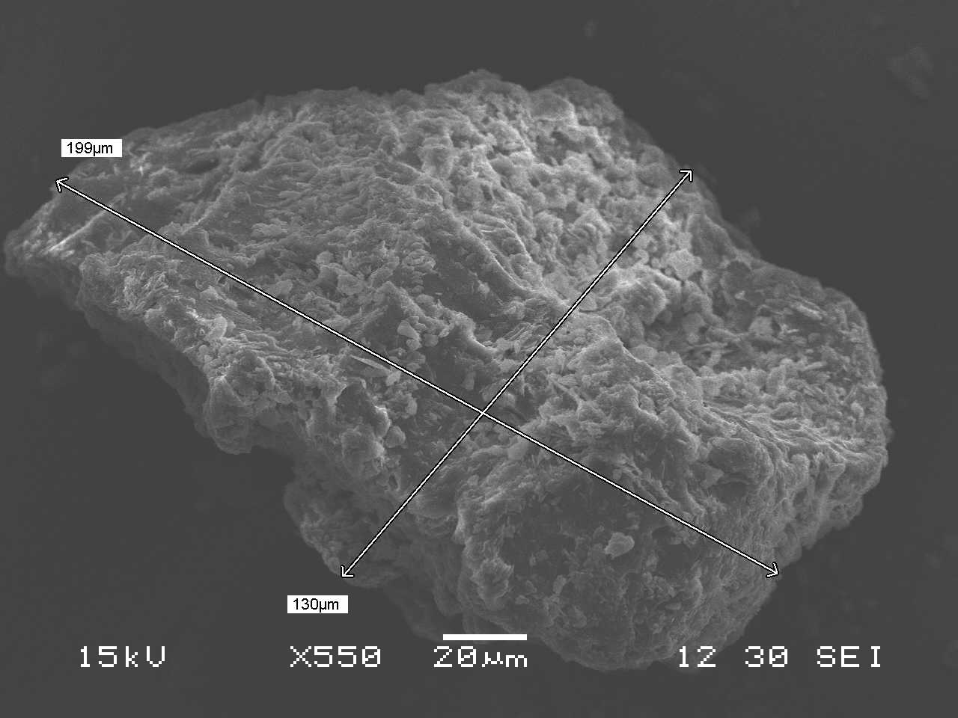

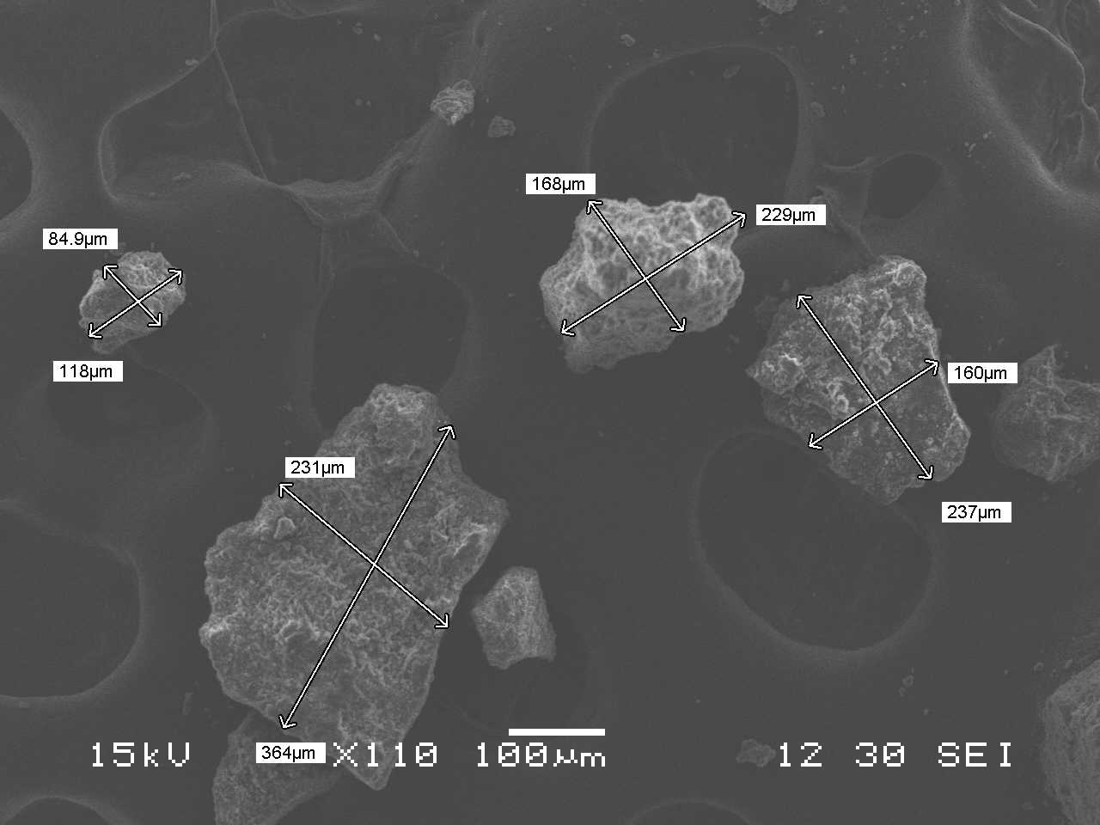

**Figure 9:** Scanning electron microscopic images of NaXS extracted lignin

The **gel permeation chromatography:** analysis revealed the weight-average (MW) and number-average (MN) molecular weights of lignin to be 4509 g/mole and 3962 g/mole, respectively (Fig. 10). The molecular weight of lignin was comparable with the lignin extracted from bagasse using dioxane, hydrotrope, tolune (3405–3868 g/mole) (Sun et al., 2011, Ansari and Gaikar, 2014), lignin isolated from bagasse by alkali treatment (1680–3020 g/mole) (Sun et al., 2003), and lignin obtained from bagasse using soda process (2160 g/ mole) (Mousavioun and Doherty, 2010).

The Kappa number values determined the oxidant demand, the degree of delignification, relative hardness and the bleachability of biomass. The Kappa number of the dry jack fruit tree foliage was determined by treating the foliage with potassium permanganate (KMnO4) in accordance with TAPPI Classical Method T 236 cm-85 “Kappa Number of Pulp.” to study its residual and post hydrotropic extraction lignin content (Agnihotri et al., 2010). The values for Kappa number was 35.3 and 18.5 for untreated foliage and 30 % w/w Na-XS treated foliage. Typically, Kappa number in the ranges of 25–30 and17–20 show good lignin content removal indicating a good quality biomass. The values Kappa number we obtained were also in agreement with Birch wood (Gabov et al., 2013) and bagasse deligniﬁcation studies (Jahan, 2006, Ansari and Gaikar, 2014).

**4. Conclusion**

The extraction of lignin from jack fruit tree dried foliage was successfully investigated by using two different aqueous hydrotropic solutions. Parameters for deligniﬁcation such as temperatures, time, hydrotrope concentrations, and suspension loading were optimized. Sodium xylene sulfonate was most satisfactory amongst different hydrotropes for the deligniﬁcation, the lignin could be recovered simply by water dilution and no solvent was used in any step. Reusability of hydrotrope was around 95 % for foliage deligniﬁcation. The current study of foliage deligniﬁcation using aqueous hydrotropic solution can overcome the problem of lignin separation from the lignocellulosic resources and also provide a good replacement to the traditional deligniﬁcation processes, where the recovery and generation of an efﬂuent is a major problem.

Disclaimer (Artificial intelligence)

Option 1:

Author(s) hereby declare that NO generative AI technologies such as Large Language Models (ChatGPT, COPILOT, etc.) and text-to-image generators have been used during the writing or editing of this manuscript.

Option 2:

Author(s) hereby declare that generative AI technologies such as Large Language Models, etc. have been used during the writing or editing of manuscripts. This explanation will include the name, version, model, and source of the generative AI technology and as well as all input prompts provided to the generative AI technology

Details of the AI usage are given below:

1.

2.

3.

References :

1. Crestini Claudia, Crucianelli Marcello, Orlandi Marco, Saladino Raffaele, **2010,** Oxidative strategies in lingnin chemistry: A new environmental friendly approach for the functionalization of lignin and lignocellulosic fibers, ***Catalysis Today***, 156, page no.: 8- 22.
2. Environment protection Rules, **1986,** Ministry of Environment and forests Deparment of Environment, Forest and Wildlife, notification New Delhi.
3. Ansari K. and Gaikar V., **2014,** Green hydrotropic extraction technology for deligniﬁcation of sugarcane bagasse by using alkybenzene sulfonates as hydrotropes, [***Chemical Engineering Science***](https://www.sciencedirect.com/science/journal/00092509)***,*** 115, page no.: 157–16.
4. Fernfindez B., Heredia F., Guillon R., Jimonez G., **1999,** Characterization of the lignin obtained by alkaline delignification and of the cellulose residue from steam-exploded olive stones, ***Bioresource Technology,*** 68, page no.: 121-132.
5. Subhedar and Gokate, **2014,** Alkaline and ultrasound assisted alkaline pre-treatment for intensification of delignification process from sustainable raw material, ***Ultrasonics Sonochemistry***, 21, page no.: 216–225.
6. Nagula and Pandit, 2016, Process intensification of delignification and enzymatic hydrolysis of delignified cellulosic biomass using various process intensification

techniques including cavitation, ***Bio-resource technology,*** [213](https://www.infona.pl/resource/bwmeta1.element.elsevier-514b204a-e137-3b63-af40-f37c8f5499ba/tab/jContent/facet?field=%5ejournalYear%5ejournalVolume&value=%5e_02016%5e_00213) ([C](https://www.infona.pl/resource/bwmeta1.element.elsevier-514b204a-e137-3b63-af40-f37c8f5499ba/tab/jContent/facet?field=%5ejournalYear%5ejournalVolume%5ejournalNumber&value=%5e_02016%5e_00213%5eC)), page no.: 162-168.

1. Moniruzzaman M., Ono T., Yusup S., Chowdhury S., Azmi Bustam M., Uemura Y., **2013,** Improved biological delignification of wood biomass via Ionic liquids pretreatment: A one step process, ***Journal of Energy Technologies and Policy,*** 3 (11), page no.: 144-152.
2. Kalogiannis K., Matsakas L., Aspden J., Lappas A., Rova U. and Christakopoulos P., **2018,** Acid Assisted Organosolv Deligniﬁcation of Beechwood and Pulp Conversion towards High Concentrated Cellulosic Ethanol via High Gravity Enzymatic Hydrolysis and Fermentation, ***Molecules,*** 23, page no.: 1647
3. Li Z., Liu W., Gu Z., Li C., Hong Y., Cheng L., **2015,** ***Food Hydrocolloids***, 48, page no.: 189 -196.
4. Wang Q., Chen K., Li J., Yang G., Liu S., and Xu J., **2011,** The solubility of lignin from bagasse in a 1, 4- butanediol/water system, ***BioResources***, 6 (3), page no.: 3034-3043.
5. Dandekar D., Jayaprakasha G., Patil B., **2008,** Hydrotropic extraction of bioactive limonin from sour orange (Citrus aurantium L.) seeds, ***Food Chemistry,*** 109, page no. 515-520.
6. Raman G. and Gaikar V., **2003,** Hydrotropic solubilisation of Boswellic acids from Boswellia serrate resin, **Langmuir,** 19 (19), page no.: 8026- 8032.
7. Mishra S. and Gaikar V., **2004,** Recovery of Diosgenin from Dioscorea Rhizomes using aqueous hydrotropic solutions of sodium cumene sulfonate, ***Ind. Eng. Chem. Res,*** 43, page no.: 5339-5346.
8. Gaikar and Dandekar, **2002,** Microwave assisted extraction of curcuminoids from curcuma longa, ***Separation science and technology,*** 37(11), page no.: 2669-2690.
9. Mishra and Gaikar, **2004,** Recovery of Diosgenin from *Dioscorea* Rhizomes Using Aqueous Hydrotropic Solutions of Sodium Cumene Sulfonate, **Ind. Eng. Chem. Res.,** *43* (17), page no.: 5339–5346.
10. [Sherrard](https://pubs.acs.org/author/Sherrard%2C+E.+C.) E. C., and [Harris](https://pubs.acs.org/author/Harris%2C+E.+E.) E. E., **1932,** Factors Influencing Properties of Isolated Wood Lignin, ***Industrial and Engineering Chemistry,*** 24 (1), page no. 103- 106.
11. Peterson C., Walde A., Hixon R., **1932,** Effect of temperature on sulphuric acid method for lignin, ***Industrial Engineering Chemistry Resource,*** 41, page no.: 2966- 2976.
12. Korpinen and Fardim, **2009,** Reinforcement potential of bleached sawdust kraft pulp in different mechanical pulp furnishes, Peer-Reviewed Article, **BioResources**, 4 (4), page no.: 1572-1585.
13. Tan S., MacFarlane D., Upfal J. and Scott J., **2009,** Extraction of lignin from lignocellulose at atmospheric pressure using alkylbenzenesulfonate ionic liquid, ***Green Chemistry,*** 11(3) page no.: 1-6.
14. Mai N., Ahn K., Koo Y., **2014,** Methods for recovery of ionic liquids- A review, Process Biochemistry, ***Process Biochemistry,*** 49, page no.: 872–881.
15. Boeriu C., Bravo C., Gosselink R., Jan D., **2004,** Characterisation of structure-dependent functional properties of lignin with infrared spectroscopy, ***Industrial Crops and Products,*** 20, page no.: 205–218
16. Faix O. and Bottcher. H., **1992,** The influence of particle size and concentration in transmission and diffuse reflectance spectroscopy of wood, ***Holz als Roh- und Werkstoff,*** 50, page no.: 221- 226
17. Javor T., Buchberger W., and Tanzcos I., **2000,** Determination of Low-Molecular-Mass Phenolic and Non-Phenolic Lignin Degradation Compounds in Wood Digestion Solutions by Capillary Electrophoresis, **Mikrochim. Acta**, 135, page no.: 45- 53.
18. Luo Q., Peng H., Zhou M., Lin D., Ruan R., Wan Y., Zhang J. and Liu Y., **2011,** Alkali extraction and physicochemical characterization of hemicelluloses from young bamboo (Phyllostachys Pubescens Mazel), 2012, ***BioResources,*** 7 (4), page no.: 5817- 5828.
19. Lisperguer J., Perez P., Urizar S., **2009,** Structure and thermal properties of lignins: characterization by infrared spectroscopy and differential scanning calorimetry, ***J. Chil. Chem. Soc.,*** 54, page no.: 4.
20. Vallejos M., Felissia F., Curvelo A., Zambon M., Ramos L., Area M., **2011,** Chemical and physic-chemical characterization of lignins obtained from ethanol-water fractionation of bagasse, ***BioResources,*** 6 (2), 1158-1171.
21. NI Y. and HU Q., **1995,** Lignin solubility in ethanol water mixture, ***AlCell,*** page no. 1441- 1446.
22. Saariaho A., Hortling B., Jääskeläinen A., Tamminen T. and Vuorinen T., **2003,** Simultaneous Quantification of Residual Lignin and Hexenuronic Acid from Chemical Pulps with UV Resonance Raman Spectroscopy and Multivariate Calibration, ***Journal of Pulp and paper Science,*** 29: 11
23. Kumar S., Negi Y., Upadhaya J., **2010,** Studies on characterization of corn cob based nano particles, ***Adv. Matter Letter,*** 1, page no.: 246- 253.
24. Singh R., Singh S., Trimukhe K., Pandare K., Bastawade K., Gokhale K., Verma A., **2005,** Lignin carbohydrate complexes from sugarcane baggase:, preparation, purification and characterization, ***Carbohydrate polymers,*** 62, page no.: 57-66.
25. Sarkanen K., Ludwig C., **1971,** Lignin, Occurances, Formation, ***Structure and reactions,*** John Willey and Sons, New York, page no. 916.
26. [Devendra](https://www.sciencedirect.com/science/article/pii/S0960148116301331#!) L., [Pandey](https://www.sciencedirect.com/science/article/pii/S0960148116301331#!) A., **2016,** Hydrotropic pre- treatment on rice straw for bioethanol production, [Renewable Energy](https://www.sciencedirect.com/science/journal/09601481), [***Renewable Energy***](https://www.sciencedirect.com/science/journal/09601481)***,*** [98](https://www.sciencedirect.com/science/journal/09601481/98/supp/C), Page no.: 2-8.
27. Mihai Brebu and Cornelia Vasile, **2009,** Thermal Degradation of Lignin – A review, cellulose chemistry and technology, ***Cellulose Chem. Technol.,*** 44 (9), page no.: 353-363.
28. Chakar F. and Ragauskas A., **2004,** Review of current and future softwood kraft lignin process chemistry, ***Industrial*** [***Industrial Crops and Products***](https://www.sciencedirect.com/science/journal/09266690)***,*** [20 (2](https://www.sciencedirect.com/science/journal/09266690/20/2)), page no.: 131-141.
29. Dandekar D. and Gaikar V., **2003,** Hydrotropic extraction of curcuminoids from turmeric, ***Sep. Sci. Technol.*** 38, page no.: 1185–1215.
30. Negi A. and Gaikar V., **2009,** Partitioning of o/p- nitrophenols in the presence of hydrotropes in aqueous solutions, ***Separation Science Technology,*** 44, page no.: 734 -752.
31. Balasubramanian, D., Srinivas, V., Gaikar V., Sharma, M.M., **1989,** Aggregation behavior of hydrotropes in aqueous solutions, ***J. Phys. Chem.*** 93, page no.: 3865–3870.
32. Vallejos M., Felissia, F., Cruvelo G., Zambon M., Ramos L., Area M., **2011,** Chemical and physico-chemical characterization of lignin obtained from ethanol water fractionation of bagasse, ***Bioresources***, 6, page no.: 1158–1171.
33. Aulin- Erdtman G., **1954,** Specctrographic contributions to lignin chemistry V. Phenolic groups in spruce lignin, **Sven. Papperstidin,** 57, page no.: 745- 760.
34. Goldschmid O., **1954,** Determination of phenolic hydroxyl content of lignin preparations by ultraviolet spectrophotometry, ***Analytical Chemistry,*** 26, page no.: 1421- 1423.
35. Lisperguer J., Perez P., Urizar S., **2009,** Lignin extraction from wood biomass by a hydrotropic solution, **O Papel,** 70, page no.: 69- 82.
36. Mihai Brebu , Cornelia Vasile, **2009,** Thermal Degradation of lignin – A Review, cellulose chemistry and technology, ***Cellulose Chem. Technol.,*** 44 (9), page no.: 353-363.
37. [FengSun](https://www.sciencedirect.com/science/article/pii/S0926669010003250#!) X., [Jing](https://www.sciencedirect.com/science/article/pii/S0926669010003250#!) Z., [Fowler P,](https://www.sciencedirect.com/science/article/pii/S0926669010003250#!) [Wu](https://www.sciencedirect.com/science/article/pii/S0926669010003250" \l "!) Y., [Rajaratnam](https://www.sciencedirect.com/science/article/pii/S0926669010003250#!) M., **2011,** Structural characterization and isolation of lignin and hemicelluloses from barley straw, ***Industrial Crops and Products,*** 33, page no.: 588- 598.
38. Mousavioun, P., Doherty, W.O.S., **2010.** Chemical and thermal properties of fractionated bagasse soda lignin, ***Ind. Crops Prod.*** 31, page no.: 52–58.
39. Agnihotri S., Dutt D., Tyagi C., **2010,** Complete characterization of bagasse of early species of Saccharum Officinerum CO 89003 for pulp and paper making, ***Bioresources,*** 5, page no.: 1197- 1214.
40. Gabov K., Fardim P., da Silva Junior F., **2013,** Hydrotropic fractionation of Birch wood into cellulose and lignin: a new step towards green biorefinery, **Bioresources,** 8, page no.: 3518- 3531.
41. Jahan S., **2006,** Formic acid pulping of bagasse, Bangladesh journal of scientific ***Industrial research,*** 41, page no.: 245- 250.
42. Labrath, Y.P. Hydrotropic Extraction of Lignin from Vegetation Mass. International Journal on Emerging Technologies 12(2): 221-234(2021)
43. Ji, H., Wang, L., Tao, F., Yao, Z., Li, X., Dong, C., & Pang, Z. (2022). A hydrotrope pretreatment for stabilized lignin extraction and high titer ethanol production. Bioresources and Bioprocessing, 9(1), 40.
44. Nansereko, Sophie, and John. H. Muyonga. 2021. “Exploring the Potential of Jackfruit (Artocarpus Heterophyllus Lam)”. Asian Food Science Journal 20 (9):97-117. https://doi.org/10.9734/afsj/2021/v20i930346.

**Figure 4:** UV-Vis graph of extracted lignin in NaXS

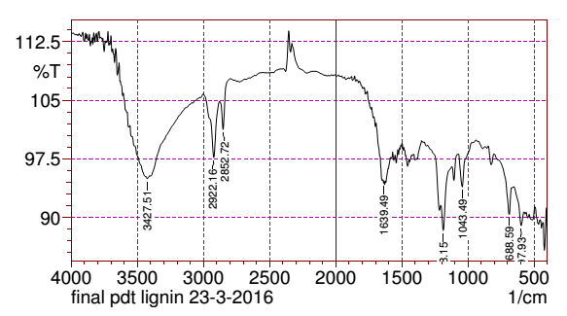

**Figure 5:** Infra red spectrum of NaXS extracted lignin

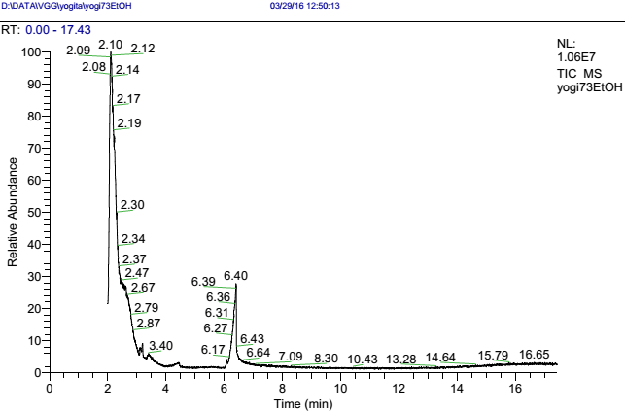

**Figure 6:** Gas chromatography of sonication ethanol: water:: 70: 30 treated lignin

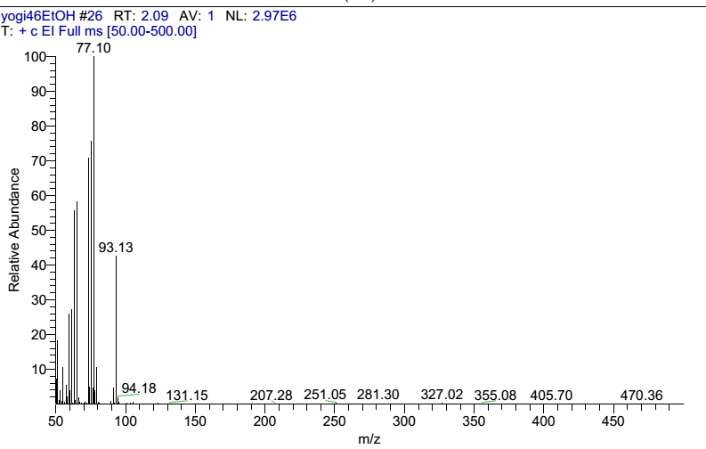

**Figure 7:** Gas chromatography Mass spectrum of sonication ethanol: water:: 70: 30 treated lignin

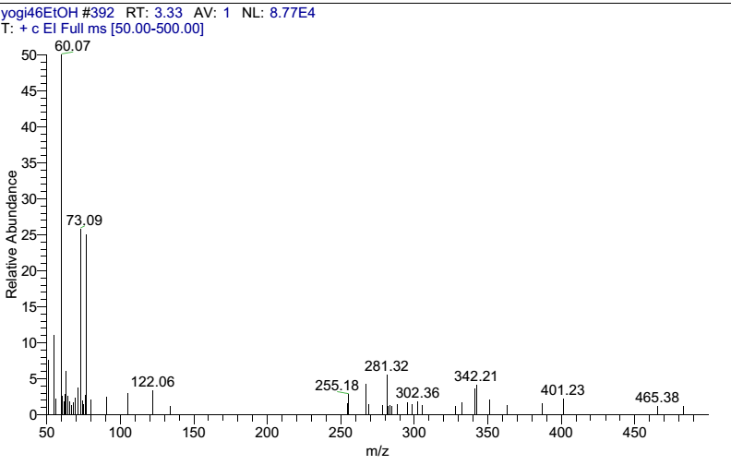

**Figure 8:** Gas chromatography Mass spectrum of sonication ethanol: water:: 70: 30 treated lignin

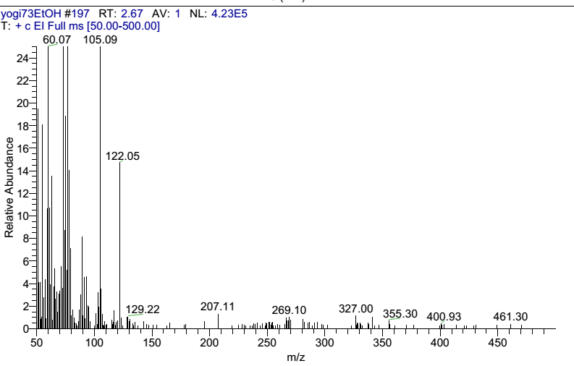

**Figure 10:** Gas chromatography Mass spectrum of sonication ethanol: water:: 70: 30 treated lignin

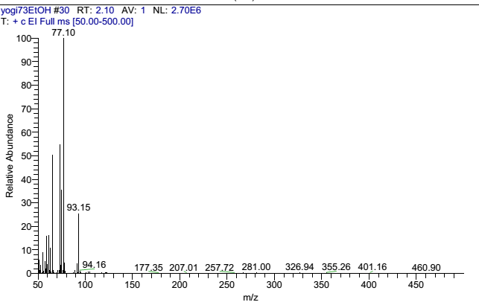

**Figure 11:** Gas chromatography Mass spectrum of sonication ethanol: water:: 70: 30 treated lignin



**Figure 12:** Differential scanning calorimeter graph of NaXS extracted Lignin

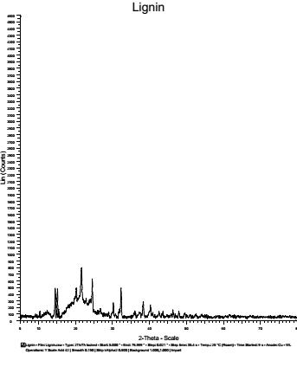

**Figure 12:** X-ray diffraction spectrum of extracted lignin

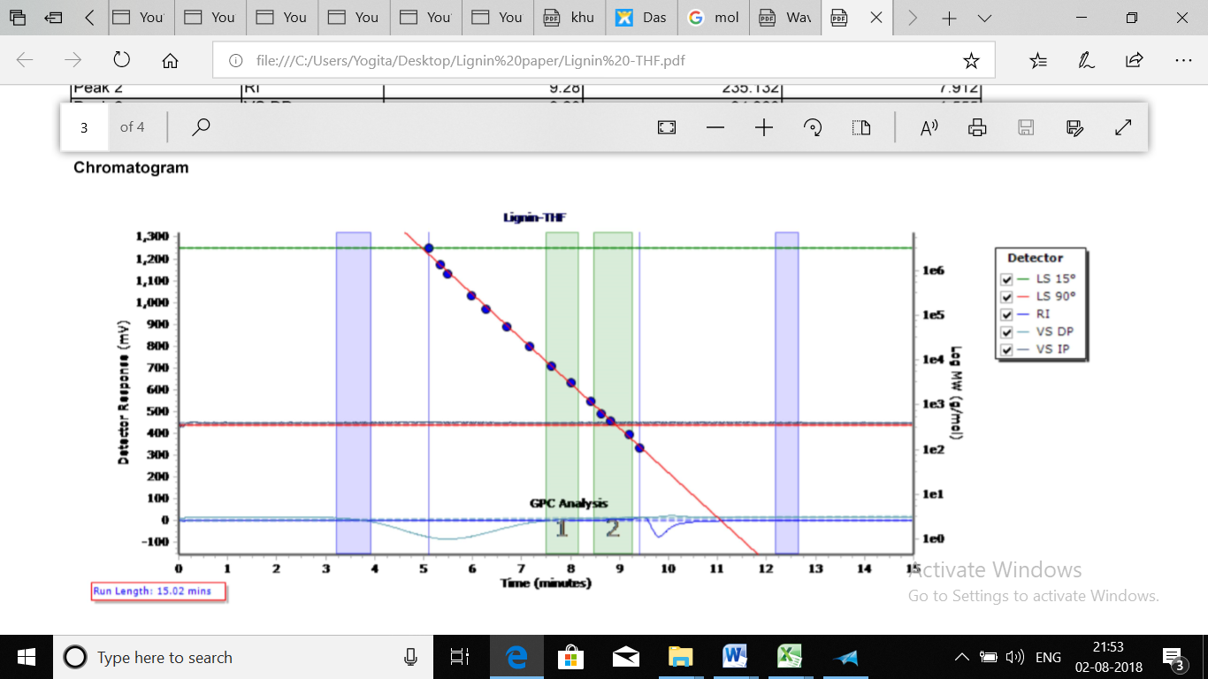

**Figure 13:** Gel permeation chromatogram of NaXS extracted lignin

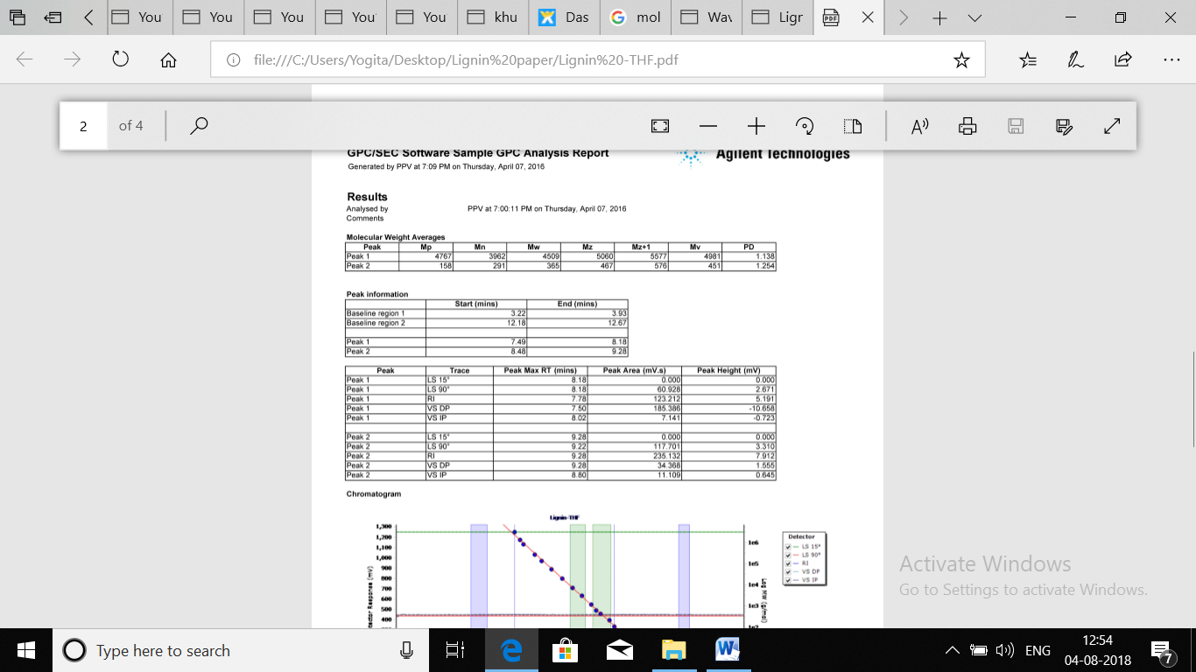

**Figure 14:** Gel permeation chromatography peak details of NaXS extracted lignin