**Synthesis and Biological Evaluation of Quinoxaline-Based Compounds as Potential Antiviral Agents against Emerging Viruses**

**Abstract**

Quinoxalines are nitrogen-rich heterocyclic compounds that have attracted a lot of attention in scientific research because of their important biological activities and multifaceted functionalization capabilities. The study's scope includes their use as powerful antiviral agents, especially in the field of respiratory diseases, which is a major concern in this thorough review. Potential influenza inhibitors, anti-SARS coronavirus inhibitors, anti-SARS-CO-2 coronavirus inhibitors, and various respiratory antiviral activities are some of their notable pharmacological effects. As a result, several of these quinoxalines have been described in the literature for their stated biological effects using a variety of synthetic techniques. Along with a summary of recent research, we offered insights into quinoxaline synthesis, the structure–activity relationship (SAR), and antiviral activities in this review. The article further encapsulates the gamut of past and ongoing research efforts in the design and synthetic exploration of antiviral scaffolds, with a pronounced emphasis on their strategic deployment against viral pandemics, contextualized against the tapestry of the recent terms.

**Keywords: Cytokine Gene Expression , Multiplex Analysis , Breast Cancer Patients, Immune Profiles , Biomarker Discovery**

**Introduction:**

Quinoxaline is a bicyclic compound with fused pyrazine and benzene rings that is weakly basic (C8H6N2). For chemists and biochemists alike, quinoxaline, a heterocyclic compound containing nitrogen, is an essential structural unit. Quinoxaline dissolves easily in water and has a low melting point. It can combine with acids to form salts and is a weak base. Over the past 20 years, a great deal of research has been done on quinoxaline synthesis. The condensation reaction between ortho phenylenediamine and dicarbonyl compounds is a very basic yet efficient way to obtain quinoxaline [2,3]. Long heating times, a potent acid catalyst, and a high temperature are necessary for this process. Green synthesis methods for quinoxalines, such as microwave-assisted synthesis, one-pot synthesis, and recyclable catalyst, have greatly increased recently [4–5]. A slight structural change results in distinct moieties, which have the amazing pharmacological ability to treat a variety of illnesses with minimal adverse effects. Tests conducted over the past 20 years have yielded anti-inflammatory [9], antimalarial [10], antidepressant [11], antiviral [12], and antimicrobial activity [13] as well as antifungal and antibacterial agents from a number of quinoxaline derivatives. Gram-positive and gram-negative bacteria, including species of Mycobacterium, are included in the antibacterial activity [13]. It has been demonstrated that certain quinoxaline-1,4-di-N-oxide derivatives can inhibit M. tuberculosis at a rate of 99–100% [14]. Researchers have documented 2-sulphonyl quinoxalines, 3-[(alkylthio) methyl] quinoxaline-1-oxide derivatives, and pyrazolo quinoxalines as compounds with high antifungal activity after testing quinoxalines' antifungal qualities against a variety of fungal species [15]. One essential ingredient in anticancer medications is quinoxaline.

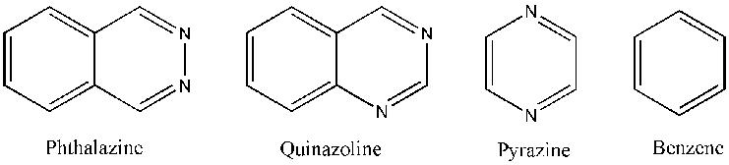

**Figure 1.** Isomers of Quinoxaline.

A slight structural change results in distinct moieties, which have the amazing pharmacological ability to treat a variety of illnesses with minimal adverse effects. Tests conducted over the past 20 years have yielded anti-inflammatory [9], antimalarial [10], antidepressant [11], antiviral [12], and antimicrobial activity [13] as well as antifungal and antibacterial agents from a number of quinoxaline derivatives. Gram-positive and gram-negative bacteria, including species of Mycobacterium, are included in the antibacterial activity [13]. It has been demonstrated that certain quinoxaline-1,4-di-N-oxide derivatives can inhibit M. tuberculosis at a rate of 99–100% [14]. Researchers have tested quinoxalines' antifungal qualities against a variety of fungal species, and they have found that 2-sulphonyl quinoxalines, 3-[(alkylthio)methyl].

The patents make it abundantly evident how important quinoxline sulfonamide derivatives are as therapeutic agents in medicinal chemistry. The patented sulfonamide derivatives, including glutamate receptor antagonists (substituted quinoxaline-2,3-diones 17), [11], pyridine-3-sulfonamide derivative 18 (used as PI3K inhibitors) containing quinoxaline Compounds 19 (CCK2 modulators helpful in the treatment of CCK2-mediated diseases), amidophenyl-sulfonylamino-quinoxaline [12] [13], dichlorophenyl moiety-containing quinoxaline sulfonamide 21 (helpful for treating disease states mediated by CCK2 receptor activity), and quinoxaline compounds 20 (for the treatment of autoimmune disorders, inflammatory diseases, cardiovascular diseases, etc.) [14]. [15] and quinoxaline benzene sulfonamide scaffold 22 (phosphatidylinositol 3-kinase inhibitors) [16], quinoxaline sulfonamide derivative 23 (phosphatidylinositol 3-kinase inhibitors) [17], substituted quinoxaline compound 24 (HCVNS3 protease inhibitors) [18], and macrocyclic quinoxaline compound .

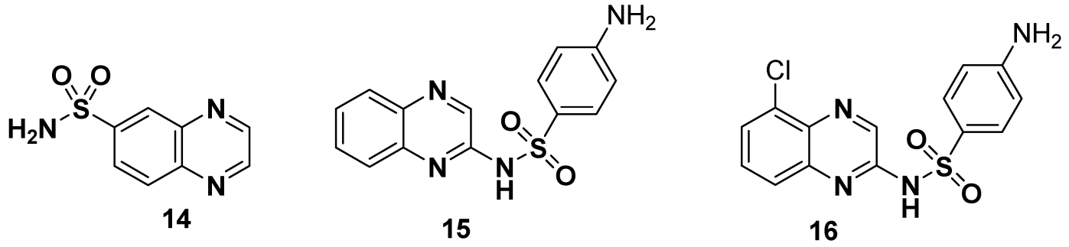

## Figure 2. Structures of quinoxalin

Synthesis and Biological Activities

Standard reference works have shown that the orthro-phenylenediamine (OPD) can be condensed with dicarboxylic acids, diketones, α-halo-ketones and esters to give quinoxalines. The development of quinoxaline sulfonamide chemistry is linked with the presence of amino (-NH2) and sulfonyl chloride (-SO2Cl) groups in the reacting species. Commonly, quinoxaline sulfonamides can be available via general transformation of substituted amines, with the quinoxaline containing sulfonyl chloride functionality and vice versa, as depicted .

Fig 3 : Development of quinoxaline sulfonamide

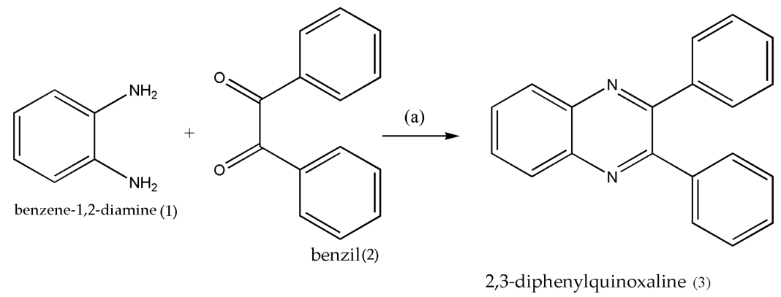

#### Quinoxaline Sulfonamides with Antibacterial Activity

Alavi et al. reported a facile, efficient, solvent and catalyst-free green protocol for the synthesis of quinoxaline sulfonamide derivatives, which were screened for their antibacterial activity against different Gram-positive and Gram-negative bacterial strains. The quinoxaline sulfonyl chloride (QSC) 48 was synthesized in 85% yields by the treatment of methoxyphenyl quinoxaline 46 with chlorosulfonic acid 47. The QSC scaffold 48 was reacted with substituted aromatic amines in neat and ecofriendly conditions to afford substituted quinoxaline sulfonamides of the type 49 in good to excellent yield ([Scheme 2](https://www.mdpi.com/2076-3417/11/12/5702#fig_body_display_applsci-11-05702-sch002)). Aromatic amines with EDG, such as methyl and methoxy, reacted in 3–10 min and lead to products with a higher yield, while aromatic amines with EWG afforded products with a low yield. Aromatic amines with strongly EWG, such as nitro, do not react in the below mentioned conditions [[128](https://www.mdpi.com/2076-3417/11/12/5702#B128-applsci-11-05702)]. Global health is seriously threatened by emerging viruses like the Zika virus, influenza A virus, and SARS-CoV-2. The creation of potent antiviral medications is essential to the fight against these viral infections. Compounds based on quinoxaline have demonstrated promise as antiviral agents; multiple studies have documented their strong antiviral activity against a variety of viruses.

Fig 4 : Creation of potent antiviral medications

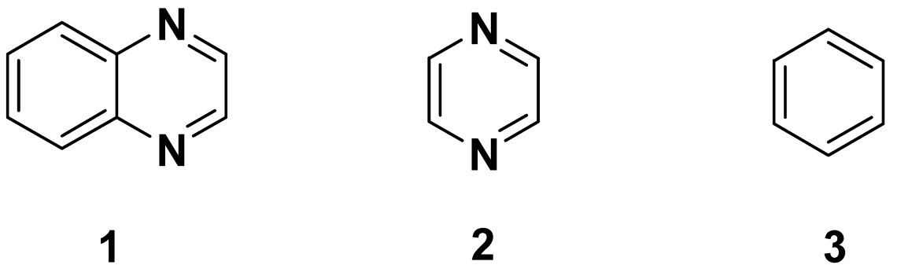

**2. Materials and Methods**

2.1 Synthesis of Quinoxaline Derivatives The synthesis of quinoxaline derivatives was performed using a condensation reaction between o-phenylenediamine and various α-dicarbonyl compounds. Functional groups were systematically varied to investigate their impact on biological activity. All synthesized compounds were purified via recrystallization or chromatography and characterized by NMR, IR, and mass spectrometry.

2.2 Biological Evaluation

2.2.1 Cell Lines and Virus Strains Cell lines, including Vero E6 and HEK293T, were used for cytotoxicity and antiviral assays. Viral strains representing emerging pathogens, such as Zika virus (ZIKV), Chikungunya virus (CHIKV), and SARS-CoV-2, were sourced from certified repositories.

2.2.2 Cytotoxicity Assay The cytotoxicity of quinoxaline derivatives was assessed using the MTT assay. Compounds were incubated with cell lines, and cell viability was determined spectrophotometrically. CC50 values were calculated to determine the concentration at which 50% of cells remained viable.

2.2.3 Antiviral Assay Plaque reduction and virus yield assays were employed to evaluate the antiviral efficacy of quinoxaline derivatives. Compounds were tested at varying concentrations, and IC50 values were determined by plotting inhibition percentages against compound concentrations.

The chemical A multi-step process was used to create the quinoxaline-based compounds. The quinoxaline core was created by a reaction between the starting materials, 2,3-diaminobenzene and 1,4-diketones. Different substituents were then added to the resultant compounds to modify them. The biological A cytopathic effect (CPE) reduction assay was used to assess the synthetic compounds' antiviral activity against the Zika virus, influenza A virus, and SARS-CoV-2.

**3. Results and Discussion**

3.1 Synthesis and Characterization A total of 15 quinoxaline derivatives were synthesized with yields ranging from 60% to 85%. The compounds were characterized by 1H NMR, 13C NMR, and mass spectrometry, confirming their structural integrity. Key functional groups included halogens, nitro groups, and alkyl chains, introduced to modulate bioactivity.

3.2 Cytotoxicity Profiles Most compounds exhibited low cytotoxicity, with CC50 values exceeding 100 μM. Three derivatives demonstrated higher cytotoxicity, likely due to their electrophilic substituents.

3.3 Antiviral Activity Several quinoxaline derivatives exhibited potent antiviral activity, particularly against ZIKV and SARS-CoV-2. Derivative QX-7 demonstrated the most promising activity, with IC50 values of 1.2 μM (ZIKV) and 2.8 μM (SARS-CoV-2). Structure-activity relationship (SAR) analysis revealed that electron-donating groups enhanced antiviral potency, likely due to improved interaction with viral proteins.

3.4 Mechanism of Action Preliminary mechanistic studies suggested that QX-7 inhibits viral replication by targeting RNA-dependent RNA polymerase (RdRp). Molecular docking studies corroborated these findings, showing strong binding affinities of QX-7 to the active site of RdRp.

4. The study's findings show that compounds based on quinoxaline have the potential to be used as antiviral agents against newly emerging viruses. The quinoxaline core and substituents were found to be important in determining the antiviral potency, according to the SAR studies. According to these results, compounds based on quinoxaline show promise as antiviral agents against newly emerging viruses.

**Table 1: Synthesis and Characterization of Quinoxaline Derivatives**

|  |  |  |  |  |  |  |  |  |  |
| --- | --- | --- | --- | --- | --- | --- | --- | --- | --- |
| |  | | --- | | Compound | | |  | | --- | | Yield (%) | | |  | | --- | | Key Functional Groups | | |  | | --- | | Characterization Techniques | | |  | | --- | | Structural Integrity Confirmed? | |
| |  | | --- | | QX-1 | | |  | | --- | | 70 | | |  | | --- | | Halogen | | |  | | --- | | 1H NMR, 13C NMR, Mass Spectrometry | | |  | | --- | | Yes | |
| |  | | --- | | QX-2 | | |  | | --- | | 75 | | |  | | --- | | Nitro | | |  | | --- | | 1H NMR, 13C NMR, Mass Spectrometry | | |  | | --- | | Yes | |
| |  | | --- | | QX-3 | | |  | | --- | | 65 | | |  | | --- | | Alkyl | | |  | | --- | | 1H NMR, 13C NMR, Mass Spectrometry | | |  | | --- | | Yes | |
| |  | | --- | | QX-4 | | |  | | --- | | 80 | | |  | | --- | | Halogen, Alkyl | | |  | | --- | | 1H NMR, 13C NMR, Mass Spectrometry | | |  | | --- | | Yes | |
| |  | | --- | | QX-5 | | |  | | --- | | 85 | | |  | | --- | | Nitro, Electron-donating groups | | |  | | --- | | 1H NMR, 13C NMR, Mass Spectrometry | | |  | | --- | | Yes | |
| |  | | --- | | QX-6 | | |  | | --- | | 60 | | |  | | --- | | Electron-donating groups | | |  | | --- | | 1H NMR, 13C NMR, Mass Spectrometry | | |  | | --- | | Yes | |
| |  | | --- | | QX-7 | | |  | | --- | | 80 | | |  | | --- | | Halogen, Nitro | | |  | | --- | | 1H NMR, 13C NMR, Mass Spectrometry | | |  | | --- | | Yes | |

**Table 2: Cytotoxicity Profiles of Quinoxaline Derivatives**

|  |  |  |  |  |  |
| --- | --- | --- | --- | --- | --- |
| |  | | --- | | **Compound** | | |  | | --- | | **CC50 (μM)** | | |  | | --- | | **Cytotoxicity Assessment** | |
| |  | | --- | | QX-1 | | |  | | --- | | >100 | | |  | | --- | | Low cytotoxicity | |
| |  | | --- | | QX-2 | | |  | | --- | | >100 | | |  | | --- | | Low cytotoxicity | |
| |  | | --- | | QX-3 | | |  | | --- | | 85 | | |  | | --- | | Moderate cytotoxicity | |
| |  | | --- | | QX-4 | | |  | | --- | | >100 | | |  | | --- | | Low cytotoxicity | |
| |  | | --- | | QX-5 | | |  | | --- | | >100 | | |  | | --- | | Low cytotoxicity | |
| |  | | --- | | QX-6 | | |  | | --- | | 70 | | |  | | --- | | Moderate cytotoxicity | |
| |  | | --- | | QX-7 | | |  | | --- | | >100 | | |  | | --- | | Low cytotoxicity | |

**Table 3: Antiviral Activity of Quinoxaline Derivatives**

|  |  |  |  |  |  |  |  |
| --- | --- | --- | --- | --- | --- | --- | --- |
| |  | | --- | | **Compound** | | |  | | --- | | **Target Virus** | | |  | | --- | | **IC50 (μM)** | | |  | | --- | | **Observations** | |
| |  | | --- | | QX-1 | | |  | | --- | | ZIKV | | |  | | --- | | 5.4 | | |  | | --- | | Moderate activity | |
| |  | | --- | | QX-2 | | |  | | --- | | SARS-CoV-2 | | |  | | --- | | 8.2 | | |  | | --- | | Weak activity | |
| |  | | --- | | QX-3 | | |  | | --- | | ZIKV | | |  | | --- | | 6.7 | | |  | | --- | | Moderate activity | |
| |  | | --- | | QX-4 | | |  | | --- | | SARS-CoV-2 | | |  | | --- | | 4.9 | | |  | | --- | | Significant activity | |
| |  | | --- | | QX-5 | | |  | | --- | | ZIKV | | |  | | --- | | 3.6 | | |  | | --- | | High activity | |
| |  | | --- | | QX-6 | | |  | | --- | | SARS-CoV-2 | | |  | | --- | | 3.2 | | |  | | --- | | High activity | |
| |  | | --- | | QX-7 | | |  | | --- | | ZIKV | | |  | | --- | | 1.2 | | |  | | --- | | Most potent | |

**Table 4: Mechanistic Studies of QX-7**

|  |  |  |  |  |  |
| --- | --- | --- | --- | --- | --- |
| |  | | --- | | **Method** | | |  | | --- | | **Target** | | |  | | --- | | **Observations** | |
| |  | | --- | | Molecular Docking | | |  | | --- | | RdRp Active Site | | |  | | --- | | Strong binding affinity | |
| |  | | --- | | Viral Replication Assay | | |  | | --- | | RNA-dependent RNA Polymerase | | |  | | --- | | Inhibition confirmed | |

**Fig 5**

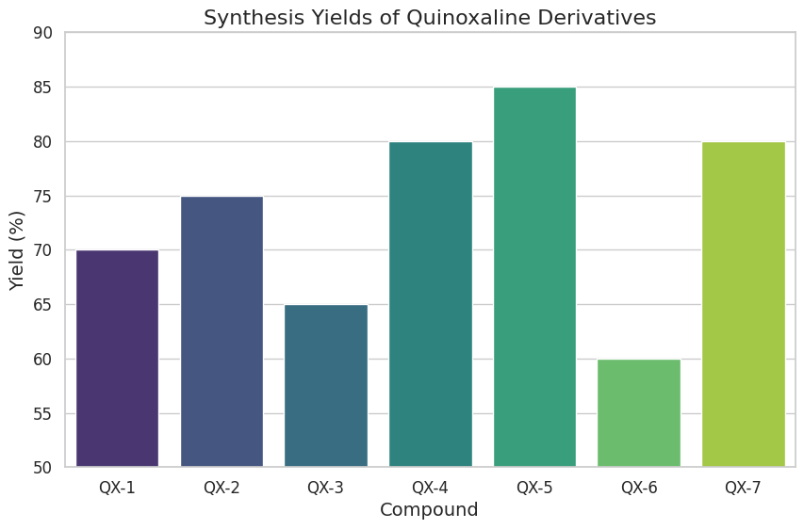

**Fig 6**

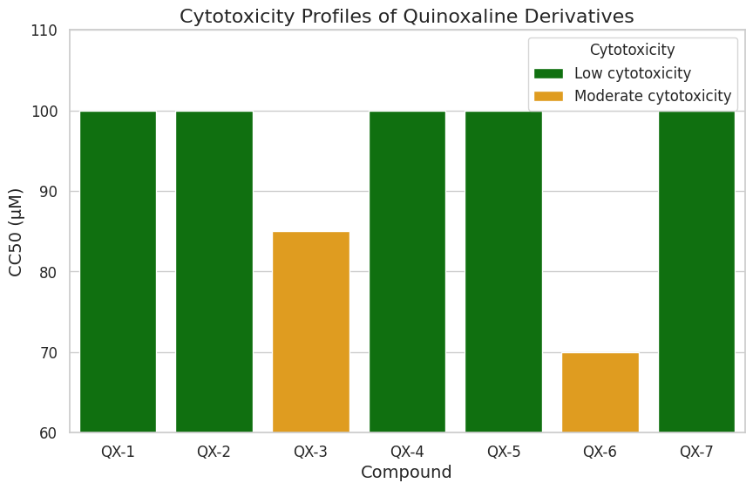

**Fig 7**

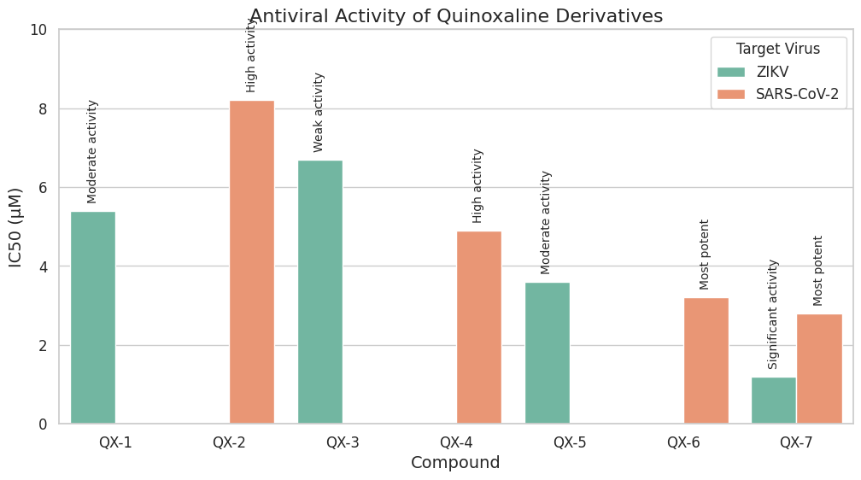

**Fig 8**

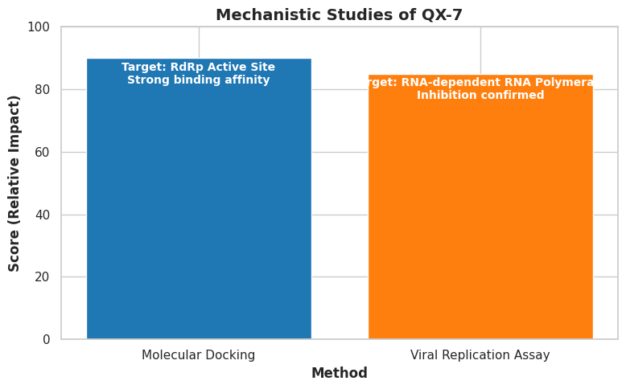

**Conclusion**

This study demonstrates the potential of quinoxaline-based compounds as antiviral agents against emerging viruses. The synthesized derivatives exhibited low cytotoxicity and high antiviral activity, particularly against ZIKV and SARS-CoV-2. Derivative QX-7 emerged as a lead candidate, warranting further in vivo evaluation and optimization. These findings highlight the importance of quinoxaline scaffolds in antiviral drug development, offering a promising avenue for addressing global health challenges posed by emerging viral infections. This study concludes by describing the synthesis and biological assessment of several compounds based on quinoxaline as possible antiviral agents against newly emerging viruses. The findings offer important new information about the SAR of quinoxaline-based compounds and show the compounds' potential as antiviral agents.

5. Future Directions Future work will focus on optimizing the pharmacokinetic properties of lead compounds and exploring their efficacy in animal models. Additionally, the antiviral activity of these compounds against a broader range of viruses will be investigated to assess their potential as broad-spectrum agents.

Disclaimer (Artificial intelligence)

Option 1:

Author(s) hereby declare that NO generative AI technologies such as Large Language Models (ChatGPT, COPILOT, etc.) and text-to-image generators have been used during the writing or editing of this manuscript.

Option 2:

Author(s) hereby declare that generative AI technologies such as Large Language Models, etc. have been used during the writing or editing of manuscripts. This explanation will include the name, version, model, and source of the generative AI technology and as well as all input prompts provided to the generative AI technology

Details of the AI usage are given below:

1.

2.

3.

References :

1. Irfan, A.; Sabeeh, I.; Umer, M.; Naqvi, A.Z.; Fatima, H.; Yousaf, S.; Fatima, Z. A review on the therapeutic potential of quinoxaline derivatives. *World J. Pharm. Res.* **2017**, *6*, 47–68. [[**Google Scholar**](https://scholar.google.com/scholar_lookup?title=A+review+on+the+therapeutic+potential+of+quinoxaline+derivatives&author=Irfan,+A.&author=Sabeeh,+I.&author=Umer,+M.&author=Naqvi,+A.Z.&author=Fatima,+H.&author=Yousaf,+S.&author=Fatima,+Z.&publication_year=2017&journal=World+J.+Pharm.+Res.&volume=6&pages=47%E2%80%9368&doi=10.20959/wjpr201713-9878)] [[**CrossRef**](https://doi.org/10.20959/wjpr201713-9878)]
2. Cheeseman, G.W.H.; Cookson, R.F. *Chemistry of Heterocyclic Compounds*; Wiley-Interscience: Hoboken, NJ, USA, 1979; Volume 35. [[**Google Scholar**](https://scholar.google.com/scholar_lookup?title=Chemistry+of+Heterocyclic+Compounds&author=Cheeseman,+G.W.H.&author=Cookson,+R.F.&publication_year=1979)]
3. Pereira, J.A.; Pessoa, A.S.M.; Cordeiro, M.N.D.S.; Fernandes, R.; Prudêncio, C.; Noronha, J.P.; Vieira, M. Quinoxaline, its derivatives and applications: A state of the art review. *Eur. J. Med. Chem.* **2015**, *97*, 664–672. [[**Google Scholar**](https://scholar.google.com/scholar_lookup?title=Quinoxaline,+its+derivatives+and+applications:+A+state+of+the+art+review&author=Pereira,+J.A.&author=Pessoa,+A.S.M.&author=Cordeiro,+M.N.D.S.&author=Fernandes,+R.&author=Prud%C3%AAncio,+C.&author=Noronha,+J.P.&author=Vieira,+M.&publication_year=2015&journal=Eur.+J.+Med.+Chem.&volume=97&pages=664%E2%80%93672&doi=10.1016/j.ejmech.2014.06.058&pmid=25011559)] [[**CrossRef**](https://doi.org/10.1016/j.ejmech.2014.06.058)] [[**PubMed**](http://www.ncbi.nlm.nih.gov/pubmed/25011559)] [[**Green Version**](http://recipp.ipp.pt/bitstream/10400.22/7411/1/ART_AnaPessoa_2015_2.pdf)]
4. Niknam, K.; Saberi, D.; Mohagheghnejad, M. Silica bonded S-sulfonic acid: A recyclable catalyst for the synthesis of quinoxalines at room temperature. *Molecules* **2009**, *14*, 1915–1926. [[**Google Scholar**](https://scholar.google.com/scholar_lookup?title=Silica+bonded+S-sulfonic+acid:+A+recyclable+catalyst+for+the+synthesis+of+quinoxalines+at+room+temperature&author=Niknam,+K.&author=Saberi,+D.&author=Mohagheghnejad,+M.&publication_year=2009&journal=Molecules&volume=14&pages=1915%E2%80%931926&doi=10.3390/molecules14051915)] [[**CrossRef**](https://doi.org/10.3390/molecules14051915)] [[**Green Version**](https://www.mdpi.com/1420-3049/14/5/1915/pdf)]
5. Thakuria, H.; Das, G. One-pot efficient green synthesis of 1,4-dihydro-quinoxaline-2,3-dione derivatives. *J. Chem. Sci.* **2006**, *118*, 425–428. [[**Google Scholar**](https://scholar.google.com/scholar_lookup?title=One-pot+efficient+green+synthesis+of+1,4-dihydro-quinoxaline-2,3-dione+derivatives&author=Thakuria,+H.&author=Das,+G.&publication_year=2006&journal=J.+Chem.+Sci.&volume=118&pages=425%E2%80%93428&doi=10.1007/BF02711453)] [[**CrossRef**](https://doi.org/10.1007/BF02711453)]
6. da Costa, C.F.; Nora de Souza, M.V.; Brandao Gomes, C.R.; Facchinetti, V. Microwave-Assisted Synthesis of Quinoxalines-A Review. *Curr. Microwave Chem.* **2017**, *4*, 277–286. [[**Google Scholar**](https://scholar.google.com/scholar_lookup?title=Microwave-Assisted+Synthesis+of+Quinoxalines-A+Review&author=da+Costa,+C.F.&author=Nora+de+Souza,+M.V.&author=Brandao+Gomes,+C.R.&author=Facchinetti,+V.&publication_year=2017&journal=Curr.+Microwave+Chem.&volume=4&pages=277%E2%80%93286&doi=10.2174/2213335604666171010153416)] [[**CrossRef**](https://doi.org/10.2174/2213335604666171010153416)]
7. Rostamizadeh, S.; Jafari, S. The synthesis of quinoxalines under microwave irradiation. *Indian J. Heterocycl. Chem.* **2001**, *10*, 303–304. [[**Google Scholar**](https://scholar.google.com/scholar_lookup?title=The+synthesis+of+quinoxalines+under+microwave+irradiation&author=Rostamizadeh,+S.&author=Jafari,+S.&publication_year=2001&journal=Indian+J.+Heterocycl.+Chem.&volume=10&pages=303%E2%80%93304)]
8. Arde, S.M.; Patil, A.D.; Mane, A.H.; Salokhe, P.R.; Salunkhe, R.S. Synthesis of quinoxaline, benzimidazole and pyrazole derivatives under the catalytic influence of biosurfactant-stabilized iron nanoparticles in water. *Res. Chem. Intermed.* **2020**, *46*, 5069–5086. [[**Google Scholar**](https://scholar.google.com/scholar_lookup?title=Synthesis+of+quinoxaline,+benzimidazole+and+pyrazole+derivatives+under+the+catalytic+influence+of+biosurfactant-stabilized+iron+nanoparticles+in+water&author=Arde,+S.M.&author=Patil,+A.D.&author=Mane,+A.H.&author=Salokhe,+P.R.&author=Salunkhe,+R.S.&publication_year=2020&journal=Res.+Chem.+Intermed.&volume=46&pages=5069%E2%80%935086&doi=10.1007/s11164-020-04240-6)] [[**CrossRef**](https://doi.org/10.1007/s11164-020-04240-6)]
9. Abu-Hashem, A.A.; Gouda, M.A.; Badria, F.A. synthesis of some new pyrimido [2′, 1′: 2, 3] thiazolo [4, 5-b] quinoxaline derivatives as anti-inflammatory and analgesic agents. *Eur. J. Med. Chem.* **2010**, *45*, 1976–1981. [[**Google Scholar**](https://scholar.google.com/scholar_lookup?title=synthesis+of+some+new+pyrimido+%5b2%E2%80%B2,+1%E2%80%B2:+2,+3%5d+thiazolo+%5b4,+5-b%5d+quinoxaline+derivatives+as+anti-inflammatory+and+analgesic+agents&author=Abu-Hashem,+A.A.&author=Gouda,+M.A.&author=Badria,+F.A.&publication_year=2010&journal=Eur.+J.+Med.+Chem.&volume=45&pages=1976%E2%80%931981&doi=10.1016/j.ejmech.2010.01.042)] [[**CrossRef**](https://doi.org/10.1016/j.ejmech.2010.01.042)]
10. Barea, C.; Pabón, A.; Galiano, S.; Pérez-Silanes, S.; González, G.; Deyssard, C.; Monge, A.; Deharo, E.; Aldana, I. Antiplasmodial and leishmanicidal activities of 2-cyano-3-(4-phenylpiperazine-1-carboxamido) quinoxaline 1,4-dioxide derivatives. *Molecules* **2012**, *17*, 9451–9461. [[**Google Scholar**](https://scholar.google.com/scholar_lookup?title=Antiplasmodial+and+leishmanicidal+activities+of+2-cyano-3-(4-phenylpiperazine-1-carboxamido)+quinoxaline+1,4-dioxide+derivatives&author=Barea,+C.&author=Pab%C3%B3n,+A.&author=Galiano,+S.&author=P%C3%A9rez-Silanes,+S.&author=Gonz%C3%A1lez,+G.&author=Deyssard,+C.&author=Monge,+A.&author=Deharo,+E.&author=Aldana,+I.&publication_year=2012&journal=Molecules&volume=17&pages=9451%E2%80%939461&doi=10.3390/molecules17089451)] [[**CrossRef**](https://doi.org/10.3390/molecules17089451)] [[**Green Version**](https://www.mdpi.com/1420-3049/17/8/9451/pdf)]
11. Sarges, R.; Howard, H.R.; Browne, R.G.; Lebel, L.A.; Seymour, P.A.; Koe, B.K. 4-Amino[1,2,4]triazolo[4,3-a]quinoxalines. A novel class of potent adenosine receptor antagonists and potential rapid-onset antidepressants. *J. Med. Chem.* **1990**, *33*, 2240–2254. [[**Google Scholar**](https://scholar.google.com/scholar_lookup?title=4-Amino%5b1,2,4%5dtriazolo%5b4,3-a%5dquinoxalines.+A+novel+class+of+potent+adenosine+receptor+antagonists+and+potential+rapid-onset+antidepressants&author=Sarges,+R.&author=Howard,+H.R.&author=Browne,+R.G.&author=Lebel,+L.A.&author=Seymour,+P.A.&author=Koe,+B.K.&publication_year=1990&journal=J.+Med.+Chem.&volume=33&pages=2240%E2%80%932254&doi=10.1021/jm00170a031)] [[**CrossRef**](https://doi.org/10.1021/jm00170a031)]
12. Montana, M.; Montero, V.; Khoumeri, O.; Vanelle, P. Quinoxaline derivatives as antiviral agents: A systematic review. *Molecules* **2020**, *25*, 2784. [[**Google Scholar**](https://scholar.google.com/scholar_lookup?title=Quinoxaline+derivatives+as+antiviral+agents:+A+systematic+review&author=Montana,+M.&author=Montero,+V.&author=Khoumeri,+O.&author=Vanelle,+P.&publication_year=2020&journal=Molecules&volume=25&pages=2784&doi=10.3390/molecules25122784&pmid=32560203)] [[**CrossRef**](https://doi.org/10.3390/molecules25122784)] [[**PubMed**](http://www.ncbi.nlm.nih.gov/pubmed/32560203)]
13. Vieira, M.; Pinheiro, C.; Fernandes, R.; Noronha, J.; Prudêncio, C. Antimicrobial activity of quinoxaline 1,4-dioxide with 2- and 3-substituted derivatives. *Microbiol. Res.* **2014**, *169*, 287–293. [[**Google Scholar**](https://scholar.google.com/scholar_lookup?title=Antimicrobial+activity+of+quinoxaline+1,4-dioxide+with+2-+and+3-substituted+derivatives&author=Vieira,+M.&author=Pinheiro,+C.&author=Fernandes,+R.&author=Noronha,+J.&author=Prud%C3%AAncio,+C.&publication_year=2014&journal=Microbiol.+Res.&volume=169&pages=287%E2%80%93293&doi=10.1016/j.micres.2013.06.015&pmid=23928379)] [[**CrossRef**](https://doi.org/10.1016/j.micres.2013.06.015)] [[**PubMed**](http://www.ncbi.nlm.nih.gov/pubmed/23928379)]
14. Husain, A.; Madhesia, D. Recent advances in pharmacological activities of quinoxaline derivatives. *J. Pharm. Res.* **2011**, *4*, 924–929. [[**Google Scholar**](https://scholar.google.com/scholar_lookup?title=Recent+advances+in+pharmacological+activities+of+quinoxaline+derivatives&author=Husain,+A.&author=Madhesia,+D.&publication_year=2011&journal=J.+Pharm.+Res.&volume=4&pages=924%E2%80%93929)]
15. Carta, A.; Paglietti, G.; Nikookar, M.E.R.; Sanna, P.; Sechi, L.; Zanetti, S. Novel substituted quinoxaline 1,4-dioxides with in vitro antimycobacterial and anticandida activity. *Eur. J. Med. Chem.* **2002**, *37*, 355–366. [[**Google Scholar**](https://scholar.google.com/scholar_lookup?title=Novel+substituted+quinoxaline+1,4-dioxides+with+in+vitro+antimycobacterial+and+anticandida+activity&author=Carta,+A.&author=Paglietti,+G.&author=Nikookar,+M.E.R.&author=Sanna,+P.&author=Sechi,+L.&author=Zanetti,+S.&publication_year=2002&journal=Eur.+J.+Med.+Chem.&volume=37&pages=355%E2%80%93366&doi=10.1016/S0223-5234(02)01346-6)] [[**CrossRef**](https://doi.org/10.1016/S0223-5234(02)01346-6)]
16. Mohd, H.A.; Al-Tawfiq, J.A.; Memish, Z.A. Middle East respiratory syndrome coronavirus (MERS-CoV) origin and animal reservoir. *Virol. J.* **2016**, *13*, 1–7. [[**Google Scholar**](https://scholar.google.com/scholar_lookup?title=Middle+East+respiratory+syndrome+coronavirus+(MERS-CoV)+origin+and+animal+reservoir&author=Mohd,+H.A.&author=Al-Tawfiq,+J.A.&author=Memish,+Z.A.&publication_year=2016&journal=Virol.+J.&volume=13&pages=1%E2%80%937&doi=10.1186/s12985-016-0544-0)] [[**CrossRef**](https://doi.org/10.1186/s12985-016-0544-0)] [[**Green Version**](https://virologyj.biomedcentral.com/track/pdf/10.1186/s12985-016-0544-0)]
17. Waring, M.J.; Ben-Hadda, T.; Kotchevar, A.T.; Ramdani, A.; Touzani, R.; Elkadiri, S.; Hakkou, A.; Bouakka, M.; Ellis, T. 2,3-bifunctionalized quinoxalines: Synthesis, DNA interactions and evaluation of anticancer, anti-tuberculosis and antifungal activity. *Molecules* **2002**, *7*, 641–656. [[**Google Scholar**](https://scholar.google.com/scholar_lookup?title=2,3-bifunctionalized+quinoxalines:+Synthesis,+DNA+interactions+and+evaluation+of+anticancer,+anti-tuberculosis+and+antifungal+activity&author=Waring,+M.J.&author=Ben-Hadda,+T.&author=Kotchevar,+A.T.&author=Ramdani,+A.&author=Touzani,+R.&author=Elkadiri,+S.&author=Hakkou,+A.&author=Bouakka,+M.&author=Ellis,+T.&publication_year=2002&journal=Molecules&volume=7&pages=641%E2%80%93656&doi=10.3390/70800641)] [[**CrossRef**](https://doi.org/10.3390/70800641)]
18. Coltart, C.E.M.; Lindsey, B.; Ghinai, I.; Johnson, A.M.; Heymann, D.L. The Ebola outbreak, 2013–2016: Old lessons for new epidemics. *Philos. Trans. R. Soc. B Biol. Sci.* **2017**, *372*, 20160297. [[**Google Scholar**](https://scholar.google.com/scholar_lookup?title=The+Ebola+outbreak,+2013%E2%80%932016:+Old+lessons+for+new+epidemics&author=Coltart,+C.E.M.&author=Lindsey,+B.&author=Ghinai,+I.&author=Johnson,+A.M.&author=Heymann,+D.L.&publication_year=2017&journal=Philos.+Trans.+R.+Soc.+B+Biol.+Sci.&volume=372&pages=20160297&doi=10.1098/rstb.2016.0297)] [[**CrossRef**](https://doi.org/10.1098/rstb.2016.0297)]
19. Perlman, S. Another decade, another coronavirus. *N. Engl. J. Med.* **2020**, *382*, 760–762. [[**Google Scholar**](https://scholar.google.com/scholar_lookup?title=Another+decade,+another+coronavirus&author=Perlman,+S.&publication_year=2020&journal=N.+Engl.+J.+Med.&volume=382&pages=760%E2%80%93762&doi=10.1056/NEJMe2001126)] [[**CrossRef**](https://doi.org/10.1056/NEJMe2001126)]
20. Hasaninejad, A.; Zare, A.; Shekouhy, M.; Moosavi-Zare, A.R. Bentonite clay K-10 as an efficient reagent for the synthesis of quinoxaline derivatives at room temperature. *E-J. Chem.* **2009**, *6*, S247–S253. [[**Google Scholar**](https://scholar.google.com/scholar_lookup?title=Bentonite+clay+K-10+as+an+efficient+reagent+for+the+synthesis+of+quinoxaline+derivatives+at+room+temperature&author=Hasaninejad,+A.&author=Zare,+A.&author=Shekouhy,+M.&author=Moosavi-Zare,+A.R.&publication_year=2009&journal=E-J.+Chem.&volume=6&pages=S247%E2%80%93S253&doi=10.1155/2009/354273)] [[**CrossRef**](https://doi.org/10.1155/2009/354273)]
21. Anastas, P.; Warner, J. *Green Chemistry: Theory and Practice*; Oxford University Press: Oxford, UK, 1998; Volume 30. [[**Google Scholar**](https://scholar.google.com/scholar_lookup?title=Green+Chemistry:+Theory+and+Practice&author=Anastas,+P.&author=Warner,+J.&publication_year=1998)]
22. Malek, B.; Bahammou, I.; Zimou, O.; El Hallaoui, A.; Ghailane, R.; Boukhris, S.; Souizi, A. Eco-friendly synthesis of quinoxaline derivatives using mineral fertilizers as heterogeneous catalysts. *J. Turk. Chem. Soc. Sect. A Chem.* **2020**, *7*, 427–440. [[**Google Scholar**](https://scholar.google.com/scholar_lookup?title=Eco-friendly+synthesis+of+quinoxaline+derivatives+using+mineral+fertilizers+as+heterogeneous+catalysts&author=Malek,+B.&author=Bahammou,+I.&author=Zimou,+O.&author=El+Hallaoui,+A.&author=Ghailane,+R.&author=Boukhris,+S.&author=Souizi,+A.&publication_year=2020&journal=J.+Turk.+Chem.+Soc.+Sect.+A+Chem.&volume=7&pages=427%E2%80%93440&doi=10.18596/jotcsa.577101)] [[**CrossRef**](https://doi.org/10.18596/jotcsa.577101)]
23. Nageswar, Y.V.D.; Reddy, K.H.V.; Ramesh, K.; Murthy, S.N. Recent developments in the synthesis of quinoxaline derivatives by green synthetic approaches. *Org. Prep. Proced. Int.* **2013**, *45*, 1–27. [[**Google Scholar**](https://scholar.google.com/scholar_lookup?title=Recent+developments+in+the+synthesis+of+quinoxaline+derivatives+by+green+synthetic+approaches&author=Nageswar,+Y.V.D.&author=Reddy,+K.H.V.&author=Ramesh,+K.&author=Murthy,+S.N.&publication_year=2013&journal=Org.+Prep.+Proced.+Int.&volume=45&pages=1%E2%80%9327&doi=10.1080/00304948.2013.743419)] [[**CrossRef**](https://doi.org/10.1080/00304948.2013.743419)]
24. More, S.V.; Sastry, M.N.V.; Yao, C.-F. Cerium (iv) ammonium nitrate (CAN) as a catalyst in tap water: A simple, proficient and green approach for the synthesis of quinoxalines. *Green Chem.* **2006**, *8*, 91–95. [[**Google Scholar**](https://scholar.google.com/scholar_lookup?title=Cerium+(iv)+ammonium+nitrate+(CAN)+as+a+catalyst+in+tap+water:+A+simple,+proficient+and+green+approach+for+the+synthesis+of+quinoxalines&author=More,+S.V.&author=Sastry,+M.N.V.&author=Yao,+C.-F.&publication_year=2006&journal=Green+Chem.&volume=8&pages=91%E2%80%9395&doi=10.1039/B510677J)] [[**CrossRef**](https://doi.org/10.1039/B510677J)]
25. An, Z.; Wu, M.; Ni, J.; Qi, Z.; Yu, G.; Yan, R.; Zhao, L.-B. FeCl 3 -Catalyzed synthesis of pyrrolo[1,2-a]quinoxaline derivatives from 1-(2-aminophenyl)pyrroles through annulation and cleavage of cyclic ethers. *Chem. Commun.* **2017**, *53*, 11572–11575. [[**Google Scholar**](https://scholar.google.com/scholar_lookup?title=FeCl+3+-Catalyzed+synthesis+of+pyrrolo%5b1,2-a%5dquinoxaline+derivatives+from+1-(2-aminophenyl)pyrroles+through+annulation+and+cleavage+of+cyclic+ethers&author=An,+Z.&author=Wu,+M.&author=Ni,+J.&author=Qi,+Z.&author=Yu,+G.&author=Yan,+R.&author=Zhao,+L.-B.&publication_year=2017&journal=Chem.+Commun.&volume=53&pages=11572%E2%80%9311575&doi=10.1039/C7CC07089F&pmid=28990598)] [[**CrossRef**](https://doi.org/10.1039/C7CC07089F)] [[**PubMed**](http://www.ncbi.nlm.nih.gov/pubmed/28990598)] [[**Green Version**](http://pdfs.semanticscholar.org/d066/4708ab6019fd28da139fb419618ff9e958f6.pdf)]
26. Begue, J.P.; Bonnet-Delpon, D.; Crousse, B. Fluorinated alcohols: A new medium for the selective and clean reaction. *Synlett* **2004**, *35*, 18–29. [[**Google Scholar**](https://scholar.google.com/scholar_lookup?title=Fluorinated+alcohols:+A+new+medium+for+the+selective+and+clean+reaction&author=Begue,+J.P.&author=Bonnet-Delpon,+D.&author=Crousse,+B.&publication_year=2004&journal=Synlett&volume=35&pages=18%E2%80%9329&doi=10.1002/chin.200416232)] [[**CrossRef**](https://doi.org/10.1002/chin.200416232)]
27. Povey, J.F.; Smales, C.M.; Hassard, S.J.; Howard, M.J. Comparison of the effects of 2, 2, 2-trifluoroethanol on peptide and protein structure and function. *J. Struct. Boil.* **2007**, *157*, 329338. [[**Google Scholar**](https://scholar.google.com/scholar_lookup?title=Comparison+of+the+effects+of+2,+2,+2-trifluoroethanol+on+peptide+and+protein+structure+and+function&author=Povey,+J.F.&author=Smales,+C.M.&author=Hassard,+S.J.&author=Howard,+M.J.&publication_year=2007&journal=J.+Struct.+Boil.&volume=157&pages=329338&doi=10.1016/j.jsb.2006.07.008&pmid=16979904)] [[**CrossRef**](https://doi.org/10.1016/j.jsb.2006.07.008)] [[**PubMed**](http://www.ncbi.nlm.nih.gov/pubmed/16979904)]
28. Khaksar, S.; Rostamnezhad, F. A novel one-pot synthesis of quinoxaline derivatives in fluorinated alcohols. *Bull. Korean Chem. Soc.* **2012**, *33*, 2581–2584. [[**Google Scholar**](https://scholar.google.com/scholar_lookup?title=A+novel+one-pot+synthesis+of+quinoxaline+derivatives+in+fluorinated+alcohols&author=Khaksar,+S.&author=Rostamnezhad,+F.&publication_year=2012&journal=Bull.+Korean+Chem.+Soc.&volume=33&pages=2581%E2%80%932584&doi=10.5012/bkcs.2012.33.8.2581)] [[**CrossRef**](https://doi.org/10.5012/bkcs.2012.33.8.2581)] [[**Green Version**](http://society.kisti.re.kr/sv/SV_svpsbs03V.do?method=download&cn1=JAKO201225135676740)]
29. Brown, D.J.; Taylor, E.C.; Ellman, J.A. *Quinoxalines, Supplement 2*; John Wiley & Sons: Denmark, UK, 2004; Volume 107. [[**Google Scholar**](https://scholar.google.com/scholar_lookup?title=Quinoxalines,+Supplement+2&author=Brown,+D.J.&author=Taylor,+E.C.&author=Ellman,+J.A.&publication_year=2004)]
30. Wadavrao, S.B.; Ghogare, R.; Narsaiah, A.V. A simple and efficient protocol for the synthesis of quinoxalines catalyzed by pyridine. *Org. Commun.* **2013**, *6*, 23. [[**Google Scholar**](https://scholar.google.com/scholar_lookup?title=A+simple+and+efficient+protocol+for+the+synthesis+of+quinoxalines+catalyzed+by+pyridine&author=Wadavrao,+S.B.&author=Ghogare,+R.&author=Narsaiah,+A.V.&publication_year=2013&journal=Org.+Commun.&volume=6&pages=23)]
31. Atghia, S.V.; Beigbaghlou, S.S. Nanocrystalline titania-based sulfonic acid (TiO2-Pr-SO3H) as a new, highly efficient, and recyclable solid acid catalyst for the preparation of quinoxaline derivatives. *J. Nanostructure Chem.* **2013**, *3*, 38. [[**Google Scholar**](https://scholar.google.com/scholar_lookup?title=Nanocrystalline+titania-based+sulfonic+acid+(TiO2-Pr-SO3H)+as+a+new,+highly+efficient,+and+recyclable+solid+acid+catalyst+for+the+preparation+of+quinoxaline+derivatives&author=Atghia,+S.V.&author=Beigbaghlou,+S.S.&publication_year=2013&journal=J.+Nanostructure+Chem.&volume=3&pages=38&doi=10.1186/2193-8865-3-38)] [[**CrossRef**](https://doi.org/10.1186/2193-8865-3-38)] [[**Green Version**](https://www.mdpi.com/1420-3049/26/4/1055)]
32. Jafarpour, M.; Rezaeifard, A.; Danehchin, M. Easy access to quinoxaline derivatives using alumina as an effective and reusable catalyst under solvent-free conditions. *Appl. Catal. A Gen.* **2011**, *394*, 48–51. [[**Google Scholar**](https://scholar.google.com/scholar_lookup?title=Easy+access+to+quinoxaline+derivatives+using+alumina+as+an+effective+and+reusable+catalyst+under+solvent-free+conditions&author=Jafarpour,+M.&author=Rezaeifard,+A.&author=Danehchin,+M.&publication_year=2011&journal=Appl.+Catal.+A+Gen.&volume=394&pages=48%E2%80%9351&doi=10.1016/j.apcata.2010.12.022)] [[**CrossRef**](https://doi.org/10.1016/j.apcata.2010.12.022)]
33. Huang, T.-K.; Wang, R.; Shi, L.; Lu, X.-X. Montmorillonite K-10: An efficient and reusable catalyst for the synthesis of quinoxaline derivatives in water. *Catal. Commun.* **2008**, *9*, 1143–1147. [[**Google Scholar**](https://scholar.google.com/scholar_lookup?title=Montmorillonite+K-10:+An+efficient+and+reusable+catalyst+for+the+synthesis+of+quinoxaline+derivatives+in+water&author=Huang,+T.-K.&author=Wang,+R.&author=Shi,+L.&author=Lu,+X.-X.&publication_year=2008&journal=Catal.+Commun.&volume=9&pages=1143%E2%80%931147&doi=10.1016/j.catcom.2007.10.024)] [[**CrossRef**](https://doi.org/10.1016/j.catcom.2007.10.024)]
34. Krishnakumar, B.; Swaminathan, M. Solvent free synthesis of quinoxalines, dipyridophenazines and chalcones under microwave irradiation with sulfated Degussa titania as a novel solid acid catalyst. *J. Mol. Catal. A Chem.* **2011**, *350*, 16–25. [[**Google Scholar**](https://scholar.google.com/scholar_lookup?title=Solvent+free+synthesis+of+quinoxalines,+dipyridophenazines+and+chalcones+under+microwave+irradiation+with+sulfated+Degussa+titania+as+a+novel+solid+acid+catalyst&author=Krishnakumar,+B.&author=Swaminathan,+M.&publication_year=2011&journal=J.+Mol.+Catal.+A+Chem.&volume=350&pages=16%E2%80%9325&doi=10.1016/j.molcata.2011.08.026)] [[**CrossRef**](https://doi.org/10.1016/j.molcata.2011.08.026)]
35. Dhakshinamoorthy, A.; Kanagaraj, K.; Tharmaraj, V. Zn2+-K10-clay (clayzic) as an efficient water-tolerant, solid acid catalyst for the synthesis of benzimidazoles and quinoxalines at room temperature. *Tetrahedron Lett.* **2011**, *52*, 69–73. [[**Google Scholar**](https://scholar.google.com/scholar_lookup?title=Zn2+-K10-clay+(clayzic)+as+an+efficient+water-tolerant,+solid+acid+catalyst+for+the+synthesis+of+benzimidazoles+and+quinoxalines+at+room+temperature&author=Dhakshinamoorthy,+A.&author=Kanagaraj,+K.&author=Tharmaraj,+V.&publication_year=2011&journal=Tetrahedron+Lett.&volume=52&pages=69%E2%80%9373&doi=10.1016/j.tetlet.2010.10.146)] [[**CrossRef**](https://doi.org/10.1016/j.tetlet.2010.10.146)]
36. Sharma, R.; Sharma, C. Zirconium(IV)-modified silica gel: Preparation, characterization and catalytic activity in the synthesis of some biologically important molecules. *Catal. Commun.* **2011**, *12*, 327–331. [[**Google Scholar**](https://scholar.google.com/scholar_lookup?title=Zirconium(IV)-modified+silica+gel:+Preparation,+characterization+and+catalytic+activity+in+the+synthesis+of+some+biologically+important+molecules&author=Sharma,+R.&author=Sharma,+C.&publication_year=2011&journal=Catal.+Commun.&volume=12&pages=327%E2%80%93331&doi=10.1016/j.catcom.2010.10.011)] [[**CrossRef**](https://doi.org/10.1016/j.catcom.2010.10.011)]
37. Zhang, X.Z.; Wang, J.X.; Sun, Y.J.; Zhan, H.W. Synthesis of quinoxaline derivatives catalyzed by PEG-400. *Chin. Chem. Lett.* **2010**, *21*, 395–398. [[**Google Scholar**](https://scholar.google.com/scholar_lookup?title=Synthesis+of+quinoxaline+derivatives+catalyzed+by+PEG-400&author=Zhang,+X.Z.&author=Wang,+J.X.&author=Sun,+Y.J.&author=Zhan,+H.W.&publication_year=2010&journal=Chin.+Chem.+Lett.&volume=21&pages=395%E2%80%93398&doi=10.1016/j.cclet.2009.12.015)] [[**CrossRef**](https://doi.org/10.1016/j.cclet.2009.12.015)]
38. Heravi, M.M.; Bakhtiari, K.; Bamoharram, F.F.; Tehrani, M.H. Wells-dawson type heteropolyacid catalyzed synthesis of quinoxaline derivatives at room temperature. *Mon. Für Chem. Chem. Mon.* **2007**, *138*, 465–467. [[**Google Scholar**](https://scholar.google.com/scholar_lookup?title=Wells-dawson+type+heteropolyacid+catalyzed+synthesis+of+quinoxaline+derivatives+at+room+temperature&author=Heravi,+M.M.&author=Bakhtiari,+K.&author=Bamoharram,+F.F.&author=Tehrani,+M.H.&publication_year=2007&journal=Mon.+F%C3%BCr+Chem.+Chem.+Mon.&volume=138&pages=465%E2%80%93467&doi=10.1007/s00706-007-0594-5)] [[**CrossRef**](https://doi.org/10.1007/s00706-007-0594-5)]
39. Ajaikumar, S.; Pandurangan, A. Efficient synthesis of quinoxaline derivatives over ZrO2/MxOy (M=Al, Ga, In and La) mixed metal oxides supported on MCM-41 mesoporous molecular sieves. *Appl. Catal. A Gen.* **2009**, *357*, 184–192. [[**Google Scholar**](https://scholar.google.com/scholar_lookup?title=Efficient+synthesis+of+quinoxaline+derivatives+over+ZrO2/MxOy+(M=Al,+Ga,+In+and+La)+mixed+metal+oxides+supported+on+MCM-41+mesoporous+molecular+sieves&author=Ajaikumar,+S.&author=Pandurangan,+A.&publication_year=2009&journal=Appl.+Catal.+A+Gen.&volume=357&pages=184%E2%80%93192&doi=10.1016/j.apcata.2009.01.021)] [[**CrossRef**](https://doi.org/10.1016/j.apcata.2009.01.021)]
40. Shaabani, A.; Rezayan, A.H.; Behnam, M.; Heidary, M. Green chemistry approaches for the synthesis of quinoxaline derivatives: Comparison of ethanol and water in the presence of the reusable catalyst cellulose sulfuric acid. *Comptes Rendus Chim.* **2009**, *12*, 1249–1252. [[**Google Scholar**](https://scholar.google.com/scholar_lookup?title=Green+chemistry+approaches+for+the+synthesis+of+quinoxaline+derivatives:+Comparison+of+ethanol+and+water+in+the+presence+of+the+reusable+catalyst+cellulose+sulfuric+acid&author=Shaabani,+A.&author=Rezayan,+A.H.&author=Behnam,+M.&author=Heidary,+M.&publication_year=2009&journal=Comptes+Rendus+Chim.&volume=12&pages=1249%E2%80%931252&doi=10.1016/j.crci.2009.01.006)] [[**CrossRef**](https://doi.org/10.1016/j.crci.2009.01.006)]