Original Research Article
Comparative Analysis of Physicochemical and Sensory Properties of Local Sesame Tahini

ABSTRACT
Aims: This study examines the physicochemical, sensory, and nutritional properties of five local sesame tahini samples (A, B, C, D, and E) to assess their quality in comparison to industry standards. Random samples were collected from markets in Sulaimani city and stored under controlled conditions.
Methodology: Five random sesame tahini samples were collected from some supermarkets in Sulaimani City under good conditions during transportation to the laboratory. The analysis entailed moisture, ash, acid-insoluble ash, pH, fat content, and protein. Moisture was between 0.140 percent (Sample B) and 2.560 percent (Sample C), higher than Codex standards. The ash content was most elevated in sample B (2.680%), but below the 3.5 percent standard. Acid-insoluble ash varied, with samples A and D having Codex standards (0.3%), while others were lower. pH was near neutrality (6.040–6.450), rendering all the samples fit for consumption. Fat content ranged from 53.010 percent (Sample C) to 69.590 percent (Sample A), mostly within the range. Protein content in all the samples was below the 25 percent Codex standard, the highest being for sample A (23.750%) and the lowest for Sample C (19.680%), which may indicate potential variation in processing.
Local manufacturers can improve product quality and marketability by knowing their sensory qualities and economic development possibilities. Helping local sesame growers may strengthen the national economy, improve local product quality and general health relevance.
Sensory assessment determined color, flavor, taste, and texture. Sample A rated highest for color (4.100) and flavor (3.600), possibly due to better roasting. Samples A and D rated highest for taste (3.500), while sample C rated lowest for all traits, a sign of processing discrepancies.
Results: Results highlight the high heterogeneity of tahini quality, highlighting the necessity for more sophisticated processing technology and high-quality raw materials to survive in the market. These findings provide valuable insights for producers wishing to enhance product quality and consumer satisfaction.
Conclusion: After analysing different samples, generally commercial local sesame tahini samples have differed in terms of physicochemical properties and sensory attributes. Fat and protein contents were found to have significant effects on texture, taste, and the overall quality rating. There for, local sesame tahini often retains more nutrients and freshness due to shorter supply chains, can offering a healthier, additive-free option, sustainable consumption, but requires industry innovation.
Keywords: Fat content; Physicochemical properties; Protein content; Sesame tahini; Sensory evaluation.

1. INTRODUCTION
Sesame is an important source of income and one of the major oilseed crops for farmers, hence supporting the food and nutritional security of farmers (Lawali et al., 2024). Sesamum indicum L. is the scientific name used for Sesame. Sesame cocoons from this area have been reported for their potential production of high-added-value herbal and medicinal products, as sesame is economically feasible with excellent nutritional value and several consumptions (culinary, medicinal, pharmaceutical, industrial, and agricultural) in literature (Pal et al., 2020; Wei et al., 2022; Mary et al., 2022). Sesame seeds are now receiving well in the therapeutic domains of medicine because of their disease-preventative potential that is due to their high content of bio reactive compounds that can uphold the normal function of the liver and avert the risk of chronic diseases from developing, notably cancer and cardiovascular disease (Abbas et al., 2022). Tahini is a paste food made of ground sesame seeds that has long been featured in the cuisines of Africa, Asia, the Middle East, and Eastern Europe. Because it is packed with essential fatty acids, protein, vitamins, and trace minerals (calcium, iron, magnesium, and zinc), it is known as a functional food (Batu & Batu, 2020; Salih et al., 2021). Lastly, tahini is rich in bioactive phytochemicals such as lignans, which have strong antioxidant and anti-inflammatory activity and therefore may also contribute to their potential health benefits (Namiki, 2007). This paper suggests that tahini ingested daily can positively impact blood pressure and endothelial function in healthy adults, so it could only help as a gouter (Sakketou et al., 2021; Palani et al., 2025; Shekh & Aziz, 2021).
Factors like moisture content, fatty acid composition, protein content, and pH affect the physicochemical properties of sesame tahini, which in turn determine its consistency, shelf stability, and sensory acceptability (Kilci & Çetin, 2022; Omar et al., 2025). Sensory characteristics (color, flavor, aroma, and texture) play important roles in consumer acceptance and marketability (Sanja et al., 2015). The use of tahini is widespread, but product quality varies due to the diversified characteristics of tahini, which are affected by sesame seed origin, processing methods (roasting, grinding, and emulsification), and storage (Ali et al., 2022; Rababah et al., 2017; Rahman et al., 2021).
Although tahini is generally consumed, limited studies have assessed the physicochemical and sensory characteristics of locally produced products in Sulaimani markets. The gym attendees in Sulaymaniyah also take nutritional supplements, indicating that the trend is moving toward diet quality and functional foods, including those based on sesame and tahini products (Mahmood et al., 2021; Elias & Al Juboury, 2023). Sesame tahini is a staple in many cuisines and has gained popularity due to its nutritional benefits. Local manufacturers can improve product quality and marketability by knowing their sensory qualities and economic development possibilities. Helping local sesame growers may strengthen the economy, generate employment, and encourage sustainable farming methods. Countries with high-quality sesame tahini can explore international markets, might investigate foreign markets to generate export income. Balancing economic growth with sustainable practices is vital for the longevity of local sesame tahini production (Hamasalih et al., 2025). Promoting ecologically friendly farming practices can improve soil health, reduce water pollution, and lower chemical inputs, hence ensuring sustained sesame production (Salih et al., 2018; Hameed et al., 2025; Abdulrahman et al., 2025).
The growing demand for these foods that are high-quality and nutritionally dense has created a need for studying the sensory and physicochemical characteristics of sesame tahini produced in local conditions in order to ensure standardization, improve production processes, and meet market demand (Fatah et al., 2025; Salih et al., 2019).
This study is aimed at a detailed study of the physicochemical properties, sensory effects, and potential health impact of sesame tahini manufactured locally within the Sulaimani markets. This information will be helpful in terms of methods of processing used, quality control, and the acceptability of the product to the consumer. This study is also useful for improving tahini production methods and for obtaining high-quality products in response to the increasing demand for functional foods.

2. MATERIAL AND METHODS
2.1 Study Area
This research was conducted in Sulaimani City, located in the Kurdistan Region of Iraq at coordinates 35.5558° N, 45.4351° E shown in Fig. 1, where all samples were purchased from local supermarkets (Neima et al., 2021).
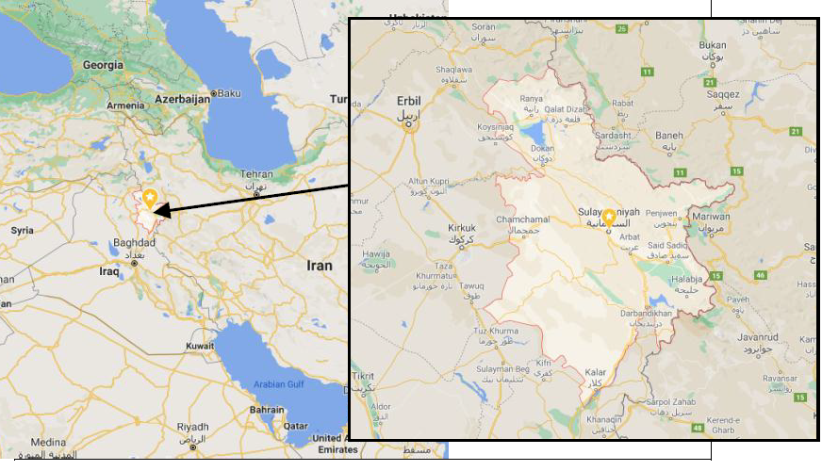
Fig. 1. Map of Sulaimani Governorate (Source: Neima et al., 2021)

2.2 Data collection
Five random sesame tahini samples were collected from some supermarkets in Sulaimani City under good controlled during transportation to the laboratory. The samples involved commercial and locally available products. All the samples were labeled and stored under controlled conditions before they were analyzed. Details of collected sesame tahini samples are provided in Fig.2. Weight and production city for every sample are as indicated below:

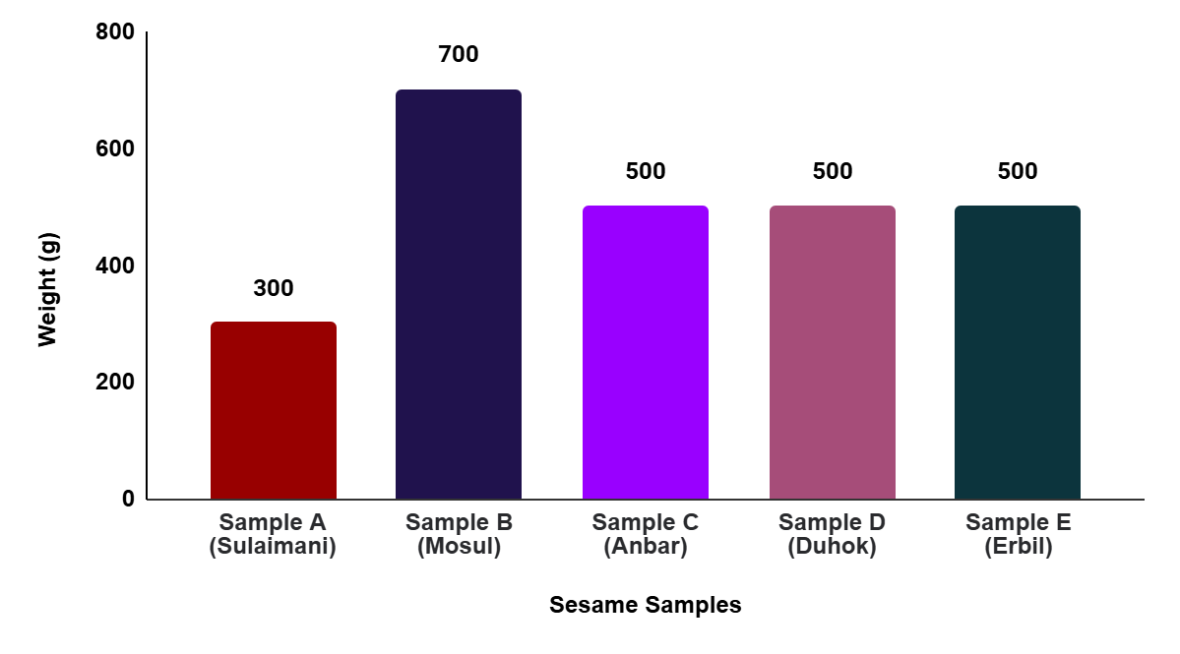
Fig. 2. Sample Information of Sesame Tahini Weights across different brands
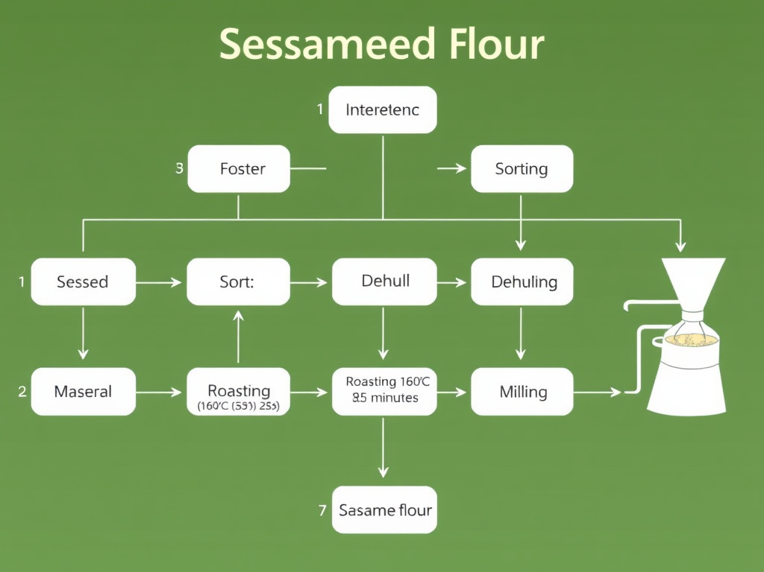
Fig.3. The process of producing sesame seed flour.

2.3 Data Analysis and Calculation
One-way ANOVA was used for statistical analysis to identify the differences among the samples. Data analysis was carried out using XLStat software version 7.5.2 (Dzhivoderova-Zarcheva et al., 2024). Six indicators, including moisture, ash, acid-insoluble, pH, fat, and protein, were utilized by this study to determine sesame tahini's physicochemical properties.
Moisture was determined using AACC Method 44-15.02 (AACC, 2000). A gravimetric drying method was used wherein the samples of tahini were placed to dry in the oven at 102°C for 24 hours. The percentage of moisture was determined using the formula:
$$Moisture Content (\%)=\frac{Initial weight-Final weight}{Initial weight}×100$$
Ash content was determined by AOAC 923.03 (AOAC, 2005). Approximately 5-10 g of each sample was placed in a muffle furnace at 550°C for 12-18 hours. The weight of residual ash thereafter was taken and ash content was determined as:
$$Total Ash Content (\%)=\frac{Weight of ash}{Weight of sample}×100$$
Acid-insoluble ash was determined by subjecting the ash residue to HCl (1:1) for 1 hour, filtering, and ignition. The weight of acid-insoluble ash was recorded at the end and expressed as a percentage by the method of Van Keulen & Young (1977). Because tahini is high in oil content, 5 g of sample was diluted with 45 mL of distilled water before measuring pH using a digital pH meter (Mirak et al., 2021; Al-Baraznji & Al-Abdullah, 2016).
The Soxhlet extraction method was used to determine the fat content, as per AOAC 963.15 (AOAC, 2005). The petroleum ether was extracted from the samples for 6 hours, and the fat content was calculated based on the residue discharged by the solvent:
$$Total Fat Content (\%)=\frac{Weight of extracted fat​}{Weight of sample}×100$$
The Kjeldahl method was used to determine the protein content, which was then converted into protein content using a conversion factor of 6.25 (Sumaina & Abegaz, 2021; Sdiq & Saeed, 2019). Digestion involved the treatment of a 1 g sample with 20 mL H₂SO₄ (18%) and a catalyst blend (K₂SO₄, CuSO₄, H₂O₂) at 370°C. Released ammonia was distilled and titrated against 0.1N HCl.
$$Protein (\%)=\frac{(Volume of HCl used-Blank)×1.4×6.25}{Sample weight}$$
A trained panel of 10 panelists evaluated the samples for color, aroma, taste, and texture using a 5-point hedonic scale (1 = dislike and 5 = like) (Yang et al., 2024). Aftertaste, creaminess, and consistency were also evaluated.
3. RESULT AND DISCUSSION
3.1 Physicochemical Properties of Sesame Tahini Samples
The results of the physicochemical analysis are summarized in Table 1. showcasing significant variations among the samples.
Table 1. Physiochemical properties of sesame tahini samples
Samples | Moisture % | Ash % | Acid-insoluble Ash % | PH | Fat % | Protein%
A | 1.360^{b} | 2.620^{b} | 0.260^{b} | 6.090^{b} | 69.590ª | 23.750ª
B | 0.149e | 2.680ª | 0.150^{c} | 6.040^{d} | 64.950^{c} | 21.490^{c}
C | 2.560ª | 1.110^{d} | 0.060e | 6.450ª | 53.010e | 19.680e
D | 0.630^{d} | 2.620^{b} | 0.240^{b} | 6.080^{b} | 66.380^{b} | 23.000^{b}
E | 1.310^{c} | 1.760^{c} | 0.080^{d} | 6.060^{c} | 64.850^{d} | 21.030^{d}
The means within the same row that have different letters (a, b, c, etc.) are significantly different (P < 0.05); ± S.D.

Moisture Content
Moisture content is one of the key determinants of tahini shelf life and microbial stability. Higher moisture content can stimulate microbial growth and affect the texture of the product (Kilci & Çetin, 2022). Sample C had the highest moisture content among the analyzed samples (2.560%), above the Codex standard (1.5%), which can reduce its stability and quality in the long term. In contrast, sample B had the lowest moisture content (0.140%), which suggests a higher shelf life and reduced microbial risk. variations in the processing of sesame seeds, roasting temperature, and storage conditions may be responsible for the variations in the moisture content.

Ash Content
Total ash content can be used as an indicator of the mineral content of dried seed and possibly raw sesame seed quality before processing. The highest percentage of ash was in sample B (2.680%), with the lowest being in sample C (1.110%), possibly variance in the source of sesame seeds or processing practices (Baysal et al., 2022). While all of the samples were under the Codex limit of 3.5%, the variance indicates possible variance in the level of nutrients and purity.
Acid-Insoluble Ash Content
The acid-insoluble ash is a measure of insoluble mineral residue content, which indicates the level of impurities or poor processing (Ardalan et al., 2021). Acid-insoluble ash levels in samples A and D (0.260% and 0.240%, respectively) were higher than the acid-insoluble ash content in sample C (0.060%). Lower values for certain samples may indicate the presence of lesser insoluble impurities, which in turn can be corroborated with better seed selection and purification procedures.
PH Level
It determines the stability, safety, and sensory profile of tahini. The ideal pH for quality and shelf life is between 6.0 and 7.0 (Mirak et al., 2021). The pH levels of the test tahini samples were 6.040 (Sample B) to 6.4 (Sample C), all of which are acceptable. Given this, sample C (6.4 pH) could imply a higher degree of processing technique or possibly a difference in ingredient ratio that might affect this sample's stability over time.
Fat Content
Both lipids are big players in determining texture, mouthfeel, and storage stability in tahini. The Soxhlet extraction procedure showed high variability of fat content between the samples. The content of sample A (69.590%) is the fattest, which is in line with traditional high-fat tahini products and contributes to a silkier texture and more robust flavour (Coulombe & Tamber, 2022). Meanwhile, sample C (53.010%) contained the least amount of fat, which meant below the recommended 50-60 percent fat content of tahini (producing a thicker product, which impacts sensory acceptability). These variations may result from variations in the quality of sesame seed, extraction methods, or processing conditions.
Protein Content
Protein is one of the essential nutrients of tahini, about it nutritional value and emulsification properties. These results could be validated by Kjeldahl assessment, showing that protein levels of all the tested samples were lower than 25%, which is the Codex limit (Rababah et al., 2017). Sample A had the most protein content (23.750%), and therefore the most nutrient-rich sample of the ones analysed. Sample C had the lowest protein content (19.680%). For some samples, lower protein content may have been due to differences in sesame seed type or processing conditions, or even dilution (Kilci & Çetin, 2022).
Therefore, the physicochemical analysis of tahini samples demonstrated substantial variability in their composition. The moisture content varied between 0.140 percent (Sample B) and 2.560 percent (Sample C), and Sample C exceeded the Codex standard (1.5%), indicating potential shelf-life limitations (Kilci & Çetin, 2022). Ash content varied from 1.110 percent (Sample C) to 2.680 percent (Sample B), representing differences in mineral composition (Baysal et al., 2022). Acid-insoluble ash content was highest in Samples A (0.260%) and D (0.240%), while sample C had the lowest (0.060%), demonstrating purity differences (Ardalan et al., 2021). Additionally, fat content varied from 69.590 percent (Sample A) to 53.010 percent (Sample C), which had proportional impacts on texture and sensory acceptability (Coulombe & Tamber, 2022). The greatest protein content occurred in sample A (23.750%), and the least was in sample C (19.680%), which was below 25 percent, as stipulated in Codex, which may impact nutritional value (Rababah et al., 2017). The greatest amount of fat and protein was found in sample A and the least amount in sample C in over one parameter, possibly reflecting processing heterogeneity.
3.2 Sensory Evaluation
Sensory testing is an important factor that determines consumer acceptability and marketability of tahini. The panel evaluated color, odor, flavor, and texture on a 5-point hedonic scale, with 1 = dislike and 5 = like. Sensory characteristics of the samples analyzed are shown in Table 2.
Table 2. Sensory evaluation properties of sesame tahini samples

Samples | Color | Aroma | Taste | Texture
A | 4.100ª | 3.600ª | 3.500ª | 3.500^{a,b}
B | 3.600^{a,b} | 3.400ª | 2.500ª | 3.500^{a,b}
C | 3.100^{b} | 3.200ª | 2.600ª | 2.800^{b}
D | 4.000^{a,b} | 3.300ª | 3.100ª | 3.300^{a,b}
E | 3.500^{a,b} | 3.400^{a,} | 2.800ª | 3.800ª
Color
The color of tahini is affected by sesame seed variety, roasting temperature, and oil content. Sample A had the highest color rating (4.100), which is a good golden color, which may be caused by optimal roasting conditions. Sample C had the lowest rating (3.100), which is a darker or less appealing color, which may be caused by over-roasting, under-roasting, or oil separation (Ali et al., 2022).
Aroma
The degree of roasting and volatile compound content affect aroma. Regardless, sample A had the highest score in taste (3.600), with aroma possibly explained by the improved roasting process, which increased the typical nutty smell of sesame. Sample C, possibly due to uneven roasting or oxidation (Sanja et al., 2015), received the lowest score (3.200), indicating poor or bad aroma.

Taste
Flavour is one of the most important characteristics influencing consumer palatability. The highest sensory values (3.500) were obtained for samples A and D, which presented a well-rounded mouthfeel and pleasant roasted sesame flavour. Sample C, having the minimum taste value (2.600), probably owing to bitterness, under-roasting, or little fat, reduced mouthfeel (Ardia et al., 2023).
Texture
The texture depends on the fat content, how the oil is distributed, and the grinding process. The highest score of texture (3.800) was obtained for sample E and refers to the creamy smooth texture. The high rating (2.800) of sample C suggested a dense or thick structure, possibly attributed to a low-fat level and a low grinding degree (Zamzmi, 2019).
So overall, Sample A recorded the highest quality and more sensory attributes, and Sample C got the worst result for sure in regards to either roasting quality, fat content, or ingredients mix. Their textural and flavour characteristics were significantly better than those of higher fat-containing samples (A, D, and E), which indicates a contribution of fat contents to the sensory quality of tahini.
The results highlight the importance of maximum roast conditions, fat content, and grinding practices to achieve sensory consistency. The results are helpful for manufacturers to improve processing practices for high-quality tahini with consumer-accepted colour, aroma, flavour, and texture.

4. CONCLUSION
There were wide physicochemical and sensory differences between commercial local sesame tahini samples. Important attributes influencing texture, taste, and the global quality assessment were identified in fat and protein contents. Finally, Sample A showed overall higher fat and protein content, which indicates the highest quality and more sensory attributes. However, sample C showed reduced fat and protein content, higher moisture content, and lower sensory scores, which suggested that the processing method may not be consistent.
These findings signify the direction to which the optimization of tahini production should be targeted to standardize its quality and make it widely accepted by consumers, regarding the roasting parameters, fat retention, and moisture control. Local sesame tahini come up with trends toward health-conscious, sustainable consumption, but requires industry innovation Future research endeavours should focus on more comprehensive chemical profiling, a more detailed investigation of the nutritional and functional properties, and an in-depth elucidation of consumer behaviour to further improve the quality and consistency of tahini. This will disrupt the industry by allowing better standardization of products, furnishing better data on how to simplify their production processes, and meeting new market demands.

Disclaimer (Artificial intelligence)
We are hereby declare that NO generative AI technologies such as Large Language Models (ChatGPT, COPILOT, etc.) and text-to-image generators have been used during the writing or editing of this manuscript.

REFERENCES
AACC International. (2000). Approved Methods of Analysis (11th ed.). Method 44‐15.02. Moisture – Air‐Oven Methods. St. Paul, MN, USA: AACC International.
Abbas, S., Sharif, M., Sibt-E-Abbas, M., Teferra, T., Sultan, M., & Anwar, M. (2022). Nutritional and Therapeutic Potential of Sesame Seeds. Journal of Food Quality. https://doi.org/10.1155/2022/6163753.
Abdulrahman, R. R., Salih, A. M., Hussein, H. H. S., Aivas, S. A., Ahamd, K. H., Fatah, N. A., & Bayz, H. A. (2025). The role of agriculture sector in eradicating poverty: Challenges, policies, and pathways for economic growth in less developed countries. Education, 5(2), 208–213.
Al-Baraznji, Z. O. O., & Al-Abdullah, B. Y. (2016). Study of chemical composition, minerals, vitamins & phytochemicals for some local wheat cultivars used as bulgurs. Tikrit Journal for Agricultural Sciences, 16(1), 154–163. ISSN 1813-1646.
Ali, H. S., Badr, A. N., Alsulami, T., Shehata, M. G., & Youssef, M. M. (2022). Quality attributes of sesame butter (tahini) fortified with lyophilized powder of edible mushroom (Agaricus blazei). Foods, 11(22), 3691.
AOAC. (2005). Official methods of analysis (18th ed.). Association of Official Analytical Chemists.
Ardalan, A. U., Eshaghi, M. R., & Nateghi, L. (2021). Effects of sesame oil and paste (tahini) on physicochemical and sensory properties of rice cookies.
Ardia, Y. K., Shaltout, O. E. S., Abouel-Yazeed, A. M., & Abdolgader, R. E. (2023). Chemical and nutritional evaluation of bitter melon seeds and their use in the preparation of tahini. Journal of Advances in Agricultural Research, 28(3), 560-570.
Baysal, G., Aksu, E., Gulsunoglu, Z., & Ozpinar, H. (2022). The antioxidant activity and nutritional values of tahini marmalade. International Journal of Research in Engineering and Science (IJRES), 10(6), 610-614.
Coulombe, G., & Tamber, S. (2022). Salmonella enterica outbreaks linked to the consumption of tahini and tahini-based products. Microorganisms, 10(11), 2299.
Dzhivoderova-Zarcheva, M., Nikovska, K., Ivanova, S., & Dimitrova, E. (2024). Sensory profiling of dairy starch dessert creams enhanced with various types and concentrations of tahini. International Journal of Gastronomy and Food Science, 36, 100925.
Elias, S. K., & Al Juboury, M. I. A. (2023). The reality of health service quality from the perspective of the American Institute of Medicine (IOM) in Bakhshin Hospital in Sulaymaniyah Governorate. NTU Journal for Administrative and Human Sciences, 3(3), 191–211. https://doi.org/10.56286/ntujahs.v3i
Fatah, N. A., Bayz, H. A., Yaqub, K. Q., Karem, L. E., Ahamd, K. H., Hussein, H. H. S., ... & Aivas, S. A. (2025). Beyond economic growth: neo-liberalism, alternative theories, and the future of economic development. British Journal of Interdisciplinary Research, 2(4), 1-15.
Hamasalih, I. K., Salih, A. M., Mohammed, B. A., Yaqub, K. Q., Ahmed, Y. A., & Palani, P. M. (2025). Attracting foreign direct investment is central to successful economic development and balance with environmental protection. Int J Sci R Tech, 2(3).
Hamasalih, I. K., Salih, A. M., Sdiq, S. J. M., Yaqub, K. Q., Raheem, S. M., & Latif, A. D. (2025). Tanjaro River pollution and its impact on the aquatic food chain. Science and Education, 5(3), 235-244.
Hameed, K., Sirwan, K., Omar, Z. O., Mohammed, E. F., Sourkan, S., Salih, A. M., & Yaqub, K. Q. (2025). Addressing the issue of Poverty, Economic Growth, Health Matters, and Environmental Challenges. International Journal of Scientific Research in Modern Science and Technology, 4(3), 18-32.
Kilci, Z., & Çetin, R. Ü. (2022). Determination of chemical and microbiological quality in commercial tahini samples. Turkish Journal of Agriculture - Food Science and Technology, 10, 2977-2981.
Lawali, S., Boureima, S., & Idi, S. (2024). A gender-responsive breeding approach to the intensification of sesame (Sesamum indicum L.) production in the Maradi region of Niger. Frontiers in Sociology, 9. https://doi.org/10.3389/fsoc.2024.1254094.
Mahmood, A. A., Hadi, J. M., & Maolood, I. Q. (2021). Use of Nutritional Supplements Among Gym Clubs Participants in Sulaymaniyah City, Kurdistan Region of Iraq.
Mary, N., Sowjanya, B., Sunandini, G., & Supriya, K. (2022). Economic Feasibility Analysis of Processing of Sesame (Edible Oil) in Northern Telangana Zone. International Journal of Environment and Climate Change. https://doi.org/10.9734/ijecc/2022/v12i1030933.
Mirak, T. N., Koushki, N., Khodaparast, M. H. H., Naghipour, F., & Vazifedoost, M. V. (2021). The effect of extraction and isoelectric pH values on functional and thermal properties of tahini meal protein.
Mohammed, A., Salih, A., & Raof, H. (2020). Vipulanandan constitutive models to predict the rheological properties and stress–strain behavior of cement grouts modified with metakaolin. Journal of Testing and Evaluation, 48(5), 3925–3945.
Namiki, M. (2007). Nutraceutical Functions of Sesame: A Review. Critical Reviews in Food Science and Nutrition, 47, 651 - 673. https://doi.org/10.1080/10408390600919114.
Neima, H.A., Sirwan, K. & Hameed, K. (2021). Consumers choice and preference for chicken meat in Sulaymaniyah. In IOP Conference Series: Earth and Environmental Science (Vol. 910, No. 1, p. 012028). IOP Publishing.

Oboulbiga, E., Douamba, Z., Compaore-Sereme, D., Semporé, J., Dabo, R., Semdé, Z., Tapsoba, F., Hama-Ba, F., Songré-Ouattara, L., Parkouda, C., & Dicko, M. (2023). Physicochemical, potential nutritional, antioxidant and health properties of sesame seed oil: a review. Frontiers in Nutrition, 10. https://doi.org/10.3389/fnut.2023.1127926.
Omar, Z. O., Hamasalih, I. K., Salih, A. M., Mohammed, K. S., Sdiq, S. J. M., Ali, S., & Ahmed, A. (2025). Gypsum Calcination in order to Clear Impurities and to Use Phosphogypsum at its Entire Cycle Microbial Bioremediation. Int. J. Sci. R. Tech, 2(3).
Pal, D., Chandra, P., & Sachan, N. (2020). Sesame Seed in Controlling Human Health and Nutrition. , 183-210. https://doi.org/10.1016/b978-0-12-818553-7.00015-2.
Palani, P. M., Ahmed, Y. A., Yaqub, K. Q., Salih, A. M., & Mohammed, B. A. (2025). Rethinking economic growth: Integrating environmental constraints into growth theories. Journal of Environmental Economics, 15(3), 45–60.
Rababah, T., Al-U’datt, M., Al-Mahasneh, M. A. J. D. I., Odeh, A., Ajouly, T. E., & Feng, H. (2017). Effect of processing and storage at different temperatures on the physicochemical and mineral content of sesame seeds and tehina. Bulgarian Journal of Agricultural Science, 23(5).
Rahman, A., Khazini, L., & Salih, A. M. (2021). Origins of water pollution in Tanjaro River. Third National Congress of Chemistry and Nanochemistry from Research to National Development, 45–50.
Sakketou, E., Baxevanis, G., Tentolouris, N., Konstantonis, G., Karathanos, V., Fragkiadakis, G., & Kanellos, P. (2021). Tahini consumption affects blood pressure and endothelial function in healthy males. Journal of Human Hypertension, 1 - 5. https://doi.org/10.1038/s41371-021-00624-2.
Salih, A. M. (2018). The purification of industrial wastewater to remove heavy metals and investigation into the use of zeolite as a remediation tool [Doctoral dissertation, University of Wolverhampton]. Wolverhampton Research Archive. https://wlv.openrepository.com/items/3300e578-bd9c-4b5e-841e-5cf3c1894280
Salih, A. M., Abdulrahman, R. R., Hussein, H. H. S., Aivas, S. A., Yaqub, K. Q., & Latif, A. D. (2025). Characterization of natural zeolite and evaluation of its adsorption capacity. British Journal of Interdisciplinary Research, 2(4), 31–47.
Salih, A. M., Williams, C., & Khanaqa, P. (2019). Heavy metal removals from industrial wastewater using modified zeolite: Study the effect of pre-treatment. Journal of University of Garmian, 6(2), 405–416.
Salih, A. M., Williams, C., & Khanaqa, P. (2020). Synthesis of zeolite A from Iraqi natural kaolin using a conventional hydrothermal synthesis technique. UKH Journal of Science and Engineering, 4(2), 11–23.
Sanja, O. Ž., Naira, M., Spaho, N., Jasmina, T., Akagić, A., & Džafić, A. (2015). Effects of production and ingredients on tahini halvah quality. Journal of Food Science and Engineering, 5, 122-129.
Sdiq, S. J. M., & Saeed, M. W. M. (2019). Physicochemical study for manna (gazo) collected from different places of Sulaimani governorate. Journal of Food and Dairy Sciences, 10(11), 423–426. https://doi.org/10.21608/jfds.2019.64593
Shekh, Q., & Aziz, J. M. (2021). Test of nano-fertilizer and different irrigation intervals on growth and yield of maize Zea mays L. NTU Journal of Agriculture and Veterinary Science, 1(1), 14-20.
Sumaina, G., & Abegaz, W. B. (2021). Tahini: The magical condiment. Journal of Food Process Technology, 12, 859.
Van Keulen, J. Y. B. A., & Young, B. A. (1977). Evaluation of acid-insoluble ash as a natural marker in ruminant digestibility studies. Journal of Animal Science, 44(2), 282-287.
Wei, P., Zhao, F., Wang, Z., Wang, Q., Chai, X., Hou, G., & Meng, Q. (2022). Sesame (Sesamum indicum L.): A Comprehensive Review of Nutritional Value, Phytochemical Composition, Health Benefits, Development of Food, and Industrial Applications. Nutrients, 14. https://doi.org/10.3390/nu14194079.
Yang, M., Hou, L., Dong, Y., Wang, B., Liu, H., & Wang, X. (2024). SAFE-GC-O-MS and descriptive sensory analysis were used to reveal the chemical sensory characteristics of sesame paste (tahini) at different storage stages. Food Chemistry, 139809. https://doi.org/xxxxx.
Zamzmi, F. M. (2019). Preparing probiotic tahini as a novel functional food and investigating its effect along with fish oil against Alzheimer’s disease in rats. Journal of Food and Dairy Sciences, 10(8), 271-279.

