***Review Article***

Review on Innovative Smart Packaging Solutions for Seafood Preservation

**ABSTRACT**

Innovative techniques are used into smart packaging to promote food preservation, guaranteeing longer freshness, increased safety, and less waste. This strategy optimizes food quality and streamlines supply chain operations by combining intelligent, active, and connected packaging technologies. Time-temperature indicators (TTIs), oxygen scavengers, biosensors, radio-frequency identification (RFID) devices, and internet-connected digital platforms for real-time monitoring are important technologies. For extremely perishable goods like seafood, which degrade quickly because of their high protein and moisture content, these improvements are especially important. Smart packaging reduces food waste, improves traceability, and guarantees adherence to strict food safety rules by facilitating real-time tracking and quality assessment. An important step toward effective and sustainable food supply chain management is this technical development.

**KEYWORDS:-**Connected packaging, Intelligent packaging, Active packaging, Food preservation, Supply chain management, Seafood, Real-time monitoring

# INTRODUCTION

Smart packaging is a technique that monitors and shares product information using digital IDs and built-in sensors. Various businesses, including the food and pharmaceutical industries, can use this type of packaging system (Schaefer *et al*.,2018). Smart packaging helps in quality assurance by strengthening supply chain management through real-time tracking and is helpful to customers by increasing chances of consumer satisfaction with transparency by giving them more product information. When coming to smart packaging in seafood, Fish is classified as a low-acid food and is extremely perishable with high water activity (0.98–0.99) (Chen *et al*.,2020). It has high protein and moisture content, making it particularly vulnerable to microbial deterioration. Rancidity is one of the worries when it comes to fish because of the high concentration of polyunsaturated fatty acids. Furthermore, the two main causes of spoiling are bacterial and enzymatic (Gram *et al*.,1996). Incorporating smart packaging technologies allows for continuous monitoring of food quality, extends the durability of products, and ensures a more efficient and waste-reduced supply chain (Chen *et al*.,2020).

# TYPES OF SMART PACKAGING AND THEIR APPLICATIONS

Connected packaging, active packaging, and intelligent packaging are three major categories of smart packaging. The main purpose of this type of packaging system is the protection, communication, accessibility, and isolation of food, which is crucial in the case of seafood (Salgado *et al*.,2021). Therefore, the goal of effective packaging is to convey goods to final consumers in the best possible state for their intended purpose. According to European Regulation (EC) No. 450/2009, active packaging is such packaging that will release or absorb materials into or out of the packed foods or their surroundings whereas intelligent packaging monitors the condition of packaged food or its surrounding environment. The idea is not new, but it has made great strides in the last few decades. The benefits of smart packaging complement those of conventional packaging by, for example, increasing shelf life by acting as an oxygen scavenger and using active monitors like sensors or indicators to show the product’s condition. Smart packaging refers to systems that combine **active** (e.g., oxygen scavengers, antimicrobials) and **intelligent** (e.g., sensors, indicators) functionalities to extend shelf life, ensure safety, and provide real-time data on food quality (Robertson, 2016). The details of smart packaging and its importance of smart packaging are presented in Tables1 to 6.

**Table 1 Key Technologies in Smart Packaging**

|  |  |  |  |  |
| --- | --- | --- | --- | --- |
| **Technology** | **Description** | **Example** | **Application** | **Reference** |
| Biosensors | Detect pathogens or spoilage metabolites (e.g., biogenic amines, Salmonella). | Nanomaterial-enhanced sensors for poultry. | Meat, and seafood safety monitoring. | (Ghaani *et al*.,2021) |
| Time-Temperature Indicators (TTIs) | Visual labels showing cumulative temperature exposure. | FreshCode® for dairy products. | Cold chain monitoring for vaccines and dairy. | (Taoukis *et* *al*.,2020) |
| RFID/NFC Tags | Wireless data carriers for tracking location, temperature, and shelf life. | Thinfilm® tags in retail seafood. | Supply chain transparency and inventory management. | (Bibi *et al*.,2017) |
| Gas-Sensitive Films | pH-responsive materials that change color with spoilage gases (e.g., CO₂, NH₃). | Anthocyanin-based films for meat packaging. | Freshness monitoring in poultry and fish. | (Nopwinyuwong *et al*.,2014) |
| **Indicators** | Visual cues (e.g., color-changing labels) for freshness or temperature abuse. | Color-changing labels to indicate spoilage or temperature changes. | Monitoring food freshness and safety in supply chains. | Mihindukulasuriya & Lim, 2014 |
| Data Carriers | RFID tags or QR codes linking to blockchain-enabled supply chain data. | RFID tags or QR codes for tracking product history and authenticity. | Enhancing traceability and transparency in supply chains. | Bibi et al., 2017 |
| Active Agents | Oxygen absorbers or ethanol emitters to delay spoilage. | Oxygen absorbers or ethanol emitters in food packaging. | Extending shelf life and maintaining food quality. | Realini & Marcos, 2014 |

**Table 2 Material Innovations in Smart Packaging**

|  |  |  |  |
| --- | --- | --- | --- |
| **Material** | **Function** | **Example Use Case** | **Reference** |
| Chitosan-Cellulose Films | Biodegradable substrates with antimicrobial properties. | Clove oil-infused films for fruit preservation. | (Rhim et al.,2013) |
| Graphene Oxide Hybrids | Nanocomposites enhancing mechanical strength. | Snack packaging with improved gas barriers. | (Azeredo *et al*.,2017) |
| Edible Starch Sensors | pH-monitoring indicators are safe for human consumption. | Beetroot extract sensors in yogurt packaging. | (Fang *et al*.,2017) |

**Table 3 Applications of Smart Packaging Across Industries**

|  |  |  |  |
| --- | --- | --- | --- |
| **Industry** | **Technology Used** | **Purpose** | **Reference** |
| Meat & Seafood | CO₂ sensors and biosensors. | Detect anaerobic spoilage in vacuum-packed meats. | (Kerry *et al*.,2006) |
| Fruits & Vegetables | Ethylene-absorbing sachets + RFID tags. | Optimize avocado ripening and reduce overstock. | (Mills *et al*.,2018) |
| Pharmaceuticals | TTIs (Time-Temperature Integrators). | Monitor cold chain integrity for vaccines. | (Taoukis *et al*.,2020) |
| Retail | NFC tags with blockchain integration. | Provide farm-to-table data via smartphone scans. | (Bibi *et al*.,2017) |

**Table 4 Benefits and Challenges of Smart Packaging**

|  |  |  |  |
| --- | --- | --- | --- |
| **Aspect** | **Benefits** | **Challenges** | **Reference** |
| Waste Reduction | Reduces retail food waste by up to 40%. | High costs of RFID tags (0.20–0.20–0.80/unit). | FAO (2023); (Bibi *et al*.,2017) |
| Safety | Detects pathogens in <1 hour, minimizing recalls. | Lack of global sensor accuracy standards. | (Ghaani *et al*.,2021); (Restuccia *et al*.,2010) |
| Sustainability | Biodegradable materials reduce environmental impact. | Non-recyclable nanocomposites contribute to e-waste. | (Mihindukulasuriya & Lim, 2014) |
| **Consumer Engagement** | QR codes linking to farm-to-table data boost brand trust. | QR codes might lead users to share personal data or unknowingly download malicious content if proper security checks aren’t in place. | (Vanderroost *et al*., 2017) |

**Table 5 Future Directions in Smart Packaging**

|  |  |  |  |
| --- | --- | --- | --- |
| **Innovation** | **Description** | **Potential Impact** | **Reference** |
| IoT Integration | Cloud-connected sensors with AI-driven analytics. | Predictive spoilage alerts for supply chains. | (Yam *et al*.,2022) |
| Circular Economy Models | Biodegradable sensors from agricultural waste. | Reduces e-waste and supports sustainability. | (Rhim *et al*.,2013) |
| Personalized Packaging | 3D-printed containers adjusting preservative release. | Customized solutions for dietary needs. | (Fang *et al*.,2017) |

**Table 6 Smart Packaging Innovations for Seafood**

|  |  |  |  |  |
| --- | --- | --- | --- | --- |
| **Technology** | **Mechanism** | **Materials/Components** | **Application in Seafood** | **References** |
| **Edible Coatings** | Biodegradable films with antioxidants/antimicrobials for direct food contact. | Chitosan-starch, alginate-beetroot extract | Shrimp, squid | Perdones et al. (2014); Rhim et al. (2013) |
| **IoT-Enabled Sensors** | Cloud-based monitoring of temperature, humidity, and spoilage gases. | Nanosensors, IoT platforms | Live lobster tanks, retail seafood displays | Yam et al. (2022); Li et al. (2023) |
| **Self-Healing Films** | Repair micro-cracks to maintain barrier properties during storage. | Polyurethane-cellulose nanocomposites | Processed seafood (e.g., surimi) | Sreejith et al. (2020) |
| **Biodegradable Packaging** | Compostable materials to reduce environmental impact. | PLA, chitosan-rice husk composites | Eco-friendly seafood trays | Rhim et al. (2013); Deshmukh & Gaikwad (2024) |

## INTELLIGENT PACKAGING

Intelligent packaging is a system that monitors, detects, or communicates information about food quality, safety, or environmental conditions (Realini & Marcos, 2014). Unlike active packaging, which interacts with the product (e.g., releasing preservatives), intelligent packaging serves the primary function of monitoring the condition of food products without directly influencing them. Intelligent packaging assesses variations in temperature and pH to keep an eye on the condition of the food inside the container or in its immediate surroundings (Dodero *et al.*,2021). Wireless sensors linked to IoT systems detect product changes and relay the data to devices like smartphones. They utilize Bluetooth, ZigBee, RFID, and NFC technologies for seamless connectivity (Kassal *et al*.,2018). RFID tags can improve product security by automatically gathering and uploading electronic data on humidity, temperature, gas, pH, and integrity (Kalpana *et al*.,2019), and wireless tags store data on origin, expiry dates, and storage conditions (Bibi *et al*.,2017). By incorporating techniques like pattern recognition, intelligent packaging enhances real-time product monitoring, freshness detection, and food safety while also preventing spoilage and out-of-stock scenarios through real-time updates on product location and availability (Le *et al.*,2023).

By sensing bioactivity or stimulation in packaged goods, sensors measure food quality. The types of sensors include chemical sensors, gas sensors, and biological sensors. Biosensors have nanomaterial-based devices detecting pathogens like *Salmonella* or *E. coli* (Ghaani *et al*.,2021). Common employing techniques include pH-sensitive dyes/colorimetric dyes like methyl red and curcumin (the pigment found in turmeric) to detect basic volatile amines generated from rotting meat and fish (Kuswandi *et al*.,2011). This is an indication used in combination with sensors for the detection of gaseous analytes such as oxygen, water vapor, carbon dioxide, and ethylene. In seafood, bacterial metabolism raises TVB-N levels, and intelligent packaging technologies for fish employ luminous dyes that change hue upon exposure to CO2 while assessing levels of biogenic amines and TVB-N (Pacquit *et al*.,2007).

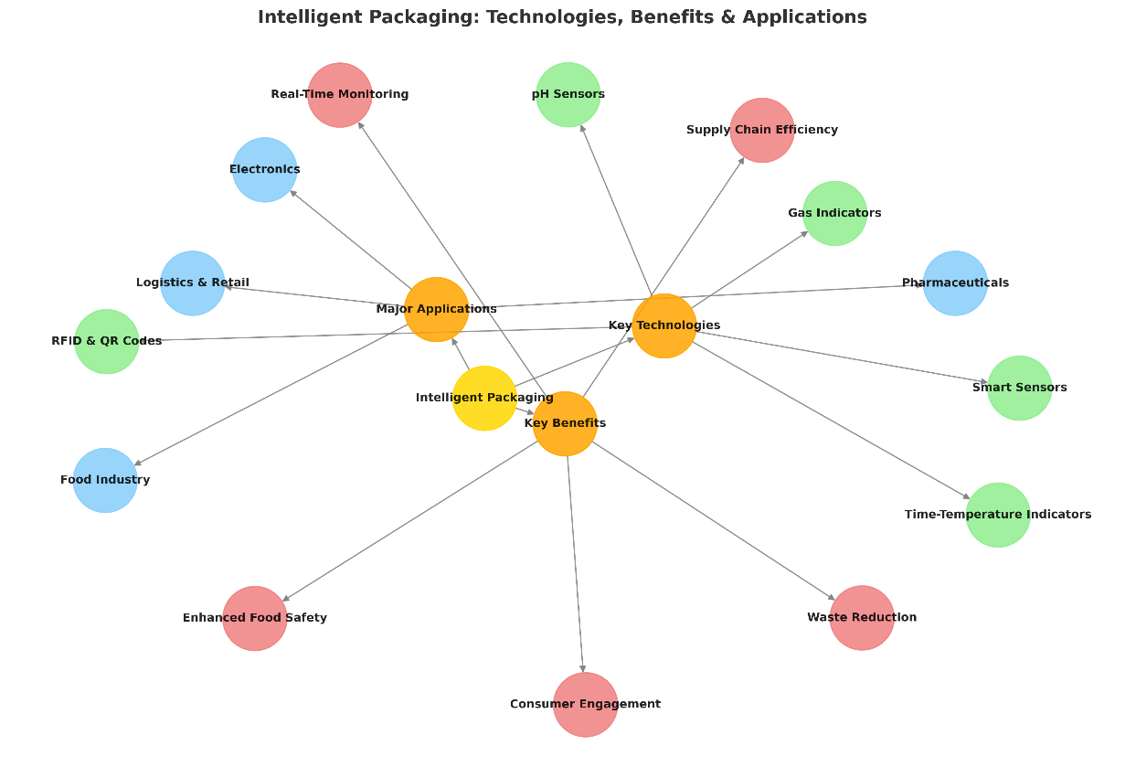

**Fig 1 Intelligent Packaging techniques**

By exhibiting distinctive optical changes, such as color shifts, indicators can be used to identify the presence, concentration, or interaction of two or more compounds. The dynamics of food product spoiling are often determined by time-temperature indicators. It is their responsibility to indicate whether the ambient temperature of the food that has been stored has risen above the threshold temperature, as well as the shortest amount of time that the food product has been above the threshold temperature. Redox-sensitive dyes, which change color in response to changes in oxygen concentration in MAP meals, make up visual oxygen indicators. Modified Atmosphere Packaging (MAP) with high oxygen levels can lead to lipid oxidation, which affects meat color. However, in fresh fish, oxygen helps inhibit the transformation of TMAO into TMA. Nitrogen (N₂), being inert and tasteless, is commonly used in MAP to dilute other gases and stabilize packaging by preventing collapse caused by CO₂ absorption (Mohan *et al.*,2019). Time-Temperature Indicators (TTIs) are sophisticated devices designed to monitor the thermal exposure of perishable commodities such as fish based on either physical changes or chemical or biological activity (Osmólska *et al.*,2022; Firouz *et al.*,2021) and they have enzymatic or polymer-based labels that visually signal cumulative temperature exposure (Taoukis *et al*., 2020).

. They employ mechanical, chemical, electrochemical, enzymatic, or microbiological changes to provide a visible indication of temperature history, thereby ensuring the integrity of the cold supply chain (Mohan *et al.*,2019).

Some organizations like Seapak® and Nestlé® use smart packaging solutions like TempTrust (Nestlé®) to enhance food safety and quality during storage and transportation. SmartFish is an innovative intelligent packaging system that uses refined colorimetric sensors implanted in its packaging materials, and it was created especially for the fish sector. These sensors provide a visible color shift that reveals the freshness of the seafood in response to biochemical changes, such as pH levels and volatile compounds emitted during spoiling.

The global food supply chain faces escalating challenges in ensuring safety, quality, and transparency, with foodborne illnesses affecting 600 million people annually (World Health Organization [WHO],2023). Traditional packaging systems, while effective in physical protection, lack real-time monitoring capabilities to address dynamic risks such as microbial contamination, temperature abuse, and spoilage. **Intelligent packaging** has emerged as a revolutionary solution, integrating sensors, indicators, and data carriers to monitor food conditions, communicate freshness, and enhance traceability (Yam *et al*.,2022). This technology bridges the gap between passive containment and proactive quality assurance, aligning with consumer demands for transparency and sustainability (Vanderroost *et al*.,2017).

**Table 7 Key Technologies in Intelligent Packaging**

|  |  |  |  |
| --- | --- | --- | --- |
| **Technology** | **Description** | **Application** | **Reference** |
| **TTIs (Time-Temperature Indicators)** | Fresh-Check® labels use polymer reactions to display color changes. | Monitoring temperature abuse in frozen foods. | (Taoukis *et al*., 2020) |
| **Gas Sensors** | Electrochemical sensors detect ethylene levels. | Signaling optimal ripeness in fruit packaging. | (Mills *et al*., 2018) |
| **Smart Labels** | Thinfilm® NFC tags enable product history scanning via smartphones. | Product information and traceability. | (Bibi *et al*., 2017) |
| **Nanocomposite Sensors** | Graphene-oxide films detect ammonia. | Detecting spoilage in seafood with high sensitivity. | (Ghaani *et al*., 2021) |

**Table 8 Material Innovations in Intelligent Packaging**

|  |  |  |  |
| --- | --- | --- | --- |
| **Material Innovation** | **Description** | **Application** | **Reference** |
| **Conductive Polymers** | Polyaniline films are used for humidity sensing. | Monitoring humidity levels in bakery products. | (Fang *et al*., 2017) |
| **Cellulose-Based Substrates** | Biodegradable paper sensors printed with anthocyanins as pH indicators. | Indicating meat freshness by detecting pH changes. | (Nopwinyuwong *et al*., 2014) |
| **Silica Nanoparticles** | Enhance the stability of colorimetric sensors in high-moisture environments. | Improving sensor performance in high-moisture conditions | (Mihindukulasuriya & Lim, 2014) |

**Table 9 Benefits and Challenges over Conventional Systems**

|  |  |  |
| --- | --- | --- |
| **BENEFITS** | | |
| **Aspect** | **Description** | **Reference** |
| **Waste Reduction** | TTIs reduce chilled food waste by 30% by identifying temperature breaches. | (Taoukis *et al*., 2020) |
| **Consumer Trust** | Smart labels provide transparent sourcing data, boosting brand loyalty. | (Vanderroost *et al*., 2017) |
| **Regulatory Compliance** | Real-time monitoring simplifies adherence to FSMA and EU food safety standards. | (Kerry *et al*., 2006) |
| **CHALLENGES** | | |
| **Aspect** | **Description** | **Reference** |
| **Standardization** | The lack of universal protocols for sensor accuracy complicates implementation. | (Mihindukulasuriya & Lim, 2014) |
| **Consumer Misinterpretation** | Misreading color-based indicators may lead to unnecessary discards. | (Pacquit et al., 2007) |

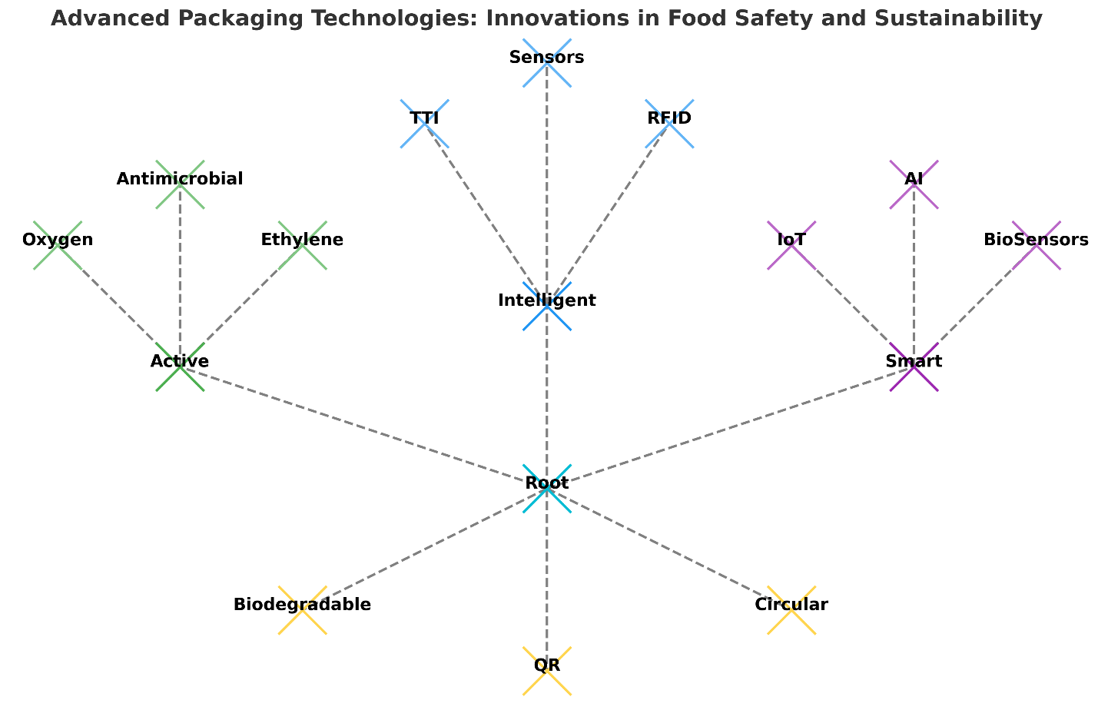

**Fig 2 Advanced Packaging Techniques**

**Table 10 Applications of Intelligent Packaging in Seafood Industry**

|  |  |  |
| --- | --- | --- |
| **Technology** | **Application** | **Reference** |
| **Chemical Sensors** | Detect changes in food composition, such as pH shifts. | (Kuswandi *et al*., 2011) |
| **Gas Sensors** | Identify gaseous analytes like oxygen, CO₂, and ethylene. | (Kuswandi *et al*., 2011) |
| **Biological Sensors** | Monitor bioactivity in food products to assess freshness. | (Kuswandi *et al*., 2011) |
| **Colorimetric Indicators** | Use dyes like methyl red and curcumin to detect volatile amines from meat and fish spoilage. | (Pacquit *et al*., 2007) |
| **Luminous Dyes** | Change color upon exposure to CO₂ to assess biogenic amines and TVB-N in fish. | (Pacquit *et al*., 2007) |
| **Time-Temperature Indicators (TTIs)** | Monitor thermal exposure of fish and perishable goods. | (Osmólska *et al*.,2022); (Firouz *et al*.,2021) |
| **Modified Atmosphere Packaging (MAP)** | Uses nitrogen (N₂) to prevent spoilage and maintain package stability. | (Mohan *et al*.,2019) |

**Table 11 Intelligent Packaging Solutions for Seafood Monitoring**

|  |  |  |  |  |
| --- | --- | --- | --- | --- |
| **Technology** | **Mechanism** | **Materials/Components** | **Application in Seafood** | **References** |
| **Time-Temperature Indicators (TTIs)** | Color-changing labels show cumulative temperature exposure. | Polymer-based enzymatic systems | Frozen shrimp, tuna shipments | (Taoukis *et al*., 2020); (Abedi-Firoozjah *et* *al*., 2023) |
| **Freshness Sensors** | Detect spoilage metabolites (e.g., biogenic amines, NH₃) via color shifts. | Anthocyanin-based films, pH-sensitive dyes | Salmon fillets, mackerel | (Nopwinyuwong *et al*., 2014); (Pacquit *et al*., 2007) |
| **RFID/NFC Tags** | Track real-time temperature and location during | Wireless RFID chips, blockchain integration | High-value seafood (e.g., sushi-grade tuna) | (Bibi *et al*., 2017); (Chen *et al*., 2020) |
| **Biosensors** | Detect pathogens (e.g., Vibrio spp.) using antibody-nanoparticle complexes. | Graphene oxide, gold nanoparticles | Oysters, clams | (Ghaani *et al*.,2021) |

## ACTIVE PACKAGING

The global food industry faces significant challenges in preserving product quality and safety, with approximately one-third of all food produced lost to spoilage and waste (Gustavsson *et al*.,2011). While effective in providing physical protection, traditional packaging methods often fall short in addressing dynamic factors such as microbial growth, oxidation, and moisture accumulation. So as a replacement, **active packaging** has emerged as a transformative approach, integrating functional components that interact with food products or their environment to extend shelf life, enhance safety, and maintain nutritional integrity (Yildirim *et al*.,2018). This innovation represents a paradigm shift from passive containment to proactive preservation, aligning with consumer demands for sustainability and natural preservation methods (Carocho *et al*.,2018).

Active packaging refers to systems that incorporate substances capable of releasing or absorbing compounds to modulate the internal atmosphere of a package (Suppakul *et al*.,2003). These mechanisms include oxygen scavenging, antimicrobial agent release, ethylene absorption, and moisture regulation (Gaikwad *et al*.,2020). For instance, oxygen scavengers mitigate oxidative rancidity in lipid-rich foods, while antimicrobial films inhibit pathogen growth, reducing reliance on synthetic preservatives (Appendini & Hotchkiss,2002). Such technologies are engineered to respond dynamically to environmental changes, offering tailored solutions for diverse food matrices. The term "active packaging" refers to a novel idea that modifies the state of the package and keeps it that way for the duration of storage to increase shelf life, enhance safety, or preserve sensory qualities without sacrificing the quality of the packaged food.

**Table 12 Overview of Active Packaging**

|  |  |  |
| --- | --- | --- |
| **Aspect** | **Description** | **Reference** |
| **Definition** | Active packaging is designed to interact with food or the environment to enhance food preservation. | Holben & Murray, 2012 |
| **Purpose** | Maintains food safety, extends shelf life, and reduces food waste. |
| **Mechanism** | Uses materials that release or absorb substances to modify the food environment. |
| **Advantages** | - Minimizes bacterial contamination  - Reduces the migration of harmful substances  - Improves product quality |

**Table 13 Common Components in Active Packaging**

|  |  |  |
| --- | --- | --- |
| **Component Type** | **Function** | **Reference** |
| **Oxygen Scavengers** | Prevents oxidation, reducing food spoilage. | Holben & Murray, 2012 |
| **Ethylene Scavengers** | Slows down ripening in fresh produce. |
| **Odor Absorbers** | Controls unwanted food odors. |
| **Antimicrobial Agents** | Inhibit microbial growth to enhance safety. |
| **Antioxidant Releasers** | Prevents food degradation by neutralizing oxidation. |

Oxygen scavengers, CO2 emitters, moisture regulators, antimicrobial packaging, and antioxidant release packaging are most common in seafood. The oxidation of fish products, which results in the growth of aerobic microorganisms and undesirable color changes (like the discoloration of pigments, off-odors, and flavors (like rancidity due to lipid oxidation), and nutrient loss negatively impact the product's quality. Thus, it's critical to regulate the oxygen content of food packaging to reduce the rate at which food deteriorates and spoils. Oxygen scavengers and CO2 emitters are available in the form of sachets, labels, or film, which are included in the primary packaging. They are based on either ferrous carbonate or a mixture of ascorbic acid and sodium bicarbonate packaging (Sreejith *et al.*,2020; Mohan *et al.*,2019). Oxygen scavengers and CO2 emitters inhibit aerobic bacteria, maintaining color and texture (McKeen, 2017). The primary oxygen scavenging systems utilize materials such as iron, platinum, and palladium metals. They also incorporate unsaturated hydrocarbons, tocopherol, ascorbic acid, enzymes, and microorganism-based scavengers (Firouz *et al.*,2021). Regarding Moisture regulators, Silica gel is the most widely used desiccant because it is non-toxic and non-corrosive. Natural antioxidants, primarily obtained from plant-based and microbial sources, are integral to active food packaging, offering safer solutions compared to hazardous synthetic counterparts (Deshmukh *et al*.,2024). In antimicrobial packaging, to prevent the films from deteriorating, antioxidants are added to plastic films. It is common practice to incorporate tannins, phenols, essential oils, and butylated hydroxytoluene (BHT) as antioxidants into the packaging film (Fadiji *et al*.,2023). However, because BHT tends to accumulate in human adipose tissue, there has been considerable concern regarding the physiological implications of eating BHT (Kamemura *et al*.,2018). As a result, fewer artificial antioxidants are being used in interaction with food. Therefore, using safe and natural antioxidants is preferred. The common natural antioxidants, vitamins E and C, are still in the experimental stage when it comes to their inclusion in polymer films to exhibit antioxidative effects (Albano *et al*.,2011).

The vacuum-sealed fish items produced by the Icelandic Group use active packaging technology that includes oxygen scavengers. To keep fish from spoiling and oxidatively deteriorating, this packaging technique works by absorbing excess oxygen. By extending the product's shelf life, the technology helps to preserve its freshness and quality throughout distribution. The Icelandic Group fulfills the growing consumer demand for fresher, longer-lasting products by incorporating this creative solution, which also enhances the safety and lifespan of their seafood.

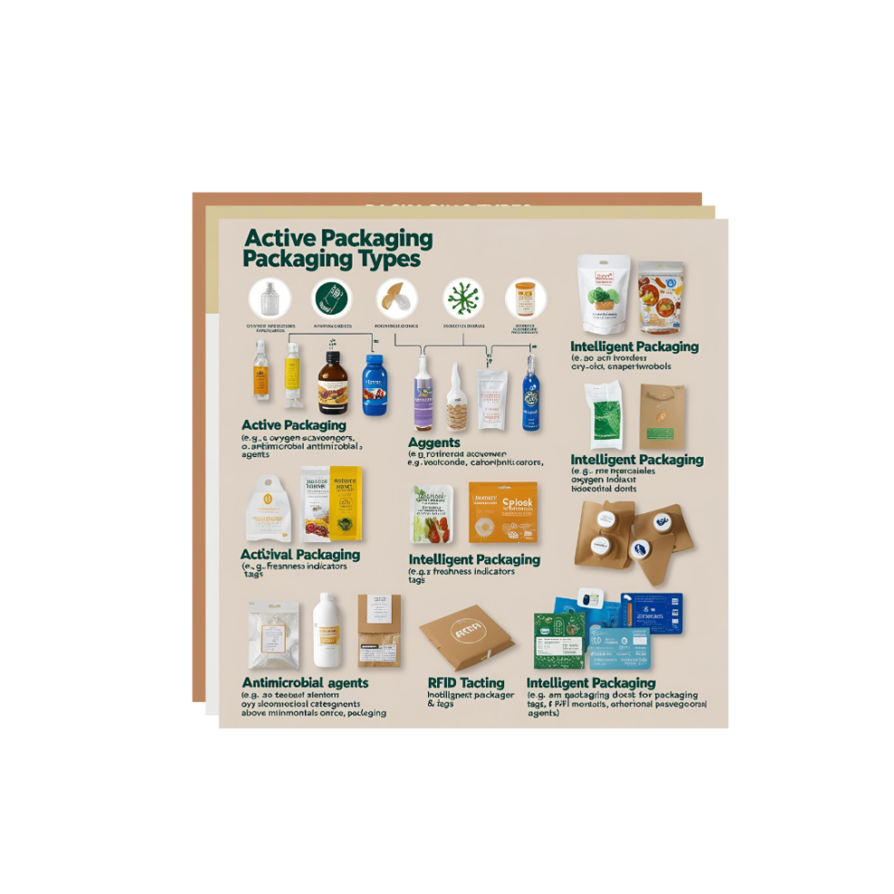

Fig 3 : Types of packaging

**Table 14 Key Technologies in Active Packaging**

| **Technology** | **Description** | **Applications** | **References** |
| --- | --- | --- | --- |
| **Oxygen Scavengers** | Iron-based compounds or enzymatic systems that reduce residual oxygen. | Preserves color and flavor in beverages and meats. | (Gaikwad *et al*., 2020) |
| **Antimicrobial Packaging** | Films infused with organic acids, essential oils, or nanoparticles (e.g., silver). | Extends shelf life of perishables like dairy and seafood. | (Suppakul et al., 2003) |
| **Ethylene Absorbers** | Clay-based or potassium permanganate sachets that adsorb ethylene gas. | Delays ripening in fruits and vegetables. | (Mangaraj et al., 2009) |
| **Moisture Control Systems** | Silica gel or cellulose-based layers that manage humidity. | Prevents condensation in fresh produce packaging. | (Robertson, 2016) |

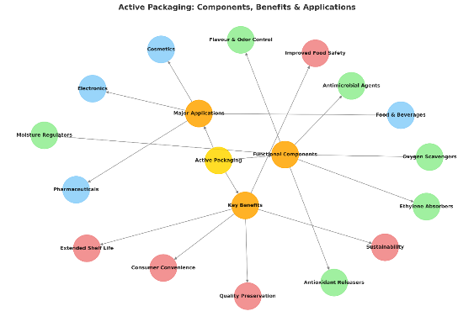

**Fig 4 Active Packaging**

**Table 15 Material Innovation in Active Packaging**

| **Material Innovation** | **Description** | **Functionality/Properties** | **References** |
| --- | --- | --- | --- |
| **Biopolymers (e.g., PLA, Chitosan)** | Eco-friendly materials that degrade naturally and serve as carriers for active agents. | Biodegradable, sustainable, and functional. | (Rhim et al., 2013) |
| **Chitosan Films with Thyme Oil** | Chitosan films embedded with thyme oil for dual functionality. | Antimicrobial and antioxidant barriers. | (Perdones et al., 2014) |
| **Nanocomposites** | Nanocomposites enhance mechanical and barrier properties. | Improved tensile strength and barrier performance. | (Azeredo et al., 2017) |
| **Cellulose Nanocrystals** | Nanocrystals are incorporated into films to improve mechanical properties. | Enhanced tensile strength and durability. | (Azeredo et al., 2017) |

**Table 16 Benefits and Challenges Over Conventional Packaging**

|  |  |  |
| --- | --- | --- |
| **Benefits Over Conventional Packaging** | | |
| **Aspect** | **Details** | **References** |
| **Reduction in Food Waste** | Active systems reduce food waste by up to 50% in certain categories. | (Han *et al*., 2018) |
| **Clean-Label Trends** | Minimizes synthetic additives; uses natural agents like citric acid and rosemary extract. | (Carocho *et al*., 2018) |
| **Economic Advantages** | Extended shelf life lowers logistical costs and enhances market reach. | (Robertson, 2016) |
| **Challenges and Considerations** | | |
| **Aspect** | **Details** | **References** |
| **Regulatory Compliance** | Varying global standards complicates commercialization. | (Restuccia *et al*., 2010) |
| **Migration Safety** | Ensuring active substances do not exceed legal limits requires rigorous testing. | (Han *et al*., 2018) |
| **Consumer Acceptance** | Education is needed to address misconceptions about nanotechnology and synthetic materials. | (Vanderroost *et al*., 2014) |

**Table 17 Active Packaging Solutions for Seafood Preservation**

|  |  |  |  |  |
| --- | --- | --- | --- | --- |
| **Technology** | **Mechanism** | **Materials/Agents** | **Application in Seafood** | **References** |
| **Oxygen Scavengers** | Absorb residual oxygen to prevent lipid oxidation and microbial growth. | Iron-based compounds, nanocomposites (PLA) | Vacuum-packed fish, shrimp | (Azeredo *et al.*, 2017);(Mohan & Ravishankar, 2019) |
| **Antimicrobial Films** | Release natural agents (e.g., essential oils) to inhibit pathogens. | Chitosan-clove oil, silver nanoparticles | Salmon, tuna, shellfish | (Appendini & Hotchkiss, 2002); (Deshmukh & Gaikwad, 2024) |
| **Ethylene Absorbers** | Adsorb ethylene gas to delay ripening in packaged vegetables accompanying seafood. | Zeolite, potassium permanganate | Mixed seafood salads | (Suppakul et al., 2003) |
| **CO₂ Emitters** | Release CO₂ to inhibit aerobic bacteria in modified atmosphere packaging (MAP). | Sodium bicarbonate, citric acid | Lobster, crab | (Mangaraj et al., 2009) |

## CONNECTED PACKAGING

Connected packaging facilitates the integration of digital content and services through QR codes and other mobile-enabled technologies, enhancing the accuracy of information provided, transparency, personalization, and accessibility. Information is delivered directly from the cloud with real-time content via the package through serialized QR codes, RFID chips, or other methods. It offers customers insights into the brand, including philanthropic initiatives, sustainability goals, supplier data, and business values, along with detailed ingredient specifications, such as allergy information. Additionally, track-and-trace capabilities inform customers about the product’s journey from farm or plant to store. Details like authentication information, geo-tagged marketing, and interaction data can be monitored alongside updates on recalls, all made possible by connected packaging.

Nestlé® employs QR codes and NFC (Near Field Communication) technology in its packaging to enhance consumer interaction and engagement. Customers can access detailed nutritional information, trace ingredient sources, and find culinary suggestions right from their smartphones. This strategy promotes transparency about sustainability programs and aligns with Nestlé's commitment to digital innovation. Additionally, the incorporation of augmented reality features creates immersive experiences, enriching the consumer journey and utilizing connected packaging to enhance customer satisfaction.

**Table 18: Connected Packaging Applications – Nestlé Case Study**

|  |  |
| --- | --- |
| **Feature** | **Application in Nestlé Packaging** |
| **QR Codes & NFC** | Consumers access detailed nutritional information, ingredient sources, and culinary suggestions via smartphones. |
| **Transparency & Sustainability** | Promotes traceability of ingredients and aligns with Nestlé’s sustainability goals. |
| **Augmented Reality (AR)** | Creates immersive experiences to enhance customer engagement and brand interaction. |
| **Consumer Engagement** | Strengthens the brand-consumer relationship through interactive digital content. |
| **Digital Innovation** | Supports real-time updates and integrates with cloud-based data. |

**Table 19 Challenges and Future Trends**

|  |  |  |  |
| --- | --- | --- | --- |
| **Aspect** | **Challenges** | **Future Directions** | **References** |
| **Cost** | High production costs of nanocomposites and RFID tags. | Use agricultural waste (e.g., banana peels) for low-cost sensors. | (Restuccia *et al*.,2010) |
| **Regulatory Compliance** | Lack of global standards for migration limits of active agents. | Harmonize EU/WHO/FDA regulations for intelligent packaging. | EFSA (2009) |
| **Consumer Acceptance** | Skepticism about nanotechnology and edible coatings. | Educate consumers via QR codes linked to safety data. | (Vanderroost *et al*.,2017) |
| **Sustainability** | Non-recyclable materials in smart packaging. | Develop circular economy models for biodegradable sensors. | (Rhim *et al*., 2013); (FAO 2023) |

# CONCLUSION

The introduction of smart seafood packaging is a revolutionary development in improving the quality and safety of the product. Smart packaging offers real-time data on the state of seafood across its supply chain by integrating cutting-edge technologies, including oxygen scavengers, freshness indicators, and RFID tags. These innovations reduce food waste, increase consumer confidence, and lengthen shelf life. The industry's approach to food preservation and safety will ultimately undergo a revolution as smart packaging becomes more widely used and plays a more significant role in guaranteeing the sustainability and quality of seafood. The integration of **active**, **intelligent**, and **smart packaging** technologies represents a transformative leap in seafood preservation, addressing critical challenges such as spoilage, safety, and sustainability. Emerging smart packaging solutions, including IoT-enabled sensors and biodegradable materials, further bridge the gap between technological innovation and environmental responsibility. Edible coatings and self-healing films exemplify the potential for multifunctional materials that preserve quality while reducing plastic dependency. As the seafood industry navigates climate-driven supply chain disruptions and escalating waste concerns, smart packaging stands as a cornerstone for building resilient, sustainable food systems.

Disclaimer (Artificial intelligence)

Option 1:

Author(s) hereby declare that NO generative AI technologies such as Large Language Models (ChatGPT, COPILOT, etc.) and text-to-image generators have been used during the writing or editing of this manuscript.

Option 2:

Author(s) hereby declare that generative AI technologies such as Large Language Models, etc. have been used during the writing or editing of manuscripts. This explanation will include the name, version, model, and source of the generative AI technology and as well as all input prompts provided to the generative AI technology

Details of the AI usage are given below:

1.

2.

3.

**REFERENCE**

1. Abedi‐Firoozjah, R., Salim, S. A., Hasanvand, S., Assadpour, E., Azizi‐Lalabadi, M., Prieto, M. A., & Jafari, S. M. (2023). Application of smart packaging for seafood: A comprehensive review. Comprehensive Reviews in Food Science and Food Safety, 22(2), 1438–1461. https://doi.org/10.1111/1541-4337.13130
2. Albano, C., Perera, R., Karam, A., De Abreu, L., Sanchez, Y., & Silva, P. (2011). Characterization of blends of PP with vitamins “C” and “E” exposed to gamma radiation at sterilization dose. Polymer Bulletin, 66(8), 1137–1148. https://doi.org/10.1007/s00289-011-0462-7
3. Appendini, P., & Hotchkiss, J. H. (2002). Review of antimicrobial food packaging. Innovative Food Science & Emerging Technologies, 3(2), 113–126. https://doi.org/10.1016/S1466-8564(02)00012-0
4. Azeredo, H. M. C., Rosa, M. F., & Mattoso, L. H. C. (2017). Nanocomposites for food packaging applications. Food Research International, 98, 1–11. https://doi.org/10.1016/j.foodres.2017.01.015
5. Bibi, F., Guillaume, C., Gontard, N., & Sorli, B. (2017). RFID technology having sensing aptitudes for food industry and their contribution to tracking and monitoring of food products. Trends in Food Science & Technology, 62, 91–103. https://doi.org/10.1016/j.tifs.2017.01.013
6. Carocho, M., Morales, P., & Ferreira, I. C. F. R. (2018). Natural food additives: Quo vadis? Trends in Food Science & Technology, 71, 181–189. https://doi.org/10.1016/j.tifs.2017.12.004
7. Chen, S., Brahma, S., Mackay, J., Cao, C., & Aliakbarian, B. (2020). The role of smart packaging system in food supply chain. Journal of Food Science, 85(3), 517–525. https://doi.org/10.1111/1750-3841.15015
8. Deshmukh, R. K., & Gaikwad, K. K. (2024). Natural antimicrobial and antioxidant compounds for active food packaging applications. Biomass Conversion and Biorefinery, 14(4), 4419–4440. https://doi.org/10.1007/s13399-022-02354-y
9. Dodero, A., Escher, A., Bertucci, S., Castellano, M., & Lova, P. (2021). Intelligent packaging for real-time monitoring of food-quality: Current and future developments. Applied Sciences, 11(8), 3532. https://doi.org/10.3390/app11083532
10. ~~European Food Safety Authority (~~EFSA~~)~~. (2009). Guidelines on submission of a dossier for safety evaluation by the EFSA of active or intelligent substances present in active and intelligent materials and articles intended to come into contact with food. EFSA Journal, 7(8), 1208. https://doi.org/10.2903/j.efsa.2009.1208
11. Fadiji, T., Rashvand, M., Daramola, M. O., & Iwarere, S. A. (2023). A review on antimicrobial packaging for extending the shelf life of food. Processes, 11(2), 590. https://doi.org/10.3390/pr11020590
12. FAO. (2023). Global food losses and food waste. Food and Agriculture Organization. http://www.fao.org/food-loss-and-food-waste
13. Fang, Z., Zhao, Y., Warner, R. D., & Johnson, S. K. (2017). Smart packaging in meat industry. Trends in Food Science & Technology, 61, 60–71. https://doi.org/10.1016/j.tifs.2017.01.002
14. Firouz, M. S., Mohi-Alden, K., & Omid, M. (2021). A critical review on intelligent and active packaging in the food industry: Research and development. Food Research International, 141, 110113. https://doi.org/10.1016/j.foodres.2021.110113
15. Gaikwad, K. K., Singh, S., & Lee, Y. S. (2020). Oxygen scavenging films in food packaging. Environmental Chemistry Letters, 18(3), 567–588. https://doi.org/10.1007/s10311-020-00963-5
16. Ghaani, M., Cozzolino, C. A., Castelli, G., & Farris, S. (2021). Intelligent packaging technologies in food sector. Trends in Food Science & Technology, 105, 385–398. https://doi.org/10.1016/j.tifs.2020.09.008
17. Gram, L., & Huss, H. H. (1996). Microbiological spoilage of fish and fish products. International Journal of Food Microbiology, 33(1), 121–137. https://doi.org/10.1016/0168-1605(96)01134-8
18. Gustavsson, J., Cederberg, C., Sonesson, U., van Otterdijk, R., & Meybeck, A. (2011). Global food losses and food waste. Food and Agriculture Organization. http://www.fao.org/3/mb060e/mb060e.pdf
19. Han, J. H., Ho, C. H. L., & Rodrigues, E. T. (2015). Intelligent packaging. In J. H. Han (Ed.), Innovations in food packaging (pp. 138–155). Elsevier. https://doi.org/10.1016/B978-0-12-394601-0.00006-6
20. Holben, D. H., & Murray, D. H. (2012). Food and nutrient delivery: Planning the diet with cultural competency. Journal of Nutrition Education and Behavior, 44(4), S1–S5. https://doi.org/10.1016/j.jneb.2012.03.001
21. Kalpana, S., Priyadarshini, S. R., Leena, M. M., Moses, J. A., & Anandharamakrishnan, C. (2019). Intelligent packaging: Trends and applications in food systems. Trends in Food Science & Technology, 93, 145–157. https://doi.org/10.1016/j.tifs.2019.09.008
22. Kamemura, N. (2018). Butylated hydroxytoluene, a food additive, modulates membrane potential and increases the susceptibility of rat thymocytes to oxidative stress. Computational Toxicology, 6, 32–38. https://doi.org/10.1016/j.comtox.2017.12.002
23. Kassal, P., Steinberg, M. D., & Steinberg, I. M. (2018). Wireless chemical sensors and biosensors: A review. Sensors and Actuators B: Chemical, 266, 228–245. https://doi.org/10.1016/j.snb.2018.03.074
24. Kerry, J. P., O’Grady, M. N., & Hogan, S. A. (2006). Active packaging for meat products. Meat Science, 74(1), 113–130. https://doi.org/10.1016/j.meatsci.2006.04.024
25. Kuswandi, B., Wicaksono, Y., Jayus, Abdullah, A., Heng, L. Y., & Ahmad, M. (2011). Smart packaging: Sensors for monitoring of food quality and safety. Sensing and Instrumentation for Food Quality and Safety, 5(3), 137–146. https://doi.org/10.1007/s11694-011-9120-x
26. Li, X., Liu, D., Pu, Y., & Zhong, Y. (2023). Recent advances of intelligent packaging aided by artificial intelligence for monitoring food freshness. Foods, 12(15), 2976. https://doi.org/10.3390/foods12152976
27. Mangaraj, S., Goswami, T. K., & Mahajan, P. V. (2009). Applications of plastic films for modified atmosphere packaging of fruits and vegetables: A review. Food Engineering Reviews, 1(2), 133–158. https://doi.org/10.1007/s12393-009-9007-3
28. McKeen, L. W. (2017). Film properties of plastics and elastomers (4th ed.). William Andrew.
29. Mihindukulasuriya, S. D. F., & Lim, L. T. (2014). Nanotechnology in food packaging. Trends in Food Science & Technology, 40(2), 149–167. https://doi.org/10.1016/j.tifs.2014.09.009
30. Mills, A., Hazafy, D., & Lawrie, K. (2018). Nanoparticle-based sensors. Nanoscale, 10(18), 8652–8662. https://doi.org/10.1039/C8NR01239C
31. Mohan, C. O., & Ravishankar, C. N. (2019). Active and intelligent packaging systems-application in seafood. Journal of Packaging Technology and Research, 3(3), 245–258. https://doi.org/10.1007/s41783-019-00077-6
32. Nopwinyuwong, A., Trevanich, S., & Suppakul, P. (2014). Development of a novel colorimetric indicator label for monitoring freshness of intermediate-moisture dessert spoilage. Talanta, 130, 547–554. https://doi.org/10.1016/j.talanta.2014.07.048
33. Osmólska, E., Stoma, M., & Starek-Wójcicka, A. (2022). Application of biosensors, sensors, and tags in intelligent packaging used for food products—a review. Sensors, 22(24), 9956. <https://doi.org/10.3390/s22249956>
34. Kahar, G. S., Gosavi, R., Khatal, M. M., Thul, P. P., Sawant, A. A., & Manaswini, C. Development and Shelf-Life Study of Twin-Screw Extruded Fish Snacks Using Mackerel and Rohu Powder.
35. Kahar, G. S., Kolhe, P., Khatal, M. M., Jadhav, V., Mishra, A. K., Dalvi, S. B., ... & Khune, P. M. (2024). The production, yield, and area of the jowar (great millet) in the states of India using the pivot table. IJECS, 6(1), 56-60.
36. :Kahar, G. S., Jawake, P., Sawant, A. A., Bansode, P. B., & Langote, K. S. (2024). Shelf-life enhancement of guava by using ethylene inhibitor and different coating material.
37. Kahar, G. S., Gosavi, R., Sawant, A. A., Kad, V. P., Kalse, S. B., & Rupanawar, H. D. Transforming Agricultural Process Engineering: The convergence of IoT and AI.
38. Manjit M Khatal, GS Kahar, RA Gosavi, Pooja P Thul, AM Kutwal, KK Kashid and Anunay Kumar. Pulsed electric field: A novel technique for sustainability in fruit and vegetable processing. International Journal of Agriculture Food Science 2025;7(3):60-67
39. Ozdemir, M., & Floros, J. D. (2004). Active food packaging technologies. Critical Reviews in Food Science and Nutrition, 44(3), 185–193. https://doi.org/10.1080/10408690490441578
40. Pacquit, A., Frisby, J., Diamond, D., Lau, K. T., Farrell, A., Quilty, B., & Diamond, D. (2007). Smart packaging for fish spoilage monitoring. Food Chemistry, 102(2), 466–470. https://doi.org/10.1016/j.foodchem.2006.05.052
41. Perdones, Á., Vargas, M., Atarés, L., & Chiralt, A. (2014). Effect of chitosan-lemon essential oil coatings on strawberry preservation. Carbohydrate Polymers, 113, 186–194. https://doi.org/10.1016/j.carbpol.2014.07.012
42. Realini, C. E., & Marcos, B. (2014). Active and intelligent packaging systems. Meat Science, 98(3), 404–419. https://doi.org/10.1016/j.meatsci.2014.06.031
43. Restuccia, D., Spizzirri, U. G., Parisi, O. I., Cirillo, G., Curcio, M., Iemma, F., Puoci, F., Vinci, G., & Picci, N. (2010). Active packaging regulations. Food Control, 21(11), 1425–1435. https://doi.org/10.1016/j.foodcont.2010.04.028
44. Rhim, J. W., Park, H. M., & Ha, C. S. (2013). Bio-nanocomposites for food packaging applications. Progress in Polymer Science, 38(10–11), 1629–1652. https://doi.org/10.1016/j.progpolymsci.2013.05.008
45. Schaefer, D., & Cheung, W. M. (2018). Smart packaging: Opportunities and challenges. Procedia CIRP, 72, 1022–1027. https://doi.org/10.1016/j.procir.2018.03.240
46. Sreejith, S., Mohan, C. O., & Ravishankar, C. N. (2020). Packaging technology for seafood goes hi-tech. Journal of Food Science and Technology, 57(12), 4303–4317. https://doi.org/10.1007/s13197-020-04756-0
47. Suppakul, P., Miltz, J., Sonneveld, K., & Bigger, S. W. (2003). Active packaging technologies with an emphasis on antimicrobial packaging and its applications. Journal of Food Science, 68(2), 408–420. https://doi.org/10.1111/j.1365-2621.2003.tb05687.x
48. Taoukis, P. S., Tsironi, T. N., & Gogou, E. (2020). Cold chain management and temperature monitoring. In P. S. Taoukis (Ed.), Food engineering innovations across the food supply chain (pp. 463–488). Academic Press. https://doi.org/10.1016/B978-0-12-821292-9.00029-1
49. Vanderroost, M., Ragaert, P., Devlieghere, F., & De Meulenaer, B. (2017). Intelligent food packaging. Trends in Food Science & Technology, 39(1), 47–62. https://doi.org/10.1016/j.tifs.2014.06.009
50. World Health Organization. (2023). Food safety. https://www.who.int/news-room/fact-sheets/detail/food-safety
51. Yam, K. L., Takhistov, P. T., & Miltz, J. (2022). Intelligent packaging: Concepts and applications. Journal of Food Science, 70(1), R1–R10. https://doi.org/10.1111/j.1365-2621.2005.tb09052.x
52. Yildirim, S., Röcker, B., Pettersen, M. K., Nilsen-Nygaard, J., Ayhan, Z., Rutkaite, R., Radusin, T., Suminska, P., Marcos, B., & Coma, V. (2018). Active packaging materials for food applications. Springer. <https://doi.org/10.1007/978-3-319-76002-5>