*Original Research Article*

Assessment of Mycotoxin Contamination in Rice and Groundnuts from Local Vendors’ Stores in Markets of Kericho, Kenya.

.

ABSTRACT

|  |
| --- |
| **Aims:** The presence of mycotoxins in food crops is associated with severe health hazards and economic losses worldwide. The aim of this study was to assess the quantities of mycotoxins, specifically fumonisin and aflatoxin, found in rice and groundnut seeds sold by vendors in local stores. Rice and groundnut samples were obtained from three main markets in Kericho County.  **Study design:** Cross-sectional laboratory-based study design was used.  **Place and Duration of Study:** The samples used in the study were collected from the Kapsuser, Kericho Town, and Nyagacho markets in Kericho County. The analysis was carried out at the Kenya Medical Research Institute in Nairobi from August 2022 to August 2023.  **Methodology:** We included a total of 138 samples in the study. This consisted of 69 samples of rice and 69 samples of groundnuts. The samples were collected from randomly selected vendors selling rice and/or groundnuts. The Envirologix QuickTox Kit for QuickScan Aflatoxin was used in this study to analyze mycotoxin levels.  **Results:** The data was analyzed using the R and Statistical Package for Social Science (SPSS) software packages. The statistical significance level was set at p<0.05. The findings showed a significant presence of fumonisins and aflatoxins in different concentrations. These results highlight how crucial routine monitoring and control procedures are to reducing mycotoxin contamination in food supply.  **Conclusion:** The presence of aflatoxin and fumonisin which exceed the acceptable levels presents a risk to food safety and, in turn, consumer health. The need to increase awareness among rice and peanut traders is quite enormous. To guarantee food safety and public health protection, more study is advised to examine efficient actions and legislative frameworks. |

*Keywords: Aflatoxin, Food Safety, Fumonisin, Groundnuts, Mycotoxins, Rice.*

1. INTRODUCTION

Mycotoxins are toxic secondary metabolites produced by certain fungi, predominantly belonging to the genera *Aspergillus*, *Fusarium*, and *Penicillium.* These toxic compounds pose significant health risks to humans and animals, including carcinogenic, teratogenic, neurotoxic, and immunosuppressive effects. Among the various mycotoxins, aflatoxins and fumonisins are of particular concern due to their prevalence in staple food crops and their severe health impacts. Aflatoxins, primarily produced by *Aspergillus flavus* and *Aspergillus* *parasiticus* (Fariha et al., 2016), are potent carcinogens and have been classified as Group 1 carcinogens by the International Agency for Research on Cancer (IARC) in Lyon, France (International Agency for Research on Cancer, 2002;Ostry et al., 2017) Chronic exposure to aflatoxins can lead to liver cancer, immunosuppression, and growth retardation in children(Sirma et al., 2018), while acute exposure can cause aflatoxicosis, characterized by severe liver damage and potentially fatal outcomes. The significance of aflatoxins in food safety is underscored by numerous studies that have documented their widespread occurrence and detrimental health effects (Probst et al., 2007).

Fumonisins, produced by *Fusarium verticillioides* and *Fusarium proliferatum*, are predominantly associated with maize but also contaminate other crops such as rice and groundnuts (Deepa & Sreenivasa, 2017). Fumonisins interfere with sphingolipid metabolism, leading to diseases such as leukoencephalomalacia in horses, pulmonary edema in pigs, and esophageal cancer in humans. The global prevalence of fumonisins, along with their severe health impacts, highlights the need for ongoing research and intervention to mitigate their presence in food supplies (Fandohan et al., 2005;Shephard, 2008). The contamination of food crops with mycotoxins is a global issue, exacerbated by factors such as climate change, poor agricultural practices, and inadequate storage conditions (Id et al., 2020). Studies have shown that cereals and legumes are particularly vulnerable to fungal contamination and subsequent mycotoxin production. Rice and groundnuts, essential components of the diet in many regions, are frequently contaminated with aflatoxins and fumonisins, posing significant health risks to consumers. Previous research has highlighted the widespread occurrence of mycotoxins in food crops across various regions. For instance, a study by (Udomkun et al., 2017) reported high levels of aflatoxin contamination in groundnuts from sub-Saharan Africa, attributing the contamination to factors such as high humidity, inadequate drying practices, and poor storage conditions. Mycotoxin contamination of rice and groundnuts immensely raises a lot of concern since they are not only eaten directly but also used as raw materials for other food products (Imienwanrin & Makun, 2020). These findings emphasize the critical need for improved agricultural and storage practices to reduce the risk of mycotoxin contamination. The health impacts of mycotoxins are profound and multifaceted, hence the need for continuous monitoring and control measures to protect public health.

Economically, mycotoxin contamination leads to significant losses through reduced market value of contaminated crops, increased healthcare costs, and decreased agricultural productivity. In regions heavily dependent on agriculture, such as sub-Saharan Africa, the economic burden of mycotoxin contamination is substantial, affecting both food security and economic stability. The economic impacts extend beyond the immediate losses, as they also influence international trade and market access, further exacerbating the challenges faced by affected regions (Bhat et al., 2010).

Kericho County, located in the highlands of Kenya, is characterized by favorable agricultural conditions, including moderate temperatures, ample rainfall, and low evaporation rates. Despite these advantages, the region's agricultural produce is susceptible to fungal contamination due to various environmental and handling factors. Farmers in Kericho practice domestic farming, growing crops such as sorghum, tea, sugarcane, pineapples, tomatoes, maize, coffee, sweet potatoes, and barley. However, rice and groundnuts, the focus of this study, are not grown locally but are imported from neighboring counties, introducing additional risks of contamination during transportation and storage (Government of Kenya, 2018) . The reliance on external sources for rice and groundnuts introduces multiple points of vulnerability in the supply chain, where contamination can occur. Factors such as improper drying, inadequate storage facilities, and long transportation times can exacerbate the risk of fungal growth and mycotoxin production. Understanding the specific conditions in Kericho County that contribute to mycotoxin contamination is essential for developing targeted interventions to ensure the safety of these staple foods.

The ability of fungi to produce mycotoxins is influenced by various factors, including environmental conditions, crop type, and storage practices. For instance, inadequate drying of crops post-harvest can lead to increased moisture content, providing a conducive environment for fungal growth and mycotoxin production. (Ti et al., 2019). Similarly, poor storage conditions, such as high humidity and temperature, can exacerbate the problem, leading to significant levels of contamination. Research has shown that controlling these factors can significantly reduce the risk of mycotoxin contamination, highlighting the importance of good agricultural and storage practices (Magan et al., 2003; Miller, 2008). To mitigate the risks associated with mycotoxin contamination, several strategies have been proposed and implemented. These include good agricultural practices (GAP), such as timely harvesting, proper drying, and adequate storage of crops, as well as the use of biocontrol agents to inhibit fungal growth. Additionally, regular monitoring and testing of crops for mycotoxin levels are crucial to ensure food safety and to implement timely interventions (Bhat et al., 2010).Public awareness campaigns and education programs aimed at farmers and consumers can also play a significant role in reducing mycotoxin contamination. By understanding the risks and adopting best practices, farmers can minimize the chances of fungal growth and mycotoxin production, thereby ensuring the safety and quality of their produce. Government and non-governmental organizations have a critical role in disseminating information and providing resources to support these initiatives (Shephard, 2008).

The literature highlights the significant threat posed by mycotoxins to food safety, public health, and economic stability. The prevalence of aflatoxins and fumonisins in staple food crops such as rice and groundnuts underscore the need for continuous monitoring, effective control measures, and public awareness to mitigate the risks associated with mycotoxin contamination. Also, most studies in Kenya on mycotoxin contamination focus on maize and groundnuts largely during production and processing stages, with very little focus on rice in urban market contamination at retail-level ( (Birgen et al., 2020 ; Ankwasa EM, Francis I and Ahmad T., 2021). There is also inadequate data on the burden of mycotoxins in stores of small-scale vendors where most of the urban population purchase food from. Moreover, while previous studies have examined mycotoxin levels in Kenya, there is still a paucity of data for high-altitude regions like Kericho, where unique climatic conditions may influence fungal growth and toxin accumulation. This study aims to address these gaps by undertaking a thorough examination of mycotoxin contamination in rice and groundnuts sold in Kericho's local markets. By analysing contamination levels and identifying potential risk factors related with storage and handling procedures in Kericho County, the study will give crucial data for food safety policies, mycotoxin monitoring systems, and public health protection. The findings will also help to raise awareness among vendors and consumers about mycotoxin hazards and best practices for contamination prevention, resulting in safer food consumption and contribute to the broader efforts to improve food safety and security in the region and beyond.

2. material and methods

**2.1 Study area and site**

Figure 1 represents the map of Kericho County where the study was carried out. The County has a favorable climate and receives relief rainfall, with moderate temperatures of 17 °C and low evaporation rates. Temperatures range between 10°C - 29°C. The mean annual rainfall varies from 1800mm around Kericho town. Most local farmers practice domestic farming(United Agency for International Development 2019, 2017). The crops grown include; sorghum, tea, sugarcane, fruits (pineapples), tomatoes, maize, coffee, sweet potatoes, and barley. However, crops under study are not grown but imported and bought from neighboring counties. Kericho County is well positioned to benefit from various markets provided by the neighboring counties as it has robust national and county roads connecting to the rest of the counties. The target population is vendors who store rice and groundnuts in their farm stores for either commercial or consumption purposes.

**Fig.1: Map of Kericho showing the study regions.**

**2.2 Research Design**

Cross-sectional laboratory-based research design was employed in this study. The study focused on mycotoxins produced by the fungi genera *Aspergillu*s and *Fusarium* isolated from samples of two grains: rice cereal grains and groundnut legume grains.

**2.3 Sampling procedure**

Cereal grains and legume grains were collected from three markets: Kericho town market, Kapsuser market and Nyagacho market. Using simple random sampling, vendors selling rice and/or groundnuts were picked using a questionnaire.

**2.4 Sample Collection and Processing**

The samples from the selected vendors were obtained aseptically using sterilized polystyrene spoons (Indiamart company), placed in well-labeled transparent and plain PVC Peel and zeal VCI zip lock bags (10/16 inches and 50-150 microns’ thickness, Indiamart company) and then transported to the Centre of Microbiology Research (CMR), at Kenya Medical Research Institute (KEMRI), Nairobi for analysis.

Sample bags were labeled using two identifiers, the date of collection and unique codes assigned to the different vendors, for confidentiality. Laboratory analysis of the collected rice and groundnut samples were involved in the isolation and characterization of environmental fungi. The selected samples were accompanied with information such as the storage practices and food type. Briefly, 10 grams each of rice and groundnut samples were surface sterilized using 0.2% sodium hypochlorite (NaOCl) solution for 2 minutes and then rinsed three times using sterilized distilled water. Sterilization was done to kill fungi found on the surface of samples since the fungi found inside the sample was of interest. One gram of each of the groundnut and rice samples was grounded.

**2.5 Determination of Mycotoxin Levels**

The aflatoxins kit known as Envirologix QuickTox Kit for QuickScan Aflatoxin flex (AQ 309 BG, kit Lot: 318-23, version 5.8.1) (Figure 2) was used to analyze the mycotoxin levels. This is in the conformance range of 5.0-300 parts per billion(ppb).High Liquid Paper Chromatography(HPLC) was used for confirmation of positive samples of aflatoxin.

**Fig 2: (a) Envirologix Quick Toxin kit (b) Quick scanner reader**

Extraction procedures were done as previously described by (USDA 2019). Briefly, 10 grams of the ground sample was transferred to a hard-walled extraction container (ACC019) for rice and groundnuts. One dissolvable EB 17 pouch was then added to the extraction container. Using a 250ml cylinder, 150ml of distilled water was added to the extraction container, the container sealed and shaken well by hand immediately for 10 seconds avoiding delays between the additions of water and shaking. The extraction mixture was then vortexed at a speed of 300 rotations per minute for one minute on an orbital shaking platform. The extract was filtered by pouring it onto an approved coffee filter (ACC 083) and then into a clean vessel for collection. The sample was allowed to filter for 2 minutes. Thereafter, the filter paper was discarded and the filtered extract was tested for aflatoxin and fumonisin.

3. results and discussion

Aflatoxin levels in groundnuts were higher than in rice, whereas fumonisin occurrence in rice was higher than in groundnuts. Descriptive statistics (Table 1) were used to show the aflatoxin levels and fumonisin distribution in Kericho from the three markets combined. Box plot was used to visually show aflatoxin distribution in the three markets combined (Fig. 3).

Three product types were further assessed to compare aflatoxin and fumonisin levels in groundnuts. The boxplot (Figure 4a) results showed that roasted groundnuts had higher levels of aflatoxin than groundnuts with pods and unroasted groundnuts. Also, the aflatoxin level was higher in the Kapsuser market than in Nyagacho and Kericho. Some locations had no substantive data to allow for representation, for instance, unroasted groundnuts in Kericho and Kapsuser. With regard to fumonisin levels (Figure 4b) the results showed that groundnuts with pods had the highest level of fumonisin. Similarly, the fumonisin levels were higher in Nyagacho than in Kapsuser and Kericho.

Kruskal-Wallis test was used to compare the statistical differences of the aflatoxin levels in different regions. In this study, Kruskal-Wallis was employed to analyse the statistical difference in aflatoxin levels for rice and groundnuts and represented boxplots, with statistical differences between the mycotoxins shown using p-values. The results for rice show that Nyagacho had a high level of aflatoxin, followed by Kericho and lastly Kapsuser. The statistical differences in rice levels were also depicted between Kapsuser and Kericho, and between Kapsuser and Nyagacho. However, there was no statistical difference in aflatoxin levels between Kericho and Nyagacho (Figure 5). The results for groundnuts show that the aflatoxin levels between Kericho and Kapsuser, Kapsuser and Nyagacho markets were statistically significant. In contrast, aflatoxin levels between Kericho and Nyagacho were not statistically significant (Figure 6).

**Table 1: Mycotoxin contamination incidence in Rice and Groundnuts**

|  |  |  |  |  |  |  |  |
| --- | --- | --- | --- | --- | --- | --- | --- |
| **Crops** | **Mycotoxins** | **n** | **Mean** | **Std.Deviation** | **Variance** | **Minimum value** | **Maximum value** |
| **Rice** |  |  |  |  |  |  |  |
|  | Aflatoxin | 69 | 5.176 | 8.110 | 65.766 | 0 | 29 |
|  | Fumonisin | 69 | 1.670 | 3.644 | 13.281 | 0 | 12 |
|  |  |  |  |  |  |  |  |
| **Groundnuts** |  |  |  |  |  |  |  |
|  | Aflatoxin | 69 | 15.995 | 15.590 | 243.042 | 0 | 50 |
|  | Fumonisin | 69 | 0.044 | 0.070 | 0.005 | 0 | 0.3 |
|  |  |  |  |  |  |  |  |

**Fig. 3. Boxplot of Aflatoxin distribution in (left) rice and (right) groundnuts.**

**Fig.4. Boxplot of (a) aflatoxin and (b) fumonisin groundnuts based on product type per location.**

*Key: RG=Roasted Groundnuts, RUG=Raw Unopened Groundnuts, UG=Unopened Groundnuts*

*KA:Kapsuser, KC:Kericho, NY: Nyagacho*

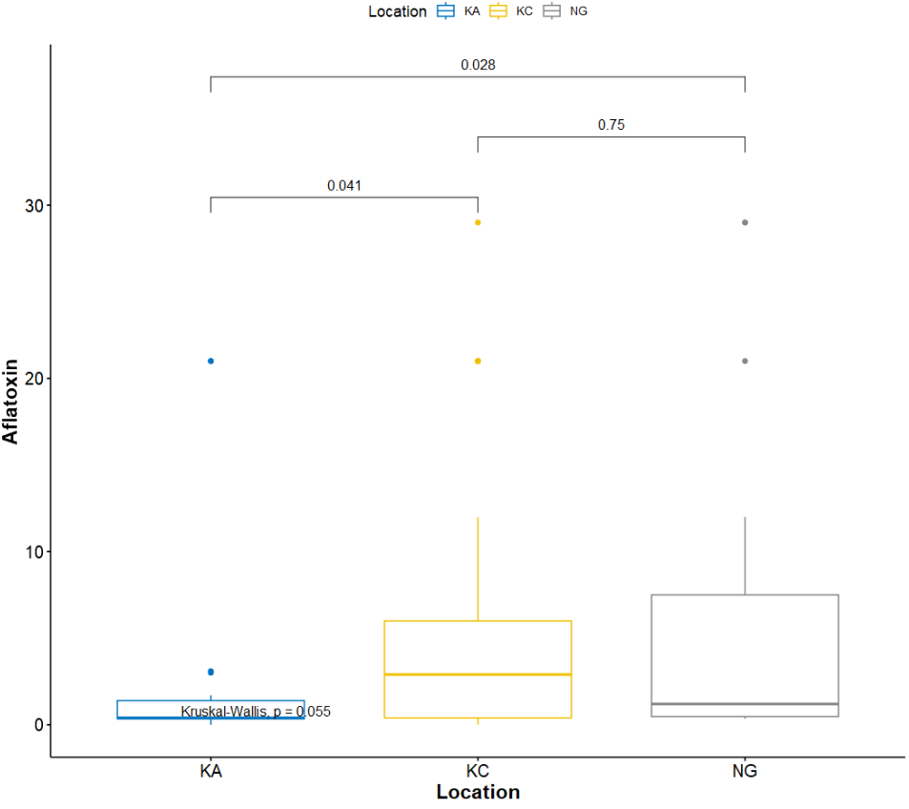

**Figure 5: Boxplot of aflatoxin in Rice based on the different locations**

The values on the top of the plot indicate p-values showing statistical differences between the locations. KA= Kapsuser, KC=Kericho, and NG=Nyagacho

significance level of 0.05 *(P*=.05).

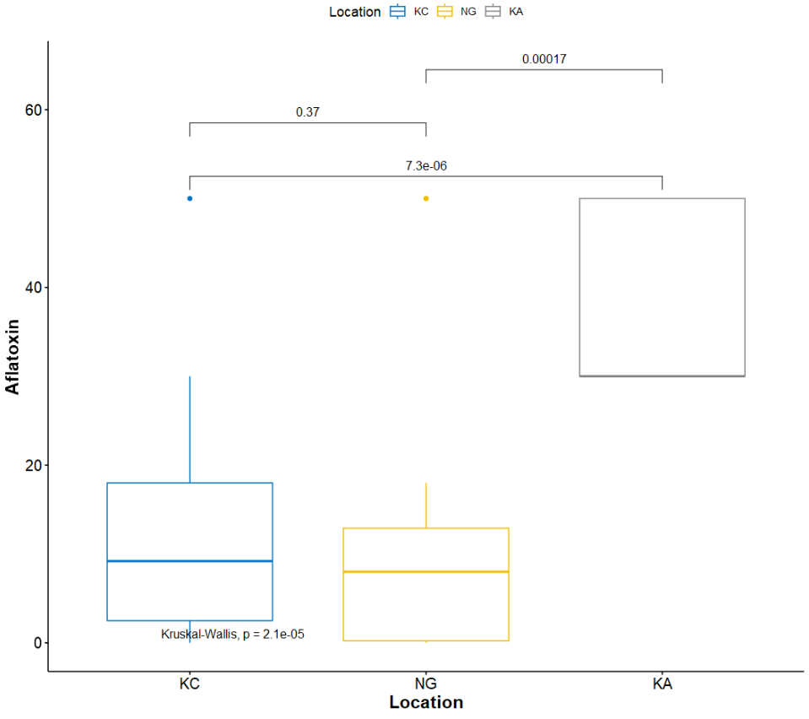

**Figure 6: Boxplot of Aflatoxin in groundnuts based on the Locations.**

The values on the top of the plot indicate p-values showing statistical differences between the locations. KA= Kapsuser, KC=Kericho, and NG=Nyagacho

significance level of 0.05 *(P*=.05).

The results of this study highlight significant levels of mycotoxin contamination in rice and groundnuts from Kericho County, emphasizing the need for immediate attention to food safety practices. The quantitative analysis revealed that both rice and groundnuts are significantly contaminated with aflatoxins and fumonisins, with many samples exceeding the maximum allowable limits set by regulatory bodies. Groundnuts exhibited higher mean aflatoxin levels (15.995 ppb) compared to rice (5.176 ppb), which aligns with the understanding that groundnuts are more susceptible to aflatoxin contamination due to their larger surface area and oil content, which provide a conducive environment for fungal growth (Ayelign & Saeger, 2020); (Ncube & Maphosa, 2020).The variability in mycotoxin levels across different markets suggests that local environmental conditions, handling, and storage practices significantly influence the extent of contamination. Nyagacho market, for instance, showed the highest aflatoxin levels in rice samples, which could be attributed to inadequate drying and storage conditions that favor fungal growth and toxin production. These findings emphasize the need for improved post-harvest handling and storage practices to mitigate mycotoxin contamination (Ezekiel et al., 2019);Wielogorska et al., 2019) (Government of Kenya, 2018; County Government of Kericho, 2022). The significant differences in mycotoxin levels between roasted, unroasted, and raw unopened groundnuts indicate that processing methods can impact the extent of contamination. Raw unopened groundnuts exhibited the highest mean aflatoxin levels, suggesting that roasting may reduce aflatoxin levels to some extent (Nyirahakizimana et al., 2013). However, even roasted groundnuts showed substantial contamination, highlighting the need for comprehensive strategies to address mycotoxin contamination at various stages of the supply chain. Statistical analysis using SPSS and R software confirmed significant differences in mycotoxin levels between the different markets and product types. The Student’s t-test and Kruskal-Wallis test demonstrated that the variations were statistically significant, underscoring the importance of targeted interventions based on specific market conditions and product types. These statistical insights provide a robust basis for developing tailored strategies to manage mycotoxin risks effectively (Id et al., 2020). The high levels of aflatoxins and fumonisins detected in the samples pose serious health risks to consumers. The economic implications are also significant, as contaminated crops result in direct losses through reduced market value and indirect losses through increased healthcare costs and decreased agricultural productivity (Bhat et al., 2010 ; Wu, 2004). This study underscores the critical need for stringent monitoring and control measures to ensure food safety in Kericho County. Regular testing of agricultural produce for mycotoxins, coupled with public awareness campaigns and education programs, can play a pivotal role in reducing contamination levels. Farmers and traders should be educated on best practices for drying, storing, and handling crops to minimize fungal growth and toxin production(Shephard, 2008). Furthermore, the implementation of good agricultural practices (GAP) and the use of biocontrol agents can help mitigate the risks associated with mycotoxin contamination. Developing and enforcing regulatory standards for mycotoxin levels in food products is essential to protect public health and ensure the safety of the food supply. To sum up, the findings of this study provide valuable insights into the prevalence and levels of mycotoxin contamination in rice and groundnuts in Kericho County. The high contamination levels call for urgent action to improve food safety practices and protect public health. By addressing the specific conditions that contribute to mycotoxin contamination, targeted interventions can be developed to mitigate these risks and ensure the safety and quality of agricultural produce in the region. This research contributes to the broader efforts to enhance food safety and security, not only in Kericho County but also in other regions facing similar challenges.

This study highlights the significant levels of mycotoxin contamination in rice and groundnuts from Kericho County, underscoring the urgent need for improved food safety practices. Quantitative analysis indicated that aflatoxin and fumonisin levels in many samples exceed the maximum allowable limits, posing serious health risks to consumers. Groundnuts exhibited higher mean aflatoxin levels compared to rice, indicating a greater susceptibility to contamination. The variability in mycotoxin levels across different markets suggests that local environmental conditions, handling, and storage practices significantly influence the extent of contamination. This emphasizes the need for targeted interventions, including improved post-harvest handling and storage practices, to mitigate mycotoxin contamination.

4. Conclusion

In conclusion, this study provides valuable insights into the prevalence and levels of mycotoxin contamination in rice and groundnuts in Kericho County. The findings call for urgent action to improve food safety practices and protect public health. By addressing the specific conditions contributing to mycotoxin contamination, targeted interventions can be developed to ensure the safety and quality of agricultural produce. This research contributes to the broader efforts to enhance food safety and security, not only in Kericho County but also in other regions facing similar challenges. Future research should explore contamination trends across regions and seasons to guide sustainable food safety interventions.

The manuscript generates qualitative and quantitative data regarding mycotoxin contamination in rice and groundnut seeds, which are staple foods, from the markets of Kenya. This is useful for the scientific community as it addresses food safety practices and the health challenges posed with the consumption of these food items. This provides an avenue for best practices in the storage, transport and other post-harvest issues, as well as control measures of the mycotoxins.

Ethical approval (wherever applicable)

Research permit was obtained through application from the National Commission for Science, Technology, and Innovation (NACOSTI). License No: NACOSTI/P/23/27236.

Disclaimer (Artificial intelligence)

Option 1:

Author(s) hereby declare that NO generative AI technologies such as Large Language Models (ChatGPT, COPILOT, etc.) and text-to-image generators have been used during the writing or editing of this manuscript.

Option 2:

Author(s) hereby declare that generative AI technologies such as Large Language Models, etc. have been used during the writing or editing of manuscripts. This explanation will include the name, version, model, and source of the generative AI technology and as well as all input prompts provided to the generative AI technology

Details of the AI usage are given below:

1.

2.

3.

References

Ayelign, A., & Saeger, S. De. (2020). Mycotoxins in Ethiopia : Current status , implications to food safety and mitigation strategies. *Food Control*, *113*(December 2019), 107163. https://doi.org/10.1016/j.foodcont.2020.107163

Bhat, R., Rai, R. V., & Karim, A. A. (2010). Mycotoxins in Food and Feed: Present Status and Future Concerns. *Comprehensive Reviews in Food Science and Food Safety*, *9*(1), 57–81. https://doi.org/10.1111/j.1541-4337.2009.00094.x

County Government of Kericho. (2022). *REPUBLIC OF KENYA COUNTY GOVERNMENT O F KERICHO*.

Deepa, N., & Sreenivasa, M. Y. (2017). *Fusarium verticillioides , a Globally Important Pathogen of Agriculture and Livestock : A Review*. *4*.

Edgar Mugizi, A., Imade, F., & Tanvir, A. (2021). Update on mycotoxin contamination of maize and peanuts in East African Community Countries. *Journal of Food Science and Nutrition Therapy*, *7*, 001–010. https://doi.org/10.17352/jfsnt.000026

Ezekiel, C., Ortega-Beltran, A., & Bandyopadhyay, R. (2019). The need for integrated approaches to address food safety risk: the case of mycotoxins in Africa. *First FAO/WHO/AU International Food Safety Conference. 12-13 Feb, Addis Ababa, Ethiopia*, *Paca*, 2016–2018.

Fandohan, P., Zoumenou, D., Hounhouigan, D. J., Marasas, W. F. O., Wingfield, M. J., & Hell, K. (2005). Fate of aflatoxins and fumonisins during the processing of maize into food products in Benin. *International Journal of Food Microbiology*, *98*(3), 249–259. https://doi.org/10.1016/j.ijfoodmicro.2004.07.007

Fariha Ibrahim, Hina Jalal, Abdul Basit Khan, Muhammad Asif Asghar, Javel Iqbal, Aftab Ahmed, Ghufrana Nadeem, F. et al. (2016). Prevalence of Aflatoxigenic Aspergillus in Food and Feed Samples from Karachi, Pakistan. *Journal of Infection and Molecular Biology*, *4*, 1–8. https://doi.org/http://dx.doi.org/10.14737/journal.jimb/2016/4.1.1.8

Government of Kenya. (2018). *Climate Risk Profile for Kericho County. Kenya County Climate Risk Profile Series.* https://hdl.handle.net/10568/96290

Id, A. W., Sudini, H. K., Pingali, P., & Nelson, R. (2020). *Exploring aflatoxin contamination and household-level exposure risk in diverse Indian food systems*. 1–29. https://doi.org/10.1371/journal.pone.0240565

Imienwanrin, M. R., & Makun, H. A. (2020). Occurrence of major mycotoxins and their dietary exposure in North-Central Nigeria staples. *Scientific African*, *7*, e00188. https://doi.org/10.1016/j.sciaf.2019.e00188

International Agency for Research on Cancer. (2002). International Agency for Research on Cancer Iarc Monographs on the Evaluation of Carcinogenic Risks To Humans. In *Iarc Monographs On The Evaluation Of Carcinogenic Risks To Humansarc Monographs On The Evaluation Of Carcinogenic Risks To Humans* (Vol. 96). http://monographs.iarc.fr/ENG/Monographs/vol83/mono83-1.pdf

Jonah K, B., Richard C, C., & Teh Exodus, A. (2020). Mycotoxin Contamination of Stored Maize in Kenya and the Associated Fungi. *Journal of Plant Pathology Research*, *2*(1). https://doi.org/10.36959/394/620

Magan, N., Hope, R., Cairns, V., & Aldred, D. (2003). Post-harvest fungal ecology: Impact of fungal growth and mycotoxin accumulation in stored grain. *European Journal of Plant Pathology*, *109*(7), 723–730. https://doi.org/10.1023/A:1026082425177

Miller, J. D. (2008). Mycotoxins in small grains and maize: Old problems, new challenges. *Food Additives and Contaminants - Part A Chemistry, Analysis, Control, Exposure and Risk Assessment*, *25*(2), 219–230. https://doi.org/10.1080/02652030701744520

Ncube, J., & Maphosa, M. (2020). Current state of knowledge on groundnut aflatoxins and their management from a plant breeding perspective : Lessons for Africa. *Scientific African*, *7*, e00264. https://doi.org/10.1016/j.sciaf.2020.e00264

Nyirahakizimana, H., Mwamburi, L., Wakhisi, J., Mutegi, C. K., Christie, M. E., & Wagacha, J. M. (2013). Occurrence of *Aspergillus* Species and Aflatoxin Contamination in Raw and Roasted Peanuts from Formal and Informal Markets in Eldoret and Kericho Towns, Kenya. *Advances in Microbiology*, *03*(04), 333–342. https://doi.org/10.4236/aim.2013.34047

Ostry, V., Malir, F., Toman, J., & Grosse, Y. (2017). Mycotoxins as human carcinogens—the IARC Monographs classification. *Mycotoxin Research*, *33*(1), 65–73. https://doi.org/10.1007/s12550-016-0265-7

Probst, C., Njapau, H., & Cotty, P. J. (2007). Outbreak of an acute aflatoxicosis in Kenya in 2004: Identification of the causal agent. *Applied and Environmental Microbiology*, *73*(8), 2762–2764. https://doi.org/10.1128/AEM.02370-06

Shephard, G. S. (2008). Impact of mycotoxins on human health in developing countries. *Food Additives and Contaminants - Part A Chemistry, Analysis, Control, Exposure and Risk Assessment*, *25*(2), 146–151. https://doi.org/10.1080/02652030701567442

Sirma, A. J., Lindahl, J. F., Makita, K., Senerwa, D., Mtimet, N., Kang’ethe, E. K., & Grace, D. (2018). The impacts of aflatoxin standards on health and nutrition in sub-Saharan Africa: The case of Kenya. *Global Food Security*, *18*(May), 57–61. https://doi.org/10.1016/j.gfs.2018.08.001

Ti, E. S., Ta, E. D., El, A., & Am, A. (2019). *Investigation of fungus associated within co- occurrence of aflatoxins and ochratoxin a in cereals from Egypt*. *5*(3), 92–99. https://doi.org/10.15406/mojt.2019.05.00161

Udomkun, P., Nimo, A., Nagle, M., Bandyopadhyay, R., Müller, J., & Vanlauwe, B. (2017). Mycotoxins in Sub-Saharan Africa : Present situation , socio-economic impact , awareness , and outlook. *Food Control*, *72*, 110–122. https://doi.org/10.1016/j.foodcont.2016.07.039

United Agency for International Development 2019. (2017). Climate Risk Profile. *Usaid*, *April*, 1–5. https://www.climatelinks.org/sites/default/files/asset/document/2017_Cadmus_Climate-Risk-Profile_Haiti.pdf%0Ahttps://www.climatelinks.org/sites/default/files/asset/document/2017_USAID ATLAS_Climate Risk Profile - India.pdf

Wielogorska, E., Mooney, M., Eskola, M., Ezekiel, C. N., Stranska, M., Krska, R., & Elliott, C. (2019). Occurrence and Human-Health Impacts of Mycotoxins in Somalia [Research-article]. *Journal of Agricultural and Food Chemistry*, *67*, 2052–2060. https://doi.org/10.1021/acs.jafc.8b05141

Wu, F. (2004). Mycotoxin risk assessment for the purpose of setting international regulatory standards. *Environmental Science and Technology*, *38*(15), 4049–4055. https://doi.org/10.1021/es035353n