Innovation in Amla Jelly Millet Cake: Comprehensive Nutritional Profiling, Sensory Analysis, Microbial Assessment, and Packaging Strategies
Abstract:
The goal of this study was to create and test a unique Amla Jelly Millet Cake, with a focus on its nutritional profile, physicochemical qualities, microbiological safety, and optimal packaging solutions. The cake combines Amla (Indian Gooseberry), which is high in Vitamin C and antioxidants, with millet flour, which is gluten-free and healthy. Comprehensive nutritional profile, while physicochemical analysis evaluated characteristics such as moisture content, pH and TSS. The microbial testing validated the product's safety and shelf life. Various packing materials were examined to determine their impact on product quality and shelf life. Key findings: The Amla Jelly Millet Cake has a balanced nutritional profile with protein, fibre, vitamins, carbohydrates and ash. Physicochemical examination indicated acceptable results within allowable limits, indicating high product quality. Microbial analysis verified the product's safety and compliance with food safety regulations. Optimal packaging solutions were established to protect product quality, extend shelf life, and increase consumer appeal. In conclusion, our study successfully created an innovative Amla Jelly Millet Cake that combines flavour, nutrition, and health advantages. The findings are useful for developing and commercialising this unique product, which will help to create a healthier and more sustainable food system.
Keywords: Millet cake, Nutritious, Sustainable food, Amla jelly, Healthy.

Introduction:
Millets are nutritionally equivalent, if not superior, to many of the most important cereal grains. Millets are high in physiologically active substances and offer numerous health benefits, such as a high antioxidant content, high fiber content, low glycaemic index, and gluten-free protein. These small-seeded crops are a great source of energy, protein, and minerals. (Sabuz, A. A., et al., 2023). Millet grains contain many vitamins, including niacin (B3), thiamine, riboflavin, and folic acid. It is estimated that nearly 70% of grains contain carbohydrates, the majority of which are soluble carbohydrates and dietary fiber. The majority of millets' polysaccharides are made up of amylopectin and amylose (70–80%). They are higher in polyphenols (0.2-0.5%), as well as dietary fiber. Millets' antioxidant activity is primarily provided by polyphenols, tannins, and phytates, which also play a role in regulating the aging process. In comparison to other grains, finger millet has the highest calcium level (344 mg/100 g) (Tripathi, M.K., et al., 2021).
A good amount of moisture (12%) is contained in sorghum millet, along with nearly 10.4% protein and 1.3% fat. The amount of fiber and minerals in grain sorghum is approximately 1.6%. Sorghum grain has a high carbohydrate content (73%), making it an excellent source of energy (349 kcal). Other carbohydrates found in sorghum include cellulose and hemicellulose. Sorghum also contains good amounts of calcium (25 mg), dietary fiber (14.3 g), iron (4.1 mg), and phosphorus (222 mg), respectively, per 100 g of edible portion (Abah, C.R. et al. 2020).
Both little millet and kodo millet, which are classified as nutraceutical crops, contain between 37 and 38% dietary fiber. Millets are widely utilized as a snack, infant food, processed food, etc. due to their high nutrient content and so are considered a complete food. In developing countries, sorghum and millets contribute greatly to nutritional security. The millets are also known as miracle grains and nutritional cereals.
Furthermore, in comparison with wheat (1.5%) and rice (0.6%), millets contain several times more minerals (1–5 g/100 g). There is an abundance of iron in Pearl Millet and Barnyard Millet, which can fulfill the iron requirement of anemic individuals. There is a high content of zinc (4.1 mg/100 g) in foxtail millet, as well as a high content of iron (Saleh, A.S., et al. 2013).
Amla is considered a powerful rejuvenator and valuable in delaying senescence and degenerative processes. Chinese, SrejuvenatorSiddha, and Unani Tibetan utilize E. Officinalis for medicine purposes. This helps improve lifespan, digestion, and relieve constipation. According to the Ayurvedic Medicine System, EO significantly decreases fever, inflammation, blood cleansing, heart health improving, benefits the vision, stimulates hair growth, strengthens the body, relieves asthma, and improves the intellect ability (Amadou, I.. et al. 2013). Fruits that are astringent are used in many folk medicines for the treatment of ophthalmic disorders, hyperacidity, osteoporosis, gastritis, premature hair graying, dyspepsia, colitis, hemorrhoids, constipation, cough, anemia, hematuria, diabetes, asthma, and tiredness. E. officinalis is probed to have anti-inflammatory, diuretic, laxative, cardioprotective, antipyretic, and hepatoprotective properties. EO is also reported as a hair tonic and digestive medicine, also effective against peptic ulcers (Baliga MS and Dsouza JJ 2013).
The noncentrifugal sugar, which is prepared from sugarcane juice, is called jaggery and is known by different names in the world, such as Panela, Kokuto, and Muscovado. The nutrient value of jaggery is increased while preparing with different methods from sugarcane juice. The micronutrients that are present in jaggery have many nutritional and medicinal aspects, such as its anticarcinogenic and antitoxic activity. Jaggery has proved itself better when compared with white sugar. Jaggery is known to produce heat and give instant energy to a human body. Sugar and sweet consumption have been popular throughout the world. The increasing trend of per capita sugar consumption assumes significance in view of the high tendency for individuals to develop insulin resistance, abdominal adiposity, and hepatic steatosis, and the increasing chronic diseases such as type 2 diabetes and cardiovascular diseases. (Kumar, A., & Singh, S. 2020)
Cake, a popular snack, is commonly prepared using refined wheat flour, resulting in a limited variety of nutrients, including dietary fibers and essential amino acids. Moreover, the presence of gluten protein in wheat flour makes it unsuitable for individuals with celiac disease. Using millet as a base for cakes can enhance their nutritional profile by providing dietary fibers, essential amino acids, and antioxidants. Additionally, millet-based cakes are gluten-free, making them cater to the nutritional and health requirements of gluten-allergic individuals. The absence of gluten in millet is a crucial factor influencing its processing. Due to this lack, it's challenging to create a network structure with mechanical emphasis for millet flour during batter development and baking. Consequently, it is impossible for millet cake batter to retain gas and form a fluffy and soft cake (Zhang, X., et al., 2024).

Methodology:
- Development of the Product
- For the preparation of the cake, we needed to preheat the oven for 20 minutes at 180 degrees Celsius.
- Firstly, we had to measure all the flours accordingly and mix them in a bowl thoroughly.
- In the dry mix bowl, we added baking soda and powder and kept this dry mix aside.
- The dry mix was sieved 2-3 times so that it had enough air settled between the granules of the dry mix.
- In a separate bowl, we mixed all the wet ingredients, like jaggery, vanilla essence, melted butter, milk, curd, and water.
- In the bowl of the wet mixture, we slowly and gradually added the dry mixture.
- We used the cut and fold method to prepare the batter of the cake.
- We greased the tin with butter and then applied butter paper to it.
- Slowly, we poured all the batter into the tin and kept it in the oven for 35 to 40 minutes at 180 degrees Celsius (Gupta P. et al., 2024)

- Preparation of jelly
- Gather Ingredients: Wash fruit thoroughly and remove stems, pits, and any spoiled parts. Chop or crush fruit as needed.
- Cook: Place amla in a large pot or saucepan and add a small amount of water to prevent sticking. Simmer fruit until soft and pulpy.
- Extract Juice: Strain cooked fruit through a muslin cloth or jelly bag to extract juice. Allow juice to drip freely without squeezing.
- Boil Mixture: Bring the mixture to a rolling boil over high heat, stirring constantly.
- Test for Gel Point: Perform a gel test to determine if the jelly has reached the desired consistency. Optionally, use a candy thermometer to monitor temperature (usually around 220°F or 104°C).
- Fill Jars: Store in a cool, dark place. (Kaviya TS. , 2023)
- Physicochemical Analysis:
Analysis of samples was carried out according to the standard analytical methods outlined by the AOAC protocols. This included determining the proximate composition, moisture, fat, ash, and protein levels. In accordance with the AOAC procedures 925.40, the samples were dried in an oven at 105 ± 2 °C until they reached a constant weight in order to measure the moisture content. In accordance with the AOAC protocol 942.05, the sample was incinerated to determine the ash concentration. Following AOAC protocols 984.13, the microKjeldahl method was used to assess the nitrogen (N) content, and the protein content was determined as N × 6.25. The Soxhlet method, in accordance with the AOAC 963.15 standard, was used to determine the lipid content. The total carbohydrate content was calculated using the difference method. The pH of various samples uniformly mixed with distilled water (1:1) ratio (w/v) was measured using a digital pH meter (MAC) after standardization at 25°C using buffers of pH 4.0 and 7.0. A solution of the samples were made and then through the dropper they were dropped onto the refractometer Following the methodology described by Onyeike et al . We performed triple analyses on all samples.
- Microbial Analysis
- Antimicrobial Test:
Antibacterial is the process of determining the presence of spoilage microorganisms that cause product deterioration, effecting the quality and safety. These include Gram-positive and Gram-negative bacteria, as well as yeasts and molds. Spoilage microorganisms are not pathogenic but can change the physical properties, such as texture, smell, taste, and color, or chemical properties of a product, making it unsuitable for consumption. It shows activity against Gram-positive (Staphylococcus aureus) and Gram-negative (Escherichia coli) bacteria was determined using the agar well disc diffusion method. Nutrient broth (14 g in 500 mL distilled water) and agar (1.3 g in 100 mL distilled water) were prepared.
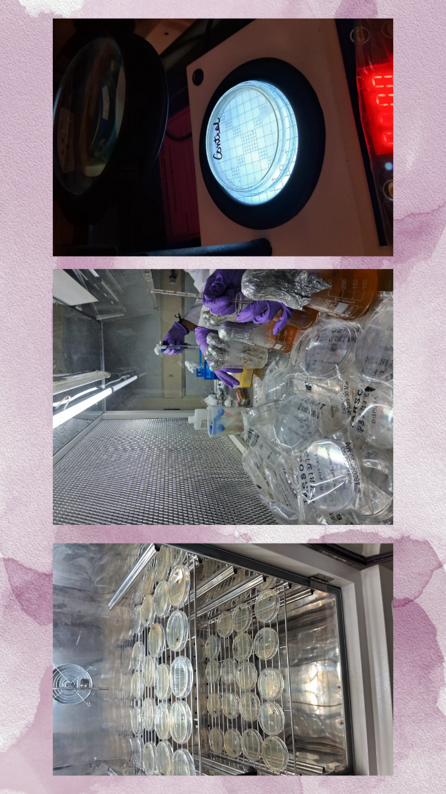
Image 1 : Analysis of samples
4. Texture / Sensory Analysis
For the sensory analysis, thirty panels that had never been trained were chosen. After tasting each sample, the panellists were given the sample and water to rinse their mouths. On a 9-point hedonic scale, each panel assessed the samples for visual puffiness, appearance/colour, smell/aroma, taste, general texture/mouthfeel, moistness, and overall like (1 being strongly disliked, 5 being neither much liked nor disliked, and 9 being highly liked). (SAINI, S.)
5. Packaging of product
The millet-based cake was packaged in a cardboard base with a polythene cover on top. In addition to providing structural support, cardboard shields the cake from damage during handling and transport. It keeps the cake from crumbling or changing shape. Polyethylene wrapping is commonly used as a liner or wrap to keep the cake moist and prevent it from drying out. A moisture-resistant barrier is necessary because dry cakes, such as pound cakes or sponge cakes, will spoil if left out in the open for an extended period of time.
We stored the jelly in glass jars because glass is non-reactive, so the acidic content of the jelly would not cause chemical reactions. This ensures that the flavour and quality of the jelly remain consistent over time. Glass jars have an airtight seal, preventing air and moisture from entering. This helps to maintain the jelly's freshness, flavour, and fragrance over time. Because glass jars allow you to see inside, it's easy to tell what type of jelly is being stored and in what condition. Glass jars are heat resistant, so they will not break or allow dangerous chemicals to seep into the jelly at the high temperatures required for canning. Glass jars are an environmentally friendly option for food storage because they can be reused and recycled.
Results and Discussion:
- Development of the product
Table 1: Millet cake ingredients
SNo. | Ingredients : | Amount :
1 | Ragi flour | 25g
2 | Bajra flour | 25g
3 | Jowar flour | 25g
4 | Jaggery powder | 50g
5 | Baking powder | 1 tsp
6 | Baking soda | ½ tsp
7 | Butter | 2 tbsp
8 | Vanilla essence | 2-3 drops
9 | Milk | 50ml
10 | Curd | 40g

Table 2: Amla jelly ingredients
SNo. | Ingredients : | Amount :
1. | Amla | 500g
2. | Lemon juice | 15g
3. | Sugar | 30g

Fig. 1: Developed jelly cake
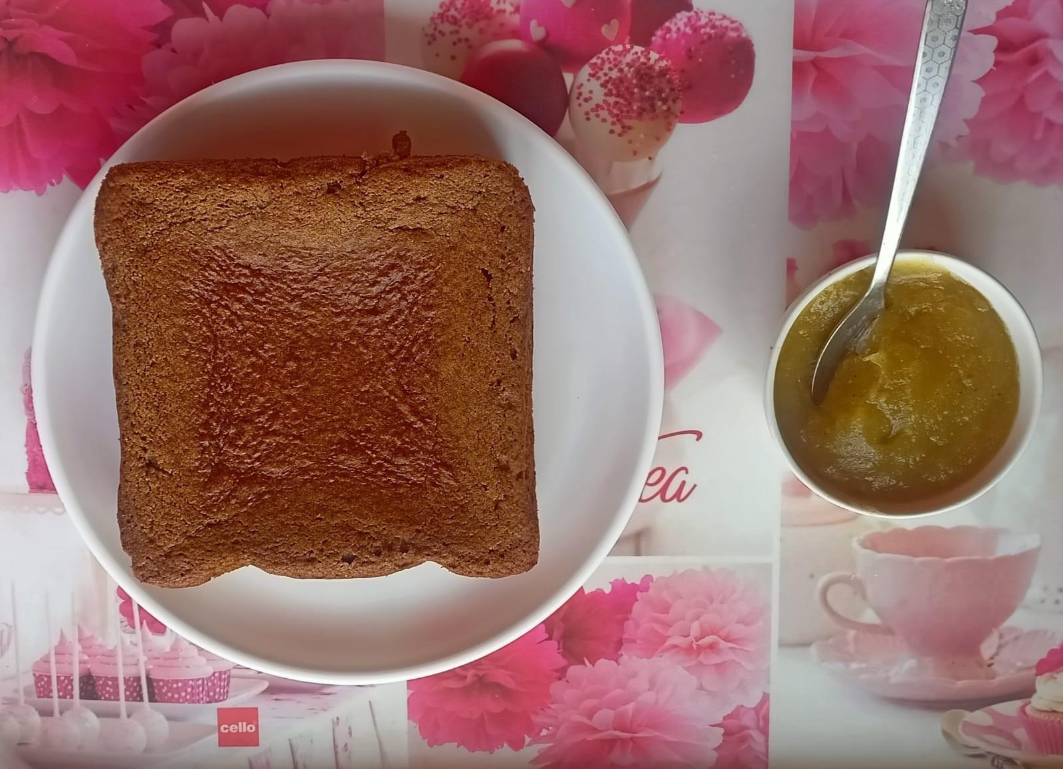
- Physicochemical Analysis:
Proximate analysis of a jelly cake involves determining its various components, providing valuable insights into its nutritional composition. Firstly, moisture content is 10.2% assessed by drying a representative sample to constant weight, revealing the proportion of water present. This helps evaluate shelf stability and susceptibility to microbial spoilage. Next, total ash content is 32.5% determined by incinerating the sample, indicating the mineral content derived from ingredients and food additives. This sheds light on the cake's nutritional value and potential health benefits. Furthermore, fat content is 24% extracted using solvents, highlighting the energy density and lipid profile of the cake. Protein content, which is 1.453%, and fiber, which is 16% crucial for growth and repair, are quantified using the Kjeldahl method, which measures nitrogen content and converts it to protein. Finally, carbohydrates are calculated by difference, subtracting the sum of moisture, ash, fat, and protein from the total weight, which is 5.78%, reflecting the sugar and starch content. Through proximate analysis, the jelly cake's composition is elucidated, aiding in dietary planning and quality assurance for only 5 g of sample.

A. Moisture content:
Table 3: Moisture content
So . | Sample | Petri Plate wt. | Sample wt. | Total wt. (W1) | Dry wt. (W2)
1. | Millet cake | 40g | 5g | 45g | 43g
2. | Amla jelly | 46g | 5g | 51g | 49g

Moisture % in cake = (45 – 43) × 100
45
= 4.4 %
Moisture % in jelly = (51- 49) × 100
51
= 5.8%

B. Ash content
Tablet 4: ash content
SNo | Sample | Crucible wt. (W1) | Sample wt. | Dry wt. | Total wt. (W2) | Ash wt. (W3)
1. | Millet cake | 18.9g | 5g | 3.5 | 22.4g | 19.9g
2. | Amla jelly | 19.4g | 5g | 2.5 | 21.9g | 19.5g

Ash % in cake = 19.9 – 18.9 × 100
22.4 – 18.9
= 28.5 %
Ash % in jelly = 19.5 – 19.4 x 100
21.9 – 19.4
= 4 %

C. Crude fibre content:
Table 5: crude fibre content
SNo | Sample | Crucible wt. | Sample wt. (W1) | Crucible wt with fibre (W2) | Ashed residue wt (W3)
1. | Millet cake | 19g | 5g | 19.37g | 19.03g
2. | Amla jelly | 22g | 5g | 22.48g | 22.02g

Crude fibre % in cake = (19.37 -19.03 )×100
5
= 6.8%
Crude fiber% in jelly = (22.48- 22.02) ×100
5
= 9.2 %

D. Fat content:
Table 6: fat content
SNo . | Sample | Sample wt. (W1) | Beaker wt. | Ether extract . (W2)
1. | Millet cake | 5g | 163g | 0.10g
2. | Amla jelly | 5g | 147g | 1.1g

Fat % of cake = 0.10 ×100
5
= 2%
Fat % of jelly = 1.1×100
5
= 22%
E. Protein content:
Table 7: Protein Content
SNo . | Sample | Sample wt. | Protein content
1. | Millet cake | 5g | 1.45g
2. | Amla jelly | 5g | 0.003g

F. Carbohydrate content:
%carbohydrates = 100 - %moisture - %protein - %fibre - %ash - %fat
Table 8: carbohydrate content
SNo . | Sample | Carbohydrate content
1. | Millet cake | 56.84 %
2. | Amla jelly | 58.94%

G. pH:
Table 9: pH
Sno. | Sample | pH
1. | Cake | 7.2
2. | Jelly | 3.65

H. Total Soluble Solids:
The proximate composition of the cake
The proximate composition of the cake sample and jelly was analyzed for ash content, moisture, fat, crude fiber, protein, carbohydrate content, and energy value. The results are as follows for 5 g of sample
Table 10 : Proximate composition of the cake
SNo | Sample | Moisture | Ash | Fat | Crude fibre | Protein | Carbohydrate
1. | Millet cake | 4.4% | 28.5% | 2% | 6.8% | 1.45% | 56.84%
2. | Amla jelly | 5.8% | 4% | 22% | 9.2% | 0.003% | 58.94%
Fig 2: TSS
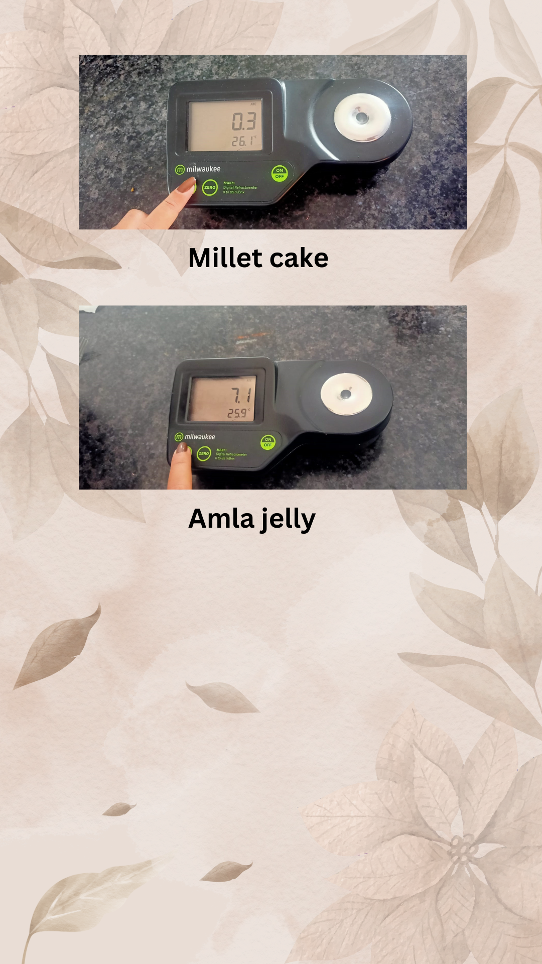
- Microbial Analysis
- Antimicrobial test
The inhibitory impact was tested using the clear zone of the circular film disc. Measurement of exact zone diameter included the diameter of the film disc; hence, if a clear zone was present, the figures were consistently greater than the diameter of the film disc. If there is no surrounding clear zone, it implies that there is no inhibitory zone, and the diameter was assigned a value of zero. The existence of a distinct inhibitory zone around the disc. The antibacterial activity of jelly cake against bacteria was moderate.
Fig. 3: inhibition zones of the jelly cake
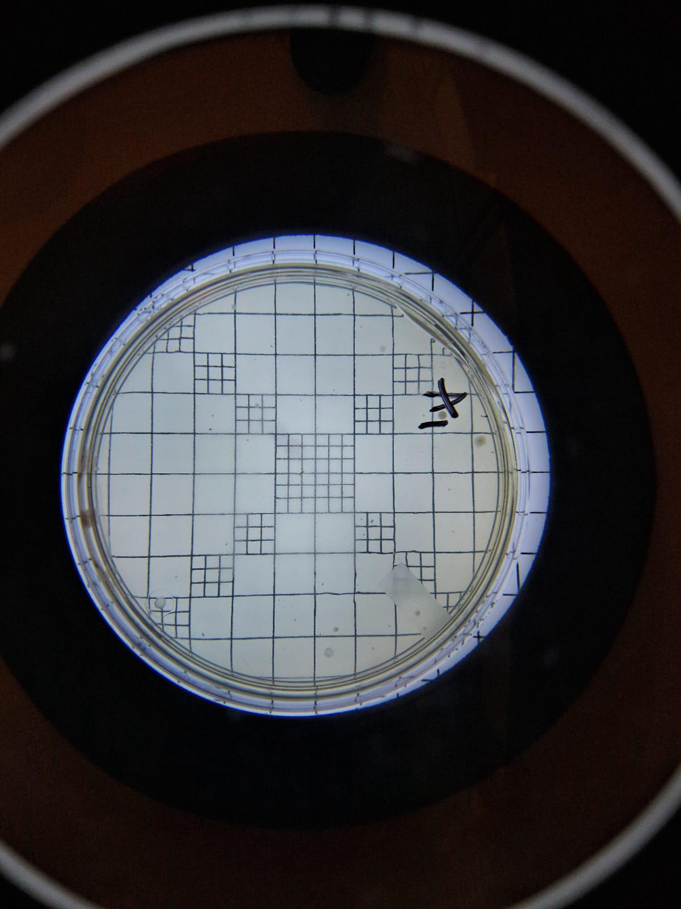
Fig. 4. Texture / Sensory Analysis
Following that, their evaluations were entered onto a Sensory Analysis Form.
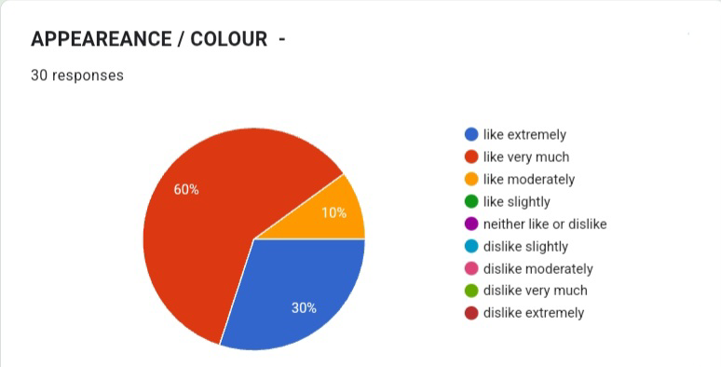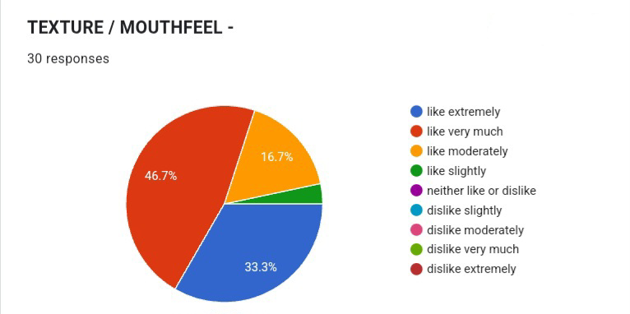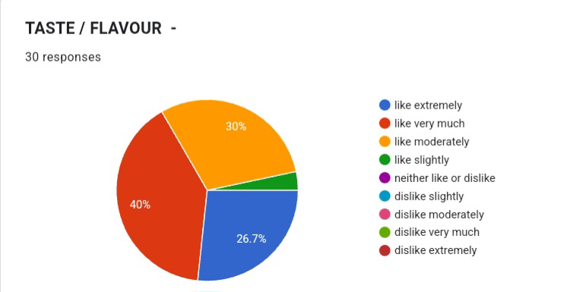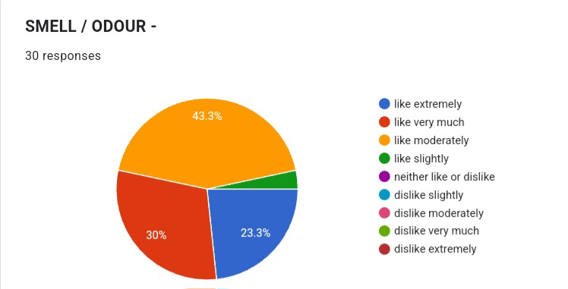
Overall, the panel found the product acceptable. Amla jelly millet cake sensory analysis reveals factors like softness, firmness and chewiness of jellies and moist and soft grainy texture of the cake .
5. Packaging of product
Both polyethylene packaging and glass jars have distinct advantages for storing millet amla jelly cake. Polyethylene packaging is practical, portable, and inexpensive, whereas glass jars provide better preservation, environmental sustainability, and aesthetic appeal. This innovative and nutritious dessert can be packaged in either polyethylene or glass jars.
Plastics exhibiting low permeability and acting as good oxygen barriers. For packaging dry cakes, polythene is a common and suitable choice due to its transparency, lightweight nature, and good moisture barrier properties and also allowing for a clear view of the cake inside, which is visually appealing for retail settings. Also provides good moisture barrier properties, helping to keep the dry cake fresh and prevent it from absorbing moisture and offers good protection against external contaminants. It also has a low oxygen transmission rate (OTR) and is used in beverage bottles and food , while it is known for its strength and gas barrier properties but against water vapor and is considered moderately permeable ( Waris Khan, et al 2024)
Glass is considered an inert, solid, and non-porous material, which contributes to its strong barrier properties against external agents, including oxygen. Glass's chemical inertness and lack of pores prevent the passage of gases, including oxygen, ensuring that the contents remain protected from external contamination (Sandra B.M. Jaime, et al 2022).

Conclusion:
This study concluded that the cake not only tastes good but also nourishes the body. Its low moisture level ensures a long shelf life, and its balanced carbohydrate, protein, fat, and mineral content make it a nutritious treat ideal for a wide range of diets. The use of amla improve its nutritional content, making it unique among healthful treats.
One healthy and beneficial component for making gluten-free cakes is millet flour. Physically modified flour and starch are becoming more popular because of customer desire for additive-free foods (Emmanuel, K., & Sackle, A. 2013). This is because the modification changes the functionality of starch without adding any extraneous materials. Consequently, flour can be used to raise the calibre of bread foods without gluten (Fathi, B et al. 2016).
The millet and amla jelly cake is a unique combination of nutrition, flavour, and inventiveness. This cake combines fun and health advantages by combining millet, a healthy whole grain strong in fibre and key minerals, as well as amla, a powerful antioxidant and vitamin C source (Adanse et al., 2021) . We discovered a cake that not only tastes good but also nourishes the body, thanks to precise formulation and proximate analysis.
Its low moisture level ensures a long shelf life, and its balanced carbohydrate, protein, fat, and mineral content make it a nutritious treat ideal for a wide range of diets. Furthermore, the use of amla provides the cake a tangy flavour while also improving its nutritional content, making it unique among healthful treats (Chauhan T et al., 2024).

Disclaimer (Artificial intelligence)
Option 1:
Author(s) hereby declare that NO generative AI technologies such as Large Language Models (ChatGPT, COPILOT, etc.) and text-to-image generators have been used during the writing or editing of this manuscript.

References:
- Sabuz, A. A., Rana, M. R., Ahmed, T., Molla, M. M., Islam, N., Khan, H. H.,... & Shen, Q. (2023). Health-promoting potential of millet: A review. Separations, 10(2), 80.
- Tripathi, M.K.; Mohapatra, D.; Jadam, R.S.; Pandey, S.; Singh, V.; Kumar, V.; Kumar, A. Nutritional Composition of Millets. In Millets and Millet Technology; Springer: Berlin/Heidelberg, Germany, 2021; pp. 101–119. [Google Scholar]
- Abah, C.R.; Ishiwu, C.N.; Obiegbuna, J.E.; Oladejo, A.A. Nutritional Composition, Functional Properties, and Food Applications of Millet Grains. Asian Food Sci. J. 2020, 14, 9–19. [Google Scholar] [CrossRef]
- Saleh, A.S.; Zhang, Q.; Chen, J.; Shen, Q. Millet Grains: Nutritional Quality, Processing, and Potential Health Benefits. Compr. Rev. Food Sci. Food Saf. 2013, 12, 281–295. [Google Scholar] [CrossRef]
- Amadou, I.; Gounga, M.E.; Le, G.-W. Millets: Nutritional Composition, Some Health Benefits, and Processing—A Review. Emir. J. Food Agric. 2013, 25, 501–508. [Google Scholar] [CrossRef]
- Baliga MS and Dsouza JJ. “Amla (Emblica officinalis Gaertn), a wonder berry in the treatment and prevention of cancer." European Journal of Cancer Prevention 20.3 (2011): 225-239.
- Kumar, A., & Singh, S. (2020). The benefit of Indian jaggery over sugar on human health. Dietary sugar, salt, and fat in human health (pp. 347-359). Academic Press.
- Zhang, X., Wu, Z., Wang, J., Bian, N., Zhao, P., Sun, N., & Chen, J. (2024). Insight into elevated quality of whole millet (Pennisetum glaucum) cake through the process of extrusion. Journal of Cereal Science, 118, 103931.
- Gupta P, Singh N, Nanda A. Nutritional Profiling and Characterization of developed cake premix using finger millets (Eleusine coracana) and sweet potato (Ipomea batatas L.). European Journal of Nutrition & Food Safety. 2024;16(1): 1-11.
- Kaviya TS. Development of nutraceutical jelly gummies from amla (Phyllanthus emblica L.) using natural sugar sources; 2023.
- Onyeike, E. N., Anyalogbu, E. A., & Monanu, M. O. (2015). Effect of heat processing on the proximate composition and energy values of African walnut (Plukenetia conophora) and African Elemi (Canarium schweinfurthii) consumed as masticatories in Nigeria. International Journal of Scientific and Technology Research, 4(8), 295-301.
- Sozer, N., Bruins, R., Dietzel, C., Franke, W., & Kokini, J. L. (2011). Improvement of shelf life stability of cakes. Journal of Food Quality, 34(3), 151-162.
- Adanse, J., Bıgson, K., Maureen, N. A., & Dorothy, A. (2021). Quality characteristics and sensory evaluation of cakes produced from composite blends of wheat (Titricum aestivum L.) and finger millet (Pennisetum glaucum) flour. Eurasian Journal of Food Science and Technology, 5(2), 190-204.
- SAINI, S. Formulation and Organoleptic Evaluation of Millets Recipes
- Waris Khan, M. G., & Ahmad, S. (2024). A review on emerging trends of plastics for food packaging in India. Engineering Headway, 11, 1-16.
- Sandra B.M. Jaime, Rosa M.V. Alves, Paula F.J. BÃ³coli (2022) Moisture and oxygen barrier properties of glass, PET and HDPE bottles for pharmaceutical products, Journal of Drug Delivery Science and Technology, Volume71,2022,103330,ISSN 1773-2247, https://doi.org/10.1016/j.jddst..103330.
- Emmanuel, K., & Sackle, A. (2013). Nutritional and sensory analysis of millet-based sponge cake. International Journal of Nutrition and Food Science, 2(6), 287-293.
- Fathi, B., Aalami, M., Kashaninejad, M., & Sadeghi Mahoonak, A. (2016). Utilization of heat‐moisture treated proso millet flour in production of gluten‐free pound cake. Journal of Food quality, 39(6), 611-619.
- Chauhan, Trishali & Singh, Neetu & Sagar, Prashant & Nanda, Alka. (2024). Development of Jelly Cake and Its Sensory Evaluation by Using Millet and Amla. Asian Food Science Journal. 23. 44-56. 10.9734/afsj/2024/v23i9743.

