**Original Research Article**

**Fabrication of ene-based Tin Oxide (GO-Sno2) Composites and Study of their Structural and Optical Absorption Properties**

**Abstract**

Pollution of accessible and limited freshwater resources by organic pollutants especially dyes is a global problem, even as wastewater treatment continues to attract attention. Since traditional wastewater treatment plants (WWTP) are not built to fully remediate or degrade these contaminants. Therefore, there’s need to develop effective wastewater treatment materials that can enhance the quality of water for aquatic and human life. This study synthesized ene oxide (GO) based catalyst (GO-SnO2) in the range of 1-4 wt.% GO,which can serve as an effective photocatalyst in waste water treatment. In order to improve its catalytic performance, SnO2 was functionalized with GO. After characterization, FTIR analyses revealed pertinent functional groups when scanned within the 400 cm−1 to 4000 cm−1 range. peaks corresponding to Sn–O and O–Sn–O, respectively, EDS analysis identified 77.84% Sn composition while the HRTEM and SEM showed that the addition of GO enhanced morphology. Additionally, BET tests confirmed an increase in surface area of SnO2 from 12.26 m2/g to 39.37 m2/g ensuring rich electron-hole pairs while the UV-Vis absorption shows that GO could optimize the optical absorption ability of GO/SnO2 nanocomposites. This phenomenon indicates that more solar energy can be absorbed by the the GO/SnO2 composites, which is beneficial for photocatalytic degradation of organic pollutants. Therefore, these easy and affordable composites can be utilized to remediate contaminated water.

**Keywords:** Photocatalyst, Morphology, Composite, Tin Oxide, ene Oxide

**1.0 Introduction**

The usage of organic compounds especially dyes in textile, paper, cosmetics, pharmaceutical, leather and food industries has gained tremendous attention over the years (Kanwal *et al.,* 2024;Elshypany *et al*., 2021; Helmy *et al*., 2018). This can lead to certain causes such as the contamination of water especially from the textile industry, which has proven to be difficult to remove (Vanitha *et al.,* 2018). The toxicity, carcinogenic, mutagenic, and the low biodegradability of these industrial dyes has been reported over the last decades (Bratovčić, 2023;Gupta *et al.,* 2012).

Most of these organic pollutants and dyes are of synthetic origin and usually consist of aromatic rings in their molecular structure, Inert and non-biodegradable when discharged into waste water without proper treatment (Sanakousar *et al*., 2022; Bellaj, *et al*., 2024). Therefore, removing such dyes from polluted water is highly urgent in terms of protecting human health and environmental resources (Cao *et al.,* 2021). Methylene blue (MB), the most commonly used base dye, is believed to have multiple uses in the printing and dyeing industry (Elaouni *et al*., 2022). In spite of the importance of MB in many industries, its presence in the environment and human health can be compromised if not managed effectively (Sánchez *et al.,* 2022; Bellaj *et al.,* 2024). MB is carcinogenic and does not degrade easily due to the characteristic stability of the aromatic rings in its molecular structure (Sanakousar *et al.,*2022). Traditional biological, chemical and physical techniques such as adsorption and chemical precipitation are recognized for the treatment of wastewater from dyeing industries (Tran *et al.,* 2024;Kayode *et al.,*2015). These methods are expensive, form sludge or generate secondary pollutants, such as dye adsorption on activated carbon, where the pollutant is only converted from the liquid phase to the solid phase, causing pollution (lin *et al.,* 2013; lei *et al.,* 2022; Vanitha *et al.,*2018). Therefore, the decomposition of dyes into non-toxic compounds is essential and recommended (Alsukaibi, 2022). The Advanced oxidation processes (AOP) are presently attracting a great deal of consideration in the field of water treatment (Gusain *et al*., 2019). These processes involve the use of mixture of photocatalysts composed of semiconductor heterojunctions (Kent *et al.,* 2013; Long *et al*., 2022). Semiconductors have been used in AOPs to photo-catalytically degrade organic and inorganic pollutants from effluents due to their ability to degrade the pollutants and also cause their complete mineralization to CO2, H2O and mineral acids (Fatima *et al.,* 2024; Gupta *et al*., 2006) especially those with the ability to absorb visible light, as a result of their wideband gaps of ~3.6 eV. (Wang *et al.,* 2013; Mubarak *et al*., 2022). Photocatalyst semiconductors such as tin dioxide (SnO2) has attracted research interest recently, this is due to its high chemical stability, anti-photo-corrosion, powerful oxidation strength, non-toxicity, low cost, and outstanding catalytic performance (Pinto *et al.,* 2022; Heba *et al*., 2013).

However, the application of SnO2 for the photodegradation of organic pollutants in aqueous matrices suffers from quick recombination of photogenerated electron-hole pairs, small surface area and the low solar energy conversion efficiency (Binaya et al., 2021; Aniket *et al.,* 2016). To overcome these limitations, an amendment to the structure of the SnO2 is one of the strategies that can be employed in improving its light absorption through doping with other semiconductors, metals or carbonaceous materials such as activated carbon (AC), ene oxide (GO), carbo-nanotube (CNT) (Binaya *et al*., 2021 and Gao *et al.,* 2023). However, considering the cost and depletable resources of other materials, the doping of semiconductors with ene Oxide (GO) is considered to be an attractive method (Heba *et al.,* 2023). It can drive charge separation efficiently, extend the lifetime of the charge carriers, and enhance the efficiency of the interfacial charge transfer to adsorbed dyes (Kar *et al.,* 2019). The photocatalytic activity of a photocatalyst can be enhanced by incorporating GO into the semiconductor nanostructure due to its exceptional electrical conductivity and extremely efficient adsorption (Jiang *et al.,* 2021). ene oxide is a two-dimensional material with sp2 bonded carbon atoms arranged in a honeycomb lattice (binaya *et al.,*2023). ene oxide is known for its supportive nature in photocatalytic application due to its extraordinary advantages, such as large theoretical specific surface area (2630 m2 /g) (Dong *et al*., 2012), superior electronic and excellent chemical stability (Loh *et al*., 2010). It was first isolated from 3D ite by mechanical exfoliation (Novoselov *et al*., 2004). It has also been reported that the ene metal oxide composite possesses good photocatalytic activity, compared to the pure metal oxide (Amoh *et al.,* 2024; Zhang *et al*., 2013). As a potential photocatalytic material, GO-SnO2 has been used in the decolorization of Methylene Blue and Rhodamine B (Araújo *et al.,* 2023; Dong, *et al*., 2012). There is need to fabricate new photocatalyst material with improved morphological characteristics for the degradation of organic pollutant from the environment, especially aqueous medium like water owing to human dependency on water consumption. Furthermore, combining two oxides (tin oxide and ene oxide), photocatalyst with improved characteristics would be obtained.

**2.0 Methods**

**2.1 Synthesis of Tin-oxide (SnO2)**

SnO2 was synthesized using the liquid phase co-precipitation method. About 2g of Stannous Chloride Di-hydrate (SnCl2.2H2O) was dissolved in 100ml deionized Water in a beaker after which ammonia solution (25%) was added drop wise with constant stirring. The resulting gel-type precipitate form was filtered off and dried at 80oC for 24 hours to remove water molecules. Finally, tin oxide nano-products was obtained through calcination at 550oC for 4-6 hours.

**2.2 Synthesis of ene Oxide-Tin Oxide (GO-SnO2) Nanocomposite**

About 1g of SnO2 nanosheet was dispersed in 120ml beaker and ultrasonicated for 45min at room temperature. The sonicated SnO2 suspension was stirred continuously at room temperature for 45min followed by the addition of different masses of GO (10,20,30,50 mg) to different aliquots to achieve equivalent weight percentages of 1,2,3 & 4 respectively. The resulting homogeneous mixtures was stirred, afterwards, 3ml of HCl was added to each of them. The resulting suspensions was stirred again for another 45min and then transferred into a 100ml Teflon-lined stainless autoclaves and kept at 180oC in an oven and allowed to cool to room temperature. The resulting precipitates of the different coupled amounts of GO nanocomposites was obtained via centrifugation and thereafter, washed severally with deionized water and ethanol. It was dried overnight in a hot air oven at 80oC to obtain GO-SnO2 nanocomposites crystals which was grinded into GO-SnO2 nano-powder. The composite was further characterized using; HRTEM, SEM and FTIR.

**3.0 Results and discussion**

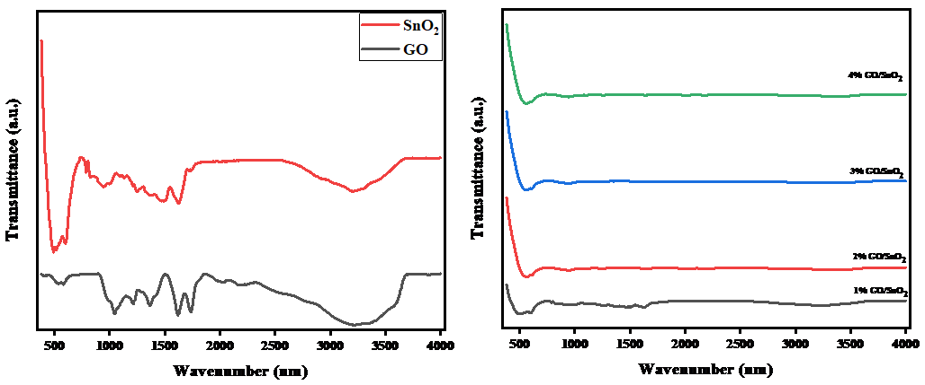

**Figure 1: FTIR spectra of the synthesized composites**

**3.1 Functional Group Analysis of GO, SnO2 and GO-SnO2 nanocomposites**

As seen in Figure 1, FTIR spectroscopy was used to ascertain if a functional group was present in the GO-SnO2 produced composites. SnO2, GO, and various masses of GO-SnO2 composites were generated nanoparticles that were scanned within the 400 cm−1 to 4000 cm−1 range. There are several peaks present in the pure SnO2 nanoparticles, which correspond to Sn–O and O–Sn–O, respectively, at around 528, and 668 cm−1. O–H, CO2, and C––O can be attributed to the peaks at 3448, 1835, and 1724 cm−1, respectively (Amoh *et al.,* 2024). Meanwhile, other functional groups with only slight differences are visible when different weight percentages of GO are incorporated into SnO2. The presence of functional groups in the GO helped for a better dispersion and adsorption of dye as was identified by FTIR (Sahu *et al.,* 2021).

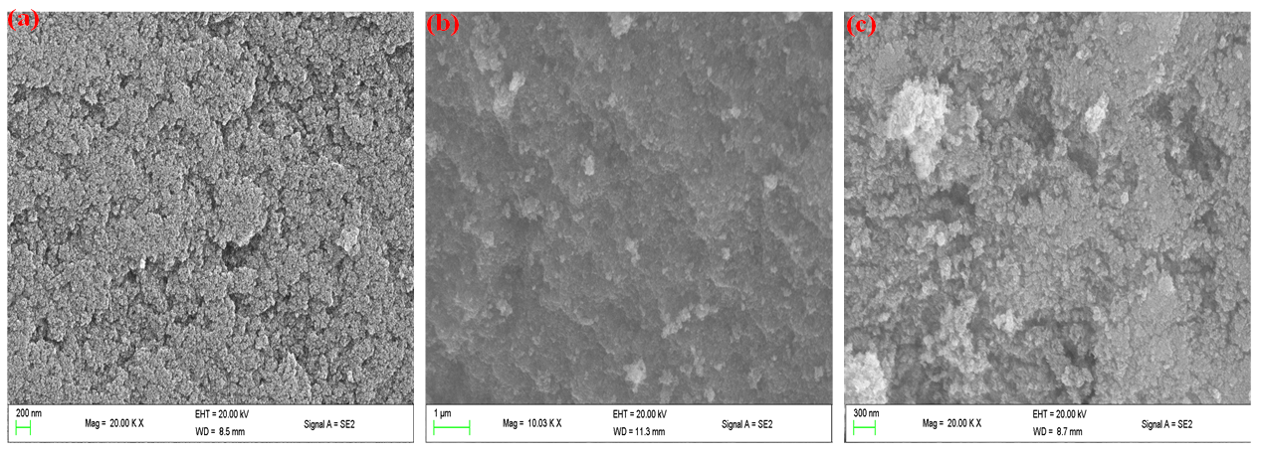

**Figure 2: SEM image of synthesized (a) GO, (b) SnO2 and GO/SnO2 composites**

**3.2 SEM analysis of the synthesized materials**

All materials’ morphologies are examined using SEM technique. From figure 2, it is evident that ene oxide (GO) has a sheet-like structure, which is a sign of a well synthesized material while the SnO2 particles have a surface morphology that is almost uniform, and they appear to be in a mixed condition that includes both parted and agglomerated forms. It is clear that tiny GO nanoparticles aggregate to form bigger clusters on the surface of SnO2, a characteristic shared by all nanocomposite morphologies (Mizaj et al 2024). The interface of SnO2 quantum dots (QDs) with GO was studied as composites, the synergy improved surface morphology and in turn electron-hole pairs while defect from SnO2 improved the conductivity in GO-SnO2 is verified using EIS and well supported by EXAFS (Sahu *et al.,* 2021).

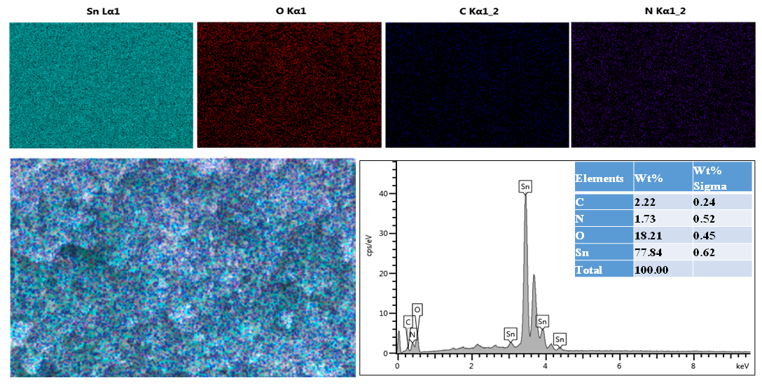

**Figure 3: SEM-EDS elemental mapping and EDS spectrum of GO-SnO2**

**3.3 EDS analysis of the GO-SnO2 composites**

The chemical composition of the nanoparticles is confirmed by the EDS of the produced GO-SnO2 samples, which is also reported in figure 3. The EDS spectra of the modified GO/SnO2 showed the presence of the following element Sn, C, N and O, with C and N having lower atomic percentages which could be as a result of the low weight percentages of GO used in the synthesis.

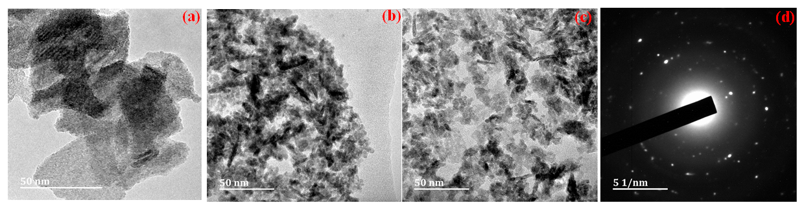

**Figure 4: TEM images of (a) GO, (b) SnO2, (c) GO-SnO2 and (d) SAED spectrum of GO-SnO2**

**3.4 TEM and HRTEM analysis of the as-prepared composites**

The TEM and HRTEM of the as-prepared composites was further investigated to gain a thorough understanding of the GO-SnO2 microstructure. TEM pictures reveals that the sheets that make up GO have a curly morphology shown in figures 5(a-d), with the edges of the sheets somewhat folded and scrolled ( Zhang *et al.,*2013; Dutta *et al.,*2024). The TEM image of SnO2 nanoparticles in Figure 5(b) depicts an agglomeration of almost tiny spherical particles. As illustrated in Figure 5(c), the GO-SnO2 showed dispersion of GO on the composites of GO-SnO2 which means the successful construction of heterojunctions between GO nanosheet and SnO2 nanoparticles. The SAED spectrum of the composites in Figure 5(d) shows that the crystallinity of the SnO2 nanoparticle remains intact even with the inclusion of GO purposely due to the low quantity of GO in the composites.

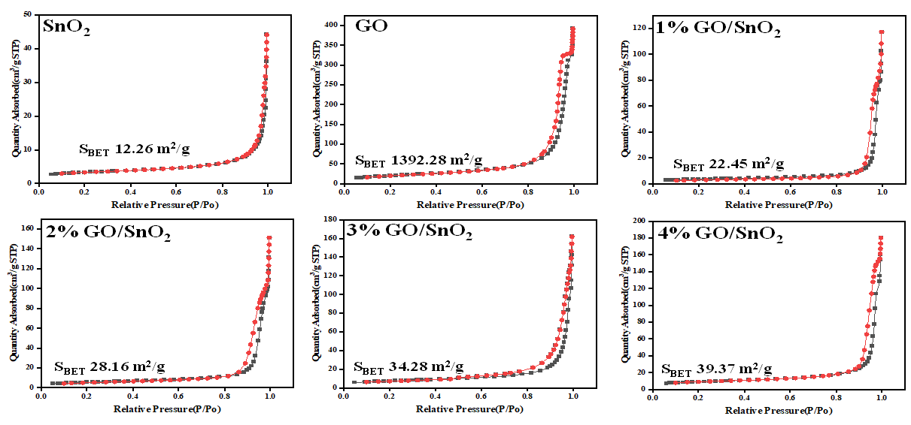

**Figure 5: Nitrogen adsorption-desorption isotherms of the synthesized materials**

**3.5** **BET Analysis of the materials**

GO-SnO2, SnO2, and synthesized GO surface areas shown in figure 5. were measured utilizing the nitrogen adsorption and desorption isotherm of a BET analyzer. Adsorption-desorption profile followed type IV characteristic with type H3 hysteresis loop, indicating mesoporous structure development for all the synthesized composites (Azim *et al.,* 2021; Serban *et al.,* 2025). In comparison to SnO2, the synthesized various masses of composite materials showed an increase in BET specific surface area. In particular, the addition of GO, which has a surface area of 1392.28 m2/g, caused the surface area of SnO2 to rise from 12.26 m2/g to 39.37 m2/g. The cross-section area of the pollutants and the adsorption surface area grew together, improving the composite's photocatalytic efficacy. Room temperature-built gas sensors were fabricated from ene oxide (GO), pristine and doped SnO2 nanostructures and it was observed from BET and TEM studies that doping GO to SnO2 improved the morphology and also the photosensitivity of the materials (Amoh *et al*., 2024)

The photocatalytic reaction in the presence of SnO2 photocatalysts consists of a free radical reaction initiated by light irradiation (photons) (Amoh *et al*., 2024; Baran 2008) which is greatly influenced by the surface morphology. When the energy of solar radiation exceeds the bandgap of SnO2 (i.e., photon energy reaches or exceeds its bandgap energy), the surface of the photocatalyst becomes excited, and the electrons transit from the valence band (VB) to the conduction band (CB), hence by improving the surface area of SnO2 from 12.26 m2/g to 39.37 m2/g, this will enable the creation of more electron-hole pairs (generating electron (e) and hole (H+) pairs).

**Figure 6: (a) UV–vis DRS spectrum and (b) Kubelka-Munk plot of the synthesized composite**

**3.6 UV-vis DRS Analysis of the materials**

UV-vis absorption spectra of the pristine SnO2 and different masses of the GO-SnO2 nanocomposites were obtained in order to examine the optical absorption characteristics of the as-prepared composites. Because of its naturally existing wide band gap, SnO2 nanoparticles exhibit a strong absorption in the 200–430 nm region, as seen in Figure 6(a). The optical absorption edges of SnO2 nanoparticles are at about 410 nm, which could not make full use of visible light while for the different masses of GO/SnO2 nanocomposites, the absorption shows a broad elevated background in the visible region with increasing content of GO nanosheet implying that the GO could optimize the optical absorption ability of GO/SnO2 nanocomposites. This phenomenon indicates that more solar energy can be absorbed by the photocatalyst, which is beneficial for photocatalytic degradation of organic pollutants. Wu & Wang (2019), using UV-vis DRSin analysis,indicated the successful formation of GO/SnO2  micro nanostructure. Also, the photocatalytic activity tested with RhB aqueous solution revealed that GO/SnO2 had excellent photocatalytic properties compared with SnO2. The photocatalytic efficiency of GO/SnO2 was much higher (about 2.5 times) than that of pure SnO2 under visible light irradiation.

Furthermore, the equation (αhv) = A(hν-Eg)n/2can be used to estimate the band gap of a photocatalyst. Here, α, ν, h, Eg, and A stand for the absorption coefficient, light frequency, Planck constant, band gap energy, and a constant, respectively. Depending on the kind of optical transition the semiconductor has, n can have a value of 1 or 4. An indirect transition has a value of 4. As shown in Figure 6(b), the Eg values of SnO2 nanoparticles and the different masses of GO/SnO2 are 3.12, 2.75 and 2.62 eV, respectively. It is obvious that the optical band gap of GO/SnO2 nanocomposites was gradually decreased with increasing amount of GO when compared to pristine SnO2 nanoparticle.

**4.0 Conclusion**

this study investigated the impact of functionalizing SnO2 with GO to improve its composition and morphological features. Since this will have a significant impact on the photocatalytic performance of the synthesized GO-based catalyst GO/SnO2. FTIR and EDS analysis revealed pertinent functional groups and elemental compositions of the synthesized (GO) based catalyst (GO-SnO2). Additionally, the HRTEM and SEM showed that the addition of GO increased the surface area of SnO2, which in turn increased the creation of electron-hole pairs. According to BET tests confirm the surface area of SnO2 to have increased from 12.26 m2/g to 39.37 m2/g upon the addition of GO there by enabling the creation of more electron-hole pairs which influence photocatalysis. The UV Vis absorption shows a broad elevated background in the visible region with increasing content of GO nanosheet implying that the GO could optimize the optical absorption ability of GO/SnO2 nanocomposites. Therefore, these easy and affordable composites can be utilized to remediate organic pollutants in contaminated water.

**DISCLAIMER (ARTIFICIAL INTELLIGENCE)**

Author(s) hereby declare that NO generative AI technologies such as Large Language Models (ChatGPT, COPILOT, etc) and text-to-image generators have been used during writing or editing of this manuscript.

**REFERENCES**

Alsukaibi, A. K. (2022). Various approaches for the detoxification of toxic dyes in wastewater. *Processes*, *10*(10), 1968.

Amoh, P. O., Elwardany, A., Fujii, M., & Shokry, H. (2024). Room Temperature-Built Gas Sensors from Green Carbon Derivative: A Comparative Study between Pristine SnO2 and GO-SnO2 Nanocomposite. *Journal of Nano Research*, *82*, 77-94.

Amoh, P. O., Elwardany, A., Fujii, M., & Shokry, H. (2024, May). A comparative study on the gas sensing performance of SnO2 and GO-SnO2 sensor devices. In *Journal of Physics: Conference Series* (Vol. 2754, No. 1, p. 012009). IOP Publishing.

Aniket, K., Lipeeka, R., Satish, K.A., Anurag, M., Rajendra, S.D., Priyabrat, D. (2016). An investigation into solar light driven enhanced photocatalytic properties of a ene oxide-SnO2-TiO2 ternary nanocomposite. Journal of Royal society of chemistry advances Doi:10.1039/c6ra02067d

Araújo, E. S., Pereira, M. F., da Silva, G. M., Tavares, G. F., Oliveira, C. Y., & Faia, P. M. (2023). A review on the use of metal oxide-based nanocomposites for the remediation of organics-contaminated water via photocatalysis: fundamentals, bibliometric study and recent advances. *Toxics*, *11*(8), 658.

Azim, M. B., Jani, M., Qadir, M., Hasanuzzaman, M., Gafur, M., Gulshan, F., & Firoz, S. (2021). GO-SnO2 nanocomposite for photodegradation of methyl orange under direct sunlight irradiation and mechanism insight. *Department of Materials and Metallurgical Engineering, BUET, Dhaka, Bangladesh*.

Bellaj, M., Naboulsi, A., Aziz, K., Regti, A., El Himri, M., El Haddad, M., ... & Aziz, F. (2024). Bio-based composite from chitosan waste and clay for effective removal of Congo red dye from contaminated water: Experimental studies and theoretical insights. *Environmental Research*, *255*, 119089.

Binaya, K.S., Rabindra, N.J., Madhusmita, S., Ravi, K., Das, A. (2021). Interface of GO with SnO2 quantum dots as an efficient visible-light photocatalyst. Surface and nanoscience institute

Bratovčić, A. (2023). Recent Achievements in Photocatalytic Degradation of Organic Water Contaminants. *Kemija u industriji: Časopis kemičara i kemijskih inženjera Hrvatske*, *72*(9-10 (special issue)), 573-583.

Cao, M., Shen, Y., Yan, Z., Wei, Q., Jiao, T., Shen, Y., ... & Yue, T. (2021). Extraction-like removal of organic dyes from polluted water by the ene oxide/PNIPAM composite system. *Chemical Engineering Journal*, *405*, 126647.

Dong, P., Wang, Y.,Guo, L., , B., Xin, S., Zhang, J., Shi, Y., Zeng, W., Yin, S. (2012). A facile one-step solvothermal synthesis of ene/rod-shaped TiO2 nanocomposite and its improved photocatalytic activity, Nanoscale 4:4641-4649. <https://doi.org/10.1039/c2nr31231j>

Dutta, T., Llamas-Garro, I., Velázquez-González, J. S., Bas, J., Dubey, R., & Mishra, S. K. (2024). A new generation of satellite sensors based on ene and carbon nanotubes: A Review. *IEEE Sensors Journal*.

Elaouni, A. et al. ZIF-8 metal organic framework materials as a superb platform for the removal and photocatalytic degradation of organic pollutants: A review. RSC Adv. 12, 31801– 31817 (2022).

Elshypany, R., Hanaa, S., Ahmad, H.M., Sadeek, A.S., Sharaa, S.I., Patrice, R., Amir, A.N. (2021) Magnetic ZnO crystal nanoparticle growth on reduced ene oxide for enhanced photocatalytic performance under visible light irradiation. Molecules 26, 2269

Fatima, S., Abbas, N., Iqbal, J., Irshad, M., & Khan, M. A. (2024). Role and Perspective of Metal-Oxide Based Nanocomposites for Wastewater Treatment: A Review. *Environmental Protection Research*, 128-155.

Gao, C., Guo, M., Liu, Y., Zhang, D., Gao, F., Sun, L., ... & Wang, Y. (2023). Surface modification methods and mechanisms in carbon nanotubes dispersion. *Carbon*, *212*, 118133.

Giahi, M. et al. Preparation of Mg-doped TiO2 nanoparticles for photocatalytic degradation of some organic pollutants. Stud. Univ. Babes-Bolyai Chem. 64, 7–18 (2019).

Gupta, A.K., Pal, A., Sahoo, C. (2006). Photocatalytic degradation of a mixture of Crystal Violet (Basic Violet 3) and Methyl Red dye in aqueous suspensions using Ag+ doped TiO2, Dyes and Pigments. 69:224–232. https://doi.org/10.1016/j.dyepig.

Gusain, R., Gupta, K., Joshi, P. & Khatri, O. P. (2019). Adsorptive removal and photocatalytic degradation of organic pollutants using metal oxides and their composites: A comprehensive review. Advance College Interface. Science, 272, 102009.

Heba, M.E., Amira, M.S., Rania, E., Hanaa, S. (2023). Efficient photocatalytic degradation of organic pollutants over TiO2 nanoparticles modified with nitrogen and MoS2 under visible light irradiation. Scientific Reports 13:8845 <https://doi.org/10.1038/s41598-023-35265->Helmy, E. T., El Nemr, A., Mousa, M., Arafa, E., Eldafrawy, S. (2018). Photocatalytic degradation of organic dyes pollutants in the industrial textile wastewater by using synthesized TiO2, C-doped TiO2, S-doped TiO2 and C, S co-doped TiO2 nanoparticles. Journal of Water Environmental Nanotechnology, 3,116–127.

Jiang, D. J., Tunmise, A. O., Yuanyuan, O., Noor, F. S., Song, W., Ailing, Z., Sanxi, L. (2021). A Review on Metal Ions Modiﬁed TiO2 for Photocatalytic Degradation of Organic Pollutants. <http://doi.org/10.3390/catal11091039>

Kanwal, F., Javed, T., Hussain, F., Wasim, M., & Batool, M. (2024). Enhanced dye photodegradation through ZnO and ZnO-based photocatalysts doped with selective transition metals: a review. *Environmental Technology Reviews*, *13*(1), 754-793.

Kar, A., Olszowka, J., Sain, S., Sloman, S. R. I., Montes, O., Fernandez, A., ... & Wheatley, A. E. (2019). Morphological effects on the photocatalytic properties of SnO2 nanostructures. *Journal of Alloys and Compounds*, *810*, 151718.

Kayode, A.A., Olugbenga, S. B. (2015). Dye sequestration using agricultural wastes as adsorbents, Water Resource Industry, 12: 8–24, https://doi. org/10.1016/j.wri.09.002.

Kent, F.C., Montreuil, K.R., Brookman, R.M., Sanderson, R., Dahn, J.R., Gagnon, G.A. (2011). Photocatalytic oxidation of DBP precursors using UV with suspended and fixed TiO2, Water Resources :45: 6173–6180. <https://doi.org/10.1016/j.watres.2011.09.013>

Lei, C. et al. Bio-photoelectrochemical degradation, and photocatalysis process by the fabrication of copper oxide/zinc cadmium sulfde heterojunction nanocomposites: Mechanism, microbial community and antifungal analysis. Chemosphere 308, 136375 (2022).

Lin, L., Yang, Y., Men, L., Wang, X., He, D., Chai, Y., Zhao, B., Ghoshroyb, S., Tang, Q. (2013). A highly efficient TiO2@ZnO n–p–n heterojunction nanorod photocatalyst, Nanoscale. 5 588–593. <https://doi.org/10.1039/c2nr33109h>

Loh, K.P., Bao, Q., Ang, P.K., Yang, J. (2010). The chemistry of ene, 2277–2289. <https://doi.org/10.1039/b920539j>.

Mizaj, S.S., Hayarunnisa, A., Farzana, N., Musthafa, H.A., Sarya, A., Jothi, R.R., Johaina, K.A., John-John, C., Muthusany, K., Kishor, K.S. (2024). Photocatalytic degradation of organic dyes using r/GO. Journal of Advanced Materials <https://doi.org/10.1038/s41598-024-> 53626-8

Mubarak, M. F., Selim, H. & Elshypany, R. (2022). Hybrid magnetic core–shell TiO2@ CoFe3O4 composite towards visible light-driven photodegradation of Methylene blue dye and the heavy metal adsorption: Isotherm and kinetic study. Journal of Environmental Health Science England 20, 265–280.

Novoselov, K. S., Geim, A. K., Morozov, S. V., Jiang, D. E., Zhang, Y., Dubonos, S. V., ... & Firsov, A. A. (2004). Electric field effect in atomically thin carbon films. *science*, *306*(5696), 666-669.

Pinto, A. H., Nogueira, A. E., Dalmaschio, C. J., Frigini, I. N., de Almeida, J. C., Ferrer, M. M., ... & de Mendonça, V. R. (2022). Doped tin dioxide (d-SnO2) and its nanostructures: Review of the theoretical aspects, photocatalytic and biomedical applications. *Solids*, *3*(2), 327-360.

Sánchez, M., Ruiz, I., & Soto, M. (2022). The potential of constructed wetland systems and photodegradation processes for the removal of emerging contaminants—a review. *Environments*, *9*(9), 116.

Sahu, B. K., Juine, R. N., Sahoo, M., Kumar, R., & Das, A. (2021). Interface of GO with SnO2 quantum dots as an efficient visible-light photocatalyst. *Chemosphere*, *276*, 130142.

Sanakousar, F., Vidyasagar, C., Jiménez-Pérez, V., Prakash, K. (2022). Recent progress on visible-light-driven metal and non-metal doped ZnO nanostructures for photocatalytic degradation of organic pollutants. Material Science Semiconductor Process, 140, 106390.

Serban, B. C., Dumbravescu, N., Buiu, O., Bumbac, M., Brezeanu, M., Pachiu, C., ... & Cobianu, C. (2025). Holey Carbon Nanohorns-Based Nanohybrid as Sensing Layer for Resistive Ethanol Sensor. *Sensors*, *25*(5), 1299.

Tran, V. V., Ta, Q. T. H., & Lee, D. (2024). Photodegradation of Emerging Contaminants in Aqueous Solutions. In *Bioremediation of Emerging Contaminants in Water. Volume 1* (pp. 129-148). American Chemical Society.

Vanitha, K., Jibrail, K., Sie, Y.L. (2018). Efficiency of various recent wastewater dye removal methods: A Review. Journal of Environmental Chemical Engineering, https://doi.org/10.1016/j.jece.06.060

Wang, S., Sun, H., Ang, H. M. & Tadé, M. O. 2013. Adsorptive remediation of environmental pollutants using novel ene-based nanomaterials. Chemical Engineering Journal, 226, 336-347.

Wu, Z., & Wang, L. (2019). ene oxide (GO)-doping SnO2 flower-like structure to enhance photocatalytic activity. *Fullerenes, Nanotubes and Carbon Nanostructures*, *27*(5), 387-394.

Zhang, J., Xiong, Z., Zhao, X.S. (2013). ene–metal–oxide composites for the degradation of dyes under visible light irradiation, Journal of Material Chemistry 21:3634–3640. <https://doi.org/10.1039/c0jm03827j>.