Original Research Article

Assessment of Water and Sanitation Services in the Department of Biankouma (Mountainous Rural Area) in Western Côte d'Ivoire

.

ABSTRACT

|  |
| --- |
| **Aims:** Access to adequate water and sanitation services for all is a major issue in developing countries, particularly in rural mountainous areas. The aim of this study was to examine water access and sanitation conditions in the department of Biankouma, Côte d'Ivoire.  **Place and Duration of Study:** The research was conducted from April to June 2023 in several villages in the Biankouma department.  **Methodology:** Data collection consisted of a household survey and field observations in villages in the Sub-prefectures of Blapleu, Kpata and Gbangbegouiné, all in the department of Biankouma. In order to obtain representative results, a quota of 10% of the households surveyed was applied in each village concerned. Thus, 449 households were surveyed out of a total of 4,489 households in the target villages.  **Results:** The results showed that the majority of households had between 5 and 10 people (56.12%), with 32.1% using other types of water in addition to tap water, such as well, borehole and marigot water. All households visited had latrines: pit latrines with a slab (39.9%), mechanical flush latrines (39.2%), manual flush latrines (4.5%) and traditional latrines (6.4%). In most households, toilet water was discharged into septic tanks (53.9%) and laundry water was discharged into the street (69.9%), as was dishwater (51.7%). Cases of malaria were reported in 62% of households in the department, compared with 38% for diarrhea.  **Conclusion:** Following the success of the policy to end open defecation in the department of Biankouma, the government and donors should focus future interventions on building boreholes and raising awareness of wastewater and excreta management to keep the nests of environmental diseases away from villages. |

*Keywords: Biankouma Department, Côte d’Ivoire, Households, Latrines, Sanitation, Water source*

1. INTRODUCTION

Guaranteeing access to water and sanitation for all, and ensuring sustainable management of water resources, is now recognized as a fundamental human right by the United Nations, which has made it the sixth Sustainable Development Goal (SDG). SDG 6 aims to ensure universal and equitable access to safe drinking water, hygiene and sanitation for all by 2030, especially for vulnerable populations. It also calls for sustainable management of this resource and mentions reducing the number of people suffering from water scarcity (United Nations 2018; UN-Water 2020 and 2021).

Indeed, water and sanitation-related diseases remain one of the most serious child health problems. Approximately 1.8 billion people consume water contaminated with fecal matter, and almost 2.4 million people lack access to basic sanitation services such as toilets or latrines (WHO-UNICEF 2021)**.** More than 80% of wastewater generated by human activities is discharged untreated into rivers and oceans, polluting them. More than 80% of wastewater generated by human activities is discharged untreated into rivers and oceans, contributing to their pollution. As a result, more than 90% of children under the age of five, mostly living in developing countries (DCs), die from diarrheal diseases (including cholera), and 88% of this morbidity can be attributed to poor water quality, inadequate sanitation and poor hygiene, as has been the case for several years (Boschi-Pinto *et al.,* 2008 ; Birhan *et al.,* 2023). Diarrhea alone is responsible for 5,000 child deaths per day worldwide, and children in developing countries suffer five to six episodes of diarrhea per year. Despite significant global progress, difficulties remain in achieving MDG 6, particularly in developing countries (Fehling *et al.* 2013; Herrera *et al.* 2019; Akter *et al.* 2022).

The proportion of the world's population using safely managed sanitation services rose from 47% to 54%, and the proportion practicing open defecation fell by a third, from 739 million to 494 million. Coverage of hand-washing facilities with soap and water increased from 67% to 71% between 2015 and 2020. Over the same period, the proportion of the world's population using safely managed drinking water supply services rose from 70% in 2015 to 74% in 2020. However, two billion people will still be deprived, including 1.2 billion without access to a basic service. Eight out of ten of these people live in rural areas, in the least developed countries (United Nations 2022). This confirms the MDG (2013) report, which encouraged developing countries to focus their efforts on rural areas and low-income groups to improve access to drinking water and sanitation.

The delay in achieving MDG 6, which is particularly evident in developing countries, especially in Sub-Saharan Africa, is justified by the vulnerability of some conflict-affected countries and the lack of sustained national policies (Payen and Fonlladosa 2017; Odafivwotu and Tano 2018; Okoudjou and Correia 2020). Although an increasing number of organizations and donors (*e.g.* UNICEF, Red Cross, UNDP, WHO, etc.) are providing financial support to these countries to help them achieve the MDGs in general and MDG 6 in particular (WHO-UNICEF 2021), it is important to identify all the other local constraints that limit the achievement of this goal. These include, in particular, local access conditions, the levels of education of the population, natural constraints (*i.e.* geology, geomorphology of the land, etc.), the local economic situation, etc.

In Côte d'Ivoire, for example, very few studies have addressed the issue of population constraints, particularly in the mountainous rural areas of the country. However, populations living on the western slopes of the mountains could face enormous difficulties in accessing water resources and sanitation services, given the rocky nature of the local terrain. Against this background the present study aims to make an inventory of drinking water supply and sanitation services in the department of Biankouma, with a view to formulating recommendations to remedy the situation. The specific objectives of this study are to (i) identify the sources and uses of household water supplies in three of the department's sub-prefectures (Blapleu, Kpata and Gbangbegouiné), (ii) examine household wastewater and excreta management practices, and (iii) assess the health risks associated with poor wastewater and excreta management and inadequate water services

2. literature review

**2.1 Geographic and demographic situation of the study area**

The present study was carried out in the west of Côte d'Ivoire, in the Department of Biankouma, one of the localities in the Tonpki region (Figure 1). This border region with Guinea and Liberia is the most rugged in the country, with mountains reaching 1,357 m in altitude. Biankouma Department is located between 7°44′00″ latitude North and 7°37′00″ longitude West (Avenard 1971).

According to the 2021 census, the department has a population of 238,714, mainly made up of Yacoubas, Wobés and Touras, and is home to seven (7) sub-prefectures: Biankouma, Blapleu, Gbangbegouine, Gouiné, Gbonné, Kpata, Santa-Biankouma (INS 2021).

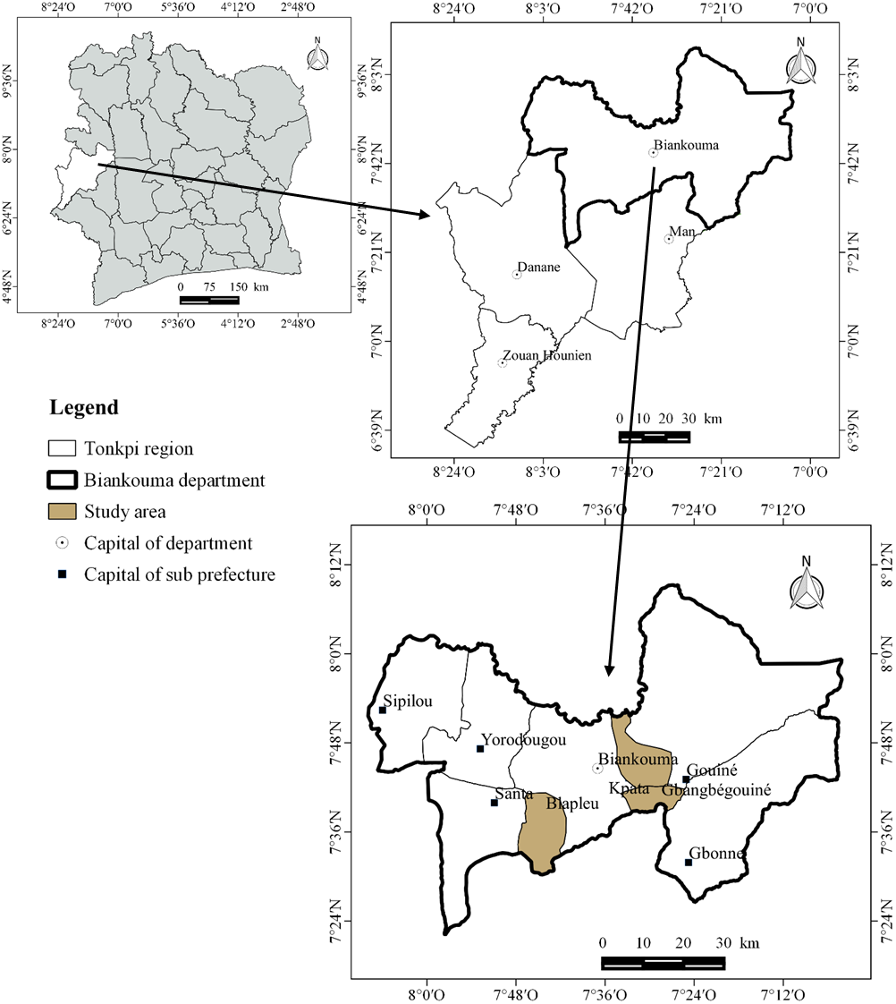

**Fig. 1. Geographical location of Biankouma department.**

**2.2 Relief and soil**

The department of Biankouma is located in the eastern extension of the Dorsale Guinéen. It is located in the Man mountain massif, which is characterized by mountains between 500 and 1,000 m high (Avenard, 1971). The region is essentially granitic (Lauginie, 2007).

It can be differentiated:

* to the south, the area of the Monts Toura, including Mont Sangbé (1,072 m);
* to the north, a series of hills with tabular peaks of 600 to 700 m, dominating vast granitic plateaus in the Touba region;
* to the east, the Sassandra "gutter", bordered by gullied terraces separated by sandy shallows;
* the Bafing depression, at an altitude of less than 500 meters, which crosses the Toura mountains and the south-western part of the department.

The soils of the department of Biankouma are ferralitic. The granite bedrock has led to the formation of moderately desaturated ferralitic soils. However, some areas are underlain by highly desaturated ferralitic soils (INS, 2021). These moderately desaturated ferralitic soils can be divided into two groups:

* Reworked ferralitic soils, with a sandy-clay texture in the upper part and clay at depth, up to one meter thick.
* Typical ferralitic soils with a clay-depleted texture, where the weathering horizon is rich in coarse and varied elements (cuirass debris, quartz gravel and pebbles, etc.), belonging to the reworked group, a weakly rejuvenated subgroup (Perraud, 1971).

**2.3 Climate**

The department of Biankouma is located in a transition zone between sub-equatorial and tropical climates. However, it benefits from a particular mountain climate due to the presence of mountains in the region (Eldin, 1971). This climate has two main seasons: a dry season from November to February and a rainy season from March to October (Figure 2) [Kpangui *et al.,* 2021]. The average temperature in the region varies between 24ºC and 28ºC. January is the hottest month, with an average temperature of 28ºC. Average rainfall in the region ranges from 05 mm to 150 mm/year, with a peak of 150 mm/year in September.

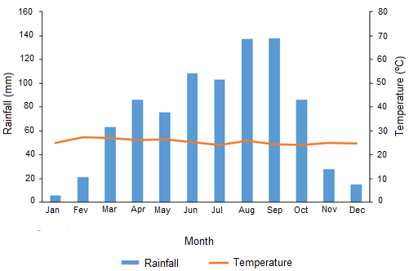

**Fig. 2. Ombrothermal diagram of the sub-prefecture of Biankouma from 1989 to 2018 (Kpangui *et al*., 2021).**

**2.4 Vegetation and flora**

The department of Biankouma lies in a transitional zone between the ombrophilous and mesophilous sectors. Savannah, forest and mixed formations intermingle. The savannah sections are characterized by woody stands dominated by *Daniellia oliveri*, *Lophira lanceolata* and *Terminalia schimperiana*. The forest islands include plant species such as *Aubrevillea kerstingii* and *Khaya grandifolia*, *Afzelia africana*, etc. To the north, these patches give way to the dense dry forest group, with species such as *Diospyros mespiliformis* and *Afzelia africana*. The gallery forests are rich in tree species such as *Cola laurifolia*, *Cola cordifolia*, *Berlinia grandiflora*, etc. (Guillaumet & Adjanohoun 1971; Poilecot 1996).

**2.5 Economic activities**

In the department of Biankouma, agriculture remains the main activity of rural households. Perennial crops cultivated in the department are dominated by coffee growing, with production of 105,601 tons in the 2015-2016 season. The main food crops in the area are rainfed and lowland rice, cassava, maize and bananas (Konan *et al.,* 2017; FAO, 2018).

Livestock production in western Côte d'Ivoire, which accounts for 2% of the country's total GDP, is of a short duration. However, in addition to these activities, other activities such as mineral extraction and logging are present in the area covered by the department of Biankouma. Increasingly, people are interested in growing cocoa (Tiebre *et al.,* 2016).

3. material and methods

To carry out this study, data were collected from April to June 2023 in several villages in the Biankouma department from various households in these villages, using the following equipment:

* A survey form, addressed to heads of household or any adult in the household, to record information on the household's socio-economic characteristics, available water sources and the various uses made of them, wastewater and excreta management, and the health risks associated with poor waste management.
* A digital camera for field photography.

**3.1 Data collection**

Data collection consisted in conducting a household survey in villages in the Sub-prefectures of Blapleu, Kpata and Gbangbegouiné, all in the Biankouma department. The survey consisted in filling in the forms drawn up for this purpose, by interviewing and questioning the head of household or any adult in the household. It gathered information on:

* Socio-economic characteristics of households ;
* Available water sources and uses;
* Wastewater and excreta management;
* Health and environmental risks associated with poor sanitation.

In addition, field observations were made to assess the state of sanitation. These consisted in assessing the socio-economic characteristics of households, the source and uses of water, excreta management, wastewater management, and making illustrations by taking photographs.

A household being a family made up of the father, mother and dependent child (ren), in some localities of the study area, certain families made up of several households sharing the same concession were also considered as a household. To achieve representative results, the quota of 10% of households surveyed was applied in each village concerned (Statistics Canada, 2013). Thus, 449 households were surveyed out of a total of 4,489 households in the target villages. Details of the number of households surveyed per village in the Sous-prefectures are given in Table 1.

**Table 1. Number of households surveyed in the villages of the sub-prefectures of the study area (Biankouma Department).**

|  |  |  |  |  |
| --- | --- | --- | --- | --- |
| Sub-prefectures | Population | Village | Households | Sample |
| Blapleu | 25 371 | Blapleu | 3 342 | 334 |
| Klapleu | 164 | 16 |
| Gouele | 234 | 23 |
| Kpata | 9 278 | Kpata | 260 | 26 |
| Dantomba | 73 | 7 |
| Gaote | 85 | 9 |
| Gbangbegouiné | 4 132 | Gbangbegouine | 225 | 23 |
| Gan Santa | 38 | 4 |
| Gnanlé 1 | 68 | 7 |
| Total | 38 781 | 09 | 4 489 | 449 |

**3.2 Data analysis**

The data collected from the questionnaire were standardized and coded, then grouped by variable (i.e. socio-economic characterization of households, water sources and uses, excreta management, wastewater management, health and environmental risks). The relative percentages of each variable were calculated in relation to the number of households surveyed according to relationship (1):

$$P=\frac{X}{Y} x 100 (1)$$

With:

P: Percentage (%);

X: Number of the modality considered;

Y: Total number of the modality considered.

The arithmetic mean was used to estimate the average value of variables such as the distribution of the number of households in the villages of the sub-prefectures surveyed. It was calculated using relationship (2):

$\overline{X}=\frac{1}{n} x \sum_{i=1}^{n}{X_{i}} (2$)

With:

$\overline{X}$ = Mean value of the variable under consideration;

$n$ = Total number of households surveyed;

$x_{i}$ = Variable considered.

4. results

**4.1 Socio-demographic characteristics and typology of the habitat for surveyed households**

Table 2 shows the socio-demographic characteristics and typology of the habitat of the households surveyed. Among all households surveyed, the proportion of unique courtyards (51%) is roughly equal to that of common courtyards (49%).

In terms of household size, those with between 5 and 10 people are the most numerous (252, or 56.1% of households surveyed). Next come households of 1 to 5 people, numbering 179, or 39.9% of households surveyed.

The level of education of heads of household is high overall, at 72.4%, compared with 27.6% for those not attending school. Of those who did attend school, 3.1% had a higher level of education, 39.6% had attended secondary school and 29.6% had completed only primary school.

Overall, three activities are practiced by heads of household in the department. They are farmers, shopkeepers and civil servants, the majority of whom are farmers (62.58%) and shopkeepers (22.05%).

**Table 2. Socio-demographic characteristics and typology of the habitat for surveyed households.**

|  |  |  |  |
| --- | --- | --- | --- |
| Socio Demographic Characteristics | | Number of household | Percentage |
| Typology of Habitat | Unique courtyards | 229 | 51% |
| Common courtyards | 220 | 49% |
| Size of households | [1 ; 5[ | 179 | 39.9% |
| [5 ; 10[ | 252 | 56.1% |
| [10 ; More[ | 18 | 4% |
| Education level of head households | High school education | 14 | 3.1% |
| Secondary school education | 178 | 39.6% |
| Primary school education | 133 | 29.6% |
| No formal education | 124 | 27.6% |
| Profession of head households | Wage and salary earners | 69 | 15.4% |
| Farmers | 281 | 62.6% |
| Tradespeople | 99 | 22% |

By sub-prefecture, the villages of Kpata and Gbangbegouiné are predominantly made up of common courtyards, with proportions of 79% and 65% respectively (Figure 3A). On the other hand, Blapleu has a majority of unique courtyards (53%). Figure 4 illustrates some of the courtyards found in these localities.

As shown in Figure 3B, the majority of households in Blapleu (57.9%) and Kpata (71.4%) are home to between 5 and 10 people. In Gbangbegouiné, on the other hand, most households (58.8%) are home to between 1 and 5 people.

Furthermore (Figure 3C), it can be seen that respondents with primary education are dominant in Gbangbegouiné (65%) and Kpata (67%). In Blapleu, on the other hand, the majority of respondents have secondary education (46%).

With regard to the activities of heads of household, agriculture is the most common. There are 209 heads of household, or 56.03% in Blapleu, and 90.48% (38) and all (34) in Kpata and Gbangbegouiné respectively (Figure 3D).

**Figure 3. Sociodemographic characteristics and typology of the habitat of surveyed households by sub-prefecture. HSE = High school education, SSE = Secondary school education, PSE = Primary school education, NFE = No formal education; Civ Ser = Civil servant, Farm = Farmers, Tradesp = Tradespeople.**

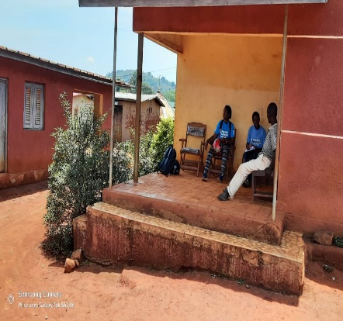 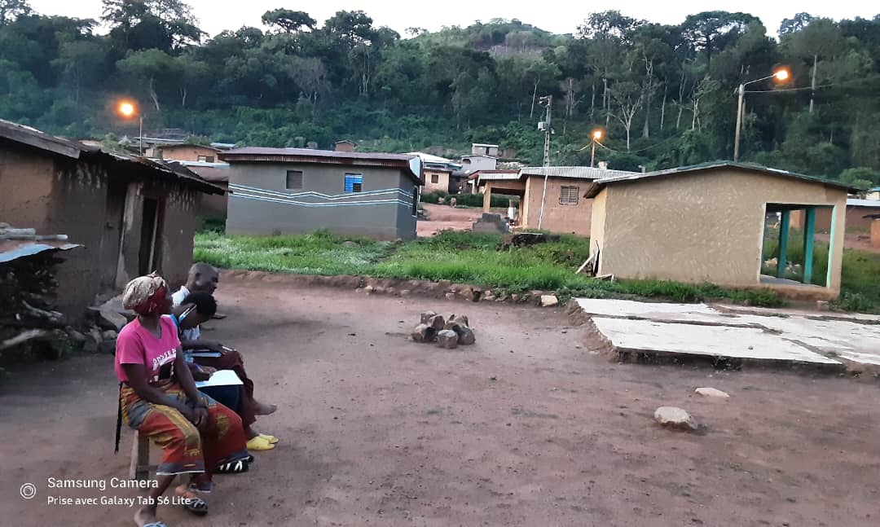 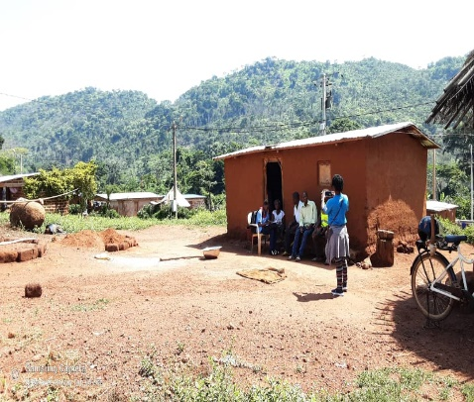

**A**

**B**

**C**

**Fig. 4. Illustration of some habitats in the study area; A = unique courtyards (Gbangbegouiné sub-prefecture), B = common courtyards (Kpata sub-prefecture), C = unique courtyards (Blapleu sub-prefecture).**

**4.2 Water supply Sources and uses**

Figure 5 illustrates water sources and their proportion of use in Biankouma department. In addition to tap water, other types of water are used in the households surveyed. These include well, borehole and marigot water, used by 32.1% of households. Figure 6 gives an overview of these water sources.

**Fig. 5. Sources of water used in households in Biankouma department.**

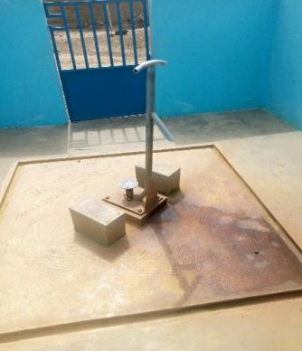 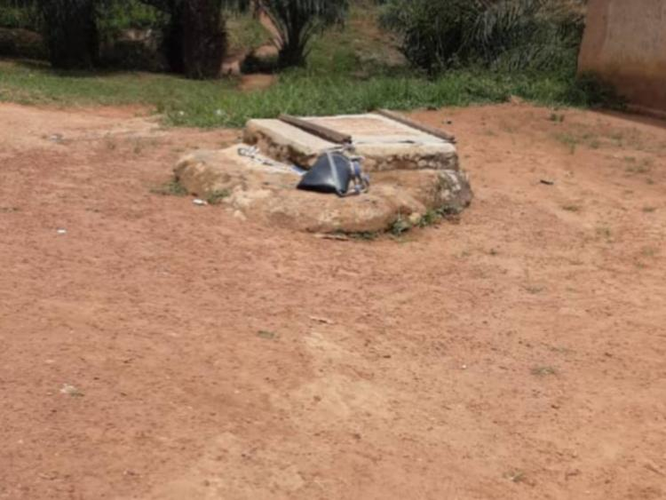 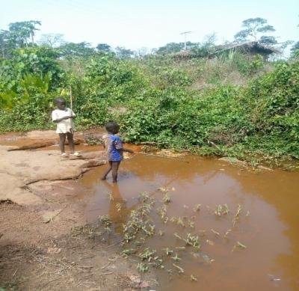 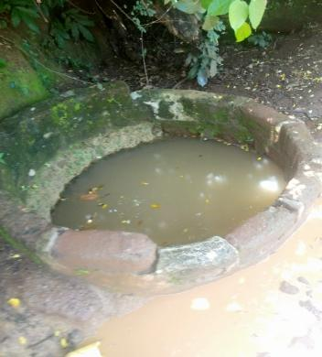

**A**

**B**

**C**

**D**

**Fig. 6. Overview of water sources used, in addition to tap water, in households in the Biankouma department. A= borehole, B= well, C and D = Margots**

With regard to the realities observed in each of the sub-prefectures (Figure 7), we note that, apart from tap water, other types of water are used in 27% of households in Blapleu, 23% in Kpata and in all households, i.e. 100%, in Gbangbegouiné, where the villages surveyed have no drinking water service (tap water).

**Fig. 7. Water sources used by households in the sub-prefectures surveyed in Biankouma department.**

However, the survey revealed that all the water used by the population of all the villages visited is used on a daily basis for all household activities, including drinking, washing up, toilets and bathing (Table 3).

**Table 3. Uses of water types used in households; * materializes the use of the water type.**

|  |  |  |  |  |
| --- | --- | --- | --- | --- |
| Types of water | Uses | | | |
| Drinking | Toilets | washing up | Bathing |
| Tap water | * | * | * | * |
| Marigot water | * | * | * | * |
| Borehole water | * | * | * | * |
| Well water | * | * | * | * |

**4.3 Wastewater and excreta management**

**4.3.1 Latrine coverage rate in the department**

The survey revealed that all households visited in the Biankouma department have a latrine. There were four types of latrine: Pit Latrines with Slab (PLS) in 39.9% of households (179), followed by Mechanical Flush Latrines (MeFL) in 39.2% of households (176), Manual Flush Latrines (MaFL) in 14.5% of cases (65 households) and Traditional latrines (TL) in 6.4% of households (29) [Table 4].

**Table 4. Types of latrine encountered in the Biankouma department**.

|  |  |  |
| --- | --- | --- |
| **Types of latrines** | **Households** | **Percentage (%)** |
| Pit latrines with slab | 179 | 39.9% |
| Mechanical flush latrine | 176 | 39.2% |
| Manually Flush Latrines | 65 | 14,5 |
| Traditional latrines | 29 | 6.4 |
| Total | 449 | 100 |

At sub-prefecture level (Figure 8), households in Kpata (55%) and Gbangbegouiné (68%) are dominated by pit latrines with slab (PLS), while the Blapleu sub-prefecture is dominated by Mechanical Flush Latrines (MeFL). Figure 9 illustrates the types of latrines encountered in the Sub-prefectures visited.

**Fig. 8. Types of latrines found in the Sub-prefectures; MeFL = Mechanical flush latrine, PLS = Pit Latrines with Slab, MaFL = Manually Flush Latrines and TL = Traditional Latrines**

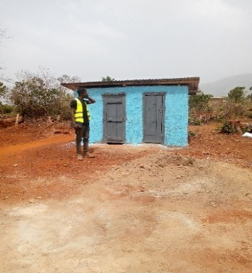 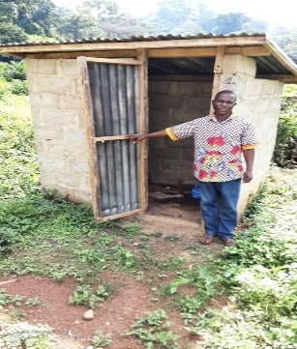 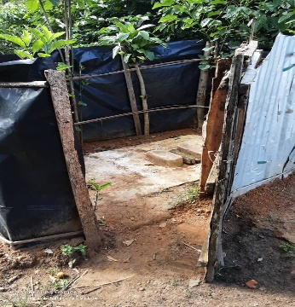 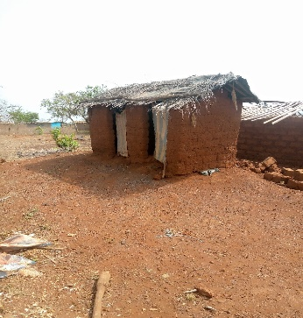

**A**

**B**

**C**

**D**

**Fig. 9 Illustration of some latrines in the study area, A = Manual Flush Latrines; B & C = Pit Latrines with Slab and D = Traditional Latrines.**

**4.3.2 Drainage methods for toilet, laundry and dishwashing water**

As shown in Table 5, toilet water is mainly discharged into septic tanks (53.9%), while laundry water is discharged into the street in most households (69.9%) in the department. Dishwater is discharged into septic tanks (48.3%) and into the street (51.7%).

**Table 5. Toilet, laundry and dishwashing water disposal areas for households surveyed in Biankouma department**

|  |  |  |  |
| --- | --- | --- | --- |
| **Type of wastewater** | **Disposal areas** | **Households** | **Percentage** |
| Toilet waters | Septic tanks | 242 | **53.9 (%)** |
| Infiltration wells | 162 | 36.1 (%) |
| Streets | 45 | 10 (%) |
| Laundry water | Septic tanks | 135 | 30.1 (%) |
| Infiltration wells | 0 | 0 (%) |
| Streets | 314 | **69.9 (%)** |
| Dishwater | Septic tanks | 217 | **48.3 (%)** |
| Infiltration wells | 0 | 0 (%) |
| Streets | 232 | **51.7 (%)** |

By sub-prefecture, toilet water is disposed of in septic tanks in the majority of households (64.9%) in Blapleu, and in infiltration wells in Kpata (66.7%) and Gbangbegouiné (66.7%) [Figure 10A]. Laundry water (Figure. 10B) is discharged into the streets in the majority of households in Blapleu (63.8%) and in all households in Kpata and Gbangbegouiné. The same applies to dishwater in Kpata and Gbangbegouiné. On the other hand, most households in Blapleu (58.2%) discharge this water into septic tanks (Figure 10C). Fig. 11 illustrates some of the places where wastewater is disposed of in villages in the Biankouma department.

**Fig. 10. Toilet, laundry and dishwashing water disposal areas in the sub-prefectures.**

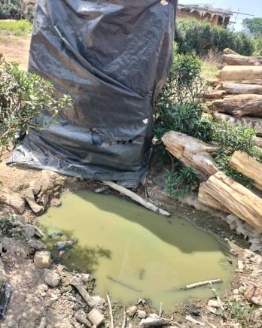 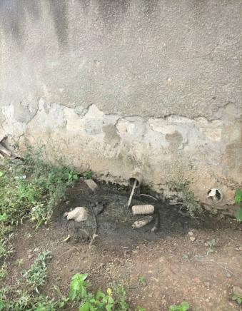 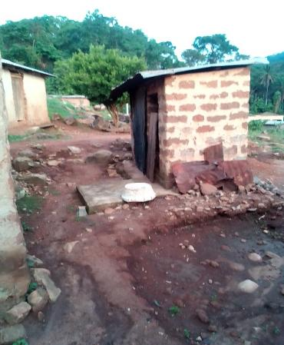 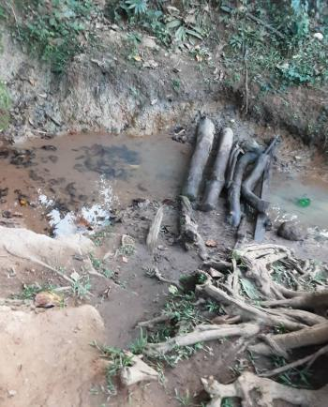

**C**

**A**

**B**

**D**

**Fig. 11. Toilet, laundry and dishwashing water disposal areas for households in the villages. A & B = discharge of toilet water into the streets, C & D = discharge of laundry water and dishwater into the streets.**

**4.3.3 Risks associated with poor wastewater and excreta management in the department**

Overall, all the populations surveyed are aware of the risks associated with poor wastewater and excreta management. According to them, these practices are likely to cause illness, and children are particularly exposed to fecal matter discharged through effluent. However, cases of illness have been recorded in localities, notably diarrhea and malaria (Figure 12), the latter being the most contracted at both departmental and sub-prefecture levels.

Cases of malaria occurred in 62% of households in the department, compared with 38% of cases of diarrhea (Figure 12A). In each of the sub-prefectures, malaria cases were recorded in 58%, 92% and 86% of households in Blapleu, Kpata and Gbangbegouiné, respectively (Figure 12B).

**Fig. 12. Pathologies contracted in all households surveyed in the department as a whole (A) and in each sub-prefecture (B).**

4. discussion

This study presents the realities in terms of access to water and sanitation services in one of Côte d'Ivoire's remote mountainous areas (i.e. the department of Biankouma). The survey revealed that most village households are home to between 5 and 10 people (56.12%), living mainly in common courtyards in Kpata (79%) and Gbangbegouiné (65%), and in unique courtyards yards in Blapleu (53%). This situation may be linked to the status of household heads. In fact, in the sub-prefectures of Kpata and Gbangbegouiné, unique courtyards are mostly inhabited by house owners who are natives of the village, while common courtyards are mostly inhabited by non-native tenants. In Blapleu, the existence of community infrastructures such as health centers and elementary school has favored the settlement of non-native tenants, which can be explained by the higher rates of 18.50% civil servants and 50% school attendance (including secondary and higher education), recorded in the locality. However, while most heads of household have had some schooling, in rural areas of developing countries this is at primary level, due to the limited financial resources of parents, who are mostly farmers (Peng *et al.,* 2023).

In addition to tap water, we found that other water sources, such as wells, boreholes and marigots, are used in some of the households (32.1%) surveyed. These waters, particularly marigot water, are of dubious quality, given their appearance and environment, and could be sources of waterborne diseases (Oguntoke *et al.,* 2009; Nwabor *et al.,* 2016; Mutono *et al.,* 2020). Indeed, the rocky conditions of the area, as in the Tonkpi region of Côte d'Ivoire, make it difficult to excavate the canals needed to supply tap water to all households. Given the current state of affairs, we need to think of other alternatives to achieve this, for the benefit of the populations of these disadvantaged areas. The situation in Gbangbegouiné reveals the urgency of action, insofar as the villages investigated in this locality have no drinking water infrastructure capable of delivering tap water to the population. This shows how rural water supply is overshadowed by that of urban areas, as mentioned by Omarova *et al.,* (2019), while indicating that this must now change, as the Sustainable Development Goals call for water for all.

The majority of households (67.93%) in the Biankouma department, located in favorable areas, use drinking water from the country's tap water distribution company and/or boreholes. This reflects the population's growing awareness of the risks associated with drinking unsafe water, as well as the government's efforts to promote access to drinking water in rural areas (Coulibaly *et al.,* 2004; Mutono *et al.,* 2020). However, the daily use of all types of water in all domestic activities, including drinking, washing up, toilets and bathing could raise the risk of waterborne infections and diseases (Nwabor *et al.,* 2016).

With regard to wastewater and excreta management, the survey revealed that the majority of households have a pit latrine with slab. This is due to the Community-Led Total Sanitation (CLTS) programs run by the NGO ASAPSU and UNICEF in the various villages. CLTS is an approach that gives the community the opportunity to make decisions collectively to end open defecation and promote hygiene and sanitation behavior change (Kamal *et al.*, 2011 and 2024). The Department has benefited from this in the two years preceding the present study. However, the CLTS approach should focus on the management of wastewater and excreta emanating from latrine installations, given the observations made (*i.e.* dumping of wastewater in the streets, etc.) and the diseases recorded (*i.e.* malaria, diarrhea, etc.) in the villages.

Indeed, while the population is aware of the risks associated with poor wastewater and excreta management, and believes that the disposal of these effluents is likely to cause illness if done incorrectly, cases of diarrhea (38%) and malaria (62%) have occurred in localities. This could be explained by poor household sanitation. In fact, most household wastewater (shower wastewater, laundry wastewater, dishwater) is discharged directly into the streets. However, puddles of wastewater and stagnant excreta are conducive to the proliferation of flies and mosquitoes, vectors of malaria, diarrhea, cholera, acute respiratory infections, etc. (Omang *et al.,* 2021; Basaria *et al.,* 2023). Similar observations have been made in various parts of developing countries, linking the said pathologies to the state of the environment, degraded by poor sanitation (Oguntoke *et al.,* 2009; Onohuean and Nwodo 2023; Sikder *et al.,* 2023).

5. Conclusion

This study sheds light on access to water and sanitation services in the department of Biankouma, one of the disadvantaged mountainous areas of Côte d'Ivoire, West Africa. Households are dominated by communal courtyards and mostly house between 5 and 10 people (56.12%), using water sources of dubious quality such as marigots and wells, which are poorly maintained. These water sources and the discharge of wastewater and excrement, mainly in the streets, remain the undisputed causes of environmental diseases, with malaria present in 62% of households and diarrhea in 38%.

As all households have latrines, the state should build more boreholes, especially in the most disadvantaged areas, to guarantee water of acceptable quality. Households should also be encouraged to acquire improved latrines, and environmental hygiene awareness in the department should be stepped up. Further studies on the physicochemical and microbiological quality of the water consumed in the locality would confirm the recommendations made at the end of the present investigation. Furthermore, as the study was limited to nine villages due to the inaccessibility of most of them, it would be appropriate to extend the work to other villages in the area in due course.

Declaration

All contributing authors read and approved the final manuscript for publication.

DEFINITIONS, ACRONYMS, ABBREVIATIONS

FAO : Food and Agriculture Organization of the United Nations

INS : Institut National de la Statistique

ORSTOM : Office de la recherche scientifique et technique outre-mer

RGPH : Recensement général de la population et de l’habitat

UN : United Nation

UNDP : United Nations Development Programme

UNICEF : United Nations Children's Fund

WHO : World Health Organization

DISCLAIMER (ARTIFICIAL INTELLIGENCE)

Author(s) hereby declare that NO generative AI technologies such as Large Language Models (ChatGPT, COPILOT, etc) and text-to-image generators have been used during writing or editing of this manuscript

References

Akter, M., Maruf, K., Tahrima, H. B., and Sarker, M. M. R. (2022). Determinants of Adapted Improved Sanitation in Rural and Urban of Bangladesh and Pakistan. Asian Journal of Agricultural Extension, Economics & Sociology, 40(9):398-410. <https://doi.org/10.9734/ajaees/2022/v40i931020>

Avenard, J. M. (1971). Aspects of geomorphology. In the natural environment of the Ivory Coast. ORSTOM, Paris, France.

Basaria, A. A. A., Ahsan, A., Nadeem, A., Tariq, R. & Raufi N. (2023**).** Infectious diseases following hydrometeorological disasters: current scenario, prevention, and control measures. Annal of Medicine and Surgery, 85(8), 3778-3782, <https://doi.org/10.1097/MS9.0000000000001056>.

Birhan, T. A., Bitew, B. D., Dagne, H., Amare, D. E., Azanaw, J., Genet, M., Engdaw, G. T., Tesfaye, A. H, Yirdaw, G. & Maru, T. (2023). Prevalence of diarrheal disease and associated factors among under-five children in flood-prone settlements of Northwest Ethiopia: A cross-sectional community-based study. Frontiers in Pediatrics. 1, 1056129, [https://doi.org/10.3389/fped.2023.1056129](%20https://doi.org/10.3389/fped.2023.1056129).

Boschi-Pinto, C., Velebit, L. & Shibuya, K. (2008). Estimating child mortality due to diarrhoea in developing countries. Bulletin of the World Health Organization. 86(9), 710-717 <https://doi.org/10.2471/blt.07.050054>.

Coulibaly, L., Diomandé, D., Coulibaly, A. & Gourène, G. (2004). Use of water resources, sanitation and health risks in the precarious neighborhoods of the commune of Port-Bouët (Abidjan; Ivory Coast). Vertigo, 5, 3299-3310, <https://doi.org/10.4000/vertigo.3299>.

Eldin, M., Avenard, J. M., Girard, G., Coulin, J., Touchebeuf, P. & Perraud, A. (1971). The natural environment of the Coast. ORSTOM, 50, Paris, France, 77-108.

FAO (2018) The State of Food and Agriculture 2018. Migration, Agriculture and Rural Development. Rome, Italy.

Fehling, M., Nelson, B. D. & Venkatapuram, S. (2013). Limitations of the Millennium Development Goals: a literature review. Global Public Health. 8(10), 1109-22, <https://doi.org/10.1080/17441692.2013.845676>.

Guillaumet, J. L. & Adjanohoun, E. (1971). The vegetation of the Ivory Coast. In The natural environment of the Ivory Coast. ORSTOM, 50, Paris, France, 161-263.

Herrera, V. (2019). Reconciling global aspirations and local realities: challenges facing the sustainable development goals for water and sanitation. World Development, 118, 106-117, <https://doi.org/10.1016/j.worlddev.2019.02.009>.

National Institute of Statistics (INS) (2021) General Population and Housing Census (RGPH). Overall results. Permanent Technical Secretariat of the RGPH Technical Committee, National Institute of Statistics, Abidjan, Ivory Coast.

Kamal, K. & Chambers, R. (2024). Handbook on Community-Led Total Sanitation. Plan: UK and Institute of Development Studies (IDS). Brighton, United Kingdom.

Kamal, K. & Milward, K (2011) Digging, Planting and Growing: Introducing CLTS in Africa, Institute of Development Studies. IDS Practice Paper 8, Brighton, UK.

Konan, K. M. Atta, B. N., Touré, Y., Yapo, A. & Gbongue, M. (2017). Evolution of the cocoa and coffee sector from 2012 to 2017. In JNCC, 4th Edition of the Cocoa and Chocolate Days, Abidjan, Ivory Coast, September 26-October 1, 2017.

Kpangui, K. B., Konan, G. D., Koua, K. A. N. & Barima, Y. S. S. (2021). Impacts of cocoa plantations on landscape dynamics in the forest-savannah contact zone of Biankouma (west, Ivory Coast). African Agronomy, 33 (2), 57-68.

Lauginie, F. (2007). Nature conservation and protected areas in Ivory Coast. NEI/Hachette and Afrique Nature, Abidjan, Ivory Coast.

MDG (2013) Assessing Progress in Africa toward the Millennium Development Goals. MDG Report 2013, Food security in Africa: Issues, challenges and lessons. <https://hdl.handle.net/10855/22433>

Mutono N, Wright J, Mutembei H, Muema J, Thomas M, Mutunga M, Thumbi S M (2020**)** The nexus between improved water supply and water-borne diseases in urban areas in Africa: a scoping review protocol. AAS Open Research.3, 12, <https://doi.org/10.12688/aasopenres.13063.2>

Nwabor, O. F., Nnamonu, E. I., Martins, P. E. & Ani, O. C. (2016). Water and Waterborne Diseases: A Review*.* International Journal of TROPICAL DISEASE & Health, 12(4), 1-14, <https://doi.org/10.9734/IJTDH/2016/21895>

Odafivwotu, O. & Tano, D. A. (2018). Assessment of Water, Sanitation and Hygiene Services in Sub-Saharan Africa. European Scientific Journal, 14(35), 308-326. <https://doi.org/10.19044/esj.2018.v14n35p308>

Oguntoke, O., Aboderin, O. & Bankole, A. (2009). Association of water-borne diseases morbidity pattern and water quality in parts of Ibadan City, Nigeria. Tanzania Journal of Health Research, 11(4), 189-195, <https://doi.org/10.4314/thrb.v11i4.50174>

Okoudjou, A. K. & Correia, T. (2020). Regional monitoring report of National Development Plans or Poverty Reduction Strategies focused on the Sustainable Development Goals, PND/SRP.

Omang, D. I., John, G. E., Inah, S. A. & Bisong, J. O. (2021). Public health implication of solid waste generated by households in Bekwarra Local Government area. African Health Sciences, 21(3), 1467-1473, <https://doi.org/10.4314/ahs.v21i3.58>

Omarova, A., Tussupova, K., Hjorth, P., Kalishev, M. & Dosmagambetova, R. (2019). Water Supply Challenges in Rural Areas: A Case Study from Central Kazakhstan. International Journal of Environmental Research Public Health, 6(5), 688, <https://doi.org/10.3390/ijerph16050688>.

Onohuean, H. & Nwodo, U. U. (2023). Demographic dynamics of waterborne disease and perceived associated WASH factors in Bushenyi and Sheema districts of South-Western Uganda. Environmental Monitoring and Assessment, 195(7), 864, <https://doi.org/10.1007/s10661-023-11270-1>.

Payen, G. & Fonlladosa, P. (2017). How to finance the achievement of the Sustainable Development Goal “Water” by 2030? Annales des Mines - Responsibility and environment, 4(88), 53-57.

Peng, Y., Peng, X., Yin, M., He, J. & Ma, L. (2023). The welfare effects of impoverished rural areas: Review and research prospects. Heliyon, 9(9), e19513, <https://doi.org/10.1016/j.heliyon.2023.e19513>.

Perraud, A. (1971). Soils. In the natural environment of the Ivory Coast. ORSTOM, 50, Paris, France, 263-327.

Poilecot, P. (1996). Contribution to the monographs of the national parks and reserves of Côte d’Ivoire: elements of the natural environment of the national parks of Comoé, Marahoué, Monts Péko and Sangbé as well as the reserves of Haut Bandama and Mont Nimba. WWF, Abidjan, Côte d’Ivoire.

Sikder, M., Deshpande, A., Hegde, S. T., Malembaka, E. B., Gallandat, K., Reiner, R. C., Lessler, J., Lee, E.C. & Azman, A. S. (2023). Water, Sanitation, and Cholera in Sub-Saharan Africa. Environmental Science & Technology, 57(28), 10185-10192, <https://doi.org/10.1021/acs.est.3c01317>.

Statistics Canada (2013). Health in Canada: Welcome to the Vital Statistics Council for Canada. Statistics Canada. [http://www.statcan.gc.ca/health-sante/vital/vscc-csecc-eng.htm. Accessed 06 May 2024](http://www.statcan.gc.ca/health-sante/vital/vscc-csecc-eng.htm.%20Accessed%2006%20May%202024).

Tiebre, M. S., Ouattara, D., Kpangui, K. B., Kouassi, D. F. & N’guessan, K. E. (2016). Floristic diversity of the Foungbesso region in the forest-savannah transition zone in western Côte d’Ivoire. International Journal of Biological and Chemical Sciences, 10, 1007-1016. <https://doi.org/10.4314/ijbcs.v10i3.8>

United Nation (2022) The Sustainable Development Goals Report 2022. United Nations publication, Department of Economic and Social Affairs; New York, United States of America.

United Nations (2018) Sustainable Development Goal 6 Synthesis Report 2018 on Water and Sanitation. United Nations Publications, New York, United States of America.

UN-Water (2020) Monitoring water and sanitation in the 2030, Agenda for Sustainable Development, Integrated Monitoring Initiative for SDG 6. UN-Water. Geneva, Switzerland.

UN-Water (2021) Summary Progress Update 2021: SDG 6 —Water and Sanitation for all. UN-Water. Geneva, Switzerland.

WHO-UNICEF (2021) Progress on household drinking water, sanitation and hygiene 2000-2020: Five years into the SDGs. World Health Organization (WHO) and the United Nations Children’s Fund (UNICEF), Geneva, Switzerland.