**Enhancing Safety and Emissions Control in Offshore Drilling: A Framework for Oil Spill Prevention and Environmental Protection**

**ABSTRACT**

|  |
| --- |
| **Aim:** This study addresses strategies for enhancing safety measures and emissions control in offshore drilling towards preventing oil spills and environmental protection. It explores technological innovations, regulatory policies, and best practices for preventing the risks associated with offshore oil drilling.  **Study Design:** A systematic peer review of offshore drilling safety and emissions control measures, considering literature between 2019 and 2025. The study compares engineering advancements, environmental regulations, and risk management frameworks to determine their effectiveness in reducing oil spills and toxic emissions.  **Methodology:** This research adopts a systematic review of literature where information is drawn from academic databases such as Google Scholar, Scopus, ScienceDirect, and Environmental Science & Policy. Related studies aim at preventing oil spillage, reduction of emissions, regulatory compliance, and technological measures in offshore drilling.  **Results:** This review reveals critical developments, such as real-time monitoring systems, spill prediction models, and automating safety protocols. It is seen that enhanced regulatory compliance through international framework like the Oil Pollution Act (OPA) and Occupational Safety and Health Administration (OSHA) regulations increases offshore drilling safety. Emission control measures, including carbon capture and flare gas recovery, significantly reduce greenhouse gas (GHG) emissions from offshore operations.  **Conclusions:** Effective integration of technological solutions and regulatory policies is needed in order to minimize offshore drilling hazards to the barest minimum. While current strategies are promising, additional research needs to be conducted in order to develop adaptive frameworks that integrate artificial intelligence (AI)-based spill prevention systems and improved environmental governance to ensure long-term sustainability. |

***Keywords:*** *Emissions Control, Offshore Drilling, Carbon Capture, Flare Gas Recovery, Green House Gas (GHG).*

**1. INTRODUCTION**

Offshore drilling plays a key role in meeting world energy demand, supplying a significant percentage of crude oil and natural gas [1]. However, these activities are grave environment and safety hazards, particularly in terms of oil spillage and GHG emissions. Over the past decades, disasters such as the 2010 Deepwater Horizon spill and the 1979 Ixtoc I spill have demonstrated the catastrophic consequences of oil spillage, which lead to long-term environmental destruction, economic destruction, and human health [2]. As global focus on sustainability and environmental protection increases, enhancing safety standards and emissions control in offshore drilling is an urgent necessity. This calls for the use of advanced monitoring technologies, predictive modeling, regulatory policies, and sustainable engineering methods to minimize risks associated with offshore oil production.

Oil spills remain one of the most significant risks associated with offshore drilling. They are created by well blowouts, pipeline leaks, equipment failure, and extreme weather [3]. Crude oil consists of toxic chemicals such as polycyclic aromatic hydrocarbons (PAHs) and heavy metals, which cause extensive damage to marine organisms, disrupt fisheries, and impact coastal communities [4]. The Deepwater Horizon leak dumped around 4.9 million barrels of oil in the Gulf of Mexico, which caused extensive marine ecosystems biodiversity loss and long-term sediment and water column pollution [5]. Despite advancements in containment practices, conventional response techniques such as chemical dispersants, mechanical skimmers, and in-situ burning have been insufficient in gigantic oil spills, which has called for more effective preventive strategies [6].

Besides oil spills, offshore drilling also poses a major cause of air pollution and climate change. The industry is responsible for bulk emissions of methane, an extremely potent greenhouse gas that possesses roughly 25 times the global warming potential of carbon dioxide when measured over 100 years [7]. Gas flaring, common in offshore operations, releases carbon dioxide (CO₂), nitrogen oxides (NOₓ), and volatile organic compounds (VOCs), leading to environmental degradation and health risks [8]. Furthermore, emissions from drilling platforms, supply vessels, and processing facilities are contributors to air pollution, acid rain, and ocean acidification [9]. Solutions to these issues are the use of low-emission technologies, implementation of regulations, and environmental management practices for sustainable energy.

Real-time monitoring technologies have revolutionized the prevention of oil spills and offshore safety. Advanced satellite remote sensing, autonomous underwater vehicle (AUV), and machine learning also enable early spill detection and response efficiency optimization [2]. As an example, hyperspectral imaging and synthetic aperture radar (SAR) provide high-resolution data for oil slick identification on ocean surfaces, thus allowing rapid response containment [10]. In addition, predictive modeling enhances risk estimation by analyzing historical spill records, weather, and operating conditions to forecast probable failures [11].

Offshore safety has also been boosted considerably by automation and robotics. Artificial intelligence (AI) based blowout preventer (BOP) systems can detect anomalies and carry out emergency shut-ins autonomously, reducing human failure in crisis situations [10]. Besides, unmanned surface vehicles (USVs) and remotely operated vehicles (ROVs) provide pipeline inspections, subsea maintenance, and leak detection, with less exposure of human divers to hazardous environments [12]. All these showcase the potential of digitalization and Artificial Intelligence (AI) in augmenting offshore safety systems and lowering the risks of operations.

Stringent regulatory frameworks are instrumental in enforcing safety and environmental standards in offshore drilling. The Oil Pollution Act (OPA) of 1990, enacted after the Exxon Valdez spill, mandates oil spill response plans, financial responsibility policies, and stringent safety measures among offshore operators [7]. The Occupational Safety and Health Administration (OSHA) further enforce workplace safety regulations to protect offshore employees from hazardous situations [1].

Globally, the United Nations Environment Programme (UNEP) and the International Maritime Organization (IMO) regulate offshore drilling activities for ensuring environmental sustainability. The International Convention on Oil Pollution Preparedness, Response and Cooperation (OPRC) requires the signatory states to maintain national oil spill response systems [13. Despite these regulations, there are still enforcement challenges, particularly where regulatory control is poor and spill response infrastructure is lacking. Enhancing international cooperation and offshore safety standardization remains of utmost importance to minimize the hazards of oil spills and safeguard the environment in the long term.

Offshore drilling emissions may be reduced by a multi-faceted strategy that combines engineering technologies, energy efficiency, and alternative energy. The carbon capture and storage (CCS) technology has been seen as a potential method for reducing CO₂ emissions from offshore installations. CCS involves capturing CO₂ from industrial processes and injecting it into deep underground geological formations, trapping it and preventing it from entering the atmosphere [12]. In addition, flare gas recovery systems combust excess gas as fuel, avoiding wastage and reducing methane emissions [9]. Offshore drilling uptake of electrification also contributes to reducing emissions. Hybrid power systems powered by renewable energy sources, i.e., offshore wind and sunlight, can replace traditional diesel engines, reducing fuel consumption and environmental impact [14].

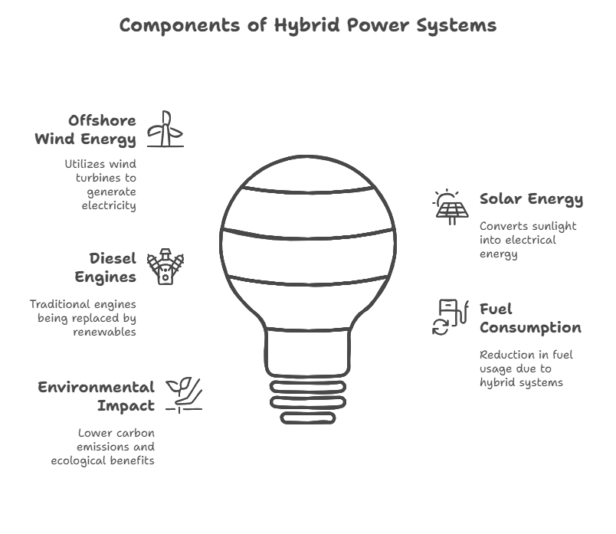

***Figure 1: Components of Hybrid Power Systems***

Furthermore, formulations of drilling fluids such as water-based muds and biodegradable muds improve toxic discharges into oceanic environments [15]. These advancements align with global sustainability goals and emphasize the need for continued innovation in offshore emissions management.

While there have been significant improvements in offshore safety and emissions control, various research gaps still remain. While predictive modeling and real-time monitoring have enhanced spill detection, there is very little application of AI-based autonomous spill containment systems. The deployment of fully automatic response systems would significantly improve offshore emergency preparedness. Also, regulatory compliance is uneven across different jurisdictions, and therefore there is uneven enforcement of safety and environmental regulations. Enhanced international cooperation and the establishment of global offshore drilling standards could correct this.

Although carbon capture and reduction technologies hold promise, their operational complexity and expensive implementation limit mass deployment. Additional research is needed to develop these technologies for maximum efficacy, enhanced cost-reduction, and integration with existing offshore infrastructure. Lastly, opportunities for novel energy transition methods, such as hydrogen-based offshore operations and carbonless drilling operations, are yet unknown. Research must seek to explore the scalability and feasibility of novel substitutes for traditional offshore drilling operations in the future. This study aims to fill these research gaps by outlining a comprehensive approach to enhanced safety and emission control in offshore drilling. Integrating technological innovation, regulatory compliance, and engineering controls, the study also presents future direction for managing offshore operational risk and environmental sustainability.

**2. METHODOLOGY**

The methodology of this study is based on a systematic peer review of literature, a process by which research studies pertaining to offshore drilling safety, emissions, and oil spill prevention are chosen, critically examined, and analyzed. By this method, an entire range of existing literature is carefully evaluated with regard to the extent to which these technologies and controls mitigate environmental risks owing to offshore oil extraction.

In order to identify appropriate literature, a systematic search strategy was applied on four leading academic databases: Google Scholar, Scopus, ScienceDirect, and Environmental Science & Policy. The databases were chosen as they have extensive coverage of environmental science, engineering, and policy-related research. The search entailed the application of a mix of keywords such as "offshore drilling safety," "oil spill prevention," "emissions control in oil extraction," "real-time monitoring in offshore operations," and "regulatory frameworks for oil spill management." Boolean operators such as AND, OR, and NOT were also utilized to narrow down search results and filter out non-relevant studies. Additionally, search filters were applied to narrow down results to journal articles between the years 2019-2025 and that have undergone peer review. The focus of the study is therefore on new developments and regulatory developments.

The initial search resulted in a total of 80 records from the desired databases, 25 of which were from Google Scholar, 20 from Scopus, 20 from ScienceDirect, and 15 from Environmental Science & Policy. After removing duplicates, there were 60 unique records that were screened against their titles and abstracts. Articles that did not concentrate specifically on offshore drilling safety, emission control, and oil spill prevention were rejected, which cut down the articles by 42. The other 18 full-text articles were carefully examined for quality and methodological soundness. Eight studies were then chosen for qualitative analysis since they addressed directly important elements of offshore drilling safety, technological advancements, and regulatory compliance measures. There were some exclusion criteria applied during selection to focus on the research objectives. Research primarily focusing on onshore oil spills or not giving importance to emissions control technologies was excluded. Similarly, articles presenting regulatory opinions without integrating technological or engineering solutions were excluded. Also, studies in non-English language journals were excluded to avoid difficulties in accessing them and lack of uniformity in data interpretation.

Despite the systematic approach adopted, the study has a few limitations. First, only literature from the last five years is reviewed here, which could leave out fundamental studies that have had significant impact on the topic. Also, the utilization of four databases would mean that potential studies of significance in other sources may have been missed. Besides, peer-reviewed journals alone were utilized, excluding government reports, industry white papers, and conference proceedings that may have valuable information. Lastly, since the review is based on secondary data, publication bias is present, where studies with significant findings are more likely to be published and therefore unsuccessful or inconclusive efforts may be overlooked.

Despite such limitations, the research provides a balanced view of the offshore drilling safety, measures for control of emissions, and oil spill prevention as it currently exists. The findings contribute much to arguments for strengthening environmental protection in the petroleum sector through the use of technological advancements as well as robust regulatory enforcement.

**3. RESULTS AND DISCUSSION**

This systematic review reveals advancements in offshore drilling safety, oil spill prevention, and emissions management; it also assesses the effectiveness of technological innovations and regulatory frameworks. From a synthesis of evidence from new studies, this section provides critical assessment of their contribution to environmental sustainability and risk mitigation.

**3.1 Technological Innovations in Oil Spill Prevention and Offshore Safety**

The use of advanced monitoring and automation systems has significantly improved offshore drilling safety and oil spill prevention. Real-time monitoring technologies such as synthetic aperture radar (SAR), hyperspectral imaging, and infrared sensors have enhanced the detection of early oil spills and leaks [16, 17]. Such systems provide high-resolution data that enables rapid containment response, which reduces environmental pollution. Furthermore, remotely operated vehicles (ROVs) and autonomous underwater vehicles (AUVs) are employed to carry out subsea inspections, leak detection, and pipeline repair in hazardous offshore environments [18]. Machine learning and AI-based predictive spill detection models are also transforming risk avoidance strategies as well as risk assessment.

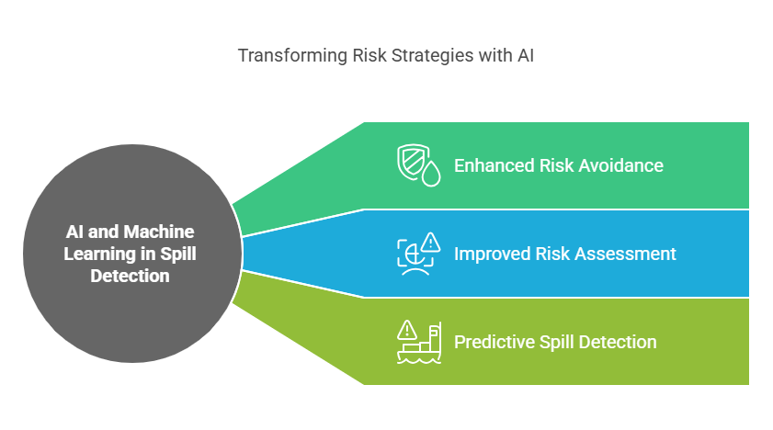

***Figure 2: Impact of AI and Machine Learning in Oil Spill Detection***

AI platforms utilize historical records of spills, drilling conditions, and environmental factors to predict potential blowouts and equipment malfunctions [19, 20]. These predictive capabilities enable proactive maintenance and real-time adjustment of safety conditions, lessening the risk of catastrophic spills. Moreover, artificial intelligence-enabled blowout preventers (BOPs) equipped with shut-in automation has demonstrated increased efficiency in averting well control accidents [21].

Despite these advancements, there are still issues to fully embracing AI-enabled technologies in offshore drilling safety operations. High implementation cost, lack of accessible data, and connectivity in remote offshore areas pose challenges to wider adoption. Future research can focus on further optimizing AI algorithms for offshore conditions, improving the quality of real-time data communication, and maximizing the cost effectiveness of predictive monitoring systems. Addressing these issues will be critical to ensuring offshore AI-based technologies realize their full potential for reducing environmental risks and optimizing operational safety.

**3.2 Regulatory Frameworks and Compliance in Offshore Drilling**

Stringent regulatory systems are a fundamental instrument in enacting safety and environmental policies against offshore drilling. Regulations such as the Oil Pollution Act (OPA) and the International Convention on Oil Pollution Preparedness, Response, and Cooperation (OPRC) demand spill response planning, terms of liability, and environmental risk analysis [22, 23]. Regulation compliance has led to additional safety controls, particularly in high-regulation enforcement regions.

However, variations in enforcement are experienced across jurisdictions. Countries with weak regulatory structures and weak governance institutions find it difficult to ensure compliance with international safety standards [1, 22, 24]. New offshore oil economies in developing nations often lack the capacity and technical ability to implement strict environmental protection measures, leading to heightened risks of oil spills and inadequate response measures.

Conversely, inconsistent regulation among nations creates compliance issues for multinational oil corporations. It may minimize the inconsistencies and maximize compliance among multinational oil corporations by way of a globally harmonized offshore safety system that can include best practices from leading-regulatory agencies. Increased international cooperation, improved cross-border regulatory practices, and encouragement of capacity-building efforts in weakly regulated areas would be key steps toward environmental risk avoidance. Furthermore, industry accountability by means of stricter liability mechanisms, financial penalties, and mandatory environmental insurance can enhance regulatory adherence and spill prevention.

**3.3 Emissions Control Strategies in Offshore Drilling**

Reduction of offshore drilling greenhouse gas (GHG) emissions is a top priority due to rising climate change concerns. Carbon capture and storage (CCS) technology has been very effective in mitigating CO₂ emissions, with offshore CCS activities achieving carbon emissions mitigation of up to 85% [25, 31].

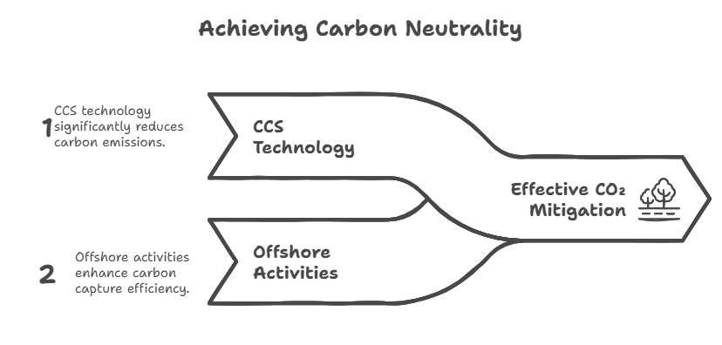

***Figure 3: Mitigating CO₂ Emissions in Achieving Carbon Neutrality***

Additionally, flare gas recovery systems make optimal use of surplus gas as consumable energy, mitigating methane emissions and maximizing efficiency in operations [26]. Hybrid power systems integrating renewable power sources, such as offshore wind and solar, are emerging as potential alternatives to diesel generators for offshore drilling operations [14, 27]. The systems lower fuel usage and carbon footprint by a significant extent [28]. Moreover, advancements in environmentally friendly drilling fluids, such as biodegradable and water-based muds, have minimized toxic discharges to the ocean environment [29, 30].

However, the extensive use of low-emission technologies is constrained by exorbitant maintenance and installation costs. The fiscal justification of CCS and flare gas recovery systems is of pressing interest to offshore operators. Government subsidies and industry incentives on CCS deployment would accelerate implementation while making such technologies more affordable to offshore operators. Future research needs to focus on optimizing CCS operations, cost reduction, and other low-emission alternative technologies such as hydrogen-fueled offshore drilling and carbon-free energy sources.

**3.4 Research Gaps and Future Directions**

Despite enhanced offshore drilling safety and emissions control, there are areas of knowledge gaps that must be filled. Though AI-based spill detection has expedited response time, the employment of fully autonomous containment systems remains in the prototype phase. Subsequent research is required to focus on robotic containment booms, dispersant placement via AI coordination, and auto-cleanup systems to enhance spill response efficiency [19, 21].

Moreover, real-time transmission of data is still an issue in remote offshore environments due to connectivity limitations. Advances in satellite-based and underwater communication networks would improve the dependability of real-time monitoring with little latency even in remote environments [16]. Regulatory inconsistency between jurisdictions is still an obstacle to successful compliance. While some jurisdictions have stringent safety controls, others lack the infrastructure and capability to implement international standards. Future research needs to take into account strategies for harmonizing offshore safety regulation and, in specific terms, capacity-building activities in jurisdictions that are currently under-regulated [22, 24]. Strong international cooperation and formation of industry-regulator relationships will be essential to global safety compliance.

On a final note, while carbon capture and emission reduction technology holds much promise, the cost and infrastructure demands are a major hindrance to its application. Research must be directed at optimizing CCS processes, reducing costs, and exploring alternative technologies such as hydrogen-fueled drilling and incorporating renewable power into offshore production [25- 27]. Bridging these gaps will play a crucial role in developing more eco-friendly offshore drilling practices.

**4. CONCLUSION**

This review highlights the key role of technological innovation and regulation in enhancing offshore drilling safety, oil spill prevention, and emission reduction. Technologies such as real-time monitoring, predictive modeling, and automation have significantly increased spill detection and response capability, while regulatory systems have enhanced industry compliance. However, there are challenges, particularly in regulatory inconsistencies, prohibitively high costs of emission-reduction technologies, and the need for further automation in spill containment. In the future, it will be essential to overcome these challenges through policy incentives, regulatory convergence, and collaborative research. Encouraging collaboration between oil companies, regulatory agencies, and environmental researchers can result in the adoption of new safety and sustainability practices, which will lead to safer and more environmentally sound offshore drilling operations.

**COMPETING INTERESTS DISCLAIMER**:

Authors have declared that they have no known competing financial interests OR non-financial interests OR personal relationships that could have appeared to influence the work reported in this paper.

Disclaimer (Artificial intelligence)

Author(s) hereby declare that NO generative AI technologies such as Large Language Models (ChatGPT, COPILOT, etc.) and text-to-image generators have been used during the writing or editing of this manuscript.

**REFERENCES**

1. Ochulor OJ, Sofoluwe OO, Ukato A, Jambol DD. Technological advancements in drilling: A comparative analysis of onshore and offshore applications. World Journal of Advanced Research and Reviews. 2024;22(2):602-611.

2. El Moussaoui N, Idelhakkar B. The impact of oil spills on the economy and the environment. European Journal of Economic and Financial Research. 2023;7(4). 10.46827/ejefr.v7i4.1570.

3. Brkić D, Praks P. Probability analysis and prevention of offshore oil and gas accidents: Fire as a cause and a consequence. Fire. 2021;4(4):71.

4. Shah G, Soni V. Comprehensive insights into the impact of oil pollution on the environment. Regional Studies in Marine Science. 2024:103516.

5. Vazquez-Botello A, Ponce-Velez G, Soto LA, Villanueva S. Black Tides: Petroleum in the Ocean. InCoastal and Deep Ocean Pollution 2020 Mar 10 (pp. 3-40). CRC Press.

6. Jayarathna MD, Rajapaksha AU, Samarasekara S, Vithanage M. Oil Spill Response: Existing Technologies, Prospects and Perspectives. Clean Materials. 2024;1(1):71-96. doi.org/10.1002/clem.17

7. Shindell D, Ravishankara AR, Kuylenstierna JC, Michalopoulou E, Höglund-Isaksson L, Zhang Y, et al. Global methane assessment: Benefits and costs of mitigating methane emissions. United Nations Environment Programme; 2021 May 6.

8. Isiah G. Oil Exploitation and Environmental Sustainability in the Middle East: Issues and Solutions. Influence: International Journal of Science Review. 2024;6(2):90-98.

9. Lekamge SA, Mahawaththa I, Weerasinghe SD. Offshore Oil and Gas Operations: Environmental Impacts and Mitigation Methods. Coastal and Marine Pollution: Source to Sink, Mitigation and Management. 2025:67-87.

10. Hammoud B, Wehn N. Recent Advances in Oil-Spill Monitoring Using Drone-Based Radar Remote Sensing [Internet]. Environmental Sciences. IntechOpen; 2023. Available from: http://dx.doi.org/10.5772/intechopen.106942

11. Sevgili C, Fiskin R, Cakir E. A data-driven Bayesian Network model for oil spill occurrence prediction using tankship accidents. Journal of Cleaner Production. 2022;370:133478.

12. Nasiri H. Managing Undersea Pipeline Damage: Strategies for Prevention, Response, and Recovery. InNinth International Conference on Civil, Structural and Seismic Engineering, Iran 2024;1-12.

13. Hernandez M. Interim Support Project: Assessment of the Wider Caribbean Region's Oil Spill Preparedness and Response Capabilities December 2023. International Oil Spill Conference Proceedings 2024 (Vol. 2024, No. 1). Allen Press.

14. Khurshid H, Mohammed BS, Al-Yacoubya AM, Liew MS, Zawawi NA. Analysis of hybrid offshore renewable energy sources for power generation: a literature review of hybrid solar, wind, and waves energy systems. Developments in the Built Environment. 2024:100497. doi.org/10.1016/j.dibe.2024.100497

15. Yang J, Sun J, Wang R, Qu Y. Treatment of drilling fluid waste during oil and gas drilling: A review. Environmental science and pollution research. 2023;30(8):19662-19682.

16. Yekeen ST, Balogun AL. Advances in remote sensing technology, machine learning and deep learning for marine oil spill detection, prediction and vulnerability assessment. Remote Sensing. 2020;12(20):1-31.

17. Ma J, Ma R, Pan Q, Liang X, Wang J, Ni X. A global review of progress in remote sensing and monitoring of marine pollution. Water. 2023;15(19):3491.

18. Dias A, Mucha A, Santos T, Oliveira A, Amaral G, Ferreira H, et al. Oil Spill Mitigation with a Team of Heterogeneous Autonomous Vehicles. Journal of Marine Science and Engineering. 2024;12(8):1281.

19. Arinze CA, Izionworu VO, Isong D, Daudu CD, Adefemi A. Integrating artificial intelligence into engineering processes for improved efficiency and safety in oil and gas operations. Open Access Research Journal of Engineering and Technology. 2024;6(1):39-51.

20. Ok E, Joseph G. Preventing Drilling Incidents and Protecting the Environment with Real-Time Fluid Monitoring and Predictive Analytics.

21. Benny A, VR R. A review of risk analysis and accident prevention of blowout events in offshore drilling operations. Safety in Extreme Environments. 2025;7(1):1.

22. Ogbu AD, Ozowe W, Ikevuje AH. Oil spill response strategies: A comparative conceptual study between the USA and Nigeria. GSC Advanced Research and Reviews. 2024;20(1):2082-27.

23. Salvi RG, Singer E, Sahlit SD, Leite LM, Burger K, Steer R. Benchmark and Legal Framework Study on Oil Spill Prompt Response and Contingency Resources for Oil & Gas Offshore Structures: A Global Cooperation. InInternational Oil Spill Conference 2021 May 1 (Vol. 2021, No. 1, p. 690820).

24. Seyyedattar M, Zendehboudi S, Butt S. Technical and non-technical challenges of development of offshore petroleum reservoirs: Characterization and production. Natural Resources Research. 2020;29(3):2147-2189.

25. Ibigbami OA, Onilearo OD, Akinyeye RO. Post‐combustion capture and other Carbon Capture and Sequestration (CCS) technologies: a review. Environmental Quality Management. 2024;34(1):e22180.

26. Elgarahy AM, Hammad A, Shehata M, Ayyad A, El-Qelish M, Elwakeel KZ, et al. Reliable sustainable management strategies for flare gas recovery: technical, environmental, modeling, and economic assessment: a comprehensive review. Environmental Science and Pollution Research. 2024 (19):27566-608.

27. Igbinenikaro OP, Adekoya OO, Etukudoh EA. Conceptualizing sustainable offshore operations: Integration of renewable energy systems. International Journal of Frontiers in Science and Technology Research. 2024;6(02):031-43.

28. Chen H, Wang Y, Wang Q, Song H, Li J. An overview of green offshore electric energy systems: Types, advances, potential challenges, and solutions. International Journal of Green Energy. 2025:1-4.

29. Ikram R, Mohamed Jan B, Sidek A, Kenanakis G. Utilization of eco-friendly waste generated nanomaterials in water-based drilling fluids; state of the art review. Materials. 2021;14(15):4171.

30. Ekunke OV, Nzereogu SK, Oluyimika JO, Okiemute RO, Agbonze NG, Ugbine OF, et al. Advancements in eco-friendly drilling fluids: A review of recent innovations and their environmental impacts. International Journal of Advanced Engineering and Management. 2024;9:179-187.

31. Kweku DW, Bismark O, Maxwell A, Desmond KA, Danso KB, Oti-Mensah EA, Quachie AT, Adormaa BB. Greenhouse Effect: Greenhouse Gases and Their Impact on Global Warming. J. Sci. Res. Rep. [Internet]. 2018 Feb. 15 [cited 2025 Apr. 2];17(6):1-9. Available from: https://journaljsrr.com/index.php/JSRR/article/view/830