Integrating Advanced Wastewater Treatment Technologies for Sustainable Water Resource Management in the United States

.

ABSTRACT

|  |
| --- |
| **Aim:** To examine the integration of advanced wastewater treatment technologies for sustainable water resource management in the United States.  **Problem Statement:** The increase in industrialization and rise in the population of citizens in the United States have resulted in increase in the volume of industrial and domestic wastewater generated. This also contributes to scarcity of water due to high demand. The increased in the volume of wastewater generated has resulted into rise in the toxic pollutants in the environment when they wastewaters are discharged into lagoons and rivers.  **Significance of Study:** There is need to develop and incorporate advanced wastewater treatment technologies asides the previous insufficient and inefficient methodologies to tackle the problems of environmental pollution and water scarcity in order to meet up with the SDGs stated by the United Nations.  **Methodology:** This review article was compiled with the aid of published articles and relevant books downloaded from scopus, google and other research journal database in the area of advanced wastewater treatment technologies and sustainable water resource management.  **Discussion:** In this article, the problems emanating from the discharge of wastewater into the environment together with limited supply of water are discussed. The need to control these two menaces is examined through the incorporation of advanced water treatment technologies which include advanced oxidation process, ultrasound technique, membrane bioreactor, advanced green technologies and hydrodynamic cavitation technology. The article discusses how useful end-products can be made from the wastewater treatment for water resource management sustainability and circular economy purposes. The various steps required in wastewater treatment are also examined while Arizona was cited as a case study.  **Conclusion:** Sufficient volume of water can be generated from wastewater treatment facilities to support suburban populations and cities in the United State to tackle the problem of water scarcity. In conclusion, building of more wastewater treatment facilities in the United States is imperative for further waste minimization, curbing discharge of harmful effluents and making sufficient water available to support suburban populations and cities while the circular economy is maintained as well. |

*Keywords: Wastewater Treatment,* *Water Resource Management, United States, CLEAN Water and Sanitation, Water Pollutants*

1. INTRODUCTION

Different activities such as agricultural, households and industrial have led to the emergence of wastewaters on daily basis having varying compositions [1]. These effluents coming from various sectors comprise of inorganics, nitrogenous organics, organic carbon, heavy metals and suspended/dissolved solids. A case study was reported in China where huge SARS-CoV viral infection spread was linked to contaminated wastewater having aerosolized droplets. SARS-CoV-2 existence in wastewater was noticed and the potential transmission risk was given an alert of this virus via wastewater while focusing specially on the workers in the wastewater treatment plants. Additionally, other diseases can also be transferred from wastewater. For instance, millions of lives are usually lost on yearly basis due to typhoid, cholera, dysentery and other diarrheal ailments due to poor sanitation. Thus, improper management and disposal of wastewaters into water bodies has caused serious havoc in the society [2]. Also, industrialization and urbanization have adversely contributed to the environmental pollution through the discharge of untreated wastewaters. Societies around the global are now facing different kinds of challenges in the modern environment and thus, inclination towards sustainable development is now imperative in many areas of life. It is vital in making sure that huge focus is placed on sustainable development together with the identification and rectification of activities that are adversely contributing to the societies.

Currently the United States government is now showing serious concern regarding negativities and adversities being caused by individuals and industries to the environment and society at large. Asides this, significant institutes have been engaged in contributing positively to some wastewater management cases together with other numerous challenges. Considering the established facts of resources scarcity, there is need for societies to ensure optimal resources utilization while simultaneously giving huge focus on sustainable development [3]. Also, effective wastewater treatment contributes to the circular economy. The concept of circular economy is built in ensuring persistent, consistent and regular supply chain economy of materials, products and raw materials for longer period of time. Also, circular economy ensures waste treatment as secondary raw material in order to reuse them and form part of the supply chain economy. The strengths of the wastewater treatment plants in positively influencing the circular economy are water reusability; and nutrients and energy recovery. Wastewater treatment facility contribution to SDGs has been seriously analyzed by several studies since the adoption and inception of SDGs in 2015 [4].

Many of the studies were, however, focusing on contributing to clean water and sanitation as one of the SDGs or implementing a multi-criteria decision analysis to estimate the increasing wastewater technologies while targeting their contribution to the improvement of circular economy [5]. Additionally, the analysis of wastewater treatment facilities on other SDGs have not been critically analyzed by many of the previous studies which makes the provision of guideline on enhancing the contribution by decision-maker to be difficult. The primary objectives of wastewater treatment include coarse particles removal, pollutants extraction, toxicants elimination and killing of potential pathogen. This is to ensure that the effluent containing the remaining clean water can be discharged into the environment in order to meet different purposes. It has been estimated that approximately 770 million people around the globe do not have accessibility to safe and clean water for both domestic and drinking purposes [6]. Treatment of wastewater is targeted at increasing water availability for usage and minimizing pressure on natural water resources. Wastewater treatment is now one of the best dependable alternatives to enhance water sustainability due to the increase in water scarcity accorded with rise in its demand and encroachment of drought conditions. More pressure will continuously be exerted on natural resources due to the increase in human population needing clean water for industrial and domestic purposes. There is high risk of serious water shortages alongside ailments that are linked with contaminated water, to be faced by the whole world if sustainable measures are not put into places for water management [7].

Water scarcity is a either man-made or natural problem. Greater than 700 million people around the globe are currently living in different countries with a prolonged water shortage [4]. The number of people who face water scarcity has been estimated by the United Nations Water to rise to approximately 1.8 billion by 2025 [5]. The increase in the climate change hazard is additionally forcing greater than 50% of the world population to be living in areas where water shortage is their major challenge. The sub-Saharan Africa regions are the most likely affected because they presently account for the highest number of water-stressed countries around the world. Nonetheless, between 70 and 250 million people have been estimated by the United Nations to face severe water shortages in Africa [8]. It is imperative to take necessary steps for quick reversal of the disastrous effects of living in the absence of safe and clean water for agriculture, drinking or industrial usage by adopting advanced wastewater treatment technologies.

Larger volume of wastewater in the United States originates from industries, homes and businesses. In homes, water from bathtubs, toilets, dishwashers, showers, sinks and washing machines is usually channeled via collection pipes into sewage treatment plants. Industrial-based processes like cooling and manufacturing usually generate wastewater that may possibly contain solid particles and chemicals. Some businesses set-up in the United States such as restaurants and hotels also generate substantial volumes of wastewater which is needed to be cleaned and provided for the next use [9]. Water treatment is usually structured to meet up with “fit-for-purpose specifications” for the particular next use. The requirements that should be met in order to protect the environment and the public from the possible dangers linked with wastewater are the “fit-for-purpose specifications”. Contaminated water may subject consumers to different public health problems such as dysentery, cholera outbreaks and typhoid. The debris and decaying organic matter in wastewater discharged into oceans and lakes can consume the dissolved oxygen needed by fishes and other aquatic life for survival [10].

The connectivity between wastewater treatment and sustainable resource management has not been satisfactorily addressed despite it has received noteworthy research attention. Many of the present literature has emphasized on different methods of wastewater treatment while little consideration was given to sustainability. Some relevant wastewater treatment techniques examined in previous studies are physical treatment, sludge treatment, biological organisms utilization and chemical treatment [7]. The fundamental steps of wastewater treatment which are majorly screening and pumping; and primary, secondary and sludge treatment have been explored by previous studies. However, wastewater treatment processes are principally function of the intended use. Figure 1 represents the flow chart of common wastewater treatments categorized as physical, chemical, biological and advanced treatments. The physical treatment method emphasizes on large solids separation through the use of filters or screens. The conversion of contaminants in wastewater into precipitated solids is achieved via chemical treatment method. In biological treatment, microorganisms and bacteria are utilized to break down organic matters available in the wastewater. The advanced treatment methods require using membrane filtration; adsorption process with aid of activated carbon; disinfection using ultraviolet radiation and chlorine; and advanced oxidation [[11].

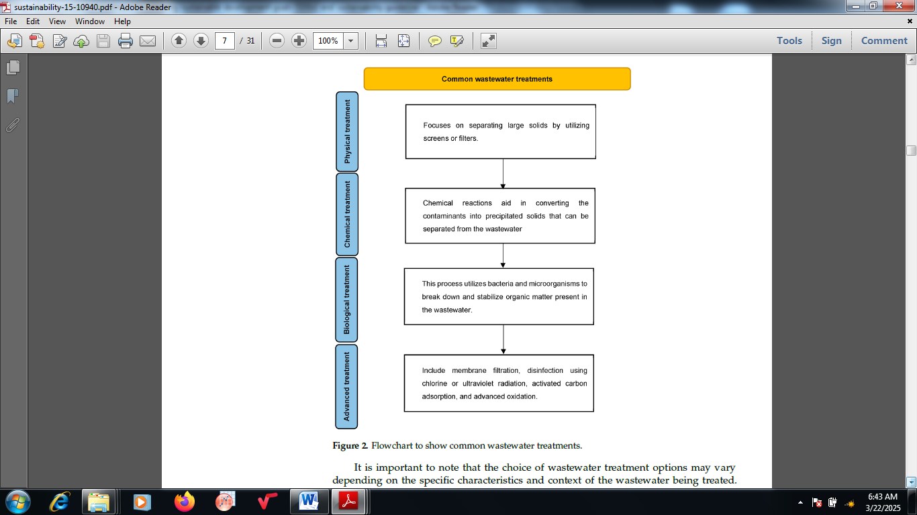

Figure 1: Flowchart indicating common wastewater treatments [4]

The main target of sustainability is to ensure there is adequate clean water needed by the present generation without jeopardizing the potential of prospective generations to get the same commodity [12]. The accessibility of water is usually limited despite the established fact that water is among the most abundant natural resources present on the planet. There is low water accessibility to sustainable and clean water by people living in arid and semi-arid areas. Thus, critical examination and incorporation of advanced wastewater treatment technologies for sustainable water resource management is needed to be discussed. In this paper, the integration of advanced wastewater treatment technologies was discussed in order to ensure sustainable water resource management in the United States [13].

2.0 Wastewater Treatment Technologies and Sustainability

The transformation of wastewater into a valuable resource involves a change in pattern which adopts technology to address the problems faced in water sanitation and supply. In the past, wastewater was perceived as a liability and a potential origin of diseases. Wastewater is usually avoided by people through the creation of channels via which the chemicals, sludge and other related sold matter present in wastewater can be carefully discharged to reduce the harm caused to the human population. However, people living in arid and semi-arid locations have usually been mandated to find alternatives via which conversion of wastewater into domestic and economic use can be achieved [14]. Wastewater treatment has been proved to be a principal contributor to the circular economy. In view of this, consideration has been given to wastewater as a treasured resource, rather than being a liability. Products and materials regeneration and reuse are the major priorities of circular economy in order to reduce pressure on natural resources while the environmental sustainability is being supported.

Wastewater treatment is now an essential origin of clean water, energy, nutrients and fertilizers. For example, it has become a vital origin of biogas which can be utilized for both domestic and industrial purposes. Energy production from this source lowers tension on natural resources and over-dependence on fossil fuels. Ways via which wastewater can be transformed into useful products have now been realized by many governments globally rather than disposing in nearby lakes, rivers or oceans [15]. Nonetheless, the numerous advantages attached to its transformation have created substantial interest from policy makers who are looking for other options to enhance their economic growth. Various initiatives have been developed by some notorious organizations such as the World Bank targeting raising of awareness regarding the potentials that wastewater possess as a resource. Global initiatives guiding the financing and planning of resource recovery after wastewater treatment are seriously needed [12].

There is need for policy makers to develop different procedures via which wastewater conversion into useful resources can be promoted. The awareness based on the advantages of wastewater treatment in different parts of the world is still minute. Moreover, the decentralized technique to achieve this has proved to be more effective than the centralized method. The decentralized technique allows individuals to engage in the treatment. This may involve domestic reservoirs establishment where wastewater is gathered and directed to the treatment facilities. A substantial quantity of this emanates from domestic actions such as cooking and washing. It is imperative for Individuals to understand routes via which rain-water runoffs can be directed to the treatment facilities [16].

Many financial institutions like the World Bank have been influential in funding different projects targeted at valuable products recovery from wastewater after treatment. The achievement of sustainable development goals (SDGs) in different countries has been linked to wastewater management. Particularly, the SDG 6 is targeted towards ensuring easy accessibility to sanitation and safe drinking water focusing on wastewater treatment, management of sustainable water resource and preservation of ecosystem [9]. The objectives of SDG for wastewater treatment include reduction of people’s number exposed to water scarcity, water quality improvement, achievement of water use efficiency and attainment of an integrated water resource management system. Clean water for washing, cooking, drinking and other domestic purposes can be provided through wastewater treatment. Treated water can also be recycled back into industrial plants to enhance different needs if the quality is satisfactory. Clean water supply can also be enhanced by treated wastewater particularly in locations where there is scarcity of water. The improvement in water supply lowers the number of the global population experiencing different problems linked with water scarcity. Wastewater treatment is a noteworthy technique towards attaining sustainable development goals and enhancing people’s health around the world [10].

2.1 Stages of wastewater treatment

Figure 2 depicts the three major steps required for wastewater treatment which are primary treatment, secondary treatment, and tertiary treatment. The screening of the collected wastewater is executed at the sludge treatment and preliminary treatment indicated at the beginning. Both fine and coarse solid materials are removed via mechanical means after passing the wastewater through the screen. More than 60% of the solid materials are removed at this stage. The percentage removal is a function of the desired use of the final product. More than 80% of the solid materials may be removed in cases where the purpose of water treatment is for drinking. The materials are either burnt or buried once removed [17].

The primary treatment stage is the second stage where channeling of the wastewater into holding tanks to allow settling of the solid particles at the bottom is executed such that chemicals like oil float at the top [5]. A substantial volume of impurities available in the wastewater is removed at this stage where effluent or wastewater is allowed to pass slowly through grit tanks in order to allow the fine sand particles to settle down. There is still the possibility of finer sand particles to be suspended in the wastewater. To remove these, the wastewater passes into series of big primary sedimentation tanks where sludge is formed from solid material. Approximately 70% of the suspended solid materials are removed at the primary treatment stage. The left over liquid often comprises of very fine solids in dissolved matter nature. All the solid materials must be removed from water during this stage in order to make it suitable for cooking and drinking purposes. In cases of irrigation, the wastewater may be utilized if solid materials and potentially toxic chemicals are absent [12].

The organic compounds of the solid waste is broken down with the aid of aerobic bacteria integrated into the treatment system at the secondary treatment stage which is structured to eliminate about 90% of the suspended solid materials present in the wastewater. Aerobic bacteria provide the oxidative energy needed for organic materials dissolution [3]. The suspended materials removal rate using the microorganisms is a function of the volume of oxygen available. Activated sludge and filter beds are the main techniques which could be applied to eliminate the dissolved materials present in the wastewater during secondary treatment [7].

In the tertiary treatment, toxic compounds such as nitrogen and phosphorus compounds which are difficult to be eliminated during the first-two treatment stages are removed. About 40% of the chemicals or toxic compounds in the wastewater can only be removed by both the secondary and primary treatments [18]. Different tools such as filter membranes, UV lights and other kinds of disinfectants are employed during the tertiary treatment in order to ensure that toxic compounds which may be hazardous to plants and humans are absent in the treated water. The final product is subjected to screening to ascertain that chemicals or other potentially toxic compounds are absent [14].

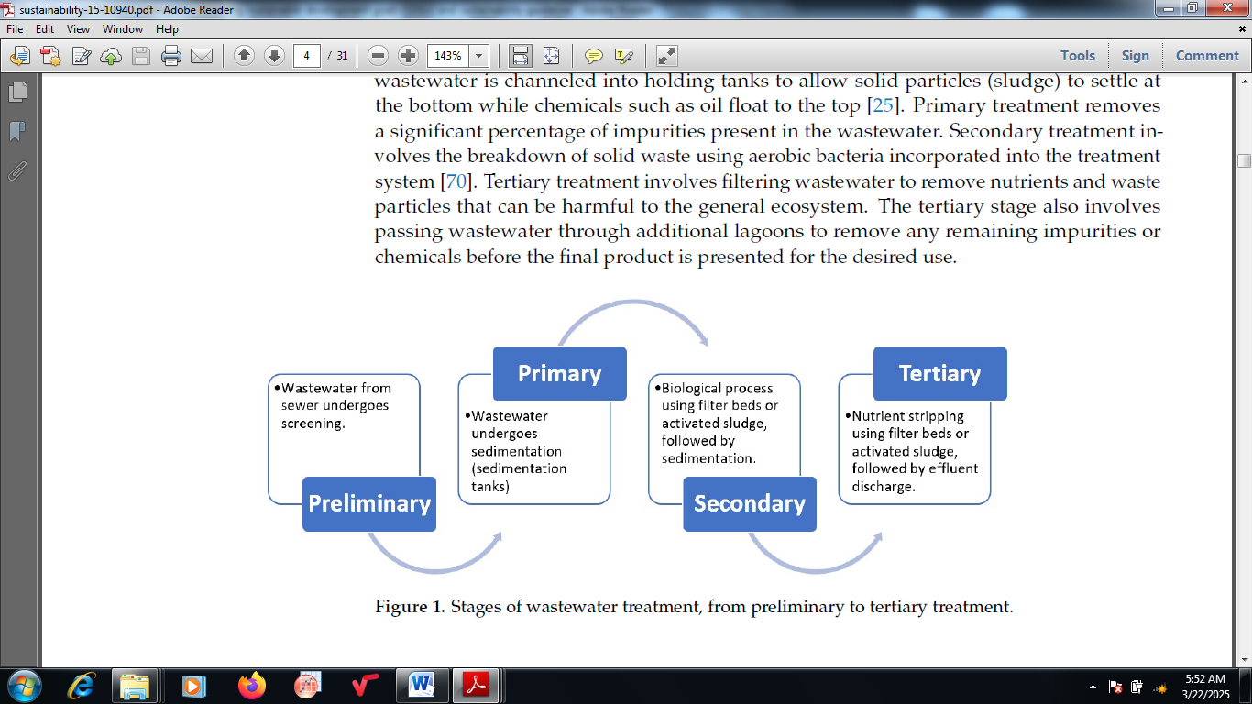

Figure 2: Stages of wastewater treatment

3.0 Advanced Wastewater Treatment Technologies

The conventional techniques of wastewater management are not adequate for the rising streams of polluted wastewater from industrial and municipal activities. This resulted from the increase in the quantities of wastewater and the pollution rate. Thus, there is need to develop and design innovative and advanced wastewater treatment technologies to ascertain the safety of industrial and municipal wastewater discharged into the ecosystems [19]. This involves using majorly hybrid techniques where two or more treatment methods are merged to fulfill the quality of discharged water that is needed. The hybrid systems save time, energy consumption, operational space and cost. The advanced wastewater treatment technologies are discussed thus:

* **Advanced oxidation process**

The mechanism of operation using advanced oxidation process (AOP) involves disintegrating the organic contaminants in the contaminated wastewater into CO2, H2O and simpler products using hydroxyl radical (•OH). Two approaches can be adopted in integrating AOPs into membrane technologies [15]. The first comprises performing the AOP in two stand-alone units as a pre-treatment stage under post-treatment or membrane fouling. The second approach involves combining the two processes together in the same reactor forming a hybrid system which is more preferred as a result of its attached benefits such as better efficiency, lower-space needed for the treatment unit and ease of operation as a result of high filtrated flux aided by electrostatic force. The challenges of using membrane fouling are reduced as a result of the contaminants’ electrochemical oxidation which extends the membrane’s life span, gives better removal efficiency, performs at the same voltage and promotes the design compactness. Thus, mass transfer enhancement and energy consumption reduction are achieved as a result of the organic contaminants drag [20].

* **Ultrasound technique**

This technique uses hydro-mechanical shear forces and high oxidant compounds like H2O2, H•, and OH• to break down various organic and toxic pollutants into biodegradable and simple compounds. The major shortcomings of this technique include high operating and capital costs; and low removal efficiency in cases where the volume of wastewater to be treated is large with highly variable compositions when used lonely [21]. The ultrasound technique is merged with other processes such as adsorption, advanced oxidative process, membrane treatment and nanotechnology to tackle the aforementioned obstacles [16].

* **Membrane bioreactor**

In membrane bioreactor, both membranes and aeration are incorporated into the bioreactor to remove organic compounds. The major benefits of this technique include small footprint, high efficiency, low maintenance requirement, low sludge production and capacity to treat various types of wastewaters [21]. Additionally, there is high treatment stability as a result of the microorganisms or biocatalyst being retained within the hybrid system. However, clogging and fouling of the membrane are the major drawbacks as frequent cleaning is required which increases the cost of operation because pressure is needed to be applied which subsequently decreases the lifespan of the membrane [22].

* **Advanced green technologies**

These types of technologies rely on non-toxic chemical processes and clean energies in collaboration with environmental monitoring to reduce the negative influences caused by human activities. Provision of high-end products while the environmental sustainability is not compromised is the major objective of using green technologies [17]. One of the widely acceptable technologies in this category is the vermifiltration which comprises a biofilter cultivated with earthworms in order to support organics decomposition into compost which is very useful in making fertilizer. The mechanism involves passing of raw wastewater via the activated layer where the transformation of the organics into humus supported vermicompost occurs [10]. Then it is channeled via filter media where effluent clarification, microorganisms enhancement, and trapping of the dissolved and suspended solids in the wastewater take place. Figure 3 presents the mechanism of vermifiltration technology. The major pollutants of target are organic matters, solids, total nitrogen, total phosphorus and pathogens [18].

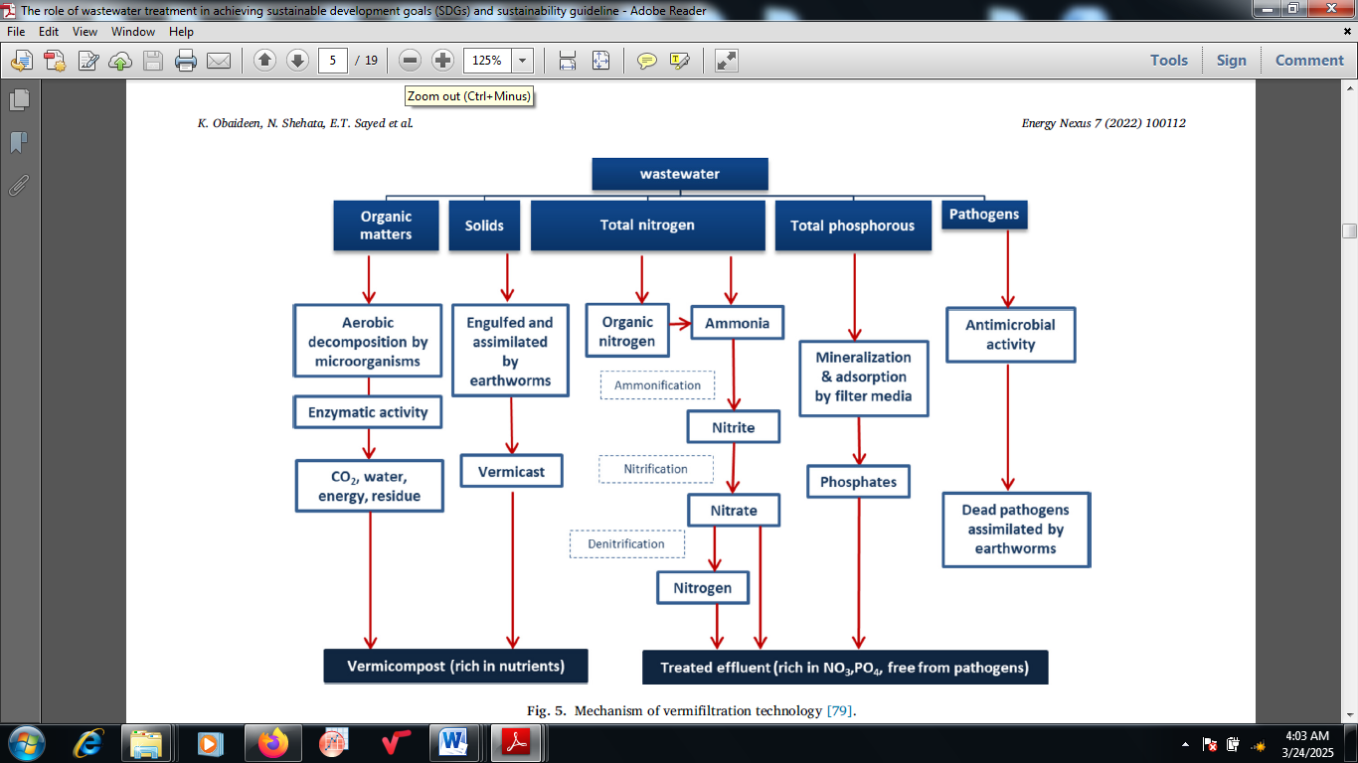

Figure 3: Vermifiltration technology mechanism [5]

* **Hydrodynamic cavitation technology**

Hydrodynamic cavitation as a technology of wastewater treatment relies on the development of microbubbles as a result of the pressure drop generated within the system and increase in the fluid velocity increase [8]. Active spots are produced due to cavities collapse together with sufficient energy needed for the water molecules dissociation into strong oxidative radicals and generation of a high mechanical shear force occurs which is sufficient for the pollutants degradation [23]. The complex compounds biodegradability is increased by the effects and make the treatment to be easier.

3.1 Sustainable Water Resource Management in the United States: Arizona as a case study

Achieving sustainability may be a difficult task despite seeing sustainability concept as instrumental in making ideal urban growth policies giving consideration to water and its uses. With reference to freshwater, sustainability is known to be water provision for both the environment and people taking note of generations to come as well. Regrettably, plans put in place for the growth of urban locations hardly appreciate this definition for water policy [24]. Instead, the focus is principally on new supplies pursuit to enable future growth without considering the required environmental water. Water conflict is now a hallmark in the southwestern United States. Rapid economic and urban expansion is now being facilitated in the 20th Century by large-scale water infrastructure projects at the expense of the environment. Diminishing of surface flow is being experienced at some regions due to rise in pumping groundwater modified with hydrologic regimes in the entire western United States. Continuous expansion of cities and populations is observed in the western United States calling for the need to enhance how sustainable water use can be moved forward [25]

In Arizona as a case study, the population has been predicted to double by 2050 coupled with projected depletion of streamflow documented in the entire state [18]. Out of the state’s thirty-three native fish species, only seventeen has status under the U.S. Endangered Species Act. Human aquatic habitats modification and non-native species introduction have resulted in driving three fish species (Monkey Spring pupfish, Las Vegas dace and Pahranagat spinedace) within the Colorado River Basin into extinction. There is possibility of depletion of further stream flow and imperilment of additional species if actions are not taken to reverse the present trends [21]. A scenario-based assessment approach can be developed in Arizona to serve as an instrument to explore water sustainability for both the environment and people using water management strategies [23].

4. Conclusion

During wastewater treatment, pollutants are extracted, coarse particles are neutralized, toxicants are eliminated and pathogens are killed purposely to make provision for clean water used in cooking, drinking and others. Waste is eliminated through wastewater treatment by making sure that transformation of dirty water into useful products such as clean water, energy and fertilizers is executed. Sufficient nutrients are also provided via wastewater treatment which can improve the yield of crops when applied for agricultural purposes. In the United States, sustainable resource management can be attained via reduction of water waste, rise in clean water supply, conversion of waste to energy, development of sustainable communities and cities, and being responsible for production and consumption. There is high contribution and interconnectivity between all these elements and the sustainable development goals. In conclusion, possibility of advancing towards the achievement of fair access and universal sanitation and clean water is assured in the United States if the implementation of sustainable waste-to-energy solutions and water conservation promotion can be implemented.

COMPETING INTERESTS DISCLAIMER:

Authors have declared that they have no known competing financial interests or non-financial interests or personal relationships that could have appeared to influence the work reported in this paper.

Disclaimer (Artificial intelligence)

Option 1:

Author(s) hereby declare that NO generative AI technologies such as Large Language Models (ChatGPT, COPILOT, etc.) and text-to-image generators have been used during the writing or editing of this manuscript.

References

1. Rashid, R.; Shafiq, I.; Akhter, P.; Iqbal, M.J.; Hussain, M. A state-of-the-art review on wastewater treatment techniques: The effectiveness of adsorption method. Environ. Sci. Pollut. Res. 2021, 28, 9050–9066.

2. Sardana, A.; Cottrell, B.; Soulsby, D.; Aziz, T.N. Dissolved organic matter processing and photo-reactivity in a wastewater treatment constructed wetland. Sci. Total Environ. 2023, 648, 923–934.

3. Liang, Y.; Zhu, H.; Banuelos, G.; Yan, B.; Zhou, Q.; Yu, X.; Cheng, X. Constructed wetlands for saline wastewater treatment: A review. Ecol. Eng. 2022, 98, 275–285.

4. Zeng, S.; Chen, X.; Dong, X.; Liu, Y. Efficiency assessment of urban wastewater treatment plants in China: Considering greenhouse gas emissions. Resour. Conserv. Recycl. 2019, 120, 157–165.

5. Arora, S.; Saraswat, S.; Vermifiltration as a natural, sustainable and green technology for environmental remediation: a new paradigm for wastewater treatment process, Curr. Res. Green Sustain. Chem. 4, 2023, 100061.

6. Awad, H.; Alalm, M.G.; El-Etriby, H.K. Environmental and cost life cycle assessment of different alternatives for improvement of wastewater treatment plants in developing countries. Sci. Total Environ. 2024, 660, 57–68.

7. Baskar, A.V.; Bolan, N.; Hoang, S.A.; Sooriyakumar, P.; Kumar, M.; Singh, L.; Jasemizad, T.; Padhye, L.P.; Singh, G.; Vinu, A.; Recovery, regeneration and sustainable management of spent adsorbents from wastewater treatment streams: A review. Sci. Total Environ. 2023, 822, 153555.

8. Canaj, K.; Mehmeti, A.; Morrone, D.; Toma, P.; Todorovi´c, M. Life cycle-based evaluation of environmental impacts and external costs of treated wastewater reuse for irrigation: A case study in southern Italy. J. Clean. Prod. 2021, 293, 126142.

9. Zhang, J.; Wang, H.; Shao, Y.; Liu, G.H.; Qi, L.; Dang, W.; Yuan, J.; Li, Y.; Xia, Z. Analysis on common problems of the wastewater treatment industry in urban China. Chemosphere 2022, 291, 132875.

10. Sun, Y.; Chen, Z.; Wu, G.; Wu, Q.; Zhang, F.; Niu, Z.; Hu, H.Y. Characteristics of water quality of municipal wastewater treatment plants in China: Implications for resources utilization and management. J. Clean. Prod. 2016, 131, 1–9.

11. Ghimire, U.; Sarpong, G.; Gude, V.G. Transitioning wastewater treatment plants toward circular economy and energy sustainability. ACS Omega 2021, 6, 11794–11803.

12. Yoshida, H.; Mønster, J.; Scheutz, C. Plant-integrated measurement of greenhouse gas emissions from a municipal wastewater treatment plant. Water Res. 2023, 61, 108–118.

13. Fito, J.; Van Hulle, S.W. Wastewater reclamation and reuse potentials in agriculture: Towards environmental sustainability. Environ. Dev. Sustain. 2021, 23, 2949–2972.

14. Kamble, S.; Singh, A.; Kazmi, A.; Starkl, M. Environmental and economic performance evaluation of municipal wastewater treatment plants in India: A life cycle approach. Water Sci. Technol. 2019, 79, 1102–1112.

15. Liao, Z.; Chen, Z.; Xu, A.O.; Gao, Q.; Song, K.; Liu, J.; Hu, H.Y. Wastewater treatment and reuse situations and influential factors in major Asian countries. J. Environ. Manag. 2021, 282, 111976.

16. López-Morales, C.A.; Rodríguez-Tapia, L. On the economic analysis of wastewater treatment and reuse for designing strategies for water sustainability: Lessons from the Mexico Valley Basin. Resour. Conserv. Recycl. 2019, 140, 1–12.

17. Ofori, S.; Puškáˇcová, A.; R° užiˇcková, I.; Wanner, J. Treated wastewater reuse for irrigation: Pros and cons. Sci. Total Environ. 2021, 760, 144026.

18. Singh, R.; Samal, K.; Dash, R.R.; Bhunia, P. Vermifiltration as a sustainable natural treatment technology for the treatment and reuse of wastewater: A review. J. Environ. Manag. 2024, 247, 140–151.

19. Lu, Z.; Loftus, S.; Sha, J.; Wang, W.; Park, M.S.; Zhang, X.; Johnson, Z.I.; Hu, Q. Water reuse for sustainable microalgae cultivation: Current knowledge and future directions. Resour. Conserv. Recycl. 2020, 161, 104975.

20. Delanka-Pedige, H.M.; Munasinghe-Arachchige, S.P.; Abeysiriwardana-Arachchige, I.S.; Nirmalakhandan, N. Wastewater infrastructure for sustainable cities: Assessment based on UN sustainable development goals (SDGs). Int. J. Sustain. 2021, 28, 203–209.

21. Baawain, M.S.; Al-Mamun, A.; Omidvarborna, H.; Al-Sabti, A.; Choudri, B.S. Public perceptions of reusing treated wastewater for urban and industrial applications: Challenges and opportunities. Environ. Dev. Sustain. 2020, 22, 1859–1871.

22. Machineni, L. Review on biological wastewater treatment and resources recovery: Attached and suspended growth systems. Water Sci. Technol. 2019, 80, 2013–2026.

23. Palansooriya, K.N.; Yang, Y.; Tsang, Y.F.; Sarkar, B.; Hou, D.; Cao, X.; Meers, E.; Rinklebe, J.; Kim, K.H.; Ok, Y.S. Occurrence of contaminants in drinking water sources and the potential of biochar for water quality improvement: A review. Crit. Rev. Environ. Sci. Technol. 2020, 50, 549–611.

24. Kalair, A.R.; Seyedmahmoudian, M.; Stojcevski, A.; Abas, N.; Khan, N. Waste to energy conversion for a sustainable future. Heliyon 2021, 7, e08155.

25. United Nations. Scarcity, Decade,Water for Life, 2015, UN-Water, United Nations, MDG,Water, Sanitation, Financing, Gender, IWRM, Human Right, Transboundary, Cities, Quality, Food Security, United Nations. 2023.