Securing the Energy Sector: Advancing cyber resilience through innovative technologies and best practices

.

ABSTRACT

|  |
| --- |
| **Aim:** In this study, the improvement of cyber resilience in the energy sector was considered with consideration to a case study of best practices and emerging technologies.  **Problem Statement:** Cyber threats have escalated in relation to digital ecosystem and thus pose remarkable risks in energy sector. Currently, the energy sector is critically vulnerable to cyber threats and thus, immediate action is needed to improve its cyber resilience.  **Significance of Study:** The energy sector is as an essential component of modern human life which also contributes significantly to the economic growth of a nation. Thus, investigation on the cybersecurity within the energy sector is imperative.  **Methodology:** Literatures, scopus-indexed journals, thesis, dissertations, research write-ups, books and other related materials were consulted and referenced to compile this review article.  **Discussion:** Cybersecurity in relation to critical infrastructure such as the energy sector is becoming more significant for energy production safety, security, transmission, distribution and storage. Numerous benefits are attached to digital transformation in energy sector organizations but they are also exposed to some cybersecurity challenges. In this article, the fundamental principles of cybersecurity were examined in relation to energy sector together with factors influencing easy cyberattack. It was noticed that the cybersecurity landscape of energy sector is often oppressed with some barriers and challenges that affect security measures enhancement. Also, prolonged impacts on the resilience and energy systems security are expected for energy infrastructure cyber-attacks together with the instantaneous influences on data integrity and energy delivery.  **Conclusion:** Cyber resilience in the energy sector can be improved with utilizing best practices and emerging technologies. Improvement in the investment of cybersecurity structure is recommended to safeguard energy systems against cyber threats. |

*Keywords: Cyber resilience, Energy sector, Emerging technologies, Cyber-attacks,* *Threat detection*

1. INTRODUCTION

The significance of vigorous cyber security procedures cannot be overlooked in this present era that is marked by persistent cyber threats. The issues of cyber threats have escalated in the present day interrelated digital ecosystem and thus pose remarkable risks to businesses, individuals and governments globally [1]. The speedy technological advancement alongside widespread utilization of cloud computing and internet-enabled devices has greatly influenced an era of exceptional innovation and connectivity. Nonetheless, transformation in digital world has opened room for a germane opportunity for cybercriminals to abuse vulnerabilities for nasty benefits. Cyber-attacks have become apparent in different kinds ranging from relatively easy malware infections and phishing scams to highly complex cyber warfare campaigns and nation-state-sponsored espionage. Sensitive data, intellectual property, critical infrastructure and financial systems are the usual targets of these attacks which in return pose harsh threats to economic stability, national security and individual privacy [2]. Additionally, the evolution of inter-related devices in the Internet of Things (IoT) period has greatly influenced the cyber security attack which in return hinders its landscape and makes cyber world to be a complex entity. Thus, different organizations are now giving preference to cybersecurity initiatives in order to mitigate potential risks and protect their digital assets with reference to the complicated challenges. Penetration testing was identified as one of the proactive steps that could be employed to identify and address susceptibilities before exploitation by fraudsters [3].

In penetration testing, cyber-attacks are usually simulated against networks, applications and systems to ensure the weaknesses are uncovered risk mitigation and security controls strategies. It assists organizations to recognize the potential points of entry for attackers through having insights into their security bearings and giving superiority to remediation efforts. The flowchart showing penetration testing methodologies is presented as Figure 1. It comprises selection of testing methodology, test execution and tests evaluation. With this, valuable intelligence which enhances the incident response capabilities of an organization, allows strengthening the organization’s defenses and mitigation of cyber threats impact are provided [4]. Despite these, there are still some challenges that surround the effectiveness and implementation of penetration testing despite it’s growing importance and recognition. Constraints such as insufficient skilled personnel, limited resources and growing attack vectors are often faced by organizations which hinder the execution of effective and comprehensive penetration tests. Additionally, cyber threats dynamic attribute has made the refinement and continual adaptation of penetration testing methodologies to be compulsory in order to ensure the pace is maintained with the emerging risks [5]. There is need to evaluate a cybersecurity report website after its development and also ensure the integration of advanced technologies such as artificial intelligence (AI) in order to mitigate capabilities and aid threat detection. Contribution to cybersecurity practices advancement and fortification of cyber resilience in the digital age can be achieved via empirical data and historical insights comprehensive analysis. One of the key sectors where cyber resilience is calling for serious improvement is the energy sector [6].

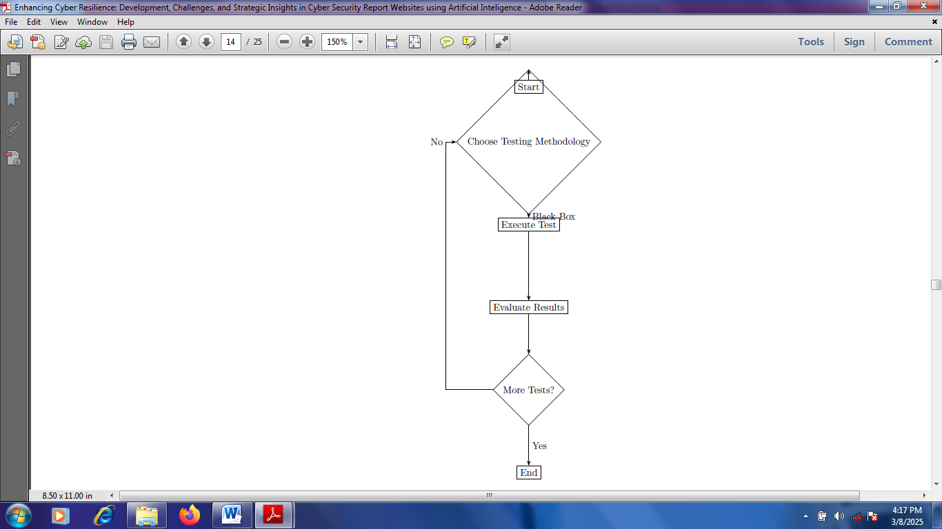

Figure 1: Flowchart showing Penetration Testing Methodologies

The energy sector acts as an essential component of modern human life and also contributes significantly to the economic growth of a nation. Thus, life without fuel and electricity may be difficult because present-day work infrastructures depend heavily on energy. The world demand for energy has risen by 2.2% as at 2023 with reference to the International Energy Agency (IEA) while there is high expectation that the annual growth will rise by 3.4% in the year 2026 [7]. Evolving economies like India and China have experienced increase in the electricity consumption growth while the EU and US are experiencing a minor decrease in electricity consumption. By 2026, double energy consumption was predicted for technological advancements such as cryptocurrency, data centers and artificial intelligence. These statistics have given insight on the necessity for additional sources of energy production and effective management of energy distribution, production and use [8].

The significance of cybersecurity within the energy sector is vital especially in the area of renewable energy sources. Cybersecurity of the energy systems is highly supreme because of the increase in the reliance of global community on renewable and sustainable energy to tackle climate change while sustainable development is ascertained [9]. A multifaceted web of technological innovations is introduced due to the incorporation of renewable energy sources into the already existing grid. Consequently, possibilities of new vulnerabilities to cyber threats are ascertained. This complexity is exemplified by the smart grids reliance which are significant for the effective renewable energy distribution. The grids are characterized by their communication technologies and advanced computing which make them to be more connected inherently to the Internet and to each other with increased exposure to possible cyber-attacks [10].

Cyber-attacks that have the intention of compromising energy infrastructure have the potential to cause noteworthy risks, financial losses and disruptions to national security. The energy industry is basically vulnerable to cyber-attacks because of its dependence on additional digital technologies to run essential systems and operations. it is very vital to understand cyber assaults impact on energy infrastructure in order to ascertain energy systems resilience and effective design of mitigation techniques. One of the most direct impacts of cyber-attacks on energy infrastructure is the electricity supply interruption [11]. Distribution operations and energy production can be harshly hindered by ransomware attacks leading to interruptions and service outages for customers. These assaults demand money for decryption and also encrypt vital systems. Energy businesses may intermittently be obliged to temporarily close production facilities or halt operations in order to stop malware spread and restore system performance. Harsh financial losses and hinder to their reputation may result from these observations [12].

There may be consequences for cyber-attacks on energy infrastructure outside the energy industry. For example, hindrance to the energy supply may affect other essential infrastructure areas such as transportation, healthcare and telecommunications alongside subsequent negative impacts on the society and economy. The national security may also be negatively influenced as a result of cyber-attacks on energy infrastructure especially if it emanated due to state-sponsored actors trying to compromise a nation's stability and security. The security and integrity of sensitive data are usually affected by cyber-attacks together with causing operational interruptions in the energy infrastructure. Customer information, confidential information and operational specifics may be exposed by breaches of cyberattack-related data which thus put the influenced energy organizations and their stakeholders at serious risk [13]. Additionally, manipulating data and malevolent actors stealing may damage the faith in the reliance of the energy supply which may in return lessen the trust in the energy systems integrity.

Energy infrastructure cyber-attacks may have prolonged impacts on the resilience and energy systems security in addition to the instantaneous influences on energy delivery and data integrity. Continuous security difficulties and persistent risks may be the result of successful cyber-attacks that exhibit weaknesses in energy infrastructure which could be utilized by prospective attackers. The efforts to improve and update energy infrastructure may be obstructed while investment in cybersecurity measures may be discouraged by cyber-attacks. This may purposely result from counter growing risks from reputational harm and financial effects. This review article presents the improvement of cyber resilience in the energy sector considering a case study of best practices and emerging technologies. Chapter one discusses the fundamental principles of cybersecurity in relation to energy sector and factors enabling easy cyberattack. Chapter two discusses the evolution of cyber threats, necessity for cybersecurity in energy sector and successful implementations of cyber defense strategies. Chapter three discusses the case studies revealing substantial cyber-attacks on energy systems. The conclusion of the study is presented in Chapter four.

2.0 Evolution of Cyber Threats

The advancement of cyber threats has been described by an uninterrupted arms race between defenders and malicious actors, enhanced by digital landscape changes and technology advancements. Cyber threats have developed in in scale, complexity and impact as computing technology has become more interconnected and pervasive. This poses substantial challenges for organizations, individuals and governments globally. Cyber threats have advanced from unpretentious, unscrupulous attacks to extremely orchestrated and targeted campaigns coordinated by criminal organizations, nation-states, and hacktivist groups. Prompt threats like worms, viruses and denial-of-service attacks have given opportunities to more sophisticated and stealthy kinds of malware which include zero-day exploits, advanced persistent threats and ransomware [5]. The evolution of new paradigms and technologies such as artificial intelligence, the Internet of Things and cloud computing has widened the attack surface and presented new vulnerabilities to exploit the adversaries. These technologies have permitted novel attack vectors like AI-powered cyber-attacks, fileless malware and supply chain attacks. Thus, the traditional security paradigms are being challenged calling for innovative defensive techniques [8].

Additionally, cybercrime globalization and cybercriminal marketplaces proliferation have supported having access to hacking expertise and tools. This even allows unprofessional hackers to launch complex attacks with lowest resources. This has led to cybercrime commodification which has catalyzed cybercriminal ecosystems development where malware-as-a-service, stolen data and exploit tools are sold and bought on underground forums. There is need for organizations to adopt a multi-layered technique to cybersecurity in response to these growing threats. With reference to this, combination of threat intelligence, technical controls and user education is required to guide against broad range of threats [10]. Cyber risks can be anticipated and curbed by organizations via adequate knowledge about the growing techniques and tactics adopted by cyber adversaries. This can be supported with assets safeguarding and trust maintainance in a progressively digital world. Figure 2 presents the flowsheet and architectural design of a typical cybercrime reporting website which starts from the user interface to database.

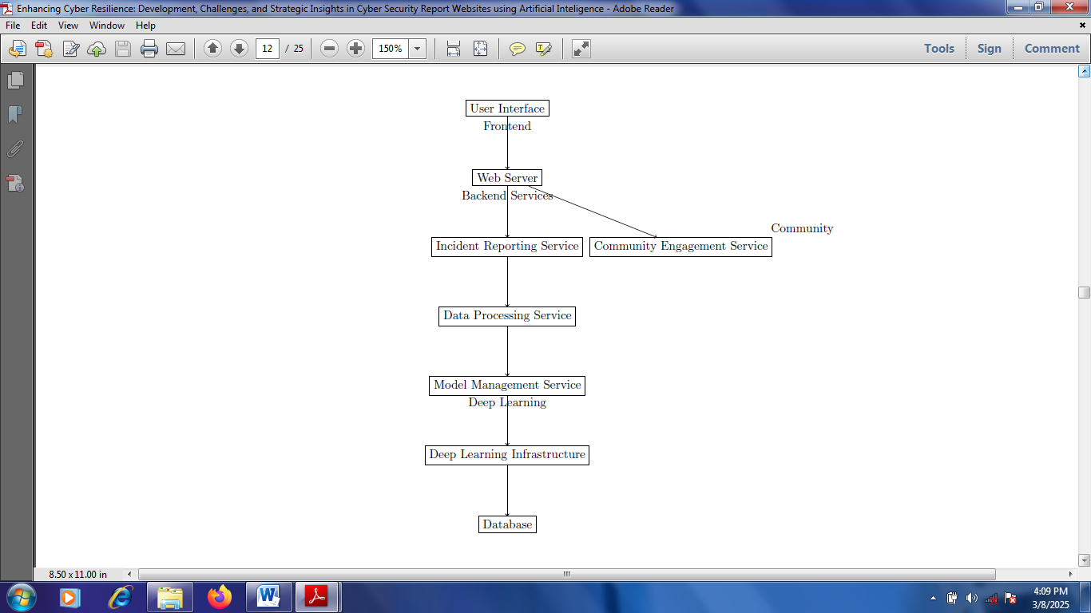

Figure 2: Architectural design/flowsheet of a typical cybercrime reporting website

2.1 Neccessity for Cybersecurity in Energy Sector

As the energy industry is attaining a smart grid that incorporates interconnected grid components such as smart meters and electricity generators in houses, automation and digitalization have a substantial impact. The advent of 5G networks is making internet connection for gadgets to be easier which enhances the opportunity of cyber-attacks and unintentional disruptions. Sustainable energy practices stress installations of distributed solar, wind and hydropower; and equally push interconnection and decentralization in the target of a climate-neutral energy system [1]. The incorporation is an addition to the increasing number of possibly vulnerable networked devices on the electrical grid in combination with the utilization of storage options, smart appliances, flexible industrial demand and electric vehicles. Robust cybersecurity steps are imperative giving consideration to the market reforms which permit new market entrants and consumers such as energy communities, aggregators and energy firms. There may be over reliance on service providers, software and certified hardware due to the inexperience of these stakeholders in cybersecurity [4].

Threats emanate from adversaries' continuously evolving capabilities such as those of terrorist organizations, cybercriminals, military cyber-commands and state-sponsored hackers. Advanced cybersecurity techniques are more essential than ever because of the potential usage of artificial intelligence and challenges posed by automated attack tools. It is imperative to promote knowledge exchange, automation and information sharing in order to address cybersecurity talent scarcity and maximize the current capabilities. Additionally, public funding and governmental action may be essential in cases of insufficient resilience measures and market incentives for security [13]. Cybersecurity in energy system continues to be a major discussion in US and other developed countries given these instant alterations in the information/communication technology and energy sectors. Security regulations and measures must be constantly adjusted to evolving threats in order to improve energy systems resilience against unintentional interruptions and intentional attacks. Making provision for adequate investments in cybersecurity, cooperative information exchange and training are imperative to ensuring a dependable and safe electricity supply [9].

2.2 Successful Implementations of Cyber Defense Strategies

There is rapid evolution of cybersecurity landscape in energy sector which necessitate innovative defense techniques to safeguard critical infrastructure. Cybersecurity implementations in the energy sector, information on the growing number of successful cyber-attacks and cybersecurity critical role in certifying energy security have been discussed [14]. Emphasis has been laid on the essentiality for energy companies to rank cybersecurity to ensure the protection of their systems against threats posed by mischievous actors. Studies have presented the significance of creating committed cybersecurity cells within organizations and enhance wide-level understanding of cybersecurity cases to ascertain efficient protection of the energy infrastructure.

An analytical assessment of the flexibility of Ukraine's critical energy infrastructure to cyber threats amid ongoing conflict has been presented. Cyber resilience variables and their reliabilities were identified in order to emphasize the essentiality for comprehensive techniques to augment the energy sector resilience [15]. The processes for executing big data processing after collection were proposed in order to optimize public-private cooperation and organize cyber training to improve cybersecurity level for critical infrastructure. The efficiency of reacting to cybersecurity crises was proposed to be improved by this approach. The unique understanding of Ukraine in executing such research was highlighted alongside its potential to act as a model for other countries.

Also, the function of digital substations in electricity sector transformation has been explored with a major target on cybersecurity problems linked with the acceptance of information and communication technologies. A simulated substation environment to show successful spoofing attacks was presented while the significance of handling cyber risks in digital systems was highlighted. The susceptibilities within communication protocols were revealed and characteristics for early attack detection were proposed [16]. This provides valuable guidance for innovative applications implementation and improvement of human capital information in the energy sector. The effective execution of cyber defense techniques in the energy sector is vital to protect key infrastructure against progressing cyber threats. The significance and importance of comprehensive techniques to improve resilience, innovative cybersecurity solutions and public-private support in protecting the energy sector have been emphasized. There must be direct relationship between integration of advanced technologies in energy sector and cybersecurity measures which are structured to guide it in order to ensure the reliability and security of energy systems globally [17].

3.0 Case Studies revealing Substantial Cyber-attacks on Energy Systems

The dependence of energy sector on Supervisory Control and Data Acquisition (SCADA) systems for vital infrastructure management has unprotected it from substantial cyber risks. SCADA systems susceptibilities via an investigation of nine case studies across numerous utility sectors including water, energy and transport have been presented. These case studies exposed the way SCADA systems have been compromised by past cyber-attacks resulting into economic, financial and physical injury to the public [18]. The relevance of understanding the theories behind cyber-terrorist decision-making and competences to effectively prepare for prospective cybersecurity threats against SCADA systems was underscored.

The shift to smart grids in the United States demonstrates the sector's improving digital susceptibility. A case study revealing the Ukrainian power grid cyber-attack has been presented in a way that the vulnerabilities applied by the power systems digitalization were highlighted. The attack gives crucial information and acts as a critical lesson in the significance of protecting energy systems against cyber threats. This was because the electricity supply was disrupted and the possibility for substantial impacts on economic stability and national security were demonstrated [11]. The necessity for a comprehensive technique to cybersecurity was emphasized with the incorporation of both strategic planning and technological solutions to curb cyber-attacks risks on power systems.

Also, coordinated cyber-attacks threat on active distribution systems has been explored together with distributed energy resources exhibiting high penetration of distributed energy resources from an attacker's viewpoint. Insights were provided into the complexity of modern cyber-attacks against energy systems via the formulation of an optimization challenge to compromise voltage control and development of a multi-stage attack algorithm. The significance of comprehending the attacker's perspective to enhance energy systems resilience against cyber threats and develop effective countermeasures was highlighted. Cyber threats complex landscape facing the energy sector was illustrated in another case study [19]. The vital requirement for cybersecurity measures that are robust in nature was highlighted. In this case, the strategic aspects of cyber defense and energy systems technological susceptibilities were adequately addressed. The need to protect energy systems from cyber-attacks is still supreme in order to guarantee the safety, reliability and security of essential energy infrastructure [12].

3.1 Innovative Approaches in Cyber Defense for the Energy Sector

The transition of energy sector towards decentralization with the incorporation of many producers of smaller energy together with conventional large-scale projects has undermined the vital need for vigorous cybersecurity procedures. The advancement of tailored cybersecurity solutions for different actors within the energy sector has been discussed such that the initiative of the SPEAR consortium was highlighted in order to secure the energy system against cyber-attacks. This initiative is predominantly relevant for small energy plants which usually lack the resources for costly cybersecurity systems andare thus left susceptible [20]. A scenario of a hydro power plant in Bulgaria has been reported. It experienced a cyber-attack previously which underscores the present and exact danger of such threats to the security and stability of energy sector. New cybersecurity challenges have been introduced by digital management services expansion within the energy sector especially in the context of cyber-physical systems [14]. The formation of an Integrated Digital Data Management Platform has been proposed to establish a safe information structure for intercorporate exchange of electronic documents and data within the energy sector. The initiative was to support cyber-physical systems security across different kinds of government bodies and ownership while showcasing the significance of a unified technique to cybersecurity in the presence of digital transformation [10].

3.2 Barriers in Enhancing Cybersecurity in Energy Sector

The cybersecurity landscape of energy sector is oppressed with barriers and challenges that affect security measures enhancement. The increasing worries about cyber-attacks among U.S. policymakers on the energy infrastructure of the nation have been highlighted. The vital need for improved cybersecurity measures was emphasized [21]. The federal government's commitment was underscored by establishing the National Risk Management Center (NRMC) by the U.S. Department of Homeland Security (DHS) purposely to protect critical infrastructure against deteriorating threats with energy sector inclusive. The geopolitical complications and the exigent need for vigorous cybersecurity frameworks were pointed out by the Smith analysis in order to guard the energy sector from potential challengers [22].

The applicability of the EU cybersecurity regulatory framework in water and energy sectors has been addressed. The challenges posed by the extensive deployment of smart devices and technologies were the major focus. The security and privacy complications of smart meters regulatory regime was examined in association with their use and installation. The challenges of already existing legal framework was presented and additional steps that are required to influence water and energy sectors’ cyber resilience were suggested considering the evolving cyber threats [23]. The challenges of cybersecurity that are linked with virtual power plants and the prospective application of edge computing logics to improve security were explored. A comprehensive edge-based security framework targeted at lowering risks and safeguarding physical systems were presented while data protection and privacy are ensured.

This study underscores the technological advancements and the persistent challenge of mitigating risks and vulnerabilities in the energy sector, highlighting the importance of innovative solutions to bolster cybersecurity. The barriers and challenges in improving cybersecurity in the energy sector are incorporating geopolitical, multifaceted, technological, regulatory and privacy concerns [24]. Both the challenges and opportunities have been introduced by power energy system digitalization. The cybersecurity fundamental principles with reference to power energy sector digitalization has been explored focusing on the adoption of future internet technologies such as the cloud, Internet of Things (IoT) and fog computing. The energy sector was exposed to a broad range of cybersecurity cases by the digitaltransformation while giving consideration to the significant advantages with reference to flexibility and efficiency [25].

4. Conclusion

In order to effectively curb cyber risks, it is imperative for industry stakeholders to give superiority to the implementation of developed comprehensive cybersecurity techniques that encompass human, technological and policy dimensions. Proactive defense mechanisms can be provided via investment in advanced cybersecurity technologies such as machine learning and artificial intelligence. Furthermore, it is imperative to foster training among employees and awareness of cybersecurity. It is also essential to engage stakeholders in international collaborations in order to leverage global standards and share best practices for cybersecurity in energy sector. Also, the global energy growth has necessitated cyber protection against attacks. The adoption of holistic approach can be helpful in achieving cybersecurity activities with operations in the energy sector. It is suggested that investment in cybersecurity structure should be improved to protect energy systems against cyber threats. This entails threat detection, continuous monitoring and incident response capabilities. Nonetheless, it is imperative for stakeholders to execute broad training programs to improve the personnel skills working in the energy sector and also increase the cybersecurity awareness.

Disclaimer (Artificial intelligence)

Option 1:

Author(s) hereby declare that NO generative AI technologies such as Large Language Models (ChatGPT, COPILOT, etc.) and text-to-image generators have been used during the writing or editing of this manuscript.

References

1. Xiong, Y., Liu, R., Hao, S., Binti Md Nor, D. M., Guo, H., & Song, A. (2023). Quantifying Sustainable and Reliable Urban Microgrid Energy Solutions: Probabilistic Analysis of Renewable Adoption, Economic Viability, and Technological Innovations. Sustainable Cities and Society, 101,105157.

2. Tuyen, N. D., Quan, N. S., Linh, V. B., Tuyen, V. V., & Fujita, G. (2022). A Comprehensive Review of Cybersecurity in Inverter-Based Smart Power System amid the Boom of Renewable Energy," in IEEE Access, vol. 10, pp. 35846-35875.

3. Timčenko, V., Rakas, S. B., Kabović, M., & Kabović, A. (2023). Digitalization in Power Energy Sector: Principles of Cybersecurity, 30th International Conference on Systems, Signals and Image Processing (IWSSIP), Ohrid, North Macedonia, 2023, pp. 1-5.

4. Smith, D. C. (2018). Enhancing cybersecurity in the energy sector: a critical priority. Journal of Energy & Natural Resources Law, 36(4), 373-380.

5. Sharma, M. A., & Saraswat, P. (2021). Review of the Literature on Smart Grid Cybersecurity. International Journal of Innovative Research in Computer Science & Technology (IJIRCST), 9(6), 253-256.

6. Lamnatou, C., Cristofari, C., & Chemisana, D. (2023). Renewable energy sources as a catalyst for energy transition: Technological innovations and an example of the energy transition in France. Renewable Energy, 119600.

7. Hossain, M., Gao, X., Ali, M., Rahman, A., & Sun, W. (2023). Coordinated Cyber-attacks in Distribution Grid with Distributed Energy Resources: Attacker Perspective," 2023 IEEE Kansas Power and Energy Conference (KPEC), Manhattan, KS, USA, 2023, pp. 1-4.

8. Gaggero, G., Piserà, D., Girdinio, P., Silvestro, F., & Marchese, M. (2023). Novel Cybersecurity Issues in Smart Energy Communities," 1st International Conference on Advanced Innovations in Smart Cities (ICAISC), Jeddah, Saudi Arabia, pp. 1-6.

9. Funabashi, Y., & Dickson, M. F. (2023). Fukushima: Lessons learned from a devastating “near-miss”. Bulletin of the Atomic Scientists, 79(3), 161-165.

10. Markopoulou, D. (2023). Tackling cybersecurity challenges in the energy and water sectors in the context of the cybersecurity and sectoral regulatory frameworks: the case of smart metering systems in the new digitalised environment. International Review of Law, Computers & Technology, 37(1), 52-77.

11. Adegbite, A. O., Akinwolemiwa, D. I., Uwaoma, P. U., Kaggwa, S., Akindote, O. J., & Dawodu, S. O. (2023). Review of Cybersecurity Strategies in Protecting National Infrastructure: Perspectives from the USA. Computer Science and Information Technology Research Journal, 4(3), 200-219.

12. Darem, A. A., Alhashmi, A. A., Alkhaldi, T. M., Alashjaee, A. M., Alanazi, S. M., & Ebad, S. A. (2023). Cyber threats classifications and countermeasures in banking and financial sector. IEEE Access, 11, 125138-125158.

13. Chobanov, V., & Doychev, I. (2022). Congress on Human-Computer Interaction, Optimization and Robotic Applications (HORA), Ankara, Turkey, 2022, pp. 1-5.

14. Darem, A. A., Alhashmi, A. A., Alkhaldi, T. M., Alashjaee, A. M., Alanazi, S. M., & Ebad, S. A. (2023). Cyber threats classifications and countermeasures in banking and financial sector. IEEE Access, 11, 125138-125158.

15. Okeke, K., & Sesan, O. (2025). Enhancing cybersecurity measures in critical infrastructure: Challenges and innovations for resilience. Journal of Scientific Research and Reports, 31(2): 474-484.

16. Ersoy, N., & Taslak, S. (2023). Comparative Analysis of MCDM Methods for the Assessment of Corporate Sustainability Performance in Energy Sector. Ege Academic Review, 23(3), 341-362.

17. Giriraj, A., Haggag, S., & Haggag, H. (2022). Human centric framework for customising and producing effective cybersecurity training materials. In Joint 4th International Workshop on Experience with SQuaRE Series and Its Future Direction and 1st Asia-Pacific Software Engineering and Diversity, Equity, and Inclusion Workshop, IWESQ 2022+ APSEDEI 2022, Tokyo, Japan, December 6, pp. 69-77.

18. Mohamed, N., El-Guindy, M. E., Oubelaid, A., & Almazrouei, S. K. (2023). Smart Energy Meets Smart Security: A Comprehensive Review of AI Applications in Cybersecurity for Renewable Energy Systems. International Journal of Energy and Environmental Research, 11(3). 728-732.

19. Nasir, S. (2023). Exploring the effectiveness of cybersecurity training programs: factors, best practices, and future directions. In Proceedings of the Cyber Secure Nigeria Conference, pp. 151-160.

20. Okoli, U. I., Obi, O. C., Adewusi, A. O., & Abrahams, T. O. (2024). Machine learning in cybersecurity: A review of threat detection and defense mechanisms. World Journal of Advanced Research and Reviews, 21(01), 2286–2295.

21. Nazare, T., Nardo, L., Arias-Garcia, J., & Nepomuceno, E. (2023). Ensuring Resilience in Ocean Energy Power Plants: A Survey of Cybersecurity Measures. In Proceedings of the European Wave and Tidal Energy Conference (Vol. 15). <https://doi.org/10.36688/ewtec-2023-452>.

22. Ohalete, N. C., Aderibigbe, A. O., Ani, E. C., Efosa, P. O. & Akinoso A.E. (2023). Data Science in Energy Consumption Analysis: A Review of AI Techniques in Identifying Patterns and Efficiency Opportunities, 4(6), 357-380.

23. Rambabu, M., Nuvvula, R. S. S., Kumar, P. P., Mounich, K., Loor-Cevallos, M. E., & Gupta, M. K. (2023). Integrating Renewable Energy and Computer Science: Innovations and Challenges in a Sustainable Future," 2023 12th International Conference on Renewable Energy Research and Applications (ICRERA), Oshawa, ON, Canada, pp. 472-479.

24. Tobar Rosero, O. A., Pérez González, E., Botero Vega, J. F., Zapata Madrigal, G. D., Roa, O., Candelo-Becerra, J., & GarcÍa Sierra, R. (2023). Digital Substations and Cybersecurity in the Transformation of the Electricity Sector, IEEE Colombian Caribbean Conference (C3), Barranquilla, Colombia, 2023, pp. 1-6.

25. Yeremyan, A., & Yeremyan, L. (2022). International Law Issues of Cyber Defense. Moscow Journal of International Law, (2), 85-100.