An Acute Coronary Syndromes (ACS) revealing a severe mitral stenosis: A Case Report

Abstract:

**Background**: Coronary artery embolization is an exceedingly rare cause of myocardial infarction, but a few cases in association with prosthetic mechanical valves have been reported. We report a case of embolic myocardial infarction in a patient with critical mitral stenosis and AF.

**Objective**: Presenting a Rare co-existance of disease or pathology.

**Case Report**: A 62-year-old man was admitted to the catheterization lab for early coronary intervention due to an ST-elevation myocardial infarction. His electrocardiogram showed ST elevation in leads II, III, and aVF, along with a Q wave of necrosis and atrial fibrillation. Coronary angiography revealed a complete blockage of the posterior descending artery with a thrombus. Following treatment with thrombo- aspiration and tirofiban, the thrombus was moved distally. Echocardiography identified severe mitral stenosis. The combination of angiographic findings, atrial fibrillation, and mitral stenosis confirmed coronary embolism as the underlying cause of the myocardial infarction. Anticoagulation therapy was started, and the patient was referred for mitral valve replacement.

**Conclusion**: Coronary artery thromboembolism is a rare cause of acute coronary syndrome. Treatment typically involves intensive anticoagulation, antiplatelet therapy, and different interventional strategies. In this context, secondary prevention is crucial and includes educating patients on proper anticoagulation management

with an oral vitamin K antagonist, as well as providing medical guidance on the potential risks of thromboembolism

**Keywords:** acute coronary syndromes (ACS), mitral stenosis, atrial fibrillation, anticoagulation, Coronary artery thromboembolism

**Introduction:**

“Cardiovascular disease (CVD) remains the most common cause of morbidity and mortality worldwide” [16,17,18]. “Mitral stenosis (MS) poses significant challenges in diagnosis and management due to its varied etiologies, such as rheumatic mitral stenosis (RMS) and degenerative mitral stenosis (DMS)” [19].

“Coronary artery embolization is an exceedingly rare cause of myocardial infarction, but a few cases in association with prosthetic mechanical valves have been reported. We report a case of embolic myocardial infarction in a patient with critical mitral stenosis and AF”.[19]

**Case Presentation:**

A 62-year-old man was admitted to our hospital with sudden onset of severe chest pain of 6 h duration. He had diabetes mellitus managed with oral antidiabetic drugs (OAD) with an HbA1c of 6.7% and was a former smoker, but had no history of hypertension, dyslipidemia, or substance abuse.

Examination revealed an irregularly irregular pulse at a rate of 70 beats per minute, a blood pressure of 117/73 mm Hg, respiratory rate of 18 breaths per minute, and a temperature of 36.7°C. Examination revealed a long mid-diastolic rumbling murmur at the mitral area, a hepatojugular reflux, and a spontaneous jugular vein distension. Apex beat was located in the right 5th intercostals space. The lungs were clear to auscultation. Other systems were normal.

The electrocardiogram (ECG) showed atrial fibrillation with ST elevation in leads II, III, and aVF, along with a Q wave of necrosis (figure 1). Base line laboratoy reports were normal.

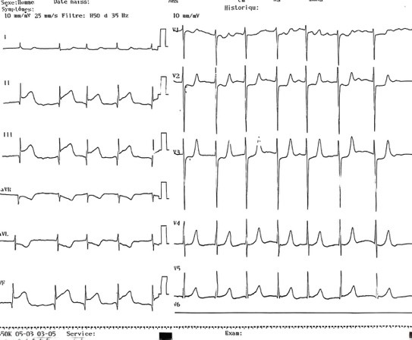

**Figure 1: ECG showing an atrial fibrillation with a ST elevation in inferior territory with a Q wave of necrosis.**

The diagnosis of ST-segment elevation myocardial infarction (STEMI) was made and treatment with 3000 units of heparin, 300 mg aspirin, and 300 mg clopidogrel was initiated while directly transported to our catheterisation laboratory for primary coronary intervention (PCI) after proper consent. Coronary angiography (CAG) was performed via the right radial artery. This revealed a normal left coronary artery. The right coronary artery (RCA) was dominant with an occlusion in the posterior descending artery (PDA) with a TIMI 0 flow.

After performing several thrombus aspirations using an EXPORT ADVANCE ASPIRATION CATHETER(medtronic) in the PDA, which retrieved thrombotic material, an intracoronary injection of Tirofiban was done at the end of thromboaspiration.

TIMI III flow was restored in the PDA without any angiographic lesion identified in this artery, with evidence of thrombotic

material migration very distally in the posterior left ventricular artery, without electrical changes or chest pain. At this point the suspicion of coronary artery embolism as the cause of the STEMI was high. This angiographic appearance of normal coronary arteries together with the atrial fibrillation was highly suggestive.

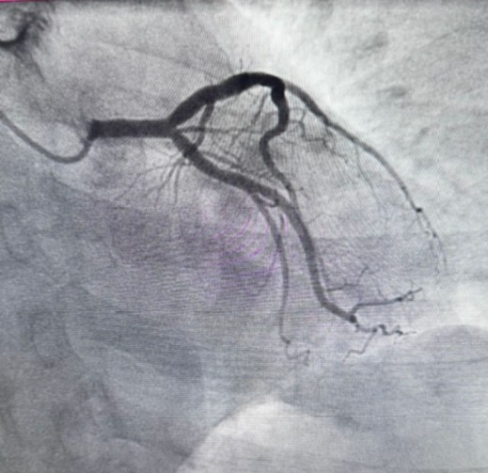

**Figure 2: image of strict caudal incidence showing a long left coronary artery that bifurcates into the CX and LAD arteries. The left network is slightly atheromatous without significant stenosis.**

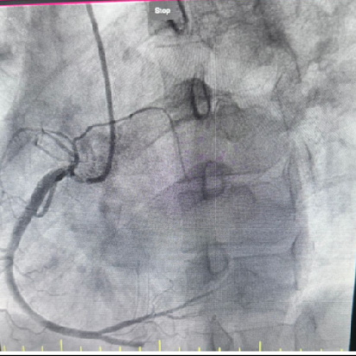

**Figure 3: image of strict Left Anterior Oblique view highlighting a slightly atheromatous right coronary artery, which bifurcates into the posterior interventricular artery and the left retroventricular artery. There is the**

**presence of a total thrombotic occlusion of the PIV (posterior interventricular artery) in its mid-segment**

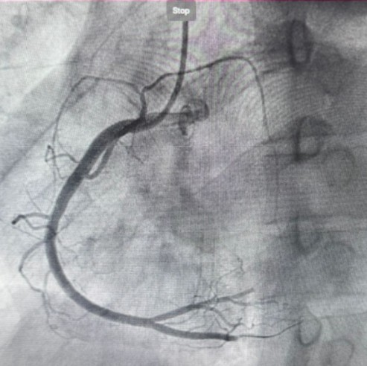

**Figure 4: Passage of a 0.014 guidewire at the level of the distal PIV, followed by several thrombectomy procedures that removed a fresh thrombus, resulting in the recovery of a TIMI III flow.**

The patient was shifted to the coronary care unit where transthoracic echocardiography with Doppler revealed critical mitral stenosis and severe tricuspid regurgitation, with dilated atrial cavities.

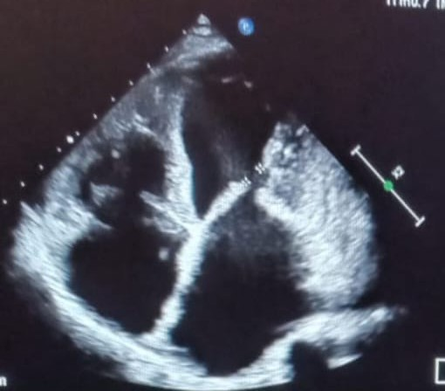

**Figure 5 : Four-chamber view showing a critical stenosis with a limited inter-valvular distance of 0.7 cm**

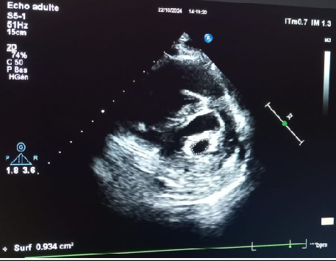“MI with nonobstructive coronary artery disease (MINOCA) refers to a group of conditions that exhibit similar angiographic characteristics. It is defined by the absence of coronary stenosis greater than or equal to 50% and no signs of ruptured atherosclerotic plaques, occurring in 5–8% of acute coronary syndromes (ACS)”.[2,3]

**Figure 6: Parasternal short-axis view: surface area of the mitral valve by planimetry is 0.9 cm².**

Heparin was given until the acenocoumarol was in the therapeutic range of the international normalised ratio (INR). During further observation, the patient didn’t have any sign of systemic embolism and no complications occurred he was referred for Mitral valve replacement with a mechanical prosthesis with a tricuspid valve repair. He was also counselled about importance of anticoagulation and prophylaxis measures against infective endocarditis.

**Discussion:**

“The most common cause of myocardial infarction (MI) is the rupture of an atherosclerotic plaque, which leads to the formation of an intracoronary thrombus”.[1]

“Coronary embolism occurs in the left coronary artery in 75% of cases and most of them present with ST elevation myocardial infarction which could be due to the preferential flow into the artery related to aortic valve morphology”.[4]

“Some patients may have thrombus with underlying atherosclerosis, complicating the diagnosis. If aspiration results in full restoration of coronary flow and a normal angiographic appearance, IVUS or OCT can be used to further assess the potential embolic source of isolated plaque erosion”.[5]

The etiologies of coronary artery embolism can be divided into three categories:

* Direct CE secondary to thrombus originating from the left atrial , left ventricle, the aortic or mitral valves as our case, aorta or pulmonary veins. It may result

from endocarditis and rarely from cardiac tumors.[6–9]

* Paradoxical emboli through an atrial septal defect, patent foramen ovale, or arteriovenous malformations.[7,10,11]
* Iatrogenic emboli while interventional procedures(valve remplacements or percutaneous coronary interventions )[7,12]

“The therapeutic approach to coronary embolism (CE) should be personalized to each patient, taking into account the patient's individual characteristics, the timing of presentation (i.e., the duration since symptom onset), the underlying cause (such as atrial fibrillation, endocarditis, or prosthetic thrombosis), and the presence or absence of concurrent embolic sites outside the coronary circulation”.[13]

“In cases of small and distal coronary embolism (CE) without hemodynamic instability, anticoagulation therapy alone is typically indicated. However, when there is a high intracoronary thrombus burden coupled with instability, thrombus aspiration should be considered. If angiography suggests a coronary embolism and the coronary anatomy is suitable, thrombectomy may be attempted, with

careful analysis of any removed fragments. While the use of intracoronary thrombolysis or glycoprotein IIb/IIIa inhibitors has not been evaluated in randomized clinical trials, they are frequently reported in clinical practice. Primary stenting may be considered if TIMI is <2 after thrombus aspiration. IVUS or OCT may be considered if TIMI is ≥2 after thrombus aspiration and the clinical team wishes to look for plaque erosion . A minimalistic revascularization procedure should be preferred to obtain a TIMI flow grade 3, without stenting if possible .In case of CE related to AF, long term anticoagulation is required” .[14,15]

**Conclusion:**

Mitral stenosis presenting for the first time as acute STEMI is rare but implies a challenge because of the need of a personalized and exact diagnostic and an adapted therapeutic approach. Further prospective studies evaluating this rare etiopathogenesis of myocardial infarction including a systemic diagnostic approach and an individualized therapeutic approach are called for.

**Consent:**

As per international standards or university standards, patient(s) written consent has been collected and preserved by the author(s).

**Disclaimer (Artificial intelligence)**

Option 1:

Author(s) hereby declare that NO generative AI technologies such as Large Language Models (ChatGPT, COPILOT, etc.) and text-to-image generators have been used during the writing or editing of this manuscript.

Option 2:

Author(s) hereby declare that generative AI technologies such as Large Language Models, etc. have been used during the writing or editing of manuscripts. This explanation will include the name, version, model, and source of the generative AI technology and as well as all input prompts provided to the generative AI technology

Details of the AI usage are given below:

1.

2.

3.

**References:**

1. Thygesen K, Alpert JS, Jaffe AS, Chaitman BR, Bax JJ, Morrow DA, et al. Fourth Universal Definition of Myocardial Infarction (2018). Journal of the American College of Cardiology [Internet]. 30 oct 2018

[https:/[/www.sciencedirect.com/scienc](http://www.sciencedirect.com/scienc) e/article/pii/S0735109718369419

1. 2023 ESC Guidelines for the management of acute coronary syndromes [Internet]. [https:/[/www.escardio.org/Gui](http://www.escardio.org/Guidelines/) [delines/](http://www.escardio.org/Guidelines/) Clinical-Practice-

Guidelines/Acute- Coronary- Syndromes-ACS-Guidelines, https:/[/www.escardio.org/Guid](http://www.escardio.org/Guidelines/) [elines/](http://www.escardio.org/Guidelines/) Clinical-Practice- Guidelines/Acute- Coronary- Syndromes-ACS-Guidelines

1. Pasupathy S, Air T, Dreyer RP, Tavella R, Beltrame JF. Systematic Review of Patients Presenting With Suspected Myocardial Infarction

and Nonobstructive Coronary Arteries. Circulation [Internet]. 10 mar 2015 https:/[/www.ahajournals.org/doi/f](http://www.ahajournals.org/doi/full/) [ull/](http://www.ahajournals.org/doi/full/)10.1161/CIRCULATIONAHA.114. 0112

1. Coronary Embolism in Valvular Heart Disease

| QJM: An International Journal of Medicine |

Oxford Academic [Internet]. [https://academic.oup.com/qjmed/arti cle-](https://academic.oup.com/qjmed/arti%20cle-abstract/51/2/147/1592202) [abstract/51/2/147/1592202](https://academic.oup.com/qjmed/arti%20cle-abstract/51/2/147/1592202)

1. Diagnosis of Spontaneous Coronary Artery Dissection by Optical Coherence Tomography

| Journal of the American College of Cardiology [Internet]. https:/[/www.jacc.org/doi/abs/10.101](http://www.jacc.org/doi/abs/10.101) 6/j.jacc.2011.08.082

1. Aortic Mural Thrombus in the Normal or Minimally Atherosclerotic Aorta - ScienceDirect [Internet]. [https:/[/www.sciencedirect.com/scienc](http://www.sciencedirect.com/scienc) e/article/abs/pii/S089050961200258 0
2. Raphael CE, Heit JA, Reeder GS, Bois MC, Maleszewski JJ, Tilbury RT, et al. Coronary Embolus: An Underappreciated Cause of

Acute Coronary Syndromes. JACC: Cardiovascular Interventions [Internet]. 22 janv 2018 https:/[/www.sciencedirect.com/scienc](http://www.sciencedirect.com/scienc) e/article/pii/S1936879817319738

1. Cardoz J, Jayaprakash K, George R. Mitral stenosis and acute ST elevation myocardial infarction. Proceedings (Baylor University Medical Center) [Internet]. avr 2015 https://pmc.ncbi.nlm.nih.gov/articles

/ PMC4365122/

1. Lazaros G, Latsios G, Tsalamandris S, Sfyras N, Toutouzas K, Tsiamis E, et al. Cardiac myxoma and concomitant myocardial infarction. Embolism, atherosclerosis or combination? International Journal of

Cardiology [Internet]. 15 févr 2016 [https://www.internationaljournalofcar diology.com/article/S0167- 5273(15)30868- 8/abstract

1. Manolis AS, Manolis AA, Manolis TA, Melita

H. Acute coronary syndromes in patients

with angiographically normal or near normal (non-obstructive) coronary arteries. Trends in Cardiovascular Medicine [Internet]. 1 nov 2018 https:/[/www.sciencedirect.com/scienc](http://www.sciencedirect.com/scienc) e/article/pii/S1050173818300768

1. Crump R, Shandling AH, Natta BV, Ellestad M. Prevalence of patent foramen ovale in patients with acute myocardial infarction and angiographically normal coronary arteries. American Journal of Cardiology [Internet]. https:/[/www.ajconline.org/article/S00](http://www.ajconline.org/article/S00) 02-9149(00)00772-4/abstract
2. Sucato V, Testa G, Puglisi S, Evola S, Galassi AR, Novo G. Myocardial infarction with non- obstructive coronary arteries (MINOCA): Intracoronary imaging-based diagnosis and

management. Journal of Cardiology [Internet]. 1/05/ 2021 https:/[/www.sciencedirect.com/scienc](http://www.sciencedirect.com/scienc) e/article/pii/S0914508721000046

1. Niccoli G, Scalone G, Crea F. Acute myocardial infarction with no obstructive coronary atherosclerosis: mechanisms and management. European Heart Journal [Internet].

https://doi.org/10.1093/eurheartj/eh u469

1. Coronary Embolism Among ST- Segment– Elevation Myocardial Infarction Patients [Internet]. https:/[/www.ahajournals.org/doi/epu](http://www.ahajournals.org/doi/epu) b/10.1161/CIRCINTERVENTIONS.117. 005587
2. Contemporary Diagnosis and Management of Patients With Myocardial Infarction in the Absence of Obstructive Coronary Artery Disease: A Scientific Statement From the American Heart Association [Internet]. https:/[/www.ahajournals.org/doi/ep](http://www.ahajournals.org/doi/epu) [u](http://www.ahajournals.org/doi/epu) b/10.1161/CIR.0000000000000670
3. Byrne, R.A.; Rossello, X.; Coughlan, J.J.; Barbato, E.; Berry, C.; Chieffo, A.; Claeys, M.J.; Dan, G.A.; Dweck, M.R.; Galbraith, M.; et al. 2023 ESC Guidelines for the management of acute coronary syndromes. *Eur. Heart J.* **2023**, *44*, 3720–3826.
4. Bhatt, D.L.; Lopes, R.D.; Harrington, R.A. Diagnosis and Treatment of Acute Coronary Syndromes: A Review. *JAMA* **2022**, *327*, 662–675.
5. Fardman, A., Chernomordik, F., & Beigel, R. (2024). Looking Back, Leaning Forward—A Contemporary Overview of Acute Coronary Syndrome. *Journal of Clinical Medicine*, *13*(23), 7331.
6. Napoli, F., Vella, C., Ferri, L., Ancona, M. B., Bellini, B., Russo, F., ... & Montorfano, M. (2024). Rheumatic and Degenerative Mitral Stenosis: From an Iconic Clinical Case to the Literature Review. *Journal of Cardiovascular Development and Disease*, *11*(5), 153.