*Original Research Article*

Comparative Study of Curcumin, All-trans Retinoic Acid and Resveratrol: Therapeutic Targeting of Breast Cancer Signalling

.

ABSTRACT

|  |
| --- |
| **Aims:** Breast cancer is the most prevalent cancer affecting women worldwide. Aberrant signalling through the phosphatidylinositol 3’ kinase (PI3K) and extracellular signal regulated kinase (ERK) pathways promotes metastatic spread of breast carcinomas. As prevalent chemotherapeutic treatments can cause toxic side effects, exploring the anti-tumorigenic potential of natural phytochemicals as inhibitors of these pathways is important. **Methodology:** In our study we analyzed binding efficacy and patterns of interactions of the phytochemicals curcumin, resveratrol and all-trans retinoic acid (ATRA) with PI3K and ERK using molecular docking and computer based analysis. **Results & Discussion:** Molecular docking showed curcumin, ATRA and resveratrol to have very good binding affinity and interactions with PI3K-α and ERK2 indicating their excellent potential as inhibitors of these signalling cascades with ATRA showing the highest binding affinity (ΔG = -7.73 kcal/mole) to PI3K-α and curcumin showing the highest binding affinity (ΔG = -8.10 kcal/mole) to ERK2. Analysis showed that curcumin, ATRA and resveratrol interact at a similar site on PI3K-α while for ERK2, ATRA and curcumin interact at a similar site while resveratrol interacts with a different site. While most synthetic inhibitors target a single signalling pathway, curcumin, ATRA and resveratrol all show excellent potential for targeting both signalling pathways which may prevent cancer cells from circumventing treatment by activating alternative pathways. Using these phytochemicals for therapy may also help in reducing side effects. **Conclusion:** Our study highlights the excellent potential of curcumin, ATRA and resveratrol for targeting both PI3K and ERK signalling pathways which could lead to inhibition of breast cancer progression and metastasis and, following further *in vitro* and *in vivo* studies, pave a pathway for therapies with less side effects and better clinical outcomes. |

*Keywords: breast cancer, curcumin, all-trans retinoic acid (ATRA), resveratrol, phosphatidylinositol 3’ kinase (PI3K), extracellular signal regulated kinase (ERK)*

1. INTRODUCTION

The GLOBOCAN 2022 data of World Health Organization showed breast cancer to be the leading form of cancer affecting women in India with around 192,020 cases of breast cancer reported which account for 26.6% of cancers in women. It was also the leading cause of cancer related deaths (World Health Organization, International Agency for Research on Cancer). Breast cancer was also diagnosed in younger Indian women and was reported to be more aggressive compared to western countries (Bhardwaj et al., 2024). Research has indicated various cellular signalling pathways play important roles in breast cancer development and progression. Aberrant expression and signalling through the phosphatidylinositol 3’ kinase (PI3K) pathway and the extracellular signal regulated kinase (ERK) pathway have been reported to cause breast cancer development and metastasis (Li et al., 2023; Miricescu et al., 2020; Ortega et al., 2020)

.

Signalling via receptor tyrosine kinases (RTKs) and G-protein coupled receptors lead to activation of PI3K via phosphorylation at the 3rd position of the inositol ring. This activates other protein kinases like Akt (known as protein kinase B). Akt activates downstream targets to promote breast cancer development and metastasis (Ortega et al., 2020; Paplomata et al., 2014). Around 30-40% of breast cancers show mutations in the PIK3CA gene which encodes for p110α catalytic subunit. HER2 positive, ER (oestrogen receptor) positive and luminal breast cancers show overexpression of PI3K-Akt activity with PIK3CA mutations, along with loss of PTEN function (Miricescu et al., 2020). Aberrant signalling via PI3K-Akt pathway has been reported in various breast cancer subtypes including triple negative breast cancers (Costa et al., 2018; Ortega et al., 2020). Dysregulation of PI3K signalling was reported to cause epithelial to mesenchymal transition along with MMP-2 and MMP-9 expression in MDA-MB 231 cells (Rajendran et al., 2020). Activation of EGFR mediated signalling through PI3K promoting high MMP-2, MMP-9 and MT1-MMP expression has been reported in MCF-7 breast cancer cells (Majumder et al., 2019).

Aberrant signalling through the MEK/ ERK (ERK1/2 isoforms) pathway following interaction of ligands with integrin or growth factor receptors plays important roles in cancer development and metastasis (Li et al., 2017; Zhu et al., 2020). Treatment of SK-BR3 cells with TGF-α and EGF lead to activation of EGFR phosphorylation mediated ERK1/2 signalling and MMP-1 overexpression (Park et al., 2011). Heregulin-β1 treatment of SK-BR3 and MCF-7 cells was shown to upregulate PI3K and ERK signalling promoting MMP-9 expression and activity (Yao et al., 2001). Over expression of FGFR1 receptor in breast cancer led to metformin resistance via activation of ERK signalling as studied in MCF-7 and T47D cells (Shi et al., 2021). Treatment of MDA-MB-231 cells with IGF-1 caused over expression of VEGF-C and ERK1/2 phosphorylation to promote metastasis to lymphatic vessels (Zhu et al., 2011). Long non-coding RNAs have been reported to promote angiogenesis by activating the IGF-1/ERK pathway in breast cancers (Zhang et al., 2020).

Chemotherapy remains the major technique for therapy in metastatic breast cancers and a number of chemotherapeutic drugs including synthetic signalling pathway inhibitors are currently under study or in use for breast cancer treatment. However, development of drug resistance and negative side effects (including fatigue, nausea, anaemia, hair loss and myelosuppression) may limit effectiveness of treatment (Wiranata et al., 2024; Wopat et al., 2024). An alternative method of treatment could involve use of natural phytochemical compounds with anti-tumorigenic potential for breast cancer therapy.

Curcuminis obtained from the rhizome of turmeric plant (*Curcuma longa)* and is a potent phytophenol with anti-microbial, anti-viral, anti-oxidant, anti-inflammatory, anti-diabetic, cardio-protective, neuroprotective and anti-cancer properties (Barcelos et al., 2022; Fu et al., 2021; Liu et al., 2018). Curcumin modulates NF-κB signalling to mediate mitochondrial-endoplasmic reticulum stress and cause cell arrest in G2/M phase, apoptosis and inhibition of cancer cell proliferation (Liu et al., 2018). Curcumin has been reported to inhibit proliferation and induce apoptosis in breast cancer cells (Barcelos et al., 2022). Curcumin reduces gemcitabine resistance along with sensitization to paclitaxel, cyclophosphamide and 5-fluro-uracil in breast cancer cells via regulation of NF-κB pathway (Farghadani et al., 2021). Treatment of Hs578T and MDA-MB-231 breast cancer cells with curcumin reduced expression of β catenin, p-Akt, Akt, p-S6, S6, mTOR, N-cadherin and fibronectin and blocked EMT (Chen et al., 2024). Treatment of breast cancer cells with curcumin reduced expression of cancer stem cell markers like ALDH1A1, CD44, Oct4, Nanog via downregulation of Shh and Wnt/β catenin signalling pathways (Li et al., 2018).

All-trans retinoic acid (ATRA), a metabolite of retinol and active form of Vitamin A found in carotenoid rich fruits and vegetables, mediates tissue organization, differentiation and embryo development by interacting mainly with retinoic acid receptors (RARs). ATRA has anti-inflammatory and anti-oxidant properties along with immune-stimulation and has shown potent effects in treating pro-myelocytic leukemia (Das et al., 2013; Siddikuzzaman et al., 2013). ATRA has been reported to downregulate EMT in cancers by upregulating E-cadherin expression and downregulating vimentin expression (Bobal et al., 2021; Caricasulo et al., 2024). Treatment of MCF-7 breast cancer cells with ATRA led to cellular signalling which caused downstream regulation of Bcl-xl, Bcl-2 and Bax, promoting apoptosis (Ye et al., 2004). Binding of ATRA with RARα has been reported to modulate MAPK signalling in breast cancer cells and tumour fibroblasts through interaction with G-protein αq (Caricasulo et al., 2024). Targeting overexpressed Pin1 (peptidyl-prolyl-isomerase) with ATRA treatment downregulated ERK-1/2 and Akt expression and transcriptional activity of ERα and inhibited cell proliferation and viability in tamoxifen resistant breast cancer cells (Huang et al., 2019).

Resveratrol (3,5,4′-trihydroxy-*trans*-stilbene) is a non-flavonoid phytopolyphenol and phytoestrogen obtained from berries, peanuts, pomegranate and soy beans. Resveratrol shows anti-inflammatory and anti-bacterial properties and has been shown to improve outcomes in patients suffering from metabolic disorders, cardiologic problems, diabetes, hypertension and Alzheimer’s disease (Singh et al., 2019; Sinha et al., 2016). Resveratrol has been reported to improve prognosis by inhibiting cell proliferation and reducing cell viability and invasion in breast cancer cells (Behroozaghdam et al., 2022). Resveratrol regulates the STAT3 cascade causing reversal of chemoresistance and doxorubicin resistance and promotion of apoptosis *in vitro* and *in vivo* via regulation of PI3K/ Akt pathway in breast cancer cells (Chen et al., 2018; Kohandel et al., 2021). Downregulation of Akt phosphorylation and Bcl-2 with activation of caspase-9 mediated apoptosis was reported in MCF-7 cells under resveratrol treatment (Li et al., 2006).

Thus, using natural compounds for targeting signalling pathways in breast cancer has considerable potential for cancer treatment. With this objective, we analysed the potential of curcumin, ATRA and resveratrol by studying their interactions with important components of some specific signalling pathways which play important roles in breast cancer.

2. methodology

In order to study and analyse the interactions between curcumin, ATRA and resveratrol with macromolecules, molecular docking technique with AutoDock Tools (ADT) 1.5.6 (Scripps Research Institute, USA, https://ccsb.scripps.edu/mgltools/1-5-6/) was used. The crystal structures of the macromolecules (PI3K, ERK2 and MAPK) were obtained from Research Collaboratory for Structural Bioinformatics (RCSB) Protein Data Bank (www.rcsb.org/). Crystal structures of human PI3K-α (PDB ID: 8EXU) and human ERK2 (PDB ID: 5NHJ) were obtained from the Protein Data Bank site. Structure of the phytochemicals, curcumin, ATRA and resveratrol, were obtained from PubChem, NIH, National Centre for Biotechnology Information (National Center for Biotechnology Information, PubChem https://pubchem.ncbi.nlm.nih.gov/). Post molecular docking, analysis of docked macromolecule-ligand complexes was conducted using PYMOL (version 2.5.4, Schrodinger, LLC). Surface images of docked complexes were obtained using Chimera 1.18 and PYMOL. Some macromolecule structures obtained from PDB had bound ligands. Prior to docking with above natural compounds, these inherent ligands were removed. In the docking process, water molecules were removed, polar hydrogens and Kollman charges were added to assign AD4 subtype to prepare macromolecules. Ligand preparation with choosing and detection of roots was done, followed by setting up grid parameters, grid box and docking parameters involving both the protein and ligand. After docking, generation of protein ligand complex of the best conformation was done where pattern of interactions was analysed via PYMOL (https://www.pymol.org). Binding pattern and affinity were studied by considering the lowest ΔG value of conformations of the docked protein-ligand complexes.

3. results

**3.1 Interactions of curcumin, ATRA and resveratrol with PI3K**

Molecular docking (Table 1) showed high binding affinity of curcumin, ATRA and resveratrol with human PI3K-α with ATRA (ΔG = -7.73 kcal/mole) showing a higher binding affinity compared to resveratrol (ΔG = -7.46 kcal/mole) and curcumin (ΔG = -7.32 kcal/mole). The domains and amino acids of PI3K with which curcumin, ATRA and resveratrol interact are as shown in Fig. 1. Curcumin formed hydrogen bonds with Arg-162, Met-697 and His-701 (Fig. 1E), ATRA formed hydrogen bonds with Gln-661 and His-701 (Fig. 1G) and resveratrol formed hydrogen bonds with Pro-168, Asp-258, Gln-661 and Arg-662 (Fig. 1I).

**3.2 Interactions of curcumin, ATRA and resveratrol with ERK2**

Molecular docking (Table 2) showed high binding affinity of curcumin, ATRA and resveratrol with human ERK2 with curcumin (ΔG = -8.10) having the highest binding affinity followed by ATRA (ΔG = - 7.79 kcal/mole) and resveratrol (ΔG = - 7.20 kcal/mole). The domains and amino acids of ERK2 with which curcumin, ATRA and resveratrol interact are as shown in Fig. 2. Curcumin formed hydrogen bonds with Tyr-36, Lys-54 and Met-108 (Fig. 2E), ATRA formed hydrogen bonds with Ala-35 and Arg-67 (Fig. 2G) and resveratrol formed hydrogen bonds with Asn-238, Pro-247 and Leu-267 (Fig. 2I).

**Table 1: Binding affinities of curcumin, ATRA and resveratrol with human PI3K-α (PDB ID: 8EXU)**

|  |  |  |  |  |
| --- | --- | --- | --- | --- |
| **Compound** | **PubChem CID** | **Molecular Weight** | **ΔG**  **(Kcal/mole)** | **H-Bonding to Amino Acids with Bond Lengths** |
| Curcumin | 969516 | 368.4 | -7.32 | Arg-162 (2.6Ǻ), Met-697 (2.3Ǻ), His-701 (2.0Ǻ) |
| ATRA | 444795 | 300.4 | -7.73 | Gln-661(2.6Ǻ), His-701 (2.3Ǻ) |
| Resveratrol | 445154 | 228.24 | -7.46 | Pro-168 (1.9Ǻ), Asp-258 (2.6Ǻ), Gln-661 (1.8Ǻ), Arg-662 (2.6Ǻ) |

**Table 2: Binding affinities of curcumin, ATRA and resveratrol with human ERK2 (PDB ID: 5NHJ)**

|  |  |  |  |  |
| --- | --- | --- | --- | --- |
| **Compound** | **PubChem CID** | **Molecular Weight** | **ΔG**  **(Kcal/mole)** | **H-Bonding to Amino Acids with Bond Lengths** |
| Curcumin | 969516 | 368.4 | -8.10 | Tyr-36 (2.2Ǻ), Lys-54 (2.0 Ǻ), Met-108 (1.6Ǻ & 2.5Ǻ) |
| ATRA | 444795 | 300.4 | -7.79 | Ala-35(2.0Ǻ), Arg-67 (1.8Ǻ & 2.7Ǻ) |
| Resveratrol | 445154 | 228.24 | -7.20 | Asn-238 (2.2Ǻ), Pro-247 (2.0Ǻ), Leu-267 (2.0Ǻ) |

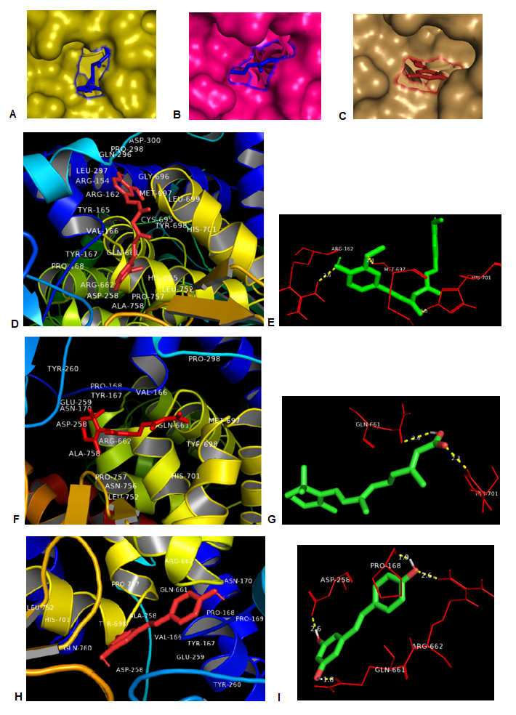

**Fig. 1: Analysis of interactions of curcumin, ATRA & resveratrol with human PI3K.** Interactions of human PI3K-α (PDB ID: 8EXU) with curcumin, ATRA and resveratrol represented using surface zoomed view (Fig. 1A, 1B, 1C respectively) and ribbon representations (Fig. 1D, 1F, 1H respectively) and hydrogen bonding of amino acids of human PI3K with curcumin (Fig. 1E), ATRA (Fig. 1G) and resveratrol (Fig. 1I) with estimated bond distances.

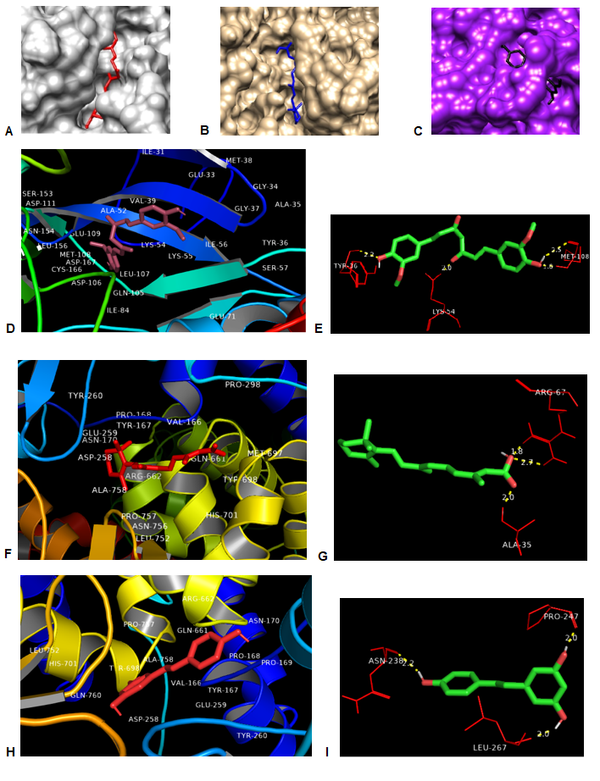

**Fig. 2: Analysis of interactions of curcumin, ATRA and resveratrol with human ERK2.** Interactions of human ERK2 (PDB ID: 5NHJ) with curcumin, ATRA and resveratrol represented using surface zoomed view (Fig. 2A, 2B, 2C respectively) and ribbon representations (Fig. 2D, 2F, 2H respectively) and hydrogen bonding of amino acids of human ERK2 with curcumin (Fig. 2E), ATRA (Fig. 2G) and resveratrol (Fig. 2I) with estimated bond distances.

**Analysis of sites of interaction of curcumin, ATRA and resveratrol with human PI3K-α and ERK2**

Superimposition of protein-ligand complexes indicated the regions on the molecules with which curcumin, ATRA and resveratrol interact. For PI3K-α, curcumin, ATRA and resveratrol interact at similar sites (Fig. 3A) while for ERK2, ATRA and curcumin interact at similar sites while resveratrol shows interaction with a different site (Fig. 3B).

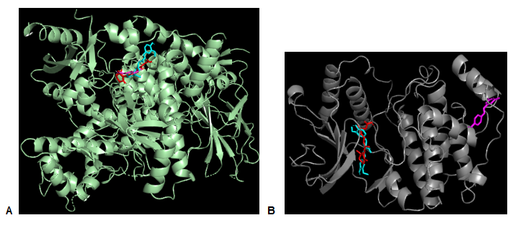

**Fig. 3: Sites on signalling molecules with which curcumin, ATRA and resveratrol interact.** Sites of interaction of curcumin, ATRA and resveratrol with human PI3K-α (PDB ID: 8EXU), and human ERK2 (PDB ID: 5NHJ). Curcumin is shown in cyan, ATRA in red and resveratrol in purple.

4. discussion

Breast carcinomas develop and metastasize via activation of important signalling pathways including the PI3K and ERK pathways. Aberrant signalling via these pathways activates downstream factors which aid in cellular migration, motility, EMT, intravasation, extravasation, angiogenesis and metastasis (Li et al., 2023; Miricescu et al., 2020; Ortega et al., 2020). Chemotherapeutic treatment of metastatic breast cancers has been shown to pose adverse side effects (Wopat et al., 2024). Anthracycline-taxane combined adjuvant/ neo-adjuvant chemotherapy for longer cycles was reported to cause extensive gastro-intestinal, epithelial and psycho-neurological damages in patients and extensive use of taxanes was reported to cause neurological, gastrointestinal and hematological toxicity in breast cancer patients (Jivani et al., 2024; Wiranata et al., 2024). Even post-treatment, late toxic effects of chemotherapy included pneumonitis, cardiologic toxicity, reproductive issues, oedema in arm lymph circulation, neuro-pathological issues and skin damage Agrawal et al., 2014). Research with natural compounds may lead to development of treatments with less side effects and targeting signalling pathways with natural phytochemical compounds having anti-tumorigenic potential could thus be important for breast cancer therapy.

Curcumin, ATRA and resveratrol all showed appreciable binding affinity for PI3K-α with the binding affinity of ATRA being the highest followed by resveratrol and curcumin; binding affinity of all three phytochemicals were in a similar range. Analysis of patterns of amino acid interactions and protein-ligand complexes indicated that curcumin, ATRA and resveratrol interact around a similar site on PI3K-α. PI3K has been associated with a variety of solid tumours with the catalytic subunit p110α showing aberrant expression and activity due to gene amplification or activating mutations. Activating mutations of the p110α subunit can increase PI3K mediated signalling, promoting cell growth and invasion (Madsen et al., 2018; Ortega et al., 2020). The high binding affinity of curcumin, ATRA and resveratrol for PI3K-α indicate their excellent potential as possible inhibitors of p110α activity and the PI3K/Akt signalling pathway for breast cancer therapy.

Curcumin, ATRA and resveratrol all showed high binding affinity for ERK2 with binding affinity of curcumin being the highest followed by ATRA and resveratrol which had somewhat lower but still appreciably high binding affinity. Analysis of amino acid interactions and protein-ligand complexes showed ATRA and curcumin interact with similar sites on the ERK2 molecule while resveratrol interacts with a different site. High levels of ERK2 expression and activity have been correlated with a lower survival rate in triple-negative breast cancer (TNBC) patients and breast cancer patients with tumours having high expression levels of ERK2 show a poorer prognosis in comparison to patients having tumours with low ERK2 expression. ERK2 has been reported to promote metastasis and the cancer stem cell (CSC) phenotype in breast cancer cells and ERK2 knockdown inhibits metastasis and alters CSC formation (Gagliardi et al., 2020). The high binding affinity of curcumin, ATRA and resveratrol indicate their excellent potential as possible inhibitors of the ERK2 signalling pathway for breast cancer therapy.

Interestingly, our analysis indicated that even when curcumin, ATRA and resveratrol bind at similar sites on the protein molecules, the same amino acids can engage in different kinds of interactions with different phytochemicals. For instance, in the case of PI3K-α, both Pro-168 and Asp-258 showed hydrogen bonding with resveratrol but nonpolar interactions with curcumin while Arg-662 showed hydrogen bonding with resveratrol but nonpolar interactions with both ATRA and curcumin. Gln-661 showed hydrogen bonding with both ATRA and resveratrol but nonpolar interactions with curcumin. In the case of ERK2, Arg-67 showed hydrogen bonding with ATRA but nonpolar interactions with curcumin while Tyr-36 showed hydrogen bonding with curcumin but nonpolar interactions with ATRA. Thus, modes of interaction with, and consequently mechanisms of inhibition of PI3K and ERK signalling by curcumin, ATRA and resveratrol may be different even when they appear to interact at similar sites on these protein molecules. This indicates the possibility that simultaneous treatment with two or more of these phytochemicals could have synergistic effects on inhibition of signalling pathways by reinforcing each other’s inhibitory effects.

A number of synthetic inhibitors of PI3K and ERK are currently under study or in use for treatment of cancers including breast cancers. While many of these synthetic inhibitors appear to be quite effective in inhibiting signalling pathways *in vitro*, their efficacies as therapeutic agents are often hampered because of toxicity and effective pharmacological doses not being well tolerated physiologically. For instance, phase III clinical trials using the PI3K inhibitor taselisib in breast cancers showed improved survival but serious side effects (Baselga et al., 2018). Treatment with alpelisib, (BYL719), a PI3K inhibitor approved by FDA for breast cancer therapy, had to be discontinued in around 25% patients due to side effects like diarrhea and hyperglycemia (Andre et al., 2019). Using natural phytochemical compounds like curcumin, ATRA and resveratrol for targeting signalling pathways may help in reducing side effects, as these natural compounds and the plant sources they are obtained from are a part of human diet.

Also, synthetic signalling pathway inhibitors each usually target a single signalling pathway. Cross talk between different signalling pathways including PI3K and ERK have been reported in various cancers and studies indicate that PI3K/Akt and MEK/ERK cascades are interconnected at various levels and mutations in these pathways can occur simultaneously (Li et al., 2022; Saini et al., 2013). Therefore, even if signalling through one pathway is inhibited by a specific synthetic inhibitor, maintenance of signalling through the other pathway may allow cancer cells to continue to proliferate, metastasize and evade apoptosis. As curcumin, ATRA and resveratrol all show excellent potential for inhibiting signalling through multiple signalling pathways like PI3K and ERK, targeting multiple signalling pathways simultaneously by treatment with these phytochemicals may prevent cancer cells from circumventing treatment by activating alternative pathways of signalling and developing resistance to treatment.

5. CONCLUSION

Our study indicated that curcumin, ATRA and resveratrol showed excellent potential for targeting PI3K and ERK signalling pathways which play key roles in breast cancer progression. Targeting multiple signalling pathways at the same time by treatment with curcumin or ATRA or resveratrol, or by synergistic treatment with two or more of these phytochemicals, has good potential of improving prognosis and treatment outcomes in breast cancers. Using these phytochemicals may also help in reducing side effects and could also possibly lower the treatment costs. Further study and analysis for understanding the pattern of interactions of curcumin, ATRA and resveratrol with target molecules, beside *in vitro* and *in vivo* studies about their anti-cancer potential could pave a pathway for future therapies with less side effects and better clinical outcomes for breast cancer patients.

Ethical approval

This article does not contain any studies with human participants or animals performed by the authors.

DISCLAIMER (ARTIFICIAL INTELLIGENCE)

Th authors declare that no generative AI technologies such as Large Language Models (ChatGpt, COPILOT, etc.) And text-to-image generators have been used during the writing or editing of this manuscript.

References

Agrawal, S. (2014). Late effects of cancer treatment in breast cancer survivors. *South Asian Journal of Cancer*, 3(2), 112-115.

Andre, F., Ciruelos, E., Rubovszky, G., Campone, M., Loibl, S., Rugo, HS., *et al.* (2019). Alpelisib for PIK3CA-mutated, hormone receptor–positive advanced breast cancer. *New England Journal of Medicine ,*380(20), 1929-1940

Barcelos, K.A., Mendonça, C.R., Noll M., Botelho, A.F., Francischini, C.R.D., Machado Silva, M.A. (2022). Antitumor Properties of Curcumin in Breast Cancer Based on Preclinical Studies: A Systematic Review. Cancers (Basel), 14(9), 2165.

Baselga, J., Dent, SF., Cortes, J., Im, YH., Dieras, V., Harbeck, N., *et al.* (2018). Phase III study of taselisib (GDC-0032) + fulvestrant (FULV) v FULV in patients (pts) with estrogen recep-tor (ER)-positive, PIK3CA-mutant (MUT), locally advanced or meta-static breast cancer (MBC): primary analysis from SANDPIPER. LBA1006-LBA1006. *Journal of Clinical Oncology* 36(18).

Behroozaghdam, M., Dehghani, M., Zabolian, A., Kamali, D., Javanshir, S., Hasani Sadi F., et al. (2022). Resveratrol in breast cancer treatment: from cellular effects to molecular mechanisms of action. *Cellular and Molecular Life Sciences*, 79(11), 539.

Bhardwaj, P.V., Dulala, R., Rajappa, S., & Loke, C. (2024). Breast cancer in India: screening, detection, and management. *Hematology/Oncology Clinics* *of North America*, 38(1), 123-135.

Bobal, P., Lastovickova M., Bobalova J. (2021). The Role of ATRA, Natural Ligand of Retinoic Acid Receptors, on EMT-Related Proteins in Breast Cancer: Minireview. *International Journal of Molecular Sciences*, 22(24), 13345.

Caricasulo, M.A., Zanetti, A., Terao, M., Garattini, E., & Paroni, G. (2024). Cellular and micro-environmental responses influencing the antitumor activity of all-trans retinoic acid in breast cancer. *Cell Communication and Signaling*, 22(1), 127.

Chen, J.M., Bai, J.Y., & Yang, K.X. (2018). Effect of resveratrol on doxorubicin resistance in breast neoplasm cells by modulating PI3K/Akt signaling pathway. *IUBMB life*, 70(6), 491-500

Chen, Z., Lu, P., Li, M., Zhang, Q., He, T., & Gan, L. (2024). Curcumin suppresses metastasis of triple-negative breast cancer cells by modulating EMT signaling pathways: An integrated study of bioinformatics analysis. *Medicine*, 103(8), 37264.

Costa, R.L., Han, H.S., & Gradishar, W.J. (2018). Targeting the PI3K/AKT/mTOR pathway in triple-negative breast cancer: a review. *Breast Cancer Research and Treatment*, 169,397-406.

Das, S., Guha, I., Chatterjee, A., & Banerji, A. (2013). Anti-cancer potential of all-trans retinoic acid (ATRA): A Review. *Proceedings of the Zoological Society* ,66, 1-7.

Farghadani, R., & Naidu, R. (2021). Curcumin: modulator of key molecular signaling pathways in hormone-independent breast cancer. *Cancers*, 13(14),3427.

Fu, Y.S., Chen, T.H., Weng, L., Huang, L., Lai, D., & Weng, C.F. (2021). Pharmacological properties and underlying mechanisms of curcumin and prospects in medicinal potential. *Biomedicine & Pharmacotherapy,* 141, 111888.

Jivani, A., & Shinde, R.K. (2024). A Comprehensive Review of Taxane Treatment in Breast Cancer: Clinical Perspectives and Toxicity Profiles. *Cureus*, 16(4).

Huang, S., Chen, Y., Liang, Z.M., Li, N.N., Liu, Y., Zhu, Y., et al. (2019). Targeting pin1 by all-trans retinoic acid (ATRA) overcomes tamoxifen resistance in breast cancer via multifactorial mechanisms. *Frontiers in Cell and Developmental Biology*, *7*, 322.

Kohandel, Z., Farkhondeh, T., Aschner, M., Pourbagher-Shahri, A.M., & Samarghandian, S. (2021). STAT3 pathway as a molecular target for resveratrol in breast cancer treatment. *Cancer Cell International*, *21*, 1-9.

Liczbiński, P., Michałowicz, J., & Bukowska, B. (2020). Molecular mechanism of curcumin action in signaling pathways: Review of the latest research. *Phytotherapy Research,* 34(8), 1992-2005.

Li, F., Wang, J., Yan, Y.Q., Bai, C.Z., & Guo, J.Q. (2023). CD147 promotes breast cancer migration and invasion by inducing epithelial-mesenchymal transition via the MAPK/ERK signaling pathway. *BMC Cancer*, 23(1), 1214.

Li, J., Guo, Y., Duan, L., Hu X., Zhang, X., Hu, J., *et al.* (2017). AKR1B10 promotes breast cancer cell migration and invasion via activation of ERK signaling. *Oncotarget*, 8(20), 33694-33703.

Li, Q., Li, Z., Luo, T., & Shi, H. (2022). Targeting the PI3K/AKT/mTOR and RAF/MEK/ERK pathways for cancer therapy. *Molecular Biomedicine*, 3(1), 47.

Li, X., Wang, X., Xie, C., Zhu, J., Meng, Y., Chen, Y., *et al.* (2018). Sonic hedgehog and Wnt/β-catenin pathways mediate curcumin inhibition of breast cancer stem cells. *Anti-Cancer Drugs*, 29(3),208-215.

Li, Y., Liu, J., Liu, X., Xing, K., Wang, Y., Li, F., *et al.* (2006). Resveratrol-induced cell inhibition of growth and apoptosis in MCF7 human breast cancer cells are associated with modulation of phosphorylated Akt and caspase-9. *Applied Biochemistry and Biotechnology*, *135*, 181-192.

Liu, H.T., & Ho, Y.S. (2018). Anticancer effect of curcumin on breast cancer and stem cells. *Food Science and Human Wellness*, 7(2) ,134-137.

Madsen, R.R., Vanhaesebroeck, B., & Semple, R.K. (2018). Cancer-associated PIK3CA mutations in overgrowth disorders. *Trends in Molecular Medicine*, 24(10), 856-870.

Majumder, A., Ray, S., & Banerji, A. (2019). Epidermal growth factor receptor-mediated regulation of matrix metalloproteinase-2 and matrix metalloproteinase-9 in MCF-7 breast cancer cells. *Molecular and Cellular Biochemistry*, 452, 111-121.

Miricescu, D., Totan, A., Stanescu-Spinu, I.I., Badoiu, S.C., Stefani, C., & Greabu, M., (2020). PI3K/AKT/mTOR signaling pathway in breast cancer: from molecular landscape to clinical aspects. *International Journal of Molecular Sciences*, 22(1),173.

National Center for Biotechnology Information, PubChem https://pubchem.ncbi.nlm.nih.gov

National Center for Biotechnology Information. PubChem Compound Summary for CID 969516, Curcumin. https://pubchem.ncbi.nlm.nih.gov/compound/Curcumin.

National Center for Biotechnology Information. PubChem Compound Summary for CID 444795, Tretinoin. https://pubchem.ncbi.nlm.nih.gov/compound/Tretinoin.

National Center for Biotechnology Information. PubChem Compound Summary for CID 445154, Resveratrol. https://pubchem.ncbi.nlm.nih.gov/compound/Resveratrol.

Ortega, MA., Fraile-Martinez, O., Asunsolo, A., Bujan, J., Garcia-Honduvilla, N., & Coca, S. (2020). Signal transduction pathways in breast cancer: the important role of PI3K/Akt/mTOR. *Journal of Oncology*, 2020, article ID 9258396.

Paplomata, E., & O’Regan, R. (2014). The PI3K/AKT/mTOR pathway in breast cancer: targets, trials and biomarkers. *Therapeutic Advances in Medical Oncology*, 6(4), 154-166.

Park, S., Jung, H.H., Park, Y.H., Ahn, J.S., & Im, Y.H. (2011). ERK/MAPK pathways play critical roles in EGFR ligands-induced MMP1 expression. *Biochemical and Biophysical Research Communications*, 407(4), 680-686.

PYMOL. https://www.pymol.org

Rajendran, P., Ben Ammar, R., Al‐Saeedi, F.J., Elsayed Mohamed, M., Islam, M.I.H., & Al‐Ramadan, S.Y. (2020). Thidiazuron decreases epithelial‐mesenchymal transition activity through the NF‐kB and PI3K/AKT signalling pathways in breast cancer. *Journal of Cellular and Molecular Medicine*, 24(24), 14525-14538.

Research Collaboratory for Structural Bioinformatics (RCSB) Protein Data Bank. https://www.rcsb.org/

Saini, K.S., Loi, S., de Azambuja, E., Metzger-Filho, O., Saini, M.L., Ignatiadis, M., et al (2013). Targeting the PI3K/AKT/mTOR and Raf/MEK/ERK pathways in the treatment of breast cancer. *Cancer Treatment Reviews*, *39*(8), 935-946.

Scripps Research Institute, USA. https://ccsb.scripps.edu/mgltools/1-5-6/

Shi, Y., Ma, Z., Cheng, Q., Wu, Y., Parris, A.B., Kong, L., *et al.* (2021). FGFR1 overexpression renders breast cancer cells resistant to metformin through activation of IRS1/ERK signaling. *Biochimica et Biophysica Acta (BBA)-Molecular Cell Research,* 1868(1),118877.

Siddikuzzaman, & Grace, V.M.B. (2013). Antioxidant potential of all-trans retinoic acid (ATRA) and enhanced activity of liposome encapsulated ATRA against inflammation and tumor-directed angiogenesis. *Immunopharmacology and Immunotoxicology*, *35*(1), 164-173.

Singh, A.P., Singh, R., Verma, S.S., Rai, V., Kaschula, C.H., Maiti, P., *et al.* (2019). Health benefits of resveratrol: Evidence from clinical studies. *Medicinal Research Reviews*, *39*(5), 1851-1891.

Sinha, D., Sarkar, N., Biswas, J., & Bishayee, A. (2016). Resveratrol for breast cancer prevention and therapy: Preclinical evidence and molecular mechanisms. *Seminars in Cancer Biology* ,40, 209-232.

Wiranata, J.A., Hutajulu, S.H., Astari, Y.K., Leo, B., Bintoro, B.S., Hardianti, M.S., *et al.* (2024). Patient-reported outcomes and symptom clusters pattern of chemotherapy-induced toxicity in patients with early breast cancer. *Plos one*, 19(2), 0298928.

Wopat, H., Harrod, T., Brem, R.F., Kaltman, R., Anderson, K., & Robien, K. (2024). Body composition and chemotherapy toxicity among women treated for breast cancer: a systematic review. *Journal of Cancer Survivorship*, 18(4), 1356-1369

World Health Organization, International Agency for Research on Cancer. https://gco.iarc.who.int/media/globocan/factsheets/populations/356-india-fact-sheet.pdf

Yao, J., Xiong, S., Klos, K., Nguyen, N., Grijalva, R., Li, P., *et al.* (2001). Multiple signaling pathways involved in activation of matrix metalloproteinase-9 (MMP-9) by heregulin-β1 in human breast cancer cells. *Oncogene*, 20(56),8066-8074.

Ye, X.F., Wu, Q., Liu, S., Lin, X.F., Zhang, B., Wu, J.F., *et al.* (2004). Distinct role and functional mode of TR3 and RARα in mediating ATRA-induced signalling pathway in breast and gastric cancer cells. *The International Journal of Biochemistry & Cell Biology*, *36*(1), 98-113.

Zhang, Qi., Li, T., Wang, Z., Kuang, X., Shao, N., Lin, Y. (2020). lncRNA NR2F1-AS1 promotes breast cancer angiogenesis through activating IGF-1/IGF-1R/ERK pathway. *Journal of Cellular and Molecular Medicine*, 24(14), 8236-8247.

Zhu, C., Qi, X., Chen, Y., Sun, B., Dai, Y., & Gu, Y. (2011). PI3K/Akt and MAPK/ERK1/2 signaling pathways are involved in IGF-1-induced VEGF-C upregulation in breast cancer. *Journal of Cancer Research and Clinical Oncology*, 137, 1587-1594.

Zhu, X., Li, Y., Xu, G., & Fu, C.Q. (2020). Growth hormone receptor promotes breast cancer progression via the BRAF/MEK/ERK signaling pathway. *FEBS Open Bio*, 10(6), 1013-20.