**The effects of pulsing solution on the shelf life of Nerium flowers (*Nerium oleander* L. Cv. Pink)**

**Abstract**

The present study determines the effects of pulsing solution on the shelf life of Nerium flowers (*Nerium oleander* L. Cv. Pink). The floriculture industry in India is characterized by the growing of ornamentals, loose and cut flowers under open and protected environmental conditions. The offering and exchange of flowers on all social occasions, in places of worship and their use for the adornment of hair by women and home decoration have become an integral part of human living. *Nerium oleander* L. belongs to the Apocynaceae family and is an evergreen shrub. It is indigenous to the Mediterranean region and Northern Africa. Due to its long-lasting and prolific flowering habit, as well as its resistance to heat, salinity, and drought, globally it is well acclaimed as an ornamental plant. In order to determine the lifespan of the floral characteristics—freshness, color fading, physiological loss weight, and shelf life, The post-harvest experiment was carried out in this study to extend the shelf life of Nerium flowers using several pulse solutions, namely boric acid, citric acid and sucrose. This experiment revealed a positive effect, when flowers were treated with boric acid 4% (T4) and when treated with 4% sucrose (T6), improves the shelf life of the flower under a refrigerated condition with polybag 1% ventilation. Appropriate packaging and storage of flowers combined with the pulsing are helpful to ensure the fresh quality of flowers for consumers and also offer the potential advantage of extending shelf life.

Keywords: Nerium, Pulse Solutions, Flower, Ornamental

**INTRODUCTION**

*“*The term ‘Pulsing’ means placing freshly harvested flowers for a relatively short time for few second to hours in a solution specially formulated to extend their vase life. The blockage of Xylem vessel by air and microorganisms that might cause xylem occlusion is one of the major problems of cut flowers shelf life” (Singh et al., 2023; Akoumianaki-Ioannidou et al., 2010).*“*Flowers are one of the most beautiful creations in nature and are universally acclaimed as a gift of nature to mankind. Floriculture has emerged as a viable diversification option in the horticulture business. The floriculture industry in India is characterized by the growing of ornamentals, loose and cut flowers under open and protected environmental conditions. The offering and exchange of flowers on all social occasions, in places of worship and their use for the adornment of hair by women and home decoration have become an integral part of human living. Nerium flowers are commonly used for worship in homes and temples. Several varieties have become very popular as cultivated shrubs because of their fragrant showy blooms” (Pooja *et al*., 2024).

“Due to the perishable nature of the flowers, there is huge post-harvest loss ranging from 30-40 percent. Qualitative losses like consumer acceptability of fresh produce are much more difficult to assess than quantitative losses. Quantitative losses occur during the entire market chain given lack of improper post-harvest handling” (Bhattacharjee, 2002). “In India, this could be on a higher side, which might be due to a lack of knowledge on the ‘Post-harvest handling’ of flowers. The major cause of post-harvest loss was a depletion of carbohydrates, rapid deterioration due to microorganisms and increased accumulation of ethylene availability of processing of commodities. These losses can only be minimized by proper handling, packaging, storage, marketing and processing of flowers” (Preethi *et al*., 2013).

*Nerium oleander* L. is an important flowering shrub that adds beauty to a garden (Adome *et al*., 2003). In any tropical location, this decorative shrub can be grown commercially. Nerium flowers are used extensively as loose flowers in religious ceremonies and for garland-making. They are growing as shrubs along a border wall in the garden or to cover up lawn areas, including picnic places. (Rajiv *et al.,* 2018). These days, Nerium is highly in demand in landscape architecture for the attractiveness of public, industrial, and residential gardens as well as traffic dividers in highways, train stations, airports, and historical sites.

“The flexible branches of oleander have smooth, green bark that gradually turns dark grey. The leaves are 5 to 20 cm long, narrow, acuminated, or acute in the apex, shortly petiolate, with a coriaceus dark-green blade.  Some cultivars have white or yellow variegated leaves. Flowers are produced in terminal heads in a range of colors, including red, orange, yellow, white, salmon, apricot, purple, lilac, carmine, and deep to pale pink”. (Ponni,2004 and Rajiv *et al*., 2018).

**MATERIAL AND METHODS**

The study was conducted in Department of floriculture and Landscaping at Horticultural College and Research Institute, Coimbatore. The experiment was laid out in CRD with three replications. The Nerium flowers were harvested at the early morning at 6.30 am. The stage of harvest was mature buds in unopened condition. Harvested flower buds are immersed in chemical solution by dipping and surface drying was done after that kept with packing and storage condition compared to treated flowers in polybag for studying the shelf life of the flowers in different concentrations of pulsing solutions are as follows in three replications.

List 1: **Treatments details**

|  |  |  |
| --- | --- | --- |
| **Notation** | **Treatments (with 1% vent and packing with poly bag)** | |
| T1 | 4% Boric acid | (under ambient condition)  Temperature – 20-223°C and RH- 60to 75% |
| T2 | 2% Citric acid |
| T3 | 4% Sucrose |
| T4 | 4% Boric acid | (under refrigerated condition)  Temperature – 6 to 7°C and RH- 85to 95% |
| T5 | 2% Citric acid |
| T6 | 4% Sucrose |
| T7 | Control (under ambient condition without treatment) | |
| T8 | Control (under refrigerated condition without treatment) | |

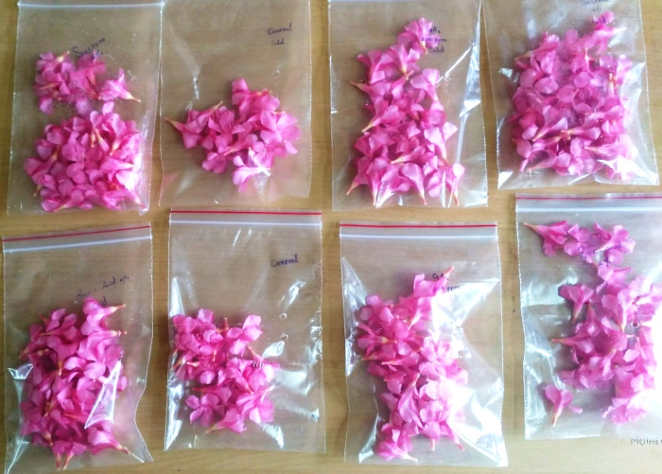

**Figure. 1 Flowers are in different treatments of pulsing solution**

**Observation Recorded**

Data were recorded on flower opening and colour fading based on hedenic scale scoring (Madhu 1999). Ethylene level can be measured by F950 handheld ethylene analyzer, Felix instruments, USA. Physiological loss weight, shelf life is recorded daily were averaged and analyzed statistically. Freshness percentage was calculated using the formula:

Solutions are as follows:

Number of fresh florets

Freshness % = ------------------------- × 100

Total number of florets

**RESULTS AND DISCUSSION**

 Results revealed that post harvest treatments showed a positive effect on the enhancement of shelf life. Among the treatments, the earliest flower opening (Table 1) was registered in T4 (98% in the 3rd day) and followed by T6 (94% at 3rd day).

|  |
| --- |
| **Table 1**  **Effect of chemicals and storage conditions of flower blooming (%) and freshness (%) on Nerium** |

|  |  |  |  |  |  |  |  |  |  |  |
| --- | --- | --- | --- | --- | --- | --- | --- | --- | --- | --- |
| **Flower blooming (%)** | | | | | | **Freshness (%)** | | | | |
| **Treatments** | **Day 1** | **Day 2** | **Day 3** | **Day 4** | **Mean** | **Day 1** | **Day 2** | **Day 3** | **Day 4** | **Mean** |
| T1 | 50 | 70 | 92 | 97 | 77.25 | 100 | 92 | 81 | 64 | 84.25 |
| T2 | 50 | 65 | 87 | 97 | 74.75 | 100 | 88 | 72 | 58 | 79.50 |
| T3 | 50 | 70 | 92 | 97 | 77.25 | 100 | 92 | 81 | 64 | 84.25 |
| T4 | 50 | 76 | 98 | 100 | 81.00 | 100 | 100 | 100 | 84 | 96.00 |
| T5 | 50 | 67 | 92 | 95 | 76.00 | 100 | 100 | 92 | 82 | 93.50 |
| T6 | 50 | 70 | 94 | 98 | 78.00 | 100 | 98 | 94 | 76 | 92.00 |
| T7 | 50 | 60 | 74 | 86 | 67.50 | 100 | 75 | 68 | 42 | 71.25 |
| T8 | 50 | 62 | 78 | 90 | 70.00 | 100 | 90 | 80 | 71 | 85.25 |
| S.E.± | 0.90 | 1.18 | 1.36 | 1.43 |  | 1.54 | 1.42 | 0.36 | 0.96 |  |
| C.D. (P=0.05) | 1.96 | 2.18 | 2.64 | 3.02 |  | 3.86 | 2.98 | 0.78 | 1.89 |  |

     These results are in agreement with the flower opening in cut roses where experiments have shown to be dependent on carbohydrate level in the petals. (Jadhav and Gurav, 2018). It might be due to that boric acid helps in membrane stability and resistance enhancement against senescence-related changes which increase the amount of protein (Hashemabadi *et al.* 2011) resulting in increased bud opening.

“The flower freshness was highest in T4 (100% at 3rd day) and it was followed by T6 (Table 1). This may be attributed to the maximum accumulation of carbohydrates. This, in turn, reduced solute leakage from flowers, indicating increased membrane integrity of flowers. Boric acid treatment positively impacted antioxidant enzyme activity, potentially preventing the accumulation of free radicals and thus preserving the freshness of flowers” (Lavanya *et al.* 2016; Krishnamoorthy, 2021 and Reshma *et al*., 2023) all these factors proved effective in retaining the freshness index of flowers, thus delaying wilting. Boric acid was used as a mineral salt that could increase osmotic concentration and pressure potential of petal cells, thus improving their water balance and longevity in cut flowers. The potential of boric acid in prolonging the postharvest life of flowers has been reported earlier in flower crops by Binisundar, 2011, Jawaharlal *et. al* 2012, Manimaran *et. al*, 2018 and Choudhury *et al*., 2020

|  |
| --- |
| **Table 2**  **Effect of chemicals and storage conditions of colour fading (%) and of physiological loss in weight (%) on nerium** |

|  |  |  |  |  |  |  |  |  |  |  |
| --- | --- | --- | --- | --- | --- | --- | --- | --- | --- | --- |
| **Colour Fading (%)** | | | | | | **Physiological loss in weight (%)** | | | | |
| **Treatments** | **Day 1** | **Day 2** | **Day 3** | **Day 4** | **Mean** | **Day 1** | **Day 2** | **Day 3** | **Day 4** | **Mean** |
| T1 | 100 | 91 | 86 | 66 | 86.00 | 0.00 | 4.77 | 9.53 | 20.15 | 11.48 |
| T2 | 100 | 80 | 72 | 67 | 79.75 | 0.00 | 9.47 | 15.3 | 24.12 | 16.51 |
| T3 | 100 | 95 | 84 | 69 | 86.75 | 0.00 | 4.03 | 9.22 | 21.72 | 11.66 |
| T4 | 100 | 100 | 100 | 88 | 97.00 | 0.00 | 4.28 | 8.11 | 16.83 | 9.74 |
| T5 | 100 | 95 | 87 | 83 | 91.50 | 0.00 | 5.79 | 8.44 | 17.64 | 10.62 |
| T6 | 100 | 98 | 90 | 75 | 90.75 | 0.00 | 4.46 | 9.10 | 17.42 | 10.19 |
| T7 | 100 | 73 | 68 | 56 | 74.25 | 0.00 | 10.47 | 14.38 | 23.14 | 16.00 |
| T8 | 100 | 80 | 74 | 65 | 79.75 | 0.00 | 6.78 | 14.53 | 20.18 | 13.83 |
| S.E.± | 1.56 | 1.34 | 1.04 | 1.15 |  | 0.00 | 0.21 | 0.42 | 0.68 |  |
| C.D. (P=0.05) | 3.37 | 2.78 | 2.13 | 2.58 |  | 0.00 | 0.46 | 0.96 | 1.13 |  |

The maximum colour retention was registered in T4 (100 % at 1 to 3rd day storage) and it was followed by T6 (100 % at 1st day, 98 % for 2nd day and 90 % for 3rd day) (Table 2). This might be due to the effectiveness of boric acid in increasing anti-oxidant activity besides an anti- ethylene activity and had reduced per cent of solute leakage from the florets indicating increased membrane integrity of florets due to which good colour retention is observed. The potential of boric acid has also been reported earlier by Bhattacharjee (2002) in crossandra.

“The minimum physiological loss in weight was recorded in T4 (4.28 % at2nd day and 8.11 % for 3nd day) and it was followed by T6 (4.46 % at 2nd t day and 9.10 % for 3rd day). The highest shelf life (Table 2) was registered in T4, T6 and T5 (up to 5days) and it was followed by T1 and T3 in (4 days). This may be due to the water loss which accounts for percent loss in physiological weight which was less when loose flowers were stored at a lower temperature” (Bhuvaneswari and Sangama, 2020). Moreover, low cold storage temperature slows down the transpirational loss of water and respirational loss of carbohydrates which reduces the loss of weight during storage. Polyethylene reduces the permeability to moisture thereby leading to the reduction in the loss of moisture and preventing the wilting of flowers thus maintaining the freshness of flowers by delaying the symptom of senescence. These results are in close conformity with the findings of Varu and Barad (2008); Manimaran *et al*., (2018) and Rajiv *et al*., (2018).

**T4  4% Boric acid T6 4% Sucrose**

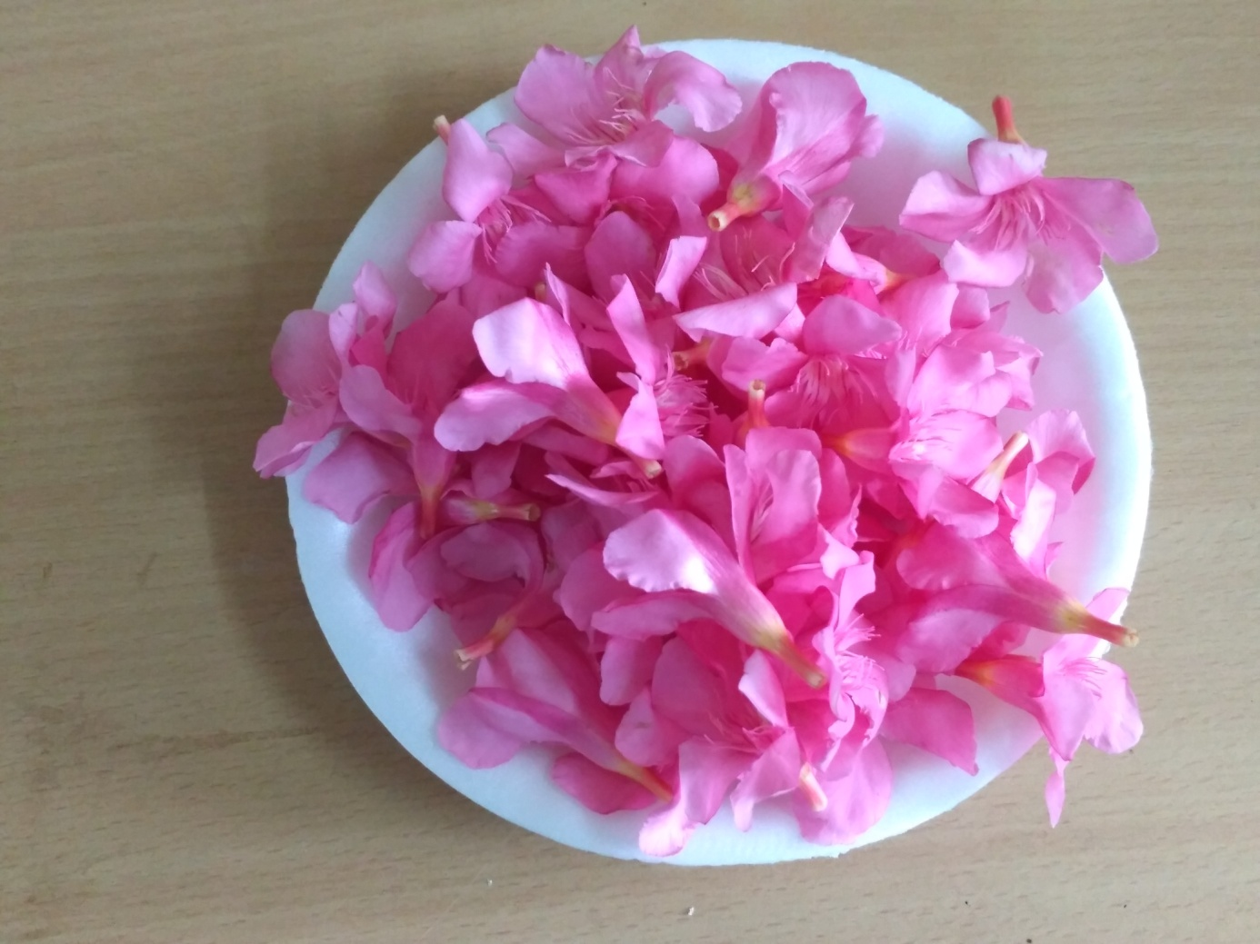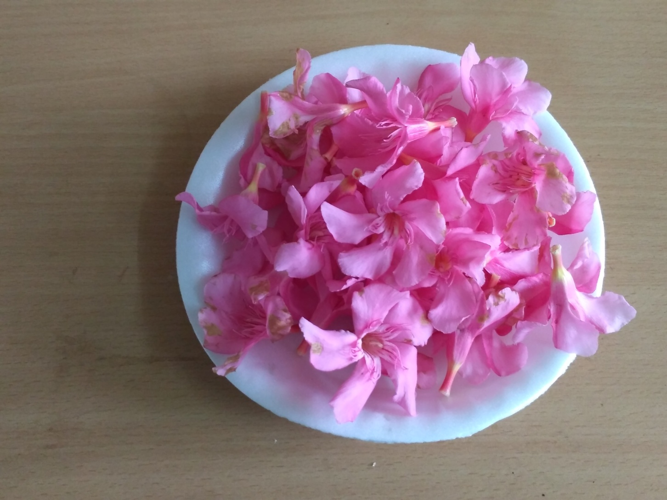

**Figure. 2. Effect of Different Pulse Solution on Fourth Day of Evaluation**

**Figure3. Ethylene concentration levels in 1st and 4th day of storage**

More amount of ethylene was present in T7 and T8  are compared at the refrigerated condition with sucrose 4% followed by 4% boric acid released lesser amount of ethylene, which extends the shelf life of the flower.

“The enhanced longevity of pulsed stems could be attributed to continued and increased water uptake in the stems, cellular turgidity, enhanced fresh weight and dry weight, better petal size and optimum continuation of cell metabolism, especially respiration that facilitated cell growth and development, formation of cellular constituents and liberation of energy for other cellular function” (Gupta and Dubey, 2018; Abdulla and Celikel, 2019; Rahaman et al. 2018).  Boric acid extending the vase life and preventing fresh weight loss resulted in strong inhibition of the climacteric ethylene production could be due to the prevention of ethylene synthesis by reducing the amount of ACC synthase and ACC oxidase activity. These results are in accordance with Hoseinzadeh Liavali & Zarchini (2012), Ahmadnia *et al.* (2013). Average percent weight loss and shelf life were also significantly influenced by chemical treatments and storage conditions in Nerium flowers.

**CONCLUSION**

The loose flower should be harvested and immediately brought to shade to avoid water and weight loss. Appropriate packaging and storage of flowers combined with the pulsing are helpful to ensure the fresh quality of flowers for consumers and also offer the potential advantage of extending shelf life.

**REFERENCES**

Abdulla, M.F. and Çelikel, F.G. (2019). Postharvest quality and extending vase life of *Narcissus tazetta* flowers by sucrose. Acta Hortic. 1263, 455-460.

Adome RO, Gachihi JW, Onegi B, Tamale J, Apio SO (2003) The cardiotonic effect of the crude ethanolic extract of nerium oleander in the isolated guinea pig hearts. African Health Sciences, 3(2), 77-82.

Bhattacharjee, S.K. (2002). Post harvest management of flowers. In: Handbook of horticulture. (Ed.), New Delhi, India: ICAR, PP.969-981.

Bhuvaneswari S and Sangama (2020). Standardisation of Packages For Freshness Retention and Shelf Life Extension of Crossandra Flowers Under Different Storage Conditions. Plant Archives. 20 (1) :2037-2039.

Bini Sundar, S.T. 2011. Investigation on the production system efficiency of precision technology in comparison with conventional system in gundumalli (*jasminum sambac* ait.) Ph. D. Thesis, TNAU, Coimbatore.

Chawla L, Dipal Bhatt, Sudha Patil and Parmeshvari Chaudhari (2020). Standardization of chemicals for improving post harvest life of loose flowers of tuberose (*Polianthes tuberosa*),Ind. J. Agrl. Sciences,90 (10): 2029–32.

Gloria Alicia, Tejacal, Colinas-León, Valdez-Aguilar and Clara Pelayo (2019). Postharvest physiology and technology of the tuberose (*Polianthes tuberosa* L.): an ornamental flower native to Mexico, [Horticulture, Environment, and Biotechnology](https://link.springer.com/journal/13580) , 60: 281–293.

Gupta and Dubey, (2018). Factors Affecting Post-Harvest Life of Flower Crops. Int.J.Curr.Microbiol.App.Sci., 7(1):548-557.

Hardenburg, R.E., Watada, A.E. and Wang, C.Y. (1990). The commercial storage of fruits, vegetables and florist and nursery stocks. USDA Agri. Handbook, 66: 130.

Hashemabadi D. 2011. Final Report of Research Project to Islamic Azad University, Rasht Branch, Rasht, Iran.p. 101.

Hoseinzadeh Liavali MB, Zarchini M. J. Ornament. Hortic. Plants. 2012;2(2):123-130

Jadhav and Gurav (2018). Extension of the Storage and Post-Storage Life of Tuberose (*Polianthes tuberosa* L.) Loose Flowers cv. ‘Local’., Int.J.Curr.Microbiol.App.Sci, 7(1): 2798-2807.

Jawaharlal M, Thamaraiselvi SP, Ganga M.(2013) Standardization of export packaging technology for jasmine (*Jasminum sambac* ait.) Flowers. Acta Horticulture, 970:81-91.

Krishnamoorthy, C. 2021. Influence of Post-harvest Chemical Treatments on Shelf life of Gerbera (*Gerbera jamesonii*). Int.J.Curr.Microbiol.App.Sci. 10(01): 1716-1722.

Lavanya V, Nidoni UR, Kurubar AR, Sharanagouda H, Ramachandra CT.(2016) Effect of pre-treatment and different packaging materials on shelf-life of jasmine flowers (*Jasminum sambac*). Journal of Environment and Ecology.34(1A):341-345.

ManimaranP, Ganga M, Kannan M and Arulmozhiselvan K (2018). Standardization of post harvest management techniques for *Jasminum nitidum* flowers., Chem Sci Rev Lett , 7(26), 652-658.

Pooja AB, Yathindra HA, Babu AG, Devindrappa, Raghavendra, Mutturaju GP, Sudarshan GK.(2024) Studies on the effect of plant growth retardants on growth and post-harvest parameters in Nerium (*Nerium oleander* L.) cv. Pink Single. Pharma Innovation,13(5):16-20.

Preethi, T.L., Kumar, M., Shivani, P. and Ponnuswami, V. (2013). Improvement in post harvest attributes of nerium (*nerium oleander* L. cv. Red). Internat. J. Proc. & Post Harvest Technol., 4 (1) : 41-44.

Rajiv G, Jawaharlal M, Subramanian S, Sudhakar D and Uma D (2018). Studies on morphological characteristics and categorization of nerium accessions based on utility. Electronic Journal of Plant Breeding, 9 (3): 1100 – 1106.

Reshma R, Ganga M., Visalakshi M., Irene Vethamoni P., and Chitdeshwari T. 2023. “Standardization of Post-Harvest Management Techniques for Ixora (*Ixora* spp.)”. International Journal of Environment and Climate Change 13 (10):1267-80.

Sajjad Ahmadnia, Davood Hashemabadi, Shahram Sedaghathoor (2013). Effects of Boric Acid on Postharvest Characteristics of Cut Carnation (*Dianthus caryophyllus* L. cv. ‘Nelson’). Annals of Biological Research, 4 (1):242-245.

Singh, Kushal, Kumar, Gunjeet, Saha, T. N. and Kumar, Ramesh. 2013. Post-Harvest Technology of Cut Flowers. Pp. 26-28. Venus Printers and Publishers, New Delhi.

Srivastava, Gunjan and Satish Chand ( 2015). Post-Harvest Life of Cut Chrysanthemum Cultivars in Relation to Chemicals,Wrapping Material and Storage Conditions. J Horticulture , 2(1).

Sushree Choudhury, Jatindra Nath Das, Chitta Ranjan Mohanty, Arun Kumar.Das and Bijaya Kumar Mishra (2019). Packaging Technology for Extending Shelf Life of Jasmine (*Jasminum sambac* CV. Gundumalli) Flowers. *Int.J.Curr.Microbiol.App.Sci.* 8(09): 1724-1732.

Varu, D. K and Barad, A.V. (2008). Effect of different packing methods on vase life and quality of cut flowers in tuberose (*Polianthes tuberosa* L.) cv. Double. Asian J. of Bio Sci. 3 (1) : (159-162).

Singh, S., Malik, S., Kumar, M., Kumar, S., Singh, S. P., & Singh, B. (2023). Evaluation of Sucrose and Sodium Hypochlorite as Pulsing Solution in Improving the Post-harvest Quality in Chrysanthemum cv. White Star. Biological Forum – An International Journal 15(9): 34-44

Akoumianaki-Ioannidou, A., Darras, A. I., & Diamantaki, A. (2010). Post-harvest vase solutions and storage effects on cut Nerium oleander inflorescences. *The Journal of Horticultural Science and Biotechnology*, *85*(1), 1-6.

Rahaman, S. K. S. R., Adhikari, P., Islam, S., Banerjee, A., & Uddin, A. F. M. J. (2018). Effect of NAA for callus induction of lisianthus [Eustoma grandiflorum (Raf.) Shinn] on MS and B5 medium. In *Advances in Floriculture and Urban Horticulture Proceedings of the National Symposium on Recent Advances in Floriculture and Urban Horticulture in Global Perspective*.