**Azolla as a Sustainable Feed Alternative in Turkey: A Sustainable Revenue Model and Nutrition**

**ABSTRACT**

A vital area of chicken production, Turkey (*Meleagris gallapavo*) farming provides both nutritional and financial advantages on a worldwide scale. Cost-effective rearing techniques, substitute feed sources, and enhanced health precautions are required due to the growing demand for turkey meat. The investigation of unconventional choices, such as the very nutritious aquatic plant azolla (*Azolla pinnata*), has been spurred by traditional feed costs. Studies show that supplementing turkeys with azolla improves their immune system, nutritional utilization, growth performance, and feed efficiency. In addition to lowering feed costs, Azolla's rich protein, fiber, and vital minerals promote improved digestion, nitrogen retention, and energy usage. Additionally, by raising antibody titers, boosting immunological cells, and lowering inflammation, azolla improves immune competence. Turkey farming is profitable for both large and small producers. Small-scale farms profit from reduced investment and direct marketing options, whereas large-scale systems take advantage of economies of scale. Turkey meat is a premium protein source that is abundant in micronutrients and important amino acids, encouraging health-conscious consumption. Sustainable turkey production can improve economic growth, environmental sustainability, and food security when backed by alternate feeds and effective farming methods. Azolla's contribution to increasing turkey productivity while cutting expenses is highlighted in this evaluation, making turkey farming a profitable endeavor for both commercial and smallholder growers.

*Keywords:**Azolla, Turkey feed, Sustainable farming, Cost-effective feed, Environmental sustainability.*

**1. INTRODUCTION**

Poultry production is playing a pivotal role in global economic development, food security, and uplifting rural life by supplying a cheap source of quality protein (Abbas et al., 2022; Abbas et al., 2023). This sector meets the global demand for eggs and meat and also provides entrepreneurship and employment opportunities, especially in developing countries (Abbas et al., 2020a). Advances in nutrition, genetics, and disease prevention and control have significantly revolutionized the poultry productivity, contributing to play major role in agricultural sustainability (Abbas et al., 2020a; Abbas et al., 2022b). Moreover, the development within poultry farming, including the chickens farming, ducks farming, quails farming, and turkeys farming, has enabled producers to explore new alternate feed ingredients for better profitability whilst catering to various consumer preferences (Abbas et al., 2020a; Abbas et al., 2022b).

Turkey is a quickly growing bird. It required more energy, minerals, vitamins and proteins as compared to chicken for quick growth. Due to their growing habits, aquatic plants have a larger potential than tree leaves as a protein source for monogastric animals because they do not accumulate secondary plant components. Aquatic plants provide an affordable alternative to animal feed and have a wide range of possible uses, including compost, biofertilizers, human food, and animal feed. From the standpoint of ease of culture, productivity, and nutritional value, the water fern Azolla is possibly the most promising (Meena et al., 2023).

Turkey rearing is a critical industry under poultry production that offers a lasting source of protein and economic empowerment globally. There has been a growing demand for turkey meat to necessitate proper rearing mechanisms, affordable alternative feeds, and enhanced health care measures. Literature indicates that turkeys need proper nutrition with ample protein, amino acids, and minerals to exhibit maximum growth and productivity (Shukla et al., 2018). However the exorbitant price of traditional feed ingredients has prompted scientists to seek novel feed sources like azolla, a water plant with high nutritional value that has shown promise in enhancing feed efficiency and lowering production costs (Meena et al., 2023). The poultry industry of Bangladesh has been growing day by day and thus, is also providing a source of protein along with employment in the nation. Production of turkey might not be prevalent in Bangladesh, but the district livestock officer and the farmer who succeeded financially through turkey production attested that it can be a good means for the Asian nation to thrive (Hamid et al., 2016). But the domestic turkey *Meleagris gallopavo*, a large bird of poultry size, is one of the two species of the genus *Meleagris* and identical to the wild turkey (Aslam et al., 2012).

We have observed that turkeys eat vegetables (green feeds) more than poultry. Therefore, the feed factor plays a very important role in turkeys under intensive rearing, as they come into direct contact with plant feeds, particularly green feeds. In addition, the spectacular rise in poultry production has come at the expense of traditional human foodstuffs causing shortage and raising the price of traditional feedstuffs (Buchanan et al., 1996). Azolla is small water fern that floats on the surface of the water. Its application as a medicine, the restoration of saline soils (Raja et al., 2012) and bioremediation (Sood et al., 2011, Yadav et al., 2014) has also been studied. There are very few studies conducted on chicken to evaluate the impact of azolla meal and raw azolla feeding on chicken performance (Bhattacharyya et al., 2016 and Sujatha et al., 2013). If turkeys successfully utilize non-conventional feed materials such as azolla without lowering the performance, it will raise the profitability of turkey enterprise. It has previously been confirmed that choice-feeding system can play a central function in minimizing the cost of laying hens' and turkeys' feed in developing nations (Bhattacharyya et al., 2006). Turkey farming is as same as other poultry birds farming such as chickens, ducks, and quails (Chowdhury et al., 2004). Therefore, the current study was conducted to assess the impact of dry *azolla pinnata* meal compared with raw azolla as selection feeding on the body weight, feed conversion ratio (FCR), blood biochemical characteristics, and immune proficiency traits of growing turkeys in an intensive system. The immune status of turkeys is another significant factor that affects their growth and overall productivity. Studies indicate that turkeys fed with bioactive feed additives, including azolla, have better immune responses, increased antibody titers, and enhanced disease resistance (Samad et al., 2020).

Experiments have proven the advantages of azolla in promoting growth performance, feed efficiency, and immunity in poultry. The addition of azolla in turkey feed has been shown to enhance nutrient use, including dry matter and protein digestibility, and minimize dependency on expensive traditional feeds. As the poultry industry develops further, innovations in feed formulation, disease prevention, and affordable farming techniques will be vital in ensuring the profitability and sustainability of turkey farming. This paper discusses the impact of azolla on turkey production, with emphasis on nutrient utilization, immune system, cost of farming, and economic returns of turkey production.

**Table 1. Nutrient Composition of azolla Meal and Turkey Feed**

|  |  |  |
| --- | --- | --- |
| **Nutrient** | **Percentage/Content** | **Reference** |
| Dry Matter | 98.8% (azolla), 89.96% (T1), 85.95% (T2) | Shukla et al., 2018 |
| Total Ash | 21.67% (azolla), 3.29% (T1), 3.85% (T2) |
| Ether Extract | 3.15% (azolla), 4.31% (T1), 4.25% (T2) |
| Calcium | 1.11% (azolla), 0.89% (T1), 1.41% (T2) |
| Phosphorous | 0.59% (azolla), 0.52% (T1), 0.79% (T2) |
| Crude Protein | 25.64% (azolla), 19.30% (T1), 19.67% (T2) |
| Crude Fiber | 17.29% (azolla), 3.91% (T1), 4.58% (T2) |

**T1:** Birds of the control group fed a basal diet

**T2:** Birds of the group fed 5% of basal diet replaced by dry Azolla powder on Daily basis

**2. EFFECTS OF AZOLLA FOR GROWTH PERFORMANCE ON TURKEY**

Parthasarathy et al. (2002) observed in their experiment, sno differential body weight gain between the treatment groups. Likewise, there was no difference in body weight gain of broilers fed on basal and 5% azolla diets. Balaji et al. (2009) also recorded that feeding up to 4.5% azolla inclusion in rations did not affect body weight gain in broiler chicken. These findings indicated that green azolla, when fed ad libitum on the basal diet or substituted 5% of the basal diet on DM basis, did not have any negative impact on body weight gain. Additionally, Naghshi et al. (2014), observed that chicken received 5% azolla powder containing significantly (p<0.01 better weight gain on a daily basis in comparison with basal diet. Azolla (*Azolla pinnata*) is extensively researched because of its usefulness as a feed ingredient for substitution in poultry diets owing to its high protein level and nutrient value.

Examined the impact of azolla supplementation on the growth performance, feed conversion ratio (FCR), and immune characteristics of turkeys, and found that turkeys allowed choice-feeding access to azolla and a basal diet demonstrated significantly enhanced FCR than control groups, without any negative impacts on blood biochemical properties (Shukla et al., 2018). Explored the influence of various rearing systems on the performance of turkeys, such as those fed on alternative protein sources such as azolla. The research identified turkeys under semi-intensive systems supplemented with green feed (such as azolla) performed better than their intensive confinement counterparts. Increased body weight gain in semi-intensive groups was attributed to improved nutrient availability and natural foraging behaviour, suggesting that azolla has a positive role to play in enhancing turkey growth in diversified rearing environments (Anandh et al., 2012). Also, research on White Pekin broiler ducks showed that supplementing them with fresh azolla led to improved growth performance and feed utilization efficiency (Acharya et al., 2015) and feeding azolla with direct-fed microbial supplements in broilers also increased feed efficiency and nutrient utilization (Shambhvi et al., 2020).

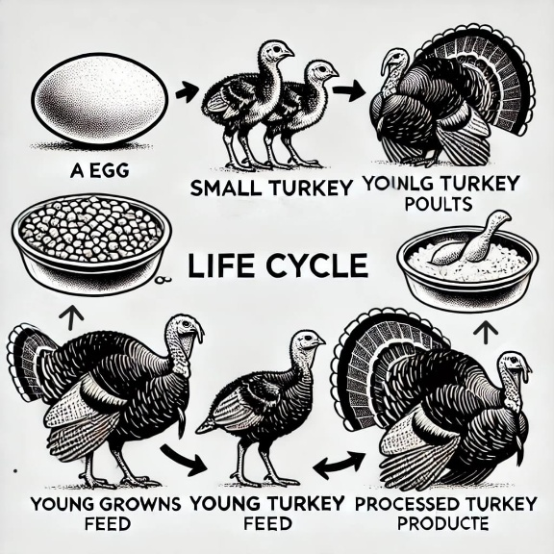 **Fig. 1. Life Cycle of Turkey**

Also investigated inclusion of azolla in broiler chicken rations and reported that supplementation with a level of 15% improved nutrient digestibility and body weight gain without ill health effects and thus suggested azolla as an efficient source of sustainable protein (Samad et al., 2020). Furthermore, azolla has also been chemically analysed, validating it as an essential source of protein that may successfully substitute with other protein sources traditionally used in poultry feeds (Alalade et al., 2006).

**Table 2. Estimated Cost of Rearing Turkeys (Per Bird)**

|  |  |  |  |
| --- | --- | --- | --- |
| **Expense Category** | **Cost per Bird (₹)** | **Cost per 10 Birds (₹)** | **Remarks** |
| Purchase of Poults (1-day old) | 80 - 150 | 800 - 1500 | Price varies based on breed |
| Brooding Cost (0-4 weeks) | 50 - 80 | 500 - 800 | Includes heating, bedding, and initial care |
| Feed Cost (up to 6 months) | 900 - 1200 | |  | | --- | |  |  9000 - 12000 | |  | | --- | |  |  Major cost; includes starter, grower, and finisher feed |
| Housing & Equipment | 100 - 300 | 1000 - 3000 | Includes shelter, feeders, drinkers, fencing |
| Vaccination & Medication | 30 - 50 | 300 - 500 | Disease prevention & treatment |
| Labor/Management | 100 - 200 | 1000 - 2000 | If hiring workers for care |
| Miscellaneous Costs | 50 - 100 | 500 - 1000 | Includes water, electricity, unexpected expenses |
| Total Estimated Cost per Bird | ₹1310 - ₹2080 | ₹13,100 - ₹20,800 | Approximate range |

**Table 3. Estimated Cost of Rearing Large Turkeys (10-15 kg)**

|  |  |  |  |
| --- | --- | --- | --- |
| **Expense Category** | **Cost per Bird (₹)** | **Cost per 10 Birds (₹)** | **Remarks** |
| Purchase of Poults  (1-day old) | 100 - 200 | 1000 - 2000 | Higher price for large breed poults |
| Brooding Cost  (0-4 weeks) | 80 - 120 | 800 - 1200 | Includes heating, bedding, and initial care |
| Feed Cost  (up to 6 months) | 1500 - 2500 | 15,000 - 25,000 | Major cost; includes starter, grower, and finisher feed |
| Housing & Equipment | 200 - 500 | 2000 - 5000 | Includes shelter, feeders, drinkers, fencing |
| Vaccination & Medication | 50 - 100 | 500 - 1000 | Disease prevention & treatment |
| Labour/ Management | 200 - 400 | 2000 - 4000 | If hiring workers for care |
| Miscellaneous Costs | 100 – 200 | 1000 - 2000 | Water, electricity, unexpected expenses |
| Total Estimated Cost per Bird | ₹2230 - ₹4020 | ₹22,300 - ₹40,200 | Approximate range |

**Table 4. Profit Consideration**

|  |  |
| --- | --- |
| **Parameter** | **Value** |
| **Market Weight** | 5-10 kg in 5-6 months |
| **Selling Price** | ₹300 - ₹600 per kg (depends on market demand) |
| **Expected Revenue per Bird** | ₹1500 - ₹5000 (based on weight & market rate) |
| **Profit Margin** | ₹200 - ₹3000 per bird (depending on costs and selling price) |

**Table 5. Profit Estimation for Large Turkey**

|  |  |
| --- | --- |
| **Parameter** | **Value** |
| **Market Weight** | 10-15 kg (reached in 8-9 months) |
| **Selling Price** | ₹300 - ₹600 per kg (depends on demand) |
| **Expected Revenue per Bird** | ₹3000 - ₹9000 |
| **Profit Margin per Bird** | ₹1000 - ₹5000 (depending on weight, feed cost, and selling price) |

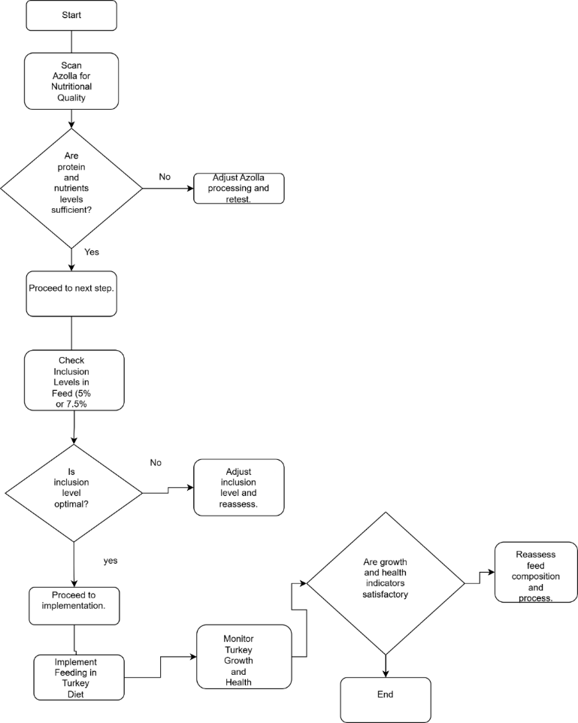

**Fig. 2. Turkey rearing with feed of azolla**

**3. EFFECTS ON NUTRIENT UTLIZATION**

Azolla (*Azolla pinnata*) is known for its important contribution to enhancing nutrient utilization in poultry feed because of its high protein content, essential amino acids, and fiber content. Studies have proven that turkeys fed with azolla had higher crude protein intake (CPI) and dry matter intake (DMI), which resulted in improved growth performance and nutrient utilization (Meena et al., 2023), while higher ether extract and nitrogen-free extract digestibility helped improve energy utilization (Shukla et al., 2018).The azolla contains high fiber which supports gut health and digestion, ensuring effective feed conversion and retention of minerals (Samad et al., 2020), which is an important factor in poultry bone strength and metabolic processes (Acharya et al., 2015). In addition to protein and fiber metabolism, azolla has been demonstrated to enhance mineral uptake, especially calcium and phosphorus, required for the development of bones and eggshells in poultry (Shambhavi et al., 2020), with the bioactive compounds promoting micronutrient uptakes like iron and zinc (Alalade et al., 2006).

Research has shown that turkeys receiving azolla-based diets showed lower nitrogen excretion and lower plasma uric acid concentrations, indicating more efficient protein metabolism and reduced wastage of nutrients (Shukla et al., 2018), while the increased activity of digestive enzymes was correlated with enhanced breakdown and absorption of macronutrients, consequently improving feed conversion efficiency (Samad et al., 2020). Moreover, azolla has been discovered to promote gut microbiota equilibrium, resulting in enhanced nutrient uptake and minimized feed wastage, thus qualifying as a cost-saving and environmentally friendly feed substitute (Meena et al., 2023), while its capacity to chelate with anti-nutritional factors in traditional feeds maximizes its effectiveness as a feed supplement (Shukla et al., 2018). The natural antioxidants present in azolla also shield against oxidative stress, minimizing nutrient loss and enhancing the bioavailability of key vitamins and minerals (Shambhvi et al., 2020), thus enhancing immune function and overall poultry health (Alalade et al., 2006). The combined results from these research works verify that azolla is a very good feed supplement for maximizing nutrient use in turkeys by enhancing digestibility, increasing protein retention, lowering nitrogen loss, and raising mineral availability (Shukla et al., 2018; Meena et al., 2023). Consequently, azolla is increasingly becoming accepted as a green and cost-effective replacement for conventional poultry feedstuff, with economic and environmental advantages in turkey production.

**3.1 Nitrogen Retention**

Among the major advantages of azolla supplementation is its power to increase nitrogen retention in turkeys, thereby resulting in increased protein utilization and decreased nitrogen excretion (Shukla et al., 2018), a critical aspect in maximizing feed efficiency and limiting environmental footprint (Samad et al., 2020). Research has proved that turkeys fed with diets containing azolla had lower levels of plasma uric acid, indicating better nitrogen metabolism and lower excretion of excess nitrogen (Acharya et al., 2015).

**3.2 Energy Utilization**

Azolla has been reported to enhance energy utilization in the diet of poultry because it is highly rich in bioavailable nutrients. Studies have shown that turkeys fed azolla showed greater efficiency in metabolizing dietary energy, which resulted in better growth rates and body weight gain (Meena et al., 2023), and the inclusion of essential fatty acids in azolla ensures proper lipid metabolism and energy storage (Shambhvi et al., 2020). Enhanced energy use also leads to greater stamina, improved immune function, and overall stronger physiological processes (Alalade et al., 2006).

**3.3 Impact of Anti-Nutritional Factors**

Azolla possesses natural compounds that help mitigate the effects of anti-nutritional factors commonly found in poultry feed ingredients. Research suggests that azolla supplementation can bind with anti-nutrients such as tannins and phytic acid, reducing their negative effects on nutrient bioavailability (Shukla et al., 2018), while also improving gut health by promoting beneficial microbial activity (Meena et al., 2023). Additionally, the presence of bioactive compounds and antioxidants in azolla has been associated with reduced oxidative stress and improved overall metabolism (Acharya et al., 2015).

**3.4 Improved Digestive Efficiency**

Incorporation of azolla into turkeys' diet has been correlated with improved activities of digestive enzymes, ensuring easy breakdown and uptake of macronutrients (Samad et al., 2020), whereas fiber compounds in azolla ensure better gut microflora, enhancing digestion and nutrient uptake (Shambhvi et al., 2020). Research also pinpoints greater crude fiber retention as well as overall ash content retention, ensuring optimal mineral uptake as well as maintaining gut integrity (Meena et al., 2023).

**3.5 Economic Advantage in Nutrient Utilization**

Azolla is a low-cost feed supplement ingredient that substitutes for part of the normal protein sources in the diet with minimal impact on growth and nutrient utilization. Replacing some of the traditional feed with azolla substantially reduces feed expenditure without affecting growth performance (Shukla et al., 2018), and enhanced feed conversion ratios have the potential for higher economic return for poultry farmers (Alalade et al., 2006). Due to its low-cost production and high nutritional content, azolla offers a sustainable alternative for lowering poultry production costs (Meena et al., 2023).

**Table 6. Fat Content and Calorie Chart**

|  |  |  |  |  |  |  |
| --- | --- | --- | --- | --- | --- | --- |
| **Turkey**  **Cut** | **Calories** | **Total Fat(g)** | **Saturated Fat(g)** | **Cholesterol**  **(mg)** | **Protein(g)** | **Reference** |
| Ground White Meat 99% Fat Free | ~120 | ~1.5 | ~0.5 | ~65 | ~26 | Jahan et al., 2018 |
| Ground (13% Fat) | ~250 | ~17 | ~5.5 | ~80 | ~22 |
| Thigh | ~140 | ~6 | ~2 | ~70 | ~24 |
| Drumstick | ~150 | ~7 | ~2 | ~75 | ~23 |
| Wing | ~160 | ~8 | ~2.5 | ~80 | ~22 |
| Whole Turkey | ~160 | ~7 | ~2.5 | ~75 | ~24 |
| Tenderloins | ~120 | ~1.5 | ~0.5 | ~60 | ~27 |
| Breast Cutlets | ~130 | ~2 | ~0.5 | ~65 | ~26 |
| Turkey Breast | ~140 | ~3 | ~1 | ~70 | ~25 |

**4. IMMUNE AND PATTERN**

The immune-modulating activity of azolla has received considerable interest in poultry studies, especially in turkeys, since it has demonstrated the ability to enhance immune function and disease resistance. The bioactive compounds, such as antioxidants and essential micronutrients, play a role in enhanced immune response, elevated antibody production, and overall poultry health (Shukla et al., 2018).

**4.1 Improved Antibody Titers**

Experiments of Meena et al. (2023) have shown that turkeys provided with azolla-supplemented diets showed increased antibody titers against typical poultry pathogens, reflecting improved immune response. Moreover, the higher immunoglobulin M (IgM) and hemagglutination (HA) titer levels in azolla-supplemented turkeys reflect improved adaptive immunity, which is important in the protection against pathogens (Shambhvi et al., 2020). In addition, food supplementation with azolla has been associated with augmented production of immunoglobulin G (IgG), necessary for long-term immune defence and enhanced vaccine efficacy (Samad et al., 2020).

**4.2 Stimulation of Immune Competence**

Azolla has been reported to enhance immune competence by enhancing the activity of immune cells like macrophages and lymphocytes. Research has shown that turkeys fed azolla-based diets had increased white blood cell (WBC) counts, showing an improved immune surveillance system with improved pathogen detection and elimination (Acharya et al., 2015). Also, the existence of bioactive polysaccharides in azolla is responsible for the stimulation of cytokine pathways, enhancing the bird's natural immune system and resistance to infection (Alalade et al., 2006).

**4.3 Anti - Anti-inflammatory Properties**

In addition to immune enhancement, azolla also contains anti-inflammatory properties that help alleviate systemic inflammation and stress-induced immune suppression. According to research, azolla-fed turkeys exhibited decreased levels of pro-inflammatory cytokines, including interleukin-6 (IL-6) and tumour necrosis factor-alpha (TNF-α), linked to inflammatory processes in poultry (Shukla et al., 2018). The antioxidant molecules found in azolla have been reported to counteract oxidative stress, thus safeguarding immune cells from destruction and facilitating effective immune function (Meena et al., 2023).

**5. COST OF TURKEY FARMING AND ITS BENEFITS FOR HUMANS**

Turkey's production is an important part of poultry farming that offers humans economic gain and nutritional value. The cost-effectiveness of turkey production is influenced by factors such as feed, housing, and health, while the advantages to humans involve high-quality protein consumption and economic gain in large-scale and small-scale production.

**5.1 Cost of Turkey Farming**

Turkey production costs differ about farm systems, costs of feeds, and infrastructure input. Research explains that feeds occupy about 60-70% of production expenditures, representing the highest expenditure cost in turkey farming (Shukla et al., 2018). Others have been in search of non-traditional feed materials such as azolla to ensure minimizing feed expenditures in addition to continued optimal growth performances and turkey well-being (Meena et al., 2023). Moreover, labour, housing, and veterinary costs add to the total cost of farming, with low-scale farms having lower initial investments than large-scale commercial farms (Samad et al., 2020).

**5.2 Benefits of Turkey for Humans**

Turkey meat is a rich source of good-quality protein, essential vitamins, and minerals. Research indicates that turkey meat consists of higher protein content with reduced fat percentages than other poultry meat, so it is a healthy option (Acharya et al., 2015). Moreover, turkey meat is abundant with essential amino acids like tryptophan, which helps to maintain brain and overall health (Shambhvi et al., 2020). The need for turkey meat has also brought about economic growth through job opportunities in the poultry sector and associated industries like the production of feeds and processing of meat.

**5.3 Large – Scale Farming**

Large-scale turkey production is based on intensive production systems with sophisticated technology, computerized feeding systems, and high biosecurity levels. Commercial turkey farms have been proven to take advantage of economies of scale by reducing the cost of production per bird while producing maximum output (Shukla et al., 2018). Improved breeding methods and nutrition management also increase productivity, with improved meat yield and improved growth rates experienced in intensive turkey production systems (Meena et al., 2023). Large-scale production, however, entails huge capital inputs and effective waste management practices to ensure sustainability (Samad et al., 2020)

**5.4 Small – Scale Farming**

Small-scale turkey production is a feasible alternative for rural farmers and smallholder poultry farmers. Research has shown that small-scale turkey production can yield a sustainable source of income at a lower capital outlay than commercial production (Acharya et al., 2015). The inclusion of azolla and other non-conventional feed sources has been shown to enhance feed efficiency and lower overall production costs in small-scale production units (Shambhvi et al., 2020). Also, small-scale farmers can gain from direct marketing and niche markets, where free-range and organic turkey meat is highly sought after (Alalade et al., 2006). Overall, turkey farming is of economic and nutritional benefits for small and large-scale farmers alike. Affordability-oriented strategies like integrating alternate sources of feeds and practicing effective rearing practices are possible steps toward augmenting the profitability and sustainability of turkey farming

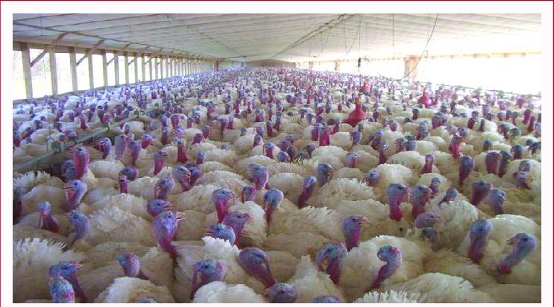

**Fig 3. Turkey Rearing System (Jahan et al., 2018)**

**6. CONCLUSION**

Turkey production provides a remunerative and sustainable means of high-quality protein while opening economic opportunities for producers. The production cost of turkeys is largely fueled by feed cost, labor, and housing, with the use of alternative feeds like azolla being economical in enhancing feed efficiency and minimizing total costs. Mass production of turkeys takes advantage of economies of scale, whereas small-scale production offers a sustainable source of income for rural farmers with less initial capital outlay. Furthermore, turkey meat is a nutritionally rich food product, high in protein, essential amino acids, and micronutrients, making it a perfect option for health-oriented consumers. Through the application of sustainable farming methods and improving feed efficiency, turkey production can help ensure food security, and promote economic growth, and environmental sustainability in the poultry sector.

Disclaimer (Artificial intelligence)

Option 1:

Author(s) hereby declare that NO generative AI technologies such as Large Language Models (ChatGPT, COPILOT, etc.) and text-to-image generators have been used during the writing or editing of this manuscript.

Option 2:

Author(s) hereby declare that generative AI technologies such as Large Language Models, etc. have been used during the writing or editing of manuscripts. This explanation will include the name, version, model, and source of the generative AI technology and as well as all input prompts provided to the generative AI technology

Details of the AI usage are given below:

1.

2.

3.

**REFERENCES**

Acharya, P., Mohanty, G. P., Pradhan, C. R., Mishra, S. K., Beura, N. C., & Moharana, B. (2015). Exploring the effects of inclusion of dietary fresh Azolla on the performance of White Pekin broiler ducks. Veterinary World, 8(11), 1293–1299. <https://doi.org/10.14202/vetworld.2015.1293-1299>

Alalade, O. A., & Iyayi, E. A. (2006). Chemical composition and the feeding value of Azolla (*Azolla pinnata*) meal for egg-type chicks. International Journal of Poultry Science, 5(2), 137-141. <https://doi.org/10.3923/ijps.2006.137.141>

Anna Anandh, M., Richard Jagatheesan, P., Kumar, P., Paramasivam, A., & Rajarajan, G. (2012). Effect of Rearing Systems on Reproductive Performance of Turkey. Veterinary World, 226. <https://doi.org/10.5455/vetworld.2012.226-229>

Aslam, M. L. (2012). *Genetic control and variation in turkey: molecular insights in selection*. Wageningen University and Research <https://doi.org/10.18174/222257>

Balaji, K., Jalaludeen, A., Churchil, R. R., Peethambaran, P. A., & Senthilkumar, S. (2009). Effect of dietary inclusion of Azolla (Azolla pinnata) on production performance of broiler chicken. *Indian Journal of Poultry Science*, *44*(2), 195-198.

Bhattacharyya, A., Shukla, P. K., Roy, D., & Shukla, M. (2016). Effect of Azolla Supplementation on Growth, Immunocompetence and Carcass Characteristics of Commercial Broilers. Journal of Animal Research, 6(5), 941. <https://doi.org/10.5958/2277-940x.2016.00122.4>

Bhattacharyya, A., Majumdar, S., Bhanja, S. K., & Singh, R. P. (2006). Effect of feeding green berseem on growth and carcass characteristics of growing Turkey poults. *Indian Journal of Poultry Science*, *41*(1), 58-63.

Buchanan, G. (1996). Council for Agricultural Science and Technology (CAST). The Professional Animal Scientist, 12(3), 199–200. <https://doi.org/10.15232/s1080-7446>

Chowdhury, M. M. I., Ashraf, A., Mondal, S. P., Mondol, N. M. A. A. M., & Hasan, M. M. (2004). Effect of season on the hatchability of duck eggs. International Journal of Poultry Science, 3(6), 419-421. <https://doi.org/10.3923/ijps.2004.419.421>

Hamid, M. A., Rahman, M. A., Ahmed, S., & Hossain, K. M. (2016). Status of Poultry Industry in Bangladesh and the Role of Private Sector for its Development. Asian Journal of Poultry Science, 11(1), 1–13. <https://doi.org/10.3923/ajpsaj.2017.1.13>

Jahan, B., Ashraf, A., Rahman, M. A., Molla, M. H. R., Chowdhury, S. H., & Megwalu, F. O. (2018). Rearing of high yielding turkey poults: Problems and future prospects in Bangladesh: A review. SF J Biotechnol Biomed Eng. 2018; 1 (2), 1008.

Meena, K., Gupta, L., Pal, B., & Kewat, R. N. (2023). Effect of feeding Azolla (Azolla pinnata) leaf powder on growth performance of turkey poults. International Journal of Veterinary Sciences and Animal Husbandry, 8(4), 215-219. Retrieved from <https://www.veterinarypaper.com/archives/2023/8/4/D/8-4-41>

Mishra, D. B., Roy, D., Kumar, V., Bhattacharyya, A., Kumar, M., Kushwaha, R., & Vaswani, S. (2016). Effect of feeding different levels of Azolla pinnata on blood biochemicals, hematology and immunocompetence traits of Chabro chicken. Veterinary World, 9(2), 192–198. <https://doi.org/10.14202/vetworld.2016.192-198>.

Naghshi, H., Khojasteh, S., & Jafari, M. (2014). Investigation the effect of different levels of Azolla (*Azolla pinnata*) on performance and carcass characteristics of cobb broiler chicks. *International Journal of farming and allied sciences*, *3*(1), 45-49.

Parthasarathy, R., Kadirvel, R. and Kathaperumal, V. (2002) Azolla as a partial replacement for fishmeal in broiler rations. Indian Vet. J., 79: 144-146.

Raja, W., Rathaur, P., John, S. A., & Ramteke, P. W. (2012). Azolla: an aquatic pteridophyte with great potential. *Int. J. Res. Biol. Sci*, *2*(2), 68-72.

Samad, F. A. A., Idris, L. H., Abu Hassim, H., Goh, Y. M., & Loh, T. C. (2020). Effects of Azolla spp. as feed ingredient on the growth performance and nutrient digestibility of broiler chicken. Journal of Animal Physiology and Animal Nutrition, 104(6), 1704–1711. Portico. <https://doi.org/10.1111/jpn.13345>

Shambhvi, Katoch, S., Chauhan, P., & Mane, B. G. (2020). Effect of feeding Azolla pinnata in combination with direct-fed microbial on broiler performance. Tropical Animal Health and Production, 53(1). <https://doi.org/10.1007/s11250-020-02437-w>

Shukla, M., Bhattacharyya, A., Shukla, P. K., Roy, D., Yadav, B., & Sirohi, R. (2018). Effect of Azolla feeding on the growth, feed conversion ratio, blood biochemical attributes and immune competence traits of growing turkeys. Veterinary World, 11(4), 459–463. <https://doi.org/10.14202/vetworld.2018.459-463>

Sood, A., Uniyal, P. L., Prasanna, R., & Ahluwalia, A. S. (2011). Phytoremediation Potential of Aquatic Macrophyte, Azolla. AMBIO, 41(2), 122–137. <https://doi.org/10.1007/s13280-011-0159-z>

Sujatha, T., Udhayakumari, D., Kundu, A., Jeyakumar, S., Sundar, J., & Kundu, M. S. (2013). Utilization of raw Azolla as a natural feed additive for sustainable production in Nicobari fowl. *Anim Sci*, *7*.

Yadav, R. K., Abraham, G., Singh, Y. V., & Singh, P. K. (2014). Advancements in the Utilization of Azolla-anabaena System in Relation to Sustainable Agricultural Practices. Proceedings of the Indian National Science Academy, 80(2), 301. <https://doi.org/10.16943/ptinsa/2014/v80i2/55108>

Abbas, G., M. S. Imran, M. Ali, M. Arshad1, M. A. Jabbar1, A. Mustafa, Z. Sultan, I. Hussain, A. Shafique, M. I. Laghari, Z. K. Niazi, M. Hussain, N. Ali, S. G. mohyuddin, S. Jaffery, D. K. A. Al-Taey, H. Ali. 2023. Effect of soybean unavailability situattions and covid-19 on the poultry industry of pakistan: a comprehensive analysis problems faced and its solution for sustainable animal production. *Pakistan Journal of Science*, *75*(02): 264-272.

Abbas, G., S. Jaffrery, A. H. Hashmi, M.Arshad, S. J. Usmani, M.S.Imran, A. J.Tanveer, M. Tariq, M.Saleem, Q. Amin, A. A. Khan, M. A. Alvi, S. B. Shabbir, R. A. M. Qureshi, A. Mustafa, T. A. Iqbal, A. Iqbal, M. Hassan, S. Abbas, W. Abbas, H. Abbas, S. G. Mohyyuddin, W. Ismail, D. K. A. AL-Taey, & B. Shaukat. 2022. Current prospects of nanotechnology use in animal production and its future scenario. Pakistan Journal of Science, 74 (3), 203–222. <https://doi.org/10.57041/pjs.v74i3.789>.

Abbas, G., M. Arshad, A. J.Tanveer, M. A. Jabbar, M. Arshad, D. K. A. AL-Taey, A. Mahmood, M. A. Khan, A. A. Khan, Y. Konca, Z. Sultan, R. A. M. Qureshi, A. Iqbal, F. Amad, M. Ashraf, M. Asif1, R. Mahmood, H. Abbas, S. G. Mohyuddin, M. Y. Jiang. 2022a. Combating heat stress in laying hens a review. Pakistan J. Sci. 73 4 : 633-655.

Abbas, G., M. Arshad, M. Saeed, Imran S, Kamboh AA, Al-Taey DK, Aslam MA, Imran MS, Ashraf M, Asif M, Tanveer AJ, Qureshi RAM, Arshad M, Niazi HAK, Tariq M, Abbas S. 2022b. An Update on the Promising Role of Organic Acids in Broiler and Layer Production. Journal of Animal Health Production. 10 3: 273-286.

Abbas, G., M. Abduljabbar 1 and M. Arshad Javid. 2020a. Dietary Inclusion of Azolla (Azolla pinnata) Meal as a Protein Source in Poultry Feed. International Journal of Animal Husbandry and Veterinary Science. Volume 5 (3): 2455-8567.

Meena K., Gupta, L., Bhavya Pal, JP Meena and RN Kewat. Effect of feeding Azolla (Azolla pinnata) leaf powder on nutrient utilization in turkey poults. International Journal of Veterinary Sciences and Animal Husbandry 2023; 8(4): 182-185