**Echoes of the past: A Needle’s long wait beneath the skin**

**Abstract**

Never events” pertain to medical errors that are deemed unacceptable, such as the inadvertent retention of a foreign object in a patient following a surgical procedure. The incidence of these occurrences varies, as most data is derived from retrospective studies and case reports. Moreover, the reluctance to report such events due to their sensitive nature, confidentiality concerns, and potential legal ramifications hinders the publication of comprehensive data. However, these incidents serve as valuable learning opportunities for surgical teams to prevent future recurrences and ensure appropriate management. In this case study, we will discuss an instance involving a misplaced needle that was fortuitously discovered after a decade, yet inflicted prolonged suffering upon the patient.

**Keywords:** Retention of foreign objects, Retained surgical instruments (RSI), medical negligence, skin

**Introduction**

The retention of foreign objects (sponges, needles, and instruments) within a patient post-surgery constitutes a medical error that frequently leads to negative outcomes for patients and can severely implicate the healthcare professionals involved. This mistake is categorized among 'never events' outlined by the National Quality Forum in the United States1 and in the guidelines issued by the United Kingdom2 Department of Health. Procedures performed on the incorrect patient, side, or site, as well as the retention of foreign objects post-surgery, are entirely preventable factors contributing to morbidity and potentially mortality3. Proving medical negligence in cases of retained surgical instruments (RSI) is straightforward due to the doctrine of res ipsa loquitur ('the thing speaks for itself'). The act of leaving an object in a location where it does not belong becomes indefensible.

The occurrence of retained surgical instruments and sponges varies from 1 in 1,000 to 18,760 operations, translating to one case annually for a sizable hospital4,5. Most documented cases of retained surgical instruments (RSI) are observed in open body cavities. Identified risk factors include elevated body mass index, surgeries following trauma, intraoperative complications, unforeseen procedural changes, and a substantial presence of surgical tools within the surgical field3,6.

In certain case reports, the initial surgical teams chose to retain the surgical needles following unsuccessful attempts at retrieval. Subsequent complications observed in these patients like inflammation, haemorrhage, persistent pain, and in severe scenario migration towards critical anatomical structures like the heart 7.

Here we are exploring the case of a patient who has been incidentally found to have a needle at the perineum, and ways to mitigate such occurrences.

Case Report:

A 33-year-old P2L2 patient presented as a follow-up case of chronic pelvic pain (perineal pain) persisting for the past decade. Her symptoms originated in 2015 following a full-term vaginal delivery of a 4kg infant at a medical facility, during which she endured a substantial perineal tear that required multiple reparative interventions due to episiotomy wound dehiscence and subsequent infection. Approximately one year later, she returned to our care reporting persistent pain at the former episiotomy site, exacerbated during menstruation. Upon examination, aside from localized tenderness and minor induration, no other abnormalities were found. A provisional diagnosis of scar endometriosis was made, and treatment ensued accordingly. Despite several recommendations for perineal ultrasonography, it was not done. In 2019, she conceived once more and underwent a full-term vaginal delivery without episiotomy at our institution. Following discharge in stable condition, she revisited after 2.5 months postpartum, citing continued discomfort at the previous episiotomy site. Subsequent ultrasonography, finally conducted in 2019, revealed an ill-defined collection in the subcutaneous plane of the perineum. Treatment comprised analgesics, physiotherapy and Tab Dienogest for Scar endometriosis. As her pain persisted, a referral to a pain clinic was made, where Pregabalin was administered to alleviate symptoms. Although intermittent relief was noted, her visits persisted. She was examined during her menstrual cycle, notably, nodularity was absent at the episiotomy site upon examination. A follow-up ultrasonography reported no discernible lesions at the scar site, despite probe tenderness, hence no biopsy or FNAC was carried out to rule out endometriosis. Consequently, an MRI was recommended, revealing a foreign object that was later identified as a needle upon X-ray of the pelvis (Fig 1). Subsequent ultrasonography pinpointed a thin echogenic foreign body located 3mm beneath the skin in the right perineal subcutaneous tissue. A procedural plan was devised to extract the embedded needle under saddle block anesthesia by a surgical team. A skin incision was made on right labia over clinically appreciable site, incision deepened into subcutaneous plane and dissection done using artery forceps to identify the needle and finally a semicircular needle is retrieved from subcutaneous plane 2cm from the skin on side of right labia. Subcutaneous tissue sutured with 3’o vicryl and skin closed with nylon suture. Postoperatively, a normal X-ray confirmed successful needle retrieval, with an uneventful recovery period and commendable wound healing progress (Fig 1).

Discussion:

Repairing a vaginal or perineal tear or performing an episiotomy is perhaps the most common surgical intervention in obstetrics. While an episiotomy may seem straightforward, like all surgical procedures, it is not without risk and can sometime present challenging complications. One such complication is the occurrence of needle breakage during episiotomy repair. Although not extensively discussed in literature, some studies have reported that the incidence of needle breakage during episiotomy suture placement is approximately 0.17‰ 8 .

Sharp pointed objects such as needle fragments have the potential to inflict severe harm on blood vessels and internal organs. The consequences of such injuries can manifest in two distinct ways: either with no apparent symptoms, thus necessitating incidental detection, or with symptomatic indications such as pain or the presence of discharging sinuses. When foreign objects are inadvertently left behind during surgical procedures, they may incite either an exudative or an aseptic fibrous tissue response9. The exudative reaction tends to manifest early in the postoperative phase, often precipitating infections due to bacterial contamination. On the other hand, the aseptic fibrous response progresses at a slower pace, involving the activation of fibroblasts that result in the development of adhesions, granulomas, or pseudotumors. Remarkably, patients may remain asymptomatic for many years despite the presence of these tissue reactions10.

Imaging plays a pivotal role in the diagnostic process. Computed tomography is the preferred modality for ruling out RSI. Plain radiography is also commonly utilized; however, certain materials like wood, plastic, glass, fish, and chicken bones may evade detection on radiographs. Foreign bodies can sometimes be too minuscule to be distinctly visualized through radiographs, posing a challenge for three-dimensional localization using plain film x-rays. Despite the presence of radiopaque markers on surgical sponges, there remains a false negative rate of 10–25% 11. Additional modalities such as ultrasound-guided localization or fluoroscopy can aid in the localization process12. Intra-operative ultrasonography, while beneficial, may be hindered by limited tissue penetration, reliance on operator skills, and restricted availability during surgery. Fluoroscopy, with its superior soft tissue penetrance, exposes the patient to ionizing radiation and may not be accessible in resource-limited settings. Notwithstanding the constraints of these imaging techniques, image-guided localization allows for smaller incisions, precise dissection, and minimal damage to nerves, blood vessels, and soft tissues. Magnetic resonance imaging and other pertinent radiological methods like barium contrast studies may also be employed based on the clinical scenario13.

From a medical, forensic, and psychological perspective, it is now deemed essential to directly notify the patient and extract the foreign body. The timeframe between the initial surgery, diagnosis, and removal of retained surgical items (RSI) holds significant clinical importance, as the morbidity and mortality rates are substantially lower when the RSI is promptly removed post the initial procedure compared to delayed detection and retrieval10. The evidence supporting the advantages of RSI removal remains ambiguous and necessitates a case-specific evaluation, weighing the risks and benefits of undergoing another surgical intervention14. This matter should be thoroughly discussed with the patient.

In the aforementioned scenario, the needle may have been misplaced during the initial episiotomy repair or subsequent reexploration without detection. This oversight could be attributed to limited experience, the complexity of the surgical procedure, or the presence of numerous instruments and needles. Such occurrences are not exclusive to any particular surgeon and necessitate heightened vigilance.

To prevent such mishaps, each medical facility has established protocols, with the meticulous tracking of sponges, needles, and instruments being a crucial aspect. However, human error remains a possibility, making the counting process as a sole screening method for RSI which is not entirely foolproof. Numerous studies recommend the implementation of standardized procedures, the creation of local counting protocols, and strict adherence to counting sponges and instruments both before and multiple times during surgery3,15. These protocols, although effective, demand significant labor and can consume up to 14% of the operative time. Subsequently, it is essential for the surgeon to conduct a thorough examination of the body cavity to eliminate any chances of RSI before proceeding with closure. Any discrepancies in the count should immediately prompt a comprehensive search for the missing item. If the discrepancy persists, it is imperative to conduct appropriate imaging such as radiography or computed tomography to identify any potential retained objects. Though every hospital has protocol for sponge, instruments and needle count in major procedures, episiotomy being minor procedures, no standard operating protocol was found. But whether it is minor or major procedure, manual counting should always be performed. In our hospital, in minor procedures like episiotomy needle count is ensured by nursing staff and doctor performing repair though sponge counting is not made, but a post repair per-vaginal examination is always carried out to rule out leaving gauge behind.

The surgical environment is intricate, ever-changing, and occasionally tense, making it easy to overlook human errors. The existing evidence supporting the regular utilization of innovative technologies to aid in sponge counting is currently limited. Therefore, all prominent surgical facilities must analyze their unique practices in the operating room and establish standardized protocols to prevent Retained Surgical Items (RSI). As conscientious healthcare professionals, we must remain vigilant in recognizing the dangers posed by RSI. Transparent and comprehensive communication, coupled with a compassionate, and respectful patient-physician relationship, can sometimes avert legal cases.

Conclusion:

RSI is an undesirable and preventable cause of surgical morbidity and mortality. Healthcare providers should not attempt to deny, conceal, or downplay the occurrence of this complication. In cases where needle retrieval proves challenging due to profuse bleeding or deeper perineal tissue, the utilization of percutaneous image-guided retrieval can mitigate the morbidity linked with open tissue exploration. This approach can also reduce prolonged surgical duration, extended hospital stay, and aid in expediting recovery. Embracing innovative technologies and collaborating with industry partners should be encouraged to enhance existing counting processes and protocols. Moreover, urgent implementation of prospective multicenter studies is imperative to evaluate the effectiveness of these new technologies. It is crucial for us to collaborate and take proactive measures to develop systems that will eradicate RSI entirely.

Table 1. Clinical presentation of RSI

|  |  |
| --- | --- |
| Asymptomatic | Symptomatic |
| Incidental detection | Early- Unexplained pain, features of generalised sepsis, formation  of abscess |
|  | Delayed- Non-healing wounds, discharging sinuses, mass, signs and  symptoms of intestinal obstruction, internal fistula formation, transmural migration and spontaneous expulsion |

**Disclaimer (Artificial intelligence)**

Option 1:

Author(s) hereby declare that NO generative AI technologies such as Large Language Models (ChatGPT, COPILOT, etc.) and text-to-image generators have been used during the writing or editing of this manuscript.

Refrences

1. National Quality Forum. *Serious Reportable Events In Healthcare – 2011*

*Update.* Washington DC: NQF: 2011.

2. Department of Health. *The ‘Never Events’ List 2011/12*. London: DH; 2011.

3. Gawande AA, Studdert DM, Orav EJ *et al*. Risk factors for retained instruments

and sponges after surgery. *N Engl J Med* 2003; **348**: 229–235.

1. Jayadevan R, Stensland K, Small A, et al. A protocol to recover needles lost during minimally invasive surgery. J Soc Laparoend Surgeon. 2014;18(4).

5. Hariharan D, Lobo DN. Retained surgical sponges, needles and instruments. Ann R Coll Surg Engl. 2013;95(2):87–92.

6. Zejnullahu VA, Bicaj BX, Zejnullahu VA, et al. Retained surgical foreign bodies after surgery. Open Access Maced J Med Sci. 2017;5(1):97–100.

7.Lovrec VG, Cokan A, Lukman L, et al. Retained surgical needle and gauze after cesarean section and adnexectomy: a case report and literature review. J Int Med Res. 2018;46(11):4775–4780.

8. Bettelheim D, Schaller A (1996) Bruch der chirurgischen Nadel bei Nahtversorgung der Episiotomie. Gynakol Geburtshilfliche Rundsch 36:159–162

9. Sturdy JH, Baird RM, Gerein AN. Surgical sponges: a cause of granuloma and

adhesion formation. *Ann Surg* 1967; **165**: 128–134.

10. Lauwers PR, Van Hee RH. Intraperitoneal gossypibomas: the need to count

sponges. *World J Surg* 2000; **24**: 521–527.

11. Choi BI, Kim SH, Yu ES *et al*. Retained surgical sponge: diagnosis with CT and

sonography. *Am J Roentgenol* 1988; **150**: 1,047–1,050.

1. Nwawka O.K., Kabutey N.-K., Locke C.M., Castro-Aragon I., Kim D. Ultrasound-guided needle localization to aid foreign body removal in pediatric patients. J. Foot Ankle Surg. 2013;53(1):67–70.
2. . Sakorafas GH, Sampanis D, Lappas C *et al*. Retained surgical sponges: what

the practicing clinician should know. *Langenbecks Arch Surg* 2010; **395**:

1,001–1,007.

1. Greenberg CC, Gawande AA. Retained foreign bodies. *Adv Surg* 2008; **42**:

183–191.

1. Stawicki SP, Evans DC, Cipolla J *et al*. Retained surgical foreign bodies: a

comprehensive review of risks and preventive strategies. *Scand J Surg* 2009;

**98**: 8–17.

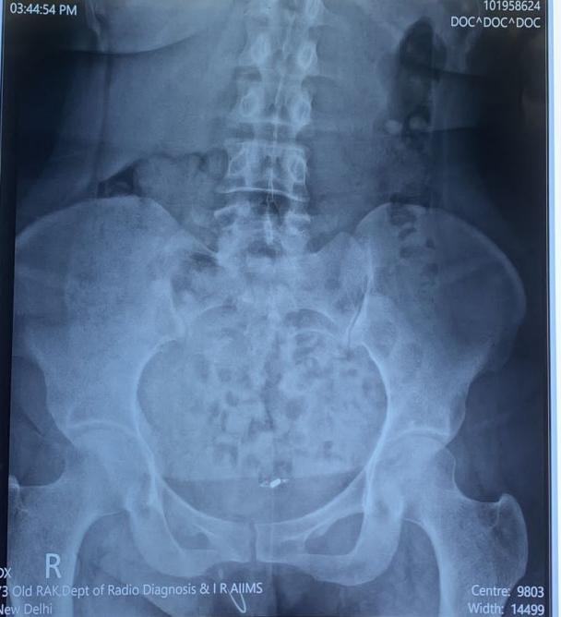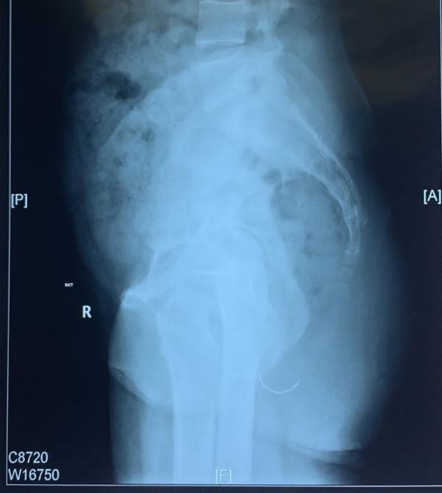

Fig 1(A &B): Xray picture showing needle

Fig 1B- X-ray Lateral View showing needle

Fig: 1A- X-ray AP view showing needle