Recurrent Anencephaly in Pregnancy: A Case Report and Review of Risk Factors and Management

Abstract:

Anencephaly is a severe, lethal, neural tube defect characterized by the partial or total absence of the brain and calvarium, with a 100% mortality rate either in utero or shortly after birth. It occurs when anterior neuropore fails to close between 23-26 days post- conception. The condition can be diagnosed early in pregnancy, usually between the 11th and 14th weeks of pregnancy, by ultrasound identifying the lack of cranial ossification and failure to measure the biparietal diameter and also by detection through maternal serum alpha-fetoprotein levels. Here we report a case of women with recurrent Anencephaly in two pregnancies which was terminated. This emphasize that early diagnosis is essential for effective management and counselling, particularly because of the high likelihood of pregnancy termination due to the fatal prognosis.

**Keywords:** Anencephaly, Acrania, Maternal AFP, Neurulation, Pregnancy termination

# Introduction:

“Anencephaly is a severe, lethal, neural tube defect characterized by the partial or total absence of the brain and calvarium”. (1) It is one of the most common types of neural tube defects (8). “Anencephaly has an incidence of 1 to 5 in every 1000 births, and the mortality rate is 100% during intrauterine life or within hours or days after birth” (8)(4) with the termination rate of pregnancy is around 83 %. (10)”I can be associated with other structural anomalies in 12–25% and genetic abnormalities detected in around 1– 5%”. (11)

# Case report:

Miss H is 40 years old female at 11 weeks of gestation with no significant past medical nor surgical comorbidities. All her previous deliveries were spontaneous vaginal delivery with no complications. Presented to Nizwa Hospital for rescan as suspected fetus with anencephaly. She was commenced on folic acid 5 mg daily 3-month preconception as she was advised before as her previous obstetric history of having fetus with anencephaly which was terminated at 15 weeks of gestation. She also had history of un explained Intra- uterine fetal death (IUFD) at 24 weeks, which was also

terminated by giving misoprostol (synthetic prostaglandin E1). She had no significant family history of anomalies nor early neonatal death. There is no history of consanguineous marriage with her couple.

On her presentation to us, she was having no complain. Examination revealed average built well-nourished lady, not pale. Her investigations were within normal. Blood group RH positive. Her scan showed fetus at 11 weeks with anencephaly (Fig 1&2)

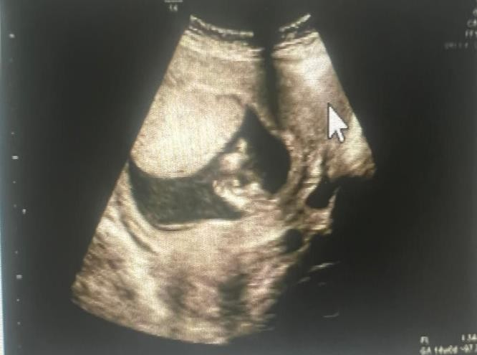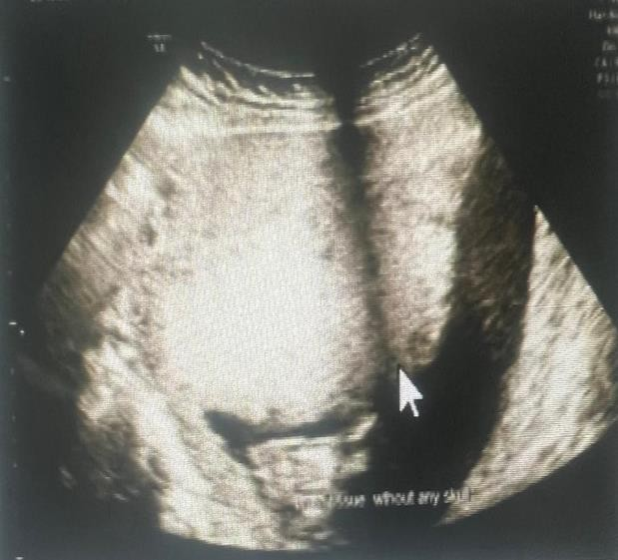

Fig 1: fetus at 11 weeks, head with acrania Fig 2: Hugue placenta

Patient and her husband were counselled about scan findings and the rate of recurrence and they understood well. She was admitted as inpatient and she received misoprostol protocol 400 mic every 4 hours, after 2nd dose she expelled the fetus. Then she had severe vaginal bleeding for which she underwent emergency dilatation and curettage, next day she was discharged home in stable condition with recommendation to use contraception to avoid pregnancy as she is at high risk for fetus anomaly due to her age and her previous obstetric history.

# Discussion:

“Anencephaly is serious birth defect of brain and skull , it is a severe malformation of the central nervous system (CNS) and one of the most known common types of neural tube defects” .(8)”It is classically subdivided into two forms : holo-anencephaly ( complete absence of forebrain and cranium ) and mero-anencephaly , in which the cranium and the brain are present in rudimentary form” others use the related terms “holo-acrania and meroacrenia “ referring to the degree of bone absence” .(6)(9) “Other classification of Anencephaly can be classified as mero-acrania if *foramen magnum* is not involved, holo-acrania if the defect goes beyond *foramen magnum* and holoacrania with rachischisis if it is associated with *spina bifida”* .(9)

“In Anencephaly the complex developmental sequence begins with failure of the anterior [neural groove](https://www.sciencedirect.com/topics/medicine-and-dentistry/neural-groove) to close at approximately 10 to 20 post ovulatory days (dysraphia). As development continues, a relatively normal-appearing brain forms that lacks a covering skull/calvarium and [meninges](https://www.sciencedirect.com/topics/medicine-and-dentistry/meninx) (exencephaly). Mechanical and chemical influences of the [amniotic fluid](https://www.sciencedirect.com/topics/medicine-and-dentistry/amnion-fluid) on the exposed brain subsequently causes it to disintegrate, and the skull and [cerebral hemispheres](https://www.sciencedirect.com/topics/medicine-and-dentistry/cerebral-hemisphere) fail to develop (anencephaly)”

(5). “The bony structures of the base of the skull and face and [facial features](https://www.sciencedirect.com/topics/medicine-and-dentistry/facies) are preserved. The [cerebrum](https://www.sciencedirect.com/topics/medicine-and-dentistry/huperzine-a), [cerebellum](https://www.sciencedirect.com/topics/medicine-and-dentistry/cerebellum), and [basal ganglia](https://www.sciencedirect.com/topics/medicine-and-dentistry/basal-ganglia) are missing, although the [brainstem](https://www.sciencedirect.com/topics/medicine-and-dentistry/brainstem) remains”.(5)

“In the past, screening for anencephaly and other NTDs has been performed using maternal [serum alpha fetoprotein](https://www.sciencedirect.com/topics/biochemistry-genetics-and-molecular-biology/alpha-fetoprotein-blood-level) measurement between 15 and 22 weeks of [gestation](https://www.sciencedirect.com/topics/biochemistry-genetics-and-molecular-biology/pregnancy)”.

(5) “The improvements in ultrasonography skills has resulted in reported rates of ultrasonographic diagnosis for anencephaly around 100% during the first and [second](https://www.sciencedirect.com/topics/medicine-and-dentistry/second-trimester-pregnancy) [trimesters](https://www.sciencedirect.com/topics/medicine-and-dentistry/second-trimester-pregnancy) of pregnancy” . (5)(4)

“The ultrasonographic signs of exencephaly include a wide and irregularly shaped head that lacks the echogenic calvarium surrounding the brain and the brain landmarks appropriate for gestational age. In well-dated pregnancies, a size or date discrepancy can often be seen. In the sagittal plane, the head appears flat and irregular, and the commonly seen intracranial features are missing. In the coronal plane, the exposed cerebellar hemispheres may be seen falling to the side of the head, resulting in the typical bilobed or “Mickey Mouse”–shaped head”. (5)

The Incidence of anencephaly is 1 in 1000 pregnancy, can be higher in women who have had previous pregnancy affected by anencephaly. (8) The risk of having another child with anencephaly in the presence of positive family history varies between 2% to 10%, compared to 0.006% in woman with no prior history. The recurrence risk is high in siblings of affected individuals compared to the general population. (12)

“Anencephaly should be considered to be a lethal abnormality. In a recent series of 26 pregnancies complicated by anencephaly, 42% of the fetuses were born alive.

Overall, [stillbirth](https://www.sciencedirect.com/topics/medicine-and-dentistry/stillbirth) occurred in 58% of the cases; of these, 23% were in utero deaths, and 35% were [intrapartum](https://www.sciencedirect.com/topics/medicine-and-dentistry/intrapartum) [fetal deaths](https://www.sciencedirect.com/topics/medicine-and-dentistry/fetus-death). Among the live births, most neonates died within the first day of life; however, some neonates survived for up to 1 week. Neonates with anencephaly should be given [palliative care](https://www.sciencedirect.com/topics/medicine-and-dentistry/symptomatic-treatment), and family members should be offered support”.(5)

Most common causes of anencephaly, genetic or chromosomal changes, insufficient intake of folic acid, environmental toxin, certain medicine like, phenytoin, carbamazepine. (2),(3)

“[Chromosomal abnormalities](https://www.sciencedirect.com/topics/biochemistry-genetics-and-molecular-biology/chromosomal-abnormalities) have been reported in 2.5% to 10.3% of fetal

and [newborn](https://www.sciencedirect.com/topics/medicine-and-dentistry/neonatal-infant) patients with common NTDs. [Chromosomal abnormalities](https://www.sciencedirect.com/topics/medicine-and-dentistry/chromosome-aberration) that have been associated with anencephaly include [trisomies](https://www.sciencedirect.com/topics/medicine-and-dentistry/trisomy) 2, 9, 13, 18, and 21; trisomy 11 mosaicism; and [triploidy](https://www.sciencedirect.com/topics/biochemistry-genetics-and-molecular-biology/triploidy). There was 1 case described of a family with a variant in

the TRIM36 gene on chromosome 5q22 thought to have caused anencephaly”. (5)

“Although it isn’t always possible to prevent anencephaly, women may be able to reduce their chance of having a child with the condition by getting plenty of folic acid: 400 mcg of folic acid daily at least 3 months pre conception. The UK and Hungarian studies showed that periconceptional supplementation of women with folate (FA) reduces significantly both the first occurrence and recurrence of NTD in the offspring”. (2)

Women should discuss changes on medications with a healthcare provider as certain medications that regulate seizures and other conditions may cause birth defects like NTDs. Women should also manage their health condition pre conception, if she has

any underlying health condition, like diabetes, she should talk to her healthcare provider about ways to manage the condition so she can stay in good health.

In our case, patient most likely had undiagnosed DM as she was diagnosed in her last two pregnancies was with gestational diabetes (GDM) and she did not follow up

after delivery for repeat OGTT (oral glucose tolerance test), in addition she had history of previous pregnancy with anencephaly which put her at higher risk of having recurrent fetal anomaly though she received preconception folic acid.

Case reports and epidemiologic studies have implicated a number of chemicals, widely differing therapeutic drugs, environmental contaminants, pollutants, infectious agents, and solvents. Maternal hyperthermia, use of valproate by epileptic women during

pregnancy, deficiency and excess of certain nutrients and chronic maternal diseases (e.g. diabetes mellitus) are reported to cause a manifold increase in the incidence of NTD

# Conclusion:

Anencephaly can be diagnosed as early as 11 week although preconception folic acid can reduce incidence but recurrence is high if previous pregnancy with anencephaly

.Since anencephaly is rarely associated with aneuploidy so amniocentesis for karyotyping is not necessary in all cases .The need for periconceptional folic acid

,avoid nutritional deficiency, avoid toxic drugs and also patient awareness about risk of recurrence is one of the most important line for prevention .To decrease the risk of recurrence of NTDs, 4 mg of [folate](https://www.sciencedirect.com/topics/biochemistry-genetics-and-molecular-biology/folic-acid) should be recommended pre pregnancy . This report emphasize that early diagnosis is essential for effective management and counselling, particularly because of the high likelihood of pregnancy termination due to the fatal prognosis.

**Disclaimer (Artificial intelligence)**

Option 1:

Author(s) hereby declare that NO generative AI technologies such as Large Language Models (ChatGPT, COPILOT, etc.) and text-to-image generators have been used during the writing or editing of this manuscript.

Option 2:

Author(s) hereby declare that generative AI technologies such as Large Language Models, etc. have been used during the writing or editing of manuscripts. This explanation will include the name, version, model, and source of the generative AI technology and as well as all input prompts provided to the generative AI technology

Details of the AI usage are given below:

1.

2.

3.

# References:

1. Usha Devi Gopalan*, Florence Nightingle Sagar, Sowmiya Ravi .Anencephaly: a case report on the rare neural tube defect. International Journal of Reproduction, Contraception, Obstetrics and Gynecology Gopalan UD et al. Int J Reprod Contracept Obstet Gynecol. 2024 Nov;13(11):3368-3370 [www.ijrcog.org](http://www.ijrcog.org/) .
2. Padmanabhan R. Etiology, pathogenesis and prevention of neural tube defects. Congenit Anom (Kyoto). 2006 Jun;46(2):55-67. doi: 10.1111/j.1741-4520.2006.00104.x. PMID: 16732763.
3. Zhang T, Lou J, Zhong R, Wu J, Zou L, Sun Y, Lu X, Liu L, Miao X, Xiong G. Genetic variants in the folate pathway and the risk of neural tube defects: a meta-analysis of the published literature. PLoS One. 2013 Apr 4;8(4):e59570. doi: 10.1371/journal.pone.0059570. PMID: 23593147; PMCID: PMC3617174.
4. Obeidi N, Russell N, Higgins JR, O'Donoghue K. The natural history of anencephaly. Prenat Diagn. 2010 Apr;30(4):357-60. doi: 10.1002/pd.2490. PMID: 20198650.
5. Ana Monteagudo, Exencephaly-anencephaly Sequence,American Journal of Obstetrics and Gynecology,Volume 223, Issue 6,2020,Pages B5-B8,ISSN 0002-9378 https://doi.org/10.1016/j.ajog.2020.08.176.
6. Shewmon, D. Alan. “Anencephaly: Selected Medical Aspects.” *The Hastings Center Report* 18, no. 5 (1988): 11–19. <https://doi.org/10.2307/3562217>.
7. L. Edwards, L. Hui .First and second trimester screening for fetal structural anomalies Semin Fetal Neonat Med, 23 (2018), pp. 102-111
8. Munteanu O, Cîrstoiu MM, Filipoiu FM, Neamţu MN, Stavarache I, Georgescu TA, Bratu OG, Iorgulescu G, Bohîlţea RE. The etiopathogenic and morphological spectrum of anencephaly: a comprehensive review of literature. Rom J Morphol Embryol. 2020 Apr-Jun;61(2):335-343. doi: 10.47162/RJME.61.2.03. PMID: 33544785; PMCID: PMC7864317.
9. Theofanakis C, Theodora M, Sindos M, Daskalakis G. Prenatal diagnosis of sirenomelia with anencephaly and craniorachischisis totalis: a case report study. Medicine (Baltimore) 2017;96(50):e9020–e9020. doi: 10.1097/MD.0000000000009020
10. Johnson CY, Honein MA, Dana Flanders W, Howards PP, Oakley GP, Rasmussen SA. Pregnancy termination following prenatal diagnosis of anencephaly or spina bifida: a systematic review of the literature. Birth Defect Res A Clin Mol Teratol. 2012;94(11):857–863. doi: 10.1002/bdra.23086
11. Wertaschnigg D, Reddy M, Ramkrishna J, da Silva Costa F, Sepulveda W, Rolnik

DL, Meagher S. Ultrasound appearances of the acrania-anencephaly sequence at 10 to 14 weeks’ gestation. J Ultrasound Med. 2020 doi: 10.1002/jum.15267

1. Agopian AJ, Tinker SC, Lupo PJ, Canfield MA, Mitchell LE. National Birth Defects Prevention Study. Proportion of neural tube defects attributable to known risk factors. Birth Defects Res A Clin Mol Teratol. 2013;97(1):42–46. doi: 10.1002/bdra.23100