**From Fields to Markets: The Rise of Strawberry Farming in Abohar, Punjab, India**

**Abstract**

Strawberry (Fragaria × ananassa Duch) has emerged as a commercially significant fruit crop in both temperate and subtropical regions of India due to its high market demand, nutritional value, and excellent export potential. Its adaptability to diverse agro-climatic conditions, coupled with its rapid growth and relatively short cropping cycle, makes it an ideal candidate for commercial cultivation. The fruit is highly valued not only for fresh consumption but also for its application in a variety of value-added products such as milkshakes, juices, ice creams, jams, and conserves. Harvest maturity is typically determined when approximately 98% of the fruit is edible, ensuring optimal flavor and marketability. As a high-value cash crop, strawberry cultivation offers promising returns, especially for small-scale and part-time farmers seeking profitable alternatives to traditional crops. Recent trends have shown increased adoption of innovative cultivation practices, such as protected farming and the use of low tunnels, enabling multiple cropping cycles and better control over environmental variables. These methods contribute to improved yield and fruit quality, while also extending the growing season. Furthermore, the use of micropropagation techniques presents a viable solution for the large-scale production of disease-free planting materials, including virus-free and day-neutral cultivars. This biotechnological approach enhances uniformity, ensures genetic fidelity, and accelerates the availability of high-quality planting stock, which is essential for sustainable commercial production. The primary aim of this study is to explore and evaluate the cultivation strategies, propagation methods, irrigation practices, harvest, and post-harvest handling along with the challenges arises during the cultivation of strawberries. This piece of study paves a way for enhancing the productivity, quality, and profitability of strawberry cultivation along with the broader goal of promoting strawberry as a viable high-income crop across diverse Indian agro-climatic zones.

**Keywords:** Day neutral, protected cultivation, low tunnels and octaploid

**1. Introduction**

Due to its genotypic diversity, highly heterozygous nature, and wide range of environmental adaptations, the strawberry (*Fragaria × ananassa Duchesna* L.) is one of the soft fruits with the greatest potential for global distribution. The word "strawberry" is said to have come from the growers' practice of covering their plants with straw as the berries began to form (Ventakalakshmi et al., 2023). It is one of the few fruit crops that provides quick and exceptionally high returns per unit area on the original capital input, as the crop is ready for harvesting six months after planting. Since it is an annual fruit crop that is herbaceous, it may be easily grown in nutri-gardens, roof-top gardens, small containers, pots, etc. (Thakur et al., 2024). In addition to having a great flavor and taste, strawberries are also a fantastic source of fiber, carbs, potassium, and vitamins (Sharma and Sharma, 2004). Millions of people worldwide eat strawberries, and the fruit processing businesses add value to them by turning them into jams, juices, nectar, ice cream, milkshakes, and chocolates (Pergola et al., 2023). Numerous products use artificial strawberry flavorings and perfumes, such as candy, hand sanitizers, perfume, lip gloss, and many more. Although this crop is usually cultivated outdoors, it can also be grown in a greenhouse to take advantage of the profitable off-season market (Shahida & Swarup, 2024).

China is the largest producer of strawberries in the world (Lei et al., 2021). In India strawberry fruits are cultivated in an area of 2.4 thousand hectares, with production of 17.1 thousand MT. Strawberry has been more and more popular in recent years because of its delicious flavor and refreshing properties (Palombini et al., 2023). There are a variety of agro-climatic zones in the Fazilka district, where many crops are grown in various parts of Fazilka, including Kinnow, peaches, guava, plum, cucurbitaceous and cruciferous family vegetables. However, the district's farmers do not like strawberries because of weed problems, erratic weather, and short shelf lives (Devi et al., 2021). Due to emerging industries in the Punjab state and nearby areas, there is now a greater need for strawberry cultivation, which is carried out by farmers in open fields under protected conditions. While strawberries may be cultivated once a year in open conditions, they can be grown year-round under protected conditions by adhering to certain multicultural practices (Devi et al., 2021).

Certain cultivars are becoming more and more popular these days for both open and protected growing. Chandler variety is grown in the majority of nations because of its phenotypic stability, extended harvest season, cold tolerance, early maturation, superb flavor, beautiful red color, and great producing potential. Introduced from California, the Camarosa variety is one of the most promising strawberry cultivars. It boasts the greatest quality of firm flesh and even offers potential for distant marketing. "Winter Dawn," a day-neutral variety that bears fruit from March to May whether planted in the final week of January or the first week of October, was the third variety chosen for the experiment. The price of shelling has increased by 100 to 150 rupees per kilogram because of the increased demand for fruit, which has resulted in a multiplication of farmer income and standard income. Thus, it can be concluded that strawberries have emerged as a promising crop for farmers in the Fazilka area (Devi et al., 2021).

As shown in fig. 1 from 2011–12 to 2023–24, strawberry cultivation in India has shown a gradual but inconsistent upward trend. In the initial years, both area and production were relatively low, but over time, there has been a noticeable increase in both due to rising demand and better awareness among farmers. However, this growth has not been standardized or uniform across the country, highlighting significant potential for expansion and improvement. Despite the challenges, regions like Mahabaleshwar in Maharashtra and Saharwa in Haryana have emerged as key contributors. By 2023–24, the area under strawberry cultivation reached 2.4 thousand hectares, with total production rising to 17.1 thousand metric tons, indicating a promising future for strawberry farming in India

**Fig. 1 Area and production of strawberry in India (India Stat)**

**2. History and Origin**

The contemporary cultivated strawberry, sometimes known as the desert strawberry, was brought to the world from France in the 17th century. It is currently grown commercially all throughout India. *Fragaria virginiana* was introduced to Europe in 1624 and is currently present in Canada and the United States, whereas *Fragaria chiloensis* is known to afflict Chile and the coastal regions of South America. It is currently believed that the Duchesne hybrid was the original parent of all contemporary Fragaria x cultivars (Baruzzi & Faeidi 2016; Al-Khayri et al. 2018). The world's top producer of strawberries is China, which is followed by the US, Turkey, Spain, Egypt, and Mexico. Strawberry was first brought to India in the early 1960s by the NBPGR Regional Research Station in Shimla, Himachal Pradesh. These days, it may be cultivated up to 3000 meters on both plains and slopes. Some of the states that cultivate strawberries are Madhya Pradesh, Jharkhand, Kerala, Himachal Pradesh, Tamil Nadu, Chhattisgarh, Maharashtra, Haryana, Mizoram, Jammu & Kashmir, Meghalaya and Punjab.

**3. Importance and Uses**

One of the most delicious fruit harvests, strawberries are known for their distinctive organoleptic qualities and nutritional value. It is a great source of dietary fiber, carotene, vitamin C, and other essential components for human nutrition and health. It has a higher concentration of vitamin C, phenolics, and flavonoids than other berry fruits (Hakkinen and Torronen, 2000). Since the beginning of time, the fruits have been used in medicines. Due to their high polyphenol content, which also has anti-cancer and anti-diabetic properties, they may help lower the risk of cardiovascular diseases. Magnesium and potassium, which promote smooth blood pressure circulation and nerve relaxation, are abundant in fresh strawberries. Fruits are a food of tremendous interest and significance to the human diet due to their nutritional makeup (Table 1). Strawberries' nutritional content varies substantially across varieties. It is prized for its high fibre, zero cholesterol and low-calorie carbohydrate contents. They are often eaten raw, processed in making jams, juices, nectar, ice cream, milkshakes and chocolates.

**Table 1: Composition of a strawberry fruit (per 100 g edible portion)**

|  |  |  |  |
| --- | --- | --- | --- |
| **Fruit composition** | **Content** | **Fruit composition** | **Content** |
| Water (%) | 87-90 | Magnesium (mg) | 10 |
| Carbohydrates (%) | 7.0 | Sodium (mg) | 1.0 |
| Total sugar (%) | 3.3-9.1 | Iron (mg) | 0.4 |
| Protein (%) | 0.2-0.7 | Vitamin A (I.U.) | 60 |
| Fat (%) | 0.2-0.5 | Thiamine (mg) | 0.03 |
| Fiber (%) | 1.1 | Riboflavin (mg) | 0.07 |
| Calcium (%) | 21.0 | Niacin (mg) | 0.60 |
| Phosphorus (%) | 21.0 | Vitamin C (mg) | 26-60 |
| Potassium (%) | 164 | Acidity (%) | 0.9-1.8 |

**Source:** (https://www.researchgate.net/publication/316464943_Impacts_of_Elevated_Carbon_Dioxide_and_Temperature_on_Physicochemical_and_Nutrient_Properties_in_Strawberries/figures?lo=1)

**4. Anatomy**

The anatomy of a strawberry plant consists of several key structures, each essential to its growth and reproduction. At the base, the root system anchors the plant and absorbs water and nutrients. The crown**,** located at the junction of the roots and leaves, stores nutrients and is responsible for producing new growth, including runners or stolons, which are horizontal stems that help the plant propagate asexually. The plant's leaves are composed of three leaflets, playing a crucial role in photosynthesis and transpiration. The stem supports the leaves, flowers, and fruit, with the petiole attaching the leaves to the stem. Strawberry flowers are white, with five petals and numerous stamens, and are both male and female, allowing for pollination to occur. The fruit is an aggregate, where each small yellow seed (called an achene) on the surface is a separate fruit, and the red, fleshy part we eat is actually the swollen receptacle of the flower. This unique structure enables strawberries to reproduce both sexually (through seeds) and asexually (through runners), making the plant highly adaptable and capable of rapid growth.

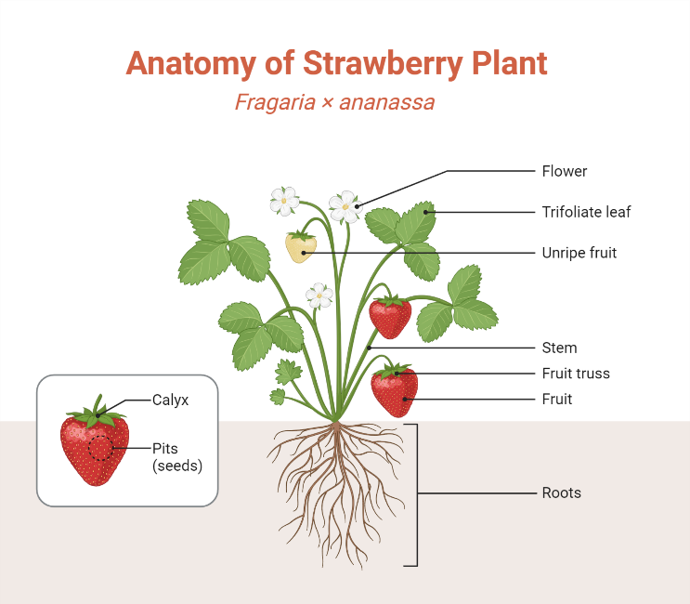

**Fig. 2 Anatomy of Strawberry (**[**https://www.biorender.com**](https://www.biorender.com)**)**

**5. Climate**

The strawberry plant has well adapted to a variety of climates. Although it may be grown well in a subtropical climate, it does best in a temperate one. The development and yield of plants are greatly influenced by environmental parameters such as temperature, photoperiod, and light intensity. The growth of flower buds requires a suitable temperature and twelve hours of daylight. It requires at least eight hours of sunlight exposure every day for ten days in order to begin flowering because it is a short-day plant. Strawberries require an optimal daytime temperature of 22 °C and a nighttime temperature of 13 °C, even if both are necessary for optimal growth and yield (Shoemaker, 1977). Unfavorable weather conditions including frost, heavy rain, hail, and temperature fluctuations, especially during flowering and fruiting, restrict its cultivation.

**6. Soil**

Strawberry plants may thrive in a range of soil types. On sandy loam soil with enough drainage, it thrives. Soils that are rich in organic matter and have a light texture are ideal for producing runners. The top 15 to 30 cm of soil contains the majority of the roots, thus it is essential that this layer be humus-rich and porous. Growing it is not recommended on soils with a lot of standing water. Strawberries grow best in soil with an EC of less than 0.7 mS/cm and a pH between 5.5 and 6.5. The plants are adversely affected by both salt and alkalinity. When there is too much calcium in the soil, the leaves become yellow. According to Singh et al. (2007), growing strawberries on the same piece of land or on land that was previously used to grow raspberries, potatoes, tomatoes, egg plants, and peppers is not advised.

**7. Popular Varieties**

The selection of an appropriate variety that is well-suited to a growing zone is crucial for optimizing strawberry yield.

**1. Chandler:** It is a short-day type with a high yield, and the plants can withstand viral infections. It is also impervious to rain-induced bodily harm. The fruit has outstanding color, flavor, and texture and is of exceptionally high desert quality. The fruits are large (15–18 g), high in vitamin C (55 mg/100 g of edible section), low in acidity (0.85%), and high in TSS (10–12%).

**2. Winter down:** It is productive. Fruits are medium to big in size and have a modest resistance to fruit rot diseases caused by botrytis and anthracnose.

**3. Pajero:** In the summer, it works really well. This variety is resistant to leaf scorch, wilt, and fruit rot. The dessert and processing quality of fruits is good. Despite their size, symmetry, beautiful red color, and firmness, fruits are vulnerable to physical harm from rain.

Winter down is the most suited variety for cultivation in Punjab state. Other promising strawberry cultivars cultivated under various climatic conditions include Festival, Kalimpong Local, Pusa Early Dwarf, Katrain Sweet, Olympus, Hood & Shuksan Midway, Midland, Cardinal, Hood, Redchief and Beauty Dilpasand Royal Sovereign Polka, Gilbert, Oso Grand, Cavalier, Arking, Bangalore, Bilirubin, Tristar, Tribute, Redcoat, and Red Rich.

**8. Propagation**

Strawberry is propagated through runners that are formed after the blooming season. Viral infections are frequently spread by runners alone, despite the fact that runners generate true-to-type plants. It is therefore necessary to employ a separate bed for runner production. Choose the location and soil where the strawberry hasn't been cultivated in at least three or four years. Runners are used for propagation; they develop after the flowering season. The plants may be allowed to set as many runners as possible but not permitted to set fruits. Under ideal conditions, a single plant will typically yield 12 to 18 runners.

**9. Land preparation and Planting**

Before planting strawberries, the ground should be adequately prepared by harrowing and heavy plowing. Before planting, the soil should be well mixed with organic manure. Strawberries can be grown on raised beds, in hill rows, matted rows, or flat beds. It is recommended to plant on hills in irrigated regions. The ideal planting space is 30 x 30 cm on well prepared 15-20 cm raised beds of 80 cm width. The distance of 40 cm between the beds should be maintained. We can accommodate 22000 plants per acre. Mid-October is the ideal time of year to transplant strawberry plants. To increase fruit quality and yield, cover the beds with **30 µ of silver-black** polyethylene mulch. It suppresses weeds, preserves soil moisture, and shields plants and their roots from sharp temperature swings. From the end of December to the middle of February, strawberry plants should be covered with a low tunnel translucent plastic sheet **(50 µ thick)** over the iron frame at a center height of 60 cm. This will reduce winter damage, plant death, and increase productivity. Maintain a 2.50 m gap between each subsequent frame.

**10. Irrigation**

Since strawberries have shallow roots, they need to be watered more frequently but with less water each time. Over-irrigation causes stolons and leaves to develop at the expense of fruits and flowers and raises the risk of Botrytis rot. There are furrows between the rows where irrigation is done. These days, trickle and sprinkler irrigation systems are growing in popularity. In humid climates, even brief droughts lower yields and harm the shallow root system, therefore irrigation is essential. Strawberries should be drip irrigated daily with lateral pipes having dripper discharge of 2.2 liters per hour and drippers are placed at 30 cm apart. The leaves and fruits should not be moist with water as this might raise the risk of fungal infestation. It should be properly watered during the harvest period to improve fruit size and quality.

**11. Fertilization Methods**

Commercial cultivation of strawberries normally takes one of the following fertilization schemes:

* As the crop grows, apply a base dressing and a few side treatments. This technique is frequently used by farmers without a fertigation (nutrigation) setup.
* Throughout the crop's development cycle, apply base dressing and many side dressing treatments. "Many" might mean once a week, once a day, or even several daily applications, which are done by fertigation, or nutrigation.
* Foliar feeding: It serves as a complimentary treatment to assist the application, when the encountering problems of soil uptake, and when fast correction results are needed.

**12. pH Amendment**

* If the soil pH is below pH 6.0 apply either agricultural lime or dolomite at least 6 months before planting. Dolomite is best used if soil magnesium is low. The lower the pH value, the higher the rate of lime or dolomite that should be applied. The rate also depends on the planned lifespan of the crop. About 5 MT/ha (2 ST/A) of ground limestone per expected year, will keep the soil at a relatively stable pH.
* The lime or dolomite should be worked into the soil to a depth of 30 cm, which is the effective root region of strawberries.

**Table 2. Fertilizers Recommendation doses/ha**

|  |  |  |  |  |
| --- | --- | --- | --- | --- |
| **N** | **P2O5** | **K2O** | **CaO** | **MgO** |
| 150 | 150 | 240 | 120 | 60 |

Abbreviation: N: Nitrogen; P2O5: Phosphorus pentoxide; K2O: Potassium oxide ; CaO: Calcium oxide ; MgO: Magnesium oxide

It is beneficial to apply fertilizers by multiple sessions during the life cycle of a strawberry field, especially on lighter soils (that tend to leach nitrogen more easily than medium and heavier soils).

**Table 3. Some common fertilizers used in nutrigation, their solubility, nutrient content and soil reaction**

|  |  |  |  |
| --- | --- | --- | --- |
| **Product** | **Analysis** | **Solubility (g/L) at 20 °C** | **Reaction** |
| Urea | 46% N | 1,070 | Neutral |
| Ammonium Nitrate | 34% N | 1952 | Acidic |
| Ammonium Sulphate | 21% N + 24% S | 754 | Acidic |
| MAP | 12.5% N + 61% P2O5 | 370 | Acidic |
| Phosphoric Acid | 61% P2O5 | Liquid | Very Acidic |
| Potassium Nitrate | 13% N + 46% K2O | 320 | Basic |
| Potassium Sulphate | 40% K2O + 16% S | 110 | Neutral |
| Calcium Nitrate | 15.5% N + 26% CaO | 1200 | Basic |
| Magnesium Nitrate | 11% N + 16% MgO | 2250 | Slightly Acidic |

**13. Harvesting & Post-Harvest Handling**

The strawberry is a highly perishable, non-climacteric fruit crop. Strawberries should be picked when between half and three-quarters of the skin has turned color. Harvesting is often done every second or third day, usually in the morning hours, depending on the environment. It facilitates better shelf baskets. Berries should be picked along with a small steam portion attached. It is possible to preserve strawberries for 6-9 days at 5±10 °C and 90-95% relative humidity, and for up to 2 days at room temperature.

* **Insect-Pests**:

1. **White grubs and Cutworms:** Cut the root and stem of young plants. Deep ploughing and Drench the soil with Chlorpyriphos @ 2ml/L water.
2. **Root weevil:** Feed on the rootlets; make deep tunnels in the crown base and finally the plants collapse. The application of Carbofuran (6-10 kg/ha) and Parathion (0.017%) around the plants can effectively control the insect.

* **Diseases**:

1. **Verticillium wilt:** The older leaves turn brown and shrivelled and finally plants may die. The proper crop rotation should follow besides soil fumigation with formalin (5000 L/ha) or Chloropicrin (210 L/ha).
2. **Leaf spot complex:** Spot of different shapes and sizes appears on the leaves during rainy season, which results in drying and defoliation Give 2-3 sprays of Hexaconazole (100 ml/200 L water) or 5 sprays of Carbendazim (100g/200 L water) at 21 days intervals.

* **Viral diseases:** Stunting of plants and marginal yellowing and upwards curling of young leaves Use of virus free runners, isolation of infected plants and control of aphid vectors with systematic insecticides and use of virus vector tolerant cultivars reduces the problem.
* **Disorders:**

Albinism (lack of fruit color during ripening) is a physiological disorder in strawberry. It is probably caused by certain climatic conditions and extremes in nutrition. Fruits remain irregularly pink or even totally white and sometimes swollen. They have acid taste and become less firm. Albino fruits are often damaged during harvesting and are susceptible to Botrytis infection and decay during storage.

* **Cost Components of a One Acre Model Strawberry Plantation**

The cost components of a one-acre model strawberry plantation typically include land preparation, which covers tilling, leveling, and fertilization; purchasing strawberry seedlings or plants; irrigation setup, including drip systems or sprinklers; labor costs for planting, maintenance, and harvesting; fertilizers and pesticides for soil health and pest control; equipment costs for tools, machinery, and containers; and ongoing operational expenses such as water, electricity, and weed management. Additionally, there may be costs for packaging, transportation, and marketing if selling the produce. These components contribute to the overall investment and operational budget for a successful strawberry plantation.

**Table 4: Average proposed budget for the plantation of strawberries**

|  |  |  |  |  |  |
| --- | --- | --- | --- | --- | --- |
| **Sl. No.** | **Components** | | | **Proposed Expenditure** | |
| **1.** | **Cultivation Expenses** | | | | |
|  | Cost of planting material | | | 200000 | |
|  | Fertilizers & Pesticides | | | 11000 | |
|  | Mulching | | | 12400 | |
|  | Cost of labour | | | 14400 | |
|  | Others, if any (power) | | | 3600 | |
|  | **Sub total** | | | 241000 | |
| **2.** | **Irrigation** | | | | |
|  | Tube-well/submersible pump | | | 50000 | |
|  | Cost of Pipeline | | | -- | |
|  | Others, if any | | | -- | |
|  | **Sub total** | | | 50000 | |
| **3.** | **Cost of Drip (Turboline) with Fertigation** | | | 40000 | |
| **4.** | **Infrastructure** | | |  | |
|  | Store & Pump House | | | 20000 | |
|  | Labour room | | | 10000 | |
|  | Agriculture Equipment’s &  Implements | | | 5000 | |
|  | Others, if any, please specify | | | -- | |
|  | **Sub total** | | |  | |
| **5.** | **Land Development** | | | | |
|  | Soil leveling | | | 4000 | |
|  | Digging | | | -- | |
|  | Fencing | | | 29600 | |
|  | Others, if any, please specify | | | -- | |
|  | **Sub total** | | | 33600 | |
|  | **Grand Total** | | | 400000 | |
| **Benefit Cost Ratio/ acre** | | | | | |
| **Cost of Cultivation** | **Avg. Yield** | **Gross Return** | **Net Return** | | **B:C Ratio** |
| 400000 | 60q/ acre | 750000 | 350000 | | 1.87 |

**Plate 1: Strawberry cultivation** **in the research farm of Abohar**

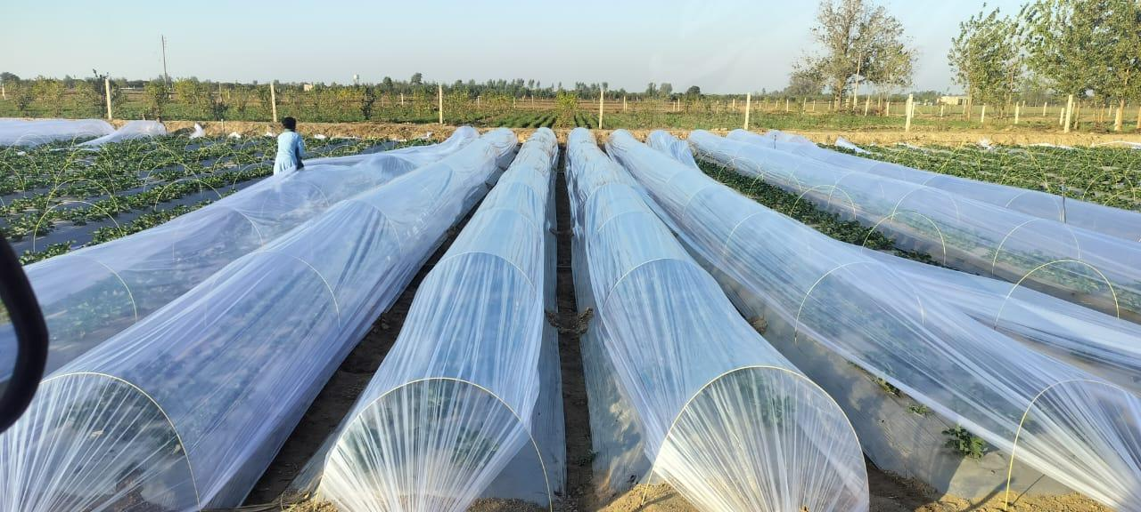 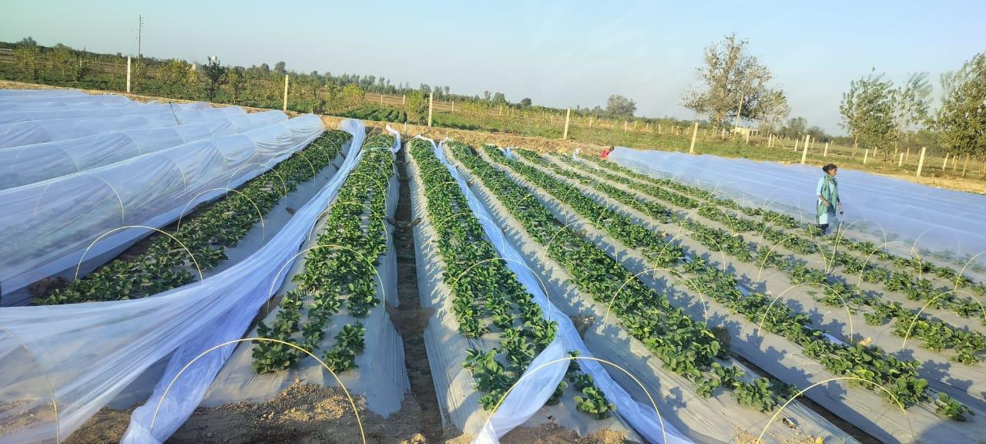

**Plate 2: Post-Harvest handling of strawberry fruits**

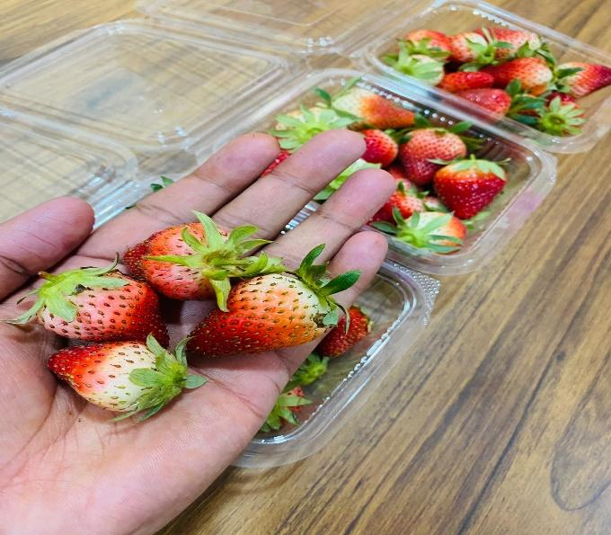 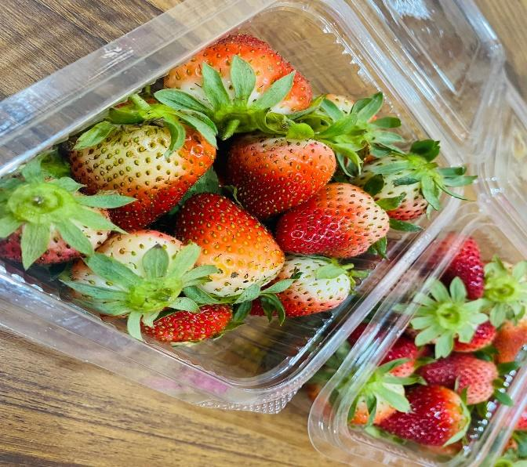

**14. Post-Harvest Handling**

Post-harvest handling of strawberries is a critical process that requires careful attention to detail to maintain their quality, freshness, and shelf life. Immediately after harvest, strawberries should be cooled to around 32°F (0°C) within 1-2 hours using methods like hydro cooling or forced-air cooling to remove field heat and prevent spoilage. They should be handled gently to avoid bruising and damage, and packaged in clean, dry containers or clamshells with adequate ventilation to prevent moisture buildup. Strawberries should be stored at a consistent refrigerated temperature between 32°F (0°C) and 40°F (4°C) with high humidity (80-90%) to maintain their texture and flavor. Regular inspections, temperature monitoring, and pest management are crucial for quality control and to prevent infestations. Additionally, avoiding washing strawberries before storage, using ethylene-absorbing materials, and harvesting at optimal maturity can also help extend their shelf life. By following these guidelines, strawberry growers and handlers can help ensure that their produce remains fresh and of high quality for consumers.

**15. Challenges**

1. Shortage of irrigation water during the summer season is the major problem for our area during strawberry cultivation.
2. Lack of knowledge about biological control measures of insect pests and disease management.
3. High cost of manures and fertilizers.
4. Lack of technical knowledge about doses of manure, fertilizers, pesticides and insecticides.
5. Shortage of labour is the major problem these days.
6. High cost of insecticides and pesticides.
7. Lack of knowledge about sustainable farming.
8. Unavailability of cold storage facilities near the locality of Abohar.
9. Lack of knowledge about improved sustainable practices in strawberry cultivation.
10. Market rates are not known in time
11. Lack of technical knowledge about grading and packaging.

**16. Conclusions**

Strawberry cultivation in Punjab presents a high potential opportunity for farmers due to its lucrative market demand and profitability. The region’s favorable climate conditions, along with increasing consumer preference for fresh and healthy produce, position strawberries as a promising crop for diversification in agriculture. With proper management, it can lead to increased income for farmers and contribute to the region’s agricultural economy. Additionally, there is growing interest in the export potential of strawberries, which can open avenues for international trade. However, there are several constraints hindering the full exploitation of strawberry cultivation in Punjab. One major challenge is the labor problem. Strawberry farming requires intensive labor, particularly during planting, harvesting, and maintenance. The shortage of skilled labor and high labor costs can impact profitability. Another issue is marketing. Farmers often face difficulties in reaching profitable markets, and there is a lack of organized channels to help them sell their produce at competitive prices, leading to inefficiencies and reduced income. Furthermore, the lack of knowledge regarding post-harvest handling practices poses a significant barrier. Improper handling, packaging, and storage techniques can lead to significant post-harvest losses and lower quality produce, affecting the overall supply chain. In conclusion, while strawberry cultivation in Punjab holds great promise, addressing issues related to labor, marketing, and post-harvest management is crucial to fully harness its potential. With improved infrastructure, education, and support, strawberry farming can significantly benefit the agricultural landscape of Punjab.

**Disclaimer (Artificial intelligence)**

Option 1:

Author(s) hereby declare that NO generative AI technologies such as Large Language Models (ChatGPT, COPILOT, etc.) and text-to-image generators have been used during the writing or editing of this manuscript.

Option 2:

Author(s) hereby declare that generative AI technologies such as Large Language Models, etc. have been used during the writing or editing of manuscripts. This explanation will include the name, version, model, and source of the generative AI technology and as well as all input prompts provided to the generative AI technology

Details of the AI usage are given below:

1.

2.

3.

**17. References**

Baruzzi G, Faedi W. Strawberry Breeding. In Husami AM, Neri D (eds) Strawberry: growth, development and diseases. London: CAB International, 2016, 26-33.

Hakkinen SH, Torronen AR. Content of flavonols and selected phenolic acids in strawberries and *Vaccinium* species: Influence of cultivar, cultivation site and technique. Food Res. Int. 2000; 33:517-524.

<https://www.indiastat.com/table/agriculture/area-production-strawberry-india-2011-2012-2023-20/962349>

Lei, J. J., Jiang, S., Ma, R. Y., Xue, L., Zhao, J., & Dai, H. P. (2021, May). Current status of strawberry industry in China. In IX International Strawberry Symposium 1309 (pp. 349-352).

Palombini, M. C., Palencia, P., Pavão, J. M. S., & Chiomento, J. L. (2023). Efficiency of strawberry cultivation under the effect of different types of plants in a soilless system in the high-altitude regions of southern Brazil. *Agronomy*, *13*(8), 2179.

Pergola, M., Maffia, A., Carlucci, G., Persiani, A., Palese, A. M., Zaccardelli, M., ... & Celano, G. (2023). An environmental and economic analysis of strawberry production in southern Italy. *Agriculture*, *13*(9), 1705.

Shahida, C., & Swarup , D. (2024). Active Packaging for Improving the Shelf Life and Quality of Strawberry (Fragaria x ananassa Duch.). *International Journal of Environment and Climate Change*, *14*(1), 369–373.

Sharma RR, Sharma VP. The Strawberry. ICAR, New Delhi, India, 2004.

Shoemaker JS. Small floriculture. -The Avi. Publishing Company, Westport, Connecticut, USA, 1977.

Singh A, De LC, Bujarbaruah KM. Improved package of practices of strawberry cultivation. Technical Bulletin No. 28, ICAR-Research Complex for NEH Region, Umroi Road, Umiam, Meghalaya, 2007, 1-30.

Thakur, V., Gogoi, B., Borah, N., & Dutta, H. S. (2024). Evaluation of Strawberry (Fragaria × ananassa Duch.) under Rice Fallow as Influenced by Tillage, Stubble Mulch and Nutrient Management. *International Journal of Plant & Soil Science*, *36*(7), 508–516.

Ventakalakshmi, H., Nagavalli , P., Singh , D., Chaurasia, J., & Manoj , A. (2023). Effect of Nutrient Management on Growth, Yield, and Quality of Strawberry in Open Field Condition, and Study of Packaging Materials and Shelf Life of Strawberry after Harvesting . *International Journal of Plant & Soil Science*, *35*(18), 1125–1131.