The Lapat System: An Indigenous Natural Resource Management Practice Of The Isnags In Apayao, Philippines

ABSTRACT

The Lapat System is one of the Isnags’ traditional practices that promotes the conservation of natural resources. The Lapat term means prohibition, restriction, or no trespassing while the Isnags are the native people of the Apayao Province in the Philippines. This study documented and validated the Lapat system in the municipalities of Conner, Kabugao, Pudtol and Calanasan, Apayao as a way of conserving natural resources. The study utilized a descriptive-survey method complemented by Focus Group Discussions and interviews. The researcher also employed direct observation during both the declaration and termination phases of Lapat in identified areas. Based on the results, the practice of Lapat by the Isnags has in it the unique characteristics of providing a wealth of knowledge in environmental management. Today, Lapat is still practiced by the elders to declare a body of water, forests, plantation, and residential lots as sacred in honor of a dead member of the family. These areas are preserved by the bereaved family within a year or two by imposing penalties to intruders or violators, thus making the area untouched within the prescribed period. Lifting of the Lapat is commenced through a say-am or a grand festivity with many rituals usually held within 2-3 days celebrated by all the members, relatives of the family and the community people. Neighboring barangays are likewise invited. By application and through consistent practice by the Isnags, Lapat has contributed significantly in preserving and conserving the natural resources in the province. The forests especially those rich with flora and fauna have been protected by the abusive use of kaingeros, small scale loggers and nomadic vegetable gardening. Marine resources have also been protected by all forms of illegal fishing practices which significantly increases the propagation rate of fresh water fishes especially the most endangered species. Lapat is a way of life and a culture-bound indigenous practice in promoting natural resources therefore, it should be conserved. It was recommended that the local government units in Apayao should legislate the adoption and support the implementation of the Lapat system to all the 7 municipalities in the province.

Keywords: Lapat system, Indigenous, natural resource, Isnags, Apayao

1. INTRODUCTION

The Isnags, natives of Apayao are endowed with rich cultural heritage that make them unique from the other tribes in the country. They live in the northern part of the Cordillera administrative region. Most of them inhabited the municipalities of Conner, Kabugao, Calanasan, and Pudtol.

One most striking is their traditions and beliefs system where they believe the “anitos” form part of the rituals particularly in the conservation and preservation of natural resources (Walsh et al., 2013). To them, preserving and giving respect to nature especially the forests where medicinal plants and first grown trees are found is a lofty way of pleasing the anitos. They believe that these are the dwelling places of their gods, hence, there is the abundance of fauna (Tripathi & Bhattarya, 2004).

The Lapat System is one of the Isnags’ traditional practices that promotes the conservation of natural resources. Lapat is an Isnag term which means prohibition, restriction, or no trespassing. When a lapat is declared, the Isnag folks invoke the presence of the anitos and the spirit of the dead to help them guard the lapat area to preserve its sacredness from intruders and violators. This is not an ordinary segment of the Isnag culture, but rather one of the most respected practices even today (Cayaba, 2018; Chunhabunyatip et al., 2018). This is also now practiced by some other municipalities of Apayao even though these are not dominantly inhabited by Isnags because of its positive impact to natural resources conservation (DeWalt, 1994).

Jocano (1994) expressed the necessity to study about the beliefs and practices of indigenous peoples (IPs) to preserve these cultures while there are still old folks who can provide significant and adequate information about this culture. This is further stressed by Grenier (1998) when he said that when a knowledgeable old man dies, a whole library dies with him.

In 1912 when the first group of Catholic missionaries came to Apayao, they have appreciated and accepted the practice and became part of its advocacy in the communities they served to minimize rampant and wanton loss of natural resources (Mabborang, 2022; Bohensky et al., 2013). Likewise, when the Americans came, they upheld the tradition with awe and admiration to the Isnags for maintaining an effective social and environmental standard that controlled the unwise utilization and consumption of the vast and rich natural wealth of the place during that time (Assefa & Hans-Rudolf, 2017).

However, in the early 80’s, when several forms of businesses were opened in the province, and commercialism was the focus of the trade industry, several methods of illegal fishing and hunting were introduced by the different business owners, which have strongly influenced the perspectives of the natives in their traditional fishing and hunting (Rajasekaran et al., 1991). The natives found the modern method amazing, easier, and with much fun, thus making the elderly more challenged to impose the practice of lapat in the community (Caronan, 2019).

Today, it is lamentable to note that the practice of illegal fishing and hunting has now become a regular way of living for the Iyapayaos. Hence, this study was conducted with the conviction that it can significantly contribute to the wide dissemination of the lapat system as a way of preserving and conserving the natural resources in the province that will eventually reinforce the practice and can become a model to be adopted by the whole province. Moreover, the need to document it is very imperative because of its impact on the conservation of natural resources and its contribution to the Isnag cultural heritage (Notzke, 1995).

2. OBJECTIVES

Generally, this study aims to document and to validate the Lapat system of the Isnags in Apayao as an indigenous practice in the conservation of natural resources. Specifically, it delved more on the following:

- To establish data on:

- Process of the declaration of Lapat along:
  - Time for the declaration
  - Reason for declaration
  - Authorize person to declare
  - Areas to be declared

- Duration and Signs/ symbols of the declared lapat:
2.1. Span of time for the declaration of a particular area as lapat
2.2. Signs and symbols

- Sanctions to the violator of a Lapat
- Lifting of the Lapat
- Benefits derived from the Lapat System

- To reinforce the practice of Lapat by institutionalizing it as way of life among the Iayapayaos.

3. METHODOLOGY

3.1. Research Design
The study used the descriptive- survey method. Focus Group Discussion and actual interviews were conducted to the elders and leaders of the four municipalities where the lapat system is part of their culture.

3.2. Research Instrumentation
The questionnaire was used as an instrument to elicit pertinent data and information needed for the study.

3.3. Locale of the study
The study was conducted in the four municipalities of the province namely Kabugao, Conner, Calanasan, Pudtol where the “Lapat system” is still practiced even today.

3.4. Tools
The researcher used the personal interview and questionnaire. Likewise, direct observation during the declaration of the area covered by Lapat and during the termination of the Lapat in the identified areas.
The questionnaire was used for the conduct of the study to elicit relevant data and information related to the study. The Ilokano translation of the questionnaire was also provided to ensure valid and reliable results.

3.5. Respondents
There were 90 key informants as participants included in the study. The distribution of respondents in the four municipalities is shown in Table 1.

Table 1. Distribution of Respondents in Conner, Kabugao, Calanasan and Pudtol, Apayao
Municipality | Number of Respondents
Conner | 20
Kabugao | 30
Pudtol | 20
Calanasan | 20
Total | 90

4. results and discussion

4.1. Declaration of the Lapat

As gleaned in table 2, 100% or all the respondents from the four municipalities declared death of a loved one as the primary reason to declare a particular area as lapat. This is formally declared to the public only when a member of the family dies as a means of expressing one’s deep sorrow and a gesture of giving honor and respect to the dead especially if the person is a very prominent figure in the community like war heroes or the mengal, a leader or an apuwan since the Isnags are known to be clannish. Only a few claim lapat just merely as a tradition and a symbol without the accompaniment of the human grief.
The leader of the family is the authority to declare a river, or a plantation as lapat as reflected in Table 1. Moreover, some respondents mentioned that the oldest in the family or an elder in the community is authorized to declare lapat. Based from Table 2, 16 out of the 20 or 80% of respondents in Conner declare the rivers or bodies of water as lapat while 95% from Pudtol and 45% from Calanasan, respectively declare plantations as Lapat. In Kabugao, 33.33 % declare both rivers or bodies of water and plantations as Lapat. In a follow-up interview with some of the key informants, forests are only declared lapat if these are owned by the bereaved family.
Developed areas such as plantations are mostly identified for the declaration of lapat because they value so much their labor, followed by bodies of water/ rivers. The forest where flora and fauna abound is also being considered sacred, where more often, it is violated because resources and income generation through kaingin is being practiced. Their houses and residential lots are the least priority in the valuing process from which significant resources are being valued as sacred.
Specifically, in Conner, Kabugao and Pudtol , residential lots can be declared as lapat except in Calanasan. The whole house and its backyard can also be declared as lapat for those who do not have plantations in the four Municipalities. One cannot enter the house or the backyard except the direct members of the family. In an interview, a particular portion of the house can also be declared as a lapat if this place has a significant and sentimental bearing to the dead while he was still living like his bedroom or any part of the house which he used to be his favorite place to spend most of his leisure time or a place where he used to stay while doing any productive activity.
Moreover, abstaining to eat the favorite food of a beloved dead is also a form of lapat in the Isnags of Kabugao which is called the “Maglu” or abstinence. However, this is not a communal practice, but rather, it is more of a private and voluntary way of expressing one’s deep sorrow particularly by a mother or a father. There are still other forms of lapat like not cutting one’s hair for a period of one year, not wearing colored clothes or the magpangisit and abstaining from doing the things a beloved dead used and loved to do like hunting, fishing, playing basketball, strumming the guitar, singing or dancing, use of perfumes and jewelries and going to parties. All these form part of the personalized lapat.
For the Isnag folks, the lapat area is considered as a sacred place guarded by the anitos and the spirits of all their beloved dead. Everybody must observe with full obedience and respect the rules of the lapat because in doing so, they strongly believe that the spirit of the dead will continue to guard and to protect the family and their properties, to help them in times of crises, to guide, and to bless them with success in all their endeavors.

Table 2. Declaration of the Lapat in Conner, Kabugao, Pudtol and Calanasan, Apayao
Declaration of Lapat | Municipalities
Declaration of Lapat | Conner |  | Kabugao |  | Pudtol |  | Calanasan |  | Total
Declaration of Lapat | F  n=20 | % | F  n=30 | % | F  n=20 | % | F  n=20 | %
a. Time for the declaration of the Lapat
1. During the death of a loved one | 20 | 100 | 30 | 100 | 20 | 100 | 20 | 100 | 90
2. During special occasion | - | - | - | - | - | - | - | -
b. Reasons for the declaration of Lapat
1. It is a part of their mourning and a way  to express family grief | 12 | 60 | 13 | 43.33 | 20 | 100 | 18 | 90 | 63
2. In honor and in memory of a family member  who died | 12 | 60 | 10 | 33.33 | 2 | 10 | 18 | 90 | 42
3. It is a custom and tradition | 5 | 25 | 1 | 3.33 | - | - | 2 | 10 | 8
c. Authorized person to declare Lapat
1. An elder in the community | 2 | 10 | 1 | 3.33 | 7 | 35 | - | - | 10
2. The oldest in the family | 4 | 20 | 3 | 10 | 8 | 40 | 9 | 45 | 24
3. The leader in the family | 16 | 80 | 20 | 66.67 | 14 | 70 | 11 | 55 | 61
4. Barangay Captain | 1 | 5 | 3 | 10 | 7 | 35 | - | - | 11
d. Area/s declared as Lapat
1. Rivers or bodies of water | 16 | 80 | 10 | 33.33 | 17 | 85 | 3 | 15 | 46
2. Plantations or Forests | 15 | 75 | 10 | 33.33 | 19 | 95 | 9 | 45 | 53
3. House and its backyard | 1 | 5 | 5 | 16.67 | 11 | 55 | 8 | 40 | 25
4. Residential lot | 1 | 5 | 5 | 16.67 | 9 | 45 | - | - | 15
5. A part of the house | 6 | 30 | 8 | 26.67 | 8 | 40 | 2 | 10 | 24

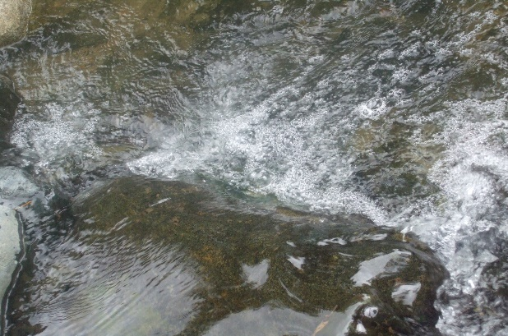
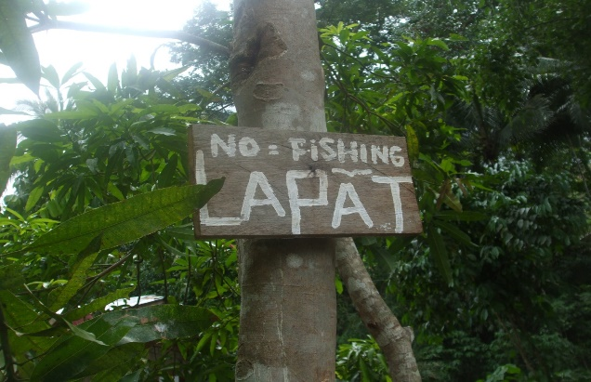

Figure 1. Picture of an area declared as Lapat.
A signboard with the word lapat is printed and nailed in a conspicuous tree. Fishing is the activity particularly prohibited in this area.

Figure 2. Picture of the body of water declared as lapat that is found within the area of a plantation declared also as lapat. No one is allowed to enter the area until the lapat is lifted.

4.2. The Process And Implementation

Just after the burial or magtaman, all those who joined in the funeral procession are invited to the house of the bereaved family to eat the butchered sacrificial animal or the attu as a symbol of thanksgiving to those who sympathized with them. After the meal, the leader of the family gathers all the members of the family, their relatives, the community elders and leaders for a consultation about the moral, social, spiritual and economical aspects of the lapat and its impact to the family and to the community, the areas and activities to be covered, the sanctions to be imposed in case there are violations, exceptions to the rule if there are, and the duration of the lapat.
In as much as the lapat system of the Isnags is considered sacred, violations to the rules set during the consultation meeting is a serious offense that may even cause a bloody conflict between the bereaved family and the family of the violator or a community disgrace if the leaders can not resolve the issue.
When the consultation is done, the rules and all the aspects of the lapat are now formally announced by the leader of the family. Wide dissemination of the rules are done by all the elders and leaders who attended the consultation during barangay meetings and even during informal gatherings in any house called the maggahayam .

Table 3. Duration and Signs/ symbols of the declared lapat
Duration and Signs/  symbols of the declared lapat | Municipalities |  |  |  |  |  |  |  | Total
Duration and Signs/  symbols of the declared lapat | Conner |  | Kabugao |  | Pudtol |  | Calanasan
Duration and Signs/  symbols of the declared lapat | F  n=20 | % | F  n=30 | % | F  n=20 | % | F  n=20 | %
a. Span of time for the declaration of a particular area as lapat
1. Less than 1 year | - | - | 5 | 16.67 | 1 | 5 | 5 | 25 | 11
2. One (1) year | 20 | 100 | 22 | 73.33 | 19 | 95 | 15 | 75 | 76
3. Two (2) years | - | - | 1 | 3.33 | - | - | - | - | 1
4. More than 2 years | - | - | 2 | 6.66 | - | - | - | - | 2
b. Signs/ Symbols of Lapat
Sign boards | 18 | 90 | 20 | 66.67 | 17 | 85 | 20 | 100 | 75
Fencing around | 1 | 5 | 3 | 10 | 3 | 15 | 20 | 100 | 27
Public information | 9 | 45 | 1 | 3.33 | 3 | 15 | 5 | 25 | 18

The span of time an area is declared as lapat takes a year in the four municipalities surveyed. Table 3 reveals that 100% of the Isnag respondents in Conner declare the area for 1 year, 73.33 % in Kabugao and 95% in Pudtol and 75 % of the respondents in Calanasan declare lapat in a year. For Kabugao, 3.33 % and 6.66% respondents mentioned that the lapat declaration can be extended for 2 years or more. Results of the survey in Kabugao, Pudtol and Calanasan further disclosed that some declare lapat in less than 1 year as indicated by 16.67%, 5% and 25 %, respectively. According to some of the key informants, this usually happens when another member of the family dies within the one-year period of the lapat or if there are bad omens besetting the family.
In the same table, all the 4 municipalities use signboards printed with the word “lapat” to indicate the restricted area. The signboards are strategically nailed in conspicuous trees at the demarcation line of the lapat area to indicate that the forest, plantation, or a part of the river is declared “lapat”. Fishing, hunting, gathering fire woods, farming, cutting of trees even for useful purposes, taking any object, or just simply entering into the area are strictly prohibited within the duration of the lapat period. Other respondents used fencing and public information to declare that an area is Lapat.

4.3. Violations, Sanctions and Lifting of the Lapat
Once an area is declared lapat, this becomes a binding agreement between and among all the people in the community. It is the responsibility and obligation of everybody to watch and guard the sanctity of the lapat area. Likewise, it is their duty to report to the community leaders and elders any violation they observed for proper sanction or punishment. Neighboring barangays and towns and even visitors are obliged to obey and to respect the rules.
Table 4 presents the corresponding sanctions to any of the violations committed such as entering the lapat, picking any object, cutting trees, farming, gathering firewood or fruits if there are, hunting, fishing, and making unnecessary noise.

Table 4. Sanctions to the violator of a Lapat
Sanctions to the violator  of a Lapat | Municipalities |  |  |  |  |  |  |  | Total
Sanctions to the violator  of a Lapat | Conner |  | Kabugao |  | Pudtol |  | Calanasan
Sanctions to the violator  of a Lapat | F  n=20 | % | F  n=30 | % | F  n=20 | % | F  n=20 | %
a. sanctions or penalty
1. Provide say- am to the whole community | 17 | 85 | 30 | 100 | 15 | 75 | 20 | 100 | 82
3. Will provide “Awat” in any form | 6 | 30 | 20 | 66.67 | 2 | 10 | 18 | 90 | 46
b. Authorized Person to give sanctions or penalty
1. An elder in the community | 4 | 20 | 3 | 10 | - | - | - | - | 7
2. Council of leaders | 4 | 20 | 1 | 3.33 | 15 | 75 | 15 | 75 | 35
3. Leader and member of the family | 14 | 70 | 19 | 63.33 | 2 | 10 | 4 | 20 | 39
4. Barangay captain | 2 | 10 | 5 | 16.67 | 2 | 10 | 1 | 5 | 10

Data show that 100% of the respondents in Kabugao and Calanasan, 85% in Conner, and 75% in Pudtol provide say -am to the whole community in case the rules of the lapat are violated. “Awat” is likewise imposed to violators as shown in the data above provided the bereaved family opted to accept the offer.
Furthermore, as reflected in the same Table, in Conner and in Kabugao, the leader of the family generally gives the sanction as indicated by 70% and 63.33% respectively. While 75% of the respondents from Pudtol and Calanasan claim that the authorize person to give the sanctions is the council of elders. Further, It is remarkably noted that 20% of the respondents in Conner and 10% in Kabugao claim that the elder in the community can also give the sanctions to violators, however; in extreme cases only according to some of the old folks who were interviewed in both municipalities. It is further noted that the barangay captain can likewise give sanctions in some cases.
Once, a common decision is made relative to the penalty imposed, and was accepted by the offender, the peace agreement or the palna is executed between the bereaved family and the violator. In most cases, the heaviest penalty imposed to the violator is to provide a say-am or a grand feast. for all the community people where they have to butcher a cow, a number of pigs and a dog. However, in an interview conducted it was found out that there are also cases where other penalties or punishments are decided otherwise like mahawat or to pay a large amount of money, to give a hectare of land; a carabao or cow; a husi ( expensive jars); sinali or sahaban ( expensive beads made of precious stones). This is only done if the bereaved family does not accept the say-am since the one year period for their mourning is not yet over. However; the beheading of a dog in the lapat area is required to be done in order to appease the anitos and the spirits of their dead whom they believe are the guardians of their lapat. Otherwise, they believe that the anitos and the spirits that dwell in the lapat as guardians will cause them sickness or any form of a curse that will cause death.

The lifting of the lapat is called mangukas which is the highlight during the kalyas ( celebration of a death anniversary of a loved one) which is a form of a say-am that lasts for 3 to 7 days for the rich, and a day only for the less privileged. During the mangukas, the panglakayan, the eldest in the family or the mengal, war hero in the family follows a ritual to open the lapat area. First, the panglakayan relates as he shouts heroic deeds he has done to protect the family which is called magpakkaw while his hand is positioned up high with a sharp ( pinagsay) bolo or aliwa ready to behead the dog. This is done simultaneously with dancing the taddo and salip with the loudest play of the gongs and the ludags accompanied by the ayaya, a monosyllabic musical sound of the durarakit or the old women in the barangay who can be used as mediators of the anitos or the spirits. Others in the say-am sing and chant ( magdewdewas) the beautiful recounts they have with the bereaved family as they drink basi ( native wine made of sugarcane).

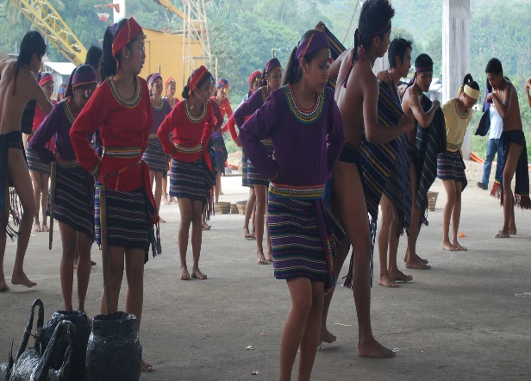
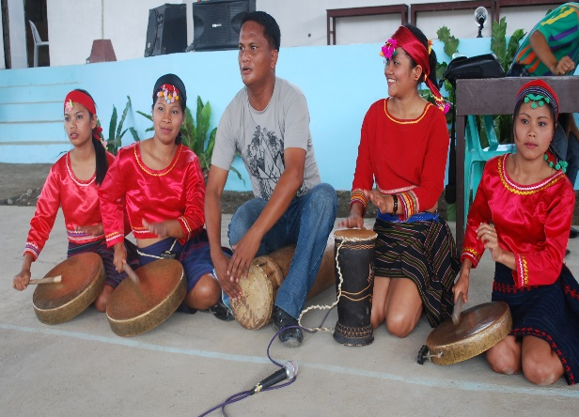

Figure 4. Dancing the taddo and salip with the native attire of the Isnags during a say-am

Figure 3. Gongs and ludags are played while dancing

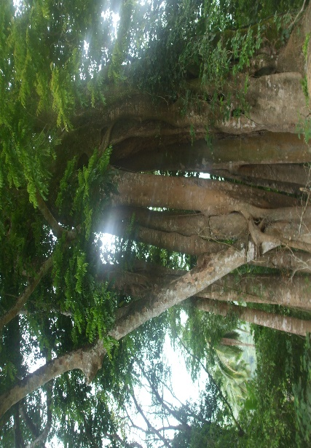
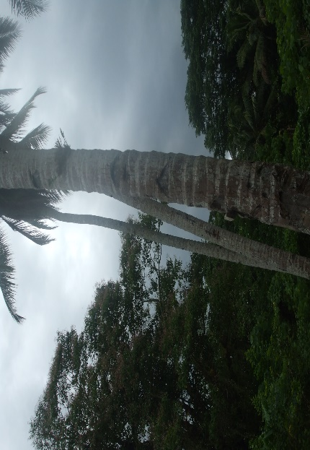
Mangukas entails other rituals. The liver and blood of the dog are offered to the spirits and the anitos as their food by wrapping the liver with a piece of red cloth and tie it in a tiny bamboo called the patanggu. The blood of the dog is poured inside the patanggu for the anitos and the spirits to drink .This is hung in the Ammadingan, a big tree within the Forest believed to be the dwelling place of the spirits and the anitos. According to the old folks, this ritual is done to ask the blessings and the permission of the anitos and the spirits who protected the lapat. In doing so, nobody will be cursed to death.

Figure 6. A picture of an Ammadingan, a tree believed to be the dwelling place of the anitos and the spirits.

Figure 5. A picture of an Ammadingan, a tree believed to be the dwelling place of the anitos and the spirits.

Once the lapat is lifted, the areas are now open to the public for fishing and hunting using only the traditional methods. All fruits found in the lapat area can be harvested by the public. Farming can also be now allowed but confined only to particular areas because there is a portion of the forest called the pulon that cannot be used for farming due to the trees that are protected by the family. Timber can only be cut from the pulon if this is used by the family to build a house.

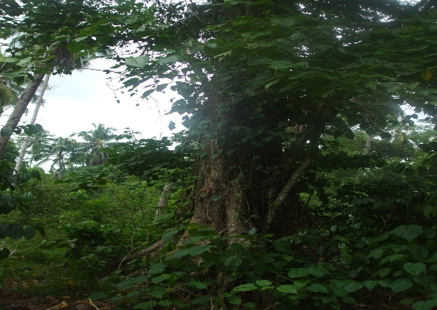


Table 5. Benefits derived from declaring an area as Lapat
Figure 8. A sample picture of a Pulon, an area protected from farming and cutting trees

Figure 7. A sample picture of a Pulon, an area protected from farming and cutting trees

Table 5 shows that 100% of the respondents from the four municipalities considered respect and honor is duly accorded to the dead member of the family when lapat is declared which is primarily a family-centered cultural value. Likewise, they equally give priority to resource- based conservation practices and protection of land and water resources. Both are strictly protected in times when lapat is declared. Consequently, land and water productivity is increased as gleaned from the responses of the 59 or 65.55% respondents. Stronger family ties was also identified as a benefit from the 14 or 15.55% respondents which is of less significant to the impact of lapat when declared. Power and authority, honor and respect to the family, and blessings from the anitos came out to be the least significant among all with only 6 or 6.66% respondents.
These benefits particularly respect and honor to the dead member of the family, protection of natural resources and stronger family ties became culture-bound because they have become a way of life to the Isnags.
It is then implied that indeed Lapat is a tradition-held practice of the isnags in the conservation of their natural resources.

Table 5. Benefits derived from declaring an area as Lapat
Benefits | Municipalities |  |  |  |  |  |  |  | Total
Benefits | Conner |  | Kabugao |  | Pudtol |  | Calanasan
Benefits | F  n=20 | % | F  n=30 | % | F  n=20 | % | F  n=20 | % | 90
1. Respect and honor is duly accorded to the dead member of the family | 20 | 100 | 30 | 100 | 20 | 100 | 20 | 100 | 90
2. Power and authority | 2 | 10 | 1 | 3.33 | 2 | 10 | 1 | 5 | 6
3. Honor and respect to the family | 2 | 10 | 1 | 3.33 | 2 | 10 | 1 | 5 | 6
4. Land properties and water bodies are protected | 20 | 100 | 30 | 100 | 20 | 100 | 20 | 100 | 90
5. Blessings from the anitos | 3 | 15 | 3 | 10 | - | - | - | - | 6
6. Land and water productivity is increased | 4 | 20 | 25 | 83.33 | 15 | 75 | 15 | 75 | 59
7.Stronger family ties | 5 | 25 | 2 | 6.67 | 2 | 10 | 5 | 25 | 14

6. conclusion

Lapat is a way of life and a culture-bound indigenous practice in promoting natural resources conservation in the four municipalities of Apayao namely, Conner, Kabugao, Pudtol and Calanasan, respectively. It was recommended that the local government units in Apayao should legislate the adoption and support the implementation of the Lapat system to all the 7 municipalities in the province.

Consent (where ever applicable)

I affirm that the respondents voluntarily agreed to participate after being fully informed about the purpose, nature, and potential implications of the study. Their responses have been collected with utmost respect for their privacy and confidentiality, in accordance with ethical research guidelines.

Ethical approval (where ever applicable)

The study was conducted with the approval and in accordance with the standards of the college. No ethical approval was required, as the research followed all applicable ethical guidelines, ensuring respect for the respondents' privacy and confidentiality

DISCLAIMER (ARTIFICIAL INTELLIGENCE)
The author is hereby declaring that NO generative AI technologies such as Large Language Models (ChatGPT, COPILOT, etc.) and text-to-image generators have been used during the writing or editing of this manuscript.

References

Assefa, E., & Hans-Rudolf, B. (2017). Indigenous resource management practices in the Gamo Highland of Ethiopia: challenges and prospects for sustainable resource management. Sustainability Science, 12, 695-709.

Bohensky, E. L., Butler, J. R., & Davies, J. (2013). Integrating indigenous ecological knowledge and science in natural resource management: perspectives from Australia. Ecology and Society, 18(3).
Caronan, A. M. (2019). The level of family life of the indigenous people of apayao. International Journal of Advanced Research in Management and Social Sciences, 8(2), 200-219.

CAYABA, D. J. C. (2018). CALANASAN LAPAT SYSTEM: INDIGENOUS PRACTICE IN ENVIRONMENTAL GOVERNANCE.
Chunhabunyatip, P., Sasaki, N., Grünbühel, C., Kuwornu, J. K., & Tsusaka, T. W. (2018). Influence of indigenous spiritual beliefs on natural resource management and ecological conservation in Thailand. Sustainability, 10(8), 2842.

DeWalt, B. R. (1994). Using indigenous knowledge to improve agriculture and natural resource management. Human organization, 53(2), 123-131.

Grenier, L. (1998). Working with indigenous knowledge: A guide for researchers. idrc.

Jocano, F. L., Marquez, L., & Caguimbal, M. Q. (1994). Problems & methods in the study of Philippine indigenous ethnic cultures: a preliminary overview. (No Title).

Mabborang, F. D. N. (2022). Causes and Effects of Division of Pentecostal- Evangelical Christian Churches. Asian Journal of Education and Social Studies, 28, 26-35.

Notzke, C. (1995). A new perspective in aboriginal natural resource management: co- management. Geoforum, 26(2), 187-209.

Tripathi, N., & Bhattarya, S. (2004). Integrating indigenous knowledge and GIS for participatory natural resource management: State‐of‐the‐practice. The electronic journal of information systems in developing countries, 17(1), 1-13.

Rajasekaran, B., Warren, D. M., & Babu, S. C. (1991). Indigenous natural‐resource management systems for sustainable agricultural development—a global perspective. Journal of international development, 3(3), 387-401.

Walsh, F. J., Dobson, P. V., & Douglas, J. C. (2013). Anpernirrentye: a framework for enhanced application of indigenous ecological knowledge in natural resource management. Ecology and Society, 18(3).

