Morpho-Anatomical and Pharmacognostic Properties Of Whitfieldia elongata (P. Beauv.) De Wild. & T. Durand

ABSTRACT
Whitfieldia elongata (P. Beauv.) De Wild. & T. Durand is a species in the family Acanthaceae which is used in folklore medicine for the management of pains, food poisoning and stomach complaints. The aim of this study was to document the taxonomic and pharmacognostic characters for its identification and standardization. The microscopic, micromeritics, chemomicroscopy, flourescense analysis, powder microscopy, foliar epidermal and petiole anatomy, moisture content, ash values, extractive values, preliminary phytochemical screening and Gas chromatography-Mass spectrometry were done using standard methods. Irregular epidermal cell shapes were present on the adaxial and abaxial surfaces. Stomatal distribution was hypostomatc with diacytic stomata on the abaxial surface. The leaf had a good flow while the stem had a poor flow rate with the value higher than 40⁰. Moisture contents were 13.8% and 13.6% for the leaf and stem respectively. Total ash values were 13.9 %w/w and 4.5 % w/w for the leaf and stem respectively. Water-insoluble ash 0.8 % w/w and 1.5 % w/w for the leaf and stem respectively. Chemomicroscopy reavealed the presence of mucilage, lignin, starch, cellulose and protein while calcium oxalate crystal was absent. Oil was present and in the stem powder. Fluorescence characteristics showed the presence of different colours supporting the various phytoconstituents for the leaf and stem. The preliminary phytochemical result revealed the presence of saponins, tannins, flavonoids, terpenes and glycosides while alkaloid was absent. The GC-MS analysis of the ethanol leaf and stem extract revealed the presence of 34 and 33 phytochemicals respectively. The findings of this study may help in establishing standards for quality, purity, safety and efficacy of Whitfieldia elongata for phytomedicine.
Keyword:
Diacytic, folklore medicine, phytomedicine, Standardization, terpenes,

INTRODUCTION
Whitfieldia elongata (P. Beauv.) De Wild. & T. Durand is a pantropical species in the family
Acanthaceae. The family comprises of about 140 species distributed in West Africa, AsiaMalesian region and South America [1]. “The species are erect or creeping herbs, subshrubs or shrubs, the flowers bearing an unequally 5-segmented calyx (the posterior segment being larger than the others, the lateral segments much smaller, and the anterior segments of intermediate size), and an androecium of four didynamous stamens with bithecae anthers and a reduced staminode” [1].
“Anatomical and micromorphological characteristics of leaves, stems, and roots have played important roles in plant taxonomy, especially at the generic and specific levels. Studies in this field have attracted the attention of plant morphologists and systematists to resolve taxonomic conflicts in different groups of plants” [2]. “The foliar epidermis has yielded some of the most important characters used in taxonomic studies. Such structures include the ultrastructures of epidermal cells, stomata, and trichomes, their sizes, lengths, distribution, orientation, and frequency are of significant importance in taxonomy as well as phylogeny” [3].
Most of the researches in pharmacognosy have been done in identifying controversial species of plants, authentication of commonly used traditional medicinal plants through morphological, phytochemical and physicochemical analysis. The importance of pharmacognosy has been widely felt in recent times. “Pharmacognosy is basically divided into two groups: conventional and modern pharmacognosy. The conventional pharmacognosy includes the study of macroscopic and sensory characters (size, shape, colour, texture and odour of powdered drug), microscopic characters (anatomical and maceration) and quantitative microscopic characters (vein-islet number, vein-islet termination, palisade ratio, trichome number, epidermal cell and stomatal number” [4]. “Unlike taxonomic identification, pharmacognostic study includes parameters which help in identifying adulteration in dry powder form also. This is again necessary because once the plant is dried and made into powder form, it loses its morphological identity and easily prone to adulteration. Pharmacognostic studies ensure plant identity, lays down standardization parameters which will help in the detection and prevention of adulterations. Such studies will help in authentication of the plants and ensures reproducible quality of herbal products leading to guarantee in the safety and efficacy of natural products” [4].
“Pharmacognostic evaluation includes the macroscopic, microscopic, physico-chemical, fluorescence, phytochemical and biological studies of whole plant parts or powdered drug. Herbal raw material shows a number of problems when quality and authentication aspects are considered. This is because of the nature of herbal parts, ingredients and different phytochemicals present in crude drugs [6]. To ensure quality of herbal medicines, proper control of starting raw material is very important. The physico-chemical evaluation includes qualitative and quantitative tests, assays and instrumentation analysis. Qualitative and quantitative chemical tests include the presence or absence, quantity, number, values and identification of various phtyochemicals like flavonoids, glycosides, saponins and alkaloids” [7].
The study was aimed at identifying, describing and documenting the pharmacognostic and diagnostic characters through the microscopy of the foliar epidermis and petioles, micromeritic analysis, chemomicroscopic evaluation of the leaf and stem and the GC-MS analysis of the leaf and stem of Whitfieldia elongata.

MATERIAL AND METHODS Materials
The following materials were used during the course of this research work; Beakers, Electronic weighing balance, test tubes, filter paper, oven, water bath, pen, pencil, funnel, glass stirrer, measuring cylinder, beakers, conical flash, sieves, graduating cylinders, spatula, marker, masking tape, foil paper, thongs, evaporating dish, silica gel, knife, mortar and pestle, electronic microscope, microscope slide, full-scape sheets, meter rule,

Reagents
Reagents used include, distilled water, glycerol, safranin, Sodium hydroxide, 5% Hydrochloric acid, concentrated hydrochloric acid, ferric chloride, pottasium hydroxide, Concentrated sulphuric acid,

Collection and Identification
Fresh sample of Whitfieldia elongata was collected in April, 2021 and was identified and authenticated by Prof. M. E. Bassey, a taxonomist in the Department of Botany and Ecological Studies, University of Uyo, Uyo, Akwa Ibom State and with herbarium number UUH4361 and specimen deposited in the University of Uyo Herbarium. Plant sample collected was preserved in FAA (Formalin Acetic Acid Alcohol) for the anatomical studies [8].

Preparation of Surface Specimens of Leaf
The preserved plant material was rinsed with distilled water. Small portions were obtained from the median part of well expanded mature leaves. The epidermal peels of both abaxial and adaxial surfaces were made by placing the leaf blade in a clean glass slide, with the surface to be studied facing down.
The specimens were irrigated with water holding it downward from one end; and then the epidermis above the desired surface was scrapped-off carefully with sharp razor blade. The loose cells were washed away from the epidermal peels with the aid of soft camel hair brush. The cleaned portion/epidermis was further cleared in 5% solution of sodium hypochlorite (Jik) for about 2-3minutes. The cleared portions of the leaf were finally washed in 3-4 changes of distilled water [9]
The epidermal peels were stained in 1% aqueous solution of safranin-O for 4-8 minutes, carefully washed in water to remove excess stain and mounted in 10% glycerol on a glass slide and covered with a glass cover slip then viewed using an Olympus CX21 binocular microscope. Photomicrographs were taken from good preparation using the Olympus CX21 binocular microscope fitted with an MD500 Amscope microscope eyepiece camera.
All measurements were made of the widest points using a calibrated ocular micrometer and an Amscope. Ten (10) microscopic fields chosen at random were used and data presented as Mean  Standard Error of Mean (SEM).

Micrometric evaluation
Measurements of dimensions (length and width) were done at the widest portion of the various diagnostic microscopic characters of the leaf; namely stomatal length, stomatal width, epidermal cell length, epidermal cell width, guard cell length, guard cell width, length of trichome and width of trichome [10].

Quantitative Leaf Microscopy
Quantitative microscopy was done to determine stomatal number, epidermal cell number, veinislet number, vein termination number and stomatal index. The Stomatal Index was determined according to the method of Metcalfe and Chalk [11].
S.I =
Where S = Number of stomata per unit area
E = Number of epidermal cell

Preparation of Petiole Sections
Thin cut of the cross or transverse section of the petiole was prepared by embedding the portion in pawpaw tissue after which free-hand sectioning was made with a sharp razor blade. The section was cleared in 20 % sodium hypochlorite (NaOCl) for 3-5 minutes and thereafter thoroughly rinsed five times in distilled water. Sections were stained in safranin-O solution for a period of 2-3 minutes then rinsed carefully with distilled water to remove excess stain. Dehydration follows and then mounted with 10 % glycerol solution and viewed with an Olympus CX21 binocular microscope. Photomicrographs were taken with an MD500 Amscope camera
[12].

Preparation of Microscopical Specimen of Powdered Drugs
A little quantity of the powdered sample was cleared using Sodium Hypochlorite (Jik), then a small quantity transferred on to a slide, stained with Safranin O, mounted with glycerol and a cover-slip then slightly pressed to remove excess fluid from the margin of the cover-slip with a strip of filter - paper, then viewed under a microscope and the photograph of the image was taken [13].
Micromeritic Properties of Whitfieldia elongata

Determination of Bulk Volume, Tapped Volume, Bulk Density, Tapped Density, Carr’s IndexHausner’s Ratio and Angle of Repose
Leaf powder was passed through 350 micron mesh size. The leaf powder (10 g) was weighed into a 100 mL measuring cylinder and the volume (bulk volume) was recorded. The cylinder was tapped gently 100 times and the volume was recorded (tapped volume). This was carried out two more times and the mean volume recorded. The procedure was repeated with the stem powder and the mean volume recorded. The result was used to calculate the following flow properties: Bulk density (g/mL), which was obtained by dividing the weight of the sample (10 g) by the bulk volume; Tapped density (g/mL), which was obtained by dividing the weight of the sample (10 g) by the tapped volume; Carr’s index [(Carr’s compressibility index) %], calculated using the formula below. The value below 25 % indicates good flow characteristics and a value above 25 % indicates poor flow characteristics [14].
Carr’s index = 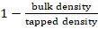 x 100
Hausner’s ratio which is obtained by dividing the tapped density by the bulk density. Values less than 1.25 indicate good flow and a value greater than 1.25 indicates poor flow.
The leaf powder (10 g) was filled into a funnel held 5.9 cm from the surface of the working bench and then allowed to flow. The flow time was recorded using a stop watch, and the powder heap height, powder heap diameter and radius were measured using a ruler and recorded. The procedure was repeated using the stem powder and the mean values were recorded. The flow rate (g/s) was calculated by dividing the weight of the sample (10 g) by the flow time [14]. The angle of repose was calculated using the formula
Tan⁻ ¹ɵ = 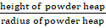

Chemomicroscopic Evaluation of Leaf and Stem Powders
The powdered leaf and stem was mounted on the microscope slides and observed under compound microscope for the presence of chemical substances like: cellulose, fat, oil, starch, lignin, calcium oxalate and calcium carbonate [15].

Cellulose Test
The powdered samples were mounted in N/50 iodine solution followed by 66 % sulphuric acid. A blue coloration indicated the presence of cellulose.

Mucilage Test
The powdered samples were mounted in ruthenium-red. Reddish/dark pink colouration indicated a positive result.

Lignin Test
The powdered samples were mounted in phloroglucinol followed by concentrated hydrochloric acid; a red colouration indicated lignifications.

Starch Test
The powdered samples were mounted in N/50 iodine. Bluish colouration indicated the presence of starch.

Calcium Oxalate Crystals Test
The powdered samples were cleared in sodium hypochlorite solution. The presence of calcium oxalate crystals was indicated as bright structures of definite shapes and sizes on the slide after the addition of 80 % hydrochloric acid and viewing under microscope, disappearance of calcium oxalate crystals confirmed their presence.

Protein Test
Picric acid (1 %) and million’s reagent was used. Yellowish strands on the structure (microscopic) in case of picric acid indicated the presence of protein.

Test for Oils
The powdered sample was mounted in Sudan IV reagent. A pinkish colouration indicated the presence of oil.

Determination of Moisture Content (Loss on Dry Method)
Four crucibles were heated to constant weight and the weight recorded. The powdered drug of 3 g was accurately weighed into the 4 crucibles and the crucibles and their content were placed in an oven at 105 ºC and dried to constant weight which was achieved by checking the weight at thirty minutes intervals after an initial drying of one hour. Two consecutive same weights confirmed the constant weight which was recorded. The total loss in weight (i.e. the weight of the crucibles and powdered drug from the initial weight of the moisture) was obtained by subtracting the final weight of the crucibles and powered drug. The moisture content was calculated in percentage with reference to its initial weight and the mean values was determined and recorded [16].

Determination of Ash Values Determination of Ash Value (Total Ash)
The crucibles and their contents from moisture content determination were transferred into the muffle furnace and the heat was gradually increased to 450 ⁰C for 8 hours, it was cooled and weighed. The weight of the ash was calculated by subtracting the weight of the crucibles from the final weight (that is the weight of the crucibles + residues or ashes). The ash value was calculated in percentage with reference to its initial weight and the mean value was obtained [16].

Determination of Acid- Insoluble Ash Value
The ash in the crucibles from total ash value so determined was separately transferred into each beaker containing 25 mL of 5 % dilute hydrochloric acid. They were boiled for five minutes and filtered through ashless filter paper(s). The beakers and crucibles washed in hot water and then passed through the ashless filter paper and the washing repeated for three times and every time passing the washing through the filter paper in a manner so that the residues were collected in the tip of the filter paper(s). The filter paper with the residue above were then folded into a small cone and transferred into the weighed crucibles and the crucibles heated gently until the paper were completely dried and transferred into the muffle furnace heated at 450 ºC for 8 hours. The crucibles were cooled, transferred into a well charged dessicator with silica gel and weights obtained. The final total weights were determined. The weights of the residue (the acidinsoluble ash) were calculated by subtracting the weight of the crucible from final weight (i.e. weight of the crucible and residue or ash) and the mean values were obtained. The acid-insoluble ash values were calculated in percentage with reference to initial weight of the powered drug [16].

Determination of Water-Soluble Ash Value
The ash in each crucible from the total ash value so determined was transferred to each beaker containing 25 mL of distilled water. They were boiled for five minutes and filtered through ashless filter paper(s). The ashless filter-paper and residue were folded into small cones, transferred into the crucibles, dried in an oven at 105 ºC. The crucibles and content were transferred into the muffle furnace heated at 450 ⁰C for 8 hours. The crucibles with their content were cooled, transferred into a charged dessicator and weighed finally to get the final weight. The weights of the residues (the water- insoluble ash) were calculated by subtracting the weight of the crucibles from the final weights above. The weights of the water-soluble ash were obtained by subtracting the weights of the water-insoluble matter from the weight of the total ash (from ash value determined). The percentage of the water-soluble ash was calculated with reference to the initial weight of powdered drug [16].

Determination of Extractive Values Ethanol-Soluble Extractive Value
The powdered drug (4 g) was accurately weighed into a 250 mL well stoppered conical flask. 90 % ethanol (100 mL) was added to the flask and firmly stoppered. The flask was shaken for 6 hours at 30 minutes intervals and allowed to stand for 18 hours without shaking. The extract was filtered and the volume measured. Aliquot of the filtrate (25 mL) was put into adequately weighed 3 evaporating dishes and evaporated to dryness on a hot plate. The residue was dried to constant weight at 105 ⁰C in an oven. The final weight of the powdered drug and the mean value was calculated [16].

Water-Soluble Extractive Value
The powdered drug (4 g) was accurately weighed into 250mL stoppered conical flask after which 100 mL of chloroform-water (20 mL chloroform: 80 mL water) was added and the stopper replaced firmly. The flask was vigorously shaken for 6 hours at interval of 30 minutes and then allowed to stand for 18 hours. The extract was filtered and the volume measured. Aliquot of the filtrate (25 mL) was measured and put into adequately weighed three (3) evaporating dishes and evaporated to dryness on a hot plate. The residue was dried to a constant weight at105 ⁰C in an oven and the final weight recorded. The weight of residue obtained from the 25 mL aliquot extract was determined by subtracting the weight of the evaporating dish from the final weight. The water-soluble extractive value (in %) with reference to the initial weight of the powdered drug was calculated and the mean value recorded [16].

Methanol-Soluble Extractive Value
The powdered drug (4 g) was accurately weighed into a 250 mL stoppered conical flask. Methanol (100 mL) was added to the flask and firmly stoppered. The flask was shaken for 6 hours at 30 minutes intervals and allowed to stand for 18 hours without shaking. The extract was filtered and the volume measured. Aliquot of the filtrate (25 mL) was put into adequately weighed three (3) evaporating dishes and evaporated to dryness on a hot plate. The residue was dried to constant weight at 105 ⁰C in an oven. The final weight of the powered drug and the mean value was calculated [16].

Statistical Analysis
Data obtained were expressed in Mean ± SEM using (Statistical Package for Social Sciences) SPSS 17.0 and the terminology used in describing epidermal features is that of [11].

Phytochemical Screening
Each 60 g of the plant leaf and stem powders were extracted by maceration in 1200 mL of 70 % ethanol in a conical flask. The mixture was vigorously stirred intermittently and allowed to stand for 72 hours. It was filtered into a conical flask and concentrated on a water bath at 40 ⁰C. All extracts obtained were stored in a refrigerator until required for use.
The standard methods of Sofowora,[17] were used in the preliminary phytochemical screening of leaf and stem extract.

Test for Tannins
About 0.5 g of extract was mixed with 10 mL of distilled water and filtered. Ferric chloride was added to the filtrate. A blue-black precipitate was seen as evidence for the presence of tannins.

Test for Alkaloids
About 0.5 g of the plant extract was dissolved with 5 mL of 5 % hydrochloric acid in a test tube and heated in water bath. The mixture was allowed to cool and then filtered. The filtrate was then divided into two test tubes.
The first portion was treated with few drops of Dragendoff’s precipitating reagent while the second portion was treated with Mayer’s reagent and observed. Brick red Precipitation or turbidity was taken as preliminary evidence for the presence of alkaloid in the plant extract.

Test for Saponins
About 0.5 g of the extract was shaken vigorously with 10 mL of distilled water in a graduated measuring cylinder for 15 minutes, frothing which persisted on warming after 15 minutes, indicates the presence of saponins. Also, few drops of olive oil was added to 1ml of the extract and vigorously shaken. Formation of soluble emulsion in the extract indicated the presence of Saponin.

Test for Flavonoids
The extract (0.5 g) was stirred with 10 mL of distilled water and filtered. Few pieces of magnesium metal were added to the filtrate followed with concentrated hydrochloric acid. The formation of a reddish precipitate indicated the presence of flavonoids.

Test for Cardiac Glycosides
About 0.5g of the plant extract was dissolved in 2 mL of chloroform. Concentrated sulphuric acid was gently added by running it down the side of the test tube to form a distinct lower layer. A reddish brown coloration at the inter-phase indicated the presence of the steroidal ring.

Fluorescence Analysis
Water, methanol, dichloromethane, ethyl acetate and n-hexane of the leaf and stem were prepared and spotted on a chromatographic plate. The colours were observed with the naked eye and under the UV- light at 365 nm and 253.7 nm and were recorded.

Gas Chromatography and Mass Spectrometry (GC-MS) analysis
The GCMS-QP2010SE Shimadzu, Japan system was used in the analysis included a fused silica column packed with Elite-1 and the components were separated using helium as a carrier gas at a constant flow rate of 1 ml/min. Ethanol extracts of 2 µl of the extracts were used for GC–MS analysis (Merlin et al., 2009). The sample extracts were injected into the instrument and detected. During the 23rd min of the GC extraction process, the oven was maintained at a temperature of 290 °C with 2 min. Mass spectra were obtained at 70 eV, a scan interval of 0.5 s, and fragments from 40 to 440 Da. The relative % amount of each component was calculated by comparing its average peak area to the total areas.

Identification of Phytocomponents
Interpretation of mass-spectrum GC-MS was conducted using the database of National Institute of Standards and Technology (NIST) having more than 62,000 patterns. The spectrum of the unknown components was compared with the spectrum of known components stored in the NIST library. The retention time, compound name, molecular weight, and percentage area of the test materials were ascertained.

RESULTS
The morphological descriptions, qualitative and quantitative micromorphology data obtained for Whitfieldia elongata are summarized below (Table 1 and Figures 1 –3)

Mophorlogical description of Whitfieldia elongata (P Beauv) De Wild. & T. Durand

This is an evergreen shrub with an erect, glabrous or slightly pubescent woody stem. The plant can grow to a height of about 1 to 3 meters. The leaf is simple, opposite, acuminate, entire, attenuate, elliptic, and glabrous, 8.3 – 13cm long and 4.5-7cm broad. The inflorescence is a terminal raceme which often branch to form a panicle and it flowers between November to January. The flowers are bracteate (barcts are caducous, green in colour and linear in shape). Calyx with 5 sepals, white in colour. Corolla is tubular with 5 lobes, white to cream colour. Stamens 4, didynamous (two long and two short) attached to the corolla tube with two celled anthers and a pistil.

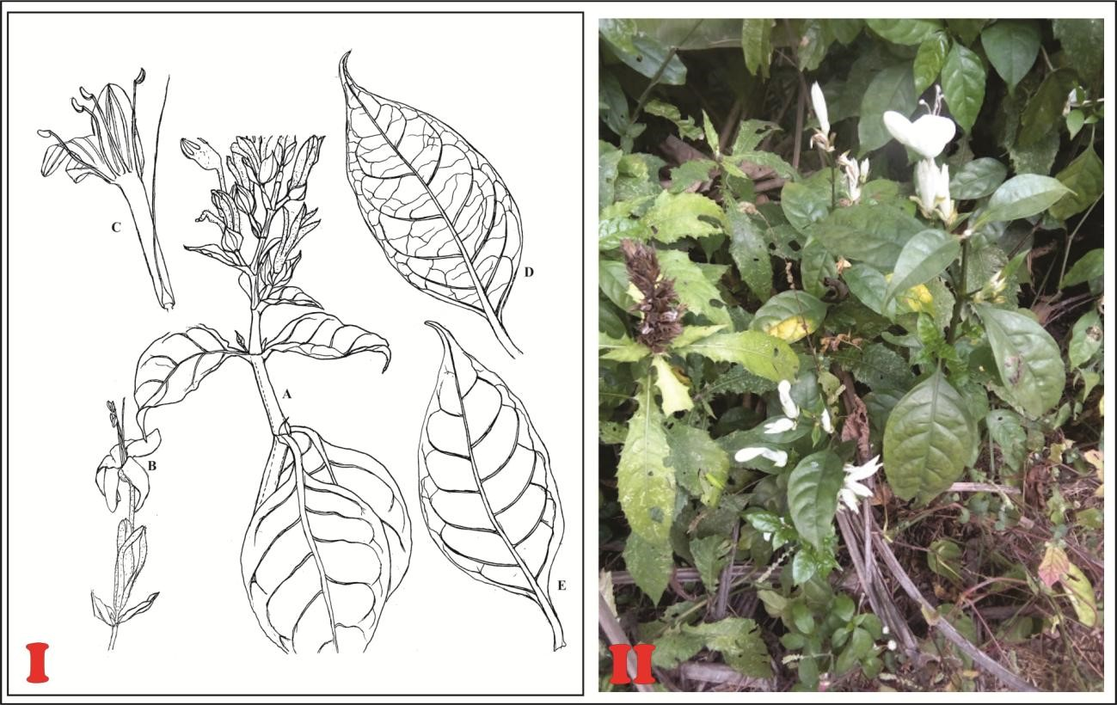
Figure 1: I-Morphology of Whitfieldia elongata A-Habit, B- Flower, C- Half Flower, D- Abaxial Leaf Surface, E- Adaxial Leaf Surface; II- Whitfieldia elongata in its Natural Habitat.

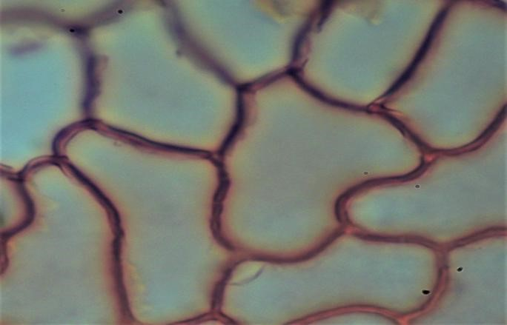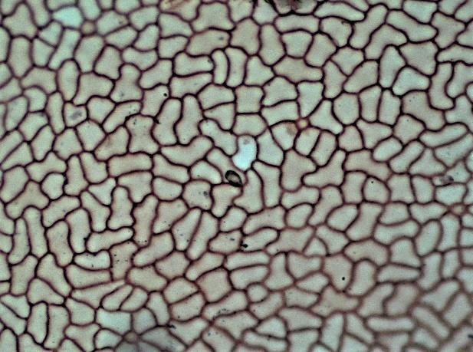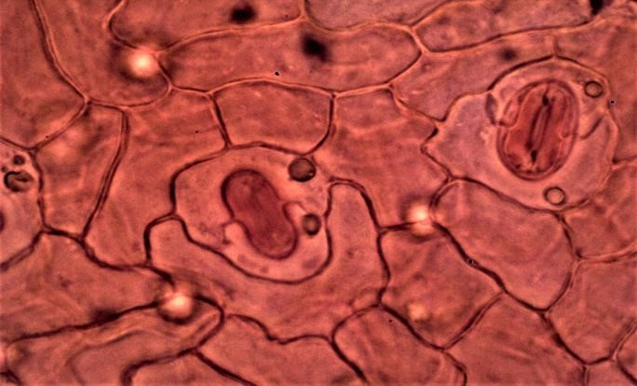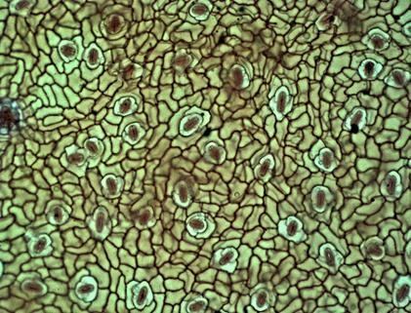

IEC

A

Dst

IEC

IEC

UAWP

B

C

D

Dst

Figure 2. (A&B): Irregular epidermal cells (IEC) and undulate anticlinal wall pattern (UAWP) ×10 & ×40 respectively, (C); Diacytic stomata (Dst) × 10, (D); Irregular epidermal cell (IEC), Diacytic stomata (Dst) × 40.

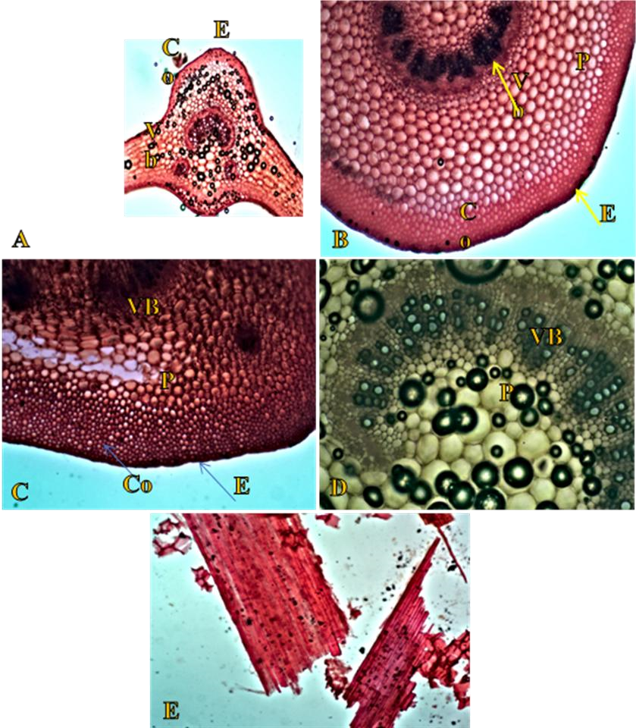

Figure 3.
(A):Transverse section of the leaf of Whitfieldia elongata: × 4, (B); Cholenchyma cells (C);Vascular bundle(Vb), Epidermis (E), Parenchyma cells (P) × 10, (D); Transverse section of petiole Cholenchyma cells(Co), Vascular bundle(Vb), Epidermis(E), Parenchyma cells (P) × 10, (D); Vascular bundle (Vb), Parenchyma cells (P) × 40,
(E); Powdered stem showing Fibres × 10.

Table 1: Microscopy Results for W. elongata
Leaf surface | Abaxial | Adaxial
Epidermal cell wall pattern | Undulate
Distribution of stomata | Hypostomatic | Hypostomatic
Stamata length (µm) | 17.97(21.18±0.599)23.91 | -
Stomata width | 8.58(11.18±0.44)12.60 | -
Stomata number | 46(49±0.53)56 | -
Stomata index (%) | 10 | -
Epidermal cell number | 328(417±4.40)422 | 590(621±6.33)650
Length of epidermal cell | 35.99(41.47±1.28)47.01 | 27.39(38.07±1.8)45.28
Width of epidermal cell | 5.46(15.19±2.13)18.80 | 12.68(15.24±0.6)19.84
Thickness of epidermal cell wall | 2.04(2.43±0.14).3.52 | 2.45(3.26±0.18)3.65
Length of guard cell(µm) | - | 11.92(14.49±0.45)16.82
Width of guard cell(µm) | - | 3.47(4.40±0.20)5.35

Table 2: Micromeritic evaluation of powdered leaf and stem of Whitfieldia elongata
Micromeritic Parameters | Leaf | Stem
Bulk volume(mL) | 32.66±0.33 | 58.0±0.57
Tapped volume(mL) | 25.66±0.33 | 43.66±0.33
Bulk density(g/mL) | 1.523±0.00 | 0.856±0.00
Tapped density(g/mL) | 1.94±0.00 | 1.145±0.00
Hausners ratio | 1.27(±0.00) | 1.32(±0.01)
Carr’s index(%) | 21.43(±0.21) | 24.70(±0.96)
Diameter of heap(cm) | 6.69±0.06 | 8.43±0.03
Height of heap(cm) | 1.86±0.08 | 2.93±0.08
Flow time(sec) | 24.06(±1.48) | 57.61(±1.60)
Flow rate(g/sec) | 2.10 | 0.86
Angle of repose(°) | 27.50 | 45.45

Table 3: Chemomicroscopic evaluation of the leaf and stem of Whitfieldia elongata
TEST | LEAF | STEM
Mucilage | + | +
Lignin | + | +
Calcium oxalate | - | -
Starch | + | +
Oils | - | +
Cellulose | + | +
Protein | + | +
Key: + = present; - = absent

Table 4: Moisture content, Ash value, Acid-soluble and Acid-insoluble ash value, Water-soluble and water-insoluble ash value
Parameter | Leaf (%w/w) | Stem (%w/w)
Moisture content | 13.80±0.00 | 13.6%
Total ash | 13.90% | 4.55%
Water-soluble ash | 13.085% | 3.35%
Water-insoluble ash | 0.885% | 1.155%
Acid-insoluble ash | 7.45% | 1.645%

Table 5: Flourescence analysis for the leaf and stem of Whitfieldia elongata
Extract | Sample | Ordinary Light | UV-365 nm | UV-252.7 nm
Water | Leaf | Green | Light yellow | Grey
 | Stem | Light green | Light green | Grey
Methanol | Leaf | Green | Orange | Light ash
 | Stem | Light green | Pink | Light orange
Ethanol | Leaf | Green | Pink | Orange
 | Stem | Light green | Orange | Brown
Dichloromethane | Leaf | Green | Pink | Light brown
 | Stem | Green | Red | Light green
N-hexane | Leaf | Yellow | Pink | Light brown
 | Stem | Yellow | Pink | Grey
Ethyl acetate | Leaf | Green | Pink | Light brown
 | Stem | Light green | Pink | Ash
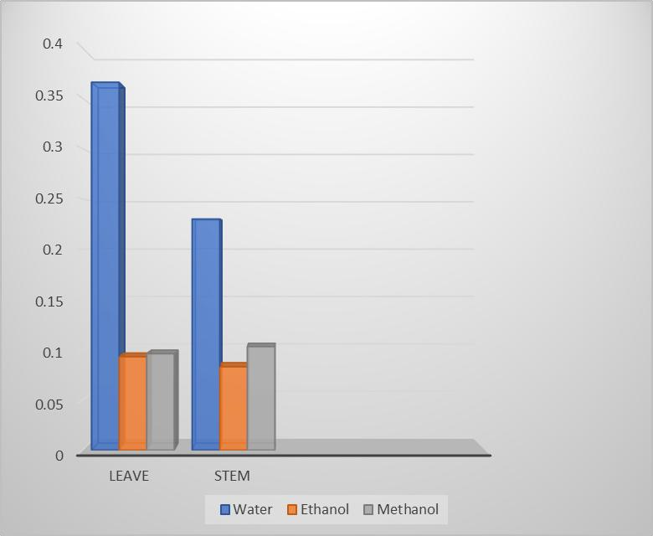
Figure 4: Extractive value for the leaf and stem of Whitfieldia elongata

Table 6: Showing the chemical constituents from GCMS analysis of Whitfieldia elongata Stem
S/N | RETENTION COMPOUND NAME  TIME |  | MOLECULAR MOLECULAR AREA% FORMULAR WEIGHT
1 | 4.508 | Bicyclo[3.1.0]hexan-2-one | C₆H₈O | 96 | 0.47
2 | 4.994 | Cyclopentanone, 2-methyl- | C6H10O | 98 | 1.22
3 | 5.255 | 2-Furancarboxaldehyde, 5methyl- | C6H6O2 | 110 | 0.50
4 | 5.483 | 2,4-Dihydroxy-2,5-dimethyl-  3(2H)-furan-3-one | C6H8O4 | 144 | 0.61
5 | 5.698 | 7-Norbornyl t-butyl ether | C11H20O | 168 | 0.83
6 | 5.967 | Benzeneacetic acid, 2-octyl ester | C16H24O2 | 248 | 0.27

- 6.295 2,5-Dimethyl-4-hydroxy- C₆H₈O₃ 128 1.69
3(2H)-furanone
- 6.425 2,4,5-Trihydroxypyrimidine C₄H₄N₂O₃ 128 1.32
- 6.534 Phenol, 2-methoxy- C₇H₈O₂ 124 3.99
- 7.194 4H-Pyran-4-one, 2,3-dihydro- C₆H₈O₄ 144 12.18
3,5-dihydroxy-6-methyl-
- 7.635 Estragole C₁₀H₁₂O 148 2.33
- 8.025 5-Hydroxymethylfurfural C₆H₆O₃ 126 11.33
- 8.809 2-Methoxy-4-vinylphenol C₉H₁₀O₂ 150 1.01
- 9.073 Phenol, 2,6-dimethoxy- C₈H₁₀O₃ 154 5.25
- 9.503 2-(2,3-Dimethyloxiran-2- C₉H₁₁NO 149 0.39 yl)pyridine
- 9.696 Thiazolo[3,2-c]pyrimidin-4- C₇H₉BrN₂S 232 0.64
ium, 2,3-dihydro-5-methyl-, bromide
- 10.868 2-Decanynoic acid C₁₀H₁₆O₂ 168 2.95
- 11.220 13-Oxadispiro[5.0.5.1]tridecan- C₁₂H₁₈O₂ 194 0.74
1-one
- 11.323 Ethyl N-(o-anisyl)formimidate C₁₀H₁₃NO₂ 179 0.44

- 11.731 Imidazolo[1,2-a]pyrimidine- C₈H₉N₃O₂ 179 0.59
2,5(1H,3H)-dione, 3,7dimethyl-
- 12.251 Ethyl .alpha.-d- C₈H₁₆O₆ 208 36.29
glucopyranoside
- 12.609 4-((1E)-3-Hydroxy-1- C₁₀H₁₂O₃ 180 4.38 propenyl)-2-methoxyphenol
- 13.150 5,12-Naphthacenedione, 10- C₃₂H₃₄N₂O₁₂ 638 2.08
((3-(3-cyano-4-morpholinyl)2,3,6-trideoxy-.alpha.-L-lyxohexopyranosyl)oxy)-7,8,9,10tetrahydro-6,8,
- 14.247 n-Hexadecanoic acid C₁₆H₃₂O₂ 256 3.49
- 14.446 Hexadecanoic acid, ethyl ester C₁₈H₃₆O₂ 284 0.68
- 15.420 Oleic acid C₁₈H₃₄O₂ 282 1.43
- 15.583 Octadecanoic acid C₁₈H₃₆O₂ 284 0.59
- 16.816 Oxiraneoctanoic acid, 3-octyl-, C₁₈H₃₄O₃ 298 0.51 cis-
- 16.930 9-Octadecenamide, (Z)- C₁₈H₃₅NO 281 0.15
- 17.002 2(3H)-Benzofuranone, C₁₁H₁₈O₂ 182 0.59
hexahydro-4,4,7a-trimethyl-

- 18.150 Octadecanoic acid, 2,3- C₂₁H₄₂O₄ 358 0.52 dihydroxypropyl ester
- 18.437 Bis(2-ethylhexyl) phthalate C₂₄H₃₈O₄ 390 0.25 33 19.735 Octadecanoic acid, 2,3- C₂₁H₄₂O₄ 358 0.28
dihydroxypropyl ester

Table 7: The Chemical Constituents From GCMS Analysis Of Whitfieldia Elongata

Leaves
S/N | RETENTION TIME | COMPOUND NAME | MOLECULAR FORMULAR | MOLECULAR WEIGHT | AREA%
1 | 4.532 | B Succinic acid, cyclohex-2enylmethyl undecyl ester | C22H38O4 | 366 | 1.63
2 | 6.974 | Ethanethioic acid, S-[2-  (dimethylamino)ethyl] ester | C₆H₁₃NOS | 147 | 54.76
3 | 7.643 | Estragole | C10H12O | 148 | 5.70
4 | 7.792 | 4-Hydroxy-4-methylhex-5-enoic acid, tert.-butyl ester | C11H20O3 | 200 | 0.12
5 | 8.022 | Benzofuran, 2,3-dihydro- | C₈H₈O | 120 | 6.49
6 | 8.646 | Indole | C₈H₇N | 117 | 0.41
7 | 8.863 | 2-Methoxy-4-vinylphenol | C9H10O2 | 150 | 0.77
8 | 9.191 | Phenol, 2,6-dimethoxy- | C8H10O3 | 154 | 0.63
9 | 9.558 | Tricyclo[3.3.1.1(3,7)]decane, 2methoxy- | C11H18O | 166 | 1.32
10 | 9.720 | Pyrrolidine, 1-(1-cyclohexen-1-yl)- | C10H17N | 151 | 1.25
11 | 10.670 | Phenol, 2,4-bis(1,1-dimethylethyl)- | C14H22O | 206 | 0.12
12 | 11.199 | Vanillin, acetate | C10H10O4 | 194 | 0.51
13 | 11.250 | 1-(p-Ethoxycarbonylphenyl)-3-(pbromophenyl) triazene | C15H14BrN3O2 | 347 | 0.41
14 | 11.469 | Butanedioic acid, pentacosyl-, dimethyl ester | C31H60O4 | 496 | 3.62
15 | 11.751 | N-(2-Carboxyethyl)1desoxinojirimycin | C9H17NO6 | 235 | 7.40
16 | 12.500 | (+)-1-Cyano-d-camphidine | C11H18N2 | 178 | 0.28
17 | 12.668 | 5-Bromopentanoic acid, 2ethylcyclohexyl ester | C13H23BrO2 | 290 | 1.10
18 | 12.771 | 2(3H)-Furanone, dihydro-5tetradecyl- | C18H34O2 | 282 | 0.78
19 | 12.866 | 9-Undecenol, 2,10-dimethyl- | C13H26O | 198 | 3.87
20 | 13.451 | Guanidine,N-[3-[(2-  bromophenyl)amino]-1-propenyl]- | C10H13BrN4 | 268 | 0.37
21 | 13.512 | 3-Methyl-5-(1,4,4-  trimethylcyclohex-2-enyl)pentan-1- | C15H28O | 224 | 1.66
ol
- 13.967 Hexadecanoic acid, methyl ester C17H34O2 270 0.39
- 14.101 Phthalic acid, octyl tridec-2-yn-1-yl C29H44O4 456 0.19 ester
- 14.236 n-Hexadecanoic acid C16H32O2 256 1.25
- 15.076 Octadecanoic acid, 7-oxo-, methyl C19H36O3 312 0.09 ester
- 15.165 6-Octadecenoic acid, methyl ester, C19H36O2 296 0.44
(Z)-
- 15.345 Methyl stearate C19H38O2 298 0.15
- 15.463 3-Tetradecyn-1-ol C14H26O 210 0.37
- 16.197 3-Hydroxydecanoic acid C10H20O2 188 0.17
- 16.267 2-Methyl-3-[(1S,2S)-2-ethyl-1,3,3- C16H30O 238 0.11 trimethylcyclohexyl]tetrahydrofuran
- 16.983 9-Octadecenamide, (Z)- C18H35NO 281 0.49
- 18.168 Hexadecanoic acid, trimethylsilyl C19H40O2Si 328 1.56 ester
- 18.435 Bis(2-ethylhexyl) phthalate. C24H38O4 390 0.57
- 19.758 Floxuridine C9H11FN2O5 1.03

DISCUSSION
The epidermal cell shape for the adaxial and abaxial surfaces were irregular with undulate anticlinal wall pattern (Figure 2) Aworinde [18] reported the use of these parameters in the delimitation some sterculiaceae species in Nigeria. Leaf epidermal cell studies provide a variety of features that could be useful for taxonomical purposes and most researchers have applied leaf anatomy for solving taxonomic problems in species of plants [19].
The stomatal distribution was hypostomatic as it can be used as a diagnostic tool for the identification of Whitfieldia elongata. Diacytic stomata were observed on the abaxial surface. The occurrence of stomata on the abaxial surface and no stomata on the adaxial surface is an adaptation to water loss as this signifies a coping strategy to survive drought [20]. Whitfieldia elongata recorded the stomatal number of (49 ± 0.53) and the Stomatal Index of 10 %, stomatal length was 21.18 ± 0.599 µm, stomatal width was 11.18 ± 0.44 µm as shown in Table 1. Johnny and Bassey [21]. reported hypostomatic distribution of stomata of Cola pachycarpa as distinctive features for identification.
The micromeritics properties of Whitfieldia elongata was determined a follows; the bulk and tapped densities of the leaf of Whitfieldia elongata was determined to be 1.52 and 1.94 and that of the stem 0.85 and 1.14 respectively, as shown in Table 2.The Hausner’s ratio, the Carr's index and angle of repose of the leaf of Whitfieldia elongata were 1.27, 21.43% and 27.5° and that of the stem 1.32, 25.20 % and 45.5° respectively as shown in Table 2. The Hausners ratio and Carr's index are parameters used to determine the flow properties and powder characteristics. Hausers ratio values less than 1.25 indicate good flow while those Greater than 1.25 indicate poor flow. Carr’s index with value below 25 % indicates good flow characteristics and a value

above 25 % indicates poor flow characteristics. Angle of repose greater than 40° indicate poor flow. [14].
From the results of the study of Whitfieldia elongata, the angle of repose for the leaf powder was 40° indicating good flow while the angle of repose for the stem power was greater than 40° indicating poor flow. This is due to factors such as moisture content, temperature, particle size, particle shape and texture. The greater the moisture content, the stronger the cohesive forces between the particles, this reduces flow properties. Temperature also affects the powder flow because some powders are sensitive to increase in Temperature and others are sensitive to constant temperature. The particle size of a power affects the flowability of the powder because as the power remains at rest, it becomes more cohesive and hence difficult to flow [5].
From the experiment carried out, the moisture content of Whitfieldia elongata leaves and stems were 13.8 % and 13.6 % respectively, as stated in Table 4. According to the African pharmacopoeia, the moisture content of a vegetable crude drug should not exceed 14 % w/w with few exceptions such as that if the leaves of Digitalis with the value of 6 % w/w [16]. From the results of this study, the moisture content of the leaf and stem of Whitfieldia elongata is within the recommended standard, although very close to the limit. The presence of excess moisture in a sample suggests that if the drug is inappropriately prepared and stored, it will lead to the breakdown of important constituents by hydrolytic reactions or enzymatic activities and may encourage the growth of micro-organisms, for example yeast or fungi, during storage (African Pharmacopeia, 1986).
“The total ash value is a method used to measure the total amount of residual substances that is not volatilized when the drug sample is ignited. Ash contains inorganic radicals like phosphates, carbonates and silicates of sodium, potassium, magnesium, calcium, etc. Ash may be derived from the plant itself and it is usually called the “physiological ash” or may come from the extraneous matter, especially sand and soil that adhere to the surface of the drug and it is usually called the “non-physiological ash”. Generally, the amount of ash contained in a crude vegetable must be low. It indicates to some extent the amount of care taken in the preparation of the drug” [22]. Adulteration due to substitution with a close relative and misidentification of crude drugs can cause serious health problems on administration of the drugs, therefore caution must be taken to safeguard consumers [21].
Total ash value of the crude vegetable drug Whitfieldia elongata leaf and stem were 13.9 % w/w and 4.5 % w/w respectively as shown in Table 4. The European pharmacopoeia limits for total ash value for crude vegetable drugs range should not be above 14 % w/w (European pharmacopoeia, 2007). The total ash in Whitfieldia elongata crude vegetable drugs is well within the acceptable limits. From the results obtained, acid insoluble ash value of a crude vegetable drug Whitfieldia elongata leaf and stem are 7.5 % w/w and 1.6 % w/w respectively. The European pharmacopoeia limit of acid insoluble Ash value for crude vegetable drugs should exceed 2 % w/w. The acid soluble Ash value for leaves and stems were 6.4 % w/w and 3.0 % w/w respectively as shown in Table 4. This also is found to be within limits [23].
The water-soluble ash value of the crude vegetable drugs Whitfieldia elongata leaf and stem were 13.0 % w/w and 3.35 % w/w respectively. While the water insoluble Ash values of the leaf and stem were 0.8 % w/w and 1.5 % w/w respectively, as shown in Table 4.
Determination of extractive value shows the amount of constituents that are extractable by different solvents and therefore highlights the best solvents for the extraction of such drugs. From the result of the research, water had the best extractive value for both the stems and leaves of Whitfieldia elongata compared to the alcoholic solvents (Figure 4). The fluorescence analysis revealed the presence of different colours indicating the presence of phytoconstituents in both leaf and stem of the plant.
Phytochemical screening of the ethanol leaf extract revealed the presence of saponins, tannins, flavonoids, terpenes and glycosides while alkaloid was absent. For the stem terpenes and glycosides were recorded. The presence of these phytoconstituents may serve as chemotaxonomic markers for their identification as reported by [21] in Cola pachycarpa as a classifactory tool.
The GC-MS analysis of the ethanol leaf and stem extract revealed the presence of 34 (Table 6) and 33 (Table 7) phytochemicals respectively. Ethanethioic acid, S-[2-(dimethylamino) ethyl] ester was the most abundant with 54.76 % while the stem revealed the presence of Ethyl.alpha-d-glucopyranoside with 36.1 %.
CONCLUSION.
This study on Whitfieldia elongata is serve as one of the few researches on the species and the results of the microscopic, flow rate, ash values, moisture content, chemomicrospy, fluorescence and phytochemical analyses would serve as a source of more information. The significant differences in the anatomical features, micromeritic properties, moisture content, ash values, and the presence of oil in the stem powder are essential for distinguishing between the leaves and stems of Whitfieldia elongata and for standardizing herbal products derived from this plant and for identification of this plant material in further investigation and application.

Disclaimer (Artificial intelligence)
Option 1:
Author(s) hereby declare that NO generative AI technologies such as Large Language Models (ChatGPT, COPILOT, etc.) and text-to-image generators have been used during the writing or editing of this manuscript.
Option 2:
Author(s) hereby declare that generative AI technologies such as Large Language Models, etc. have been used during the writing or editing of manuscripts. This explanation will include the name, version, model, and source of the generative AI technology and as well as all input prompts provided to the generative AI technology
Details of the AI usage are given below:
1.
2.
3.
References
- Daniel, T.F. & McDade, L.A. (2014) Nelsonioideae (Lamiales: Acanthaceae): Revision of genera and catalog of species. Aliso 32: 1–45.
- Sonibare, M. A., Oke, T. A. and Soladoye, M. O. (2014). A pharmacobotanical study of two medicinal species of Fabaceae. Asian Pacific Journal of Tropical Biomedicine, 4(2): 131–136.
- Albert, S. and Sharma, B. (2013). Comparative foliar micromorphological studies of some Bauhinia (Leguminosae) species. Turkish Journal of Botany, 37(2): 276–281.
- Deepthy Mol, M. J., Radhamany, P. M. and Anju, V. J. (2015). Pharmacognostic studies on leaf of Tamilnadia uliginosa (Retz.) Tirveng. Sastre (Rubiaceae). International Journal of Advance Research, 3(12):118 – 123.
- Sumitra, C. (2014). Importance of pharmacognostic study of medicinal plants: An overview, Journal of Pharmacognosy and Phytochemistry, 2 (5): 69-73.
- World Health Organization (2011).Quality Control Methods for Medicinal Plants.WHO, Geneva, Switzerland, p. 31.
- Evans, W. C. (2002). “Trease and Evans pharmacognosy”, 15 th edition, W. B. Saunders Ltd., London, United Kingdom. pp. 191-393.
- Johansen, D. A. (1940). Plant microtechnique. New York: McGraw- Hill, 523p.
- Killedar, G. S., Harianth, N. and Sameer J., Nadaf, S. and Karade, R. (2014). Phytochemical potential of Memecyclon umbellatum. Burm. Leaf extracts. Journal of Drug Delivery and Therapeutics, 4(2): 30-35.
- Kokate, P., Purohit, A. P. and Gokhale, S. B. (2008). Pharmacognosy. 20th ed. India: Nirali Publication, pp. 1 - 14.
- Metcalfe, C. R. and Chalk, L. (1979). Anatomy of the Dicotyledons.Vol. I. 2nd Ed. Clarendon Press, Oxford, 279p.
- Essiett, U. A. and Archibong, I. A. (2014). The taxonomic significance of certain anatomical variation in four genera of Asteraceae. Bulletin of Environment Phramacology and Life Sciences, 3(5): 150-163.
- Evans. W. C. (2009). Trease and Evans Pharmacognosy. 16th edition. Elserviers Ltd., United Kingdom, pp 560-562, 568-570.
- Mbah, C. C., Builders, P.F., Akuodor, G. C. and Kunle, O. O. (2012). Pharmaceutical characterization of Bridelia ferruginea Benth (Euphorbiaceae). Tropical Journal of Pharmaceutical Research, 11(4): 637- 644.
- Kokoski, C. J., Kokoski, R. J. and Slama, F. J. (1958). Fluorescence of powdered vegetable drugswith particular Reference to Development of Ultraviolet Light Radiation. Journal of the American Pharmaceutical Association, 38: 715- 71.
- African Pharmacopoeia (1986). General method of analysis.OAU/STRC Scientific Publication, Lagos, 3(1): 128 – 142.
- Sofowora, A. (1993). Medicinal Plants and Traditional Medicine in West Africa. John Wiley and Sons, New York, 289p.
- Aworinde, D. O., Ogundairo, B. O., Osuntoyinbo, K. F. and Olanloye, O. A. (2012). Foliar epidermal characters of some Sterculiaceae species in Nigeria. Bayero Journal of Pure and Applied Sciences. 5(1):48-56
- Carlquist, S. (1961). Comparative Plant Anatomy. Holt, Rinchart and Winston, New York, pp. 29-36.

- Mbagwu, F. N., Nwachukwu, C. U. and Okoro, O. O. (2008). Compartive leaf epidermal studies on S. marcrocarpon and S. nigrum. Research Journal of Botany, 3(1): 45-48.
- Johnny, I. I. and Bassey, M. E. (2020). Pharmacognostic and taxonomic Studies of Cola parchycarpa K.Schum. (Malvaceae). Asian Plant Research Journal, 6(3): 33-45
- Abere, A. T. and Onwukaeme, N. D. (2012). Pharmacognostic evaluation of the leaves of Secamone afzelii (Schult) K. Schum (Asclepiadaceae). Tropical Journal of Pharmaceutical Research, 11 (1): 125-131.
- European Pharmacopoeia (2007). Pharmacopoeia Limits of Crude Drugs. Strasbourg:
Council of Europe, 6: 124 -164.

