Role of Smooth Muscle Actin and Cytokeratin 5/6 as Markers of Basallike Classification among Sudanese Triple Negative Breast Carcinoma Patients
Abstract
This is hospital based descriptive retrospective case study conducted in isotope hospital in Khartoum state, during the period from March 2019 to June 2019. The study aimed to detect the expression Cytokeratin 5/6 and Smooth Muscle Actin in Triple Negative breast carcinoma tumors using immunohistochemical method. Thirty paraffin embedded blocks from patients samples previously diagnosed as invasive ductal breast carcinoma with triple negative phenotype were collected. A tissue microarray block made and one section of 3 micron thickness was cut from the microarray block by rotary microtome and stained by immunohistochemical method (avidin biotin technique) for detection of cytokeratin 5/6 and another for detection of smooth muscle actin. Data collected from patient's files and results were analyzed using SPSS computer program.
All thirty samples were invasive ductal carcinoma with triple negative phenotype . the patients age range between 20 to 70 years with mean age of 40 years. Basal-like breast carcinoma revealed by strong positive expression of cytokeratin 5/6 in 25 (83.3 %) samples, while only 6 (20 %) were positive expression of smooth muscle actin among
TNBC,
There was significant correlation between the positive expression of CK 5/6 and the lack of expression of SMA, we found that the lack of SMA among the positive CK 5,6 was
21/25 (84 %)
which agreed with Gorski, J.J et al.(2010) who found that The lack of SMA in basal-like breast cancers could reflect the activation of mechanisms responsible for the development of squamous metaplasia that also deregulate control of CK expression, Conclusion:
On the basis of this study we conclude that the expression of CK 5/6 is more than SMA among TNBC, and also there is correlation between the expression of CK 5/6 and the lack of expression of SMA among TNBC.

KEYWORDS: immunohistochemical method, carcinoma tumors, squamous metaplasia, phenotype
Introduction:
Triple Negative Breast Carcinoma (TNBC) is a subtype of breast cancer that based on immunohistochemistry (IHC) and defined by the lack of estrogen receptor (ER), progesterone receptor (PR) and human epidermal growth factor receptor 2 (HER2 neu) expressions, they are generally larger in size, higher in grade, have lymph node involvement at diagnosis, and are biologically more aggressive than other types of breast cancer (1).
It constitutes about 10%–20% of all breast cancers; more frequently affects younger patients, and is more prevalent in African-American women who have a family history of breast cancer, and have a mutation in the BRCA1 gene (2).
TNBCs are usually high-grade, invasive ductal carcinomas. Triple-negative breast cancers can be divided into two subtypes by IHC: basal-like and non-basal-like tumors
(3).
The basal-like TNBCs are defined by CK5 or CK5/6 and have a worse prognosis than non-basal-like TNBCs (4).
The term basal has been applied to the well-defined myoepithelial (ME) cells (exhibits features of both epithelial and smooth muscle cells.) and to a specific subpopulation of basal CK-expressing cells that may be found in either a luminal or basal location regardless of smooth muscle marker expression (5).
A panel of four antibodies (ER, EGFR, HER2, and cytokeratin 5/6) had been proposed to identify basal-like tumors in which the basal-like tumors are identified as those tumors that were ER, HER2 not amplified, and showed expression of cytokeratin 5/6 and/or EGFR. It is unknown whether other basal/myoepithelial markers such as smooth muscle actin (SMA), p63, or CD10 are expressed in the basal-like subtype of breast carcinoma
(6).
Cytokeratin 5/6 has been employed as amarker of basal differentiation resulting in association with triple negative molecular subtype that, in turn, has been related to younger Age, high tumor grade, mitoses, high nuclear grade and p53 expression (7). The lack of targeted growth driver (ER,PR,and Her2) require another therapeutic strategy other than chemotherapy because more than one-half of TNBCs do not respond to chemotherapy , These strategies include EGFR targeted agents, androgen receptor targeted agents, anti-antigenic agents (8).
Breast carcinomas are classified as ER (luminal A and luminal B), HER2þ, or triple negative. The different types demonstrate different tumor biology, prognoses, and therapy responses based on their gene expression profiles. Triple negative breast carcinomas (TNBCs) represent approximately 15% of all breast carcinomas and have the worst 5-year survival rate of any type of breast cancer , Over the past decade, our understanding and treatment of breast cancer has undergone a metamorphosis, shifting from a generally homogeneous approach to a more sophisticated view as guided by gene expression analysis (9).
Basal and Myoepithelial :
The term ‘‘basal’’ was first introduced to refer to cells in normal multi-layered epithelia that are juxtaposed next to the stroma and/or the basement membrane. It has also been used to refer to cells that are similarly positioned in a benign or malignant lesion. In the mammary glands of adult mice and humans, most of the basal cells have features of smooth muscle cells. These include the presence of contractile proteins (such as myosin and smooth muscle actin [SMA]) that enable the gland to express the milk produced during lactation down the ducts and out the nipple—hence the alternate description of basal mammary cells as ‘‘myoepithelial’’ cells (10).
Triple Negative and Basal-like:
It is important to clarify the relationship between triple-negative breast cancer and the
Basal-like phenotype. Triple-negative is a term based on clinical assays for ER, PR, and HER2, whereas basal-like is a molecular phenotype initially defined using cDNA microarrays (11).
Although most triple-negative breast tumors do cluster within the basal-like subgroup, these terms are not synonymous; there is up to 30% discordance between the two groups (12).
Several studies have shown that breast tumors arising in women carrying germline mutations of the BRCA1 tumor-suppressor gene are triple-negative (13).
Tumor Heterogeneity of TNBCs:
Recent studies by molecular analysis have demonstrated that TNBCs are a heterogeneous group of tumors. Six TNBC were identified using gene expression profiling:basal-like carcinoma (BL1 and BL2), which is the major subtype; immunomodulatory; mesenchymal; mesenchymal stem-like; luminal androgen receptor; and unstable subtypes.
This further characterization of TNBCs has allowed for specific targeting of the unique biologic behavior of each subtype. For instance, the basal-like subtype was noted to have high expression of genes involved in cell cycle and division, and several studies have shown increased benefit in women with basal-like TNBC treated with mitotic inhibitors, such as taxanes (14).
Tumor Markers Reviews:
Human breast cancers in which the BRCA1 gene is mutated generally contain a high proportion of proliferating cells that lack ER, PR, and HER2, and express basal CKs (CK5/ CK14 and CK17), but not CD10 or SMA(15).
Most basal-like breast cancers, expression of two characteristic features of normal basal cells, CD10 and/or SMA, is low or absent(16).
The lack of CD10 and SMA in basal-like breast cancers could reflect the activation of mechanisms responsible for the development of squamous metaplasia that also deregulate control of CK expression(17).
Cytokeratin 5/6 expression in tumors was significantly associated with the basal-like subtype (P = 0.0001) , in which22% (4/18 ) of the basal-like tumors showed immunoreactivity for SMA, and 61%(11/18) basal-like tumors showed immunoreactivity for cytokeratin 5/6(18).
Cytokeratin 5/6 showed positive immunostaining in 93.7 % (15/16) cases and smooth muscle actin in 42.7 %(7/16) cases(19).
Ck 5/6 is a sensitive marker for squamous differentiation and is expressed in both benign and malignant tumours found in the epithelium, squamous mucosa, and myoepithelium. Its expression in TNBC is correlated with poor prognosis, high grade differentiation and axillary lymph node metastasis. Gene expression profiling is the gold standard for the identification of basal type TNBC (20).
Prognostic value of SMA and CK 5/6 in TNBC :
Patients with positive expressions of CK 5/6 after receiving neoadjuvant chemotherapy [NAC] still showed worse prognosis than the patients with negative expressions (21). Patients with TNBC with low SMA expression were less sensitive to embelin and rucaparib inhibitors . Also the impaired development of vascularised granulation tissue in embelin-treated animals was associated with a significant reduction in SMA-stained myofibroblasts . Patient’s with TNBC with high SMA expression had significantly shorter relapse-free survival (RFS) also compared to patients with low expression, patients with high SMA expression had up-regulation of the Transforming growth factor beta signalling pathway which inhibits tumour growth by triggering cytostasis and apoptosis. Patients with TNBC can be further stratified by SMA expression-based drug sensitivity prediction (22).
Materials and Methods :
Archived tissue blocks previously diagnosed as invasive ductal breast carcinoma with triple negative phenotype were used in this study.
This is hospital based descriptive retrospective case study the role of SMA and CK5/6 as marker of Basal-like Classification among Sudanese Triple Negative Breast Carcinoma Patients using immunohistochemical method.
Thirty tissue formalin fixed paraffin blocks of breast were obtained from tissue previously diagnosed as invasive ductal breast carcinoma with triple negative phenotype.
This study held in Radiation and Isotopes Center-Khartoum Histopathology Laboratory during the period from March 2019 to June 2019.
Sampling Technique:
Blocks Preparation for Tissue Microarray (TMA):
Target area from origin block was identified on the H& E ready stained sections using permanent marker so that the corresponding area on the tissue block can be sampled.
Origin block was then subjected to 3mm skin punch (Miltex biopsy punch, Germany) and tissue was carefully punched. The selected core was then brought in to a recipient paraffin block. The surface of TMA blocks were then pressed by preheated clean glass slide until the surface became smooth, then the blocks were placed in refrigerator until cooling. Glass slide was then detached and the block was ready for cutting.
Sectioning:
Tissue microarray block was sectioned by using Rotary microtome (Leica RM 2125) and low profile disposable knives by using 4 micron as thickness of choice.
Sections were then floated on a floating water bath adjusted to 45^{о}C. Finally clean coated glass slides in addition to ordinary slides were used to pick up the floated sections and slides were left in a 60^{о}C for 2 hours.
Immunohistochemical Staining:
Antigen Retrieval:
The slides and positive controls were dewaxed in xylene, dehydrated through graded alcohols to distilled water. Slides were then placed in preheated sodium citrate buffer PH 6.0at 97^{о} C in a water bath for 10 minutes. After completion of the retrieval the coplin jar that contained the slides were removed from water bath and allowed to cool to room temperature.
Staining Protocol:
The Staining procedures were carried out by using Zytomed Systems Anti-mouse/ AntiRabbit IgG/ HRP DAB liquid kits as followings:
After slides reached the room temperature, slides were washed in phosphate buffer with
Tween 20, pH 7.6 for 5 minutes. After that circle made around the sections by using Dako pen (Dako Denmark A/S). The sections were then covered with 3% hydrogen peroxidase blocker incubate 30 mints at room temperature, for endogenous peroxidase enzymes blocked. , washed in phosphate buffer for 5min, and the primary antibody applied on the sections for 30 minutes .Slides then were washed in phosphate buffer for 5minutes, and then applied primary anti body enhancer on section for 30 mints, and wash by phosphate buffer for 5 minutes, covered by anti-rabbit/anti-mouse IgG-polymer HRP and washed in phosphate buffer for 10 min. The DAB chromogen was then applied on to the slides (1ml substrate buffer+ 2drop of DAB chromogen). After that sections were washed in distilled water and counterstained with Mayer’s Haematoxlyin for 1 min, washed in distilled water and left to air dry for 5min. Finally slides were cleared in xylene and mounted with a cover glass using DPX.
Mouse anti-Actin, smooth muscle:
Antibodies to alpha smooth muscle actin, don’t detect the other actin isoforms, also called smooth muscle actin SMA, clone 1A4 or sm-1 (16 ml ready to use).Identify smooth muscle cells and myoepthelial cells in normal, reactive, or neoplastic tissue. The membranous or cytoplasmic staining was interpreted as positive result.
Mouse anti-Cytokeratin 5/6:
Basic (type II) cytokeratins of molecular weight 58 kDa (CK5) and 56 kDa (CK6) common antibodies which directed against both cytokeratin 5 and 6 ( 16 ml ready to use). Stainsbasal/myoepithelial cells of breast. The diffuse cytoplasmic staining with perinuclear enhancement was interpreted as positive result.
Statistical analysis:
Data were analyzed using SPSS version computer program, frequencies and Chisquare tests were calculated.
Results
Thirty samples previously diagnosed as high grade invasive ductal carcinoma with triple negative expression were used in this study. The patient ages were 22 (73.3 %) less than 50 years old and 8 (26.7 %) were more than 50 years old (Table 1).
Positive expression of cytokeratin 5/6 among study population was found in 25/30 (83.3 %) and the negative expression was 5/30 (16.7 %) (Table 2).
Positive expression of smooth muscle actin among study population was 6/30 (20 %) and negative expression was 24/30 (80%) (Table 3).
The correlation between cytokeratin 5/6 and smooth muscle actin among TNBC showed on (Table 4).
Table 1; Distribution of age groups among study population:
Age group (Years) | Frequency | Percent
50> | 22 | 73.3%
50< | 8 | 26.7%
Total | 30 | 100%
Table 2; Expression of Cytokeratin 5/6 among study population:
Expression | Frequency | Percent
Positive | 25 | 83.3%
Negative | 5 | 16.7%
Total | 30 | 100%
Table 3; Expression of Smooth Muscle Actin among study population:
Expression | Frequency | Percent
Positive | 6 | 20%
Negative | 24 | 80%
Total | 30 | 100%
Table 4; Relation between Cytokeratin 5/6 and Smooth Muscle Actin:
 |  | SMA
 |  | Positive | Negative | Total
CK 5,6 | Positive | 4 | 21 | 25
CK 5,6 | Negative | 2 | 3 | 5
Total |  | 6 | 24 | 30
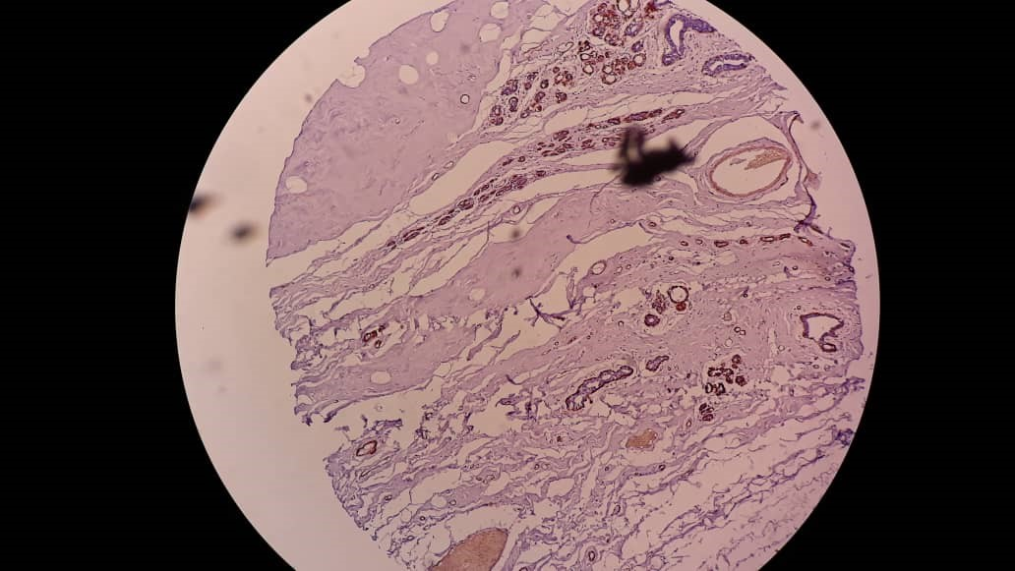

Plate (1): TNBC showing expression of Smooth Muscle Actin (40 x).
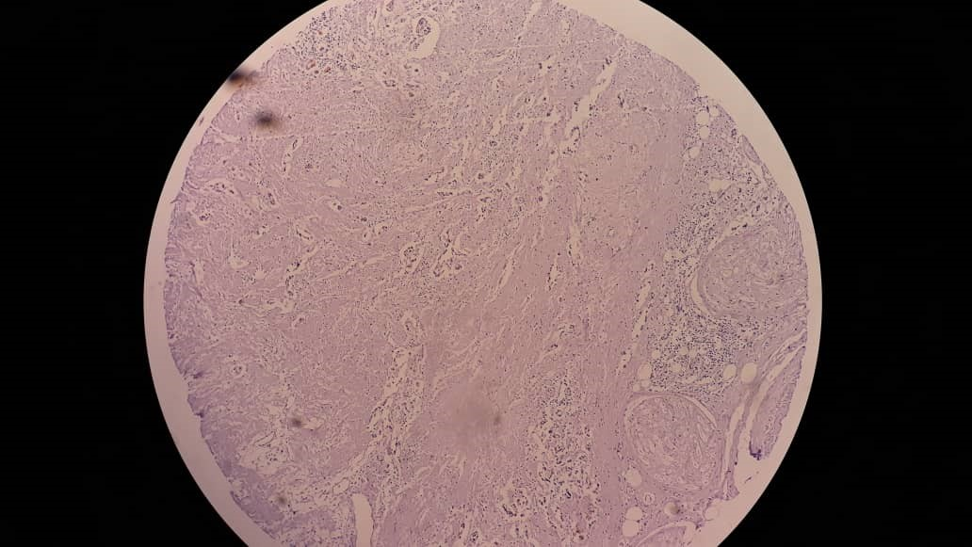

Plate (2): TNBC showing lack of expression of Smooth Muscle Actin (40 x).
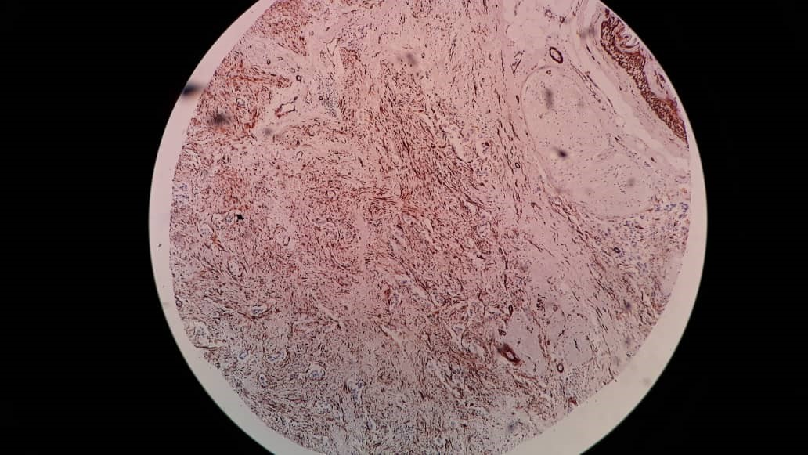

Plate (3): TNBC showing expression of Cytokeratin 5/6 (40 x).
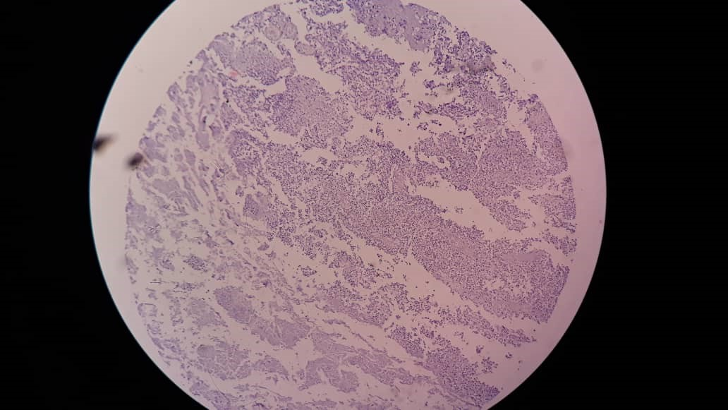

Plate (4): TNBC showing lack of expression of Cytokeratin 5/6 (40 x).
Discussion:
The present study involves thirty cases of high grade invasive ductal breast carcinoma with triple negative phenotype for immuohistochemical staining by cytokeratin 5/6 and smooth muscle actin.
Regarding the age of the population, the study revealed that the most of patients were less than 50 years. So, it proves that TNBCs are more common in younger patients which is compatible with , who reported that TNBCs are more frequently affects younger patients,
The positive expression of Cytokeratin 5/6 was in 83.3 % of TNBC, which reflect the basal-like phenotype among TNBC as Cytokeratin 5/6 has been employed as a marker of basal differentiation resulting in association with triple negative molecular subtype according to . And it also reflect that the basal-like subtype is more frequently than the non-basal-like among TNBCs.
The positive expression of Smooth Muscle Actin was in 20% of TNBC , which does not reflect any significance alone, but when correlated with the positive expression of Cytokeratin 5,6 it appears to have more value, we found that the lack of SMA among the positive CK 5,6 was 21/25 (84 %) which agreed with (17) who found that the lack of SMA in basal-like breast cancers could reflect the activation of mechanisms responsible for the development of squamous metaplasia that also deregulate control of CK expression,
Conclusion:
Breast carcinomas are classified as ER (luminal A and luminal B), HER2þ, or triple negative. The different types demonstrate different tumor biology, prognoses, and therapy responses based on their gene expression profiles. On the basis of this study, we conclude: the expression of CK 5/6 is more than SMA among TNBC, and also there is correlation between the expression of CK 5/6 and the lack of expression of SMA among TNBC.

Ethical considerations:
Hospital administration agreements were taken ethically for archive samples and patients data collection.
Consent
As per international standards or university standards, patient(s) written consent has been collected and preserved by the author(s).

Disclaimer (Artificial intelligence)
Option 1:
Author(s) hereby declare that NO generative AI technologies such as Large Language Models (ChatGPT, COPILOT, etc.) and text-to-image generators have been used during the writing or editing of this manuscript.
Option 2:
Author(s) hereby declare that generative AI technologies such as Large Language Models, etc. have been used during the writing or editing of manuscripts. This explanation will include the name, version, model, and source of the generative AI technology and as well as all input prompts provided to the generative AI technology
Details of the AI usage are given below:
1.
2.
3.

References
1-G.J. Morris GJ, Naidu S, Topham AK, Guiles F, Xu Y, McCue P, et al. Differences in breast carcinoma characteristics in newly diagnosed African-American and Caucasian patients: A single-institution compilation compared with the National Cancer Institute’s Surveillance, Epidemiology and End Results database, Cancer,110(4) (2007), 876-884.)
2-Pal SK et al. Triple negative breast cancer: unmet medical needs. Breast Cancer Res Treat. 2011;125(3):627–636.)
3-Foulkes WD, Smith IE, Reis-Filho JS. Triple-negative breast cancer. N Engl JMed.
2010;363(20):1938–1948.))
4-Sutton LM, Han JS, Molberg KH, et al. Intratumoral expression level ofepidermal growth factor receptor and cytokeratin 5/6 is significantly associatedwith nodal and distant metastases in patients with basal-like triple-negative breastcarcinoma. Am J Clin Pathol. 2010;134(5):782– 787.))
5- Emad Rakha, Jorge S. Resis-Filho , Basal-like breast carcinoma , From Expression Profiling to Routine Practice , Arch Pathol Lab Med. 2009;133:860-868
6-Nielsen TO, Hsu FD, Jensen K, et al. Immunohistochemical and clinical characterization of the basal-like subtype of invasive breast carcinoma. Clin Cancer Res 2004;10:5367–5374.)
7-Pillai et al., 2012; Rattan et al., 2012; Alshareeda et al., 2013].
8-Oakman C, Moretti E, Galardi F, et al. Adjuvant systemic treatment for individual patients with triple negative breast cancer. Breast. 2011;20(suppl 3):S135–S141.)
9-Perou CM, Sorlie T, Eisen MB, et al. Molecular portraits of human breast tumours. Nature2000;406:747–752. [PubMed: 10963602]])
10-Linzell, J.L. (1952). The silver staining of myoepithelial cells, particularly in the mammary gland, and their relation to the ejection of milk. J. Anat. 86, 49–57.}
11-Sorlie T, Perou C, Tibshirani R, et al. Gene expression patterns of breast carcinomasdistinguish tumorsubclasses with clinical implications. Proc Natl Acad Sci U S A 2001;98:10869–10874.[PubMed:11553815]])
12-Bertucci F, Finetti P, Cervera N, et al. How basal are triple-negative breast cancers? . Int
JCancer2008;123:236–240. [PubMed: 18398844])
13-Akhani S, Reis-Filho J, Fulford L, et al. Prediction of BRCA1 status in patients withbreast cancerusing estrogen receptor and basal phenotype. Clin Cancer Res 2005;11:5175–5180. [PubMed:16033833])
14-Lehmann BD, Bauer JA, Chen X, et al. Identification of human triple-negative breastcancer subtypes and preclinical models for selection of targetedtherapies. J Clin Invest. 2011;121(7):2750–2767)
15-Lim, E., Vaillant, F., Wu, D., Forrest, N.C., Pal, B., Hart, A.H., Asselin- Labat, M.L., Gyorki, D.E., Ward, T., Partanen, A., et al. (2009). Aberrant luminal progenitors as the candidate target population for basal tumor development in BRCA1 mutation carriers. Nat. Med. 15, 907–913.} 16-Livasy C, Karaca G, Nanda R, et al. Phenotypic evaluation of the basal-like subtype ofinvasive breastcarcinoma. Mod Pathol 2006;19:264–271. [PubMed: 16341146]]).
17-Gorski, J.J., James, C.R., Quinn, J.E., Stewart, G.E., Staunton, K.C.,Buckley, N.E., McDyer, F.A., Kennedy, R.D., Wilson, R.H., Mullan,P.B., et al. (2010). BRCA1 transcriptionally regulates genes associated with the basal-like phenotype in breast cancer. Breast Cancer Res. Treat. 122, 721–731.}
18-Chad A Livasy, Gamze Karaca, Rita Nanda, Maria S Tretiakova, Olufunmilayo Olopade, Dominic T Moore and Charles M Perou, Phenotypic evaluation of the basal-like subtype of invasive breast carcinoma, ModernPathology (2006) 19, 264–271.
19-David J Dabbs, Mamatha Chivukula, Gloria Carter and Rohit BhargavaDepartment of Pathology, Magee-Women’s Hospital of UPMC, Pittsburgh, PA, USA.Basal phenotype of ductal carcinoma in situ: recognition and immunohistologic profile, Modern Pathology (2006) 19, 1506–1511. doi:10.1038/modpathol.3800678; published online 25 August 2006 }
- Amanpreet Singh Rattan, Manisha Sharma, Arshdeep Kaur, Manas Madan and Karamjit Singh Gill. To study the expression of cytokeratin 5 and 6 in triple negative breast carcinoma: An imunohistochemical study. Int. J. Clinton. Diagn. Pathol. 2023;6(1):30-35. Doi: 10.33545/ pathol.2023.v6.i1a.508.
- Wang Z, Liu L, Li Y, Song Z, Jing Y, Fan Z and Zhang S (2021 ) Analysis of CK 5/6 and EGFR and its Effect on Prognosis of Triple Negative Breast Cancer. Front. Oncol.
10:575317. doi: 10.3389/fonc.2020.575317.
- Li Q, Li M, Zheng K, Tang S, Ma S. Expression pattern analysis and drug differential sensitivity of cancer-associated fibroblasts in triple- negative breast cancer. Transl Oncol.2021 Jan;14(1):100891. Doi:10.1016/j.tranon.2020.100891. EPUB 2020 Oct 14. PMID: 33069102; PMCID: PMC7563008.

