**A COMPARATIVE STUDY BETWEEN CONVENTIONAL SKIN SUTURES, STAPLES AND ADHESIVE SKIN GLUE FOR SURGICAL SKIN CLOSURE**

**ABSTRACT**

**Introduction:** The final appearance of a surgical scar significantly influences the perceived success of a procedure, making the choice of skin closure method important. This study compares sutures, staples, and tissue glue in terms of application time, post-operative pain, wound complications, cosmetic outcomes, and cost-effectiveness.

**Methods:** A two-year prospective randomized controlled trial was conducted on 90 patients undergoing elective surgeries at an Indian Medical College. Patients were assigned to receive either sutures, staples, or tissue glue for primary wound closure.

**Result:** Staples required the least application time (mean: 53.3 seconds), followed by glue (103.9 s) and sutures (294.9 s). Glue was associated with significantly lower post-operative pain (VAS scores declining from 63.1 at 12 hours to 4.7 at day 7), better cosmetic scores (mean: 5.8, 88.9, and 96.1 at day 7, 1 month, and 5 months), and shorter hospital stays (mean: 3.47 days), all with statistical significance.

**Conclusion:** While staples offer the fastest application, tissue glue provides superior pain control, cosmetic outcomes, and cost-effectiveness, making it a safe and efficient alternative for wound closure in elective surgeries.

**Keywords:** Modified hollander scale, Octyl-2-cyanoacrylate, Staplers, Sutures, Tissue glue, VAS, Wound closure.

**INTRODUCTION**

The final appearance of a surgical scar is often seen as a reflection of surgical quality. Therefore, the method of skin closure must be simple, time-efficient, cost-effective, and yield favorable cosmetic results. Although sutures and staples remain standard, tissue adhesives are increasingly being used in clinical practice due to their ease of application and reduced tissue trauma.

Surgical wound closure aims to approximate skin edges to promote rapid healing, minimize complications, and optimize aesthetic outcomes. Surgical site infections (SSI) are among the most common post-operative complications, occurring in 1–3% of cases, with risk factors including advanced age, diabetes, obesity, immunosuppression, prior radiotherapy, malnutrition, and wound contamination [1-3]. Wound dehiscence, hypertrophic scarring, and keloid formation further complicate healing and may prolong hospitalization and increase healthcare costs [4,5].

Sutures remain widely used due to their strength, biocompatibility, and versatility. However, they may impair blood flow and increase the risk of infection. Staples, typically made of stainless steel, provoke less tissue reaction and are faster to apply, with reported benefits including reduced wound width and better resistance to infection in contaminated wounds [6–13]. Yet, studies offer conflicting results, with some randomized trials showing no significant differences between sutures and staples, while others suggest increased wound-related complications with staples [14–17].

Given these uncertainties, further evaluation of closure methods is warranted across surgical contexts. Tissue adhesives represent a promising alternative, but data on their cost-effectiveness and clinical performance remain limited.

The primary aim of this study was to compare the clinical efficacy of three commonly used skin closure techniques—sutures, staples, and adhesive glue—in patients undergoing elective surgeries. The evaluation focused on several critical parameters, including the time efficiency of each method, the intensity of post-operative pain, and the incidence of wound-related complications. In addition, the study examined the cosmetic outcomes at various postoperative intervals, the overall cost-effectiveness of each technique (including duration of hospital stay), as well as the preferences of operating surgeons and satisfaction levels of patients. By assessing these multifaceted aspects, the study seeks to identify the most suitable and patient-friendly approach for optimal surgical wound closure.

**MATERIAL AND METHODS**

This prospective comparative study was conducted on 90 patients, with 30 patients allocated to each of the three groups. The sample size of 90 (30 per group) was determined based on a power analysis assuming a medium effect size (f = 0.30) for differences in VAS pain scores, with α = 0.05 and power (1–β) = 0.80. GPower software (v3.1) was used for this calculation. Patients were randomly assigned to the three groups using computer-generated random numbers and allocation concealment was ensured using envelopes.

All patients were admitted to the Department of General Surgery at Dr. M.K. Shah Medical College and Research Centre, located in Chandkheda, Ahmedabad, and the study was carried out from February 2023 to February 2025. Patients selected were in good overall health and undergoing one of the following elective procedures: open/laparoscopic inguinal hernioplasty, open/laparoscopic appendectomy, lipoma excision, laparoscopic cholecystectomy.

After performing subcutaneous approximation to eliminate dead space and align the wound edges, patients were randomly assigned to one of three groups. In Group A, the incisions were closed using skin adhesive (octyl-2-cyanoacrylate), which was applied with a ProPen device. A thin layer of adhesive was spread along the entire length of the wound, extending 5–10 mm beyond each edge. The adhesive was allowed to dry for 15–20 seconds before applying two additional layers. No further bandaging was applied.

In Group B, non-absorbable skin staples were used to close the incisions, applied in a single layer while the wound edges were held together using forceps.

In Group C, 3-0 non-absorbable nylon sutures (Ethilon) were employed to close the incisions in a vertical mattress technique.

Before surgery, a detailed patient history and comprehensive physical examination were conducted. Routine blood tests were performed, including a complete hemogram, bleeding time (BT), clotting time (CT), HIV test, HBsAg test, blood sugar, blood urea, and serum creatinine levels, with additional tests done as necessary. A uniform antibiotic regimen was followed for all patients, with a 1 gm dose of intravenous ceftriaxone administered at the time of anaesthesia induction.

For all three groups, the time required to close the incised wound using the designated method was recorded with a stopwatch and compared across the groups. Post-operative pain was assessed at 12, 24, and 48 hours, 72 hours, and on the 7th day using the Visual Analog Scale (VAS), where 0 indicated no pain and 100 represented the worst possible pain, as reported by the patients. Wound outcomes were evaluated on the 3rd, 5th, and 7th post-operative days (POD) using a standardized wound asepsis scoring system ranging from 0 to 10 (Table 1).

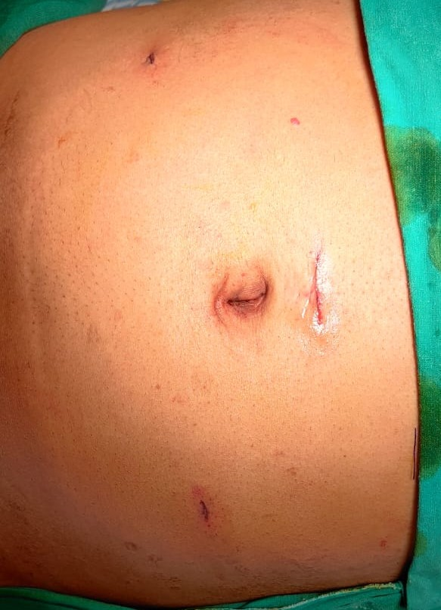

**Figure 1: Skin closure with glue in laparoscopic hernioplasty**

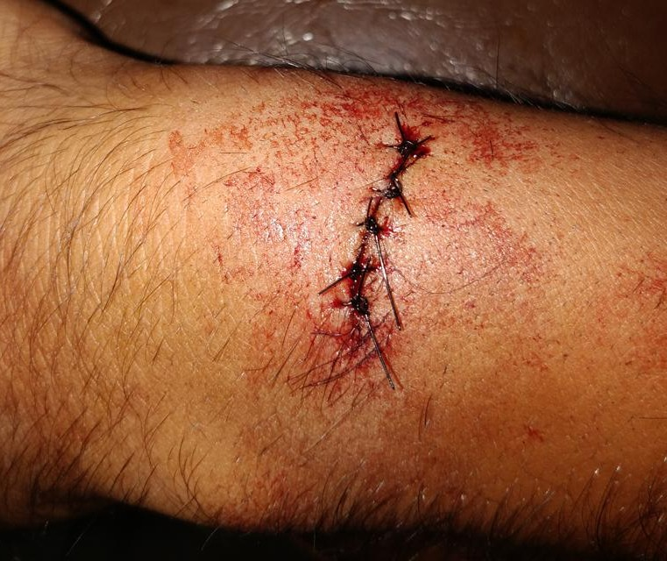

**Figure 2: Skin closure with sutures in lipoma excision**

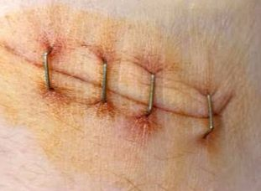

**Figure 3: Skin closure with stapler in laparoscopic cholecystectomy**

**Table 1: ASEPSIS score [18,19]**

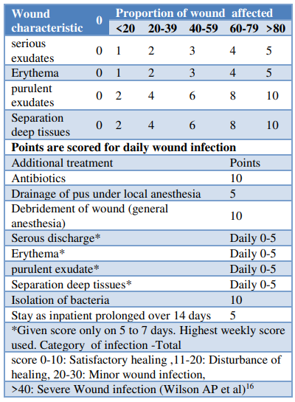

Wound cosmesis was assessed on the 7th post-operative day (POD) using the modified Hollander cosmesis scale, which ranges from 1 to 6. A score of 6 indicated optimal cosmesis, while a score of 5 or below was considered suboptimal. During follow-up visits at the 1st and 3rd months, wound cosmesis was re-evaluated by an independent, blinded observer using the Visual Analog Cosmesis Scale (VAS), where 0 represented the worst cosmetic outcome and 100 represented the best possible cosmesis. The following parameters were also assessed during evaluation:

* Step-off of the wound borders (0 for yes, 1 for no)
* Contour irregularities such as puckering (0 for yes, 1 for no)
* Wound margin separation (0 for yes, 1 for no)
* Wound edge inversion (0 for yes, 1 for no)
* Excessive wound distortion (0 for yes, 1 for no)
* Overall appearance (0 for poor, 1 for acceptable)

**Inclusion Criteria**

Patients undergoing clean, elective surgical procedures with skin closure performed using conventional suturing, staples, or adhesive skin glue, all following the same antibiotic protocol, between February 2023 and February 2025.

**Exclusion Criteria**

* Critical cases requiring damage control surgery.
* Cases where stomas are necessary.
* Patients unable to attend follow-up appointments on the 7th or 15th post-operative days.
* Wounds located on the face, bony prominences, or highly mobile areas that are unsuitable for stapler closure.
* Wounds located at mucocutaneous junctions (e.g., lips) or on friction-prone areas such as hands and feet, where adhesive glue would be inappropriate.
* Patients with a history of diabetes mellitus (DM), immunosuppression, malignancy, or a tendency for keloid or scar formation.

**Statistical Analysis**

Both descriptive and inferential statistical methods were employed for analysis in this study. Continuous data are presented as Mean ± SD (Min-Max), whereas categorical data are expressed as number (%). A significance level of 5% was used to determine statistical significance. The following assumptions were made regarding the data:

* The dependent variables should follow a normal distribution.
* The samples should be randomly drawn from the population, and the cases within the samples should be independent.

Analysis of Variance (ANOVA) was used to assess the significance of study parameters among three or more patient groups. To evaluate the significance of categorical data across two or more groups, the Chi-square or Fisher Exact test was applied. Non-parametric methods were employed for qualitative data analysis, with Fisher's exact test used when the sample size in cells was particularly small.

**P-Value Significance Levels:** +Suggestive significance (P value: 0.05 < P < 0.10); ++moderately significant (P value: 0.01 < P ≤ 0.05); +++strongly significant (P value: P ≤ 0.01)

The data analysis was conducted using SPSS version 18.0 and R version 3.2.2. Graphs, tables, and other visual representations were created using Microsoft Word and Excel.

All skin closures were performed by a single experienced surgeon assisted by the same operating team to eliminate inter-operator variability and maintain consistency across the groups.

**RESULTS**  
A total of 90 patients were enrolled in the study, with 30 patients randomly assigned to each group: suturing, stapling, and skin glue. The mean age of participants was 41.78 years, with 20% of patients falling within the 31–50-year age range. The mean age for the skin glue group was 41.10 years ± 19.85, for the skin staple group was 44.25 years ± 17.90, and for the suturing group was 39.00 years ± 18.30. The male population predominated, comprising 66 patients (73.3%) overall (Table 2). The demographic characteristics and surgical variables of the study population were comparable across all three groups. The mean age was 38.6 ± 12.4 years in the glue group, 40.2 ± 11.9 years in the staple group, and 39.8 ± 13.1 years in the suture group (p = 0.87, ANOVA), indicating no significant age-related difference.

Similarly, the mean incision length was 4.82 ± 1.14 cm in the glue group, 4.76 ± 1.21 cm in the staple group, and 4.91 ± 1.17 cm in the suture group (p = 0.93, ANOVA), confirming that incision length did not differ significantly among groups.

The study included patients who underwent four types of surgeries: laparoscopic appendectomy, lipoma excision, laparoscopic cholecystectomy, and hernioplasty. The authors ensured an equal distribution of patients across the groups for each surgery, in order to obtain unbiased outcomes and to compare variables consistently. The following graph demonstrates the even distribution of patients across the different surgical procedures performed in each group.

In this study, the lengths of the incisions varied from 1 to 4 cm. The time taken to close the wounds was measured in seconds using a stopwatch. The results revealed that 73.3% (22 patients) in the staple group completed the wound closure in under 60 seconds. In contrast, 96.7% (29 patients) in the glue group required 60-200 seconds. The suturing group, however, had the longest closure times, with more than 200 seconds needed for most cases.

The Visual Analogue Scale (VAS), calibrated from 0 to 100 (Table 3), was used to assess pain scores at 12, 24, 48, 72 hours, and on the 7th day post-operatively. The results showed that at 12 hours post-operatively, the pain score was lowest in the glue group (mean = 64.50). Similarly, at 24 hours post-operatively, the glue group again reported the least pain (mean = 43.60), and at 48 hours, the glue group continued to have the lowest pain score (mean = 17.50). 72 hours post operatively again glue scored the least among the three population.

This finding is statistically significant, with a p-value of <0.001, supporting that the use of glue results in the least amount of pain when compared to staples and sutures. Among the 90 patients, 12 experienced serous exudates at the wound site as a complication of the skin closure method. The incidence of erythema was lowest in the glue group, followed by the staples group, and then the sutures group. Purulent exudates were observed in all three groups.

The ASEPSIS score (Table 4), calculated using the parameters outlined in the methodology, indicated that a lower score represented better wound outcomes. The score was recorded on days 3, 5, and 7 post-operatively. The glue group demonstrated the lowest ASEPSIS scores on both days 3 and 5, with statistical significance observed on day 3 and suggestive significance on day 5. However, no statistical significance was found on day 7, although the glue group still had the best asepsis scores when compared across all groups.

Wounds in all three groups were evaluated for cosmesis on the 7th day using the Modified Hollander Cosmesis Scale (Table 5), and again at the 1st and 5th months using the Visual Analog Scale (VAS) for cosmesis. In terms of material costs, sutures were found to be the most cost-effective method among the three skin closure techniques. Cost-effectiveness was further assessed by comparing the total post-operative hospital stay. The results revealed that patients in the glue group had the shortest hospital stays, followed by those in the staples group, and finally the sutures group. The comparison between the groups showed a statistically significant difference with a p-value of 0.006, confirming significance.

**Table 2: Details of the surgeries performed**

|  |  |  |  |  |
| --- | --- | --- | --- | --- |
| **Variable** | **Glue** | **Staples** | **Sutures** | **Total** |
| Age (mean + SD) | 42.10 ± 19.85 | 44.25 ± 17.90 | 39.00 ± 18.30 | 41.78 ± 18.68 |
| Female | 9 (30%) | 7 (23.3%) | 8 (26.7%) | 24 (26.7%) |
| Male | 21 (70%) | 23 (76.7%) | 22 (73.3%) | 66 (73.3%) |
| Surgical procedure |  |  |  |  |
| Lap appendicectomy | 8 (26.7%) | 6 (20%) | 7 (23.3%) | 21 (23.3%) |
| Lap cholecystectomy | 4 (13.3%) | 4 (13.3%) | 4 (13.3%) | 12 (13.3%) |
| Lap hernioplasty | 14 (46.7%) | 16 (53.3%) | 15 (50%) | 45 (50%) |
| Lipoma excision | 4 (13.3%) | 4 (13.3%) | 4 (13.3%) | 12 (13.3%) |
| Incision length (cms) (mean +SD) | 6.60 ± 1.20 | 6.35 ± 1.40 | 6.50 ± 1.45 | 6.48 ± 1.35 |
| Time taken for wound closure (mean + SD) | 106.50 ± 16.00 | 55.10 ± 9.20 | 289.80 ± 45.00 | 150.47 ±107.20 |
| Complications |  |  |  |  |
| Serous exudate | 2 (6.7%) | 4 (13.3%) | 6 (20%) | 12 (13.3%) |
| Erythema | 1 (3.3%) | 3 (10%) | 11 (36.7%) | 15 (16.7%) |
| Purulent exudates | 0 (0%) | 1 (3.3%) | 2 (6.7%) | 3 (3.3%) |
| Wound gaping | 1 (3.3%) | 2 (6.7%) | 2 (6.7%) | 5 (5.6%) |
| Length of hospital stay | 3.40 ± 1.00 | 6.05 ± 4.30 | 6.75 ± 5.10 | 5.40 ± 4.13 |

**Table 3: Post-operative pain in three groups of patients**

|  |  |  |  |  |  |
| --- | --- | --- | --- | --- | --- |
| **Post-operative pain** | **Glue** | **Staples** | **Sutures** | **Total** | **P value** |
| 12 hrs | 64.50 ± 17.20 | 71.90 ± 13.70 | 80.40 ± 11.10 | 72.27 ± 15.33 | <0.001** |
| 24 hrs | 43.60 ± 11.90 | 47.30 ± 13.00 | 60.20 ± 11.50 | 50.37 ± 14.13 | <0.001* |
| 48 hrs | 17.50 ± 9.00 | 25.60 ± 8.40 | 34.70 ± 12.10 | 25.93 ± 12.34 | <0.001** |
| 72hrs | 7.90 ± 5.30 | 12.30 ± 7.80 | 17.60 ± 11.00 | 12.60 ± 9.37 | <0.001** |
| 7 days | 4.90 ± 5.20 | 9.10 ± 14.30 | 10.80 ± 14.50 | 8.27 ± 12.35 | 0.127 |

**Table 4: ASEPSIS score distribution in three groups of patients**

|  |  |  |  |  |  |
| --- | --- | --- | --- | --- | --- |
| **Asepsis score** | **Glue (n=30)** | **Staples (n=30)** | **Sutures (n=30)** | **Total (n=90)** | **P value** |
| Day 3 | | | | | |
| 0 | 25 (83.3%) | 22 (73.3%) | 17 (56.7%) | 64 (71.1%) | 0.021 |
| 1-10 | 5 (16.7%) | 8 (26.7%) | 13 (43.3%) | 26 (28.9%) |
| 11-20 | 0 (0%) | 0 (0%) | 0 (0%) | 0 (0%) |
| >20 | 0 (0%) | 0 (0%) | 0 (0%) | 0 (0%) |
| Mean ±SD | 0.63 ± 1.57 | 1.10 ± 2.15 | 1.60 ± 1.95 | 1.11 ± 1.93 |
| Day 5 | | | | | |
| 0 | 28 (93.3%) | 27 (90%) | 24 (80%) | 79 (87.8%) | 0.090 |
| 1-10 | 2 (6.7%) | 3 (10%) | 6 (20%) | 11 (12.2%) |
| 11-20 | 0 (0%) | 0 (0%) | 0 (0%) | 0 (0%) |
| >20 | 0 (0%) | 0 (0%) | 0 (0%) | 0 (0%) |
| Mean ±SD | 0.30 ± 1.50 | 0.67 ± 2.01 | 0.92 ± 1.65 | 0.63 ± 1.72 |
| Day 7 | | | | | |
| 0 | 29 (96.7%) | 28 (93.3%) | 27 (90%) | |  | | --- | | 84 (93.3%) | | 0.999 |
| 1-10 | 1 (3.3%) | 1 (3.3%) | 2 (6.7%) | 4 (4.4%) |
| 11-20 | 0 (0%) | 0 (0%) | 0 (0%) | 0 (0%) |
| >20 | 0 (0%) | 1 (3.3%) | 1 (3.3%) | 2 (2.2%) |
| Mean ±SD | 0.15 ± 0.75 | 0.95 ± 4.80 | 1.25 ± 5.70 | 0.78 ± 4.35 |
|  | | | | | |

**Table 5: Cosmesis Score distribution in three groups of patients**

|  |  |  |  |  |  |
| --- | --- | --- | --- | --- | --- |
| **Cosmesis** | **Glue (n=30)** | **Staples (n=30)** | **Sutures (n=30)** | **Total (n=90)** | **P value** |
| 7th day | | | | | |
| 0 | 0 (0%) | 1 (3.3%) | 2 (6.7%) | 3 (3.3%) | 0.762 |
| 1-3 | 0 (0%) | 0 (0%) | 0 (0%) | 0 (0%) |
| 4-6 | 30 (100%) | 29 (96.7%) | 28 (93.3%) | 87 (96.7%) |
| Mean ±SD | 5.80 ± 0.50 | 5.32 ± 1.12 | 5.10 ± 1.25 | 5.41 ± 1.04 |
| 1st month | | | | | |
| 0-20 | 0 (0%) | 0 (0%) | 0 (0%) | 0 (0%) | <0.001 |
| 21-40 | 0 (0%) | 1 (3.3%) | 0 (0%) | 1 (1.1%) |
| 41-60 | 0 (0%) | 2 (6.7%) | 4 (13.3%) | 6 (6.7%) |
| 61-80 | 2 (6.7%) | 13 (43.3%) | 17 (56.7%) | 32 (35.6%) |
| 81-100 | 28 (93.3%) | 14 (46.7%) | 9 (30%) | 51 (56.7%) |
| Mean ±SD | 88.67 ± 6.10 | 78.80 ± 13.50 | 71.30 ± 13.20 | 79.59 ± 13.20 |
| 5th month | | | | | |
| 0-20 | 0 (0%) | 0 (0%) | 0 (0%) | 0 (0%) | 0.061 |
| 1-40 | 0 (0%) | 0 (0%) | 0 (0%) | 0 (0%) |
| 41-60 | 0 (0%) | 1 (3.3%) | 3 (10%) | 4 (4.4%) |
| 61-80 | 0 (0%) | 2 (6.7%) | 4 (13.3%) | 6 (6.7%) |
| 81-100 | 30 (100%) | 27 (90%) | 23 (76.7%) | 80 (88.9%) |
| Mean ±SD | 96.03 ± 3.40 | 92.20 ± 8.85 | 88.67 ± 11.60 | |  | | --- | | 92.30 ± 9.00 | |

**DISCUSSION**

In the present study, three distinct methods of skin closure were evaluated: conventional suturing and two suture-less alternatives, namely skin staples and tissue adhesive (glue).

**Age**  
The majority of participants were in the 31–50 years age group. The mean age of patients in the glue group was 41.78 years, in the staples group was 44.25 years, and in the suturing group was 39.00 years. However, the influence of age in correlation with the type of surgical procedure and underlying disease was not analysed, which may pose a confounding factor in the assessment of wound healing outcomes.

**Gender**  
The study population had a predominance of male participants, accounting for 73.3%, while females made up 26.7% of the total sample.

**Incision Length**

The wounds closed in this study ranged from 0 to 4 cm in length, limiting the use of tissue adhesive to small sized incisions. This aligns with previously reported limitations of cyanoacrylate-based adhesives such as Dermabond, which are generally not suitable for closing long surgical wounds. Previous researchers have assessed these adhesives in specific contexts—for instance, Mota R et al. used tissue adhesives for episiotomy repair [20], while Elmasalme FN et al. and Sinha R et al. evaluated their effectiveness in eye surgical incisions [21,22]. Furthermore, Göktas et al. compared tissue adhesive and suturing for laceration repair in the emergency department and found both methods effective, with tissue adhesive offering advantages in ease of application and patient comfort [23]. Notably, none of these studies applied the adhesive to extensive skin wounds, emphasizing its limited utility in such scenarios.

**Time Taken for Skin Closure**

Ridgway et al. [24] reported that, in neck surgeries involving cervicotomy incisions, the meantime taken for closure with tissue adhesive was significantly greater than with skin staples, with a difference of approximately 67 seconds. Similarly, in a study on patients undergoing total hip or knee replacement, the average skin closure time using adhesive was 100 seconds, whereas staple closure took about 30 seconds [14]. However, Chibbaro et al. reported no statistically significant difference in closure time between adhesives and staples for neurosurgical scalp incisions [19].

In the present study, the duration of wound closure was significantly shorter in the staple group compared to the glue and sutures groups. This difference was statistically significant, underscoring the efficiency of staples in reducing operative time.

**Post-Operative Pain**

Post-operative pain levels were evaluated using the Visual Analogue Scale (VAS), as reported by the patients. Findings from the current study indicated that patients in the glue group experienced the least pain, followed by those in the staple group, and finally the suture group, across multiple postoperative intervals.

These findings are consistent with studies which showed that abdominal wounds closed with sutures were linked to higher post-operative pain levels [6,25]. Additionally, while Zempsky et al. and Jenkins et al. reported reduced pain with adhesive use, their studies did not achieve statistical significance [26,27]. In contrast, the present study revealed a statistically significant reduction in pain with glue closures, further supporting its potential advantages in pain management.

**Complications / ASEPSIS Score**

This study observed several wound-related complications across all groups, including serous discharge, purulent discharge, erythema, and wound dehiscence. Of these, only erythema showed statistically significant differences among the groups, with the glue group presenting the lowest incidence compared to staples and sutures.

Khan et al. and Chibbaro et al. previously reported no significant difference in serous fluid accumulation between closure methods [14,19]. However, cases involving skin staples were more prone to wound gaping than those closed with glue. Meta-analyses from four notable trials indicated that suture closure was associated with a significantly lower rate of wound dehiscence when compared to other methods, without heterogeneity among studies. Conversely, Blondeel et al. [28], in a series of 209 patients closed using octyl-2-cyanoacrylate, concluded that this newer formulation offers closure results comparable to standard methods, with a tendency toward reduced wound infections.

In alignment with these findings, the present study demonstrated a significantly lower ASEPSIS score in the glue group, suggesting a lower rate of wound infection. A strong statistical significance was evident on post-operative day 3, while day 5 showed suggestive significance.

**Wound Cosmesis**

The cosmetic outcomes of wounds were assessed in all three study groups on postoperative day 7, at 1 month, and at 3 months using both the Modified Hollander and VAS Cosmesis scales. While the mean cosmesis scores on day 7 slightly favoured the glue group, the difference was not statistically significant. By the 1-month follow-up, the score differences between groups widened noticeably, with glue showing superior cosmetic results, which was statistically significant. At 3 months, the scores among the groups narrowed slightly, with glue scoring 96.03, staples 92.20, and sutures 88.67, demonstrating a trend toward statistical significance.

Switzer et al.[32] reported similar findings. This aligns with the current study’s conclusion that glue yields better cosmetic outcomes than staples or sutures, supported by strong statistical evidence.

**Cost-Effectiveness**

Analysis of material costs revealed that conventional sutures were the most economical option for skin closure. However, when polyglactin sutures were used for subcuticular closure, the cost increased. In contrast, the glue group showed a significantly shorter hospital stay, contributing to better overall cost-efficiency, and this difference was statistically significant.

Shamiyeh et al. [30]evaluated cost-effectiveness and found that skin adhesives were significantly more economical than sutures, with a *p* value < 0.001, despite similar clinical outcomes between methods. Additionally, a study conducted in Texas, USA, compared cyanoacrylate glue to Monocryl/Vicryl sutures for laparoscopic wound closure and reported an average cost saving of $303 per patient in the adhesive group, attributed to reduced surgical time [31]. These findings are consistent with our study, which demonstrated that skin glue offers greater cost-effectiveness compared to staples or sutures, with robust statistical significance.

**Conclusion**

This prospective comparative study evaluating adhesive skin glue, staples, and sutures for wound closure suggests that skin glue offers several advantages. Patients in the glue group experienced reduced postoperative pain, fewer wound-related complications, shorter hospital stays, and better cosmetic outcomes. Although the application time for glue was longer compared to staples and it incurred slightly higher costs than sutures, the overall benefits of skin glue are considerable.

Moreover, due to its bacteriostatic properties and the absence of a need for removal postoperatively, adhesive skin glue appears to be a favourable option for achieving optimal wound closure.

**Ethical Approval:** Approved by the Institutional Ethics Committee.

Consent

As per international standards or university standards, patient(s) written consent has been collected and preserved by the author(s).

**Disclaimer (Artificial intelligence):** Author(s) hereby declare that NO generative AI technologies such as Large Language Models (ChatGPT, COPILOT, etc.) and text-to-image generators have been used during the writing or editing of this manuscript.

**REFERENCES**

1. Mastud K, Lamture Y, Nagtode T, Rewale V. A Comparative Study Between Conventional Sutures, Staples, and Adhesive Glue for Clean Elective Surgical Skin Closure. Cureus. 2022 Nov 7;14(11):e31196. doi: 10.7759/cureus.31196.
2. Ban KA, Minei JP, Laronga C, Harbrecht BG, Jensen EH, Fry DE, et al. American College of Surgeons and Surgical Infection Society: Surgical Site Infection Guidelines, 2016 Update. J Am Coll Surg. 2017 Jan;224(1):59-74. doi: 10.1016/j.jamcollsurg.2016.10.029.
3. Korol E, Johnston K, Waser N, Sifakis F, Jafri HS, Lo M, et al. A systematic review of risk factors associated with surgical site infections among surgical patients. PLoS One. 2013 Dec 18;8(12):e83743. doi: 10.1371/journal.pone.0083743.
4. de Lissovoy G, Fraeman K, Hutchins V, Murphy D, Song D, Vaughn BB. Surgical site infection: incidence and impact on hospital utilization and treatment costs. Am J Infect Control. 2009 Jun;37(5):387-397. doi: 10.1016/j.ajic.2008.12.010.
5. van Ramshorst GH, Nieuwenhuizen J, Hop WC, Arends P, Boom J, Jeekel J, Lange JF. Abdominal wound dehiscence in adults: development and validation of a risk model. World J Surg. 2010 Jan;34(1):20-7. doi: 10.1007/s00268-009-0277-y.
6. Dumville JC, Coulthard P, Worthington HV, Riley P, Patel N, Darcey J, Esposito M, van der Elst M, van Waes OJF. Tissue adhesives for closure of surgical incisions. Cochrane Database of Systematic Reviews 2014, Issue 11. Art. No.: CD004287. DOI: 10.1002/14651858.CD004287.pub4.
7. Ste-Marie-Lestage C, Adler S, St-Jean G, Carrière B, Vincent M, Trottier ED, et al. Complications following chin laceration reparation using tissue adhesive compared to suture in children. Injury. 2019 Apr;50(4):903-907. doi: 10.1016/j.injury.2019.03.047.
8. Walter CJ, Dumville JC, Sharp CA, Page T. Systematic review and meta-analysis of wound dressings in the prevention of surgical-site infections in surgical wounds healing by primary intention. Br J Surg. 2012 Sep;99(9):1185-94. doi: 10.1002/bjs.8812.
9. Omolabake BI, Ozoila KN. A comparison of postoperative wound infection rates after preoperative hair removal with razors versus clippers in a sub-urban setting. Int Surg J. 2020;7(11):3627–32. doi:10.18203/2349-2902.isj20204662.
10. Smith TO, Sexton D, Mann C, Donell S. Sutures versus staples for skin closure in orthopaedic surgery: meta-analysis. BMJ. 2010 Mar 16;340:c1199. doi: 10.1136/bmj.c1199.
11. Wille-Jørgensen P, Guenaga KF, Matos D, Castro AA. Pre-operative mechanical bowel cleansing or not? an updated meta-analysis. Colorectal Dis. 2005 Jul;7(4):304-10. doi: 10.1111/j.1463-1318.2005.00804.x.
12. Tandon S, Ensor ND, Pacilli M, Laird AJ, Bortagaray JI, Stunden RJ, Nataraja RM. Tissue adhesive, adhesive tape, and sutures for skin closure of paediatric surgical wounds: prospective randomized clinical trial. Br J Surg. 2022 Oct 14;109(11):1087-1095. doi: 10.1093/bjs/znac254.
13. Kanegaye JT, Vance CW, Chan L, Schonfeld N. Comparison of skin stapling devices and standard sutures for pediatric scalp lacerations: a randomized study of cost and time benefits. J Pediatr. 1997 May;130(5):808-13. doi: 10.1016/s0022-3476(97)80025-x.
14. Khan RJ, Fick D, Yao F, Tang K, Hurworth M, Nivbrant B, Wood D. A comparison of three methods of wound closure following arthroplasty: a prospective, randomised, controlled trial. J Bone Joint Surg Br. 2006 Feb;88(2):238-42. doi: 10.1302/0301-620X.88B2.16923.
15. Shetty AA, Kumar VS, Morgan-Hough C, Georgeu GA, James KD, Nicholl JE. Comparing wound complication rates following closure of hip wounds with metallic skin staples or subcuticular vicryl suture: a prospective randomised trial. J Orthop Surg (Hong Kong). 2004 Dec;12(2):191-3. doi: 10.1177/230949900401200210.
16. Raja BS, Choudhury AK, Paul S, Gowda AKS, Kalia RB. No Additional Benefits of Tissue Adhesives for Skin Closure in Total Joint Arthroplasty: A Systematic Review and Meta-Analysis of Randomized Controlled Trials. J Arthroplasty. 2022 Jan;37(1):186-202. doi: 10.1016/j.arth.2021.07.012.
17. Krishnan R, MacNeil SD, Malvankar-Mehta MSComparing sutures versus staples for skin closure after orthopaedic surgery: systematic review and meta-analysisBMJ Open 2016;6:e009257. doi: 10.1136/bmjopen-2015-009257
18. Soni A, Narula R, Kumar A, Parmar M, Sahore M, Chandel M. Comparing cyanoacrylate tissue adhesive and conventional subcuticular skin sutures for maxillofacial incisions--a prospective randomized trial considering closure time, wound morbidity, and cosmetic outcome. J Oral Maxillofac Surg. 2013 Dec;71(12):2152.e1-8. doi: 10.1016/j.joms.2013.08.029.
19. Chibbaro S, Tacconi L. Use of skin glue versus traditional wound closure methods in brain surgery: A prospective, randomized, controlled study. J Clin Neurosci. 2009 Apr;16(4):535-9. doi: 10.1016/j.jocn.2008.08.004.
20. Mota R, Costa F, Amaral A, Oliveira F, Santos CC, Ayres-De-Campos D. Skin adhesive versus subcuticular suture for perineal skin repair after episiotomy--a randomized controlled trial. Acta Obstet Gynecol Scand. 2009;88(6):660-6. doi: 10.1080/00016340902883133.
21. Elmasalme FN, Matbouli SA, Zuberi MS. Use of tissue adhesive in the closure of small incisions and lacerations. J Pediatr Surg. 1995 Jun;30(6):837-8. doi: 10.1016/0022-3468(95)90760-2.
22. Sinha R, Kumar C, Sharma N. Use of tissue adhesives in ophthalmology. Indian J Ophthalmol. 2009 Sep-Oct;57(5):409–13. doi: 10.4103/0301-4738.55059.
23. Göktas N, Karcioglu O, Coskun F, Karaduman S, Menderes A. Comparison of tissue adhesive and suturing in the repair of lacerations in the emergency department. Eur J Emerg Med. 2002 Jun;9(2):155-8. doi: 10.1097/00063110-200206000-00010.
24. Ridgway DM, Mahmood F, Moore L, Bramley D, Moore PJ. A blinded, randomised, controlled trial of stapled versus tissue glue closure of neck surgery incisions. Ann R Coll Surg Engl. 2007 Apr;89(3):242-6. doi: 10.1308/003588407X179062.
25. BB Ananda, Vikram J, BS Ramesh, Khan HM. A comparative study between conventional skin sutures, staples, and adhesive skin glue for surgical skin closure. Int Surg J. 2019;6(3):775–82. doi:10.18203/2349-2902.isj20190489.
26. Zempsky WT, Parrotti D, Grem C, Nichols J. Randomized controlled comparison of cosmetic outcomes of simple facial lacerations closed with Steri Strip Skin Closures or Dermabond tissue adhesive. Pediatr Emerg Care. 2004 Aug;20(8):519-24. doi: 10.1097/01.pec.0000136068.45198.ae.
27. Jenkins LE, Davis LS. Comprehensive Review of Tissue Adhesives. Dermatol Surg. 2018 Nov;44(11):1367-1372. doi: 10.1097/DSS.0000000000001576.
28. Blondeel PN, Murphy JW, Debrosse D, Nix JC 3rd, Puls LE, Theodore N, Coulthard P. Closure of long surgical incisions with a new formulation of 2-octylcyanoacrylate tissue adhesive versus commercially available methods. Am J Surg. 2004 Sep;188(3):307-13. doi: 10.1016/j.amjsurg.2004.04.006.
29. Switzer EF, Dinsmore RC, North JH Jr. Subcuticular closure versus Dermabond: a prospective randomized trial. Am Surg. 2003 May;69(5):434-6.
30. Shamiyeh A, Schrenk P, Stelzer T, Wayand WU. Prospective randomized blind controlled trial comparing sutures, tape, and octylcyanoacrylate tissue adhesive for skin closure after phlebectomy. Dermatol Surg. 2001 Oct;27(10):877-80. doi: 10.1046/j.1524-4725.2001.01111.x.
31. Jones CD, et al. Comparison of glues, sutures, and other commercially available methods of skin closure: a review of literature. Med Res Arch. 2017;5(7). Available from: https://esmed.org/MRA/mra/article/view/1419.