***Case report***

**Carpal Tunnel Syndrome: Compression By The Thenar Motor Branch-A Case Report**

**Abstract**

**Introduction**

Carpal tunnel syndrome is predominantly idiopathic, with secondary causes being rare and anatomical etiologies being exceptionally uncommon. Variations of the thenar motor branch are rare, and its origin from the ulnar border of the median nerve is exceedingly rare. In this report, we describe a novel entity: median nerve compression caused by an anatomical variant of the thenar motor branch. A literature review was conducted.

**Case Presentation**

A 47-year-old right-handed female tailor presented with bilateral severe carpal tunnel syndrome, confirmed by electromyography. Surgical exploration of the right hand via a mini-open approach revealed compression of the median nerve by an ulnar-sided thenar motor branch originating at the carpal tunnel level, directly compressing the affected nerve just after its passage. Following neurolysis, the patient experienced complete resolution of symptoms.

**Conclusion**

This case underscores the importance of recognizing anatomical variations of the median nerve during carpal tunnel surgery. This case highlights the need to consider anatomical variations of the median nerve during carpal tunnel surgery. Careful dissection and thorough exploration of the nerve within the carpal tunnel are crucial to avoiding iatrogenic injury.

**Introduction:**

Carpal tunnel syndrome is the most common entrapment neuropathy (1,2). With increasing industrialization and the rise in manual labor, median nerve compression has become more prevalent, 5-10% of the general population experiences carpal tunnel syndrome (CTS) (2,3). It primarily affects women in their forties (4). It is idiopathic in 90% of cases, while secondary causes are rare, with anatomical causes being even less frequent. After a literature review, we confirmed that a compression of the median nerve by the thenar motor branch (TMB) has never been reported in the literature.

**Case Presentation:**

We report the case of a 47-year-old right-handed female tailor with a medical history of depression, currently under treatment. For the past year, she has experienced bilateral paresthesia in the territory of the median nerve, with symptoms worsening at night and accompanied by episodes of object dropping. On clinical examination, in the right hand we found a positive pseudo-Tinel sign at the wrist, a negative Phalen test. Sensory and motor evaluation of the median nerve revealed S3+ and M5 using the medical research council classification (5), while the ulnar nerve was graded S4M5. Similar findings were noted in the left hand. Electromyography confirmed a severe bilateral CTS. The patient underwent median nerve neurolysis starting with the right via a mini-open approach. We proceeded with the sectioning of the superficial palmar aponeurosis and did not find a transverse carpal muscle. After the release of the anterior carpal ligament and the volar carpal structures, we observed that the TMB originates from the ulnar border of the median nerve, crosses it transversely, and then joins the thenar compartment (figure 2, B). As it passes through it compresses the nerve, with a neuroma upstream (figure 2, A) and a hyperemic and purplish nerve downstream (figure 2, C). Following neurolysis, the patient reported complete resolution of paresthesia from the first postoperative day.

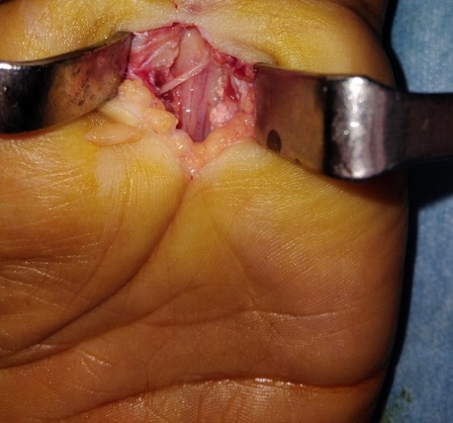

Figure 1: compression of the median nerve by an ulnarward thenar motor branch

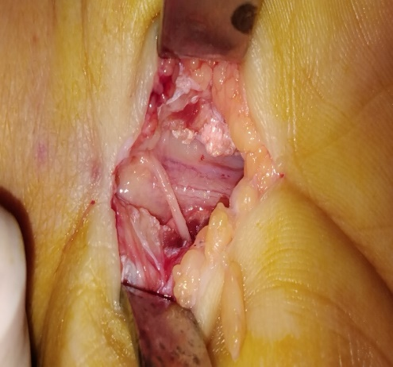

**C**

**B**

**A**

Figure 2: median nerve compression (A) neuroma (B) ulnar-sided MTB (C) hyperemic median nerve

**Discussion:**

The carpal tunnel is a fibro-osseous passage bordered by the carpal bones and the transverse carpal ligament. It contains the flexor tendons of the fingers along with the median nerve, which is typically positioned superficially. After exiting the tunnel, the median nerve gives rise to the recurrent motor branch, the radial collateral nerve of the thumb, the first, the second, and the third interdigital nerves. The CTS is a frequent affection, in most cases idiopathic. The secondary causes are rare. Among this we find anatomic variation (palmaris profoundus muscle (6,7), hypertrophy of lumbrical tendon (6). At the wrist level anatomical variations of the median nerve can occur. Lanz et al. (1977) (8) classified anatomical variations of the median nerve at the wrist into five groups. Group 0 represents the ordinary variation, where the thenar motor branch is extraligamentous. Group I includes variations in the course of the thenar motor branch: (1A) subligamentous, (1B) transligamentous, (1C) ulnarward (corresponding to our case), and (1D) supraligamentous. Group II describes accessory branches of the median nerve at the distal carpal tunnel. Group III refers to a high division of the median nerve, while Group IV includes accessory branches proximal to the carpal tunnel.

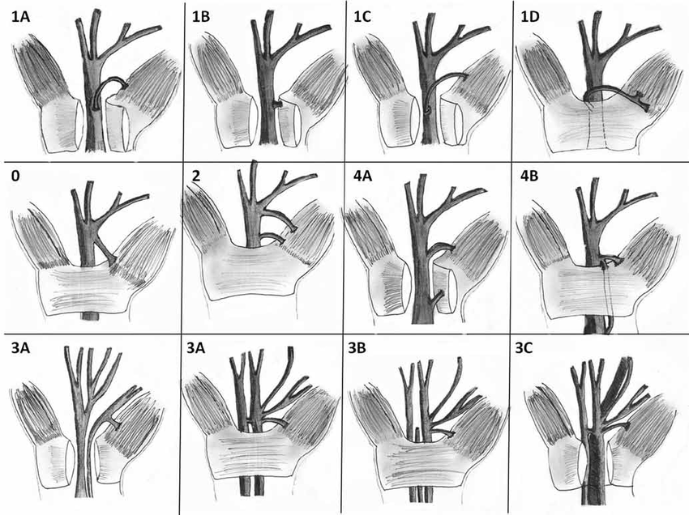

Figure 3 : Lanz classification of the anatomical variation of the median nerve at the wrist (9)

These anatomical variations are relatively uncommon in the literature. Henry et al. (2015) (10) conducted a meta-analysis on the prevalence of median nerve variations and reported pooled prevalence rates of 75.2% for the extraligamentous course, 13.5% for the subligamentous course, and 11.3% for the transligamentous course. The prevalence of Lanz Groups II, III, and IV was 4.6%, 2.6%, and 2.3%, respectively. Notably, an ulnar-sided branching of the TMB like in our case was found in only 2.1% of cases. Jegal et al. (11) studied 192 operated cases of carpal tunnel syndrome and identified a thenar motor branch originating from the ulnar-anterior side in five cases and exclusively from the ulnar side in one case. Tountas et al. (1987) (12) analyzed 821 cases during carpal tunnel surgery and 92 cadaveric dissections of the median nerve, reporting an overall prevalence of anatomical variations of 9.8% in surgical cases and 18% in cadaveric studies. However, no cases of an ulnar-sided TMB were observed, same for petrover et al. (2017) (13).

Moeller et al. (2024) (14) reported that the presence of the transverse carpal muscle makes the origin of the thenar motor branch (TMB) unpredictable, with a significantly higher likelihood of the branch arising from a more ulnar position on the median nerve than what is typically observed. In our case, there is no transverse carpal muscle.

Although several studies have described an ulnar-sided motor branch of the median nerve, we found no reported cases of carpal tunnel syndrome caused by direct compression of the median nerve by a Type 1C thenar branch.

Conclusion:

This case highlights a rare anatomical variation of the median nerve, causing the compression of the nerve. No previous reports have directly linked this variation to carpal tunnel syndrome. This finding underscores the importance of thorough anatomical awareness during carpal tunnel release, particularly in the context of percutaneous techniques, which are becoming increasingly common. This raises the question of whether routine preoperative ultrasound should be considered, especially since studies have demonstrated the effectiveness of high-frequency ultrasonography in detecting variations of the thenar motor branch (13,15).

Disclaimer (Artificial intelligence)

Option 1:

Author(s) hereby declare that NO generative AI technologies such as Large Language Models (ChatGPT, COPILOT, etc.) and text-to-image generators have been used during the writing or editing of this manuscript.

**References:**

1. Nakano KK. Nerve entrapment syndromes: Curr Opin Rheumatol. 1997 Mar;9(2):165–73.

2. Genova A, Dix O, Saefan A, Thakur M, Hassan A. Carpal Tunnel Syndrome: A Review of Literature. Cureus [Internet]. 2020 Mar 19 [cited 2025 Feb 23]; Available from: https://www.cureus.com/articles/29112-carpal-tunnel-syndrome-a-review-of-literature

3. Padua L, Coraci D, Erra C, Pazzaglia C, Paolasso I, Loreti C, et al. Carpal tunnel syndrome: clinical features, diagnosis, and management. Lancet Neurol. 2016 Nov 1;15(12):1273–84.

4. Bahri DM, Khiari H, Gmati A, Mizouni H, Meddeb N, Sahli H, et al. Le syndrome du canal carpien : A propos d’une série hospitalière Tunisienne. Tunis Med. 2011;90.

5. MRC-011221-AidsToTheExaminationOfThePeripheralNervousSystem.pdf [Internet]. [cited 2025 Feb 22]. Available from: https://www.ukri.org/wp-content/uploads/2021/12/MRC-011221-AidsToTheExaminationOfThePeripheralNervousSystem.pdf

6. Sbai MA, Arab RB, Essid L, Gallas A, Khelil K, Boussen M, et al. Carpal Tunnel Syndrome Caused by Anatomic Anomalies Muscles: A Three Cases Report.

7. Baba N, Bellila S, Sbei F, Sbai MA. Carpal Tunnel Syndrome Caused by Palmaris Profundus Sharing Common Sheath with Median Nerve. 6(1).

8. Lanz U. Anatomical variations of the median nerve in the carpal tunnel. J Hand Surg. 1977 Jan;2(1):44–53.

9. Demircay E, Civelek E, Cansever T, Kabatas S, Yilmaz C. Anatomic variations of the median nerve in the carpal tunnel: a brief review of the literature. Turk Neurosurg [Internet]. 2011 [cited 2025 Apr 11]; Available from: http://www.turkishneurosurgery.org.tr/summary_en_doi.php3?doi=10.5137/1019-5149.JTN.3073-10.1

10. Henry BM, Zwinczewska H, Roy J, Vikse J, Ramakrishnan PK, Walocha JA, et al. The Prevalence of Anatomical Variations of the Median Nerve in the Carpal Tunnel: A Systematic Review and Meta-Analysis. Cappello F, editor. PLOS ONE. 2015 Aug 25;10(8):e0136477.

11. Jegal M, Woo SJ, Lee HI, Shim JW, Shin WJ, Park MJ. Anatomical Relationships between Muscles Overlying Distal Transverse Carpal Ligament and Thenar Motor Branch of the Median Nerve. Clin Orthop Surg. 2018;10(1):89.

12. Tountas CP, Bihrle DM, MacDonald CJ, Bergman RA. Variations of the median nerve in the carpal canal. J Hand Surg. 1987 Sep;12(5):708–12.

13. Petrover D, Bellity J, Vigan M, Nizard R, Hakime A. Ultrasound imaging of the thenar motor branch of the median nerve: a cadaveric study. Eur Radiol. 2017 Nov 1;27(11):4883–8.

14. Moeller E, Krasnoff CC, Hathaway BA, Kamenko S, Burch S, Carboy J, et al. Predicting thenar motor branch anatomy for a safer carpal tunnel release. Clin Neurol Neurosurg. 2024 Nov;246:108606.

15. Riegler G, Pivec C, Platzgummer H, Lieba-Samal D, Brugger P, Jengojan S, et al. High-resolution ultrasound visualization of the recurrent motor branch of the median nerve: normal and first pathological findings. Eur Radiol. 2017 Jul;27(7):2941–9.