Case report

Acute cholecystitis in patient with situs inversus totalis : Two case reports

# Abstract

A rare disorder called situs inversus partialis (SIP) is characterized by the transposition of organs in the abdomen or thoracic cavity from one side of the body to the other (the mirror image of normal). Autosomal dominant, autosomal recessive, rare genetic mutations, and X-linked recessive inheritance patterns have been identified to be involved in this condition. Laparoscopic cholecystectomies have been successfully performed on patients with SIT. Due to challenges in spatial orientation and the identification of anatomical variations brought on by the abdominal organs' mirror image, surgery is more complicated and takes longer.

Laparoscopic cholecystectomy remains the gold standard treatment for acute cholecystitis, even in patients with SIT. However, the procedure is more technically demanding due to the altered anatomy, particularly for right-handed surgeons.

# We present two cases of acute cholecystitis with cholelithiasis in patients with situs inversus totalis (SIT). The first case involves a 30-year-old female patient who underwent an open cholecystectomy. The second case is of a 30-year-old male patient who recently underwent a laparoscopic cholecystectomy.

# Keywords

Situs inversus totalis, cholecystitis, laparoscopic cholecystectomy.

# Introduction

“Situs inversus totalis (SIT) is a rare autosomal recessive anomaly in which the thoracic and abdominal organs are transposed, creating a complete mirror-image reversal of normal anatomy. This condition was first described by Fabricius in 1600, with an estimated incidence of 1 in 10,000 to 1 in 20,000 live births”. [1,2,3]

“SIT is often associated with various congenital anomalies, including congenital heart disease, renal dysplasia, and biliary atresia. Additionally, Kartagener’s syndrome is a well-known triad of situs inversus totalis, bronchiectasis, and sinusitis”. [4,5]

“The diagnosis and management of symptomatic gallbladder stones in patients with SIT can be challenging. Radiological confirmation of SIT is achieved through chest X-ray, CT scan, and

ultrasonography. A chest X-ray typically reveals dextrocardia, while a CT scan provides a definitive

diagnosis, detailing the position of visceral organs, cardiac apex orientation, and the arrangement of great vessels. Ultrasound, CT, and MRI are essential for accurately assessing the anatomical variations before surgical intervention to prevent potential complications”. [1,2,4]

“Surgical management in SIT patients presents technical and ergonomic challenges, particularly for right-handed surgeons. The dissection of Calot’s triangle and proper orientation within the left upper quadrant require careful adaptation of technique. Despite these challenges, laparoscopic

cholecystectomy remains a feasible and preferred approach, provided it is performed by an experienced laparoscopic surgeon”. [4,5,7]

# Case Presentation

A 30-year-old female patient was admitted to our center on March 13, 2001, with complaints of pain in the left upper quadrant and epigastric region, followed by vomiting. She had a history of three similar episodes in the past.

On general examination, the patient appeared stable, with no jaundice or fever. Abdominal

examination revealed tenderness in the left hypochondrium, while the rest of the abdomen was normal. Cardiovascular examination detected heart sounds on the right side of the chest. A chest X-ray confirmed dextrocardia. Routine blood investigations, including liver and kidney function tests, were within normal limits.

Ultrasonography (USG) of the abdomen revealed: A large, thick-walled gallbladder containing multiple large calculi with posterior acoustic shadowing. No intrahepatic biliary dilation. A normal common bile duct (CBD) in both size and diameter. The spleen was located on the right side, confirming situs inversus totalis (SIT).

A CT abdomen was not performed due to the patient's poor condition. The final diagnosis of situs inversus totalis with cholelithiasis was confirmed through chest X-ray (showing dextrocardia) and

ultrasonography.

Surgical Management. The patient underwent open cholecystectomy under general anesthesia. The surgeon stood on the left side of the patient, and a left subcostal incision was made. Upon entering the peritoneal cavity: The gallbladder was overdistended and thick-walled. Calot’s triangle was identified.

The cystic artery and cystic duct were separately ligated and divided. The gallbladder was removed from its fossa. Additionally, an appendectomy was performed in the same setting. The abdomen was closed in layers, and a drain was placed.

Gross examination of the gallbladder: Size: 10 × 5 cm, Wall: Thickened Lumen: Contained multiple

large, yellowish-colored stones. Postoperative Course. The open cholecystectomy was uneventful. The drain was removed on the 3rd postoperative day. The patient had a smooth recovery and was discharged on the 8th postoperative day**. (Fig 1-7)**

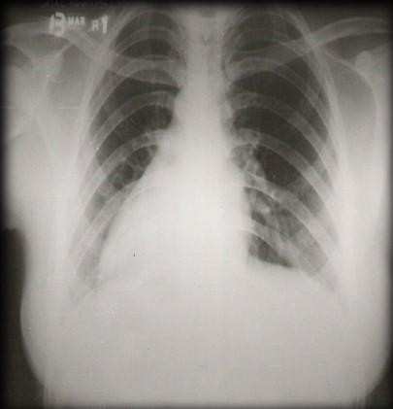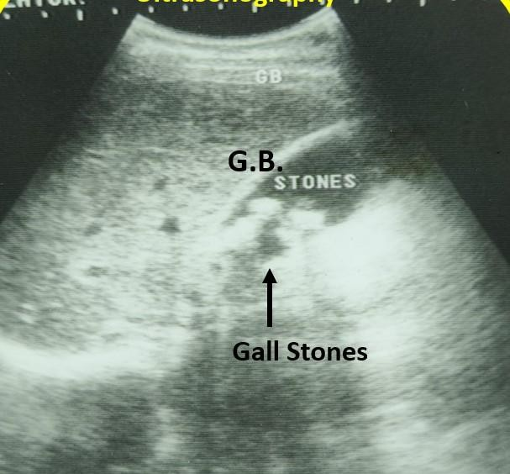

**Fig-1 X-ray chest showing dextrocardia**

**Fig-2 Ultrasonography abdomen showing multiple gall stones**

**with thick-walled gall bladder at left upper abdomen**

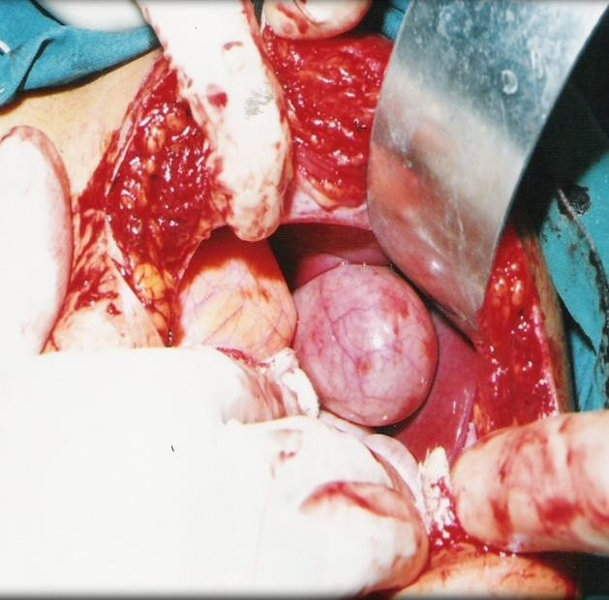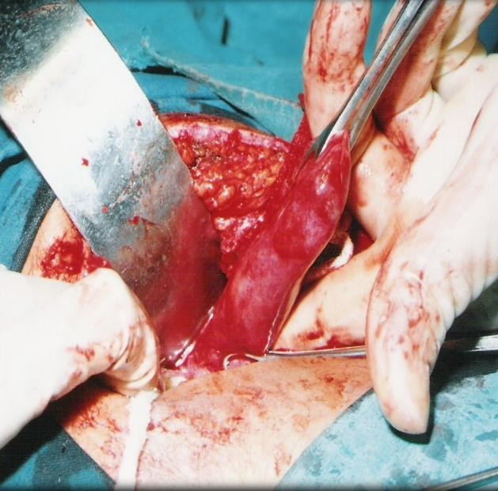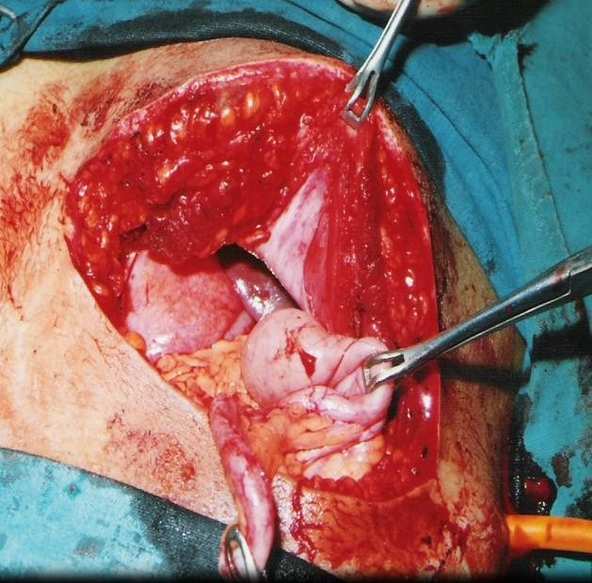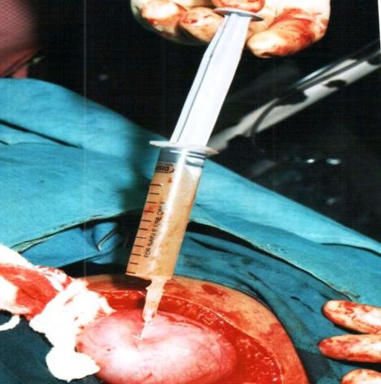

**Fig-3 Intraoperative photograph showing distended**

**and inflamed gallbladder at left upper abdomen**

**Fig-4 Intraoperative photograph showing aspiration of**

**distended gall bladder**

**Fig-5 Intraoperative photograph showing dissection of Fig-6 intraoperative photograph showing left sided**

**gall bladder appendix**

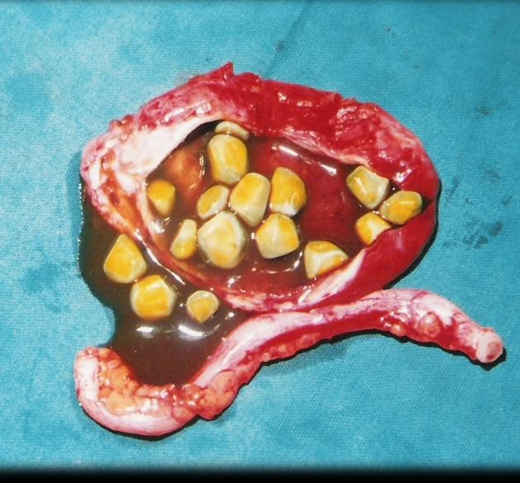

**Fig-7 Gross specimen showing multiple yellow colored gall stones with thick wall gallbladder with appendectomy**

# Case II – Laparoscopic cholecystectomy

A 30-year-old male patient was admitted to our center on October 15, 2021, with complaints of

epigastric and left upper quadrant pain, accompanied by vomiting for the past two days. He had a history of similar episodes over the last two years.

On clinical examination, the patient had tenderness in the left upper quadrant of the abdomen, with no signs of jaundice. Investigations, Blood tests: Total blood count: 15,500/mm³ (elevated), Polymorphs: 80%, Liver and kidney function tests normal

Radiological findings: Chest X-ray: Dextrocardia. Abdominal ultrasonography: Acutely inflamed, tense

gallbladder in the left upper quadrant, with the spleen located on the right side. CT abdomen: Confirmed situs inversus totalis (SIT), with an inflamed gallbladder in the left upper quadrant, while the CBD and hepatobiliary system appeared normal. A final diagnosis of acute cholecystitis with dextrocardia was established.

Surgical Management: A laparoscopic cholecystectomy was planned, and the operating room setup was arranged as a mirror image of the standard configuration. The monitor was placed on the left side of the patient. The surgeon and camera assistant stood on the right side, while the first assistant stood on

the left side. The abdomen was scrubbed and draped using standard aseptic technique.

Port Placement: A 10 mm infraumbilical port was introduced using a Veress needle, and pneumoperitoneum was maintained at 14 mmHg. Two 5 mm ports were placed: One at the

xiphisternum. One at the left anterior axillary line, 5 cm from the costal margin, used for gallbladder fundus retraction by the second assistant. A 10 mm working port was placed at the left midclavicular line, 2 cm below the costal margin, serving as the primary working port for the surgeon’s right hand.

Intraoperative Findings & Procedure: Laparoscopic inspection of the abdominal cavity confirmed situs inversus totalis, with the liver and gallbladder on the left side and the spleen on the right side. Calot’s triangle was identified. The gallbladder was distended and acutely inflamed, resembling a mucocele.

Aspiration of the gallbladder was performed using a Veress needle, revealing mucous-like fluid, which was completely drained to decompress the gallbladder. The peritoneum overlying the gallbladder fundus was incised, exposing the cystic duct and cystic artery. The cystic artery was managed using harmonic

energy, while the cystic duct was clipped and divided. Gallbladder dissection was performed using the surgeon’s right hand, while manipulation was done with the left hand through the epigastric port. The gallbladder was retrieved through the umbilical port.

Postoperative Course: The total operative duration was 80 minutes, which was longer than a conventional laparoscopic cholecystectomy. The patient had an uneventful recovery and was discharged on the 5th postoperative day. Histopathological examination confirmed chronic cholecystitis with mucocele. No postoperative complications were noted. **(Fig 8-17)**

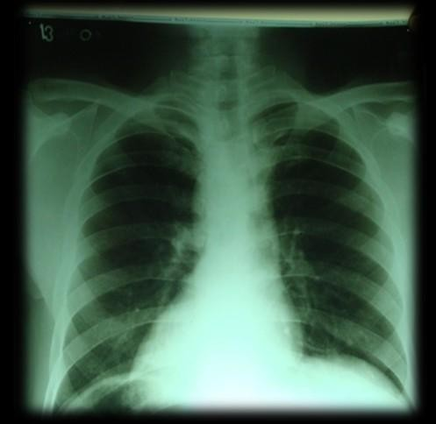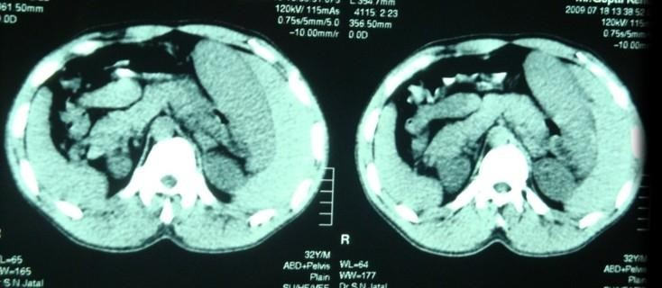

**Fig-8 X-ray chest showing dextrocardia Fig-9 CT abdomen showing dextrocardia with left side acute,**

**inflamed, distended gallbladder in left upper quadrant (SIT)**

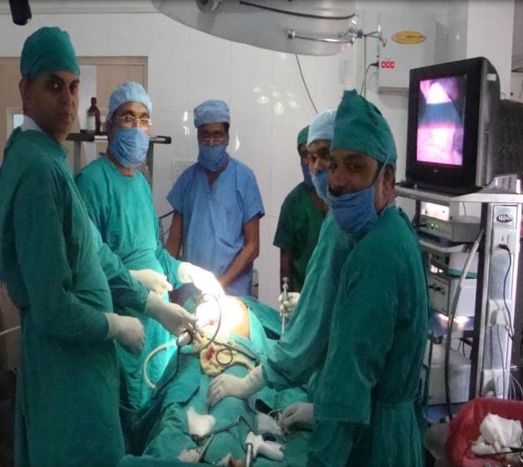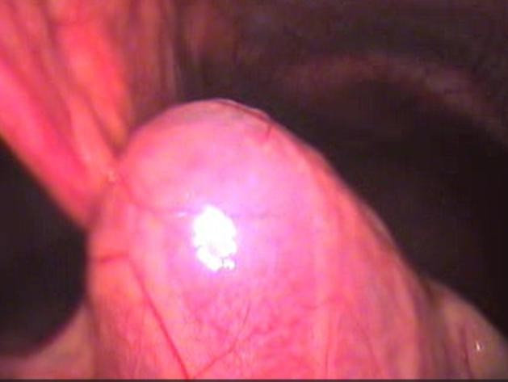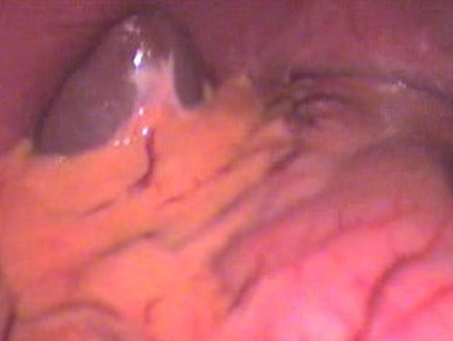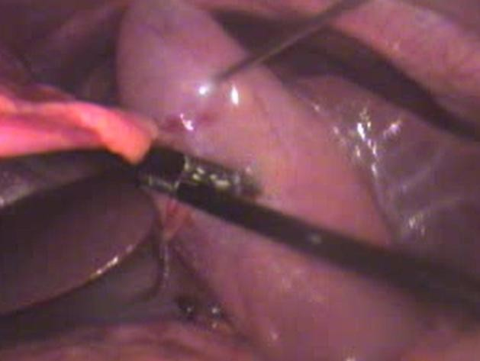

**Fig-10 The operating room setup was arranged as a**

**mirror image of the standard configuration (SIT)**

**Fig-11 Laparoscopic photograph showing left**

**acute inflamed distended gall bladder**

**Fig-12Laparoscopic photograph showing the spleen**

**was located on the right side, confirming (SIT)**

**Fig-13 Laparoscopic photograph showing**

**mucocele. Aspiration of the gallbladder**

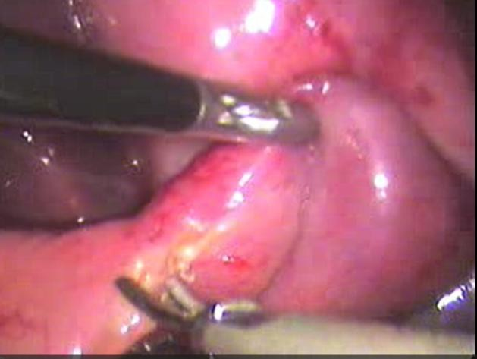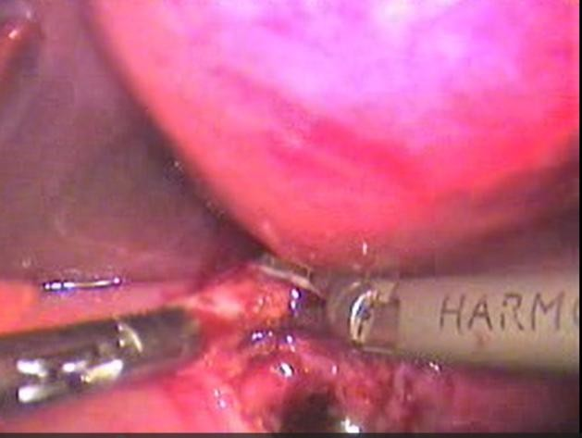

**Fig-14 Laparoscopic photograph showing dissection**

**of calot’s tringle**

**Fig-15 Laparoscopic photograph showing the cystic artery was managed using harmonic**

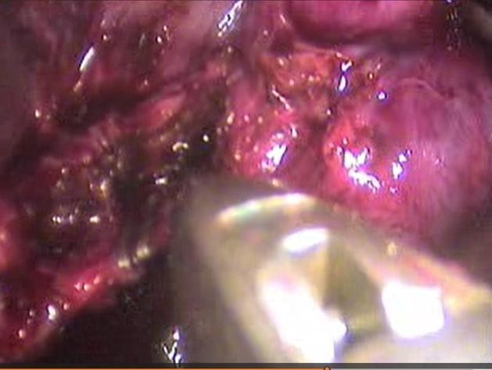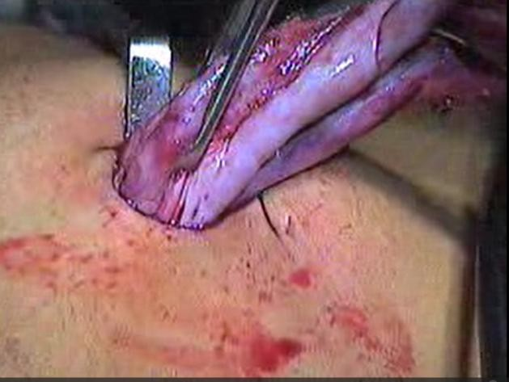

**Fig-16 Laparoscopic photograph showing clipping of cystic duct Fig-17 Laparoscopic photograph showing extraction of gall**

**bladder through umbilical port**

# Discussion

“Situs inversus totalis (SIT) is a rare autosomal recessive congenital anomaly characterized by the complete transposition of thoracic and abdominal organs, resulting in a mirror-image arrangement of normal anatomy. SIT can be associated with various congenital syndromes, including: Kartagener’s syndrome, which consists of situs inversus totalis, sinusitis, and bronchiectasis. Yoshikawa’s syndrome, characterized by situs inversus totalis, bilateral renal dysplasia, pancreatic fibrosis, and meconium ileus”. [1,2,5]

“Before the advent of laparoscopic surgery, open cholecystectomy was the standard treatment for cholelithiasis, including in patients with SIT. Approximately 40 cases of open cholecystectomy in SIT patients have been reported in the literature. Our one case open cholecystectomy was performed in 2001 and total 41 cases of open cholecystectomy”. [5,6,7,9]

“In 1991, Campos and Sipes performed the first successful laparoscopic cholecystectomy in a patient with SIT. Since then, 91 cases have been documented in medical literature. Our one case Laparoscopic cholecystectomy was performed in 2021 and total 92 cases of open cholecystectomy”. [7,8,9]

# Challenges of Laparoscopic Cholecystectomy in SIT

“Laparoscopic cholecystectomy is now the gold standard for gallstone disease due to its numerous advantages, including: Minimal incisions. Reduced postoperative pain. Faster recovery and early return to work. Improved cosmetic outcomes”. [5,6,9,10]

“However, in patients with situs inversus totalis, laparoscopic cholecystectomy presents unique technical challenges, particularly for right-handed surgeons, due to the mirror-image anatomy. These challenges include: Altered orientation of anatomical structures, making dissection more complex.

increased risk of iatrogenic injuries due to difficulty in visualizing and identifying key structures.” [1,2,5,9]

# Surgical Considerations

* Careful and well-defined dissection of Calot’s triangle is essential to ensure the safe identification and division of the cystic duct and cystic artery.
* A 10 mm port was placed at the midclavicular line instead of the standard 5 mm port, allowing easier clip application with the right hand.
* The common bile duct (CBD), which is normally found on the left side of Calot’s triangle in a

typical anatomy, is instead located on the right side in SIT patients—this must be constantly kept in mind during dissection.

* Right-handed surgeons may find the dissection more difficult, while left-handed surgeons may have an easier time adapting to the reversed orientation.
* Conversion to open surgery should be considered if there is any doubt about the anatomy. [9,10,12]

# Conclusion

Situs inversus totalis (SIT) is a rare autosomal recessive congenital anomaly in which the thoracic and abdominal organs are transposed, creating a mirror-image of normal human anatomy. Performing a laparoscopic cholecystectomy in patients with SIT presents unique challenges, requiring: Careful preoperative planning, Skilled surgical technique, Adaptation to reversed anatomy and Effective team coordination.

Despite these challenges, laparoscopic cholecystectomy remains the gold standard procedure for acute cholecystitis, even in patients with SIT. Though slightly more time-consuming, it can be performed safely and effectively by an experienced laparoscopic surgeon.

**Ethical Approval:**

As per international standards or university standards written ethical approval has been collected and preserved by the author(s).

**Consent**

As per international standards or university standards, patient(s) written consent has been collected and preserved by the author(s).

Disclaimer (Artificial intelligence)

Option 1:

Author(s) hereby declare that NO generative AI technologies such as Large Language Models (ChatGPT, COPILOT, etc.) and text-to-image generators have been used during the writing or editing of this manuscript.

Option 2:

Author(s) hereby declare that generative AI technologies such as Large Language Models, etc. have been used during the writing or editing of manuscripts. This explanation will include the name, version, model, and source of the generative AI technology and as well as all input prompts provided to the generative AI technology

Details of the AI usage are given below:

1.

2.

3.

# References

1. Herrera Ortiz AF, Lacouture JC, Sandoval Medina D, Gómez Meléndez LJ, Uscategui R. Acute Cholecystitis in a Patient With Situs Inversus Totalis: An Unexpected Finding. Cureus. 2021 Jun 21;13(6):e15799. doi: 10.7759/cureus.15799. PMID: 34306867; PMCID: PMC8294112.
2. Ashwanth Reddy, Surendran Paramasivam, Naveen Alexander, Management of a patient with situs inversus totalis with acute cholecystitis and common bile duct stones: A case report, International Journal of Surgery Case Reports, Volume 5, Issue 11, 2014,Pages 821-823,

<https://doi.org/10.1016/j.ijscr.2014.08.0>

1. Althunayan S A, AlRubaysh N S, Alshaban J A, et al. (May 12, 2024) Acute Cholecystitis in a Patient With Situs Inversus. Cureus 16(5): e60172. doi:10.7759/cureus.60172
2. Anam Sayed Mushir Ali1, LAPAROSCOPIC TURNED TO OPEN CHOLECYSTECTOMY IN SITUS INVERSUS

TOTALIS : A CASE REPORT, International Journal of Academic Medicine and Pharmacy [(www.academicmed.org)](http://www.academicmed.org/) ISSN (O): 2687-5365; ISSN (P): 2753-6556

1. Salama IA, Abdullah MH, Houseni M, Laparoscopic cholecystectomy in situs inversus totalis: Feasibility and review of literature.. Int J Surg Case Rep. 2013;4:711–715. doi:

10.1016/j.ijscr.2013.02.030. [[DOI](https://doi.org/10.1016/j.ijscr.2013.02.030)] [[PMC free article](https://pmc.ncbi.nlm.nih.gov/articles/PMC3710908/)] [[PubMed](https://pubmed.ncbi.nlm.nih.gov/23810920/)] [[Google Scholar](https://scholar.google.com/scholar_lookup?journal=Int%20J%20Surg%20Case%20Rep&title=Laparoscopic%20cholecystectomy%20in%20situs%20inversus%20totalis%3A%20Feasibility%20and%20review%20of%20literature&volume=4&publication_year=2013&pages=711-715&pmid=23810920&doi=10.1016/j.ijscr.2013.02.030)]

1. Omar AlKhlaiwy, Ahmed Mohammed AlMuhsin, Eman Zakarneh, Mohamed Yassin Taha,

Laparoscopic cholecystectomy in situs inversus totalis: Case report with review of techniques, International Journal of Surgery Case Reports, <https://doi.org/10.1016/j.ijscr.2019.05.050>.

1. Baxi, K., Jha, N., Khurana, V., Neeli, D., & Dogra, L. (2023). Laparoscopic cholecystectomy in situs inversus with partially intrahepatic gallbladder: a case report. International Surgery Journal, 10(11), 1854–1858. <https://doi.org/10.18203/2349-2902.isj20233357>
2. He T, Zou J, Song H, Yi B, Sun K, Yang J, Lei T, Xu L and Li G (2022) Laparoscopic Cholecystectomy in a Patient With Situs Inversus Totalis Presenting With Cholelithiasis: A Case Report. Front. Surg. 9:874494. doi: 10.3389/fsurg.2022.874494
3. Goyal, Sunder; Garg, Aditya; Singla, V. K.1. Laparoscopic cholecystectomy in situs inversus totalis: Two case reports with review of literature. Archives of Medicine and Health Sciences 3(2):p 272-278, Jul–Dec 2015. | DOI: 10.4103/2321-4848.171921
4. Meza-Martinez D A, Palomino-Payan J A, Andrade-Ordoñez S J, et al. (October 02, 2023) Overcoming Anatomical Challenges: Laparoscopic Cholecystectomy in Situs Inversus Totalis. Cureus 15(10):

e46371. doi:10.7759/cureus.46371

1. Sardar H Arif, Laparoscopic Cholecystectomy in Situs Inversus Totalis World Journal of Laparoscopic Surgery, May-August 2010;3(2):63-65
2. Lakhey, P., Shrestha, M., Sharma, R. and Lakhey, P.J. (2025), Laparoscopic Cholecystectomy in Situs Inversus Totalis: A Case Report. Clin Case Rep, 13: e70222. <https://doi.org/10.1002/ccr3.70222>