ABSTRACT:

Idiopathic scrotal calcinosis is a rare benign condition with an unknown pathology and unclear etiology. Patients with this condition typically presented with multiple, irregular, hard, painless nodules. Treatment of this condition involves single-stage excision.

There are only 85 publications on this condition. Because of its rarity, we report here with the case of 42 years old male who presenting with multiple, irregular, hard, painless nodules over the scrotum for three years. The diagnosis was based on a clinical examination. Single-stage excision of the nodules was performed with scrotoplasty and confirmed by histopathology. Excision and scrotoplasty gives an excellent cosmetic results and enhancement of sexual quality of life. There was no recurrence reported during 6 months follow ups.

*Keywords: Idiopathic scrotal calcinosis; Calcinosis Cutis; Surgical excision*

INTRODUCTION:

Idiopathic scrotal calcinosis is a rare benign condition characterized by the development of multiple large calcified nodules in the scrotum. These nodules are painless and vary in size. The exact cause of scrotal calcinosis is not known, but may be related to underlying systemic metabolic conditions, such as scleroderma and dermatomyositis, or could be a result of dystrophic calcification of the epidermal cyst. Lewinsky first describe the condition in 1883. They are usually present in the third to fourth decades of life and may present silently for several years before seeking treatment. Patients may visit the hospital for cosmetic reasons. Some cases may present with pruritus or soreness and white chalky exudate discharge, and may also be affected by infection [1,7].

Differential diagnosis may include epidermal inclusion cysts, lipomas, angiokeratomas, solitary neurofibromas, genital leiomyomas, scleroderma, and steatocystoma. Particularly in patients with CREST syndrome (calcinosis cutis, Renaud’s phenomenon, esophageal dysfunction, sclerodactyly, telangiectasia), dermatomyositis, pilomatrixoma, and scabies in nodular variant [1]. Epidermal inclusion cysts with non-tender, firm, skin-colored nodules resembled idiopathic scrotal calcinosis. Some authors have suggested that it may develop into idiopathic scrotal calcinosis []. Steatocystomas are skin-coloured nodules 1-3 cm in diameter and fordyce angiokeratomas are 2-5 cm in diameter with darker pink-purple-colored papules with surrounding erythema, in contrast to idiopathic scrotal calcinosis. Solitary genital leiomyomas are deeper than idiopathic scrotal calcinosis. CREST is included in the differential diagnosis because calcinosis cutis is seen in 20-40% of cases [**1**].

The diagnosis of idiopathic scrotal calcinosis is based on excisional biopsy. The gold standard treatment for this condition is surgical excision of nodules and primary wound closure. Occasionally, en-block excision and successful reconstruction of the scrotal skin (multiple flap transfers) are performed.

 Histopathology confirms the diagnosis, characterized by calcified deposits of varying sizes in the dermis, surrounded by histocytes and inflammatory giant cell reactions.

CASE REPORT:

A 42-year-old male, presented to the outpatient department (OPD) with multiple painless scrotal swellings, which had gradually increased in number and size over the last three years. Physical examination revealed multiple hard, painless subcutaneous nodules ranging from 2 to 10 mm in diameter. There was no itching or skin discoloration over the nodules; however, multiple whitish skin discoloration over the nodules was noted. There had no history of scrotal infection, trauma, or metabolic disease. All other blood parameters, including thyroid hormone, serum Na+, K+, Alkaline phosphate levels, were normal.

A diagnosis of idiopathic scrotal calcinosis was made, and a single-stage excision with scrotoplasty was planned. This procedure consists of thorough dissection between dermis and dartos muscle layer followed by scrotoplasty using single interrupted suture under spinal anaesthesia.

Histological specimen tissue measuring 13x8x8 cm. The outer surface appeared nodular, with white nodules. The cut section shows multiple spaces filled with chalky white material. The tissue appeared gritty during cutting. Microscopic examination revealed scrotal tissue lined with squamous epithelium. The underlying dermis appears fibrocollagenous and contains multiple large areas of granules and globules of basophilic calcified material. No evidence of atypia, malignancy or granuloma.

Histopathological examination confirmed the diagnosis of idiopathic scrotal calcinosis. The patient recovered uneventfully and was discharged home. No recurrence was reported at the follow-up visits, and the patient was doing well after six months.

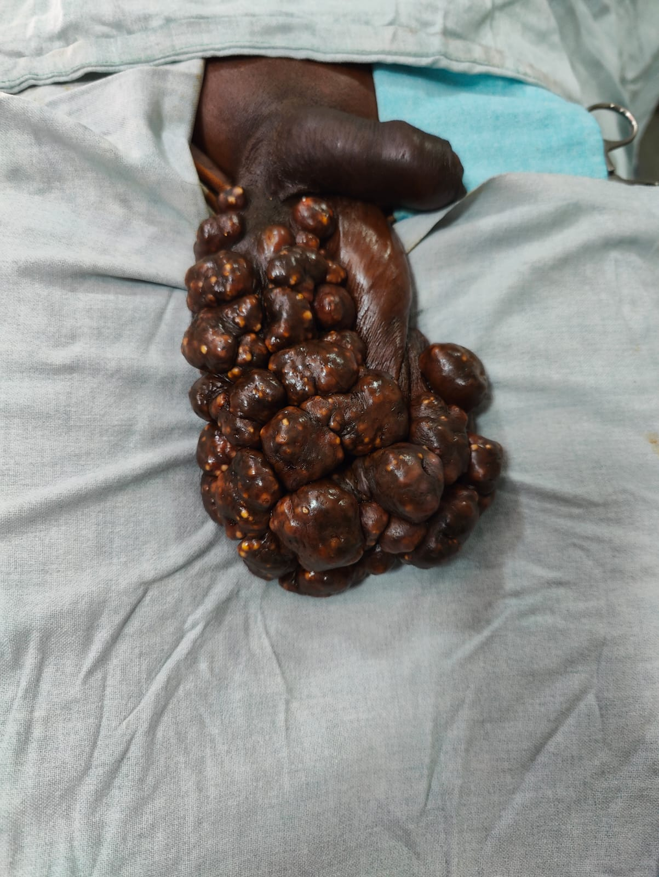

Fig.1. Patient before surgery

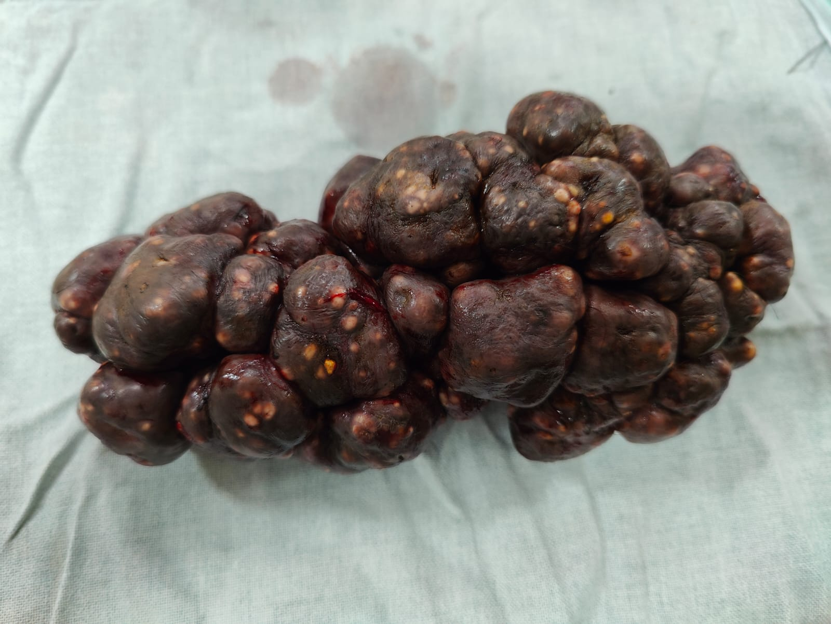

Fig. 2. Retrieved Specimen

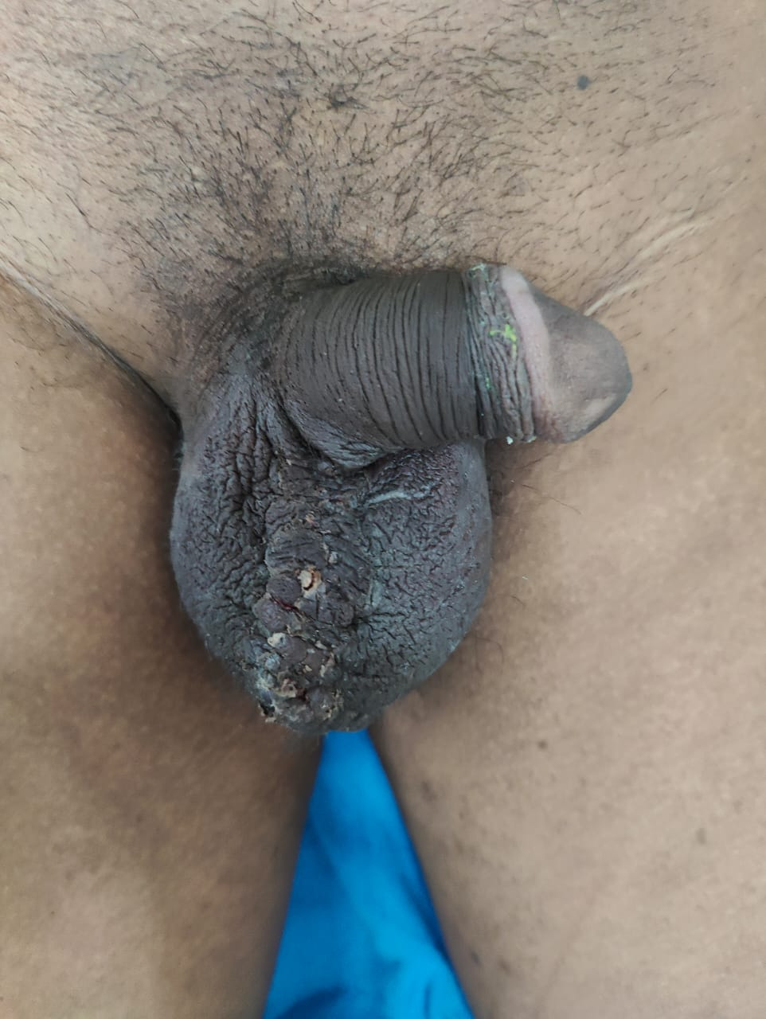

Fig.3 Results after scrotoplasty

DISCUSSION:

Idiopathic scrotal calcinosis (IC) is a benign condition characterized by multiple calcified nodules in the scrotal skin. Its origin is controversial and may be due to the dystrophic calcification of epidermal cysts. They mostly arise de novo without any history of underlying metabolic disorders or trauma. In our case, the lesions were idiopathic as no other causative factors were present.

The patient presented with multiple subcutaneous painless nodules of varying sizes in the scrotum, along with calcified deposits in the dermis and subcutis.  Extensive involvement of the scrotum is not observed. This is rare condition, and was first described by Lewinski in 1883 [3]and established as a distinct entity by Shapiro et al. in 1970[4]. They proposed an idiopathic nature as there were multiple cyst walls. This theory is supported by a majority of studies. Shah V et al [5] found cyst wall in 14 out of 20 cases. Song et al [6] found cyst wall structure in various stage of inflammation with calcification in 51 nodules from 1 case. Dubey et al [7] reported inflamed cyst with intact cyst wall in 53% cases, pseudocysts in 56% of cases out of total 100 cases. Cyst wall formation was not observed in the present case. Chalky discharge from the nodules, and some may present with secondary infections of the skin. Our patient had no history of pruritus, soreness, exudation, or infection. The mean age of patients with idiopathic scrotal calcinosis is 31.5 years, of which 70% present with a third decade of life [7]. Cosmetic appearance and decreased sexual quality of life were the main concerns of this case. Taren et al [1] in 2018 and Pompo et al 2013 [8] describe the condition mostly as symptomatic and some may present with pruritus, soreness and white chalky discharge. The pathogenesis of idiopathic scrotal calcinosis remains unknown and has been a subject of long-term controversy. In this case, there were no such findings, and the patient was idiopathic.

The gold standard treatment is surgical excision [9] followed by scrotoplasty. Various surgical methods are available, including enucleation, wide local excision with direct closure, and complex reconstruction in single or multiple settings. Chang et al [10] in 2004 advocated pinch punch excision for scrotal calcinosis, it is a noble method for fewer and smaller lesions. Deng Cui et al [2] perform multiple en-bloc excisions with successful reconstruction of scrotal skin by multiple flap transfers. In this case, wide local excision with scrotoplasty was preferred. Our patient reported the desired cosmetic improvement and significant enhancement in sexual quality of life, contributing to overall satisfaction with the surgical procedure. There were multiple follow-up evaluations after surgery, with no signs of recurrence noted during the 6 months of postoperative period.

HPE shows deposits of calcium in the dermis, surrounded by histocytes and giant cell reactions. Parietal epithelial lining may also be observed in some cases. In this case, microscopic examination revealed scrotal tissue in the squamous epithelium. The underlying dermis was fibrocollagenous with multiple large areas of granules and globules of calcified materials. There was no evidence of atypia or granulomas.

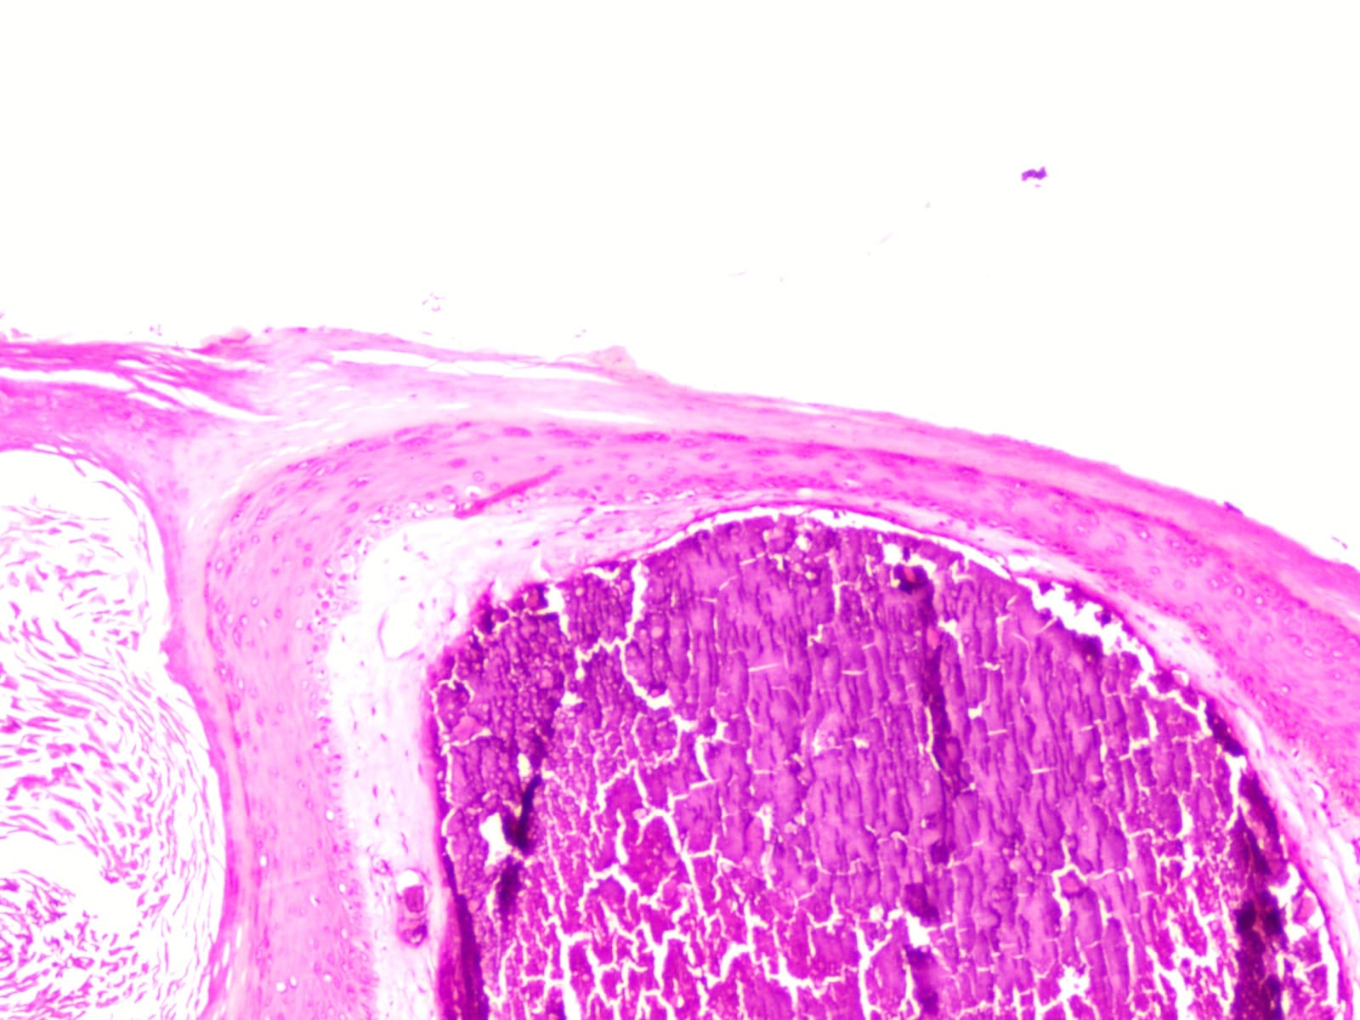

Fig. 4. Calcium deposits in dermis

CONCLUSION:

As it is benign and has a negative impact on cosmesis and sexual quality of life, the main steam of treatment is complete surgical excision, followed by scrotoplasty. The main etiology and pathogenesis are still controversial, but in this case, we believe that it was due to idiopathic calcification. Complete surgical excision is excellent with minimal or no recurrence.

CONSENT:

All authors declare that ‘written informed consent was obtained from the patient for publication of this case report and accompanying image.

CONFLICT OF INTEREST:

Authors don’t have any conflict of interest.

REFERENCES:

1. Tareen A, Ibrahim RM. Idiopathic scrotal calcinosis – A case report. International Journal of Surgery Case Reports [Internet] 2018; 44:51–3 -PubMed
2. Cui D, Chen G, Luo J, Liu C. Successful surgical treatment of extensive idiopathic scrotal calcinosis: A case report. Urology Case Reports [Internet] 2023; 51:102553 – PubMed
3. Lewinski HM. Lymphangiome der Haut mitVerkalklemInhalt. Arch Pathol Anat. 1883;91:371–4 – Google Scholar
4. Shapiro, L. (1970) Idiopathic Calcinosis of the Scrotum. Archives of Dermatology, 102(2), 199 – JAMA Dermatology
5. Shah V, Shet T. Scrotal calcinosis results from calcification of cysts derived from hair follicles: a series of 20 cases evaluating the spectrum of changes resulting in scrotal calcinosis. American Journal of Dermatopathology [Internet] 2007;29(2):172–5 – PubMed
6. Song DH, Lee KH, Kang WH. Idiopathic calcinosis of the scrotum: Histopathologic observations of fifty-one nodules. Journal of the American Academy of Dermatology [Internet] 1988;19(6):1095–101 – PubMed
7. Dubey S, Sharma R, Maheshwari V. Scrotal calcinosis: Idiopathic or dystrophic? Dermatology Online Journal [Internet] 2010;16(2) – Dermatology online journal
8. Pompeo A, Molina W, Pohlman G, Sehrt D, Kim F. Idiopathic scrotal calcinosis: A rare entity and a review of the literature. Canadian Urological Association Journal [Internet] 2013;7(5–6):439 – PubMed
9. Jayarajah U, De Silva L, De Silva C, Seneviratne S. Idiopathic scrotal calcinosis: a case report of a rare entity. Case Reports in Urology [Internet] 2019; 2019:1–3 – PubMed
10. Chang, C.-H., Yang, C.-H., & Hong, H.-S. (2004).
11. Surgical pearl: pinch-punch excisions for scrotal calcinosis. Journal of the American Academy of Dermatology, 50(5), 780–781 – JAAD